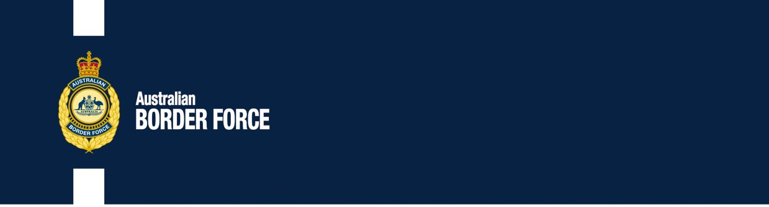

Australian Customs Notice No. 2020/34

Precursor chemicals and drug regulation amendments

On 12 August 2020 the *Criminal Code and Customs Legislation Amendment (Precursors and Drugs) Regulations 2020* (the Regulations) comes into effect.

The Regulations amend the following:

* *Criminal Code Regulations 2019* (the Code Regulations) to list additional substances as controlled precursors and border controlled precursors,
* *Customs (Prohibited Exports) Regulations 1958* (the PE Regulations) and the *Customs (Prohibited Imports) Regulations 1956* (the PI Regulations) to impose controls on the importation and exportation of drugs, and the importation of precursors, and
* *Customs Regulation 2015* (the Customs Regulation) to include additional precursors as Tier 1 goods.

# Amendments in relation to precursors

The Regulations add ten additional precursors in section 13 and twelve additional precursors in section 16 of the Code Regulations, as well as specifying commercial and marketable quantities for these substances. The Government has identified that these precursors have no known legitimate industrial or commercial use.

The Regulations add relevant border controlled precursors to Schedule 4 of the PI Regulations. This amendment empowers the Australian Border Force to seize these substances at the border without a warrant if imported without the required permission.

The Regulations amend the commercial quantities and marketable quantities for phenyl-2- propanone (a controlled precursor and a border controlled precursor). The previous quantities are replaced with smaller quantities, reflecting methods for producing methamphetamine from phenyl- 2-propanone.

The Regulations amend the Customs Regulation to enable prosecution of a person under section 233BAA of the *Customs Act 1901* for unlawful exportation and importation of precursors. This amendment intends to deter the unlawful exportation and importation of precursors.

***Australia’s customs service***

# Amendments in relation to drugs

Australia is a signatory to the United Nations Commission on Narcotic Drugs for the *Single Convention on Narcotic Drugs of 1961*, as amended by the *1972 Protocol,* the *Convention on Psychotropic Substances of 1971* and the *United Nations Convention against Illicit Traffic in Narcotic Drugs and Psychotropic Substances 1988*.

As a signatory to these Conventions, Australia is obliged to impose import and export controls on substances scheduled in these Conventions. The Regulations ensure Australia’s continuing compliance with these Conventions by adding the newly scheduled substances to Schedule 8 to the PE Regulations and Schedule 4 to the PI Regulations.

To better align Commonwealth controls with state and territory controls, the Regulations add seven additional substances to Schedule 4 to the PI Regulations. The Department of Health has classified these substances as Prohibited Substances in Schedule 9 to the *Standard for the Uniform Scheduling of Medicines and Poisons.*

**Further information**

For detailed information on these changes, please consult the legislation directly, including the explanatory statement (https://[www.legislation.gov.au/Details/F2020L01003).](http://www.legislation.gov.au/Details/F2020L01003))

For more information on exporting or importing prohibited substances and drugs from or to Australia, please see: https://[www.abf.gov.au/importing-exporting-and-manufacturing/prohibited-](http://www.abf.gov.au/importing-exporting-and-manufacturing/prohibited-) goods.

[Signed]

Matthew Duckworth Assistant Secretary

Customs and Trade Policy Branch Customs Group

10 August 2020

| 2