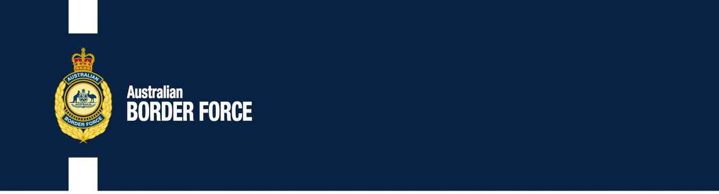Australian Customs Notice No. 2020/35

Application for Customs Broker Licences

The following individuals and companies have applied to the Comptroller-General of Customs for a customs broker licence:

**INDIVIDUALS: CORPORATE:**

Mark Power “K” Line Logistics (Australia) Pty Limited Jamie Risteski

ABN 97 119 645 797

Level 2, 187 Todd Road Port Melbourne, VIC 3207

Persons in Authority Alan Miles

Craig Sayer Anthony Donovan Keiji Kubo

Nominee Broker Mark Boundy Jing Wang

Lisa Nicotera

Any person wishing to make written representation in respect of any of these applicants should address the correspondence, by 23 August 2020, to:

Broker Licensing

Australian Border Force Or email:

3 Molongolo Drive [brokers.licensing@abf.gov.au](mailto:brokers.licensing@abf.gov.au) Canberra Airport

CANBERRA ACT 2609

Principles of procedural fairness in respect of information that is potentially adverse to the applicant will be applied and if information is received that is considered credible, relevant and significant, the applicant will be made aware of the substance of the representation and given the opportunity to respond to the representation.

[SIGNED]

Steve Moore

Director, Customs Licensing

Trusted Trader and Trade Compliance Branch | Customs Group Australian Border Force

CANBERRA ACT

7 August 2020