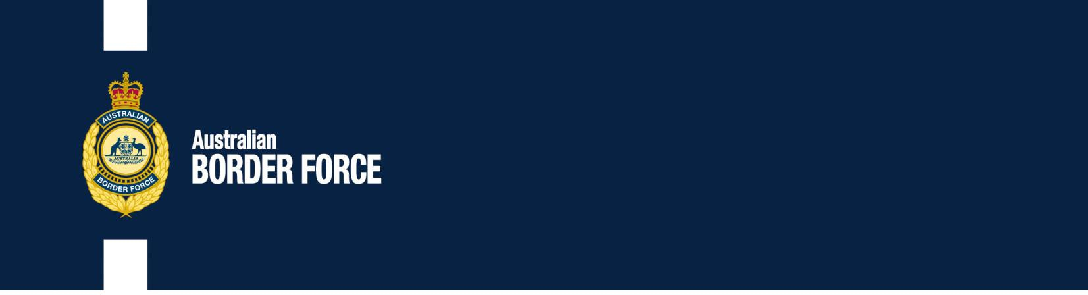Australian Customs Notice No. 2020/37

Objectionable Goods ‘advocating the doing of a terrorist act’

From 27 August 2020, the definition of ‘advocating the doing of a terrorist act’ has been amended in Regulation 4A of the *Customs (Prohibited Imports) Regulations 1956* (PI Regulations) and Regulation 3 of the *Customs (Prohibited Exports) Regulations 1958* (PE Regulations). This amendment aligns the definition with the *Classification (Publications, Films and Computer Games) Act 1995* and the *Criminal Code Act 1995*.

# Definition of ‘doing a terrorist act’

Paragraph 4A(1B)(c) of the PI Regulations and paragraph 3(2A)(c) of the PE Regulations prohibit the import and export of goods that ‘advocate the doing of a terrorist act’ if the goods praise the doing of a terrorist act and there is a risk that such praise might lead a person to engage in a terrorist act. The amended Regulations now require the risk be ‘substantial’.

Paragraphs 4A(1B)(a) of the PI Regulations and 3(2A)(a) of the PE Regulations prescribe that goods will advocate the doing of a terrorist act if they ‘counsel or urge’ such acts. The amended Regulations now include material that ‘promotes’ and ‘encourages’ the doing of a terrorist act.

# Further information

For information regarding these changes, please consult the relevant legislation, including the explanatory statement, at https://[www.legislation.gov.au/Details/F2020L01046.](http://www.legislation.gov.au/Details/F2020L01046)

For information on the Australian controls on objectionable goods, please see: https://[www.abf.gov.au/importing-exporting-and-manufacturing/prohibited-](http://www.abf.gov.au/importing-exporting-and-manufacturing/prohibited-) goods/categories/miscellaneous and select ‘pornography’ and ‘objectionable material’.

[Signed]

Matthew Duckworth Assistant Secretary

Customs and Trade Policy Branch 24 August 2020

***Australia’s customs service***