[Chemosphere 253 (2020) 126774](https://doi.org/10.1016/j.chemosphere.2020.126774)



Contents lists available at [ScienceDirect](www.sciencedirect.com/science/journal/00456535)

Chemosphere

j o u r n a l h o m e p a g e : [w w w . e l s e v i e r . c o m / lo c a t e / c h e m o s p h e r e](www.elsevier.com/locate/chemosphere)

Mushroom residue modification enhances phytoremediation potential of Paulownia fortunei to lead-zinc slag



Liangze Han a, Yonghua Chen a, *, Mingli Chen a, **, Yangfeng Wu a, Rongkui Su a, Lu Du a, Zhiming Liu b

1. College of Environmental Science and Engineering, Central South University of Forestry and Technology, Changsha, 410004, China
2. Department of Biology, Eastern New Mexico University, Portales, NM, 88130, USA

h i g h l i g h t s g r a p h i c a l a b s t r a c t

Mushroom residue can alleviate the toxicity of lead zinc slag to Paulownia fortunei.

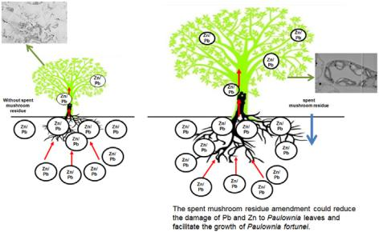

Mushroom residue can enhance the phytoremediation potential of Paulownia fortunei in lead zinc slag. Mushroom residue can transform lead and zinc in Paulownia fortunei into weak migration state.

Mushroom residue can increase the content of photosynthetic pigments in Paulownia fortunei leaves.

a r t i c l e i n f o a b s t r a c t

Article history:

Received 19 December 2019 Received in revised form 25 March 2020

Accepted 9 April 2020 Available online 14 April 2020

Handling Editor: T Cutright

Keywords:

Chemical forms

Woody plants

Subcellular distribution

Heavy metal stress



Phytoremediation is an effective strategy for the remediation of lead-zinc slag, while the response of plant on lead and zinc was less concerned. In this study, mushroom residue was adding in lead-zinc slag to enhance the phytoremediation potential of P. fortunei, the effects of three treatments (lead-zinc slag, red soil, lead-zinc slag þ 10% (m/m) mushroom residue) on the growth, physiology and microstructure of P. fortunei were determined. The results showed that the addition of mushroom residue increased the biomass, plant height and chlorophyll concentration of P. fortunei, indicating that the addition of mushroom residue can facilitate the growth of P. fortunei. Moreover, the proportions of oxalate-Pb forms and phosphate-Zn were dominant in leaves and stems of P. fortunei. With the addition of mushroom residue, Pb and Zn were transformed to the extraction state with weak migration activity, which can reduce the damage level of Pb and Zn to P. fortunei. The results from scanning transmission electron microscopy (STEM) showed that, the mushroom residue amendment could maintain the integrity of the cell structural of P. fortunei. The results from fourier transform infrared spectrometer (FTIR) analysis showed that the mushroom residue amendment could increase the contents of proteins and poly-saccharides in P. fortunei, which can combine with the metals. Clearly, the mushroom residue amend-ment could promote the growth ability of P. fortunei in lead and zinc slag and strengthen the phytoremediation potential.

© 2020 Elsevier Ltd. All rights reserved.

|  |  |
| --- | --- |
| * Corresponding author. | 1. Introduction |
| ** Corresponding author. |  |
| E-mail addresses: [chenyonghua3333@163.com](mailto:chenyonghua3333@163.com) (Y. Chen), [chml18@163.com](mailto:chml18@163.com) | China is rich in lead and zinc resources (Zhang et al., 2012). Over- |
| (M. Chen). |  |
| <https://doi.org/10.1016/j.chemosphere.2020.126774> |  |
| 0045-6535/© 2020 Elsevier Ltd. All rights reserved. |  |

2 L. Han et al. / Chemosphere 253 (2020) 126774

exploitation of lead and zinc slag has caused serious environmental pollution and ecosystem degradation (Pan and Li, 2016). Phytor-emediation is a cost-effective, promising, and environmental-friendly technique for tailing restoration (Wang et al., 2019; Ali et al., 2013). Hyperaccumulators have been widely studied in phy-toremediation (Rascio and Navari-Izzo, 2011; Yang et al., 2014). By accumulation of heavy metals in the aboveground part of the hyperaccumulator, the heavy metals can be removed from the soils by harvesting the aboveground part of the biomass regularly (Brown et al., 1995). However, at present, most of the hyper-accumulators are annual herbaceous plants with low biomass, so it is difficult to be applied in a large-scale remediation project (Jaffre et al., 2013). In addition, there is a risk that the heavy metals absorbed by the plants may enter the food chain (Peterson et al., 2003). Woody plant phytoremediation has been received more and more attention in recent years due to the high accumulation of heavy metals (Luo et al., 2016). Woody plants with well-developed root systems, abundant biomass, and rapid growth in harsh soil environments have become the alternative to hyperaccumulators (Gallagher et al., 2008). On the one hand, phytostabilization can reduce soil and water loss, and on the other hand, it can reduce the migration and diffusion of heavy metals, especially in the slags where heavy metal pollution is serious in large areas (Bert et al., 2009).

In terms of phytostabilization, P. fortunei (Zhang et al., 2019), Populus L (He et al., 2013), Platanus acerilolia (Kang et al., 2018), Robinia pseudoacacia (Yakun et al., 2016) have been reported to be useful in tailings restoration. Our previous research showed that P. fortunei was a typical tolerant tree species, which could survive in lead-zinc slag, and showed excellent phytoremediation effects (Tang et al., 2019).

The lead-zinc tailing has a poor structure and extremely low organic matter content (Li et al., 2013). Plants are difficult to grow on it. It is necessary to add amendment in lead-zinc slag to promote the growth of plants in harsh soil environments. At present, there are more and more studies on soil amendments, such as sepiolite (Abad-Valle et al., 2016), zeolite (Querol et al., 2006), clay (Garcia-Sanchez et al., 2002), and peat (Perez-de-Mora et al., 2007). The addition of organic modifier could improve fertility and physico-chemical properties of tailing slag, and increase the tolerability of plants to heavy metals (Walker et al., 2004), and then promote the growth of plants (Kogbara et al., 2017). Compost can be applied to copper mine restoration (Novo et al., 2013), and spent mushroom residue can strengthen the phytoremediation potential of Ricinus communis to Cd- and Zn-polluted soil (Xue et al., 2018). Mushroom residue is the waste substrate after mushroom production with low bulk density and high organic matter content (Buswell, 2013). The addition of mushroom residue can increase the aeration and water retention capacity of soil through the fluffy structure of mushroom residue, which is a potential effective method to increase the phytostabilization efficiency (Courtney et al., 2009). Our research team found that adding 10% (m/m) mushroom residue in lead-zinc slag could significantly increase P. fortunei biomass. However, it is not clear how mushroom residue helps P. fortunei resist heavy metal stress.

This study is intended to: (1) investigate the effect of mushroom residue added in lead-zinc slag on the growth of P. fortunei, including biomass, plant height and root architecture; (2) explore the response of the physiological characteristics of P. fortunei to heavy metal stress, including diurnal variation of photosynthesis and chlorophyll content of P. fortunei leaves in lead-zinc slag; (3) explore the effect of mushroom residue on the micromorphology and structure of P. fortunei, including subcellular distribution, chemical forms of Pb and Zn, the microscopic morphology and functional groups of P. fortunei in lead-zinc slag. This study attempts

to provide a theoretical reference and amended materials for lead-zinc slag restoration by woody plants.

2. Materials and methods

2.1. Experimental design

The lead-zinc slag was obtained from lead-zinc tailings in Chenzhou Hunan. The red soil was taken from the nursery of the Central South Forestry University of Science and Technology. And the mushroom residue was purchased from the flower market in Changsha city. P. fortunei seminal roots were obtained from a nursery in Henan, China. P. fortunei seminal roots were cultivated in red soil before the experiment, and P. fortunei were selected for reserve when they grew to about 10 cm. Pot experiment was con-ducted at the nursery of the Central South Forestry University of Science and Technology. Mushroom residue was selected as soil amendment, lead-zinc slag and red soil were stirred into three pot substrates according to different mass ratios: A (100% lead-zinc slag), B (100% red soil), and C (90% lead-zinc slag þ 10% mush-room residue), respectively. Each pot had a stock of 10 kg with three replicates. Plants were cultivated with tap water. The experimental period was from March to November, 2018. Physicochemical characterization of all prepared substrates was tested before the experiment (Table 1).

2.2. Experimental methods

2.2.1. Plant height, biomass and root length

Plant samples were treated according to the method of Pan et al. (2019) with some modifications. The height of the harvested plants was measured from the root to the top by tape. The harvested plants were divided into roots, stems and leaves, and rinsed with tap water followed by deionized water. After washing, plant sam-ples were heated to 105 C for 30 min, dried to a constant value of plant biomass at 75 C. Root length was analysed by WinRHIZO PRO Root Analysis System Software (WinRHIZO(2013e), Canada).

2.2.2. Subcellular fractions of Pb and Zn in leaves, stems, and roots The harvested plants were washed with clean water, soaked in

EDTA-2Na solution for 10 min to remove the heavy metals on the surface, and then rinsed them with clean water. Plant samples were treated according to the method of Wang et al. (2012) with some modifications. Plant tissues were homogenized with cooled extraction buffer [250 mM sucrose, 1.0 mM DTT (C4H10O2S2) and 50 mM Tris-HCl, pH 7.5]. The homogenate was centrifuged at

1. g for 30 s and precipitated into cell wall fraction (F1); the supernatant was centrifuged at 10,000 g for 30 min and precipi-tated into organelle fraction (F2); the supernatant was soluble fraction (F3). All operations were carried out at 4 C.

2.2.3. Chemical forms of Pb and Zn in leaves, stems and roots

Plant samples were treated according to the method of Yang et al. (2018). Pb and Zn chemical forms were extracted from the following steps: (1) inorganic forms extracted by 80% ethanol; (2) organic forms extracted by H2O; (3) pectates and protein forms extracted by 1 M NaCl; (4) undissolved phosphate forms extracted by 2% HAc; (5) oxalate forms extracted by 0.6 M HCl; and (6) the residual Pb, Zn form.

2.2.4. Photosynthetic parameters and chlorophyll content in leaves Chlorophyll concentration was determined by UV-5100 ultra-

violet and visible spectrophotometer (Feng et al., 2017). Net photosynthetic rate (Pn), stomatal conductance (Gs), intercellular carbon dioxide (Ci), transpiration rate (Tr) parameters were

|  |  |  |  |  |  |  |  |  |  |  |  |
| --- | --- | --- | --- | --- | --- | --- | --- | --- | --- | --- | --- |
|  |  | L. Han et al. / Chemosphere 253 (2020) 126774 | | | |  |  |  |  | 3 | |
| Table 1 |  |  |  |  |  |  |  |  |  |  |  |
| Physicochemical characterization of all prepared substrates. | | |  |  |  |  |  |  |  |  |  |
|  |  |  |  |  |  |  | | | |  |  |
| Substrates and standards | pH | Organic substances (％) | Soil porosity (%) |  |  | Metal content（mg/kg） | | | |  |  |
|  |  |  |  |  |  |  | |  | |  |  |
|  |  |  |  |  | Pb | Zn | | Cu | | Cd | |
|  |  |  |  |  | |  |  |  |  |  |  |
| A | 7.35 ± 0.02 | 2.48 ± 0.07 | 29±6 | 3417 ± 24 | | 5013 | ± 272 | 164 | ± 10 | 49±1 |  |
| B | 6.90 ± 0.03 | 3.65 ± 0.04 | 45±5 | 251 ± 10 | | 264 | ± 58 | 39 | ± 1 | 3.7 ± 0.1 |  |
| C | 7.15 ± 0.01 | 2.67 ± 0.03 | 49±5 | 3117 ± 77 | | 4606 | ± 175 | 145±4 | | 45±4 |  |
|  |  |  |  |  |  |  |  |  |  |  |  |

Note: A ¼ 100% lead-zinc slag, B ¼ 100% red soil, C ¼ 90% lead-zinc slag þ 10% mushroom residue.

measured by portable photosynthetic meter (Li-6400, USA) at 8:30, 10:30, 12:30, 14:30, 16:30 and 18:30 respectively on a sunny day from July to August. Three plants were randomly selected in the experiment, and three leaves with normal growth and basically identical leaf positions were selected for each plant.

2.2.5. Plant microstructure and functional group composition analysis

The microstructure of plant roots, stems, leaves was observed by

scanning transmission electron microscopy (STEM).

2 mm 2 mm 1 mm fresh roots, stems and leaves of P. fortunei were chosen and preserved in 2.5% glutaraldehyde solution at 4 C for testing. The microstructure of P. fortunei roots, stems and leaves was tested by Qingdao Sci-tech Innovation Quality Testing Co. Ltd. The functional group composition analysis were performed by fourier transform infrared spectrometer (FTIR). The harvested plants were divided into roots, stems and leaves, and rinsed with tap water followed by deionized water. After washing, plant sam-ples were heated to 105 C for 30 min, dried to a constant value of plant biomass at 75 C. The dried samples were passed through a 200 mm mesh sieve and then take 20 ml samples were analysed using FTIR (Nicolet iS 10, Thermo Scientific, America) within the range 400e4000 cm 1. KBr was taken as the background material. This FTIR analysis was measured by Shanghai Hui Ming detection equipment Co. Ltd.

The composition of functional groups of samples was tested by Shanghai Hui Ming Testing Company. Roots, stems and leaves were heated to 105 C for 30 min, dried at 75 C to a constant weight, and ground the powder into 200 mesh sieve with plant grinder for testing. The composition of functional groups of the samples was tested by Shanghai Hui Ming Testing Company.

2.3. Data analysis

All results were tested by one-way ANOVA using the SPSS 22 statistical package. All figures were drawn using the Origin 2017 statistical package. The Duncan test at 5% probabilities was per-formed for later comparison to test for treatment differences.

3. Results

3.1. P. fortunei growth parameters

The height and the amount of total biomass of P. fortunei among tree treatments showed the tendency of C > B > A, which indicated that mushroom residue added to the slag can significantly promote

Table 2

The height and biomass of Paulownia fortunei on three kinds of substrates.

plant growth (Table 2). The height and biomass of P. fortunei in treatment C increased by 76.13% and 225.94% respectively compared with treatment A. There was no significant difference in total biomass between treatment B and treatment C, indicating that the effect of mushroom residue on plant height and biomass was similar to that of red soil.

3.2. P. fortunei root structures change

Compared with treatment A, treatment C increased the total root length by 406%, the total surface area by 144%, the total volume by 32%, and the number of root tips by 640% (Table 3), indicating that the addition of mushroom residue alleviated the toxic effect of heavy metals on the roots and promoted the growth and devel-opment of roots. There was no significant difference between treatment B and C.

3.3. Photosynthetic pigments of P. fortunei leaves

Compared with treatment A, treatment C increased the con-centration of chlorophyll a by 74%, the carotenoid by 75%, total chlorophyll by 53%, and chlorophyll a/b by 44%, indicating that the addition of mushroom residue significantly increased the concen-tration of photosynthetic pigments in P. fortunei leaves under the lead-zinc slag stress, even more than that in red soil treatment (Table 4).

3.4. Diurnal variation of photosynthesis in P. fortunei leaves

The maximum net photosynthetic rate (Pn) showed typical bimodal variation, and the average of Pn in treatment C was the highest, which was consistent with the high content of photosyn-thetic pigments (Fig. 1). Compared with treatment A, the net photosynthetic rate of treatment C increased by 47%. At 14:30, the values of Pn in treatments A and C were declined less obviously than that in treatment B, which might be explained that many mineral nutrients in lead-zinc slag could provide a material basis for plants and participate in photosynthesis during the lunch breaks (Maier et al., 2008).

The changes of transpiration rate (Tr) and stomatal conductance (Gs) were consistent with Pn, and both showed typical bimodal variation. Compare with treatment A, the average of Tr and Gs in treatment C increased by 130% and 138%. The intercellular CO2 concentration (Ci) of P. fortunei leaves in different substrates pre-sented a "W" pattern distribution, and the difference between treatments was small, basically contrary to Pn, which was

|  |  |  |  |  |  |
| --- | --- | --- | --- | --- | --- |
| Treatment | plant height (cm) | Total biomass(g) | Root biomass(g) | Stem biomass(g) | Leaf biomass(g) |
|  |  |  |  |  |  |
| A | 26.86 ± 5.17b | 10.95 ± 1.00b | 9.47 ± 1.33b | 0.98 ± 0.36c | 0.50 ± 0.02b |
| B | 39.29 ± 5.99a | 30.59 ± 7.47a | 24.31 ± 6.11a | 4.89 ± 1.35b | 1.38 ± 0.3b |
| C | 47.29 ± 9.72a | 35.69 ± 5.98a | 19.72 ± 4.61ab | 10.75 ± 1.00a | 5.23 ± 1.36a |

Note: Data is the means of three replicates (n ¼ 3). Different lowercase letters represent statistically significant difference between treatments (p < 0.05). A ¼ 100% lead-zinc slag, B ¼ 100% red soil, C ¼ 90% lead-zinc slag þ10% mushroom residue.

4 L. Han et al. / Chemosphere 253 (2020) 126774

Table 3

The root structure of Paulownia fortunei on three kinds of substrates.

|  |  |  |  |  |  |  |
| --- | --- | --- | --- | --- | --- | --- |
| Treatment | Total root length | Total root surface | Total root volume | Average root diameter | Root tip number | |
|  | （cm） | （cm2） | （cm3） | （mm） |  |  |
| A | 229.17 ± 47.61b | 192.52 ± 33.12b | 12.84 ± 0.75a | 3.35 ± 0.44ab | 375 | ± 55.72b |
| B | 945.66 ± 5.48a | 456.67 ± 57.35a | 18.36 ± 6.62a | 1.66 ± 0.25b | 2831 | ± 538.60a |
| C | 1158.46 ± 157.89a | 471.58 ± 106.33a | 17.05 ± 4.24a | 4.98 ± 1.18a | 2775 | ± 381.20a |

Note: Data is the means of three replicates (n ¼ 3). Different lowercase letters represent statistically significant difference between treatments (p < 0.05). A ¼ 100% lead-zinc slag, B ¼ 100% red soil, C ¼ 90% lead-zinc slag þ10% mushroom residue.

Table 4

The photosynthetic pigments of Paulownia fortunei leaves on three kinds of substrates.

|  |  |  |  |  |  |  |  |  |
| --- | --- | --- | --- | --- | --- | --- | --- | --- |
| Treatment | Chlorophyll a（mg$g | 1） | Chlorophyll b（mg$g | 1） | Carotenoid | Total chlorophyll（mg$g | 1） | Chlorophyll a/b |
|  |  |  |  |  | （mg$g 1） |  |  |  |
| A | 4.71 ± 0.53b |  | 2.75 ± 0.81a |  | 1.12 ± 0.33b | 1.07 ± 0.03b |  | 1.95 ± 0.82b |
| B | 6.95 ± 0.25a |  | 1.46 ± 0.62a |  | 1.75 ± 0.09a | 1.27 ± 0.09b |  | 5.55 ± 1.83a |
| C | 8.18 ± 0.91a |  | 2.91 ± 0.32a |  | 1.96 ± 0.18a | 1.63 ± 0.18a |  | 2.81 ± 0.04ab |

Note: Data is the means of three replicates (n ¼ 3). Different lowercase letters represent statistically significant difference between treatments (p < 0.05). A ¼ 100% lead-zinc slag, B ¼ 100% red soil, C ¼ 90% lead-zinc slag þ10% mushroom residue.

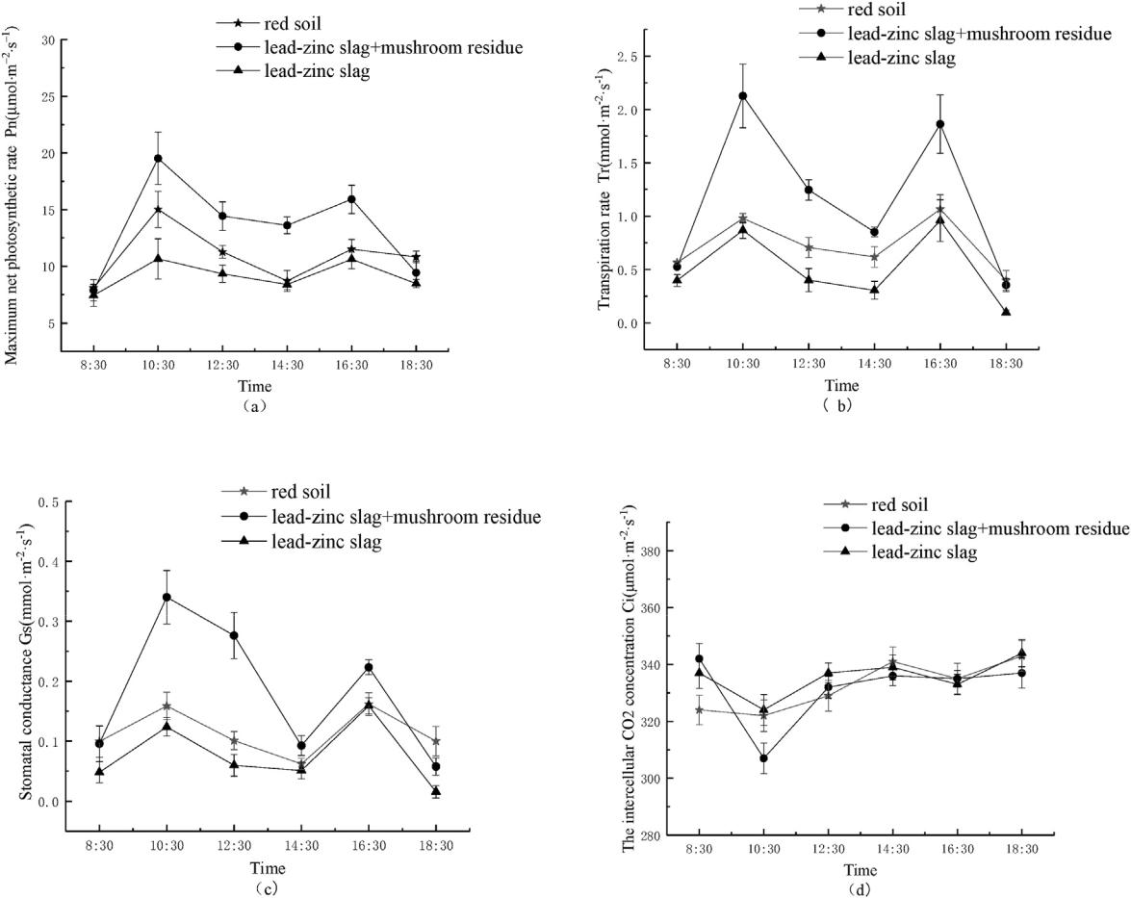

Fig. 1. The diurnal variation of photosynthetic parameters in Paulownia fortunei on three kinds of substrates. Note: Data is the means of five replicates (n ¼ 5).

consistent with the results of Tholen and Zhu (2011).

3.5. Pb and Zn subcellular distribution and chemical forms

Compared to organelles, Pb was mainly distributed in cell wall and soluble part (Fig. 2a). It showed that in order to reduce the

toxicity of Pb, P. fortunei mainly stored Pb in the lower active parts (Zhang et al., 2019). In treatment A, the distribution of Pb in each subcellular fraction of P. fortunei showed F1 > F3 > F2. However, in treatment C, Pb decreased in cell wall (F1) and increased in soluble component (F3), indicating that the addition of mushroom residue enhanced the retention effect of soluble component on Pb.

|  |  |
| --- | --- |
| L. Han et al. / Chemosphere 253 (2020) 126774 | 5 |

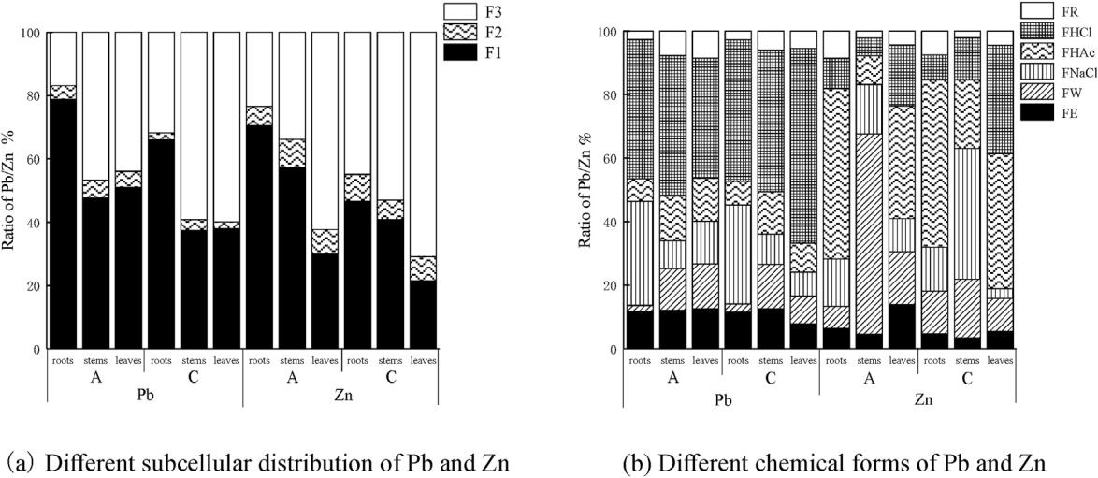

Fig. 2. Subcellular and chemical forms distribution of Pb and Zn in Paulownia fortunei. Note: F1 represents cell wall fraction, F2 represents organelle fractions, F3 represents soluble fractions. FE represents ethanol extraction state, FW represents water extraction state, FNaCl represents sodium chloride extraction state, FHAc represents acetic acid extraction state, FHCl represents hydrochloric acid extraction state, FR represents residual extraction state. A ¼ 100% lead-zinc slag, C ¼ 90% lead-zinc slag þ10% mushroom residue.

Moreover, after adding mushroom residue, the proportion of Pb in the organelle components (F2) decreased by 2%, 3% and 3% respectively in root, stem, and leaf cells. It indicated that after adding mushroom residue, the damage level of Pb to organelles was reduced, which was beneficial to cellular metabolism. Zinc was mainly distributed in cell wall and soluble part, and also in or-ganelles, which might be related to the fact that zinc is an essential element for plant growth (Gong and Shen, 2010). In treatment A, the proportion of Zn subcellular components in root and stem of P. fortunei was F1 > F3 > F2, and the proportion of each subcellular component in leaf was F3 > F1 > F2. The addition of the mushroom residue decreased the proportion of Zn in cells of P. fortunei, and increased the soluble components, indicating that the addition of mushroom residue enhanced the retention effect of soluble com-ponents on zinc.

Most of Pb was extracted by hydrochloric acid (35%e51%) and sodium chloride (7%e33%) from the plant tissues, followed by acetic acid (7%e14%) (Fig. 2b). Compared with treatment A, treat-ment C increased the extraction state of hydrochloric acid in P. fortunei leaves, reduced the other forms, and changed the roots and stems little. This indicated that after adding mushroom residue, Pb was transformed to the extraction state with weak migration activity, especially reduced the toxicity of Pb to leaves. Zn was extracted by acetic acid (9%e54%) and water (7%e63%), followed by sodium chloride (3%e41%). Compared with treatment A, treatment C reduced the ethanol extraction and water extraction state of P. fortunei stems and leaves, and increased the proportion of hy-drochloric acid extraction state and acetic acid extraction state. It indicated that after adding mushroom residue, Zn was transformed to the extraction state with weak migration activity, especially in the aboveground part of P. fortunei.

3.6. Microstructure of P. fortunei roots, stems and leaves

Treatment B of P. fortunei showed the root (Fig. 3. B-root), stem (Fig. 3. B-stem), leaf (Fig. 3. B-leaf) cell wall, membrane structure integrity, smooth and continuous cytoplasmic membrane, uniform chromatin, no obvious damage to organelles, and intact outer membrane of chloroplast, clear and uniform layer structure, dense matrix and uniform distribution of starch granules. Treatment C of P. fortunei showed the root (Fig. 3. C-root), stem (Fig. 3. C-stem), leaf

(Fig. 3. C-leaf) cell wall, membrane structure integrity without significant damage. The ultrastructure of chloroplast was not significantly changed. The outer shape and the structure of grana were basically the same as those of treatment B. Osmiophilic granules and thylakoids were evenly distributed around starch granules. Black particles were observed around the cell walls and intercellular spaces in the cells of P. fortunei root (Fig. 3. A-root), stem (Fig. 3. A-stem) and leaf (Fig. 3. A-leaf) in treatment A, which might be heavy metal precipitation. Dou et al. (2009) had a similar finding and indicated that black substances in Phytolacca Americana leaf cells were manganese oxides. Black matter adhered to the cell wall or the periphery of the cell membrane, and the contents of the cytoplasmic membrane were concentrated, resulting in the phe-nomenon of plasmolysis. The chloroplast was damaged obviously, the inner structure was disordered, and the bilayer membrane structure was broken or disappeared, especially in leaves.

3.7. FTIR analysis of P. fortunei roots, stems and leaves

Compared with treatment B, the FTIR spectral peak shape of the root, stem, and leaf cells of P. fortunei in treatments A and C remained the same, but their transmittances showed obvious dif-ferences at 3420, 2920, 1630 and 1040 cm 1 (Fig. 4). The absorption peaks near 3420 cm 1 represents the functional group of eOH, mainly from polysaccharides, hemicellulose and cellulose (NO.1). The absorption peak near 2920 cm 1 represents the functional group of-CH, mainly from vitamin, protein, cellulose and pectin in the cell wall (No.2). The absorption peak near 1630 cm 1 represents the functional groups of eCOO and C]O, mainly from amino acids, peptides and proteins (No.3). The absorption peak near 1040 cm 1 represents the functional groups of S]O, mainly from poly-saccharide carbohydrates (No.4) (Sinha et al., 2015). After adding mushroom residue, the transmittances of the absorption peaks at 3420, 2920, 1630 and 1040 cm 1 were decreased obviously. It might be because the mushroom residue amendment improved the ability of the cell walls and vacuoles to bind the metal. These changes were most obvious in root cells, followed by leaves and stems. This can be attributed mainly to the plant roots and leaves which have a rich content of proteins, lipids, organic acids and polysaccharides than woody stem tissues (Poorter and De Jong, 1999). These materials provide a large number of functional

6 L. Han et al. / Chemosphere 253 (2020) 126774

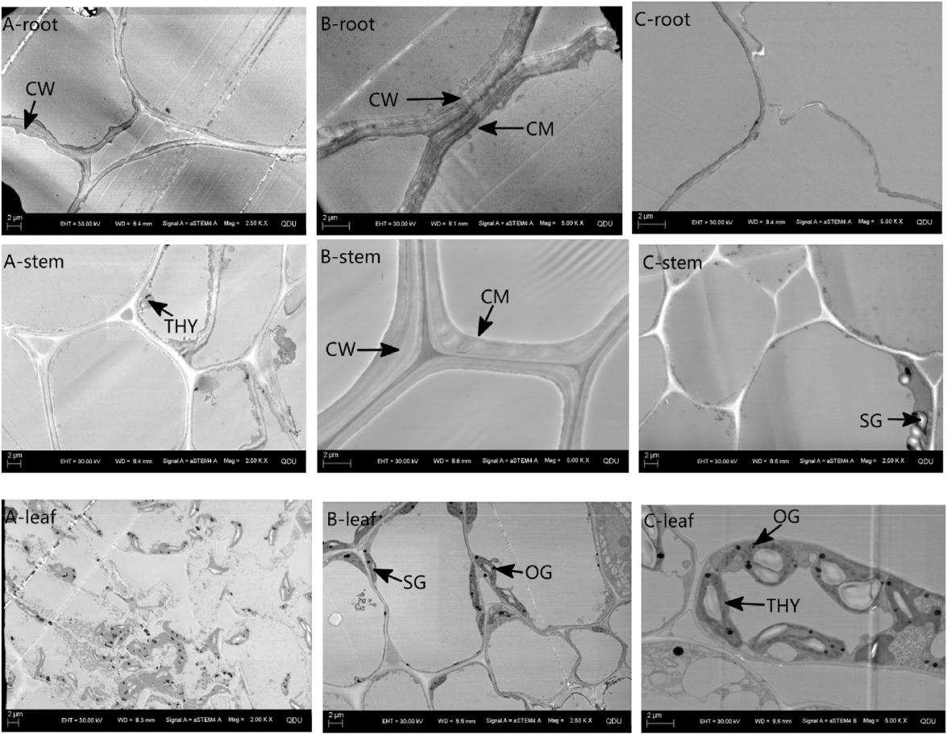

Fig. 3. The microstructure of Paulownia fortunei tissue on three kinds of substrates. Note: CW represents cell wall, CM represents cell membranes, SG represents starch granules, OG represents osmiophilic granules, THY represents thylakoid. A ¼ 100% lead-zinc slag, B ¼ 100% red soil, C ¼ 90% lead-zinc slag þ10% mushroom residue.

groups that can bind with the metal.

4. Discussions

4.1. Effects on the growth of P. fortunei

Lead and zinc are common metal elements in plants. However, excessive lead and zinc in soils would suppress the growth of plants (Zhang et al., 2014). Some studies showed that addition of organic matter is beneficial to soil structure development, and finally re-duces the toxicity of heavy metals to the growth of plants (Courtney et al., 2009). In this experiment, the plant height and total biomass of P. fortunei in treatment A were significantly inhibited, while the total biomass of P. fortunei in treatment C was 226% higher than that of treatment A, indicating that the mushroom residue as a modifier significantly improved the physical and chemical properties of lead-zinc tailings, increased the porosity and the organic matter content of tailings, and reduced the content of Pb and Zn (Table 1). Our results were consistent with the result of Wiszniewska et al. (2016).

As the part that directly contacts the lead-zinc slag, the roots of P. fortunei had the highest heavy metal content. In this experiment, compared with the treatment A, the total root length, total root surface area and root tip number of P. fortunei were significantly increased in treatment C (P < 0.05), indicating that mushroom residue can make the soil looser, improve permeability, increase fertility and facilitate root growth. In addition, the average root

diameter of P. fortunei increased after the addition of mushroom residue, indicating that P. fortunei roots could protect root cells from heavy metal stress by increasing the barrier thickness of epidermis, epidermis, endodermis and non-protoplast barrier (Ryser and Emerson, 2007; Lux et al., 2004; Barcelo and Poschenrieder, 2004). It has been found that the strengthening of root cork and the Kjeldahl belt are also the important mechanisms of root resis-tance against heavy metal ions (Vaculík et al., 2012).

4.2. Effects on photosynthetic pigments and parameters of P. fortunei

Chlorophyll content in chloroplasts directly affects plant growth and development (Jain et al., 2009). In this experiment, the con-centration of chlorophyll a, chlorophyll b and carotenoids in leaves of P. fortunei decreased in the treatment A, which may be due to the inhibition of chloroplast or chlorophyll enzyme activity in leaves under heavy metal stress (Rout et al., 2008). At the same time, the ratio of chlorophyll a to chlorophyll b of P. fortunei decreased significantly, indicating that the chloroplast structure was destroyed severely in P. fortunei leaves. The results were consistent with the data from microstructure of P. fortunei (Karpinski et al., 1994). However, the concentration of photosynthetic pigments in P. fortunei leaves in treatment C was significantly higher than that of treatment A, suggesting that the addition of mushroom residue reduced the damage of chlorophyll and chlorophyll enzyme activity under heavy metal stress (Li and Liu, 2006).

|  |  |
| --- | --- |
| L. Han et al. / Chemosphere 253 (2020) 126774 | 7 |

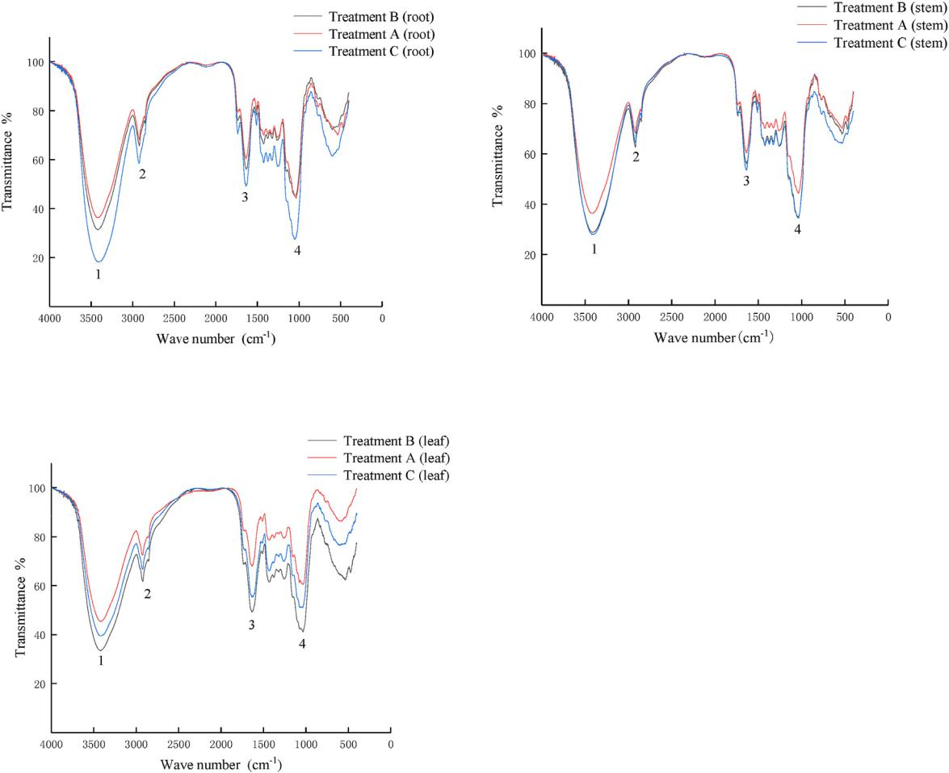

Fig. 4. The functional groups of Paulownia fortunei tissues on three kinds of substrates. Note: A ¼ 100% lead-zinc slag, C ¼ 90% lead-zinc slag þ10% mushroom residue.

Net photosynthetic rate (Pn), transpiration rate (Tr), stomatal conductance (Gs) and intercellular CO2 concentration (Ci) are important indicators of photosynthesis. Studies have shown that the net photosynthetic rate decline is caused by two reasons (Farquhar and Sharkey, 1982). One is the enhancement of solar radiation at noon, the increase of stomatal resistance, and the obstruction of CO2 entering leaves, resulting in the decrease of CO2 concentration and photosynthetic rate, the other is non-stomatal factors. Farquhar believes that stomatal closure is not the cause of photosynthesis decline, but the most important is whether or not the CO2 concentration in the intercellular space is reduced. In this experiment, the net photosynthetic rate of P. fortunei decreased at noon, while the intercellular CO2 concentration increased, indi-cating that the decrease of net photosynthetic rate was caused by non-stomatal factors. After adding mushroom residue, P. fortunei leaves could activate defense mechanism to regulate the osmotic pressure of chloroplast and maintain the integrity of chloroplast (Fig. 3), so that the average of Pn increased significantly (Fig. 1). At the same time, the daily average variation of Tr and Gs of P. fortunei was the largest in treatment C, indicating that mushroom residue could improve the absorption ability of P. fortunei to water and inorganic salts and resist the osmotic imbalance caused by the heavy metals.

4.3. Effects on the microcosmic structure response of P. fortunei

Cell wall solidification and vacuole-dominated soluble

partitioning are two major pathways for detoxification of heavy metals in plants (Hall, 2002). In this experiment, Pb and Zn were mainly distributed in the cell wall and soluble fraction. The cell wall is regarded as the first barrier of heavy metal entering the cell. The black matter appears around the cell wall in the rhizomes and leaves of P. fortunei by STEM. This may be due to the fact that plant cell wall contains polysaccharide, protein, carboxyl, aldehyde, amino and other metallophilic coordination groups, and is easy to fix heavy metals (Pan et al., 2019; Ghori et al., 2019). When the heavy metal ions bound to the cell wall are saturated, heavy metals entering the cell body will be transported to vacuoles, and complex with organic acids and inorganic salts in the vacuole to achieve compartmentalization (Cosio et al., 2004). After adding mushroom residue, the proportion of Pb in the soluble component increased (Fig. 2a), which might be because vacuoles acting as the major component of soluble fraction could chelate Pb (Wang et al., 2016). Meanwhile, after adding mushroom residue, the proportion of Zn in the soluble components (F3) increased by 22%, 19% and 9% respectively in root, stem and leaf cells, which partly increased the transport of Zn in Paulownia, so as to increase the content of chlorophyll and the net photosynthetic rate (Wang and Jin, 2005).

Heavy metals in plants can exist in a variety of chemical forms, and there are significant differences in migration abilities and ac-tivities of heavy metals in different forms (Zhu et al., 2017). Pb and Zn in inorganic and organic forms have higher transfer capacities followed by pectates and protein forms, undissolved phosphate forms, oxalate forms and residues had the lowest transfer capacity

8 L. Han et al. / Chemosphere 253 (2020) 126774

and toxicity (Hu et al., 2010). In this experiment, after adding mushroom residue, the proportion of oxalate forms and residues increased (Fig. 2b) in the leaf of P. fortunei, indicating that Pb was transferred to the forms with weak migration activities. Memon and Yatazawa (1984) suggested that oxalic acid was one of the most effective organic acids in plants to chelate and detoxify heavy metals. After adding mushroom residues, the proportion of water extraction in the aboveground part of P. fortunei decreased, indi-cating that the transformation of Zn to extract with weak migration activity reduced the toxicity of Zn to plants (Zhou et al., 2017). This study showed that the addition of mushroom residues could transfer Pb and Zn to a weak migration activity, and reduced their toxicity to P. fortunei.

Fourier transform infrared spectroscopy (FTIR) is a structural analysis technique based on the vibration of functional groups and polar bonds in compounds. It can be used for structural analysis of macromolecular compounds and secondary structure analysis of proteins (Bosch et al., 2006). In this experiment, the fixation of cell wall and the separation of vacuole might be relative to eCH at 2920 cm 1, eCOO and C]O at 1630 cm 1. These function groups could bind metal in the cell walls and vacuoles, so as to reduce metal toxicity to P. fortunei. After the addition of mushroom residue, the contents of amino acid and carboxylic acid in P. fortunei cell walls and vacuoles increased, and thus enhance the binding the amino acids and the heavy metals. The mushroom residue amendment could increase the amount of hydroxyl groups at 3420 cm 1, removing hydroxyl radicals, thus reducing the damage of free radicals to plant cells. In addition, Xue et al. (2011) found that the absorption peak at 1040 cm 1 might be related to the degree of membrane lipid peroxidation of plant cell membrane, the mush-room residue amendment could increase the amount of thionyl groups at 1040 cm 1, thus decreasing the degree of membrane peroxidation. FTIR analysis of P. fortunei roots, stems and leaves showed that the main functional groups in P. fortunei were ester, carbonyl, methine, hydroxyl and thionyl. These functional groups are mainly part of proteins and polysaccharides, that have the ability to bind heavy metal ions (Parrotta et al., 2015). In this experiment, the addition of mushroom residue could increase the contents of proteins and polysaccharides in P. fortunei and help reduce the toxicity of metals to plants.

5. Conclusions

The study has shown that P. fortunei is an effective woody plant to stabilize heavy metal elements on lead-zinc slag because its large biomass could fix a large amount of Pb and Zn. Moreover, mush-room residue amendment could improve soil fertility, reduce the toxicity of Pb and Zn, and enhance the growth of the plant. The addition of mushroom residue reduced the damage of heavy metals to chloroplast structure and increased the rate of photosynthesis of the plant. In addition, the mushroom residue amendment could change the Pb and Zn in P. fortunei to fewer active forms thus and reduce the toxicity of Pb and Zn to P. fortunei. Further, the addition of mushroom residue could increase the contents of proteins and polysaccharides in P. fortunei to reduce the toxicity of the heavy metals to the plant.

Declaration of competing interest

All authors that they have no financial and personal relation-ships with other people or organizations.

CRediT authorship contribution statement

Liangze Han: Methodology, Formal analysis, Writing - review &

editing. Yonghua Chen: Supervision, Validation, Writing - review &

editing. Mingli Chen: Supervision, Validation, Writing - review &

editing. Yangfeng Wu: Writing - review & editing. Rongkui Su:

Writing - review & editing. Lu Du: Writing - review & editing.

Zhiming Liu: Writing - review & editing.

Acknowledgements

This study was jointly supported by the National Environmental Protection Public Welfare Industry Targeted Research Fund [201509037] and Primary Research & Development Plan of Hunan Province [2018SK2017]. We thank the College of Environmental Science and Engineering of the Central South University of Forestry and Technology for providing the experimental platform and the anonymous reviewers for their constructive comments.

References

Abad-Valle, P., Alvarez-Ayuso, E., Murciego, A., et al., 2016. Assessment of the use of

sepiolite amendment to restore heavy metal polluted mine soil. Geoderma 280, 57e66. <https://doi.org/10.1016/j.geoderma.2016.06.015>.

Ali, H., Khan, E., Sajad, M.A., 2013. Phytoremediation of heavy metalsdconcepts and

applications. Chemosphere 91, 869e881. [https://doi.org/10.1016/](https://doi.org/10.1016/j.chemosphere.2013.01.075) [j.chemosphere.2013.01.075](https://doi.org/10.1016/j.chemosphere.2013.01.075).

Barcelo, J., Poschenrieder, C., 2004. Structural and Ultrastructural Changes in Heavy Metal Exposed Plants. Heavy Metal Stress in Plants. Springer, pp. 223e248. <https://doi.org/10.1007/978-3-662-07743-6_9>.

Bert, V., Seuntjens, P., Dejonghe, W., et al., 2009. Phytoremediation as a manage-ment option for contaminated sediments in tidal marshes, flood control areas and dredged sediment landfill sites. Environ. Sci. Pollut. Control Ser. 16, 745e764. <https://doi.org/10.1007/s11356-009-0205-6>.

Bosch, A., Serra, D., Prieto, C., et al., 2006. Characterization of Bordetella pertussis growing as biofilm by chemical analysis and FT-IR spectroscopy. Appl. Micro-biol. Biotechnol. 71, 736. <https://doi.org/10.1007/s00253-005-0202-8>.

Brown, S.L., Chaney, R.L., Angle, J.S., et al., 1995. Zinc and cadmium uptake by hyperaccumulator Thlaspi caerulescens and metal tolerant Silene vulgaris grown on sludge-amended soils. Environ. Sci. Technol. 29, 1581e1585. [https://](https://doi.org/10.1021/es00006a022) [doi.org/10.1021/es00006a022](https://doi.org/10.1021/es00006a022).

Buswell, J.A., 2013. Potential of spent mushroom substrate for bioremediation purposes. J.A. Buswell 2. <https://doi.org/10.1080/1065657x.1994.10757931>.

Cosio, C., Martinoia, E., Keller, C., 2004. Hyperaccumulation of cadmium and zinc in Thlaspi caerulescens and Arabidopsis halleri at the leaf cellular level. Plant Physiol. 134, 716e725. <https://doi.org/10.1104/pp.103.031948>.

Courtney, R., Jordan, S., Harrington, T., 2009. Physico-chemical changes in bauxite residue following application of spent mushroom compost and gypsum. Land Degrad. Dev. 20, 572e581. <https://doi.org/10.1002/ldr.926>.

Dou, C.M., Fu, X.P., Chen, X.C., et al., 2009. Accumulation and detoxification of manganese in hyperaccumulator Phytolacca americana. Plant Biol. 11, 664e670. <https://doi.org/10.1111/j.1438-8677.2008.00163.x>.

Farquhar, G.D., Sharkey, T.D., 1982. Stomatal conductance and photosynthesis. Annu.

Rev. Plant Physiol. 33, 317e345. [https://doi.org/10.1146/](https://doi.org/10.1146/annurev.pp.33.060182.001533) [annurev.pp.33.060182.001533](https://doi.org/10.1146/annurev.pp.33.060182.001533).

Feng, H., Chen, G., Xiong, L., et al., 2017. Accurate digitization of the chlorophyll distribution of individual rice leaves using hyperspectral imaging and an inte-grated image analysis pipeline. Front. Plant Sci. 8, 1238. [https://doi.org/10.3389/](https://doi.org/10.3389/fpls.2017.01238) [fpls.2017.01238](https://doi.org/10.3389/fpls.2017.01238).

Gallagher, F.J., Pechmann, I., Bogden, J.D., et al., 2008. Soil metal concentrations and vegetative assemblage structure in an urban brownfield. Environ. Pollut. 153, 351e361. <https://doi.org/10.1016/j.envpol.2007.08.011>.

Garcia-Sanchez, A., Alvarez-Ayuso, E., Rodriguez-Martin, F., 2002. Sorption of as (V) by some oxyhydroxides and clay minerals. Application to its immobilization in two polluted mining soils. Clay Miner. 37, 187e194. [https://doi.org/10.1180/](https://doi.org/10.1180/0009855023710027) [0009855023710027](https://doi.org/10.1180/0009855023710027).

Ghori, N.-H., Ghori, T., Hayat, M., et al., 2019. Heavy metal stress and responses in plants. Int. J. Environ. Sci. Technol. 16, 1807e1828. [https://doi.org/10.1007/](https://doi.org/10.1007/s13762-019-02215-8) [s13762-019-02215-8](https://doi.org/10.1007/s13762-019-02215-8).

Gong, H., Shen, Y., 2010. Research progress in mechanisms of plant tolerance to zinc. Acta Bot. Boreali Occident. Sin. 30, 633e644. <https://doi.org/10.1111/j.1365-3040.1994.tb00278.x>.

Hall, J., 2002. Cellular mechanisms for heavy metal detoxification and tolerance.

J. Exp. Bot. 53, 1e11. <https://doi.org/10.1093/jexbot/53.366.1>.

He, J., Ma, C., Ma, Y., et al., 2013. Cadmium tolerance in six poplar species. Environ.

Sci. Pollut. Control Ser. 20, 163e174. <https://doi.org/10.1007/s11056-011-9301-9>.

Hu, J., Zheng, A., Pei, D., et al., 2010. Bioaccumulation and chemical forms of cad-mium, copper and lead in aquatic plants. Braz. Arch. Biol. Technol. 53, 235e240. <https://doi.org/10.1590/S1516-89132010000100029>.

Jaffre, T., Pillon, Y., Thomine, S., et al., 2013. The metal hyperaccumulators from New Caledonia can broaden our understanding of nickel accumulation in plants. Front. Plant Sci. 4, 279. <https://doi.org/10.3389/fpls.2013.00279>.

|  |  |
| --- | --- |
| L. Han et al. / Chemosphere 253 (2020) 126774 | 9 |

Jain, P., Kachhwaha, S., Kothari, S., 2009. Improved micropropagation protocol and enhancement in biomass and chlorophyll content in Stevia rebaudiana (Bert.) Bertoni by using high copper levels in the culture medium. Sci. Hortic. 119, 315e319. <https://doi.org/10.1016/j.scienta.2008.08.015>.

Kang, W., Bao, J., Zheng, J., et al., 2018. Phytoremediation of heavy metal contami-nated soil potential by woody plants on Tonglushan ancient copper spoil heap in China. Int. J. Phytoremediation 20, 1e7. [https://doi.org/10.1080/](https://doi.org/10.1080/15226514.2014.950412) [15226514.2014.950412](https://doi.org/10.1080/15226514.2014.950412).

Karpinski, S., Karpinska, B., Wingsle, G., et al., 1994. Molecular responses to photooxidative stress in Pinus sylvestris. I. Differential expression of nuclear and plastid genes in relation to recovery from winter stress. Physiol. Plantarum 90, 358e366. <https://doi.org/10.1111/j.1399-3054.1994.tb00400.x>.

Kogbara, R.B., Dumkhana, B.B., Ayotamuno, J.M., et al., 2017. Recycling stabilised/ solidified drill cuttings for forage production in acidic soils. Chemosphere 184, 652e663. <https://doi.org/10.1016/j.chemosphere.2017.06.042>.

Li, Y., Liu, D., 2006. Physiological metabolism and protective enzyme activity of Equisetum ramosissimum under Cu stress. Chin. J. Appl. Ecol. 17, 498e501. <https://doi.org/10.4028/www.scientific.net/amr.788.307>.

Li, Y.Z., Yao, Y., Peng, D.P., et al., 2013. The study of groundwater environment pollution risk assessment in lead zinc ore. Advanced Materials Research. Trans Tech Publ, pp. 307e310. <https://doi.org/10.1016/S0379-4172(06)60102-9>.

Luo, Z.-B., He, J., Polle, A., et al., 2016. Heavy metal accumulation and signal transduction in herbaceous and woody plants: paving the way for enhancing phytoremediation efficiency. Biotechnol. Adv. 34, 1131e1148. [https://doi.org/](https://doi.org/10.1016/j.biotechadv.2016.07.003) [10.1016/j.biotechadv.2016.07.003](https://doi.org/10.1016/j.biotechadv.2016.07.003).

Lux, A., Sottníkova, A., Opatrna, J., et al., 2004. Differences in structure of adventi-

tious roots in Salix clones with contrasting characteristics of cadmium accu-mulation and sensitivity. Physiol. Plantarum 120, 537e545. [https://doi.org/](https://doi.org/10.1111/j.0031-9317.2004.0275.x) [10.1111/j.0031-9317.2004.0275.x](https://doi.org/10.1111/j.0031-9317.2004.0275.x).

Maier, C.A., Palmroth, S., Ward, E., 2008. Short-term effects of fertilization on photosynthesis and leaf morphology of field-grown loblolly pine following long-term exposure to elevated CO2 concentration. Tree Physiol. 28, 597e606. <https://doi.org/10.1093/treephys/28.4.597>.

Memon, A.R., Yatazawa, M., 1984. Nature of manganese complexes in manganese accumulator plant-Acanthopanax sciadophylloides. J. Plant Nutr. 7, 961e974. <https://doi.org/10.1080/01904168409363257>.

Novo, L.A., Covelo, E.F., Gonzalez, L., 2013. The use of waste-derived amendments to promote the growth of Indian mustard in copper mine tailings. Miner. Eng. 53, 24e30. <https://doi.org/10.1016/j.mineng.2013.07.004>.

Perez-de-Mora, A., Madrid, F., Cabrera, F., et al., 2007. Amendments and plant cover influence on trace element pools in a contaminated soil. Geoderma 139, 1e10. <https://doi.org/10.1016/j.geoderma.2006.12.001>.

Pan, G., Yan, W., Zhang, H., et al., 2019. Subcellular distribution and chemical forms involved in manganese accumulation and detoxification for Xanthium struma-

rium L. Chemosphere 237, 124531. [https://doi.org/10.1016/](https://doi.org/10.1016/j.chemosphere.2019.124531) [j.chemosphere.2019.124531](https://doi.org/10.1016/j.chemosphere.2019.124531).

Pan, Y., Li, H., 2016. Investigating heavy metal pollution in mining brownfield and its policy implications: a case study of the Bayan Obo rare earth mine, Inner Mongolia, China. Environ. Manag. 57, 879e893. <https://doi.org/10.1007/s00267-016-0658-6>.

Parrotta, L., Guerriero, G., Sergeant, K., et al., 2015. Target or barrier? The cell wall of early-and later-diverging plants vs cadmium toxicity: differences in the response mechanisms. Front. Plant Sci. 6, 133. [https://doi.org/10.3389/](https://doi.org/10.3389/fpls.2015.00133) [fpls.2015.00133](https://doi.org/10.3389/fpls.2015.00133).

Peterson, L.R., Trivett, V., Baker, A.J., et al., 2003. Spread of metals through an invertebrate food chain as influenced by a plant that hyperaccumulates nickel. Chemoecology 13, 103e108. <https://doi.org/10.1007/s00049-003-0234-4>.

Poorter, H., De Jong, R.O.B., 1999. A comparison of specific leaf area, chemical composition and leaf construction costs of field plants from 15 habitats differing in productivity. New Phytol. 143 (1), 163e176. [https://doi.org/10.1046/](https://doi.org/10.1046/j.1469-8137.1999.00428.x) [j.1469-8137.1999.00428.x](https://doi.org/10.1046/j.1469-8137.1999.00428.x).

Querol, X., Alastuey, A., Moreno, N., et al., 2006. Immobilization of heavy metals in polluted soils by the addition of zeolitic material synthesized from coal fly ash. Chemosphere 62, 171e180. <https://doi.org/10.1016/j.chemospere.2005.05.029>.

Rascio, N., Navari-Izzo, F., 2011. Heavy metal hyperaccumulating plants: how and why do they do it? And what makes them so interesting? Plant Sci. 180, 169e181. <https://doi.org/10.1016/j.plantsci.j.plantsci.2010.08.016>.

Rout, G., Senapati, S., Panda, J., 2008. Selection of salt tolerant plants of Nicotiana tabacum L. through in vitro and its biochemical characterization. Acta Biol. Hung. 59, 77e92. <https://doi.org/10.1556/abiol.59.2008.1.7>.

Ryser, P., Emerson, P., 2007. Growth, root and leaf structure, and biomass allocation in Leucanthemum vulgare Lam.(Asteraceae) as influenced by heavy-metal-containing slag. Plant Soil 301, 315e324. <https://doi.org/10.1007/s11104-007-9451-x>.

Sinha, V., Pakshirajan, K., Chaturvedi, R., 2015. Evaluation of Cr(VI) exposed and unexposed plant parts of Tradescantia pallida (rose) D. R. Hunt. For Cr removal from wastewater by biosorption. Int. J. Phytoremediation 17 (12). [https://](https://doi.org/10.1080/15226514.2015.1045135) [doi.org/10.1080/15226514.2015.1045135](https://doi.org/10.1080/15226514.2015.1045135).

Tang, C., Chen, Y., Zhang, Q., et al., 2019. Effects of peat on plant growth and lead and zinc phytostabilization from lead-zinc mine tailing in southern China: screening plant species resisting and accumulating metals. Ecotoxicol. Environ. Saf. 176, 42e49. <https://doi.org/10.1016/j.ecoenv.2019.03.078>.

Tholen, D., Zhu, X.G., 2011. The mechanistic basis of internal conductance: a theo-retical analysis of mesophyll cell photosynthesis and CO2 diffusion. Plant Physiol. 156, 90e105. <https://doi.org/10.1104/pp.111.172346>.

Vaculík, M., Konlechner, C., Langer, I., et al., 2012. Root anatomy and element dis-tribution vary between two Salix caprea isolates with different Cd accumulation capacities. Environ. Pollut. 163, 117e126. [https://doi.org/10.1016/](https://doi.org/10.1016/j.envpol.2011.12.031) [j.envpol.2011.12.031](https://doi.org/10.1016/j.envpol.2011.12.031).

Walker, D.J., Clemente, R., Bernal, M.P., 2004. Contrasting effects of manure and compost on soil pH, heavy metal availability and growth of Chenopodium album L. in a soil contaminated by pyritic mine waste. Chemosphere 57, 215e224. <https://doi.org/10.1016/j.chemosphere.2004.05.020>.

Wang, B., Xie, H.L., Ren, H.Y., et al., 2019. Application of AHP, TOPSIS, and TFNs to plant selection for phytoremediation of petroleum-contaminated soils in shale gas and oil fields. J. Clean. Prod. <https://doi.org/10.1016/j.jclepro.2019.05.301>.

Wang, H., Jin, J., 2005. Photosynthetic rate, chlorophyll fluorescence parameters, and lipid peroxidation of maize leaves as affected by zinc deficiency. Photo-synthetica 43, 591e596. <https://doi.org/10.1007/s11099-005-0092-0>.

Wang, Q.Y., Liu, J.S., Hu, B., 2016. Integration of copper subcellular distribution and chemical forms to understand copper toxicity in apple trees. Environ. Exp. Bot. 123, 125e131. <https://doi.org/10.1016/j.envexpbot.2015.11.014>.

Wang, Y., Huang, J., Gao, Y., 2012. Arbuscular mycorrhizal colonization alters sub-cellular distribution and chemical forms of cadmium in Medicago sativa L. and resists cadmium toxicity. PloS One 7, e48669. [https://doi.org/10.1371/](https://doi.org/10.1371/journal.pone.0048669) [journal.pone.0048669](https://doi.org/10.1371/journal.pone.0048669).

Wiszniewska, A., Hanus-Fajerska, E., Muszynska, E., et al., 2016. Natural organic amendments for improved phytoremediation of polluted soils: a review of recent progress. Pedosphere 26, 1e12. [https://doi.org/10.1016/s1002-0160(15)](https://doi.org/10.1016/s1002-0160(15)60017-0) [60017-0](https://doi.org/10.1016/s1002-0160(15)60017-0).

Xue, C., He, C.Q., Shi, Z.C., et al., 2018. Effect of spent mushroom substrate on strengthening the phytoremediation potential of Ricinus communis to Cd- and Zn-polluted soil. Int. J. Phytoremediation 20, 1389e1399. [https://doi.org/](https://doi.org/10.1080/15226514.2018.1474439) [10.1080/15226514.2018.1474439](https://doi.org/10.1080/15226514.2018.1474439).

[Xue, S.G., Wang, J., Liu, H., et al., 2011. Physiological response of Phytolacca acinosa to](http://refhub.elsevier.com/S0045-6535(20)30967-X/sref53) [manganese stress by FTIR spectroscopy. J. Cent. S. Univ. 42, 1852](http://refhub.elsevier.com/S0045-6535(20)30967-X/sref53)e[1857](http://refhub.elsevier.com/S0045-6535(20)30967-X/sref53).

Yakun, S., Xingmin, M., Kairong, L., et al., 2016. Soil characterization and differential patterns of heavy metal accumulation in woody plants grown in coal gangue wastelands in Shaanxi, China. Environ. Sci. Pollut. Control Ser. 23, 13489e13497. <https://doi.org/10.1007/s11356-016-6432-8>.

Yang, L.P., Zhu, J., Wang, P., et al., 2018. Effect of Cd on growth, physiological response, Cd subcellular distribution and chemical forms of Koelreuteria pan-iculata. Ecotoxicol. Environ. Saf. 160, 10e18. [https://doi.org/10.1016/](https://doi.org/10.1016/j.ecoenv.2018.05.026) [j.ecoenv.2018.05.026](https://doi.org/10.1016/j.ecoenv.2018.05.026).

Yang, W., Zhang, T., Li, S., et al., 2014. Metal removal from and microbial property improvement of a multiple heavy metals contaminated soil by phytoextraction with a cadmium hyperaccumulator Sedum alfredii H. J. Soils Sediments 14, 1385e1396. <https://doi.org/10.1007/s11368-014-0875-7>.

Zhang, C., Song, N., Zeng, G.M., et al., 2014. Bioaccumulation of zinc, lead, copper, and cadmium from contaminated sediments by native plant species and Acrida cinerea in South China. Environ. Monit. Assess. 186, 1735e1745. [https://doi.org/](https://doi.org/10.1007/s10661-013-3489-4) [10.1007/s10661-013-3489-4](https://doi.org/10.1007/s10661-013-3489-4).

Zhang, Q., Chen, Y., Du, L., et al., 2019. Accumulation and subcellular distribution of heavy metal in Paulownia fortunei cultivated in lead-zinc slag amended with

peat. Int. J. Phytoremediation 1e8. [https://doi.org/10.1080/](https://doi.org/10.1080/15226514.2019.1612844) [15226514.2019.1612844](https://doi.org/10.1080/15226514.2019.1612844).

Zhang, X., Yang, L., Li, Y., et al., 2012. Impacts of lead/zinc mining and smelting on the environment and human health in China. Environ. Monit. Assess. 184, 2261e2273. <https://doi.org/10.1007/s10661-011-2115-6>.

Zhou, J., Wan, H., He, J., et al., 2017. Integration of cadmium accumulation, subcel-lular distribution, and physiological responses to understand cadmium toler-ance in apple rootstocks. Front. Plant Sci. 8, 966. [https://doi.org/10.3389/](https://doi.org/10.3389/fpls.2017.00966) [fpls.2017.00966](https://doi.org/10.3389/fpls.2017.00966).

Zhu, G., Xiao, H., Guo, Q., et al., 2017. Subcellular distribution and chemical forms of heavy metals in three types of compositae plants from lead-zinc tailings area. Environ. Sci. J. Integr. Environ. Res. 38, 3054e3060. [https://doi.org/10.13227/](https://doi.org/10.13227/j.hjkx.201612249) [j.hjkx.201612249](https://doi.org/10.13227/j.hjkx.201612249).