[Science of the Total Environment 726 (2020) 138594](https://doi.org/10.1016/j.scitotenv.2020.138594)



Contents lists available at [ScienceDirect](http://www.sciencedirect.com/science/journal/)



Science of the Total Environment

j o u r n a l h o m e p a g e : [w w w . e l s e v i e r . c o m / l o c a t e / s c i t o t e n v](www.elsevier.com/locate/scitotenv)



Cd heavy metal and plants, rather than soil nutrient conditions, affect soil arbuscular mycorrhizal fungal diversity in green spaces during urbanization

Litao Lin a,b, Yun Chen a,b,1, Laiye Qu a, Yuxin Zhang a, Keming Ma a,b,

1. State Key Laboratory of Urban and Regional Ecology, Research Center for Eco-Environmental Sciences, Chinese Academy of Sciences, Beijing 100085, PR China
2. University of Chinese Academy of Sciences, Beijing 100049, PR China

HIGHLIGHTS GRAPHICAL ABSTRACT

* Neutral AM fungal richness and com-munity difference were observed be-

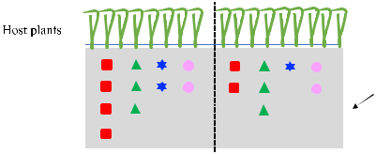

tween urban and rural areas.

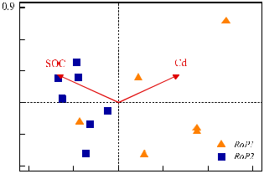

• High AM fungal richness likely emerged



at the low Cd and plant-rich sites.



• Dissimilarity of plants and Cd contents



positively correlated with the β-



diversity of AM fungi.

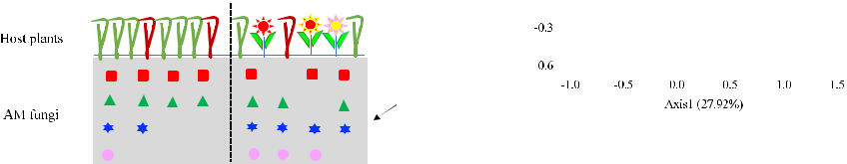

a r t i c l e i n f o

Article history:

Received 10 December 2019

Received in revised form 26 March 2020 Accepted 7 April 2020 Available online 12 April 2020

Editor: Charlotte Poschenrieder

Keywords:

Urban green space

Arbuscular mycorrhizal fungi

Cd

Diversity

Herbaceous plants

a b s t r a c t

Urbanization accelerates pollution and habitat fragmentation, and the mechanism that shapes the arbuscular mycorrhizal (AM) fungal community in urban ecosystem still remains poorly understood. In this study, soil sam-ples from 23 sites (from rural to urban), belonging to 4 green space types (country park, Co; urban park, Pa; road-side green space1, RoP1; and roadside green space2, RoP2), were collected to assess the effects of the urbanization on the AM fungal diversity.

Using 454 pyrosequencing, a total of 79 AM fungal OTUs were uncovered. We found that urbanization showed a neutral effect on Shannon diversity, Simpson diversity, Pielou diversity, and community composition of the AM fungi. Within urban areas, the composition of AM fungal community was significantly different between RoP1 and RoP2. The db-RDA analysis of RoP1 and RoP2 revealed that the soil Cd accounted for the largest community composition variation, with an explanation rate of 20.5%, followed by the SOC (15.1%).

Across 23 sites, Cd may have an obvious ecological toxicity on AM fungi, with significantly negative correlations between the soil Cd content and the AM fungal species richness and evenness. The AM fungal community also indicated significantly Mantel correlation with the soil Cd contents. Additionally, high herbaceous richness pro-moted rich AM fungi. The herbaceous composition, not the richness, has a significant impact on the AM fungal community composition.

Corresponding author at: Research Center for Eco-Environmental Sciences, Chinese Academy of Sciences, Beijing 100085, PR China.

E-mail address: [mkm@rcees.ac.cn](mailto:mkm@rcees.ac.cn) (K. Ma).

1 Co-first author.

<https://doi.org/10.1016/j.scitotenv.2020.138594>

0048-9697/© 2020 Elsevier B.V. All rights reserved.

2 L. Lin et al. / Science of the Total Environment 726 (2020) 138594

This study suggests that the toxicity of Cd from traffic should receive more attention during urban green space construction and management, and reasonable plant configuration contributed to the maintenance of the AM fungal community.

© 2020 Elsevier B.V. All rights reserved.

1. Introduction

Cities are not only hot spots of production, consumption, and waste generation, but they are also the likely focus areas of ecological and en-vironmental problems (Ash et al., 2008; Grimm et al., 2008). Notably, arbuscular mycorrhizal (AM) fungi exerted a decisive role in maintain-ing plant community diversity and productivity (Chagnon and Brisson, 2017; van der Heijden et al., 1998; Vogelsang et al., 2006). Compared with the essential role of AM fungi on plants (Chagnon and Brisson, 2017; Newbound et al., 2010), the mechanism that shapes the AM fun-gal community has remained poorly understood in urban areas. To date, a great deal of research on the distribution of mycorrhizal fungi in vari-ous types of ecosystems has been conducted, but it has primarily fo-cused on agricultural ecosystems (Lin et al., 2012; Xiang et al., 2014) and various types of natural ecosystems (Eom et al., 2000; Hiiesalu et al., 2014; Wilson et al., 2009), and yet it has often overlooked human-dominated urban ecological surveys.

The rapid urbanization of land use/cover type conversion, inducing the climate, hydrology, soils, and plant biodiversity modification, has a direct or indirect impact on mycorrhizal fungi (Grimm et al., 2008; Newbound et al., 2010). Articles in the literature from 1900 to 2019 were reviewed using the “Web of Science core collection” database. Using “mycorrhiza*” as the key word, we obtained 26,496 documents. By setting “mycorrhiza*” and “urban” as the key words, only 173 docu-ments (September 23th, 2019), or approximately 0.56% mycorrhiza ar-ticles, were related to urban areas. In these papers, the essential role of AM fungi in plants (Burrows and Pfleger, 2002; Chagnon and Brisson, 2017) and the effect of urban refuse amendments (Cabaret et al., 2002; Pierart et al., 2018) were widely researched, but there was still a lack of studies about the mechanism that shapes the AM fungal com-munity. Martinova et al. (2016) have noted that red oak mycorrhizal fungi in highly urbanized areas showed a significantly lower infection rate and richness level than that of undisturbed forests. The mycorrhizal fungal infection status of 26 tree species in southern Ontario also showed that the AM and ECM fungal infection rates of city trees were significantly lower than those of the suburbs (Bainard et al., 2011). Fur-thermore, some experiments have also reported no significant differ-ence between urban parks and mature forests (Karlinski et al., 2014). However, the current research on urban mycorrhizal fungal diversity has primarily emphasized brief descriptions on the diversity index and community composition, and it has attributed the difference between results to urbanization, human interference, or adverse environmental conditions (Bainard et al., 2011; Schaefer and Hocking, 2015), but there is a lack of in-depth explanations on the key mechanisms of influ-ence, especially for the soil AM fungal pools.

The urbanization effect on the mycorrhizal fungal diversity could be multifaceted, involving host plants, soil properties, and pollution. Gen-erally, the AM fungal diversity could be affected by soil factors, e.g., the soil type, pH, soil nutrient conditions, and soil water conditions (Gryndler et al., 2006). The soil chemical properties were essential fac-tors influencing the woodland fungal communities along an urban-rural gradient. Martinova et al. (2016) confirmed the significant role of the pH, AP, TN, and SOC in regulating the fungal community compo-sition of urban areas. Apart from the traditional impact factors in natural ecosystems, environmental pollution, eutrophication, habitat fragmen-tation, heat island effects, biogeochemical cycle changes, and other is-sues also posed a serious threat to urban biodiversity (McKinney, 2008; Pierart et al., 2018), thus altering the composition and

maintenance of urban AM fungi. Compared with natural ecosystems, there is an urgent need for further explanations of the role of the soil properties, heavy metals, and vegetation on AM fungi in urban areas. In relation to pollution, most of the relevant experiments have primarily focused on the essential role of AM fungi in plant revegetation under re-fuse amendment or heavy metal-contaminated conditions (Pierart et al., 2019), indicating a greater capacity for heavy metal tolerance by AM fungi than aboveground plants (Gonzalez-Chavez and Carrillo-Gonzalez, 2013). However, the specific concentration, and form of heavy metal pollutants could also significantly affect the AM fungal di-versity, through factors such as the mycelial biomass, infectivity reduc-tion, and richness (Zarei et al., 2008). Municipal solid waste and sewage sludge were used as fertilizers, and despite being subjected to a complex series of physical, chemical and biological methods, they still contained high levels of pathogens, heavy metals, and other toxic substances (Cabaret et al., 2002), and they posed high pathological and environ-mental risks to mycorrhizal fungi (Weissenhorn et al., 1995). Therefore, when using AM fungi as the research object, elucidating the mechanism of AM fungal variation in relation to the environment is highly essential in urban sites. To date, most relevant experiments have been conducted in the form of controlled trials (Gonzalez-Chavez and Carrillo-Gonzalez, 2013; Pierart et al., 2019), whereas fewer have been reported regarding the mechanism shaping the soil AM fungi based on in situ field observations.

To limit the involvement of these complex factors in direct investiga-tions of urban species diversity, the urbanization gradient analysis has become an effective means of studying urban ecological problems (McDonnell and Hahs, 2008). Within the Fifth Ring of Beijing, a built-up area of natural vegetation was replaced with artificial green space. As of 2011, there were a total of 218 parks and green park area of

1. km2 in Beijing (<http://www.stats.gov.cn>). The goal of this study was to emphasize and explain the spatial variability in mycorrhizal fun-gal diversity along an urbanization gradient and its potential mecha-nism. Based on these concepts, we assumed that (1) urban green space AM fungi possessed lower species richness than rural fungi, and that the AM community composition was significantly different among the diverse green space types in urban areas; (2) the soil nutri-ent characteristics and heavy metals were two principle factors affect-ing the AM fungal diversity; (3) vegetation characteristics had a neutral effect on the AM fungal richness and composition.

2. Material and methods

2.1. Study site and sampling

This study was conducted in Beijing city (39°28′–41°05′ N, 115°25′– 117°30′ E), which is located in the northern part of the North China Plain. Beijing has a typical continental monsoon climate, with a mean annual precipitation of 571.8 mm and a mean annual temperature of 10–12 °C. This area has cinnamon soil with a loamy texture. Roadside green spaces (Ro), urban parks (Pa), and country parks (Co) were in-volved in this study. To assess the heavy metal contamination from urban traffic (Chen et al., 2010), 2 types of roadside green spaces were considered in this study, namely adjacent road (RoP1) and sub-adjacent road green spaces (RoP2). The detailed soil physicochemical properties (0–20 cm) for each layer are presented in Table 1.

Fieldwork was performed from July–August 2013. Soil samples were taken from 23 defined sites in the study area (Fig. 1). At each site, a

|  |  |  |  |  |  |  |  |  |  |  |  |  |  |  |
| --- | --- | --- | --- | --- | --- | --- | --- | --- | --- | --- | --- | --- | --- | --- |
|  |  |  |  |  | L. Lin et al. / Science of the Total Environment 726 (2020) 138594 | | | | | |  |  |  | 3 |
| Table 1 |  |  |  |  |  |  |  |  |  |  |  |  |  |  |
| Mean and ANOVA results of environmental variables in different green space types. | | | | | | | |  |  |  |  |  |  |  |
|  |  |  |  | |  | |  | |  | |  |  |  | |
| Type | pH |  | AP (mg/kg) | | TN (%) | | SOC (%) | | Pb (mg/kg) | | Cd (mg/kg) | Cr (mg/kg) | Richness of plants | |
|  |  |  |  |  |  |  |  |  |  |  |  |  |  |  |
| Country park | 7.92 | (0.47)b | 10.75 | (11.60) | 1.03 | (0.17)c | 0.09 | (0.01)ab | 19.60 | (1.28)b | 0.99 (0.05) | 71.40 (24.76) | 53.80 | (8.67)a |
| Urban park | 8.57 | (0.12)ab | 18.24 | (17.89) | 2.06 | (0.34)ab | 0.10 | (0.05)ab | 21.75 | (5.75)ab | 0.99 (0.04) | 83.38 (27.32) | 23.80 | (12.21)b |
| RoP1 | 8.73 | (0.08)a | 11.03 | (4.52) | 1.70 | (0.29)b | 0.06 | (0.01)b | 18.88 | (2.48)b | 1.40 (0.72) | 88.99 (22.68) | 19.83 | (6.55)b |
| RoP2 | 8.56 | (0.10)ab | 19.48 | (17.23) | 2.51 | (0.46)a | 0.11 | (0.03)a | 29.13 | (6.57)a | 0.99 (0.02) | 73.88 (32.99) | 27.14 | (6.77)b |
|  |  |  |  |  |  |  |  |  |  |  |  |  |  |  |

RoP1, roadside green space1; RoP2, roadside green space2. AP, available phosphorus; TN, total nitrogen; SOC, soil organic carbon; Pb, lead; Cd, cadmium; Cr, chromium. The same below.

Letters within column indicate 0.05 significant differences.

20 × 20 m2 plot was surveyed. Fifteen soil cores (3.5 cm diameter × 20 cm deep) were collected from each plot and pooled to yield a composite sample. After the coarse roots and stones were removed, the soil sam-ples were thoroughly homogenized and passed through a 2 mm sieve. Subsamples for DNA extraction were frozen and stored at −80 °C before processing, and the other ones for the chemical and heavy metal analy-ses were stored at 4 °C. The herbaceous vegetation survey from the 23 defined sites was performed simultaneously with the soil sampling. At each site, a 20 × 20 m2 plot was set and three subplots (1 m2) were ran-domly sampled from each plot to investigate the plant species composi-tion. In the study area, the common herbaceous plants primarily included Ixeris sonchifolia, Inula japonica, Cirsium setosum, Viola yedoensis, Potentilla supina, Setaria viridis, Solanum nigrum, and Plantago depressa.

2.2. Sample analyses

Three replicates of the PCR products from each sample were pooled and examined on ethidium bromide- stained 2% agarose gels, and they were purified using Axy Prep™ DNA Gel Extraction Kit (Axygen Biosci-ences, USA). After being eluted in Tris-HCl, the purified DNA was quan-tified with a QuantiFluor-ST fluorometer (Promega) and mixed at equimolar concentrations. This DNA mix was subjected to sequencing with a Sequencing Method Manual_XLR70 kit on a Roche Genome Se-quencer FLX+ platform (Majorbio Bio-Pharm Technology Co., Ltd., Shanghai, China).

The soil pH was measured at a soil/water ratio of 1:2.5 (w/v). The available phosphorus (AP) in the soils was determined using an extrac-tion with sodium bicarbonate. The soil organic carbon (SOC) was

measured directly by dry combustion after removing the inorganic C by excess addition of HCl (1:1, V%). The soil organic carbon (SOC) and total nitrogen (TN) were determined by direct combustion using the El-ement Analyzer (Vario EL, Elementar, Germany). According to the envi-ronmental quality standard for soils (GB 15618-1995), the soil samples (0.25 g) were first soaked with HNO3-HF-HClO4 (6 ml + 6 ml + 2 ml) acid mixture for 12 h. After 180 °C by microwave digestion with an HNO3-HF-HclO4 acid mixture (Wang et al., 2013), the soil Cr was deter-mined with an ICP-OES (Optima 8300, PerkinElmer, USA), and the Cd and Pb were determined with an ICP-MS (7500 a, Agilent Technologies, USA).

2.3. Bioinformatical analyses

The sequence reads were processed with a QIIME toolkit (Caporaso et al., 2010). First, the sequence reads were quality-filtered and demultiplexed; the minimum length ≥ 170 bp (excluding barcode and primer sequences), ambiguous bases ≤ 0, homopolymer length ≤ 10 bp, maximum number of primer or barcode mismatches ≤ 0, and minimum mean quality score ≥ 25. After quality filtering, the sequences were sub-jected to de novo chimera detection and clustered into operational tax-onomic units (OTUs) at a 97% shared sequence identity level using the USEARCH algorithm. The OTUs sequences were then subjected to a BLASTN search on the NCBI (National Centre for Biotechnology Informa-tion) nr/nt database (September 2013). All the non-AMF clusters (which were identified based on the closest BLAST hit not annotated as “Glomeromycota”) were removed as were those with a b90% shared identity and/or 90% coverage of an AMF sequence. Clusters with b5 reads were discarded from further processing. For comparative

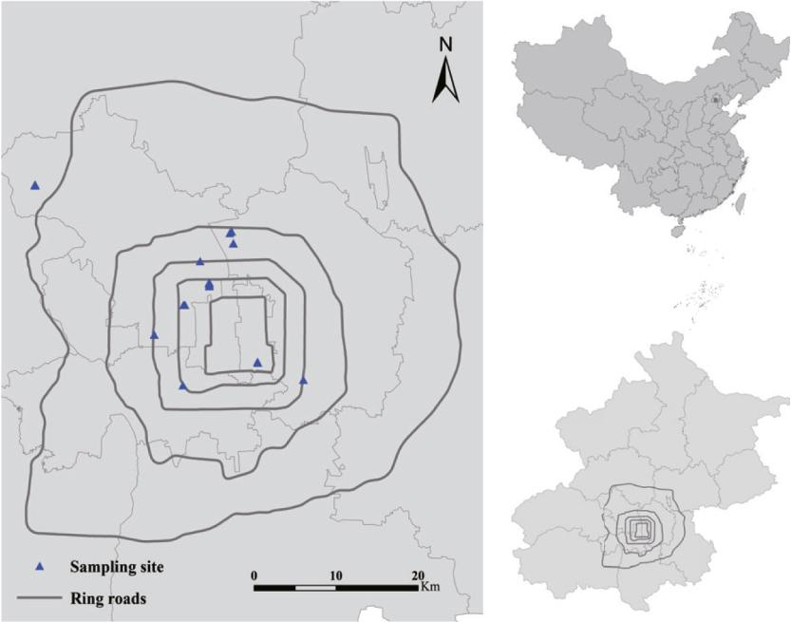

Beijing

Fig. 1. Geographic distribution of the sampling sites in this study.

4 L. Lin et al. / Science of the Total Environment 726 (2020) 138594

analyses, the OTU table was rarefied without replacement to 211 reads (the lowest number of sequences of all the samples) per sample. A phy-logenetic analysis was performed for the sequences obtained in this study and for sequences corresponding to the closest matches from the nr database. A neighbor-joining (NJ) phylogenetic tree was con-structed using Kimura's two-parameter model. The robustness of this phylogenetic tree was evaluated using 1000 bootstrap replications. A multiple sequence alignment and the construction of the NJ tree were performed using MEGA6.0. The representative sequences of AMF OTUs in the present study have been deposited in GenBank ([http://www.](http://www.ncbi.nlm.nih.gov) [ncbi.nlm.nih.gov](http://www.ncbi.nlm.nih.gov)) under accession numbers KM658397 to KM658452.

2.4. Characterization of pyrosequencing data and AMF taxonomy

The 454 pyrosequencing, compared with the Illumina sequencing, had a longer DNA base sequencing length, thus more bioinformation could be provided and contributed to the mycorrhizal fungal phyloge-netic analysis. Through 454 pyrosequencing, all the soil samples yielded a total of 86,179 sequences after quality control, with the shortest 171 bp, longest 552 bp, an average of 360.4 bp length. Using the de novo approach, we detected 162 chimeric sequences, and the remaining non-chimeric sequences yielded 503 initial OTUs based on 97% se-quence similarity clustering. Through an NCBI nt database comparison, 89 OTUs (20,647 sequences) were identified as Glomeromycota, with 229 OTUs (28,515 sequences) as other groups of fungi including Asco-mycota, Chytridiomycota, Basidiomycota and some unknown fungi, 56 OTUs (11,383 sequences) belonging to Viridiplantae, 47 OTUs (12,888 sequences) attributed to Metazoa, 14 OTUs (794 sequences) as Protists, and 68 OTUs (7452 sequences) as unclassified Eukaryotes.

Among the 89 AM fungal OTU sequences, in which the similarity or coverage of 2 OTUs was below 90% and the clustering sequence number of 5 OTUs was b5, the sequences were removed in the subsequent anal-yses, and yielded a total of 82 AM fungal OTUs (20,505 sequences). Each sample AM fungi sequence number varied between 211 and 2056, with an average of 897.1 sequences. After a standard dilution of the AM fun-gal sequence set, we ultimately obtained 79 AM fungal OTUs (4853 se-quences). The phylogenetic tree was created through NJ, with 57 OTUs belonging to Glomeraceae (72.15%), 9 OTUs belonging to Paraglomeraceae (11.39%), 7 OTUs belonging to Claroideoglomeraceae (8.86%), and 6 OTUs belonging to Diversisporaceae (7.59%).

2.5. Statistical analyses

2.5.1. Alpha diversity analyses

Using the R software (<https://cran.r-project.org>) vegan package (Oksanen et al., 2007), we calculated the OTU richness (S), Shannon di-versity (H = − ∑ pi[ln(pi)]), Simpson diversity (D = 1 − ∑ p2i), Pielou diversity (E = H/ ln (S)), where S was the number of OTUs in each sam-ple and pi represented a single OTU sequence abundance ratio of each sample's total abundance. To compare the AM fungal diversity among different green space types, a one-way ANOVA in combination with Tukey's HSD test method was used. We used a (partial) correlation anal-ysis to examine the relationship between soil AM fungi alpha diversity and various environmental factors, with the herbaceous plants richness being normalised with a log (x + 1) conversion prior to calculation.

2.5.2. Beta diversity analyses

All the AM fungal community structure analyses adopted the Bray-

Curtis distance, the index of which was calculated as follows:

|  |  |  |  |  |  |
| --- | --- | --- | --- | --- | --- |
|  | Pn | xik−xjk | | |  |
| BC ¼ | k¼1 |  |  |  |  |
| Pn | xik | þ | xjk |  |
|  | k¼1 |  |  |  |

where i and j represented different samples, x was the sequence num-ber of the k-th OTU, and n was the sum of the total number of OTUs in all the samples. We used the principal coordinates analysis (PCoA) to

probe the effects of different types of green space on the AM fungal community structure, and we simultaneously conducted ANOSIM (analysis of similarity) and MRPP (multiresponse permutation proce-dure) tests. The relationships between the AM fungal community com-position, and the environmental factors, the herbaceous community structure were processed with a (partial) Mantel test. The Euclidean dis-tance index was used to represent the variance in environmental factors and herbaceous beta diversity between plots. The db-RDA analyses were calculated with CANOCO 5.0 (Microcomputer Power, Ithaca, NY, USA) software, and the model significance test was performed using a Monte Carlo permutation test, with the replacement number set at 499; the remaining analyses were performed with R software.

3. Result

3.1. AM fungal richness analysis

Across all the 23 soil samples, 79 AM fungal OTUs (4853 sequences) were reserved, with 57 OTUs belonging to Glomeraceae (72.15%), 9 OTUs belonging to Paraglomeraceae, 7 OTUs belonging to Claroideoglomeraceae, and 6 OTUs belonging to Diversisporaceae.

No significant difference was observed between the Shannon diver-sity, Simpson diversity, Pielou diversity of AM fungi in country parks, and those in urban areas (Fig. 2). Only the AM fungal OTU richness of the country parks was significantly higher than that of RoP2 (P b 0.05).

The soil Cd exerted a strong influence on the soil AM fungal OTU richness, Shannon diversity, Simpson diversity, and Pielou diversity. Four types of alpha diversity indexes were all significantly correlated with the soil Cd concentration (all |r| N 0.5, all P b 0.05). Additionally, the herbaceous species richness also had a significantly positive correla-tion with both the AM fungal OTU richness (P b 0.01) and Shannon di-versity (P b 0.05) (Table 2).

3.2. AM fungal community composition analysis

No significant difference was observed between the AM fungal com-munity structure of the country parks (Co) and that of the urban parks (Pa), roadside green spaces1 (RoP1), and roadside green spaces2 (RoP2). Within the urban areas, the ANOSIM and MRPP analyses showed that the AM fungal community composition displayed a signif-icant difference between RoP1 and RoP2 (r = 0.353, P b 0.01; δ = 0.620, P b 0.05) (Fig. 3, Table 3). Regarding the community difference between RoP1 and RoP2, the Cd accounted for the largest community composi-tion variation with an explanation rate of 20.5% (pseudo-F = 2.8, P = 0.044), followed by the SOC, with an explanation rate of 15.1% (pseudo-F = 2.3, P = 0.022) (Fig. 4).

Among all 23 sites, the (partial) Mantel tests showed that both the soil Cd content and herbaceous plants dissimilarity had significantly positive influences on the AM fungal community composition (P b 0.05), while other environmental factors had no significant correla-tion with the AM fungal community composition (P N 0.05) (Table 4).

4. Discussion

4.1. Neutral effect of urbanization on the soil AM fungal richness and com-munity structure

In this study, 23 soil samples from the urban green space were col-lected, and they yielded a total of 79 AM fungal OTUs. The AM fungal richness values of forest ecosystems were reportedly 37–70 (Dumbrell et al., 2011), with the farmland ecosystem richness of 33–70 (Lin et al., 2012), and the farming-pastoral transitional zone being 101 (Xiang et al., 2014) when using the same sequencing method. Thus, the soils in the Beijing urban green space contained abundant AM fungi taxa, which was the opposite of the original assumptions. Gener-ally, the fungal diversity in urban areas presented a decreasing tendency

|  |  |  |  |  |  |  |  |  |  |  |  |  |  |  |  |  |  |  |  |  |  |  |  |  |  |  |  |  |  |  |  |  |  |  |  |  |  |  |
| --- | --- | --- | --- | --- | --- | --- | --- | --- | --- | --- | --- | --- | --- | --- | --- | --- | --- | --- | --- | --- | --- | --- | --- | --- | --- | --- | --- | --- | --- | --- | --- | --- | --- | --- | --- | --- | --- | --- |
|  |  |  |  |  |  |  |  |  | L. Lin et al. / Science of the Total Environment 726 (2020) 138594 | | | | | | | | | | | | | | | | | 5 | | | | | | | | | | | | |
|  |  |  |  |  |  |  |  |  |  |  |  |  |  |  |  |  |  |  |  |  |  |  |  |  |  |  |  |  |  |  |  |  |  |  |  |  |  |  |
|  |  |  |  |  |  |  |  |  |  |  |  |  |  |  |  |  |  |  |  |  |  |  |  |  |  |  |  |  |  |  |  |  |  |  |  |  |  |  |
|  |  |  |  |  |  |  |  |  |  |  |  |  |  |  |  |  |  |  |  |  |  |  |  |  |  |  |  |  |  |  |  |  |  |  |  |  |  |  |
|  |  |  |  |  |  |  |  |  |  |  |  |  |  |  |  |  |  |  |  |  |  |  |  |  |  |  |  |  |  |  |  |  |  |  |  |  |  |  |
|  |  |  |  |  |  |  |  |  |  |  |  |  |  |  |  |  |  |  |  |  |  |  |  |  |  |  |  |  |  |  |  |  |  |  |  |  |  |  |
|  |  |  |  |  |  |  |  |  |  |  |  |  |  |  |  |  |  |  |  |  |  |  |  |  |  |  |  |  |  |  |  |  |  |  |  |  |  |  |
|  |  |  |  |  |  |  |  |  |  |  |  |  |  |  |  |  |  |  |  |  |  |  |  |  |  |  |  |  |  |  |  |  |  |  |  |  |  |  |
|  |  |  |  |  |  |  |  |  |  |  |  |  |  |  |  |  |  |  |  |  |  |  |  |  |  |  |  |  |  |  |  |  |  |  |  |  |  |  |
|  |  |  |  |  |  |  |  |  |  |  |  |  |  |  |  |  |  |  |  |  |  |  |  |  |  |  |  |  |  |  |  |  |  |  |  |  |  |  |
|  |  |  |  |  |  |  |  |  |  |  |  |  |  |  |  |  |  |  |  |  |  |  |  |  |  |  |  |  |  |  |  |  |  |  |  |  |  |  |
|  |  |  |  |  |  |  |  |  |  |  |  |  |  |  |  |  |  |  |  |  |  |  |  |  |  |  |  |  |  |  |  |  |  |  |  |  |  |  |
|  |  |  |  |  |  |  |  |  |  |  |  |  |  |  |  |  |  |  |  |  |  |  |  |  |  |  |  |  |  |  |  |  |  |  |  |  |  |  |
|  |  |  |  |  |  |  |  |  |  |  |  |  |  |  |  |  |  |  |  |  |  |  |  |  |  |  |  |  |  |  |  |  |  |  |  |  |  |  |
|  |  |  |  |  |  |  |  |  |  |  |  |  |  |  |  |  |  |  |  |  |  |  |  |  |  |  |  |  |  |  |  |  |  |  |  |  |  |  |
|  |  |  |  |  |  |  |  |  |  |  |  |  |  |  |  |  |  |  |  |  |  |  |  |  |  |  |  |  |  |  |  |  |  |  |  |  |  |  |
|  |  |  |  |  |  |  |  |  |  |  |  |  |  |  |  |  |  |  |  |  |  |  |  |  |  |  |  |  |  |  |  |  |  |  |  |  |  |  |
|  |  |  |  |  |  |  |  |  |  |  |  |  |  |  |  |  |  |  |  |  |  |  |  |  |  |  |  |  |  |  |  |  |  |  |  |  |  |  |
|  |  |  |  |  |  |  |  |  |  |  |  |  |  |  |  |  |  |  |  |  |  |  |  |  |  |  |  |  |  |  |  |  |  |  |  |  |  |  |
|  |  |  |  |  |  |  |  |  |  |  |  |  |  |  |  |  |  |  |  |  |  |  |  |  |  |  |  |  |  |  |  |  |  |  |  |  |  |  |
|  |  |  |  |  |  |  |  |  |  |  |  |  |  |  |  |  |  |  |  |  |  |  |  |  |  |  |  |  |  |  |  |  |  |  |  |  |  |  |
|  |  |  |  |  |  |  |  |  |  |  |  |  |  |  |  |  |  |  |  |  |  |  |  |  |  |  |  |  |  |  |  |  |  |  |  |  |  |  |
|  |  |  |  |  |  |  |  |  |  |  |  |  |  |  |  |  |  |  |  |  |  |  |  |  |  |  |  |  |  |  |  |  |  |  |  |  |  |  |
|  |  |  |  |  |  |  |  |  |  |  |  |  |  |  |  |  |  |  |  |  |  |  |  |  |  |  |  |  |  |  |  |  |  |  |  |  |  |  |

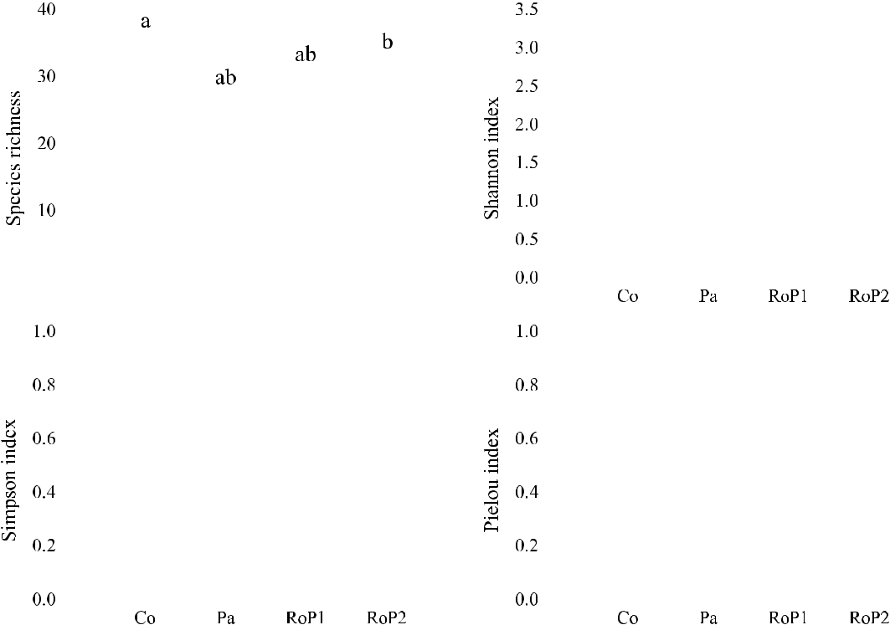

Fig. 2. Comparisons of species richness, Shannon diversity, Simpson diversity, and Pielou diversity indexes among 4 types of urban green spaces. Note: Lowercase letters above the bars indicate a significant difference (P b 0.05). Co, country park; Pa, urban park; roadside green space1, RoP1; and roadside green space2, RoP2. The same abbreviations are used below.

compared with the adjacent suburbs (Bainard et al., 2011; Martinova et al., 2016). In this study, the Shannon diversity, Simpson diversity, and Pielou diversity were not significantly different among the four types of green spaces (Fig. 2). Furthermore, the ANOSIM and MRPP anal-ysis also showed no significant difference between the structure of the AM fungal community in the country parks and the structure of the other environments, indicating a neutral effect of urbanization on the soil AM fungal composition (Table 3). Glomeraceae was the dominant family of AM fungi groups in the urban green space of this study. Glomus possessed a strong ability to survive and some resistance to physical dis-turbance (Helgason et al., 1998), and thus it was more suitable for the highly heterogeneous environment and frequent artificial disturbance of urban areas. Glomus fungi also possessed high sporulation rates and a strong colonization ability by mycorrhizal fragments (Biermann and Linderman, 1983). Horse chestnut trees in urban and rural environ-ments also revealed a similar range of AM colonization levels (Karlinski et al., 2014).

Generally, the urbanization process could pose certain threats to AM fungal survival along the gradient of urban to rural areas (Bainard et al., 2011). Unlike the previous assumption, this study showed a neutral

Table 2

(Partial) correlation coefficients between the environmental variables and α diversity and evenness indexes.

|  |  |  |  |  |  |
| --- | --- | --- | --- | --- | --- |
| Environmental variables | | OTU | Shannon's | Simpson's | Pielou's |
|  |  | richness | diversity | diversity | diversity |
|  |  |  |  |  |  |
| Partial | pH | 0.02 | −0.14 | −0.11 | −0.19 |
| correlation | AP | −0.24 | −0.01 | 0.05 | 0.07 |
|  | TN | −0.37 | −0.07 | −0.03 | 0.04 |
|  | SOC | 0.11 | −0.09 | −0.06 | −0.16 |
|  | Pb | 0.15 | −0.02 | −0.07 | −0.08 |
|  | Cd | −0.75 | −0.62 | −0.57 | −0.54 |
|  | Cr | 0.42 | 0.21 | 0.14 | 0.13 |
| Correlation | Herbaceous | 0.56 | 0.44 | 0.32 | 0.35 |

richness

Asterisks within column indicate 0.05 significant differences.

effect from urbanization on the soil AM fungi diversity. The abundant AM Fungi taxa in urban green space could be attributed to high soil or-ganic matter content (Fig. 1). Organic matter enrichment could promote fungal mycelial growth and increase the AM fungal spore density and diversity by improving the soil nutritional status (Gryndler et al., 2006; Martinova et al., 2016). Field survey experiments also revealed significantly positive correlations between the SOC and AM fungal bio-mass (Wilson et al., 2009; Xiang et al., 2014). The urbanization process would also accelerate the urban soil organic carbon (SOC) accumulation (Fig. 4, Table 1) due to regular fertilization and irrigation management (Churkina et al., 2010). Furthermore, many alien plants were introduced for landscaping needs, and the natural top soils of city parks, lawns, and other green land were often replaced with external soils (Jim, 1998). Ac-companied with these exotic plants and soil, non-local AM fungal mycelia, spores and other propagules from non-native species of AM

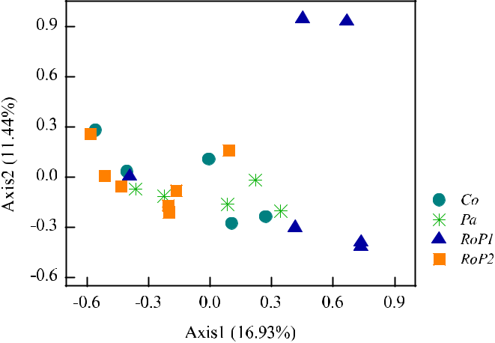

Fig. 3. Principal coordinates analysis (PCoA) of the AM fungal community composition.

6 L. Lin et al. / Science of the Total Environment 726 (2020) 138594

Table 3

ANOSIM and MRPP analyses of AM fungal community compositions between different green space types.

|  |  |  |
| --- | --- | --- |
| Data sets | ANOSIM (P value) | MRPP (P value) |
|  |  |  |
| Country park–Urban park | 0.252 | 0.346 |
| Country park–RoP1 | 0.178 | 0.106 |
| Country park–RoP2 | 0.078 | 0.092 |
| Urban park–RoP1 | 0.083 | 0.065 |
| Urban park–RoP2 | 0.307 | 0.633 |
| RoP1–RoP2 | 0.004 | 0.021 |

*, significant at 0.05 level; **, significant at 0.01 level.

fungal mycelia, spores, and other propagules were also brought in, thus increasing the AM fungal species richness of the urban area (Fig. 2, Table 1).

4.2. Toxic effect of Cd heavy metal on AM fungi

Across 23 sites, the Cd concentration was negatively correlated with the AM fungal species richness, Shannon diversity, Simpson diversity, and Pielou diversity (Table 2). Cd could significantly inhibit or influence the microbial biomass, enzyme activity, metabolic processes, ecological function, population, and community structure (Khan et al., 2010; Leyval et al., 1997). Because AM fungi cannot be grown in vitro in pure culture to date, studies on the direct effects of the relevant heavy metals have rarely been reported, with the primary focus being on the beneficial effects of mycorrhizal symbiosis on host plant growth under polluted conditions (Aderholt et al., 2017). Our result confirmed the ob-vious ecological toxic effects of Cd on the soil AM fungal richness in urban green areas (Table 2). High levels of soil Cd in the urban green space might lead to a reduction, or even an extinction, of populations of Cd-sensitive fungal species (Table 2). Cd showed a significant Mantel correlation with the AM fungal community (Table 3), also indicating that there were different degrees of resistance to heavy metals among AM fungi in urban areas (Leyval et al., 1997; Pawlowska and Charvat, 2004). Thus, Cd toxicity could have a cascading influence on the ecolog-ical functions of AM fungi in urban ecosystems (Khan et al., 2010). The common soil heavy metals Pb and Cr were also investigated in this study, and yet no significant effect was observed on both the richness and composition of the AM fungi (Table 2, Table 4), which might be due to the relatively lower Pb, Cr levels and low solubility of Pb, Cr in the soil samples, and hence they did not show significant toxicity. The top soil (0–5 cm) Pb content of 30 parks in Beijing averaged 66.2 mg/kg, higher than the local soil Pb background value

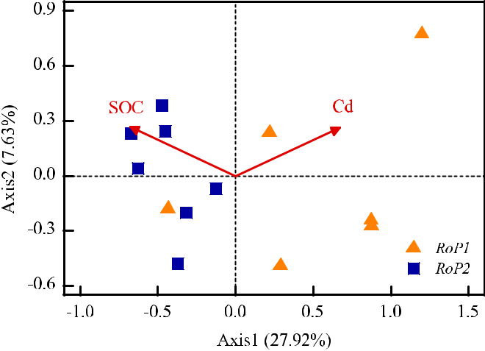

Fig. 4. Distance-based redundancy analysis of the AM fungal community compositions in roadside green space in relation to environmental parameters. Note: Arrows indicate significant explanatory variables.

Table 4

Relationships of AM fungal community compositions with environmental variables and herbaceous plant community structure.

|  |  |  |
| --- | --- | --- |
| Environmental variables | r value (Mantel tests) | r value (partial Mantel tests) |
|  |  |  |
| pH | −0.20 | −0.20 |
| AP | −0.13 | −0.19 |
| TN | −0.06 | −0.10 |
| SOC | 0.11 | 0.11 |
| Pb | −0.04 | −0.06 |
| Cd | 0.38 | 0.38 |
| Cr | −0.02 | −0.02 |
| Herbaceous richness | 0.099 | 0.07 |
| Herbaceous β diversity | 0.37 | 0.37 |

*, significant at 0.05 level; **, significant at 0.01 level.

(25.1 mg/kg) (Chen et al., 2005). In this study, the country park, urban park, and roadside green space1 (RoP1) soil average Pb concentrations were lower than the background values, whereas the soil in the road-side green space2 (RoP2) had the highest average Pb content (29.13 mg/kg), still showing little difference from the background values (Table 1). Although the soil Cr had higher concentrations than the background values (68.1 ± 15.9 mg/kg, China National Environ-mental Monitoring Center, CNEMC), the Cr concentration showed a high level of variations among the sites (Table 1), and the Cr bioavail-ability and toxicity could be mediated by the soil nutrient conditions. Therefore, no significant relationships were observed between heavy metal Pb and Cr and the soil AM fungal community.

Cd is widely used in a series of industrial products, such as paints, dyes, electroplating, plastics, rubber, gasoline, and diesel oil (Ajmone-Marsan and Biasioli, 2010). In this study, the country parks, urban parks, and RoP2 soil Cd contents were 0.99 mg/kg, whereas the RoP1 soil Cd content was up to 1.40 mg/kg (Table 1), indicating that the soil Cd content was influenced by the traffic flow. A heavy metals survey in Beijing also confirmed that more than half of the soil samples (N =

1. were subjected to mild or moderate Cd pollution, with the soil Cd concentration tending to decrease with the increasing distance from the road (Chen et al., 2010). In this study, only two roadside green spaces showed significant differences in the AM fungal community composition (Table 4). The db-RDA analysis also showed that the AM community structure of the RoP1 was primarily affected by Cd, and the RoP2 primarily by SOC (Fig. 4). Although there were no significant differences between the RoP1 and RoP2 soil Cd contents, the average Cd content of RoP1 was clearly higher than that of the RoP2 soil (Table 1). We speculated that the tire wear and, gasoline combustion activities along urban roads with high traffic flow caused high Cd accu-mulation in soil near the roads greenbelt, threatening the survival of some Cd-sensitive AM fungi, and thus affecting the composition and di-versity of the community.

4.3. Positive effect of urban green plants on AM fungi

The relationships between the aboveground vegetation and under-ground fungal diversity are one of the key topics in mycorrhizal ecology (van der Heijden et al., 1998; Vogelsang et al., 2006). For urban soils, our result demonstrated that the herbaceous plant community of urban green spaces contributed to the maintenance of the belowground my-corrhizal fungal richness (Table 2) and community composition (Table 4). The field control experiments also showed that increasing the plant diversity could increase the spore number and total spore vol-ume of AM fungi, and significantly increase the spore density of spore-producing species (Gigaspora spp. and Scutellospora spp.) (Burrows and Pfleger, 2002), indicating that high plant richness had a positive ef-fect on the AM fungal richness. In a natural grassland, the AM fungal richness was also significantly positively correlated with the plant spe-cies richness (Hiiesalu et al., 2014). Bais et al. (2006) noted that the sig-nal molecules in plant root exudates played an important role in AM fungi in terms of identifying the host plant and hyphae morphogenesis.

|  |  |
| --- | --- |
| L. Lin et al. / Science of the Total Environment 726 (2020) 138594 | 7 |

The species-rich plant communities could produce a variety of root ex-udates in the underground soils and diverse root structures, creating suitable microhabitats environments for more microorganisms (Hooper et al., 2000; Hui et al., 2017).

The composition of herbaceous plants also played an essential role in regulating the AM fungal community composition (Table 4). Experi-ments with the same soil and five dominant prairie tallgrass plants showed significantly different rhizosphere AM fungal spore species, densities, and abundance (Eom et al., 2000). There was a given specific-ity between the AM fungi and the host plants (Eom et al., 2000). The va-riety of root exudates contributed to the diverse C utilization preferences of AM fungi (Burrows and Pfleger, 2002; Hooper et al., 2000). The dependence of the host plants on the mycorrhizal symbiotic relationship, phenology or other characteristics all had impacts on the AM fungal community (Bonfante and Genre, 2010). Thus, the plant composition and abundance configuration in urban green spaces showed significant influences on the underground microbial communi-ties (Table 4).

5. Conclusion

Urbanization did not significantly affect the soil AM fungal Shannon diversity, Simpson diversity, Pielou diversity, and community composi-tion of the green space. Cd exerted clear ecological toxicity in the AM fungal community, with significant negative effects on the AM fungal alpha diversity. The herbaceous species richness was positively corre-lated with the OTU richness and Shannon diversity, while the dissimi-larity of the plant community was also positively correlated with the AM fungal community composition. Thus, during urban green space construction and management, the toxicity of heavy metals should re-ceive more attention, and a reasonable plant configuration contributed to the maintenance of the AM fungal community diversity.

CRediT authorship contribution statement

Litao Lin: Formal analysis, Writing - original draft, Writing - review

* editing. Yun Chen: Methodology, Investigation, Formal analysis. Laiye Qu: Methodology. Yuxin Zhang: Methodology. Keming Ma: Methodol-ogy, Writing - review & editing.

Declaration of competing interest

The authors declare that they have no known competing financial interests or personal relationships that could have appeared to influ-ence the work reported in this paper.

Acknowledgements

This project was supported by the National Natural Science Founda-tion of China (41430638).

References

Aderholt, M., Vogelien, D.L., Koether, M., Greipsson, S., 2017. Phytoextraction of contami-nated urban soils by Panicum virgaturn L. enhanced with application of a plant growth regulator (BAP) and citric acid. Chemosphere 175, 85–96. [https://doi.org/](https://doi.org/10.1016/j.chemosphere.2017.02.022) [10.1016/j.chemosphere.2017.02.022](https://doi.org/10.1016/j.chemosphere.2017.02.022).

Ajmone-Marsan, F., Biasioli, M., 2010. Trace elements in soils of urban areas. Water Air Soil Pollut. 213, 121–143. <https://doi.org/10.1007/s11270-010-0372-6>.

Ash, C., Jasny, B.R., Roberts, L., Stone, R., Sugden, A., 2008. Reimagining cities - introduc-tion. Science 319. <https://doi.org/10.1126/science.319.5864.739>739–739.

Bainard, L.D., Klironomos, J.N., Gordon, A.M., 2011. The mycorrhizal status and coloniza-tion of 26 tree species growing in urban and rural environments. Mycorrhiza 21, 91–96. <https://doi.org/10.1007/s00572-010-0314-6>.

Bais, H.P., Weir, T.L., Perry, L.G., Gilroy, S., Vivanco, J.M., 2006. The role of root exudates in rhizosphere interations with plants and other organisms. Annu. Rev. Plant Biol. 57, 233–266. <https://doi.org/10.1146/annurev.arplant.57.032905.105159>.

Biermann, B., Linderman, R.G., 1983. Use of vesicular arbuscular mycorrhizal roots, intraradical vesicles and extraradical vesicles as inoculum. New Phytol. 95, 97–105. <https://doi.org/10.1111/j.1469-8137.1983.tb03472.x>.

Bonfante, P., Genre, A., 2010. Mechanisms underlying beneficial plant-fungus interactions in mycorrhizal symbiosis. Nat. Commun. 1. <https://doi.org/10.1038/Ncomms1046>.

Burrows, R.L., Pfleger, F.L., 2002. Arbuscular mycorrhizal fungi respond to increasing plant diversity. Can. J. Bot. Rev. Can. De Bot. 80, 120–130. <https://doi.org/10.1139/B01-138>.

Cabaret, J., Geerts, S., Madeline, M., Ballandonne, C., Barbier, D., 2002. The use of urban sewage sludge on pastures: the cysticercosis threat. Vet. Res. 33, 575–597. [https://](https://doi.org/10.1051/vetres:2002040) [doi.org/10.1051/vetres:2002040](https://doi.org/10.1051/vetres:2002040).

Caporaso, J.G., Kuczynski, J., Stombaugh, J., Bittinger, K., Bushman, F.D., Costello, E.K., et al., 2010. [QIIME allows analysis of high-throughput community sequencing data. Nat.](http://refhub.elsevier.com/S0048-9697(20)32110-0/rf0050) [Methods 7, 335.](http://refhub.elsevier.com/S0048-9697(20)32110-0/rf0050)

Chagnon, P.L., Brisson, J., 2017. The role of mycorrhizal symbioses in phytotechnology.

Botany 95, 971–982. <https://doi.org/10.1139/cjb-2017-0032>.

Chen, T.B., Zheng, Y.M., Lei, M., Huang, Z.C., Wu, H.T., Chen, H., et al., 2005. Assessment of heavy metal pollution in surface soils of urban parks in Beijing, China. Chemosphere 60, 542–551. <https://doi.org/10.1016/j.chemosphere.2004.12.072>.

Chen, X., Xia, X.H., Zhao, Y., Zhang, P., 2010. Heavy metal concentrations in roadside soils and correlation with urban traffic in Beijing, China. J. Hazard. Mater. 181, 640–646. <https://doi.org/10.1016/j.jhazmat.2010.05.060>.

Churkina, G., Brown, D.G., Keoleian, G., 2010. Carbon stored in human settlements: the conterminous United States. Glob. Chang. Biol. 16, 135–143. [https://doi.org/](https://doi.org/10.1111/j.1365-2486.2009.02002.x) [10.1111/j.1365-2486.2009.02002.x](https://doi.org/10.1111/j.1365-2486.2009.02002.x).

Dumbrell, A.J., Ashton, P.D., Aziz, N., Feng, G., Nelson, M., Dytham, C., et al., 2011. Distinct seasonal assemblages of arbuscular mycorrhizal fungi revealed by massively parallel pyrosequencing. New Phytol. 190, 794–804. <https://doi.org/10.1111/j.1469-8137.2010.03636.x>.

Eom, A.H., Hartnett, D.C., Wilson, G.W.T., 2000. Host plant species effects on arbuscular mycorrhizal fungal communities in tallgrass prairie. Oecologia 122, 435–444. <https://doi.org/10.1007/s004420050050>.

Gonzalez-Chavez, M.D.A., Carrillo-Gonzalez, R., 2013. Tolerance of Chrysantemum maxi-mum to heavy metals: the potential for its use in the revegetation of tailings heaps. J. Environ. Sci. 25, 367–375. <https://doi.org/10.1016/s1001-0742(12)60060-6>.

Grimm, N.B., Faeth, S.H., Golubiewski, N.E., Redman, C.L., Wu, J.G., Bai, X.M., et al., 2008. Global change and the ecology of cities. Science 319, 756–760. [https://doi.org/](https://doi.org/10.1126/science.1150195) [10.1126/science.1150195](https://doi.org/10.1126/science.1150195).

Gryndler, M., Larsen, J., Hrselova, H., Rezacova, V., Gryndlerova, H., Kubat, J., 2006. Organic and mineral fertilization, respectively, increase and decrease the development of ex-ternal mycelium of arbuscular mycorrhizal fungi in a long-term field experiment. Mycorrhiza 16, 159–166. <https://doi.org/10.1007/s00572-005-0027-4>.

Helgason, T., Daniell, T.J., Husband, R., Fitter, A.H., Young, J.P.W., 1998. Ploughing up the wood-wide web? Nature 394. <https://doi.org/10.1038/28764>431–431.

Hiiesalu, I., Partel, M., Davison, J., Gerhold, P., Metsis, M., Moora, M., et al., 2014. Species richness of arbuscular mycorrhizal fungi: associations with grassland plant richness and biomass. New Phytol. 203, 233–244. <https://doi.org/10.1111/nph.12765>.

Hooper, D.U., Bignell, D.E., Brown, V.K., Brussaard, L., Dangerfield, J.M., Wall, D.H., et al., 2000. Interactions between aboveground and belowground biodiversity in terrestrial ecosystems: patterns, mechanisms, and feedbacks. Bioscience 50, 1049–1061. [https://doi.org/10.1641/0006-3568(2000)050[1049:Ibaabb]2.0.Co;2](https://doi.org/10.1641/0006-3568(2000)050<1049:Ibaabb>2.0.Co;2).

Hui, N., Liu, X.X., Kotze, D.J., Jumpponen, A., Francini, G., Setala, H., 2017. Ectomycorrhizal fungal communities in urban parks are similar to those in natural forests but shaped by vegetation and park age. Appl. Environ. Microbiol. 83, 12. [https://doi.org/10.1128/](https://doi.org/10.1128/aem.01797-17) [aem.01797-17](https://doi.org/10.1128/aem.01797-17).

Jim, C.Y., 1998. Soil characteristics and management in an urban park in Hong Kong. En-viron. Manag. 22, 683–695. <https://doi.org/10.1007/s002679900139>.

Karlinski, L., Jagodzinski, A.M., Leski, T., Butkiewicz, P., Brosz, M., Rudawska, M., 2014. Fine root parameters and mycorrhizal colonization of horse chestnut trees (Aesculus hippocastanum L.) in urban and rural environments. Landsc. Urban Plan. 127, 154–163. <https://doi.org/10.1016/j.landurbplan.2014.04.014>.

Khan, S., Hesham, A.E.L., Qiao, M., Rehman, S., He, J.Z., 2010. Effects of cd and Pb on soil microbial community structure and activities. Environ. Sci. Pollut. Res. 17, 288–296. <https://doi.org/10.1007/s11356-009-0134-4>.

Leyval, C., Turnau, K., Haselwandter, K., 1997. Effect of heavy metal pollution on mycorrhi-zal colonization and function: physiological, ecological and applied aspects. Mycor-rhiza 7, 139–153. <https://doi.org/10.1007/s005720050174>.

Lin, X.G., Feng, Y.Z., Zhang, H.Y., Chen, R.R., Wang, J.H., Zhang, J.B., et al., 2012. Long-term balanced fertilization decreases arbuscular mycorrhizal fungal diversity in an arable soil in North China revealed by 454 pyrosequencing. Environ. Sci. Technol. 46, 5764–5771. <https://doi.org/10.1021/es3001695>.

Martinova, V., van Geel, M., Lievens, B., Honnay, O., 2016. Strong differences in Quercus robur-associated ectomycorrhizal fungal communities along a forest-city soil sealing gradient. Fungal Ecol. 20, 88–96. <https://doi.org/10.1016/j.funeco.2015.12.002>.

McDonnell, M.J., Hahs, A.K., 2008. The use of gradient analysis studies in advancing our understanding of the ecology of urbanizing landscapes: current status and future di-rections. Landsc. Ecol. 23, 1143–1155. <https://doi.org/10.1007/s10980-008-9253-4>.

McKinney, M.L., 2008. Effects of urbanization on species richness: a review of plants and animals. Urban Ecosyst. 11, 161–176. <https://doi.org/10.1007/s11252-007-0045-4>.

Newbound, M., Mccarthy, M.A., Lebel, T., 2010. Fungi and the urban environment: a review.

Landsc. Urban Plan. 96, 138–145. <https://doi.org/10.1016/j.landurbplan.2010.04.005>.

Oksanen, J., Kindt, R., Legendre, P., O'Hara, B., Stevens, M., 2007. The vegan package. Com-munity ecology package. available at. <http://www.R-project.org>, Accessed date: Oc-tober 2008.

Pawlowska, T.E., Charvat, I., 2004. Heavy-metal stress and developmental patterns of arbuscular mycorrhizal fungi. Appl. Environ. Microbiol. 70, 6643–6649. [https://doi.](https://doi.org/10.1128/Aem.70.11.6643-6649.2004) [org/10.1128/Aem.70.11.6643-6649.2004](https://doi.org/10.1128/Aem.70.11.6643-6649.2004).

8 L. Lin et al. / Science of the Total Environment 726 (2020) 138594

Pierart, A., Dumat, C., Maes, A.Q., Roux, C., Sejalon-Delmas, N., 2018. Opportunities and risks of biofertilization for leek production in urban areas: influence on both fungal diversity and human bioaccessibility of inorganic pollutants. Sci. Total Environ. 624, 1140–1151. <https://doi.org/10.1016/j.scitotenv.2017.12.100>.

Pierart, A., Maes, A.Q., Dumat, C., Sejalon-Delmas, N., 2019. Vermicompost addition influ-ences symbiotic fungi communities associated with leek cultivated in metal-rich soils. Environ. Sci. Pollut. Res. 26, 20040–20051. <https://doi.org/10.1007/s11356-018-2803-7>.

Schaefer, V., Hocking, M., 2015. Detecting the threshold between ornamental landscapes and functional ecological communities: soil microarthropods as indicator species. Urban Ecosyst. 18, 1071–1080. <https://doi.org/10.1007/s11252-015-0467-3>.

van der Heijden, M.G.A., Klironomos, J.N., Ursic, M., Moutoglis, P., Streitwolf-Engel, R., Boller, T., et al., 1998. [Mycorrhizal fungal diversity determines plant biodiversity, eco-system variability and productivity. Nature 396, 69–72.](http://refhub.elsevier.com/S0048-9697(20)32110-0/rf0190)

Vogelsang, K.M., Reynolds, H.L., Bever, J.D., 2006. Mycorrhizal fungal identity and richness determine the diversity and productivity of a tallgrass prairie system. New Phytol. 172, 554–562. <https://doi.org/10.1111/j.1469-8137.2006.01854.x>.

Wang, M., Zhao, C.H., Fan, N.Q., Zhang, J., Li, Q., 2013. Determination of heavy metals in soil by microwave digestion-atomic absorption spectrometry. J. Anhui Agric. Sci. 41 (7128–7129), 7176. <https://doi.org/10.13989/j.cnki.0517-6611.2013.16.020>.

Weissenhorn, I., Mench, M., Leyval, C., 1995. Bioavailability of heavy-metals and arbuscular mycorrhiza in a sewage-sludge-amended Sandy soil. Soil Biol. Biochem. 27, 287–296. <https://doi.org/10.1016/0038-0717(94)00179-5>.

Wilson, G.W.T., Rice, C.W., Rillig, M.C., Springer, A., Hartnett, D.C., 2009. Soil aggregation and carbon sequestration are tightly correlated with the abundance of arbuscular mycorrhizal fungi: results from long-term field experiments. Ecol. Lett. 12, 452–461. <https://doi.org/10.1111/j.1461-0248.2009.01303.x>.

Xiang, D., Verbruggen, E., Hu, Y.J., Veresoglou, S.D., Rillig, M.C., Zhou, W., et al., 2014. Land use influences arbuscular mycorrhizal fungal communities in the farming-pastoral ecotone of northern China. New Phytol. 204, 968–978. [https://doi.org/10.1111/](https://doi.org/10.1111/nph.12961) [nph.12961](https://doi.org/10.1111/nph.12961).

Zarei, M., Konig, S., Hempel, S., Nekouei, M.K., Savaghebi, G., Buscot, F., 2008. Community structure of arbuscular mycorrhizal fungi associated to Veronica rechingeri at the Anguran zinc and lead mining region. Environ. Pollut. 156, 1277–1283. [https://doi.](https://doi.org/10.1016/j.envpol.2008.03.006) [org/10.1016/j.envpol.2008.03.006](https://doi.org/10.1016/j.envpol.2008.03.006).