[Science of the Total Environment 727 (2020) 138669](https://doi.org/10.1016/j.scitotenv.2020.138669)



Contents lists available at [ScienceDirect](http://www.sciencedirect.com/science/journal/)



Science of the Total Environment

j o u r n a l h o m e p a g e : [w w w . e l s e v i e r . c o m / l o c a t e / s c i t o t e n v](www.elsevier.com/locate/scitotenv)



Understanding the importance of spatial scale in the patterns of grassland invasions

M. Czarniecka-Wiera a, , T.H. Szymura b, Z. Kącki a

1. Department of Vegetation Ecology, Botanical Garden, University of Wroclaw, S. Przybyszewskiego 63, 51-148 Wroclaw, Poland
2. Department of Ecology, Biogeochemistry and Environmental Protection, University of Wroclaw, Wrocław, Poland

HIGHLIGHTS GRAPHICAL ABSTRACT

* The importance of factors explained in-vasion patterns depends on spatial-scale.
* Soil moisture explains most of the pres-ence of invasive species in fine scale.
* Topographic wetness and sum of edges has the strongest impact at medium scale.
* At coarse-scale the most important fac-tor was temperature seasonality.
* The meaning of fine scale factors de-creases with increasing spatial-scale.

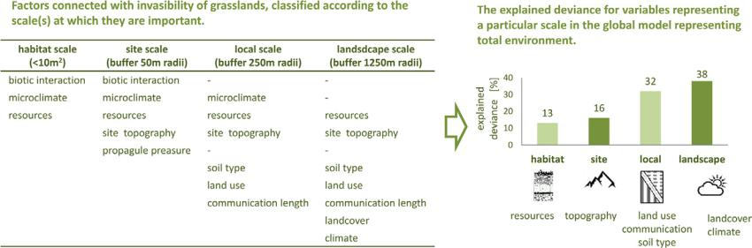

a r t i c l e i n f o

Article history:

Received 21 January 2020

Received in revised form 4 April 2020 Accepted 10 April 2020 Available online 13 April 2020

Editor: Darrel Jenerette

Keywords:

Plants invasion

Grasslands

Environmental factors

Spatial scale

Boosted regression trees

a b s t r a c t

The invasion of alien plant species is a serious problem for conservation and the maintenance of biodiversity in grasslands. Therefore, it is important to find environmental factors correlated with the distribution of invasive species in such areas. In this study, we examined the impacts of environmental factors operating at different spa-tial scales on the distribution of invasive species. The study area were located in the Sudetes Mountains, Poland (3800 km2). We sampled field data from 163 random plots located in grassland, among which there were 94 plots with invasive species and 69 plots without invasive species. For each plot, we collected data on resident veg-etation (species richness, community structure), geodiversity (topography, soil type), environmental heteroge-neity (landscape structure) and climate (temperature and precipitation). Since the factors examined are likely to operate at different spatial scales, we calculated values of environmental variables with different spatial scopes (10m2 plot and buffers with 50, 250 and 1250 m radii). The probability of invasive plant presence was modeled using boosted regression trees (BRT). The results of our study showed that the distribution of invasive species is explained by factors operated at different spatial scale: in the finer scale the presence of invasive species was driven predominantly by the average Ellenberg's Indicator Values for soil moisture, in medium-scale by the av-erage topographic wetness index and sum of edges, while at coarse-scale by temperature. It was also presented that the effect of drivers operating at fine-spatial scale is overwhelming by effect of drivers operating at coarse scale. From a practical point of view, the results demonstrate that effective grassland management should be planned on a larger spatial context, because focussing on the management of a single site cannot be successful. © 2020 Elsevier B.V. All rights reserved.

Corresponding author.

E-mail address: [m.czarniecka86@gmail.com](mailto:m.czarniecka86@gmail.com) (M. Czarniecka-Wiera).

<https://doi.org/10.1016/j.scitotenv.2020.138669> 0048-9697/© 2020 Elsevier B.V. All rights reserved.

1. Introduction

Grasslands provide a wide range of ecosystem services such as food production, recreation, tourism and biodiversity maintenance (Duelli and Obrist, 2003; Bonari et al., 2017). However, despite the value of

2 M. Czarniecka-Wiera et al. / Science of the Total Environment 727 (2020) 138669

grasslands, their area and quality in Europe has reduced during the last few decades as a result of agricultural, economic and social changes (MacDonald et al., 2000; Poschlod et al., 2005). This issue is especially visible in eastern Europe, where the total area of grasslands declined by 17% (about 2188 km2) from 1990 to 2017 (FAO (Food and Agricultural Organisation of the United Nations), 2006). Grasslands are influenced by agricultural improvement involving the use of highly con-centrated chemical fertilisers instead of traditional, organic substances such as dung and manure. Excessive use of these productive chemical fertilisers also plays a hand in eutrophication, which is increased by ni-trogen pollution. In the case of wet grasslands, alterations to hydro-graphic regimes usually results in a lower water table level or prevents inundation (Janssen et al., 2016). Moreover, numerous grass-lands have been converted into arable areas or abandoned, which leads to the expansion of tree and shrub cover and to the invasion of alien species (Falcucci et al., 2007; Prévosto et al., 2011). The invasibility of grasslands in Central Europe, compared to other habitats, is relatively low (Chytrý et al., 2008), but taking into consideration the high value of ecosystem services provided by seminatural grasslands, invasion by alien plants is considered a serious problem (Buckland et al., 2001; Eriksson et al., 2006). For example, Solidago gigantea and S. candensis de-crease biodiversity of vascular plant species in the infested European ecosystems (Hejda et al., 2009; Pal et al., 2015) and negatively influence the diversity and number of several animals, such as birds (Skórka et al., 2010), wild pollinators (Moroń et al., 2009) and ants (Lenda et al., 2013). Moreover, the increasing area of coverage by these invasive gold-enrods reduces the number of native flowers visited by pollinators (Fenesi et al., 2015). Lupinus polyphyllus, which is also invasive to Cen-tral European grasslands, increases soil fertility in oligotrophic montane and sub-montane meadows, which in turn leads to change in the struc-ture of plant communities (Hejda et al., 2009).

Invasion ecology defines invasive plants as naturalised species whose offspring are capable of reproducing at long distance from their parent plants and as a result can spread over large areas (Richardson et al., 2000; Pyšek et al., 2004). Consequently, invasive species have become a threat to biodiversity, ecosystem services, local economies and even to human well-being (Pyšek et al., 2004). Successful invasion depends on both the specific species' traits and the features of the habitat. Invasion consists of several subsequent stages: transport, introduction, establishment and spread. In each stage, there are barriers that need to be overcome for a species or population to pass on to the next stage (Alpert et al., 2000; Blackburn et al., 2011). First, the broad ecological conditions in the new range must fit the species' requirements (Catford et al., 2009). Regarding the invading species, a successful coloniser should present functional traits that do not completely overlap with those of the res-ident community (Funk et al., 2008). Community resistance to inva-sion correlates with more complementary use of available resources in functionally diverse communities (Frankow-Lindberg, 2012; Schittko et al., 2014). Additionally, the dominant species and their trait values could have a great impact on resistance to invasion (Smith et al., 2004), but dominant species can either increase or de-crease resistance to colonisation in a community (Galland et al., 2019).

The invasion process is extremely complex; however, it could be stressed that the level of invasion is affected by simultaneous action of propagule pressure, abiotic and biotic factors (Catford et al., 2009). In the modelling of invasive species distribution, different environmental variables are considered to be a proxy of propagule pressure, abiotic and biotic factors (Bazzichetto et al., 2018). Propagule pressure is ex-plained by dispersal efficiency of the invader and is mostly associated with environmental heterogeneity i.e. overall landscape structure (e.g. amount of edges and certain habitats types as urbanised areas) and the distance to particular landscape features which could act as reser-voirs for invasive plant seeds (e.g. the distance to road, urban areas, wa-tercourses/rivers) (Brothers and Spingarn, 1992; Kiviniemi and

Eriksson, 2002; Szymura et al., 2018). Abiotic factors include environ-mental characteristics related to geodiversity (e.g. soil type, land relief) and climate (e.g. temperature and precipitation) (Buckland et al., 2001; Kakembo et al., 2007; Nobis et al., 2016; Peltzer et al., 2016; Bailey et al., 2017). While biotic factors explain the biotic interactions of the resident community and are mostly characterised by community composition, diversity and biomass indices (Kolb et al., 2002; Roscher et al., 2009). The invasion process is controlled by the combination of these three fac-tors and is mediated by human activities (Catford et al., 2009).

The invasion process is even more complex when we consider that different invasion drivers operate more strongly at different spatial scales. At coarser levels, climate can be a crucial factor, mostly with regards to the temperature and precipitation regime (Shi et al., 2010), while the importance of landscape factors becomes important at intermediate scales; at finer scale, biotic interactions may be more significant (Catford et al., 2009; Milbau et al., 2009). Only a few stud-ies have investigated simultaneous effects of different drivers on successful invasion (e.g. Bazzichetto et al., 2018; Szymura et al., 2018) and even fewer studies have focussed on the scale that these factors operate on (e.g. Deutschewitz et al., 2003; Pauchard and Shea, 2006; Dyderski and Jagodziński, 2016). It is important for both scientists and grasslands managers to know to what extent in-vasion risk is related to local vegetation structure, which is con-nected to grassland management methods, as well as to what degree it is influenced by the wider ecological context, such as its po-sition in the landscape, infrastructure development and/or the ef-fects of climate.

In the present study, we evaluate the impacts of environmental fac-tors operating at different spatial scales on the distribution of invasive species in grasslands. Specifically, we asked the questions: 1) Which set of variables that operate at different spatial scales could have a key role in the presence of invasive species in grasslands? 2) How does the importance of different variables change with increasing spatial scale? We hypothesised that grassland invasion probability is explained by the simultaneous effect of variables representing resident vegetation, geodiversity, environmental heterogeneity and climate. We also hy-pothesis that the effect of drivers operating at fine-spatial scales are overwhelmed by the effect of drivers operating at coarse scales. The hi-erarchical framework presented here could aid in increasing our under-standing of invasion processes and help facilitate effective nature conservation.

2. Materials and methods

2.1. Study site

The study was carried out in the Sudetes Mountains, S\\W Poland, Central Europe (50°0′–50°10′N, 15°20′–16°55′E), over an area covering approximately 3800 km2, with elevation ranging from 280 to 840 m a.s. l. (Fig. 1a). Mean annual temperature ranged from 5 to 8 °C and mean annual precipitation from 490 to 650 mm (Karger et al., 2017). The landscape structure of the Sudetes Mountains was correlated with ele-vation; areas at the highest elevation are mainly covered by forests, while lower areas are mostly used for agriculture (e.g. urban areas, fields and grasslands).

2.2. Vegetation studied

The grasslands studied corresponded to three phytosociological classifications: the Arrhenatherion, Polygono-Trisetion and Calthion alliances (Kącki et al., 2013). Both Arrhenatherion and Polygono-Trisetion vegetation types qualified as Natura 2000 habitats in the European Union and have been characterised by high species rich-ness, with numerous rare plant and animal species (Annex I of the Habitat Directive). However, their continuation has been threatened by the invasion of alien species such as: Solidago canadensis, Solidago

|  |  |
| --- | --- |
| M. Czarniecka-Wiera et al. / Science of the Total Environment 727 (2020) 138669 | 3 |

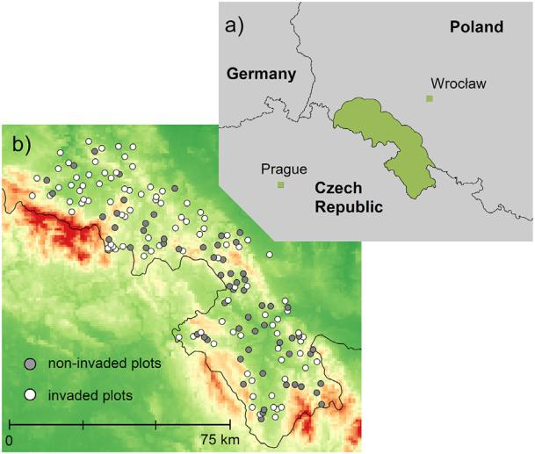

Fig. 1. Location of the study area (a) and sampling plots with background showing elevation (b).

gigantea, Lupinus polyphyllus, Reynoutria sachalinensis, Erigeron canadensis, Impatiens glandulifera and Digitalis purpurea (species names are given following the Euro Med Plant list [http://ww2.](http://ww2.bgbm.org/EuroPlusMed/) [bgbm.org/EuroPlusMed/](http://ww2.bgbm.org/EuroPlusMed/) [accessed 2nd November 2018]). These plants have been defined as highly invasive species with a tendency to dominate an ecosystem and outcompete native plants (Tokarska-Guzik, 2005).

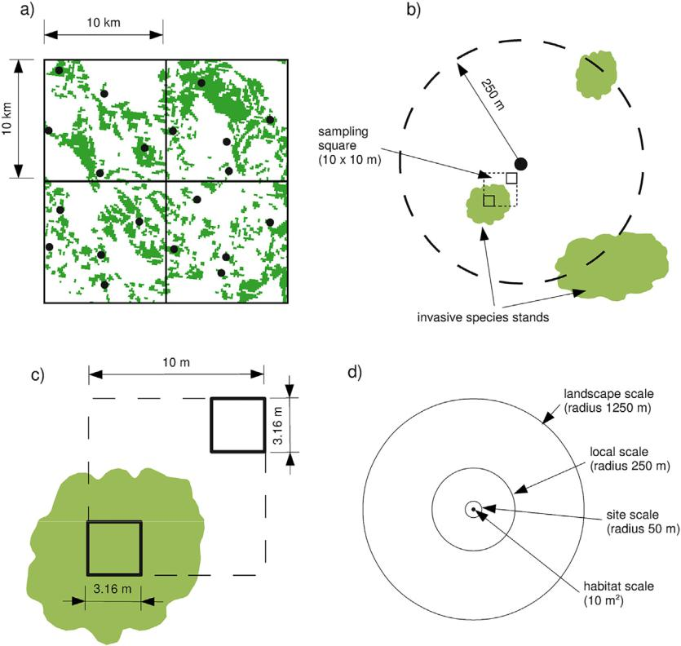

2.3. Sampling procedures

Grasslands across the Sudetes Mountains were sampled between July and August from 2012 to 2014. The selection of these study sites was based on digitised maps of grassland distribution in the Sudetes Mountains, which were prepared by the Institute of Technology and Life Sciences in Falenty. The maps were prepared according to the Digi-tal Terrain Model (elevation, slope and aspect), land cover and soil types (Nadolna and Żyszkowska, 2011). The grasslands accounted for 16% of the studied area and varied considerably in grassland patch sizes from 1 ha to 3500 ha, with an average patch size of 23 ha. The area of the Sudetes Mountains was covered by a 10 × 10 km grid (37 grids cells in total). In each grid cell, five points which were placed in separate grassland patches were randomly selected using Quantum GIS software by function random points tool (Fig. 2a). Around each point, a circular buffer of a 250 m radius was created (Fig. 2b). To be sure that the buffer zones did not overlap, we ensured a 1 km minimum distance between the random points. During field work, we visited each buffer and searched for invasive species starting from the central point of the buffer. In the stands of invasive species, we established a sampling plot of a 10 × 10 m square. If we found more than one stand of invasive species, we established the sampling plot that was closest to the central point of the buffer. If no invasive species were found within the buffer, a sampling plot without invasive species at the central point was selected (Fig. 2b). The sampling plot consisted of two paired subplots of 10 m2 (3.16 × 3.16 m), arranged in two opposite corners of a sampling plot (10 × 10 m square) (Fig. 2c). In case of invaded grasslands one subplot was established in a stand with invasive species (invaded subplot) and the second one in a stand without invasive species (non-invaded sub-plot), representing the vegetation of the grassland before invasion. Within the subplots, all vascular plants were recorded and their cover

Fig. 2. (a) An example of the location of five points (black dots) within each 10 × 10 km square on the background of grassland patch distribution (grey). (b) Buffer with a radius of 250 m around the central point (black dot), searched for invasive species. A sampling square (10 × 10 m) was established from the invasive species stand situated closest to the central point. If no invasive species were found within the buffer, the vegetation was sampled from a square, whose centre was placed directly on the central point. (c) A sampling square with two subplots (10 m2), established on plots where stands of invasive species were found. The position of the sampling square was fixed in order to cover both invaded and non-invaded parts of the grassland. (d) Arrangement of concentric circular buffers with a 10m2 subplot in the centre for collecting environmental data. Note that the figure is not to scale.

4 M. Czarniecka-Wiera et al. / Science of the Total Environment 727 (2020) 138669

was visually assessed using the Braun-Blanquet (1964) cover-abundance scale. If no invasive species were found within the 250 m buffer, the vegetation data was collected from the one subplot established in the central point of the buffer. Detailed vegetation data was used to calculate resident vegetation characteristics (e.g. species richness and community type). The database used in this study is stored in the Polish Vegetation Database in .xml format (Kącki and Śliwiński, 2012).

2.4. Dataset

In this study, the presence/absence of any invasive species was con-sidered as a modeled (response) variable. We collected data from 163 plots, among which there were 94 invaded plots and 69 non-invaded plots (Fig. 1b). In the studied grasslands we found 7 different invasive species: Solidago canadensis (45 plots), Solidago gigantea (22 plots), Lupinus polyphyllus (22 plots), Digitalis purpurea (2 plots), Reynoutria sachalinensis (1 plot), Erigeron canadensis (1 plot) and Impatiens glandulifera (1 plot).

Based on the literature and data availability, we prepared set vari-ables which represented resident vegetation (e.g. species richness and community structure), geodiversity (topography, soil type), environ-mental heterogeneity (landscape structure) and climate (e.g. tempera-ture and precipitation). The environmental variables were divided by their dependence on spatial scales at which they were likely to operate. The spatial scales corresponded to different sizes of buffers for which the values of environmental variables were assessed: (a) habitat scale, 10m2; (b) site scale, buffer radii 50 m, approximately 0.8 ha; (c) local scale, radii 250 m, approximately 20 ha and (d) landscape scale, buffer radii 1250 m, approximately 500 ha (Fig. 2d). The buffer size increased, assuming that finer scale plots characterised resident vegetation, medium-scale were mainly related to geodiversity and environmental heterogeneity, broad-scale buffers were linked to climate. Data was col-lected during fieldwork or derived from global and regional datasets (landuse: Corine, 2012; soil: Harmonized World Soil Database v 1.2; landrelief: European Digital Elevation Model with a resolution of 30 × 30 m; climate: Hijmans et al., 2005). The detailed list and the de-scription of explanatory variables and their data sources are shown in Appendix 1.

2.5. Statistical analysis

We used the boosted regression tree technique (BRT) to assess the effectiveness of environmental variables in explaining invasive species distribution in grasslands. As a response variable, we used data regard-ing any invasive species presence/absence. The BRT is a machine-learning method and can be considered as an advanced form of regres-sion. It combines the advantages of two approaches: regression trees and boosting. The regression tree method splits the modeled variable into small clusters, as homogenously internally as possible, to obtain the best predictions. Numerous regression trees are constructed and as-sembled, using the boosting procedure, to obtain an ‘averaged’ model (De'Ath, 2007; Elith et al., 2008). Stochasticity in tree construction is in-troduced via the ‘bagging’ approach, which increases model accuracy and minimalizes model overfitting by only retaining significant explan-atory variables (De'Ath, 2007). The BRT technique offers excellent pre-dictive ability, as well as the capacity to both quantify and visualise interactions among predictors (De'Ath 2007). Compared with multiple linear regression, the BRT is better suited for analysing biogeographical data as it captures non-stationary relationships between predictors and responses, lacks assumptions regarding spatially autocorrelated data (Hawkins, 2012) and deals well with collinearity among predictors (Dormann et al., 2013).

For each data set, an optimal BRT setting included the following: tree complexity, learning rate, the bag fraction and number of trees in the final assemblage. Tree complexity determines the model complexity

in terms of the number of interactions among predictors (i.e. the maxi-mum number of nodes in each regression tree). The learning rate (i.e. the ‘shrinkage parameter’) defines the influence of individual regression trees on the final assemblage. The bag fraction represents the fraction of input data excluded from the fitting of a particular tree, which is subse-quently used for model training (bagging). The optimal BRT settings as well as quality of prediction, can be assessed using cross-validation (cv), which allows for testing of a model without an additional independent data set. In addition to bagging, model shrinkage can be applied to avoid model overparametrisation (overfit) (Elith et al., 2008). Non-informative variables are excluded during tree fitting and a model sim-plification procedure, analogous to backward elimination in regression, is applied. The process progressively simplifies the model and uses the average cv error to decide how many variables should be removed from the original model without affecting model's predictive perfor-mance (Elith et al., 2008).

Prior to performing BRT modelling, we reduced the number of pre-dictors by rejecting those highly correlated. For this purpose, we used Spearman's correlation and excluded predictors when the Spearman rank correlation was above 0.8. The correlation matrix is shown in Ap-pendix 2. Afterward, we built a separate BRT model for each group of ex-planatory variables, divided according to scale (10 m2 and buffers with radii of 50, 250 and 1250 m). To analyse each subsequent scale, we used factors disclosed on a finer scale to find the scale-dependent differences that determined the importance of the selected environmental factors. Subsequently, the models were simplified in each step. These methods allowed us to build a model for the landscape scale (1250 m), which in-volved previously selected variables from each scale analysed. The land-scape scale model was used to interpret the most important variables connected with the distribution of invasive species.

In calibrating the BRTs, we tested different combinations of bag frac-tions (0.25, 0.5 and 0.75), learning rate (0.001, 0.0005 and 0.0001) and tree complexity (1, 2, 3, 4 and 5). The optimal parameters setting was selected based on explained deviance and AUC. We chose the settings: tree complexity = 5, bag fraction = 0.5 and learning rate = 0.001, while the tree number was independently set for each model. In this re-search, we used a 10-fold cross-validation. Models were evaluated using the area under the receiver operating statistics curve (ROC), where re-sults close to 1 represented a perfect fit and results of 0.5 indicated a poor fit (Šimundić, 2008). The ROC values for the fitted model (self-sta-tistics, ss) reflect internal model consistency, while values based on cv represented the predictive ability. For ecological interpretation of the model, we calculated the relative influence of explanatory variables and drew partial dependency plots for each explanatory variable. Rela-tive influence (ri) expressed the contribution of certain variables in explaining the probability of invader occurrence and was expressed as a percentage. The sum of ri for all variables introduced into the model was set to 100%. The partial dependency plots showed the modeled ef-fects of particular variables on the occurrence of invasive species after accounting for the average effects of all other variables (De'Ath, 2007).

3. Results

The presence of invasive species on grasslands at the habitat scale was explained mainly by the average Ellenberg's Indicator Values for soil moisture and temperature. At the site scale, the occurrence of inva-sive species was driven predominantly by the average topographic wet-ness index and average diurnal anisotropic heating. At the local scale, invasive occurrence was driven by the sum of edges and soil type. And at the landscape scale, it was driven by temperature seasonality and percentage of urbanised areas (Fig. 3).

The landscape scale model, which included most of the important variables from all scales, revealed that the presence of invasive species was explained by variables operating at each spatial scale studied (Fig. 4). The most important invasion driver was the dominant soil type, with Eutric Fluvisols (Fig. 4a). The presence of invasive species

|  |  |
| --- | --- |
| M. Czarniecka-Wiera et al. / Science of the Total Environment 727 (2020) 138669 | 5 |

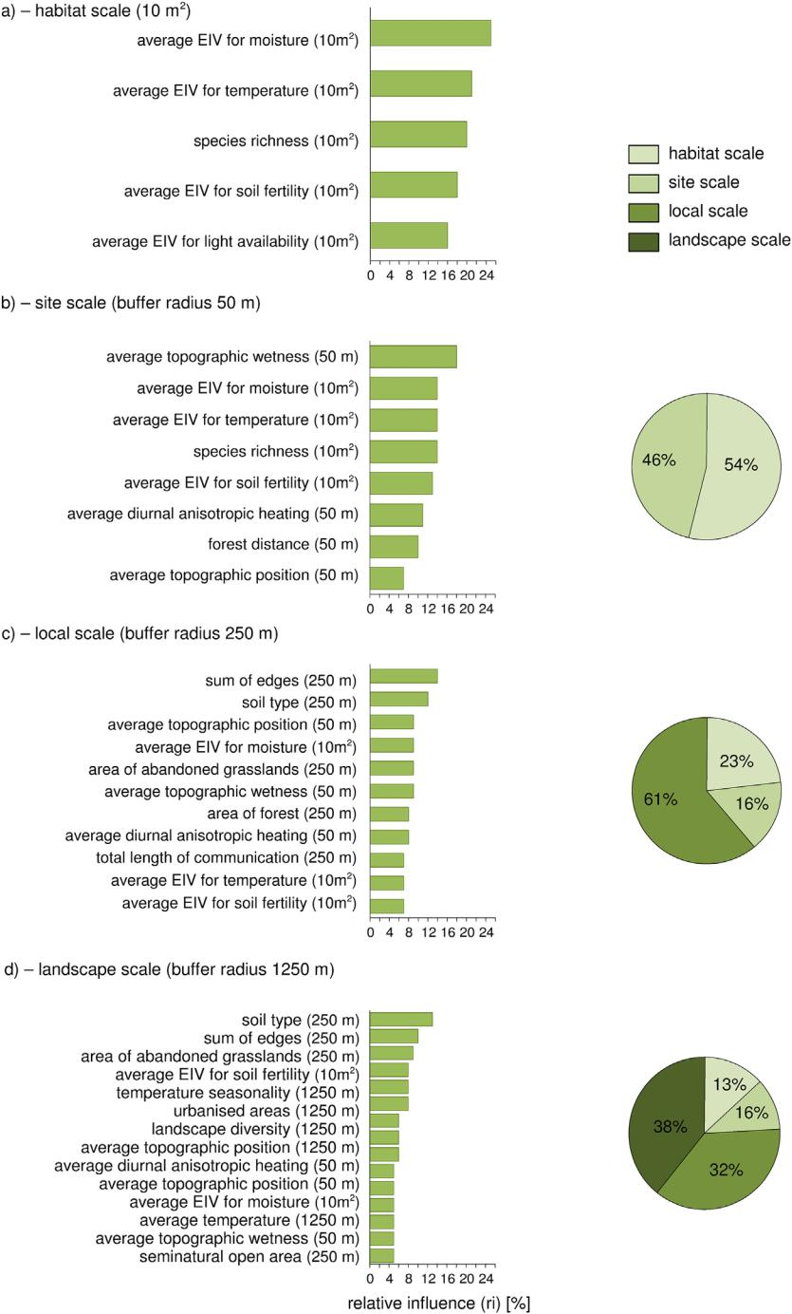

Fig. 3. Left panel: relative influence (ri) of variables significantly improving models at habitat (a), site (b), local (c) and landscape (d) scales. Right panel: sum of ri for variables representing particular spatial scales.

was positively correlated with the sum of edges, the area of abandoned grasslands, the average Ellenberg's Indicator Values for soil fertility and moisture, urbanised areas, landscape diversity, the average topographic position index, the average diurnal anisotropic heating, the average to-pographic wetness index and seminatural open areas (Fig. 4). In terms of climate, the presence of invasive species was more likely in warmer areas with low values of seasonality coefficients (Fig. 4e, l).

Our results show that generally, the predictive ability of the models increased when variables operating at larger spatial scales were in-cluded (as indicated by the ROC values - Table 1). Accordingly, with in-creasing spatial scales, the ri of factors specified for finer scales decreased (Fig. 3, right panel). However, our analyses revealed a

group of finer scale variables that also influenced the models at broad scales (Fig. 3, left panel). In particular, the variables specific to habitat scale (10 m2) had a high ri on both site (50 m) and local (250 m) scale models (Fig. 3b, c). In the model representing landscape scale (1250 m) the habitat factors were represented only by the average Ellenberg's Indicator Values for soil fertility and moisture (Fig. 3d). Of the four environmental variables assigned at the site scale (forest dis-tance, average topographic wetness index, average diurnal anisotropic heating and average topographic position index), the latter three were represented in the 250 m and 1250 m model. Of the 5 variables specific for the local scale (250 m), only four were used to build the landscape (1250 m) model (Fig. 3d). In accordance with the model representing

6 M. Czarniecka-Wiera et al. / Science of the Total Environment 727 (2020) 138669

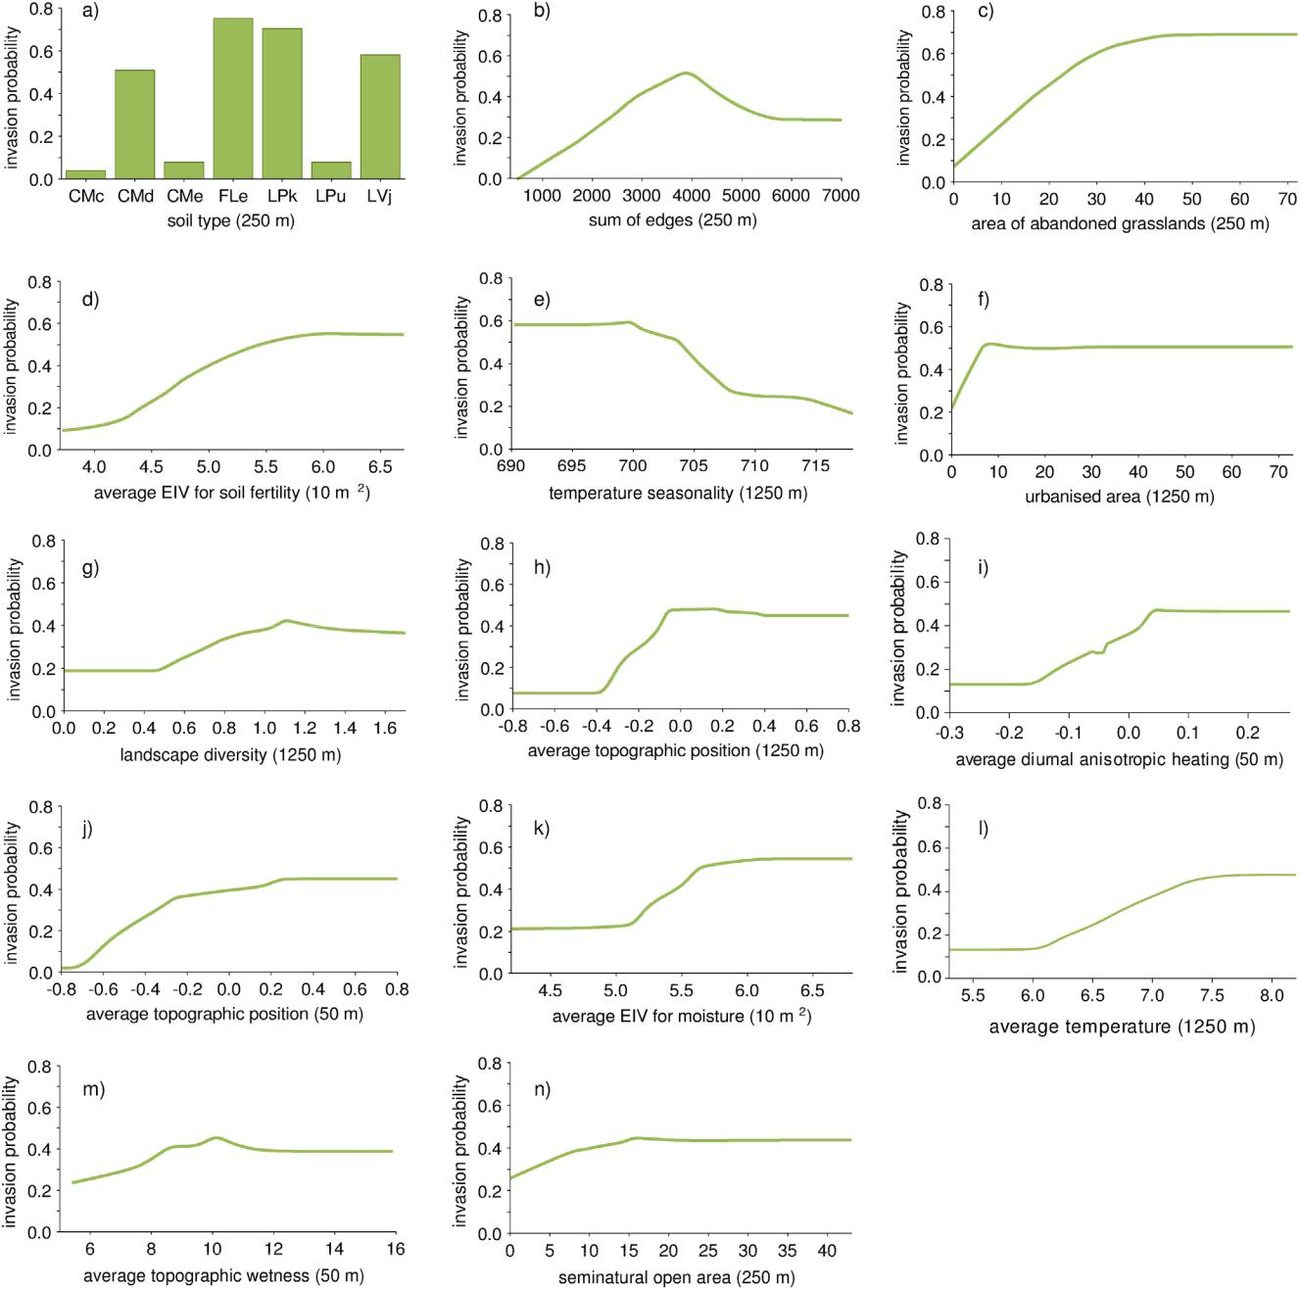

Fig. 4. The partial dependency plots of variables included in the regional model. The plots are ordered according to decreasing relative influence of the variables (List of soil types: Calcaric Cambisols - CMc, Dystric Cambisols - CMd, Eutric Cambisols - CMe, Eutric Fluvisols - FLe, Umbric Leptosols - LPu, Rendzic Leptosols - LPk, Stagnic Luvisols - LVj).

the landscape scale (1250 m), the highest fraction of model variation was explained by variables typical for the landscape scale (38%), followed by local (32%), site (16%) and habitat (13%) scale (Fig. 3,

Table 1

The number of trees (N trees) and values of receiver operating characteristic (ROC) curve for self-statistics (ss) and cross-validation statistics (cv) of BRT models for different buffer sizes. For cv statistic the standard deviation (s.d.) are also shown.

|  |  |  |  |  |  |  |  |
| --- | --- | --- | --- | --- | --- | --- | --- |
| Buffer size/subsampling plot area | N trees | ss | |  | cv |  |  |
|  |  |  |  |  |  |  |  |
|  |  | ROC | | ROC | | s.d. | |
|  |  |  |  |  | |  |  |
| 10 m2 | 1600 | 0.93 |  | 0.641 | | 0.044 |  |
| 50 m | 1600 | 0.972 | | 0.630 | | 0.039 |  |
| 250 m | 2400 | 0.995 | | 0.676 | | 0.045 |  |
| 1250 m | 2500 | 0.994 | | 0.721 | | 0.033 |  |
|  |  |  |  |  |  |  |  |

right panel). The full list of explanatory variables included in the models and their ri is shown in Fig. 3.

Finally, the results show that the probability of invasion in grass-lands is explained by variables representing environmental heterogene-ity, resident vegetation, geodiversity and climate, which are proxies of propagule pressure, biotic interaction and abiotic factors. It was also shown that the effect of drivers operating at the fine-spatial scale are overwhelmed by effect of drivers operating at the coarse scale.

4. Discussion

4.1. Effect of environmental variables on the distribution of invasive species

In this study, we prove that the presence of invasive species in grass-lands depends on numerous variables that operate at different scales.

|  |  |
| --- | --- |
| M. Czarniecka-Wiera et al. / Science of the Total Environment 727 (2020) 138669 | 7 |

The most important drivers were related to environmental heterogene-ity (landscape structure), geodiversity (land relief, soil), climate (tem-perature) and resident vegetation (average Ellenberg's Indicator Values for nitrogen and moisture).

The environmental heterogeneity (e.g. the presence of potential mi-gration routes as well as the presence and spatial configuration of par-ticular habitats), which was associated with the broad scale – buffer size 1250 m, influenced the distribution of invasive species. In the ob-served grasslands, invasive plants are found in more diversified and fragmented landscapes (i.e. high landscape diversity and high sum of edges). As shown by Vilà and Ibáñez (2011), landscapes with numerous small patches and habitat edges are beneficial to the spread of invasive species. In addition, the presence of specific habitats, such as abandoned grasslands and urbanised areas, increase the probability of invader oc-currence, which could be interpret as an effect of high propagule pres-sure on target grasslands (Botham et al., 2009; Pruchniewicz, 2017). The percentage of urbanised areas could also be considered as a proxy measure of human-induced disturbance, which is usually favourable for the establishment of invasive species (Pyšek et al., 2010). Our results suggest that this anthropogenic effect is not restricted to the proximity of urban areas but operates at the level of the entire region.

Recent studies have highlighted the effect of geodiversity on species distribution (Kolb et al., 2002; Kakembo et al., 2007; Bailey et al., 2017; Szymura et al., 2018). In the grasslands studied here, land relief which was connected to the fine-scale (buffer radius 50 m) caused variations in the microclimate, which, in turn, encouraged the establishment of in-vasive species found more often in warmer sites (Fig. 4i). These correla-tions can be related to the climatic requirements of the invasive species (Pyšek et al., 2003; Chytrý et al., 2008). In our investigation, only one species, Digitalis purpurea was common to mountains, while the re-maining species were most abundant in lowlands with a temperate cli-mate (Tokarska-Guzik, 2005). There were also landscape coarse-scale relationships (buffer radius 1250 m), showing that grassland areas in convex regions hosted more invasive species than those in concave landforms (Fig. 4h). In the context of Central Europe, concave land-forms, especially large river valleys, are often considered to be the main routes of invasion and have higher numbers of invasive species (Szymura et al., 2018); because of this discrepancy, the observed effect should be considered rather as a local idiosyncrasy. In this study, the ef-fect of river valleys can be autocorrelated with soils, because the inva-sive species were numerous on fertile alluvial soils in the initial phases of development (Eutric Fluvisols, Fig. 4a), which typically occurs along watercourses.

Regarding the effect of climate, in more harsh climates, the number of invasive species is usually lower (Szymura et al., 2018); and, in Cen-tral Europe, the pool of invasive species adapted to cold climatic condi-tions is smaller than that of species from moderate climates (Pyšek et al., 2003). Generally, Central European mountains can be considered less invaded than lowlands (Chytrý et al., 2008). In our study, the continu-ous increase in the probability of invasive species occurrence started when the average yearly temperature exceeded 6 °C (Fig. 4l). In the Sudetes Mountains, this generally corresponds with an elevation of 500 m a.s.l., which is considered to be the boundary between the foot-hills and the montane vegetation zone.

Regarding the effect of resident vegetation, only an average value of Ellenberg's Indicator Values for soil fertility and moisture was correlated with the probability of invasion (Fig. 4d, k). The Ellenberg's Indicator Values for soil fertility and moisture is considered to reflect the biomass productivity of grasslands (Wagner et al., 2007) and this result is broadly in agreement with the idea that invasive species prefer more productive habitats, where they can attain competitive dominance (Peltzer et al., 2016).

The effect of species richness, which theoretically should decrease the probability of alien invasion (Hector et al., 2001; Weisser et al., 2017), was observed only at finer spatial scales, which underlines the importance of spatial scale in the invasion process (Czarniecka-Wiera

et al., 2019). Our results suggest that the effect of species richness was not strong enough to mitigate the effects of other variables (e.g. soil properties and landscape structure) and it was not included in the broad-scale model. On the other hand, the importance of species rich-ness in biotic resistance to invasion has recently been undermined (Eriksson et al., 2006). It seems that the amount of resources that are available for a new coloniser is more important than species number. As a result, invading plants are often functionally different compared to native species and can therefore occupy an empty niche (Hejda and De Bello, 2013).

4.2. Spatial scale effect

Our results demonstrate that the effect of fine-scale factors decrease with increasing spatial scale of the research. These results are in line with observations that the factors driving invasive species distribution form hierarchical sets of filters, where in each spatial scale, other factors are most important. In this hierarchical system, factors operating at finer scales are superseded by broad-scale factors (Milbau et al., 2009; Bailey et al., 2017). A good example presented in our study is the de-creasing influence of species richness and indicators of grassland tro-phic status (fine-scale factors) coinciding with the introduction of climate, landscape factors and soil type (broad-scale factors). But there are also fine-scale factors: the average Ellenberg's Indicator Values for soil fertility and moisture, that are also important for the invasion process in the broad-scale model. This result is in accordance with Milbau et al. (2009) who found that if conditions at the broad-scale are favourable to invasion, the fine-scale factors are still important in the modelling of invasive species distribution. This scale-dependent ef-fect is often studied for scientific purposes, but rarely addressed for the purpose of practical management (Carranza et al., 2010).

4.3. Strengths and weaknesses of the approach

The explanatory power of our models, according to their ROC values, is relatively low (Šimundić, 2008), which might be the result of low mathematical model flexibility and/or the use of inappropriate factors as explanatory variables. However, biological invasions are considered to be extremely complex phenomena and the low explanatory value re-flects the complexity of the invasion process. In this study, we used a BRT technique, which is recognised as a flexible regression modelling method that has important benefits for modelling ecological data (De'ath, 2007). As a set of explanatory variables, factors that are already known to influence invasive species distribution and occurrence were used. Thus, we think that the complexity of invasion processes highly contributed to the low ROC values.

Moreover, we studied a range of invasive species which differ re-garding their biology and ecology as well as the year and way of intro-duction. This variation can cause additional noise in our models because responses of particular species to explanatory variables could be different, although all species studied are relatively strong competi-tors. It can be assumed that the species that arrives and establishes on

1. particular grassland first exerts competitive exclusion (Shulman et al., 1983). As a result, in areas with high levels of invasion, the inter-actions between invaders should also be taken into consideration (Catford et al., 2012). Thus, the construction of separate models for cer-tain invasive species can also be less meaningful, since the absence of an invasive species could result from either the environment or the pres-ence of another invader (Szymura and Szymura, 2016). Moreover, the management of certain grassland can influence invasion probability be-cause managed grasslands are more resistant to invasion compared with abandoned grasslands (Pruchniewicz, 2017). However, in our kind of study, it was impossible to collect detailed data regarding the management history of a particular grassland.

8 M. Czarniecka-Wiera et al. / Science of the Total Environment 727 (2020) 138669

4.4. Policy and management implications

The results presented here can be interesting for both policymakers and conservationists. For policymakers, it is important to monitor the spreading of invasive species, however, monitoring of the entire region or country is difficult (if even possible) and expensive. Therefore, iden-tification of high-risk regions for invasion seems to be more beneficial. For this purpose, it is necessary to recognise the most important factors, which can aid in either the promotion or resistance of invasive species. In our study, we demonstrate an easy way to determine which factors are fundamental for the occurrence of invasive species in grasslands. A similar procedure can be carried out for other habitats or regions. An im-portant conclusion presented here is that large-scale factors are the first filter in the invasion process and defining them allows us to limit the monitoring area and save money in the process.

For the conservationists, it is important to note that site-focussed management, applied by owners or managers of particular grasslands, has limited influence on alien species invasion or conservation at-tempts. The coarse-scale context, usually independent from and out of the control of a farmer (e.g. landscape structure), is the first filter for the introduction of invasive species. Our study provides evidence that efficient planning of invasive-species control on grasslands should be landscape-scale oriented.

Supplementary data to this article can be found online at [https://doi.](https://doi.org/10.1016/j.scitotenv.2020.138669)

[org/10.1016/j.scitotenv.2020.138669](https://doi.org/10.1016/j.scitotenv.2020.138669).

CRediT authorship contribution statement

M. Czarniecka-Wiera:Conceptualization, Methodology, Software, Formal analysis, Investigation, Data curation, Writing - original draft, Writing - review & editing.T.H. Szymura:Methodology, Software, For-mal analysis, Visualization, Writing - original draft, Writing - review & editing.Z. Kącki:Methodology, Investigation, Validation, Writing - orig-inal draft, Writing - review & editing, Resources.

Declaration of competing interest

The authors declare that they have no known competing financial interests or personal relationships that could have appeared to influ-ence the work reported in this paper.

Acknowledgements

No conflicts of interest have been declared.

References

Alpert, P., Bone, E., Holzapfel, C., 2000. Invasiveness, invasibility and the role of environ-mental stress in the spread of non-native plants. Perspectives in Plant Ecology, Evolu-tion and Systematics 3, 52–66. <https://doi.org/10.1078/1433-8319-00004>.

Bailey, J.J., Boyd, D.S., Hjort, J., Lavers, C.P., Field, R., 2017. Modelling native and alien vas-cular plant species richness: at which scales is geodiversity most relevant? Glob. Ecol. Biogeogr. 26, 763–776. <https://doi.org/10.1111/geb.12574>.

Bazzichetto, M., Malavasi, M., Barták, V., Acosta, A.T.R., Moudrý, V., Carranza, M.L., 2018. Modeling plant invasion on Mediterranean coastal landscapes: an integrative ap-proach using remotely sensed data. Landsc. Urban Plan. 171, 98–106. [https://doi.](https://doi.org/10.1016/j.landurbplan.2017.11.006) [org/10.1016/j.landurbplan.2017.11.006](https://doi.org/10.1016/j.landurbplan.2017.11.006).

Blackburn, T.M., Pyšek, P., Bacher, S., et al., 2011. A proposed unified framework for bio-logical invasions. Trends Ecol. Evol. 26, 333–339. [https://doi.org/10.1016/j.](https://doi.org/10.1016/j.tree.2011.03.023) [tree.2011.03.023](https://doi.org/10.1016/j.tree.2011.03.023).

Bonari, G., Fajmon, K., Malenovský, I., et al., 2017. Management of semi-natural grasslands benefiting both plant and insect diversity: the importance of heterogeneity and tra-dition. Agric. Ecosyst. Environ. 246, 243–252. [https://doi.org/10.1016/j.](https://doi.org/10.1016/j.agee.2017.06.010) [agee.2017.06.010](https://doi.org/10.1016/j.agee.2017.06.010).

Botham, M.S., Rothery, P., Hulme, P.E., et al., 2009. Do urban areas act as foci for the spread of alien plant species? An assessment of temporal trends in the UK. Divers. Distrib. 15, 338–345. <https://doi.org/10.1111/j.1472-4642.2008.00539.x>.

Braun-Blanquet, J., 1964. [Pflanzensociologie. Grundzüge der Vegetationskunde.](http://refhub.elsevier.com/S0048-9697(20)32186-0/rf0035) [3.](http://refhub.elsevier.com/S0048-9697(20)32186-0/rf0035)

[AuflageSpringer Verlag, Wien.](http://refhub.elsevier.com/S0048-9697(20)32186-0/rf0035)

Brothers, T.S., Spingarn, A., 1992. Forest fragmentation and alien plant invasion of central Indiana old-growth forests. Conserv. Biol. 6, 91–100. <https://doi.org/10.1046/j.1523-1739.1992.610091.x>.

Buckland, S.M., Thompson, K., Hodgson, J.G., et al., 2001. Grassland invasions: effects of manipulations of climate and management. J. Appl. Ecol. 38, 301–309. [https://doi.](https://doi.org/10.1046/j.1365-2664.2001.00603.x) [org/10.1046/j.1365-2664.2001.00603.x](https://doi.org/10.1046/j.1365-2664.2001.00603.x).

Carranza, M.L., Carboni, M., Feola, S., et al., 2010. Landscape-scale patterns of alien plant species on coastal dunes: the case of iceplant in central Italy. Appl. Veg. Sci. 13, 135–145. <https://doi.org/10.1111/j.1654-109X.2009.01065.x>.

Catford, J.A., Jansson, R., Nilsson, C., 2009. Reducing redundancy in invasion ecology by in-tegrating hypotheses into a single theoretical framework. Divers. Distrib. 15, 22–40. <https://doi.org/10.1111/j.1472-4642.2008.00521.x>.

Catford, J.A., Vesk, P.A., Richardson, D.M., et al., 2012. Quantifying levels of biological invasion: towards the objective classification of invaded and invasible ecosys-tems. Glob. Chang. Biol. 18, 44–62. <https://doi.org/10.1111/j.1365-2486.2011.02549.x>.

Chytrý, M., Jarošík, V., Pyšek, P., et al., 2008. Separating habitat invasibility by alien plants from the actual level of invasion. Ecology 89, 1541–1553. <https://doi.org/10.1890/07-0682.1>.

Corine, 2012. data base (Online). Available. <http://clc.gios.gov.pl/>.

Czarniecka-Wiera, M., Kącki, Z., Chytrý, M., Palpurina, S., 2019. Diversity loss in grasslands due to the increasing dominance of alien and native competitive herbs. Biodivers. Conserv., 1–16 <https://doi.org/10.1007/s10531-019-01794-9>.

De’Ath, G., 2007. Boosted trees for ecological modeling and prediction. Ecology 88, 243–251. [https://doi.org/10.1890/0012-9658(2007)88[243:BTFEMA]2.0.CO;2](https://doi.org/10.1890/0012-9658(2007)88<243:BTFEMA>2.0.CO;2).

Deutschewitz, K., Lausch, A., Kühn, I., Klotz, S., 2003. Native and alien plant species rich-ness in relation to spatial heterogeneity on a regional scale in Germany. Glob. Ecol. Biogeogr. 12 (4), 299–311. <https://doi.org/10.1046/j.1466-822X.2003.00025.x>.

Dormann, C.F., Elith, J., Bacher, S., et al., 2013. Collinearity: a review of methods to deal with it and a simulation study evaluating their performance. Ecography 36, 27–46. <https://doi.org/10.1111/j.1600-0587.2012.07348.x>.

Duelli, P., Obrist, M.K., 2003. Regional biodiversity in an agricultural landscape: the contri-bution of seminatural habitat islands. Basic and Applied Ecology 4, 129–138. [https://](https://doi.org/10.1078/1439-1791-00140) [doi.org/10.1078/1439-1791-00140](https://doi.org/10.1078/1439-1791-00140).

Dyderski, M.K., Jagodziński, A.M., 2016. Patterns of plant invasions at small spatial scale correspond with that at the whole country scale. Urban Ecosyst. 19, 983–998. <https://doi.org/10.1007/s11252-015-0524-y>.

Elith, J., Leathwick, J.R., Hastie, T., 2008. A working guide to boosted regression trees.

J. Anim. Ecol. 77, 802–813. <https://doi.org/10.1111/j.1365-2656.2008.01390.x>.

Eriksson, O., Wikström, S., Eriksson, Å., et al., 2006. Species-rich Scandinavian grasslands are inherently open to invasion. Biol. Invasions 8, 355–363. [https://doi.org/10.1007/](https://doi.org/10.1007/s10530-004-4720-6) [s10530-004-4720-6](https://doi.org/10.1007/s10530-004-4720-6).

European Digital Elevation Model (EU-DEM) (Online), d. . Available:. [https://www.eea.](https://www.eea.europa.eu/data-and-maps/data/eu-dem)

[europa.eu/data-and-maps/data/eu-dem](https://www.eea.europa.eu/data-and-maps/data/eu-dem).

Falcucci, A., Maiorano, L., Boitani, L., 2007. Changes in landuse/land-cover patterns in Italy and their implications for biodiversity conservation. Landsc. Ecol. 22, 617–631. [https://doi.org/10.1007/s10980-302 006-9056-4](https://doi.org/10.1007/s10980-302).

FAO (Food and Agricultural Organisation of the United Nations), 2006. [FAO Statistical](http://refhub.elsevier.com/S0048-9697(20)32186-0/rf0125) [Yearbook. FAOSTAT.](http://refhub.elsevier.com/S0048-9697(20)32186-0/rf0125)

Fenesi, A., Vágási, C.I., Beldean, M., et al., 2015. Solidago canadensis impacts on native plant and pollinator communities in different-aged old fields. Basic and Applied Ecology 16, 335–346. <https://doi.org/10.1016/j.baae.2015.03.003>.

Frankow-Lindberg, B.E., 2012. Grassland plant species diversity decreases invasion by in-creasing resource use. Oecologia 169, 793–802. <https://doi.org/10.1007/s00442-011-2230-7>.

Funk, J.L., Cleland, E.E., Suding, K.N., Zavaleta, E.S., 2008. Restoration through reassembly: plant traits and invasion resistance. Trends in Ecology and Evolution 23, 695–703. <https://doi.org/10.1016/j.tree.2008.07.013>.

Galland, T., Adeux, G., Dvořáková, H., et al., 2019. Colonization resistance and establish-ment success along gradients of functional and phylogenetic diversity in experimen-tal plant communities. J. Ecol. 107, 2090–2104. <https://doi.org/10.1111/1365-2745.13246>.

Harmonized World Soil Database V 1.2. (Online), d. . Available. [http://www.fao.org/soils-portal/soil-survey/soil-maps-and-databases/harmonized-world-soil-database-v12/](http://www.fao.org/soils-portal/soil-survey/soil-maps-and-databases/harmonized-world-soil-database-v12/en/) [en/](http://www.fao.org/soils-portal/soil-survey/soil-maps-and-databases/harmonized-world-soil-database-v12/en/).

Hawkins, B.A., 2012. Eight (and a half) deadly sins of spatial analysis. J. Biogeogr. 39, 1–9.

<https://doi.org/10.1111/j.1365-2699.2011.02637.x>.

Hector, A., Dobson, K., Minns, A., Bazeley-White, E., Hartley Lawton, J., 2001. Community diversity and invasion resistance: an experimental test in a grassland ecosystem and a review of comparable studies. Ecol. Res. 16, 819–831. [https://doi.org/10.1046/](https://doi.org/10.1046/j.1440-1703.2001.00443.x) [j.1440-1703.2001.00443.x](https://doi.org/10.1046/j.1440-1703.2001.00443.x).

Hejda, M., De Bello, F., 2013. Impact of plant invasions on functional diversity in the veg-etation of Central Europe. J. Veg. Sci. 24, 890–897. <https://doi.org/10.1111/jvs.12026>.

Hejda, M., Pyšek, P., Jarošík, V., 2009. Impact of invasive plants on the species richness, di-versity and composition of invaded communities. J. Ecol. 97, 393–403. [https://doi.](https://doi.org/10.1111/j.1365-2745.2009.01480.x) [org/10.1111/j.1365-2745.2009.01480.x](https://doi.org/10.1111/j.1365-2745.2009.01480.x).

Hijmans, R.J., Cameron, S.E., Parra, J.L., et al., 2005. Very high resolution interpolated cli-mate surfaces for global land areas. Int. J. Climatol. 25, 1965–1978. [https://doi.org/](https://doi.org/10.1002/joc.1276) [10.1002/joc.1276](https://doi.org/10.1002/joc.1276).

Janssen, J.A., Rodwell, J.S., Criado, M.G., 2016. [European Red List of Habitats. Part 2. Terres-trial and Freshwater Habitats. European Union.](http://refhub.elsevier.com/S0048-9697(20)32186-0/rf0180)

Kącki, Z., Śliwiński, M., 2012. The polish vegetation database: structure, resources and de-velopment. Acta Soc. Bot. Pol. 81, 75–79. <https://doi.org/10.5586/asbp.2012.014>.

Kącki, Z., Czarniecka, M., Swacha, G., 2013. Statistical determination of diagnostic, con-stant and dominant species of the higher vegetation units of Poland. Monographiae Botanicae 103, 1–267. <https://doi.org/10.5586/mb.2013.001>.

|  |  |
| --- | --- |
| M. Czarniecka-Wiera et al. / Science of the Total Environment 727 (2020) 138669 | 9 |

Kakembo, V., Rowntree, K., Palmer, A.R., 2007. Topographic controls on the invasion of Pteronia incana (blue bush) onto hillslopes in Ngqushwa (formerly Peddie) district, Eastern Cape, South Africa. Catena 70, 185–199. [https://doi.org/10.1016/j.](https://doi.org/10.1016/j.catena.2006.08.005) [catena.2006.08.005](https://doi.org/10.1016/j.catena.2006.08.005).

Karger, D.N., Conrad, O., Böhner, J., et al., 2017. Climatologies at high resolution for the earth’s land surface areas. Scientific Data 4, 170122. [https://doi.org/10.1038/](https://doi.org/10.1038/sdata.2017.122) [sdata.2017.122](https://doi.org/10.1038/sdata.2017.122).

Kiviniemi, K., Eriksson, O., 2002. Size-related deterioration of semi-natural grassland frag-ments in Sweden. Divers. Distrib. 8, 21–29. <https://doi.org/10.1046/j.1366-9516.2001.00125>.

Kolb, A., Alpert, P., Enters, D., Holzapfel, C., 2002. Patterns of invasion within a grassland community. J. Ecol. 90, 871–881. <https://doi.org/10.1046/j.1365-2745.2002.00719.x>.

Lenda, M., Witek, M., Skórka, P., Moroń, D., Woyciechowski, M., 2013. Invasive alien plants affect grassland ant communities. Colony size and foraging behavior. Biol. Invasions 15, 2403–2414. <https://doi.org/10.1007/s10530-013-0461-8>.

MacDonald, D., Crabtree, J.R., Wiesinger, G., et al., 2000. Agriculture abandonment in mountain areas of Europe: environmental consequences and policy response. J. Environ. Manag. 59, 47–69. <https://doi.org/10.1006/jema.1999.0335>.

Milbau, A., Stout, J.C., Graae, B.J., et al., 2009. A hierarchical framework for integrating invasibility experiments incorporating different factors and spatial scales. Biol. Inva-sions 11, 941–950. <https://doi.org/10.1007/s10530-008-9306-2>.

Moroń, D., Lenda, M., Skórka, P., Szentgyörgyi, H., Settele, J., Woyciechowski, M., 2009. Wild pollinator communities are negatively affected by invasion of alien goldenrods in grassland landscapes. Biol. Conserv. 142, 1322–1332. [https://doi.org/10.1016/j.](https://doi.org/10.1016/j.biocon.2008.12.036) [biocon.2008.12.036](https://doi.org/10.1016/j.biocon.2008.12.036).

Nadolna, L., Żyszkowska, M., 2011. Characteristics of grasslands in the Polish Sudetes in view of fodder production potential and grassland protection. J Water Land Dev 15, 29–40. [https://doi.org/10.2478/v1002 5-012-0003-2](https://doi.org/10.2478/v1002 -2).

Nobis, A., Żmihorski, M., Kotowska, D., 2016. Linking the diversity of native flora to land cover heterogeneity and plant invasions in a river valley. Biol. Conserv. 203, 17–24. <https://doi.org/10.1016/j.biocon.2016.08.032>.

Pal, R.W., Chen, S., Nagy, D.U., Callaway, R.M., 2015. Impacts of Solidago gigantea on other species at home and away. Biol. Invasions 17, 3317–3325. [https://doi.org/10.1007/](https://doi.org/10.1007/s10530-015-0955-7) [s10530-015-0955-7](https://doi.org/10.1007/s10530-015-0955-7).

Pauchard, A., Shea, K., 2006. Integrating the study of non-native plant invasions across spatial scales. Biol. Invasions 8, 399–413. <https://doi.org/10.1007/s10530-005-6419-8>.

Peltzer, D.A., Kurokawa, H., Wardle, D.A., 2016. Soil fertility and disturbance interact to drive contrasting responses of co-occurring native and nonnative species. Ecology 97, 515–529. <https://doi.org/10.1890/15-0298.1>.

Poschlod, P., Bakker, J.P., Kahmen, S., 2005. Changing land use and its impact on biodiver-sity. Basic and Applied Ecology 6, 93–98. <https://doi.org/10.1016/j.baae.2004.12.001>.

Prévosto, B., Kuiters, L., Bernhardt-Römermann, M., et al., 2011. Impacts of land abandon-ment on vegetation: successional pathways in European habitats. Folia Geobotanica 46, 303–325. <https://doi.org/10.1007/s12224-010-9096-z>.

Pruchniewicz, D., 2017. Abandonment of traditionally managed mesic mountain meadows affects plant species composition and diversity. Basic and Applied Ecology 20, 10–18. <https://doi.org/10.1016/j.baae.2017.01.006>.

Pyšek, P., Sádlo, J., Mandák, B., et al., 2003. Czech alien flora and the historical pattern of its formation: what came first to Central Europe? Oecologia 135, 122–130. [https://doi.](https://doi.org/10.1007/s00442-002-1170-7) [org/10.1007/s00442-002-1170-7](https://doi.org/10.1007/s00442-002-1170-7).

Pyšek, P., Richardson, D.M., Rejmánek, M., et al., 2004. Alien plants in checklists and floras: towards better communication between taxonomists and ecologists. Taxon 53, 131–143. <https://doi.org/10.2307/4135498>.

Pyšek, P., Chytrý, M., Jarošík, V., 2010. [Habitats and land-use as determinants of plant in-vasions in the temperate zone of Europe. In: Perrings, C., Mooney, H.A., Williamson,](http://refhub.elsevier.com/S0048-9697(20)32186-0/rf0285) [M. (Eds.), Bioinvasions and Globalization: Ecology, Economics, Management and Pol-icy. Oxford Univ. Press, Oxford, pp. 66–79.](http://refhub.elsevier.com/S0048-9697(20)32186-0/rf0285)

Richardson, D.M., Pyšek, P., Rejmanek, M., et al., 2000. Naturalization and invasion of alien plants: concepts and definitions. Divers. Distrib. 6, 93–107. [https://doi.org/10.1046/](https://doi.org/10.1046/j.1472-4642.2000.00083.x) [j.1472-4642.2000.00083.x](https://doi.org/10.1046/j.1472-4642.2000.00083.x).

Roscher, C., Bessler, H., Oelmann, Y., et al., 2009. Resources, recruitment limitation and in-vader species identity determine pattern of spontaneous invasion in experimental grasslands. J. Ecol. 97, 32–47. <https://doi.org/10.1111/j.1365-2745.2008.01451.x>.

Schittko, C., Hawa, M., Wurst, S., 2014. Using a multi-trait approach to manipulate plant functional diversity in a biodiversity-ecosystem function experiment. PLoS One 9, e99065. <https://doi.org/10.1371/journ al.pone.0099065>.

Shi, J., Luo, Y., Zhou, F., et al., 2010. The relationship between invasive alien species and main climatic zones. Biodivers. Conserv. 19, 2485–2500. [https://doi.org/10.1007/](https://doi.org/10.1007/s10531-010-9855-4) [s10531-010-9855-4](https://doi.org/10.1007/s10531-010-9855-4).

Shulman, M.J., Ogden, J.C., Ebersole, J.P., et al., 1983. Priority effects in the recruitment of juvenile coral reef fishes. Ecology 64, 1508–1513. <https://doi.org/10.2307/1937505>.

Šimundić, A.M., 2008. [Measures of diagnostic accuracy: basic definitions. Medical and bi-ological sciences 22, 61–65.](http://refhub.elsevier.com/S0048-9697(20)32186-0/rf0315)

Skórka, P., Lenda, M., Tryjanowski, P., 2010. Invasive alien goldenrods negatively affect grassland bird communities in Eastern Europe. Biol. Conserv. 143, 856–861. [https://](https://doi.org/10.1016/j.biocon.2009.12.030) [doi.org/10.1016/j.biocon.2009.12.030](https://doi.org/10.1016/j.biocon.2009.12.030).

Smith, M.D., Wilcox, J.C., Kelly, T., Knapp, A.K., 2004. Dominance not richness determines invasibility of tallgrass prairie. Oikos 106, 253–262. <https://doi.org/10.1111/j.0030-1299.2004.13057.x>.

Szymura, M., Szymura, T.H., 2016. Historical contingency and spatial processes rather than ecological niche differentiation explain the distribution of invasive goldenrods (Solidago and Euthamia). Plant Ecol. 217, 565–582. <https://doi.org/10.1007/s11258-016-0601-1>.

Szymura, T.H., Szymura, M., Zając, M., et al., 2018. Effect of anthropogenic factors, land-scape structure, land relief, soil and climate on risk of alien plant invasion at regional scale. Sci. Total Environ. 626, 1373–1381. [https://doi.org/10.1016/j.](https://doi.org/10.1016/j.scitotenv.2018.01.131) [scitotenv.2018.01.131](https://doi.org/10.1016/j.scitotenv.2018.01.131).

Tokarska-Guzik, B., 2005. [The Establishment and Spread of Alien Plant Species](http://refhub.elsevier.com/S0048-9697(20)32186-0/rf0340) [(Kenophytes) in Poland. Uniwersytet Śląski, Katowice, Poland.](http://refhub.elsevier.com/S0048-9697(20)32186-0/rf0340)

Vilà, M., Ibáñez, I., 2011. Plant invasions in the landscape. Landsc. Ecol. 26, 461–472.

<https://link.springer.com/article/10.1007%2Fs10980-011-9585-3>.

Wagner, M., Kahmen, A., Schlumprecht, H., et al., 2007. Prediction of herbage yield in grassland: how well do Ellenberg N-values perform? Appl. Veg. Sci. 10, 15–24. <https://doi.org/10.1111/j.1654-109X.2007.tb00499.x>.

Weisser, W.W., Roscher, C., Meyer, S.T., et al., 2017. Biodiversity effects on ecosystem functioning in a 15-year grassland experiment: patterns, mechanisms, and open questions. Basic and applied ecology 23, 1–73. [https://doi.org/10.1016/j.](https://doi.org/10.1016/j.baae.2017.06.002) [baae.2017.06.002](https://doi.org/10.1016/j.baae.2017.06.002).