[Carbohydrate Polymers 246 (2020) 116591](https://doi.org/10.1016/j.carbpol.2020.116591)



Contents lists available at [ScienceDirect](http://www.sciencedirect.com/science/journal/01448617)



Carbohydrate Polymers

journal homepage: [www.elsevier.com/locate/carbpol](https://www.elsevier.com/locate/carbpol)

|  |  |  |
| --- | --- | --- |
| Combining online size exclusion chromatography and electrospray | [T](http://crossmark.crossref.org/dialog/?doi=10.1016/j.carbpol.2020.116591&domain=pdf) |  |
| ionization mass spectrometry to characterize plant polysaccharides |  |
|  |  |



Qing Jianga, Ying Wanga, Hongli Lia,*, David D.Y. Chena,b,*

1. Jiangsu Collaborative Innovation Center of Biomedical Functional Materials, Jiangsu Key Laboratory of Biomedical Materials, School of Chemistry and Materials Science, Nanjing Normal University, Nanjing 210023, China
2. Department of Chemistry, University of British Columbia, Vancouver BC V6T 1Z1, Canada

ARTICLE INFO

Keywords:

Plant polysaccharides

Size exclusion chromatography

Mass spectrometry

Source-induced dissociation

ABSTRACT

Characterizing polysaccharides with large molecular weights and isomeric heterogeneity with mass spectro-metry (MS) is generally diﬃcult. In this work, we demonstrate how coupling size exclusion chromatography (SEC) and high-resolution MS with source-induced dissociation (SID) can be used for the separation and direct structural evaluation of intact polysaccharides. The analytical method was successfully developed using dextran standards up to 3755 kDa. This method was used to separate naturally occurring plant polysaccharides based on size, after which numerous polysaccharide fragments were identified from the resulting MS spectra. The results provided strong evidence for structural diversity, complexity, and heterogeneity among polysaccharides. MS showed superior sensitivity and reliability for the polysaccharides in eluted fractions when compared to a re-fractive index detector. Putative compositions for the fragments were proposed based on exact mass values. The work demonstrated that SEC-SID-MS is a feasible alternative for obtaining valuable structural information from the analysis of intact polysaccharides.

1. Introduction

Plant polysaccharides extracted from traditional Chinese herbs have been reported to exert numerous therapeutic eﬀects and potential medicinal functions such as blood sugar regulation, immunomodula-tion, as well as antitumor and antiviral activities (Aizpurua-Olaizola et al., 2018; Gray et al., 2016; Varki, 2016; Wolfert & Boons, 2013). Some of the herbs from which valuable polysaccharides can be ex-tracted, e.g., Dendrobium oﬃcinale, are listed in the Pharmacopoeia of the People’s Republic of China (Wang, Zhao, Yang, Wang, & Kuang, 2016; Yu, Shen, Song, & Xie, 2018). The diverse structures among plant polysaccharides may confer diﬀerent physical and chemical properties, which are directly related to their functions in living organisms (Ferreira, Passos, Madureira, Vilanova, & Coimbra, 2015; Yu et al., 2018). As is common for all carbohydrates, polysaccharides show great isomeric heterogeneity that stems from monomer stereochemistry, se-quence connection, linkage positions and branching variation (Hofmann, Hahm, Seeberger, & Pagel, 2015; Li, Bendiak, Siems, Gang,

* Hill, 2015). Moreover, polysaccharides are polymeric macro-molecules that can form spatial aggregates through non-covalent in-teractions between functional groups in the monomers from which they



are built. Analytical methods that provide insight into the structural heterogeneity and diversity of plant polysaccharides is critical for un-derstanding their functions in biological systems. Unfortunately, the availability of such analytical tools is currently very limited.

Digesting polysaccharides into smaller molecules remains one of the most popular sample preparation approaches for analyzing these com-pounds. Enzymatic, physical or chemical digestion methods can be used, but these approaches can also be costly and time-consuming (F. Ma, Wang et al., 2018; Zykwinska et al., 2018). Once a polysaccharide is completely hydrolyzed, the monomer composition can be determined by matching the hydrolysates with sugar standards using chromato-graphic methods (Luo et al., 2010; Xu et al., 2009). Because carbohy-drates do not have chromophores or fluorophores, derivatization is needed for ultraviolet or fluorescence detection (Xia, Wang, Sun, Liang,

* Kuang, 2018; Xu et al., 2014). Chromatographic analysis, when im-plemented alone, often leads to insuﬃcient identification due to the co-elution of isomers or other compounds. For this reason, researchers have integrated mass spectrometry (MS) into chromatographic analyses designed for compound identification and structure elucidation (Poad et al., 2018; Zhang et al., 2019). Oligosaccharides from partial hydro-lysis can first be resolved through capillary electrophoresis (CE)

Corresponding authors at: Jiangsu Collaborative Innovation Center of Biomedical Functional Materials, Jiangsu Key Laboratory of Biomedical Materials, School of Chemistry and Materials Science, Nanjing Normal University, Nanjing 210023, China.

E-mail addresses: [lihongli@njnu.edu.cn](mailto:lihongli@njnu.edu.cn) (H. Li), [chen@chem.ubc.ca](mailto:chen@chem.ubc.ca) (D.D.Y. Chen).

<https://doi.org/10.1016/j.carbpol.2020.116591>

Received 14 February 2020; Received in revised form 3 June 2020; Accepted 4 June 2020

Available online 12 June 2020

0144-8617/ © 2020 Elsevier Ltd. All rights reserved.

Q. Jiang, et al.

(Westphal, Schols, Voragen, & Gruppen, 2010) or alternatively, liquid-or gas-chromatography (LC or GC) methods (Guadalupe, Martínez-Pinilla, Garrido, Carrillo, & Ayestarán, 2012; Huang et al., 2016), and then structurally characterized by MS or tandem MS analysis (Doco, Williams, Meudec, Cheynier, & Sommerer, 2015; Gedda, Gopal, & Wu, 2012). However, the saccharide digests require additional sample-pre-treatment steps and, more importantly, some of the carbohydrate linkage or branching features may be lost or modified during the hy-drolysis and/or derivatization processes.

Because polysaccharides have large molecular weights (tens to thousands of kDa) and complicated structures, it is diﬃcult to directly characterize intact polysaccharides with MS alone (Ma et al., 2018). The formation of multiply charged ions and the high mass-to-charge ratios require a high-resolution mass analyzer with an extensive mass range. For this reason, the direct structural evaluation of large and in-tact polysaccharide compounds has previously been unsuccessful. Ma-trix-assisted laser desorption ionization (MALDI) can be used to de-termine the structures of large biomolecules such as proteins and oligonucleotides (Chatterjee, Ytterberg, Son, Loo, & Garrell, 2010; Gregorius, Jakoby, Schaumlöﬀel, & Tholey, 2013). Several MALDI-MS studies have shown that this method may hold promise for short polysaccharide chains or saccharide fractions, yet high-quality mass spectra were still diﬃcult to obtain for molecules with a MW greater than10 kDa (Gedda et al., 2012; Harvey, Martin, Jackson, & Sutton, 2004). An earlier report describes how in-source collision-induced dissociation was used to degrade bacterial polysaccharides. However, because on-line capillary electrophoresis was used more for desalting than separation, only a mixture of polysaccharides was observed (Li, Wang, & Altman, 2005).

In-source collision induced-dissociation, or source induced dis-sociation (SID) is used when the intact precursor ions are diﬃcult to generate. (Bencsath & Field, 1988; Schneider, Douglas, & Chen, 2001) When source-induced fragmentation was combined with electrospray ionization (ESI) MS, the degradation of glycosaminoglycan standards yielded simpler mass spectra that consisted primarily of mono-saccharide and disaccharide ions (Hu, Fang, & Chess, 2009). Recently, direct analysis in real time (DART)-MS was used to break up large saccharides into smaller products ions, which produced distinctive chemical fingerprints for diﬀerent plant polysaccharides (H. Ma, Wang et al., 2018). However, the fragments generated by DART pyrolysis are mainly below m/z 300, and are not good enough for structural eluci-dation. As ESI or MALDI sources cannot directly analyze large sac-charide macromolecules, they should be coupled with an eﬀective se-paration procedure and in-source dissociation to identify and characterize polysaccharides without sample pre-digestion.

Polysaccharides in natural products are characterized by diverse molecular weights and structures, i.e., a high degree of polydispersity. For this reason, a certain level of pre-separation is usually required prior to digestion and subsequent analysis. Size exclusion chromato-graphy (SEC) or anion exchange chromatography are commonly used to separate the initial pool of saccharides into distinct fractions, after which the MWs of the analytes can be established through calibration curves based on polymer standards (Perez-Moral, Plankeele, Domoney,

* Warren, 2018; Sun, Wang, & Ye, 2013). Oﬄine SEC separation is generally performed, with the various collected fractions used in sub-sequent experiments.

This work aims to develop a novel analytical method that can be used to evaluate the structural complexity of natural polysaccharides. More specifically, size exclusion chromatography (SEC) was coupled to electrospray high-resolution MS for the online separation and direct structural characterization of intact plant polysaccharides. SID was successfully applied to fragment the eluted plant polysaccharides into numerous products below m/z 3000. The SEC clearly separated the polysaccharides according to their size, and the mass spectrometric data demonstrated distinct structural heterogeneity among the poly-saccharides. The compositions and ion forms of the polysaccharide

*Carbohydrate Polymers 246 (2020) 116591*

fragments were assigned based on the exact mass values measured.

2. Materials and methods

2.1. Chemicals and materials

Most of the chemicals used in the experiments, including ethanol, trichloromethane, phenol and sulfuric acid, were purchased from SinoPharm Chemical Reagent Co., Ltd. (Shanghai, China), while butyl alcohol was purchased from Shenbo Chemical Co., Ltd. (Shanghai, China). All of the experiments were performed with WaHaha purified water (WaHaha, Nanjing, China). The dextran standards with molecular weights of 25, 80, 270, 670 and 3755 kDa were provided by Sigma Aldrich (St. Louis, MO, USA). Polysaccharides from four diﬀerent plants were investigated in this study. Dried Codonopsis pilosula (CP) stems were collected from the Hubei province of China. Astragalus membra-naceus (AM) slices were purchased from Beijing Tongrentang Co., Ltd. (Fuzhou, China). Dendrobium oﬃcinale (DO) powders were obtained from local manufacturers in Zhejiang, China. Poria cocos (PC) poly-saccharides were purchased in the form of oral liquid from Bu Tian Medicine Co., Ltd. (Hunan, China).

2.2. Extraction and purification of plant polysaccharides

Mechanochemical extraction (MCE) was used to quickly and eﬃ-ciently release the saccharide components from the CP, AM, DO and PC plant powders, with a detailed description of the MCE method provided in our previous reports (Wang et al., 2018; Wang, Bi, Huang, & Chen, 2016). The procedure used in this study to extract and purify plant polysaccharides is outlined in the Supporting Information (SI). Analyses of samples from diﬀerent plants after a phenol-sulfuric acid reaction showed UV-absorption at 480 nm (Evolution 201, Thermo Fisher Sci-entific, Waltham, MA, USA) (Fig. S1, Supporting information), which indicated the successful extraction of plant polysaccharides. All poly-saccharide samples were prepared as 2.0 mg mL−1 in water prior to chromatographic and mass spectrometric analysis.

2.3. Size exclusion chromatography evaluation of intact polysaccharides

Size exclusion chromatography (SEC) analysis was performed on an Ultimate 3000 UPLC system (Thermo Fisher Scientific). Two columns, more specifically, a PolySep-GFC-P Linear column (300 × 7.8 mm, MW range ≤1 × 104 kiloDalton (kDa), Phenomenex, Torrance, CA, USA) and a TSKgel G3000PWXL column (300 × 7.8 mm, MW range ≤60 kDa, Tosoh, Tokyo, Japan), were connected in sequence to separate the polysaccharides with high selectivity. The mobile phase was 100 % water at a flow rate of 0.8 mL min−1, and the injected volume was 10 μL of 2 mg mL−1 polysaccharide solution. The SEC columns were either connected to a refractive index (RI) detector (ERC RefractoMax520, DataApex Ltd., Prague, Czech Republic) or a mass spectrometer for the detection and analysis of resolved polysaccharides. The temperature of the RI detector was set at 32 °C, and multiple replicates (n≥3) of each sample were analyzed.

The molecular weights (MWs) of saccharides were determined based on the calibration curve from a series of dextran standards, and a polyethylene oxide (PEO) standard of 5000 kDa was also included to expand the upper MW range of the curve (Fig. S2 and Table S1). The two resolved fractions of DO (peak a and peak b) were determined as 1480 kDa and 108 kDa. However, the MWs of the CP, PC saccharides and AM fractions were found to be beyond the MW range of the cali-bration curve, being either smaller than 5 kDa or larger than 5000 kDa (Table S2). Therefore, the MW results obtained, probably ranging from a few kDa to thousands of kDa, are considered estimation and not ac-curate calculation here. Whereas, the SEC separation appears more important to show the diverse and broad size distribution of the sac-charide sizes investigated in this case.

2

Q. Jiang, et al.

2.4. Source-induced dissociation MS analysis of intact polysaccharides

The MS analyses were performed using an Orbitrap Fusion Lumos high-resolution mass spectrometer with a direct ESI source (Thermo Fisher Scientific), which was operated in positive ion mode. Several key parameters were set as follows: spray voltage: 3.5 kV; Orbitrap re-solution: 60,000; maximum injection time: 100 ms; automatic gain control: 2e5; and ion transfer tube temperature: 350 °C. The sheath flow rate was 50 L min−1, while auxiliary gas and sweep gas flow rates of 25 L min-1 and 10 L min−1, respectively, were used during the ESI process. The vaporizer temperature was set at 350 °C so that the spray needle would eﬀectively vaporize the LC liquid flow when the SEC is con-nected to the MS. In-source fragmentation energy ranged from 20 to 80 V to degrade intact polysaccharides. In the case of direct infusion, the sample was injected to the ESI source at a rate of 0.1 mL min−1 using a syringe pump (Chemyx Inc., Staﬀord, TX, USA). Each sample was analyzed at least three times.

2.5. Data analysis

Raw SEC separation and RI detection data were collected with Chromeleon 7.2 SR4 (Thermo Fisher Scientific). The original MS data were acquired using Tune Plus and the raw data were processed in Xcalibur 2.1 (Thermo Fisher Scientific). All of the final figures were plotted with Origin 8.6 (OriginLab, Northampton, MA, USA) using data exported from either Chromeleon 7.2 SR4 or Xcalibur 2.1. The mole-cular formulae and structures were manually assigned based on accu-rate mass values.

3. Results and discussion

3.1. SEC-SID-MS method development using dextran standards

Dextrans are homologous polysaccharides composed of glucose monomers that commonly contain an α (1→6)-linked D-glucopyranosyl backbone, with modifications including small side chains and branches (Li, Zeng, Wu, Zhang, & Hu, 2017; Tapia, Hibbard, & Reynolds, 2017; Yi et al., 2015). In this study, we tested how well ESI-MS with source-induced dissociation (SID) could identify dextran standards with var-ious MWs (25, 80, 270, 670, and 3755 kDa). Fig. 1A and B show the optimization of source fragmentation energy using an 80 kDa dextran compound. There is clear improvement in the intensity of the total ion chromatogram when fragmentation energy increases from 20 to 60 V, but the signal decreases at 80 V (Fig. 1A). A similar trend was observed when selected dextran products (m/z 85.03, 163.06 and 325.11) were monitored with various source fragmentation energies (20, 40, 60 and 80 V; Fig. 1B). Thus, 60 V was used as the source fragmentation energy for all of the polysaccharide samples. The optimized mass spectra for 80 kDa dextran acquired through online SEC elution and SID-MS analysis are presented in Fig. 1C and D. The ions with m/z < 400 were mainly monosaccharide or disaccharide fragments (listed in Table 1). No clear signals for any of the tested dextran compounds were detected between m/z 500 and m/z 2000. The fragments in the m/z 2000–3000 range, e. g. m/z 2130.67, 2292.72, 2454.77 in Fig. 1D are mainly water loss products from polymeric glucose chains, and this complies with the structural features of dextran compounds. These products are mainly singlet, doublet and triplet sodium adducts, and the respective proton ions with a mass diﬀerence of 22 Da were observed as well but with low intensity. Due to the overlapped m/z values from diﬀerent charge species, the isotopic m/z peaks with highest intensity are annotated in Fig. 1D. The details and proposed assignments for the series of m/z 2130.67 fragments are included in SI with mass errors less than 5 ppm. Whereas the ion at m/z 2049.66 could be assigned as [Glucose15－4CH2O2－12H2O+H]+ (mass error 1.4 ppm). The molecular formulae for other dextran products can be derived according to the annotated dissociation patterns. The mass spectra for the 25, 270, 670, and 3755

*Carbohydrate Polymers 246 (2020) 116591*

kDa dextran standards were acquired through direct infusion by ap-plying 60 V source fragmentation energy, with the results shown in Figs. S3 and S4 in SI. The proposed carbohydrate losses are included in Fig. S5. ESI-MS with SID yielded highly similar products, and no sig-nificant diﬀerences between the analyzed dextrans were observed. This can be explained by the fact that all dextrans share similar structural compositions, with the only diﬀerence being chain length (Li et al., 2017; Tapia et al., 2017; Yi et al., 2015). It is important to note that direct ESI-MS analysis did not yield reliable dextran signals (Tapia et al., 2017; Yi et al., 2015). However, when source-induced dissocia-tion was applied, intact dextrans with MWs up to 3755 kDa were fragmented into smaller products that were instantaneously detected by a mass analyzer. Hence, the combination of SEC and SID-MS enabled the online separation and direct structural evaluation of large and intact saccharide polymers.

3.2. SEC-SID-MS analysis of diﬀerent polysaccharides

All plant polysaccharides were analyzed through the integrated SEC high-resolution MS system employing SID. For the plant poly-saccharides, mass signals were acquired separately for the m/z 50–500 and m/z 500–2000 ranges in order to obtain sensitive and high-quality mass spectra for these ranges. The spectra from SEC-SID-MS analysis of polysaccharide extracts of Codonopsis pilosula (CP) are displayed in Fig. 2. The chromatograms from SEC-RI, along with those for SEC-MS with ranges of m/z 50–500 and m/z 500–2000, show a consistent peak with a retention time of 21.0 min (Fig. 2A). A majority of the fragments observed below m/z 400 are similar to dextran standards, but with minor diﬀerences (Fig. 2B). For example, m/z 163.03 is almost invisible for CP, and the relative intensity of m/z 185.05 is much higher for the dextrans. A mass diﬀerence of 22 again indicates the diﬀerence be-tween protonated and sodiated ions. Polysaccharide products with higher m/z values are displayed in Fig. 2C, and all of these products were present as sodiated ions. Both singly- (z = 1) and doubly-charged (z = 2) products were observed, and the spectrum displayed in Fig. 2C shows examples of selected mass peaks. A series of hexose losses (C6H10O5) were annotated for multiple ions with diﬀerent charge states. The loss of water molecules was also apparent. The proposed fragmentation pathways for the diﬀerences observed between m/z peaks in the spectra are depicted in Fig. S5, and the validations of carbohydrate losses are listed in Table S3 (including mass errors). Saccharide products at m/z 1661.53 and 1571.50 were assigned as [Hex10+Na]+ and [Hex19+2Na]2+, respectively, and only the most prominent ions are listed in Table 1. In addition, good reproducibility was obtained for the SEC separation and SID-MS spectra of multiple replicates (n≥3). The intensities of MS signals varied within ± 10 % in height. The composition of other ions can be deduced from the diﬀer-ences labelled in the spectra. Polysaccharides extracted from CP seem to contain long chains of hexose units, but the structural features of these compounds significantly diﬀer from those witnessed for dextrans based on the detected ion fingerprint.

The chromatographic and mass spectrometric results for Poria cocos (PC) saccharides are presented in Fig. 3 and demonstrate that the PC polysaccharides eluted much earlier than the CP polysaccharides (13.3 min vs. 21.0 min). This indicates that the analyzed PC polysaccharides were far larger than the analyzed CP polysaccharides. The SEC-SID-MS analytical procedure yielded more fragments characterized by m/z under 500 (Fig. 3B) than what was observed for the analyzed CP polysaccharides (Fig. 2B), with some being unique, e.g., ions at m/z 155.03, 203.05, 221.07, 279.07, 383.12, and 441.12, among others. These ions are composed of hexose (Hex), hexose alditol (Hexol) and hexuronic acid (Hexid) units. For example, the product at m/z 383.12 corresponds to a fragment from the oligosaccharide Hex1Hexol1Hexid1 (Table 1). The spectrum for fragments of PC polysaccharides with m/ z > 500 is shown in Fig. 3C, with some of the peaks illustrating the presence of protonated molecules and sodium adducts. The

3

Q. Jiang, et al. *Carbohydrate Polymers 246 (2020) 116591*

Fig. 1. Source fragmentation energy optimiza-tion and SEC-SID-MS method development with 80 kDa dextran chosen as the analyte. (A) Size exclusion chromatogram demonstrating the results from source fragmentation energies of 20 V, 40 V, 60 V, and 80 V. (B) Extracted peak areas of selected fragments of m/z 85.03, 163.06 and 325.11 ions at diﬀerent source fragmentation energies. (C) Selected SEC-SID-MS spectra acquired in the mass range of m/z 50 – 500, and (D) SEC-SID-MS spectra in the mass range of m/z 2000 – 3000. The arrows indicate diﬀerences of C6H10O5 (hexose unit, 162 Da) and mass diﬀerences of 22 Da between m/z peaks, as labelled.

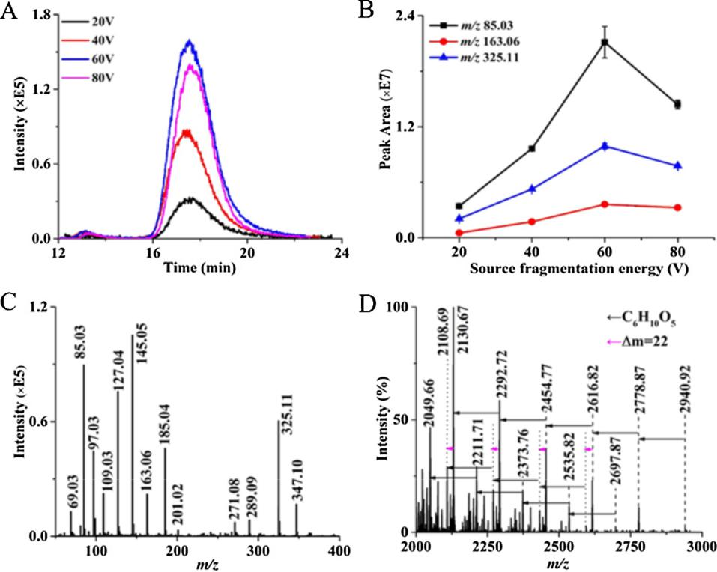

representative fragments were present at m/z 1493.43, m/z 1435.42 and m/z 1389.39, with each showing a typical loss of C6H10O5 (hexose unit). These results suggest that the PC polysaccharide is composed of fragments with diﬀerent monomer compositions, more information is available in Table 1. As a result, there were significant diﬀerences in the mass spectra of dextran compounds, PC polysaccharides and CP poly-saccharides in terms of polymer size, fragmentation pattern and de-tected mass range. In addition, the larger digested products were more eﬀective at revealing distinct diﬀerences among the analyzed poly-saccharides than the fragments with m/z < 500. As such, the SEC-SID-MS methodology is a promising alternative for obtaining structural information about intact polysaccharides, and provides a significantly simplified analytical protocol for polysaccharide macromolecules.

3.3. SEC-SID-MS analysis of resolved DO polysaccharide fractions

The SEC analysis of polysaccharides extracted from Dentrobium of-ficinale (DO) revealed a few separate peaks, with elution times ranging from 15 to 25 min (Fig. 4A). The refractive index (RI) detector identi-fied two peaks (peaks a, b) with poorly resolved shoulders, which is consistent with the MS detection results acquired for the m/z 50–500 mass range. A total of four partially resolved peaks (peaks a, b, c and d) were observed when the 60 V source fragmentation energy was applied to m/z 500–2000 mass range. Although RI detectors are universally applicable to various compounds, their sensitivity is not comparable to that of a mass spectrometer (Zhao, Deng, & Li, 2017). This may be why RI detection did not identify some of the fractions that were observed from MS spectra. According to the MS spectra, all four fractions, especially peaks c and d, contain abundant fragmentation products in the m/z 500–2000 range. The first two peaks only contain ions below m/z 500. Fig. 4B and C show the SEC-SID-MS spectra (range m/z 50–500) of resolved fractions a and b for DO polysaccharides. No de-finitive mass signals were obtained for the shoulder peaks. Unlike the CP and PC species, distinctive ions at m/z 187.06, 205.07, 247.08, 331.10 and 349.11 were identified for DO saccharides, and the MS spectra for peaks a and b showed no obvious diﬀerences (Fig. 4B and C).

These fragmentation products may correspond to hexitol, or an oligo-saccharide that includes hexitol along with hexose (Table 1). Isomeric carbohydrates or carbohydrate compounds having minor structural diﬀerences normally lead to similar or even identical fragments (Wang, Liu, Ma, & Liu, 2014; Zhan et al., 2018). This suggests that the struc-tural diﬀerences between the resolved saccharide fractions probably lie in linkage positions, branching patterns and/or monosaccharide ste-reochemistry. Although no significant mass signal diﬀerences were observed between fractions a and b, the distinct elution times (14.8 min and 16.9 min for fractions a and b, respectively) showed that the compounds in the resolved polysaccharide fractions had diﬀerent sizes and molecular weights (1480 kDa and 108 kDa). This enhanced ability to identify diﬀerences between analyzed fractions is another advantage of combining online separation and MS detection.

The SEC-SID-MS spectra (m/z 500–2000 range) for the four resolved fractions of DO polysaccharides are displayed in Fig. 5. The products in Fig. 5B are generally two mass units larger than the fragments in Fig. 5A. For example, m/z 1609.51 versus m/z 1607.49, m/z 1567.50 versus m/z 1565.48, and m/z 553.18 versus m/z 551.16. This could be attributed to diﬀerent monosaccharide compositions, i.e. hexitol (C6H14O6) instead of hexose (C6H12O6). Notably, these ions went through systematic 42 (blue arrow, C2H2O) and 36 (pink arrow, 2H2O) Da losses. For example, the ion at m/z 1607.49 showed total losses of 162 Da (3 × 42 + 1 × 36) to form the ion at m/z 1445.44. Poly-saccharide products showing higher m/z values mainly consist of Hex and Hexitol units (listed in Table 1). The compositions for a single m/z value representing a sodium adduct or protonated ion forms were de-termined based on the mass accuracy acquired from high-resolution MS. The similarities in the spectra collected for fractions a and b in the m/z 500 – 2000 range also suggest that there are only minor structural diﬀerences between the compounds in fractions a and b, as illustrated by the m/z 50–500 mass range (Fig. 4B and C). The most prevalent products for DO polysaccharide peak c were at m/z 1621.54, 1319.41, and 1241.38 (Fig. 5C). The first two fragments are water loss products from hexose chains, while the ion at m/z 1241.38 may correspond to [Hex6Hexid1Hexol1－5H2O＋H]+ (Table 1). Peak d generated a simple

4

Q. Jiang, et al. *Carbohydrate Polymers 246 (2020) 116591*

Table 1

Proposed putative compositions and ion forms for the major products obtained for plant polysaccharides by SEC-SID-MS analysis, presented together with mass errorsa.

|  |  |  |  |
| --- | --- | --- | --- |
| Proposed composition and ion forms | Measured | Accurate | Mass error |
|  | m/z value | m/z value |  |
|  |  |  |  |
| [Hexol1－3H2O－2CH2O＋H]+ | 69.0337 | 69.0340 | −5.8 |
| [Hex1－2H2O－2CH2O＋H]+ | 85.0287 | 85.0290 | −3.5 |
| [Hex1－3H2O－CH2O＋H]+ | 97.0284 | 97.0290 | −6.2 |
| [Hex1－3H2O＋H]+ | 127.0393 | 127.0395 | −1.6 |
| [Hex1－2H2O＋H]+ | 145.0495 | 145.0501 | −4.1 |
| [Hex1－H2O－CH2O＋Na]+ | 155.0338 | 155.0321 | 11.0 |
| [Hex1－H2O＋H]+ | 163.0600 | 163.0607 | −4.3 |
| [Hex1－H2O＋Na]+ | 185.0444 | 185.0426 | 9.7 |
| [Hexol1－H2O＋Na]+ | 187.0605 | 187.0582 | 12.3 |
| [Hex1＋Na]+ | 203.0594 | 203.0532 | 3.1 |
| [Hexol1＋Na]+ | 205.0710 | 205.0688 | −10.7 |
| [Hex1Hexid1－3CH2O－CH2O2＋H]+ | 221.0654 | 221.0661 | −3.2 |
| [Hex2－5H2O－CH2O＋H]+ | 223.0600 | 223.0607 | −3.1 |
| [Hexol1Hexid1－H2O－4CH2O＋Na]+ | 243.0497 | 243.0481 | 6.6 |
| [Hex2－2H2O－2CH2O＋H]+ | 247.0817 | 247.0818 | −0.4 |
| [Hex1Hexid1－H2O－CH2O＋H]+ | 279.0716 | 279.0719 | −1.1 |
| [Hex2－3H2O＋H]+ | 289.0918 | 289.0923 | −1.7 |
| [Hex2－H2O＋H]+ | 325.1125 | 325.1135 | −3.1 |
| [Hex1Hexol1－2H2O＋Na]+ | 331.1028 | 331.1005 | 6.9 |
| [Hex2－H2O＋Na]+ | 347.0947 | 347.0954 | −2.1 |
| [Hex1Hexol1－H2O＋Na]+ | 349.1135 | 349.1111 | 6.9 |
| [Hex1Hexol1Hexid1－2H2O－3CH2O＋H]+ | 383.1190 | 383.1192 | −0.5 |
| [Hex2Hexid1－H2O－2CH2O＋H]+ | 441.1236 | 441.1244 | −2.5 |
| [Hex19＋2Na]2+ (CP) | 1571.4992 | 1571.4967 | 1.6 |
| [Hex10＋Na]+ (CP) | 1661.5312 | 1661.5284 | 1.7 |
| [Hex4Hexid1HexNAc2Hexol1－11H2O＋H]+ (PC) | 1215.3718 | 1215.3728 | −4.4 |
| [Hex7Hexid1HexNAc2－8H2O－4CH2O－C4H8O3＋Na]+ (PC) | 1389.3811 | 1389.3869 | −4.1 |
| [Hex7Hexid1HexNAc2－8H2O－4CH2O－C2H2O2＋Na]+ (PC) | 1435.4247 | 1435.4287 | −2.9 |
| [Hex7Hexid1HexNAc2－8H2O－4CH2O＋Na]+ (PC) | 1493.4283 | 1493.4342 | −4.0 |
| [Hex10－3H2O－2C2H2O＋Na]+ (DO-peak a) | 1523.4687 | 1523.4758 | −4.7 |
| [Hex10－3H2O－C2H2O＋Na]+ (DO-peak a) | 1565.4833 | 1565.4865 | −2.0 |
| [Hex10－3H2O＋Na]+ (DO-peak a) | 1607.4926 | 1607.4969 | −2.7 |
| [Hex9Hexol－3H2O－2C2H2O＋Na]+ (DO-peak b) | 1525.4923 | 1525.4914 | 0.6 |
| [Hex9Hexol－3H2O－C2H2O＋Na]+ (DO-peak b) | 1567.5030 | 1567.5010 | 1.3 |
| [Hex9Hexol－3H2O＋Na]+ (DO-peak b) | 1609.5108 | 1609.5126 | −1.1 |
| [Hex6Hexid1Hexol1－5H2O＋H]+ (DO-peak c) | 1241.3810 | 1241.3830 | −1.6 |
| [Hex8－H2O＋Na]+ (DO-peak c) | 1319.4117 | 1319.4124 | −0.5 |
| [Hex10－H2O＋H]+ (DO-peak c) | 1621.5383 | 1621.5361 | 1.4 |
| [Hex7＋Na]+ (DO-peak d) | 1175.3691 | 1175.3701 | −0.9 |

The fragments > m/z 500 are listed in order according to the types of plant polysaccharides displayed in the results section. The proposed structures of the carbohydrate losses are indicated in Fig. S5 in SI. Mass errors are in ppm.

1. Hex represents hexose (C6H12O6), Hexol describes hexitol, the alditol form of hexose, (C6H14O6), Hexid indicates hexuronic acid (C6H10O7), and HexNAc describes N-acetylhexosamine (C8H15NO6).

mass spectrum (Fig. 5D) that contained various sodium adducts of hexose chains. Interestingly, the diﬀerences among decomposition products observed in the spectra varied between the polysaccharides of the four distinct herbs as well as across the resolved polysaccharide fractions of the specific plants. For example, in the m/z 50–500 range, the DO saccharides showed the diﬀerences of C6H10O5, C2H2O, CH2O, and H2O, while the CP and PC polysaccharides were demonstrated by patterns of C6H10O5, CH2O, H2O, and formation of protonated and corresponding sodiated molecules ( mass = 22) is widely observed for CP and PC fragments. Regarding products identified from the DO samples with an m/z > 500, fractions a and b indicated diﬀerences of C6H10O5, C2H2O, and 2H2O while the fragments in fraction d only showed distinction of C6H10O5 between m/z peaks. This observation is most likely the result of structural variations among various poly-saccharides, and the detailed mechanisms underlying these loss pat-terns need to be further investigated. It was not possible to define the exact connection order, branching form, or monomer configuration of the identified polysaccharides based on the MS data collected in this work. However, SEC successfully diﬀerentiated polysaccharides from a single DO sample into fractions based on size, after which the structures were directly evaluated by SID-MS. It is important to state that the diﬀerent saccharide fractions exhibited great structural diversity and

heterogeneity.

3.4. SEC-SID-MS analysis of resolved polysaccharide fractions of AM

The SEC-SID-MS analysis results for the polysaccharides in Astragalus membranaceus (AM) samples are shown in Figs. S6, S7 and Table S4 in SI. The results indicate that certain water-soluble polymeric compounds remain in the sample even after multiple purification steps. As was noted for the other analyzed plants, multiple saccharide frac-tions were resolved from the AM sample, and the multiple decom-position products were clearly distinguishable in the m/z 500–2000 range. The three resolved fractions all significantly diﬀered in terms of the characteristic ions and the mass diﬀerence patterns observed be-tween m/z peaks. In particular, the mass spectrometric signatures of fractions containing AM and DO polysaccharides that eluted at a similar speed are unambiguously diﬀerent. For a detailed description of the polysaccharides identified from the AM fractions, please refer to the Supporting Information. The polysaccharides identified from the AM samples further demonstrate the structural complexity and hetero-geneity among large polysaccharides extracted from either diﬀerent species of medicinally-important herbs or diﬀerent eluted fractions from the same species.

5

Q. Jiang, et al. *Carbohydrate Polymers 246 (2020) 116591*

Fig. 2. SEC-SID-MS analysis of polysaccharide extracts from Codonopsis pilosula (CP). (A) SEC separation profiles with detection by RI and MS (either in the m/z 50 – 500 (1, red line) or m/z 500 – 2000 (2, blue line) range). The normal-ized intensities were enhanced by 20 % for a better view and comparison. SEC-SID-MS spectra acquired for either the (B) m/z 50 – 500 and (C) m/z 500 – 2000 range, with the range on the right of (C) showing the doubly-charged ions. The arrows indicate diﬀerences of C6H10O5 (162 Da), CH2O (30 Da), H2O (18 Da) and mass diﬀerences of 22 Da between m/z peaks, as labelled.

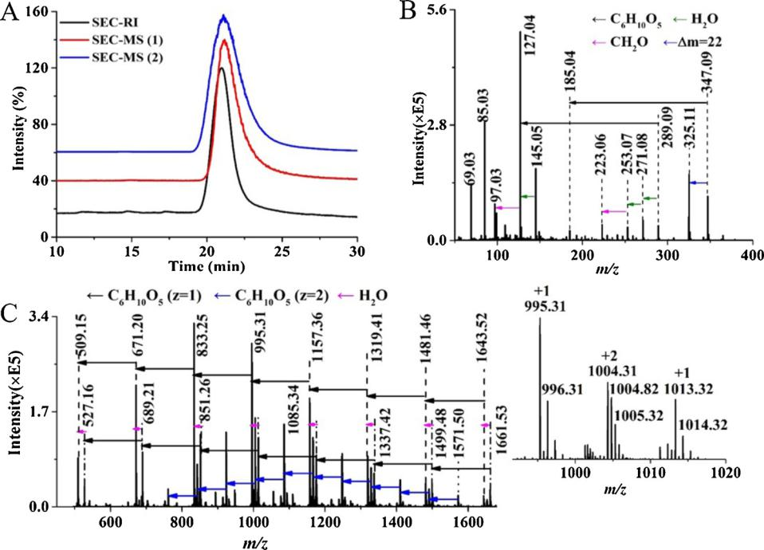

As demonstrated, the SEC-SID-MS method enables the online chro-matographic fractionation of polymeric saccharides using sensitive MS detection, and is advantageous for the direct acquisition of fragmen-tation patterns from intact saccharide macromolecules. This leads to the exploration of additional saccharide fractions, and their structural characteristics can be directly assessed without pretreatment steps. This approach is applicable for saccharides with a broad MW range, from just a few to thousands of kDa, with typical carbohydrate compositions, such as hexose, hexol, and hexNAc.

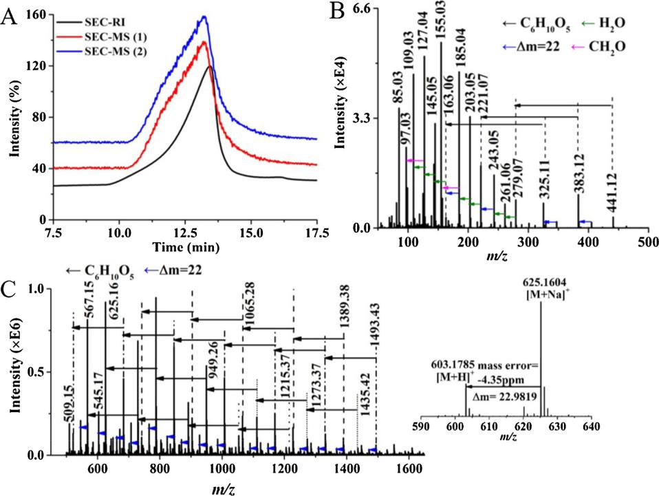

4. Conclusions

To the best of our knowledge, the results presented in this work is the first analysis of plant polysaccharides with the combination of SEC and high-resolution MS with source-induced dissociation. The use of ESI-MS made the analysis of large polysaccharides possible, and also removed the tedious pre-digestion and pre-treatment steps from the analytical process. The tested dextran standards, plant polysaccharides and resolved fractions all exhibited unique mass spectra across diﬀerent molecular weight ranges, which provides strong evidence of the struc-tural complexity and isomeric heterogeneity among saccharide

Fig. 3. SEC-SID-MS analysis of polysaccharide extracts of Poria cocos (PC). (A) SEC separation profiles with detection through either RI or MS in the m/z 50 – 500 (1, red line) and m/z 500 – 2000 (2, blue line) ranges. The normalized in-tensities were enhanced by 20 % to better il-lustrate the diﬀerences between methodolo-gies. Selected SEC-SID-MS spectra acquired for the (B) m/z 50 – 500 and (C) m/z 500 – 2000 mass ranges. The 590-640 m/z range has been enhanced and shown alone to provide an ex-ample of a sodium adduct (two peaks and their mass diﬀerence shown). The arrows indicate diﬀerences of C6H10O5 (162 Da), CH2O (30 Da), H2O (18 Da) and mass diﬀerences of 22 Da between m/z peaks, as labelled.

6

Q. Jiang, et al. *Carbohydrate Polymers 246 (2020) 116591*

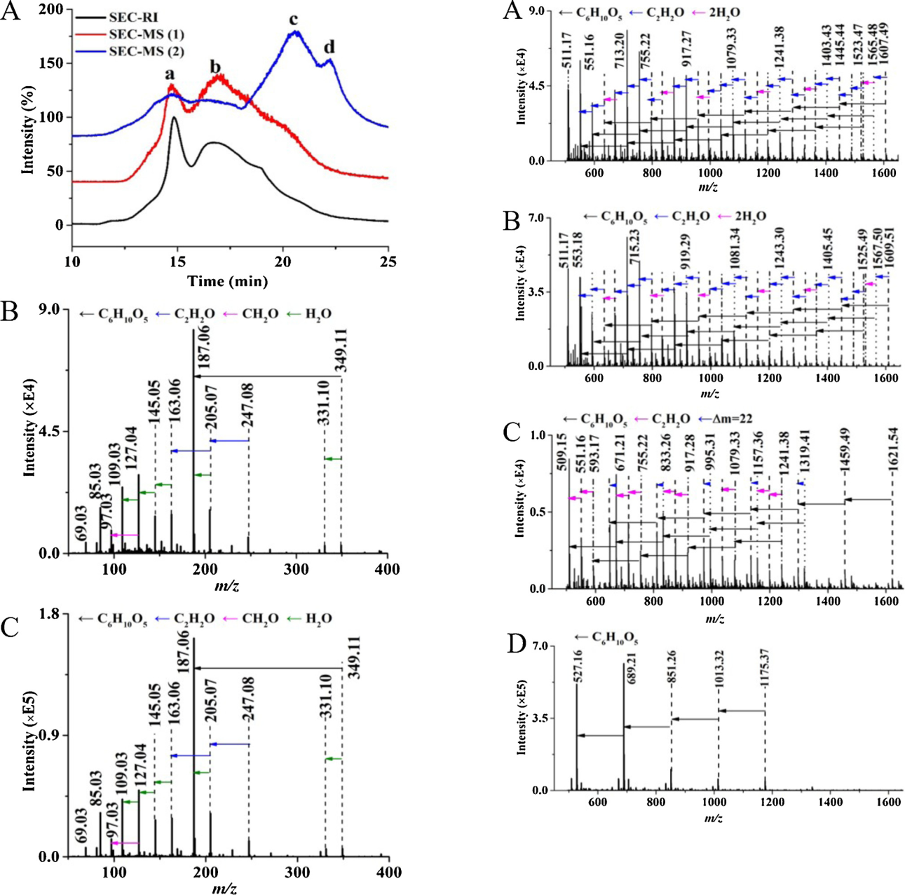

Fig. 4. SEC-SID-MS analysis of polysaccharide extracts of Dendrobium oﬃcinale (DO). (A) SEC separation profiles from detection by RI and MS (either in the m/ z 50 – 500 (1, red line) or m/z 500 – 2000 (2, blue line) range). The normalized intensities were enhanced by 40 % for better comparison between methodol-ogies. SEC-SID-MS spectra of DO polysaccharides in peak a (B) and peak b (C), acquired in the m/z 50 – 500 mass range. The arrows in (B) and (C) indicate the diﬀerences of C6H10O5 (162 Da), C2H2O (42 Da), CH2O (30 Da) and H2O (18 Da) between m/z peaks, as labelled.

macromolecules. Furthermore, MS showed better sensitivity and relia-bility towards polysaccharide fragments than RI detection. High-re-solution MS enabled us to propose molecular compositions for a large number of the identified saccharide fragments with low mass error. In summary, SEC-SID-MS is a simple and robust method for analyzing naturally occurring polydisperse saccharide polymers, and may be able to provide valuable structural information through the direct char-acterization of intact polysaccharides.

Fig. 5. SEC-SID-MS spectra (m/z 500 – 2000 range) of Dendrobium oﬃcinale (DO) polysaccharides in the (A) the first resolved fraction (elution peak a); (B) the second resolved fraction (elution peak b); (C) the third resolved fraction (elution peak c); and (D) the fourth resolved fraction (elution peak d). The arrows indicate the diﬀerences of C6H10O5 (162 Da), C2H2O (42 Da), 2H2O (36 Da) and mass diﬀerences of 22 between m/z peaks, as labelled.

Author statement

Hongli Li and David D. Y. Chen conceptualized the project and ex-perimental design, organized the equipment and obtained the reagents for the experiment. They also analyzed the data, and revised the manuscript for publication. Qing Jiang and Ying Wang carried out the experiment and help analyzed the data. Qing Jiang also wrote the first draft of the manuscript.

Acknowledgements

This work was supported by the National Natural Science Foundation of China (Grant No. 21475061 and 21904067), and the Program of Natural Science Research of Jiangsu Higher Education Institutions of China (Grant No. 17KJB150027).

7

Q. Jiang, et al.

Appendix A. Supplementary data

Supplementary material related to this article can be found, in the online version, at doi:<https://doi.org/10.1016/j.carbpol.2020.116591>.

References

[Aizpurua-Olaizola, O., Sastre Toraño, J., Falcon-Perez, J. M., Williams, C., Reichardt, N.,](http://refhub.elsevier.com/S0144-8617(20)30765-7/sbref0005)

* [Boons, G. J. (2018). Mass spectrometry for glycan biomarker discovery. TRAC](http://refhub.elsevier.com/S0144-8617(20)30765-7/sbref0005) [Trends in Analytical Chemistry, 100, 7–14](http://refhub.elsevier.com/S0144-8617(20)30765-7/sbref0005).

[Bencsath, F. A., & Field, F. H. (1988). Ion retardation and collision-induced dissociation in](http://refhub.elsevier.com/S0144-8617(20)30765-7/sbref0010) [the thermospray ion source. Analytical Chemistry, 60(13), 1323–1329](http://refhub.elsevier.com/S0144-8617(20)30765-7/sbref0010).

[Chatterjee, D., Ytterberg, A. J., Son, S. U., Loo, J. A., & Garrell, R. L. (2010). Integration of](http://refhub.elsevier.com/S0144-8617(20)30765-7/sbref0015) [protein processing steps on a droplet microfluidics platform for MALDI-MS analysis.](http://refhub.elsevier.com/S0144-8617(20)30765-7/sbref0015) [Analytical Chemistry, 82(5), 2095–2101](http://refhub.elsevier.com/S0144-8617(20)30765-7/sbref0015).

[Doco, T., Williams, P., Meudec, E., Cheynier, V., & Sommerer, N. (2015). Complex car-bohydrates of red wine: Characterization of the extreme diversity of neutral oligo-saccharides by ESI-MS. Journal of Agricultural and Food Chemistry, 63(2), 671–682](http://refhub.elsevier.com/S0144-8617(20)30765-7/sbref0020).

[Ferreira, S. S., Passos, C. P., Madureira, P., Vilanova, M., & Coimbra, M. A. (2015).](http://refhub.elsevier.com/S0144-8617(20)30765-7/sbref0025)

[Structure–function relationships of immunostimulatory polysaccharides: A review.](http://refhub.elsevier.com/S0144-8617(20)30765-7/sbref0025)

[Carbohydrate Polymers, 132, 378–396](http://refhub.elsevier.com/S0144-8617(20)30765-7/sbref0025).

[Gedda, G., Gopal, J., & Wu, H.-F. (2012). Electrospray ionization and matrix-assisted laser](http://refhub.elsevier.com/S0144-8617(20)30765-7/sbref0030) [desorption/ionization mass spectrometric analysis of extrapolysaccharides of](http://refhub.elsevier.com/S0144-8617(20)30765-7/sbref0030) [Escherichia coli. Rapid Communications in Mass Spectrometry, 26(14), 1609–1616](http://refhub.elsevier.com/S0144-8617(20)30765-7/sbref0030).

[Gray, C. J., Thomas, B., Upton, R., Migas, L. G., Eyers, C. E., Barran, P. E., et al. (2016).](http://refhub.elsevier.com/S0144-8617(20)30765-7/sbref0035) [Applications of ion mobility mass spectrometry for high throughput, high resolution](http://refhub.elsevier.com/S0144-8617(20)30765-7/sbref0035) [glycan analysis. Biochimica et Biophysica Acta (BBA) – General Subjects, 1860(8),](http://refhub.elsevier.com/S0144-8617(20)30765-7/sbref0035) [1688–1709](http://refhub.elsevier.com/S0144-8617(20)30765-7/sbref0035).

[Gregorius, B., Jakoby, T., Schaumlöﬀel, D., & Tholey, A. (2013). Monitoring of protease](http://refhub.elsevier.com/S0144-8617(20)30765-7/sbref0040) [catalyzed reactions by quantitative MALDI MS using metal labeling. Analytical](http://refhub.elsevier.com/S0144-8617(20)30765-7/sbref0040) [Chemistry, 85(10), 5184–5190](http://refhub.elsevier.com/S0144-8617(20)30765-7/sbref0040).

[Guadalupe, Z., Martínez-Pinilla, O., Garrido, Á., Carrillo, J. D., & Ayestarán, B. (2012).](http://refhub.elsevier.com/S0144-8617(20)30765-7/sbref0045) [Quantitative determination of wine polysaccharides by gas chromatography–mass](http://refhub.elsevier.com/S0144-8617(20)30765-7/sbref0045) [spectrometry (GC–MS) and size exclusion chromatography (SEC). Food Chemistry,](http://refhub.elsevier.com/S0144-8617(20)30765-7/sbref0045) [131(1), 367–374](http://refhub.elsevier.com/S0144-8617(20)30765-7/sbref0045).

[Harvey, D. J., Martin, R. L., Jackson, K. A., & Sutton, C. W. (2004). Fragmentation of N-linked glycans with a matrix-assisted laser desorption/ionization ion trap time-of-flight mass spectrometer. Rapid Communications in Mass Spectrometry, 18(24),](http://refhub.elsevier.com/S0144-8617(20)30765-7/sbref0050) [2997–3007](http://refhub.elsevier.com/S0144-8617(20)30765-7/sbref0050).

[Hofmann, J., Hahm, H. S., Seeberger, P. H., & Pagel, K. (2015). Identification of carbo-hydrate anomers using ion mobility–mass spectrometry. Nature, 526(7572), 241–244](http://refhub.elsevier.com/S0144-8617(20)30765-7/sbref0055).

[Hu, P., Fang, L., & Chess, E. K. (2009). Source-induced fragmentation of heparin, heparan,](http://refhub.elsevier.com/S0144-8617(20)30765-7/sbref0060) [and galactosaminoglycans and application. Analytical Chemistry, 81(6), 2332–2343](http://refhub.elsevier.com/S0144-8617(20)30765-7/sbref0060).

[Huang, R., Zong, C., Venot, A., Chiu, Y., Zhou, D., Boons, G.-J., et al. (2016). De novo](http://refhub.elsevier.com/S0144-8617(20)30765-7/sbref0065) [sequencing of complex mixtures of heparan sulfate oligosaccharides. Analytical](http://refhub.elsevier.com/S0144-8617(20)30765-7/sbref0065) [Chemistry, 88(10), 5299–5307](http://refhub.elsevier.com/S0144-8617(20)30765-7/sbref0065).

[Li, H., Bendiak, B., Siems, W. F., Gang, D. R., & Hill, H. H. (2015). Determining the](http://refhub.elsevier.com/S0144-8617(20)30765-7/sbref0070) [isomeric heterogeneity of neutral oligosaccharide-alditols of bovine submaxillary](http://refhub.elsevier.com/S0144-8617(20)30765-7/sbref0070) [mucin using negative ion traveling wave ion mobility mass spectrometry. Analytical](http://refhub.elsevier.com/S0144-8617(20)30765-7/sbref0070) [Chemistry, 87(4), 2228–2235](http://refhub.elsevier.com/S0144-8617(20)30765-7/sbref0070).

[Li, J., Wang, Z., & Altman, E. (2005). In-source fragmentation and analysis of poly-saccharides by capillary electrophoresis/mass spectrometry. Rapid Communications in](http://refhub.elsevier.com/S0144-8617(20)30765-7/sbref0075) [Mass Spectrometry, 19(10), 1305–1314](http://refhub.elsevier.com/S0144-8617(20)30765-7/sbref0075).

[Li, R.-h., Zeng, T., Wu, M., Zhang, H.-b., & Hu, X.-q. (2017). Eﬀects of esterification on the](http://refhub.elsevier.com/S0144-8617(20)30765-7/sbref0080) [structural, physicochemical, and flocculation properties of dextran. Carbohydrate](http://refhub.elsevier.com/S0144-8617(20)30765-7/sbref0080) [Polymers, 174, 1129–1137](http://refhub.elsevier.com/S0144-8617(20)30765-7/sbref0080).

[Luo, A., He, X., Zhou, S., Fan, Y., Luo, A., & Chun, Z. (2010). Purification, composition](http://refhub.elsevier.com/S0144-8617(20)30765-7/sbref0085) [analysis and antioxidant activity of the polysaccharides from Dendrobium nobile](http://refhub.elsevier.com/S0144-8617(20)30765-7/sbref0085) [Lindl. Carbohydrate Polymers, 79(4), 1014–1019](http://refhub.elsevier.com/S0144-8617(20)30765-7/sbref0085).

[Ma, F., Wang, D., Zhang, Y., Li, M., Qing, W., Tikkanen-Kaukanen, C., et al. (2018).](http://refhub.elsevier.com/S0144-8617(20)30765-7/sbref0090)

[Characterisation of the mucilage polysaccharides from Dioscorea opposita Thunb.](http://refhub.elsevier.com/S0144-8617(20)30765-7/sbref0090)

[with enzymatic hydrolysis. Food Chemistry, 245, 13–21](http://refhub.elsevier.com/S0144-8617(20)30765-7/sbref0090).

[Ma, H., Jiang, Q., Dai, D., Li, H., Bi, W., & Chen, D. D. Y. (2018). Direct analysis in real](http://refhub.elsevier.com/S0144-8617(20)30765-7/sbref0095) [time mass spectrometry for characterization of large saccharides. Analytical](http://refhub.elsevier.com/S0144-8617(20)30765-7/sbref0095) [Chemistry, 90(5), 3628–3636](http://refhub.elsevier.com/S0144-8617(20)30765-7/sbref0095).

*Carbohydrate Polymers 246 (2020) 116591*

[Perez-Moral, N., Plankeele, J.-M., Domoney, C., & Warren, F. J. (2018). Ultra-high per-formance liquid chromatography-size exclusion chromatography (UPLC-SEC) as an](http://refhub.elsevier.com/S0144-8617(20)30765-7/sbref0100) [eﬃcient tool for the rapid and highly informative characterisation of biopolymers.](http://refhub.elsevier.com/S0144-8617(20)30765-7/sbref0100) [Carbohydrate Polymers, 196, 422–426](http://refhub.elsevier.com/S0144-8617(20)30765-7/sbref0100).

[Poad, B. L. J., Zheng, X., Mitchell, T. W., Smith, R. D., Baker, E. S., & Blanksby, S. J.](http://refhub.elsevier.com/S0144-8617(20)30765-7/sbref0105) [(2018). Online ozonolysis combined with ion mobility-mass spectrometry provides a](http://refhub.elsevier.com/S0144-8617(20)30765-7/sbref0105) [new platform for lipid isomer analyses. Analytical Chemistry, 90(2), 1292–1300](http://refhub.elsevier.com/S0144-8617(20)30765-7/sbref0105).

[Schneider, B. B., Douglas, D. J., & Chen, D. D. Y. (2001). Collision-induced dissociation of](http://refhub.elsevier.com/S0144-8617(20)30765-7/sbref0110) [bradykinin ions in the interface region of an ESI-MS. Journal of the American Society](http://refhub.elsevier.com/S0144-8617(20)30765-7/sbref0110) [for Mass Spectrometry, 12(7), 772–779](http://refhub.elsevier.com/S0144-8617(20)30765-7/sbref0110).

[Sun, Y.-D., Wang, Z.-H., & Ye, Q.-S. (2013). Composition analysis and anti-proliferation](http://refhub.elsevier.com/S0144-8617(20)30765-7/sbref0115) [activity of polysaccharides from Dendrobium chrysotoxum. International Journal of](http://refhub.elsevier.com/S0144-8617(20)30765-7/sbref0115) [Biological Macromolecules, 62, 291–295](http://refhub.elsevier.com/S0144-8617(20)30765-7/sbref0115).

[Tapia, J. B., Hibbard, H. A. J., & Reynolds, M. M. (2017). Derivatization of dextran for](http://refhub.elsevier.com/S0144-8617(20)30765-7/sbref0120)

[multiply charged ion formation and electrospray ionization time-of-flight mass](http://refhub.elsevier.com/S0144-8617(20)30765-7/sbref0120) [spectrometric analysis. Journal of the American Society for Mass Spectrometry, 28(10),](http://refhub.elsevier.com/S0144-8617(20)30765-7/sbref0120) [2201–2208](http://refhub.elsevier.com/S0144-8617(20)30765-7/sbref0120).

[Varki, A. (2016). Biological roles of glycans. Glycobiology, 27(1), 3–49](http://refhub.elsevier.com/S0144-8617(20)30765-7/sbref0125).

[Wang, J., Zhou, Y., Wang, M., Bi, W., Li, H., & Chen, D. D. Y. (2018). High-throughput](http://refhub.elsevier.com/S0144-8617(20)30765-7/sbref0130) [analysis for artemisinins with deep eutectic solvents mechanochemical extraction and](http://refhub.elsevier.com/S0144-8617(20)30765-7/sbref0130) [direct analysis in real time mass spectrometry. Analytical Chemistry, 90(5),](http://refhub.elsevier.com/S0144-8617(20)30765-7/sbref0130) [3109–3117](http://refhub.elsevier.com/S0144-8617(20)30765-7/sbref0130).

[Wang, Y., Liu, L., Ma, L., & Liu, S. (2014). Identification of saccharides by using direct](http://refhub.elsevier.com/S0144-8617(20)30765-7/sbref0135) [analysis in real time (DART) mass spectrometry. International Journal of Mass](http://refhub.elsevier.com/S0144-8617(20)30765-7/sbref0135) [Spectrometry, 357, 51–57](http://refhub.elsevier.com/S0144-8617(20)30765-7/sbref0135).

[Wang, M., Bi, W., Huang, X., & Chen, D. D. Y. (2016). Ball mill assisted rapid mechan-ochemical extraction method for natural products from plants. Journal of](http://refhub.elsevier.com/S0144-8617(20)30765-7/sbref0140) [Chromatography A, 1449, 8–16](http://refhub.elsevier.com/S0144-8617(20)30765-7/sbref0140).

[Wang, P.-C., Zhao, S., Yang, B.-Y., Wang, Q.-H., & Kuang, H.-X. (2016). Anti-diabetic](http://refhub.elsevier.com/S0144-8617(20)30765-7/sbref0145) [polysaccharides from natural sources: A review. Carbohydrate Polymers, 148, 86–97](http://refhub.elsevier.com/S0144-8617(20)30765-7/sbref0145).

[Westphal, Y., Schols, H. A., Voragen, A. G. J., & Gruppen, H. (2010). MALDI-TOF MS and](http://refhub.elsevier.com/S0144-8617(20)30765-7/sbref0150) [CE-LIF fingerprinting of plant cell wall polysaccharide digests as a screening tool for](http://refhub.elsevier.com/S0144-8617(20)30765-7/sbref0150) [Arabidopsis cell wall mutants. Journal of Agricultural and Food Chemistry, 58(8),](http://refhub.elsevier.com/S0144-8617(20)30765-7/sbref0150) [4644–4652](http://refhub.elsevier.com/S0144-8617(20)30765-7/sbref0150).

[Wolfert, M. A., & Boons, G.-J. (2013). Adaptive immune activation: Glycosylation does](http://refhub.elsevier.com/S0144-8617(20)30765-7/sbref0155) [matter. Nature Chemical Biology, 9(12), 776–784](http://refhub.elsevier.com/S0144-8617(20)30765-7/sbref0155).

[Xia, Y.-G., Wang, T.-L., Sun, H.-M., Liang, J., & Kuang, H.-X. (2018). Gas chromato-graphy–mass spectrometry-based trimethylsilyl-alditol derivatives for quantitation](http://refhub.elsevier.com/S0144-8617(20)30765-7/sbref0160) [and fingerprint analysis of Anemarrhena asphodeloides Bunge polysaccharides.](http://refhub.elsevier.com/S0144-8617(20)30765-7/sbref0160) [Carbohydrate Polymers, 198, 155–163](http://refhub.elsevier.com/S0144-8617(20)30765-7/sbref0160).

[Xu, J., Li, S.-L., Yue, R.-Q., Ko, C.-H., Hu, J.-M., Liu, J., et al. (2014). A novel and rapid](http://refhub.elsevier.com/S0144-8617(20)30765-7/sbref0165) [HPGPC-based strategy for quality control of saccharide-dominant herbal materials:](http://refhub.elsevier.com/S0144-8617(20)30765-7/sbref0165) [Dendrobium oﬃcinale, a case study. Analytical and Bioanalytical Chemistry, 406(25),](http://refhub.elsevier.com/S0144-8617(20)30765-7/sbref0165) [6409–6417](http://refhub.elsevier.com/S0144-8617(20)30765-7/sbref0165).

[Xu, W., Zhang, F., Luo, Y., Ma, L., Kou, X., & Huang, K. (2009). Antioxidant activity of a](http://refhub.elsevier.com/S0144-8617(20)30765-7/sbref0170) [water-soluble polysaccharide purified from Pteridium aquilinum. Carbohydrate](http://refhub.elsevier.com/S0144-8617(20)30765-7/sbref0170) [Research, 344(2), 217–222](http://refhub.elsevier.com/S0144-8617(20)30765-7/sbref0170).

[Yi, L., Ouyang, Y., Sun, X., Xu, N., Linhardt, R. J., & Zhang, Z. (2015). Qualitative and](http://refhub.elsevier.com/S0144-8617(20)30765-7/sbref0175) [quantitative analysis of branches in dextran using high-performance anion exchange](http://refhub.elsevier.com/S0144-8617(20)30765-7/sbref0175) [chromatography coupled to quadrupole time-of-flight mass spectrometry. Journal of](http://refhub.elsevier.com/S0144-8617(20)30765-7/sbref0175) [Chromatography A, 1423, 79–85](http://refhub.elsevier.com/S0144-8617(20)30765-7/sbref0175).

[Yu, Y., Shen, M., Song, Q., & Xie, J. (2018). Biological activities and pharmaceutical](http://refhub.elsevier.com/S0144-8617(20)30765-7/sbref0180) [applications of polysaccharide from natural resources: A review. Carbohydrate](http://refhub.elsevier.com/S0144-8617(20)30765-7/sbref0180) [Polymers, 183, 91–101](http://refhub.elsevier.com/S0144-8617(20)30765-7/sbref0180).

[Zhan, L., Xie, X., Li, Y., Liu, H., Xiong, C., & Nie, Z. (2018). Diﬀerentiation and relative](http://refhub.elsevier.com/S0144-8617(20)30765-7/sbref0185) [quantitation of disaccharide isomers by MALDI-TOF/TOF mass spectrometry.](http://refhub.elsevier.com/S0144-8617(20)30765-7/sbref0185) [Analytical Chemistry, 90(3), 1525–1530](http://refhub.elsevier.com/S0144-8617(20)30765-7/sbref0185).

[Zhang, W., Wang, T., Chen, X., Pang, X., Zhang, S., Obaroakpo, J. U., et al. (2019).](http://refhub.elsevier.com/S0144-8617(20)30765-7/sbref0190) [Absolute quantification of twelve oligosaccharides in human milk using a targeted](http://refhub.elsevier.com/S0144-8617(20)30765-7/sbref0190) [mass spectrometry-based approach. Carbohydrate Polymers, 219, 328–333](http://refhub.elsevier.com/S0144-8617(20)30765-7/sbref0190).

[Zhao, J., Deng, Y., & Li, S.-p. (2017). Advanced analysis of polysaccharides, novel func-tional components in food and medicine dual purposes Chinese herbs. TrAC Trends in](http://refhub.elsevier.com/S0144-8617(20)30765-7/sbref0195) [Analytical Chemistry, 96, 138–150](http://refhub.elsevier.com/S0144-8617(20)30765-7/sbref0195).

[Zykwinska, A., Berre, L. T.-L., Sinquin, C., Ropartz, D., Rogniaux, H., Colliec-Jouault, S.,](http://refhub.elsevier.com/S0144-8617(20)30765-7/sbref0200) [et al. (2018). Enzymatic depolymerization of the GY785 exopolysaccharide produced](http://refhub.elsevier.com/S0144-8617(20)30765-7/sbref0200) [by the deep-sea hydrothermal bacterium Alteromonas infernus: Structural study and](http://refhub.elsevier.com/S0144-8617(20)30765-7/sbref0200) [enzyme activity assessment. Carbohydrate Polymers, 188, 101–107](http://refhub.elsevier.com/S0144-8617(20)30765-7/sbref0200).

8