[Agriculture, Ecosystems and Environment 301 (2020) 107050](https://doi.org/10.1016/j.agee.2020.107050)



Contents lists available at [ScienceDirect](http://www.sciencedirect.com/science/journal/01678809)



Agriculture, Ecosystems and Environment

journal homepage: [www.elsevier.com/locate/agee](https://www.elsevier.com/locate/agee)

Soil phosphorus accumulation changes with decreasing temperature along a T 2300 m altitude gradient 



Xiao Ming Moua,1, Yining Wua,1, Ziqi Niua, Bin Jiaa, Zheng-Huan Guana, Jie Chena, Hu Lia, Hongyan Cuia, Yakov Kuzyakova,b,c, Xiao Gang Lia,*

1. State Key Laboratory of Grassland and Agro-ecosystems, School of Life Sciences, Lanzhou University. 222 South Tianshui Road, Lanzhou, 730000, China
2. Department of Soil Science of Temperate Ecosystems, Department of Agricultural Soil Science, University of Goettingen, Göttingen, Germany
3. Agro-Technological Institute, RUDN University, 117198, Moscow, Russia

ARTICLE INFO

Keywords:

Grasslands

Soil phosphorus transformation Soil organic phosphorus Microbial biomass phosphorus Plant phosphorus Temperature

ABSTRACT

Understanding the abundance of organic P in soil is a prerequisite for predicting the eﬀects of climate change on P dynamics and availability in cold alpine regions. We sampled plant roots (up to 40 cm depth) and soils (100 cm depth) in grasslands along a 2300 m altitude gradient (1286–3589 m above sea level, mean annual temperature (MAT) from 9 to 0.3 °C) between alpine steppes on the Loess Plateau and alpine meadows on the Tibetan Plateau. A modified Hedley P fractionation in combination with root and microbial P, alongside phosphatase activity, was used to characterize P transformations depending on climate. Both the roots and microorganisms stored more P and produced higher phosphatase activity in cold meadow than in warm steppe soils. Total inorganic P (Pi) content decreased in cold meadow (MAT < 3 °C) compared with warm steppe soils because of the decrease of moderately labile Pi (extracted with diluted HCl) in cold meadow soils. Available P (NaHCO3) and labile Pi (NaOH) contents increased upslope, whereas the recalcitrant Pi (concentrated HCl) contents remained stable at all sites down to 100 cm soil depth. Labile (NaHCO3), moderately labile (NaOH) and recalcitrant (concentrated HCl) organic P (Po) contents sharply increased in cold meadow compared with warm steppe soils. The residue P in the 0–100 cm along the temperature gradient was similar to that of all Po fractions. The Po proportion in the total P was less than 10 % at sites with a MAT above 3 °C, but sharply increased up to 50 % at sites with a MAT below 0.7 °C. The greater root and microbial P uptake versus slower Po mineralization in cold meadows than in warm steppes increase the incorporation of Pi into organic pools in cold alpine areas. This accumulation of Po forms is a mechanism to prevent P losses by leaching as inorganic forms. The increased plant available P in cold meadows was associated with the increased phosphatase activity and Po contents compared with warm steppe soils. We conclude that the on-going climate warming could stimulate P cycling more in cold meadows than in warm steppe regions because Po dominated the total soil P in cold areas.

1. Introduction

The Tibetan Plateau (known as the third pole of the Earth, the lar-gest grassland on the Eurasian continent) is an important area in terms of the global hydrological cycle, C storage, and the livelihood of local herders. These ecosystem services are determined by the status of grasslands, which are inherently susceptible to climate changes and intensive management (reviewed by Liu et al., 2018). Currently, the temperature increase on the Tibetan Plateau is about three times faster than the average rate of global warming (Qiu, 2008; Thakuri et al., 2019; Zhu et al., 2019). In response to the warming, glaciers have



Corresponding author.

E-mail address: [lixiaogang@lzu.edu.cn](mailto:lixiaogang@lzu.edu.cn) (X.G. Li).

1. These authors contributed equally to this submission.

retreated dramatically and permafrost is thawing rapidly. The climate warming in combination with overgrazing and other factors have jointly led to substantial decreases in soil organic carbon (SOC) and nutrient stocks (Liu et al., 2018).

Understanding of the dynamics of soil P in response to climate change is vitally important for predicting the responses of ecosystems to climate change in cold alpine regions on the Tibetan Plateau. Phosphorus is an essential element for plants and microorganisms, re-sponsible for energy transfer and cell structure, and a constituent of nucleic acids. Strong P deficiency, common in alpine grasslands, aﬀects plant species richness, community composition and decreases primary

<https://doi.org/10.1016/j.agee.2020.107050>

Received 1 April 2020; Received in revised form 22 May 2020; Accepted 31 May 2020

Available online 13 June 2020

0167-8809/ © 2020 Elsevier B.V. All rights reserved.

X.M. Mou, et al.

production (Henkin et al., 2006; Turner et al., 2007; Ma et al., 2019; Zarzycki and Kopeć, 2020). Phosphorus limitation retards carbon turnover because microbial biomass becomes less eﬃcient in substrate utilization (Saggar et al., 2000; Hamdan et al., 2012; Poeplau et al., 2018; Chen et al., 2019).

Phosphorus contained in primary minerals is transformed into a variety of forms that diﬀer in their availability to plants and micro-organisms (Walker and Syers, 1976). Organic P is originated from biological transformations and is a component of soil organic matter (SOM). The decomposition of SOM (and thus the release of nutrients) in cold alpine regions is predicted to be more sensitive to the global cli-mate change than in warm regions (Kirschbaum, 1995; Del Grosso et al., 2005). Thus, understanding the occurrence and abundance of organic P in soil is a prerequisite for predicting how the changes of climate and vegetation may influence the P dynamics and availability in cold alpine regions (Feng et al., 2016; Hou et al., 2018).

Altitude regulates temperature gradients, with consequences for vertical zonation of vegetation and soils, and changes of geochemical and biological element cycling (e.g., Hofmann et al., 2016; Müller et al., 2017; Zhang et al., 2019; Cui et al., 2019; Peters et al., 2019). Tem-perature in combination with precipitation directly influences the weathering of P-containing minerals and P leaching from the soil. Temperature also indirectly aﬀects biological P immobilization (plant and microbial P uptake from soil) and organic P mineralization (mi-crobial release of P from organic compounds) through altering the characteristics of vegetation in altitudinal gradients. Comparison of the P forms in soils with contrasting climatic and other biotic and abiotic environmental variables in altitudinal gradients can provide invaluable information about the eﬀects of climate change on P transformation and cycling (Frenne et al., 2013).

Globally, the change in the P transformation with altitude is un-clear. For example, it has been reported that soil P availability may decrease (Vitousek et al., 1988; Raich et al., 2000; Soethe et al., 2008; Vincent et al., 2014), not change (Köhler et al., 2006; Xu et al., 2018), or increase (Katarzyna et al., 2010) with increasing altitude. Especially, studies on how the occurrence and abundance of organic P in soils change with climate factors along the altitude are rather scarce in lit-erature. Unlike C and N (which are sourced primarily from the atmo-sphere through photosynthesis, microbial fixation and abiotic deposi-tion), P is derived from primary minerals by weathering. Thus, P content and transformation in soil depends on the compositions of bedrocks and parent materials and weathering rates (Mage and Porder, 2013). As a result of the common changes of the soil parent materials with altitude, the trend of soil P transformation along altitudinal gra-dients may be biased. Therefore, comparable parent materials are im-portant for examining the eﬀects of climate on P transformations and forms with changes in altitude.

The Hedley sequential phosphorus fractionation is widely used to characterize the biogeochemical P cycling in natural, unfertilized, and uncultivated soils and in diﬀerently managed soils (Cross and Schlesinger, 1995; Negassa and Leinweber, 2009). In the present study, we sampled soils in contiguous grassland areas between the Loess Plateau and Tibetan Plateau (Fig. 1a) with homogeneous parent ma-terials comprising loess or loess-like sediments (Table 1; Figure S1). A modified Hedley P fractionation procedure (Tiessen and Moir, 2007) in combination with analyses of root and microbial biomass P as well as phosphatase activity was used to characterize P pools and transforma-tion in the uppermost 100 cm of soil. We hypothesized that P stored in root and microbial biomass would increase with decreasing mean an-nual temperature (i.e., increasing altitude). This is because plants have greater investment in belowground organs for clonal reproduction, for competing for limited belowground resources, and for adaptation to a short growing season in cold than in warm regions (Frenne et al., 2013; Schleuss et al., 2015). A greater root biomass at higher altitudes can also be the result of a retarded decomposition. Greater root biomass and higher SOC content in low- than in high-temperature areas can be

*Agriculture, Ecosystems and Environment 301 (2020) 107050*

expected to support a larger microbial population at low-temperature sites. We further hypothesized that a greater proportion of soil P would be stored in organic pools in low- compared with high-temperature areas, leading to a smaller proportion of P being present in inorganic forms because of slow decomposition of P-containing organic com-pounds at cold sites. Our objectives were to clarify the eﬀects of tem-perature on soil P pools and transformation in cold alpine natural grasslands.

2. Methods and materials

2.1. Site description and experimental design

The altitude of sampling areas rises from 1286 m at Site S1 on the west edge of the Loess Plateau to 3589 m at Site S10 on the east edge of the Tibetan Plateau, spanning a distance of about 350 km and an ele-vation range of 2300 m (Table 1; Fig. 1a). Mean annual temperature (MAT) and precipitation (MAP) at each site were calibrated using al-titude, annual temperature, and precipitation recorded at a weather station close to the site according to the method described by Fick and Hijmans (2017). MAT linearly decreased from 9.0 °C at Site S1 to 0.3–0.7 °C at Sites S9–S10, whereas MAP slightly decreased from 579

1. at Site S1 to 518 mm at Site S3 and henceforth gradually increased up to 640 mm at Site S10 in the last two decades (Fig. 1b, c).

The vegetation in sampling areas was classified as alpine steppe at Sites S1–S4 and alpine meadow at Sites S5–S10 (Table 1). Plant com-munities had two dominant functional groups: grasses and sedges, with very rare forbs and legumes. Generally, with increasing altitude, plant community composition changed in dominance from drought-tolerant (e.g., Stipa capillata and Poa annua) in alpine steppes to cold-tolerant species (e.g., Kobresia capillifolia and Carex atrofusca) in alpine mea-dows (Table 1). Species richness (the number of species in a 0.5 m × 0.5 m quadrate) increased with altitude (6.3–8.3 at Sites S1–S4 vs.

8.7–12.3 at S5–S10). All sites were heavily grazed, with negligible litter accumulation on the land surface. Grasslands at all sites were not fer-tilized. At sampling, vegetation cover was lower at S5 and S6 (72.9–77.7 %) than the other sites (90.0–97.3 %). Soils developed on loess or loess-like sediments and are consisted mainly of silt loam down to the 100 cm depth across all ten sites (Table 1; Fig. S1). Clay pro-portions in the whole 100-cm profile were similar (about 10 %), but silt and sand contents varied slightly among sites (Fig. S1). Soils at Sites S1–S4 and S6 generally contained carbonates (about 5%–15 %, in-creasing with depth) (Gansu Province Soil Census Oﬃce, 1993). Soil pH values in the 20 cm were higher at Sites S1–S4 and S6 than those at Sites S5 and S7–S10 (Table 1. Soil pH values in the lower profile were included in Fig. S2a). According to the Chinese Soil Classification System, soils were classified as Drab Soil (similar to Ustalfs according to US Soil Taxonomy) at Site S1, Chernozems (Ustolls) at S2–S6, and Al-pine Meadow Soil (Borolls) at Sites S7–S10. Soil bulk density in the top 20 cm across ten sites ranged from 0.94 to 1.24 g cm−3 and increased with depth. The SOC content in the top 20 cm increased from 13.3 g kg–1 at Site S1 to 77.1 g kg–1 at Site S8 and decreased with depth (Fig. S2b). The SOC stock in the whole 100-cm profile was highest at Sites S7–S10 (28.0–41.2 kg m–2), intermediate at Sites S4–S6 (22.0–24.7 kg m–2), and lowest at Sites S1–S3 (5.66–16.1 kg m–2) (Table 1).

2.2. Soil sampling

In June 2018, we randomly selected three 20 m × 20 m sampling plots at each site. Each sampling plot was well naturally-vegetated, with a slope < 15°. At each site, land surface and micro relief was not af-fected by artificial disturbances (e.g., cultivation or benching), and there were no signs of recent water erosion. Aboveground litter at each site was negligible because of grazing. At each plot, soils were sampled from three points using an auger (35 mm inner diameter) at 20 cm intervals down to the depth of 100 cm, after removal of aboveground

2

X.M. Mou, et al. *Agriculture, Ecosystems and Environment 301 (2020) 107050*

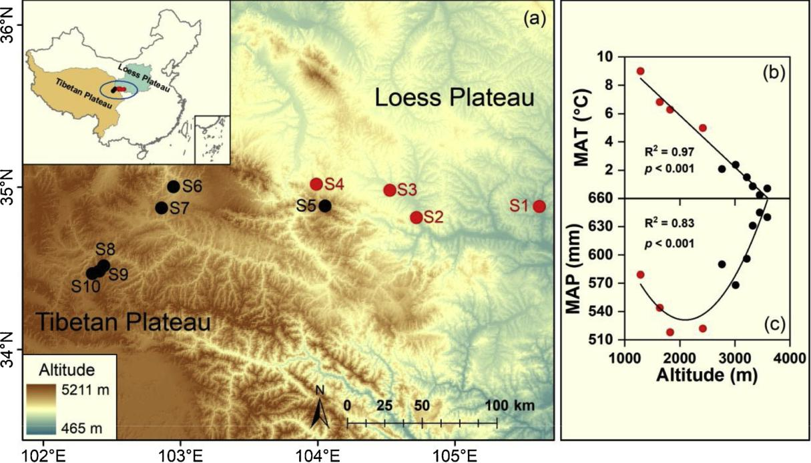

Fig. 1. Sampling sites (S1–S10) in transition areas between the Loess Plateau and Tibetan Plateau (a), relationships between mean annual temperature (MAT) (b) and mean annual precipitation (MAP) (c) with the increasing altitude. Sites S1–S4 on the Loess Plateau are alpine steppe (red points) and Sites S5–S10 on the Tibetan Plateau are alpine meadow (black points). (For interpretation of the references to colour in this figure legend, the reader is referred to the web version of this article).

plant biomass. Soil subsamples at the same depth from the three sam-pling points of the same subplot were pooled to form a composite sample. At each site, 15 soil samples (3 replicates by 5 depths) were collected and transported on ice to the laboratory. After the roots had been picked out, all soil samples were sieved through a 2-mm aperture screen (plant remains and tiny amounts of gravel on the sieve were

Table 1

discarded). One portion was stored in a refrigerator at 4 °C for analyses of soil microbial biomass P (MBP) and acid and alkaline phosphatase activities at the field moisture level. Soil samples air-dried at room temperature were used for analyses of soil particle-size composition, pH, P fractions, total P contents, and SOC.

Root biomass within each subarea was sampled from three points

Geographic locations, soil parent materials, dominant vegetation species composition, soil pH, and organic carbon (SOC) and total P contents at 0–100 cm soil depth in the 10 sampling sites (S1–S10) (see also Fig. 1 for locations on the map).

|  |  |  |  |  |  |  |  |
| --- | --- | --- | --- | --- | --- | --- | --- |
| Site a | Geographic coordinates and | Soil parent material | Vegetation dominant species | pH at 0–20 cm soil | SOC at 0–100 | | Total soil P (HClO4 dig.) at |
|  | altitude above sea level |  | composition | depth | cm soil depth | | 0–100 cm soil depth (g |
|  |  |  |  | (soil:water | (kg m–2)b | | m–2)b |
|  |  |  |  | = 1:2.5)b |  |  |  |
|  |  |  |  |  |  |  |  |
| S1 | 34°56′N, 105°38′E; | Loess | Agropyron cristatum; Leymus secalinus; | 8.48 | 5.66 | (0.13)e | 519 (46)c |
|  | 1286 m |  | Stipa capillata; Artemisia tangutica. | (0.01)a |  |  |  |
| S2 | 34°52′N, 104°43′E; | Loess | Poa annua; Leymus secalinus; Stipa | 8.40 | 15.9 | (0.47)d | 715 (11)b |
|  | 1637 m |  | capillata; Artemisia tangutica. | (0.05)a |  |  |  |
| S3 | 35°2′N, 104°31′E; | Loess | Artemisia gmelinii; Leymus secalinus; | 8.69 | 16.1 | (1.46)d | 485 (23)c |
|  | 1826 m; |  | Artemisia tangutica. | (0.05)a |  |  |  |
| S4 | 35°4′N, | Loess | Artemisia gmelinii; Leymus secalinus; Poa | 8.52 | 24.4 | (1.37)c | 689 (29)b |
|  | 103°58′E |  | annua; Stipa capillata. | (0.06)a |  |  |  |
|  | 2418 m |  |  |  |  |  |  |
| S5 | 34°56′N, | Early Quaternary or late | Polygonum viviparum; Carex atrofusca; | 6.82 | 24.7 | (0.58)c | 832 (20)a |
|  | 104°2′E | Tertiary red deposits | Potentilla multifida. | (0.07)bc |  |  |  |
|  | 2764 m |  |  |  |  |  |  |
| S6 | 35°2′N, 102°54′E; | Loess-like | Kobresia capillifolia; Potentilla multifida; | 8.45 | 22.0 | (0.86)c | 713 (13)b |
|  | 3014 m |  | Carex atrofusca. | (0.06)a |  |  |  |
| S7 | 34°54′N, 102°49′E; | Loess-like | Polygonum viviparum; Oxytropis | 6.99 | 31.7 | (1.28)b | 745 (7)b |
|  | 3217 m |  | ochrocephala; Anemone rivularis; | (0.26)b |  |  |  |
|  |  |  | Potentilla multifida. |  |  |  |  |
| S8 | 34°32′N, 102°24′E; | Loess-like | Polygonum viviparum; Carex atrofusca; | 6.65 | 41.2 | (5.17)a | 725 (57)b |
|  | 3323 m |  | Kobresia capillifolia; Potentilla multifida. | (0.09)cd |  |  |  |
| S9 | 34°30′N, 102°22′E; | Loess-like | Carex atrofusca; Anemone rivularis; | 6.48 | 32.9 | (1.20)b | 753 (17)ab |
|  | 3451 m |  | Potentilla anserina. | (0.07)d |  |  |  |
| S10 | 34°29′N, 102°19′E; | Loess-like | Polygonum viviparum; Carex atrofusca; | 6.15 | 28.0 | (1.03)bc | 546 (11)c |
|  | 3589 m |  | Kobresia capillifolia. | (0.02)e |  |  |  |

aSites S1–S4 on the Loess Plateau are alpine steppe and Sites S5–S10 on the Tibetan Plateau are alpine meadow.

bNumbers in brackets after means are one standard errors of the means; lowercase letters after brackets indicate significant diﬀerences between sites (p < 0.05).

3

X.M. Mou, et al.

using a root sampler (inner diameter 70 mm) in the 0–20 and 20–40 cm depth range. Three root subsamples were pooled to form a composite sample for each depth. After the soil was washed oﬀ the roots on a screen (aperture 1 mm), the roots were dried at 65 °C to constant weight and ground to powder for measurement of the P content. Soil bulk density was measured using cutting rings (volume 100 cm3, inner diameter 50 mm) from a 100 cm profile dug at each site. Each 1 m profile was also divided into five depths at the 20 cm increments. After removing roots and residue, soils were dried at 105 °C to constant weight to calculate bulk densities.

2.3. Measurements of soil properties, organic carbon and total phosphorus

After removal of organic matter and carbonates, soil samples (< 2

1. were dispersed in 0.5 M sodium hexametaphosphate solution. Soil particle-size composition in the suspension was scanned using a particle size analyzer (Malvern Mastersizer 2000, Malvern Instruments, UK). Soil pH values were measured using a pH meter (at soil:water = 1:2.5). The SOC content was measured on air-dry samples (ground to < 0.15
2. with the Walkley and Black dichromate oxidation method (Nelson and Sommers, 1982) and a factor of 1.32 was applied to adjust the SOC recovery (Lu, 2000). Total soil P was determined colorimetrically at 700 nm (UV-1800, Mapada, Shanghai, China) after the digestion of air-dry soil (< 0.15 mm) in an HClO4 and H2SO4 mixture (Lu, 2000).

2.4. Root P, MBP and phosphatase activity measurements

Root P content was colorimetrically measured after digestion in a H2SO4 and H2O2 mixture (Lu, 2000). The MBP was analyzed using a chloroform fumigation-extraction procedure on the basis of the diﬀer-ence in inorganic P extracted with 0.5 M NaHCO3 between the fumi-gated and unfumigated soils (Brookes et al., 1982; Morel et al., 1996). Briefly, 2 mL of ethanol-free CHCl3 was added to each moist soil sample (equivalent to 5 g in oven-dried weight) in a 50-mL glass beaker. Beakers containing chloroform-added soils were evacuated with a high vacuum pump for 15 min in a desiccator containing a beaker with an additional 50 mL of CHCl3, and were then incubated for 1 h in the desiccator in the dark at 25 °C. After complete removal of residual CHCl3 from fumigated soils, the fumigated and non-fumigated samples were shaken for 30 min in the 0.5 M NaHCO3 extractant at a soil:so-lution ratio of 1:10 (Khan and Joergensen, 2012). Simultaneously, an-other portion of each moist soil sample was used to detect the recovery of inorganic P, with 50 mg P kg−1 (as KH2PO4) added. After filtration, the inorganic P in all extracts was determined with the ammonium molybdate spectrophotometric method at 700 nm. The MBP was cal-culated based on the diﬀerence in the inorganic P extracted from fu-migated and non-fumigated samples divided by 0.4, and then divided by recovery (70–90 % across all samples) (Khan and Joergensen, 2012).

The activities of acid and alkaline phosphatases (phosphomonoes-terases) were assayed by colorimetric determination of p-nitrophenol released when soil was incubated with p-nitrophenyl phosphate in pH 6.5 or 11 buﬀers, respectively, for 1 h at 37 °C (Tabatabai, 1982; Hopkins et al., 2008). Moist soil equivalent to 1 g oven-dried weight was placed into 30-mL glass vials containing 4 mL of buﬀer and 1 mL of substrate solution, and incubated. After incubation, 1 mL of 0.2 M CaCl2 and 4 mL of 0.2 M NaOH (Margenot et al., 2018) were added to slurries to terminate enzymatic reactions. Immediately after filtration, the ab-sorbance of enzyme extracts was measured at 410 nm.

2.5. Soil phosphorus fractionation

A modified Hedley P fractionation was conducted for air-dry soil samples (ground to pass a 0.85-mm aperture screen), following the procedure described by Tiessen and Moir (2007), except that the ex-traction of plant available P by using resin strips was omitted (Fig. S3). The P was extracted progressively in five steps using increasingly

*Agriculture, Ecosystems and Environment 301 (2020) 107050*

aggressive extractants from a 0.5 g air-dry soil sample (Figure S3). The resultant P fractions were grouped into:

1. Inorganic (Pi) fractions: plant available P (i.e., Olsen P), labile Pi, moderately labile Pi and recalcitrant Pi;
2. Organic (Po) fractions: labile Po, moderately labile Po and re-calcitrant Po; and
3. Residue P.

In short, in the first step, P in soil was extracted with 0.5 M NaHCO3, and the P in the extracts was then separated into available P and labile Po. In the second step, the remaining soil P was extracted with 0.1 M NaOH, and the P in the extracts was separated into labile Pi and moderately labile Po. In the third step, the remaining P in soil was extracted using 1 M HCl solution, and the extracted P was assigned to be all inorganic forms (moderately labile Pi). In the fourth step, the remaining P in soil was further extracted using concentrated HCl at 80 °C, and the P in the extracts was fractionated into inorganic (re-calcitrant Pi) and organic forms (recalcitrant Po). In the first (0.5 M NaHCO3), second (0.1 M NaOH), and fourth (hot concentrated HCl) extraction steps, Po in the extracts was the diﬀerence between total P and Pi. The total P in an extract was the amount after digestion with H2SO4 and (NH4)2S2O8 in an autoclave under 121 kPa (Tiessen and Moir, 2007), whereas the Pi in the extract was directly measured. Fi-nally, the sequentially treated soil was digested in H2SO4–H2O2 to re-lease the residual P (Tiessen and Moir, 2007) (Fig. S3).

We used the sum of available P, labile Pi, moderately labile Pi, and recalcitrant Pi to represent the total Pi content in soil and the sum of labile Po, moderately labile Po, and recalcitrant Po as the content of total Po. We used the sum of total Pi, total Po, and residue P to re-present the total P extracted using the Hedley fractionation procedure (Psum).

2.6. Statistical analysis

Because MAT was linearly correlated with altitude (Fig. 1b, R2 = 0.97), all data were plotted against MAT across sites. Regression ana-lysis was conducted to reveal the eﬀects of MAT on measured P frac-tions and other variables within each soil depth. Curve fitting was carried out by OriginPro 9.1 (OriginLab Corp., Northampton, MA, USA). Ordinary least square of polynomial fitting was used to examine the significance in the regression relationship between dependent variables and MAT at p ≤ 0.05. The correlations between parameters were expressed as Pearson’s product moment correlation coeﬃcients (SPSS version 19.0, SPSS Inc., USA).

3. Results

3.1. Root and soil microbial biomass P and phosphatase activity

Roots mostly grew in the top 20 cm of soil at each site. Root biomass and P content in the roots in the top 20 cm both increased with de-creasing MAT (i.e., increasing altitude) (Fig. 2), resulting in an in-creasing root P stock (Fig. 2). The MBP content and acid and alkaline phosphatase activities all increased with decreasing MAT (Fig. 2). Acid phosphatase activity was closely correlated to both the root biomass (p < 0.05) and MBP (p < 0.01).

3.2. Soil P fractions

The available P content in the upper 40 cm and labile Pi at 0–100 cm soil depth increased with decreasing MAT (Fig. 3a). Unlike the trends of labile Pi and available P fractions along the MAT gradients, the moderately labile Pi contents (above 80 cm) decreased with de-creasing MAT, whereas the contents of recalcitrant Pi fractions down to 100 cm soil depth were stable across all sites and similar among soil layers at each site (Fig. 3b). Summing available P and labile, moder-ately labile, and recalcitrant Pi fractions, the total Pi contents in soil

4

X.M. Mou, et al. *Agriculture, Ecosystems and Environment 301 (2020) 107050*

Fig. 2. Dependences of root biomass, P content in roots, root P stock, microbial biomass P (MBP), and acid and alkaline phosphatase ac-tivities in the top 20 cm soil on mean annual temperature (MAT). PNP = p-nitrophenol. All regression lines are significant at least at p < 0.01. The scale order of horizontal axis is in the reverse direction to reflect the increasing altitude.

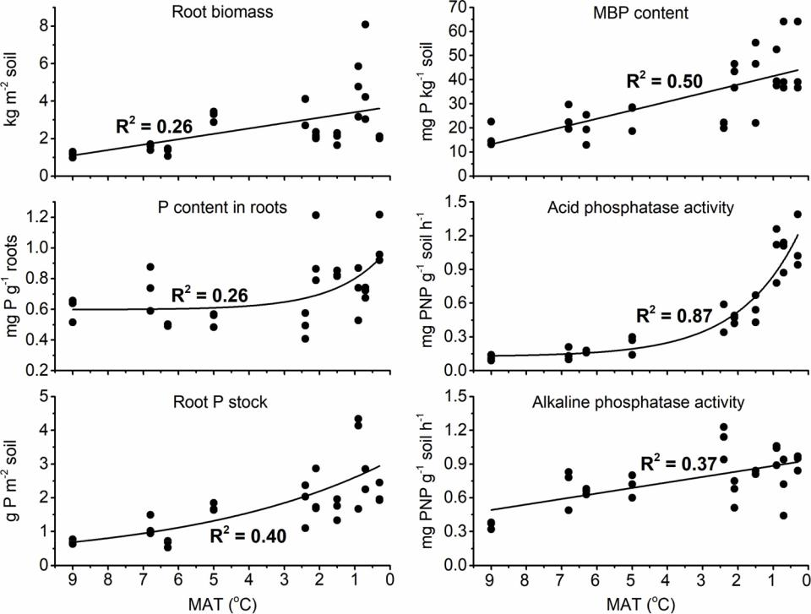

above 80 cm decreased with decreasing MAT (Fig. 4a).

Labile, moderately labile, and recalcitrant Po fractions (Fig. 3c) or their total (total Po, Fig. 4a) in soil sharply increased with decreasing MAT lower than 3 °C. Residue P content in each depth changed simi-larly to the total Po, along the altitude gradient (Fig. 4a). At each depth, total Po and residue P were each closely correlated to SOC content (Fig. 5a, b). At each depth, the percentages of total Po and residue P within Psum both exponentially or linearly increased with decreasing MAT (Fig. 4b, c).

The total Pi stock at 0–100 cm soil depth exponentially decreased with decreasing MAT (Fig. 6). The total Po and residue P stocks had the opposite trend to the total Pi (Fig. 6). The Psum stock linearly increased with decreasing MAT (i.e., increasing altitude) (Fig. 6).

4. Discussion

4.1. Root and microbial phosphorus

We confirmed our first hypothesis that roots and microbes stored greater P amounts under lower than higher temperature in alpine re-gions. The increased root biomass with decreasing MAT (Fig. 2) reflects a comprehensive influence of increasing environmental stress (low temperature, short growing season, and high solar radiation) and plant community adaptation along the elevation gradient (Mokany et al., 2005; Frenne et al., 2013; Schleuss et al., 2015). Root biomass and root:shoot ratio in grasslands usually increase with decreasing tem-perature (Mokany et al., 2005; Frenne et al., 2013). Greater root bio-mass is typically found in cold alpine meadows than warm steppes. For example, the root biomass (0.2–0.6 kg m–2) reported by Deng et al., 2014, 2016 and Zhu et al. (2016) in steppes on the Loess Plateau are all much lower than those in alpine meadows on the Tibetan Plateau (3.0–6.0 kg m–2) (Fan et al., 2008; Schleuss et al., 2015; Mou et al., 2018).

The higher P content in root biomass in alpine meadows than steppes (Fig. 2) indicate that plants in cold regions eﬃciently acquire P from soil (Frenne et al., 2013; Schleuss et al., 2015). The underlying mechanisms include varying plant physiology, species composition, and soil nutrient availability (Yang et al., 2016). Physiologically, the

nutrient contents in plants increase to oﬀset the decreases in plant metabolic rate as the temperature decreases (Woods et al., 2003; Reich and Oleksyn, 2004). Species composition is the primary determinant of plant stoichiometry (Townsend et al., 2007; He et al., 2008; Oelmann et al., 2011), which varied among sites (Table 1). Soil P availability was greater in cold meadows than in warm steppes (Fig. 3a), which is beneficial to the uptake of P by plants in low-temperature areas (Reich and Oleksyn, 2004). The larger root biomass (Fig. 2) and higher SOC contents (Fig. S1b) in meadows than steppes feed the larger microbial biomass (Fig. 2) present in the high-altitude alpine meadows. In addi-tion, drier climate and thus insuﬃcient soil moisture in lower altitude areas (Fig. S4) might have retarded microbial growth compared with higher altitude sites.

4.2. Organic phosphorus

Our second hypothesis that a greater proportion of soil P would have been allocated to organic pools in low-temperature areas com-pared with high-temperature areas was also confirmed (Fig. 4b). The increased Po contents with decreasing MAT in the upper 80 cm of soil (Fig. 3c) echoed the increased root and microbial P stored in low- re-lative to high-temperature areas (Fig. 2). Most importantly, it is es-tablished that SOM decomposition decreases at low temperatures (Peters et al., 2019; Li et al., 2017). The high SOC storage in cold alpine regions is generally explained by a slow decomposition rate due to low temperature (Yang et al., 2008; Li et al., 2017, 2018). Organic P was closely correlated with SOC content in all depths down to 100 cm (Fig. 5a). Thus, the increased root and microbial biomass P inputs versus a decreased decomposition rate in cold compared with warm areas enhanced the Po accumulation in cold meadow soils.

4.3. Inorganic phosphorus

There are several reasons for the increased plant available P content in the top 40 cm soil with decreasing temperature (Fig. 2). Firstly, in-suﬃcient soil moisture in lower altitude areas (Fig. S4) retarded root and microbial activity and thus phosphatase production compared with higher altitude sites. Phosphatases catalyze the phosphate release from

5

X.M. Mou, et al. *Agriculture, Ecosystems and Environment 301 (2020) 107050*

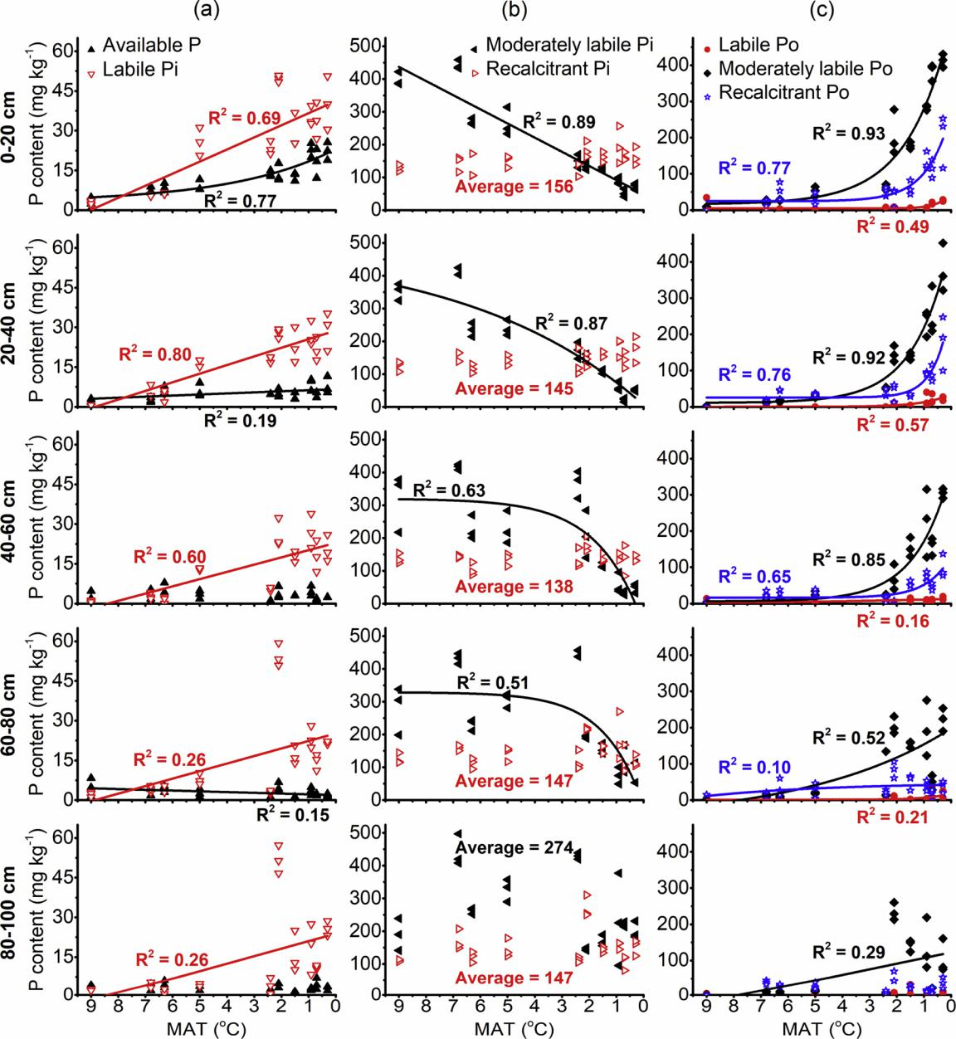

Fig. 3. Dependences of P fractions in soil depths down to 100 cm on the mean annual temperature (MAT). Column a: available P and labile inorganic P (Pi); Column

1. moderately labile Pi and recalcitrant Pi; Column c: labile Po, moderately labile Po and recalcitrant Po. All regression lines are significant at least at p < 0.01. The non-significant relationships are not presented.

phosphate esters (Turner, 2008; Chen et al., 2003). Both the roots and microorganisms synthesize and release phosphatases to soil (Giles et al., 2018). Acid and alkaline phosphatase activities all increased with de-creasing temperature (i.e., increasing soil moisture) (Fig. 2) and the acid phosphatase activity correlated to both the root and microbial biomass. Insuﬃcient soil moisture also decreased P solubility. Secondly, similar change trends between available P and total Po contents in the upper 40 cm soil along the altitudinal gradient would indicate a linkage between the depolymerization of P-containing organic compounds and increased available P concentration. In addition, the lower soil pH in meadow than steppe areas (Table 1; Fig. S1a) might have increased the solubility of phosphates in soils at meadow sites. P availability is greatest at soil pH values between 6 and 7 (Tiessen and Moir, 2007).

The decreased total Pi in cold meadows compared with warm steppes is mainly connected with the decrease of moderately labile Pi (soluble in the 1 M HCl solution). This is because available P (extracted

with NaHCO3) and labile Pi (soluble in the 0.1 M NaOH solution) fractions increased with decreasing temperature, whereas the re-calcitrant Pi (only soluble in concentrated HCl) was stable across all sites (Fig. 3a, b). The moderately labile Pi decreased with decreasing temperature because of the enhanced biological transformation to the Po pools and biogeochemical stabilization as the residue P in cold al-pine meadow soils. In addition, potentially greater leaching losses from the meadow soils compared with steppe soils might have increased the depletion of moderately labile Pi with altitude. Because of cold climate and high air moisture, evapotranspiration is small in low-temperature areas. The high precipitation at sites with altitudes above 3000 m (Fig. 1c) in combination with weaker evapotranspiration in meadow than in steppe areas led to a larger infiltration through the profile at meadow sites and thus, higher leaching. This potentially higher leaching in meadows also resulted in the reduced pH (Table 1; Fig. S1a), due to losses of base cations and carbonates.

6

X.M. Mou, et al. *Agriculture, Ecosystems and Environment 301 (2020) 107050*

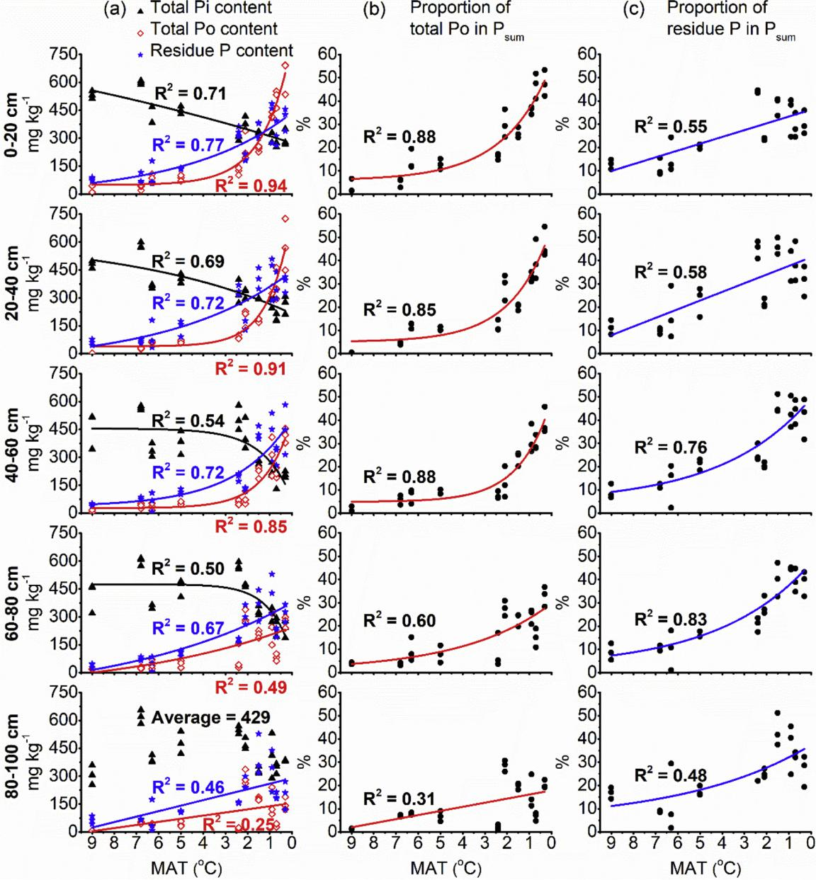

Fig. 4. Dependences of total Pi, total Po and residue P (Column a) and proportions of total Pi (Column b) and residue P (Column c) in the Psum (sum of all Hedley P fractions) on mean annual temperature (MAT) in diﬀerent soil depths. All regressions are significant at least at p < 0.01.

The labile Pi fraction is not completely separate from available P (Tiessen and Moir, 2007; Izquierdo et al., 2013). The labile Pi in the uppermost 100 cm of soil increased with decreasing temperature. A similar change pattern between labile Pi and Po fractions along the altitudinal gradient in each soil depth (Fig. 3a, c) indicates a linkage of the labile Pi with the P-containing organic compounds. The NaOH ex-traction depolymerized some moderately labile P-containing organic compounds, leading to the release of phosphate anions.

Recalcitrant Pi (only soluble in the concentrated HCl) remained stable across all sites, and the contents were similar between soil depths at every site (Fig. 3b). Consequently, the recalcitrant P-containing mi-nerals in the loess and loess-like sediments had not been aﬀected be-cause of the slow pedogenesis under cold semiarid climate. The un-changed recalcitrant Pi among sites confirmed similar soil parent materials among sites, which is important for investigating P transfor-mation based on altitudinal or latitudinal gradients.

4.4. Residue phosphorus

The residue P and its proportion of Psum in the 0–100 cm soil profile also increased with decreasing temperature (Fig. 4a). According to Tiessen and Moir (2007) and Izquierdo et al. (2013), the P remaining in soil after hot concentrated HCl extraction represents highly recalcitrant Pi. In the present study, the change pattern of the residue P at each soil depth across sites closely matched that of the SOC (Fig. 5b). This may suggest that with increasing SOM content, more inorganic P in soil was firmly bound to the organo-mineral complexes in cold than in warm areas. The chemical nature of residue P needs further investigation.

5. Conclusions and implications

Using Hedley P fractionation, we revealed clear trends of various P fractions with decreasing temperature from low- to high-altitude areas: the organic P (Po) and very recalcitrant residue P were accumulated in

7

X.M. Mou, et al. *Agriculture, Ecosystems and Environment 301 (2020) 107050*

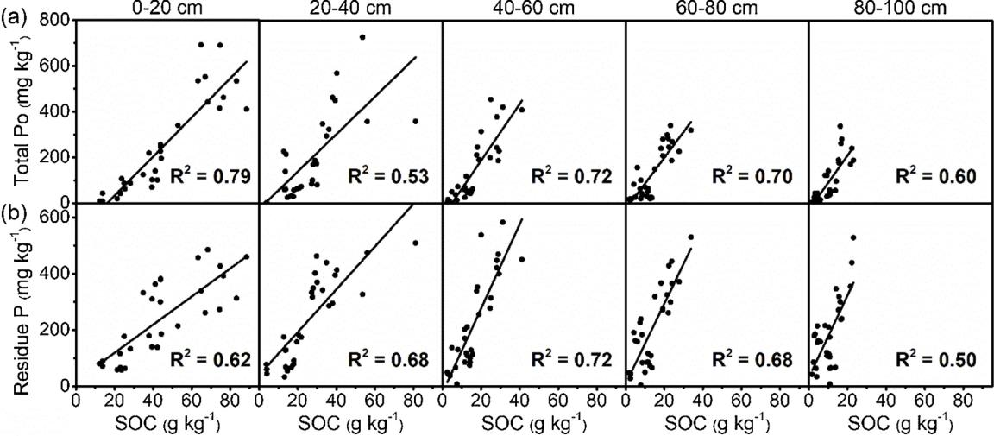

Fig. 5. Correlations of total organic P (Po) (Line a) and residue P (Line b) with the soil organic carbon (SOC) contents across sites in diﬀerent soil depths. All regressions are significant at p < 0.001.

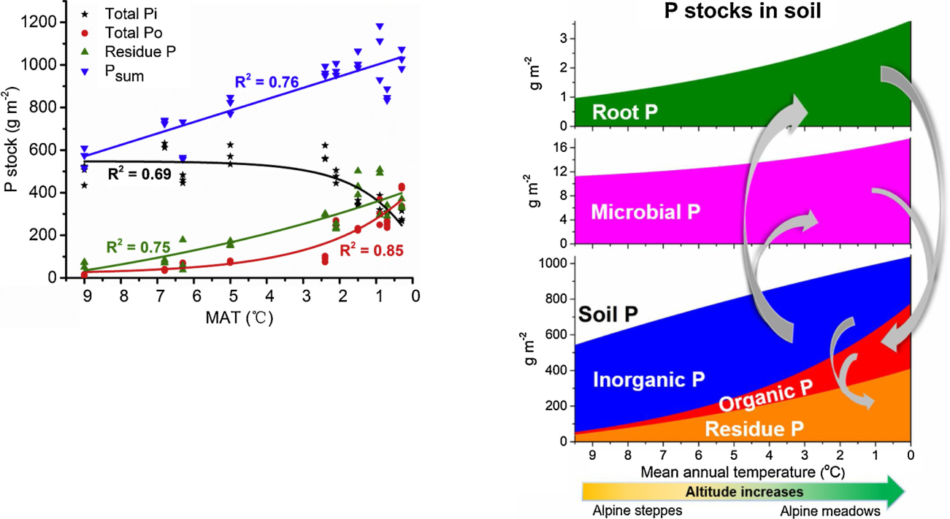

Fig. 6. Dependences of total inorganic P (Pi), total organic P (Po), residue P, and Psum (sum of total Pi, total Po and residue P) stocks at 0–100 cm soil depth on mean annual temperature (MAT) across all sites. All regressions are sig-nificant at p ≤ 0.001.

the top 100 cm, but the remaining labile inorganic P (Pi) content in the upper 80 cm decreased. P availability for plants increased in the top 40 cm of soil. Consequently, soil P is increasingly shifted to organic forms and very recalcitrant residues in cold meadows compared with warm steppes. Both the roots and microbial biomass had larger size and thus stored more P in meadows than in steppes. Increased root and microbial biomass P inputs versus a slow rate of organic matter decomposition at cold sites resulted in the increased incorporation of labile inorganic P into organic pools in cold compared with warm areas (Fig. 7). We conclude that P transfer from inorganic to organic forms and further to the residue P increased in cold climate soils. The accumulation of or-ganic and residue P forms is a mechanism to prevent P losses by leaching as labile inorganic forms in cold alpine regions.

Our results are particularly important to understand how climate warming may diﬀerentially aﬀect the P cycle in cold and warm alpine regions. The ongoing climate warming would stimulate P cycling more in cold meadows than in warm steppe, because of the dominance of organic P and a greater warming rate in the cold regions. The fast re-lease of available P from the Po pool would be conducive to the im-provement of primary productivity on the Tibetan Plateau where P availability deficiency is a limiting factor (Ma et al., 2019). On the other hand, the Po accumulated in alpine meadow soils was an outcome of

Fig. 7. General trends of the stocks of P pools in the 0–100 cm soil with de-creasing temperature (i.e., increasing altitude). The arrows show the main pathways for the increased net accumulations of organic and residue P in cold alpine grassland soils.

evolution of natural ecosystems under cold climate. This Po pool is at risk of loss, if its regenerating through litter production could not match the speed of Po mineralization accelerated by warming.

Data deposition

All data related to this submission have been deposited in Mendeley Data (https://doi.org/10.17632/7z28zj3w5g).

Declaration of Competing Interest

The authors declare that they have no known competing financial

8

X.M. Mou, et al.

interests or personal relationships that could have appeared to influ-ence the work reported in this paper.

Acknowledgements

This study was supported by the National Key R&D Program of China (Project No. 2017YFC0504801). We thank Qiu-Jin Ma and Fencan Li for their assistance in soil and plant analysis and data pre-sentation. The publication was prepared with the support of the “RUDN University program 5-100”. Authors highly appreciate comments from anonymous reviewers and editors on the previous version, which helped improve the quality of this paper.

Appendix A. Supplementary data

Supplementary material related to this article can be found, in the online version, at doi:<https://doi.org/10.1016/j.agee.2020.107050>.

References

[Brookes, P.C., Powlson, D.S., Jenkinson, D.S., 1982. Measurement of microbial biomass](http://refhub.elsevier.com/S0167-8809(20)30235-8/sbref0005) [phosphorus in soil. Soil Biol. Biochem. 14, 319–329](http://refhub.elsevier.com/S0167-8809(20)30235-8/sbref0005).

[Chen, C.R., Condron, L., Sinaj, M.S., Davis, M.R., Sherlock, R.R., Frossard, E., 2003.](http://refhub.elsevier.com/S0167-8809(20)30235-8/sbref0010)

[Eﬀects of plant species on phosphorus availability in a range of grassland soils. Plant](http://refhub.elsevier.com/S0167-8809(20)30235-8/sbref0010)

[Soil 256, 115–130](http://refhub.elsevier.com/S0167-8809(20)30235-8/sbref0010).

[Chen, J., Seven, J., Zilla, T., Dippold, M.A., Blagodatskaya, E., Kuzyakov, Y., 2019.](http://refhub.elsevier.com/S0167-8809(20)30235-8/sbref0015) [Microbial C:N:P stoichiometry and turnover depend on nutrient availability in soil: a](http://refhub.elsevier.com/S0167-8809(20)30235-8/sbref0015) [14C, 15N and 33P triple labelling study. Soil Biol. Biochem. 131, 206–216](http://refhub.elsevier.com/S0167-8809(20)30235-8/sbref0015).

[Cross, A.F., Schlesinger, W.H., 1995. A literature review and evaluation of the Hedley](http://refhub.elsevier.com/S0167-8809(20)30235-8/sbref0020) [fractionation: applications to the biogeochemical cycle of soil phosphorus in natural](http://refhub.elsevier.com/S0167-8809(20)30235-8/sbref0020) [ecosystems. Geoderma 64, 197–214](http://refhub.elsevier.com/S0167-8809(20)30235-8/sbref0020).

[Cui, Y., Bing, H., Fang, L., Wu, Y., Yu, J., Shen, G., et al., 2019. Diversity patterns of the](http://refhub.elsevier.com/S0167-8809(20)30235-8/sbref0025) [rhizosphere and bulk soil microbial communities along an altitudinal gradient in an](http://refhub.elsevier.com/S0167-8809(20)30235-8/sbref0025) [alpine ecosystem of the eastern Tibetan Plateau. Geoderma 338, 118–127](http://refhub.elsevier.com/S0167-8809(20)30235-8/sbref0025).

[Del Grosso, S.J., Parton, W.J., Mosier, A.R., Holland, E.A., Pendall, E., Schimel, D.S.,](http://refhub.elsevier.com/S0167-8809(20)30235-8/sbref0030) [Ojima, D.S., 2005. Modeling soil CO2 emissions from ecosystems. Biogeochemistry](http://refhub.elsevier.com/S0167-8809(20)30235-8/sbref0030) [73, 71–91](http://refhub.elsevier.com/S0167-8809(20)30235-8/sbref0030).

[Deng, L., Zhang, Z., Shangguan, Z., 2014. Long-term fencing eﬀects on plant diversity and](http://refhub.elsevier.com/S0167-8809(20)30235-8/sbref0035) [soil properties in China. Soil Till. Res. 137, 7–15](http://refhub.elsevier.com/S0167-8809(20)30235-8/sbref0035).

[Deng, L., Wang, K., Li, J., Zhao, G., Shangguan, Z., 2016. Eﬀect of soil moisture and](http://refhub.elsevier.com/S0167-8809(20)30235-8/sbref0040) [atmospheric humidity on both plant productivity and diversity of native grasslands](http://refhub.elsevier.com/S0167-8809(20)30235-8/sbref0040) [across the Loess Plateau. China. Ecol. Eng. 94, 525–531](http://refhub.elsevier.com/S0167-8809(20)30235-8/sbref0040).

[Fan, J., Zhong, H., Harris, W., Yu, G., Wang, S., Hu, Z., Yue, Y., 2008. Carbon storage in](http://refhub.elsevier.com/S0167-8809(20)30235-8/sbref0045) [the grasslands of China based on field measurements of above-and below-ground](http://refhub.elsevier.com/S0167-8809(20)30235-8/sbref0045) [biomass. Clim. Change 86, 375–396](http://refhub.elsevier.com/S0167-8809(20)30235-8/sbref0045).

[Feng, J., Turner, B.L., Lü, X., Chen, Z., Wei, K., Tian, J., et al., 2016. Phosphorus trans-formations along a large-scale climosequence in arid and semiarid grasslands of](http://refhub.elsevier.com/S0167-8809(20)30235-8/sbref0050) [northern China. Global Biogeochem. Cy. 30, 1264–1275](http://refhub.elsevier.com/S0167-8809(20)30235-8/sbref0050).

[Fick, S.E., Hijmans, R.J., 2017. WorldClim 2: new 1-km spatial resolution climate surfaces](http://refhub.elsevier.com/S0167-8809(20)30235-8/sbref0055) [for global land areas. Int. J. Climatol. 37, 4302–4315](http://refhub.elsevier.com/S0167-8809(20)30235-8/sbref0055).

[Frenne, P.D., Graae, B.J., Rodríguez-Sánchez, F., Kolb, A., Chabrerie, O., Decocq, G.,](http://refhub.elsevier.com/S0167-8809(20)30235-8/sbref0060)

[et al., 2013. Latitudinal gradients as natural laboratories to infer species’ responses to](http://refhub.elsevier.com/S0167-8809(20)30235-8/sbref0060)

[temperature. J. Ecol. 101, 784–795](http://refhub.elsevier.com/S0167-8809(20)30235-8/sbref0060).

[Gansu Province Soil Census Oﬃce, 1993. Soils in Gansu. Agricultural Publishing House,](http://refhub.elsevier.com/S0167-8809(20)30235-8/sbref0065) [Beijing](http://refhub.elsevier.com/S0167-8809(20)30235-8/sbref0065).

[Giles, C.D., Dupuy, L., Boitt, G., Brown, L.K., Condron, L.M., Darch, T., et al., 2018. Root](http://refhub.elsevier.com/S0167-8809(20)30235-8/sbref0070) [development impacts on the distribution of phosphatase activity: improvements in](http://refhub.elsevier.com/S0167-8809(20)30235-8/sbref0070) [quantification using soil zymography. Soil Biol. Biochem. 116, 158–166](http://refhub.elsevier.com/S0167-8809(20)30235-8/sbref0070).

[Hamdan, R., El-Rifai, H.M., Cheesman, A.W., Turner, B.L., Reddy, K.R., Cooper, W.T.,](http://refhub.elsevier.com/S0167-8809(20)30235-8/sbref0075) [2012. Linking phosphorus sequestration to carbon humification in wetland soils by](http://refhub.elsevier.com/S0167-8809(20)30235-8/sbref0075) [31P and 13C NMR spectroscopy. Environ. Sci. Technol. 46, 4775–4782](http://refhub.elsevier.com/S0167-8809(20)30235-8/sbref0075).

[He, J.-S., Wang, L., Flynn, D.F.B., Wang, X., Ma, W., Fang, J., 2008. Leaf nitrogen:pho-sphorus stoichiometry across Chinese grassland biomes. Oecologia 155, 301–310](http://refhub.elsevier.com/S0167-8809(20)30235-8/sbref0080).

[Henkin, Z., Sternberg, M., Seligman, N.G., Noy-Meir, I., 2006. Species richness in relation](http://refhub.elsevier.com/S0167-8809(20)30235-8/sbref0085) [to phosphorus and competition in a Mediterranean dwarf-shrub community. Agric.](http://refhub.elsevier.com/S0167-8809(20)30235-8/sbref0085) [Ecosyst. Environ. 113, 277–283](http://refhub.elsevier.com/S0167-8809(20)30235-8/sbref0085).

[Hofmann, K., Lamprecht, A., Pauli, H., Illmer, P., 2016. Distribution of prokaryotic](http://refhub.elsevier.com/S0167-8809(20)30235-8/sbref0090) [abundance and microbial nutrient cycling across a high-alpine altitudinal gradient in](http://refhub.elsevier.com/S0167-8809(20)30235-8/sbref0090) [the Austrian Central Alps is aﬀected by vegetation, temperature, and soil Nutrients.](http://refhub.elsevier.com/S0167-8809(20)30235-8/sbref0090) [Microb. Ecol. 72, 704–716](http://refhub.elsevier.com/S0167-8809(20)30235-8/sbref0090).

[Hopkins, D.W., Sparrow, A.D., Shillam, L.L., English, L.C., Dennis, P.G., Novis, P., et al.,](http://refhub.elsevier.com/S0167-8809(20)30235-8/sbref0095)

[2008. Enzymatic activities and microbial communities in an Antarctic dry valley soil:](http://refhub.elsevier.com/S0167-8809(20)30235-8/sbref0095)

[responses to C and N supplementation. Soil Biol. Biochem. 40, 2130–2136](http://refhub.elsevier.com/S0167-8809(20)30235-8/sbref0095).

[Hou, E., Chen, C., Luo, Y., Zhou, G., Kuang, Y., Zhang, Y., et al., 2018. Eﬀects of climate](http://refhub.elsevier.com/S0167-8809(20)30235-8/sbref0100) [on soil phosphorus cycle and availability in natural terrestrial ecosystems. Glob.](http://refhub.elsevier.com/S0167-8809(20)30235-8/sbref0100) [Change Biol. Bioenergy 24, 3344–3356](http://refhub.elsevier.com/S0167-8809(20)30235-8/sbref0100).

[Izquierdo, J.E., Houlton, B.Z., van Huysen, T.L., 2013. Evidence for progressive phos-phorus limitation over long-term ecosystem development: examination of a biogeo-chemical paradigm. Plant Soil 367, 135–147](http://refhub.elsevier.com/S0167-8809(20)30235-8/sbref0105).

[Katarzyna, S., Cezary, K., Anna, K., Adam, B., Pawel, J., 2010. Pools of available nutrients](http://refhub.elsevier.com/S0167-8809(20)30235-8/sbref0110)

*Agriculture, Ecosystems and Environment 301 (2020) 107050*

[in soils from diﬀerent altitudinal forest zones located in a monitoring system of the](http://refhub.elsevier.com/S0167-8809(20)30235-8/sbref0110) [karkonosze mountains national park. Poland. Pol. J. Soil Sci. 43, 173–188](http://refhub.elsevier.com/S0167-8809(20)30235-8/sbref0110).

[Khan, K.S., Joergensen, R.G., 2012. Relationships between P fractions and the microbial](http://refhub.elsevier.com/S0167-8809(20)30235-8/sbref0115) [biomass in soils under diﬀerent land use management. Geoderma 173–174, 274–281](http://refhub.elsevier.com/S0167-8809(20)30235-8/sbref0115).

[Kirschbaum, M.U.F., 1995. The temperature dependence of soil organic matter decom-position and the eﬀect of global warming on soil organic C storage. Soil Biol.](http://refhub.elsevier.com/S0167-8809(20)30235-8/sbref0120) [Biochem. 27, 753–760](http://refhub.elsevier.com/S0167-8809(20)30235-8/sbref0120).

[Köhler, L., Gieger, T., Leuschner, C., 2006. Altitudinal change in soil and foliar nutrient](http://refhub.elsevier.com/S0167-8809(20)30235-8/sbref0125) [concentrations and in microclimate across the tree line on the subtropical island](http://refhub.elsevier.com/S0167-8809(20)30235-8/sbref0125) [mountain Mt. Teide (Canary Islands). Flora 201, 202–214](http://refhub.elsevier.com/S0167-8809(20)30235-8/sbref0125).

[Li, D., Fan, J., Zhang, X., Xu, X., He, N., Wen, X., et al., 2017. Hydrolase kinetics to detect](http://refhub.elsevier.com/S0167-8809(20)30235-8/sbref0130) [temperature-related changes in the rates of soil organic matter decomposition. Eur. J.](http://refhub.elsevier.com/S0167-8809(20)30235-8/sbref0130) [Soil Biol. 81, 108–115](http://refhub.elsevier.com/S0167-8809(20)30235-8/sbref0130).

[Li, J., Yan, D., Pendall, E., Pei, J., Noh, N.J., He, J.-S., et al., 2018. Depth dependence of](http://refhub.elsevier.com/S0167-8809(20)30235-8/sbref0135)

[soil carbon temperature sensitivity across Tibetan permafrost regions. Soil Biol.](http://refhub.elsevier.com/S0167-8809(20)30235-8/sbref0135)

[Biochem. 126, 82–90](http://refhub.elsevier.com/S0167-8809(20)30235-8/sbref0135).

[Liu, S., Zamanian, K., Schleuss, P.-M., Zarebanadkouki, M., Kuzyakov, Y., 2018.](http://refhub.elsevier.com/S0167-8809(20)30235-8/sbref0140)

[Degradation of Tibetan grasslands: consequences for carbon and nutrient cycles.](http://refhub.elsevier.com/S0167-8809(20)30235-8/sbref0140)

[Agric. Ecosyst. Environ. 252, 93–104](http://refhub.elsevier.com/S0167-8809(20)30235-8/sbref0140).

[Lu, R.K., 2000. Soil and Agro-chemistry Analysis. China Agricultural Scio-technological](http://refhub.elsevier.com/S0167-8809(20)30235-8/sbref0145) [Press, Beijing](http://refhub.elsevier.com/S0167-8809(20)30235-8/sbref0145).

[Ma, B., Zhou, X., Zhang, Q., Qin, M., Hu, L., Yang, K., et al., 2019. How do soil micro-organisms respond to N, P and NP additions? Application of the ecological framework](http://refhub.elsevier.com/S0167-8809(20)30235-8/sbref0150) [of (co-) limitation by multiple resources. J. Eco. 107, 2329–2345](http://refhub.elsevier.com/S0167-8809(20)30235-8/sbref0150).

[Mage, S.M., Porder, S., 2013. Parent material and topography determine soil phosphorus](http://refhub.elsevier.com/S0167-8809(20)30235-8/sbref0155) [status in the Luquillo Mountains of Puerto Rico. Ecosystems 16, 284–294](http://refhub.elsevier.com/S0167-8809(20)30235-8/sbref0155).

[Margenot, A.J., Nakayama, Y., Parikh, S.J., 2018. Methodological recommendations for](http://refhub.elsevier.com/S0167-8809(20)30235-8/sbref0160)

[optimizing assays of enzyme activities in soil samples. Soil Biol. Biochem. 125,](http://refhub.elsevier.com/S0167-8809(20)30235-8/sbref0160) [350–360](http://refhub.elsevier.com/S0167-8809(20)30235-8/sbref0160).

[Mokany, K., Raison, R.J., Prokushkin, A.S., 2005. Critical analysis of root:shoot ratios in](http://refhub.elsevier.com/S0167-8809(20)30235-8/sbref0165) [terrestrial biomes. Glob. Change Biol. Bioenergy 12, 84–96](http://refhub.elsevier.com/S0167-8809(20)30235-8/sbref0165).

[Morel, C., Tiessen, H., Stewart, J.W.B., 1996. Correction for P-sorption in the measure-](http://refhub.elsevier.com/S0167-8809(20)30235-8/sbref0170)

[ment of soil microbial biomass P by CHCl3 fumigation. Soil Biol. Biochem. 28,](http://refhub.elsevier.com/S0167-8809(20)30235-8/sbref0170) [1699–1706](http://refhub.elsevier.com/S0167-8809(20)30235-8/sbref0170).

[Mou, X.M., Li, X.G., Zhao, N., Yu, Y.W., Kuzyakov, Y., 2018. Tibetan sedges sequester](http://refhub.elsevier.com/S0167-8809(20)30235-8/sbref0175) [more carbon belowground than grasses: a 13C labeling study. Plant Soil 426,](http://refhub.elsevier.com/S0167-8809(20)30235-8/sbref0175) [287–298](http://refhub.elsevier.com/S0167-8809(20)30235-8/sbref0175).

[Müller, M., Oelmann, Y., Schickhoﬀ, U., Böhner, J., Scholten, T., 2017. Himalayan](http://refhub.elsevier.com/S0167-8809(20)30235-8/sbref0180) [treeline soil and foliar C:N:P stoichiometry indicate nutrient shortage with elevation.](http://refhub.elsevier.com/S0167-8809(20)30235-8/sbref0180) [Geoderma 291, 21–32](http://refhub.elsevier.com/S0167-8809(20)30235-8/sbref0180).

[Negassa, W., Leinweber, P., 2009. How does the Hedley sequential phosphorus fractio-nation reflect impacts of land use and management on soil phosphorus: a review. J.](http://refhub.elsevier.com/S0167-8809(20)30235-8/sbref0185) [Plant Nutr. Soil Sci. 172 (172), 305–325](http://refhub.elsevier.com/S0167-8809(20)30235-8/sbref0185).

[Nelson, D.W., Sommers, L.E., 1982. Total carbon, organic carbon, and organic matter. In:](http://refhub.elsevier.com/S0167-8809(20)30235-8/sbref0190) [Page, A.L., Miller, R.H., Keeney, D.R. (Eds.), Methods of Soil Analysis. Part 2, second](http://refhub.elsevier.com/S0167-8809(20)30235-8/sbref0190) [ed. Agronomy Monography 9. ASA and SSSA, Madison, WI, pp. 539–579](http://refhub.elsevier.com/S0167-8809(20)30235-8/sbref0190).

[Oelmann, Y., Richter, A.K., Roscher, C., Rosenkranz, S., Temperton, V.M., Weisser, W.W.,](http://refhub.elsevier.com/S0167-8809(20)30235-8/sbref0195) [Wilcke, W., 2011. Does plant diversity influence phosphorus cycling in experimental](http://refhub.elsevier.com/S0167-8809(20)30235-8/sbref0195) [grasslands? Geoderma 167–168, 178–187](http://refhub.elsevier.com/S0167-8809(20)30235-8/sbref0195).

[Peters, M.K., Hemp, A., Appelhans, T., Becker, J.N., Behler, C., Classen, A., et al., 2019.](http://refhub.elsevier.com/S0167-8809(20)30235-8/sbref0200) [Climate-land use interactions shape tropical mountain biodiversity and ecosystem](http://refhub.elsevier.com/S0167-8809(20)30235-8/sbref0200) [functions. Nature 568, 88–92](http://refhub.elsevier.com/S0167-8809(20)30235-8/sbref0200).

[Poeplau, C., Zopf, D., Greiner, B., Geerts, R., Korvaar, H., Thumm, U., Don, A., Heidkamp,](http://refhub.elsevier.com/S0167-8809(20)30235-8/sbref0205) [A., Flessa, H., 2018. Why does mineral fertilization increase soil carbon stocks in](http://refhub.elsevier.com/S0167-8809(20)30235-8/sbref0205) [temperate grasslands? Agr. Agric. Ecosyst. Environ.. 265, 144–155](http://refhub.elsevier.com/S0167-8809(20)30235-8/sbref0205).

[Qiu, J., 2008. China: the third pole. Nature 454, 393–396](http://refhub.elsevier.com/S0167-8809(20)30235-8/sbref0210).

[Raich, J.W., Parton, W.J., Russell, A.E., Sanford Jr, R.L., Vitousek, P.M., 2000. Analysis of](http://refhub.elsevier.com/S0167-8809(20)30235-8/sbref0215) [factors regulating ecosystem development on Mauna Loa using the Century model.](http://refhub.elsevier.com/S0167-8809(20)30235-8/sbref0215) [Biogeochemistry 51, 161–191](http://refhub.elsevier.com/S0167-8809(20)30235-8/sbref0215).

[Reich, P.B., Oleksyn, J., 2004. Global patterns of plant leaf N and P in relation to tem-perature and latitude. P. Nati. Acad Sci. USA. 101, 11001–11006](http://refhub.elsevier.com/S0167-8809(20)30235-8/sbref0220).

[Saggar, S., Hedley, C.B., Giddens, K.M., Salt, G.J., 2000. Influence of soil phosphorus](http://refhub.elsevier.com/S0167-8809(20)30235-8/sbref0225) [status and nitrogen addition on carbon mineralization from 14C-labelled glucose in](http://refhub.elsevier.com/S0167-8809(20)30235-8/sbref0225) [pasture soils. Biol. Fert. Soils 32, 209–216](http://refhub.elsevier.com/S0167-8809(20)30235-8/sbref0225).

[Schleuss, P.-M., Heitkamp, F., Sun, Y., Miehe, G., Xu, X., Kuzyakov, Y., 2015. Nitrogen](http://refhub.elsevier.com/S0167-8809(20)30235-8/sbref0230) [uptake in an alpine Kobresia pasture on the Tibetan Plateau: localization by 15N la-beling and implications for a vulnerable ecosystem. Ecosystems 18, 946–957](http://refhub.elsevier.com/S0167-8809(20)30235-8/sbref0230).

[Soethe, N., Lehmann, J., Engels, C., 2008. Nutrient availability at diﬀerent altitudes in a](http://refhub.elsevier.com/S0167-8809(20)30235-8/sbref0235) [tropical montane forest in Ecuador. J. Trop. Ecol. 24, 397–406](http://refhub.elsevier.com/S0167-8809(20)30235-8/sbref0235).

[Tabatabai, M.A., 1982. Soil enzymes. In: Page, A.L., Miller, R.H. (Eds.), Methods of Soil](http://refhub.elsevier.com/S0167-8809(20)30235-8/sbref0240) [Analysis, Part 2. Chemical and Microbiological Properties, second ed. American](http://refhub.elsevier.com/S0167-8809(20)30235-8/sbref0240) [Society of Agronomy, Madison, WI, pp. 903–943](http://refhub.elsevier.com/S0167-8809(20)30235-8/sbref0240).

[Thakuri, S., Dahal, S., Shrestha, D., Guyennon, N., Romano, E., Colombo, N., Salerno, F.,](http://refhub.elsevier.com/S0167-8809(20)30235-8/sbref0245) [2019. Elevation-dependent warming of maximum air temperature in Nepal during](http://refhub.elsevier.com/S0167-8809(20)30235-8/sbref0245) [1976–2015. Atmos. Res. 228, 261–269](http://refhub.elsevier.com/S0167-8809(20)30235-8/sbref0245).

[Tiessen, H., Moir, J.O., 2007. Characterization of available P by sequential extraction. In:](http://refhub.elsevier.com/S0167-8809(20)30235-8/sbref0250) [Carter, M.R., Gregorich, E.G. (Eds.), in Soil Sampling and Methods of Analysis, 2nd](http://refhub.elsevier.com/S0167-8809(20)30235-8/sbref0250) [ed. CRC Press, Boca Raton, FL, USA, pp. 293–306](http://refhub.elsevier.com/S0167-8809(20)30235-8/sbref0250).

[Townsend, A.R., Cleveland, C.C., Asner, G.P., Bustamante, M.M.C., 2007. Controls over](http://refhub.elsevier.com/S0167-8809(20)30235-8/sbref0255) [foliar N: P ratios in tropical rain forests. Ecology 88, 107–118](http://refhub.elsevier.com/S0167-8809(20)30235-8/sbref0255).

[Turner, B.L., 2008. Resource partitioning for soil phosphorus: a hypothesis. J. Ecol. 96,](http://refhub.elsevier.com/S0167-8809(20)30235-8/sbref0260) [698–702](http://refhub.elsevier.com/S0167-8809(20)30235-8/sbref0260).

[Turner, B.L., Condron, L.M., Richardson, S.J., Peltzer, D.A., Allison, V.J., 2007. Soil or-ganic phosphorus transformations during pedogenesis. Ecosystems 10, 1166–1181](http://refhub.elsevier.com/S0167-8809(20)30235-8/sbref0265).

[Vincent, A.G., Sundqvist, M.K., Wardle, D.A., Giesler, R., 2014. Available soil phosphorus](http://refhub.elsevier.com/S0167-8809(20)30235-8/sbref0270) [decreases with increasing elevation in a subarctic tundra landscape. PLoS One 9,](http://refhub.elsevier.com/S0167-8809(20)30235-8/sbref0270)

9

X.M. Mou, et al.

[e92942](http://refhub.elsevier.com/S0167-8809(20)30235-8/sbref0270).

[Vitousek, P.M., Matson, P.A., Turner, D.R., 1988. Elevational and age gradients in](http://refhub.elsevier.com/S0167-8809(20)30235-8/sbref0275) [Hawaiian montane rainforest: foliar and soil nutrients. Oecologia 77, 565–570](http://refhub.elsevier.com/S0167-8809(20)30235-8/sbref0275).

[Walker, T.W., Syers, J.K., 1976. The fate of phosphorus during pedogenesis. Geoderma](http://refhub.elsevier.com/S0167-8809(20)30235-8/sbref0280) [15, 1–19](http://refhub.elsevier.com/S0167-8809(20)30235-8/sbref0280).

[Woods, H.A., Makino, W., Cotner, J.B., Hobbie, S.E., Harrison, J.F., Acharya, K., Elser,](http://refhub.elsevier.com/S0167-8809(20)30235-8/sbref0285) [J.J., 2003. Temperature and the chemical composition of poikilothermic organisms.](http://refhub.elsevier.com/S0167-8809(20)30235-8/sbref0285) [Funct. Ecol. 17, 237–245](http://refhub.elsevier.com/S0167-8809(20)30235-8/sbref0285).

[Xu, Z., Chang, Y., Li, L., Luo, Q., Xu, Z., Li, X., et al., 2018. Climatic and topographic](http://refhub.elsevier.com/S0167-8809(20)30235-8/sbref0290) [variables control soil nitrogen, phosphorus, and nitrogen:phosphorus ratios in a Picea](http://refhub.elsevier.com/S0167-8809(20)30235-8/sbref0290) [schrenkiana forest of the Tianshan Mountains. PLoS One 13, e0204130](http://refhub.elsevier.com/S0167-8809(20)30235-8/sbref0290).

[Yang, Y., Fang, J., Tang, Y., Ji, C., Zeng, C., He, J., Zhu, B., 2008. Storage, patterns, and](http://refhub.elsevier.com/S0167-8809(20)30235-8/sbref0295) [controls of soil organic carbon in the Tibetan grasslands. Glob. Change Biol.](http://refhub.elsevier.com/S0167-8809(20)30235-8/sbref0295) [Bioenergy 14, 1592–1599](http://refhub.elsevier.com/S0167-8809(20)30235-8/sbref0295).

[Yang, X., Chi, X., Ji, C., Liu, H., Ma, W., Mohhammat, A., et al., 2016. Variations of leaf N](http://refhub.elsevier.com/S0167-8809(20)30235-8/sbref0300)

*Agriculture, Ecosystems and Environment 301 (2020) 107050*

[and P concentrations in shrubland biomes across northern China: phylogeny, climate,](http://refhub.elsevier.com/S0167-8809(20)30235-8/sbref0300) [and soil. Biogeosciences 13, 4429–4438](http://refhub.elsevier.com/S0167-8809(20)30235-8/sbref0300).

Zarzycki, J., Kopeć, M., 2020. The scheme of nutrient addition aﬀects vegetation com-position and plant species richness in diﬀerent ways: results from a long-term grasslands experiment. Agric. Ecosyst. Environ.. 291, 106789. [https://doi.org/10.](https://doi.org/10.1016/j.agee.2019.106789) [1016/j.agee.2019.106789](https://doi.org/10.1016/j.agee.2019.106789).

[Zhang, Y., Li, C., Wang, M., 2019. Linkages of C: N: P stoichiometry between soil and leaf](http://refhub.elsevier.com/S0167-8809(20)30235-8/sbref0310) [and their response to climatic factors along altitudinal gradients. J. Soils Sediment.](http://refhub.elsevier.com/S0167-8809(20)30235-8/sbref0310) [19, 1820–1829](http://refhub.elsevier.com/S0167-8809(20)30235-8/sbref0310).

[Zhu, G.-Y., Deng, L., Zhang, X.-B., Shangguan, Z.-P., 2016. Eﬀects of grazing exclusion on](http://refhub.elsevier.com/S0167-8809(20)30235-8/sbref0315) [plant community and soil physicochemical properties in a desert steppe on the Loess](http://refhub.elsevier.com/S0167-8809(20)30235-8/sbref0315) [Plateau. China. Ecol. Eng. 90, 372–381](http://refhub.elsevier.com/S0167-8809(20)30235-8/sbref0315).

[Zhu, X., Wei, Z., Dong, W., Wen, X., Zheng, Z., Chen, G., Liu, Y., 2019. Projected tem-perature and precipitation changes on the Tibetan Plateau: results from dynamical](http://refhub.elsevier.com/S0167-8809(20)30235-8/sbref0320) [downscaling and CCSM4. Theor. Appl. Climatol. 138, 861–875](http://refhub.elsevier.com/S0167-8809(20)30235-8/sbref0320).

10