[South African Journal of Botany 132 (2020) 432 462](https://doi.org/10.1016/j.sajb.2020.04.030)

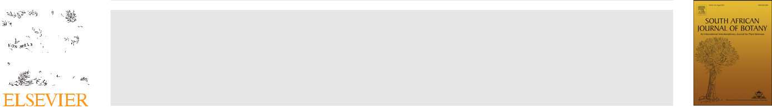

Contents lists available at [ScienceDirect](http://www.ScienceDirect.com)

South African Journal of Botany

journal homepage: [www.elsevier.com/locate/sajb](http://www.elsevier.com/locate/sajb)



The genus Sida L. (Malvaceae): An update of its ethnomedicinal use, pharmacology and phytochemistry

Felicidade Caroline Rodrigues, Antonio^ Fernando Morais de Oliveira*

Universidade Federal de Pernambuco, Departamento de Botanica,^ Av. da Engenharia, s/n, Cidade Universitaria, 50670-420, Recife, PE, Brazil

ARTICLE INFO

Article History:

Received 11 December 2019 Revised 14 April 2020 Accepted 23 April 2020 Available online 27 June 2020

Keywords:

Antioxidants

Bioactivity

Ethnobotany

Ethnopharmacology

Medicinal plants

ABSTRACT

Sida L. is one of the most diverse genera in the Malvaceae family and its species are used in different countries of the world for the treatment of various diseases, with such ethnomedicinal use supported by pharmacolog-ical assays. The main objective of this study is to update the knowledge on the biological and pharmacologi-cal activities and phytochemistry of Sida since the last revision of the genus published in 2015. Ethnobotanical, pharmacological and phytochemical information on the genus Sida was collected through various scientific research platforms. Our findings showed that the best studied species are S. acuta, S. cordifo-lia and S. rhombifolia, while few works have been dedicated to other species such as S. galheirensis. Sida spe-cies are traditionally used for the treatment of various conditions, especially ulcers, asthma, fever, pain, rheumatism and diarrhea. A total of 121 chemical constituents were listed, of which 89 were discovered in the last five years.

© 2020 SAAB. Published by Elsevier B.V. All rights reserved.

1. Introduction

The genus Sida L. is one of the most diverse in the Malvaceae fam-ily, with about 200 species distributed around the world, 189 of them occurring in the Americas and 112 in Brazil (Brandao~ et al., 2017). Recently, Yoshikawa et al. (2019) described a new species of the

genus from Brazil, S. uniaristata Goncalez¸ & Yoshikawa, increasing this number to 113 species. In Brazil, Sida species are known by the popular name of “guanxuma”, from the Tupi “gwa’xima” (Constantin et al., 2007; Souza and Lorenzi, 2012). Morphologically, Sida is distin-guished from other Malvaceae genera by the presence of two main characteristics: I) a calyx commonly with 10 veins, and II) schizocarp fruits with 5 10 one-seed mericarps (Fryxell, 1997; Brandao~ et al., 2017). For more taxonomic details see Brandao~ et al. (2017).

Some species of the genus Sida, such as S. cordifolia L. and S. rhom-bifolia L., are considered invasive and/or weeds and may infest crops and damage agriculture (Ferreira et al., 1984). Other species have eth-nomedicinal importance and are used to treat various health condi-tions such as asthma, ulcers, parasite infections, headaches and inflammatory diseases, among others (Dinda et al., 2015; Ahmed et al., 2018). Due to the versatile traditional uses, several works have been developed to investigate the substances responsible for the var-ious biological and pharmacological activities (Jindal et al., 2012; Chaves et al., 2013; Biftu et al., 2014).

* Corresponding author.

E-mail address: [afmoliveira@gmail.com](mailto:afmoliveira@gmail.com) (A.F.M. de Oliveira).

<https://doi.org/10.1016/j.sajb.2020.04.030>

0254-6299/© 2020 SAAB. Published by Elsevier B.V. All rights reserved.

According to the literature, 142 chemical constituents belonging to various classes had been reported for Sida until 2015. Alkaloids, flavonoids and phytosteroids were predominant, with approximately 16%, 13% and 11% of all classes found, respectively. It is noteworthy that alkaloids and flavonoids were the constituents with the highest number of biological and pharmacological activities reported for the genus (Dinda et al., 2015).

Previous studies have demonstrated the pharmacological poten-tial of various Sida species. Sida alba L., for example, has antibacterial activity (Konate et al., 2012a). Sida cordifolia and S. acuta Burm. f. present analgesic potential (Konate et al., 2012b). Sida cordata Burm. f. has hypoglycemic action (Shah and Khan, 2014), and S. tiagii Bhan-dari has anti-inflammatory and analgesic activity (Kumawat et al., 2012a, 2012b). According to Dinda et al. (2015), various formulations based on Sida species (e.g., S. acuta, S. cordifolia and S. rhombifolia L.) contribute to lose weight, combat neurological and rheumatic prob-lems, and also act as antimalarial drugs. Some of these formulations have already been patented.

Given the well-known ethnomedicinal use and pharmacological potential of the genus Sida, the aim of this study was to update the knowledge on the biological and pharmacological activities and phy-tochemistry of the genus Sida, focusing on the last five years, after the last review published by Dinda et al. (2015).

2. Methodology

The keyword “Sida” was associated with “biological activity”, “pharmacology”, “bioactive”, “ethnomedicinal use”, “traditional use”,

|  |  |
| --- | --- |
| F.C. Rodrigues and A.F.M. de Oliveira / South African Journal of Botany 132 (2020) 432 462 | 433 |

“ethnobotany”, “ethnopharmacology”, “toxicity”, “natural products” and “phytochemistry” to collect information published from 2015 to 2019, available on the Google ScholarTM, Medline , ResearchGate, Scopus and Web of ScienceTM platforms. Patent databases were not consulted. Species names were checked and confirmed on The Plant List . When appropriate, species names, synonyms and authors were corrected. The findings were categorized into ethnomedicinal use, antioxidant activity, antimicrobial potential, anti-inflammatory activity, toxicity, antiparasitic potential, anticancer activity, hypogly-cemic activity, healing potential, analgesic activity, and other activi-ties. The results were summarized in a table, where the isolated chemical constituents and their respective biological activities were listed.

3. Ethnomedicinal uses of Sida

Sida cordifolia is one of the most studied species of the genus. It is popularly known in Brazil as “malva-branca” (white mallow) and var-ious parts of the plant are used to treat inflammatory diseases, gonor-rhea, asthma, nasal congestion and stomatitis (Ahmed et al., 2018). In India, S. cordifolia is used as a diuretic agent and for the treatment of rheumatism, Parkinson’s disease and wounds (Srinithya et al., 2016), and its roots are used to strengthen the central nervous system and treat neurological disorders such as hemiplegia, facial paralysis, sciat-ica, weight loss, cervical spondylosis, neuralgia, neurosis (Vassou et al., 2015), asthma, chronic dysentery, and gonorrhea (Pallela et al., 2018).

Sida acuta is a multipurpose species used in Colombia and Central American countries to treat malaria, diarrhea, asthma, headache, cold, fever, skin diseases, urinary diseases, ulcers, snake bite, facial paralysis, and it is also used as an anti-fertility and sedative agent (George et al., 2017; Senthilkumar et al., 2018). In Ayurvedic medi-cine, the juice of S. acuta leaves is boiled in oil and applied to scrotal swellings and elephantiasis. In the Philippines, S. acuta leaves are used as poultice for the treatment of wounds, and they also present anticancer activity (Senthilkumar et al., 2018).

Sida corymbosa R.E. Fr. is one of the most commonly used plants in traditional Nigerian medicine (Chukwuemeka et al., 2018). It is used to treat ulcers, wounds, and to cure liver disease (Jacob et al., 2018). In India, S. rhombifolia is popularly used to treat hypertension, diabe-tes and gout (Chaves et al., 2017). In Brazil, S. rhombifolia is popularly known as “mata-pasto”, “relogio” or “guanxuma” (Chaves et al., 2017) and it is used to treat kidney and skin diseases, bleeding, tooth-ache, diarrhea, gastritis and fever (Heinichen et al., 2017). In India, S. glutinosa Roxb. (synonym of S. glutinosa Cav.) is used to treat pulmo-nary tuberculosis and rheumatism (Das et al., 2016).

Sida tuberculata R.E. Fr. is widespread in southeastern Brazil and is used to treat hyperglycemia, hypercholesterolemia, inflammation and infections (Rosa et al., 2018a). In Cameroon, S. pilosa Mill. [syno-nym of Melochia pilosa (Mill.) Fawc. & Rendle] is used for the treat-ment of intestinal helminthiasis. The recommended form of preparation is maceration of the entire plant in water, which is to be drunk until cure is achieved (Jatsa et al., 2018).

In Kantakinibala, India, S. spinosa L. is used to treat ulcers, urinary and skin diseases, asthma, snake bites, arthritis, bronchitis, burning sensation, hemorrhoids, intermittent fever, and general weakness (Sharma et al., 2018). Sida planicaulis Cav. (synonym of S. acuta), native but not endemic to Brazil, is used in several Brazilian states to treat body pain (Sobreira et al., 2018). In Nepal, S. cordata (Burm.f.) Borss. Waalk. is used in the form of juice to remove pus from wounds (Paudel et al., 2018).

4. Biological and pharmacological activities of Sida

The pharmacological potential of the genus Sida has been widely investigated. The pharmacological activities most frequently reported

to date are presented in Fig. 1. Studies have demonstrated a consider-able antioxidant potential, which was the most emphasized in recent years, accounting for 27% of the citations. It is worth noting that the antioxidant potential of plant species has been extensively investi-gated in recent years because of their ability to reduce the occurrence of free radicals, which are responsible for the emergence of diseases such as cancer (Greenwell and Rahman, 2015; Zhang et al., 2015; Khurana et al., 2018). Despite the good pharmacological prospects, 10% of the studies warn about toxicity in some species. The aerial parts of the plants, especially the leaves, are the most frequently used in folk medicine and, consequently, the most investigated in pharma-cological studies (Fig. 2).

4.1. Antioxidant activity

The aqueous extract of S. alnifolia L. leaves showed significant antioxidant activity (Attanayake et al., 2015). The ethanolic extract of S. acuta leaves reduced the effects of oxidative stress in rats (Nwankpa et al., 2015). Muneeswari et al. (2016, 2019) confirmed the antioxidant potential of different extracts of the aerial parts of S. acuta using 2,2-Diphenyl-1-picrylhydrazyl (DPPH ), nitric oxide (NO), hydroxyl radical (OH ) and Ferric Reducing Antioxidant Power (FRAP) assays. The ethanolic extract of S. acuta leaves significantly reduced monosodium glutamate-induced oxidative stress in rats, reverting it to values similar to those in the control experiment (Owoeye and Salami, 2017).

In the study by Mah et al. (2017), some extracts, and especially ethyl acetate extract of S. rhombifolia showed antioxidant activity in DPPH and FRAP assays. Similarly, Arciniegas et al. (2017) showed the antioxidant power of hexanic, methanolic and acetonic extracts of S. acuta and S. rhombifolia, as well as of isolated substances. The antioxidant potential of S. rhombifolia was also confirmed by Ferro et al. (2019).

Siddiqui et al. (2016) investigated the antioxidant potential of S. cordifolia through DPPH and superoxide anion radical (O2 ) assays. The ethanolic extract of this species reduced alcohol-induced oxidative stress in livers (Rejitha et al., 2015). Gupta et al. (2016) also confirmed such antioxidant activity using chronic and acute oxidative stress models in rats. The assays indi-cated significant efficacy as a non-toxic antioxidant capable of

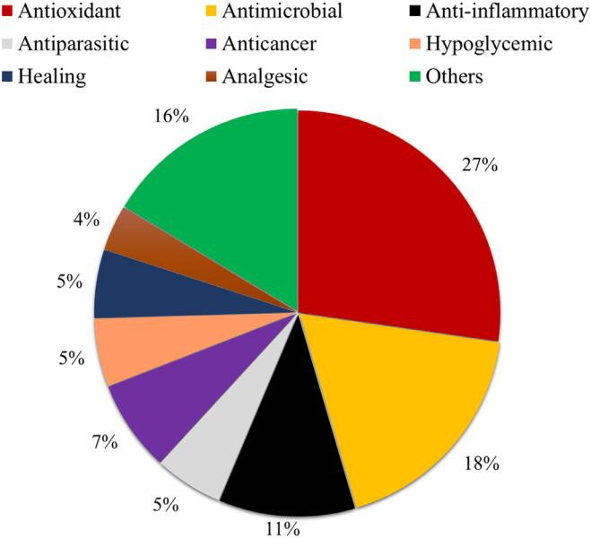

Fig. 1. Pharmacological activities reported for Sida species in the last five years (2015 2019).

434 F.C. Rodrigues and A.F.M. de Oliveira / South African Journal of Botany 132 (2020) 432 462

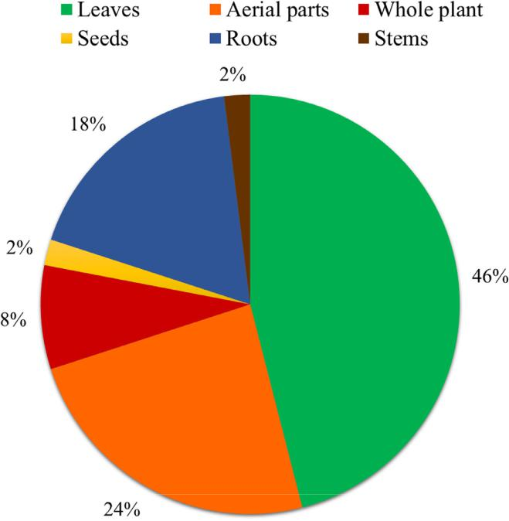

Fig. 2. Plant organs used in studies on biological and pharmacological activities reported for Sida species in the last five years (2015 2019). Aerial parts are not speci-fied by the authors of the studies.

counteracting the negative effects of induced oxidative stress in animals. Ankad et al. (2015) tested the antioxidant activity of eight species of Sida and found significant results using root extracts, with the best activity being reported for S. cordifolia. Sri-nithya et al. (2016) used the leaf extract of S. cordifolia to synthe-tize silver nanoparticles and found greater free radical scavenging activity than standard drugs. Sida cordifolia is a natural source of antioxidants, as evidenced by DPPH assays (Zaman and Khalid, 2015; Mahato and Banerjee, 2017).

4.2. Antimicrobial potential

Some species of the genus Sida stand out for their pronounced antimicrobial activity. Infusions from leaves and roots of S. tubercu-lata, for example, had significant clinical results against Candida kru-sei, with minimal inhibitory concentration (MIC) ranging from 3.9 to 62.5 mg/mL for leaves and from 1.95 to 31.25 mg/mL for roots (Rosa et al., 2015).

Halilu et al. (2016) observed the antibacterial activity of S. cordifo-lia against Staphyloccocus aureus and Bacillus subtilis, corroborating previous studies with the species (Mahesh and Satish, 2008). In addi-tion to antibacterial activity, S. cordifolia had also significant results against the pathogenic fungus C. albicans (Venkatachalam et al., 2019).

Recently, Bora (2016) demonstrated the antifungal activity of S. carpinifolia L.f. (synonym of S. acuta) against three species of the genus Candida. In a series of studies with compounds isolated from S. glutinosa, Das et al. (2016) identified pentyl-10,12-dimethyl-11-hydroxioleate as responsible for antifungal activity against Fusarium oxysporum. Rai et al. (2017) reported that the chloroform extract of the aerial parts of S. rhombifolia had antifungal potential against Aspergillus niger.

In the study by George et al. (2017), the ethanolic extract of S. acuta had higher antimicrobial activity than ciprofloxacin. In this case, antibacterial activity was attributed to the alkaloids present in the extract. Sida acuta also showed considerable antibacterial activity against S. aureus strains (Chumpol et al., 2018).

The action of extracts of S. corymbosa against S. aureus, E. coli, Pseudomonas aeruginosa and Streptococcus pyogenes was evaluated. All pathogens except E. coli were susceptible to the methanolic extract of the plant, thus proving its antibacterial activity (Jacob et al., 2018).

4.3. Anti-inflammatory activity

According to Tanumihardja et al. (2016), S. rhombifolia had an anti-inflammatory effect on periapical lesions in rats. Sida rhombifolia extracts, particularly n-hexane extract, also showed anti-inflamma-tory activity, presenting a half maximal inhibitory concentration (IC50) of 52.16 in a NO assay, and 146.03 mg/mL in a protein denatur-ation inhibition model (Mah et al., 2017). Sida rhombifolia also showed anti-inflammatory activity by inhibiting the enzyme cycloox-ygenase (COX-1 and COX-2) (Tanumihardja et al., 2019). According to Azad et al. (2017), the methanolic extract of S. rhombifolia has a dose-dependent anti-inflammatory effect leading to lower levels of blood sugar, inflammation, and pain in induced mouse paw edema. Moder-ate anti-inflammatory activity of the acetone extract of S. rhombifolia and S. acuta was also found (Arciniegas et al., 2017).

High anti-inflammatory activity was detected for S. cordifolia. The activity evaluated was the inhibition of mediators that usually increase during anti-inflammatory activity (as products of the arachi-donic acid metabolism pathway). It was observed that leaf extracts were able to inhibit the release of these mediators, consequently resulting in high anti-inflammatory activity (Martins et al., 2018). An indigenous formulation of S. cordifolia extracts also presented anti-inflammatory effect, and antioxidant as well as antiarthritic activity (Ratheesh et al., 2017).

4.4. Toxicity

Leaf and root extracts of S. tuberculata showed low toxicity against Artemia salina (Rosa et al., 2016). Silver nanoparticles synthesized from S. cordifolia extract showed lower cytotoxicity than commercial drugs (Srinithya et al., 2016).

The hexanic extract of S. rhombifolia showed strong toxicity against A. salina, while the methanolic and ethanolic extracts showed moderate activity (Mah et al., 2017). Sida acuta also showed cytotoxic activity (Kanthal, 2017). In the study by Nwankpa et al. (2018), S. acuta extracts showed toxicity in rat kidneys, with potential to induce renal dysfunction.

Sida carpinifolia, widely distributed in humid and shady areas in Brazil, is responsible for the poisoning of goats, horses, cattle and cer-vids (Reis et al., 2019).

4.5. Antiparasitic potential

Jatsa et al. (2015) found that the aqueous extract and especially the n-butanolic fraction of S. pilosa had strong antiparasitic activity against Schistosoma mansoni, with a median-lethal concentration (LC50) of 1.25 mg/mL. The remaining fractions showed 100% mortality only after 24 h of exposure. In other investigations (Jatsa et al., 2016, 2018), these authors found that the aqueous extract of S. pilosa dra-matically decreased the concentration of S. mansoni eggs in the liver

|  |  |
| --- | --- |
| F.C. Rodrigues and A.F.M. de Oliveira / South African Journal of Botany 132 (2020) 432 462 | 435 |

and intestine of infected mice, thus indicating the species as a prom-ising source of bioactive compounds against S. mansoni.

4.6. Anticancer activity

Anticancer activity of S. cordifolia using the in silico approach tar-geting Bcl-2 and VEGFR2 showed to be promising (Muthuraman et al., 2017). The silver nanoparticles synthesized from S. cordifolia leaves demonstrated anticancer activity against Ehrlich ascites carci-noma (EAC) and HT-29 cell lines (Srinithya et al., 2016). Sida acuta exhibited significant anticancer property in an in vivo model (Thon-dawada et al., 2016), and its chloroform extract showed anticancer activity against human A-431 squamous cell carcinoma and HeLa cer-vical carcinoma cell lines (Kanthal et al., 2017).

4.7. Hypoglycemic activity

The ethanolic extract of S. rhombifolia leaves showed dose-depen-dent inhibition of a-amylase and a-glucosidase, promoting glucose uptake and reducing blood glucose, thus showing antidiabetic activ-ity in rats (Bati et al., 2018). Sida cordifolia also had in vitro antidia-betic activity (Siddiqui et al., 2016). The methanolic, hexanic and ethyl acetate extracts of S. acuta and S. rhombifolia had their antihy-perglycemic activity against yeast and mammalian a-glucosidase enzyme assessed by Arciniegas et al. (2017). According to these authors, the acetone extract showed a higher inhibitory effect over the yeast enzyme, but no significant results were seen in the inhibi-tion of the enzyme in mammals.

4.8. Healing potential

The methanolic extract of the aerial parts of S. cordifolia signifi-cantly accelerated wound healing in diabetic rats (Pawar et al., 2016). Sida rhombifolia also showed potential for increased wound healing (Francis et al., 2018). The ethereal, acetate, methanolic and aqueous extracts of S. cordifolia accelerated the wound healing process in mice, thus providing support for its traditional use (Kumar et al., 2019).

4.9. Analgesic activity

Sida rhombifolia leaves showed analgesic activity, dose-depen-dently reducing acetic acid-induced pain in rats (Azad et al., 2017). Rosa et al. (2018a) proved the effective antinociceptive activity of S. tuberculata leaves, reducing acetic acid-induced abdominal contrac-tions in rats by about 70%.

4.10. Other activities

A recent study showed that the extract of S. rhombifolia associ-ated with the drug meloxicam is an alternative for the treatment of osteoarthritis (Sari and Marpaung, 2019). Shahed-Al-Mahmud et al. (2018) provided support for the ethnomedicinal use of S. cordifolia to control diarrhea. According to these authors, the hydroalcoholic extract of roots provided a significant and dose-dependent protection against castor oil- and magnesium sulfate-induced diarrhea in rats. Shah et al. (2017) demonstrated the

protective effect of S. cordata in the kidneys of rats with induced nephrotoxicity.

The extracts of S. acuta had sedative, hypnotic and anxiolytic effects, what indicates that this species can cause alterations in the central nervous system, thus providing support for its tradi-tional use to treat diseases of the nervous system (Benjumea et al., 2016). The hexanic extract of S. rhombifolia showed anti-cholinesterase activity (Mah et al., 2017) and a vasodilator effect (Chaves et al., 2017).

Sida corymbosa showed a hypolipidemic effect, acting on the con-trol of cholesterol levels and, therefore, potential to prevent cardio-vascular diseases (Chukwuemeka et al., 2018). The species also has antihemorrhagic properties (John-Africa and Aboh, 2015).

The photoprotective potential of S. galheirensis Ulbr. was investi-gated, but no significant results were found. It is believed that the negligible activity was due to the low amount of flavonoids in the ethanolic extract of the species (Nunes et al., 2018).

5. Chemistry of the genus Sida

A total of 142 chemical constituents had been identified in the genus Sida until 2015. Our study presents an update of the list of substances by including data published since the last review by Dinda et al. (2015). One hundred and twenty-one further sub-stances are reported now, 89 of which are described for the first time for the genus Sida, increasing the number of molecules to

1. (Table 1). Terpenoids and fatty acids were the main classes, with the largest number of constituents reported in the present update (Fig. 3).

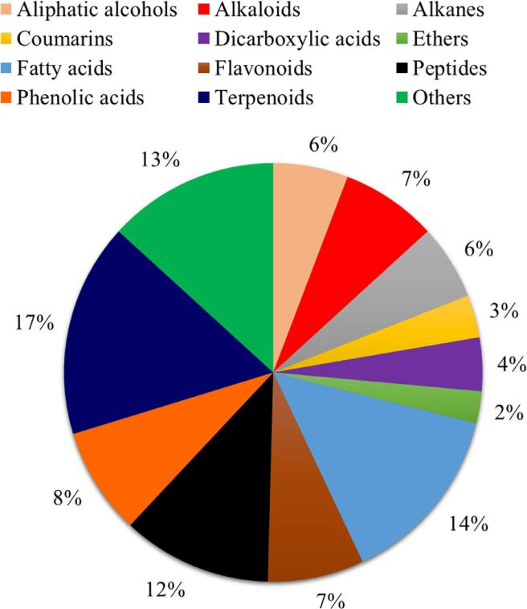

Fig. 3. Percentage of the main chemical classes found in species of the genus Sida in the last five years (2015 2019).

Table 1

Substances identified in the genus Sida L. and their respective biological activities.

|  |  |  |  |  |  |  |
| --- | --- | --- | --- | --- | --- | --- |
| Classes/Compounds | | | Species | Plant organ | Biological activity | References |
|  | |  |  |  |  |  |
| Aliphatic alcohols | | |  |  |  |  |
| 1) | 1-Heptatriacotanol* | | S. cordata | Whole plant | Antimicrobial | Ganesh and Mohanku- |
|  |  |  |  |  |  | mar, (2017) |
| 2) | 2-Methyl-1-hexadecanol* | | S. cordata | Whole plant | Antimicrobial | Ganesh and Mohanku- |
|  |  |  |  |  |  | mar, (2017) |
|  |  | |  |  |  |  |
|  |  |  |  |  |  |  |
| 3) | Z,Z-2,5-Pentadecadien-1-ol* | | S. cordata | Whole plant | - | Ganesh and Mohanku- |
|  |  |  |  |  |  | mar, (2017) |

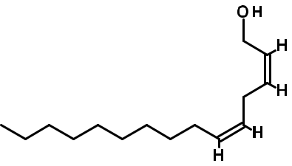

|  |  |  |  |  |  |  |  |  |  |  |  |  |
| --- | --- | --- | --- | --- | --- | --- | --- | --- | --- | --- | --- | --- |
| 4) | 3,7,11,15-Tetramethyl-2-hexadecan-1-ol | | | | | |  | S. cordata | Whole plant | Antimicrobial, anti- | Ganesh and Mohanku- |  |
|  |  |  |  |  |  |  |  |  |  | inflammatory | mar, (2017) |  |
|  |  |  |  |  |  |  |  |  | Whole plant | Antimicrobial | Ganesh and Mohanku- |  |
|  |  | |  | |  |  |  |  |  |
|  |  | |  |  |  |  |  |  |  |
| 5) | 1-Hexadecanol* | | | | | |  | S. cordata |  |
|  |  |  |  |  |  |  |  |  |  |  | mar, (2017) |  |
| 6) | 2-Hexadecen-1-ol* | | | | | |  | S. acuta | Leaves | - | Chinonso and Emeka, |  |
|  |  |  |  |  |  |  |  |  |  |  | (2017) |  |
|  |  |  |  |  |  |  |  |  | Leaves | - | Chinonso and Emeka, |  |
|  |  |  |  |  |  |  |  |  |  |
|  |  | |  | |  | |  |  |  |
| 7) | 1-Decanol* | | | | | |  | S. acuta |  |
|  |  |  |  |  |  |  |  |  |  |  | (2017) |  |
| Alkaloids | | | | | | |  |  |  |  |  |  |
| 8) | Quindolinone | | | | | |  | S. rhombifolia | Aerial parts | Vasorelaxant | Chaves et al., (2017) |  |

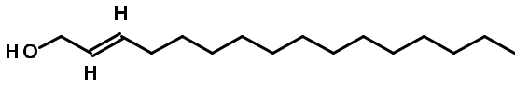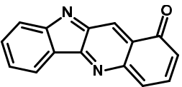

9) 11-Methoxy-quindoline S. rhombifolia Aerial parts Vasorelaxant Chaves et al., (2017)

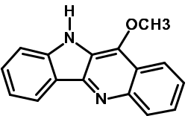

|  |
| --- |
| 436 |

|  |
| --- |
| F.C. Rodrigues and A.F.M. de Oliveira / South African Journal of Botany 132 (2020) 432 462 |

(continued on next page)

Table 1 (Continued)

Classes/Compounds

1. Quindoline

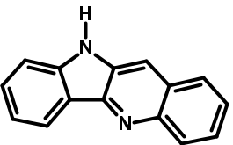

1. Salt of cryptolepine

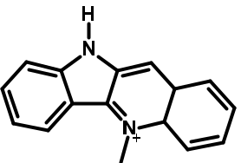

1. 1-(4-Bromobutyl)-2-piperidinone*

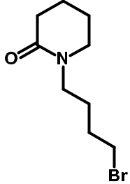

1. Vasicine

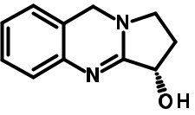

1. N‐Feruloyltyramine

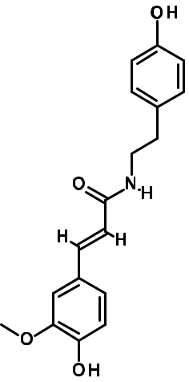

Species Plant organ Biological activity References

S. rhombifolia Aerial parts - Chaves et al., (2017)

S. rhombifolia Aerial parts - Chaves et al., (2017)

S. cordata Whole plant Antimicrobial, anti- Ganesh and Mohanku-

inflammatory mar, (2017)

S. tuberculata Leaves and roots Nociceptive Rosa et al., (2018a)

S. tuberculata Leaves and roots Antimicrobial, Nociceptive Rosa et al. (2015 and

2018a)

(continued on next page)

|  |
| --- |
| F.C. Rodrigues and A.F.M. de Oliveira / South African Journal of Botany 132 (2020) 432 462 |

|  |
| --- |
| 437 |

Table 1 (Continued)

Classes/Compounds

1. Norhamane

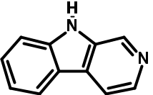

1. Epinephrine

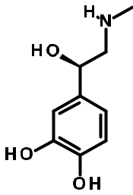

Alkanes

1. Cyclopentane*
2. Cyclohexane*
3. Tetracontane*
4. Tetrapentacontane*

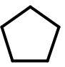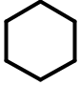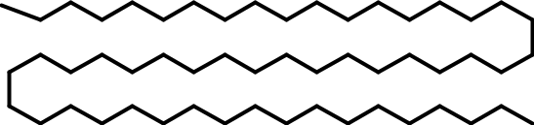

1. Dodecane, 2,6,10-trimethyl*
2. Octadecane, 1-(ethenyloxy)*
3. 1-Iodo-2-methylundecane*

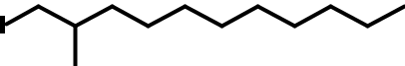

Species Plant organ Biological activity References

S. cordifolia Aerial parts Antioxidant Kumar et al., 2019

S. cordifolia Aerial parts Antioxidant Kumar et al., 2019

|  |  |  |  |
| --- | --- | --- | --- |
| S. acuta | Leaves | - | Chinonso and Emeka, |
|  |  |  | (2017) |
| S. acuta | Leaves | - | Chinonso and Emeka, |
|  |  |  | (2017) |
| S. rhombifolia | Whole plant | Antioxidant, anti-inflamma- | Mah et al. (2017) |
|  |  | tory, anti-cholinesterase, |  |
|  |  | cytotoxic |  |
| S. rhombifolia | Whole plant | Antioxidant, anti-inflamma- | Mah et al. (2017) |
|  |  | tory, anti-cholinesterase, |  |
|  |  | cytotoxic |  |
| S. cordata | Whole plant | - | Ganesh and Mohanku- |
|  |  |  | mar, (2017) |
| S. cordata | Whole plant | - | Ganesh and Mohanku- |
|  |  |  | mar, (2017) |
| S. cordata | Whole plant | - | Ganesh and Mohanku- |
|  |  |  | mar, (2017) |

|  |
| --- |
| 438 |

|  |
| --- |
| F.C. Rodrigues and A.F.M. de Oliveira / South African Journal of Botany 132 (2020) 432 462 |

(continued on next page)

Table 1 (Continued)

Classes/Compounds

Coumarins

1. Scopoletin
2. Scoparone

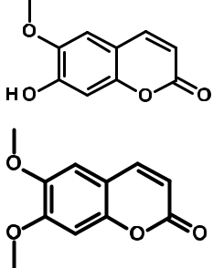

1. Ethoxy-ferulate*

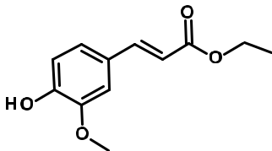

1. Bergenin*

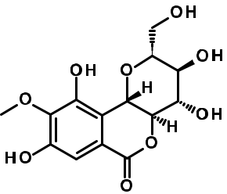

Dicarboxylic acids

1. 1,2-Benzenedicarboxylic acid, mono(2-ethylhexyl) ester

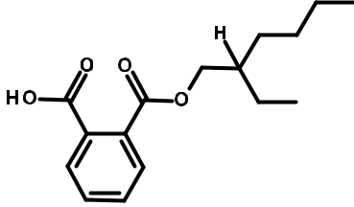

1. Citraconic acid*

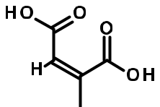

|  |  |  |  |
| --- | --- | --- | --- |
| Species | Plant organ | Biological activity | References |
| S. rhombifolia | Aerial parts | - | Chaves et al., (2017) |
| S. rhombifolia | Aerial parts | - | Chaves et al., (2017) |
| S. rhombifolia | Aerial parts | - | Chaves et al., (2017) |
| S. cordifolia | Aerial parts | Antioxidant | Kumar et al., 2019 |
| S. cordata | Whole plant | Cytotoxic | Ganesh and Mohanku- |
|  |  |  | mar, (2017) |
| S. cordifolia | Aerial parts | - | Kumar et al., 2019 |

|  |
| --- |
| F.C. Rodrigues and A.F.M. de Oliveira / South African Journal of Botany 132 (2020) 432 462 |

(continued on next page)

|  |
| --- |
| 439 |

Table 1 (Continued)

|  |  |  |  |  |  |  |  |  |  |
| --- | --- | --- | --- | --- | --- | --- | --- | --- | --- |
| Classes/Compounds | | |  |  | Species | Plant organ | Biological activity | References |  |
|  |  |  |  |  |  |  |  |  |  |
| 30) Diglycolic acid* | | |  |  | S. cordifolia | Aerial parts | - | Kumar et al., 2019 |  |
|  |  |  |  |  |  | Aerial parts | Skin diseases | Kumar et al., 2019 |  |
|  |  |  |  |  |  |  |
| 31) Mucic acid | | |  |  | S. cordifolia |  |
|  |  | |  |  |  | Aerial parts | Antioxidant | Kumar et al., 2019 |  |
|  |  | |  |  |  |  |
|  |  | |  |  |  |  |
|  |  | |  |  |  |  |
| 32) Terephthalic acid* | | |  |  | S. cordifolia |  |

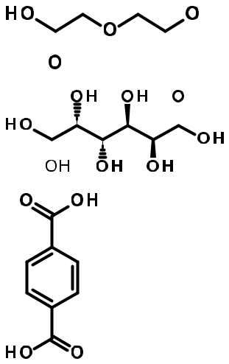

Ethers

33) Diethylene glycol monododecyl ether* S. cordata Whole plant Surfactant Ganesh and Mohanku-



mar, (2017)

34) Diethyl oxaloacetate* S. cordifolia Aerial parts - Kumar et al., 2019

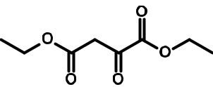

35) 4-Hydroxypenbutolol 4-[(2S)-3-(tert-butylamino)-2-hydroxypropoxy]-3-cyclopentylphenol* S. cordifolia Aerial parts - Kumar et al., 2019

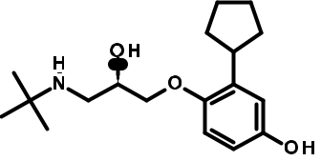

|  |  |  |  |  |  |  |  |
| --- | --- | --- | --- | --- | --- | --- | --- |
| Fatty acids | | |  |  |  |  |  |
| 36) 13-Docosenoic acid* | | | S. acuta | Leaves | - | Chinonso and Emeka, |  |
|  |  |  |  |  |  | (2017) |  |
|  |  |  |  |  |  | Mah et al. (2017) |  |
|  |  |  |  |  |  |  |
| 37) Palmitic acid | | | S. rhombifolia | Whole plant | Antioxidant, anti-inflamma- |  |
|  |  |  |  |  | tory, |  |  |
|  |  |  |  |  | anti-cholinesterase, |  |  |
|  |  |  |  |  | cytotoxic |  |  |
|  |  |  |  |  |  |  |
|  |  |  | S. acuta | Leaves | - | Chinonso and Emeka, |  |
|  |  |  |  |
|  |  |  |  |  |  | (2017) |  |
|  |  |  |  |  |  | (continued on next page) |  |



|  |
| --- |
| 440 |

|  |
| --- |
| F.C. Rodrigues and A.F.M. de Oliveira / South African Journal of Botany 132 (2020) 432 462 |

Table 1 (Continued)

Classes/Compounds

1. Linoleic acid
2. Docosanoic acid
3. Oleic acid
4. Methoxyacetic acid, 4-tetradecyl ester*

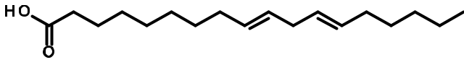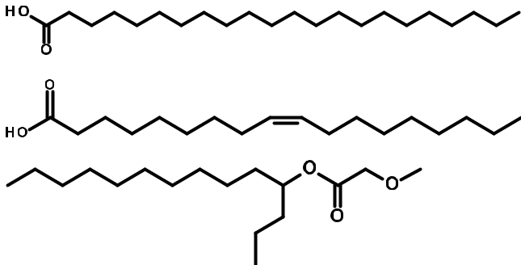

1. Octadecanoic acid*
2. 9,12-Octadecadienoic acid, methyl ester, (E,E)*

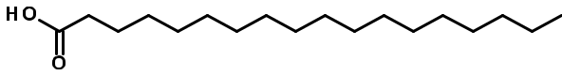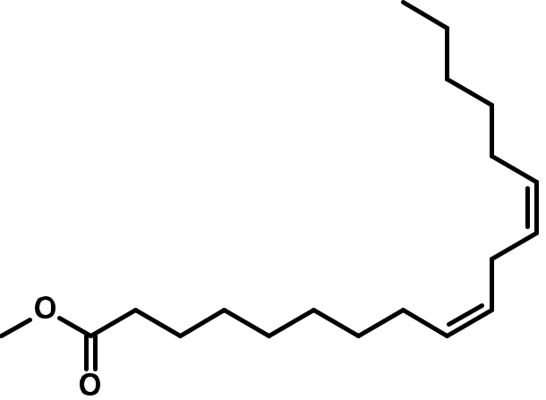

Species Plant organ Biological activity References

S. rhombifolia Whole plant Antioxidant, anti-inflamma- Mah et al. (2017)

tory,

anti-cholinesterase,

cytotoxic

S. rhombifolia Whole plant Antioxidant, anti-inflamma- Mah et al. (2017)

tory,

anti-cholinesterase,

cytotoxic

S. cordata Whole plant Anti-inflammatory, anti- Ganesh and Mohanku-

androgenic, mar, (2017)

anticancer, preservative,

hypocholesterolemic

S. cordata Whole plant Antimicrobial Ganesh and Mohanku-

mar, (2017)

S. rhombifolia Whole plant Antioxidant, anti-inflamma- Mah et al. (2017)

tory,

anti-cholinesterase,

cytotoxic

S. cordata Whole plant Antioxidant, anti- Ganesh and Mohanku-

inflammatory mar, (2017)

S. cordata Whole plant Hepatoprotective, antihista- Ganesh and Mohanku-

mine, mar, (2017)

hypocholesterolemic,

antieczemic

(continued on next page)

|  |
| --- |
| F.C. Rodrigues and A.F.M. de Oliveira / South African Journal of Botany 132 (2020) 432 462 |

|  |
| --- |
| 441 |

Table 1 (Continued)

|  |  |  |  |  |  |  |
| --- | --- | --- | --- | --- | --- | --- |
| Classes/Compounds |  |  | Species | Plant organ | Biological activity | References |
|  |  |  |  |  |  |  |
| 44) 9,12,15-Octadecadienoic acid, methyl ester, (Z,Z,Z)* |  |  | S. cordata | Whole plant | Anti-inflammatory, hypo- | Ganesh and Mohanku- |
|  |  |  |  |  | cholesterolemic, anti-can- | mar, (2017) |
|  |  |  |  |  | cer, anti-acne |  |
|  |  |  |  |  | hepatoprotective, nemati- |  |
|  |  |  |  |  | cide, antihistamine, anti- |  |
|  |  |  |  |  | eczemic, 5-Alpha |  |
|  |  |  |  |  | reductase inhibitor, anti- |  |
|  |  |  |  |  | androgen |  |
|  |  |  |  |  |  |  |
|  |  |  |  |  |  |  |

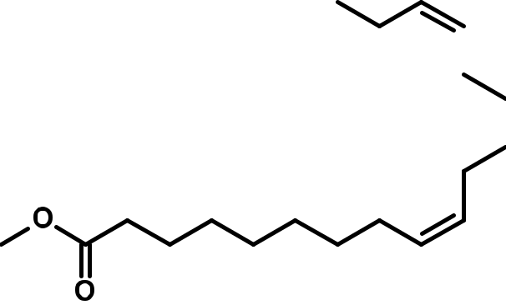

45) 9,12,15-Octadecatrienoic acid, 2-[(trimethylsilyl)oxy]-1-[[(trimethylsilyl)oxy]methyl]ethyl ester, (Z,Z,Z)* S. cordata Whole plant - Ganesh and Mohanku-

mar, (2017)

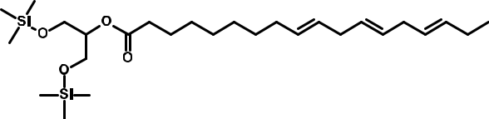

|  |  |  |  |  |  |  |  |  |
| --- | --- | --- | --- | --- | --- | --- | --- | --- |
| 46) Eicosanoic acid* | | | | S. rhombifolia | Whole plant | Antioxidant, anti-inflamma- | Mah et al. (2017) |  |
|  |  |  |  |  |  | tory, anti-cholinesterase, |  |  |
|  |  |  |  |  |  | cytotoxic |  |  |
|  |  |  |  |  |  |  |  |
| 47) Nonanoic acid* | | | | S. cordata | Whole plant | Antimicrobial | Ganesh and Mohanku- |  |
|  |  |  |  |  |  |  | mar, (2017) |  |
|  |  |  |  | S. rhombifolia | Roots | Anti-inflammatory | Tanumihardja et al., |  |
|  |  |  |  |  |
|  |  |  |  |  |  |  | (2019) |  |
| 48) 12-Oxo-14,18-dihydroxy-9Z,13E,15Z-octadecatrienoic acid* | | | |  |  |  |  |
| S. cordifolia | Aerial parts | - | Kumar et al., 2019 |  |

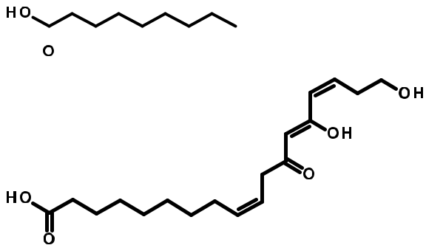

(continued on next page)

|  |
| --- |
| 442 |

|  |
| --- |
| F.C. Rodrigues and A.F.M. de Oliveira / South African Journal of Botany 132 (2020) 432 462 |

Table 1 (Continued)

Classes/Compounds

1. 4-Amino-4-deoxychorismic acid*

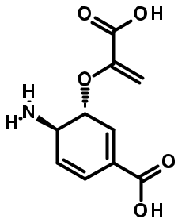

1. Undecanedioic acid*
2. Pentyl-10,12-dimethyl-11-hydroxyoleate*

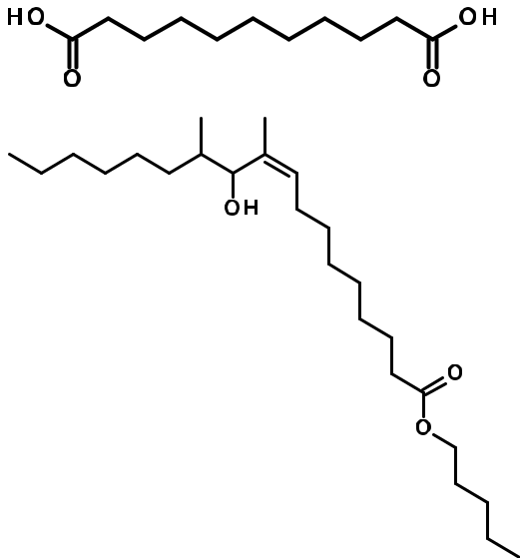

1. Z-3,6,6-Trimethyl-hept-2-en-1-ol

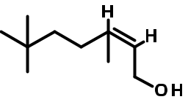

Flavonoids

1. Kaempferol-3-O-β-D-(6”-E-p-coumaroyl)-glucopyranoside

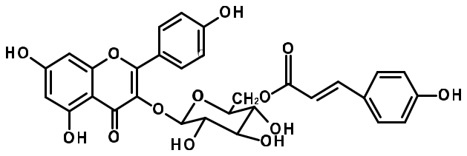

Species Plant organ Biological activity References

S. cordifolia Aerial parts - Kumar et al., 2019

S. cordifolia Aerial parts - Kumar et al., 2019

S. glutinosa Aerial parts - Das et al., (2016)

S. rhombifolia Roots Anti-inflammatory Tanumihardja et al.,

(2019)

S. tuberculata Leaves and roots Anti-Candida krusei Rosa et al., (2015)

|  |
| --- |
| F.C. Rodrigues and A.F.M. de Oliveira / South African Journal of Botany 132 (2020) 432 462 |

(continued on next page)

|  |
| --- |
| 443 |

Table 1 (Continued)

Classes/Compounds

1. Catechin

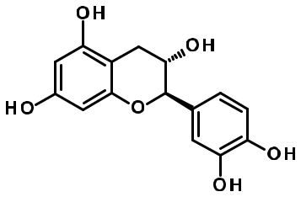

1. Kaempferol

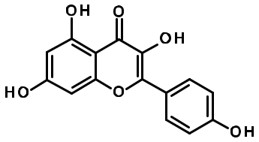

1. Kaempferol-3-O-β-D-glucose-6’’-α-D-rhamnose*

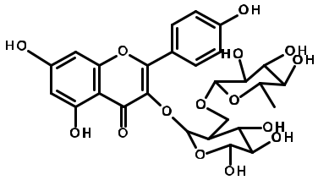

1. Kaempferol‐3‐(6‐p‐Coumaroyl) glucopyranoside*

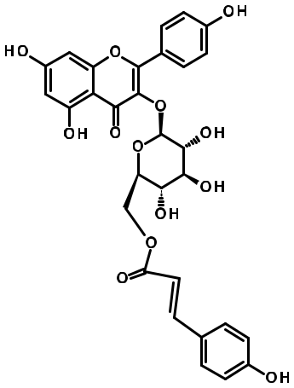

Species Plant organ Biological activity References

S. cordata Whole plant Antihyperglycemic Shah et al. (2017)

S. rhombifolia Aerial parts - Chaves et al., (2017)

S. rhombifolia Aerial parts - Chaves et al., (2017)

S. tuberculata Leaves and roots Nociceptive Rosa et al., (2018a)

|  |
| --- |
| 444 |

|  |
| --- |
| F.C. Rodrigues and A.F.M. de Oliveira / South African Journal of Botany 132 (2020) 432 462 |

(continued on next page)

Table 1 (Continued)

Classes/Compounds

1. Duartin (-)*

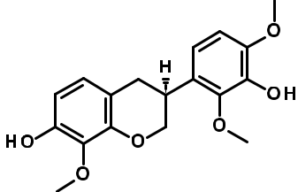

1. Duartin*

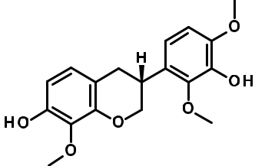

1. Apiin (Apigenin 7-O-apioglucoside)*

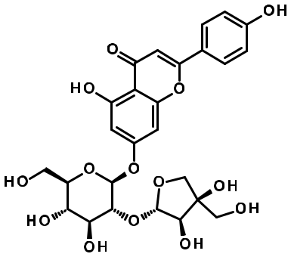

1. 2-(7-Heptadecynyloxy)tetrahydro-2H-pyran*

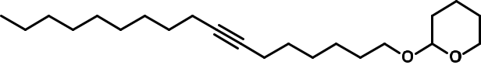

Species Plant organ Biological activity References

S. cordifolia Aerial parts Antioxidant, Kumar et al., 2019

Trypanosomicide

|  |  |  |  |  |  |
| --- | --- | --- | --- | --- | --- |
| S. cordifolia | Aerial parts | Antioxidant, anti- | Kumar et al., 2019 | C.F |  |
|  |  | fl |  |  |
|  |  | in ammatory |  | . |  |
| S. cordifolia | Aerial parts | Anticarcinogenic, anti-acne, | Kumar et al., 2019 | Oliveirade.M.F.AandRodrigues |  |
| / |  |
|  |  | atopic dermatitis |  |  |
|  |  |  | (2020)132BotanyofJournalAfricanSouth |  |
|  |  |  |  |  |
| S. cordata | Whole plant | Antimicrobial, anti-inflam- | Ganesh and Mohanku- | 432 |  |
| 462 |  |
|  |  | matory, antioxidant | mar, (2017) |  |
|  |  |  |  |  |
|  |  |  | (continued on next page) |  |  |

|  |
| --- |
| 445 |

Table 1 (Continued)

Classes/Compounds

Peptides

1. Leu Pro*

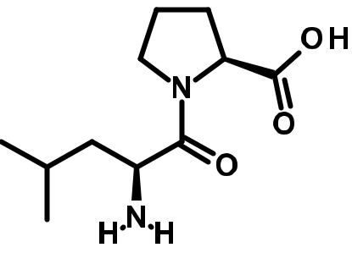

1. Ala Pro His*

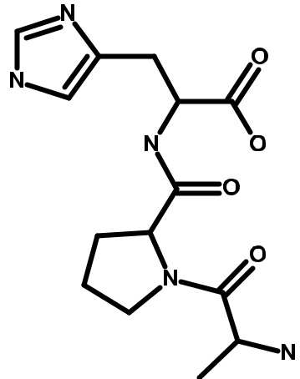

1. Pro Lys*

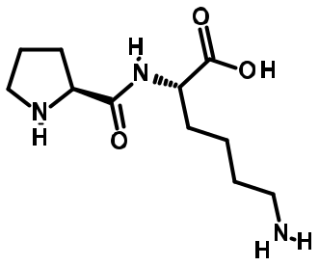

1. Ala Pro Ala*

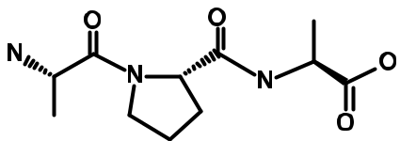

Species Plant organ Biological activity References

S. cordifolia Aerial parts - Kumar et al., 2019

S. cordifolia Aerial parts - Kumar et al., 2019

S. cordifolia Aerial parts - Kumar et al., 2019

S. cordifolia Aerial parts - Kumar et al., 2019

|  |
| --- |
| 446 |

|  |
| --- |
| F.C. Rodrigues and A.F.M. de Oliveira / South African Journal of Botany 132 (2020) 432 462 |

(continued on next page)

Table 1 (Continued)

Classes/Compounds

1. Ala Ala Val*

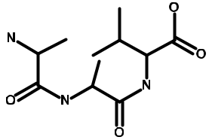

1. Val Lys Gly*

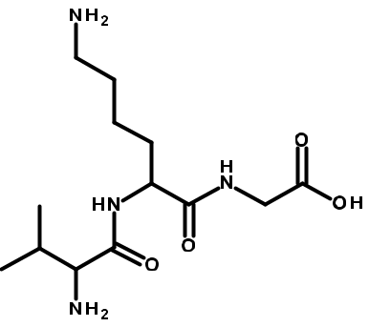

1. Trp Asp Val*

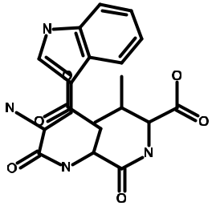

1. Trp Lys Asp*

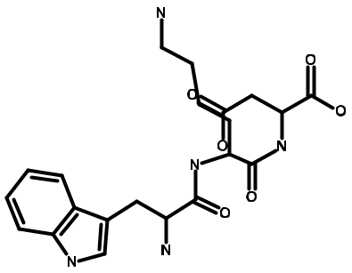

Species Plant organ Biological activity References

S. cordifolia Aerial parts - Kumar et al., 2019

S. cordifolia Aerial parts - Kumar et al., 2019

S. cordifolia Aerial parts - Kumar et al., 2019

S. cordifolia Aerial parts - Kumar et al., 2019

(continued on next page)

|  |
| --- |
| F.C. Rodrigues and A.F.M. de Oliveira / South African Journal of Botany 132 (2020) 432 462 |

|  |
| --- |
| 447 |

Table 1 (Continued)

Classes/Compounds

1. Asp Asp Trp*

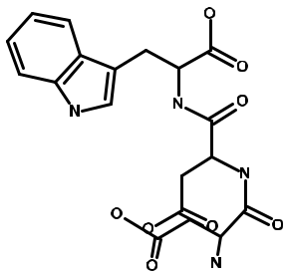

1. Phe His Gly*

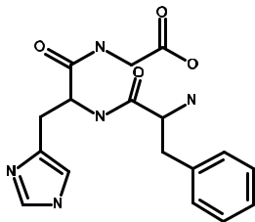

1. Pro Trp Lys*

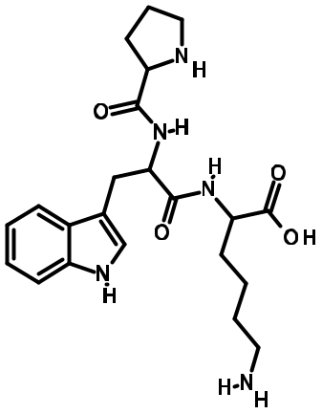

1. Arg Pro*

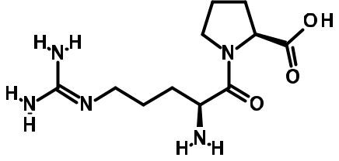

Species Plant organ Biological activity References

S. cordifolia Aerial parts - Kumar et al., 2019

S. cordifolia Aerial parts - Kumar et al., 2019

S. cordifolia Aerial parts - Kumar et al., 2019

S. cordifolia Aerial parts - Kumar et al., 2019

|  |
| --- |
| 448 |

|  |
| --- |
| F.C. Rodrigues and A.F.M. de Oliveira / South African Journal of Botany 132 (2020) 432 462 |

(continued on next page)

Table 1 (Continued)

Classes/Compounds

1. Trp Glu Pro*

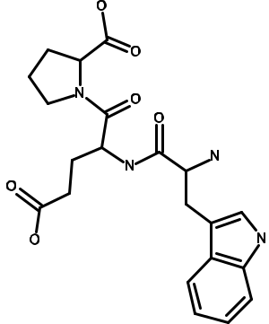

1. Trp Lys Asp*

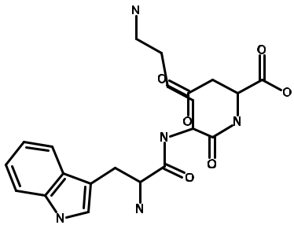

Phenolic acids

1. Gallic acid*

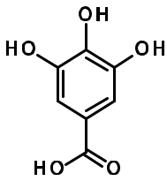

1. Caffeic acid*

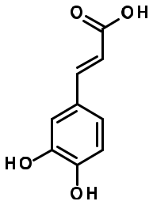

Species Plant organ Biological activity References

S. cordifolia Aerial parts - Kumar et al., 2019

S. cordifolia Aerial parts - Kumar et al., 2019

S. cordata Whole plant Antihyperglycemic Shah et al. (2017)

S. cordata Whole plant Antihyperglycemic Shah et al. (2017)

(continued on next page)

|  |
| --- |
| F.C. Rodrigues and A.F.M. de Oliveira / South African Journal of Botany 132 (2020) 432 462 |

|  |
| --- |
| 449 |

Table 1 (Continued)

Classes/Compounds

1. 4-Amino-4-deoxychorismic acid

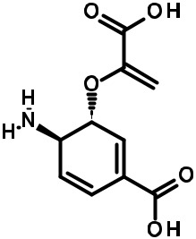

1. 2-Hydroxy-3,4-dimethoxybenzene acid*

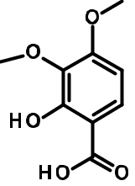

1. Homovanillic acid

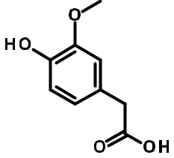

1. Eudesmic acid*

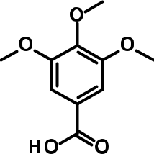

1. Atrolactic acid (2-Hydroxy-2-phenylpropanoic acid)*

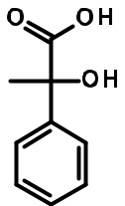

Species Plant organ Biological activity References

S. cordifolia Aerial parts - Kumar et al., 2019

S. cordifolia Aerial parts - Kumar et al., 2019

S. cordifolia Aerial parts - Kumar et al., 2019

S. cordifolia Aerial parts Antioxidant, wound healing Kumar et al., 2019

S. cordifolia Aerial parts Skin diseases Kumar et al., 2019

|  |
| --- |
| 450 |

|  |
| --- |
| F.C. Rodrigues and A.F.M. de Oliveira / South African Journal of Botany 132 (2020) 432 462 |

(continued on next page)

Table 1 (Continued)

Classes/Compounds

1. Valeryl salycilate*

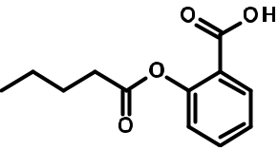

1. 2-Hydroxy-3-[4-(2-methoxyethyl)phenoxy]propanoic acid*

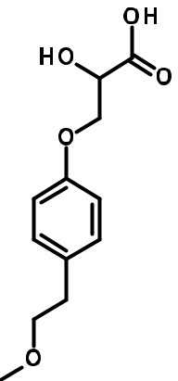

1. 3,4-Dihydroxy mandelate*

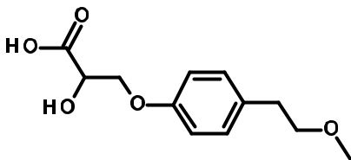

Terpenoids

1. Stigmasterol

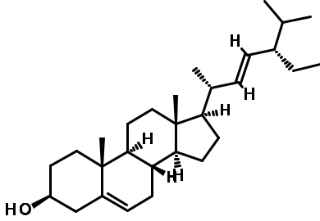

Species Plant organ Biological activity References

S. cordifolia Aerial parts - Kumar et al., 2019

S. cordifolia Aerial parts - Kumar et al., 2019

S. cordifolia Aerial parts - Kumar et al., 2019

S. cordifolia Leaves Antibacterial Halilu et al. (2016)

S. rhombifolia Whole plant Antioxidant, anti-inflamma- Mah et al. (2017)

tory,

anti-cholinesterase,

cytotoxic

(continued on next page)

|  |
| --- |
| F.C. Rodrigues and A.F.M. de Oliveira / South African Journal of Botany 132 (2020) 432 462 |

|  |
| --- |
| 451 |

Table 1 (Continued)

Classes/Compounds

1. γ-Sitosterol*

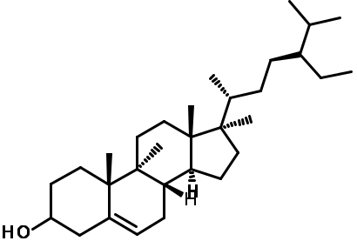

1. Sitostenone*

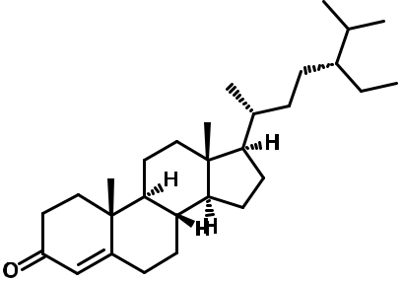

1. 5α-Cholestan-3β-ol, 2-methylene*

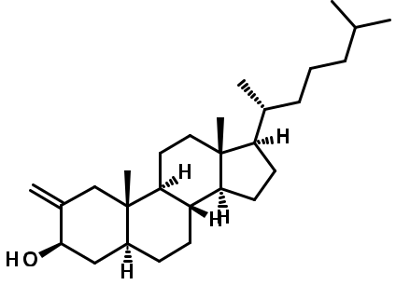

1. Spiro[androst-5-ene-17,1′-cyclobutan]-2′-one, 3-hydroxy-, (3α,17α)*

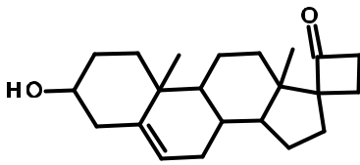

Species Plant organ Biological activity References

S. rhombifolia Whole plant Antioxidant, anti-inflamma- Mah et al. (2017)

tory,

anti-cholinesterase,

cytotoxic

S. rhombifolia Whole plant Antioxidant, anti-inflamma- Mah et al. (2017)

tory,

anti-cholinesterase,

cytotoxic

S. cordata Whole plant Antimicrobial, anticancer, Ganesh and Mohanku-

diuretic, mar, (2017)

anti-asthmatic, anti-

arthritic

S. cordata Whole plant Antimicrobial, anticancer, Ganesh and Mohanku-

diuretic, mar, (2017)

anti-asthmatic, anti-

arthritic,

anti-inflammatory

|  |
| --- |
| 452 |

|  |
| --- |
| F.C. Rodrigues and A.F.M. de Oliveira / South African Journal of Botany 132 (2020) 432 462 |

(continued on next page)

Table 1 (Continued)

Classes/Compounds

1. Ecdysone

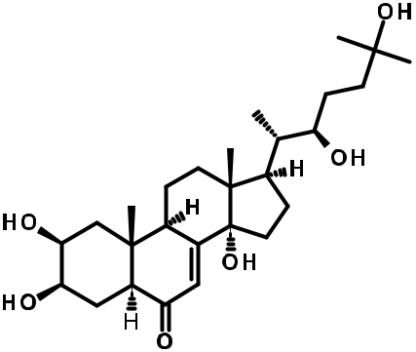

1. 20-Hydroxyecdysone

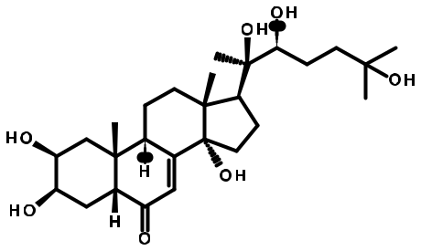

1. 5,20-Hydroxyecdysterone derivative

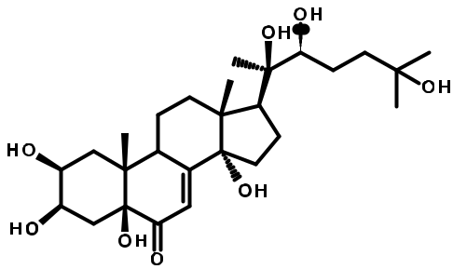

Species Plant organ Biological activity References

S. tuberculata Leaves and roots Nociceptive Rosa et al., (2018a)

|  |  |  |  |
| --- | --- | --- | --- |
| S. tuberculata | Leaves | Antimicrobial | Rosa et al., (2015) |
| S. tuberculata | Leaves and roots | Nociceptive | Rosa et al., (2018a and |
|  |  |  | 2018b) |
| S. cordifolia | Aerial parts | Wound healing | Kumar et al., 2019 |

S. tuberculata Leaves and roots Antimicrobial Rosa et al., (2015)

(continued on next page)

|  |
| --- |
| F.C. Rodrigues and A.F.M. de Oliveira / South African Journal of Botany 132 (2020) 432 462 |

|  |
| --- |
| 453 |

Table 1 (Continued)

Classes/Compounds

1. 20-Hydroxyecdysone-3-O-β-D-xylose

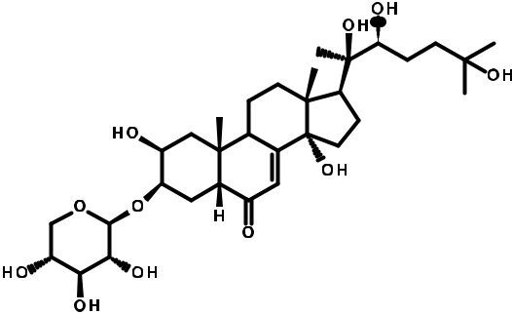

1. 20‐Hydroxyecdysone‐3‐O-β-D-glucopyranoside*

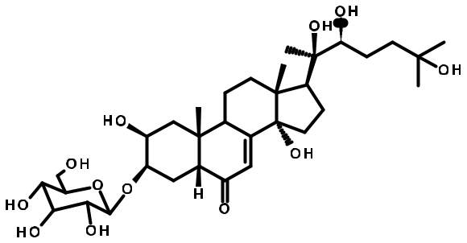

1. 5,20‐Dihydroxyecdysone

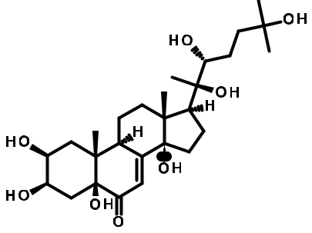

Species Plant organ Biological activity References

S. tuberculata Leaves and roots Anti-Candida krusei Rosa et al., (2015)

S. tuberculata Leaves and roots Antimicrobial, nociceptive Rosa et al. (2015 and

2018a)

S. tuberculata Leaves and roots Anti-Candida krusei, Rosa et al. (2015 and

Nociceptive 2018a)

(continued on next page)

|  |
| --- |
| 454 |

|  |
| --- |
| F.C. Rodrigues and A.F.M. de Oliveira / South African Journal of Botany 132 (2020) 432 462 |

Table 1 (Continued)

Classes/Compounds

1. 20‐Hydroxyecdysone‐3‐deoxyhexose*

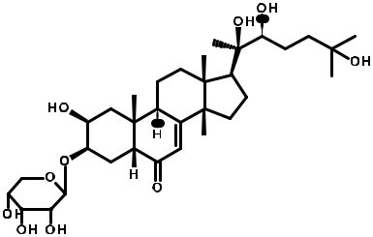

1. Phytol*
2. Cis-Z-α-Bisabolene epoxide*
3. 8-Epi-11-Hydroxyiridodial glucoside pentaacetate*

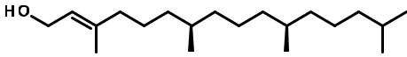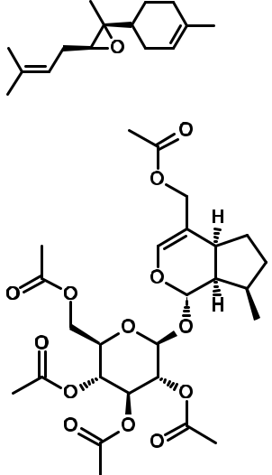

Species Plant organ Biological activity References

S. tuberculata Leaves and roots Nociceptive Rosa et al., (2018a)

S. cordata Whole plant Antinociceptive, antioxidant, Ganesh and Mohanku-

anticancer, anti-inflamma- mar, (2017)

tory, antimicrobial,

diuretic

S. cordata Whole plant Libido, hormonal Ganesh and Mohanku-

mar, (2017)

S. cordifolia Aerial parts Wound healing Kumar et al., 2019

(continued on next page)

|  |
| --- |
| F.C. Rodrigues and A.F.M. de Oliveira / South African Journal of Botany 132 (2020) 432 462 |

|  |
| --- |
| 455 |

Table 1 (Continued)

Classes/Compounds

1. Monotropein

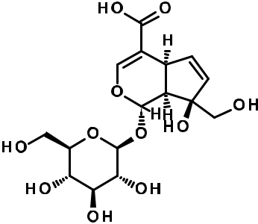

1. Plant juvenile hormone III*
2. Lupenone*

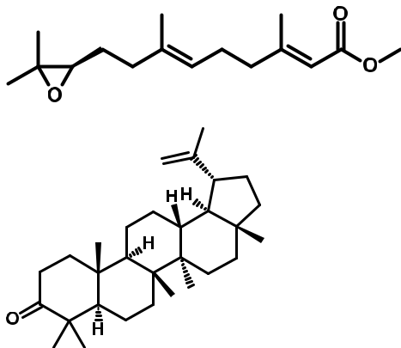

1. Lupeol*

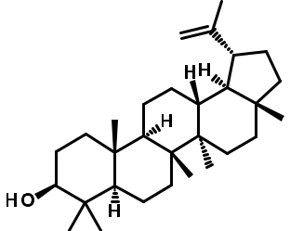

1. Squalene*

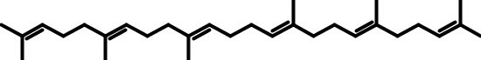

|  |  |  |  |  |  |
| --- | --- | --- | --- | --- | --- |
|  |  |  |  | 456 |  |
| Species | Plant organ | Biological activity | References |  |  |
| S. cordifolia | Aerial parts | Antioxidant, cytotoxic | Kumar et al., 2019 |  |  |
|  |  |  |  | .C.F |  |
| S. cordifolia | Aerial parts | - | Kumar et al., 2019 | de.M.F.AandRodrigues |  |
|  |  |
| S. rhombifolia | Whole plant | Antioxidant, anti-inflamma- | Mah et al. (2017) | /Oliveira |  |
|  |  | tory, |  |  |
|  |  |  |  |  |
|  |  | anti-cholinesterase, |  |  |  |
|  |  | cytotoxic |  | ofJournalAfricanSouth |  |
|  |  |  |  |  |
| S. rhombifolia | Whole plant | Antioxidant, anti-inflamma- | Mah et al. (2017) | Botany |  |
|  |  |
|  |  | tory, |  | 132 |  |
|  |  | anti-cholinesterase, |  |  |
|  |  | cytotoxic |  | 462432(2020) |  |
|  |  |  |  |  |
| S. cordata | Whole plant | Antioxaidant, antitumor | Ganesh and Mohanku- |  |  |
|  |  |  | mar, (2017) |  |  |
|  |  |  | (continued on next page) |  |  |

Table 1 (Continued)

|  |  |  |  |  |
| --- | --- | --- | --- | --- |
| Classes/Compounds | Species | Plant organ | Biological activity | References |
|  |  |  |  |  |
| Others 106) Vitamin D3* | S. cordata | Whole plant | - | Ganesh and Mohanku- |
|  |  |  |  | mar, (2017) |

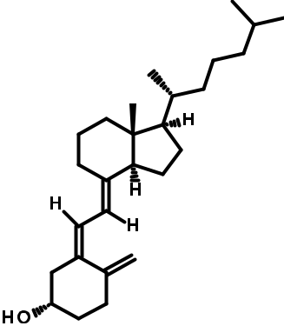

|  |  |  |  |  |  |  |  |  |  |  |  |  |  |  |  |  |  |  |  |  |  |
| --- | --- | --- | --- | --- | --- | --- | --- | --- | --- | --- | --- | --- | --- | --- | --- | --- | --- | --- | --- | --- | --- |
| 107) Vitamin E* | | | | | | | | | | | | | | | | |  | S. cordata | Whole plant | - | Ganesh and Mohanku- |
|  |  |  |  |  |  |  |  |  |  |  |  |  |  |  |  |  |  |  |  |  | mar, (2017) |
|  |  |  |  |  |  |  |  |  |  |  |  |  |  |  |  |  |  |  |  |  |  |
|  |  |  |  |  |  |  |  |  |  |  |  |  |  |  |  |  |  |  |  |  |  |
|  |  |  |  |  |  |  |  |  |  |  |  |  |  |  |  |  |  |  |  |  |  |
|  |  |  |  |  |  |  |  |  |  |  |  |  |  |  |  |  |  |  |  |  |  |
|  |  |  |  |  |  |  |  |  |  |  |  |  |  |  |  |  |  |  |  |  |  |
|  |  |  |  |  |  |  |  |  |  |  |  |  |  |  |  |  |  |  |  |  |  |
|  |  |  |  |  |  |  |  |  |  |  |  |  |  |  |  |  |  |  |  |  |  |
|  |  |  |  |  |  |  |  |  |  |  |  |  |  |  |  |  |  |  |  |  |  |

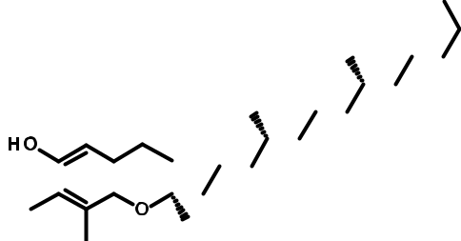

108) 3-Hexadecyloxycarbonyl-5-(2-hydroxyethyl)-4-methylimidazolium ion* S. cordata Whole plant Antifungal, Ganesh and Mohanku-

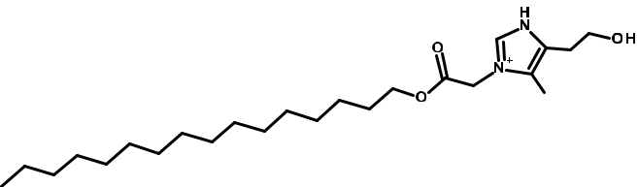

antibacterial mar, (2017)

S. cordifolia Aerial parts - Kumar et al., 2019

1. Deoxyguanosine*

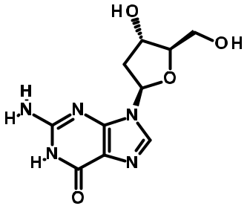

|  |
| --- |
| F.C. Rodrigues and A.F.M. de Oliveira / South African Journal of Botany 132 (2020) 432 462 |

(continued on next page)

|  |
| --- |
| 457 |

Table 1 (Continued)

Classes/Compounds

1. Guanosine*

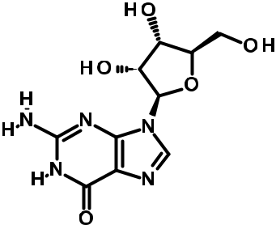

1. Succinoadenosine

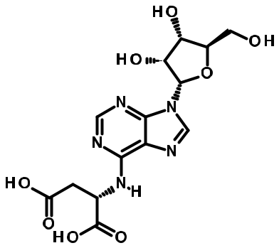

1. 6-Mercaptopurine

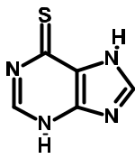

1. L-4-Hydroxy-3-methoxy-α-methylphenylalanine*

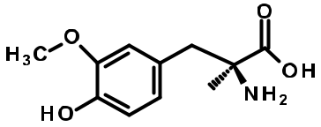

1. 3-Trifluroacetoxypentadecane*

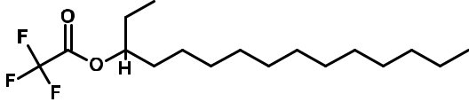

Species Plant organ Biological activity References

S. cordifolia Aerial parts - Kumar et al., 2019

S. cordifolia Aerial parts - Kumar et al., 2019

S. cordifolia Aerial parts - Kumar et al., 2019

S. cordifolia Aerial parts - Kumar et al., 2019

S. cordata Whole plant Antioxidant, anti- Ganesh and Mohanku-

nephrotoxicity mar, (2017)

(continued on next page)

|  |
| --- |
| 458 |

|  |
| --- |
| F.C. Rodrigues and A.F.M. de Oliveira / South African Journal of Botany 132 (2020) 432 462 |

Table 1 (Continued)

|  |  |  |  |  |
| --- | --- | --- | --- | --- |
| Classes/Compounds | Species | Plant organ | Biological activity | References |
|  |  |  |  |  |
| 115) Methyl 8-[2-(2-formyl-vinyl)-3-hydroxy-5-oxo-cyclopentyl]-octanoate* | S. cordifolia | Aerial parts | - | Kumar et al., 2019 |

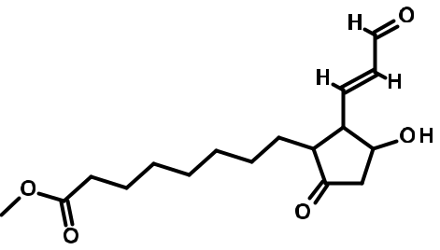

116) 1,2-15,16-Diepoxyhexadecane* S. cordata Whole plant Antitumor, anti- Ganesh and Mohanku-

inflammatory mar, (2017)



117) O-Acetylserine* S. cordifolia Aerial parts - Kumar et al., 2019

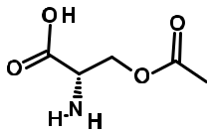

|  |  |  |  |  |  |  |
| --- | --- | --- | --- | --- | --- | --- |
| 118) Toluene* | | S. acuta | Leaves | - | Chinonso and Emeka, |  |
|  |  |  |  |  | (2017) |  |
|  |  |  |  |  |  |
|  |  |  |  |  |  |  |

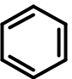

119) Desmosine* S. cordifolia Aerial parts - Kumar et al., 2019

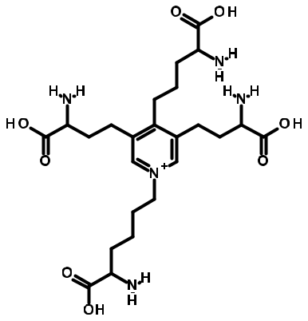

(continued on next page)

|  |
| --- |
| F.C. Rodrigues and A.F.M. de Oliveira / South African Journal of Botany 132 (2020) 432 462 |

|  |
| --- |
| 459 |

460

|  |  |  |
| --- | --- | --- |
| References | Ganesh and Mohanku-mar,(2017) | Kumar et al., 2019 |
| Biological activity | - | - |
| Plant organ | Whole plant | Aerial parts |
| Species | S. cordata | S. cordifolia |

|  |  |  |  |
| --- | --- | --- | --- |
| Table 1 (Continued) | Classes/Compounds | 120) a-D-Glucopyranosyl-(1- 3)-a-D-fructofuranosyl a-D-galactopyranoside*> | 121) Maltotriose* |

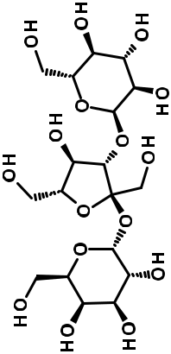

F.C. Rodrigues and A.F.M. de Oliveira / South African Journal of Botany 132 (2020) 432 462

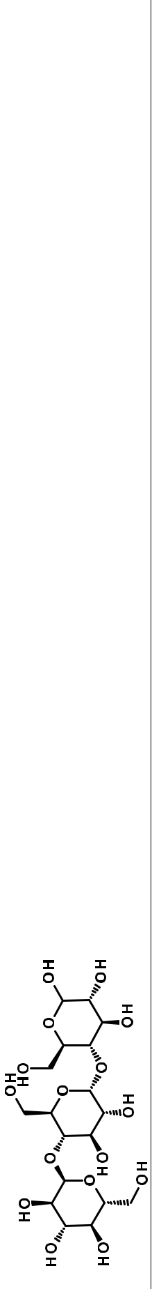

6. Conclusion

Our review compiled information on ethnomedicinal uses, pharmacological activities and phytochemistry of species of the genus Sida from 2015 to present date. Sida is a genus of great importance worldwide, whose ethnomedicinal uses have been supported by several pharmacological studies, through in vitro and in vivo assays. The studies have focused on some species of the genus, such as S. acuta, S. cordifolia and S. rhombifolia, while few works have been dedicated to other species such as S. gal-heirensis. Sida species are traditionally used for the treatment of various health conditions, especially ulcers, asthma, fever, pain, rheumatism and diarrhea. Phytochemical investigations have demonstrated the potential of this genus as a source of bioactive substances. The new substances discovered over the last few years further reinforce the medicinal importance of Sida species.

Declaration of Competing Interest

The aucthors declare that there are no conflicts of interest regard-ing the publication of this paper.

Acknowledgements

This study was financed in part by the Coordenac¸ao~ de Aperfei-

coamento¸ de Pessoal de Nível Superior - Brazil (CAPES) - Finance Code 001. FCR thanks CAPES - Brazil for the provision of master's degree fellowships. AFMO received the support of a research fellow-ship from the National Council for Scientific and Technological Devel-opment (CNPq) of Brazil.

References

|  |  |  |  |  |  |  |  |  |  |  |  |  |  |  |
| --- | --- | --- | --- | --- | --- | --- | --- | --- | --- | --- | --- | --- | --- | --- |
|  | Ahmed, H., Juraimi, A.S., Swamy, M.K., Ahmad-Hamdani, M.S., Omar, D., Rafii, M.Y., | | | | | | | | | | | | |  |
|  | Sinniah, U.R., Akhtar, M.S., 2018. Botany, chemistry, and pharmaceutical signifi- | | | | | | | | | | | | |  |
|  | cance of Sida cordifolia: a traditional medicinal plant. In: Akhtar, | | | | | | | | | | | | M., |  |
|  | Swamy, M. (Eds.), Anticancer plants: Properties and Application. Springer, Singa- | | | | | | | | | | | | |  |
|  | pore, pp. 517–537. [https://doi.org/10.1007/978-981-10-8548-2_22.](https://doi.org/10.1007/978-981-10-8548-2_22) | | | | | | | | | | | |  |  |
|  | Ankad, G., Bhagwat, S., Hegde, H., Subramanya, M., Upadhya, V., Pai, S., 2015. Total | | | | | | | | | | | | |  |
|  | polyphenolic contents and in vitro antioxidant properties of eight Sida species | | | | | | | | | | | | |  |
|  | from Western Ghats. India. J. Ayurveda. Integr. Med. 6, 24–28. [https://doi.org/](https://doi.org/10.4103/0975-9476.146544) | | | | | | | | | | | | |  |
| reported. | [10.4103/0975-9476.146544.](https://doi.org/10.4103/0975-9476.146544) | | | | | |  |  |  |  |  |  |  |  |
| metabolites from Sida acuta and Sida rhombifolia. Quim. Nova 40, 176–181. http:// | | | | | | | | | | | | |  |
|  | Arciniegas, A., Perez | | -Castorena, A.L., Nieto-Camacho, A., Kita, Y., Vivar, A.R., 2017. Anti- | | | | | | | | | | |  |
|  | hyperglycemic, | | antioxidant, and | | | | | anti-inflammatory | | | activities of extracts | | and |  |
| not | [dx.doi.org/10.21577/0100-4042.20160182.](http://dx.doi.org/10.21577/0100-4042.20160182) | | | | | | | | |  |  |  |  |  |
|  |  |  |  |  |  |
| activity | Attanayake, A.P., Jayatilaka, K.A.P.W., Pathirana, C., Mudduwa, L.K.B., 2015. Phytochem- | | | | | | | | | | | | |  |
| ical screening and in vitro antioxidant potentials of extracts of ten medicinal plants | | | | | | | | | | | | |  |
|  |  |
|  | used for the treatment of diabetes mellitus in Sri Lanka. Afr. J. Tradit. Complement. | | | | | | | | | | | | |  |
| Biological | Altern. Med. 12, 28–33. [http://dx.doi.org/10.4314/ajtcam.v12i4.5.](http://dx.doi.org/10.4314/ajtcam.v12i4.5) | | | | | | | | | | | |  |  |
| L. Leaves on Experimental Mice. Int. J. Pharm. Sci. Scient. Res. 3, 7–82. https://doi. | | | | | | | | | | | | |  |
|  | Azad, A.K., Islam, O., Khairuzzaman, M., Ferdous, J., Shaheen, S.M., 2017. Hypoglycemic, | | | | | | | | | | | | |  |
|  | analgesic and anti-inflammatory activities of methanol extract of Sida rhombifolia | | | | | | | | | | | | |  |
| - | org/10.25141/2471-6782-2017-7.0082 . | | | | | | | |  |  |  |  |  |  |
| L. | Bati, K., Kwape, T.E., Chaturvedi, P., 2018. The inhibitory effect of an ethanol extract of | | | | | | | | | | | | |  |
| Sida |  |
| Sida rhombifolia leaves on key carbohydrate hydrolyzing enzymes. J. Complement. | | | | | | | | | | | | |  |
| genus | Med. Res. 9, 1–10. [https://doi.org/10.5455/jcmr.20180424124516.](https://doi.org/10.5455/jcmr.20180424124516) | | | | | | | | | | | |  |  |
|  |  |  |
|  | Benjumea, | D.M., Gomez | | | -Betancur, I.C., Vasquez, | | | | | J., Alzate, F., García-Silva, A., | | | |  |
| the | Fontenla, J.A., 2016. Neuropharmacological effects of the ethanolic extract of Sida | | | | | | | | | | | | |  |
| acuta. | Rev. Bras. | | | Farmacogn. | | | 26, | 209–215. | | [http://dx.doi.org/10.1016/j.](http://dx.doi.org/10.1016/j.bjp.2015.09.011) | | |  |
| in |  |
| [bjp.2015.09.011.](http://dx.doi.org/10.1016/j.bjp.2015.09.011) | | |  |  |  |  |  |  |  |  |  |  |  |
| time |  |  |  |  |  |  |  |  |  |  |  |
| Biftu, A., Adane, L., Tariku, Y., 2014. Evaluation of antibacterial activities of compounds | | | | | | | | | | | | |  |
|  |  |
| rstfi | isolated from fruits of Sida rhombifolia Linn. Middle East J. Sci. Res. 22, 681–689. | | | | | | | | | | | | |  |
| [https://doi.org/10.4172/2329-6836.1000101.](https://doi.org/10.4172/2329-6836.1000101) | | | | | | | | |  |  |  |  |  |
| the | Bora, L., 2016. Anticandidal activity of medicinal plants and Pseudomonas aeruginosa | | | | | | | | | | | | |  |
| strains of clinical specimens. J. Microbiol. Immunol. Infect. 49, 276–280. [https://](https://doi.org/10.1016/j.jmii.2014.10.002) | | | | | | | | | | | | |  |
| for |  |
| [doi.org/10.1016/j.jmii.2014.10.002.](https://doi.org/10.1016/j.jmii.2014.10.002) | | | | | | |  |  |  |  |  |  |  |
| reported |  |  |  |  |  |  |  |
| Brandao,~ J.L., Baracho, G.S., Sales, M.F., Viegas Filho, M.P., 2017. Synopsis of Sida (Malva- | | | | | | | | | | | | |  |
| ceae, Malvoideae, Malveae) in the state of Pernambuco, Brazil. Phytotaxa 307, 205– | | | | | | | | | | | | |  |
| 227. [https://doi.org/10.11646/phytotaxa.307.3.5.](https://doi.org/10.11646/phytotaxa.307.3.5) | | | | | | | | |  |  |  |  |  |
| Substances | Chaves, O., Teles, Y., Monteiro, M., Mendes Junior, L., Agra, M.F., Braga, V., Silva, T.M.S., | | | | | | | | | | | | |  |
| Souza, M.F.V., 2017. Alkaloids and phenolic compounds from Sida rhombifolia L. | | | | | | | | | | | | |  |
|  |  |
|  | (Malvaceae) and vasorelaxant activity of two indoquinoline alkaloids. Molecules | | | | | | | | | | | | |  |
|  | 22, 94–103. [https://doi.org/10.3390/molecules22010094.](https://doi.org/10.3390/molecules22010094) | | | | | | | | | | |  |  |  |
| * | Chaves, O.S., Gomes, | | | R.A., | | Tomaz, | A.C.A., | | Fernandes, M.G., | | | Mendes Junior, L.D.G., | |  |
| Agra, | M.F., Braga, | | V.A., | | Souza, | M.F.V., | | 2013. Secondary | | | metabolites from | Sida |  |
|  |  |

|  |  |
| --- | --- |
| F.C. Rodrigues and A.F.M. de Oliveira / South African Journal of Botany 132 (2020) 432 462 | 461 |

rhombifolia L. (Malvaceae) and the vasorelaxant activity of cryptolepinone. Mole-cules 18, 2769–2777. [https://doi.org/10.3390/molecules18032769.](https://doi.org/10.3390/molecules18032769)

[Chinonso, B.A., Emeka, E.O., 2017. Investigating the extract constituents and corrosion](http://refhub.elsevier.com/S0254-6299(20)30900-5/sbref0013) [inhibiting ability of Sida acuta leaves. World. News. Nat. Sci. 13, 63–81.](http://refhub.elsevier.com/S0254-6299(20)30900-5/sbref0013)

Chukwuemeka, O.E., Priscilla, E., Benice, O., Kalu, A., Nwabunwanne, O.V., 2018. Effect of Sida corymbosa leaf extract on the serum lipid profile levels of alloxan-induced diabetic albino wistar rats in college of health sciences and technology, nnamdi azikiwe university, nnewi campus, anambra state, nigeria. World. J. Pharm. Res. 7, 51–59. [https://doi.org/10.20959/wjpr201811-12442.](https://doi.org/10.20959/wjpr201811-12442)

Chumpol, [W., Tavichakorntrakool, R., Lulitanond, A., Daduang, J., Saisud, P.,](http://refhub.elsevier.com/S0254-6299(20)30900-5/sbref0015) [Sribenjalux, P., Prasongwatana, V., Boonsiri, P., 2018. The antibacterial activity of](http://refhub.elsevier.com/S0254-6299(20)30900-5/sbref0015) [the aqueous extract of Sida acuta Burm. F. Southeast. Asian. J. Trop. Med. Public.](http://refhub.elsevier.com/S0254-6299(20)30900-5/sbref0015) [Health. 49, 285–291.](http://refhub.elsevier.com/S0254-6299(20)30900-5/sbref0015)

[Constantin, J., Oliveira Junior, R.S., Kajihara, L.H., Arantes, J.G.Z., Cavalieri, S.D.,](http://refhub.elsevier.com/S0254-6299(20)30900-5/sbref0016)

[Alonso, D.G., 2007. Controle de diferentes](http://refhub.elsevier.com/S0254-6299(20)30900-5/sbref0016) especies [de guanxuma com aplicac](http://refhub.elsevier.com/S0254-6299(20)30900-5/sbref0016)¸[oes](http://refhub.elsevier.com/S0254-6299(20)30900-5/sbref0016)~

[sequenciais](http://refhub.elsevier.com/S0254-6299(20)30900-5/sbref0016)€ [de flumiclorac-pentil. Acta. Sci-Agron. 29, 475–480.](http://refhub.elsevier.com/S0254-6299(20)30900-5/sbref0016)

Das, N., Saha, T., Dinda, B., 2016. A new antifungal aliphatic fatty acid ester from the aerial parts of Sida glutinosa. Chem. Nat. Compd. 52, 388–390. [https://doi.org/](https://doi.org/10.1007/s10600-016-1655-y) [10.1007/s10600-016-1655-y.](https://doi.org/10.1007/s10600-016-1655-y)

Dinda, B., Das, N., Dinda, S., Dinda, M., SilSarma, I., 2015. The genus Sida L. - A tradi-tional medicine: its ethnopharmacological, phytochemical and pharmacological data for commercial exploitation in herbal drugs industry. J. Ethnopharmacol. 176, 135–176. [http://dx.doi.org/10.1016/j.jep.2015.10.027.](http://dx.doi.org/10.1016/j.jep.2015.10.027)

Ferreira, M.B., Macedo, G.A.R., Buendia, J.P.L., 1984. Plantas daninhas com possibili-dades de forrageiras para bovinos em condic¸oes~ de cerrado. Planta. Daninha 7, 41–

1. [http://dx.doi.org/10.1590/S0100-83581984000100005.](http://dx.doi.org/10.1590/S0100-83581984000100005)

Ferro, D.M., Mazzutti, S., Vitali, L., Muller,€ C.M.O., Ferreira, S.R.S., 2019. Integrated extraction approach to increase the recovery of antioxidant compounds from Sida rhombifolia leaves. J. Supercrit. Fluid. 149, 10–19. [https://doi.org/10.1016/j.](https://doi.org/10.1016/j.supflu.2019.03.013) [supflu.2019.03.013.](https://doi.org/10.1016/j.supflu.2019.03.013)

Francis, P., Masimba, P.J., Mwakigonja, A.R., 2018. Evaluation of the wound healing activity of formulated ointments and water preparation from Sida rhombifolia leaf extract. Tan. J. Health. Res. 20. [http://dx.doi.org/10.4314/thrb.v20i4.4.](http://dx.doi.org/10.4314/thrb.v20i4.4)

Fryxell, P.A., 1997. The American genera of Malvaceae II. Brittonia 49, 204–269. [https://](https://doi.org/10.2307/2807683) [doi.org/10.2307/2807683.](https://doi.org/10.2307/2807683)

Ganesh, M., Mohankumar, M., 2017. Extraction and identification of bioactive components in Sida cordata (Burm.f.) using gas chromatography mass spec-trometry. J. Food. Sci. Tech. 54, 3082–3091. [https://doi.org/10.1007/s13197-017-2744-z.](https://doi.org/10.1007/s13197-017-2744-z)

George, M., Joseph, L., Aravind, A., 2017. Antibacterial activity of alkaloids from Sida acuta. World. J. Pharma. Res. 6, 1457–1462. [https://doi.org/10.20959/wjpr20177-8793.](https://doi.org/10.20959/wjpr20177-8793)

Greenwell, M., Rahman, P.K.S.M., 2015. Medicinal plants: their use in anticancer treat-ment. Int. J. Pharm. Sci. Res. 6, 4103. [https://doi.org/10.13040/IJPSR.0975-8232.6](https://doi.org/10.13040/IJPSR.0975-8232.6(10).4103-12) [(10).4103-12.](https://doi.org/10.13040/IJPSR.0975-8232.6(10).4103-12)

[Gupta, M., Paul, S., Karmakar, N., Sasmal, S., Chowdhury, S., 2016. Evaluation of antioxi-dant action of polyherbal formulation in oxidative stress induced animals by](http://refhub.elsevier.com/S0254-6299(20)30900-5/sbref0026) [assessment of reactive oxygen species level an in vivo study. Int. J. Pharm. Sci.](http://refhub.elsevier.com/S0254-6299(20)30900-5/sbref0026) [Rev. Res. 40, 218–227.](http://refhub.elsevier.com/S0254-6299(20)30900-5/sbref0026)

Halilu, [M.E., Muhammad, I., Dangoggo, S.M., Farouq, A.A., Ahmed, A.,](http://refhub.elsevier.com/S0254-6299(20)30900-5/sbref0027) [Shamsuddeen, A.A., Suleiman, M., Yahaya, M., 2016. Phytochemical and antibacte-rial screening of petroleum ether and ethanol extracts of Sida cordifolia leaves. J.](http://refhub.elsevier.com/S0254-6299(20)30900-5/sbref0027) [Chem. Soc. Nigeria 41, 137–142.](http://refhub.elsevier.com/S0254-6299(20)30900-5/sbref0027)

Heinichen, O.Y., Hellion-Ibarrola, M.C., Montalbetti, Y., Velazquez, A.M., Dolz€-Vargas, J.H., Ibarrola, D.A., 2017. Behavioral profile and gastrointestinal evalu-ation of the hydro-alcoholic extract of Sida rhombifolia L. (typycha hu)^ in mice. J. Appl. Pharm. Sci. 7, 021–029. [https://doi.org/10.7324/JAPS.2017.70703.](https://doi.org/10.7324/JAPS.2017.70703)

[Jacob, A.G., Ali, T., Imam, I.I., 2018. Antibacterial studies of the leaves extracts of Sida](http://refhub.elsevier.com/S0254-6299(20)30900-5/sbref0029) [corymbosa (Malvaceae). Fud. J. Sci. 2, 169–175.](http://refhub.elsevier.com/S0254-6299(20)30900-5/sbref0029)

Jatsa, H.B., Femoe, U.M., Njiaza, J., Tombe, D.S.T., Mbolang, L.N., Nkondo, E.T., Tchuente, L.A.T., Dimo, T., Kamtchouing, P., 2018. Efficacy of Sida pilosa Retz aque-ous extract against Schistosoma mansoni induced granulomatous inflammation in the liver and the intestine of mice: histomorphometry and gastrointestinal motility evaluation. BMC. Complement. Altern. Med. 18. [https://doi.org/10.1186/](https://doi.org/10.1186/s12906-018-2318-2) [s12906-018-2318-2.](https://doi.org/10.1186/s12906-018-2318-2)

Jatsa, H.B., Pereira, C.A.J., Pereira, A.B.D., Negrao~-Correa,^ D.A., Braga, F.C., Maciel, G.M., Castilho, R.O., Kamtchouing, P., Teixeira, M.M., 2015. In vitro evaluation of Sida pilosa Retz (Malvaceae) aqueous extract and derived frac-tions on Schistosoma mansoni. Pharm. Pharmacy. 6, 380–390. [https://doi.org/](https://doi.org/10.4236/pp.2015.68039) [10.4236/pp.2015.68039.](https://doi.org/10.4236/pp.2015.68039)

Jatsa, H.B., Russo, R.C., Pereira, C.A.J., Aguilar, E.C., Garcia, C.C., Araujo, E.S., Oliveira, J.L.R., Rodrigues, V.F., Oliveira, V.G., Alvarez-Leite, J.I., Braga, F.C., Tchuente, L.A.T., Kamtchouing, P., Negr~ao-Correa,^ D.A., Teixeira, M.M., 2016. Improvement of the liver pathology by the aqueous extract and the n-butanol frac-tion of Sida pilosa Retz in Schistosoma mansoni-infected mice. J. Ethnopharmacol. 180, 114–123. [https://doi.org/10.1016/j.jep.2016.01.017.](https://doi.org/10.1016/j.jep.2016.01.017)

[Jindal, A., Kumar, P., Jain, C., 2012. Antifungal activity of flavonoids of Sida acuta Burm.f.](http://refhub.elsevier.com/S0254-6299(20)30900-5/sbref0033)

[against Candida albicans. Int. J. Drug. Dev. Res. 4, 92–96.](http://refhub.elsevier.com/S0254-6299(20)30900-5/sbref0033)

John-Africa, L.B., Aboh, M., 2015. Evaluation of the haemostatic activities of Sida corym-bosa in rats. Rev. Bras. Pharmacogn. 5, 431–436. [https://doi.org/10.9734/BJPR/](https://doi.org/10.9734/BJPR/2015/15676) [2015/15676.](https://doi.org/10.9734/BJPR/2015/15676)

Kanthal, L.K., 2017. Evaluation of in-vitro cytotoxic activity of chloroform extract of Sida acuta Burm. F. Asian. J. Pharm. Clin. Res. 10, 143. [https://doi.org/10.22159/](https://doi.org/10.22159/ajpcr.2017.v10i2.14810) [ajpcr.2017.v10i2.14810.](https://doi.org/10.22159/ajpcr.2017.v10i2.14810)

Konate, K., Bassole, I.H.N., Hilou, A., Aworet-Samseny, R.R., Souza, A., Barro, N., Dicko, H.M., Datte, J.Y., M’Batchi, B., 2012a. Toxicity assessment and analgesic

activity investigation of aqueous acetone extracts of Sida acuta Burn f. and Sida cor-difolia L. (Malvaceae), medicinal plants of Burkina Faso. BMC. Complement. Altern. Med. 12, 120. [https://doi.org/10.1186/1472-6882-12-120.](https://doi.org/10.1186/1472-6882-12-120)

Konate, K., Hilou, A., Mavoungou, J.F., Lepengue, A.N., Souza, A., Barro, N., Datte, J.Y., M'Batchi, B., Nacoulma, O.G., 2012b. Antimicrobial activity of polyphenol-rich frac-tions from Sida alba L. (Malvaceae) against co-trimoxazol-resistant bacteria strains. Ann. Clin. Microb. Anti. 11, 5. [https://doi.org/10.1186/1476-0711-11-5.](https://doi.org/10.1186/1476-0711-11-5)

Pallela, P.N.V.K, Shameem, U., Kalyani, R.L., Pammi, S.V.N., Gil, Y.S., 2018. Ultra Small, mono dispersed green synthesized silver nanoparticles using aqueous extract of Sida cordifolia plant and investigation of antibacterial activity. Microb. Pathogene-sis 124, 63–69. [https://doi.org/10.1016/j.micpath.2018.08.026.](https://doi.org/10.1016/j.micpath.2018.08.026)

Kumar, S., Lakshmi, P.K., Sahi, C., Pawar, R.S., 2019. Sida cordifolia accelerates wound healing process delayed by dexamethasone in rats: effect on ROS and probable mechanism of action. J. Ethnopharmacol. 235, 279–292. [https://doi.org/10.1016/j.](https://doi.org/10.1016/j.jep.2018.07.003) [jep.2018.07.003.](https://doi.org/10.1016/j.jep.2018.07.003)

Kumawat, R., Sharma, S., Vasudeva, N., Kumar, S., 2012a. In vivo anti-inflammatory potential of various extracts of Sida tiagii Bhandari. Asian. Pac. J. Trop. Biomed. 2, 947–952. [https://doi.org/10.1016/S2221-1691(12)60342-6.](https://doi.org/10.1016/S2221-1691(12)60342-6)

[Kumawat, R.K., Kumar, S., Sharma, S., 2012b. Evaluation of analgesic activity of various](http://refhub.elsevier.com/S0254-6299(20)30900-5/sbref0041) [extracts of Sida tiagii Bhandari. Acta Pol. Pharm. 69, 1103–1109.](http://refhub.elsevier.com/S0254-6299(20)30900-5/sbref0041)

Khurana, R.K., Jain, A., Jain, A., Sharma, T., Singh, B., Kesharwani, P., 2018. Administra-tion of antioxidants in cancer: debate of the decade. Drug Discov. Today 23, 763–

1. [https://doi.org/10.1016/j.drudis.2018.01.021.](https://doi.org/10.1016/j.drudis.2018.01.021)

Mah, S.H., Teh, S.S., Ee, G.C.L., 2017. Anti-inflammatory, anti-cholinergic and cytotoxic effects of Sida rhombifolia. Pharm. Biol. 55, 920–928. [https://doi.org/10.1080/](https://doi.org/10.1080/13880209.2017.1285322) [13880209.2017.1285322.](https://doi.org/10.1080/13880209.2017.1285322)

[Mahato, G., Banerjee, N., 2017. Phytochemical analysis and DPPH antioxidant activity](http://refhub.elsevier.com/S0254-6299(20)30900-5/sbref0044) [of two traditionally used plants occurring at Purulia district of West Bengal, India.](http://refhub.elsevier.com/S0254-6299(20)30900-5/sbref0044) [Int. J. Pharm. Sci. 8, 5315–5319.](http://refhub.elsevier.com/S0254-6299(20)30900-5/sbref0044)

[Mahesh, B., Satish, S., 2008. Antimicrobial activity of some important medicinal plant](http://refhub.elsevier.com/S0254-6299(20)30900-5/sbref0045) [against plant and human pathogens. World J. Agricul. Sci. 4, 839–843.](http://refhub.elsevier.com/S0254-6299(20)30900-5/sbref0045)

Martins, C.A.F., Campos, M.L., Irioda, A.C., Stremel, D.P., Trindade, A.C.L.B., Pontarolo, R., 2018. Anti-Inflammatory effect of Malva sylvestris, Sida cordifolia, and Pelargonium graveolens is related to inhibition of prostanoid production. Molecules 22, 1883– 1898. [https://doi.org/10.3390/molecules22111883.](https://doi.org/10.3390/molecules22111883)

Muneeswari, P., Bhaskaran, S.K., Poornima, K., 2019. Identification of active pharmaceuticals of Sida acuta Burm.f. leaves using GC MS and HPTLC fingerprinting. Int. J. Pharm. Sci. 10, 1194–1207. [https://doi.org/10.13040/IJPSR.0975-8232.10(3).1194-07.](https://doi.org/10.13040/IJPSR.0975-8232.10(3).1194-07)

[Muneeswari, S.D.P., Perumal, P.C., Gopalakrishnan, V.K., Poornima, K., 2016. Phyto-chemical screening and free radical scavenging activity of chloroform extract of](http://refhub.elsevier.com/S0254-6299(20)30900-5/sbref0048) [Sida acuta Burm. F. Int. J. Pharm. Phytochem. Res. 8, 663–667.](http://refhub.elsevier.com/S0254-6299(20)30900-5/sbref0048)

[Muthuraman, M.S., Sinsinwar, S., Vetrivel, U., 2017. Anticancer Activity of Sida cordifo-lia L., - Insilico approach. J. Pharm. Sci. Res. 9, 1363–1367.](http://refhub.elsevier.com/S0254-6299(20)30900-5/sbref0049)

Nunes, A.R., Rodrigues, A.L.M., Queiroz, D.B., Vieira, I.G.P., Neto, J F.C., Junior, J.T.C., Tintino, S.R., Morais, S.M., Coutinho, H.D.M., 2018. Photoprotective potential of medicinal plants from Cerrado biome (Brazil) in relation to phenolic content and antioxidant activity. J. Photo. Photo. B. 189, 119–123. [https://doi.org/10.1016/j.](https://doi.org/10.1016/j.jphotobiol.2018.10.013) [jphotobiol.2018.10.013.](https://doi.org/10.1016/j.jphotobiol.2018.10.013)

Nwankpa, P., Chukwuemeka, O.G., Uloneme, G.C., Etteh, C.C., Ugwuezumba, P., Nwosu, D., 2015. Phyto-nutrient composition and antioxidative potential of etha-nolic leaf extract of Sida acuta in wistar albino rats. Afr. J. Biotechnol. 14, 3264– 3269. [http://dx.doi.org/10.5897/AJB2015.14897.](http://dx.doi.org/10.5897/AJB2015.14897)

Nwankpa, P., Etteh, C.C., Ekweogu, C.N., Chikezie, P.C., Chukwuemeka, O.G., Egwurugwu, J.N., 2018. Effect of ethanol root and leave extracts of Sida acuta on some kidne y function Indices and electrolytes in Albino Wistar rats. Int. J. Curr. Microbiol. App. Sci. 7, 2759–2766. [https://doi.org/10.20546/ijcmas.2018.702.336.](https://doi.org/10.20546/ijcmas.2018.702.336)

[Owoeye, O., Salami, O.A., 2017. Monosodium glutamate toxicity: sida acuta leaf extract](http://refhub.elsevier.com/S0254-6299(20)30900-5/sbref0053) [ameliorated brain histological alterations, biochemical and haematological](http://refhub.elsevier.com/S0254-6299(20)30900-5/sbref0053) [changes in wistar rats. Afr. J. Biomed. Res. 20, 173–182.](http://refhub.elsevier.com/S0254-6299(20)30900-5/sbref0053)

[Paudel, N., Adhikari, D.C., Das, B.D., 2018. Some medicinal plants uses in ethnical group](http://refhub.elsevier.com/S0254-6299(20)30900-5/sbref0054) [from Biratnagar, Eastern, Nepal. American. Scientific. Res. J. Eng. Tech. Sci. 41, 233–239.](http://refhub.elsevier.com/S0254-6299(20)30900-5/sbref0054)

Pawar, R.S., Kumar, S., Toppo, F.A., Lakshmi, P.K., Suryavanshi, P., 2016. Sida cordifolia Linn. accelerates wound healing process in type 2 diabetic rats. J. Acute. Med. 6, 82–89. [https://doi.org/10.1016/j.jacme.2016.08.004.](https://doi.org/10.1016/j.jacme.2016.08.004)

Rai, A., Prabhu, S.N., Udupi, V., Basaviah, R., Narayana, S.K.K., 2017. Phytochemical standardisation and antimicrobial effect of Sida rhombifolia Linn. aerial parts. J. Ayu. Med. Sci. 2, 269–273. [https://doi.org/10.5530/jams.2017.2.234.](https://doi.org/10.5530/jams.2017.2.234)

Ratheesh, M., Sandya, S., Pramod, C., Asha, S., Svenia, J.P., Premlal, S., GrishKumar, B., 2017. Anti-inflammatory and antioxidant effect of Kerabala: a value-added ayurve-dic formulation from virgin coconut oil inhibits pathogenesis in adjuvant-induced arthritis. Inflammopharmacology 25, 41–53. [http://dx.doi.org/10.1007/s10787-016-0298-8.](http://dx.doi.org/10.1007/s10787-016-0298-8)

Reis, M.O., Cruz, R.A.S., Oliveira, L.G.S., Bassuino, D.M., Schwertz, C.I., Bianchi, M.V., Sonne, L., Pavarini, S.P., Driemeier, D., 2019. Hydrallantois in cows naturally poi-soned by Sida carpinifolia in Brazil. J. Vet. Diagn. Invest. 31, 581–584. [http://dx.](http://dx.doi:10.1177/1040638719850610) [doi:10.1177/1040638719850610.](http://dx.doi:10.1177/1040638719850610)

Rejitha, S., Prathibha, P., Indira, M., 2015. Nrf2-mediated antioxidant response by etha-nolic extract of Sida cordifolia provides protection against alcohol-induced oxida-tive stress in liver by upregulation of glutathione metabolism. Redox. Rep. 20 (2), 75–80. [https://doi.org/10.1179/1351000214Y.0000000108.](https://doi.org/10.1179/1351000214Y.0000000108)

Rosa, H.S., Camargo, V.B., Camargo, G., Garcia, C.V., Fuentefria, A.M., Mendez, A.S., 2015. Ecdysteroids in Sida tuberculata RE Fries (Malvaceae): chemical composition by LC ESI-MS and selective anti-Candida krusei activity. Food Chem 182, 193–199. [https://doi.org/10.1016/j.foodchem.2015.02.144.](https://doi.org/10.1016/j.foodchem.2015.02.144)

Rosa, H.S., Coelho, I.S., Silva, M.D., Fernandes, M.S., Bertelli, P.R., Minetto, L., Moura, S., Paula, F., Santos, A.R., Mendez, A.S.L., Folmer, V., 2018a. Sida tuberculata extract

462 F.C. Rodrigues and A.F.M. de Oliveira / South African Journal of Botany 132 (2020) 432 462

reduces the nociceptive response by chemical noxious stimuli in mice: implica-tions for mechanism of action, relation to chemical composition and molecular docking. Phytother. Res. 33, 224–233. [https://doi.org/10.1002/ptr.6220.](https://doi.org/10.1002/ptr.6220)

Rosa, H.S., Koetz, M., Santos, M.C., Jandrey, E.H.F., Folmer, V., Henriques, A.T., Mendez, A.S.L., 2018b. Extraction optimization and UHPLC method development for determination of the 20-hydroxyecdysone in Sida tuberculata leaves. Steroids 132, 33–39. [https://doi.org/10.1016/j.steroids.2018.01.014.](https://doi.org/10.1016/j.steroids.2018.01.014)

Rosa, H.S., Salgueiro, A.C.F., Colpo, A.Z.C., Paula, F.R., Mendez, A.S.L., Folmer, V., 2016. Sida tuberculata (Malvaceae): a study based on development of extractive system and in silico and in vitro properties. Braz. J. Med. Biol. Res. 49, 5282–5292. [http://](http://dx.doi.org/10.1590/1414-431x20165282) [dx.doi.org/10.1590/1414-431x20165282.](http://dx.doi.org/10.1590/1414-431x20165282)

[Sari, I.P., Marpaung, B., 2019. Effect of sidaguri (Sida Rhombifolia L) on Womac score](http://refhub.elsevier.com/S0254-6299(20)30900-5/sbref0064) [assessment in osteoarthritis patients. Global J. Res. Anal. 8, 51–53.](http://refhub.elsevier.com/S0254-6299(20)30900-5/sbref0064)

Senthilkumar, [R.P., Bhuvaneshwari, V., Malayaman, V., Ranjithkumar, R.,](http://refhub.elsevier.com/S0254-6299(20)30900-5/sbref0065) [Sathiyavimal, S., 2018. Phytochemical screening of aqueous leaf extract of Sida](http://refhub.elsevier.com/S0254-6299(20)30900-5/sbref0065) [acuta Burm.f. and its antibacterial activity. J. Eme. Tech. Innov. Res. 5, 474–478.](http://refhub.elsevier.com/S0254-6299(20)30900-5/sbref0065)

Shah, N.A., Khan, M.R., 2014. Antidiabetic effect of Sida cordata in alloxan induced dia-betic rats. BioMed. Res. Int. 2014, 1–10. [http://dx.doi.org/10.1155/2014/671294.](http://dx.doi.org/10.1155/2014/671294)

Shah, N.A., Khan, M.R., Nigussie, D., 2017. Phytochemical investigation and nephropro-tective potential of Sida cordata in rat. BMC. Complement. Altern. Med.. [http://dx.](http://dx.doi.org/10.1155/2014/671294) [doi.org/10.1155/2014/671294.](http://dx.doi.org/10.1155/2014/671294)

Shahed-Al-Mahmud, M., Jahan, T., Islam, M.D.T., 2018. Antidiarrheal activities of hydro-alcoholic extract of Sida cordifolia roots in Wister albino rats. Orient. Pharm. Exp. Med. 18, 51–58. [https://doi.org/10.1007/s13596-017-0295-5.](https://doi.org/10.1007/s13596-017-0295-5)

[Sharma, V., Reddy, K R.C., Gautam, D.S., 2018. Phytochemistry and pharmacology of](http://refhub.elsevier.com/S0254-6299(20)30900-5/sbref0069) [Sida spinosa. Int. J. Green. Pharm. 12, 109–115.](http://refhub.elsevier.com/S0254-6299(20)30900-5/sbref0069)

Siddiqui, M.A., Rasheed, S., Saquib, Q., Al-Khedhairy, A.A., Al-Said, M.S., Musarrat, J., Choudhary, M.I., 2016. In-Vitro dual inhibition of protein glycation, and oxidation by some Arabian plants. BMC. Complement. Altern. Med. 16, 276–286. [http://dx.](http://dx.doi.org/10.1186/s12906-016-1225-7) [doi.org/10.1186/s12906-016-1225-7.](http://dx.doi.org/10.1186/s12906-016-1225-7)

Sobreira, A.L.C., Oliveira, N.R., Costa, D.A., Carmo, E.S., 2018. Prospecc¸~ao fitoquímica e avaliac¸~ao antimicrobiana de Sida planicaulis Cav. (Malvaceae) sobre leveduras

potencialmente patogenicas^. Rev. Verde. Agro. Des. Sust. 13, 356–360. [http://dx.](http://dx.doi.org/10.18378/rvads.v13i3.5967)

[doi.org/10.18378/rvads.v13i3.5967.](http://dx.doi.org/10.18378/rvads.v13i3.5967)

[Souza, V.C., Lorenzi, H., 2012.](http://refhub.elsevier.com/S0254-6299(20)30900-5/sbref0072) Botanica^ [Sistematica: Guia Ilustrado Para Identifi](http://refhub.elsevier.com/S0254-6299(20)30900-5/sbref0072)cac¸[ao](http://refhub.elsevier.com/S0254-6299(20)30900-5/sbref0072)~

[Das Famílias De](http://refhub.elsevier.com/S0254-6299(20)30900-5/sbref0072) Fanerogamas [Nativas e](http://refhub.elsevier.com/S0254-6299(20)30900-5/sbref0072) Exoticas [No Brasil, Baseado Em APG III,](http://refhub.elsevier.com/S0254-6299(20)30900-5/sbref0072) [third ed Instituto Plantarum, Nova Odessa, S](http://refhub.elsevier.com/S0254-6299(20)30900-5/sbref0072)~ao [Paulo.](http://refhub.elsevier.com/S0254-6299(20)30900-5/sbref0072)

Srinithya, B., Kumar, V.V., Vadivel, V., Pemaiah, B., Anthony, S.P., Muthuraman, M.S., 2016. Synthesis of biofunctionalized AgNPs using medicinally important Sida cordi-folia leaf extract for enhanced antioxidant and anticancer activities. Mater. Lett. 170, 101–104. [http://dx.doi.org/10.1016/j.matlet.2016.02.019.](http://dx.doi.org/10.1016/j.matlet.2016.02.019)

Tanumihardja, M., Mattulada, I.K., Natsir, N., Subehan, S., Mandey, F., Muslimin, L., 2019. structural assessment of chemical constituent of sidaguri (Sida rhombifolia Linn) and its ability to inhibit cyclooxygenase. Pesqui. Bras. Odontopediatria Clín. Integr. 19, 1–7. [http://doi.org/10.4034/PBOCI.2019.191.96.](http://doi.org/10.4034/PBOCI.2019.191.96)

[Tanumihardja, M., Natsir, N., Mattulata, I.K., Lukman, M., 2016. Potent anti-inflamma-tory effect of root of sidaguri (Sida rhombifolia L.) on rat periapical lesion model.](http://refhub.elsevier.com/S0254-6299(20)30900-5/sbref0075) [Int. J. Toxicol. Pharm. Res. 8, 412–415.](http://refhub.elsevier.com/S0254-6299(20)30900-5/sbref0075)

[Thondawada, M., Mulukutla, S., Raju, K.R.S., Dhanabal, S.P., Wadhwani, A.D., 2016. In](http://refhub.elsevier.com/S0254-6299(20)30900-5/sbref0076) [vitro and In vivo evaluation of Sida acuta burm.f. (Malvaceae) for its anti-oxidant](http://refhub.elsevier.com/S0254-6299(20)30900-5/sbref0076) [and anti-cancer activity. Der. Pharma. Chem. 8, 396–402.](http://refhub.elsevier.com/S0254-6299(20)30900-5/sbref0076)

Vassou, S.L., Kusuma, G., Parani, M., 2015. DNA barcoding for species identification from dried and powdered plant parts: a case study with authentication of the raw drug market samples of Sida cordifolia. Gene 559, 86–93. [http://dx.doi.org/](http://dx.doi.org/10.1016/j.gene.2015.01.025) [10.1016/j.gene.2015.01.025.](http://dx.doi.org/10.1016/j.gene.2015.01.025)

Venkatachalam, D., Thavamani, S., Sebastian, A.C., Anju, V.B., Mathew, C., Leon, D., Thomas, J., Muhammed, M.M., 2019. Evaluation of antimicrobial activity of Sida cordi-folia leaf extract. SAJRM 4, 1–7. [https://doi.org/10.9734/sajrm/2019/v4i130096.](https://doi.org/10.9734/sajrm/2019/v4i130096)

Yoshikawa, V.N., Duarte, M.C., Goncalez,¸ V.M., 2019. Sida uniaristata, a new species of Sida sect. Sidae L. (Malvaceae, Malvoideae) from Brazil. Syst. Bot. 44, 184–188. [https://doi.org/10.1600/036364419X698001.](https://doi.org/10.1600/036364419X698001)

[Zaman, K.A., Khalid, A.A., 2015. Free radical scavenging activity of some Bangladeshi](http://refhub.elsevier.com/S0254-6299(20)30900-5/sbref0080) [medicinal plants. Pharm. Online 3, 29–32.](http://refhub.elsevier.com/S0254-6299(20)30900-5/sbref0080)

Zhang, Y.J., Gan, R.Y., Li, S., Zhou, Y., Li, A.N., Xu, D.P., Li, H.B., 2015. Antioxidant phyto-chemicals for the prevention and treatment of chronic diseases. Molecules 20, 21138–21156. [https://doi.org/10.3390/molecules201219753.](https://doi.org/10.3390/molecules201219753)