[South African Journal of Botany 132 (2020) 346 354](https://doi.org/10.1016/j.sajb.2020.05.003)

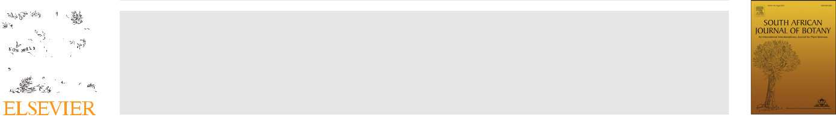

Contents lists available at [ScienceDirect](http://www.ScienceDirect.com)

South African Journal of Botany

journal homepage: [www.elsevier.com/locate/sajb](http://www.elsevier.com/locate/sajb)



Deficiency of calcium affects anatomical, biometry and nutritional status of cherry tomato

Walas Permanhane Sturiao~a, Herminia Emilia Prieto Martineza, Leonardo Araujo Oliveirab, Caroline Nery Jezlerc, Luana de Jesus Pereirab, Marília Contin Ventrellab, Carla do Carmo Milagresa,*

1. Department of Agronomy, Federal University of Vicosa,¸ Vicosa,¸ Brazil
2. Department of Botany, Federal University of Vicosa,¸ Vicosa,¸ Brazil
3. Department of Human Sciences, State University of Bahia, Bahia, Brazil

ARTICLE INFO

Article History:

Received 28 November 2018 Revised 22 March 2020 Accepted 15 May 2020 Available online 14 June 2020

Edited by AR Magee

Keywords:

Solanum lycopersicum l

nutrient solution

Hydroponics

Mineral of plants nutrition

ABSTRACT

Calcium (Ca) is one of the main problems in tomato management, due to its susceptibility to physiological disorders such as blosson end rot. This study aimed to evaluate the effects of Ca doses on the anatomy, biom-etry and nutritional status of cherry tomato hybrid BRS Iracema cultivated in a hydroponic system. The experiment consisted of an arrangement in time split-plot scheme, assigning Ca concentrations (0.5; 1.5; 3.0; 6.0 and 10.0 mmol L 1) in the plots and days after sowing (57; 84; 97 and 115) in the subplots. The design was completely randomized, with four replications. We performed a variance and regression analysis for the quantitative data and then a qualitative description of the biometric and anatomical characteristics. The best responses of biometric and production variables, as well as the better nutritional plant status occur with esti-mated concentrations from 6.0 to 7.0 mmol L 1 Ca in nutrient solution. Ca deficiency promotes anatomical changes such as phloem super development and leaf mesophyll thickness, lesions in the cortical region of the primary stem, with hypertrophied and collapsed cells and root apices shortening in relation to the first lateral roots. Consequently, lower growth and production, showing that tomato under Ca deficiency do not always express BER symptoms. The increase in Ca availability promotes an increase in Ca intake and reduc-tion in Zn, Cu and N-total contents in the distal part of the fruits.

© 2020 SAAB. Published by Elsevier B.V. All rights reserved.

1. Introduction

Cherry tomato cultivation has been increasing in recent years, especially in hydroponic systems; however, the imbalance of the fac-tors involved (like nutrients) in its cultivation can cause some physio-logical, anatomical and morphological disorders, compromising the growth, production and quality of the fruits (Marschner, 2012; Alvar-enga, 2013; Taiz and Zeiger, 2013).

Calcium (Ca), which is a macronutrient of significant importance for the growth, development and production of tomatoes, as well as fruit quality (Loos et al., 2008; Ekinci et al., 2015) directly relates to the struc-ture, stability and regulation of cell walls and membranes. It is the main component of the middle lamella, and essential for the processes of cell division, stretching and activation of several enzymes (Marschner, 2012; Taiz and Zeiger, 2013; Buchanan et al., 2015).

The Ca-based compounds in the plant present low solubility, with insignificant phloem redistribution (Marschner, 2012). As a result

* Corresponding author.

E-mail address: [carlacmilagres@yahoo.com.br](mailto:carlacmilagres@yahoo.com.br) (C.d.C. Milagres).

<https://doi.org/10.1016/j.sajb.2020.05.003>

0254-6299/© 2020 SAAB. Published by Elsevier B.V. All rights reserved.

low availability of Ca or conditions that impair its absorption and transport, leads to the occurrence of physiological disorders due to the limited contribution of Ca to fruits and meristems or to differen-ces in the partition between the different organs, causing localized Ca deficiency (Ho and White, 2005; Freitas et al., 2011, 2012; 2014).

Blosson end rot (BER), is the physiological disorder related to Ca defi-ciency more widely known and studied in the tomato crop. Its occur-rence relates to several factors such as genotype, climatic variations, nutritional balance and plant physiology (Freitas et al., 2011; 2012; 2014). As many factors and interactions are possible in Ca nutrition in tomato, there is no ideal recommendation or identification of a critical level of Ca for BER occurrence in fruits of several cultivars and hybrids. It is important to understand the role of this ion in plant physiology, under different cultivation conditions and at the different days after sowing

(DAS) (Ho and White, 2005; Terraza et al., 2008; Arruda Junior et al., 2011; Olle and Williams, 2016). The factors listed above and their possi-ble interactions in calcium nutrition are little studied and with no rele-vant information available for the majority of the tomato hybrids.

Studies focusing on the relationship of the Ca nutrition state of tomato with its primary physiological functions, such as the cellular/

|  |  |
| --- | --- |
| W.P. Sturiao~ et al. / South African Journal of Botany 132 (2020) 346 354 | 347 |

anatomical level, in the different phases of nutritional requirement of the culture can contribute significantly to the understanding and improvement of its nutritional management (Martinez et al., 2020).

Due to the lack of more detailed information, this work aimed to evaluate the effects of five Ca doses in nutrient solution on phenol-ogy, agronomic performance, nutritional status and morpho-anatom-ical changes in the leaves, stems and roots of cherry tomato under hydroponic cultivation.

2. Materials and methods

The experiment was performed during the autumn-winter of 2014 in a greenhouse of the Department of Agronomy, Federal Uni-

versity of Vicosa,¸ Brazil, located at 20°4501400 S; 42°5205500 W, 648 m above the sea level. Seedlings of the cherry tomato (Solanum lycoper-sicum L.) hybrid BRS Iracema, of indeterminate growth, were pro-duced in trays containing commercial substrate and irrigated once a day with deionized water.

When the seedlings had two definitive leaves, 25 DAS, we selected and transplanted them to 24 L trays covered with expanded polysty-rene plates and containing nutrient solution (NS) for the vegetative phase (Table 1), with half-ionic strength. Each tray received 18 seed-lings. At 32 DAS, the plants received NS at full ionic strength, and at 44 DAS they were transferred to the experimental units, consisting of 36 L plastic boxes, where four plants were cultivated.

The experiment was conducted following a split-plot scheme, with the five doses of Ca in the plots and the four evaluation dates DAS in the subplots. The experimental design was completely ran-domized, with four replications. The treatments were composed of five Ca doses as follow: (1) Control: 2.0 and 3.0 mmol L 1 Ca, for the vegetative and reproductive phases respectively; (2) low concentra-tion: 0.5 and 1.5 mmol L 1 Ca, each one used in the entire cycle of cultivation, (vegetative and reproductive phases); and (3) high con-centrations: 6.0 and 10.0 mmol L 1 Ca, each one used in the entire cycle of cultivation, (vegetative and reproductive phases). The evalu-ations took place at 57, 84, 97 and 115 DAS. The nutrient solution of the reproductive stage (Table 1) was given from the first evaluation on (57 DAS).

NS of all the experimental units was constantly aerated. It’s pH was monitored and adjusted from 5.5 to 6.5 and the solution volume checked and adjusted in a daily base. The periodic supply of the absorbed nutrients occurred based on the reduction of up to 30% ini-tial electrical conductivity. The nutrient solution was completely replaced every three weeks.

At 115 DAS, we collected samples of leaves, stems and roots from treatments 0.5; 3.0 and 10.0 mmol L 1 Ca for morpho-anatomical evaluations. The samples were fixed in FAA50 solution (formaldehyde,

Table 1

Composition of nutrient solutions, modified from Fernandes et al. (2002), for cherry tomato crop throughout their phenological cycle, in a hydro-ponic system.

|  |  |  |
| --- | --- | --- |
|  | Vegetative phase | Reproductive phase |
|  |  |  |
|  | mmol L 1 |  |
| N-NO3 | 8.0 | 12.0 |
| P H2PO4 | 2.0 | 3.0 |
| K+ | 4.0 | 8.6 |
| Ca2+ | 0.5; 1.5; 2.0; 6.0 and 10.0 | 0.5; 1.5; 3.0; 6.0 and 10.0 |
| Mg2+ | 1.0 | 1.5 |
| S-SO42 | 1.0 | 1.5 |
|  | mmol L 1 |  |
| Fe-EDTA | 50.0 | 60.0 |
| Mn | 15.0 | 20.0 |
| B | 20.0 | 25.0 |
| Zn | 4.0 | 4.0 |
| Cu | 0.9 | 1.3 |
| Mo | 0.7 | 0.7 |
|  |  |  |

acetic acid and ethyl alcohol 50% 1:1:18 v/v) for 48 h and stored in 70% ethanol (Johansen 1940). The samples were dehydrated in increasing ethylic series and included in methacrylate according to the manufacturer's recommendations 5 mm thick transverse and lon-gitudinal sections were then made using a rotary microtome. The sec-tions were stained with toluidine blue pH 4.4 and mounted on synthetic resin. We stained root samples with 1% crystal violet and photographed them for macro morphological illustration of Ca effects on the roots. Observations and photographic documentation were performed using a photomicroscope coupled to a digital camera.

At each DAS in which the plants were evaluated, we recorded number of leaves (NFL); height of plants (HOP); diameter of stem at collar height (DOS), volume of roots (VOR) and total leaf area of plants (TLA). We separated the plants into leaves, stems, roots and fruits and dried them in a forced-circulation air oven (65 °C) until a constant weight was obtained to determine the dry mass of the respective organs: leaves (LDM), stem (SDM) and roots (RDM). Total dry mass (TDM) of the plant was calculated summing the dry matter of each organ.

In the fourth evaluation, we recorded the number (NFR) and the total dry mass of the fruits produced per plant (TDMF); equatorial diam-eter and cross-cutting height of the fruits; and the numbers of fruits pre-senting blossom end rot (NFRBER) and pericarp crack (NFRUR).

To determine the nutritional status of each plant in each evalua-tion phase, we analyzed the index leaf. We also sampled total leaves and fruits of the fourth evaluation phase. The sampled fruits were those of the middle third of bunches 1 and 3, which were cross-sec-tioned at equatorial height, in two parts: proximal (P) and distal (D) relative to the peduncle. We obtained the contents of total nitrogen, phosphorus, potassium, calcium, magnesium, sulfur, boron, zinc, cop-per, manganese and iron in index leaf, leaves and fruits. After analyti-cal results, the ratio between the nutrient contents of the distal (D) and proximal (P) portions of the fruits of bunches 1 and 3 was calcu-lated by the following equation: D/P(%) = [(D/P)*100].

Data were submitted to analysis of variance and regression. We choose equation considering the response variables as functions of the Ca doses studied within each cherry tomato DAS (a = 5%). To choose the regression equation models, we considered the significance of the regres-sion coefficients, tested by the t-test (P < 0.05), the R2 (S.S.Regression/S. S.Total), and the best fit to the biological character.

3. Results

3.1. Morpho-anatomical evaluation of cherry tomato in response to Ca concentrations

The tomato plants grown with Ca restriction in the nutrient solu-tion, ie. treatments with concentrations of 0.5 and 1.5 mmol L 1 Ca for the vegetative and reproductive stages respectively, showed symptoms of Ca deficiency that became more evident from the flow-ering stage.

Visually, the first symptoms observed in the plants under these treatments were the brown root color, root volume reduction and reduction in the quantity of fine roots in comparison to the plants cultivated under the other treatments.

In addition, Ca deficient plants, especially those under 0.5 mmol

1. 1 Ca in NS, showed visual, deficiency symptoms characterized by reduced development, smaller side buds, greater floral abortion, higher number of fruits with BER and with early maturation, more fragile leaves with a brittle appearance and occurrence of death of the ferrules of the bunches, side buds and upper leaves. These charac-teristics resulted in plants less productive and with a phenological cycle shorter (less than 10 days) than those grown with the other treatments (3, 6 and 10 mmol L 1 Ca), which showed a better devel-opment, with no manifestation of Ca deficiency or toxicity symptoms, under treatment of 6 mmol L 1 Ca in NS.

348 W.P. Sturiao~ et al. / South African Journal of Botany 132 (2020) 346 354

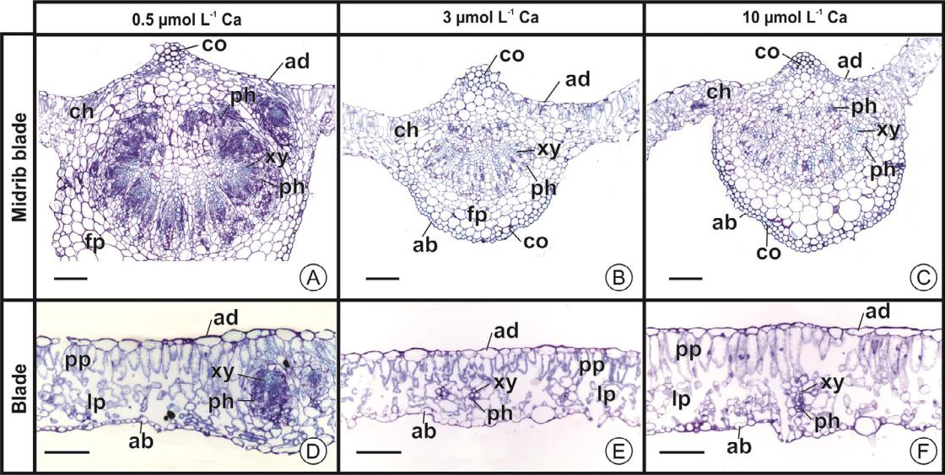

Fig. 1. Photomicrographs of Cherry tomato leaves in hydroponic culture under 0.5 (A, D), 3.0 (B, E) and 10.0 mmol L 1 Ca (C, F) at 115 DAS (cross-cutting sections). A C: midrib

blade region; D F: blade region. co: collenchyma; ab: abaxial epidermis; ad: adaxial epidermis; pH: phloem; ch: chlorophyll parenchyma; fp: fundamental parenchyma; pp: pali-

sade parenchyma; lp: lacunous parenchyma; xy: xylem. Bars = 25 mm (A C); 10 mm (D F).

The anatomical evaluation of cherry tomatoes took place at 115 DAS for plants of treatments 0.5; 3.0 and 10.0 mmol L 1 (Figs. 1 and 2). The most evident anatomical changes in leaves (Fig. 1A F), stems (Fig. 2A I) and roots (Fig. 2J 0) were under Ca deficiency (0.5 mmol

1. 1 Ca) relative to the control concentration (3.0 mmol L 1 Ca) and the concentration considered high (10.0 mmol L 1 Ca). In Ca deficiency con-ditions, the main leaf vein region (Fig. 1A) was extremely altered due to the super development of the circulatory system, especially the phloem increase. In the interveinal region (Fig. 1D), vascular bundles were also hypertrophied, mainly phloem, in addition to mesophyll thickness.

In young stems (Fig. 2A C), Ca deficiency caused lesions in the cortical region, where we observed cells with hypertrophy, collapsed cells and phenolic compounds production (Fig. 2A). In the stems in which the primary structure is already very differentiated and sec-ondary growth has already started by the cambium activation, there

were no significant differences between the treatments (Fig. 2D I). In the roots, Ca deficiency caused shortening, which can be observed

by the shorter distance between the root apices and the younger lateral root, that is, the root branches started much closer to the root apex under Ca deficiency conditions (Fig. 2K) in relation to the other treat-ments (Fig. 2M, O). In transverse section (Fig. 2J, L, N), the small anatom-ical differences observed must be associated with the differences in the number of xylem poles and at the stage of root development.

No qualitative anatomical difference were observed between the treatment with high Ca concentration and the control.

3.2. Allometric and fruit production assessments

There was a significant effect for the interaction between the Ca concentrations and the phenological phases for the biometric attributes HOP, VOR, TLA, LDM, SDM, RDM and TDM. For the NFL and DOS variables, the interaction was not significant; however, both show significance for the evaluation period, and for the latter also for Ca doses (Table 2). The main regression models adjusted for the biometric variables were linear and quadratic, mainly for the phases at 97 and 115 DAS, which most evidently highlighted the treatments effects.

There was an increase in the DOS of the cherry tomato along the phenological cycle, with increasing linear adjustments with the Ca doses at 57 and 84 DAS, representing a difference of 15% and 21% between the maximum and minimum concentrations.

The production of total dry biomass by plants grown with different Ca concentrations did not show statistical difference between the treat-ments in the first two evaluation periods. However, there were qua-dratic adjustments with the estimated concentrations at 6.0 and 6.8 mmol L 1 Ca in the 97 and 115 DAS periods. The greatest difference of dry mass between the parts of the plants occurred in the leaf bio-mass; at 115 DAS, the maximum LDM was 111.9 g at 6.6 mmol L 1 Ca concentration, which meant a 42% increase in LDM compared to that produced by the 0.5 mmol L 1 Ca treatment plants, which was 64.7 g.

In relation to the production of cherry tomatoes, Ca concentra-tions showed a significant effect on the production variables for which there were quadratic adjustments: NFL (y^ = 23.978 + 22.459*X

* 1.8291*X2; R2 = 0.56), TNFR (y^ = 11.8164 + 16.1148*X - 1.10165*X2; R2 = 0.74), TDMF (y^ = 8.6745 + 13.992*X - 1.0128*X2; R2 = 0.65). The

maximum NFL occurred at 6.1 mmol L 1 Ca, corresponding to 62.6% higher than the observed in the treatment 0.5 mmol L 1 Ca. The increase of Ca doses promoted a reduction of 29.3% in NFL at 10.0 mmol L 1 Ca. TNFR and TDMF showed maximums points with 7.3 and 6.9 mmol L 1 Ca, which represented an increase of 72 and 73%, respectively, compared to that produced by Ca deficient plants. Even though the number and dry mass of fruits were different with Ca doses, there was no significance for the measures of diameter (DFRU) and height of fruits (HEFRU), which presented averages of 27.9 and 27.8 mm, respectively. Nor was there any significance for the NFRBER, although we observed an average of 17; 2; 4; 0 and 0% fruits with BER on the total fruit produced with treatments 0.5; 1.5; 3.0; 6.0 and 10.0 mmol L 1, respectively. The NFRUR variable had a

|  |  |  |  |  |  |  |  |  |  |
| --- | --- | --- | --- | --- | --- | --- | --- | --- | --- |
| significant effect of the | | treatments, (p <0.01) (y^ = {[(3.63785 | | | | | | |  |
| 0.16117x + 0.012578 | £ | 2)2 | ] 10} | R2 | = | 0.84), with minimum of 0.0 | | |  |
|  |  |  |  | 1 | Ca. |  |
| NFRUR for the concentration of 6.4 mmol L | | | | | | |  |  |

3.3. Nutritional status of cherry tomato and nutrient allocation in fruits

The interaction among Ca treatments and phenological phases of the culture showed a significant effect for nutrient contents in the leaf tissues, with better regression adjustments mainly to the fruiting phase, 97 and 115 DAS (Figs. 3 and 4).

Treatments with Ca doses in nutrient solution also influenced cherry tomato leaf contents of micronutrients. In the reproductive stages, at 84, 97 and 115 DAS, in some cases there was no significant treatment effect on the micronutrient contents in the cherry tomato

|  |  |
| --- | --- |
| W.P. Sturiao~ et al. / South African Journal of Botany 132 (2020) 346 354 | 349 |

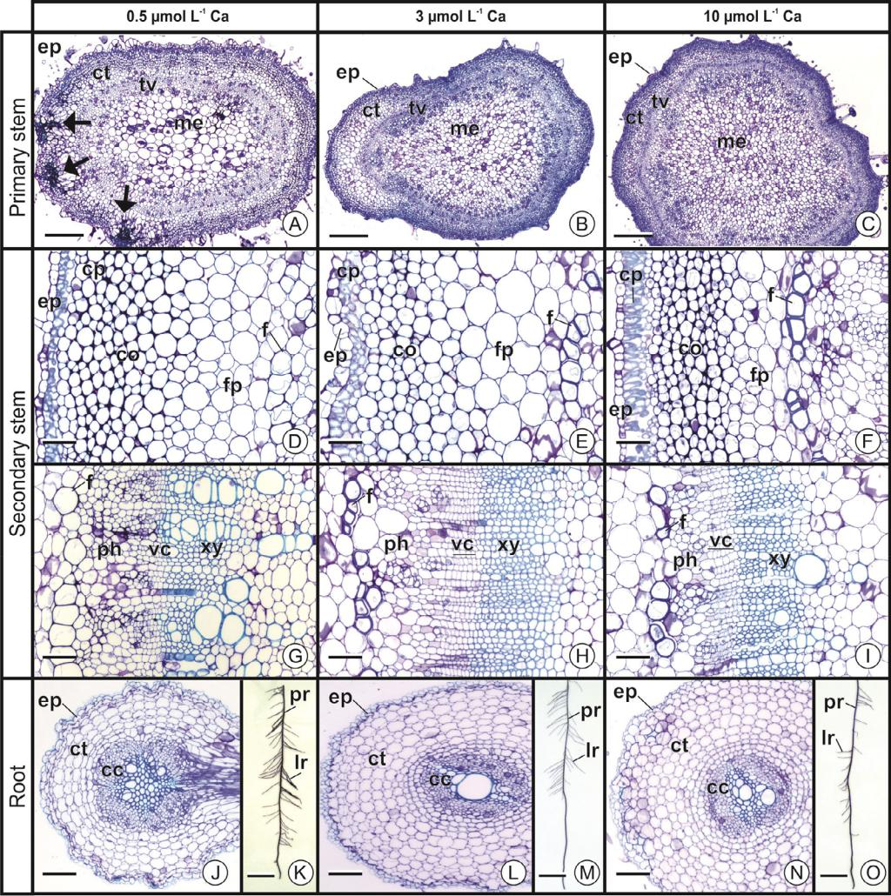

Fig. 2. Photomicrographs of stems (A I) and roots (J O) of Cherry tomato in hydroponic crop at concentrations of 0.5 (A, D, G, J, K), 3.0 (B, E, H, L, M) and 10.0 mmol L 1 Ca (C, F, I, N, O) at 115 DAS (cross-cutting sections). (A-J, L, N, cross-cutting sections; K, M, O, whole pieces). Arrows indicate necrotic regions of the cortex, with phenolic compound production (blue-green col-oring). cc: central cylinder; co: collenchyma; ct: cortex; vc: vascular cambium; ep: epidermis; f: fibers external to the phloem; pH: phloem; me: marrow; cp: chlorophyll parenchyma; fp: fundamental parenchyma; pp: palisade parenchyma; pr: principal root; lr: lateral root; tv: vascular tissue; xy: xylem. Bars = 30 mm (A C); 10 mm (D I, J, L, N); 2 cm (K, M, O).

index leaf. There were differences in nutrient contents in distal (D) and proximal (P) parts of the fruits, bunches 1 and 3 only for Ca (Table 3). According to the analysis of variance for the other nutrient contents of the fruits on bunches 1 and 3, there was no difference in Ca concentrations in D and P parts of the fruits. The D/P concentration ratio showed significance for N-total, Ca, Zn and Cu in P and D por-tions of the fruits, as shown in Fig. 5. For D/P ratio of other nutrients contents, there was no significant variantions.

D/P of N-total contents, which varied significantly with Ca doses, showed a quadratic adjustment for fruits of both bunches 1 and 3 with reduction up to of 89.6 and 88.7% at 6.8 and 6.5 mmol L 1 Ca, respectively.

The D/P ratio of Ca contents of the fruits on bunch 1 showed a qua-dratic adjustment, with a decrease of at least 49.4%, with a concentra-tion of 4.6 mmol L 1 Ca, which represented a reduction of 36.5% at the treatment 1.5 mmol L 1 Ca. With the increase of Ca concentrations, above the minimum point, this relation increased 62.8% with the maxi-mum concentration of Ca applied. In the fruits of bunch 3, the D/P ratio showed increasing linear adjustment with the increase of Ca doses, reaching a maximum of 208.9% with the treatment 10.0 mmol L 1 Ca, a difference of 66.5% over the treatment 1.5 mmol L 1 Ca. The increase of Ca doses in the nutrient solutions promoted an increase in Ca intake in the distal part of fruits, especially in bunch 3, provoking a clear reduction of the ratio Ca/ Zn, Ca/Cu and N-total.

4. Discussion

4.1. Morpho-anatomical evaluation of cherry tomato in response to Ca concentrations

In anatomical terms, membrane disintegration and loss of cellular compartmentalization occur in Ca deficient tissues, with the collapse of epidermal and subepidermal cells and consequently tissue rupture, impairing fruit formation (Ho and White, 2005; Incaper, 2010). In this study, there was no statistical significance for the number of fruits with BER as response to Ca doses in NS; however, Ca deficiency caused anatomical disorders in leaf, stem and root tissues of cherry tomato cv. Iracema and consequently lower growth and production, showing that tomato under Ca deficiency do not always express BER symptoms, whose manifestation depends on a complex of factors related to genotype and the environment.

Miqueloto et al. (2014) verified that apple trees under Ca deficiency conditions showed an early loss of xylem functionality during the fruit development phase, which caused a reduction in Ca contents, for which the cultivar is likely to suffer from Ca deficiencies. Natale et al. (2005), showed that the main effect of Ca deficiency on guava was on the mid-dle lamella disorganization, with a disruption of the cell wall, due to the alteration in the orientation of microfibrils. Martinez et al., 2020 observed that cherry tomato cv. Sindy deficient in Ca showed slight

350 W.P. Sturiao~ et al. / South African Journal of Botany 132 (2020) 346 354

Table 2

Leaf area, stem diameter, root volume and dry leaf mass, stem, roots and total of Cherry tomatoes cv. Iracema, in different phenological stages, due to Ca concentrations.

|  |  |
| --- | --- |
| DASTotal leaf area (cm2) | R2 |
|  |  |

Caracteristics

1. y^ = 1817.0984
2. y^ = 5955.9197

|  |  |  |  |  |
| --- | --- | --- | --- | --- |
| 97 | y^ = 7491.25 + 249.83*X | |  | 0.78 |
| 115 | y^ = 5914.83 + 1862.32*X | | 147.504*X2 | 0.99 |
|  | Stem diameter (mm) | |  |  |
| 57 | y^ = 6.24989 + 0.104313*X | |  | 0.97 |
| 84 | y^ = 9.20496 + 0.268938*X | |  | 0.72 |
| 97 | y^ = 9.34386 | + 0.970879*X | 0.0783997*X2 | 0.71 |
| 115 | y^ = 10.0135 | + 0.937591*X | 0.0812518*X | 0.79 |
|  | Root volume (cm3) | |  |  |
| 57 | y^ = 15.9064 | + 1.62943*X |  | 0.54 |
| 84 | y^ = 189.8597 | |  |  |
| 97 | y^ = 114.303 | + 47.4533*X | 3.94423*X2 | 0.84 |

1. y^ = 32.3732*X + 175.036 (X 5.44) e y^ = 351.25 (X > 5.44) Dry leaf mass (g)
2. y^ = 6.61
3. y^ = 48.08

|  |  |  |  |  |
| --- | --- | --- | --- | --- |
| 97 | y^ = 54.0186 + 11.7986*X | | 1.02116*X2 | 0.79 |
| 115 | y^ = 56.63 + 16.7645*X | | 1.27223*X2 | 0.80 |
|  | Dry mass of stem (g) | |  |  |
| 57 | y^ = 2.89 |  |  |  |
| 84 | y^ = 19.6405 + 3.63761*X | | 0.227718*X2 | 0.84 |
| 97 | y^ = 30.118 | + 12.342*X | 0.9849*X2 | 0.92 |
| 115 | y^ = 24.532 | + 5.535*X 0.4455*X2 | | 0.94 |

Dry mass of root (g)

1. y^ = 1.40
2. y^ = 12.56

|  |  |  |  |  |
| --- | --- | --- | --- | --- |
| 97 | y^ = 12.327 | + 4.0268*X | 0.3362*X2 | 0.89 |
| 115 | y^ = 15.218 | + 3.24*X | 0.2531*X2 | 0.78 |
|  | Total dry mass of the plant (g) | | |  |

1. y^ = 10.91
2. y^ = 88.8497

|  |  |  |  |
| --- | --- | --- | --- |
| 97 | y^ | = 92.534 + 30.52*X 2.5364*X2 | 0.93 |
| 115 | y^ | = 96.5709 + 24.9595*X 1.87917*X2 | 0.85 |

hypertrophy of phloem in the central leaf vein, collenchyma reduction, small reduction of palisade parenchyma and lacunous parenchyma increase in the interveinal region. In the secondary stem, a thickness reduction occurred in the cell wall of the phloem sclereids.

The anatomical evaluation performed at the end of the phenologi-cal cycle evidence that the main effects of Ca deficiency, 0.5 mmol

1. 1 treatment, occurred in leaves, primary stem and roots, and were much worse than the observed by Martinez et al., 2020, in the vegeta-tive phase. Thus, Ca deficiency primarily causes anatomical damage, which becomes visible and more severe with the advancement of the tomato phenological cycle (White and Broadley, 2003; Fontes, 2011).

4.2. Allometric and fruit production evaluations

The expression of Ca deficiency symptoms by tomato depends on the level of (un)availability of Ca to which each genotype is subjected, the environmental conditions and the DAS. In this work, the limitation in growth was accentuated by the succession of the DAS. Even providing only 0.5 mmol L 1 Ca for cherry tomato cv. Iracema, no significant dif-ferences were observed with the other treatments at the vegetative stage of the crop, at 57 DAS. This is because in the early growth stages, the nutritional demand is small and can be met by low Ca concentra-tions if the volume of the solution is not greatly reduced.

With the increase in the demand throughout the cherry tomato cycle, the doses of 0.5 and 1.5 mmol L 1 Ca became insufficient and the plants showed the main symptoms of this deficiency, such as deforma-tion and necrosis of young leaf margins, death of meristematic tissues, apical rot of fruits and limitations to plant growth, development and production, as reported by Alvarenga (2013) and Souza et al. (2007).

There was an increase in the DOS of the cherry tomato along the evolution of its phenological cycle. This shows that plants well-nourished with Ca showed the initial development of the stem faster and more vigorous.

In general, symptoms of Ca deficiency do not show the same expres-sions in tomato plants; however, this depends on the interaction of sev-eral factors such as genotype physiology (susceptibility or tolerance to Ca deficiency), variability of environmental conditions (water availabil-ity, temperature, relative humidity, luminosity, etc.), crop handling, Ca availability level, osmotic balance of nutrient solution and the DAS of deficiency occurrence (Ho et al., 1993; Terraza et al., 2008).

The higher and sooner Ca restriction occurs to plants the faster and more severe the effects and the presentation of these symptoms. Carvalho et al. (2016) observed that Ca omission for 50 days in the cultivation of tomato cv. Moneymaker, compared to plants grown under 5.0 mmol L 1 Ca in nutrient solution, caused a reduction of 82% in height, 93% of leaf area and 86% of total dry mass.

4.3. Evaluation of nutritional status of cherry tomato and nutrient allocation in fruits

Higher Ca concentration in NS eases the uptake by the plant by mass flow, according to the transpiration coefficient of the crop, which explains the significant Ca increase in the leaf tissues of the tomato and the competition with the fruits in the filling (Terraza et al., 2008).

In the fruits, Ca movement from the peduncle to the distal portion depends on factors such as fruit size, division rate and cell growth, as well as the insufficiency of circulatory system for the rapid transport of Ca to the distal part of the fruits, which defines the concentration of this macronutrient and fruit susceptibility to physiological disor-ders. Thus, the tissues of the distal portion of the fruit are more sus-ceptible to Ca deficiency disorders, that in more severe cases can spread throughout the fruit (Ho and White, 2005; Freitas and Mit-cham, 2012).

The analysis of fruits with BER showed marked malformation in the xylem vessels with the formation of a decreasing gradient of Ca contents from the tissues of proximal portion of fruits to the distal portion (Adams and Ho, 1992; Ho et al., 1993). This shows that the greater the availability of Ca via root, the greater the Ca allocation in the distal portion of tomato fruits, which is crucial for avoid BER physiological disorder, especially in the furthest fruits of the root.

In this experiment, the highest levels of Ca and other nutrients were recorded in the cherry tomato leaf tissues. The increase of Ca availability in NS associated to mild temperatures (Fernandes et al., 2002) promoted the macronutrient contents in the distal part of the fruits, in relation to the proximal portion, especially in those of bunch 3, demonstrating the effect of the transport of Ca via xylem to the tis-sues with greater cellular activity and transpiration and the decrease of the probability of BER occurrence.

According to Terraza et al. (2008), the increase in Ca concentration in the NS cultivation of two hybrids tomatoes promoted an increase only in Ca content in the leaves and a decrease in the number of fruits with BER. The fruits with BER showed lower contents of Ca and P and higher contents of Mg, compared to the fruits without BER. Fernandes et al. (2002), cultivating a long-life tomato with various nutrient solutions and conducted with a bunch, observed that the proximal portion of the fruits had higher Ca and K contents and, on the contrary, lower Mg.

The increase in Ca2+ availability caused a cationic imbalance in the NS and a competition for the absorption and transport sites, mainly with Mg2+, reflecting in the contents of the tissues and organs of the tomato, with an inverse proportional effect. However, there was an increase in B and S contents, with the increase in Ca2+ availability in NS, at the end of the tomato phenological cycle.

Ionic interaction is one of the main factors affecting the availabil-ity, absorption and distribution of nutrients, mainly among the

|  |  |
| --- | --- |
| W.P. Sturiao~ et al. / South African Journal of Botany 132 (2020) 346 354 | 351 |

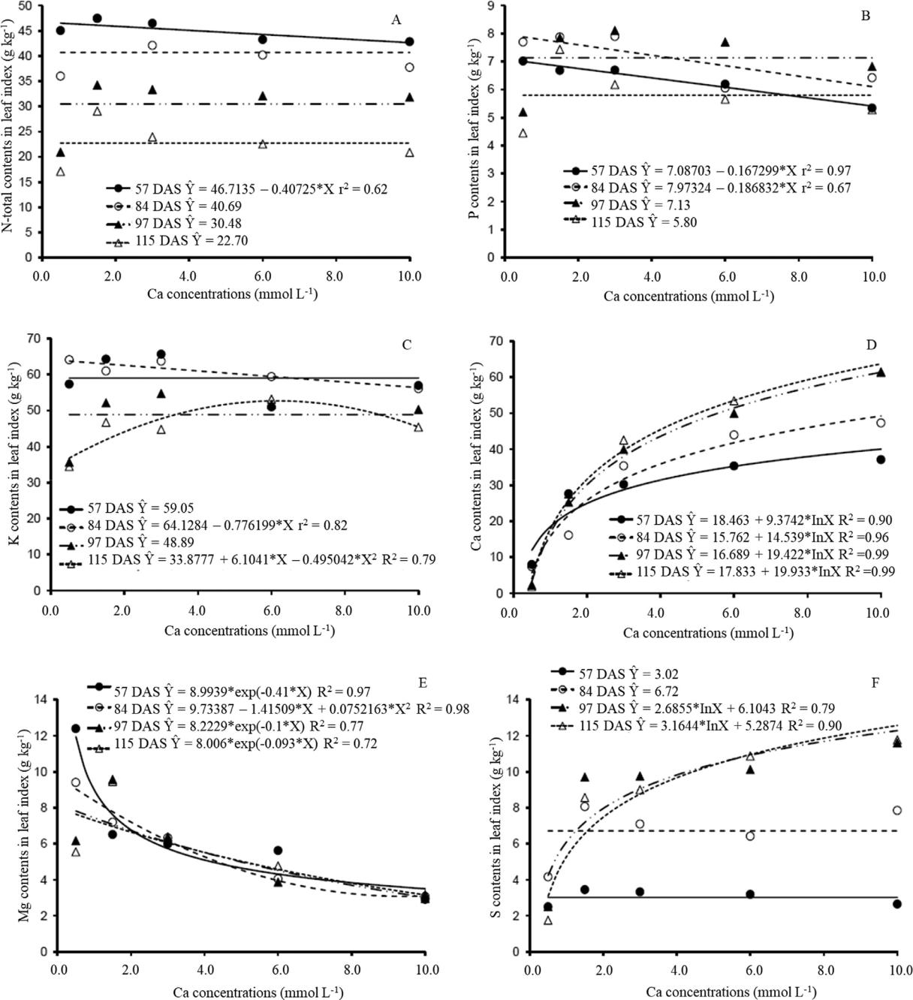

Fig. 3. N-total (A), P (B), K (C), Ca (D), Mg (E) and S (F) contents in leaf index of cherry tomato cv. Iracema, in different phenological stages, due to Ca concentrations.

cationic elements K+, Ca2+ and Mg2+ (Malavolta, 2006; Marschener, 2012). The high concentrations of Ca2+ in NS promoted effects mainly on the uptake and transport of Mg2+, and no important effects on K+ were observed.

Several studies indicate that, depending on the culture or organ-ism, there may be a synergistic effect between Ca and B, and the main results show that B can mitigate the effect of Ca deficiency. In addition, severe B deficiency, which causes damage to the xylem structure and absorption and distribution processes, induce Ca defi-ciency in tomato fruits (Redondo-Nieto et al., 2003; Gonzalez-Fontes et al., 2014).

In this experiment, there was a synergistic effect of Ca and B. The greater the Ca dose, the greater the capacity of absorption and trans-port of B to cherry tomato leaves. But this effect was not observed in fruits, in which contents were statistically equal in both portions (proximal and distal) of both bunches.

The logarithmic increase in Ca leaf content can be explained by the fact that the highest Ca proportions in the plant are insoluble, mainly as pectates of Ca, the main component of middle lamella of the cell wall, and as Ca salts, especially in specialized cell vacuoles (idioblasts), in the form of crystals of Ca oxalate (Marschner, 2012), contributing to the ionic balance and maintenance of low

352 W.P. Sturiao~ et al. / South African Journal of Botany 132 (2020) 346 354

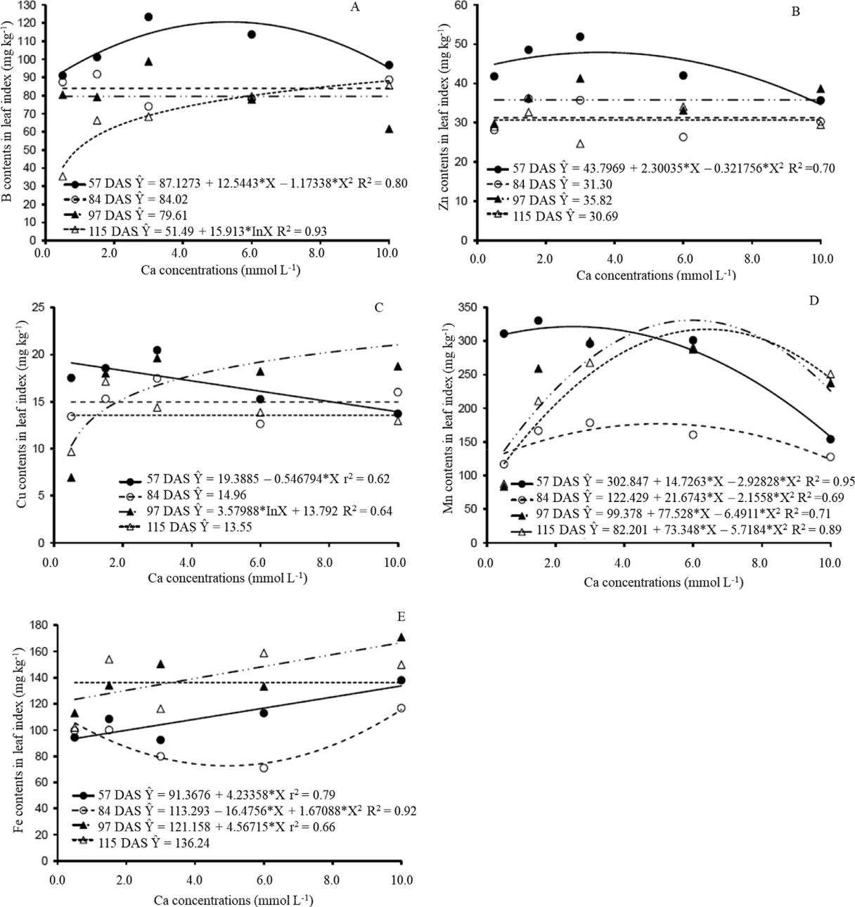

Fig. 4. B (A), Zn (B), Cu (C), Mn (D) and Fe (E) contents in leaf index of cherry tomato cv. Iracema, in different phenological stages, due to Ca concentrations.

Table 3

Mean of the Ca (g kg 1) contents of the proximal (P) and distal (D) portions of cherry tomato fruits grown with different Ca concentrations (mmol L 1) in nutrient solution.

|  |  |  |  |  |
| --- | --- | --- | --- | --- |
| Fruit | 1.5 Ca mmol | 3.0 Ca mmol | 6.0 Ca mmol | 10.0 Ca mmol |
| portion | L 1 | L 1 | L 1 | L 1 |
|  |  |  |  |  |
|  | Bunch 1 |  |  |  |
| P | 9.33 | 13.61 | 15.56 | 12.17 |
| D | 6.87 | 8.42 | 8.14 | 16.19 |
|  | Bunch 3 |  |  |  |
| P | 8.35 | 11.92 | 12.15 | 10.58 |
| D | 6.91 | 8.68 | 19.62 | 21.74 |
|  |  |  |  |  |

concentration of Ca free in the cytosol, but restricting this nutrient redistribution (Clark, 1984).

High concentrations of Ca2+ in the solution could have a direct effect on the reduction in Zn and Cu availability to the plants, because of increasing the pH of the solution, as explained by Malavolta et al. (1989). Because the adjusted pH was kept within the range consid-ered satisfactory for the crop (5.5 6.5), no such antagonistic effect was observed.

The linear reduction in Zn and Cu contents in the fruits, with increase in Ca doses in NS can be a result of ionic competition effect, resulting of higher Ca levels in the distal part of the fruits, mainly in the bunch 3. Regions in which the contents of these micronutrients were markedly lower, while the Fe contents were lower in fruits of bunch 3.

The plants showed higher growth (higher TLA, DOS, VOR and bio-mass) with Ca concentrations close to 6.0 mmol L 1, which favored higher nutrient of leaf contents. This approximately indicates the point of better nutritional balance for cherry tomato cv. Iracema,

|  |  |
| --- | --- |
| W.P. Sturiao~ et al. / South African Journal of Botany 132 (2020) 346 354 | 353 |

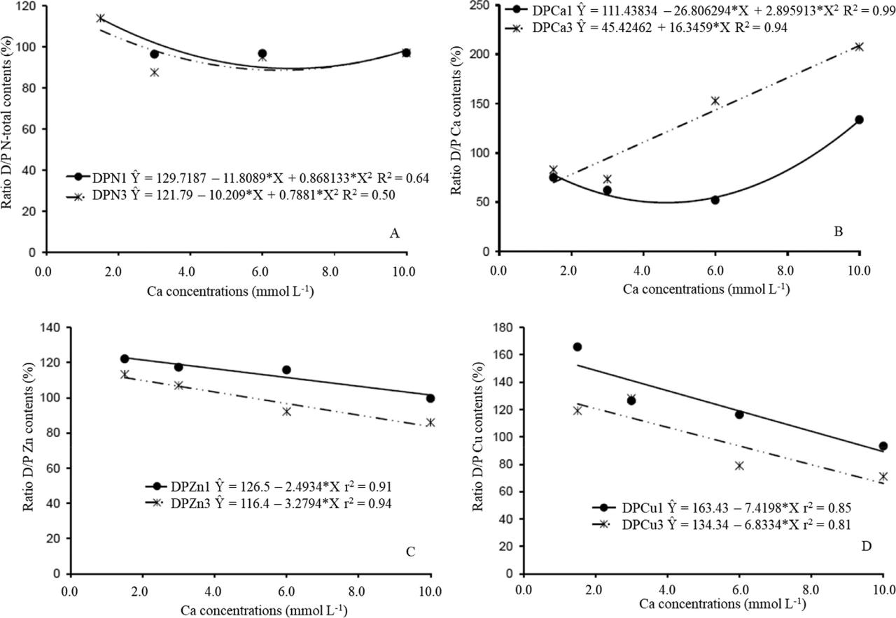

Fig. 5. Ratio between N-total (A), Ca (B), Zn (C) and Cu (D) nutrient contents of the proximal (P) and distal (D) portions of fruits of Cherry tomato cv. Iracema cultivated with Ca concentrations.

according to the conditions used in this experiment, which also reflected in its productive parameters (NFL, NFR and TDMF).

1. Conclusion
   * The estimated concentrations of 6.0 to 7.0 mmol L 1 Ca resulted in better growth and yield of cherry tomato cv. Iracema.
   * The visual and anatomical symptoms of Ca deficiency were accentuated in the fruiting phase.
   * Severe Ca deficiency caused a phloem super development and increased leaf mesophyll thickness, caused lesions in the cortical region of the primary stem, with hypertrophied and collapsed cells and the shortening of the root apices in relation to the first lateral roots.
   * The increase in Ca availability promotes an increase in Ca intake and reduction in Zn, Cu and N-total contents in the distal part of the fruits.

Declaration of Competing Interest

The authors declare that they have no known competing financial interests or personal relationships that could have appeared to influ-ence the work reported in this paper.

Acknowledgments

The authors thank the National Council for Scientific and Techno-logical Development (CNPq) for financial support. And this study was

financed in part by the Coordenac¸ao~ de Aperfeicoamento¸ de Pessoal de Nível Superior - Brasil (CAPES) Finance Code 001.

Supplementary materials

Supplementary material associated with this article can be found in the online version at doi:[10.1016/j.sajb.2020.05.003](https://doi.org/10.1016/j.sajb.2020.05.003).

References

[Adams, P., Ho, L.C., 1992. The susceptibility of modern tomato cultivars to blossom-end](http://refhub.elsevier.com/S0254-6299(20)30909-1/sbref0001) [rot in relation to salinity. Journal of Horticultural Science 67, 827–839.](http://refhub.elsevier.com/S0254-6299(20)30909-1/sbref0001)

[Alvarenga, M.A.R., 2013. Tomate: Produc](http://refhub.elsevier.com/S0254-6299(20)30909-1/sbref0002)¸~ao [Em campo, Em Casa De Vegetac](http://refhub.elsevier.com/S0254-6299(20)30909-1/sbref0002)¸ao~ [e Em](http://refhub.elsevier.com/S0254-6299(20)30909-1/sbref0002) [Hidroponia, 2](http://refhub.elsevier.com/S0254-6299(20)30909-1/sbref0002). [Ed. UFLA, Lavras.](http://refhub.elsevier.com/S0254-6299(20)30909-1/sbref0002)

[Arruda](http://refhub.elsevier.com/S0254-6299(20)30909-1/sbref0003) Junior, [S.J., Bezerra Neto, B., Barreto, L.P., Resende, L.V., 2011. Blossom-end rot](http://refhub.elsevier.com/S0254-6299(20)30909-1/sbref0003) [and productivity of tomatoes as a function of calcium and ammonium contents](http://refhub.elsevier.com/S0254-6299(20)30909-1/sbref0003) [(article in Portuguese with an abstract in English). Revista Caatinga 24, 20–26.](http://refhub.elsevier.com/S0254-6299(20)30909-1/sbref0003)

[Buchanan, B.B., Gruissem, W., Jones, R.L., 2015. Biochemistry and Molecular Biology of](http://refhub.elsevier.com/S0254-6299(20)30909-1/sbref0004) [Plants, 2nd edition American Society of Plant Physiologists, Rockville, Md.](http://refhub.elsevier.com/S0254-6299(20)30909-1/sbref0004)

[Carvalho, R.F., Moda, L.R., Silva, G.P., Gavassil, M.A., Prado, R.M., 2016. Nutrition in](http://refhub.elsevier.com/S0254-6299(20)30909-1/sbref0005) [tomato (Solanum lycopersicum L) as affected by light: revealing a new role of phy-tochrome A. Australian Journal of Crop Science 10, 331–335.](http://refhub.elsevier.com/S0254-6299(20)30909-1/sbref0005)

[Clark, R.B., 1984. In: Adams, F. (Ed.), 2](http://refhub.elsevier.com/S0254-6299(20)30909-1/sbref0006). [ed. Madison, pp. 99–170.](http://refhub.elsevier.com/S0254-6299(20)30909-1/sbref0006)

[Ekinci, M., Esringu,](http://refhub.elsevier.com/S0254-6299(20)30909-1/sbref0007)€ [A., Dursun, A., Yildirim, E., Turan, M., Karaman, M.R., Arjumend, T.,](http://refhub.elsevier.com/S0254-6299(20)30909-1/sbref0007) [2015. Growth, yield, and calcium and boron uptake of tomato (Lycopersicon escu-lentum L.) and cucumber (Cucumis sativus L.) as affected by calcium and boron](http://refhub.elsevier.com/S0254-6299(20)30909-1/sbref0007) [humate application in greenhouse conditions. Turkish Journal of Agriculture and](http://refhub.elsevier.com/S0254-6299(20)30909-1/sbref0007) [Forestry 39, 1–20.](http://refhub.elsevier.com/S0254-6299(20)30909-1/sbref0007)

[Fernandes, A.A., Martinez, H.E.P., Fontes, P.C.R., 2002. Productivity, fruit quality and](http://refhub.elsevier.com/S0254-6299(20)30909-1/sbref0008) [nutritional status of single truss long shelf life tomato, cultivated in hydroponic](http://refhub.elsevier.com/S0254-6299(20)30909-1/sbref0008) [system, with different nutrient sources (article in Portuguese with an abstract in](http://refhub.elsevier.com/S0254-6299(20)30909-1/sbref0008) [English). Horticultura Brasileira 20, 564–570.](http://refhub.elsevier.com/S0254-6299(20)30909-1/sbref0008)

[Fontes, P.C.R., 2011. Nutric](http://refhub.elsevier.com/S0254-6299(20)30909-1/sbref0009)¸~ao [Mineral De plantas: Avaliac](http://refhub.elsevier.com/S0254-6299(20)30909-1/sbref0009)¸ao~ [e Diagnose. Arka Editora,](http://refhub.elsevier.com/S0254-6299(20)30909-1/sbref0009)

[Vicosa,](http://refhub.elsevier.com/S0254-6299(20)30909-1/sbref0009)¸ [MG.](http://refhub.elsevier.com/S0254-6299(20)30909-1/sbref0009)

[Freitas, S.T., Padda, M., Wu, Q., Park, S., Mitcham, E.J., 2011. Dynamic alternations in cel-lular and molecular components during blossom-end rot development in Toma-toes expressing sCAX1, a constitutively active Ca](http://refhub.elsevier.com/S0254-6299(20)30909-1/sbref0010)2+[/H](http://refhub.elsevier.com/S0254-6299(20)30909-1/sbref0010)+ [antiporter from Arabidopsis.](http://refhub.elsevier.com/S0254-6299(20)30909-1/sbref0010) [Plant Physiology 156, 844–855.](http://refhub.elsevier.com/S0254-6299(20)30909-1/sbref0010)

[Freitas, S.T., Mitcham, E.J., 2012. Factors involved in fruit calcium deficiency disorders.](http://refhub.elsevier.com/S0254-6299(20)30909-1/sbref0011)

[Horticultural Reviews 40, 107–146.](http://refhub.elsevier.com/S0254-6299(20)30909-1/sbref0011)

354 W.P. Sturiao~ et al. / South African Journal of Botany 132 (2020) 346 354

[Freitas, S.T., Mcelrone, A.J., Shackel, K.A., Mitcham, E.J., 2014. Calcium partitioning and](http://refhub.elsevier.com/S0254-6299(20)30909-1/sbref0012) [allocation and blossom-end rot development in tomato plants in response to](http://refhub.elsevier.com/S0254-6299(20)30909-1/sbref0012) [whole-plant and fruit-specific abscisic acid treatments. Journal of Experimental](http://refhub.elsevier.com/S0254-6299(20)30909-1/sbref0012) [Botany 65, 235–247.](http://refhub.elsevier.com/S0254-6299(20)30909-1/sbref0012)

[Gonzalez-Fontes,](http://refhub.elsevier.com/S0254-6299(20)30909-1/sbref0013) [A., Navarro-Gochicoa, M.T., Camacho-](http://refhub.elsevier.com/S0254-6299(20)30909-1/sbref0013)Cristobal, [J.J., Herrera-Rodríguez, M.B., Quiles-Pando, C., Rexach, J., 2014. Is Ca](http://refhub.elsevier.com/S0254-6299(20)30909-1/sbref0013)2+ [involved in the signal trans-duction pathway of boron deficiency? New hypotheses for sensing boron deprivation.](http://refhub.elsevier.com/S0254-6299(20)30909-1/sbref0013) [Plant Science 217-218, 135–139.](http://refhub.elsevier.com/S0254-6299(20)30909-1/sbref0013)

[Ho, L.C., Belda, R., Brown, M., Andrews, J., Adams, P., 1993. Uptake and transport of cal-cium and the possible causes of blossom-end rot in tomato. Journal of Experimen-tal Botany 44, 509–518.](http://refhub.elsevier.com/S0254-6299(20)30909-1/sbref0014)

[Ho, L.C., White, F.J., 2005. A cellular hypothesis for the induction of blossom-end rot in](http://refhub.elsevier.com/S0254-6299(20)30909-1/sbref0015) [tomato fruit. Annals of Botany 95, 571–581.](http://refhub.elsevier.com/S0254-6299(20)30909-1/sbref0015)

[Incaper, 2010. Instituto Capixaba de Pesquisa,](http://refhub.elsevier.com/S0254-6299(20)30909-1/sbref0016) Assitencia^ Tecnica [e Extens](http://refhub.elsevier.com/S0254-6299(20)30909-1/sbref0016)~ao [Rural.](http://refhub.elsevier.com/S0254-6299(20)30909-1/sbref0016)

[Tomate,](http://refhub.elsevier.com/S0254-6299(20)30909-1/sbref0016) Vitoria, [ES.](http://refhub.elsevier.com/S0254-6299(20)30909-1/sbref0016)

[Johansen, D.A., 1940. Plant Microtechnique. McGraw-Hill Book Company, New York.](http://refhub.elsevier.com/S0254-6299(20)30909-1/sbref0017) [Loos, R.A., Silva, D.J.H., Fontes, P.C.R.,](http://refhub.elsevier.com/S0254-6299(20)30909-1/sbref0018) Picanco,¸ [M.C., 2008. Identification and quantifica-](http://refhub.elsevier.com/S0254-6299(20)30909-1/sbref0018)

[tion of tomato yield loss components in unheated greenhouse (article in Portu-guese with an abstract in English). Horticultura Brasileira 22, 238–242.](http://refhub.elsevier.com/S0254-6299(20)30909-1/sbref0018)

[Malavolta, E., Vitti, G.C., Oliveira, S.A., 1989. Avaliac](http://refhub.elsevier.com/S0254-6299(20)30909-1/sbref0020)¸ao~ [Do Estado Nutricional Das plan-tas: Princípios e Aplicac](http://refhub.elsevier.com/S0254-6299(20)30909-1/sbref0020)¸oes~[. POTAFOS.](http://refhub.elsevier.com/S0254-6299(20)30909-1/sbref0020)

[Malavolta, E., 2006. Manual De Nutric](http://refhub.elsevier.com/S0254-6299(20)30909-1/sbref0021)¸~ao [De Plantas.](http://refhub.elsevier.com/S0254-6299(20)30909-1/sbref0021) Agronomica^ [Ceres,](http://refhub.elsevier.com/S0254-6299(20)30909-1/sbref0021) Sao~ [Paulo.](http://refhub.elsevier.com/S0254-6299(20)30909-1/sbref0021) [Marschner, P., 2012. Marschner’s Mineral Nutrition of Higher Plants, 3. Ed. Academic](http://refhub.elsevier.com/S0254-6299(20)30909-1/sbref0022)

[Press, London.](http://refhub.elsevier.com/S0254-6299(20)30909-1/sbref0022)

[Martinez, E.P., H., Maia, T.L.S., J., Ventrella, C., M., Milagres, C., C., Cecon, R., P.,](http://refhub.elsevier.com/S0254-6299(20)30909-1/sbref0032) [Clemente, M., J., Garbin, Z., C., 2020. Leaf and stem anatomy of cherry tomato under](http://refhub.elsevier.com/S0254-6299(20)30909-1/sbref0032) [calcium and magnesium deficiencies. Brazilian Archives of Biology and Technology](http://refhub.elsevier.com/S0254-6299(20)30909-1/sbref0032) [63, 1–10.](http://refhub.elsevier.com/S0254-6299(20)30909-1/sbref0032)

[Miqueloto, A., Amarante, C.V.T., Steffens, C.A., Santos, A., Mitcham, E., 2014. Relation-ship between xylem functionality, calcium content and the incidence of bitter pit](http://refhub.elsevier.com/S0254-6299(20)30909-1/sbref0023) [in apple fruit. Scientia Horticulturae 165, 319–323.](http://refhub.elsevier.com/S0254-6299(20)30909-1/sbref0023)

[Natale, W., Prado, R.M.,](http://refhub.elsevier.com/S0254-6299(20)30909-1/sbref0024) Moro,^ [F.V., 2005. Anatomical modifications in the cell wall of](http://refhub.elsevier.com/S0254-6299(20)30909-1/sbref0024) [guava as influenced by calcium (article in Portuguese with an abstract in English).](http://refhub.elsevier.com/S0254-6299(20)30909-1/sbref0024) [Pesquisa Agropecu](http://refhub.elsevier.com/S0254-6299(20)30909-1/sbref0024)aria [Brasileira 40, 1239–1242.](http://refhub.elsevier.com/S0254-6299(20)30909-1/sbref0024)

[Olle, M., Williams, I.H., 2016. Physiological disorders in tomato and some methods](http://refhub.elsevier.com/S0254-6299(20)30909-1/sbref0025) [to avoid them. The Journal of Horticultural Science and Biotechnology 92,](http://refhub.elsevier.com/S0254-6299(20)30909-1/sbref0025) [223–230.](http://refhub.elsevier.com/S0254-6299(20)30909-1/sbref0025)

[Redondo-Nieto, M., Wilmot, A.R., El-Hamdaoui, A., Bonilla, I.,](http://refhub.elsevier.com/S0254-6299(20)30909-1/sbref0026) Bolanos,~ [L., 2003. Rela-tionship between boron and calcium in the N2-fixing legume rhizobia symbiosis.](http://refhub.elsevier.com/S0254-6299(20)30909-1/sbref0026) [Plant, Cell and Environment 26, 1905–1915.](http://refhub.elsevier.com/S0254-6299(20)30909-1/sbref0026)

[Souza, R.J., Gomes, L.A.A., Maluf, W.R., Cardoso, A.D., Vallone, H.S., 2007. Olericultura](http://refhub.elsevier.com/S0254-6299(20)30909-1/sbref0027) [Geral. UFLA/FAEPE, Lavras, MG.](http://refhub.elsevier.com/S0254-6299(20)30909-1/sbref0027)

[Taiz, L., Zeiger, E., 2013. Fisiologia Vegetal, 5ed. Artmed, Porto Alegre.](http://refhub.elsevier.com/S0254-6299(20)30909-1/sbref0028)

[Terraza, S.P., Romero, M.V.,](http://refhub.elsevier.com/S0254-6299(20)30909-1/sbref0030) Pena,~ [P.S., Madrid, J.L.C., Verdugo, S.H., 2008. Efecto del](http://refhub.elsevier.com/S0254-6299(20)30909-1/sbref0030)

[calcio y potencial](http://refhub.elsevier.com/S0254-6299(20)30909-1/sbref0030) osmotico [de la](http://refhub.elsevier.com/S0254-6299(20)30909-1/sbref0030) solucion [nutritiva em la pudricion apical,](http://refhub.elsevier.com/S0254-6299(20)30909-1/sbref0030) [composicion mineral y rendimiento de tomate. Interciencia 33, 449–456.](http://refhub.elsevier.com/S0254-6299(20)30909-1/sbref0030)

[White, P.J., Broadley, M.R., 2003. Calcium in plants. Annals of Botany 92, 487–511.](http://refhub.elsevier.com/S0254-6299(20)30909-1/sbref0031)