[Scientia Horticulturae 272 (2020) 109478](https://doi.org/10.1016/j.scienta.2020.109478)

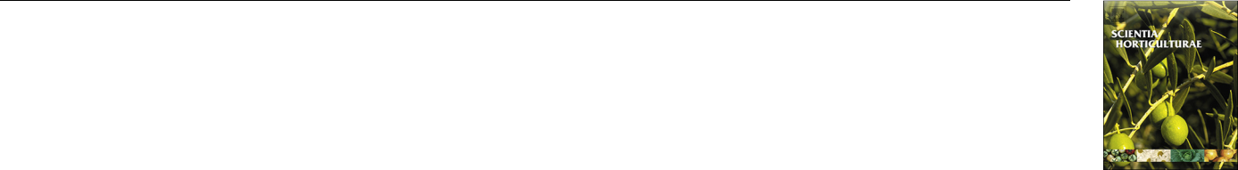

Contents lists available at [ScienceDirect](http://www.sciencedirect.com/science/journal/03044238)



Scientia Horticulturae

journal homepage: [www.elsevier.com/locate/scihorti](https://www.elsevier.com/locate/scihorti)

Regulation of extension growth and flowering of seedlings by blue radiation T and the red to far-red ratio of sole-source lighting 



Mengzi Zhanga,b, Yujin Parka,c, Erik S. Runklea,*

1. Department of Horticulture, 1066 Bogue Street, Michigan State University, East Lansing, MI 48824, United States
2. Mid-Florida Research & Education Center, University of Florida, United States
3. College of Integrative Sciences and Arts, Arizona State University, United States

ARTICLE INFO

Keywords:

Bedding plants

Controlled-environment agriculture

LEDs

Phytochrome photoequilibrium Plugs

Radiation quality

ABSTRACT

Manipulating the radiation spectrum of sole-source lighting (SSL) with light-emitting diodes (LEDs) enables the regulation of growth, development, and quality attributes of ornamental transplants. We quantified growth responses and subsequent flowering of annual bedding plant seedlings grown at 20 °C under eight SSL combi-nations of blue (B; 400−500 nm), red (R; 600−700 nm), and far-red (FR; 700−800 nm) radiation (subscript values indicate the photon flux density of each waveband, in μmol m–2 s–1): B20R160, B20R160FR10, B20R160FR20, B20R160FR40, B60R120, B60R120FR10, B60R120FR20, and B60R120FR40. Seedlings were also grown indoors under warm-white (WW180) LEDs or in a greenhouse for comparison. Among all nine species tested, the addition of FR at 40 μmol m–2 s–1 increased the seedling height of only snapdragon (Antirrhinum majus, by 64–134%) and zinnia (Zinnia elegans, by 52–96%), regardless of the proportion of B, compared with SSL treatments without FR or in the greenhouse. Similarly, WW180 promoted seedling stem elongation in snapdragon (by 75–139%) compared with SSL without FR or the greenhouse control, but not in the other species. Relative chlorophyll content of zinnia and petunia (Petunia × hybrida) generally decreased as the photon flux density of FR increased, and in both species was 13–14% greater under B at 60 μmol m–2 s–1 than at 20 μmol m–2 s–1. Radiation treatments did not influence leaf area and dry shoot weight in any species. The subsequent flowering of snapdragon was ac-celerated by 7–11 d with the additional 20 or 40 μmol m–2 s–1 of FR, or under WW180, compared with SSL without FR or the greenhouse control. We conclude that when ≥20 μmol m–2 s–1 of B is delivered to crops, the addition of FR at ≥20 μmol m–2 s–1 can accelerate flowering of at least some long-day plants, with little to no eﬀect on extension growth, but has no eﬀect on flowering of day-neutral or short-day plants.

1. Introduction

Most floriculture crops, including annuals, herbaceous perennials, potted flowering plants, and cut flowers, are produced in two distinct phases: the young plant stage and the finish plant stage (Lopez et al., 2017). To meet the largest market period during the spring and early summer, most young floriculture plants are produced commercially in greenhouses during the late winter and early spring. However, during this time, low ambient temperature and photosynthetic daily light in-tegral (DLI) in temperate climates are limiting factors to consistently produce high-quality plants on schedule (Lopez and Runkle, 2008). Commercially, sole-source lighting (SSL) is most commonly used in closed systems (e.g., plant factory) for the production of high-value specialty crops such as leafy greens, microgreens, and herbs (Mitchell



and Stutte, 2017). However, there is increasing interest in growing uniform and reliable high-value floriculture and vegetable transplants indoors, where the environment can be controlled with SSL from light-emitting diodes (LEDs).

SSL from LEDs enables control of the radiation spectrum, which photoreceptors perceive and then regulate plant growth, development, and quality attributes. At least two families of photoreceptors, crypto-chrome and phototropins, perceive blue (B; 400−500 nm) radiation (Fraser et al., 2016). B radiation typically inhibits extension growth and increases the production of secondary metabolites such as protective compounds (e.g., anthocyanins). Therefore, adding B radiation to a red-dominant spectrum inhibits stem extension and increases leaf chlor-ophyll concentration (Lobiuc et al., 2017; Mitchell et al., 2012; Wang et al., 2016). Wollaeger and Runkle (2015) reported that substituting

Abbreviations: B, blue; CELL, controlled-environment lighting laboratory; DLI, daily light integral; FR, far red; HPS, high-pressure sodium; LDP, long-day plant; LEDs, light-emitting diodes; PPE, phytochrome photoequilibrium; PPFD, photosynthetic photon flux density; R, red; SSL, sole-source lighting; WW, warm white

Corresponding author.

E-mail address: [runkleer@msu.edu](mailto:runkleer@msu.edu) (E.S. Runkle).

<https://doi.org/10.1016/j.scienta.2020.109478>

Received 14 January 2020; Received in revised form 23 April 2020; Accepted 11 May 2020

Available online 29 June 2020

0304-4238/ © 2020 Elsevier B.V. All rights reserved.

M. Zhang, et al.

1. % of red (R; 600−700 nm) (peaks = 634 and 664 nm) with B (peak = 446 nm) inhibited the stem length of impatiens (Impatiens walleriana), salvia (Salvia splendens), and tomato (Solanum lycopersicum) by 48–54% at a photosynthetic photon flux density (PPFD) of
2. μmol m–2 s–1. Similarly, hypocotyl length of lettuce (Lactuca sativa) seedlings decreased by 93% when R radiation (peak = 660 nm) was substituted with B at 60 μmol m–2 s–1 (peaks = 435−470 nm) under a similar PPFD (Hoenecke et al., 1992). Leaf chlorophyll concentration of cucumber (Cucumis sativus) increased by 38% as the proportion of B increased from 0% to 50% (Hogewoning et al., 2010). However, in-creasing B can inhibit leaf expansion and subsequent plant growth. For example, cucumber seedlings were grown under supplemental lighting at 54 μmol m–2 s–1 with diﬀerent B:R under a low DLI in the greenhouse (Hernández and Kubota, 2014). Leaf area of seedlings decreased by 7% and 13% as the B proportion increased from 0% to 4% and 16%, re-spectively. In a separate study, the leaf area of tomato, cucumber, and pepper (Capsicum annum) grown indoors decreased by 24–40% when the B proportion of SSL increased from 10% to 30% with a total PPFD of
3. μmol m–2 s–1, and similarly the dry mass decreased by 14–26% (Snowden et al., 2016).

More recently, studies have investigated the merits of including far-red (FR, 700−800 nm) radiation in SSL (Craver and Lopez, 2015; Lee et al., 2016; Meng and Runkle, 2017; Park and Runkle, 2017, 2018). Phytochrome is another photoreceptor family and primarily mediates responses to R and FR radiation. It exists in a photoequilibrium of two forms, one that primarily absorbs R radiation and another that pri-marily absorbs FR radiation. The R:FR of SSL establishes a phytochrome photoequilibrium (PPE) that regulates shade-avoidance responses and in some cases, flowering. In particular, extension growth (e.g., leaf expansion and internode elongation) increases as the R:FR decreases, especially for shade-avoiding crops. For example, the inclusion of FR (peak =731 nm) radiation to a B + R spectrum (peaks = 447 and

1. nm) stimulated stem elongation in petunia (Petunia ×hybrida), geranium (Pelagonium × hortorum), snapdragon (Antirrhinum majus), and impatiens, and leaf expansion and subsequent dry matter accu-mulation in geranium and snapdragon (Park and Runkle, 2017). Simi-larly, the addition of FR (peak = 735 nm) to B + R (peaks = 440 and
2. nm) increased leaf area and shoot fresh weight of lettuce by
3. –60% and 21–52%, respectively (Lee et al., 2016). In addition, FR radiation can promote subsequent flowering of some long-day plants (LDPs). Craig and Runkle (2016) reported that the flowering of petunia, snapdragon, black-eyed susan (Rudbeckia hirta), and fuchsia (Fuchsia × hybrida) was accelerated when FR was added to R light as night-interruption lighting in greenhouses. Similarly, the flowering of snapdragon was accelerated by 10–12 d when B + R at 160 μmol m–2 s–1 included FR at 16−64 μmol m–2 s–1 during indoor production of seedlings (Park and Runkle, 2017). Including FR radiation with B ra-diation at 80 μmol m–2 s–1 attenuated the eﬀects of FR on extension growth but not on flowering (Park and Runkle, 2019). However, con-sidering the diﬀerent sensitivities of plants to FR radiation and inter-active eﬀects of radiation wavebands, more information is needed on how FR interacts with B and R radiation to elicit desired quality attri-butes of ornamental crops.

To better understand the interactions between R, B, and FR radia-tion on the physiology of a variety of floriculture crop seedlings with diﬀerent shade tolerance, we quantified the responses of adding FR radiation to two combinations of B + R SSL lighting, and compared plants with those grown under white SSL, or under greenhouse condi-tions. We anticipated that the sensitivity of plants to FR radiation would be related to the shade tolerance and photoperiodic flowering response of crops. Specifically, we hypothesized that FR would promote stem elongation, leaf expansion, and subsequent seedling growth more in shade-avoiding species than in shade-tolerant ones. The inclusion of FR in a radiation spectrum would accelerate subsequent flowering of at least some LDP, but minimally influence subsequent flowering in short-day plants and day-neutral plants. We also hypothesized that an

*Scientia Horticulturae 272 (2020) 109478*

increase in B radiation would mitigate the eﬀects of FR radiation on stem elongation and leaf expansion while increasing leaf chlorophyll concentration.

2. Materials and methods

2.1. Plant material

LDPs dianthus (Dianthus barbatus) ‘Jolt Cherry’, petunia ‘Wave Blue’, and snapdragon ‘Liberty Classic Yellow’; short-day plants African marigold (Tagetes erecta) ‘Antigua Orange’, coleus (Solenostemon scu-tellarioides) ‘Wizard Golden’, and zinnia (Zinnia elegans) ‘Magellan Pink’; and day-neutral plants geranium ‘Pinto Premium Orange Bicolor’, im-patiens ‘Super Elfin XP Red’, and tomato ‘Micro Tom’ were selected for study according to commercial significance, photoperiodic flowering response, and shade tolerance. Impatiens and coleus are shade-tolerant plants, whereas the others are shade-avoiding plants. Seeds of each species were sown in 128-cell plug trays by a commercial young-plant producer (Raker-Roberta’s, Litchfield, MI). They were transferred to an environmentally controlled glass-glazed research greenhouse at Michigan State University (East Lansing, MI) within 7 d of seed sow and grown at 20 °C until the appearance of the first true leaves. A 16-h photoperiod (from 0600 to 2200 HR) was delivered with ambient solar radiation supplemented by high-pressure sodium (HPS) fixtures (400 W; LR48877; P.L. Light System, Beamsville, Ontario, Canada) that automatically turned on when the PPFD outdoors was < 440 μmol m–2 s–1. The average PPFD at seedling height from the HPS fixtures was 67 μmol m−2 s-1. For each replication, the days from seed sow to the start of the radiation treatments were as follows (re-plication 1, 2): African marigold (8, 10), coleus (12, 16), dianthus (9, 10), geranium (8, 10), impatiens (12, 14), petunia (12, 16), snapdragon (14, 16), tomato (12, 10), and zinnia (8, 10). Each plug tray was then divided into four sections, each with 32 seedlings, thinned to one seedling per cell, and placed under the SSL treatments.

2.2. Radiation treatments and environmental conditions during the seedling stage

The experiment was performed in one of the two compartments of the Michigan State University Controlled -Environment Lighting Laboratory (CELL), which had four racks in each compartment. Each rack (1.2 × 0.6 × 2.4 m) contained three vertically stacked shelves and the top of each shelf contained three LED panels (OSRAM, Beverly, MA) 0.5 m above the seedling trays. The panels contained B (peak = 449 nm), R (peak = 664 nm), FR (peak = 733 nm), and warm white (WW; peak = 639 nm) LEDs that faced down toward the plants. The photon flux density of each LED type was independently adjusted by computer software customized by OSRAM. Radiation treatments were designed to determine the eﬀects of the addition of FR radiation to typical B+R spectra with either a low or high B photon flux density. Three racks provided the following nine SSL radiation treatments with an 18-h photoperiod (subscript values indicate the photon flux density of each waveband, in μmol m–2 s–1): B20R160, B20R160FR10, B20R160FR20,

B20R160FR40, B60R120 , B60R120FR10, B60R120FR20, B60R120FR40, and WW180 (Fig. 1; Table 1). The WW180 treatment emitted a photon flux density for B, green (500−600 nm), R, and FR of 14, 54, 95, and 17 μmol m–2 s–1, respectively. To serve as another comparison, seedlings were grown in a greenhouse under ambient sunlight with supplemental lighting from HPS fixtures at a PPFD of 100 μmol m–2 s–1 at plant height to achieve an 18-h photoperiod and a similar DLI. For each radiation treatment, the R:FR (calculated with 100-nm wavebands), PPE (esti-mated as described by Sager et al., 1988), and the average DLI are re-ported in Table 1.

All seedlings were grown at a constant 20 °C. The PPFD at plant height in CELL or on the greenhouse bench was measured by quantum sensors (LI-190SA; LI-COR, Lincoln, NE). Seedling trays within each

2

M. Zhang, et al.

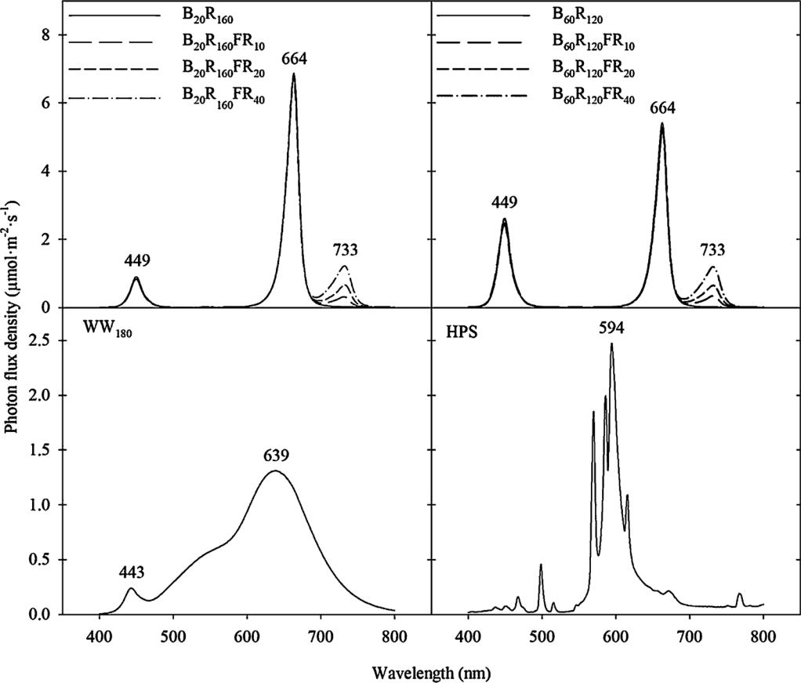

Table 1

Spectral characteristics and average photosynthetic daily light integral (DLI) of nine sole-source radiation treatments in two replications (rep) delivered in-doors by blue (B; peak = 449 nm), red (R; peak = 664 nm), far-red (FR; peak = 733 nm), and warm white (WW) light-emitting diodes (LEDs) or one greenhouse treatment with sunlight supplemented by high-pressure sodium (HPS) fixtures. The subscript values that follow each LED type indicate their photon flux density in μmol m–2 s–1.

|  |  |  |  |  |  |  |  |  |
| --- | --- | --- | --- | --- | --- | --- | --- | --- |
|  | Radiation treatment | | R:FRa | | PPEb | DLI (mol m–2 d–1) | |  |
|  |  |  |  |  |  |  |  |  |
|  |  |  |  |  |  | Rep 1 | Rep 2 |  |
|  |  |  |  | |  |  |  |  |
|  | B20R160 |  | 1:0 | | 0.88 | 12.0 | 11.7 |  |
|  | B20R160FR10 |  | 16:1 | | 0.87 | 11.7 | 11.7 |  |
|  | B20R160FR20 |  | 8:1 | | 0.85 | 11.7 | 11.4 |  |
|  | B20R160FR40 |  | 4:1 | | 0.83 | 11.9 | 11.6 |  |
|  | B60R120 |  | 1:0 | | 0.87 | 11.7 | 11.8 |  |
|  | B60R120FR10 |  | 12:1 | | 0.85 | 11.5 | 11.7 |  |
|  | B60R120FR20 |  | 6:1 | | 0.84 | 11.9 | 11.5 |  |
|  | B60R120FR40 |  | 3:1 | | 0.81 | 11.9 | 11.8 |  |
|  | WW180 |  | 5:1 | | 0.83 | 11.6 | 11.6 |  |
|  | Greenhouse | HPS | 5:1 | | 0.86 | 12.1 | 12.5 |  |
|  |  | Sunlight | 1:1 | | 0.72 |  |  |  |

1. R:FR: Ratio of the photon flux integral of R (600−700 nm) and FR

(700−800 nm) radiation.

1. PPE: Phytochrome photoequilibria estimated following Sager et al. (1988).

radiation treatment (shelf) were rotated every day to prevent positional eﬀects. Air temperature in CELL and the greenhouse was measured near plant height by thermocouples (Type E; Omega Engineering, Stamford, CT). Temperature and the PPFD at both locations were collected by data loggers (CR-1000; Campbell Scientific, Logan, UT) every 10 s and

|  |  |  |  |  |  |  |  |
| --- | --- | --- | --- | --- | --- | --- | --- |
| average values were | | recorded hourly. | | | Average | air temperatures | |
| ( ± standard | error) | in | two | replications were | | 20.1 ± 0.5 | and |
| 19.9 ± 1.3 °C | in CELL | | and | 19.9 ± 0.6 | and 21.2 ± 1.1 °C in | | the |

*Scientia Horticulturae 272 (2020) 109478*

Fig. 1. The spectral distribution of nine sole-source lighting treatments deliv-ered from blue (B; 400–500 nm), red (R; 600–700 nm), far-red (FR; 700–800 nm), and warm white (WW) light-emitting diodes (LEDs) indoors and supplemental lighting from high-pres-sure sodium (HPS) fixtures. The sub-script values after each LED type in-dicate their photon flux density in μmol m–2 s–1. The numbers above the peak of each LED type and HPS fixture indicate the peak wavelength. (For in-terpretation of the references to colour in this figure legend, the reader is re-ferred to the web version of this ar-ticle.)

greenhouse, respectively.

In CELL, the temperature was automatically controlled by an air conditioner (HBH030A3C20CRS; Heat Controller, Jackson, MI) and the air conditioner was controlled by a thermostat (TH8321R1001; Honeywell, Morris Plains, NJ) through a gateway and wireless sensor (THM6000R1002, C7189R1004; Honeywell). Humidity was monitored by a transmitter (HMDW110; Vaisala, Helsinki, Finland) and in re-plication 2, increased by a humidifier (LV600HH; Lӗvoit, Anaheim, CA) that ran continuously. The actual average relative humidity in the compartment was 29% and 41% in replication 1 and 2, respectively. In the greenhouse, whitewash (Kool Ray Classic; Continental Products Co., Euclid, OH) was applied to the greenhouse glazing to reduce the am-bient light intensity to deliver a DLI similar to that in the SSL treat-ments. Roof vents and fans were controlled by a greenhouse environ-mental control system (Integro 725; Priva North America, Vineland, Ontario, Canada). In both locations, seedlings were irrigated as neces-sary with deionized water supplemented with a water-soluble fertilizer containing (mg L–1) 50 N, 19 P, 50 K, 23 Ca, 4 Mg, 1 Fe, 0.5 Cu, 0.5 Zn, 0.5 Mn, 0.3 B, and 0.1 Mo (Michigan State University Plug Special; GreenCare Fertilizers, Inc., Kankakee, IL).

2.3. Environmental conditions during the finish stage

At the end of the seedling stage, when the seedlings had well-de-veloped root systems, ten seedlings of each species from each radiation treatment and replication were selected and transplanted into 10-cm pots containing 70% peatmoss, 21% perlite, and 9% vermiculite potting media (SUREMIX; Michigan Grower Products, Inc., Galesburg, MI) and randomly placed on benches in the research greenhouse. For each re-plication, the number of days under the radiation treatments before seedling data collection and transplanting was (replication 1, 2): African marigold (27, 27), coleus (35, 32), dianthus (27, 26), geranium

3

M. Zhang, et al.

(27, 27), impatiens (23, 24), petunia (25, 24), snapdragon (29, 28), tomato (22, 24), and zinnia (21, 21). Plants were grown at a constant 20 °C under a 16-h photoperiod provided by sunlight supplemented by 400-W HPS fixtures at a PPFD of 59 μmol m–2 s–1. Photon flux density measurements were made during the finish stage in the greenhouse with a spectroradiometer (PS-200; Apogee Instruments Inc., Logan, UT) above the benches at nine representative positions at plant height. HPS fixtures were automatically turned on from 0600 to 2200 HR when the PPFD was < 437 μmol m–2 s–1. Air temperature and PPFD were mon-itored and recorded as described above. The average air temperature and DLI during the finish stage in the greenhouse for replication 1/2 were 20.0/20.6 °C and 10.2/15.2 mol m–2 d–1, respectively. Plants were irrigated as necessary with reverse osmosis water supplemented with a water-soluble fertilizer containing (mg L–1) 125 N, 12 P, 100 K, 65 Ca, 12 Mg, 1 Fe and Cu, 0.5 Mn and Zn, 0.3 B, and 0.1 Mo (Michigan State University RO Water Special; GreenCare Fertilizers, Inc.).

2.4. Data collection and analysis

The experiment was performed twice. The most uniform 20 plants from each tray section of each species in each radiation treatment and replication were selected for data collection: ten for the seedling stage and ten for the finish stage. At the end of the seedling stage, stem length (from media level to apical meristem), leaf number, and leaf area [using a leaf area meter (LI-3000; LI-COR)] were measured for all nine species. Leaves with leaf length of ≥ 2 cm (or 3 cm for geranium, tomato, and African marigold) were counted in leaf number and included in leaf area. The average leaf area was calculated by dividing total leaf area by leaf number. An index of relative specific chlorophyll concentration (estimated by SPAD value) was measured on the second (for geranium) or third (for coleus, petunia, and zinnia) leaf from the meristem, using a SPAD meter (SPAD-502, Minolta Corporation, Ltd., Osaka, Japan). Three readings per leaf were taken and the average was recorded. After plants were dried in an oven at 80 °C for ≥ 5 d, shoot dry weight of all species and root dry weight of petunia, tomato, and zinnia were mea-sured with a balance (A&D Weighing GR-1000, San Jose, CA). During the finish stage, date of first open flower and visible bud or in-florescence number at first flowering was recorded on all species except coleus. Plant height at flowering (length of the primary stem from the substrate surface to the top of the inflorescence) was measured except for impatiens. Leaf number on the primary stem at flowering was re-corded for snapdragon, tomato, and zinnia.

The experiment used a randomized complete block design. Two replications were considered as two blocks and each shelf in CELL or the bench in the greenhouse was regarded as the experimental unit for the radiation treatment. Within the experimental unit, ten individual seedlings and ten individual plants at the finish stage per species were the subsamples. Data were pooled from two replications and were analyzed with the SAS (version 9.4; SAS Institute, Inc., Cary, NC) mixed-model (PROC MIXED) and glimmix-model (PROC GLIMMIX) procedures. Pairwise comparisons between lighting treatments were performed with Tukey’s honest significant diﬀerence test at p ≤ 0.05.

3. Results

3.1. Seedling stage

Seedling stem length of all species was similar among the ten ra-diation treatments except for snapdragon, petunia, and zinnia (Fig. 2). Stem length of snapdragon and zinnia generally increased as FR was added to either B20R160 or B60R120. Seedlings were 64–134% (for snapdragon) and 52–96 % (for zinnia) taller with the addition of FR at 40 μmol m–2 s–1 compared with that in the greenhouse or indoor treat-ments without FR. In snapdragon, stem length under WW180 was si-milar to that under B20R160FR20, B20R160FR40, and B60R120FR40. In contrast, zinnia stem length under WW180 was statistically similar to

*Scientia Horticulturae 272 (2020) 109478*

that under the other treatments. In petunia, stem length was 92% and 108% taller in the greenhouse than the indoor treatments without FR (i.e., B20R160 and B60R120), respectively, whereas stem length under these three treatments was similar to that in the other radiation treat-ments.

Under B60R120, the SPAD value of zinnia decreased by 17% with the addition of FR at 40 μmol m–2 s–1 (Fig. 3). Similarly, in petunia, the SPAD value under B60R120 decreased by 16–23% with additional FR at ≥20 μmol m–2 s–1. Under B20R160, SPAD value in petunia decreased with the addition of FR at 40 μmol m–2 s–1. SPAD value of zinnia and petunia was 14% or 13% higher under B60R120 or B20R160, respectively, whereas SPAD value was similar under B60R120 and B20R160 when the same photon flux density of FR was added. In geranium and coleus, there were no diﬀerences in SPAD value among treatments (Supple-mentary Table).

Radiation treatment did not influence average leaf area or dry shoot weight in any species (Table 2). Similarly, dry root weight of zinnia and petunia were similar under the radiation treatments. In tomato, the dry root weight of seedlings under B20R160FR10 was 40–47% greater than that under WW180 indoors or in the greenhouse, but dry root weight under these three treatments was similar to that in the other treatments (Supplementary Table).

3.2. Subsequent flowering

Radiation treatments during the seedling stage had little to no eﬀect on days to subsequent visible bud or flower, inflorescence number, plant height at flowering, or leaf number in all the species tested except for snapdragon (Table 3). In snapdragon, subsequent flowering was accelerated by 7–11 d with FR at 20 or 40 μmol m–2 s–1 (with B20R160 or B60R120) or under WW180 compared with indoor treatments without FR or in the greenhouse (Fig. 4). Plant height of snapdragon at flowering was 17–32% shorter with the addition of FR at 10–40 μmol m–2 s–1 (with B20R160 or B60R120) or under WW180 compared with that of seedling treatments without FR radiation. Snapdragon developed

8–29% fewer visible flower buds with the addition of FR at 20 or 40 μmol m–2 s–1 with B20R160, FR at 10–40 μmol m–2 s–1 with B60R120, and WW180 compared with indoor treatments without FR radiation or in the greenhouse. In addition, snapdragon developed 9 or 10 fewer leaves before flowering with the additions of FR at 20 or 40 μmol m–2 s–1 to B20R160 or FR at 40 μmol m–2 s –1 to B60R120 compared with indoor treatments without FR radiation. In geranium, plants at first flowering had an average of one more inflorescence when seedlings were grown under B60R120 than under B20R160FR20, and those had an inflorescence number similar to that of seedlings grown under the other treatments (Supplementary Table).

4. Discussion

Under vegetative shade outdoors, the R:FR decreases, and in re-sponse, plants elongate in an attempt to better capture photosynthetic light (Franklin, 2008; Gommers et al., 2013; Smith, 1994). The sensi-tivity of extension growth to the R:FR depends on shade-tolerance and species. For example, when the R:FR increased from 1:1 to 1:0, stem length of shade-avoiding geranium, snapdragon, and petunia decreased by 41–95%, whereas that of shade-tolerant impatiens decreased by 24% (Park and Runkle, 2017). We postulated that the reduction in R:FR by the addition of a relatively low FR photon flux density in SSL would promote stem elongation and leaf expansion of seedlings in shade-avoiding species and have less of an eﬀect in shade-tolerant species. Our results show that the addition of FR at 40 μmol m–2 s–1 increased stem length of shade-avoiding snapdragon and zinnia by 64–71% and 93–96%, respectively, under both B20R160 and B60R120 (Fig. 2). In contrast, the addition of FR did not meaningfully increase extension growth in the other five shade-avoiding species and both shade-tolerant species, coleus and impatiens.

4

M. Zhang, et al. *Scientia Horticulturae 272 (2020) 109478*

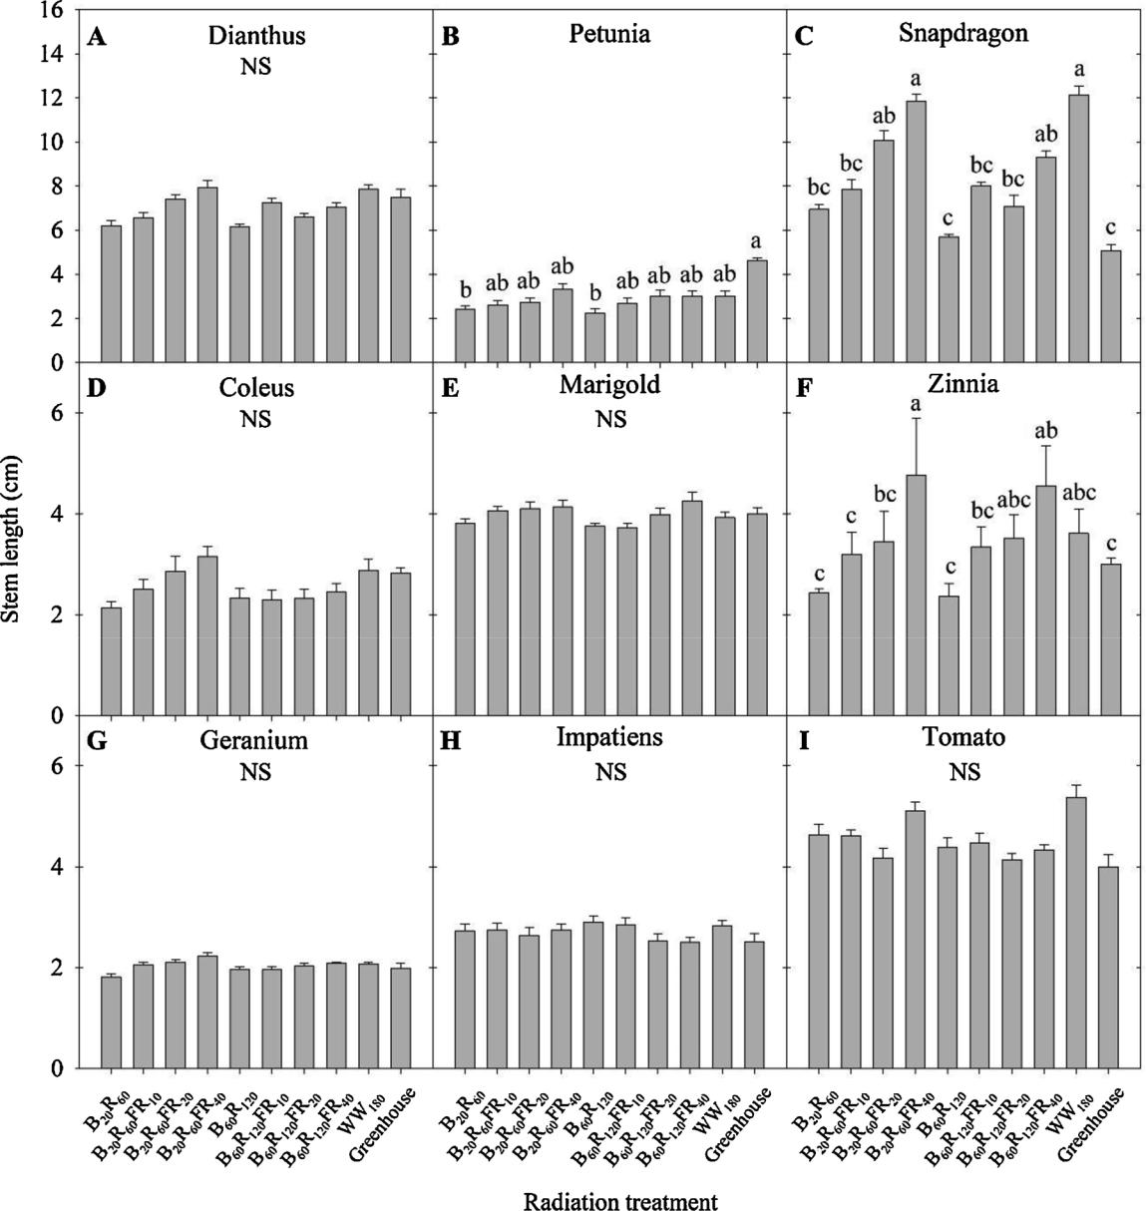

Fig. 2. Stem length of seedlings grown under eight sole-source lighting treatments emitting 0 to 40 μmol m–2 s–1 of far-red (FR; 700–800 nm) radiation with 20 or 60 μmol m–2 s–1 of blue (B; 400–500 nm) radiation and 120 or 160 μmol m–2 s–1 of red (R; 600–700 nm) radiation, or one treatment from warm white (WW) light-emitting diodes at 180 μmol m–2 s–1. Plants were also grown in a greenhouse for comparison. The top, middle, and bottom rows represent long-day plants, short-day plants, and day-neutral plants, respectively. Data for each species represent the mean of two replications with 10 subsamples (plants) per replication. Means sharing the same letter are not statistically diﬀerent by Tukey’s honest significant diﬀerence test at p ≤ 0.05 and NS indicates nonsignificance. Error bars indicate the standard error, which was calculated by 20 subsamples from two replications. (For interpretation of the references to colour in this figure legend, the reader is referred to the web version of this article.)

The magnitude of phytochrome-mediated plant responses depends on the relative amount of active phytochrome, or PPE. In a wide range of species, stem elongation increases linearly as the estimated PPE de-creases (Runkle and Heins, 2001). A PPE is established depending on the incident R:FR with a hyperbolic relationship (Smith, 1982; Craig and Runkle, 2016). As R:FR increases up to 1.2, the PPE value increases sharply, but the PPE value begins to plateau as R:FR > 1.2. In this study, the addition of 10−40 μmol m–2 s–1 of FR in SSL decreased the R:FR from 1:0 to 3:1 but only caused a small decrease in PPE, from 0.88 to 0.81 (Table 1). Therefore, in less sensitive shade-avoiding species and shade-tolerant species, the weak stem elongation responses from the decrease in R:FR can be attributed to the small decrease in PPE. In addition, although the R:FR and estimated PPE value have been used to predict the eﬀects of the radiation spectrum on phytochrome-mediated

extension growth, the PPE value of the radiation treatments was a more accurate predictor of extension growth in our study. For example, WW180, which had an R:FR = 5, had a PPE value similar to that of B20R160FR40 (R:FR = 4). Both treatments influenced seedling growth similarly in all species, including snapdragon and zinnia, under the same PPFD. In addition, B60R120FR10 and B60R120FR20, which had si-milar PPE values but diﬀerent R:FRs (12:1 and 6:1, respectively), had similar eﬀects on promoting stem elongation on snapdragon, zinnia, and petunia. Together, these findings indicate that the PPE value is a better indicator to assess crop extension growth responses compared with the R:FR, especially under higher R:FR conditions.

FR radiation is involved in regulation of photoperiodic flowering responses in some LDPs. During a long night, the flowering of a wide range of LDPs is promoted most when the night is interrupted with R

5

M. Zhang, et al. *Scientia Horticulturae 272 (2020) 109478*

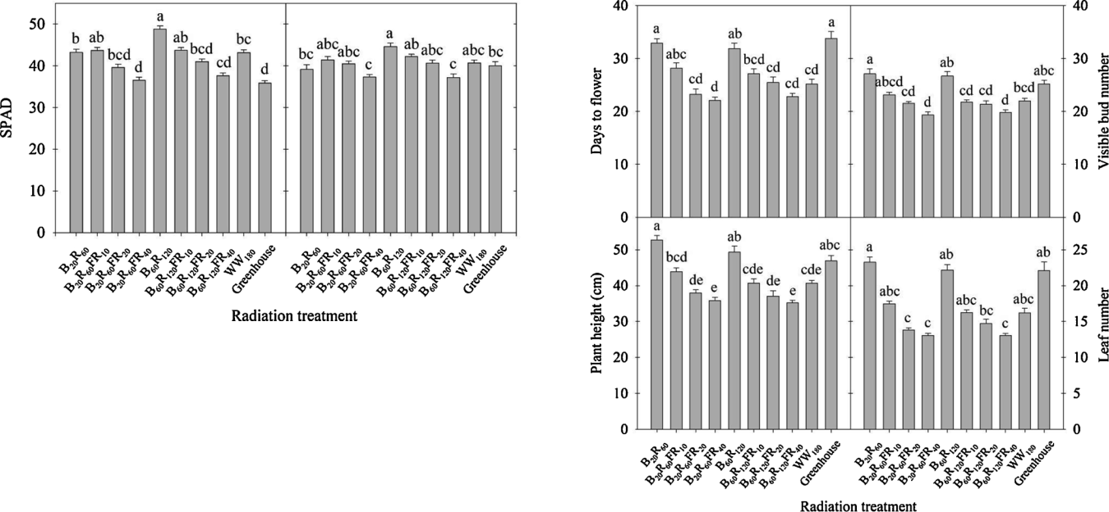

Fig. 3. Relative chlorophyll content (SPAD index) value of petunia (left) and zinnia (right) seedlings grown under nine sole-source lighting treatments de-livered by blue (B), red (R), far-red (FR), and warm white (WW) light-emitting diodes indoors and one greenhouse treatment as described in Fig. 2. Data for each species represent the mean of two replications with 10 subsamples (plants) per replication. Means sharing the same letter are not statistically diﬀerent by Tukey’s honest significant diﬀerence test at p ≤ 0.05. Error bars indicate the standard error, which was calculated by 20 subsamples from two replications. (For interpretation of the references to colour in this figure legend, the reader is referred to the web version of this article.)

Table 2

Average leaf area, dry shoot weight, and dry root weight of nine species at the end of the seedling stage. Lighting treatments had no statistical eﬀect on any species, and thus, data for each species were pooled from all lighting treat-ments. Data for each species represent the mean ( ± SE) of two replications with 10 subsamples (plants) per replication.

|  |  |  |  |  |  |
| --- | --- | --- | --- | --- | --- |
| Species | Average leaf area | | Dry shoot weight | | Dry root weight |
|  | (cm2) |  | (g) |  | (g) |
|  |  |  |  |  |  |
| African marigold | 5.96 | ± 1.45 | 0.19 | ± 0.06 | –a |
| Coleus | 4.39 | ± 1.56 | 0.10 | ± 0.03 | – |
| Dianthus | 3.99 | ± 0.69 | 0.15 | ± 0.03 | – |
| Geranium | 11.56 ± 2.04 | | 0.23 ± 0.06 | | – |
| Impatiens | 3.11 | ± 0.84 | 0.08 | ± 0.04 | – |
| Petunia | 2.37 ± 1.03 | | 0.10 ± 0.03 | | 0.042 ± 0.02 |
| Snapdragon | 3.46 ± 0.79 | | 0.16 ± 0.04 | | – |
| Tomato | 6.20 ± 1.50 | | 0.15 ± 0.04 | | 0.023 ± 0.01 |
| Zinnia | 8.02 ± 1.96 | | 0.14 ± 0.03 | | 0.062 ± 0.02 |

1. Data not collected.

Table 3

Days to flower after transplant, visible bud or inflorescence number at first flowering, plant height at flowering, and leaf number of eight species at the finish stage. Lighting treatments had no statistical diﬀerences on eight of the species and data for each species were pooled from all lighting treatments. Data for each species represent the mean ( ± SE) of two replications with 10 sub-samples (plants) per replication.

|  |  |  |  |  |  |  |
| --- | --- | --- | --- | --- | --- | --- |
| Species | Days to | | Visible flower | | Plant height | Leaf |
|  | flower after | | bud or |  | at flowering | number at |
|  | transplant | | inflorescence | | (cm) | flowering |
|  |  |  | number | |  |  |
|  |  |  |  | |  |  |
| African marigold | 39 | ± 3 | 13.8 ± 2.1 | | 13.8 ± 1.5 | –a |
| Coleus |  | – |  | – | 11.6 ± 2.5 | – |
| Dianthus | 55±4 | | 15.7 ± 2.2 | | 46.7 ± 5.3 | – |
| Geranium | 51±4 | | 3.0 | ± 0.7 | 22.9 ± 2.2 | – |
| Impatiens | 19±5 | | 26.9 | ± 12.3 | – | – |
| Petunia | 24±4 | | 18.9 ± 7.8 | | 7.9 ± 1.8 | – |
| Tomato | 10±3 | | 6.1 | ± 2.3 | 6.8 ± 1.2 | 4.2 ± 0.7 |
| Zinnia | 27±2 | | 4.2 | ± 1.2 | 15.8 ± 3.0 | 8.2 ± 0.7 |

1. Data not collected.

Fig. 4. Days to flower after transplant, visible bud number, plant height, and leaf number at flowering of snapdragon when seedlings were grown under nine sole-source lighting treatments delivered by blue (B), red (R), far-red (FR), and warm white (WW) light-emitting diodes (LEDs) indoors and one greenhouse treatment as described in Fig. 2. Data represent the mean of two replications with 10 subsamples (plants) per replication. Means sharing the same letter are not statistically diﬀerent by Tukey’s honest significant diﬀerence test at p ≤0.05. Error bars indicate the standard error, which was calculated by 20 subsamples from two replications. (For interpretation of the references to colour in this figure legend, the reader is referred to the web version of this article.)

and FR (Downs and Thomas, 1982; Oh and Runkle, 2016; Craig and Runkle, 2016). For example, in LDPs including snapdragon, night-in-terruption lighting with an intermediate PPE value (between 0.63 and 0.80) was the most eﬀective at promoting flowering (Craig and Runkle, 2016). In a separate study, the subsequent flowering of snapdragon was accelerated when SSL included FR at ≥16 μmol m–2 s–1 (creating a PPE ≤0.85), and the acceleration was saturated when the PPE was between 0.69 and 0.85 (Park and Runkle, 2017). In addition, when the PPE was between 0.69 and 0.89, increasing B photon flux density from

1. to 80 μmol m–2 s–1 did not influence the promotive eﬀects of FR on subsequent flowering in snapdragon (Park and Runkle, 2019). Con-sistent with this response, the subsequent flowering of snapdragon in this study was hastened when SSL included FR at ≥20 μmol m–2 s–1

(creating a PPE of 0.81 to 0.85) regardless of whether B radiation was at

1. or 60 μmol m–2 s–1 (Fig. 4).

We estimated chlorophyll concentration by measuring SPAD values

of leaves, which have been positively and closely correlated with de-structive leaf chlorophyll measurements in a variety of crops (Azia and Stewart, 2001; Monje and Bugbee, 1992; Schaper and Chacko, 1991; Turner and Jund, 1991). Both phytochromes and cryptochromes are involved in controlling chlorophyll biosynthesis and catabolism (Neﬀ and Chory, 1998; Stephenson and Terry, 2008). Although the relative contributions and interactions of phytochromes and cryptochromes on regulating chlorophyll accumulation are not clear, FR and B radiation generally can have antagonistic eﬀects on chlorophyll concentration; increasing FR decreases chlorophyll concentration, whereas B increases it. For example, lettuce grown indoors had 12% less chlorophyll con-centration in leaves with supplemental FR lighting of 160 μmol m–2 s–1 than without it (Li and Kubota, 2009). In geranium, petunia, and snapdragon seedlings, SPAD value decreased linearly as the estimated PPE decreased (as the R:FR decreased) (Park and Runkle, 2017). In

6

M. Zhang, et al.

contrast, increasing B from 0 to 90 μmol m–2 s–1 at a total PPFD of 100 μmol m–2 s–1 increased the chlorophyll concentration in cucumber seedlings by 50% (Hernández and Kubota, 2016). Similarly, the chlorophyll concentration in lettuce increased by 23% as B increased from 0% to 11% at a PPFD of 200 mol m–2 s–1 (Wang et al., 2016). In this study, the addition of FR at 40 μmol m–2 s–1 decreased the SPAD value of zinnia and petunia (regardless of the B proportion) and FR at ≥20 μmol m–2 s–1 decreased the SPAD value of petunia under B60R120 (Fig. 3). Increasing B from 20 to 60 μmol m–2 s–1 increased the SPAD value in petunia and zinnia by 13–14% only without FR. However, SPAD values of SSL treatments with the same FR photon flux density were all similar under B radiation at 20 or 60 μmol m–2 s–1, suggesting that the inclusion of FR at ≥10 μmol m–2 s–1 can diminish the eﬀect of increasing B by 40 μmol m–2 s–1.

Increasing the B photon flux density inhibited plant height, leaf area, and shoot dry weight in many species (Hernández and Kubota, 2016; Nanya et al., 2012; Snowden et al., 2016). In addition, increasing

1. from 0 to 80 μmol m–2 s–1 suppressed the eﬀects of R:FR or PPE on seedling height of petunia, geranium, and coleus (Park and Runkle, 2019). In this study, increasing B from 20 to 60 μmol m–2 s–1 did not aﬀect seedling height in any species tested. Wollaeger and Runkle (2015) reported that increasing B radiation from 0 to 10 μmol m–2 s–1 under a pure R radiation spectrum inhibited plant height of impatiens, salvia, and tomato, but plants under B at ≥10 μmol m–2 s–1 were gen-erally of similar height. In impatiens and salvia, there was little eﬀect on seedling height when B radiation increased from 20 to 80 μmol m–2 s–1. This suggests that B radiation at 20 μmol m–2 s–1 was suﬃcient to saturate the suppressive eﬀects of B on seedling stem elongation of most of the crops studied.

Increasing B radiation from 20 to 60 μmol m–2 s–1 did not change the leaf area and shoot dry weight in any of the species tested. In cucumber, the fresh and dry mass of seedlings was similar but leaf area decreased as the B proportion increased from 0% to 16% at a PPFD of 54 μmol m–2 s–1 (Hernández and Kubota, 2014). An increase of B from 10% to 75% at a PPFD of 100 μmol m–2 s–1, however, decreased leaf area and shoot dry mass of cucumber seedlings by 41% and 24%, respectively (Hernández and Kubota, 2016). Snowden et al. (2016) also reported that dry mass and leaf area of tomato, cucumber, and pepper sig-nificantly decreased when B was increased from 10% to 30% under a high photon flux density (500 μmol m–2 s–1), but only tomato developed a smaller leaf and a reduced dry mass under a photon flux density of 200 μmol m–2 s–1. Therefore, the eﬀects of B radiation on leaf area and shoot mass depend, at least in part, on the species, PPFD, and B photon flux density.

5. Conclusions

The sensitivity of plants to FR radiation is species specific. Including ≥40 μmol m–2 s–1 of FR radiation with R + B SSL (PPE ≤0.83) in-creased the extension growth of two shade-avoiding species, but gen-erally a low photon flux density of FR (10–40 μmol m–2 s–1) had little eﬀect on seedling growth of the other shade-avoiding species and the shade-tolerant species. The inclusion of FR radiation at ≥20 μmol m–2 s –1 during the seedling stage accelerated subsequent flowering of at least some LDP, but had little or no eﬀect on short-day and day-neutral plants. Seedling growth and subsequent flowering with or without FR were similar under the two B photon flux densities, except that the chlorophyll concentration in zinnia and petunia seedlings increased when the B photon flux density was 60 μmol m–2 s–1 and without FR. We concluded that SSL that emits a modest B photon flux density (e.g., ≥20 μmol m–2 s–1) and has an estimated PPE between 0.81 and 0.85 is recommended to produce relatively compact seedlings and accelerate subsequent flowering of sensitive LDPs. We also concluded that PPE value is a better indicator of crop extension growth responses than R:FR with 100-nm wavebands.

*Scientia Horticulturae 272 (2020) 109478*

CRediT authorship contribution statement

Mengzi Zhang: Conceptualization, Methodology, Validation, Formal analysis, Investigation, Writing - original draft, Writing - review

* editing, Visualization. Yujin Park: Conceptualization, Validation, Investigation, Resources, Writing - review & editing. Erik S. Runkle: Conceptualization, Methodology, Validation, Writing - review & editing, Supervision, Project administration, Funding acquisition.

Declaration of Competing Interest

The authors declare that they have no known competing financial interests or personal relationships that could have appeared to influ-ence the work reported in this paper.

Acknowledgments

We gratefully acknowledge the American Floral Endowment and OSRAM for supporting this project, Raker-Roberta’s and Syngenta Flowers for the donation of plant material, and Nate DuRussel for technical assistance. This work was supported by the USDA National Institute of Food and Agriculture, Hatch project 192266.

Appendix A. Supplementary data

Supplementary material related to this article can be found, in the online version, at doi:<https://doi.org/10.1016/j.scienta.2020.109478>.

References

[Azia, F., Stewart, K.A., 2001. Relationships between extractable chlorophyll and SPAD](http://refhub.elsevier.com/S0304-4238(20)30306-X/sbref0005) [values in muskmelon leaves. J. Plant Nutr. 24, 961–966](http://refhub.elsevier.com/S0304-4238(20)30306-X/sbref0005).

[Craig, D.S., Runkle, E.S., 2016. An intermediate phytochrome photoequilibria from night-interruption lighting optimally promotes flowering of several long-day plants.](http://refhub.elsevier.com/S0304-4238(20)30306-X/sbref0010) [Environ. Exp. Bot. 121, 132–138](http://refhub.elsevier.com/S0304-4238(20)30306-X/sbref0010).

[Craver, J.K., Lopez, R.G., 2015. Sole-source lighting in horticulture: bedding plant plug](http://refhub.elsevier.com/S0304-4238(20)30306-X/sbref0015) [production. Greenhouse Grower 33, 40–46](http://refhub.elsevier.com/S0304-4238(20)30306-X/sbref0015).

[Downs, R.J., Thomas, J.F., 1982. Phytochrome regulation of flowering in the long-day](http://refhub.elsevier.com/S0304-4238(20)30306-X/sbref0020) [plant, Hyoscyamus niger. Plant Physiol. 70, 898–900](http://refhub.elsevier.com/S0304-4238(20)30306-X/sbref0020).

[Franklin, K.A., 2008. Shade avoidance. New Phytol. 179, 930–944](http://refhub.elsevier.com/S0304-4238(20)30306-X/sbref0025).

[Fraser, D.P., Hayes, S., Franklin, K.A., 2016. Photoreceptor crosstalk in shade avoidance.](http://refhub.elsevier.com/S0304-4238(20)30306-X/sbref0030)

[Curr. Opin. Plant Biol. 33, 1–7](http://refhub.elsevier.com/S0304-4238(20)30306-X/sbref0030).

[Gommers, C.M., Visser, E.J., St Onge, K.R., Voesenek, L.A., Pierik, R., 2013. Shade tol-erance: when growing tall is not an option. Trends Plant Sci. 18, 65–71](http://refhub.elsevier.com/S0304-4238(20)30306-X/sbref0035).

[Hernández, R., Kubota, C., 2014. Growth and morphological response of cucumber](http://refhub.elsevier.com/S0304-4238(20)30306-X/sbref0040) [seedlings to supplemental red and blue photon flux ratios under varied solar daily](http://refhub.elsevier.com/S0304-4238(20)30306-X/sbref0040) [light integrals. Scientia Hort. 173, 92–99](http://refhub.elsevier.com/S0304-4238(20)30306-X/sbref0040).

[Hernández, R., Kubota, C., 2016. Physiological responses of cucumber seedlings under](http://refhub.elsevier.com/S0304-4238(20)30306-X/sbref0045) [diﬀerent blue and red photon flux ratios using LEDs. Environ. Exp. Bot. 121, 66–74](http://refhub.elsevier.com/S0304-4238(20)30306-X/sbref0045).

[Hoenecke, M.E., Bula, R.J., Tibbitts, T.W., 1992. Importance of “blue” photon levels for](http://refhub.elsevier.com/S0304-4238(20)30306-X/sbref0050) [lettuce seedlings grown under red-light-emitting diodes. HortScience 27, 427–430](http://refhub.elsevier.com/S0304-4238(20)30306-X/sbref0050).

[Hogewoning, S.W., Trouwborst, G., Maljaars, H., Poorter, H., van Ieperen, W., Harbinson,](http://refhub.elsevier.com/S0304-4238(20)30306-X/sbref0055) [J., 2010. Blue light dose–responses of leaf photosynthesis, morphology, and chemical](http://refhub.elsevier.com/S0304-4238(20)30306-X/sbref0055) [composition of Cucumis sativus grown under diﬀerent combinations of red and blue](http://refhub.elsevier.com/S0304-4238(20)30306-X/sbref0055) [light. J. Exp. Bot. 61, 3107–3117](http://refhub.elsevier.com/S0304-4238(20)30306-X/sbref0055).

[Lee, M.J., Son, K.H., Oh, M.M., 2016. Increase in biomass and bioactive compounds in](http://refhub.elsevier.com/S0304-4238(20)30306-X/sbref0060) [lettuce under various ratios of red to far-red LED light supplemented with blue LED](http://refhub.elsevier.com/S0304-4238(20)30306-X/sbref0060) [light. Hort. Environ. Biotechnol. 57, 139–147](http://refhub.elsevier.com/S0304-4238(20)30306-X/sbref0060).

[Li, Q., Kubota, C., 2009. Eﬀects of supplemental light quality on growth and phyto-chemicals of baby leaf lettuce. Environ. Expt. Bot. 67, 59–64](http://refhub.elsevier.com/S0304-4238(20)30306-X/sbref0065).

[Lobiuc, A., Vasilache, V., Oroian, M., Stoleru, T., Burducea, M., Pintilie, O., Zamfirache,](http://refhub.elsevier.com/S0304-4238(20)30306-X/sbref0070) [M.M., 2017. Blue and red LED illumination improves growth and bioactive com-pounds contents in acyanic and cyanic Ocimum basilicum L. microgreens. Molecules](http://refhub.elsevier.com/S0304-4238(20)30306-X/sbref0070) [22, 2111](http://refhub.elsevier.com/S0304-4238(20)30306-X/sbref0070).

[Lopez, R.G., Runkle, E.S., 2008. Photosynthetic daily light integral during propagation](http://refhub.elsevier.com/S0304-4238(20)30306-X/sbref0075) [influences rooting and growth of cuttings and subsequent development of New](http://refhub.elsevier.com/S0304-4238(20)30306-X/sbref0075) [Guinea impatiens and petunia. HortScience 43, 2052–2059](http://refhub.elsevier.com/S0304-4238(20)30306-X/sbref0075).

[Lopez, R., Currey, C., Runkle, E., 2017. Light and young plants, p. 109–118. In: Lopez,](http://refhub.elsevier.com/S0304-4238(20)30306-X/sbref0080) [R.G., Runkle, E.S. (Eds.), Light Management in Controlled Environments. Meister](http://refhub.elsevier.com/S0304-4238(20)30306-X/sbref0080) [Media Worldwide, OH](http://refhub.elsevier.com/S0304-4238(20)30306-X/sbref0080).

[Meng, Q., Runkle, E.S., 2017. Far red is the new red. Inside Grower 2, 26–30](http://refhub.elsevier.com/S0304-4238(20)30306-X/sbref0085). [Mitchell, C., Stutte, G., 2017. Sole-source lighting for controlled-environment agriculture,](http://refhub.elsevier.com/S0304-4238(20)30306-X/sbref0090)

[p. 48–58. In: Lopez, R.G., Runkle, E.S. (Eds.), Light Management in Controlled](http://refhub.elsevier.com/S0304-4238(20)30306-X/sbref0090) [Environments. Meister Media Worldwide, OH](http://refhub.elsevier.com/S0304-4238(20)30306-X/sbref0090).

[Mitchell, C.A., Both, A.J., Bourget, C.M., Burr, J.F., Kubota, C., Lopez, R.G., Morrow, R.C.,](http://refhub.elsevier.com/S0304-4238(20)30306-X/sbref0095) [Runkle, E.S., 2012. Horticultural science focus-LEDs: the future of greenhouse](http://refhub.elsevier.com/S0304-4238(20)30306-X/sbref0095)

7

M. Zhang, et al.

[lighting!. Chronica Hort. 52, 6–12](http://refhub.elsevier.com/S0304-4238(20)30306-X/sbref0095).

[Monje, O.A., Bugbee, B., 1992. Inherent limitations of nondestructive chlorophyll meters:](http://refhub.elsevier.com/S0304-4238(20)30306-X/sbref0100)

[a comparison of two types of meters. HortScience 27, 69–71](http://refhub.elsevier.com/S0304-4238(20)30306-X/sbref0100).

[Nanya, K., Ishigami, Y., Hikosaka, S., Goto, E., 2012. Eﬀects of blue and red light on stem](http://refhub.elsevier.com/S0304-4238(20)30306-X/sbref0105) [elongation and flowering of tomato seedlings. Acta Hort. 956, 261–266](http://refhub.elsevier.com/S0304-4238(20)30306-X/sbref0105).

[Neﬀ, M.M., Chory, J., 1998. Genetic interactions between phytochrome A, phytochrome](http://refhub.elsevier.com/S0304-4238(20)30306-X/sbref0110) [B, and cryptochrome 1 during Arabidopsis development. Plant Physiol. 118, 27–35](http://refhub.elsevier.com/S0304-4238(20)30306-X/sbref0110).

[Oh, W., Runkle, E.S., 2016. Flowering and morphological responses of petunia and pansy](http://refhub.elsevier.com/S0304-4238(20)30306-X/sbref0115) [as influenced by lamp type and lighting period to provide long days. Korean J. Hort.](http://refhub.elsevier.com/S0304-4238(20)30306-X/sbref0115) [Sci. Technol. 34, 207–219](http://refhub.elsevier.com/S0304-4238(20)30306-X/sbref0115).

[Park, Y., Runkle, E.S., 2017. Far-red radiation promotes growth of seedlings by increasing](http://refhub.elsevier.com/S0304-4238(20)30306-X/sbref0120) [leaf expansion and whole-plant net assimilation. Environ. Exp. Bot. 136, 41–49](http://refhub.elsevier.com/S0304-4238(20)30306-X/sbref0120).

[Park, Y., Runkle, E.S., 2018. Far-red radiation and photosynthetic photon flux density](http://refhub.elsevier.com/S0304-4238(20)30306-X/sbref0125) [independently regulate seedling growth but interactively regulate flowering. Environ.](http://refhub.elsevier.com/S0304-4238(20)30306-X/sbref0125) [Exp. Bot. 155, 206–216](http://refhub.elsevier.com/S0304-4238(20)30306-X/sbref0125).

[Park, Y., Runkle, E.S., 2019. Blue radiation attenuates the eﬀects of the red to far-red ratio](http://refhub.elsevier.com/S0304-4238(20)30306-X/sbref0130) [on extension growth but not on flowering. Environ. Exp. Bot. 168, 103871](http://refhub.elsevier.com/S0304-4238(20)30306-X/sbref0130).

[Runkle, E.S., Heins, R.D., 2001. Specific functions of red, far red, and blue light in](http://refhub.elsevier.com/S0304-4238(20)30306-X/sbref0135) [flowering and stem extension of long-day plants. J. Am. Soc. Hortic. Sci. 126,](http://refhub.elsevier.com/S0304-4238(20)30306-X/sbref0135) [275–282](http://refhub.elsevier.com/S0304-4238(20)30306-X/sbref0135).

[Sager, J.C., Smith, W.O., Edwards, J.L., Cyr, K.L., 1988. Photosynthetic eﬃciency and](http://refhub.elsevier.com/S0304-4238(20)30306-X/sbref0140) [phytochrome photoequilibria determination using spectral data. Trans. Am. Soc. Agr.](http://refhub.elsevier.com/S0304-4238(20)30306-X/sbref0140)

*Scientia Horticulturae 272 (2020) 109478*

[Eng. 31, 1882–1889](http://refhub.elsevier.com/S0304-4238(20)30306-X/sbref0140).

[Schaper, H., Chacko, E.K., 1991. Relation between extractable chlorophyll and portable](http://refhub.elsevier.com/S0304-4238(20)30306-X/sbref0145) [chlorophyll meter readings in leaves of eight tropical and subtropical fruit-tree spe-cies. J. Plant Physiol. 138, 674–677](http://refhub.elsevier.com/S0304-4238(20)30306-X/sbref0145).

[Smith, H., 1982. Light quality, photoreception, and plant strategy. Annu. Rev. Plant](http://refhub.elsevier.com/S0304-4238(20)30306-X/sbref0150) [Physiol. Plant Mol. Biol. 33 (481), 518](http://refhub.elsevier.com/S0304-4238(20)30306-X/sbref0150).

[Smith, H., 1994. Sensing the light environment: the functions of the phytochrome family,](http://refhub.elsevier.com/S0304-4238(20)30306-X/sbref0155) [p 377–416. In: Kendrick, R.E., Kronenberg, G.H.M. (Eds.), Photomorphogenesis in](http://refhub.elsevier.com/S0304-4238(20)30306-X/sbref0155) [Plants, 2nd ed. Kluwer Academic Publishers, Dordrecht, the Netherlands](http://refhub.elsevier.com/S0304-4238(20)30306-X/sbref0155).

[Snowden, M.C., Cope, K.R., Bugbee, B., 2016. Sensitivity of seven diverse species to blue](http://refhub.elsevier.com/S0304-4238(20)30306-X/sbref0160) [and green light: interactions with photon flux. PLoS One 11, e0163121](http://refhub.elsevier.com/S0304-4238(20)30306-X/sbref0160).

[Stephenson, P.G., Terry, M.J., 2008. Light signalling pathways regulating the Mg chela-tase branchpoint of chlorophyll synthesis during de etiolation in Arabidopsis](http://refhub.elsevier.com/S0304-4238(20)30306-X/sbref0165) [thaliana. Photochem. Photobiol. Sci. 7 (1243), 1252](http://refhub.elsevier.com/S0304-4238(20)30306-X/sbref0165).

[Turner, F.T., Jund, M.F., 1991. Chlorophyll meter to predict nitrogen topdress require-ment for semidwarf rice. Agro. J. 83, 926–928](http://refhub.elsevier.com/S0304-4238(20)30306-X/sbref0170).

[Wang, S., Wang, X., Shi, X., Wang, B., Zheng, X., Wang, H., Liu, F., 2016. Red and blue](http://refhub.elsevier.com/S0304-4238(20)30306-X/sbref0175) [lights significantly aﬀect photosynthetic properties and ultrastructure of mesophyll](http://refhub.elsevier.com/S0304-4238(20)30306-X/sbref0175) [cells in senescing grape leaves. Hort. Plant J. 2, 82–90](http://refhub.elsevier.com/S0304-4238(20)30306-X/sbref0175).

[Wollaeger, H.M., Runkle, E.S., 2015. Growth and acclimation of impatiens, salvia, pet-unia, and tomato seedlings to blue and red light. HortScience 50, 522–529](http://refhub.elsevier.com/S0304-4238(20)30306-X/sbref0180).

8