[Scientia Horticulturae 272 (2020) 109522](https://doi.org/10.1016/j.scienta.2020.109522)

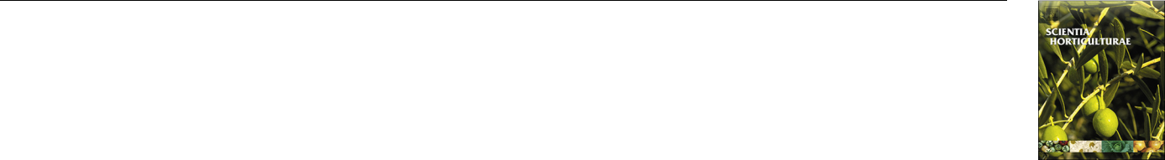

Contents lists available at [ScienceDirect](http://www.sciencedirect.com/science/journal/03044238)



Scientia Horticulturae

journal homepage: [www.elsevier.com/locate/scihorti](https://www.elsevier.com/locate/scihorti)

Assessment of diﬀerent LED lighting systems for indoor living walls

[T](http://crossmark.crossref.org/dialog/?doi=10.1016/j.scienta.2020.109522&domain=pdf)



Maria P. Kaltsidia, Rafael Fernández-Cañerob, Luis Pérez-Urrestarazua,*

1. Urban Greening and Biosystems Engineering Research Group, Area of Agro-Forestry Engineering, Universidad De Sevilla, ETSIA Ctra, Utrera Km.1, 41013, Seville, Spain
2. Urban Greening and Biosystems Engineering Research Group, Department of Agro-Forestry Sciences, Universidad De Sevilla, ETSIA Ctra, Utrera Km.1, 41013, Seville, Spain

ARTICLE INFO

Keywords:

Vertical greening system

Ornamental lighting

Plant development

Urban greening

Viewer’s perception

ABSTRACT

Building-integrated vegetation systems, such as living walls (LW), are becoming common tools for improving the sustainability of cities as well as an aesthetic resource. When used indoors, LW usually require a lighting system to ensure both an adequate plant development and a correct appearance. In this study, six commercial LED lighting systems are tested in order to assess their suitability for the proper performance of LW. The LW mon-itored were composed of two plant species (Soleirolia soleirolii and Spathiphyllum wallisii) frequently used in indoor LW. All the lamps tested (Aster and Dahlia of Ignia Green, Logar CMH, CLH and Forum of Lledó) proved to be apt for their use to light LW (except for the case of CF-UT01 of Panda Grow), as they showed a favourable performance in terms of plant development, with few diﬀerences between them in biomass production and green cover. The tested Aster (Ignia Green) and Logar CMH (Lledó) lamp models were not eﬃcient for long distances between the vegetation and the light source. Despite these results, as illumination is one of the factors that determines the indoor ambience, aesthetics and viewers’ preferences were also studied. According to the ob-servers' perception, the Dahlia model (Ignia Green) was preferred by 54.4 % of the respondents, while the rest of the lamps were preferred less.

1. Introduction

Nowadays, the inclusion of vegetation in the built environment in the form of green roofs and vertical greening systems is spreading. They are usually located outdoors, but in the case of living walls (LW), indoor installations are becoming frequent, given the multiple benefits which they oﬀer, improving indoor air quality (particles and VOC retention), environmental conditions (temperature and humidity levels), acoustics and wellbeing (Gunawardena and Steemers, 2019; Moya et al., 2019). However, when plants are grown inside a building, one of the main constraints is the light that they receive. The available natural light in indoor environments is frequently not suﬃcient, thus auxiliary artificial lighting is often required for adequate plant growth and development (Tan et al., 2017).

Selecting the proper lighting system for indoor plant growth is a demanding process that requires an accurate prior study. It should ensure certain characteristics in terms of intensity (the amount of light received by the vegetation) and quality (the spectral composition of the light source) (GOTO, 2003). In the case of LW, regulating the intensity is even more complicated, given that the lamps are usually located in the ceiling, so the lighting is not uniform over the entire vertical sur-face. In terms of quality, not only obtaining an eﬀective spectral range



is essential but also ensuring that the LW have a proper appearance (Egea et al., 2014).

Artificial lighting technologies have been used in crop production for many years, with incandescent, fluorescent or high-intensity dis-charge lamps having been those most employed. However, the advance of solid-state lighting using light-emitting diodes (LEDs), with a great technical development in the last years and an important cost reduc-tion, has displaced the other types of lamps. LEDs show several ad-vantages such as a much longer lifespan and producing a high luminous flux with a low radiant heat output (Morrow, 2008; Yeh and Chung, 2009). This makes them more competitive in energy eﬃciency and economic terms (Singh et al., 2015).

LEDs also have the ability to emit in a controlled spectral compo-sition (Olle and Viršile, 2013), which is an advantage when growing plants. Given that LEDs emit in a very narrow spectrum (20−40 nm), the specific peak absorption bands of chlorophyll can be targeted. This improves the use of energy as most emitted light can be used for pho-tosynthesis. Precisely, that is the basis of commercial LED grow lights, which mainly emit in the blue and red regions. Nevertheless, they give plants an unnatural appearance due to their colour (red/blue), so they are not so apt for aesthetical purposes, including LW lighting. In ad-dition, some studies indicate that a better plant growth is achieved

Corresponding author.

E-mail addresses: [markal1@alum.us.es](mailto:markal1@alum.us.es) (M.P. Kaltsidi), [rafafc@us.es](mailto:rafafc@us.es) (R. Fernández-Cañero), [lperez@us.es](mailto:lperez@us.es) (L. Pérez-Urrestarazu).

<https://doi.org/10.1016/j.scienta.2020.109522>

Received 17 January 2020; Received in revised form 15 April 2020; Accepted 27 May 2020

Available online 05 June 2020

0304-4238/ © 2020 Elsevier B.V. All rights reserved.

M.P. Kaltsidi, et al. *Scientia Horticulturae 272 (2020) 109522*



Nomenclature

SymbolUnits

ADW Aerial Dry Weight(g plant−1)

AFW Aerial Fresh Weight(g plant−1)

CRI Colour Rendering Index(–)

ET Evapotranspiration(l d−1)

LED Light-Emitting Diodes(–)

LW Living Wall (s) (–)

PAR Photosynthetically Active Radiation(–)

when using a broader spectrum with additional wavelengths (Kim et al., 2006). This makes white light more adequate. In order to obtain white LEDs, blue LEDs are usually coated with phosphor. Though this makes them less eﬃcient than the single-wave-peak LEDs, the visualisation of plants greatly improves (Massa et al., 2008).

In artificial lighting, the term white light refers to light formed by a mixture of colours. However, not all whites are the same, since they depend on the colours that compose them. In this sense, a white with a higher proportion of red will favour a "warmer" lighting and a white with a higher proportion of blues will give a "cooler" appearance. Colour temperature is used to classify the diﬀerent types of white light and to facilitate comparison with "full spectrum" sunlight (Morrow, 2008). This concept refers to the type of light that a black body radiates when heated to a specific temperature, so that the higher the colour temperature, the colder the light source. For instance, at 2,000–3,000 K, the colour of the light will look white yellow; at 4000 K, neutral white, and at 5,000–7,000 K, cold white. Shaw (2018) suggested that colour temperature has an eﬀect on the growth of hydroponic lettuce seed-lings, as plants under 6000 K lights grew more than under 3000 K. However, even when two light sources have the same colour tem-perature, the surfaces can be seen in diﬀerent colours, given that two lights that appear to produce the same white may be the result of dif-ferent wavelength mixes. For this reason, the concept of colour ren-dering is used to elucidate the similarity between the natural colour of

Table 1

|  |  |
| --- | --- |
| PPFD | Photosynthetic Photon Flux Density(μmol m−2 s-1) |
| RDW | Root Dry Weight(g plant−1) |
| RFW | Root Fresh Weight(g plant−1) |
| RH | Relative Humidity(%) |
| Soleirolia | Soleirolia soleirolii(–) |
| Spathiphyllum Spathiphyllum wallisii(–) | |
| SPAD | relative measure of chlorophyll content(–) |
| T | Temperature(ºC) |
| TDW | Total Dry Weight(g plant−1) |
| TFW | Total (whole-plant) Fresh Weight(g plant−1) |
| LA | mean Leaf Area(cm2leave−1) |

an object (that is, in daylight conditions) and its colour under artificial lighting. Based on this concept, the colour rendering index (CRI) clas-sifies light sources according to their colour rendering properties: the higher the CRI, the closer it is to natural colour.

LED lighting in horticultural production has been widely addressed (Islam et al., 2012; Massa et al., 2008; Morrow, 2008; Olle and Viršile, 2013; Samuoliene et al., 2013; Singh et al., 2015), but it has not been studied when it is used with an ornamental purpose (as is the case of LW illumination). Only Tan et al. (2017) and Egea et al. (2014) have addressed this topic. The former quantified the impact of growth light provision on indoor greenery and the light compensation point of two ornamental species. The latter analysed diﬀerent artificial lighting systems for LW, but in their study LEDs were not contemplated.

The main objective of the current study was to assess the adaptation of six diﬀerent commercial LED lamps (five of which were not specifi-cally designed for plant growth) for the lighting of indoor LW. Both the performance and correct development of the vegetation under each lamp and its appearance were taken into consideration. The study was completed with an analysis of public preferences.

LED lamps used in the study and their characteristics. The diﬀerent letters (A, B, C, D, E, F) refer to diﬀerent lamp type treatments and the diﬀerent numbers (1 or 2) refer to module closer (1) or farther (2) to the light source.

|  |  |  |  |  |  |  |  |  |  |  |  |
| --- | --- | --- | --- | --- | --- | --- | --- | --- | --- | --- | --- |
| Lamp Model | Projector | Curves | Dimensions | Manufacturer | LW module | Power (W) | Flux (lm) | CRI | Beam | Colour | Type of |
|  |  |  |  |  |  |  |  |  | angle (º) | temperature (K) | light |
|  |  |  |  |  |  |  |  |  |  |  |  |
| Aster |  |  |  | Ignia Green | A1 | 40 | 2.575 | > 90? | 36° | 3.700 | White |
|  |  |  |  | (Girona, Spain) |  |  |  |  |  |  |  |
| Logar CMH |  |  |  | Lledó (Madrid, | B1 | 35 | 2.650 | > 90 | 31º | 4.000 | White |
| Superflood |  |  |  | Spain) |  |  |  |  |  |  |  |
| CF-UT01 |  | NA |  | Panda Grow | C1 | 100 | 5.000 | NA | 120° | NA | Blue/ |
|  |  |  |  | (Shenzhen, China) |  |  |  |  |  |  | red |
| Dahlia |  |  |  | Ignia Green | D1-D2 | 110 | 7.950 | > 90? | 97° | 3.700 | White |
|  |  |  |  | (Girona, Spain) |  |  |  |  |  |  |  |
| Logar CLH |  |  |  | Lledó (Madrid, | E1-E2 | 48 | 3.300 | > 90 | *41º | 4.000 | White |
| Superflood |  |  |  | Spain) |  |  |  |  |  |  |  |
| Forum |  |  |  | Lledó (Madrid, | F1-F2 | 83 | 7.350 | > 80 | 68º | 4.000 | White |
|  |  |  |  | Spain) |  |  |  |  |  |  |  |

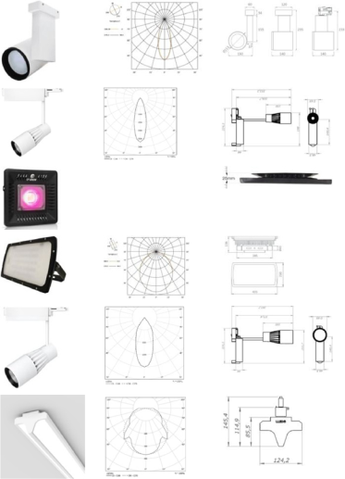

* Due to its small beam angle, two identical lamps of this model were placed at the same spot with diﬀerent angles pointing at the centre of each of the two modules. NA: Not available.

2

M.P. Kaltsidi, et al.

2. Materials and methods

2.1. Experimental setup and tests performed

The study was performed at the Urban Greening Laboratory of the School of Agricultural Engineering of the University of Seville (Seville, Spain), with no natural light. Six diﬀerent types of lamps were tested in this study and two experiments were carried out. Five of the lamps were conventional white LED lamps (4000 K) while one (C) was a commer-cial Grow-LED lamp specially designed for plant cultivation. Table 1 presents the main characteristics of each lamp and Fig. 1 shows the relative emission intensity spectrum, when available. The first experi-ment involved lamps A to C and was conducted over the period mid-May to end-July 2018 (68 days). During this period, the daily mean room temperature and relative humidity were 24.9 ± 0.7 °C and 68 ± 5 %, respectively. Lamps D, E and F were tested in a second experiment from mid-February to end-April (70 days). In this case, the daily room temperature was 22.4 ± 0.6 °C and the relative humidity was 56 ± 7 %.

In the first test, only one lamp per LW module was placed at a distance of 1 m from the wall where the LW modules were installed, pointing at the centre of each LW module (100°) (Fig. 2). In the second test, as the light intensity provided by the lamps was adequate at a higher distance, a second LW module was added right below the ex-isting ones to test the capacity of these lamps to light a higher LW up. D and F lamps were pointing between the two LW modules at a distance of 1 m from the wall and with a 120° inclination angle. E1 was pointing at the centre of the upper LW module (100°), 0.80 m apart from the LW module surface. E2 was angled to face the centre of the lower module (140°), at a distance of 1.50 m from it. The 3 phase electrified rails of the lamps B, E, F and the lamps A, C, D were attached in a metallic base 0.50 m from the ceiling. Thus, all lamps were placed just in front of the middle of the upper LW module. The inclination angles were de-termined by doing a simulation using the professional DIALux evo

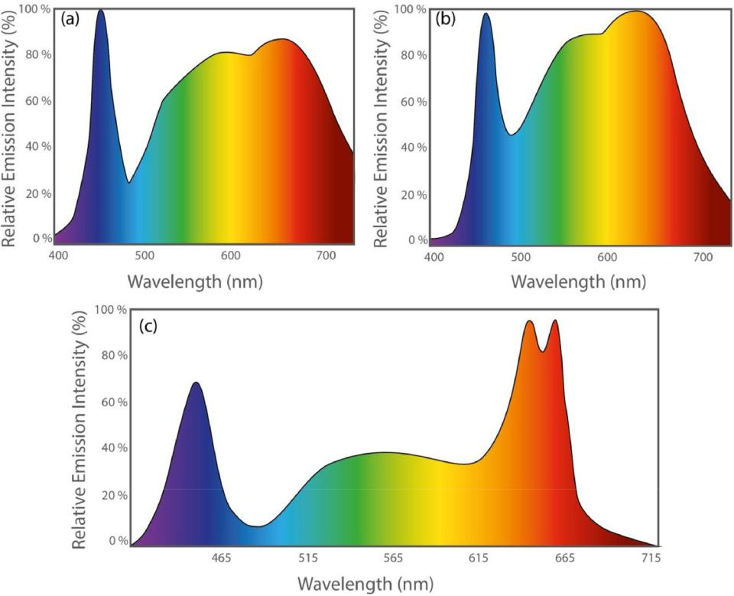

*Scientia Horticulturae 272 (2020) 109522*

lighting design software (DIAL, Lüdenscheid, Germany) for professional light planning, to optimise their illumination. The diﬀerent LW modules were separated from each other using opaque black plastic curtains and a constant photoperiod of 14 h per day was provided during both trials.

The LW modules, similar to those employed in Egea et al. (2014), were based on a felt commercial system (Fytotextile®, Terapia Urbana S.L, Spain), with dimensions of 0.72 m wide by 0.73 m high. Each of the LW modules’ structures was composed of three synthetic layers: an outer hydrophobic layer made of polyamide; an inner layer of recycled hydrophilic fibres (geotextile) which contributed to homogeneously distributing the water; and a waterproof back layer. The first two layers were sewn together with nylon thread forming a 13.5cm × 13.5cm grid resulting in 25 pockets (5 rows and 5 columns) where the plants were inserted. Watering was provided by means of a lateral PVC dripline with perforations spaced 30 mm apart, connected by a vertical poly-ethylene (PE) pipe to a submerged compact water pump with a flow of 250 l h−1 (Compact 600 7 W, Eheim, Germany) located in a water tank placed at the bottom of the LW module. The tank served as a water reservoir, collecting the excess of water drained from the modules at the same time. Electrical conductivity and pH were periodically measured in the water tanks in order to ensure that there were no other factors aﬀecting the results whereas there was neither a fertilizing nor pesticide implementation. Three-minute irrigation events twice a day were scheduled for all the modules during both tests. The recharge volume used to fill each tank up was recorded in order to determine water consumption due to evapotranspiration (ET).

Air temperature (T, ºC) and relative humidity (RH, %) readings of the LW surface were obtained hourly for each LW module throughout both tests using a HOBO U23 Pro v2 Temperature/Relative Humidity Data Logger (Onset Computer Corporation, Bourne MA, USA). The sensors were placed at the same level as the central pocket of each module and separated 0.2 m from the module.

Fig. 1. Relative emission intensity (%) spectrum for a) Lledo, Forum lamp b) Lledo, CMH, CLH lamps and c) Ignia Green, Aster and Dahlia. (Graphs courtesy Lledo and Ignia green, images modified) (For interpretation of the references to colour in this figure legend, the reader is referred to the web version of this article.).

3

M.P. Kaltsidi, et al. *Scientia Horticulturae 272 (2020) 109522*

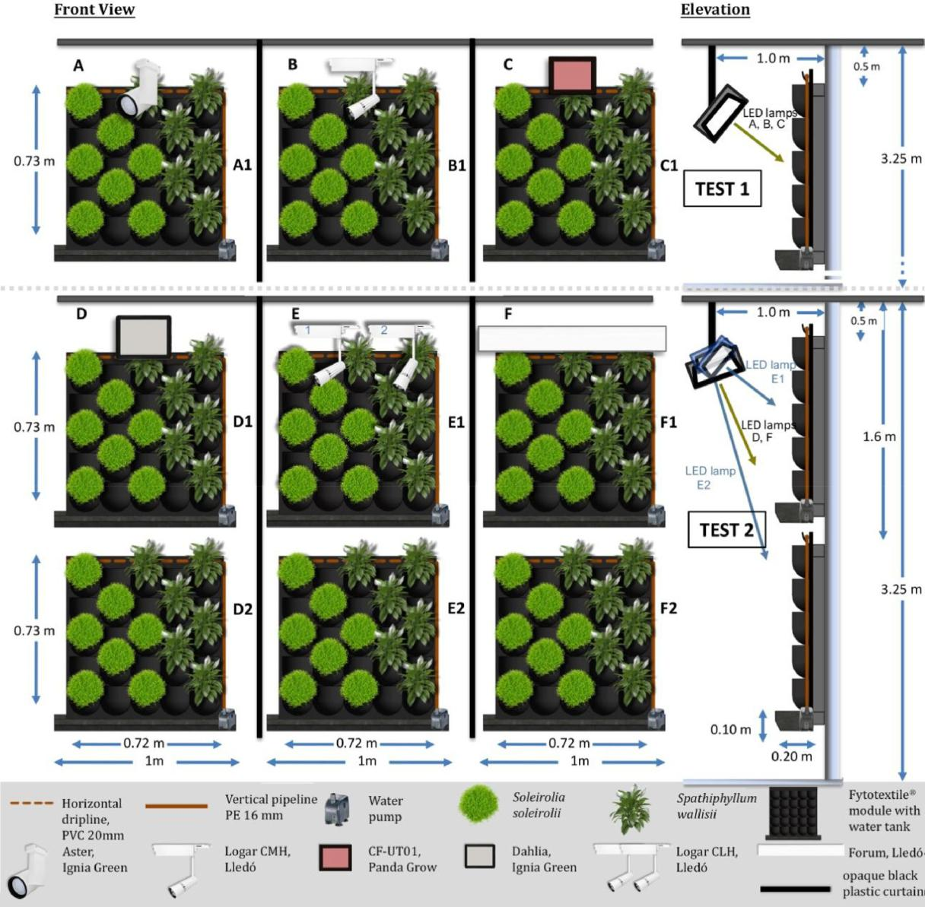

Fig. 2. Layout of the experiment. Distribution of lamps and living wall modules and location of the plants for tests 1 (up) and 2 (down).

2.2. Plant species used and planting design

In order to be able to compare the results obtained in this study with previous experiments (i.e., Egea et al., 2014; Pérez-Urrestarazu et al., 2019), Spathiphyllum wallisii Regel (Spathiphyllum) and Soleirolia soleir-olii (Req.) Dandy (Soleirolia) were the two species selected for the trials. Spathiphyllum, commonly known as peace lily, is an evergreen perennial flowering plant in the Araceae family, grown for its foliage and flowers, suitable for indoor use. Soleirolia, commonly known as baby's tears or Irish moss, is a mat forming usually evergreen prostrate perennial with small, round, vivid green leaves in the Urticaceae family (Brickell, 2011). Both of them are very commonly used in indoor LW installa-tions. Thus, Spathiphyllum was specifically chosen in order to monitor the flowering, while Soleirolia was used to address the vegetal covering. In each of the LW modules, the number of plants (7 of Soleirolia and 6 of Spathiphyllum) and their distribution was the same (depicted in Fig. 2). All plants used had the same size (9 cm pot diameter for Spathiphyllum and 10.5 cm for Soleirolia) and were planted at the beginning of each test, inserting the rootball, without adding any growing media, in the pockets of the LW modules.

2.3. Plant development monitoring

From when the LW modules were planted, the number of flowers per individual Spathiphyllum was counted weekly. Moreover, in order to assess the evolution of the vegetation cover during the tests, RGB images of each LW module were taken on a weekly basis from the same position. The fraction of the LW area covered by vegetation was de-termined using the image-processing software ImageJ (Rueden et al., 2017), separating the pixels corresponding to green cover from the background.

Photosynthetic activity (as an indirect measure of green-ness,determined by the relative chlorophyll content) was measured at the end of each test in Spathiphyllum leaves by means of a hand‐held Minolta SPAD-502 chlorophyll metre (Konica Minolta Optics, Inc, Japan). Thus, five measurements per leaf were performed in three leaves per plant and six plants per module. The Normalised Diﬀerence Vegetation Index (NDVI), is a unitless index which indicates the health and vigour of the plants and ranges from −1 to 1, corresponding the highest positive values to healthy vegetation (Turvey and Mclaurin, 2012). NDVI was obtained by making five measurements in each LW

4

M.P. Kaltsidi, et al.

module at the middle and end of each test using a GreenSeeker hand-held crop sensor (Trimble, Sunnyvale, CA, USA).

At the end of each test, all the plants were detached from the LW in order to characterise the total biomass production. Subsequently, the growing media was thoroughly removed from the roots by carefully washing with tap water. Next, the aerial part of each of the plants was separated from the root system, in order to separately obtain fresh and dry weights of both parts using an AH-300 precision scale (I.C.T, S.L., La Rioja, Spain). Before drying the Spathiphyllum leaves (in an oven during 48 h at 80 °C), an LI-3100 Leaf Area Meter (Li-Cor, Nebraska, USA) was used to determine total leaf area (TLA, cm2·plant−1) per plant.

2.4. Light measurements

The light intensity reaching diﬀerent points of the LW modules was determined both at the beginning and at the end of the tests. A line quantum sensor (LI-191 Line Quantum Sensor, Li-Cor, Nebraska, USA) was used to obtain the mean photosynthetic photon flux density (PPFD, μmol m−2 s-1). Three PPFD readings were taken at the top, middle and bottom of each LW module. At the same time, the PPFD values were obtained for each lamp at diﬀerent distances (from 0.5 m to 5 m) from the light source. Also, the illuminance (luminous flux per unit area, lx)

*Scientia Horticulturae 272 (2020) 109522*

was measured in 13 points of each LW module (corresponding to the location of the plants) by means of a lux metre (model 0635 0545) attached to a multifunctional metre (Testo SE & Co. KGaA, Lenzkirch, Germany) and compared with a simulation carried out using the DIALux evo software.

2.5. Observers’ perception

A survey was performed in order to evaluate the observers’ per-ception of the LW using each of the LED lamps. A hundred random observers (50 were male and 50 female; 5, 35, 49 and 11 participants were in the age range of 18–25, 26–40, 41–65 and over 65 years old, respectively) were presented with a questionnaire after watching each of the upper LW (with lights on) at the final stage of the experiment. The perception study only contemplated the lamps used, not the dis-tance to the light source. Therefore, only the upper modules were in-volved in the observers' questionnaire. Following a similar approach to Jost-Boissard et al. (2009), they were asked for each case if the colours under that lamp were attractive and if the plants had a natural ap-pearance. They had to answer using a Likert scale from 1 (not much) to 5 (very). They were also asked to arrange the diﬀerent lighting systems by preference from the most suitable to the least.

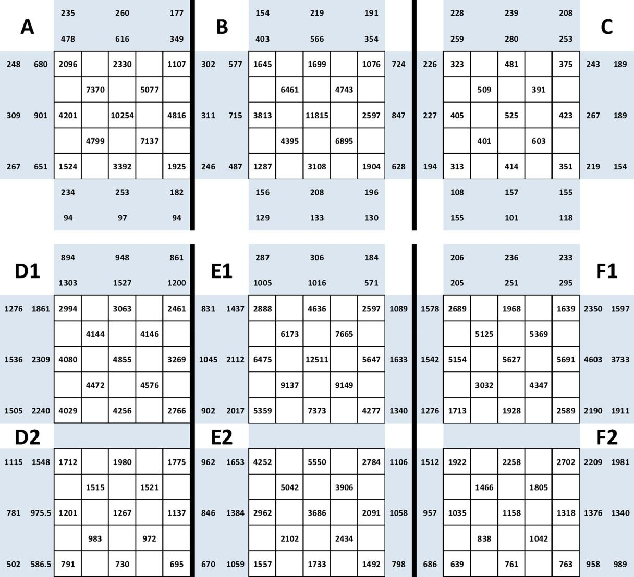

Fig. 3. Illuminance values (lx) in diﬀerent locations of the living wall modules and close to them for tests 1 (up) and 2 (down).

5

M.P. Kaltsidi, et al.

2.6. Statistical analysis

Each of the nine LW modules constituted a discrete experimental unit with six and seven replicates for Spathiphyllum and Soleirolia, re-spectively, within each unit. An Analysis of Variance (One-Way ANOVA) was performed having as a factor the lamp type (6 types) per distance (1 m, 1.5 m) and eight dependent variables (aerial and root dry and fresh weight, total fresh and dry weight, mean leaf area and NDVI). Thus, the analysis assessed the impact of the lamps and the corre-sponding distances to the light source on vegetation performance and on the daily water consumption. For the statistical analysis of daily water consumption, a comparison of means was realized using the va-lues observed in each day of the experiment. For the NDVI analysis and due to the nature (i.e., percentages) of our data, the arcsin transfor-mation was applied prior to statistical analysis (McDonald, 2014). The analysis was carried out using the statistical package Statgraphics (Statgraphics Centurion XVII) and Duncan’s multiple range test was used for means separation at the significance level P ≤ 0, 05.

3. Results

3.1. Lighting pattern

The distribution of the luminous flux per unit area received in the diﬀerent points of the LW modules is shown in Fig. 3. The highest il-luminance values are observed in all cases in the middle of the upper LW module, while they are usually lower at the bottom of the module. The highest average value of illuminance was observed in module E1 (6453 lx), followed by A (4310 lx) and B (3957 lx). In the latter, the luminous flux was more focused in the centre of the LW module, while in the rest of the modules, the illuminance values were more homo-geneous. Module C was the one receiving a lower illuminance in all the points (average of 424 lx). D1 and F1 showed a similar illuminance distribution (mean values of 3778 and 3605, respectively), though in the latter the luminous flux was more centred in the middle, the upper and lower parts of the module receiving less light. In D2 and F2, the illuminance values were obviously lower (averages of 1252 and 1362 lx, respectively) and decreased from the top to the bottom. The illuminance values observed in E2 were, however, much higher (with an average of 3045 lx), with similar levels to those observed in D1 and F1 (though at the bottom of the module they considerably decreased).

Table 2 shows the mean PPFD values measured at three heights in each module. For lamps A, B and C, the PPFD was also obtained in the locations where the lower modules would have been, but the values were below 3 μmol m−2 s-1 (making plant survival very diﬃcult). As in the case of the illuminance levels, the highest values are obtained in the middle of the upper modules. E1 was the LW module receiving a higher value (an average of 82.5 μmol m−2 s-1), followed by D1 and F1 (71.9 and 60.3 μmol m−2 s-1). Conversely, A1 and B1 showed similar PPFD values (35.7 and 25.6 μmol m−2 s-1, respectively) to those observed in the lower modules in the second test (27.8, 48.8 and 32.3 μmol m−2 s-1 for D2, E2 and F2, respectively). Module C received very poor values (7 μmol m−2 s-1 in average).

Both the illuminance received and the PPFD depend, among other factors, on the distance to the light source. Fig. 4 shows the diﬀerent values of these two factors according to the distance from the LW to the diﬀerent lamps tested. In the first metre, the values severely decrease, while this decrease is observed to be less intense as the distance in-creases.

Fig. 5 represents the relation between the measured values of illu-minance vs the PPFD for the diﬀerent lamps, hence obtaining the conversion equations between both factors, which are distinct for each lamp. Lamp A exhibited a good relation, comparing to the rest lamps, where then minimum illuminance of 420 lx corresponds to 5.8 μmol m−2 s-1 and a 1048 lx corresponds to 13.2 μmol m−2 s-1. Lamp C pre-sented the most elevated PPFD value (22.2 μmol m−2 s-1) in 1136 lx,

*Scientia Horticulturae 272 (2020) 109522*

though, to be achieved, a short distance of 0.5 m is required (Fig. 4). Lamp D had the highest PPFD value (94.8 μmol m−2 s-1) when illu-minance reaches 7204 lx. Lamp E showed a good relation between PPFD and illuminance.

Finally, an illuminance simulation of both tests was performed in DIALux evo (Fig. 6), showing a very similar pattern of lux levels to that depicted in Fig. 3. The Pearson correlation coeﬃcients results (0.95, 0.98, 0.92, 0.89, 0.95, 0.88, 0.79, 0.77 and 0.98 for modules A, B, C, D1, D2, E1, E2, F1 and F2, respectively) exhibited that the correlation between the simulations (Fig. 6) and the actual measured values (Fig. 3) was high, being slightly inferior for the lower modules.).

3.2. Temperature and water consumption

The evolution of the temperature (T) close to each module is de-picted, for both tests, in Fig. 7. Variations in T were within 5 °C even between tests. The average T of test 1 and test 2 diﬀered by 3 °C. During test 2, a diﬀerence of 1 °C on average was observed between the upper and lower modules except for D1 and D2 which did not diﬀer. RH ranged between 50 % and 70 %. The average values were higher for the first test. In the second test, the RH was lower in the upper modules compared to the lower ones.

The average daily water consumption ranged between 1 and 1.5 l m−2 d-1 (Fig. 8), resulting in more water consumed in module D2 (50.4 L) compared to B (35.2 L). Statistically significant diﬀerences (F = 2.834198; P-value = 0.00617977) in the average daily water consumption values were observed.

3.3. Vegetation performance

Plant biomass produced in each of the LW modules was calculated at the end of the tests. Both fresh and dry weights per plant were measured for the aerial and root parts. Total leaf area (TLA) was also obtained only for Spathiphyllum.

In the case of Spathiphyllum (Table 3), diﬀerences in fresh weight were more significant in the aerial part,while significant diﬀerences were exhibited only in the root system of module A. Module A had the higher fresh weights, while E2 presented the lowest. No diﬀerences were observed in fresh weight within modules lighted by lamps D, E and F. However, looking into their dry weights, the only significant diﬀerence occurred in the aerial part between E1 and D2. Even though no significant diﬀerences between upper and lower modules were ob-served, dry biomass in lower modules was 82.2 % of the average ob-served in the upper ones. Plants in module D2 had the lowest dry biomass, being 57 % of the obtained in module A, which produced the highest value (significantly diﬀerent to the rest, excepting modules B and E1). There were no significant diﬀerences in leaf area.

Table 4 shows the biomass production for Soleirolia plants. In this case, a much lower weight per plant was obtained in module C (espe-cially regarding the aerial part), followed by F2.The total dry weight of plants in module C was 35 % of that obtained in D1 and E1. Plants grown in lower modules had, on average, 66 % of the dry weight of the plants in the upper modules. However, lamps D and F showed

Table 2

Mean Photosynthetic Photon Flux Density values (μmol m−2 s-1) for all lamps (A to F) in the upper (1) and lower (2) modules at three diﬀerent heights (Up, Mid, Down) within each module.

|  |  |  |  |  |  |  |  |
| --- | --- | --- | --- | --- | --- | --- | --- |
|  |  | A | B | C | D | E | F |
|  |  |  |  |  |  |  |  |
| 1 | Up | 28.9 | 13.3 | 7.3 | 62.6 | 58.6 | 58.0 |
|  | Mid | 55.2 | 43.7 | 7.7 | 78.7 | 109.9 | 88.8 |
|  | Down | 23.0 | 19.8 | 5.9 | 74.2 | 78.9 | 34.0 |
| 2 | Up | 1.9 | 2.9 | 2.2 | 38.3 | 73.8 | 44.1 |
|  | Mid | 0.6 | 0.7 | 1.2 | 26.0 | 52.7 | 32.3 |
|  | Down | 0.4 | 0.3 | 0.8 | 19.2 | 19.9 | 20.4 |
|  |  |  |  |  |  |  |  |

6

M.P. Kaltsidi, et al. *Scientia Horticulturae 272 (2020) 109522*

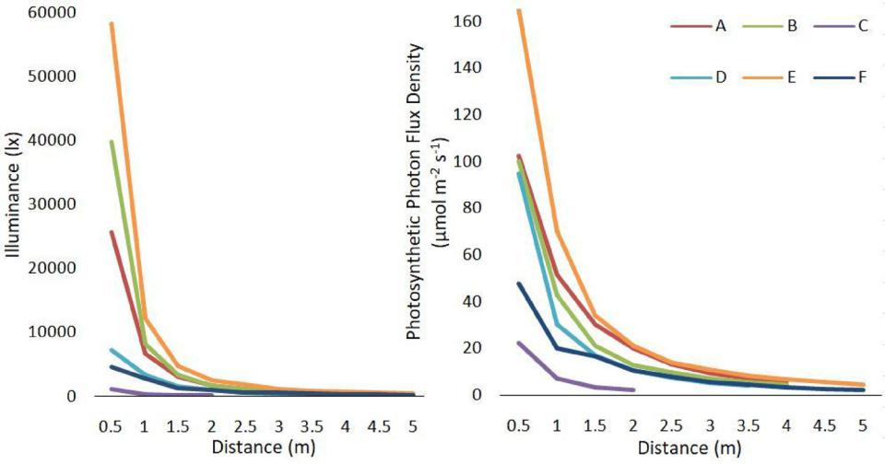

Fig. 4. Illuminance (left) and Photosynthetic Photon Flux Density (right) at diﬀerent distances from the light source for each lamp.

significant diﬀerences between the upper and lower modules only due to the root part, and no diﬀerences were found for lamp E. Precisely, lamp F was the one with a lower biomass production in the lower modules, as the average total dry weigh of plants in module F2 was 57

* of that observed in E2 (though no statistically significant diﬀerences were found between both).

The evolution of the green cover expressed by the % of the LW module covered by vegetation is shown in Fig. 9. The vegetation in-itially covered around 28 % of the LW modules and diﬀerences were already appreciated from the first week after planting. In general, the upper modules showed a higher green cover, exceeding 80 % of the LW module covered by vegetation at the end of the test in A, B and D1. E1 and F1 reached 79 % and 73 %, respectively. Module C, however, presented a much lower coverage (64 %), similar to that obtained in the lower modules of the second test (67 %, 65 % and 71 % for D2, E2 and F2, respectively).

The number of Spathiphyllum white flowers in each LW module is shown in Fig. 10 on a weekly basis. There was a big diﬀerence between tests, but not as much between the lamps used. In the first one, the average number of flowers was 11, 18 and 12 for modules A, B and C, respectively. In contrast, an average of 43, 50, 45, 46, 44 and 43 flowers were observed in D1, E1, F1, D2, E2 and F2, respectively.

Table 5 shows the mean NDVI values obtained at the middle and

end of each test. All the values ranged between 0.68 (C and E1) and 0.91 (D2). After four weeks since planting, all the values were fairly similar, though C already showed the lowest NDVI value. Modules A, B, C and F2 maintained or a slightly increased NDVI at the end of the tests. However, the NDVI decreased in D1, E1 and F1, showing lower values than the rest of the modules (even C). Conversely, the NDVI was con-siderably higher for D2 and E2 at the end of the test. Only module B did not show significant diﬀerences between weeks 4 and 10.

The chlorophyll content in Spathiphyllum leaves in each module was measured at the end of the tests and the average SPAD values are presented in Fig. 11. The lowest values were observed in the upper modules in the second test (D1, E1 and F1), ranging between 41.4 and 44.1. D2 and F2 had the highest values 54.9 and 54.1, respectively).

3.4. Observers’ perception

In order to assess the visual quality, the observers were asked if the lights (Fig. 12) produced attractive colours and a natural appearance of the plants (Table 6). Lamps D and F were the ones with the highest scores in both questions, followed by E. Lamps A and C got the lowest values. In fact, when the participants were asked to rank the lamps in order of preference, lamp D was chosen in the first position by 54.4 % of the respondents and as second by 30.4 % of them. Lamp F was the one

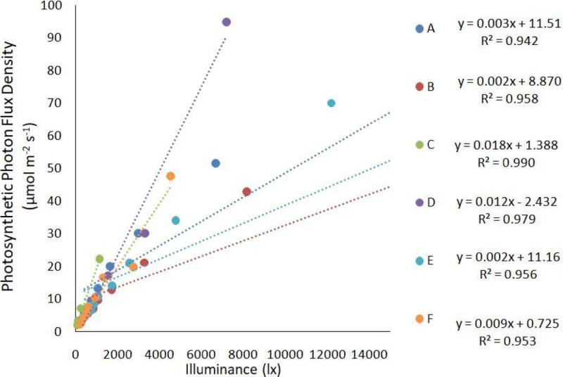

Fig. 5. Relation between illuminance (lx) and Photosynthetic Photon Flux Density.

7

M.P. Kaltsidi, et al. *Scientia Horticulturae 272 (2020) 109522*

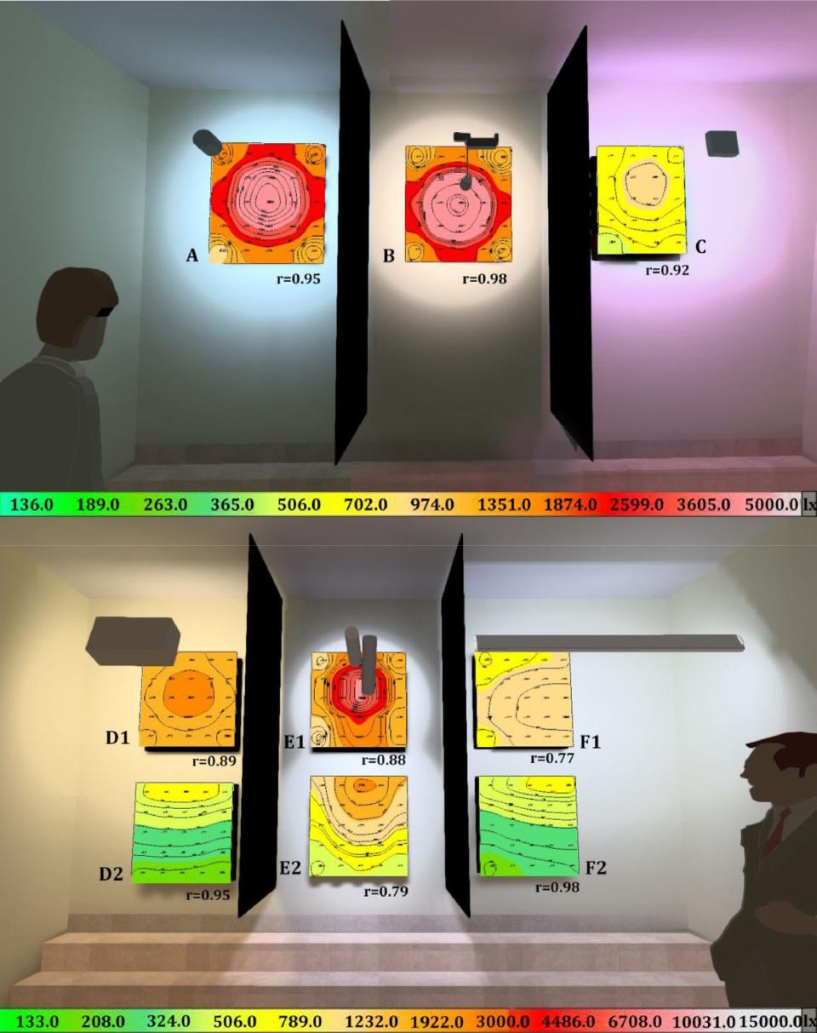

Fig. 6. Simulation of illuminance levels for Test 1 (up) and Test 2 (down) using DIALux evo software and Pearson correlation coeﬃcients (r) between the simulation and the measured illuminance values (lx).

preferred by 36.7 % of the observers and chosen as the second by 44.3

* 86.8 % of the participants selected lamp C as the least preferable. Lamp B was mainly chosen in the third (29 %) and fourth (38 %) place. Lamp A was chosen in the fifth place by 52.8 % and in the last place by 13.2 %.

4. Discussion

Including ornamental greenery indoors often requires auxiliary il-lumination when not enough natural light is available increasing the energy consumption. In this regard, specific lighting requirements for indoor ornamental plants is necessary in order to optimise the pro-gramming of the lighting and minimise the occurrence of over-com-pensation (Tan et al., 2017). It is also important to select lamps that, producing a good result in terms of vegetation development and ap-pearance, do not have excessive energy consumption and do not pro-duce too much heat. Even when the above fact is precisely the ad-vantage of LED lamps the choice of the one with the least wattage does

not guarantee the eﬀectiveness of the lamp. In fact, there are some lamps that use the energy to produce more light in the PAR spectrum, hence being more eﬀective.

In the current study, as observed in Fig. 5, lamp C is the one with a higher illuminance/PPFD relation, exhibiting a higher luminous flux within PAR wavelengths (high slope of the lx-PPFD conversion equa-tion). Lamps D and F also have a high ratio, while the worst perfor-mance in these terms is showed by lamp B. Conversely, observing the eﬃcacy values in terms of photosynthetic photons received in average per m2 per energy unit (PPDE, derived from the photosynthetic photon eﬃcacy (PPE) described in (Park and Runkle, 2018), lamp C shows an amazingly poor value (0.04 μmol m−2 J-1), compared with the highest PPDE observed (0.68 μmol m−2 J-1 for lamp E). Lamp B produces a low value (0.38 μmol m−2 J-1), while A, D and F exhibit intermediate values (0.46, 0.45 and 0.56 μmol m−2 J-1, respectively).

Even when Lamp C is specifically designed for plant growth, it is the one which has the worst behaviour (low PPFD levels and the worst performance of vegetation). This happens because this type of lamps is

8

M.P. Kaltsidi, et al. *Scientia Horticulturae 272 (2020) 109522*

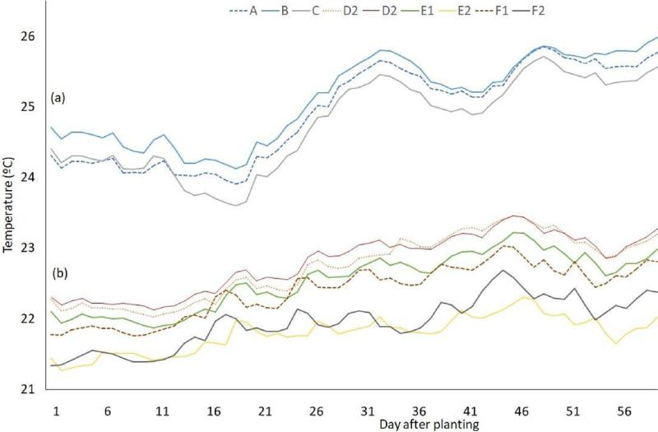

Fig. 7. Evolution of the mean daily temperature near each living wall module during both tests.

prepared to be positioned very close to the vegetation (less than 0.5 m away). Therefore, they are not suitable for this use given that the lamps cannot be located right in front of the LW and at a short distance. However, in this study the vegetation cover survived and, though its development was not as adequate as with the other lamps, the plants maintained a fairly appropriate condition. As has been already stated, an added drawback of these lamps is the unnatural appearance and unpleasant view that they produce, resulting again in unsuitability for ornamental purposes.

The eﬀectiveness of artificial lighting depends not only on the type of source, but also on several other factors such as the vertical gradient of illuminance (due to the distance from the vegetation to the light source) and the number of lamps and their position (Chen, 2005). In fact, it is well known that the illuminance is inversely proportional to the square of the distance from the source (inverse square law of light). For instance, Thiel et al. (1996) reported a vertical gradient of illumi-nance in which its value decreased between 25 % and 60 % per metre of distance to the light source. In our study, between 48 % (lamp F) and 64

* (lamp B) of illuminance was lost, in average, per metre of distance to the light source, depending on the lamp considered (excluding lamp C, with 78.6 % lost). Yet, in the first metre, between 71 % and 92 % of the illuminance was lost. However, the PPFD gradient observed is slightly

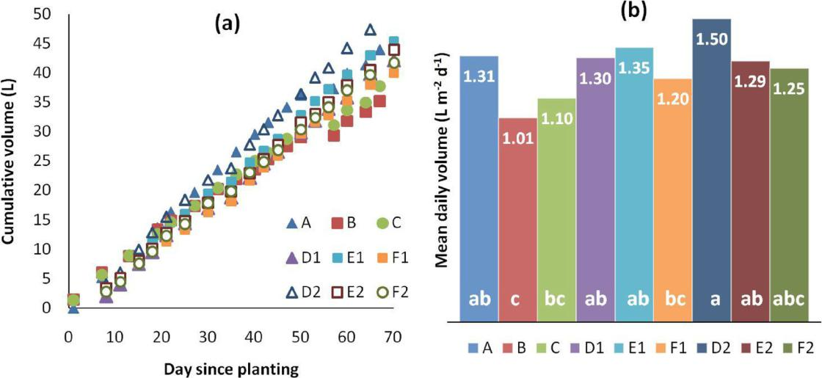

lower as the photon flux is not reduced so quickly: between 46 % and 60 %of the PPFD lost in average per metre, losing between 65 % and 82 %in the first metre. This means that the light source cannot be placed too far away from the lower part of the LW, as the PPFD levels dra-matically decrease in the first metres.

Precisely, this vertical gradient leads to a lack of illuminance uni-formity. An idea of this uniformity can be gained dividing the minimum PPDF value obtained with each lamp by the average PPFD. Therefore, uniformities of 2, 3, 19, 38, 30, and 44 % (for lamps A, B, C, D, E and F, respectively) were achieved, though if only the upper modules were considered, those values were higher (64, 52, 85, 87, 71 and 56 %, respectively). This must be taken into account to make a sound species selection in which plants with lesser light requirements will be placed at the bottom. In some cases, when the height of the LW increases, lamps located at diﬀerent elevations (or at the bottom of the LW) will be re-quired.

The PPFD values obtained in our study show how the mid-section of the upper LW modules was always the one which receives more light. In the first test, the PPFD values measured right under the upper modules were below 5 μmol m−2 s-1 (too low for the plants to survive) for all the lamps tested (A, B and C). This means that for LW higher than 1 m, these lamps are of no use unless several lamps are placed at diﬀerent

Fig. 8. Water consumption in the diﬀerent living wall modules: (a) Cumulative evolution during the tests (L) and (b) mean daily values (L m−2 d-1). Diﬀerent letters at the bottom of the bars indicate significant diﬀerences following Duncan’s multiple range test (P < 0.05).

9

M.P. Kaltsidi, et al. *Scientia Horticulturae 272 (2020) 109522*

Table 3

Weights and leaf area of Spathiphyllum plants. TFW: total fresh weight; RFW: root fresh weight; AFW: aerial fresh weight; TDW: total dry weight; RDW: root dry

weight; ADW: aerial dry weight; LA: mean leaf area.

|  |  |  |  |  |  |  |  |  |  |  |
| --- | --- | --- | --- | --- | --- | --- | --- | --- | --- | --- |
| Measured variables | LW module |  |  |  |  |  |  |  |  | P-value |
|  |  |  |  |  |  |  |  |  |  |  |
|  | A | B | C | D1 | E1 | F1 | D2 | E2 | F2 | |

TFW (g plant−1) RFW (g plant−1) AFW (g plant−1) TDW (g plant−1) RDW (g plant−1) −

ADW / RDW

TFW / TDW

LA (cm2leave−1)

|  |  |  |  |  |  |  |  |  |  |
| --- | --- | --- | --- | --- | --- | --- | --- | --- | --- |
| 170.5a | 134.9b | 112.8bc | 94.4cd | 102.0cd | 97.8cd | 88.7cd | 82.5d | 93.5cd | 0.0000 |
| 43.50a | 30.04b | 21.30b | 22.53b | 26.82b | 26.94b | 23.18b | 26.08b | 24.43b | 0.0005 |
| 126.9a | 104.82b | 91.47bc | 71.84d | 75.22cd | 70.91d | 65.53d | 56.41d | 69.05d | 0.0000 |
| 14.89a | 12.29ab | 10.71bc | 11.29bc | 12.53ab | 10.94bc | 8.50c | 9.95bc | 10.12bc | 0.0150 |
| 3.94a | 2.65abc | 1.41c | 2.60abc | 3.55ab | 2.92abc | 2.05abc | 3.06abc | 2.39abc | 0.0478 |
| 10.94a | 9.64ab | 9.31ab | 8.70bc | 8.98abc | 8.02bcd | 6.44d | 6.89cd | 7.73abc | 0.0014 |
| 2.78 | 3.64 | 6.60 | 3.35 | 2.53 | 2.75 | 3.14 | 2.25 | 3.23 | – |
| 11.5 | 11.0 | 10.5 | 8.4 | 8.1 | 8.9 | 10.4 | 8.3 | 9.2 | – |
| 15.73bc | 14.27c | 14.70bc | 15.07bc | 14.10c | 13.28c | 17.53b | 14.20c | 13.13c | 0.0768 |

For each row, mean values followed by diﬀerent letters indicate significant diﬀerences following Duncan’s multiple range test (P < 0.05) and each value is the mean of six replicates (n=6) per experimental unit (A, B, C, D1, E1, F1, D2, E2, and F2).

heights. This is normally diﬃcult given that the lamps cannot be lo-cated too far from the LW, so their placement is complicated. For this reason, other solutions using diﬀerent lamps were sought in the second test.

The light intensity pattern is also aﬀected by the lamp character-istics in terms of beam angle and shape. For example, given the con-figuration of lamp F and the angle used, the lower part of the upper module (F1) received less light than the upper part of the lower module (F2) (Table 1), as this area is partially shaded by a central structure of the lamp. This should be considered in the planting design when using this lamp. On the other hand, lamp F (with a lineal configuration and 1.52 m long) oﬀers the advantage of lighting a greater length of wall, hence requiring fewer lamps to cover the whole LW. As another ex-ample, lamp E produced a more concentrated light beam which pro-duced high levels of illuminance especially at the centre of the module but lower values in the periphery (Figs. 3 and 6). For that reason, two lamps instead of only one had to be employed. On the other hand, due to this same reason, the distance reached with reasonable levels of il-luminance was higher for this lamp.

Not only the type of lamps and their number and configuration af-fect the vegetation performance. The number of hours of artificial lighting can also aﬀect it. To take this into account, the photosynthetic daily light integral (DLI) is often employed, as it describes the cumu-lative amount of PAR delivered to a specific area over a 24-h period (Fausey et al., 2005). Species with a DLI requirement of 3 to 6 mol m−2d-1 are considered low-light(Torres and Lopez, 2010). Average PPFD values received in each of the modules (Table 1) can be easily converted to DLI knowing the number of hours of light received per day. Hence, mean DLI values in each module were 1.8 (A), 1.3 (B), 0.4

(C), 3.6 (D1), 4.2 (E1), 3.0 (F1), 1.4 (D2), 2.5(E2) and 1.6 (F2) mol m−2 d-1.

Table 4

Fig. 9. Evolution of the green cover (GC, %) in the diﬀerent living wall modules (For interpretation of the references to colour in this figure legend, the reader is referred to the web version of this article.).

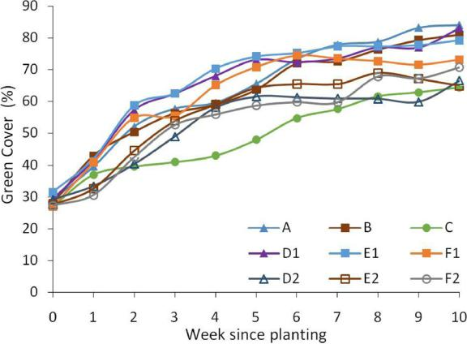

Dry biomass is expected to be higher if DLI increases (Oh et al., 2009; Warner and Erwin, 2005). This was so in our study for Soleirolia but not for Spathiphyllum plants, in which a higher DLI (or PPFD) did not involve higher dry mass (Fig. 13), presumably because Spathi-phyllum is more adapted to receive less light. The vegetation cover did not have much relation with the PPFD levels either. Egea et al.(2014) reported a clearer relation between the dry mass and the PPFD, even for Spathiphyllum. Mattson and Erwin (2005) suggested that the photo-period aﬀected the dry weight gain per day more than increasing ir-radiance, but in their study 11 species out of 41 (none of them being Spathiphyllum nor Soleirolia) were not aﬀected by any of them.

Weights determined for Soleirolia plants. TFW: total fresh weight; RFW: root fresh weight; AFW: aerial fresh weight; TDW: total dry weight; RDW: root dry weight;

ADW: aerial dry weight.

|  |  |  |  |  |  |  |  |  |  |  |
| --- | --- | --- | --- | --- | --- | --- | --- | --- | --- | --- |
| Measured variables | LW module |  |  |  |  |  |  |  |  | P-value |
|  |  |  |  |  |  |  |  |  |  |  |
|  | A | B | C | D1 | E1 | F1 | D2 | E2 | F2 | |

TFW (g plant−1) RFW (g plant−1) AFW (g plant−1) TDW (g plant−1) RDW (g plant−1) −

ADW / RDW

TFW / TDW

|  |  |  |  |  |  |  |  |  |  |
| --- | --- | --- | --- | --- | --- | --- | --- | --- | --- |
| 65.3bcd | 61.0cde | 36.1e | 92.2ab | 104.1a | 70.2bcd | 77.4abcd | 84.4abc | 51.4de | 0.0001 |
| 10.5e | 10.3e | 11.6de | 29.4ab | 32.7a | 24.4bc | 19.1cd | 21.2bc | 8.1e | 0.0000 |
| 54.8ab | 50.6ab | 24.5c | 62.8ab | 71.4a | 45.8bc | 58.2ab | 63.2ab | 43.4bc | 0.004 |
| 9.73ab | 8.83ab | 3.93d | 11.14a | 11.20a | 7.75abc | 7.00bcd | 8.12ab | 4.67cd | 0.0000 |
| 1.52cd | 1.28cd | 1.32cd | 3.92a | 3.73ab | 2.59bc | 1.74cd | 1.74cd | 0.74d | 0.0000 |
| 8.21a | 7.56ab | 2.62d | 7.22ab | 7.47ab | 5.16bcd | 5.26ab | 6.38abc | 3.92cd | 0.0002 |
| 5.40 | 5.91 | 1.98 | 1.84 | 2.00 | 1.99 | 3.02 | 3.67 | 5.30 | – |
| 6.7 | 6.9 | 9.2 | 8.3 | 9.3 | 9.1 | 11.1 | 10.4 | 11.0 | – |

For each row, mean values followed by diﬀerent letters indicate significant diﬀerences following Duncan’s multiple range test (P < 0.05) and each value is the mean of seven replicates(n=7) per experimental unit (A, B, C, D1, E1, F1, D2, E2, and F2).

10

M.P. Kaltsidi, et al. *Scientia Horticulturae 272 (2020) 109522*

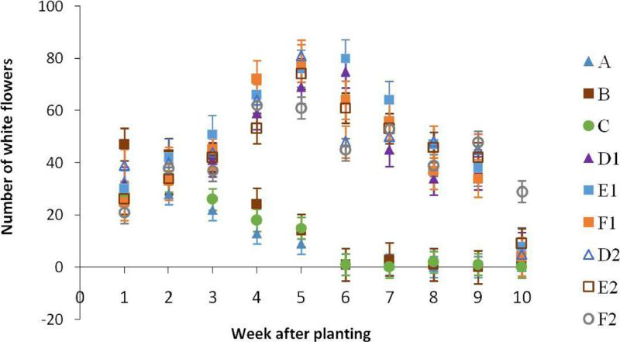

Fig. 10. Evolution of the number of Spathiphyllum white flowers in the diﬀerent modules.

The proposed optimum DLI value for Spathiphyllum is 4 mol m−2d-1(Faust, 2001), so following this recommendation, only E1 received an adequate DLI, being close in D1, but this did not have an influence on significant diﬀerences in the dry mass per Spathiphyllum plant obtained (for instance module A showed the highest dry biomass only receiving 1.8 mol m−2d-1).No proposed DLI values were found for Soleirolia, though Yue (2004) suggested a quite wide PAR scope for the growth of Soleirolia, in the range of 8.5–299 μmol m−2 s-1. In any case, the dif-ferences in plant development between the lamp treatments found in our study, higher for Soleirolia than for Spathiphyllum, suggest that the former seems to be more sensitive to DLI variations.

A higher DLI can also increase flowering (Currey and Erwin, 2011; Oh et al., 2009). In our study, this did not happen as DLI for modules A and B were similar to D2 and F2 but there were far fewer flowers in the former. In this case, the mean daily temperature might have been a key factor. According to Meng and Runkle (2014), the mean daily tem-perature and the DLI can interact to influence the flowering time of various ornamental crops. Also, the previous growing conditions in the nursery before the transplant for the trials might have aﬀected them as the diﬀerences in temperature between tests 1 and 2 were low (3−4 °C), being higher for the first one (when, precisely, higher tem-peratures are supposed to induce flowering (Blanchard et al., 2011)).

The PPFD measured in our study was in general much higher than that reported by Egea et al.(2014) (excluding lamp C). Biomass pro-duction in the present study was also higher, especially for Soleirolia plants, except for module C, which produced similar values to those observed by Egea et al.(2014).

The use of LED lamps also had implications on the water con-sumption. For instance, the daily water volume consumed was slightly higher in the lower modules than in the upper ones (for the same lamp) though the diﬀerences were not statistically significant. In contrast, the results provided by Egea et al. (2014) denoted a bigger influence of the type of lamp and the distance to the light source, as the heat produced by the lamps was an issue. In fact, the water consumed in that study ranged between 2.1 and 5 l m−2 d-1, while in the present work the values were between 1 and 1.5 l m−2 d-1.

Table 5

As LW have a marked ornamental purpose, the healthy appearance of the plants and a good vegetation cover are rather more important than the growth of the plants. In this regard, even when there were few significant diﬀerences found in the generated plant biomass, the vege-tation cover was higher in the modules close to the light source. Conversely, for lamps D, E and F (with a higher light intensity), the appearance of the plants in the modules closer to the lamp became worse with the course of time (especially in Soleirolia).

In this regard, it is interesting to note that in terms of the NDVI and the SPAD, those modules specifically receiving a lower PPFD showed higher values. Receiving an excessive luminous flux sometimes results in a decrease in the chlorophyll content of leaves and vice versa (Dibenedetto, 1991; Zhang et al., 2016). Krause and Winter (1996) even reported a certain photoinhibition of photosynthesis in species growing in a Tropical forest when subjected to a highlight intensity exposure. Diﬀerences in the NDVI can be associated with changes in pigment composition and protective mechanisms against excess light (Mielke and Schaﬀer, 2010).

In spite of this, the participants in the perception analyses preferred lamps D and F over the rest. The colour composition and temperature often have an influence on these decisions (Jost-Boissard et al., 2009), but it seems that the lamps producing a homogeneous distribution of light were also preferred over those creating a beam of light.

5. Conclusions

When artificial lighting is required for indoor greenery, selecting the most eﬃcient lamps is very important, as the wrong choice may be crucial for the survival of a green wall. All the commercial LED lamps tested in this study, except for lamp C which was precisely the one designed for crop production, are apt for LW lighting. However, their placement (the distance from the LW, the beam angle, the lamp or-ientation) should be based on the lamp characteristics and plays an important role in obtaining a proper result. Energy consumption should also be considered, as some lamps use the energy more eﬃciently to produce light in the spectrum which is more usable by the plants.

Mean Normalized Diﬀerence Vegetation Index (NDVI) values taken for each living wall module four and ten weeks after planting.

|  |  |  |  |  |  |  |  |  |  |  |
| --- | --- | --- | --- | --- | --- | --- | --- | --- | --- | --- |
|  | Module |  |  |  |  |  |  |  |  |  |
|  |  |  |  |  |  |  |  |  |  |  |
| Week | A | B | C | D1 | E1 | F1 | D2 | E2 | F2 |  |
|  |  |  |  |  |  |  |  |  |  |  |
| 4 | 0.75de* | 0.79c | 0.68f* | 0.82ab* | 0.77cd* | 0.79bc* | 0.83a* | 0.74e* | 0.79c* |  |
| 10 | 0.77d | 0.79c | 0.71e | 0.69ef | 0.68f | 0.70e | 0.91a | 0.84b | 0.82b |  |

Diﬀerent letters in a row show statistically significant diﬀerences among the treatments of each week (week 4th and week 10th) and the asterisk (*) indicates the statistically significant diﬀerences between the treatments in both weeks (e.g. module A week 4 compared to module A week 10).

11

M.P. Kaltsidi, et al. *Scientia Horticulturae 272 (2020) 109522*

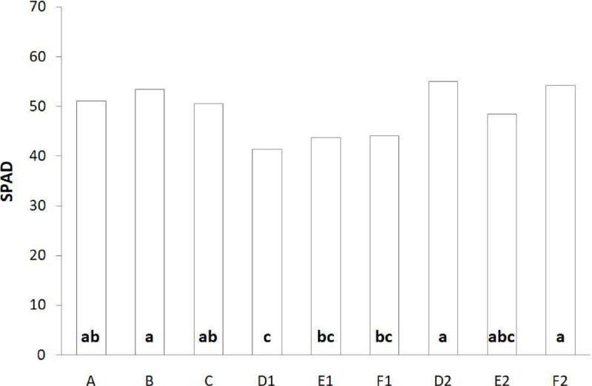

Fig. 11. Average SPAD values measured in Spathiphyllum at the end of each test. Diﬀerent letters indicate significant diﬀerences according to Duncan’s Multiple Range test (P < 0.05) and each value is the mean of three replicates per experimental unit (A, B, C, D1, E1, F1, D2, E2, and F2).

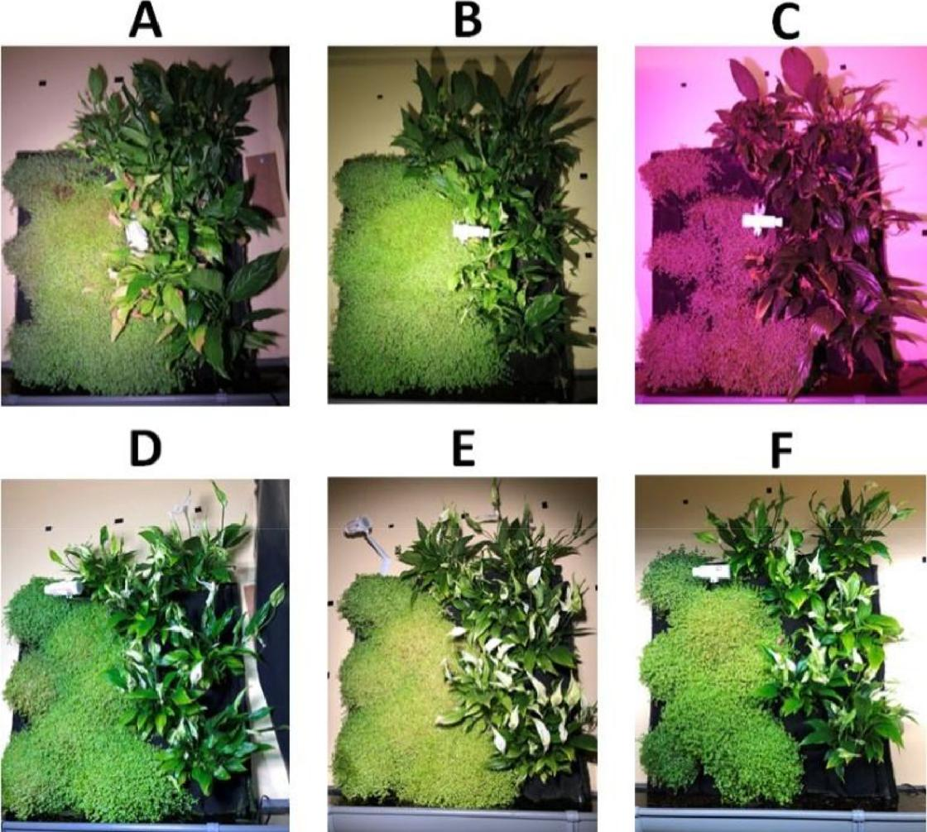

Fig. 12. Photographs of the living wall modules illuminated by each lamp at the end of the trials.

12

M.P. Kaltsidi, et al.

Table 6

Average value for each lamp of the responses obtained to the question posed (1 -do not agree- to 5 -totally agree).

|  |  |  |  |  |  |  |
| --- | --- | --- | --- | --- | --- | --- |
| Question | A | B | C | D | E | F |
|  |  |  |  |  |  |  |
| Colours under this light are attractive | 2.56 | 3.02 | 1.64 | 4.38 | 3.46 | 4.35 |
| Plants have a natural appearance under | 2.76 | 3.15 | 1.47 | 4.4 | 3.65 | 4.39 |
| this light |  |  |  |  |  |  |
|  |  |  |  |  |  |  |

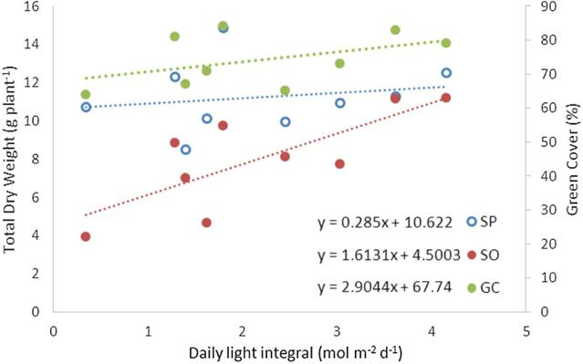

Fig. 13. Relationship between the total dry weight (TDW) of Spathiphyllum (SP) and Soleirolia (SO), green cover (GC) and the mean daily light integral (DLI). The dotted lines denote the regression lines for each group of values (For in-terpretation of the references to colour in this figure legend, the reader is re-ferred to the web version of this article.).

Lastly, the visual quality of the light in terms of producing a natural appearance of the vegetation is important in order to be pleasant for observers.

CRediT authorship contribution statement

Maria P. Kaltsidi: Formal analysis, Investigation, Writing - review & editing. Rafael Fernández-Cañero: Conceptualization, Methodology, Formal analysis, Investigation, Supervision. Luis Pérez-Urrestarazu: Conceptualization, Methodology, Formal analysis, Investigation, Writing - original draft, Writing - review & editing, Supervision.

Declaration of Competing Interest

The authors declare that they have no known competing financial interests or personal relationships that could have appeared to influ-ence the work reported in this paper.

Acknowledgments

We would like to thank the spin-oﬀ company Terapia Urbana for providing the materials to build the living wall prototypes. We are also grateful to the companies Lledó and Ignia Green who lent us the lamps for the tests. Finally, our thanks to David Sevillano, Patricio Espinosa and Ángela Morales, who helped us with the maintenance of the LW modules and the measurements; Christina Mitsi, who helped with the statistical analysis, and Antonio Franco Salas, who participated in in-stalling the lamps and living wall modules.

References

Blanchard, M.G., Runkle, E.S., Frantz, J.M., 2011. Energy-eﬃcient greenhouse production of Petunia and Tagetes by manipulation of temperature and photosynthetic daily light integral. Acta Hortic. 893, 857–864. [https://doi.org/10.17660/ActaHortic.](https://doi.org/10.17660/ActaHortic.2011.893.94) [2011.893.94](https://doi.org/10.17660/ActaHortic.2011.893.94).

*Scientia Horticulturae 272 (2020) 109522*

[Brickell, Christopher, 2011. American horticultural society. Encyclopedia of Plants and](http://refhub.elsevier.com/S0304-4238(20)30350-2/sbref0010) [Flowers. DK Publishing, 375 Hudson Street, New York, New York 10014, United](http://refhub.elsevier.com/S0304-4238(20)30350-2/sbref0010) [States First full. ed.](http://refhub.elsevier.com/S0304-4238(20)30350-2/sbref0010)

Chen, C., 2005. Fluorescent lighting distribution for plant micropropagation. Biosyst. Eng.

90, 295–306. <https://doi.org/10.1016/j.biosystemseng.2004.10.005>.

[Currey, C.J., Erwin, J.E., 2011. Photosynthetic daily light integral impacts growth and](http://refhub.elsevier.com/S0304-4238(20)30350-2/sbref0020) [flowering of several kalanchoe species. Horttechnology 21, 98–102](http://refhub.elsevier.com/S0304-4238(20)30350-2/sbref0020).

Dibenedetto, A.H., 1991. Light environment eﬀects on chlorophyll content in Aglaonema commutatum. J. Hortic. Sci. 66, 283–289. [https://doi.org/10.1080/00221589.1991.](https://doi.org/10.1080/00221589.1991.11516155) [11516155](https://doi.org/10.1080/00221589.1991.11516155).

Egea, G., Pérez-Urrestarazu, L., González-Pérez, J., Antonio, F.-S., Rafael, F.-C., 2014. Lighting systems evaluation for indoor living walls. Urban For. Urban Green. 13, 475–483. <https://doi.org/10.1016/j.ufug.2014.04.009>.

Fausey, B.A., Heins, R.D., Cameron, A.C., 2005. Daily light integral aﬀects flowering and quality of greenhouse-grown Achillea, Gaura, and Lavandula. HortScience 40, 114–118. <https://doi.org/10.21273/HORTSCI.40.1.114>.

[Faust, J.E., 2001. Light. In: Hamrick, D. (Ed.), Ball Redbook: Crop Production. Ball](http://refhub.elsevier.com/S0304-4238(20)30350-2/sbref0040) [Publishing, Batavia, IL, pp. 71–84](http://refhub.elsevier.com/S0304-4238(20)30350-2/sbref0040).

GOTO, E., 2003. Eﬀects of light quality on growth of crop plants under artificial lighting.

Environ. Control Biol. 41, 121–132. <https://doi.org/10.2525/ecb1963.41.121>.

Gunawardena, K., Steemers, K., 2019. Living walls in indoor environments. Build.

Environ. 148, 478–487. <https://doi.org/10.1016/J.BUILDENV.2018.11.014>.

Islam, M.A., Kuwar, G., Clarke, J.L., Blystad, D.R., Gislerød, H.R., Olsen, J.E., Torre, S., 2012. Artificial light from light emitting diodes (LEDs) with a high portion of blue light results in shorter poinsettias compared to high pressure sodium (HPS) lamps. Sci. Hortic. (Amsterdam). 147, 136–143. [https://doi.org/10.1016/j.scienta.2012.08.](https://doi.org/10.1016/j.scienta.2012.08.034) [034](https://doi.org/10.1016/j.scienta.2012.08.034).

Jost-Boissard, S., Fontoynont, M., Blanc-Gonnet, J., 2009. Perceived lighting quality of LED sources for the presentation of fruit and vegetables. J. Mod. Opt. 56, 1420–1432. <https://doi.org/10.1080/09500340903056550>.

Kim, H.H., Wheeler, R.M., Sager, J.C., Gains, G.D., Naikane, J.H., 2006. Evaluation of lettuce growth using supplemental green light with red and blue light-emitting diodes in a controlled environment—a review of research at Kennedy Space Center. Acta Hortic. 711, 111–120. <https://doi.org/10.17660/ActaHortic.2006.711.11>.

Krause, G.H., Winter, K., 1996. Photoinhibition of photosynthesis in plants growing in

natural tropical forest gaps. A Chlorophyll Fluorescence Study. Bot. Acta 109, 456–462. <https://doi.org/10.1111/j.1438-8677.1996.tb00598.x>.

[Massa, G.D., Kim, H.-H., Wheeler, R.M., Mitchell, C.A., 2008. Plant productivity in re-sponse to LED lighting. HortScience 43, 1951–1956](http://refhub.elsevier.com/S0304-4238(20)30350-2/sbref0075).

Mattson, N.S., Erwin, J.E., 2005. The impact of photoperiod and irradiance on flowering of several herbaceous ornamentals. Sci. Hortic. (Amsterdam). 104, 275–292. [https://](https://doi.org/10.1016/j.scienta.2004.08.018) [doi.org/10.1016/j.scienta.2004.08.018](https://doi.org/10.1016/j.scienta.2004.08.018).

[McDonald, J.H., 2014. Handbook of Biological Statistics, 3rd ed. Sparky House](http://refhub.elsevier.com/S0304-4238(20)30350-2/sbref0085). Meng, Q., Runkle, E.S., 2014. Controlling flowering of photoperiodic ornamental crops

with light-emitting diode lamps: a coordinated grower trial. Horttechnology 24, 702–711. <https://doi.org/10.21273/HORTTECH.24.6.702>.

Mielke, M.S., Schaﬀer, B., 2010. Leaf gas exchange, chlorophyll fluorescence and pigment indexes of Eugenia uniflora L. In response to changes in light intensity and soil flooding. Tree Physiol. 30, 45–55. <https://doi.org/10.1093/treephys/tpp095>.

Morrow, R.C., 2008. LED lighting in horticulture. HortScience 43, 1947–1950. [https://](https://doi.org/10.21273/HORTSCI.43.7.1947) [doi.org/10.21273/HORTSCI.43.7.1947](https://doi.org/10.21273/HORTSCI.43.7.1947).

Moya, T.A., Van Den Dobbelsteen, A., Ottelé, M., Bluyssen, P.M., 2019. A review of green systems within the indoor environment. Indoor Built Environ. 28, 298–309. [https://](https://doi.org/10.1177/1420326X18783042) [doi.org/10.1177/1420326X18783042](https://doi.org/10.1177/1420326X18783042).

[Oh, W., Cheon, I.H., Kim, K.S., Runkle, E.S., 2009. Photosynthetic daily light integral](http://refhub.elsevier.com/S0304-4238(20)30350-2/sbref0110) [influences flowering time and crop characteristics of Cyclamen persicum.](http://refhub.elsevier.com/S0304-4238(20)30350-2/sbref0110) [HortScience 44, 341–344](http://refhub.elsevier.com/S0304-4238(20)30350-2/sbref0110).

Olle, M., Viršile, A., 2013. The eﬀects of light-emitting diode lighting on greenhouse plant growth and quality. Agric. Food Sci. 22, 223–234. [https://doi.org/10.23986/afsci.](https://doi.org/10.23986/afsci.7897) [7897](https://doi.org/10.23986/afsci.7897).

Park, Y., Runkle, E.S., 2018. Spectral eﬀects of light-emitting diodes on plant growth, visual color quality, and photosynthetic photon eﬃcacy: white versus blue plus red radiation. PLoS One 13, e0202386. <https://doi.org/10.1371/journal.pone.0202386>.

Pérez-Urrestarazu, L., Fernández-Cañero, R., Campos-Navarro, P., Sousa-Ortega, C., Egea, G., 2019. Assessment of perlite, expanded clay and pumice as substrates for living walls. Sci. Hortic. (Amsterdam). 254, 48–54. [https://doi.org/10.1016/j.scienta.2019.](https://doi.org/10.1016/j.scienta.2019.04.078) [04.078](https://doi.org/10.1016/j.scienta.2019.04.078).

Rueden, C.T., Schindelin, J., Hiner, M.C., DeZonia, B.E., Walter, A.E., Arena, E.T., Eliceiri, K.W., 2017. ImageJ2: ImageJ for the next generation of scientific image data. BMC Bioinformatics 18, 529. <https://doi.org/10.1186/s12859-017-1934-z>.

Samuoliene, G., Brazaityte, A., Sirtautas, R., Viršile, A., Sakalauskaite, J., Sakalauskiene, S., Duchovskis, P., 2013. LED illumination aﬀects bioactive compounds in romaine baby leaf lettuce. J. Sci. Food Agric. 93, 3286–3291. [https://doi.org/10.1002/jsfa.](https://doi.org/10.1002/jsfa.6173) [6173](https://doi.org/10.1002/jsfa.6173).

[Shaw, J., 2018. LED colour temperature and its eﬀect on the growth of hydroponic lettuce](http://refhub.elsevier.com/S0304-4238(20)30350-2/sbref0140) [seedlings. Young Consum 2, 164–171 Insight Ideas Responsible Mark](http://refhub.elsevier.com/S0304-4238(20)30350-2/sbref0140).

Singh, D., Basu, C., Meinhardt-Wollweber, M., Roth, B., 2015. LEDs for energy eﬃcient greenhouse lighting. Renew. Sust. Energy Rev. 49, 139–147. [https://doi.org/10.](https://doi.org/10.1016/J.RSER.2015.04.117) [1016/J.RSER.2015.04.117](https://doi.org/10.1016/J.RSER.2015.04.117).

Tan, C.L., Wong, N.H., Tan, P.Y., Ismail, M., Wee, L.Y., 2017. Growth light provision for indoor greenery: a case study. Energy Build. 144, 207–217. [https://doi.org/10.1016/](https://doi.org/10.1016/j.enbuild.2017.03.044) [j.enbuild.2017.03.044](https://doi.org/10.1016/j.enbuild.2017.03.044).

Thiel, S., Döhring, T., Köﬀerlein, M., Kosak, A., Martin, P., Seidlitz, H.K., 1996. A Phytotron for Plant Stress Research: How Far Can Artificial Lighting Compare to Natural Sunlight? J. Plant Physiol. 148, 456–463. <https://doi.org/10.1016/S0176-1617(96)80279-3>.

13

M.P. Kaltsidi, et al.

[Torres, A.P., Lopez, R.G., 2010. Measuring Daily Light Integral in a Greenhouse.](http://refhub.elsevier.com/S0304-4238(20)30350-2/sbref0160) [Purdue](http://refhub.elsevier.com/S0304-4238(20)30350-2/sbref0160) [Ext. HO-238-W. pp. 1–7](http://refhub.elsevier.com/S0304-4238(20)30350-2/sbref0160).

Turvey, C.G., Mclaurin, M.K., 2012. Applicability of the normalized diﬀerence vegetation index (NDVI) in index-based crop insurance design. Weather Clim. Soc. 4, 271–284. <https://doi.org/10.1175/WCAS-D-11-00059.1>.

Warner, R.M., Erwin, J.E., 2005. Prolonged high temperature exposure and daily light integral impact growth and flowering of five herbaceous ornamental species. J. Am. Soc. Hortic. Sci. jashs 130, 319–325. <https://doi.org/10.21273/JASHS.130.3.319>.

Yeh, N., Chung, J.-P., 2009. High-brightness LEDs—energy eﬃcient lighting sources and

*Scientia Horticulturae 272 (2020) 109522*

their potential in indoor plant cultivation. Renew. Sust. Energy Rev. 13, 2175–2180.

<https://doi.org/10.1016/J.RSER.2009.01.027>.

[Yue, H., 2004. Radiation (PAR) scope of indoor grouth of Soleirolia soleirolii. Chinese J.](http://refhub.elsevier.com/S0304-4238(20)30350-2/sbref0180)

[Ecol. 03](http://refhub.elsevier.com/S0304-4238(20)30350-2/sbref0180).

Zhang, H., Zhong, H., Wang, J., Sui, X., Xu, N., 2016. Adaptive changes in chlorophyll content and photosynthetic features to low light in Physocarpus amurensis Maxim and Physocarpus opulifolius “Diabolo.”. PeerJ 2016. [https://doi.org/10.7717/peerj.](https://doi.org/10.7717/peerj.2125) [2125](https://doi.org/10.7717/peerj.2125).

14