[Scientia Horticulturae 272 (2020) 109527](https://doi.org/10.1016/j.scienta.2020.109527)

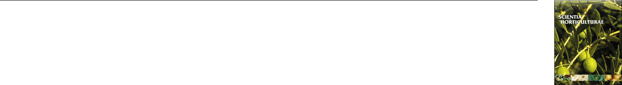

Contents lists available at [ScienceDirect](http://www.sciencedirect.com/science/journal/03044238)



Scientia Horticulturae

journal homepage: [www.elsevier.com/locate/scihorti](https://www.elsevier.com/locate/scihorti)

Initial productive development of peach trees under modern training systems

[T](http://crossmark.crossref.org/dialog/?doi=10.1016/j.scienta.2020.109527&domain=pdf)



Alison Ubertia,*, Alice Silva Santanaa, Adriana Lugaresia, Jean do Pradoa, Bachelor Louisa,b, Richardson Damisa, Doralice Lobato de Oliveira Fischerb, Clevison Luiz Giacobboa

1. *Federal University of Fronteira Sul, SC 484 Highway Km 02, Fronteira Sul, Zip code 89815-899, Chapecó, Santa Catarina, Brazil*
2. *Federal Institute Sul-Rio-Grandense, Engenheiro Ildefonso Simões Lopes Ave., Zip code 96060-290, Pelotas, Rio Grande Do Sul, Brazil*

ARTICLE INFO

*Keywords:*

*Prunus persica*(L.)

Batsch

Planting density

Peach

Compact orchard

High density

ABSTRACT

Orchards implanted under high density show highest production and precocious harvest. However, few studies in Brazil have sought to maximize production through the variation of training systems. Therefore, the objective was to evaluate the initial development of cultivars 'Barbosa' and 'Chiripá' under different planting densities and modern training systems. The experiment was evaluated during two productive cycles (2015/16 and 2016/17). In the 'Vase' system, a spacing of 3.5 m was used, in the 'Y-shape' 1.5 m was used, and in the 'Central Leader' system, a spacing of 0.8 m was used between plants. The spacing between rows was equal to 5 m. The two cultivars ('Barbosa' and 'Chiripá') were evaluated for vegetative, phenological development and productive traits. The Capdeboscq rootstock, from seedlings, was used for the two cultivars evaluated. Regarding to the vegetative development, as increase the plant density, like in 'Central Leader' training system, the pruned green mass and the canopy dimension decrease. With regard to phenology, there is no change between the systems evaluated. However, for the productive components, the 'Central Leader' system was more productive, in addition to maintaining the quality of the fruit, when compared to other systems and training. Consequently, it is concluded that the training system in 'Central Leader ' has been showing good vegetative and productive results in the first two years of evaluation. More evaluations are necessary for greater precision regarding the productive potential over the years.

**1. Introduction**

The cultivation of peach (*Prunus persica* (L.) Batsch) undergoes a constant transition and remodeling in its cultivation system. Currently, with a greater proportion, there are commercial orchards with low planting density and open training systems (Hansen et al., 2018). To a smaller extent, some orchards have a higher planting density and modern management systems, aiming mainly at increasing production by area and reducing labor (Schupp and Baugher, 2011).

High density planting crops have high yield (Glenn et al., 2011) and precocious harvest (Robinson et al., 2012), besides allowing the me-chanization of some activities (Schupp and Baugher, 2011). According to Pasa et al. (2017), the quality of the fruit does not change when comparing low and high planting density systems. However, Bussi et al. (2015) found improvements in quality, in addition to higher pro-ductivity in high density planting systems. In addition, high density



perpendicular systems reduce the incidence of brown rot (*Monilinia* spp.) in fruits (Bussi et al., 2015).

However, peach cultivars available on the market express their own performance and characteristics when managed under different training systems (Zec et al., 2016; Hansen et al., 2018). Few studies in Brazil have sought to maximize production through the variation of training systems. In this regard, the aim of this study was to evaluate the initial development of the peach cultivars 'Barbosa' and 'Chiripá' in modern plant training systems combined with planting densities.

**2. Material and methods**

In the spring of 2014, peach cultivars 'Barbosa' and 'Chiripá' were planted in an orchard located at a latitude of 27° 7′ South, Longitude 52° 42′ West and 605 m altitude above sea level. The local climate according to Köppen is Humid Subtropical and the soil is classified as

Corresponding author.

*E-mail addresses:* [alisonuberti@hotmail.com](mailto:alisonuberti@hotmail.com)(A.Uberti),[alice.ifrr@hotmail.com](mailto:alice.ifrr@hotmail.com)(A.S.Santana),[adrianalugaresi@yahoo.com.br](mailto:adrianalugaresi@yahoo.com.br)(A.Lugaresi),[jeandopradoo@hotmail.com](mailto:jeandopradoo@hotmail.com) (J.d. Prado), [bachelorlouis@gmail.com](mailto:bachelorlouis@gmail.com) (B. Louis), [richardsondamis2015@gmail.com](mailto:richardsondamis2015@gmail.com) (R. Damis), [doralicefischer@yahoo.com.br](mailto:doralicefischer@yahoo.com.br) (D.L.d.O. Fischer), [clevison.giacobbo@uffs.edu.br](mailto:clevison.giacobbo@uffs.edu.br) (C.L. Giacobbo).

<https://doi.org/10.1016/j.scienta.2020.109527>

Received 30 March 2020; Received in revised form 3 May 2020; Accepted 31 May 2020

Available online 07 June 2020

0304-4238/ © 2020 Elsevier B.V. All rights reserved.

*A. Uberti, et al.* *Scientia Horticulturae 272 (2020) 109527*

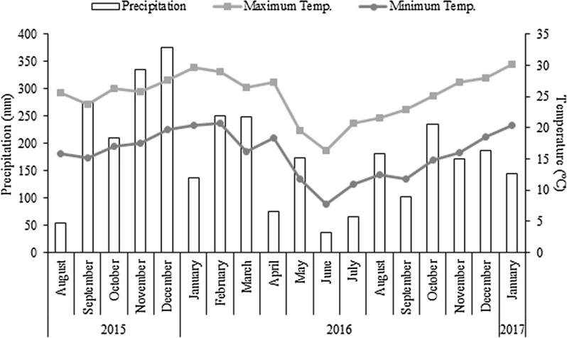

**Fig. 1.** Temperature and precipitation conditions that occurred during the trial. Adapted fromINMET - Instituto Nacional de Meteorologia (2020).

Red Latosol Distroferric. Temperature and precipitation conditions are presented in the Fig. 1.

The plants were conducted in three different training systems and planting densities. The spacing between rows was equal to 5 m, varying the spacing between plants according to the training system. In the 'Vase' system, a spacing of 3.5 m was used, in the 'Y-shape' a spacing of 1.5 m was used and in the 'Central Leader' system (CL) 0.8 m. These systems are equivalent to 571, 1333 and 2500 plants ha−1, respec-tively. 'Vase' training was used in the guard rows in addition to the control plots, since this is the traditional plant training system.

Pruning and thinning of the fruits were performed in accordance with the recommendations for each cultivar and the training system adopted (Pereira and Raseira, 2014a, 2014b; Raseira et al., 2014). The 'Capdeboscq' rootstock, from seedlings, was used for the two cultivars evaluated. The experiments were conducted in a randomized complete block design, with three treatments, 'Vase', 'Y-shape' and 'CL' and three replicates, with the experimental unit consisting of five plants. The peach cultivars were evaluated independently according to the training systems.

The evaluations were conducted during the production cycles of 2015/16 and 2016/2017. The analyzed variables were separated into vegetative, phenological and productive components. Vegetative eva-luations: a) trunk diameter (mm), measured 10 cm above the grafting point; b) canopy size (CS, cm3), measured using formulas for each training system, 'Y-shape' CS = (W.h.((e1+e2)/2)), 'Vase' and 'CL': CS

* (W.E.h), being equatorial width of the plant (W), height of the ca-nopy, measured from the first insertion of the main branches to the apex (h), canopy thickness on the right side (e1), canopy thickness on the left side (e2), transverse width of the plant (E); c) rate of increase in canopy size (%); d) accumulated mass of branches removed with pruning (kg plant−1).

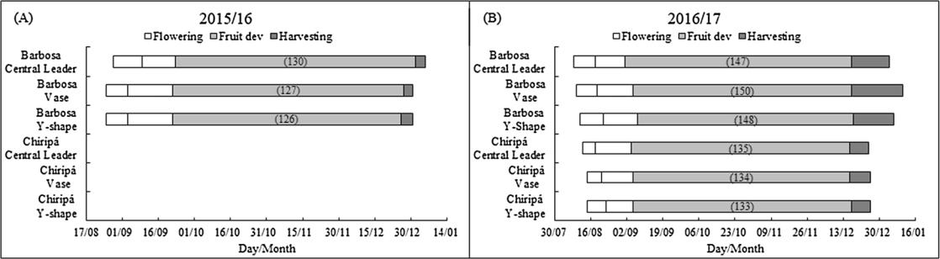

For the phenological evaluation the following variables were con-sidered: a) flowering, being beginning (10 % of open flowers), full (50 % of open flowers) and end of flowering (10 % of the flowers still had petals); b) harvest, with the start and end dates of the harvest; c) harvest duration, difference in the number of days between the beginning and end of harvest;

1. total cycle, being the number of days between the beginning of flowering and the end of the harvest. Finally, regarding the productive components, the following were evaluated: a) number of fruits per plant; b) equatorial diameter (mm); c) average fruit mass (g); d) soluble solids (°Brix); e) pro-duction per plant (kg plant−1); f) estimated productivity (t ha−1).

The collected data were submitted to analysis of variance by the F test. When significant, Tukey's test was applied, with P ≤ 0.05 of sig-nificance. The phenological results were submitted to descriptive ana-lysis, regardless of the means test.

**3. Results**

Under the conditions of the experiment, the cultivars showed different growth vigor hence not started fruit production in the same year. The cultivar (cv.) 'Barbosa' presented production in the second year of culti-vation (2015/16). However, cv. 'Chiripá' presented less and slower vege-tative growth compared to cv. 'Barbosa', consequently cv. 'Chiripá' showed production only in the third year (2016/17), being possible to evaluate the vegetative development only in the second year of cultivation.

For evaluations of vegetative development, it was observed in re-lation to the trunk diameter that the training systems had no different significant effect between the two cultivars in either of the productive cycles evaluated. On average, the cultivars 'Barbosa' and 'Chiripá', in the second cycle, had a diameter of 71.1 and 43.6 mm, respectively.

Regarding the canopy size (Fig. 2), it is observed for cv. 'Barbosa',

**Fig. 2.** Canopy size (CS), Canopy size increase rate (CSIR) and accumulated mass of branches removed with pruning (AMBP) for different training systems in peachcultivars 'Barbosa' (A and B) and 'Chiripá' (C and D) in the productive cycles of 2015/16 and 2016/17. Lower case letters in the bars and upper case letters in the row, different from each other by Tukey's test at P ≤ 0.05.

2

*A. Uberti, et al.* *Scientia Horticulturae 272 (2020) 109527*

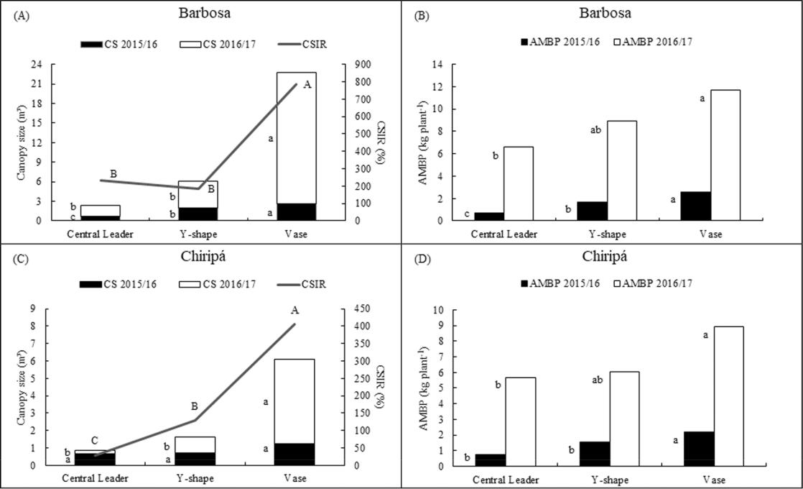

**Fig. 3.** Flowering period, fruit development and harvest for different training systems in peach cultivars 'Barbosa' and 'Chiripá' in the productive cycles of 2015/16

(A) and 2016/17 (B). The number in parenthesis total number of days of the reproductive cycle. The bar dividing the flowering period indicates full bloom stage.

the 'Vase' training system in the 2015/16 cycle, was 27 % bigger than 'Y-shape' and this 36 % bigger than 'CL', which had 0.72 m3. In the 2016/17 cycle, the 'Vase' system had 22.7 m3, five times larger when compared to the other systems. For cv. 'Chiripá', a difference was ob-served only in the second cycle, in which the 'Vase' system had 6.0 m3, four times the size of the other systems tested.

For the rate of increase in the canopy size (Fig. 2), it was observed in cv. 'Barbosa', that the 'Vase' training system showed an increase of 787

* in relation to its initial size. For the cv. 'Chiripá', it was observed an increase rate of 406 % for 'Vase', followed by 'Y-shape' and 'CL', 130 % and 30 %, respectively, in relation to its initial size.

For the variable accumulated green mass of branches removed with pruning (Fig. 2), a similar behavior was observed in the two years and in the two cultivars evaluated. It was found a linear increase in green pruned mass from the 'CL' training system to the 'Vase' training system.

Regarding the phenological variables (Fig. 3), the cv. 'Barbosa' for the first cycle (2015/16) and the two peach cultivars for the second cycle (2016/17), did not show changes in their phenological develop-ment, even varying the training system and planting density. On average cv. 'Barbosa' presented a total cycle of 127 and 148 days for the

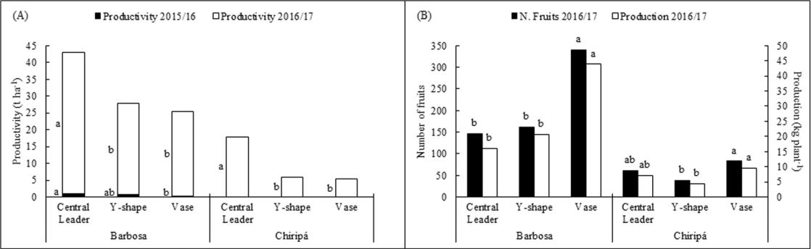

first and second cycle, respectively. For cv. 'Chiripá', a cycle of 134 days was observed in the 2016/17 cycle.

For the productive components (Fig. 4), regarding production per plant, the training systems for cv. 'Barbosa', showed a difference only in the second evaluation cycle. In this cycle, the system 'Vase' showed 43.9 kg plant−1, and twice more productive than the other training. The cv. 'Chiripá' resembling, presented a production of 9.6 kg plant-1 for the 'Vase' system, being twice higher than the 'Y-shape' system. Regarding the number of fruits per plant, results similar to production per plant were observed, which are correlated.

Regarding the estimated productivity, the opposite behavior than for production was observed (Fig. 4). The 'CL' system with the highest planting density, showed the highest productivity. For cv. 'Barbosa', this system presented 1.0 t ha−1 in the first productive cycle, being three times higher than 'Vase'. For the second cycle (2016/17), 'CL' presented 41.8 t ha−1, with the other systems reaching only 62 % of this pro-ductivity. Likewise, for cv. 'Chiripá', the 'CL' training system presented 17.9 t ha−1 and the other systems only 32 % of this productivity.

Concerning the quality of the fruits, there was no change between the training systems tested in the two peach cultivars. On average, the

**Fig. 4.** Estimated productivity (t ha−1) (A), production (kg plant−1) and number of fruits per plant (B) in different training systems in peach cultivars 'Barbosa' and'Chiripá' in the productive cycles of 2015/16 and 2016/17. Lower case letters in the columns and upper case letters in the row, different from each other by Tukey's test at P ≤ 0.05.

3

*A. Uberti, et al.*

cultivars 'Barbosa' and 'Chiripá' showed 10.7 and 11.1°Brix of soluble solids, 63.3 and 60.3 mm in diameter, and 129.7 and 119.3 g of average fruit mass, respectively.

**4. Discussion**

With regard to vegetative growth, the vigor among the different training systems and planting densities did not change in neither of the cultivars tested. Therefore, it can be inferred that there is no competi-tion between the trees under the different the training systems, while according to Layne et al. (2002), there is a reduction in trunk diameter in crops with high planting density, because there is greater competi-tion for light, water and nutrients. According to Caruso et al. (2001) low density systems invest more than 95 % of their annual dry matter gain in vegetative and root growth, resulting in higher trunk diameter growth.

Due to this high vegetative growth, open systems such as 'Vase', with low planting density, show a bigger canopy size (Hamana et al., 2016) and a greater rate of increase in size. Otherwise, plants con-ducted in 'CL' occupy less air space (Marini et al., 1995), providing, according to Stassen (2014), less base shading, less incidence of thief branches and better distribution of production throughout the entire plant.

It was verified in the 'CL' system, tested in cv. 'Chiripá', a stability in vegetative growth, that is, it did not show an increase in the canopy size as observed in the other systems. When stability is achieved, all net photosynthesis rate synthesized during the previous cycle is used for the proper bud formation, production and fruit quality of the subsequent cycle.

Related to the high growth rate of the canopy of open systems, there is higher export of green mass from the plant. Mainly due to the higher pruning intensity for proper plant formation (Caruso et al., 2001), in addition to favoring the entry of light into the interior of the plant, providing greater physical-chemical quality to the fruits (Kumar et al., 2010). As for modern systems such as 'CL', there is low demand for formation pruning, providing lower materials exported from the plant, even if summer pruning is essential for this system (Stassen, 2014).

Even if the training systems, combined with planting densities showed changes in the canopy size, growth rate and intensity of pruning in tested cultivars, the plant phenology did not change. Therefore, under the conditions of the experiment, the training does not interfere with precocity or delay the harvest time.

Furthermore, when the cv. 'Barbosa' was conducted under the 'CL' and 'Y-shape' training systems it showed the same canopy size increase rate and the same intensity of pruning for both training systems. However, the cv. 'Barbosa' showed greater yields under the 'CL' training system than under 'Y-shape' training system because these systems are related to different planting density. Peach trees under high density usually produce greater yields than peach trees under low density (Grossman and DeJong, 1998; Marini and Sowers, 2000).

In relation to productive variables, open systems at low planting density showed a high amount of fruits per plant, compared to 'CL' at high density. However, when this load is estimated by area, open sys-tems do not maintain the same rates. This is directly related to the planting density used, which for open systems such as 'Vase', contains only 571 plants per hectare, different from 'CL', which contains 2500 plants per hectare.

According to Grossman and DeJong (1998) and DeJong et al. (1999) the 'Y-shape' training system showed greater yields than 'Vase' system. However, under the conditions of the experiment, this difference was not observed in any cultivars. Although the 'Y-shape' training system showed less fruits number and less yield per plant than 'Vase' system its major plant density resulted in a similar, but not greater, yield than 'Vase' training system.

In addition to presenting higher productivity, the 'CL' system maintains the quality of the fruit, whether in size or sugar content.

*Scientia Horticulturae 272 (2020) 109527*

According to Pasa et al. (2017) there is greater profitability using modern plant training systems, because the quantity of fruit is higher and the quality is maintained in this system.

**5. Conclusion**

The conclusion is that the training system 'Central Leader' has a higher fruit yield and better vegetative performance for both 'Barbosa' and 'Chiripá' cultivars. Phenological development and fruit quality are not affected by training systems. More evaluations are necessary for greater precision regarding the productive potential over the years.

**CRediT authorship contribution statement**

**Alison Uberti:** Conceptualization, Data curation, Data curation,Formal analysis, Investigation, Methodology, Writing - original draft, Writing - review & editing. **Alice Silva Santana:** Data curation. **Adriana Lugaresi:** Data curation. **Jean do Prado:** Data curation. **Bachelor Louis:** Data curation. **Richardson Damis:** Data curation. **Doralice Lobato de Oliveira Fischer:** Funding acquisition, Resources,Supervision, Methodology. **Clevison Luiz Giacobbo:** Funding acquisi-tion, Resources, Supervision, Methodology, Writing - review & editing.

**Declaration of Competing Interest**

The authors declare that they have no known competing financial interests or personal relationships that could have appeared to influ-ence the work reported in this paper.

**Acknowledgement**

To the Viveiro Frutplan Mudas Ltda for providing the peach plants for the experiment.

**References**

Bussi, C., Plenet, D., Merlin, F., Guillermin, A., Mercier, V., 2015. Limiting brown rot incidence in peach with tree training and pruning. Fruits. 70, 303–309. [https://doi.](https://doi.org/10.1051/fruits/2015030) [org/10.1051/fruits/2015030](https://doi.org/10.1051/fruits/2015030).

Caruso, T., Barone, E., Di Vaio, C., 2001. Factors affecting tree crop efficiency in young peach trees: rootstock vigour and training system. Acta Hortic. 557, 193–197. <https://doi.org/10.17660/ActaHortic.2001.557.26>.

DeJong, T.M., Tsuji, W., Doyle, J.F., Grossman, Y.L., 1999. Comparative economic effi-ciency of four peach production systems in California. Hort. Sci. 34, 73–78. [https://](https://doi.org/10.21273/HORTSCI.34.1.73) [doi.org/10.21273/HORTSCI.34.1.73](https://doi.org/10.21273/HORTSCI.34.1.73).

Glenn, D.M., Tworkoski, T., Scorza, R., Miller, S.S., 2011. Long-term effects of peach production systems for standard and pillar growth types on yield and economic parameters. Hort. Technol. 21, 720–725. [https://doi.org/10.21273/HORTTECH.21.](https://doi.org/10.21273/HORTTECH.21.6.720) [6.720](https://doi.org/10.21273/HORTTECH.21.6.720).

Grossman, Y.L., DeJong, T.M., 1998. Training and pruning system effects on vegetative growth potential, light interception, and cropping efficiency in peach trees. J. Am. Soc. Hortic. Sci. 123, 1058–1064. <https://doi.org/10.21273/JASHS.123.6.1058>.

Hamana, Y., Sugawa, S., Hirao, A., Nakamoto, K., Shibata, K., Saneoka, H., 2016. Comparison of tree growth, fruit production, and labor-saving cultivation manage-ment between tree joint training system and straight line training system for peach during the first 4 years after planting. Hort. Res. (Japan). 15, 153–159. [https://doi.](https://doi.org/10.2503/hrj.15.153) [org/10.2503/hrj.15.153](https://doi.org/10.2503/hrj.15.153).

Hansen, S., Maughan, T., Black, B., 2018. Training and Pruning Peach Trees. Extension [Utah State University – Horticulture 01](http://refhub.elsevier.com/S0304-4238(20)30355-1/sbref0035).

INMET - Instituto Nacional de Meteorologia, 2020. <http://www.inmet.gov.br/portal/> (accessed 24 January 2020).

Kumar, M., Rawat, V., Rawat, J.M.S., Tomar, Y.K., 2010. Effect of pruning intensity on peach yield and fruit quality. Sci. Hortic. 125, 218–221. [https://doi.org/10.1016/j.](https://doi.org/10.1016/j.scienta.2010.03.027) [scienta.2010.03.027](https://doi.org/10.1016/j.scienta.2010.03.027).

Layne, D.R., Cox, D.B., Hitzler, E.J., 2002. Peach systems trial: the influence of training system, tree density, rootstock, irrigation and fertility on growth and yield of young trees in South Carolina. Acta. Hortic. 592, 367–375. [https://doi.org/10.17660/](https://doi.org/10.17660/ActaHortic.2002.592.51) [ActaHortic.2002.592.51](https://doi.org/10.17660/ActaHortic.2002.592.51).

Marini, R.P., Sowers, D.S., 2000. Peach tree growth, yield, and profitability as influenced by tree form and tree density. Hort. Sci. 35, 837–842. [https://doi.org/10.21273/](https://doi.org/10.21273/HORTSCI.35.5.837) [HORTSCI.35.5.837](https://doi.org/10.21273/HORTSCI.35.5.837).

Marini, R.P., Sowers, D.S., Marini, M.C., 1995. Tree form and heading height at planting affect peach tree yield and crop value. Hort. Sci. 30, 1196–1201. [https://doi.org/10.](https://doi.org/10.21273/HORTSCI.30.6.1196) [21273/HORTSCI.30.6.1196](https://doi.org/10.21273/HORTSCI.30.6.1196).

4

*A. Uberti, et al.*

Pasa, M.S., Fachinello, J.C., Schmitz, J.D., Rosa Júnior, H.F., Franceschi, É., Carra, B., Giovanaz, M.A., Silva, C.P., 2017. Early performance of ‘Kampai’ and ‘Rubimel’ peach on 3 training systems. Bragantia 76, 82–85. https://doi.org/10.1590/1678-4499. [627](https://doi.org/10.1590/1678-4499.627).

[Pereira, J.F.M., Raseira, A., 2014a. Poda. In: Raseira, M.C.B., Pereira, J.F.M., Carvalho,](http://refhub.elsevier.com/S0304-4238(20)30355-1/sbref0070)

[F.L.C. (Eds.), Pessegueiro. Brasília, Brazil: Embrapa, pp. 283–308](http://refhub.elsevier.com/S0304-4238(20)30355-1/sbref0070).

[Pereira, J.F.M., Raseira, A., 2014b. Raleio. In: Raseira, M.C.B., Pereira, J.F.M., Carvalho,](http://refhub.elsevier.com/S0304-4238(20)30355-1/sbref0075)

[F.L.C. (Eds.), Pessegueiro. Brasília, Brazil: Embrapa, pp. 309–328](http://refhub.elsevier.com/S0304-4238(20)30355-1/sbref0075).

[Raseira, M.C.B., Nakasu, B.H., Barbosa, W., 2014. Cultivares: descrição e recomendação.](http://refhub.elsevier.com/S0304-4238(20)30355-1/sbref0080)

[In: Raseira, M.C.B., Pereira, J.F.M., Carvalho, F.L.C. (Eds.), Pessegueiro. Brasília,](http://refhub.elsevier.com/S0304-4238(20)30355-1/sbref0080)

[Brazil: Embrapa, pp. 73–142](http://refhub.elsevier.com/S0304-4238(20)30355-1/sbref0080).

Robinson, T., Hoying, S., Reginato, G., Kviklys, D., 2012. Fruit size of high density

*Scientia Horticulturae 272 (2020) 109527*

peaches is smaller than low density systems. Acta. Hortic. 962, 425–432. [https://doi.](https://doi.org/10.17660/ActaHortic.2012.962.58)

[org/10.17660/ActaHortic.2012.962.58](https://doi.org/10.17660/ActaHortic.2012.962.58).

Schupp, J.R., Baugher, T.A., 2011. Peach blossom string thinner performance improved with selective pruning. Hort. Sci. 46, 1486–1492. [https://doi.org/10.21273/](https://doi.org/10.21273/HORTSCI.46.11.1486) [HORTSCI.46.11.1486](https://doi.org/10.21273/HORTSCI.46.11.1486).

[Stassen, P., 2014. Higher density peach orchards according to the central leader concept.](http://refhub.elsevier.com/S0304-4238(20)30355-1/sbref0095)

[Tegnologie 48–50](http://refhub.elsevier.com/S0304-4238(20)30355-1/sbref0095).

Zec, G., Colić, S., Vulić, T., Milatović, D., Oparnica, C., Đorđević, B., Đurović, D., 2016. The influence of training system on fruit characteristics of peach and nectarine cul-tivars. Acta. Hortic. 1139, 541–544. [https://doi.org/10.17660/ActaHortic.2016.](https://doi.org/10.17660/ActaHortic.2016.1139.93)

1139.93.

5