[Scientia Horticulturae 272 (2020) 109553](https://doi.org/10.1016/j.scienta.2020.109553)

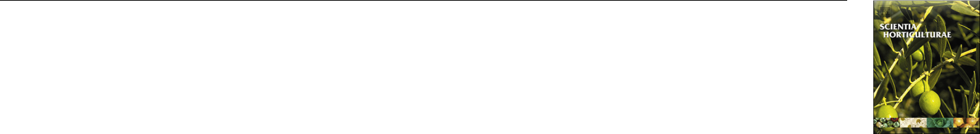

Contents lists available at [ScienceDirect](http://www.sciencedirect.com/science/journal/03044238)



Scientia Horticulturae

journal homepage: [www.elsevier.com/locate/scihorti](https://www.elsevier.com/locate/scihorti)

Ecophysiological determinants of Oregano productivity: Eﬀects of plant’s T canopy architecture on radiation capture and use, biomass partitioning and  essential oil yield



Vanina Davidencoa,*, Pablo J. Pelisseroa, Juan A. Argüelloa, Claudia R.C. Vegab

1. Cátedra de Fisiología Vegetal, Facultad de Ciencias Agropecuarias, Universidad Nacional de Córdoba, Ing. Agr. Félix Aldo Marrone 746 - Ciudad Universitaria Córdoba, Argentina
2. Estación Experimental Agropecuaria INTA Manfredi, CC 5988, Córdoba, Argentina

ARTICLE INFO

Keywords:

Origanum vulgare ssp.

Plant arrangement

Crop growth rate

Radiation use eﬃciency

Biomass partition

Essential oil yield

ABSTRACT

This research aimed at studying oregano crop responses to changes in planting patterns in terms of solar ra-diation capture (c-PAR) and use (RUE), carbon partitioning, and essential oil yield (EO). O. vulgare ssp. vulgare (OVV) and O. vulgare ssp hirtum (OVH), with creeping and erect growth habits respectively, were grown during two consecutive cycles (C) under contrasting planting patterns (PP): T (0.70 m between rows and 0.20 m be-tween plants) and H (0.35m × 0.40m). Temporal dynamics of biomass accumulation varied between subspecies, and significant interactions were found between PP and C. Crop growth rates (CGR) were highest in C1 (5 to 9.5 g m−2 d-1). Significant CGR decreases in C2 were explained by drops in RUE (≅ 54 %), which in turn could be attributed to increases in the stem proportion in detriment to photosynthetic tissues. Among subspecies, OVV exhibited the highest plasticity for light capture, use and growth. Phenological progress along with c-PAR ex-plained EO productivity. On average, reproductive phenophases yielded almost four times more than vegetative ones, and OVV yielded 30 % more EO than OVH. EO diﬀerences between subspecies could be explained by the partition to harvestable organs (Leaf + Flowers). This ecophysiological analysis presents a novel approach to disentangle the eﬀects of interactions between canopy architecture (subspecies), management and crop age on processes that regulate yield formation in Oregano.

1. Introduction

Oregano (Lamiaceae) is a perennial aromatic plant, native of the Mediterranean region, known worldwide as a spice extensively used to flavor food and beverages. This species which has been used for cen-turies as a medicinal plant is gaining more importance due to the proved eﬀects of its essential oil as antimicrobial, insecticide, antifungal and antioxidant (Şahin et al., 2004; Bakkali et al., 2008; Asensio et al., 2015). Bearing on oregano significance in food, pharmaceutical and cosmetic industries, its demand has been increasing steadily in the world market (Kintzios, 2002; Farías et al., 2010). However, there are not many studies with an eco-physiological approach to mechanisms that determine oregano productive performance.

Knowledge of the physiological processes that determine growth and yield in crops is critical to achieve an eﬃcient and sustainable



production, as they guide the selection of the most appropriate man-agement practices and provide information for the eﬃcient use of re-sources (Andrade et al., 2005). In oregano, yield improvements could be expected by understanding the factors that modulate productivity, i.e. the accumulation of biomass and essential oil (EO). These factors can be analyzed using the ecophysiological framework of the solar ra-diation-based model of Monteith (1977), widely used in other plant species such as grain crops. Biomass production and yield can be dis-aggregated into four main components: the daily incident photo-synthetically active radiation (PAR), crop interception (which de-termines the accumulated PAR during the crop cycle, c-PAR), the radiation use eﬃciency (RUE) for conversion into biomass, and the biomass allocation into harvestable organs (the partition index).

Radiation capture is modulated by the amount of incident PAR (according to latitude, season) and the intercepted PAR fraction, which

Abbreviations: OVV, Origanum vulgare ssp. vulgare; OVH, Origanum vulgare ssp. hirtum; Ba, total aerial biomass; CGR, crop growth rate; i-PAR, intercepted photo-synthetically active radiation; c-PAR, amount of photosynthetically active radiation intercepted and accumulated during the crop cycle; RUE, radiation use eﬃciency; C, crop cycle; PP, planting pattern; H, homogeneous PP; T, traditional PP; DST, days since transplant; EO, essential oil

Corresponding author.

E-mail address: [vdavidenco@agro.unc.edu.ar](mailto:vdavidenco@agro.unc.edu.ar) (V. Davidenco).

<https://doi.org/10.1016/j.scienta.2020.109553>

Received 12 September 2019; Received in revised form 15 May 2020; Accepted 5 June 2020

Available online 13 June 2020

0304-4238/ © 2020 Elsevier B.V. All rights reserved.

V. Davidenco, et al.

in turn depends on the architecture and size of the crop canopy and the crop cycle (Hall, 1980; Gardner et al., 1985; Sinclair et al., 1999). Likewise, the crop canopy architecture can be modified by spatial ar-rangements (i.e. row spacing) and plant density. In several production regions, the planting pattern in oregano is rectangular with greater distance between rows (0.70 m) than between plants (0.35−0.20 m) in the row (De Mastro et al., 2004; Atallah et al., 2011; Torres et al., 2012; Murillo-Amador et al., 2013). Also variable arrangements are recorded with rather quadrangular arrays (Ozguven et al., 2006; Karamanos and Sotiropoulou, 2013; Gerami et al., 2016; Burgos et al., 2017). Probably the selection of a particular spatial arrangement responds to the most common management practices of a specific production system, such as crop implantation techniques (by seed or by cuttings transplant) or harvesting methods (manual, mechanical). But the choice of this practice is relevant for the timing of canopy closure after every crop cutting along the growth cycles. Row spacing was studied in numerous experiments in grain, industrial and forage crops, and it was found to alter population size structure and thus, competition at the individual plant level (Park et al., 2003). The reduction of row spacing generates more square spatial arrangements that influence intraspecific compe-tition and resource utilization, especially solar radiation. This practice increased c-PAR in maize, soybean, sunflower, sugar cane and alfalfa (Vega and Andrade, 2000; Singels and Smit, 2009; Vega, 2011), and RUE in alfalfa (Mattera et al., 2013) but not in cotton (Brodrick et al., 2013). Although RUE has been largely recognized as an useful indicator of canopy photosynthesis (Sinclair et al., 1999), quite scarce or in-formation currently exists for oregano crops. RUE values from 0.75 to 0.90 g MJ−1 were reported in one study analyzing responses to N fer-tilization (Yazdani Biouki et al., 2014). Besides, and considering that oregano is a perennial species, potential eﬀects of crop age, genotype and agronomic practices on RUE are critical to understand yield de-termination.

Morphological changes involving biomass allocation patterns occur under the normal course of growth and development (Weiner, 2004). In oregano, both vegetative and reproductive organs (inflorescences) are harvested, and the partition index, the third eco-physiological yield component, can be evaluated attending to aerial biomass generation dynamics, the biomass allocation into leaves and flower (L + F), and the L + F/stem ratio (Lenardis et al., 2006). Inflorescence fractions were reported to decrease with the crop age (from 0.32 to 0.23; Sotiropoulou and Karamanos, 2010), and in Lippia, an oregano-like aromatic plant, stems were the main biomass percentage in wild and introduced plants (≅63 %; Juliani et al., 2011). Therefore is important to reveal if biomass allocation patterns vary due to changes in planting arrangements and even more if there are genotypic eﬀects in these parameters.

In oregano, the biomass allocation into harvestable organs is par-ticularly critical for flowers since glandular trichomes containing the essential oil are more abundant in this fraction (Werker et al., 1993). Flowers abundance, hence, is the main factor providing quality (i.e. flavor and many chemical properties) in this species. Besides parti-tioning, the percentage of EO is also an additional yield component in oregano (Chlodwing and Novak, 1997; Pank et al., 2002). EO content is aﬀected by light conditions (Davidenco et al., 2017) and environment (Kokkini et al., 1994). For instance, plants grown in the mediterranean climatic zones are characterized by numerous sessile glands which are rich in essential oil (ssp. hirtum -greek oregano-); whereas those grown in continental type climate have few glands and are essential oil-poor (ssp. viridulum and ssp. vulgare -common oregano-).

Although several studies analyzed seasonal, ontogenetic and de-velopmental eﬀects on EO quality and composition (Berghold et al., 2008; Gümüsçü et al., 2008; Kizil et al., 2008; Ozkan et al., 2010), there is a lack of information about how EO productivity is associated with management practices which alter radiation capture and use.

The objective of this research was to study solar radiation capture and use, carbon partitioning, and essential oil yield, as aﬀected by the

*Scientia Horticulturae 272 (2020) 109553*

planting pattern and genotype. For this, our experimental approach consisted in a two-year field study using two subspecies that diﬀer in plant architecture and agronomic traits (Davidenco et al., 2015, 2017).

2. Materials and methods

2.1. Study site and biological material

The study was conducted during two growing cycles, 2011–2012 (C1) and 2012–2013 (C2), at the experimental field of the Facultad de Ciencias Agropecuarias, Universidad Nacional de Córdoba, in Capilla de los Remedios, Córdoba (31◦26 S;63◦49 W, 360 m a.s.l.), placed in the central semiarid region of Argentina, Soil in the experimental site is a silty loam Entic Haplustoll (USDA Soil Taxonomy), deep, well drained, with well-developed A, AC and C horizons. The A horizon has 23 cm in depth and contains 667 g kg−1 of silt and 157 g kg −1 of clay; organic carbon content is 13.2 g kg−1, and the pH is 7.1 (Dardanelli et al., 1997). Annual precipitation in the area is 794 mm.

Plants of oregano were grown from cuttings of 1-year-old mother plants, and were transplanted on 20th april 2011. The experiment was conducted under irrigation through a drip system which maintained soil water close to 80 % of the soil water holding capacity. Watering was performed twice a week. No chemicals (nutrients or pesticides) were added. Weeds were controlled by hand.

2.2. Treatments and experimental design

Two subspecies: O. vulgare ssp. vulgare (OVV) -common oregano-, and O. vulgare ssp. hirtum Ietsw. (OVH) -greek oregano-, with con-trasting architectural traits (OVV creeping and OVH erect growth habit), and productivity (Kokkini et al., 1994; Torres et al., 2012; Davidenco et al., 2017) were grown using two planting patterns, the traditional (T: 0.70 m between rows and 0.20 m between plants), and the homogeneous (H: 0.35 m between rows and 0.40 m between plants). Plant density was 7 plants m−2. The plot size was 6 m long, with 5 rows in the traditional planting pattern, and 10 rows in the homogeneous. The experimental design was a split–plot with three replications, resulting in a bi-factorial arrangement: planting pattern (PP, the main plot) and subspecies (SPP, sub-plot).

2.3. Growth dynamics and productivity

Over the course of both growing seasons 12 biomass samples (6 samples in each growing season) were taken at 20–30-day intervals. Samplings began in autumn, on September 6th on C1 (135 days since transplant, DST) and on august 23th on C2 (420 DST). The final bio-mass cut was performed in full blooming (R6). In C1, an additional sampling ≅ 75 days after R6 stage (340 DST), was performed to better characterize the senescence phase.

In each sampling, total aerial biomass (Ba, g m−2) was measured by cutting plants at a height of 0.3 m to avoid damaging growing points. The sample area varied from 0.30 to 0.50 m2. Plants were separated into stem, leaves and flower organs (S, L, F respectively; g m−2) to calculate partition indexes (%) and the ratio between harvestable or-gans and stems (L + F:S). Plants were dried in a forced air oven at 60 °C to constant weight. Samplings at R6 (Davidenco et al., 2015) were named as maximun biomass (Bm) and was chosen as a measure of herb productivity. A sigmoid model was adjusted for Ba and time from transplant in days (DST). Crop growth rate (CGR, g d-1) was calculated as the slope of the linear regression adjusted for Ba after the exponential growth phase.

2.4. Essential oil analysis

In each sampling date, essential oil (EO) was extracted from a 30 g aliquot of fresh harvestable organs (i.e. L, or L and F during

2

V. Davidenco, et al.

reproductive stages), by hydro-distillation using a Clevenger-type equipment (Evans and Trease, 1995; Robbers et al., 1996). EO content was expressed in percentage based on dry weight (% v/w), and EO productivity was calculated as the product between EO content and the sample biomass (L or L + F, according phenological stage) produced per unit area (EO yield, cm3 m−2).

2.5. Radiation interception and radiation use eﬃciency

Immediately before destructive biomass samplings, the fraction (%) of intercepted photosynthetically active radiation (i-PAR) at each sampling was estimated with Eq. 1 (Gallo and Daughtry, 1986).

|  |  |
| --- | --- |
| i-PAR = 100*[1 −(I'/Io)] | (1) |

where I' is incident PAR just below the lowest layer of photo-synthetically active leaves, and Io is incident PAR at the top of the canopy. The values of I' and Io were obtained with a ceptometer LI-COR 188 B (LI-COR, Lincoln, NE) connected to a line quantum sensor 191 SB. At each sampling moment, measurements were done at noon (i.e. 1200–1400 h) on sunny days, by positioning the device in homogenous sectors of the plots across rows. The i-PAR fraction was obtained as an average of three measurements per plot. Daily values of the fractional light interception were then estimated by linear interpolation between sampling dates. Incident PAR was calculated as total solar radiation x 0.5 (Szeicz, 1974), and daily totals of solar radiation were recorded by a weather station situated about 200 m from the experimental site. The daily amount of intercepted PAR was estimated as the product of the i-PAR fraction estimated by the ceptometer and incident PAR. Cumulated intercepted PAR (c-PAR, MJ m−2), was obtained as the summation of the daily intercepted PAR from the beginning of the growth period (C1) or the re-growth period (C2).

Radiation use eﬃciency (g MJ−1) was calculated separately for each treatment in each growth season as the slope of the linear regression between total aerial biomass and c-PAR (Monteith, 1977), considering the period where the crop growth was linear.

Mean monthly air temperature data was also recorded in the weather station installed at about 200 m from the experimental site. Details of the climatic conditions during the experiment period are presented in Table 1.

2.6. Statistical analyses

Data obtained from the field trials were modeled according a tri-factorial experiment following a split–plot design with three replica-tions, using a mixed model approach. Growing cycle (C), planting pattern (PP) and subspecies (SPP) were selected as fixed factors and the replicates as a random eﬀect. In order to analyze whether the response

Table 1

Historical and average monthly air temperature (Tº) and daily mean incident solar radiation (IR) throughout the period of active growth of O. vulgare ssp. cultivated in Capilla de los Remedios, Argentina (31° 26´S; 63° 49´W). Season Average is the mean weather data of each season, and Cycles 1 and 2 indicate two consecutive growing seasons.

|  |  |  |  |  |  |  |  |  |
| --- | --- | --- | --- | --- | --- | --- | --- | --- |
|  | SEP | OCT | NOV | DEC | JAN | FEB | MAR | Season |
|  |  |  |  |  |  |  |  | Average |
|  |  |  |  |  |  |  |  |  |
| Tº (ºC) |  |  |  |  |  |  |  |  |
| Historical a | 15.1 | 18.3 | 21.1 | 23.7 | 24.3 | 22.8 | 20.7 | 20.9 |
| Cycle 1 | 16.1 | 17.7 | 22.0 | 23.3 | 25.1 | 23.9 | 21.3 | 21.3 |
| Cycle 2 | 16.1 | 18.4 | 22.2 | 24.1 | 24.3 | 22.5 | 19.2 | 21.0 |
| IR (MJ m−2 day- |  |  |  |  |  |  |  |  |
| 1) |  |  |  |  |  |  |  |  |
| Historical a | 16.0 | 19.0 | 22.6 | 24.0 | 23.9 | 20.8 | 17.6 | 20.6 |
| Cycle 1 | 16.8 | 19 | 22.9 | 24.4 | 25.2 | 20.4 | 18.3 | 21.0 |
| Cycle 2 | 15.2 | 18.3 | 22.1 | 25.3 | 24.2 | 20.5 | 16.7 | 20.9 |

1. Mean of 1959–2013 series.

*Scientia Horticulturae 272 (2020) 109553*

to growing season and planting pattern was the same or diﬀerent be-tween subspecies, the interaction between factors was included in the statistical analysis. With the aim of accounting for treatments eﬀects on dynamics of Ba generation, i-PAR, c-PAR and partition, analysis using repeated measures were performed, using DST as a covariate. For CGR and RUE, ANOVA was run using cycle, planting pattern and genotype as fixed factors. Mean comparison was performed using the DGC test with

1. significance level of 5% (Di Rienzo and Guzmán, 2002). Multiple linear regressions were fitted to model EO Yield. Model selection was based on Mallows' Cp statistic, the residue analysis, and the determi-nation coeﬃcient (R2) (Draper and Smith, 1966). Data were analyzed using the InfoStat software (Di Rienzo et al., 2014).

3. Results

3.1. Biomass generation and crop growth rate

The general Ba trend over planting pattern treatments showed that OVH always exhibited higher biomass than OVV. However, significant interactions between subspecies and time (p = 0.012) and between planting patterns and cycles (p = 0.004) were also observed, reflecting important changes in the Ba evolution along the two cycles analyzed in this study (Fig. 1; supplementary Table S1). Considering the two cycles, crop growth rate was a good integral estimate of diﬀerences among treatments. CGR varied between 1.77 and 9.49 g m−2 day−1 (Fig. 2) and was, as expected from Fig.1 aﬀected by significant interactions among factors (C*PP, PP*SPP, and C*PP*SPP; p-value = 0.019, 0.03 and 0.04, respectively).

Due to the strong eﬀect of growth cycle in CGR, an analysis parti-tioned by cycle was run (ANOVA considering both growth cycles is presented in supplementary Table S2). Noteworthy, CGR significantly diminished in C2 in comparison to C1 (p-value < 0.001), with an average drop of 40 % (from 7.8 to 3.1 g m−2 day−1; Fig. 2). Analysis of interactions showed that only OVV during the first cycle markedly decreased CGR (from 9.5 to 4.9 g DM m−2 day−1) in the traditional arrangement (Fig. 2 a). In the second cycle, CGR was influenced by SPP and PP, without interaction eﬀects. Thus in C2 CGR was always higher in OVH; and when crops were grown under the traditional PP (Fig. 2.b).

3.2. Radiation capture and use

Maximum fraction of i-PAR reached 80–98 %, and was higher (18 %) in C2 than in C1. i-PAR was modulated by cycle, planting pattern, DST and C*PP. The H planting pattern not only led to a faster canopy

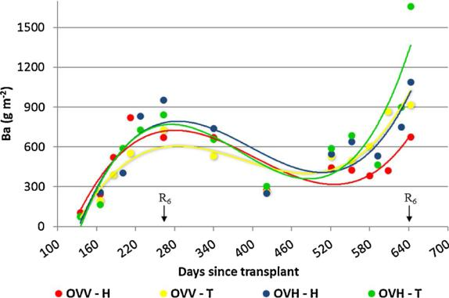

Fig. 1. Aerial biomass accumulation (Ba) from days since transplant during two consecutive growing seasons in two oregano subspecies: O. vulgare ssp. vulgare (OVV) and O. vulgare ssp. hirtum (OVH), grown under two planting patterns: Traditional (T, 0.70 m × 0.20 m) and Homogeneous (H, 0.35 × 0.40 m). Arrows indicate R6 phenological stage in each growth cycle (full blooming). ANOVA for all factors and interactions are shown in supplementary Table S1.

3

V. Davidenco, et al.

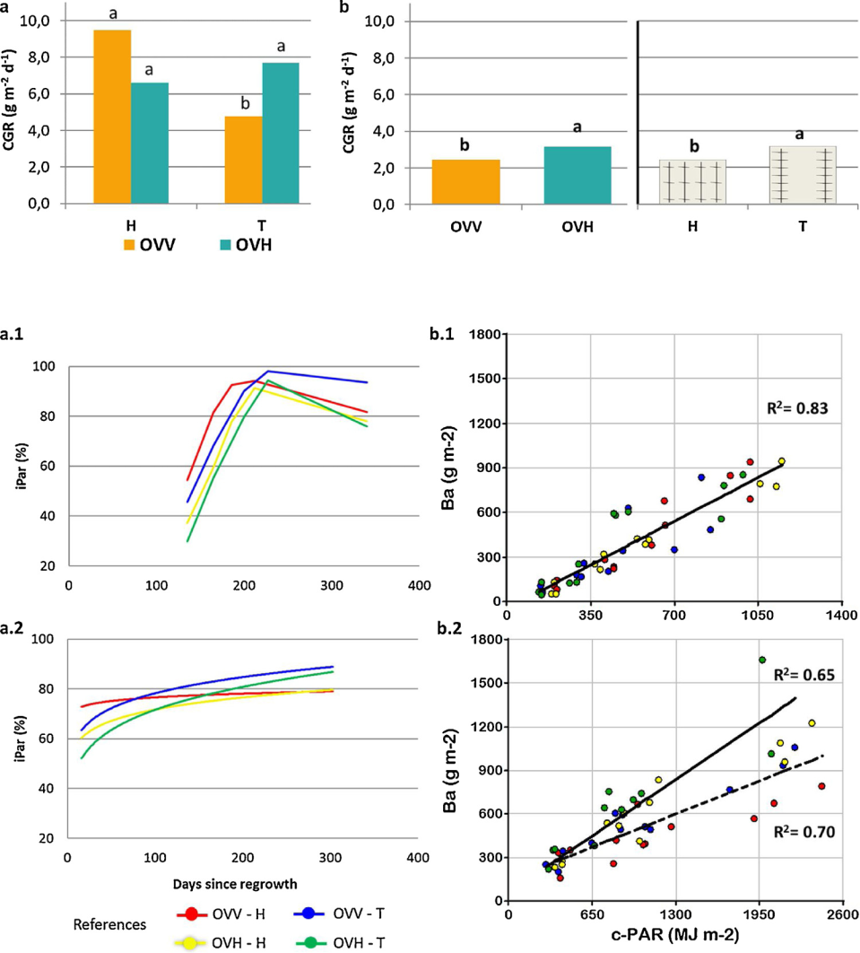

Table 2

Fraction of intercepted photosinthetically active radiation (i-PAR), accumulated intercepted PAR (c-PAR), and radiation use eﬃciency (RUE) during two con-secutive production cycles of oregano grown under two planting patterns (PP): Traditional (T, 0.70m × 0.20m) and Homogeneous (H, 0.35 × 0.40 m). Average of two subspecies: subspecies: O. vulgare ssp. vulgare and O. vulgare ssp. hirtum.

|  |  |  |  |  |
| --- | --- | --- | --- | --- |
| Means by Treatment | | i-PAR (%) | c-PAR (MJ m−2) | RUE (g MJ−1) |
|  | |  |  |  |
| Cycle | |  |  |  |
| 1 |  | 60.4 b | 548.5 b | 0.84 a |
| 2 |  | 73.6 a | 705.4 a | 0.39 b |
| Planting Pattern | |  |  |  |
| H |  | 72.7 a | – | – |
|  |  | 71 |  |  |
| T |  | 61.4 b | – | – |
| Cycle*PP | |  |  |  |
| C1 | * H | 68.3 b | – | 0.88 a |
| C1 | * T | 52.5 c | – | 0.80 a |
| C2 | * H | 77.1 a | – | 0.29 c |
| C2 | * T | 70.3 b | – | 0.49 b |
| ANOVA (p-values) | |  |  |  |
| Cycle | | < 0.0001 | 0.0052 | 0.0001 |
| Planting Pattern | | 0.0002 | ns | ns |
| Cycle*PP | | 0.029 | ns | 0.0482 |
| Days since transplant | | < 0.0001 | < 0.0001 | ns |

Diﬀerent letters within columns between treatments indicate significant dif-ferences according to DGC multiple comparison test (P < 0.05).

*Scientia Horticulturae 272 (2020) 109553*

Fig. 2. Crop growth rate (CGR) in cycle 1 (a) and cycle 2 (b), in two oregano subspecies: O. vulgare ssp. vulgare (OVV) and O. vulgare ssp. hirtum (OVH), grown under two planting pat-terns: Traditional (T, 0.70 m × 0.20 m) and Homogeneous (H, 0.35 × 0.40 m). Diﬀerent letters indicate significant diﬀerences ac-cording to DGC multiple comparison test (P < 0.05). The Subspecies*Planting Pattern was significant in the first cycle (p-value = 0.009). In the second cycle, there were no interaction eﬀects: Planting Pattern (p = 0.042) and Subspecies (p = 0.045).

Fig. 3. Temporal dynamics of the intercepted photosynthetically active radiation fraction (iPAR) (a), and relationship between aereal biomass and accumulated PAR (c-PAR) (b) of two oregano subspecies: O. vulgare ssp. vulgare (OVV) and O. vulgare ssp. hirtum (OVH), grown under two planting patterns: Traditional (T,

|  |  |  |
| --- | --- | --- |
| 0.70m × 0.20m) | and | Homogeneous (H, |
| 0.35 × 0.40 m), | along | two consecutive |

growing seasons (a.1 and b.1: cyce 1; a.2 and b.2: cycle 2). Regressions were fit considering significant diﬀerences among treatments. The slopes of the linear regressions between aereal biomass and accumulated c-PAR represent the radiation use eﬃciency, and are presented in Table 2.

closure early in the cycle (Fig. 3a.1 and 3a.2) but also exhibited higher average i-PAR than the traditional one in both genotypes (Table 2).

Interestingly, c-PAR was only modified by time and C, being 22 % higher in C2 (Table 2). Significant linear regressions between Ba and c-PAR explained 83 % of the variation in C1, and 65–70 % in C2, when two models were adjusted according to each planting pattern (Fig. 3b). Radiation use eﬃciency can be seen as the slope of the linear regres-sions and varied between 0.88 and 0.29 g MJ−1 (Table 2). It was mainly aﬀected by the interaction between growth cycle and planting pattern. In comparison to C1, RUE dropped by 46 % in C2, being mainly ex-plained by decreases in the H planting pattern (dashed-line model of Fig. 3b.2). Noteworthy, this eﬀect seemed to be more accentuated in the creeping subspecies (red series of Fig. 3b.2).

3.3. Biomass partitioning and distribution eﬃciency to harvestable plant organs

Throughout the two growing cycles, small temporal changes in the dynamics of partitioning (C*SPP*DST in Table 3; Fig. 4) were found. The percentage of average partition into flowers, leaves and stems was aﬀected by the cycle, C*SPP but no by the planting pattern. Average partitioning for flowers and leaves was higher in C1 than in C2 when the proportion of stems increased to an average of 63 % (Table 3; Fig. 4). The C*SPP interaction was explained by changes in the SPP ranking in C2 (Fig. 4).

In C1, the last sampling in OVV exhibited the drop of the flower

4

V. Davidenco, et al.

Table 3

Biomass partition (as percentage of total aerial biomass) into flowers (F), leaves

1. and stems (S) along two consecutive growing cycles in two oregano sub-species: O. vulgare ssp. vulgare and O. vulgare ssp. hirtum, grown under two planting patterns: Traditional (T, 0.70m × 0.20m) and Homogeneous (H, 0.35 × 0.40 m).

|  |  |  |  |
| --- | --- | --- | --- |
| Means by Treatment | F (%) | L (%) | S (%) |
|  |  |  |  |
| C 1 | 13.6 a | 43.5 a | 42.9 b |
| C 2 | 5.7 b | 32.1 b | 63.0 a |
| ANOVA (p-values) |  |  |  |
| Cycle | < 0.0001 | < 0.0001 | < 0.0001 |
| DST⃛ | < 0.0001 | < 0.0001 | ns |
| Cycle*Subspecies | 0.0284 | 0.0001 | 0.0248 |
| Cycle*DST | < 0.0001 | < 0.0001 | < 0.0001 |
| Subspecies * DST | 0.0252 | ns | ns |
| Cycle*Subspecies*DST | 0.0055 | 0.0001 | ns |

Diﬀerent letters indicate significant diﬀerences among treatments according to the DGC multiple comparison test (P < 0.05). DST, days since transplant.

proportion (Fig. 4 a, from DST 264–340), probably due to an ac-celerated senescence in comparison to OVH.

At full blooming (R6; Davidenco et. al. 2015), when the crop pro-ductivity is already defined, maximum aerial biomass (Bm) and biomass partition was analyzed (Table 4). Significant SPP eﬀects and C*PP in-teraction were found. Bm was 31 % superior in OVH than in OVV. The C*PP interaction on Bm was associated with the increase of productivity in the traditional PP in C2. The ratio L + F:S, was only aﬀected by SPP; with OVV being the most eﬃcient in assimilates distribution to har-vestable plant organs (Table 4).

3.4. Essential oil productivity

Essential oil productivity (EO yield) was expressed as the product between the EO percentage of harvestable organs and L + F biomass. It ranged between 0 to 25 cm3 m−2 and increased with the crop

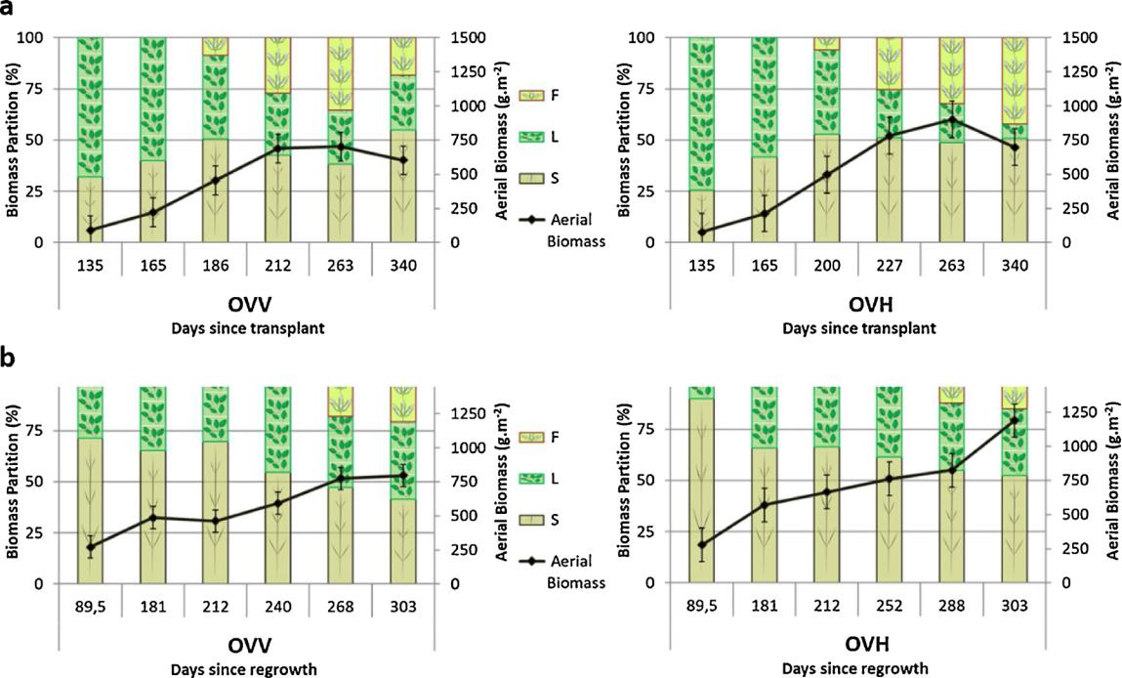

*Scientia Horticulturae 272 (2020) 109553*

Table 4

Biomass at full blooming in two oregano subspecies: O. vulgare ssp. vulgare (OVV) and O. vulgare ssp. hirtum (OVH), grown under two planting patterns: Traditional (T, 0.70m × 0.20m) and Homogeneous (H, 0.35 × 0.40 m) during two seasons. Bm indicates aerial, and L + F indicates leaves plus flowers bio-mass. L + F:S indicates the ratio between leaves + flowers and stem biomass.

|  |  |  |  |
| --- | --- | --- | --- |
| Means by Treatment | Bm (g m−2) | L + F (g m−2) | L+F:S |
|  |  |  |  |
| OVV | 794.4 b | – | 1.33 a |
| OVH | 1155.7 a | – | 0.93 b |
| 1* H | 936.0 b | 485.7 b | – |
| 1* T | 794.0 b | 420.9 b | – |
| 2 * H | 881.9 b | 444.8 b | – |
| 2 * T | 1288.1 a | 653.5 a | – |
| ANOVA (p-value) |  |  |  |
| Subespecies | 0.008 | ns | 0.007 |
| Cycle*Planting Pattern | 0.034 | 0.044 | ns |

Within each trait, diﬀerent letters indicate significant diﬀerences among treatments according to the DGC multiple comparison test (P < 0.05).

phenological progress (from maturity stage 3 onwards; Fig. 5a; Table 5). Considering EO content on a dry weight basis, reproductive phenophases yielded almost four times more than vegetative ones; and OVV produced 30 % more EO than OVH (Table 5). c-PAR was a strong variable explaining EO productivity (Cp-mallows of Fig. 5). Even though ANOVA showed only phenological stage and SPP eﬀects (Table 5), the multivariate regression model better predicted EO yield for the traditional PP. For the H planting pattern, the model tended to subestimate EO in OVV and overestimate EO in OVH.

4. Discussion

OVV and OVH are two O. vulgare subspecies commonly used in Argentina that diﬀer in plant architecture, inflorescence structure, photoperiodic sensitivity, and have diﬀerent developmental patterns (Kokkini et al., 1994; Torres, 2011; Davidenco et al., 2015, 2017). In this research, these subspecies were grown at diﬀerent spatial

Fig. 4. Biomass partition into stems (S), leaves (L) and flowers (F) and Aerial biomass production in the first (a) and the second (b) growth cycle, in two oregano subspecies: O. vulgare ssp. vulgare (OVV) and O. vulgare ssp. hirtum (OVH). Average data of two plant distribution patterns, Traditional (0.70m × 0.20m) and Homogeneous (0.35 × 0.40 m).

5

V. Davidenco, et al.

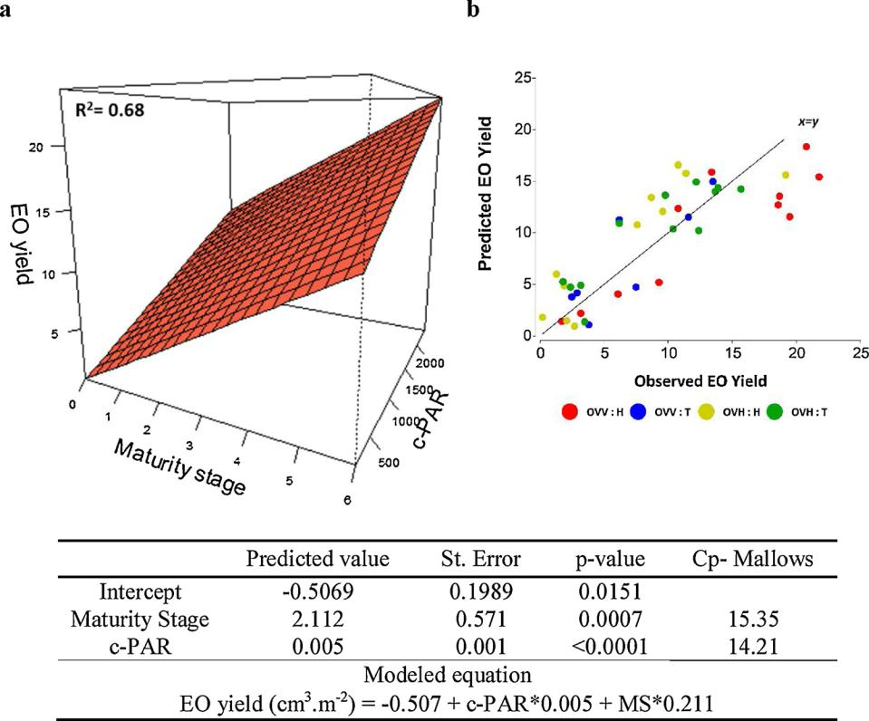

Table 5

Essential oil content (EO; % v/w, on a dry weight basis) in two oregano subspecies: O. vulgare ssp. vulgare (OVV) and O. vulgare ssp. hirtum (OVH). Average data of two plant dis-tribution patterns, Traditional (0.70m × 0.20m) and Homogeneous (0.35 × 0.40 m) on two consecutive growing seasons.

|  |  |
| --- | --- |
| Means by Treatment | EO (%, v/w) |
|  |  |
| Subspecies |  |
| OVV | 0.91 a |
| OVH | 0.64 b |
| Phenological stage |  |
| Vegetative | 0.34 b |
| Reproductive | 1.22 a |
| ANOVA (p-value) |  |
| Subspecies | 0.007 |
| Phenological stage | < 0.0001 |

Diﬀerent letters indicate significant diﬀerences among treatments according to the DGC multiple comparison test (P < 0.05).

distributions during two consecutive growth cycles. To strengthen the understanding of subspecies’ strategies for radiation capture and use, and biomass partitioning, an homogeneous planting pattern was looked up to force a row closure response, thus exploiting the diﬀerential plant architecture of the subspecies.

In general terms, aerial biomass production can be analyzed as the product between CGR and duration of the growth period (Hall, 1980). OVV, previously determined as a more precocious subspecies than OVH (lower thermal time requirements to reach full blooming (Davidenco et al., 2015), exhibited a lower biomass generation along the growth period (Ba, Fig. 1), and a lower maximum biomass at R6 (Bm, Table 4). This could be explained by its earlier induction to flowering, and hence shorter phase duration in detriment to total solar radiation capture (Ritchie and NeSmith, 1991).

CGR in OVV was very responsive to changes in planting pattern,

*Scientia Horticulturae 272 (2020) 109553*

Fig. 5. a) Essential oil productivity (EO yield, cm3 m−2) as a function of crop phenology (maturity stage) and the accumulated PAR (c-PAR), in two oregano subspecies: O. vulgare ssp. vulgare (OVV) and O. vulgare ssp. hirtum (OVH), grown under two planting frames: Traditional (T, 0.70 m × 0.20 m) and Homogeneous (H, 0.35 × 0.40 m). Maturity stages 0 to 3 indicate vegetative macrostages and maturity stages 4 to 6 indicate re-productive macrostages. b) Comparison of modelled and observed essential oil yield (EO). The 1:1 line indicates equality. Inserted table: Multiple linear regression coeficients of the fitted model.

particularly in C1 when the traditional PP markedly decreased it (Fig. 2). The creeping growth habit expressed at vegetative macrostages of OVV (Davidenco et al., 2015) coupled with an almost equidistant plant distribution in H conducted to a faster radiation capture in both growth cycles (Fig. 3a), as also found in perennial alfalfa crops (Mattera et al., 2013). Although in both subspecies, a positive eﬀect of H-planting pattern on i-PAR was observed (Fig. 1), only in C1 this eﬀect translated into higher CGR (significant for OVV). In alfalfa, reducing row spaces (maintaining plant density constant) also led to increases in RUE during the first production season (Mattera et al., 2013).

Because mean CGR declined by 40 % in C2, other traits besides i-PAR took relevance to define growth dynamics. It was noteworthy to find that RUE dropped so significantly in C2. Several factors could ex-plain this result. First, and although in general RUE is calculated on the basis of intercepted solar radiation, it cannot be assumed that all the incoming radiation is absorbed since some degree of light scattering is likely to occur (Daughtry et al., 1992). In C2, and owing to the per-ennial nature of oregano, a remnant biomass (mainly stems; Fig. 4b) at the beginning of the cycle explained high initial i-PAR which did not translate into growth. Since stems are not specialized photosynthetic organs, it is sound to expect that photosynthetic eﬃciency, and hence, RUE (as estimated in this study) decreased with crop age. Also a po-tentially higher maintenance respiration in C2 could explain the lower ability of the crop to accumulate biomass on a daily basis (Cannell and Thornley, 2000). Accordingly, lower CGR in C2 reflected decreases in RUE, which fluctuated between 0.9 and 0.3 g DM MJ−1 (Table 2). In this research, noteworthy, the H-PP no longer generated productive benefits in CGR in C2 due, probably, to excessive shading by stems and increases of maintenance costs which could have aﬀected RUE. Other factors, such as the N profile within the canopy could also explain drops in the photosynthetic capacity of crops in C2 (Hikosaka et al., 2016). Teixeira et al. (2008) found that RUE reductions in frequently defo-liated crops correlated with reduced nitrogen reserves. In general terms, and in the context of our experimental approach, the traditional planting pattern emerged as a more stable treatment over time since it

6

V. Davidenco, et al.

achieved higher Bm in C2. Higher Bm was explained by higher iPAR, c-PAR and RUE parameters (Fig. 3a.2 and b.2, Table 2).

Biomass partitioning into harvestable organs is the third ecophy-siological component in yield determination (Monteith, 1977), and can be analyzed as a mean proportion along growth cycle (Table 3). In this study, it was hypothesized that partition of biomass towards organs of physiological and agronomic utility would be aﬀected by both planting patterns and subspecies. Considering biomass percentage of F, L and S, the PP-factor did not express significant eﬀects in the annual mean value of partition, as did the C and the SPP-factors. In this sense, C2 was characterized by a major stem proportion and, as for subspecies, during C1 OVH showed a trend of higher F and L proportion, opposite to C2 in which this tendency seemed to be in favor of OVV (Fig. 4). It is worthy to note the C eﬀect on assimilate allocation. As explained by Coleman et al. (1994), in order to evaluate if treatments induce the adjustment in allocation of biomass, plant development and growth rate must be considered. In our research, growth cycles diﬀered firmly in CGR, and this could mask the phenotypic plasticity of the partition index. Therefore, analysis was made for each cycle separately. During C1, CGR and RUE were maximum, and regardless the PP, plants could easily explore the light environment, branch and generate leaf area, thus making assimilates allocation, hardly diﬀerent between SPP (almost 2

* more of F in OVH). Along C2, the light intercepted more by stems than by leaves determined the fall of RUE and thereby of CGR. Taking into account the partition average of C2, OVV allocated 6% more as-similates in L + F than OVH. Furthermore, ontogenetic drift changes biomass allocation in several species (Evans, 1972) so biomass partition was also analyzed in absolute values of biomass (g m−2) achieved at R6. In this sense, the spatial arrangement triggered diﬀerences in biomass allocation (p-value = 0.044, Table 4), although it has been argued that biomass allocation is isometric (e.g- size independent) in adult oregano plants (Husáková et al., 2016). In our research, lower CGR due to a potentially higher shading in the quadrangular PP could result in an anticipated senescence and abscission of L and F in C2, which in turn was translated into a lower biomass (both aerial and L + F; Table 4).

Essential oil productivity is the last yield component in this species, as it defines the final quality of the produced biomass. In previous re-search, photoperiodic eﬀects (i.e. extended light hours) were found to increase EO both qualitatively as quantitatively (Davidenco et al., 2017). In this study, EO yield could be explained not only by crop ontogeny, in line with previous studies in this genus and other aromatic species (Berghold et al., 2008; Arraiza et al., 2009), but also by PAR capture and accumulation. Both phenology and c-PAR were critical factors explaining almost 70 % of the variation in EO productivity (Fig. 5a). c-PAR was correlated with biomass production, particularly of flowers and leaves, in accordance with Tibaldi et al. (2011). Early stages (MS 0–3) exhibited less than 10 cm3 m−2 of EO yield, while re-productive stages (from MS 3 onwards, Davidenco et al., 2015) showed significant increases in EO yield (around 25 cm3 m−2), thus reinforcing the role of flowers as the main EO storage sites.

Although no significant PP-eﬀect on EO was detected by the ANOVA analysis (Table 5), the fitted multiple-linear regression model better estimated EO for the traditional planting pattern (Fig. 5b). It is not clear why EO was sub (OVH) or over (OVV) estimated in the quadrangular plant distribution. More studies are needed to analyze if planting pat-terns alter the canopy environment to preserve volatile compounds.

A wide range for EO content was reported for O. vulgare ssp., ranging from 0.2–5.7 % v/w (Baranauskiené et al., 2013). Additionally, some studies found that OVH has a higher level of essential oil concentration in comparison with other O. vulgare subspecies (Baranauskiené et al., 2013; Shafiee-Hajiabad et al., 2014). These results were explained by a higher density of glandular trichomes as well as a larger size of peltate trichomes in OVH compared to common oregano. In contrast to those findings, OVV yielded more EO than OVH in our study. Although in this research no trichome analysis was performed to explain the genotypic diﬀerences in EO content, the higher L + F:S ratio in OVV reinforces

*Scientia Horticulturae 272 (2020) 109553*

our findings (Table 5). Genotypic diﬀerences in the inflorescence structure could also explain EO diﬀerences between subspecies. Con-tracted and compact inflorescences of OVV (Davidenco et al., 2015) could have generated a more propitious environment to avoid trichome rupture and EO volatilization by physical factors such as wind or even harvest handling in comparison to the looser inflorescences of OVH. Regardless the proposed factors, diﬀerences in the crop growth en-vironment of sites (i.e. altitude, mean temperature or solar radiation) in ours and in the above mentioned studies could also explain diﬀerences in EO productivity (Sangwan et al., 2001).

5. Conclusion

Productivity in oregano was disaggregated into eco-physiological processes that explain biomass and essential oil yield. Changing the planting patterns in subspecies that diﬀer in architectural features al-lowed us to characterize the diﬀerent strategies in solar radiation capture and use to generate biomass and build yield.

Radiation capture and use were mainly modulated by the crop age and the planting pattern. Even though both variables were improved under the H-PP in C1, these eﬀects did not endure in C2 and, and thus only the T-PP showed a relatively good RUE. Variation in RUE ex-plained CGR among the diﬀerent treatments; and OVV appeared to have a higher phenotypic plasticity than OVH, thus maximizing light capture, use and growth in C1 under the more equidistant plant dis-tribution. Conversely, OVH revealed a more stable response along the two growing cycles.

Although a higher aerial biomass was observed in C2 in comparison to C1, a drop in the partition index for flowers and leaves was found, process associated with a higher stem proportion in C2. Considering partitioning at reproductive stages of C1, OVV exhibited the lowest F proportion leading to a slight diﬀerence in L + F proportion in favor to OVH. C*PP influence on L + F was noticeable at full blooming, being H-

1. more advantageous during C1, but T-PP the most productive during C2.

Phenological progress along with c-PAR explained EO productivity. Among subspecies, OVV appeared to be more productive due to its higher L + F:S ratio.

In this study, the ecophysiological analysis of yield formation al-lowed to explain the significant interactions between factors controlling Oregano productivity. The novel approach can be further used to im-prove knowledge on diverse crop management practices, and con-tribute to the understanding of the environmental regulation of growth and yield in this aromatic herb.

Declaration of Competing Interest

The authors declare that they have no known competing financial interests or personal relationships that could have appeared to influ-ence the work reported in this paper.

CRediT authorship contribution statement

Vanina Davidenco: Formal analysis, Investigation, Writing - re-view & editing, Visualization, Supervision. Pablo J. Pelissero: Writing - original draft, Formal analysis. Juan A. Argüello: Funding acquisi-tion, Project administration. Claudia R.C. Vega: Conceptualization, Investigation, Formal analysis, Writing - review & editing, Supervision.

Acknowledgments

The authors thank the Argentinian National Research Council (CONICET) for funding this research with a Ph.D. grant to Vanina Davidenco. We are also thankful to Secyt-UNC for financial support.

7

V. Davidenco, et al.

Appendix A. Supplementary data

Supplementary material related to this article can be found, in the online version, at doi:<https://doi.org/10.1016/j.scienta.2020.109553>.

References

[Andrade, F.H., Sadras, V.O., Vega, C.R.C., Echarte, L., 2005. Physiological determinants](http://refhub.elsevier.com/S0304-4238(20)30381-2/sbref0005) [of crop growth and yield in maize, sunflower and soybean. Their application to crop](http://refhub.elsevier.com/S0304-4238(20)30381-2/sbref0005) [management, modeling and breeding. J. Crop. Improv. 14, 51–101](http://refhub.elsevier.com/S0304-4238(20)30381-2/sbref0005).

Arraiza, M.P., Andrés, M.P., Arrabal, C., López, J.V., 2009. Seasonal variation of essential oil yield and composition of thyme (Thymus vulgaris L.) grown in castilla - la mancha (Central Spain). J. Essent. Oil Res. 21, 360–362. [https://doi.org/10.1080/10412905.](https://doi.org/10.1080/10412905.2009.9700192) [2009.9700192](https://doi.org/10.1080/10412905.2009.9700192).

Asensio, C.M., Grosso, N.R., Juliani, H.R., 2015. Quality characters, chemical composition and biological activities of oregano (Origanum spp.) Essential oils from Central and Southern Argentina. Ind. Crops Prod. 63, 203–213. [https://doi.org/10.1016/j.](https://doi.org/10.1016/j.indcrop.2014.09.056) [indcrop.2014.09.056](https://doi.org/10.1016/j.indcrop.2014.09.056).

Atallah, S.S., El Saliby, I., Baalbaki, R., Talhouk, S.N., 2011. Eﬀects of diﬀerent irrigation, drying and production scenarios on the productivity, postharvest quality and eco-nomic feasibility of Origanum syriacum, a species typically over-collected from the wild in Lebanon. J. Sci. Food Agric. 91, 337–343. <https://doi.org/10.1002/jsfa.4191>.

Bakkali, F., Averbeck, S., Averbeck, D., Idaomar, M., 2008. Biological eﬀects of essential oils – a review. Food Chem. Toxicol. 46, 446–475. [https://doi.org/10.1016/j.fct.](https://doi.org/10.1016/j.fct.2007.09.106) [2007.09.106](https://doi.org/10.1016/j.fct.2007.09.106).

[Baranauskiené, R., Venskutonis, P.R., Dambrauskiené, E., Viskelis, P., 2013. Harvesting](http://refhub.elsevier.com/S0304-4238(20)30381-2/sbref0030) [time influences the yield and oil composition of Origanum vulgare L. ssp. vulgare and](http://refhub.elsevier.com/S0304-4238(20)30381-2/sbref0030) [ssp. hirtum. Ind. Crops Prod. 49, 43–51](http://refhub.elsevier.com/S0304-4238(20)30381-2/sbref0030).

[Berghold, H., Wagner, S., Mandl, M., Thaller, A., Müller, M., Rakowitz, M., Pasteiner, S.,](http://refhub.elsevier.com/S0304-4238(20)30381-2/sbref0035) [Boechzelt, H., 2008. Yield, content and composition of the essential oil of five](http://refhub.elsevier.com/S0304-4238(20)30381-2/sbref0035) [Oregano strains (Origanum vulgare L.) depending on the developmental stage. J.](http://refhub.elsevier.com/S0304-4238(20)30381-2/sbref0035) [Med. Spice Plants 13, 36–43](http://refhub.elsevier.com/S0304-4238(20)30381-2/sbref0035).

Brodrick, R., Bange, M., Milroy, S., Hammer, G., 2013. Physiological determinants of high yielding ultra-narrow row cotton: canopy development and radiation use eﬃciency. Field Crops Res. 148, 86–94. <https://doi.org/10.1016/j.fcr.2012.05.008>.

[Burgos, Á.M., Schroeder, M.A., García, M.A.C., 2017. Producción de orégano (Origanum](http://refhub.elsevier.com/S0304-4238(20)30381-2/sbref0045) [sp) con fertilización nitrogenada en suelos arenosos de Corrientes. Agrotecnia. pp.](http://refhub.elsevier.com/S0304-4238(20)30381-2/sbref0045)

[5–10](http://refhub.elsevier.com/S0304-4238(20)30381-2/sbref0045).

Cannell, M.G.R., Thornley, J.H.M., 2000. Modelling the components of plant respiration: some guiding principles. Ann. Bot. 85, 45–54. [https://doi.org/10.1006/anbo.1999.](https://doi.org/10.1006/anbo.1999.0996) [0996](https://doi.org/10.1006/anbo.1999.0996).

[Chlodwing, F., Novak, J., 1997. Breeding of origanum species. In: Padulosi, S. (Ed.),](http://refhub.elsevier.com/S0304-4238(20)30381-2/sbref0055) [Oregano. Promoting the Conservation and Use of Underutilized and Neglected Crops.](http://refhub.elsevier.com/S0304-4238(20)30381-2/sbref0055)

1. [Proceedings of the IPGRI International Workshop on Oregano, CIHIEAM](http://refhub.elsevier.com/S0304-4238(20)30381-2/sbref0055) [Valenzano. Bari, Italy. pp. 34–48](http://refhub.elsevier.com/S0304-4238(20)30381-2/sbref0055).

Coleman, J.S., McConnaughay, K.D.M., Ackerly, D.D., 1994. Interpreting phenotypic variation in plants. Trends Ecol. Evol. (Amst.) 9, 187–191. [https://doi.org/10.1016/](https://doi.org/10.1016/0169-5347(94)90087-6) [0169-5347(94)90087-6](https://doi.org/10.1016/0169-5347(94)90087-6).

[Dardanelli, J.L., Bachmeier, O.A., Sereno, R., Gil, R., 1997. Rooting depth and soil water](http://refhub.elsevier.com/S0304-4238(20)30381-2/sbref0065) [extraction patterns of diﬀerent crops in a silty loam Haplustoll. Field Crops Res. 54,](http://refhub.elsevier.com/S0304-4238(20)30381-2/sbref0065) [29–38](http://refhub.elsevier.com/S0304-4238(20)30381-2/sbref0065).

Daughtry, C., Gallo, K., Goward, S., Prince, S., Kustas, W., 1992. Spectral estimates of absorbed radiation and phytomass production in corn and soybean canopies. Remote Sens. Environ. 39, 141–152. <https://doi.org/10.1016/0034-4257(92)90132-4>.

Davidenco, V., Vega, C.R.C., Piccardi, M.B., Argüello, J.A., 2015. Development in Origanum ssp.: a simple phenological scale to determine thermal time requirements to critical reproductive events. Sci. Hortic. 186, 70–76. [https://doi.org/10.1016/j.](https://doi.org/10.1016/j.scienta.2015.02.012) [scienta.2015.02.012](https://doi.org/10.1016/j.scienta.2015.02.012).

Davidenco, V., Argüello, J.A., Piccardi, M.B., Vega, C.R.C., 2017. Day length modulates precocity and productivity through its eﬀect on developmental rate in Origanum vulgare ssp. Sci. Hortic. 218, 164–170. [https://doi.org/10.1016/j.scienta.2017.02.](https://doi.org/10.1016/j.scienta.2017.02.028) [028](https://doi.org/10.1016/j.scienta.2017.02.028).

[De Mastro, G., Ruta, C., Marzi, V., 2004. Agronomic and technological assessment of](http://refhub.elsevier.com/S0304-4238(20)30381-2/sbref0085) [oregano (Origanum vulgare ssp.) biotypes. Acta Hortic. 355–364](http://refhub.elsevier.com/S0304-4238(20)30381-2/sbref0085).

[Di Rienzo, J.A., Guzmán, A.W., Casanoves, F., 2002. A multiple-comparisons method](http://refhub.elsevier.com/S0304-4238(20)30381-2/sbref0090) [based on the distribution of the root node distance of a binary tree. J. Agric. Biol.](http://refhub.elsevier.com/S0304-4238(20)30381-2/sbref0090) [Environ. Stat. 7, 129–142](http://refhub.elsevier.com/S0304-4238(20)30381-2/sbref0090).

[Di Rienzo, J.A., Casanoves, F., Balzarini, M.G., Gonzalez, L., Tablada, M., Robledo, C.W.,](http://refhub.elsevier.com/S0304-4238(20)30381-2/sbref0095) [2014. Universidad Nacional de Córdoba. InfoStat. Grupo InfoStat, FCA, Argentina](http://refhub.elsevier.com/S0304-4238(20)30381-2/sbref0095).

[Draper, N., Smith, H., 1966. Applied Linear Regression. Wiley, New York](http://refhub.elsevier.com/S0304-4238(20)30381-2/sbref0100).

[Evans, G.C., 1972. The Quantitative Analysis of Plant Growth. Univ of California Press](http://refhub.elsevier.com/S0304-4238(20)30381-2/sbref0105).

[Evans, W.C., Trease, G.E., 1995. Tratado de Farmacognosia. México (DF)](http://refhub.elsevier.com/S0304-4238(20)30381-2/sbref0110).

Farías, G., Brutti, O., Grau, R., Di Leo Lira, P., Retta, D., van Baren, C., Vento, S., Bandoni, A.L., 2010. Morphological, yielding and quality descriptors of four clones of Origanum spp. (Lamiaceae) from the Argentine Littoral region Germplasm bank. Ind. Crops Prod. 32, 472–480. <https://doi.org/10.1016/j.indcrop.2010.06.019>.

Gallo, K., Daughtry, C., 1986. Techniques for Measuring Intercepted and Absorbed Photosynthetically Active Radiation in Corn Canopies This work was supported by Instituto Nacional de Tecnología Agropecuaria (INTA). Facultad de Ciencias Agrarias UNMP, CREA Tandil, Consejo Nacional de Investigaciones Científicas y Técnicas (CONICET), and Monsanto Argentina, pp. 752–756. [https://doi.org/10.2134/](https://doi.org/10.2134/agronj1986.00021962007800040039x) [agronj1986.00021962007800040039x. 78.](https://doi.org/10.2134/agronj1986.00021962007800040039x)

[Gardner, F.P., Pierce, R.B., Mitchel, R.L., 1985. Physiology of Crops Plants. Iowa State](http://refhub.elsevier.com/S0304-4238(20)30381-2/sbref0125) [University Press, USA, pp. 327](http://refhub.elsevier.com/S0304-4238(20)30381-2/sbref0125).

*Scientia Horticulturae 272 (2020) 109553*

[Gerami, F., Moghaddam, P.R., Ghorbani, R., Hassani, A., 2016. Eﬀects of irrigation in-tervals and organic manure on morphological traits, essential oil content and yield of](http://refhub.elsevier.com/S0304-4238(20)30381-2/sbref0130) [oregano (Origanum vulgare L.). Anais da Academia Brasileira de Ciências 88,](http://refhub.elsevier.com/S0304-4238(20)30381-2/sbref0130) [2375–2385](http://refhub.elsevier.com/S0304-4238(20)30381-2/sbref0130).

[Gümüsçü, A., Ipek, A., Sarihan, E.O., Gürbüz, B., Kaya, M.D., Arslan, N., 2008. Eﬀects of](http://refhub.elsevier.com/S0304-4238(20)30381-2/sbref0135) [diurnal and ontogenetic variability on essential oil composition of oregano](http://refhub.elsevier.com/S0304-4238(20)30381-2/sbref0135) [(Origanum vulgare var. hirtum). Asian J. Chem. 20, 1290–1294](http://refhub.elsevier.com/S0304-4238(20)30381-2/sbref0135).

[Hall, A.J., 1980. Los componentes fisiológicos del rendimiento de los cultivos. Rev.](http://refhub.elsevier.com/S0304-4238(20)30381-2/sbref0140)

[Facultad de Agronomía 1, 73–86](http://refhub.elsevier.com/S0304-4238(20)30381-2/sbref0140).

Hikosaka, K., Anten, N.P., Borjigidai, A., Kamiyama, C., Sakai, H., Hasegawa, T., Oikawa, S., Iio, A., Watanabe, M., Koike, T., 2016. A meta-analysis of leaf nitrogen distribution within plant canopies. Ann. Bot. 118, 239–247. [https://doi.org/10.1093/aob/](https://doi.org/10.1093/aob/mcw099) [mcw099](https://doi.org/10.1093/aob/mcw099).

Husáková, I., Weiner, J., Münzbergová, Z., 2016. Species traits and shoot–root biomass allocation in 20 dry-grassland species. J. Plant Ecol. 11, 273–285. [https://doi.org/10.](https://doi.org/10.1093/jpe/rtw143) [1093/jpe/rtw143](https://doi.org/10.1093/jpe/rtw143).

Juliani, R., Koroch, A., Zygadlo, J., Trippi, V., 2011. Evaluation of micropropagation for the introduction into cultivation and conservation of Lippia junelliana, an endemic aromatic plant from Argentina. Ind. Crops Prod. 34, 1353–1357. [https://doi.org/10.](https://doi.org/10.1016/j.indcrop.2010.12.009) [1016/j.indcrop.2010.12.009](https://doi.org/10.1016/j.indcrop.2010.12.009).

Karamanos, A.J., Sotiropoulou, D.E.K., 2013. Field studies of nitrogen application on Greek oregano (Origanum vulgare ssp. hirtum (Link) Ietswaart) essential oil during two cultivation seasons. Ind. Crops Prod. 46, 246–252. [https://doi.org/10.1016/j.](https://doi.org/10.1016/j.indcrop.2013.01.021) [indcrop.2013.01.021](https://doi.org/10.1016/j.indcrop.2013.01.021).

[Kintzios, S.E., 2002. Profile of the multifaceted prince of the herbs. In: Kintzios, S.E. (Ed.),](http://refhub.elsevier.com/S0304-4238(20)30381-2/sbref0165) [Oregano – The Genera Origanum and Lippia. Taylor & Francis, London, pp. 3–8](http://refhub.elsevier.com/S0304-4238(20)30381-2/sbref0165).

Kizil, S., Ipek, A., Arslan, N., Khawar, K.M., 2008. Eﬀect of diﬀerent developing stages on some agronomical characteristics and essential oil composition of Oregano (Origanum onites). N. Z. J. Crop Hortic. Sci. 36, 71–76. [https://doi.org/10.1080/](https://doi.org/10.1080/01140670809510222) [01140670809510222](https://doi.org/10.1080/01140670809510222).

Kokkini, S., Karousou, R., Vokou, D., 1994. Pattern of geographic variations of Origanum vulgare trichomes and essential oil content in Greece. Biochem. Syst. Ecol. 22, 517–528. <https://doi.org/10.1016/0305-1978(94)90046-9>.

[Lenardis, A.E., Gil, A., Morvillo, C., 2006. “Orégano”. In: De la Fuente, E.B., Gil, A.,](http://refhub.elsevier.com/S0304-4238(20)30381-2/sbref0180) [Jiménez, P.I., Kantolic, A.G., Lopez Pereira, M., Ploschuk, E.L., Sorlino, D.M.,](http://refhub.elsevier.com/S0304-4238(20)30381-2/sbref0180) [Vilariño, M.P., Warsner, D.F., Windaver, L.B. (Eds.), Cultivos Industriales. Facultad](http://refhub.elsevier.com/S0304-4238(20)30381-2/sbref0180) [de Agronomía. Universidad de Buenos Aires. R.A.](http://refhub.elsevier.com/S0304-4238(20)30381-2/sbref0180).

[Mattera, J., Romero, L.A., Cuatrín, A.L., Cornaglia, P.S., Grimoldi, A.A., 2013. Yield](http://refhub.elsevier.com/S0304-4238(20)30381-2/sbref0185) [components, light interception and radiation use eﬃciency of lucerne (Medicago](http://refhub.elsevier.com/S0304-4238(20)30381-2/sbref0185) [sativa L.) in response to row spacing. Eur. J. Agron. 45, 87–95](http://refhub.elsevier.com/S0304-4238(20)30381-2/sbref0185).

[Monteith, J.L., 1977. Climate and the Eﬃciency of Crop Production in Britain. Philos.](http://refhub.elsevier.com/S0304-4238(20)30381-2/sbref0190)

[Trans. R. Soc. London Ser. B, pp. 277–294](http://refhub.elsevier.com/S0304-4238(20)30381-2/sbref0190).

Murillo-Amador, B., Nieto-Garibay, A., López-Aguilar, R., Troyo-Diéguez, E., Rueda-Puente, E.O., Flores-Hernández, A., Ruiz-Espinoza, F.H., 2013. Physiological, mor-phometric characteristics and yield of Origanum vulgare L. and Thymus vulgaris L. exposed to open-field and shade-enclosure. Ind. Crops Prod. 49, 659–667. [https://](https://doi.org/10.1016/j.indcrop.2013.06.017) [doi.org/10.1016/j.indcrop.2013.06.017](https://doi.org/10.1016/j.indcrop.2013.06.017).

[Ozguven, M., Ayanoglu, F., Ozel, A., 2006. Eﬀects of nitrogen rates and cutting times on](http://refhub.elsevier.com/S0304-4238(20)30381-2/sbref0200)

[the essential oil yield and components of Origanum syriacum L. var. bevanii. J.](http://refhub.elsevier.com/S0304-4238(20)30381-2/sbref0200)

[Agron. 5, 101–105](http://refhub.elsevier.com/S0304-4238(20)30381-2/sbref0200).

Ozkan, G., Baydar, H., Erbas, S., 2010. The influence of harvest time on essential oil composition, phenolic constituents and antioxidant properties of Turkish oregano (Origanum onites L.). J. Sci. Food Agric. 90, 205–209. [https://doi.org/10.1002/jsfa.](https://doi.org/10.1002/jsfa.3788) [3788](https://doi.org/10.1002/jsfa.3788).

Pank, F., Vender, C., Niekerk, L.V., Junghanns, W., Langbehn, J., Blüthner, W.D., Novak, J., Franz, C.H., 2002. Combining ability of Origanum majorana L. Strains-agrono-mical traits and essencial oil content: results of the field experiment series in 1999. J. Herbs Spices Med. Plants 9, 31–44. <https://doi.org/10.1300/J044v09n02_05>.

Park, S.E., Benjamin, L.R., Watkinson, A.R., 2003. The theory and application of plant competition models: an agronomic perspective. Ann. Bot. 92, 741–748. [https://doi.](https://doi.org/10.1093/aob/mcg204) [org/10.1093/aob/mcg204](https://doi.org/10.1093/aob/mcg204).

[Ritchie, J.T., NeSmith, D.S., 1991. Temperature and crop development. In: Hanks, J.,](http://refhub.elsevier.com/S0304-4238(20)30381-2/sbref0220)

[Ritchie, J.T. (Eds.), Modeling Plant and Soil Systems. ASA, CSSA, SSSA Publ.](http://refhub.elsevier.com/S0304-4238(20)30381-2/sbref0220)

[Madison, WI, USA, pp. 5–29](http://refhub.elsevier.com/S0304-4238(20)30381-2/sbref0220).

[Robbers, J.E., Speedie, M.K., Tyler, V.E., 1996. Pharmacognosy and](http://refhub.elsevier.com/S0304-4238(20)30381-2/sbref0225) [Pharmacobiotechology. Maryland, USA.](http://refhub.elsevier.com/S0304-4238(20)30381-2/sbref0225) .

Şahin, F., Güllüce, M., Daferera, D., Sökmen, A., Sökmen, M., Polissiou, M., Agar, G., Özer, H., 2004. Biological activities of the essential oils and methanol extract of Origanum vulgare ssp. vulgare in the Eastern Anatolia region of Turkey. Food Control 15, 549–557. <https://doi.org/10.1016/j.foodcont.2003.08.009>.

[Sangwan, N.S., Farooqi, A.H.A., Shabih, F., Sangwan, R.S., 2001. Regulation of essential](http://refhub.elsevier.com/S0304-4238(20)30381-2/sbref0235) [oil production in plants. Plant Growth Regul. 34, 3–21](http://refhub.elsevier.com/S0304-4238(20)30381-2/sbref0235).

[Shafiee-Hajiabad, M., Hardt, M., Honermeier, B., 2014. Comparative investigation about](http://refhub.elsevier.com/S0304-4238(20)30381-2/sbref0240) [the trichome morphology of Common oregano (Origanum vulgare L. Subsp. vulgare)](http://refhub.elsevier.com/S0304-4238(20)30381-2/sbref0240) [and Greek oregano (Origanum vulgare L. subsp. hirtum). J. Appl. Res. Med. Aromat.](http://refhub.elsevier.com/S0304-4238(20)30381-2/sbref0240) [Plants 1, 50–58](http://refhub.elsevier.com/S0304-4238(20)30381-2/sbref0240).

[Sinclair, T.R., Muchow, R.C., Donald, L.S., 1999. Radiation Use Eﬃciency. Advances in](http://refhub.elsevier.com/S0304-4238(20)30381-2/sbref0245) [Agronomy. Academic Press, pp. 215–265](http://refhub.elsevier.com/S0304-4238(20)30381-2/sbref0245).

Singels, A., Smit, M., 2009. Sugarcane response to row spacing-induced competition for light. Field Crops Res. 113, 149–155. <https://doi.org/10.1016/j.fcr.2009.04.015>.

Sotiropoulou, D.E., Karamanos, A.J., 2010. Field studies of nitrogen application on growth and yield of Greek oregano (Origanum vulgare ssp. hirtum (Link) Ietswaart). Industrial Crops and Products In Press[https://doi.org/10.1016/j.indcrop.2010.06.](https://doi.org/10.1016/j.indcrop.2010.06.014)

1. [Corrected Proof.](https://doi.org/10.1016/j.indcrop.2010.06.014)

[Szeicz, G., 1974. Solar radiation for plant growth. J. Appl. Ecol](http://refhub.elsevier.com/S0304-4238(20)30381-2/sbref0260).

Teixeira, E.I., Moot, D.J., Brown, H.E., 2008. Defoliation frequency and season aﬀected

8

V. Davidenco, et al.

radiation use eﬃciency and dry matter partitioning to roots of lucerne (Medicago sativa L.) crops. Eur. J. Agron. 28, 103–111. [https://doi.org/10.1016/j.eja.2007.05.](https://doi.org/10.1016/j.eja.2007.05.004) [004](https://doi.org/10.1016/j.eja.2007.05.004).

Tibaldi, G., Fontana, E., Nicola, S., 2011. Growing conditions and postharvest manage-ment can aﬀect the essential oil of Origanum vulgare L. ssp. hirtum (Link) Ietswaart. Ind. Crops Prod. 34, 1516–1522. <https://doi.org/10.1016/j.indcrop.2011.05.008>.

[Torres, L.E., 2011. Caracterización y evaluación de genotipos de orégano cultivados en las](http://refhub.elsevier.com/S0304-4238(20)30381-2/sbref0275) [principales zonas de producción de Argentina. Facultad de Ciencias Agropecuarias.](http://refhub.elsevier.com/S0304-4238(20)30381-2/sbref0275) [Escuela para Graduados. Universidad Nacional de Córdoba, Córdoba, Argentina, pp.](http://refhub.elsevier.com/S0304-4238(20)30381-2/sbref0275) [123](http://refhub.elsevier.com/S0304-4238(20)30381-2/sbref0275).

Torres, L.E., Brunetti, P.C., Baglio, C., Bauzá, P.G., Chaves, A.G., Massuh, Y., Ocaño, S.F., Ojeda, M.S., 2012. Field evaluation of twelve clones of oregano grown in the main production areas of Argentina: identification of quantitative trait with the highest discriminant value. Int. Scholarly Res. Notices Agron. 2012, 10. [https://doi.org/10.](https://doi.org/10.5402/2012/349565) [5402/2012/349565](https://doi.org/10.5402/2012/349565).

*Scientia Horticulturae 272 (2020) 109553*

[Vega, C.R.C., 2011. Determinación del rendimiento de maíz ante modificaciones en el](http://refhub.elsevier.com/S0304-4238(20)30381-2/sbref0285) [manejo de la densidad, distancia entre surcos y fecha de siembra. Análisis de](http://refhub.elsevier.com/S0304-4238(20)30381-2/sbref0285) [campañas 2007-2010 de miembros MAIZAR en el NOA. ed. electrónica.](http://refhub.elsevier.com/S0304-4238(20)30381-2/sbref0285) .

[Vega, C., Andrade, F., 2000. Densidad de plantas y espaciamiento entre hileras. Bases](http://refhub.elsevier.com/S0304-4238(20)30381-2/sbref0290) [para el manejo del maíz, girasol y la soja. EEA Balcarce INTA, FCA, UNMdP, Balcarce,](http://refhub.elsevier.com/S0304-4238(20)30381-2/sbref0290) [pp. 97–133](http://refhub.elsevier.com/S0304-4238(20)30381-2/sbref0290).

Weiner, J., 2004. Allocation, plasticity and allometry in plants. Perspect. Plant Ecol. Evol.

Syst. 6, 207–215. <https://doi.org/10.1078/1433-8319-00083>.

Werker, E., Putievsky, E., Ravid, U., Dudai, N., Katzir, I., 1993. Glandular hairs and es-sential oil in developing leaves of Ocimum basilicum L.(Lamiaceae). Ann. Bot. 71, 43–50. <https://doi.org/10.1006/anbo.1993.1005>.

[Yazdani Biouki, R., Bannayan Aval, M., Sodaeeizadeh, H., Khazaei, H.R., 2014.](http://refhub.elsevier.com/S0304-4238(20)30381-2/sbref0305) [Evaluation of yield, nitrogen use eﬃciency and radiation use eﬃciency of wild ma-joram in response to organic and chemical fertilizers. Int. J. Adv. Biol. Biomed. Res. 2,](http://refhub.elsevier.com/S0304-4238(20)30381-2/sbref0305) [260–271](http://refhub.elsevier.com/S0304-4238(20)30381-2/sbref0305).

9