[Scientia Horticulturae 272 (2020) 109579](https://doi.org/10.1016/j.scienta.2020.109579)

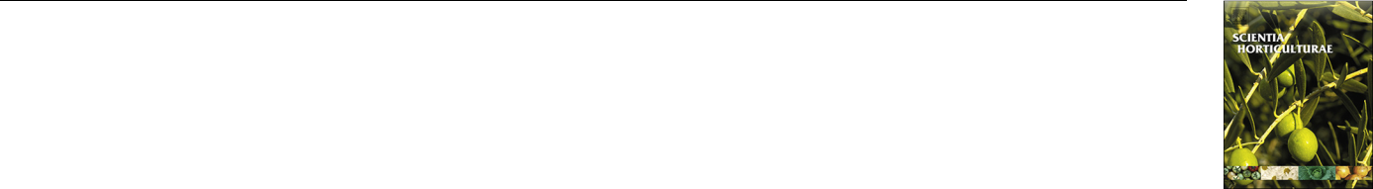

Contents lists available at [ScienceDirect](http://www.sciencedirect.com/science/journal/03044238)



Scientia Horticulturae

journal homepage: [www.elsevier.com/locate/scihorti](https://www.elsevier.com/locate/scihorti)

|  |  |  |
| --- | --- | --- |
| Diﬀerential regulatory mechanisms of secondary metabolites revealed at | [T](http://crossmark.crossref.org/dialog/?doi=10.1016/j.scienta.2020.109579&domain=pdf) |  |
| diﬀerent leaf positions in two related tea cultivars |  |
|  |  |



Yazhen Zhanga,b,1, Liyuan Wanga,1, Kang Weia, Li Ruana, Liyun Wua, Mengdi Hea, Huarong Tongb,**, Hao Chenga,*

1. Key Laboratory of Tea Plant Biology and Resources Utilization, Ministry of Agriculture, National Center for Tea Improvement, Tea Research Institute Chinese Academy of Agricultural Sciences (TRICAAS), 9 Meiling South Road, Hangzhou, Zhejiang 310008, China
2. Department of Tea Science, College of Food Science, Southwest University, Beibei District, Chongqing 400715, China

ARTICLE INFO

Keywords:

Tea plant

Leaf position

Theanine

Caﬀeine

Catechins

Gene expression

Correlation analysis

ABSTRACT

In this study, ‘Zhongcha108′ (ZC) and its oﬀspring cultivar ‘Zhongming7′ (ZM) were used to investigate the variation in characteristic compounds at diﬀerent leaf positions. The results showed that there were diﬀerences between the two cultivars beyond the leaf position. The concentrations of theanine and caﬀeine were sig-nificantly higher in ZM, whereas more catechins accumulated in ZC. The expression levels of genes related to the theanine, caﬀeine and catechin pathways were determined by quantitative real time PCR. Compared with ZC, ZM showed higher expression levels of genes involved in theanine biosynthesis and transport, including GOGAT, GS(TS), AlaAT, AspAT, AS and AAP, suggesting that eﬀective biosynthesis and translocation facilitate theanine accumulation in ZM. The caﬀeine content in ZC was positively correlated with the gene expression of TCS. However, such a correlation was not observed in ZM, which might be related to highly expressed genes involved in caﬀeine degradation, including CYP1A2, ALN and XO. Furthermore, catechin biosynthesis was regulated by diﬀerent structural genes in the two cultivars. Higher catechins contents in ZC were related to higher genes expression levels, particularly for PAL, 4CL, F3H, FLS and LAR. A correlation analysis among key genes involved in theanine, caﬀeine, and catechin biosynthesis also showed consistent results. In ZC, catechins biosynthesis was more active, which inhibited the biosynthesis of nitrogen-rich metabolites, particularly for theanine. The balance of secondary metabolisms in ZM was shifted toward increasing the synthesis of nitrogen-containing compounds, i.e., theanine and caﬀeine. Taken together, these data reveal diﬀerent regulatory mechanisms of theanine, caﬀeine, and catechins within two genetically similar tea cultivars. This work provides an important basis for further research on the characteristic metabolites of tea plants.

1. Introduction

Tea is the second most widely-consumed beverage after water. It oﬀers important health benefits due to the accumulations of high levels of bioactive secondary metabolites. Among these metabolites, theanine, caﬀeine and catechins are the three major characteristic compounds in tea plants (Sun et al., 2019). Theanine (γ-glutamylethylamide) is a unique non-protein amino acid and it is specifically found in Camellia species (Cheng et al., 2017). Theanine accounts for approximately 50% of the total amino acids in tea plants (Juneja et al., 1999). It is re-sponsible for the umami and sweet tastes, and also benefits human health through neuroprotection, anxiety reduction, stress relief, and



improvement of sleep quality and cognitive performance (Lardner, 2014; kakuda, 2011; Tamano et al., 2013; Türközü and Şanlier, 2017). Extensive research has proven that it is primarily synthesized in the tea root and is then transported through the xylem to the aerial parts of the plant, particularly the young leaves (Ruan et al., 2012). Glutamate (Glu) and ethylamine are precursors of theanine, the production of which is catalyzed by theanine synthetase (TS) (Deng et al., 2008). Glu, and glutamine (Gln) are primarily produced from assimilated nitrogen and play a central role in the nitrogen cycle (Bernard and Habash, 2009). Key enzymes involved in this process include glutamine syn-thetase (GS), glutamate synthase (GOGAT), glutamate dehydrogenase (GDH), nitrite reductase (NiR), and nitrate reductase (NR) (Liu et al.,

Corresponding author at: China Tea Research Institute Chinese Academy of Agricultural Sciences (TRICAAS), Hangzhou, Zhejiang, China.

Corresponding author at: College of Food Science, Southwest University, Chongqing, China. E-mail addresses: [huart@swu.edu.cn](mailto:huart@swu.edu.cn) (H. Tong), [chenghao@tricaas.com](mailto:chenghao@tricaas.com) (H. Cheng).

1 Yazhen Zhang and Liyuan Wang contributed equally.

<https://doi.org/10.1016/j.scienta.2020.109579>

Received 13 April 2020; Received in revised form 6 June 2020; Accepted 24 June 2020

Available online 08 July 2020

0304-4238/ © 2020 Elsevier B.V. All rights reserved.

Y. Zhang, et al.

2017a, b). Glu and Gln also serve as substrates in the production of other amino acids, which can be transformed into aspartate (Asp) and asparagine (Asn) by aspartate aminotransferases (AspAT) and aspargine synthase (AS) respectively (Kissen et al., 2010). In addition, alanine (Ala) is closely linked with theanine synthesis. Glu, the direct substrate of theanine, can be transformed to Ala by alanine aminotransferases (AlaAT) (Miyashita et al., 2007). Ala can also be eﬀectively converted to ethylamine, which is another precursor of theanine (Bai et al., 2019). Moreover, recent study determined the important role of amino acid permease (AAP) family members in theanine transport (Dong et al., 2019).

Caﬀeine(1,3,7-trimethylxanthine) is a central nervous system sti-mulant and is associated with diuretic responses (Nagatomo and Kubo, 2008; Maughan and Griﬃn, 2010). It is a dominant component of purine alkaloids in tea plants, and its concentration varies among cul-tivars, tissues, developmental stages and seasons (Mohanpuria et al., 2009). Caﬀeine is synthesized from xanthosine and is primarily accu-mulated in the tea leaves (Xia et al., 2017). Tea caﬀeine synthase (TCS), which catalyzes the methylation of 7-methylxanthine and theobromine in the last two steps of caﬀeine production, is considered to be a critical enzyme in caﬀeine biosynthesis (Kato et al., 2000). In regard to de-gradation, caﬀeine is slowly metabolized by demethylase to form xan-thine. Xanthine is then further degraded through the purine catabolism pathway (Ashihara and Crozier, 2001). Recently, Zhu et al. (2019a) found that the cytochrome P450 family 1 subfamily A polypeptide 2 (CYP1A2), xanthine oxidase (XO), and allantoinase (ALN) participate in this process.

Catechins are the major components of tea polyphenols and pri-marily include catechin (C), epicatechin (EC), gallocatechin (GC), gal-locatechin gallate (GCG), epicatechin gallate (ECG), epigallocatechin (EGC) and epigallocatechin gallate (EGCG) (Jin et al., 2014). Tea ca-techins benefit human health in many ways by acting as antioxidative, anti-inflammatory, and anti-cancer agents (Gramza and Korczak, 2005; Cavet et al., 2011; Zhang., 2011; Thomasset et al., 2007). It is widely considered that catechins biosynthesis derives from the phenylpropa-noid pathway and is one branch of the flavonoid pathway. Many key genes are involved in catechin biosynthesis, including phenylalanine ammonia-lyase (PAL), cinnamate 4-hydroxylase (C4H), 4-coumarate CoA ligase (4CL); chalcone synthase (CHS), chalcone isomerase (CHI), flava-none 3′-hydroxylase (F3′H), flavonoid 3′5′-hydroxylase (F3′5′H), flava-none 3-hydroxylase (F3H), flavonol synthase (FLS), dihydroflavonol 4-re-ductase (DFR), leucoanthocyanidin reductase (LAR), and anthocyanidin reductase (ANR) (Zhang et al., 2016; Teng et al., 2019).

To date, numerous key genes involved in the production of sec-ondary metabolites in tea plants have been identified. Variation in these characteristic compounds has also been reported across diﬀerent sea-sons, climate conditions, temperature, cultivars and developmental stages (Liu et al., 2015; Wei et al., 2011; Song et al., 2012; Teng et al., 2019). However, the crosstalk among key genes, particularly how these genes work together to aﬀect the compositions of these secondary metabolites, remains unclear. A comprehensive analysis of the mole-cular mechanisms that regulate these metabolites is required to address this knowledge gap. Generally, tea plants were highly heterogeneous, which resulted in large diﬀerence in their genetic background. There-fore, it is necessary to choose tea plants with large diﬀerence in phe-notype but similar genetic background to avoid the interference of unimportant genes. In this study, to reduce the influence of genetic background, a widely cultivated variety ‘Zhongcha108′ (ZC) and its hybrid (Longjing43 ♂×Zhongcha108♀) oﬀspring ‘Zhongming7′ (ZM) were used as research materials. Moreover, the two cultivars showed large diﬀerences in theanine, caﬀeine and catechins. Therefore, the compositions and distributions of theanine, caﬀeine and catechin may represent diﬀerent accumulations and regulation patterns in ZC and ZM. Leaves of diﬀering maturity from the first to the fifth leaf of ZC and ZM were collected for the determination of theanine, caﬀeine and ca-techin contents. The relative gene expressions and their relationships to

*Scientia Horticulturae 272 (2020) 109579*

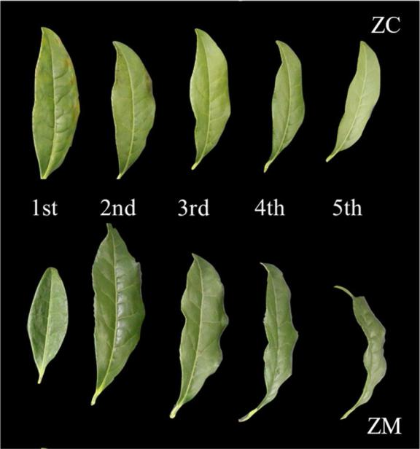

Fig. 1. Samples from the first to the fifth leaf of ‘Zhongcha108′ (ZC) and ‘Zhongming7′ (ZM).

these components were also investigated to reveal the underlying mo-lecular mechanisms. The purpose of this research is to provide a com-prehensive understanding of the molecular mechanisms for the major metabolic pathways at diﬀerent leaf positions in diﬀerent cultivars.

2. Materials and methods

2.1. Plant materials

The tea cultivars ZC and ZM were used in this study and were planted in the experimental tea garden located at Hangzhou (120°4′58″E, 30°11′26″N), China, on March 9, 2018. Leaf samples of diﬀerent maturities were collected from 10 to 15 tea plants for each cultivar (Fig. 1). The first, second, third, fourth and fifth leaves are abbreviated as 1 st, 2nd, 3rd, 4th, and 5th respectively.

2.2. Determination of amino acid content

Materials were dried and grounded into a powder, and 0.2 g samples were then extracted with 10 ml ultrapure water in a water bath at 100℃ for 30 min with shaking at 10 min intervals. The solution was cen-trifuged at 3500×g for 10 min and filtered through a 0.22 μm Millipore filter. An AccQ•Tag Ultra Derivatization Kit (Waters, MA, USA) was used for the pre-column derivatization of amino acid. Briefly, 10 μL of the extracted samples or calibration standard was mixed with 70 μL of the AccQ•Tag Ultra borate buﬀer. Next, 20 μL of reconstituted AccQ•Tag Reagent was added. The reaction proceeded for 10 min at 55℃. The measurement of amino acids was performed on a Waters Acquity ultra-performance liquid chromatography (UPLC) system with a Waters AccQ•Tag Ultra column (2.1 × 100 mm, 1.7 μm) at 43℃. The composition of the mobile phase was as follows: 100% eluent A as solvent A, 10% eluent B as solvent B, ultrapure water as solvent C, and 100% eluent B as solvent D. The elution gradient was 0-0.29 min (10% A, 90% C), 0.29–5.49 min(9.9%A, 90.1 %C), 5.49–7.10 min(9.0% A, 80% B, 11% C), 7.10–7.69 min (8.0% A, 15.6% B, 57.9% C, 18.5% D), 7.69–7.99 min (7.8% A, 70.9% C, 21.3% D), 7.99–8.68 min(4% A, 36.3% C, 59.7% D), and 8.68–10.20 min (10% A, 90% C). The samples were monitored at 260 nm with a flow rate of 700 μL min−1.

2

Y. Zhang, et al.

2.3. Determination of caﬀeine and catechin contents

The methods used to measure caﬀeine and catechin contents were based on Zhang et al. (2018). A 0.2 g (dry weight) tea sample was ex-tracted with 5 ml 70% methanol at 70℃ for 10 min with vortexing every 5 min. The solution was then centrifuged at 3500×g for 10 min and transferred into a 10 ml volumetric flask. The above steps were repeated to obtain a final volume of 10 ml supernatant. The extracts were filtered through 0.45 μm Millipore filters prior to injection. A Waters high performance liquid chromatography (HPLC) system with a reverse-phase column (Phenomenex C12, 4.6 mm × 250 mm, 5 μm) was used for the component assay. The mobile phase included 1% formic acid (solvent A), 100% acetonitrile (solvent B) and ultrapure water (solvent D). The linear elution gradient was 0–42 min (4%–18.7%

1. and, 42–43 min (18.7%-4% B). The samples were measured at 280 nm and eluted at 1 ml min−1.

2.4. Gene expression analysis

Total RNA was extracted by an RNAprep Pure Plant Kit (Tiangen, Beijing, China). The cDNA synthesis was performed using a FastQuant RT Kit (Tiangen, Beijing, China). The PrimeScript RT reagent qPCR Kit (Takara, Dalian, China) was used for quantitative real time PCR (qRT-PCR) analysis on a Roche LightCycler 480 Ⅱ Real-Time PCR system. The primers were designed using online software Primer-BLAST (displayed in additional file 1). The 10 μL reaction mixture contained 5 μL SYBR Premix Ex Taq, 1 μL cDNA template (40 ng μL−1), 0.4 μL primers (10 mM, forward and reverse), and 3.6 μL ddH2O. The qRT-PCR program was as follows: denaturation at 95℃ for 10 s and 40 cycles of ampli-fication (95℃ for 10 s and 60℃ for 32 s). The relative expression levels of the target genes were normalized using the GAPDH gene and cal-culated using the 2- Ct method (Livaka and Schmittgen, 2001).

2.5. Statistical analysis

The above-mentioned sample assay was performed a minimum of least three replicates. The data were analyzed with a one-way analysis of variance (ANOVA) using the Statistical Package for the Social Sciences (SPSS) Statistics 17.0. A bivariate correlation analysis between gene expression and chemical content was also conducted using Pearson’s parametric correlation test. A P-value < 0.05 was considered significant, and a P-value < 0.01 was considered highly significant. The figures were generated using the plotting software Origin 9 and MultiExpreiment Viewer.

3. Results

3.1. Theanine, caﬀeine and catechin contents of ZC and ZM at diﬀerent leaf positions

The total amino acids (TAA) content was measured by UPLC and included 18 diﬀerent amino acids, as shown in Fig. 2 (and additional file 2). The primary amino acid components of ZC and ZM were thea-nine (Thea), Ala, serine (Ser), Gln, Glu, and Asp. The accumulation of theanine in leaves of the same age was significantly higher in ZM than in ZC except in the 1 st leaf. Leaf position had little eﬀect on the con-centration of theanine in both cultivars (Fig. 2a). Interestingly, the content of the individual amino acids diﬀered and could be classified into two main clusters according to cultivar (Fig. 2b). Most of the amino acid concentrations in ZM were higher than those in ZC, particularly for the dominant compound such as Thea, Ser, Gln, Glu, and Asp.

Caﬀeine is an important nitrogenous compound in tea leaves. The levels of caﬀeine ranged from 5.77 mg g−1 to 8.49 mg g−1 (Fig. 3). The caﬀeine content in both cultivars decreased gradually from the 1 st leaf to the 3rd leaf, then increased in the 5th leaf of ZC and the 4th leaf of ZM. More importantly, the caﬀeine accumulation from the 1 st leaf to

*Scientia Horticulturae 272 (2020) 109579*

the 5th leaf was higher in ZM than in ZC, and the diﬀerence was sig-nificant.

The total catechins content was aﬀected by leaf age in both cultivars (Fig. 4a). The concentration of total catechins declined gradually from the 1 st leaf to the 5th leaf in tea plants. The accumulation of tea polyphenols (TP) at diﬀerent leaf positions showed a similar pattern (additional file 3). The total catechins (TC) content in ZC was higher than in ZM and the diﬀerence was notable, except in the 1 st leaf (Fig. 4a). Among of the individual catechins, EGCG and EGC were dominant and accounted for more than 70% of the TC contents (addi-tional file 4). Based on the concentrations of TP, TC, and the diﬀerent catechin compositions, the ten leaf samples were separated into two distinct clusters (Fig. 4b). The levels of these components in the younger leaves (the 1 st and 2nd) was higher than those in the older leaves (the 3rd, 4th, and 5th). Similar results were found for the dif-ferent catechin groups, including the gallated catechins (GAC = EGCG + ECG + GCG), nongallated catechins (NGAC = EGC + C + EC + GC), dehydroxylated catechins (DHL = EC + ECG), and trihy-droxylated catechins (THL = EGC + EGCG).

3.2. Relative gene expressions and correlation with theanine, caﬀeine, and catechin contents

To further investigate the molecular mechanisms of secondary me-tabolism, analyses of relative gene expression and their correlations with theanine, caﬀeine and catechin were performed. The pathways of theanine metabolism include nitrogen assimilation, theanine synthesis and its transport. As shown in Fig. 5a, the gene expression profiles of NR, NiR, GDH, GOGAT, GS (TS), AlaAT, AspAT, AS and AAP were analyzed. The genes in the two cultivars exhibited dissimilar expression patterns. Most of the gene expression levels were higher in ZM, parti-cularly for the genes involved in theanine synthesis and transport (i.e., GOGAT, GS(TS), AlaAT, AspAT, AS and AAP). Moreover, higher ex-pression levels were observed in the older leaves within ZM. The results of the correlation analysis diﬀered in the two cultivars. For ZC, the result was complicated (Fig. 5c). In ZM, most of the theanine-related genes were negatively correlated with the contents of TAA, Glu, Gln and Asp. A positive correlation was found between gene expression and the contents of Thea and Ala (Fig. 5d).

For the caﬀeine pathway, the relative expressions of genes involved in biosynthesis and degradation were analyzed (Fig. 6a). All of the TCS genes showed a similar expression pattern: higher in the 1 st leaf of ZC and in the 4th and 5th leaves of ZM. Caﬀeine degradation genes showed diﬀerences in expression between the two cultivars. CYP1A2, ALN, and XO were highly expressed in ZM, particularly in the older leaves (Fig. 6b). The gene expression of seven TCS genes were highly con-sistent with caﬀeine accumulation in ZC. However, the results diﬀered for ZM, most of the genes were negatively correlated with caﬀeine, particularly the genes involved in caﬀeine degradation (Fig. 6c).

The expression of catechin-related genes was also determined (Fig. 7a). The results showed that the two cultivars had distinctly dif-ferent gene expression patterns. ZC exhibited higher gene expression levels, particularly for PAL, 4CL, F3H, FLS and LAR. And most of the genes had the highest expression levels in the 1 st leaf (Fig. 7b). The correlation analysis showed diﬀerent patterns between catechins and relative gene expression in the two cultivars (Fig. 7c-d). All of the tested genes in ZC were positively correlated with the diﬀerent types of ca-techins, particularly CHI, F3′5′H and FLS. The correlation coeﬃcient between CHI, F3′5′H, FLS and the catechin index (CI) reached 0.811, 0.808, 0.918* respectively. In ZM, only 6 out of 10 genes had a positive correlation with catechin content.

3.3. Correlation analysis of key genes involved in theanine, caﬀeine and catechin biosynthesis

It is widely considered that the synthesis of diﬀerent secondary

3

Y. Zhang, et al. *Scientia Horticulturae 272 (2020) 109579*

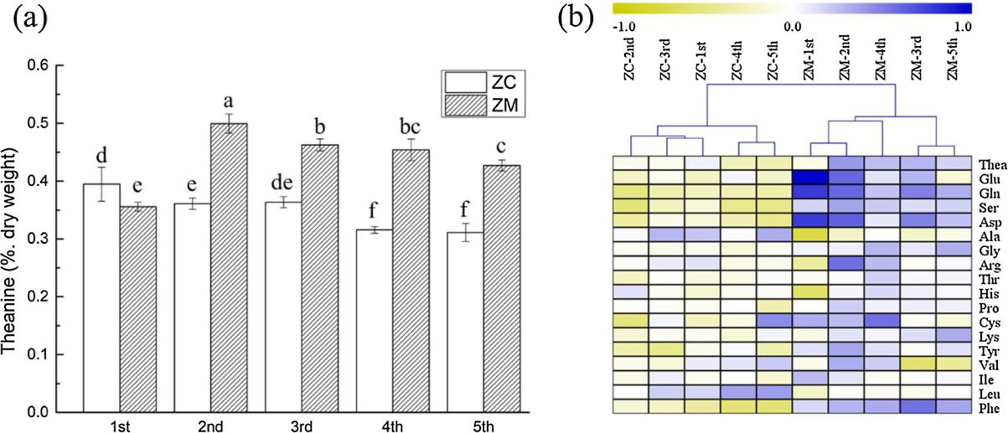

Fig. 2. Theanine content (a) and 18 amino acids compositions (b) at diﬀerent leaf positions in ZC and ZM. Data are mean ± SD from three biological replicates. The diﬀerent letters indicate a significant diﬀerence at P < 0.05. Yellow and blue colors represent low-to-high content, respectively. Thea: theanine; Glu: glutamate; Gln: glutamine; Ser: serine; Asp: aspartic acid; Ala: alanine; Gly: glycine; Arg: arginine; Thr: threonine; His: histidine; Pro: proline; Cys: cysteine; Lys: lysine; Tyr: tyrosine; Val: valine; Ile: isoleucine; Leu: leucine; and Phe: phenylalanine.

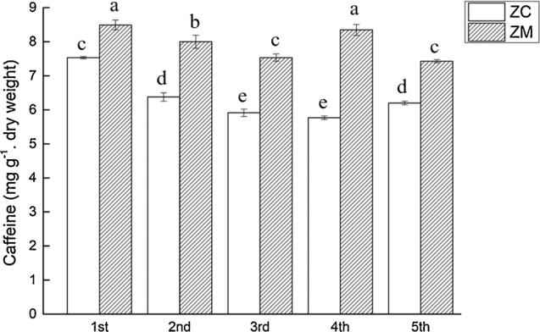

Fig. 3. Caﬀeine contents at diﬀerent leaf positions in ZC and ZM. Data are mean ± SD from three biological replicates. The diﬀerent letters indicate a significant diﬀerence at P < 0.05.

metabolites is closely linked throughout plant growth and development (Tai, et al., 2018). To further identify the relationship between thea-nine, caﬀeine and catechin, the relative expression of key synthetic genes was analyzed. Pearson correlation coeﬃcients showed diﬀerent regulatory modes of secondary metabolism in ZC and ZM. The genes involved in the biosynthesis of caﬀeine and catechin in ZC showed a consistent expression pattern and were positively correlated with one another. Genes involved in the theanine pathway showed diﬀerent expression patterns and inconsistent correlations. 8 out of 12 synthetic genes were negatively correlated with genes in the caﬀeine and ca-techin synthetic pathways (Fig. 8a). In ZM, genes in the downstream pathway of theanine biosynthesis, including GS(TS)1, GS(TS)2, AlaAT, AspAT1, AspAT2, AspAT3 and AS, showed a positive relationship with seven TCS genes. In regard to catechin biosynthesis, most of the key genes showed negatively correlation with the theanine and caﬀeine synthetic pathways (Fig. 8b).

4. Discussion

The characteristic secondary metabolites in tea plants, theanine,

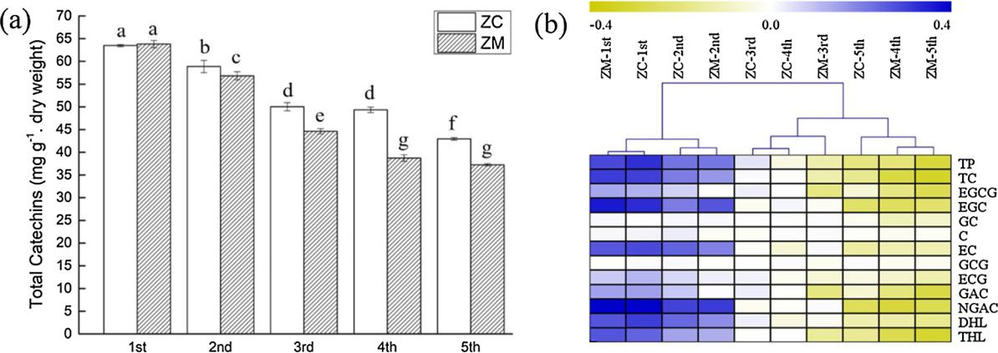

Fig. 4. Total catechin contents (a) and their compositions (b) at diﬀerent leaf positions in ZC and ZM. Data are mean ± SD from three biological replicates. The diﬀerent letters indicate a significant diﬀerence at P < 0.05. Yellow and blue colors represent low-to-high contents, respectively. TP: tea polyphenols; TC: total catechins; EGCG: epigallocatechin gallate; EGC: epigallocatechin; GC: gallocatechin; C: catechin; EC: epicatechin; GCG: gallocatechin gallate; ECG: epicatechin gallate; GAC: gallated catechins, including EGCG, ECG and GCG; NGAC: nongallated catechins, including EGC, C, EC and GC; DHL: dehydroxylated catechins, including EC and ECG; and THL: trihydroxylated catechins, including EGC and EGCG.

4

Y. Zhang, et al. *Scientia Horticulturae 272 (2020) 109579*

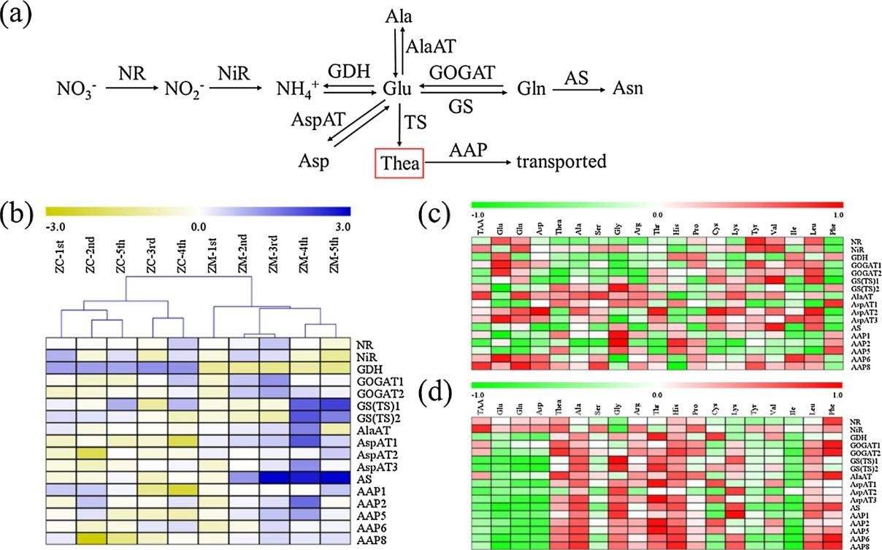

Fig. 5. Expression of key genes in the theanine biosynthetic pathway. (a) Theanine biosynthetic pathway. NR: nitrate reductase; NiR: nitrite reductase; GDH:

glutamate dehydrogenase; GOGAT: glutamate synthase; GS (TS): glutamine synthetase/theanine synthetase; AlaAT: alanine aminotransferases; AspAT: aspartate aminotransferases; AS: aspargine synthase; AAP: amino acid permease. (b) Expression levels of genes involved in the theanine biosynthetic pathway. Yellow and blue colors represent low-to-high gene expression levels, respectively. (c) Correlation analysis between gene expression and amino acid contents in ZC. (d) Correlation analysis between gene expression and amino acid contents in ZM. Green to red colors represent low-to-high correlations, respectively.

caﬀeine and catechin, not only contribute to the formation of unique flavor and aroma but are also strongly associated with plant growth and development. Therefore, the concentration of theanine, caﬀeine and catechin at diﬀerent leaf positions were determined in ZC and ZM. The relative gene expression and correlation analyses suggested that the regulatory mechanisms were diﬀerent despite the genetic similarity of the two cultivars.

4.1. Diﬀerent regulatory modes of theanine metabolism

In this study, the totally 18 amino acids including theanine and their composition showed diﬀerences between the two cultivars. The thea-nine content of ZM was significantly higher than that of ZC except in the 1 st leaf. (Fig. 2). Most of the tested genes, including GOGAT, GS

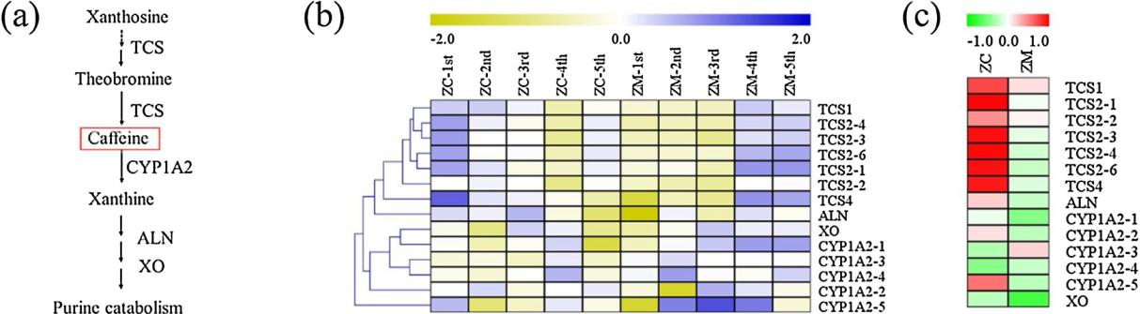

(TS), AlaAT, AspAT, AS and AAP, also showed coordinated changes and were more highly expressed in ZM (Fig. 5b). GOGAT1 and GOGAT2 are ferredoxin-dependent (Fd-GOGAT) and are involved in ammonium as-similation in leaves (Coschigano et al., 1998). GOGAT in tea plans was found to be correlated with theanine content in tea leaves under dif-ferent temperature and shading conditions (Liu et al., 2017b). Under nitrogen deficiency and suﬃciency, positive correlation between GOGAT activity and theanine content was always found in diﬀerent tissues (Liu et al., 2020). GOGAT1 and GOGAT2 in ZM also showed a positive correlation with Thea. AlaAT, AspAT, and AS are key enzymes in the reversible transformation of diﬀerent amino acids, including Glu, Gln, Asp, Ala and Asn. Those compounds could act as precursors for the biosynthesis of theanine (Miyashita et al., 2007; Zhou et al., 2009; Masclaux-Daubresse et al., 2008; Liu et al., 2020). The expression levels

Fig. 6. Expression of key genes in caﬀeine metabolism. (a) Caﬀeine biosynthetic pathway. TCS: tea caﬀeine synthase; CYP1A2: cytochrome P450 family 1 subfamily A polypeptide 2; ALN: allantoinase; and XO: xanthine oxidase. (b) Expression levels of genes involved in caﬀeine metabolism. Yellow and blue colors represent low-to-high gene expression levels, respectively. (c) Correlation analysis between gene expression and caﬀeine content in ZC and ZM. Green to red colors represent low-to-high correlations, respectively.

5

Y. Zhang, et al. *Scientia Horticulturae 272 (2020) 109579*

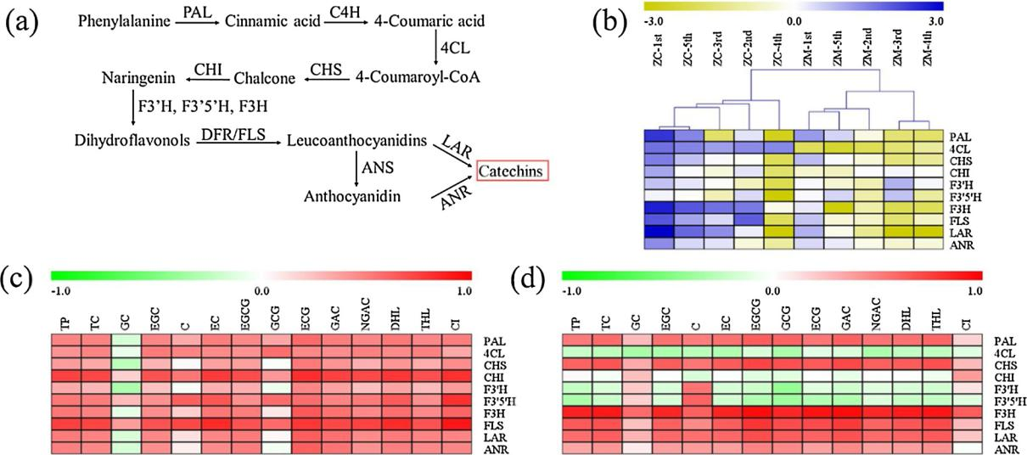

Fig. 7. Expression of key genes in the catechin biosynthetic pathway. (a) Catechin biosynthetic pathway. PAL: ammonia-lyase; C4H: cinnamate 4-hydroxylase; 4CL:

4-coumarate CoA ligase; CHS: chalcone synthase; CHI: chalcone isomerase; F3′H: flavanone 3′-hydroxylase; F3′5′H: flavonoid 3′5′-hydroxylase; F3H: flavanone 3-

hydroxylase; FLS: flavonol synthase; DFR: dihydroflavonol 4-reductase; LAR: leucoanthocyanidin reductase; and ANR: anthocyanidin reductase. (b) Expression levels of genes involved in the catechin biosynthetic pathway. Yellow and blue colors represent low-to-high gene expression levels, respectively. (c) Correlation analysis between gene expression and catechin contents in ZC. (d) Correlation analysis between gene expression and catechin contents in ZM. Green to red colors represent low-to-high correlations, respectively.

of these genes in ZM were higher, particularly in the older leaves. Ne-gative correlations between genes expression and Glu, Gln and Asp content were also found in ZM (Fig. 5d). This finding suggests that the higher levels of Glu, Gln and Asp in ZM serve as a substrate for the transition to other nitrogenous compounds such as theanine. GS and TS in tea plants share highly homologous (> 97%), and similar enzymatic activities (Deng et al., 2008; Cheng et al., 2017). In this study, both GS (TS)1 and GS (TS)2 in the older leaves of ZM were more highly ex-pressed, but there was no clear correlation between GS (TS) expression and Thea. These results indicate that the higher Thea accumulation in ZM was not primarily due to its biosynthesis. The AAP family has been demonstrated to transport theanine from roots to shoots in tea plants (Dong et al., 2019). The expression levels of AAPs were higher in ZM and were positively correlated with Thea. This finding suggests more active theanine transport from older leaves to younger leaves in ZM. Genes expression in ZC showed complicated patterns and inconsistent correlations (Fig. 5c). Taken together, these results suggest an eﬃcient adjustment mechanism in ZM, involving either more active amino acid conversion or elevated nutrient translocation from sink leaves to source leaves.

4.2. Diﬀerent regulatory modes of caﬀeine metabolism

Many studies have shown that caﬀeine content is aﬀected by leaf maturity. Caﬀeine tends to accumulate more in younger leaves and decreases with increasing leaf age (Ashihara et al., 2008). In our study, the caﬀeine content significantly decreased from the 1 st to the 3rd leaf, then increased in the older leaves in both cultivars (Fig. 3). This result is consistent with a previous study (Li et al., 2016). Genes involved in caﬀeine biosynthesis and degradation showed distinct expression pat-terns in diﬀerent cultivars (Fig. 6b). In ZC, the expression patterns of six TCS genes were highly consistent and significantly positively correlated with caﬀeine content (Fig. 6c). It is also widely demonstrated that TCS expression is directly related to the caﬀeine content in leaves during diﬀerent growth stages (Mohanpuria et al., 2009). It was inferred that the accumulation of caﬀeine in ZC was dependent on the expression of TCS. There was no clear linkage between relative gene expression and caﬀeine content in ZM. In addition, the caﬀeine degradation genes, including CYP1A2, ALN and XO showed higher expression levels in ZM,

indicating more active caﬀeine metabolism. Interestingly, compared with ZC, the caﬀeine accumulation in ZM was significantly higher re-gardless of leaf position. The genes involved in the caﬀeine metabolic pathway showed inconsistent expression patterns with respect to caf-feine content, suggesting that there were other undetected key genes involved in caﬀeine metabolism. These results imply distinct caﬀeine regulatory patterns even in cultivars with a close genetic relationship.

4.3. Diﬀerent regulatory modes of catechin metabolism

It is widely documented that catechin accumulation is greater in younger leaves and decreases with leaf growth (Li et al., 2016; Lee et al., 2011). Our results confirmed this pattern. Catechins decreased from the 1 st to 5th leaf and were higher in ZC (Fig. 4). The analysis of individual catechins implied that the reduction of TC was primarily caused by the decline in EGCG, EGC, and EC. The structural genes in-volved in catechin biosynthesis have been extensively studied in tea plants, as shown in Fig. 7a (Zhu et al., 2019b; Wei et al., 2018). Distinct from the clustering patterns of catechin components, the tested genes were classified into two clusters by cultivars according to the expression patterns. A higher gene expression level was observed in ZC, particu-larly for PAL, 4CL, F3H, FLS and LAR (Fig. 7b). All of the tested genes in ZC were not only positively correlated with catechin content, but also aﬀected catechin composition (Fig. 7c). Of these genes, CHI, F3′5′H and FLS were highly correlated with CI. Synergistic changes between CHI and F3′5′H expression and catechin content have also been confirmed in tea seedlings at diﬀerent growth stages (Zhang et al., 2018). F3′5′H was also proven to determine the CI in diﬀerent tea varieties (Wei et al., 2015). FLS plays an important role in regulating the dynamic balance between flavonols and catechins (Jiang et al., 2013). Therefore, it could be deduced that CHI, F3′5H and FLS play a critical role in the accu-mulation and contribution of catechins in ZC. In ZM, only 6 genes (PAL, CHS, F3H, FLS, LAR, ANR) were found to be closely related to catechins (Fig. 7d). These results may explain the lower catechin accumulation in ZM. Moreover, numerous studies have reported that F3H contributes to the synthesis of downstream flavonoid products such as flavonols, ca-techins and anthocyanins (Han et al., 2017; Liu et al., 2015). Similarly, F3H in ZM showed a significant positive correlation with TC (0.904*) and EGCG (0.959**), revealing its importance in catechin biosynthesis

6

Y. Zhang, et al. *Scientia Horticulturae 272 (2020) 109579*

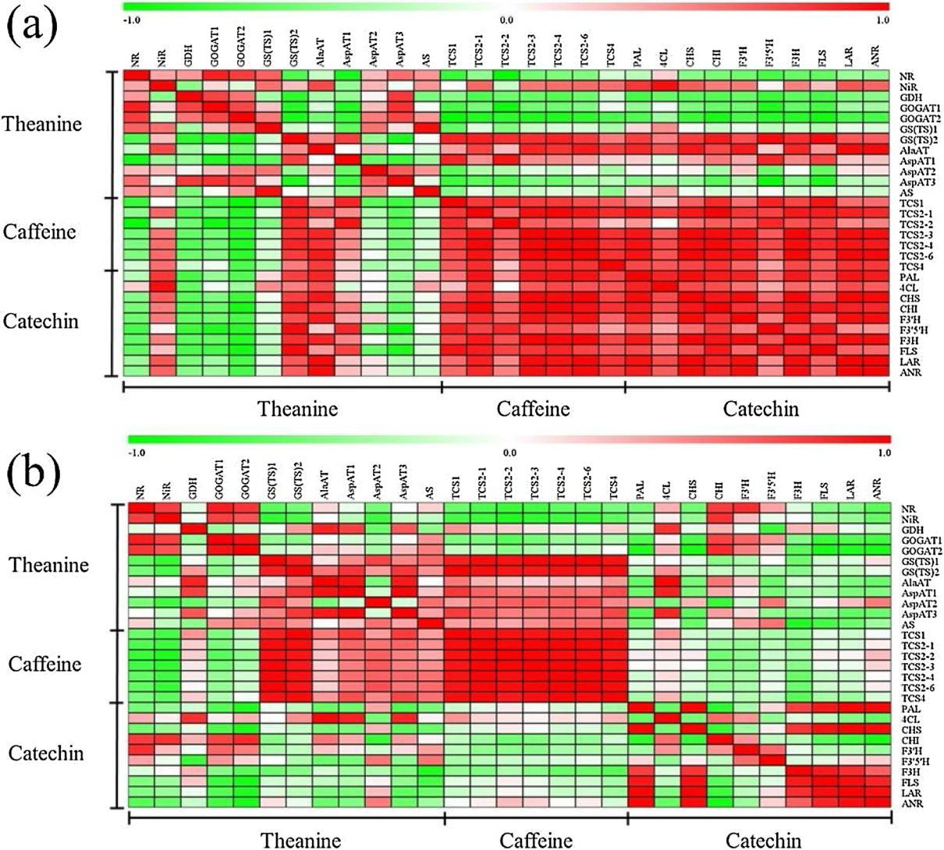

Fig. 8. Correlation analysis of key genes involved in theanine, caﬀeine and catechin biosynthesis in ZC (a) and ZM (b).

in ZM.

4.4. Coordinated regulation of theanine, caﬀeine, and catechins biosynthesis

Numerous studies have demonstrated the competition between ni-trogen and carbon allocation and have developed theoretical models, such as the carbon/nutrient balance and protein competition models (Ruan et al., 2010). Theanine and caﬀeine are important nitrogen-containing compounds and reflect the state of nitrogen metabolism. Catechins are derived from carbohydrate decomposition and transfor-mation and are related to carbon metabolism in tea plants. Tai et al (2018) identified several key genes that regulate the biosynthesis of all three metabolites, and found that the biosynthesis of theanine, caﬀeine, and catechins were influenced by one another. There was competition for substrates among theanine, caﬀeine, and catechin metabolites, thus aﬀecting the dynamic balance of carbon and nitrogen metabolism (Zhang et al., 2020). Shading inhibited the biosynthesis of catechins but improved the accumulation of theanine and caﬀeine (Zhang et al., 2014). Nitrogen was found to increase the accumulation of theanine but reduce the production of catechins (Sun et al., 2019; Ruan et al., 2010). Elevated carbon dioxide increased the concentrations of theanine and catechins, but decreased the caﬀeine concentration (Li et al., 2017). In chlorotic leaves, decreased catechin levels and increased theanine

contents were observed, which is caused by inhibited carbon metabo-lism but enhanced nitrogen metabolism (Zhang et al., 2017). In this study, we found diﬀerent coordinated regulatory modes of three char-acteristic secondary metabolites in two tea cultivars. In ZC, lower contents of theanine and caﬀeine but a higher accumulation of catechin were observed. The expression analysis of key genes involved in the biosynthetic pathways of the three metabolites also showed co-ordinated changes. These findings suggest more active carbon meta-bolism but inhibited nitrogen metabolism in ZC. In addition, caﬀeine and catechins biosynthesis were found to be negatively associated with theanine biosynthesis. One the one hand, there was competition for nitrogen sources between caﬀeine and theanine. The de novo biosyn-thetic pathways of theanine and caﬀeine are both initiated from ni-trogen assimilation. Caﬀeine biosynthesis is derived from Glu, Gln, and Asp, whereas two nitrogen atoms of theanine are derived from Glu and Ala (Deng and Ashihara, 2015). However, catechins and theanine bio-synthesis were also closely related. The degradation product of theanine could serve as precursor to be reassimilated into catechins (Kito et al., 1968; Türközü and Şanlier, 2017). Therefore, it could be deduced that theanine synthesis in ZC was suppressed by another nitrogen-rich me-tabolite—caﬀeine—directly or by a carbon-rich metabolite—ca-techins—indirectly.

In ZM, more active transcription were genes related to the synthesis and transport of theanine in the aged leaves of ZM, indicated eﬀective

7

Y. Zhang, et al.

translocation from older leaves and more active theanine metabolism. Another nitrogen-based secondary metabolite caﬀeine showed con-sistent results with theanine. It suggested that improved levels of theanine and caﬀeine were most likely due to more active nitrogen metabolism in ZM. An inverse association between the synthesis of theanine or caﬀeine and catechin was found, which is consistent with a previous study (Lee et al., 2011). This finding reveals that fewer carbon skeletons were allocated to catechin synthesis, resulting in less catechin accumulation in ZM. These results suggest that the balance of secondary metabolisms in ZM was shifted toward increasing the synthesis of ni-trogen-contained compounds, i.e., theanine and caﬀeine.

5. Conclusions

In summary, an integrated analysis of secondary metabolites and relative gene expression was conducted to identify the regulatory net-works in two closely related tea cultivars. The contents of theanine and caﬀeine were higher in ZM. The genes involved in theanine and caﬀeine pathways, including GOGAT, GS(TS), AlaAT, AspAT, AS, AAP, CYP1A2, ALN and XO, showed consistent results and highly expressed in ZM. It suggested that the balance of secondary metabolisms in ZM was shifted toward increasing the synthesis of nitrogen-containing compounds, thus leading to greater accumulations of theanine and caﬀeine. By contrast, catechins tended to accumulate more in ZC, which resulted from higher expression levels of PAL, 4CL, F3H, FLS and LAR. This ul-timately active carbon metabolism but inhibited nitrogen metabolism in ZC. This study reveals that there are diﬀerent coordinated regulatory mechanisms for theanine, caﬀeine, and catechins biosynthesis, even in two genetically similar tea cultivars. Further exploration of the key genes participating in the regulation of secondary metabolism, parti-cularly related to caﬀeine transport or degradation, is still needed.

Contributions

Liyuan Wang, Hao Cheng conceived and designed the experiments.

Liyun Wu and Mengdi He prepared materials.

Zhang, Liyuan Wang performed the experiments.

Yazhen Zhang, Liyuan Wang and Kang Wei analyzed the data. Liyuan Wang, Kang Wei, Li Ruan and Hao Cheng contributed re-

agents, materials analysis tools.

Yazhen Zhang, Liyuan Wang, Kang Wei wrote the paper.

Hao Cheng and Huarong Tong edited and revised the manuscript.

All authors read and approved the final manuscript.

Acknowledgements

This work was supported by the Central Public Interest Scientific Institution Basal Research Fund (1610212018004), the Central Public Interest Scientific Institution Basal Research Fund (1610212020002), Earmarked Fund for China Agriculture Research System (CARS-19) and the Major Science and Technology Special Project of Variety Breeding of Zhejiang Province (2016C02053-6).

Appendix A. Supplementary data

Supplementary material related to this article can be found, in the online version, at doi:<https://doi.org/10.1016/j.scienta.2020.109579>.

References

[Ashihara, H., Crozier, A., 2001. Caﬀeine: a well-known but little mentioned compound in](http://refhub.elsevier.com/S0304-4238(20)30407-6/sbref0005) [plant science. Trends Plant Sci. 6 (9), 407–413](http://refhub.elsevier.com/S0304-4238(20)30407-6/sbref0005).

[Ashihara, H., Sano, H., Crozier, A., 2008. Caﬀeine and related purine alkaloids: bio-](http://refhub.elsevier.com/S0304-4238(20)30407-6/sbref0010)

[synthesis, catabolism, function and genetic engineering. Phytochemistry 69,](http://refhub.elsevier.com/S0304-4238(20)30407-6/sbref0010) [841–856](http://refhub.elsevier.com/S0304-4238(20)30407-6/sbref0010).

[Bai, P., Wei, K., Wang, L., Zhang, F., Ruan, L., Li, H., Wu, L., Cheng, H., 2019.](http://refhub.elsevier.com/S0304-4238(20)30407-6/sbref0015)

[Identification of a novel gene encoding the specialized alanine decarboxylase in tea](http://refhub.elsevier.com/S0304-4238(20)30407-6/sbref0015)

*Scientia Horticulturae 272 (2020) 109579*

[(Camellia sinensis) plants. Molecules 24, 540](http://refhub.elsevier.com/S0304-4238(20)30407-6/sbref0015).

[Bernard, S.M., Habash, D.Z., 2009. The importance of cytosolic glutamine synthetase in](http://refhub.elsevier.com/S0304-4238(20)30407-6/sbref0020) [nitrogen assimilation and recycling. New Phytol. 182, 608–620](http://refhub.elsevier.com/S0304-4238(20)30407-6/sbref0020).

[Cavet, M.E., Harrington, K.L., Vollmer, T.R., Ward, K.W., Zhang, J.Z., 2011. Anti-in-flammatory and anti-oxidative eﬀects of the green tea polyphenol epigallocatechin](http://refhub.elsevier.com/S0304-4238(20)30407-6/sbref0025) [gallate in human corneal epithelial cells. Mol. Vis. 17, 533–542](http://refhub.elsevier.com/S0304-4238(20)30407-6/sbref0025).

[Cheng, S., Fu, X., Wang, X., Liao, Y., Zeng, L., Dong, F., Yang, Z., 2017. Studies on the](http://refhub.elsevier.com/S0304-4238(20)30407-6/sbref0030) [biochemical formation pathway of the amino acid L-theanine in tea (Camellia sinensis)](http://refhub.elsevier.com/S0304-4238(20)30407-6/sbref0030) [and other plants. J. Agric. Food Chem. 65, 7210–7216](http://refhub.elsevier.com/S0304-4238(20)30407-6/sbref0030).

[Coschigano, K.T., Melo-Oliveira, R., Lim, J., Coruzzi, G.M., 1998. Arabidopsis gls mutants](http://refhub.elsevier.com/S0304-4238(20)30407-6/sbref0035) [and distinct Fd-GOGAT genes. Implications for photorespiration and primary ni-trogen assimilation. Plant Cell 10 (5), 741–752](http://refhub.elsevier.com/S0304-4238(20)30407-6/sbref0035).

[Deng, W.W., Ogita, S., Ashihara, H., 2008. Biosynthesis of theanine (γ-ethylamino-L-glutamic acid) in seedlings of Camellia sinensis. Phytochem. Lett. 1 (2), 115–119](http://refhub.elsevier.com/S0304-4238(20)30407-6/sbref0040).

[Deng, W.W., Ashihara, H., 2015. Occurrence and de novo biosynthesis of caﬀeine and](http://refhub.elsevier.com/S0304-4238(20)30407-6/sbref0045) [theanine in seedlings of tea (Camellia sinensis). Nat. Prod. Commun. 10 (5), 703–706](http://refhub.elsevier.com/S0304-4238(20)30407-6/sbref0045).

Dong, C., Li, F., Yang, T., Feng, L., Zhang, S., Li, F., Li, W., Xu, G., Bao, S., Wan, X., Lucas, W.J., Zhang, Z., 2019. Theanine transporters identified in tea plants (Camellia sinensis L.). Plant J. <https://doi.org/10.1111/tpj.14517>.

[Gramza, A., Korczak, J., 2005. Tea constituents (Camellia sinensis L.) as antioxidants in](http://refhub.elsevier.com/S0304-4238(20)30407-6/sbref0055) [lipid systems. Trends Food Sci. Technol. 16, 351–358](http://refhub.elsevier.com/S0304-4238(20)30407-6/sbref0055).

[Han, Y., Huang, K., Liu, Y., Jiao, T., Ma, G., Qian, Y., Wang, P., Dai, X., Gao, L., Xia, T.,](http://refhub.elsevier.com/S0304-4238(20)30407-6/sbref0060) [2017. Functional analysis of two flavanone-3-hydroxylase gene from Camellia si-nensis: a critical role in flavonoid accumulation. Genes 8, 300](http://refhub.elsevier.com/S0304-4238(20)30407-6/sbref0060).

[Jiang, X., Liu, Y., Li, W., Zhao, L., Meng, F., Wang, Y., Tan, H., Yang, H., Wei, C., Wan, X.,](http://refhub.elsevier.com/S0304-4238(20)30407-6/sbref0065) [Gao, L., Xia, T., 2013. Tissue-specific, development-dependent phenolic compounds](http://refhub.elsevier.com/S0304-4238(20)30407-6/sbref0065) [accumulation profile and gene expression pattern in tea plant [Camellia sinensis].](http://refhub.elsevier.com/S0304-4238(20)30407-6/sbref0065)

[PLoS One 8 (4), e62315](http://refhub.elsevier.com/S0304-4238(20)30407-6/sbref0065).

[Jin, J.Q., Ma, J.Q., Ma, C.L., Yao, M.Z., Chen, L., 2014. Determination of catechin content](http://refhub.elsevier.com/S0304-4238(20)30407-6/sbref0070) [in representative chinese tea germplasms. J. Agric. Food Chem. 62 (39), 9436–9441](http://refhub.elsevier.com/S0304-4238(20)30407-6/sbref0070).

[Juneja, L.R., Chu, D.C., Okubo, T., Nagato, Y., Yokogoshi, H., 1999. L-Theanine – a un-ique amino acid of green tea and its relaxation eﬀect in humans. Trends Food Sci.](http://refhub.elsevier.com/S0304-4238(20)30407-6/sbref0075) [Technol. 10, 199–204](http://refhub.elsevier.com/S0304-4238(20)30407-6/sbref0075).

[Kakuda, T., 2011. Neuroprotective eﬀects of theanine and its preventive eﬀects on cog-nitive dysfunction. Pharmacol. Res. 64 (2), 162–168](http://refhub.elsevier.com/S0304-4238(20)30407-6/sbref0080).

[Kato, M., Mizuno, K., Crozier, A., Fujimura, T., Ashihara, H., 2000. Caﬀeine synthase gene](http://refhub.elsevier.com/S0304-4238(20)30407-6/sbref0085) [from tea leaves. Nature 406, 956](http://refhub.elsevier.com/S0304-4238(20)30407-6/sbref0085).

[Kissen, R., Winge, P., Tran, D.H.T., Jørstad, T.S., Størseth, T.R., Christensen, T., Bones,](http://refhub.elsevier.com/S0304-4238(20)30407-6/sbref0090) [A.M., 2010. Transcriptional profiling of an Fd-GOGAT1/GLU1 mutant in Arabidopsis](http://refhub.elsevier.com/S0304-4238(20)30407-6/sbref0090) [thaliana reveals a multiple stress response and extensive reprogramming of the](http://refhub.elsevier.com/S0304-4238(20)30407-6/sbref0090) [transcriptome. BMC Genomics 11, 190](http://refhub.elsevier.com/S0304-4238(20)30407-6/sbref0090).

[Kito, M., Kokura, H., Izaki, J., Sasaoka, K., 1968. Theanine, a precursor of the phlor-oglucinol nucleus of catechins in tea plants. Phytochemistry 7, 599–603](http://refhub.elsevier.com/S0304-4238(20)30407-6/sbref0095).

[Lardner, A.L., 2014. Neurobiological eﬀects of the green tea constituent theanine and its](http://refhub.elsevier.com/S0304-4238(20)30407-6/sbref0100) [potential role in the treatment of psychiatric and neurodegenerative disorders. Nutr.](http://refhub.elsevier.com/S0304-4238(20)30407-6/sbref0100) [Neurosci. 17 (4), 145–155](http://refhub.elsevier.com/S0304-4238(20)30407-6/sbref0100).

[Lee, J.E., Lee, B.J., Hwang, J., Ko, K.S., Chung, J.O., Kim, E.H., Lee, S.J., Hong, Y.S., 2011.](http://refhub.elsevier.com/S0304-4238(20)30407-6/sbref0105) [Metabolic dependence of green tea on plucking positions revisited: a metabolomic](http://refhub.elsevier.com/S0304-4238(20)30407-6/sbref0105) [study. J. Agric. Food Chem. 59, 10579–10585](http://refhub.elsevier.com/S0304-4238(20)30407-6/sbref0105).

Li, X., Zhang, L., Ahammed, G.J., Li, Z.X., Wei, J.P., Shen, C., Yan, P., Zhang, L.P., Han, W.Y., 2017. Stimulation in primary and secondary metabolism by elevated carbon dioxide alters green tea quality in Camellia sinensis L. Sci. Rep. 7, 7937. [https://doi.](https://doi.org/10.1038/s41598-017-08465-1) [org/10.1038/s41598-017-08465-1](https://doi.org/10.1038/s41598-017-08465-1).

[Li, Z.X., Yang, W.J., Ahammed, G.J., Shen, C., Yan, P., Li, X., Han, W.Y., 2016.](http://refhub.elsevier.com/S0304-4238(20)30407-6/sbref0115) [Developmental changes in carbon and nitrogen metabolism aﬀect tea quality in](http://refhub.elsevier.com/S0304-4238(20)30407-6/sbref0115) [diﬀerent leaf position. Plant Physiol. Biochem. 106, 327–335](http://refhub.elsevier.com/S0304-4238(20)30407-6/sbref0115).

[Liu, M., Tian, H.L., Wu, J.H., Cang, R.R., Wang, R.X., Qi, X.H., Xu, Q., Chen, X.H., 2015.](http://refhub.elsevier.com/S0304-4238(20)30407-6/sbref0120) [Relationship between gene expression and the accumulation of catechin during](http://refhub.elsevier.com/S0304-4238(20)30407-6/sbref0120) [spring and autumn in tea plants (Camellia sinensis L.). Hortic. Res. 2, 15011](http://refhub.elsevier.com/S0304-4238(20)30407-6/sbref0120).

[Liu, Z.W., Wu, Z.J., Li, H., Wang, Y.X., Zhuang, J., 2017a. L-Theanine content and related](http://refhub.elsevier.com/S0304-4238(20)30407-6/sbref0125)

[gene expression: novel insights into theanine biosynthesis and hydrolysis among](http://refhub.elsevier.com/S0304-4238(20)30407-6/sbref0125)

[diﬀerent tea plant (Camellia sinensis L.) tissues and cultivars. Front. Plant Sci. 8, 498](http://refhub.elsevier.com/S0304-4238(20)30407-6/sbref0125).

[Liu, Z.W., Li, H., Wang, W.L., Wu, Z.J., Cui, X., Zhuang, J., 2017b. CsGOGAT is important](http://refhub.elsevier.com/S0304-4238(20)30407-6/sbref0130) [in dynamic changes of theanine content in postharvest tea plant leaves under dif-ferent temperature and shading spreadings. J. Agric. Food Chem. 65 (44),](http://refhub.elsevier.com/S0304-4238(20)30407-6/sbref0130) [9693–9702](http://refhub.elsevier.com/S0304-4238(20)30407-6/sbref0130).

[Liu, Z.W., Li, H., Liu, J.X., Wang, Y., Zhuang, J., 2020. Integrative transcriptome, pro-teome, and microRNA analysis reveals the eﬀects of nitrogen suﬃciency and defi-ciency conditions on theanine metabolism in the tea plant (Camellia sinensis). Hortic.](http://refhub.elsevier.com/S0304-4238(20)30407-6/sbref0135) [Res. 7, 65](http://refhub.elsevier.com/S0304-4238(20)30407-6/sbref0135).

[Livaka, K.J., Schmittgen, T.D., 2001. Analysis of relative gene expression data using real-time quantitative PCR and the 2− Ct method. Methods 25, 402–408](http://refhub.elsevier.com/S0304-4238(20)30407-6/sbref0140).

Masclaux-Daubresse, C., Reisdorf-Cren, M., Orsel, M., 2008. Leaf nitrogen remobilisation for plant development and grain filling. Plant Biol. <https://doi.org/10.1111/j.1438-8677.2008.00097.x>.

[Maughan, R.J., Griﬃn, J., 2010. Caﬀeine ingestion and fluid balance: a review. J. Hum.](http://refhub.elsevier.com/S0304-4238(20)30407-6/sbref0150)

[Nutr. Diet. 16 (6), 411–420](http://refhub.elsevier.com/S0304-4238(20)30407-6/sbref0150).

[Miyashita, Y., Dolferus, R., Ismond, K.P., Good, A.G., 2007. Alanine aminotransferase](http://refhub.elsevier.com/S0304-4238(20)30407-6/sbref0155) [catalyses the breakdown of alanine after hypoxia in Arabidopsis thaliana. Plant J. 49,](http://refhub.elsevier.com/S0304-4238(20)30407-6/sbref0155) [1108–1121](http://refhub.elsevier.com/S0304-4238(20)30407-6/sbref0155).

[Mohanpuria, P., Kumar, V., Joshi, R., Gulati, A., Ahuja, P.S., Yadav, S.K., 2009. Caﬀeine](http://refhub.elsevier.com/S0304-4238(20)30407-6/sbref0160) [biosynthesis and degradation in tea [Camellia sinensis (L.) O. Kuntze] is under de-velopmental and seasonal regulation. Mol. Biotechnol. 43, 104–111](http://refhub.elsevier.com/S0304-4238(20)30407-6/sbref0160).

[Nagatomo, K., Kubo, Y., 2008. Caﬀeine activates mouse TRPA1 channels but suppresses](http://refhub.elsevier.com/S0304-4238(20)30407-6/sbref0165) [human TRPA1 channel. Proc. Natl. Acad. Sci. 105 (45), 17373–17378](http://refhub.elsevier.com/S0304-4238(20)30407-6/sbref0165).

[Ruan, J., Haerdter, R., Gerendás, J., 2010. Impact of nitrogen supply on carbon/nitrogen](http://refhub.elsevier.com/S0304-4238(20)30407-6/sbref0170)

8

Y. Zhang, et al.

[allocation: a case study on amino acids and catechins in green tea [Camellia sinensis](http://refhub.elsevier.com/S0304-4238(20)30407-6/sbref0170) [(L.) O. Kuntze] plants. Plant Biol. 12, 724–734](http://refhub.elsevier.com/S0304-4238(20)30407-6/sbref0170).

[Ruan, J., Ma, L., Yang, Y., 2012. Magnesium nutrition on accumulation and transport of](http://refhub.elsevier.com/S0304-4238(20)30407-6/sbref0175) [amino acids in tea plants. J. Sci. Food Agric. 92 (7), 1375–1383](http://refhub.elsevier.com/S0304-4238(20)30407-6/sbref0175).

[Song, R., Kelman, D., Johns, K.J., Wright, A.D., 2012. Correlation between leaf age, shade](http://refhub.elsevier.com/S0304-4238(20)30407-6/sbref0180)

[level, and characteristic beneficial natural constituents of tea (Camellia sinensis)](http://refhub.elsevier.com/S0304-4238(20)30407-6/sbref0180) [grown in Hawaii. Food Chem. 133, 707–714](http://refhub.elsevier.com/S0304-4238(20)30407-6/sbref0180).

[Sun, L., Liu, Y., Wu, L., Liao, H., 2019. Comprehensive analysis revealed the close re-lationship between N/P/K status and secondary metabolites in tea leaves. ACS Omega](http://refhub.elsevier.com/S0304-4238(20)30407-6/sbref0185) [4, 176–184](http://refhub.elsevier.com/S0304-4238(20)30407-6/sbref0185).

[Tai, Y., Liu, C., Yu, S., Yang, H., Sun, J., Guo, C., Huang, B., Liu, Z., Yuan, Y., Xia, E., Wei,](http://refhub.elsevier.com/S0304-4238(20)30407-6/sbref0190) [C., Wan, X., 2018. Gene co-expression network analysis reveals coordinated regula-tion of three characteristic secondary biosynthetic pathways in tea plant (Camellia](http://refhub.elsevier.com/S0304-4238(20)30407-6/sbref0190) [sinensis). BMC Genomics 19 (616)](http://refhub.elsevier.com/S0304-4238(20)30407-6/sbref0190).

[Tamano, H., Fukura, K., Suzuki, M., Sakamoto, K., Yokogoshi, H., Takeda, A., 2013.](http://refhub.elsevier.com/S0304-4238(20)30407-6/sbref0195) [Preventive eﬀect of theanine intake on stress-induced impairments of hippocamapal](http://refhub.elsevier.com/S0304-4238(20)30407-6/sbref0195) [long-term potentiation and recognition memory. Brain Res. Bull. 95, 1–6](http://refhub.elsevier.com/S0304-4238(20)30407-6/sbref0195).

[Teng, R.M., Wu, Z.J., Ma, H.Y., Wang, Y.X., Zhuang, J., 2019. Diﬀerentially expressed](http://refhub.elsevier.com/S0304-4238(20)30407-6/sbref0200) [protein are involved in dynamic changes of catechins contents in postharvest tea](http://refhub.elsevier.com/S0304-4238(20)30407-6/sbref0200) [leaves under diﬀerent temperatures. J. Agric. Food Chem. 67, 7547–7560](http://refhub.elsevier.com/S0304-4238(20)30407-6/sbref0200).

[Thomasset, S.C., Berry, D.P., Garcea, G., Marczylo, T., Steward, W.P., Gescher, A.J., 2007.](http://refhub.elsevier.com/S0304-4238(20)30407-6/sbref0205) [Dietary polyphenolic phytochemicals-promising cancer chemopreventive agents in](http://refhub.elsevier.com/S0304-4238(20)30407-6/sbref0205) [humans. A review of their clinical properties. Int. J. Cancer 120 (3), 451–458](http://refhub.elsevier.com/S0304-4238(20)30407-6/sbref0205).

[Türközü, D., Şanlier, N., 2017. L-theanine, unique amino acid of tea, and its metabolism,](http://refhub.elsevier.com/S0304-4238(20)30407-6/sbref0210) [health eﬀects, and safety. Crit. Rev. Food Sci. Nutr. 57 (8), 1681–1687](http://refhub.elsevier.com/S0304-4238(20)30407-6/sbref0210).

[Wei, K., Wang, L., Zhou, J., He, W., Zeng, J., Jiang, Y., Cheng, H., 2011. Catechin contents](http://refhub.elsevier.com/S0304-4238(20)30407-6/sbref0215) [in tea (Camellia sinensis) as aﬀected by cultivar and environment and their relation](http://refhub.elsevier.com/S0304-4238(20)30407-6/sbref0215) [to chlorophyll contents. Food Chem. 125, 44–48](http://refhub.elsevier.com/S0304-4238(20)30407-6/sbref0215).

[Wei, K., Wang, L., Zhang, C., Wu, L., Li, H., Zhang, F., Cheng, H., 2015. Transcriptome](http://refhub.elsevier.com/S0304-4238(20)30407-6/sbref0220) [analysis reveals key flavonoid 3′-hydroxylase and Flavonoid 3′,5′-hydroxylase genes](http://refhub.elsevier.com/S0304-4238(20)30407-6/sbref0220) [in aﬀecting the ratio of dehydroxylated to trihydroxylated catechins in Camellia si-nensis. PLoS One 10 (9), e0137925](http://refhub.elsevier.com/S0304-4238(20)30407-6/sbref0220).

[Wei, K., Wang, L., Zhang, Y., Ruan, L., Li, H., Wu, L., Xu, L., Zhang, C., Zhou, X., Cheng,](http://refhub.elsevier.com/S0304-4238(20)30407-6/sbref0225)

*Scientia Horticulturae 272 (2020) 109579*

[H., Edwards, R., 2018. A coupled role for CsMYB75 and CsGSTF1 in anthocyanin](http://refhub.elsevier.com/S0304-4238(20)30407-6/sbref0225) [hyperaccumulation in purple tea. Plant J. 95 (5), 825–840](http://refhub.elsevier.com/S0304-4238(20)30407-6/sbref0225).

[Xia, E.H., Zhang, H.B., Sheng, J., Li, K., Zhang, Q.J., Kim, C., Zhang, Y., Liu, Y., Zhu, T., Li,](http://refhub.elsevier.com/S0304-4238(20)30407-6/sbref0230) [W., et al., 2017. The tea tree genome provides insights into tea flavor and in-dependent evolution of caﬀeine biosynthesis. Mol. Plant 10, 866–877](http://refhub.elsevier.com/S0304-4238(20)30407-6/sbref0230).

[Zhang, Q., Shi, Y., Ma, L., Yi, X., Ruan, J., 2014. Metabolomic analysis using ultra-per-formance liquid chromatography-quadrupole-time of flight mass spectromtry (UPLC-Q-TOF MS) uncovers the eﬀects of light intensity and temperature under shading](http://refhub.elsevier.com/S0304-4238(20)30407-6/sbref0235) [treatments on the metabolites in tea. PLoS One 9 (11), e112572](http://refhub.elsevier.com/S0304-4238(20)30407-6/sbref0235).

Zhang, L.Q., Wei, K., Cheng, H., Wang, L.Y., Zhang, C.C., 2016. Accumulation of catechins and expression of catechin synthetic gene in Camellia sinensis at diﬀerent develop-mental stages. Bot. Stud. 57, 31. <https://doi.org/10.1186/s40529-016-0143-9>.

Zhang, Q., Liu, M., Ruan, J., 2017. Integrated transcriptome and metabolic analyses re-veals novel insights into free amino acid metabolism in Huangjinya tea cultivar. Front. Plant Sci. 8, 291. <https://doi.org/10.3389/fpls.2017.00291>.

[Zhang, Y., Wei, K., Li, H., Wang, L., Ruan, L., Pang, D., Cheng, H., 2018. Identification of](http://refhub.elsevier.com/S0304-4238(20)30407-6/sbref0250) [key genes involved in catechin metabolism in tea seedlings based on transcriptomic](http://refhub.elsevier.com/S0304-4238(20)30407-6/sbref0250) [and HPLC analysis. Plant Physiol. Biochem. 133, 107–115](http://refhub.elsevier.com/S0304-4238(20)30407-6/sbref0250).

Zhang, C., Wang, M., Gao, X., Zhou, F., Shen, C., Liu, Z., 2020. Multi-omics research in albino tea plants: past, present, and future. Sci. Hortic. 261, 108943. [https://doi.org/](https://doi.org/10.1016/j.scienta.2019.108943) [10.1016/j.scienta.2019.108943](https://doi.org/10.1016/j.scienta.2019.108943).

Zhou, Y., Cai, H., Xiao, J., Li, X., Zhang, Q., Lian, X., 2009. Over-expression of aspartate aminotransferase genes in rice resulted in altered nitrogen metabolism and increased amino acid content in seeds. Theor. Appl. Genet. 118, 1381–1390. [https://doi.org/](https://doi.org/10.1007/s00122-009-0988-3) [10.1007/s00122-009-0988-3](https://doi.org/10.1007/s00122-009-0988-3).

Zhu, B., Chen, L.B., Lu, M., Zhang, J., Han, J., Deng, W.W., 2019a. Caﬀeine content and related gene expression: novel insight into caﬀeine metabolism in Camellia plants containing low, normal and high caﬀeine concentrations. J. Agric. Food Chem. <https://doi.org/10.1021/acs.jafc.9b00240>.

Zhu, J., Xu, Q., Zhao, S., Xia, X., Yan, X., An, Y., Mi, X., Guo, L., Samarina, L., Wei, C., 2019b. Comprehensive co-expression analysis provides novel insights into temporal variation of flavonoids in fresh leaves of the tea plant (Camellia sinensis). Plant Sci. <https://doi.org/10.1016/j.plantsci.2019.110306>.

9