[Scientia Horticulturae 272 (2020) 109591](https://doi.org/10.1016/j.scienta.2020.109591)



Contents lists available at [ScienceDirect](http://www.sciencedirect.com/science/journal/03044238)



Scientia Horticulturae

journal homepage: [www.elsevier.com/locate/scihorti](https://www.elsevier.com/locate/scihorti)

|  |  |  |
| --- | --- | --- |
| Establishment of meristem culture for virus-free and genetically stable | [T](http://crossmark.crossref.org/dialog/?doi=10.1016/j.scienta.2020.109591&domain=pdf) |  |
| production of the endangered plant Hosta capitata |  |
|  |  |



Phyo Phyo Win Pea,b,1, Aung Htay Naingc,1, May Thu Soec, Hyunhee Kangc, Kyeung Il Parka,*, Chang Kil Kimc,*

1. Department of Horticulture & Life Science, Yeungnam University, Geyongsan, Republic of Korea
2. Department of Horticulture, Yezin Agricultural University, Nay Pyi Taw, Myanmar
3. Department of Horticultural Science, Kyungpook National University, Daegu, Republic of Korea

ARTICLE INFO

Keywords:

Endangered species

Plant growth regulator

Virus infection

Sterilization

Somaclonal variation

ABSTRACT

Hosta species endemic to Korea are currently suﬀering from infection with Hosta virus X (HVX), and it has been diﬃcult to produce virus-free plants when using infected plants as a source of material for in vitro and vegetative propagation in continuous production processes. Genetic variation in in vitro-regenerated plants has also been detected in some Hosta cultivars. Therefore, we aimed to develop an in vitro propagation method for the pro-duction of virus-free and genetically stable plants. First, we collected Hosta capitata showing symptoms of viral infection and confirmed the presence of an HVX virus gene using reverse transcription (RT)–PCR, followed by optimization of the sterilization of in vivo bulbs. Meristems derived from sterilized bulbs were cultured in media containing diﬀerent concentrations of 1-naphthaleneacetic acid (NAA) with either benzyl aminopurine (BA) or thidiazuron (TDZ). The combination of 0.1 mg/l NAA and 3.0 mg/l BA generated the highest number of shoots per explant, and these shoots had a higher fresh weight. The addition of nano-silver (NAg) particles to the regeneration medium distinctly stimulated plant growth. According to the results of RAPD analysis, the mer-istem-derived plants were genetically stable compared with donor plants grown in a greenhouse, and absence of the HVX gene was also observed, indicating freedom from HVX infection. Therefore, they would be highly valuable for use in the landscape industry. We expect that the method proposed in this study will also prove helpful for generating virus-free, genetically stable plants in the commercial production of other Hosta species.

1. Introduction

Hosta species, which are herbaceous perennial plants belonging to the family Liliaceae, are distributed in temperate regions such as the USA, Canada, Russia, China, Japan, and Korea. Some of these species, including H. capitata, H. clausa, H. longipes, H. minor, and H. yingeri, are endemic to southern parts of the Korean peninsula. Hosta species are popular in the landscape industry as groundcover plants due to their decorative foliage, diverse flower colors, attractive inflorescences, and ability to tolerate shade. However, the populations of these species have experienced a steady decline in their natural habitats due to over-har-vesting by Hosta collectors and the continuous increase in temperature due to climate change, increasing the risk of their extinction and po-tentially harming their use as perennials in the landscape industry. Although they can be propagated by the division of lateral shoots, only a few plantlets can be obtained from each mother plant (Papachatzi



Corresponding authors.

E-mail addresses: [pki0217@yu.ac.kr](mailto:pki0217@yu.ac.kr) (K.I. Park), [ckkim@knu.ac.kr](mailto:ckkim@knu.ac.kr) (C.K. Kim).

1. These authors equally contributed as first authors.

et al., 1980). In addition, propagation via seed germination cannot sa-tisfy the increased commercial demand because seed availability is seasonally limited, and the germination rate is relatively low (< 25 %; Oh et al., 2003).

Alternatively, in vitro propagation techniques have been widely used for the rapid clonal propagation of some Hosta species using various explants, such as the floret segments, flower buds, calluses, and shoot tips of H. sieboldiana (Meyer, 1980; Hill et al., 1989; Lubomski, 1989a, b; Saito and Nakano, 2002), axillary shoot-tip cultures of H. decorata (Papachatzi et al., 1981), the immature florescences and shoot tips of H. plantaginea (Papachatzi et al., 1980; Ku and Cho, 2016), the shoots of H. fortunei (Szafián et al., 1997), and the ovaries and shoot tips of several cultivars (Paek and Ma, 1996; Williams et al., 1998). However, the number of regenerated shoots reported to date has been rather low. Furthermore, to the best of our knowledge, no research on the in vitro establishment and plant regeneration of H. capitata has yet been

<https://doi.org/10.1016/j.scienta.2020.109591>

Received 3 April 2020; Received in revised form 1 July 2020; Accepted 2 July 2020

Available online 08 July 2020

0304-4238/ © 2020 Elsevier B.V. All rights reserved.

P.P.W. Pe, et al.

conducted.

A number of viral diseases, including Hosta virus X (HVX), Arabis mosaic virus, and tomato ringspot virus, have been reported globally in Hosta species (Brunt et al., 2000; Lockhart, 2006). Since 2002, HVX infection has been detected on the leaves of Hosta spp. cultivated in Korea (Ryu et al., 2002), and the distribution of the virus is likely to increase over time. As such, there is a need to develop techniques that can produce virus-free cultivars of Hosta spp. In this regard, meristem culture has been considered a promising technique for the production of virus-free plants for a number of species, including Lilium spp., which are members of the same family as Hosta spp. (Vcelar et al., 1992; Nesi et al., 2009; Chinestra et al., 2015). However, despite the use of various explants for the in vitro regeneration of Hosta spp., no previous studies have utilized meristem cultures for this purpose. In addition, because meristems can only be obtained from underground bulbs, which in-creases the risk of microbial contamination, it is necessary to develop a standardized in vitro sterilization method that can eﬃciently eliminate microbes without damaging the meristem. Another issue is that, despite the development of in vitro regeneration protocol for Hosta spp., the genetic stability of the regenerated plants has yet to be determined, except in the study by Paek and Ma (1996), which reported somaclonal variation in in vitro-regenerated plants in Hosta cultivars. Somaclonal variation in meristem-derived plants has also been reported in other plant species (Vuylsteke et al., 1988; Zucchi et al., 2002; Whitehouse et al., 2011).

To address these challenges, in the present study, we collected virus-infected plants of H. capitata and standardized a sterilization method for in vivo underground bulbs and investigated shoot regeneration from meristems cultured in media containing diﬀerent combinations and concentrations of plant growth regulators (PGRs). In addition, we de-tected absence of HVX gene in the resulting plants and assessed their genetic stability using molecular markers with the random amplifica-tion of polymorphic DNA (RAPD) technique.

2. Materials and methods

2.1. Plant materials

Plantlets of H. capitata were collected from natural habitat of Korea. The plants were allowed to grow in a greenhouse at Kyungpook National University, Republic of Korea. They were observed to have been infected by virus, showing leaf curling and mosaic symptoms (Supplementary Fig. 1).

2.2. Detection of Hosta virus X in virus-infected plants by reverse transcription–PCR (RT–PCR)

Total RNA was extracted from the virus-infected leaves (10 samples) and uninfected leaves (5 samples; as a control) using the RNeasy Plant Mini Kit (Qiagen, Germany), in accordance with the manufacturer’s instructions. Complementary DNA (cDNA) was synthesized from 1 μg of total RNA using the High Capacity cDNA Reverse Transcription Kit (Applied Biosystems, USA), in accordance with the manufacturer’s in-structions. Detection of HVX was performed using reaction mix and HVX-specific primers (HVXF: ATCCGTTATCTACAGGGGACCAG, and HVXR: TAAGTTAGTGGAACGGTTAGCCCGAT; Wei et al., 2013), with the following PCR conditions: 30 cycles of denaturation at 98 °C for 10 s, annealing at 55 °C for 30 s, and elongation at 72 °C for 1 min. The PCR products were then separated on a 2% agarose gel.

2.3. Standardization of the sterilization process

After detection of the presence of HVX in virus-infected plants using RT–PCR, the infected plants were all placed separately from the unin-fected ones. Underground bulbs were collected from the virus-infected plants when the leaves turned yellow. The bulbs were thoroughly rinsed

*Scientia Horticulturae 272 (2020) 109591*

under running tap water until the dribs had been removed and then carefully trimmed to be free of leaves and roots. They were then ster-ilized with 70 % (v/v) ethanol solution for 30–40 s and 1% sodium hypochlorite (NaOCl) plus Tween 20 for diﬀerent periods (1, 3, 5, 10, 15, 20, and 30 min), as shown in Supplementary Fig. 2, followed by five rinses with sterilized distilled water. The meristem tips (∼1 mm) were then isolated from the sterilized bulbs and cultured in PGR-free Murashige and Skoog (MS) medium. All cultures contained 3% sucrose, and each treatment consisted of 30 explants and three replicates. The explants were incubated under a photoperiod of 16 h, light intensity of 37 mmol m−2 s−1, and relative humidity of 70 %. After four weeks of culture, the numbers of contaminated explants per treatment were counted.

2.4. Eﬀect of PGRs on meristem cultures

For in vitro shoot regeneration, the bulbs were collected from the virus-infected plants and sterilized as described above (1% NaOCl for 10 min). The meristems (∼1 mm) were then excised from the bulbs and cultured in MS media containing diﬀerent concentrations and combi-nations of 1-naphthaleneacetic acid (NAA) and either benzyl amino-purine (BA) or thidiazuron (TDZ; Supplementary Fig. 3). The explants were incubated for six weeks under the same conditions as previously described, and then the survival rate, shoot regeneration rate, number of shoots per explant, and fresh weight per explant were measured. Each treatment consisted of 30 explants and three replicates. Shoot regeneration rate was calculated as below:

Shoot regeneration rate = (Number of survival explants inducing shoots / Total Number of survival explants) × 100

2.5. Eﬀects of nano-silver (NAg) on meristem culture

From the above-described experiment, the combination of BA (3.0 mg/l) and NAA (0.1 mg/l) was found to be the best for shoot re-generation from meristems; however, the meristem-derived shoots ex-hibited slow growth and were yellow in leaf tips. Therefore, diﬀerent concentrations (0, 5, 10, 15, 20, and 25 mg/l) of NAg (Duchefa Biochemie, the Netherlands) were added to the medium containing BA (3.0 mg/l) and NAA (0.1 mg/l), and their eﬀects on plant growth and development from meristems, which were derived from the above re-generated plants, were investigated. The explants were placed in the same culture conditions for six weeks, as described above. Each treat-ment consisted of 30 explants and three replicates.

2.6. Root induction, plant growth, and acclimation of regenerated plants

For rooting and plant growth, the meristem-derived shoots [from the media containing the combination of BA (3.0 mg/l) and NAA (0.1 mg/l), and NAg (20 mg/l)] were transferred to hormone-free MS basal medium and left under the same culture conditions as previously described for six weeks. The well-rooted shoots were then transplanted into plastic trays filled with peat-based soil and acclimated in a growth chamber for three weeks under the same conditions. After acclimation, the plants were transferred to a greenhouse.

2.7. Detection of HVX gene in meristem-derived plants by RT-PCR

RNA extraction, cDNA synthesis, and detection of the presence of HVX gene in meristem-derived plants [from the media containing BA (3.0 mg/l), NAA (0.1 mg/l), NAg (20 mg/l)] and the virus-infected plants grown in the greenhouse was done as described above.

2

P.P.W. Pe, et al.

2.8. Analysis of genetic variation using RAPD

Total genomic DNA was isolated from the leaves of both the in vitro-regenerated plants (produced in a medium containing a combination of 0.1 mg/l NAA and 3.0 mg/l BA, and 20 mg/l NAg) and donor plants grown in a greenhouse using a HiYield Genomic DNA Mini Kit (Real Biotech Corporation, Taipei, Taiwan). RAPD analysis was conducted as described by Naing et al. (2019). The primers and PCR conditions used for the analysis are provided in Supplementary Table 1. The reaction products were analyzed via electrophoresis on 2% (w/v) agarose gel stained with ethidium bromide and photographed under UV light. RAPD analysis using each primer was repeated with three biological samples to verify the banding patterns.

2.9. Statistical analysis

Data were analyzed using SPSS v. 11.09 (IBM Corporation, Armonk, NY, USA) and are presented as the mean of three replicates. The means were analyzed using Duncan’s multiple range test (DMRT; P < 0.05).

3. Results

3.1. Detection of HVX gene in virus-infected plants

Most of the Hosta plants (H. capitata) grown in the greenhouse showed symptoms of viral infection, while some were found to be healthy. To identify whether the appearance of these symptoms in the leaves of Hosta plants (H. capitata) was due to viral infection, we de-tected the presence of an HVX gene in the plants (10 infected plants and 5 healthy plants) using RT–PCR, with HVX-specific primers. The results corroborated that the symptoms of viral infection on leaves were indeed associated with HVX infection, while no amplification of HVX was ob-served in the healthy plants (Fig. 1). The Hosta species (H. capitata) endemic to Korea is being infected by the virus HVX.

3.2. Standardization of the sterilization method

To standardize the sterilization method for the H. capitata meristem culture, the meristems excised from the bulbs of the in vivo virus-in-fected plants were sterilized, as shown in Supplementary Fig. 1. As seen in Fig. 2, all of the explants sterilized with 1% NaOCl for 1 min were found to be contaminated with fungi and bacteria. Increasing the sterilization time to 5 min slightly lower the contamination rate. However, increasing the time to 10 min significantly reduced con-tamination levels, although approximately 45 % of the explants were still contaminated with bacteria. The uncontaminated explants survived well and started to produce shoots after four weeks of culture. Although similar percentages of uncontaminated explants were observed in the treatments lasting longer than 10 min, but most of those plants were negatively aﬀected by sterilization stress, with the appearance of a

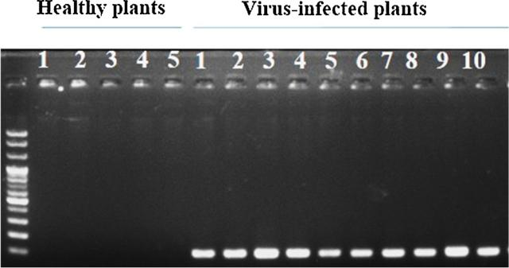

Fig. 1. Detection of the expression of HVX gene in healthy and virus-infected leaves of Hosta capitate.

*Scientia Horticulturae 272 (2020) 109591*

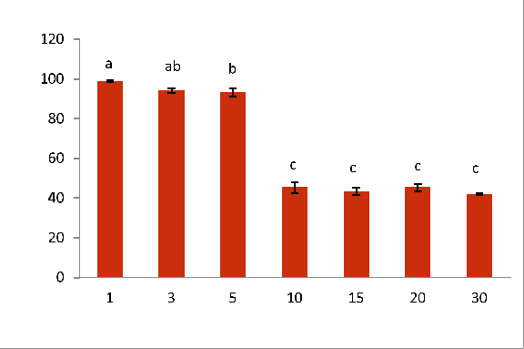

Fig. 2. Influence of sterilization times on percentages of contaminated explants in vitro. Data represent means of three replicate per treatment. Means with same letter are not significantly diﬀerent by Duncan Multiple Range Test (DMRT, P > 0.05).

color reflecting necrosis and lower survival rates (data not shown). Thus, sterilization of the explants with 1% NaOCl for 10 min was deemed the most appropriate strategy for use with the in vivo-derived meristem cultures of H. capitata

3.3. Eﬀects of PGRs on shoot regeneration from meristems

To verify the eﬀect of PGRs on shoot regeneration from meristems, the meristems were excised from the bulbs of in vivo virus-infected plants sterilized with 1% NaOCl for 10 min and cultured in MS basal medium containing diﬀerent combinations of BA (0, 0.5, 1.0, 2.0, or 3.0 mg/l) or thidiazuron (TDZ; 0, 0.5, 1.0, 2.0, or 3.0, mg/l) with NAA (0, 0.1, 0.5, or 1.0 mg/l). All of the explants survived for all combina-tions of BA and NAA, including the control, but the eﬃciency of shoot regeneration varied significantly depending on the combination used (Table 1). Generally, the rate of shoot regeneration was notably higher than in the control for all treatments, except for the combination of 0.5 mg/l BA and 1.0 mg/l NAA. For all combinations of BA and NAA, the rate of shoot formation was greater for lower concentrations of NAA than for higher concentrations, while variation in the concentration of BA did not appear to aﬀect shoot formation. The meristem (Fig. 3A) treated with 3.0 mg/l BA and 0.1 mg/l NAA produced the highest number of shoots per explant (Fig. 3B), and the number of shoots per explant was 5.33 (Table 1). Therefore, among the treatments tested, the

Table 1

Eﬀects of various combinations of BA and NAA on in vitro shoot regeneration from the meristem of Hosta after six weeks of culture.

|  |  |  |  |  |  |
| --- | --- | --- | --- | --- | --- |
| BA | NAA | Survival | Shoot | No. of | Fresh weight |
| (mg/l) | (mg/l) | rate (%) | regeneration rate | shoot/ | /explant (mg) |
|  |  |  | (%) | explant |  |
|  |  |  |  |  |  |
| 0 | 0 | 100 | 25.00e | 1.25 de | 920 b |
| 0.5 | 0.1 | 100 | 100.00a | 3.67 b | 685 c |
|  | 0.5 | 100 | 66.67bc | 2.89 c | 472 d |
|  | 1.0 | 100 | 20.00de | 1.00 e | 298 f |
| 1.0 | 0.1 | 100 | 100.00a | 3.14 bc | 654 c |
|  | 0.5 | 100 | 62.50bc | 2.75 c | 433 de |
|  | 1.0 | 100 | 55.56c | 2.33 cd | 373 e |
| 2.0 | 0.1 | 100 | 77.44b | 1.56 d | 307 f |
|  | 0.5 | 100 | 44.78cd | 2.67 c | 452 de |
|  | 1.0 | 100 | 33.33d | 1.78 d | 226 fg |
| 3.0 | 0.1 | 100 | 100.00a | 5.33 a | 1038 a |
|  | 0.5 | 100 | 77.78b | 2.44 cd | 488 d |
|  | 1.0 | 100 | 54.44c | 2.33 cd | 351 ef |

Data represent means of three replicate per treatment. Means with same letter within a column are not significantly diﬀerent by Duncan Multiple Range Test (DMRT, P > 0.05).

3

P.P.W. Pe, et al. *Scientia Horticulturae 272 (2020) 109591*

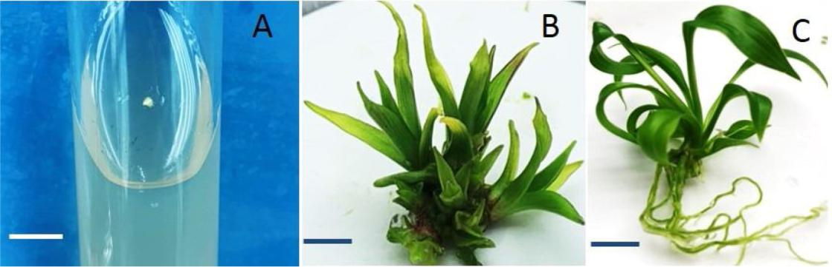

Fig. 3. In vitro regeneration from the meristem of Hosta capitata. A) Culture of the meristem on the medium containing BA 3.0 mg/l and NAA 0.1 mg/l. B) Regeneration of the shoots from the meristem on the media containing BA 3.0 mg/l and NAA 0.1 mg/l after 6 weeks of culture. C) Root induction of the shoots on the hormone-free MS basal medium after 6 weeks of culture. Size bars indicate 0.5 cm for A, 1.0 cm for B, and 1.0 cm for C, respectively.

combination of 3.0 mg/l BA and 0.1 mg/l NAA gave the highest number of shoots per explant (5.33), followed by the combination of 0.5 mg/l BA and 0.1 mg/l NAA; the results for both treatments were notably higher than for the other combinations (Table 1). In terms of fresh weight, the combination of 3.0 mg/l BA and 0.1 mg/l NAA produced the highest fresh weight per explant (1038 mg), followed by the control and the combinations of 0.5 mg/l BA and 0.1 mg/l NAA and 1.0 mg/l BA and 0.1 mg/l NAA (Table 1). Overall, the combination of 3.0 mg/l BA and 0.1 mg/l NAA significantly outperformed the other treatment combinations for all investigated parameters, particularly in terms of the number of regenerated shoots and fresh weight per explant.

As with the combined BA/NAA treatments, all of the explants sur-vived when treated with a combination of TDZ and NAA, including the control, but shoot formation eﬃciency was aﬀected by the particular combinations used (Table 2). Most combinations exhibited greater shoot formation than the control, with the combinations of 2.0 mg/l TDZ and 0.5 mg/l NAA and 3.0 mg/l TDZ and 0.1 mg/l NAA producing the highest rate of shoot regeneration (100 %). Although the shoot formation for most combinations was higher than in the control, the number of shoots per explant was not, except for the combinations of 2.0 mg/l TDZ and 0.5 mg/l NAA and 3.0 mg/l TDZ and 0.1 mg/l NAA, both of which produced a significantly higher number of shoots per explant than in the control. It was also observed that the control ex-plants had the highest fresh weight per explant (Table 2).

Table 2

Eﬀects of various combinations of TDZ and NAA on in vitro shoot regeneration from the meristem of Hosta after six weeks of culture.

|  |  |  |  |  |  |
| --- | --- | --- | --- | --- | --- |
| TDZ | NAA | Survival | Shoot | No. of | Fresh weight |
| (mg/l) | (mg/l) | rate (%) | regeneration rate | shoot/ | /explant (mg) |
|  |  |  | (%) | explant |  |
|  |  |  |  |  |  |
| 0 | 0 | 100 | 25ef | 1.25 cd | 920 a |
| 0.5 | 0.1 | 100 | 62.50c | 2.00 bc | 713 b |
|  | 0.5 | 100 | 55.56cd | 2.67 abc | 544 bcd |
|  | 1.0 | 100 | 55.56cd | 2.11 bc | 535 bcd |
| 1.0 | 0.1 | 100 | 50 d | 2.13 bc | 543 bcd |
|  | 0.5 | 100 | 57.14cd | 1.86 c | 409 cd |
|  | 1.0 | 100 | 33.33e | 1.56 c | 250 e |
| 2.0 | 0.1 | 100 | 66.67bc | 2.17 bc | 378 d |
|  | 0.5 | 100 | 100 a | 3.00 a | 423 cd |
|  | 1.0 | 100 | 75 b | 2.50 abc | 600 bc |
| 3.0 | 0.1 | 100 | 100 a | 2.86 ab | 720 b |
|  | 0.5 | 100 | 11.11g | 1.11 d | 570 bc |
|  | 1.0 | 100 | 25 ef | 1.50 abc | 364 d |

3.4. Eﬀect of nano-silver (NAg) particles on plant growth and development

Addition of NAg to the regeneration medium distinctly aﬀected plant growth and development, regardless of the concentration. The plants derived from the meristem cultured in medium containing a lower NAg concentration (5–10 mg/l) showed similar plant growth and development compared to those in the control (Table 3). NAg (20 mg/l) was found to be the most eﬀective for plant growth and greenery, but at concentrations above 20 mg/l it reduced plant height.

3.5. Rooting, plant growth, and relocation to the greenhouse

The meristem-derived plants, which were individually separated from each explant, were well rooted in the hormone-free MS basal medium and rapidly grew after six weeks of culture (Fig. 3C). Following acclimation, all of the meristem-derived plants survived when they were moved to the greenhouse (Fig. 4).

3.6. Detection of HVX gene in meristem-derived plants

To confirm whether the meristem-derived plants could eradicate the virus, we attempted to detect the presence of HVX in the meristem-derived plants [from the media containing BA (3.0 mg/l), NAA (0.1 mg/ l), NAg (20 mg/l)] and the virus-infected plants grown in the green-house using RT–PCR. As expected, the presence of HVX was not ob-served in the former plants, while it was clearly observed in the latter (Fig. 5).

3.7. RAPD analysis

To assess the somaclonal variation in the regenerated plants using RAPD analysis, in vitro-regenerated shoots derived from the media containing BA (3.0 mg/l), NAA (0.1 mg/l), NAg (20 mg/l) and donor

Table 3

Eﬀects of diﬀerent concentrations of nano-silver (NAg) on growth and devel-opment of plants regenerated from the meristem of Hosta capitata cultured on the optimal concentration of BA (3.0 mg/l) and NAA (0.1 (mg/l).

|  |  |  |
| --- | --- | --- |
| NAg (mg/l) | Plant height (mm) | Fresh weight /explant (mg) |
|  |  |  |
| 0 | 17.3b | 1050 b |
| 5 | 17.5b | 1060 b |
| 10 | 16.9b | 1047 b |
| 15 | 17.2b | 1058 b |
| 20 | 21.7a | 1175 a |
| 25 | 15.4c | 1022c |

Data represent means of three replicate per treatment. Means with same letter within a column are not significantly diﬀerent by Duncan Multiple Range Test (DMRT, P > 0.05).

Data represent means of three replicate per treatment. Means with same letter within a column are not significantly diﬀerent by Duncan Multiple Range Test (DMRT, P > 0.05).

4

P.P.W. Pe, et al. *Scientia Horticulturae 272 (2020) 109591*

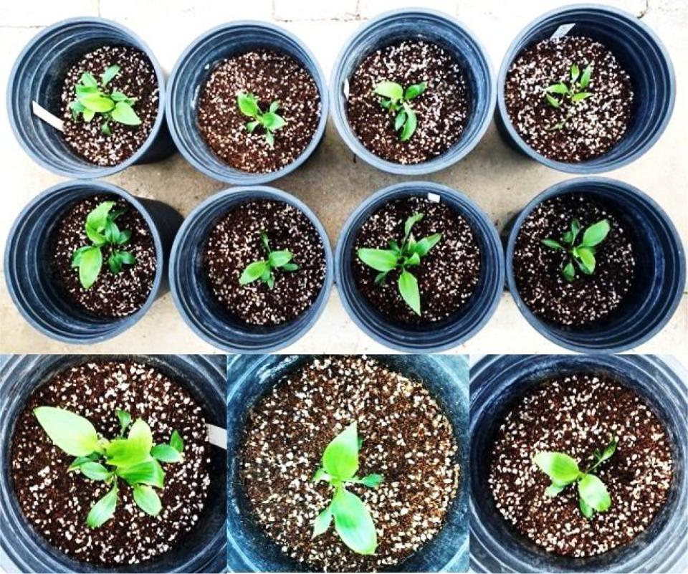

Fig. 4. Survival of acclimatized meristem-derived plants of H. capitata in the greenhouse.

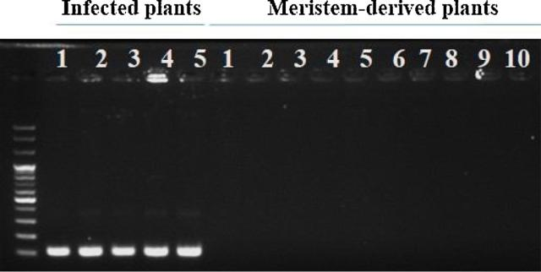

Fig. 5. Detection of the expression of HVX gene in infected plants (control) and meristem-derived plants of Hosta capitata.

plants were selected and analyzed using 40 random primers. About twelve primers successfully produced scorable bands for both the re-generated and the donor plants (Fig. 6A–L), while some exhibited polymorphic RAPD profiles; in particular, the primer numbers OPA-13, OPA-15, and OPB-09 were more polymorphic than the others (Fig. 6). As expected, the banding patterns observed in the meristem-derived plants were similar to those of the donor plants.

4. Discussion

Hosta species, which are found in temperate regions, are in danger of becoming extinct due to the rise in global temperatures, deforesta-tion, and over-harvesting by Hosta collectors. In addition, the occur-rence of Hosta virus X (HVX) disease in Hosta species distributed worldwide, including in Korea, has been reported (Ryu et al., 2002; Wei et al., 2013; Shchetynina et al., 2017; Adedire et al., 2009; Song et al., 2020). Therefore, although vegetative propagation and seed germina-tion have been employed in this genus to preserve these species and meet commercial demands, these techniques are insuﬃcient to

overcome these issues due to their low propagation rate and inability to eradicate the virus. Many researchers have thus proposed other in vitro propagation methods using various explant types for the eﬃcient pro-pagation of these species (Saito and Nakano, 2002; Ku and Cho, 2016; Szafián et al., 1997; Paek and Ma, 1996; Williams et al., 1998). Un-fortunately, those methods employed for Hosta species reported so far are also unable to produce virus-free plants. Moreover, the genetic variation observed in in vitro-regenerated Hosta plants was reported to be relatively high (Paek and Ma, 1996). Therefore, in this study, we collected virus-infected plants and attempted to create meristem cul-tures that could be used for the eﬃcient propagation and production of genetically stable virus-free H. capitata plants.

The visual appearance of virus-infected Hosta plants was identified and the presence of HVX in the collected plants was also identified molecularly using RT–PCR, as performed in previous studies (Ryu et al., 2002; Wei et al., 2013; Song et al., 2020). All of the tested plants showed the presence of the analyzed gene; thus, we collected the virus-infected plants based on visual observation and used them as materials for meristem culture.

Generally, the use of in vivo underground bulbs increases the risk of contamination by fungi and bacteria, so a standardized in vitro ster-ilization method was necessary to decontaminate the bulbs without physically damaging the meristems. In this study, sterilization of the meristems excised from the bulbs with 1% NaOCl for 1–5 min was too short to eliminate the microbial organisms from the bulbs, and those sterilized for longer than 10 min also exhibited lower rates of survival and shoot regeneration due to toxicity of NaOCl. Nongalleima et al. (2014) also reported that rhizome tissues were damaged due to longer sterilization time. In this study, the sterilization time (10 min) was found to be optimal to prevent microbial contamination of the meristem cultures and shoot regeneration. It was obvious that sterilization time is crucial to in vitro shoot regeneration when using in vivo materials as explant sources.

Investigating the eﬀects of PGRs on the meristem cultures derived

5

P.P.W. Pe, et al. *Scientia Horticulturae 272 (2020) 109591*

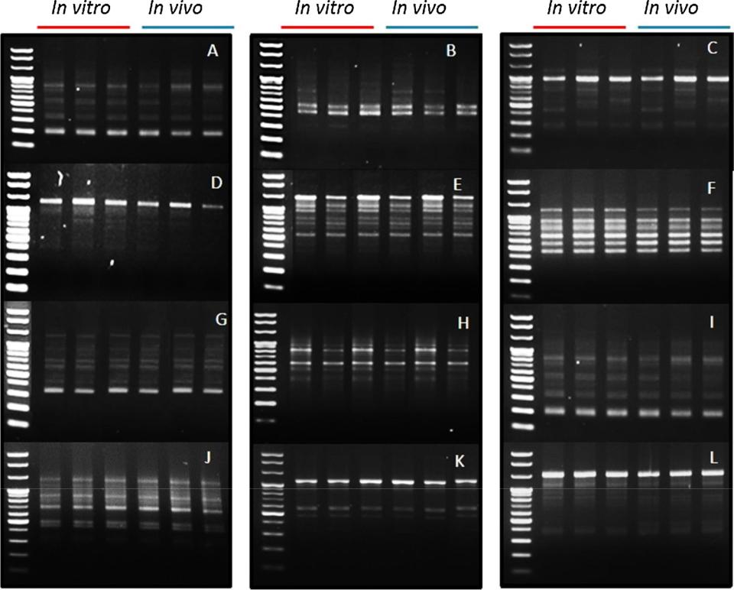

Fig. 6. Detection of somaclonal variation between meristem-derived plants (in vitro) and donor plants (in vivo) of Hosta capitata using RAPD markers (A) OPA-01, (B) OPA-03, (C) OPA-05, (D) OPA-09, (E) OPA-13, (F) OPA-15, (G) OPA-16, (H) OPA-17, (I) OPA-20, (J) OPB-09, (K) OPB-03, (L) OPB-06.

from the in vivo bulbs sterilized with 1% NaOCl for 10 min revealed that the rate of shoot regeneration observed for most combinations was significantly higher than in the control, suggesting that PGRs are ne-cessary for shoot regeneration from meristems. Despite the higher rate of shoot regeneration for most combinations, the average number of shoots per explant was not significantly higher than in the control, al-though the highest number of shoots per explant (5.33) was produced by the combination of 3.0 mg/l BA and 0.1 mg/l NAA. This suggests that specific concentrations and/or combinations of PGRs are required to generate a large number of shoots per explant.

The eﬀect of the combination of BA and NAA on shoot regeneration from various Hosta spp. explants has previously been investigated (Paek and Ma, 1996; Ku and Cho, 2016; Hill et al., 1989; Szafián et al., 1997; Williams et al., 1998). While the combination did not eﬃciently pro-duce shoots from the ovaries of H. sieboldiana (Hill et al., 1989), Paek and Ma (1996) observed that it did promote the regeneration of shoots from the shoot tips of Hosta cvs. ‘Mondana’ and ‘Anlioch.’ In particular, they reported that the combination of 3.0 mg/l BA and 0.1 mg/l NAA produced an average number of 3.2 and 3.8 shoots per explant, com-pared with 5.33 shoots per explant in the present study. In addition, the average number of shoots per explant generated by the combinations of 3.0 mg/l BA and 1.0 mg/l NAA and of 3.0 mg/l BA and 0.1 mg/l NAA were not significantly diﬀerent in Paek and Ma’s (1996) study, unlike in the present study. Similarly, Szafián et al. (1997) suggested that the combination of 3.0 mg/l BA and 0.1 mg/l NAA was eﬀective for in vitro shoot regeneration in H. fortunei, while this combination did not lead to a significantly higher number of shoots in comparison with that in the control in the present study. Saito and Nakano (2002) also reported that NAA more successfully promoted the growth of shoots from the calluses of H. sieboldiana when combined with TDZ than with BA, which was not consistent with the results of our study. The discrepancy between the studies could be due to the species and explant types used. Variation in the regeneration eﬃciency of various explants cultured in a combina-tion of BA and NAA has been reported for Hosta cv. ‘Golden Specter’

(Williams et al., 1998). In this study, the combination of NAA (0.1 mg/

1. and BA (3.0 mg/l) not only produced a suitable number of shoots

(5.33) per explant, but also produced plants with a higher fresh weight than in the control. In contrast, the combination of NAA (0.5 mg/l) and TDZ (2.0 mg/l) produced an average of 3.0 shoots per explant, but these shoots were relatively small and their fresh weight was lower than in the control. Thus, we concluded that the combination of NAA at 0.1 mg/l and BA at 3.0 mg/l was the optimal choice for the production of in vitro healthy shoots in Hosta spp. using meristem cultures.

Over the last decade, antimicrobial activities of silver nanoparticles (NAg) have been reported in in vitro culture of various plant species (Abdi et al., 2008; Sarmast et al., 2011). However, there have been fewer studies reporting its positive eﬀects on in vitro plant growth. In our study, distinct variation of plant growth was not observed in as-sociation with lower NAg concentrations (0–15 mg/l), while 20 mg/l clearly stimulated plant growth and greenery, but a reduction of plant growth was observed at concentrations higher than 20 mg/l. Jadczak et al. (2019) also observed that concentrations of NAg of 1–5 mg/l led to the development of shoots with lengths similar to those in the control plants. Moreover, a reduction of plant growth associated with a higher NAg concentration was observed in their study, as found in our work. Stimulation of plant growth by NAg may be due to an increase of cy-tokinins (Vinković et al., 2017). In contrast, a reduction of total chlorophyll content was observed in A. thaliana treated with NAg (0.2–3.0 mg/l) (Qian et al., 2013). This discrepancy may be due to the diﬀerent sizes of nanoparticles and genotypes used.

As expected, the meristem-derived plants were found to be free of HVX when analyzed using RT–PCR, with no expression of the HVX gene. This is in line with previous studies reporting the production of virus-free plants using meristem cultures (Vcelar et al., 1992; Nesi et al., 2009; Chinestra et al., 2015).

Previous studies demonstrated somaclonal variation in meristem-derived plants in some plant species (Vuylsteke et al., 1988; Zucchi et al., 2002; Whitehouse et al., 2011). Although meristem cultures of

6

P.P.W. Pe, et al.

Hosta cultivars have not previously been investigated in this respect, somaclonal variation (ranging from 1.8%–43.8%) in plants regenerated from other explants has been observed in Hosta cultivars, with the ge-netic variants showing diﬀerences in leaf area, chlorophyll content, and petiole length compared with normal plants (Paek and Ma, 1996). In the present study, meristem-derived plants that were grown in a greenhouse did not exhibit any morphological diﬀerences from the donor plants. An analysis of genetic variation using RAPD confirmed that there was no somaclonal variation in the meristem-derived plants. Therefore, this in vitro propagation method is recommended for use in the production of virus-free, genetically stable plants.

5. Conclusion

We proposed an in vitro method for propagating virus-infected H. capitata by culturing meristems in MS media containing the combina-tion of 0.1 mg/l NAA and 3.0 mg/l BA, which led to the highest rate of shoot regeneration and fresh weight per explant. The addition of NAg (20 mg/l) distinctly stimulated plant growth and greenery compared with that in the control. The resulting meristem-derived plants were not only free of viral infection but also genetically and morphologically stable when compared with donor plants grown in a greenhouse. Therefore, the plants obtained using this method would be highly va-luable in commercial production for the landscape industry. We suggest that the proposed in vitro propagation method is suitable for the com-mercial production of virus-free, true-to-type Hosta plants.

Funding

This work was supported by a grant from the New Breeding Technology Program (Project no. PJ01485801), Rural Development Administration, Republic of Korea. This work was supported by the 2014 Yeungnam University research grant.'

Author contributions

AHN designed the study. PPWP conducted the experiments and wrote a draft of the manuscript. AHN edited and revised the manu-script. MTS and HK assisted the experiments. CKK and KIP supervised the experiments at all stages and performed critical revisions of the manuscript. All authors read and approved the final manuscript.

CRediT authorship contribution statement

Phyo Phyo Win Pe: Conceptualization, Data curation, Formal analysis, Validation, Visualization, Writing - original draft. Aung Htay Naing: Methodology, Validation, Visualization, Writing - review & editing. May Thu Soe: Investigation, Methodology. Hyunhee Kang: Investigation, Methodology. Kyeung Il Park: Funding acquisition, Project administration, Supervision. Chang Kil Kim: Funding acquisi-tion, Project administration, Supervision.

Declaration of Competing Interest

The authors report no conflicts of interest.

Appendix A. Supplementary data

Supplementary material related to this article can be found, in the online version, at doi:<https://doi.org/10.1016/j.scienta.2020.109591>.

References

[Abdi, Gh., Salehi, H., Khosh-Khui, M., 2008. Nano silver: a novel nanomaterial for](http://refhub.elsevier.com/S0304-4238(20)30419-2/sbref0005)

*Scientia Horticulturae 272 (2020) 109591*

[removal of bacterial contaminants in valerian (Valeriana oﬃcinalis L.) tissue culture.](http://refhub.elsevier.com/S0304-4238(20)30419-2/sbref0005)

[Acta Physiol. Plant. 30, 709–714](http://refhub.elsevier.com/S0304-4238(20)30419-2/sbref0005).

[Adedire, O.L., Wen, R.H., Windham, A., Windham, M., Hajimorad, M.R., 2009. Hosta](http://refhub.elsevier.com/S0304-4238(20)30419-2/sbref0010) [virus X in Hosta identified in Tennessee, USA. Plant Pathol. 58, 405](http://refhub.elsevier.com/S0304-4238(20)30419-2/sbref0010).

[Brunt, A.A., Foster, G.D., Martelli, G.P., Zavriev, S.K., 2000. Potexvirus. In: Van](http://refhub.elsevier.com/S0304-4238(20)30419-2/sbref0015) [Regenmortel, M.H.V., Fauquet, C.M., Bishop, D.H.L., Carstens, E.B., Estes, M.K.,](http://refhub.elsevier.com/S0304-4238(20)30419-2/sbref0015) [Lemon, S.M., Maniloﬀ, J., Mayo, M.A., McGeoch, D.J., Pringle, C.R., Wickner, R.B.](http://refhub.elsevier.com/S0304-4238(20)30419-2/sbref0015) [(Eds.), Virus Taxonomy. Classification and Nomenclature of Viruses. Academic Press,](http://refhub.elsevier.com/S0304-4238(20)30419-2/sbref0015) [San Diego, USA, pp. 975–981 Seventh Report of the International Committee on](http://refhub.elsevier.com/S0304-4238(20)30419-2/sbref0015) [Taxonomy of Viruses](http://refhub.elsevier.com/S0304-4238(20)30419-2/sbref0015).

[Chinestra, S.C., Curvetto, N.R., Marinangeli, P.A., 2015. Production of virus-free plants of](http://refhub.elsevier.com/S0304-4238(20)30419-2/sbref0020) [Lilium spp. from bulbs obtained in vitro and ex vitro. Sci. Hortic. 194, 304–312](http://refhub.elsevier.com/S0304-4238(20)30419-2/sbref0020).

[Hill, R.A., Tuskan, G.A., Boe, A.A., 1989. In vitro propagation of Hosta sieboldiana using](http://refhub.elsevier.com/S0304-4238(20)30419-2/sbref0025) [excised ovaries from immature florets. Plant Cell Tiss.Org. Cult. 17, 71–75](http://refhub.elsevier.com/S0304-4238(20)30419-2/sbref0025).

[Jadczak, P., Kulpa, D., Bihun, M., Przewodowski, W., 2019. Positive eﬀect of AgNPs and](http://refhub.elsevier.com/S0304-4238(20)30419-2/sbref0030) [AuNPs in in vitro cultures of Lavandula angustifolia Mill. Plant Cell Tiss.Org. Cult. 139,](http://refhub.elsevier.com/S0304-4238(20)30419-2/sbref0030) [191–197](http://refhub.elsevier.com/S0304-4238(20)30419-2/sbref0030).

[Ku, B.S., Cho, M.S., 2016. In vitro multiplication of Hosta plantaginea’ Joseon’ by shoot-tip](http://refhub.elsevier.com/S0304-4238(20)30419-2/sbref0035) [culture. Flower Res. J. 24, 328–336](http://refhub.elsevier.com/S0304-4238(20)30419-2/sbref0035).

[Lockhart, B.E.L., 2006. Occurrence of Arabis mosaic virus in hostas in the United States.](http://refhub.elsevier.com/S0304-4238(20)30419-2/sbref0040)

[Plant Dis. 90, 834–837](http://refhub.elsevier.com/S0304-4238(20)30419-2/sbref0040).

[Lubomski, M., 1989a. Shoot multiplication and rooting of Hosta sieboldiana cv. Gold](http://refhub.elsevier.com/S0304-4238(20)30419-2/sbref0045) [Standard using cultured shoot tip. Acta Hort. 251, 223–228](http://refhub.elsevier.com/S0304-4238(20)30419-2/sbref0045).

[Lubomski, M., 1989b. In vitro shoot regeneration from diﬀerent explants of Hosta sie-boldiana cv. Gold Standard. Acta Hort. 251, 229–233](http://refhub.elsevier.com/S0304-4238(20)30419-2/sbref0050).

[Meyer, M.M., 1980. In vitro propagation of Hosta sieboldiana. Hort. Sci. 15, 737–738](http://refhub.elsevier.com/S0304-4238(20)30419-2/sbref0055). [Naing, A.H., Kim, S.H., Chung, M.Y., Park, S.K., Kim, C.K., 2019. In vitro propagation](http://refhub.elsevier.com/S0304-4238(20)30419-2/sbref0060)

[method for production of morphologically and genetically stable plants of diﬀerent](http://refhub.elsevier.com/S0304-4238(20)30419-2/sbref0060) [strawberry cultivars. Plant Methods 15, 36](http://refhub.elsevier.com/S0304-4238(20)30419-2/sbref0060).

[Nesi, B., Trinchello, D., Lazzereschi, S., Grassotti, A., 2009. Production of Lily symp-tomless virus-free plants by shoot meristem tip culture and in vitro thermotherapy.](http://refhub.elsevier.com/S0304-4238(20)30419-2/sbref0065) [HortScience 44, 217–219](http://refhub.elsevier.com/S0304-4238(20)30419-2/sbref0065).

[Nongalleima, K., Dikash Singh, T., Amitabha, D., Deb, L., Sunitibala Devi, H., 2014.](http://refhub.elsevier.com/S0304-4238(20)30419-2/sbref0070) [Optimization of surface sterilization protocol, induction of axillary shoots regenera-tion in Zingiber zerumbet (L.) Sm. as aﬀected by season. Biol. Rhythm Res. 45,](http://refhub.elsevier.com/S0304-4238(20)30419-2/sbref0070) [317–324](http://refhub.elsevier.com/S0304-4238(20)30419-2/sbref0070).

[Oh, H.S., Kim, H.H., Moon, S.J., Kwon, S.J., Lee, C.H., 2003. Eﬀect of temperature and](http://refhub.elsevier.com/S0304-4238(20)30419-2/sbref0075) [priming treatment on seed germination of Hosta plantaginea. J. Kor. Soc. Hort. Sci. 44,](http://refhub.elsevier.com/S0304-4238(20)30419-2/sbref0075) [267–270](http://refhub.elsevier.com/S0304-4238(20)30419-2/sbref0075).

[Paek, K.Y., Ma, S.H., 1996. In vitro propagation of Hosta using cultured shoot tips and](http://refhub.elsevier.com/S0304-4238(20)30419-2/sbref0080) [somaclonal variability of regenerants. Acta Hort. 440, 576–581](http://refhub.elsevier.com/S0304-4238(20)30419-2/sbref0080).

[Papachatzi, M., Hammer, P.A., Hasegawa, P.M., 1980. In vitro propagation of Hosta](http://refhub.elsevier.com/S0304-4238(20)30419-2/sbref0085) [plantaginea. HortScience 15, 506–507](http://refhub.elsevier.com/S0304-4238(20)30419-2/sbref0085).

[Papachatzi, M., Hammer, P.A., Hasegawa, P.M., 1981. In vitro propagation of Hosta](http://refhub.elsevier.com/S0304-4238(20)30419-2/sbref0090) [decorata’ Thomas Hogg’ using cultured shoot tips. J. Am. Soc. Hortic. Sci. 106,](http://refhub.elsevier.com/S0304-4238(20)30419-2/sbref0090) [232–236](http://refhub.elsevier.com/S0304-4238(20)30419-2/sbref0090).

[Qian, H., Peng, X., Han, X., Ren, J., Sun, L., Fu, Z., 2013. Comparison of the toxicity of](http://refhub.elsevier.com/S0304-4238(20)30419-2/sbref0095) [silver nanoparticles and silver ions on growth of terrestrial plant model Arabidopsis](http://refhub.elsevier.com/S0304-4238(20)30419-2/sbref0095) [thaliana. J. Environ. Sci. 25 (9), 1947–1956](http://refhub.elsevier.com/S0304-4238(20)30419-2/sbref0095).

[Ryu, K.H., Park, M.H., Lee, J.S., 2002. Occurrence of mosaic disease of Hosta plant caused](http://refhub.elsevier.com/S0304-4238(20)30419-2/sbref0100) [by Hosta virus X. Plant Pathol. J. 18, 313–316](http://refhub.elsevier.com/S0304-4238(20)30419-2/sbref0100).

[Saito, H., Nakano, M., 2002. Plant regeneration from suspension cultures of Hosta sie-boldiana. Plant Cell Tiss Org. Cult. 71, 23–28](http://refhub.elsevier.com/S0304-4238(20)30419-2/sbref0105).

[Sarmast, M.K., Salehi, H., Khosh-Khui, M., 2011. Nano silver treatment is eﬀective in](http://refhub.elsevier.com/S0304-4238(20)30419-2/sbref0110) [reducing bacterial contamination of Araucaria excelsa R. Br. var. glauca explants.](http://refhub.elsevier.com/S0304-4238(20)30419-2/sbref0110) [Acta Biol. Hungarica 62, 477–484](http://refhub.elsevier.com/S0304-4238(20)30419-2/sbref0110).

[Shchetynina, A., Budzanivska, I., Pereboychuk, O., Somera, M., Truve, E., 2017. First](http://refhub.elsevier.com/S0304-4238(20)30419-2/sbref0115) [report of Hosta virus X infecting hosta plants in Ukraine. Acta Virol. 61, 498–499](http://refhub.elsevier.com/S0304-4238(20)30419-2/sbref0115).

Song, S., Cui, J., Lei, G.J., Chen, Y.F., Yang, M.X., Li, Z.N., Zhang, J.H., 2020. Occurrence, infectivity and molecular characterization of hosta virus X in Northeast China. Can. J. Plant Pathol. <https://doi.org/10.1080/07060661.2020.1736638>.

[Szafián, Z., Jámbor-Benczúr, E., Csillag, A., 1997. In vitro propagation and study of the](http://refhub.elsevier.com/S0304-4238(20)30419-2/sbref0125) [epidermis of Hosta fortunei. Acta Hortic. 447, 191–192](http://refhub.elsevier.com/S0304-4238(20)30419-2/sbref0125).

[Vcelar, B.M., Ferreira, D.I., Niederwieser, J.G., 1992. Elimination of Ornithogalum mosaic](http://refhub.elsevier.com/S0304-4238(20)30419-2/sbref0130) [virus in the Ornithogalum cv. Rojel through meristems tip culture and chemotherapy.](http://refhub.elsevier.com/S0304-4238(20)30419-2/sbref0130) [Plant Cell Tissue Organ Cult. 29 (51–55), 1992](http://refhub.elsevier.com/S0304-4238(20)30419-2/sbref0130).

[Vinković, T., Novák, O., Strnad, M., Goessler, W., Domazet Jurašin, D.D., Parađiković, N.,](http://refhub.elsevier.com/S0304-4238(20)30419-2/sbref0135) [Vrčeke, I.V., 2017. Cytokinin response in pepper plants (Capsicum annuum L.) ex-posed to silver nanoparticles. Environ. Res. 156, 10–18](http://refhub.elsevier.com/S0304-4238(20)30419-2/sbref0135).

[Vuylsteke, D., Swennen, R., Wilson, G.F., DeLanghe, E., 1988. Phenotypic variation](http://refhub.elsevier.com/S0304-4238(20)30419-2/sbref0140) [among in vitro propagated plantain (Musa sp. cultivar AAB). Sci. Hort. 36, 79–88](http://refhub.elsevier.com/S0304-4238(20)30419-2/sbref0140).

[Wei, M.S., Zhang, Y.J., Li, G.F., Ma, J., Li, M., 2013. First report of Hosta virus X infecting](http://refhub.elsevier.com/S0304-4238(20)30419-2/sbref0145) [hosta plants in China. Plant Dis. 97 (3), 429](http://refhub.elsevier.com/S0304-4238(20)30419-2/sbref0145).

[Whitehouse, A.B., Govan, C.L., Hammond, K.J., Sargent, D.J., Simpson, D.W., 2011.](http://refhub.elsevier.com/S0304-4238(20)30419-2/sbref0150) [Meristem culture for the elimination of the strawberry crown rot pathogen](http://refhub.elsevier.com/S0304-4238(20)30419-2/sbref0150) [Phytophthora cactorum. J. Berry Res. 1, 129–136](http://refhub.elsevier.com/S0304-4238(20)30419-2/sbref0150).

[Williams, D.J., Al-Juboory, K.H., Skirvin, R.M., 1998. Adventitious shoot regeneration](http://refhub.elsevier.com/S0304-4238(20)30419-2/sbref0155) [from ovaries of Hosta’ golden scepter’. In Vitro Cell. Dev. Biol. – Plant. 34, 289–292](http://refhub.elsevier.com/S0304-4238(20)30419-2/sbref0155).

[Zucchi, M.I., Arizono, H., Morais, V.A., Fungaro, M.H.P., Vieira, M.L.C., 2002. Genetic](http://refhub.elsevier.com/S0304-4238(20)30419-2/sbref0160) [instability of sugarcane plants derived from meristem cultures. Genet. Mol. Biol. 25,](http://refhub.elsevier.com/S0304-4238(20)30419-2/sbref0160) [91–96](http://refhub.elsevier.com/S0304-4238(20)30419-2/sbref0160).

7