[Journal of Ethnopharmacology 258 (2020) 112803](https://doi.org/10.1016/j.jep.2020.112803)



Contents lists available at [ScienceDirect](http://www.sciencedirect.com/science/journal/03788741)



Journal of Ethnopharmacology

journal homepage: [www.elsevier.com/locate/jethpharm](https://www.elsevier.com/locate/jethpharm)

Secondary metabolites (essential oils) from sand-dune plants induce cytotoxic effects in cancer cells

[T](http://crossmark.crossref.org/dialog/?doi=10.1016/j.jep.2020.112803&domain=pdf)



Ellie Beebya,1, Mariana Magalhãesb,c,1, Juliana Poçasa,d,1, Thomas Collinsa, Marco F.L. Lemosd, Lillian Barrose, Isabel C.F.R. Ferreirae, Célia Cabralb,c,f,∗, Isabel M. Piresa,∗∗

1. *Department of Biomedical Sciences, Faculty of Health Sciences, University of Hull, HU6 7RX, UK*
2. *University of Coimbra, Coimbra Institute for Clinical and Biomedical Research (iCBR), Faculty of Medicine, 3000-548 Coimbra, Portugal*
3. *University of Coimbra, Center for Innovative Biomedicine and Biotechnology (CIBB), 3000-548 Coimbra, Portugal*
4. *MARE – Marine and Environmental Sciences Centre, Instituto Politécnico de Leiria, ESTM, 2520-630 Peniche, Portugal*
5. *Centro de Investigação de Montanha (CIMO), Instituto Politécnico de Bragança, Campus de Santa Apolónia, 5300-253 Bragança, Portugal*
6. *Centre for Functional Ecology, Department of Life Sciences, University of Coimbra, Calçada Martim de Freitas, 3000-456 Coimbra, Portugal*

ARTICLE INFO

*Keywords:*

Sand-dune plants

Essential oils

Natural products

Antitumoral properties



ABSTRACT

*Ethnopharmacological relevance:* Despite advances in modern therapeutic strategies, cancer remains the secondleading cause of death worldwide. Therefore, there is a constant need to develop more efficient anticancer targeting strategies. The anticancer therapeutic proprieties of medicinal plants and their bioactive compounds have been reported for several years, making natural extracts and/or compounds derived from these a promising source of novel anticancer agents. Sand dune plants are subjected to severe environmental stresses, leading to the development of adaptations, including the production of secondary metabolites with a wide range of bioactiv-ities, such as: anti-inflammatory, analgesic, antiseptic, hypoglycaemic, hypotensive, antinociceptive, antioxidant and anticancer.

*Aim of the study*: The anticancer potential of sand dune plants remains under-investigated, so this research de-scribes the characterisation of the composition of bioactive EOs from sand-dune plants of Peniche (Portugal), and assessment of their activity *in vitro* and potential mechanism of action.

*Materials and methods:* EOs were extracted from six sand-dune species of plants from Peniche sand dunes: *Crithmum maritimum* L., *Seseli tortuosum* L., *Artemisia campestris* subsp. *maritima* (DC.) Arcang., *Juniperus phoenicea* var. *turbinata* (Guss.) Parl., *Otanthus maritimus* (L.) Hoffmanns. & Link, and *Eryngium maritimum* L.. EOs composition was fully characterised chemically using Gas Chromatography-Mass Spectrometry (GC-MS). The assessment of anticancer activity and mechanism of action was performed *in vitro* using breast and colorectal cancer 2D and 3D spheroid cell line models, through cell proliferation assay, western blotting analysis, and cell cycle analysis.

*Results:* EOs from the majority of the species tested (*S. tortuosum*, *A. campestris* subsp. *maritima*, *O. maritimus*, and *E. maritimum*) were mainly composed by hydrocarbon compounds (sequisterpenes and monoterpenes), showing anti-proliferative activity in both 2D and 3D models*.* EO extracted from *S. tortuosum* and *O. maritimus* were identified as having the lowest IC50 values for both cell lines when compared with the other species tested. Furthermore, this antiproliferative activity was associated with increased p21 expression and induction of apoptosis.

*Conclusions:* The present study suggests that EOs extracted from *S. tortuosum* and *O. maritimus* present promisingcytotoxic properties. Further evaluation of the extracts and their key components as potential anticancer agents should therefore be explored.

*Abbreviations:* EO, essential oil; GC, gas chromatography; GC-MS, gas chromatography-mass spectroscopy; DMEM, Dulbecco's Modified Eagle's Medium; FBS, fetalbovine serum; DMSO, Dimethyl sulfoxide; MTS, 3-(4,5-dimethylthiazol-2-yl)-5-(3-carboxymethoxyphenyl)-2-(4-sulfophenyl)-2H-tetrazolium; IC50, half maximal inhibitory concentration; PBS, phosphate buffered saline; PARP, poly (ADP-ribose) polymerase; AKT, protein kinase B; p53, tumour protein 53; p21, cyclin-dependent kinase inhibitor protein; FACS, fluorescence-activated cell sorting; ER, endoplasmic reticulum; mTOR, mechanistic target of rapamycin; NF??B, factor nuclear kappa

B

* Corresponding author. Faculty of Medicine, University of Coimbra, Pólo das Ciências da Saúde, Azinhaga de Santa Comba, 3000, Coimbra, Portugal. ∗∗ Corresponding author.

*E-mail addresses:* [celia.cabral@fmed.uc.pt](mailto:celia.cabral@fmed.uc.pt)(C.Cabral),[i.pires@hull.ac.uk](mailto:i.pires@hull.ac.uk)(I.M.Pires).

1 These authors equally contributed to this work.

<https://doi.org/10.1016/j.jep.2020.112803>

Received 13 December 2019; Received in revised form 15 March 2020; Accepted 25 March 2020

Available online 03 April 2020

0378-8741/ © 2020 Elsevier B.V. All rights reserved.

*E. Beeby, et al.*

**1. Introduction**

Cancer remains the second leading cause of death worldwide, re-sponsible for 8.7 million deaths per year, even though improvements in diagnosis and treatment strategies and an increased understanding of tu-mour biology (Fitzmaurice et al., 2017; Nagai and Kim, 2017). Cancer de-velopment and progression is driven by a series of genetic and epigenetic alterations that lead to a dysregulated cell proliferation, survival, and in-vasiveness, promoted by cell cycle progression deregulation, angiogenesis, metabolic switch, and resistance to apoptosis (Roos et al., 2016; Sever and Brugge, 2015). Conventional anticancer therapeutic strategies continue to mostly rely on either radiotherapy or conventional chemotherapy ap-proaches (Miller et al., 2016). Interestingly, several of these chemotherapy compounds are either directly derived from plant extracts or chemically modified versions of specific phytoproducts, including conventional che-motherapy agent taxol/paclitaxel (Blowman et al., 2018). Plants and their bioactive compounds have been used in the treatment of disease since an-cient times. An increasingly expanding body of research has demonstrated that plant-derived products have promising anti-inflammatory, anti-bac-terial, anti-oxidant, and anticancer effects, with fewer side-effects than other compounds (Blowman et al., 2018; Cabral et al., 2017; Dhifi et al., 2016). EO (essential oil) phytoproducts comprise multifunctional chemical com-pounds extracted from aromatic plants and are responsible for the great majority of therapeutic activity attributed to these plants (Edris, 2007; Sharifi-Rad et al., 2017). EOs are secondary metabolites, mainly constituted by oxygenated compounds and hydrocarbons, in which the proportion and concentration of the complex mixture will determine the biological activity of the EO (Blowman et al., 2018; Gautam et al., 2014). Some of the main chemical constituents of EOs are terpenes, which are associated with various biological activities, including anticancer proprieties (Dhifi et al., 2016).

Vegetation patterns in coastal sand dunes hold particular interest for ecologists, in part because of their clear interaction with the dune geo-morphology (Cowles, 1911). Coastal sand dunes are subjected to severe environmental stresses and disturbance, caused by salinity, drought, nutrient limitation, substrate instability, sand burial, wind abrasion, erosion of the coastline and storms (Gornish and Miller, 2010).

Sand-dune species, due to their understudied and unexplored stress adaptation mechanisms and strategies present an opportunity for the discovery of new bioactive molecules (Murray et al., 2013). However, although work in this field has expanded in the last few years, the role of EOs as potential anti-cancer agents is still not fully explored (Gautam et al., 2014; Bhalla et al., 2013). The aromatic plants present in the sand dunes of Peniche, chosen for this research are described below.

The genus *Artemisia* L. is widespread throughout the world, growing wild over the Northern Hemisphere and belongs to the Asteraceae family. *Artemisia campestris* subsp. *maritima* (DC.) Arcang. grows in Coastal sands,usually in primary dunes (Djeridane et al., 2007). This species has been used as febrifuge, vermifuge, against digestive troubles, gastric ulcer, menstrual pain (Dob et al., 2005; Djeridane et al., 2007) and for medicinal uses, such as antispasmodic and antihelmintic (Naili et al., 2010).

*Crithmum maritimum* L., commonly known as sea fennel or rocksamphire, is a perennial member of the Apiaceae family (Meot-Duros et al., 2010). It has been attributed many interests in traditional med-icine, including diuretic, antiscorbutic, digestive and purgative prop-erties, and can be consumed as a condiment (Atia et al., 2006).

The genus *Eryngium* L. belongs to the family Apiaceae and includes around 250 species that are widespread throughout the world (Darriet et al., 2014). Among them, several *Eryngium* species have been used as ornamental plants, condiments or in traditional medicine (Küpeli et al., 2006; Darriet et al., 2014). *Eryngium maritimum* L., usually named ‘sea holly’ in England or ‘Panicaut desmers’ in France, grows wild on the sandy beaches of western Europe, the Mediterranean basin and the Black Sea (Küpeli et al., 2006a; Darriet et al., 2014). The plant is one of the typical dune species implicated in the plant network that contributes to sand dune edification and re-storation (Darriet et al., 2014). *E. maritimum* has also been reported to ex-hibit different therapeutic uses in folk medicine (Küpeli et al., 2006a).

*Journal of Ethnopharmacology 258 (2020) 112803*

The genus *Juniperus* L. (Cupressaceae) has approximately 70 species in the Northern Hemisphere (Nakanishi et al., 2004; Seca and Silva, 2005). Juniperus phoenicea var. turbinata (Guss.) Parl. is a bush growing in rela-tively dry conditions in stabilized dunes and coastal cliffs, but also on rocky slopes thermophilic, limestone outcrops and embedded river valleys (Seca and Silva, 2005). Plants of the genus *Juniperus* are used in different Eur-opean cuisines as spice and flavouring alcoholic drinks, as well as in cos-metics (Loizzo et al., 2008). These plants have an extensive history of use in global folk medicine for various disorders, such as common colds, urinary and kidney infections and dermatological disorders (Allen and Hatfield, 2004). Many biological activities have been reported for *Juniperus* sp. in-cluding anti-inflammatory (Akkol et al., 2009;Lesjak et al., 2011), diuretic, antiseptic (bacterial and fungal) (Cavaleiro et al., 2006; Ennajar et al., 2009), anthelmintic (Kozan et al., 2006), hypoglycaemic (Ju et al., 2008), hypotensive, abortifacient, antinociceptive (Akkol et al., 2009), antiviral (Sassi et al., 2008), anticancer (Kusari et al., 2011), anti-oxidant (Lesjak et al., 2011) and analgesic properties (Lesjak et al., 2011).

*Otanthus maritimus* (L.) Hoffmans. & Link belongs to the familyAsteraceae. This species has been employed in folk medicine in de-coctions as tonics, dyspeptics and for the treatment of toothache, asthmatic bronchitis, dysentery and inflammation of the urinary bladder (Reutter, 1923; Tsoukatou et al., 2000). In 2013, Cabral and collaborators evaluated the anti-inflammatory activity *in vitro* and comproved this bioactivity of the essential oil (Cabral et al., 2013).

*Seseli tortuosum* L. belongs to the family Apiaceae, which is composed ofaromatic herbs and economically important species that are used as foods, spices, condiments and ornamentals (Lawrence, 1995; Crowden et al., 1969; Pimenov & Leonov 1993). Several *Seseli* species are reported in ancient lit-erature for various healing effects, namely herbal remedy for human in-flammation, swelling, rheumatism, pain and common cold. In Turkish folk medicine, the fruit of *Seseli tortuosum* is used as emmenagogue and anti-flatulent (Baytop, 1999). This EO have been investigated for its various bio-logical properties including anti-inflammatory, antinociceptive (Küpeli et al., 2006b; Tosun et al., 2006) and antifungal activities (Gonçalves et al., 2012).

Bearing in mind that inflammation is a well established key hallmark of cancer and has a key role in promoting tumorigenesis (Hanahan and Weinberg, 2011), and taking into account that these sand-dune plants from Peniche: *A. campestris* subsp. *maritima*, *C. maritimum*, *E. maritimum, J. phoe-nicea* var. *turbinata*, *O. maritimus* and *S. tortuosum* have anti-inflammatoryproperties, this study aims to assess the anticancer properties of the essential oils (EOs) of these plants. EO extracts from these six species were tested as potential cytotoxic agents using 2D and 3D *in vitro* models of cancer, as well as, in a non-cancer cell line to evaluate off-target risks. Mechanisms of action of the EOs presenting the most pronounced cytotoxic effect were further evaluated regarding the impact on key signalling pathways involved in cell survival, cell cycle regulation, and cell death mechanisms.

**2. Materials and Methods**

*2.1. Plant materials*

Plant samples were collected from the sand dunes of Consolação beach, Peniche, Portugal. The aerial parts of the six species were collected during the flowering stage (July). The voucher specimens were identified by a plant taxonomist (Célia Cabral) and deposited in the Herbarium of Medicinal Plants, Faculty of Pharmacy, University of Coimbra, under the numbers: J. Poças 02013 (*A. campestris* subsp. *maritima*), J. Poças 06013 (*C.* *maritimum*), J. Poças 02013 (*E. maritimum*), J. Poças 05013 (*J. phoenicea* var. *turbinata*), J. Poças 01013 (*O. maritimus*), and J. Poças 04013 (*S. tortuosum*).

*2.2. Extraction of essential oils*

EOs were isolated by hydrodistillation for 3 h using a Clevenger-type apparatus, according to the procedure described in the European Pharmacopoeia (Council of Europe, 1997). Extracts were stored in glass vials at 4 °C in the dark.

2

*E. Beeby, et al.*

*2.3. Chemical characterisation of essential oils using Gas Chromatography-Mass Spectrometry (GC-MS)*

EOs were analysed by gas chromatography (GC) for quantification of extract components, and GC coupled with mass spectrometry (GC-MS) for identification of EOs components, as previously described (Falcão et al., 2018). In brief, the GC-MS unit consisted on a PerkinElmer system with a Clarus® 580 GC module and a Clarus® SQ 8 S MS module, equipped with DB-5MS fused-silica column (30 m × 0.25 mm i.d., film thickness 0.25 μm; J&W Scientific, Inc.). Oven temperature was pro-grammed, 45–175 °C, at 3 °C/min, subsequently at 15 °C/min up to 300 °C, and then held isothermal for 10 min; injector and detector tem-peratures, 280 °C. The transfer line temperature was 280 °C; ion source temperature, 220 °C; carrier gas, helium, adjusted to a linear velocity of 30 cm/s; split ratio, 1:40; ionization energy, 70 eV; scan range, 40–300 u; scan time, 1 s. The software Turbomass (software version 6.1.0, Perki-nElmer, Shelton, CT, USA) for Windows was used for data acquisition. The identity of the components was assigned by comparison of their retention indices, relative to C7–C40 n-alkane indices and GC-MS spectra from a commercial MS database. Compounds were quantified as area percentages of total volatiles using the relative values directly obtained from peak total ion current (TIC). Analyses were performed in triplicate.

*2.4. Cell line culture and treatment*

HEK293-T cell line (human embryonic kidney), RKO cell line (colorectal cancer), and MCF7 cell line (breast cancer) were purchased from ATCC and ECCAC, respectively. Cells were cultured in Dulbecco's Modified Eagle's Medium (DMEM; Biowest) supplemented with 10% fetal bovine serum (FBS; Gibco) and 1% sodium pyruvate (Biowest). Cells were maintained at 37 °C and 5% CO2, in a humidified incubator. All cell lines were routinely tested as negative for mycoplasma. For the various experimental setups, cells (2D or 3D models) were treated with a range of concentrations of EOs or the cytotoxic agent Doxorubicin hydrochloride (Sigma Aldrich). DMSO (Dimethyl sulfoxide) was used as a vehicle control when relevant.

*2.5. Spheroid generation, treatment, and imaging*

Spheroids were grown using MCF7 cells, seeded at a density of 2 × 104 cells per well in ultra-low adherence round-bottomed 96-well plates (Corning). At least 12 spheroids were generated per condition. After aggregation, spheroids were treated and media was replaced every 2 days for a total duration of 14-day treatment. Spheroids were imaged using the GelCount instrument (Oxford Optronix), and spheroid size was determined using the ImageJ software (NIH), as previously reported (Pires et al., 2012; Schneider et al., 2012).

*2.6. Cell viability and growth inhibition evaluation*

Cell viability was evaluated through 3-(4,5-dimethylthiazol-2-yl)-5-(3-carboxymethoxyphenyl)-2-(4-sulfophenyl)-2H-tetrazolium (MTS) assay, using the CellTiter 96® Aqueous One solution Cell proliferation assay (Promega) as per manufacturer's instructions. In brief, cells were seeded at a density 2 × 104 (HEK293-T), 1 ×104 (RKO), and 5× 103 (MCF7) cells per well in a 96-well plate. After 24 h, cells were treated with either vehicle (DMSO) di-luted in media, or a serial dilution of EOs in media or with the cytotoxic agent Doxorubicin. EOs were initially diluted in DMSO in a 1:4 ratio (EO/DMSO). This was further diluted in media in order to obtain a 1μL/ml concentration, and further diluted 1:10 in order to obtain a range of EO concentrations (1 μL/ml - 10−5 μL/ml). 48 h post-treatment, media was removed and re-placed with fresh culture medium containing MTS reagent solution. Cells were further incubated at 37 °C and 5% CO2. After 4 h, the absorbance of the plate was read at 490nm in a microplate reader (Bioteck ELx800). Growth inhibition was determined as the percentage of viable cells in relation to untreated cells. IC50 (half maximal inhibitory concentration) values were calculated using GraphPad Prism Software (GraphPad Software).

*Journal of Ethnopharmacology 258 (2020) 112803*

*2.7. Fluorescence-activated cell sorting (FACS) cell cycle analysis*

Cells (adherent and floating) were harvested, the cell pellet was resuspended in 1X PBS, and the cell suspension fixed in 70% Ethanol in 1X PBS. Cells were washed in 1X PBS and incubated in 1X PBS with 10 μg/ml of propidium iodide (Sigma) and 100 μg/ml of RNAse (Sigma). FACS analysis was performed previously reported (Pires et al., 2010), using a FACS Calibur analyzer (BD Biosciences). Data were analysed using the ModFIT software (Verity Software House).

*2.8. Cell lysis and western blot analysis*

Whole cell lysates were prepared as previously described (Poujade et al., 2018). Briefly, cells were washed with PBS 1X and detached me-chanically. Detached cells were also collected. Cell pellets were re-suspended with UTB lysis buffer (9 M Urea, 75 mM Tris-HCl pH 7.5 and 0.15 M β-mercaptoethanol). Lysates were sonicated and clarified, and protein concentration was determined using a NanoDrop spectro-photometer (ND-1000 version 3.5.2). 50 μg were loaded in SDS-PAGE gels and processed for western blotting. The antibodies used for Western blot analysis were anti-p53 DO1 (Santa Cruz Biotechnology), anti-p21, anti-PARP, anti-pAKT, anti-total AKT (Cell Signalling Technology). Anti β-actin (Santa Cruz Biotechnology) was used as loading control. Further antibody details are present in Supplementary Table 1. Membranes were developed using the Fluorescent Imager ChemiDoc system and the Imager Lab software (Biorad). Densitometric analysis of band intensity relative to the β-actin loading control bands and the vehicle only control samples was performed using ImageJ software (NIH) (Schneider et al., 2012).

*2.9. Statistical analysis*

All the experiments were performed using triplicates, being re-presentative of at least three independent experiments (replication is noted in Figure legends). Results are expressed as mean ± SD, unless otherwise noted. Statistical significance was determined by Student's*t*-test (one variable) or 2-way ANOVA with Tukey post hoc multiple comparison test using GraphPad Prism (GraphPad Software). \**p* < 0.05; \*\**p* < 0.01; \*\*\**p* < 0.001; \*\*\*\**p* < 0.0001.

**3. Results**

*3.1. Essential oils composition*

Yield and main compounds for each species are summarized in Table 1. The extracted EOs had variable yields for the different species, ranging between 0.08% (*E. maritimum*) and 0.66% (*S. tortuosum*). The highest yields were obtained for *S. tortuosum* and *A. campestris* subsp. *maritima* with values of 0.66% and 0.47%, respectively. Additionally,the descriptive analysis of EOs composition showed that *S. tortuosum* and *J. turbinata* EOs are mainly composed by monoterpenes (Tables S2C and S2F; Figs. S1C and S1F). The same is verified for*C. maritimum* and *O. maritimus* EOs, which are also composed by monoterpenes (TablesS2B and S2E; Figs. S1B and S1E). Meanwhile, *E. maritimum* EO is mainly constituted by sesquiterpenes, contrary to *A. campestris* subsp. *maritima* EO which presents a composition based on a mixture of monoterpenes and sesquiterpenes (Tables S2D and S2A; Figs. S1D and S1A).

*3.2. Evaluation of the cytotoxic effect of EOs extracts from the six dune plant species panel*

The potential antitumor activity of the EO extracts from the six species was initially evaluated using the MTS proliferation/viability assay. MCF7 (breast) and RKO (colorectal) cancer cells were treated for 72 h with a serial dilution range of concentrations of extracted EOs, starting at 1 μL/ml. Cell viability was determined in relation to control samples (cells treated with DMSO). EOs extracted from *O. maritimus*, *S. tortuosum*, *A. campestris* subsp.

3

|  |  |  |
| --- | --- | --- |
| *E. Beeby, et al.* | *Journal of Ethnopharmacology 258 (2020) 112803* |  |
| *maritima*, and *E. maritimum* exhibited a pronounced antiproliferative/anti- | spheroid volume was determined. (**A-F)** Histograms representing the mean |  |
| viability effect in both cell lines (Fig. 1A and B,Table 2), as compared with | spheroid volume (n = 3 independent experiments): **(A)** *A. campestris* subsp. |  |
| the known chemotherapy agent Doxorubicin (IC50 of 0.08 μM, Figs. S2–S3). | *maritima,* **(B)** *C. maritimum*,**(C)** *E. maritimum*,**(D)** *J. phoenicia* var. *turbinata*, |  |
| Interestingly, EOs extracted from *C. maritimum* and *J. turbinata* did not ex- | **(E)** *O. maritimus*, and **(F)** *S. tortuosum*. \**p*< 0.05; \*\**p*< 0.01; \*\*\**p*< 0.001 |  |
| hibit a significant cytotoxic effect in either cell lines, as relative proliferative | **(G)** Representative images of treated spheroids at days 0, 6, and 15. |  |
| capacity did not drop below 70% of control. IC50 (inhibitory concentration | *3.4. Evaluation of the mechanism of action of S. tortuosum and O.* |  |
| needed to reduce proliferation/viability by 50% compared to control) va- |  |
| lues for each EO extract were also determined (Table 2). *S. tortuosum* and *O.* | *maritimum EO extracts* |  |
| *maritimus* EOs presented the lowest IC50concentration values for the RKO | *S. tortuosum* and *O. maritimus* EO products were selected as the best leads |  |
| cell line, 0.034 and 0.34 μl/mL respectively. The outcome was similar for |  |
| MCF7 cells, with EOs obtained from *S. tortuosum*, *O. maritimus*, and *E.* | for further evaluation from our initial six species plant panel. This was due to |  |
| *maritimum* having the lowest IC50concentrations (0.0086, 0.21, and 0.15 μl/ | the EO extracts from these two species having the highest extraction yields |  |
| mL, respectively). Additionally, all extracts had a reduced cytotoxic effect in | and lowest IC50 values. In order to evaluate the mechanism of action of these |  |
| non-cancer cells HEK-293 T relatively to the observed in cancer cell lines, | extracts, two approaches were undertaken. Firstly, the impact of treatment |  |
| indicating a potential therapeutic window between cancer and non-cancer | with these extracts on cell cycle regulation was evaluated using flow cyto- |  |
| cell treatment with the EO extracts (Fig. S4). These data indicate that EOs | metry (Fig. 3 and Table 3). Secondly, the impact of EO treatment on survival, |  |
| extracted from *O. maritimus*, *S. tortuosum*, *A. campestris* subsp. *maritima*, and | cell cycle, and apoptosis signalling pathways were analysed using western |  |
| *E. maritimum* induced a robust antiproliferative/anti-viability activity in | blotting (Fig. 4 and Fig. S5). For both these approaches, MCF7 cells were |  |
| cancer cell lines *in vitro*. | treated with 1 μl/mL EOs from *S. tortuosum* and *O. maritimus* for 24 and 48 h. |  |
| MCF7 **(A)** and RKO **(B)** cells were seeded at a density of 1 × 104 and | Treatment with 2 μM Doxorubicin was used as a positive control, as this is a |  |
| 5 × 103 cells per well in a 96-well plate, respectively. Triplicate wells | well-established conventional chemotherapy agent. The results in Fig. 3 in- |  |
| were seeded per condition. Cells were treated with a range of EO con- | dicate there was no clear trend in changes in cell cycle distribution after EO |  |
| centrations (1:10 serial dilution 1 μL/ml - 10−5 μL/ml). Vehicle-only | extract treatment, albeit a significant decrease (***p < 0.005 and |  |
| controls were prepared by diluting DMSO in media at 1 μL/ml. Cells were | *p < 0.05) in the percentage of cells in the G1 phase after treatment with *S.* |  |
| exposed to EO treatment for 72 h and an MTS assay was subsequently | *tortuosum* (24 h) and *O. maritimus* (48 h) was observed. Interestingly, al- |  |
| performed. Scatter plots **(A, B)** represent cell viability expressed as per- | though there are no observable alterations of p53 levels, p21 protein ex- |  |
| centage survival of control (n = 3 independent experiments). IC50 values | pression is significantly upregulated in EO-treated samples (Fig. 4A andFigs. |  |
| for both cell lines (n = 3 independent experiments) are noted in Table 2. | S5A–B). This contrasted with treatment with Doxorubicin, which, as ex- |  |
| *3.3. Impact of treatment with EOs from the six dune plant species panel on* | pected, had a clear impact on cell cycle distribution, including a decrease of |  |
| cells in G1/S phases and increase in G2/M phase, p53 stabilization and in- |  |
| *in vitro 3D cancer models* | crease in p21 expression, denoting a clear G2/M cell cycle arrest (Figs. 3–4, |  |
| As four species were identified as having potential anti-proliferative | Table 3, and Fig. S5C). Importantly, an increase in the sub-G1 population |  |
| (which can be associated with decreased viability through apoptosis induc- |  |
| activity using the MTS assay, it was important to determine the efficacy | tion) for EO treated samples was also observed, particularly for *O. maritimum* |  |
| of all EO extracts in tumour microenvironmental-relevant models. For | (Fig. 3 and Table 3). In order to clarify if this is occurring via increased |  |
| this, multicellular spheroid models, derived from cancer cell lines, are | apoptosis, PARP cleavage, a marker of apoptosis downstream of caspase |  |
| well established as *in vitro* 3D models to be used to test the therapeutic | activation, was evaluated for all conditions using western blotting (Fig. 4 and |  |
| efficacy of novel agents (Zanoni et al., 2016). MCF7 spheroids were | Fig. S5). A significant decrease in total PARP (PARP) levels and a significant |  |
| treated with the different EO extracts for 15 days (with treatment re- | increase in cleaved PARP (cPARP) levels was observed for all samples |  |
| plenished every 2–3 days), during which spheroid size was determined | (Fig. 4A–B, Figs. S5A–B). These data indicate that loss of viability is poten- |  |
| (Fig. 2). As it can be observed, a decrease in spheroid volume in relation | tially occurring via induction of apoptosis. Finally, as there was no clear |  |
| to the vehicle control (DMSO) was observed for all species, with the | stabilization of p53 in EO-treated cells, the impact of EO extract treatment on |  |
| exception of *C. maritimum* EO extracts (Fig. 2B). The impact on spheroid | other survival signalling pathways was also evaluated (Fig. 4). For this, AKT |  |
| volume varied between species, with the most pronounced effects ob- | and phospho-AKT levels were analysed using western blotting, as AKT sig- |  |
| served for *O. maritimus, E. maritimum, S. tortuosum*, and *J. turbinata* EOs, | nalling is associated with both pro-survival and anti-apoptosis regulation |  |
| with a reduction of spheroid volume of more than 50% by 14 days | (Kalimuthu and Se-Kwon, 2013). It was observed that, although there were |  |
| (Fig. 2C–G). Furthermore, *O. maritimus* and *E. maritimum* EO extract | no observable alterations in total AKT levels after treatment, there is a sig- |  |
| treatment led to a clear reduction in spheroid volume and integrity even | nificant decrease in total phospho-ATK levels (Fig. 4A). |  |
| after 6 days of treatment (Fig. 2C, F, and G). These data show that *O.* | In summary, these data indicate that treatment with EOs extracted |  |
| *maritimus*, *E. maritimum*, and *S. tortuosum* EO extracts also have an an- | from both *S. tortuosum* and *O. maritimus* did not induce a significant cell |  |
| tiproliferative/anti-viability effect in more complex 3D *in vitro* models. | cycle arrest response, albeit leading to increased p21 levels. However, EO |  |
| MCF7 3D spheroids were established from 2.5 × 104 cells/well. 12 | extract treatment increased pro-apoptotic signalling, concomitant with |  |
| spheroids were established per condition. Spheroids were treated with ei- | decrease in pro-survival AKT expression. This indicates that the anti- |  |
| ther vehicle-only control (1 μL/ml DMSO in media) or 1 μL/ml EO extracts | proliferative/anti-viability effect observed after treatment with these ex- |  |
| from the 6 dune plants in media. Treatment was maintained for 15 days, | tracts can be underpinned by an increase in apoptotic cell death via AKT. |  |
| with medial refreshed regularly. Spheroids were imaged every 3 days and | MCF7 cells were treated for 24 and 48 h with either vehicle-only |  |

**Table 1**

Main components of EO extracts.

|  |  |  |
| --- | --- | --- |
| Species | Yield (%) | Main compounds (above 10%) |
|  |  |  |
| *Artemisia campestris* subsp. *maritima* | 0.47 | β-pinene isomer 1, γ-Muurolene |
| *Crithmum maritimum* | 0.36 | γ-terpinene, thymol methyl ether isomer 2, o-Cymene isomer 1, β-Phellandrene isomer 1 |
| *Eryngium maritimum* | 0.08 | 7-Tetracyclo [6.2.1.0 (3.8)0 (3.9)]undecanol, 4,4,11,11-tetramethyl-, D-germacrene |
| *Juniperus turbinata* subsp. *turbinata* | 0.29 | α-pinene, β-phellandrene isomer 2 |
| *Otanthus maritimus* | 0.12 | Chrysanthenone isomer 1, Verbenyl acetate |
| *Seseli tortuosum* | 0.66 | α-pinene, β-pinene isomer 1 |

4

*E. Beeby, et al.* *Journal of Ethnopharmacology 258 (2020) 112803*

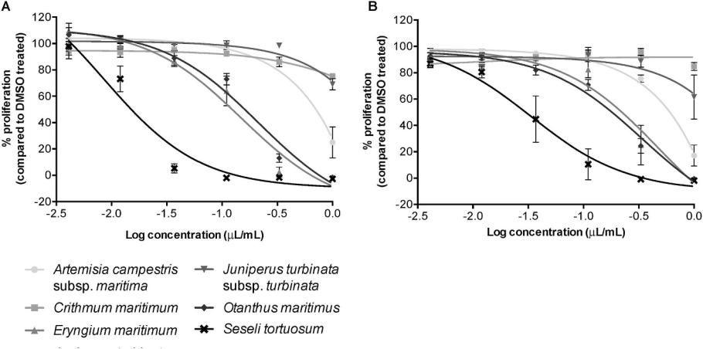

**Fig. 1.** Cytotoxic effect of EOs extracts from the 6 dune plant species panel.

**Table 2**

Cytotoxic effect of EOs extracts from the 6 dune plant species panel: IC50 values for both cell lines.

|  |  |  |
| --- | --- | --- |
| Species | IC50 (μL/mL) |  |
|  |  |  |
|  | MCF7 | RKO |
|  |  |  |
| *Artemisia campestris* subsp. *maritima* | 0.32 | 0.35 |
| *Crithmum maritimum* | ND | ND |
| *Eryngium maritimum* | 0.15 | 0.47 |
| *Juniperus turbinate* subsp. *turbinata* | ND | ND |
| *Otanthus maritimus* | 0.21 | 0.34 |
| *Seseli tortuosum* | 0.0086 | 0.034 |
|  |  |  |

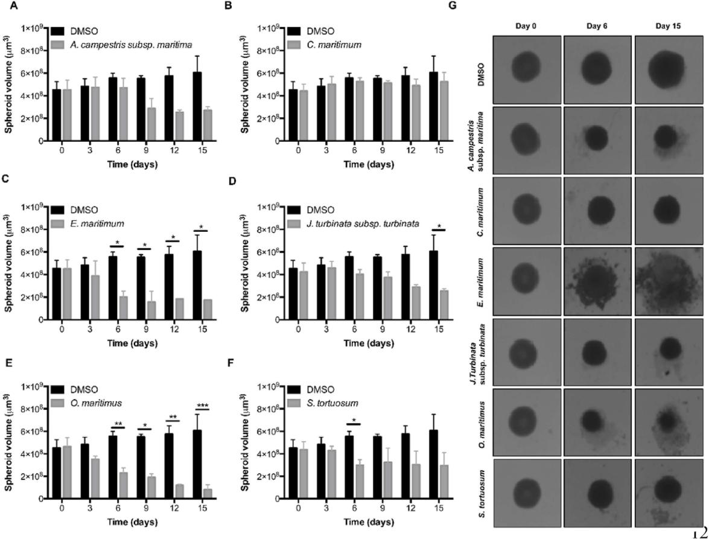

control (1 μL/ml DMSO in media), 1 μL/ml *S. tortuosum*, 1 μL/ml *O.* *maritimum* EO extracts, or 2 μM Doxorubicin. Samples were analysed byflow cytometry for DNA content. **(A**–**C)** Proportion of cells in the dif-ferent cell cycle phases (G1, S, G2/M), as well as subG1 cell debris content (SubG1) is presented as percentages of total cell population. Stacked bar graphs represent means for n = 3 independent experi-ments. Statistical significance of differences between means of vehicle control vs EO for both species, per timepoint and cell cycle phase is noted on Table 2. **(D**–**F)** Representative FACS analysis histograms from n = 3 independent experiments of *S. tortuosum* **(D)**, *O. maritimus* **(E)**, and Doxorubicin **(F)** treatments. Key: i) Vehicle control 24 h; ii) EO/ Doxorubicin 24 h; iii) Vehicle control 48 h; ii) EO/Doxorubicin 48 h.

MCF7 cells were treated with either vehicle-only control (1 μL/ml

**Fig. 2.** Impact of treatment with EOs from the 6 dune plant species panel on*in vitro*3D cancer models.

5

*E. Beeby, et al.* *Journal of Ethnopharmacology 258 (2020) 112803*

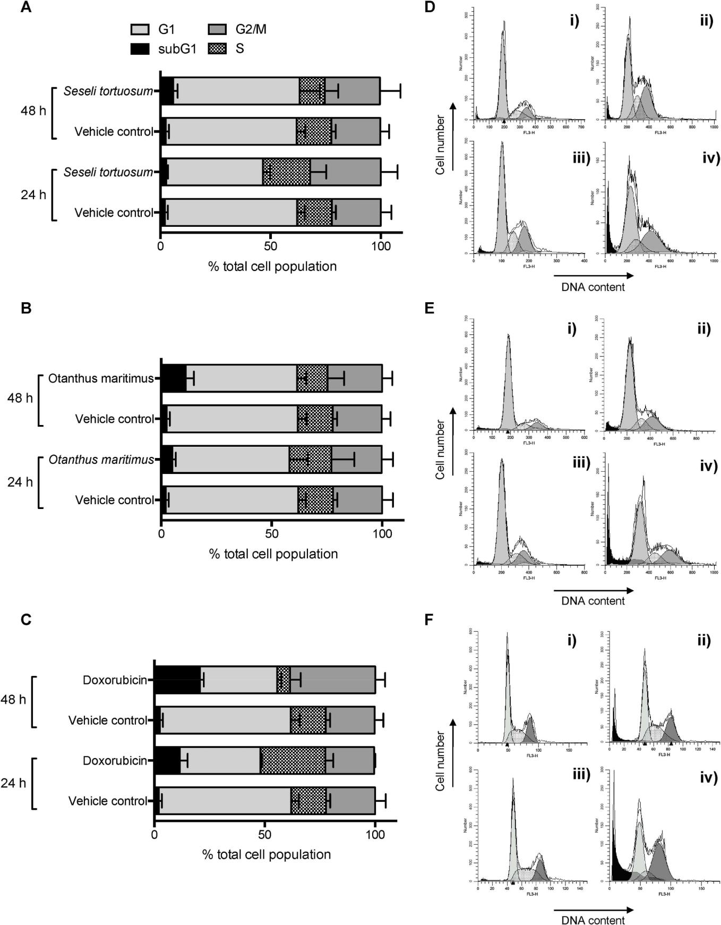

**Fig. 3. Impact of *O. maritimus* and *S. tortuosum* EO extract treatment on cell cycle progression**.

6

*E. Beeby, et al.* *Journal of Ethnopharmacology 258 (2020) 112803*

**Table 3**

**Impact of *O. maritimus* and *S. tortuosum* EO extract treatment on cell cycle progression.** Statistical significance of differences between means of vehicle controlvs EO for both species, per timepoint and cell cycle phase.

|  |  |  |  |  |  |
| --- | --- | --- | --- | --- | --- |
|  |  | subG1 | G1 | S | G2/M |
|  |  |  |  |  |  |
| Vehicle only *vs Seseli tortuosum* | **24 h** | p > 0.05 | **\*p** < **0.05** | p>0.05 | p > 0.05 |
| Vehicle only *vs Seseli tortuosum* | **48 h** | p > 0.05 | p > 0.05 | p > 0.05 | p > 0.05 |
| Vehicle only *vs Othantus maritimus* | **24 h** | p > 0.05 | p > 0.05 | p > 0.05 | p > 0.05 |
| Vehicle only *vs Othantus maritimus* | **48 h** | **\*\*p** < **0.01** | **\*p** < **0.05** | p>0.05 | p > 0.05 |
| Vehicle only *vs* Doxorubicin | **24 h** | **\*p** < **0.05** | **\*\*\*\*p** < **0.0001** | **\*\*p** < **0.01** | p>0.05 |
| Vehicle only vs Doxorubicin | **48 h** | **\*\*\*\*p** < **0.0001** | **\*\*\*\*p** < **0.0001** | **\*p** < **0.05** | **\*\*\*\*p** < **0.0001** |
|  |  |  |  |  |  |

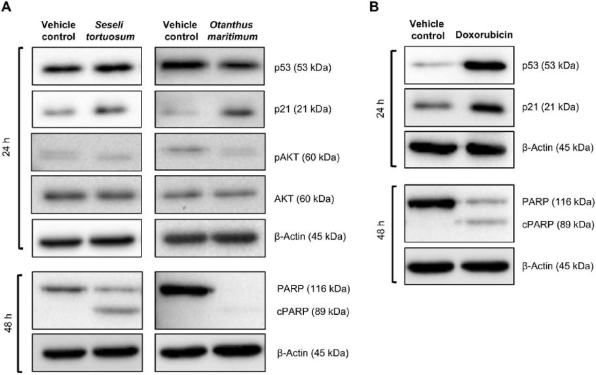

**Fig. 4.** Impact of*O. maritimus*and*S. tortuosum*treatment on cell survival and cell death signalling.

DMSO in media), 1 μL/ml *S. tortuosum* or *O. maritimum* EO extracts **(A)** or vehicle control/2 μM Doxorubicin **(B)** for 24 and 48 h p53, p21, phospho-AKT, total AKT, and PARP levels were analysed by Western blotting. β-actin was used as loading control. Representative blots of n = 3 independent experiments are shown.

**4. Discussion**

Since ancient times plants have been used in medicine to treat dif-ferent pathologies. Consequently, this traditional use conducted to an increasing interest in the study of plants bioactive compounds as po-tential therapeutic agents (Asadi-Samani et al., 2016). Moreover, phy-toproducts, such as EOs, containing active chemical compounds have been one of the main target focus for the design of novel anticancer therapies (Blowman et al., 2018; Dhifi et al., 2016; Gautam et al., 2014).

Based on that, this work aimed to assess the anticancer activity of EOs extracted from six species of sand-dune plants, containing in their che-mical composition several compounds that have known therapeutic ac-tivity. The present study has shown that EOs from *S. tortuosum*, *O.* *maritimus*, and *E. maritimum* induced a significant decrease in cell via-bility and/or proliferation, both in 2D and 3D *in vitro* cancer models, and presented the lowest IC50 values of the panel of species. This cytotoxic effect exhibited a profile similar to that with the conventional che-motherapy agent Doxorubicin. These results were somehow expected, as these EOs mixtures have in their composition compounds with pre-viously described anticancer effects and present relative low cytotoxicity effect in non-cancer cells treated with the same concentrations of EOs.

All compounds identified in the EOs of the species studied are either predominantly monoterpenes (*C. maritimum*; *J. turbinata*; *O. maritimus*; and *S. tortuosum*), sesquiterpenes (*E. maritimum*), or a mix of both these hydro-carbon compounds (*A. campestris*) (Table 1). Previous studies have reported anticancer activity induced by sesquiterpenes and monoterpenes, via

apoptosis and promotion of antiproliferative effect in cancer cell lines (Asadi-Samani et al., 2016; Bhalla et al., 2013). Furthermore, Sylvestre and colleagues analysed the chemical composition of Myrica gale EOs collected into two fractions during extraction (30 and 60 min) and its anticancer ef-fect. The higher percentage of compounds detected were monoterpenes (30 min fraction) and sesquiterpenes (60 min fraction), with the 60 min fraction showing a higher anticancer activity associated with decreased cell viability (Sylvestre et al., 2005). A study by Lone and colleagues showed that EO extracted from the leaf of Senecio graciliflorus was able to induce a strong therapeutic effect against human lung cancer cell lines, with this activity attributed to the main components of the EO, α-pinene (a mono-terpene also present in S. tortuosum in the present study) and ocimene (Lone et al., 2014). In another study, Ramadan and coworkers showed that Egyptian juniper oil, containing 26.19% of α-pinene, was associated with a more pronounced anticancer effect against HepG2, MCF7, and A549 cancer cell lines when compared with the commonly used chemotherapeutic drug, Doxorubicin (Ramadan et al., 2015). E. maritimum EO was shown to be composed predominantly by sesquiterpenes, including germacrene D. A recent study investigating the activity of EOs from Magnolia grandiflora flowers, containing in majority monoterpenes and sesquiterpenes, including germacrene D (sesquiterpene present in E. maritimum EO) and *β*-pinene (monoterpene present in A. campestris and S. tortuosum EOs) induced a cytotoxic effect against various cancer cell lines (Morshedloo et al., 2017). Furthermore, several studies have indicated that monoterpenes identified in O. maritimus EOs, such as chrysanthenone, are also components of extracts from other species reported to have anticancer activities, such as Pulicaria incisa and Artemisia herba-alba (Shahat et al., 2017; Tilaoui et al., 2015). All the described works support the potential anticancer activity attributed to the main compounds observed in the extracted EOs. However, it was not possible, at this stage, to evaluate whether specific compounds, or mixture of components, are responsible for the observed antiproliferative effects.

*S. tortuosum* and *O. maritimus* were further investigated to elucidate if the

7

*E. Beeby, et al.*

effect was cytostatic (solely impact on cell proliferation) or cytotoxic (in-creased cell death). EOs from another species, *E. maritimum*, had a similar impact on cell proliferation relative to the other two species, although the EO extraction had a much lower yield, so was not further investigated. Our data showed that the effect of the treatment with *O. maritimum* and *S. tortuosum* were mostly associated with a cytotoxic effect underpinned by decreased survival signalling and increased apoptosis. Previous studies support these results, once they reported that the monoterpene components α-pinene, β-pinene, and chrysanthenone have cytotoxic effect in cancer cells through pro-apoptotic proprieties and the impact in the regulation of AKT pathway (Suhail et al., 2011; Zhou et al., 2007). No significant impact on cell cycle progression was observed for both *O. maritimum* and *S. tortuosum* EOs, even though there was an increase of p21 levels, which presented a slight dis-crepancy with the literature, as α- and β-pinene, some of the main com-pounds of *S. tortuosum* EO, are known to be involved in cell cycle arrest (Suhail et al., 2011). Thus, the results showed that *O. maritimum* and *S. tor-tuosum* EOs most probably predominantly induced loss of viability via in-duction of apoptosis. This antitumoral mechanism of action differs from the positive control Doxorubicin, which induces apoptosis subsequent to DNA-damage induced double-strand breaks and cell cycle arrest (Tacar et al., 2013). EOs from other species previously reported to possess anticancer properties to induce loss of viability and/or antiproliferative mechanisms through a series of mechanisms, including direct impact on mitochondrial potential activating the intrinsic apoptotic pathway, ER-stress signalling ac-tivation, inhibition of survival pathways such as mTOR or NF??B signalling, or increased oxidative stress (Girola et al., 2015; Hassan et al., 2010; Seal et al., 2012). Therefore, future work will focus on further exploring the me-chanism of action of *S. tortuosum* and *O. maritimus* regarding their cytotoxic and pro-apoptotic activity. Of particular interest are the components of O. maritimus, none of which have been reported in the literature to have an-ticancer effects. Future work will also focus on evaluating the role of specific components of EOs vs. the original complex extract mixtures, and any po-tential impact of these in combination with more conventional therapeutic approaches, such as conventional chemotherapy and radiotherapy, both *in* *vitro* and *in vivo*.

To our knowledge, this is the first study proposing this class of phytoproducts, i.e. EOs, from *S. tortuosum* and *O. maritimus*, as potential and promising agents against cancer cells *in vitro*. These two EO mix-tures show a pronounced cytotoxic effect against cancer cells, through decreased survival signalling and induction of apoptosis.

**5. Conclusion**

Our study is the first to propose EO phytoproducts from*S. tortuosum* and *O. maritimus* as potential and promising anti-cancer agents. These two EOs show a cytotoxic effect against cancer cells, through decreased survival signalling and induction of apoptosis.

**List of the authors and respective contributions**

Experiments were carried out by EB, JP, LB, and CC. Data analysis was carried out by TC, IF, CC, and IMP. IMP and CC designed the ex-periments, with contribution from JP. MM, CC, and IMP wrote the paper with contributions and editing by all other authors. Funding was secured by ML, CC, and IMP.

**Declaration of competing interest**

The authors declare no conflict of interest regarding the publication of this paper.

**Acknowledgments**

We would like to thank the support provided by the following funders:

Higher Education Funding Council for England (HEFCE) through the

*Journal of Ethnopharmacology 258 (2020) 112803*

University of Hull, U.K.; Foundation for Science and Technology (FCT, Portugal), through the Strategic Projects: UID/MAR/04292/2019 (MARE), UID/NEU/04539/2013 and UID/NEU/04539/2019 (CNC.IBILI), UIDB/ 04539/2020 and UIDP/04539/2020 (CIBB); Foundation for Science and Technology (FCT, Portugal) and FEDER under Programme PT2020 for fi-nancial support to CIMO (UID/AGR/00690/2019); Foundation for Science and Technology (FCT, Portugal) project POINT4PAC (SAICTPAC/0019/ 2015-LISBOA-01-0145-FEDER-016405); EASME Blue Labs project AMALIA (EASME/EMFF/2016/1.2.1.4/03/SI2.750419), European Union; Integrated Programme of SR&TD “SmartBioR” (reference Centro-01-0145-FEDER-000018), co-funded by Centro (2020) program, Portugal 2020, European Union, through the European Regional Development Fund.

**Appendix A. Supplementary data**

Supplementary data to this article can be found online at [https://](https://doi.org/10.1016/j.jep.2020.112803) [doi.org/10.1016/j.jep.2020.112803](https://doi.org/10.1016/j.jep.2020.112803).

**References**

Akkol, E.K., Güvenç, A., Yesilada, E., 2009. A comparative study on the antinociceptive and anti-inflammatory activities of five Juniperus taxa. J. Ethnopharmacol. 125 (2), 330–336.

Allen, D.E., Hatfield, G., 2004. Medicinal Plants in Folk Tradition- An Ethnobotany of Britain & Ireland. Timber Press, Cambridge, pp. 431.

Asadi-Samani, M., Kooti, W., Aslani, E., Shirzad, H., 2016. A Systematic review of Iran's medicinal plants with anticancer effects. J. Evidence-Based Complement. Alternative Med. 21, 143–153. https://doi.org/10.1177/2156587215600873.

Atia, A., Ben, H.K., Debez, A., Abdelly, C., 2006. Salt and seawater effects on the ger-mination of *Crithmum maritimum*. In: Biosaline Agriculture and Salinity Tolerance in Plants. Birkhäuser Verlag, Switzerland, pp. 29–33.

[Baytop, T., 1999. Therapy with medicinal plants in Turkey past and present, 2nd ed.](http://refhub.elsevier.com/S0378-8741(19)34963-3/sref105)

[Nobel Tıp Kitabevi, Istanbul](http://refhub.elsevier.com/S0378-8741(19)34963-3/sref105).

Bhalla, Y., Gupta, V.K., Jaitak, V., 2013. Anticancer activity of essential oils: a review. J.

Sci. Food Agric. 93, 3643–3653. <https://doi.org/10.1002/jsfa.6267>.

Blowman, K., Magalhães, M., Lemos, M.F.L., Cabral, C., Pires, I.M., 2018. Anticancer properties of essential oils and other natural products. Evidence-based Complement. Alternative Med. 2018. https://doi.org/10.1155/2018/3149362.

[Cabral, C., Cavaleiro, C., Gonçalves, M.J., Cruz, M.T., Lopes, M.C., Salgueiro, L., 2013.](http://refhub.elsevier.com/S0378-8741(19)34963-3/sref109)

[*Otanthus maritimus* (L.) Hoffmanns. & Link as a source of a bioactive and fragrant oil.](http://refhub.elsevier.com/S0378-8741(19)34963-3/sref109)

[Ind. Crop. Prod. 43, 484–489](http://refhub.elsevier.com/S0378-8741(19)34963-3/sref109).

Cabral, C., Miranda, M., Gonçalves, M.J., Cavaleiro, C., Cruz, M.T., Salgueiro, L., 2017.

Assessment of safe bioactive doses of Foeniculum vulgare Mill. essential oil from Portugal.

Nat. Prod. Res. 31, 2654–2659. <https://doi.org/10.1080/14786419.2017.1292266>.

Cavaleiro, C., Pinto, E., Gonçalves, M.J., Salgueiro, L., 2006. Antifungal activity of Juniperus essential oils against dermatophyte, Aspergillus and Candida strains. J. Appl. Microbiol. 100 (6), 1333–1338.

[Council of Europe, 1997. European Pharmacopoeia, third ed. Council of Europe, Strasbourg](http://refhub.elsevier.com/S0378-8741(19)34963-3/sref5).

[Cowles, H.C., 1911. The causes of vegetational cycles. Ann. Assoc. Am. Geogr. 1, 3–20](http://refhub.elsevier.com/S0378-8741(19)34963-3/sref112).

[Crowden, R.K., Harborne, J.B., Heywood, V.H., 1969. Chemosystematics of the umbel-](http://refhub.elsevier.com/S0378-8741(19)34963-3/sref113)

[liferae - a general survey. Phytochemistry 8 (10), 1963–1984](http://refhub.elsevier.com/S0378-8741(19)34963-3/sref113).

Darriet, F., Andreani, S., De Cian, M.C., Costa, J., Muselli, A., 2014. Chemical variability and antioxidant activity of *Eryngium maritimum* L. essential oils from Corsica and Sardinia. Flavour Frag. J. 29 (1), 3–13.

Dhifi, W., Bellili, S., Jazi, S., Bahloul, N., Mnif, W., 2016. Essential oils' chemical char-acterization and investigation of some biological activities: a critical review. Medicines 3, 25. https://doi.org/10.3390/medicines3040025.

Djeridane, A., Yousfi, M., Nadjemi, B., Vidal, N., Lesgards, J.F., Stocker, P., 2007. Screening of some Algerian medicinal plants for the phenolic compounds and their antioxidant activity. Eur. Food Res.Technol. 224 (6), 801–809.

Dob, T., Dahmane, D., Berramdane, T., Chelghoum, C., 2005. Chemical Composition of the Essential Oil of *Artemisia campestris*. L. from Algeria. Pharm. Biol. 43 (6), 512–514.

Edris, A.E., 2007. Pharmaceutical and therapeutic Potentials of essential oils and their individual volatile constituents: a review. Phyther. Res. 21, 308–323. [https://doi.](https://doi.org/10.1002/ptr.2072) org/10.1002/ptr.2072.

Ennajar, M., Bouajila, J., Lebrihi, A., Mathieu, F., Abderraba, M., Raies, A., Romdhane, A., 2009. Chemical composition and antimicrobial and antioxidant activities of essential oils and various extracts of *Juniperus phoenicea* L. (Cupressaceae). J. Food Sci. 74 (7), 364–371.

Falcão, S., Bacém, I., Igrejas, G., Rodrigues, P.J., Vilas-Boas, M., Amaral, J.S., 2018. Chemical composition and antimicrobial activity of hydrodistilled oil from juniper berries. Ind. Crop. Prod. 124, 878–884. https://doi.org/10.1016/j.indcrop.2018.08.069.

Fitzmaurice, C., Allen, C., Barber, R.M., Barregard, L., Bhutta, Z.A., Brenner, H., Dicker, D.J., Chimed-Orchir, O., Dandona, R., Dandona, L., Fleming, T., Forouzanfar, M.H., Hancock, J., Hay, R.J., Hunter-Merrill, R., Huynh, C., Hosgood, H.D., Johnson, C.O., Jonas, J.B., Khubchandani, J., Kumar, G.A., Kutz, M., Lan, Q., Larson, H.J., Liang, X., Lim, S.S., Lopez, A.D., MacIntyre, M.F., Marczak, L., Marquez, N., Mokdad, A.H., Pinho, C., Pourmalek, F., Salomon, J.A., Sanabria, J.R., Sandar, L., Sartorius, B., Schwartz, S.M., Shackelford, K.A., Shibuya, K., Stanaway, J., Steiner, C., Sun, J., Takahashi, K., Vollset, S.E., Vos, T., Wagner, J.A., Wang, H., Westerman, R., Zeeb, H., Zoeckler, L., Abd-Allah, F., Ahmed, M.B., Alabed, S., Alam, N.K., Aldhahri, S.F., Alem, G., Alemayohu, M.A., Ali, R., Al-Raddadi, R., Amare, A., Amoako, Y., Artaman, A., Asayesh, H., Atnafu, N., Awasthi, A., Saleem, H.B., Barac, A., Bedi, N., Bensenor, I., Berhane, A., Bernabé, E.,

8

*E. Beeby, et al.*

Betsu, B., Binagwaho, A., Boneya, D., Campos-Nonato, I., Castañeda-Orjuela, C., Catalá-López, F., Chiang, P., Chibueze, C., Chitheer, A., Choi, J.Y., Cowie, B., Damtew, S., Das Neves, J., Dey, S., Dharmaratne, S., Dhillon, P., Ding, E., Driscoll, T., Ekwueme, D., Endries, A.Y., Farvid, M., Farzadfar, F., Fernandes, J., Fischer, F., Ghiwot, TT, Gebru, A., Gopalani, S., Hailu, A., Horino, M., Horita, N., Husseini, A., Huybrechts, I., Inoue, M., Islami, F., Jakovljevic, M., James, S., Javanbakht, M., Jee, S.H., Kasaeian, A., Kedir, M.S., Khader, Y.S., Khang, Y.H., Kim, D., Leigh, J., Linn, S., Lunevicius, R., El Razek, H.M.A., Malekzadeh, R., Malta, D.C., Marcenes, W., Markos, D., Melaku, Y.A., Meles, K.G., Mendoza, W., Mengiste, D.T., Meretoja, T.J., Miller, T.R., Mohammad, K.A., Mohammadi, A., Mohammed, S., Moradi-Lakeh, M., Nagel, G., Nand, D., Le Nguyen, Q., Nolte, S., Ogbo, F.A., Oladimeji, K.E., Oren, E., Pa, M., Park, E.K., Pereira, D.M., Plass, D., Qorbani, M., Radfar, A., Rafay, A., Rahman, M., Rana, S.M., Søreide, K., Satpathy, M., Sawhney, M., Sepanlou, S.G., Shaikh, M.A., She, J., Shiue, I., Shore, H.R., Shrime, M.G., So, S., Soneji, S., Stathopoulou, V., Stroumpoulis, K., Sufiyan, M.B., Sykes, B.L., Tabarés-Seisdedos, R., Tadese, F., Tedla, B.A., Tessema, G.A., Thakur, J.S., Tran, B.X., Ukwaja, K.N., Chudi Uzochukwu, B.S., Vlassov, V.V., Weiderpass, E., Wubshet Terefe, M., Yebyo, H.G., Yimam, H.H., Yonemoto, N., Younis, M.Z., Yu, C., Zaidi, Z., Zaki, M.E.S., Zenebe, Z.M., Murray, C.J.L., Naghavi, M., 2017. Global, regional, and national cancer incidence, mortality, years of life lost, years lived with disability, and disability-adjusted life-years for 32 cancer groups, 1990 to 2015: a systematic analysis for the Global Burden of Disease Study. JAMA Oncol 3, 524–548. https://doi.org/10.1001/jamaoncol.2016.5688.

Gautam, N., Mantha, A.K., Mittal, S., Gautam, N., Mantha, A.K., Mittal, S., 2014. Essential oils and their constituents as anticancer agents: a mechanistic view. BioMed Res. Int., e154106. https://doi.org/10.1155/2014/154106. 2014.

Girola, N., Figueiredo, C.R., Farias, C.F., Azevedo, R.A., Ferreira, A.K., Teixeira, S.F., Capello, T.M., Martins, E.G.A., Matsuo, A.L., Travassos, L.R., Lago, J.H.G., 2015. Camphene isolated from essential oil of Piper cernuum (Piperaceae) induces intrinsic apoptosis in melanoma cells and displays antitumor activity in vivo. Biochem. Biophys. Res. Commun. 467, 928–934. https://doi.org/10.1016/j.bbrc.2015.10.041.

Gonçalves, M.J., Tavares, A.C., Cavaleiro, C., Cruz, M.T., Lopes, M.C., Canhoto, J., Salgueiro, L., 2012. Composition, antifungal activity and cytotoxicity of the essential oils of *Seseli tortuosum* L. and *Seseli montanum* subsp. *peixotoanum* (Samp.) M. Laínz from Portugal. Ind. Crop. Prod. 39, 204–209.

Gornish, E.S., Miller, T.E., 2010. Effects of storm frequency on dune vegetation. Glob.

Chang. Biol. 16, 2668–2675. <https://doi.org/10.1111/j.1365-2486.2009.02144.x>.

Hanahan, D., Weinberg, R.A., 2011. Hallmarks of cancer: the next generation. Cell 144

(5), 646–674. <https://doi.org/10.1016/j.cell.2011.02.013>.

Hassan, S.B., Gali-Muhtasib, H., Göransson, H., Larsson, R., 2010. Alpha terpineol: a

potential anticancer agent which acts through suppressing NF-κB signalling.

Anticancer Res. 30, 1911–1919. <https://doi.org/10.1515/chem-2018-0040>.

Ju, J.B., Kim, J.S., Choi, C.W., Lee, H.K., Oha, T.K., Kim, S.C., 2008. Comparison between ethanolic and aqueous extracts from Chinese juniper berries for hypoglycaemic and hypolipidemic effects in alloxan-induced diabetic rats. J. Ethnopharm. 115 (1), 110–115.

Kalimuthu, S., Se-Kwon, K., 2013. Cell survival and apoptosis signaling as therapeutic target for cancer: marine bioactive compounds. Int. J. Mol. Sci. [https://doi.org/10.](https://doi.org/10.3390/ijms14022334) 3390/ijms14022334.

Kozan, E., Küpeli, E., Yesilada, E., 2006. Evaluation of some plants used in Turkish folk medicine against parasitic infections for their in vivo anthelmintic activity. J. Ethnopharmacol. 108 (2), 211–216.

Küpeli, E., Kartal, M., Aslanb, S., Yesilada, E., 2006a. Comparative evaluation of the anti-inflammatory and antinociceptive activity of Turkish Eryngium species. J. Ethnopharmacol. 107 (1), 32–37.

Küpeli, E., Tosun, A., Yesilada, E., 2006b. Anti-inflammatory and antinociceptive activ-ities of *Seseli* L. species (Apiaceae) growing in Turkey. J. Ethnopharmacol. 104 (3), 310–314.

Kusari, S., Zühlke, S., Spiteller, M., 2011. Chemometric evaluation of the anti-cancer pro-drug podophyllotoxin and potential therapeutic analogues in *Juniperus* and *Podophyllum* species. Phytochem. Anal. 22 (2), 128–143.

[Lawrence, B.M., 1995. The isolation of aromatic materials from natural plant products. In:](http://refhub.elsevier.com/S0378-8741(19)34963-3/sref134)

[Tuley De Silva, K. (Ed.), Manual of the Essential Oil Industry, pp. 57–154](http://refhub.elsevier.com/S0378-8741(19)34963-3/sref134).

Lesjak, M.M., Beara, I.N., Orcic, D.Z., Anackovb, G.T., Balog, K.J., Franciskovic, M.M., Mimica-Dukic, N.M., 2011. *Juniperus sibirica* Burgsdorf. as a novel source of anti-oxidant and anti-inflammatory agents. Food Chem 124 (3), 850–856.

Loizzo, M.R., Saab, A., Tundis, R., Statti, G.A., Lampronti, I., Menichini, F., Gambari, R., Cinat, J., Doerr, H.W., 2008. Phytochemical analysis and in vitro antiviral activities of the essential oils of seven Lebanon species. Chem Biodivers 5 (3), 461–470.

Lone, S.H., Bhat, K.A., Bhat, H.M., Majeed, R., Anand, R., Hamid, A., Khuroo, M.A., 2014. Essential oil composition of Senecio graciliflorus DC: comparative analysis of dif-ferent parts and evaluation of antioxidant and cytotoxic activities. Phytomedicine 21, 919–925. https://doi.org/10.1016/j.phymed.2014.01.012.

Meot-Duros, L., Cérantola, S., Talarmin, H., Le Meur, C., Le Floch, G., Magné, C., 2010. New antibacterial and cytotoxic activities of falcarindiol isolated in *Crithmum mar-itimum* L. leaf extract. Food Chem. Toxicol. 48 (2), 553–557.

Miller, K.D., Siegel, R.L., Lin, C.C., Mariotto, A.B., Kramer, J.L., Rowland, J.H., Stein, K.D., Alteri, R., Jemal, A., 2016. Cancer treatment and survivorship statistics, 2016. CA A Cancer J. Clin. 66, 271–289. https://doi.org/10.3322/caac.21349.

Morshedloo, M.R., Quassinti, L., Bramucci, M., Lupidi, G., Maggi, F., 2017. Chemical composition, antioxidant activity and cytotoxicity on tumour cells of the essential oil from flowers of Magnolia grandiflora cultivated in Iran. Nat. Prod. Res. 31, 2857–2864. https://doi.org/10.1080/14786419.2017.1303699.

Murray, P.M., Moane, S., Collins, C., Beletskaya, T., Thomas, O.P., Duarte, A.W., Nobre, F.S., Owoyemi, I.O., Pagnocca, F.C., Sette, L.D., McHugh, E., Causse, E., Pérez-López, P., Feijoo, G., Moreira, M.T., Rubiolo, J., Leirós, M., Botana, L.M., Pinteus, S., Alves, C., Horta, A., Pedrosa, R., Jeffryes, C., Agathos, S.N., Allewaert, C., Verween, A.,

*Journal of Ethnopharmacology 258 (2020) 112803*

Vyverman, W., Laptev, I., Sineoky, S., Bisio, A., Manconi, R., Ledda, F., Marchi, M., Pronzato, R., Walsh, D.J., 2013. Sustainable production of biologically active mole-cules of marine based origin. New Biotechnol. 30 (6), 839–850.

Nagai, H., Kim, Y.H., 2017. Cancer prevention from the perspective of global cancer burden patterns. J. Thorac. Dis. 9, 448–451. https://doi.org/10.21037/jtd.2017.02.75.

Naili, M.B., Alghazeer, R.O., Saleh, N.A., Al-Naijar, A.Y., 2010. Evaluation of antibacterial and antioxidant activities of *Artemisia campestris* (Astraceae) and *Ziziphus lotus* (Rhamnacea). Arabian J. Chem. 3 (2), 79–84.

Nakanishi, T., Iidaa, N., Inatomia, Y., Murataa, H., Inadaa, A., Muratab, J., Langc, F.A., Iiunumad, M., Tanaka, T., 2004. Neolignan and flavonoid glycosides in *Juniperus* *communis* var. depressa. Phytochemisty 65 (2), 207–213.

Pimenov, M.G., Leonov, M.V., 1993. The genera of the Umbelliferae. A nomenclator 156 Royal Botanic Gardens, Kew.

Pires, I.M., Bencokova, Z., Milani, M., Folkes, L.K., Li, J.-L., Stratford, M.R., Harris, A.L., Hammond, E.M., 2010. Effects of acute versus chronic hypoxia on DNA damage re-sponses and genomic instability. Can. Res. 70, 925–935. [https://doi.org/10.1158/](https://doi.org/10.1158/0008-5472.CAN-09-2715) 0008-5472.CAN-09-2715.

Pires, I.M., Olcina, M.M., Anbalagan, S., Pollard, J.R., Reaper, P.M., Charlton, P.A., McKenna, W.G., Hammond, E.M., 2012. Targeting radiation-resistant hypoxic tu-mour cells through ATR inhibition. Br. J. Canc. 107, 291–299. [https://doi.org/10.](https://doi.org/10.1038/bjc.2012.265) 1038/bjc.2012.265.

Poujade, F.-A., Mannion, A., Brittain, N., Theodosi, A., Beeby, E., Leszczynska, K.B., Hammond, E.M., Greenman, J., Cawthorne, C., Pires, I.M., 2018. WSB-1 regulates the metastatic potential of hormone receptor negative breast cancer. Br. J. Canc. 118, 1229–1237. https://doi.org/10.1038/s41416-018-0056-3.

Ramadan, M.M., Ali, M.M., Ghanem, K.Z., El-Ghorabe, A.H., 2015. Essential oils from Egyptian aromatic plants as antioxidant and novel anticancer agents in human cancer cell lines. Grasas Aceites 66, e080. https://doi.org/10.3989/gya.0955142.

[Reutter, L., 1923. Traité de Matière Médicale et de Chimie Végétale. Paris Librairie J.B.](http://refhub.elsevier.com/S0378-8741(19)34963-3/sref150)

[Baillère et Fils, Paris, France](http://refhub.elsevier.com/S0378-8741(19)34963-3/sref150).

Roos, W.P., Thomas, A.D., Kaina, B., 2016. DNA damage and the balance between sur-vival and death in cancer biology. Nat. Rev. Canc. 16, 20–33. [https://doi.org/10.](https://doi.org/10.1038/nrc.2015.2) 1038/nrc.2015.2.

Sassi, A.B., Skhiri, F.H., Bourgougnon, N., Aouini, M., 2008. Antiviral activity of some Tunisian medicinal plants against Herpes simplex virus type 1. Nat. Prod. Res. 22 (1), 53–65.

Schneider, C.A., Rasband, W.S., Eliceiri, K.W., 2012. NIH Image to ImageJ: 25 years of image analysis. Nat. Methods 9, 671–675. https://doi.org/10.1038/nmeth.2089.

Seal, S., Chatterjee, P., Bhattacharya, Sushmita, Pal, D., Dasgupta, S., Kundu, R., Mukherjee, S., Bhattacharya, Shelley, Bhuyan, M., Bhattacharyya, P.R., Baishya, G., Barua, N.C., Baruah, P.K., Rao, P.G., Bhattacharya, Samir, 2012. Vapor of volatile oils from Litsea cubeba seed induces apoptosis and causes cell cycle arrest in lung cancer cells. PloS One 7, 1–11. https://doi.org/10.1371/journal.pone.0047014.

Seca, A.M.L., Silva, A.M.S., 2005. The Chemical Composition of the Juniperus Genus (1970-2004). Phytomedicines 16, 401–522.

Sever, R., Brugge, J.S., 2015. Signal transduction in cancer. Cold Spring Harb. Perspect.

Med. 5, a006098. <https://doi.org/10.1101/cshperspect.a006098>.

Shahat, E.A., Bakr, R.O., Eldahshan, O.A., Ayoub, N.A., 2017. Chemical composition and biological activities of the essential oil from leaves and flowers of Pulicaria incisa sub. candolleana (Family Asteraceae). Chem. Biodivers. 14, e1600156. [https://doi.org/](https://doi.org/10.1002/cbdv.201600156) 10.1002/cbdv.201600156.

Sharifi-Rad, J., Sureda, A., Tenore, C.G., Daglia, M., Sharifi-Rad, Mehdi, Valussi, M., Tundis, R., Sharifi-Rad, Marzieh, Loizzo, R.M., Ademiluyi, O.A., Sharifi-Rad, R., Ayatollahi, A.S., Iriti, M., 2017. Biological activities of essential oils: from plant chemoecology to traditional healing systems. Molecules 22, E70. [https://doi.org/10.](https://doi.org/10.3390/molecules22010070) 3390/molecules22010070.

Suhail, M.M., Wu, W., Cao, A., Mondalek, F.G., Fung, K.-M., Shih, P.-T., Fang, Y.-T., Woolley, C., Young, G., Lin, H.-K., 2011. Boswellia sacra essential oil induces tumor cell-specific apoptosis and suppresses tumor aggressiveness in cultured human breast cancer cells. BMC Compl. Alternative Med. 11, 129. [https://doi.org/10.1186/1472](https://doi.org/10.1186/1472-6882-11-129)-6882-11-129.

Sylvestre, M., Legault, J., Dufour, D., Pichette, A., 2005. Chemical composition and an-ticancer activity of leaf essential oil of Myrica gale L. Phytomedicine 12, 299–304. https://doi.org/10.1016/j.phymed.2003.12.004.

Tacar, O., Sriamornsak, P., Dass, C.R., 2013. Doxorubicin: an update on anticancer mo-lecular action, toxicity and novel drug delivery systems. J. Pharm. Pharmacol. 65, 157–170. https://doi.org/10.1111/j.2042-7158.2012.01567.x.

Tilaoui, M., Mouse, H.A., Jaafari, A., Zyad, A., 2015. Comparative phytochemical analysis of essential oils from different biological parts of artemisia herba alba and their cy-totoxic effect on cancer cells. PloS One 10, 1–15. [https://doi.org/10.1371/journal.](https://doi.org/10.1371/journal.pone.0131799) pone.0131799.

Tosun, A., Baba, M., Bahadir, O., Okuyama, T., 2006. Coumarins isolated from the roots of *Seseli resinosum* in Turkey. Pharm. Biol. 44, 528–533.

Tsoukatou, M., Vagias, C., Harvala, C., Roussis, V., 2000. Essential oil and headspace analysis of the maritime *Bombycilaena erecta* and *Otanthus maritimus* species growing wild in Greece. J. Essent. Oil Res. 12, 360–364.

Zanoni, M., Piccinini, F., Arienti, C., Zamagni, A., Santi, S., Polico, R., Bevilacqua, A., Tesei, A., 2016. 3D tumor spheroid models for in vitro therapeutic screening: a sys-tematic approach to enhance the biological relevance of data obtained. Sci. Rep. 1–11. https://doi.org/10.1038/srep19103.

Zhou, H.J., Wang, W.Q., Wu, G.D., Lee, J., Li, A., 2007. Artesunate inhibits angiogenesis and downregulates vascular endothelial growth factor expression in chronic myeloid leukemia K562 cells. Vasc. Pharmacol. 47, 131–138. [https://doi.org/10.1016/j.vph.](https://doi.org/10.1016/j.vph.2007.05.002) 2007.05.002.

9