Neuron, Vol. 30, 241–248, April, 2001, Copyright 2001 by Cell Press

**Ca2**1 **Signaling via the Neuronal**

**Calcium Sensor-1 Regulates Associative Learning and Memory in *C. elegans***

**Marie Gomez,1,6 Edouard De Castro,2,6,7 Ernesto Guarin,1 Hiroyuki Sasakura,3 Atsushi Kuhara,3 Ikue Mori,3 Tamas Bartfai,1 Cornelia I. Bargmann,4 and Patrick Nef1,5**

1Department of Central Nervous System

F. Hoffmann-La Roche

Basel 4070

Switzerland

1. Department of Biochemistry University of Geneva Geneva 1201

Switzerland

1. PRESTO

Japan Science and Technology Corporation and

Division of Biological Science

Graduate School of Science

Nagoya University

Nagoya 464

Japan

1. Howard Hughes Medical Institute Department of Anatomy

University of California, San Francisco San Francisco, California 94143

**Summary**

**On a radial temperature gradient, *C. elegans* worms migrate, after conditioning with food, toward their cul-tivation temperature and move along this isotherm. This experience-dependent behavior is called isother-mal tracking (IT). Here we show that the neuron-spe-cific calcium sensor-1 (NCS-1) is essential for optimal IT. *ncs-1* knockout animals show major defects in IT behavior, although their chemotactic, locomotor, and thermal avoidance behaviors are normal. The knock-out phenotype can be rescued by reintroducing wild-type NCS-1 into the AIY interneuron, a key component of the thermotaxis network. A loss-of-function form of NCS-1 incapable of binding calcium does not re-store IT, whereas NCS-1 overexpression enhances IT performance levels, accelerates learning (faster ac-quisition), and produces a memory with slower extinc-tion. Thus, proper calcium signaling via NCS-1 defines a novel pathway essential for associative learning and memory.**

**Introduction**

The neuronal calcium sensor-1 (NCS-1) belongs to the intracellular neuronal calcium sensor family of EF-hand calcium binding proteins (Braunewell and Gundelfinger, 1999) and is highly conserved throughout evolution, with

1. To whom correspondence should be addressed (e-mail: patrick. nef@roche.com).
2. These authors contributed equally to this work.
3. Present address: Institute of Behavioral Genetics, University of Boulder, Boulder, Colorado 80309.

orthologs identified in yeast, *Drosophila*, *C. elegans*, avian birds, rodents, and humans (Nef, 1996). Its amino acid sequence is 100% conserved among vertebrates and shows only 25% divergence with *C. elegans* or 28% with yeast (De Castro et al., 1995). NCS-1 is neuron specific (Martone et al., 1999; Paterlini et al., 2000) and exhibits a high affinity for calcium of 300 nM (Cox et al., 1994), which is within the linear range of localized [Ca2_]i fluctuations in neurons (Fontana and Blaustein, 1993; Yazejian et al., 2000). The yeast, but not vertebrate (Bart-lett et al., 2000), NCS-1 protein has been shown to inter-act with phosphatidylinositol 4-OH kinase (Hendricks et al., 1999). The vertebrate recombinant NCS-1 has been reported to activate G protein receptor kinase 1 (De Castro et al., 1995; Iacovelli et al., 1999) to regulate evoked exocytosis in neuroendocrine cells (McFerran et al., 1998) and to substitute for calmodulin (Schaad et al., 1996). Indeed, calmodulin-dependent targets such as 3_:5_-cyclic nucleotide phosphodiesterase, calcineurin, nitric oxide synthase enzymes (in vitro), or the *Parame-cium* calmodulin-dependent potassium channel (in vivo)are directly activated by NCS-1 (Schaad et al., 1996). Moreover, overexpression of NCS-1 in the mouse hippo-campus increases long-term potentiation (LTP) (P. N. et al., unpublished data), and overexpression of frequenin, the *Drosophila* ortholog of NCS-1, causes a chronic fa-cilitation of transmitter release at the neuromuscular junction of flies and frogs through unknown mechanisms (Pongs et al., 1993; Rivosecchi et al., 1994; Olafsson et al., 1995). Importantly, the neuronal role of *ncs* genes in vivo has not been characterized by loss-of-function genetics in eukaryotes. To investigate the role of NCS-1 as a regulator of neuronal activity in vivo, we chose *C.* *elegans* as a model organism due to its simple nervoussystem and well-described neuronal circuitry with the ability to respond to diverse environmental stimuli such as touch, smell, taste, or temperature.

**Results**

The *Ce-ncs-1* gene, located on the left arm of chromo-some X, encodes *Ce*-NCS-1, a small acidic protein com-posed of 192 amino acids (molecular mass of 22 kDa) that binds three calcium ions via four putative EF-hands (De Castro et al., 1995). Cellular distribution of *Ce*-NCS-1 was determined by light and immunofluorescence mi-croscopy studies using a transgenic line (XA411) ex-pressing the green fluorescent protein (GFP) under the control of the *Ce-ncs-1* promoter region (Figure 1). Con-firmation of GFP staining and NCS-1-positive cells was obtained with antibodies against *Ce*-NCS-1 (data not shown). *Ce*-NCS-1 was predominantly expressed in sensory neurons (10 neuronal pairs: AWC, ASE, AWB, BAG, PHB, AWA, AFD, ADF, ASG, PHA). In addition, two pairs of interneurons (AVK, AIY), one motor neuron (RMG), and one muscle cell type (pm1) expressed *Ce-*NCS-1 (Table 1). Most of the NCS-1-expressing neurons were associated with two sensory organs, the head am-phids and tail phasmids (Figures 1A and 1B). We ob-

Neuron

242

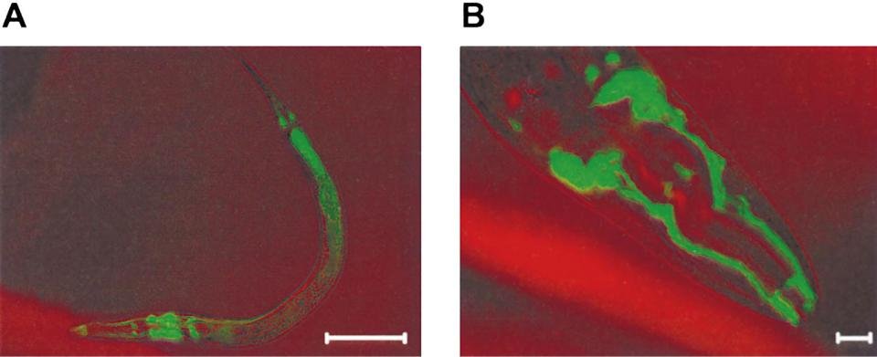

Figure 1. Expression Pattern of the *ncs-1*::GFP Reporter Gene

1. *ncs-1* gene expression is observed in amphid, phasmid, nerve ring, and ventral nerve cord of L1 stage animals as GFP staining. Scalebar: 100 _M.
2. *ncs-1* gene expression in adult head showing GFP staining in amphid dendrites. Scale bar: 10_M

served a dendritic, axonal, and cell body subcellular distribution with *Ce*-NCS-1-specific antibodies (data not shown).

To investigate the functional role of *Ce*-NCS-1, knock-out (KO) animals were generated. An *ncs-1* Tc1 transpo-son insertion mutant line [*ncs-1*(*pk242::Tc1)*] was used to isolate a deletion derivative strain *ncs-1(qa401te)* (Fig-ure 2A). The null *ncs-1* animals were viable, their devel-opmental timing normal, although they were slightly dumpy (data not shown), and the NCS-1 protein was no longer present in these KO animals (Figure 3C). Since 8/10 pairs of NCS-1-positive neurons are known to be involved in chemotaxis and volatile odorant avoidance, several classes of odor responses were measured with the KO strain. Surprisingly, null *ncs-1* mutant animals behaved like wild-type worms (data not shown), sug-gesting that calcium signaling via NCS-1 is not involved in *C. elegans* odorant detection or that other calcium sensors in olfactory neurons can substitute or compen-sate for the lack of NCS-1.

As a cold-blooded animal, viable and fertile only within

a limited temperature range (12_C–26_C), *C. elegans* has efficient thermosensory behaviors, including thermal avoidance for protection against exposure to noxious temperature (Wittenburg and Baumeister, 1999) and thermotaxis for the perception of physiological (_0.1_C) changes in local temperature (Mori, 1999). Worms learn to associate a given temperature (the growth tempera-ture) with the presence of food during a conditioning period (acquisition) of several hours (Hedgecock and Russell, 1975). This associative conditioning is reflected by a unique phenotype, the isothermal tracking (IT) be-havior, which can be observed on unseeded plates with a radial gradient of temperature with a single animal migrating to the precise growth temperature (_0.2_C) (Hedgecock and Russell, 1975) and then moving isother-mally. When the association is disrupted (by food ex-haustion), the IT behavior is conserved for several hours (extinction period), and then a searching mode is acti-vated, and the worms will cross isotherms randomly to seek food at other temperatures (Mori, 1999). But a change in temperature will not lead to a random search-

Table 1. NCS-1-Positive Cells and their Functions

|  |  |
| --- | --- |
| Positive Cells | Function |
|  |  |
| Sensory neurons |  |
| AWC (left, right) | Amphid neurons. Chemotaxis to volatile odorants (benzaldehyde, butanone, isoamyl alcohol) |
| ASE (L,R) | Amphid neurons. Chemotaxis to soluble compounds (Na_, Cl_, cAMP, biotin, lysine), egg laying |
| AWB (L,R) | Amphid neurons. Volatile avoidance |
| BAG (L,R) | Sensory neurons |
| PHB (L,R) | Phasmid neurons |
| AWA (L,R) | Amphid neurons. Chemotaxis to volatile odarants (diacetyle, pyrazine, 2,4,5-trimethylthiazol) |
| AFD (L,R) | Amphid neurons. Isothermal tracking behavior. Thermotaxis |
| ADF (L,R) | Amphid neurons. Dauer formation; chemotaxis to soluble compounds (minor) |
| ASG (L,R) | Amphid neurons. Dauer formation (minor); chemotaxis to soluble compounds (minor) |
| PHA (L,R) | Phasmid neurons |
| Interneurons |  |
| AVK (L,R) | — |
| AIY (L,R) | Isothermal tracking behavior. Thermotaxis |
| Motor neuron |  |
| RMG | Innervation of muscles in the head |
| Muscle cell |  |
| pm1 | Opening of the metastomal pharyngeal flaps |
|  |  |

NCS-1 Regulates Associative Learning and Memory

243

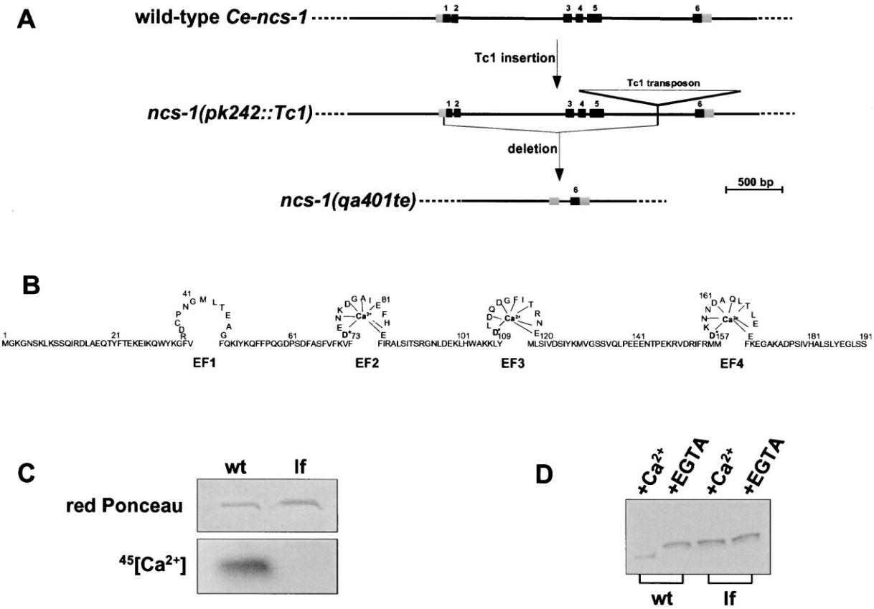

Figure 2. *Ce*-NCS-1: From Gene Structure to Calcium Sensor

1. Physical maps of wild-type *Ce-ncs-1*, *ncs-1(pk242::Tc1)*, and null *ncs-1(qa401te)* deletion genes. Black boxes represent exons 1–6, and the gray boxes the 5_ and 3_ untranslated regions of the *ncs-1* gene. Scale bar: 500 bp.
2. The NCS-1 protein contains 4 EF-hands (EF1–EF4), but the first binding site is degenerated and cannot bind Ca2_ (De Castro et al., 1995). The Asp positions D73, D109, and D157 are essential for calcium binding. Changing the three Asp residues (D*) into Ala inactivates Ca2_ binding (Putkey et al., 1989) (see below).
3. The loss-of-function (lf) triple mutant was constructed by substituting the first Asp (D*) residue to an Ala of the three EF-hands EF2, 3, and 4.
4. *Ce*-NCS-1 is a calcium sensor. Calcium bound wild-type NCS-1 displayed a greater electrophoretic mobility than the apo form, whereaslf-NCS-1 mobility was not affected by the presence (_Ca2_) or absence (_EGTA) of free calcium. It suggests that Ca2_ induces an allosteric change in the conformation and probably activity of *Ce*-NCS-1.

ing mode but rather a slow reacquisition of the associa-tion between food and the new temperature. As *Ce*-NCS-1 was found in AFD and AIY, two neurons of the thermotaxis neural circuit, *ncs-1(qa401te)* KO worms were tested for IT behavior at 20_C (measurement as percentage of worms performing isothermal tracks at 20_C). IT recordings of single worms were visualized after 90 min on testing plates as shown in Figure 3A. *Ce*-*ncs-1* KO animals were abnormal, showing a significantdifference in behavior when compared with wild-type (WT) animals (Figure 3B). Many WT animals (75% _ 8%; n _ 94) exhibited normal IT behavior, whereas only 31% _ 9% of *ncs-1(qa401te)* mutants (n _ 96) per-formed normally. The majority of the KO animals showed irregular IT behaviors and, based on previous descrip-tions of thermotaxis phenotypes by Mori and Oshima (1995), were classified into five categories: 31% were cryophilic, 27% athermotactic, 6% thermophilic, 5% showed intermediate behavior (mixed athermotactic and normal phenotypes), and 31% were normal. The

overall IT defects of the *ncs-1* mutants (mostly athermo-tactic and cryophilic) were similar to the phenotypes observed with laser-killed AFD (athermotactic and cryo-philic) or AIY (mostly cryophilic) animals, or with *ttx-3* (mostly cryophilic) mutants (Hobert et al., 1997), but were clearly different from AIZ (mostly thermophilic) la-ser-killed animals (Mori and Ohshima, 1995).

We also tested the thermal avoidance behavior of the *ncs-1* knockout strain upon exposure to a noxious temperature. Noxious temperature causes a withdrawal reflex that differs significantly from thermotaxis behav-ior, involves different neurons, and is influenced by mu-tations in distinct genes (Wittenburg and Baumeister, 1999). The behavior of the *ncs-1(qa401te)* mutant did not differ from that of wild-type worms in this assay (data not shown).

To ensure that the diminution of IT behavior with the KO mutant was due to the absence of *Ce*-NCS-1, we performed a germline rescue of the KO strain using ei-ther a 7 kb genomic fragment transgene containing the

Neuron

244

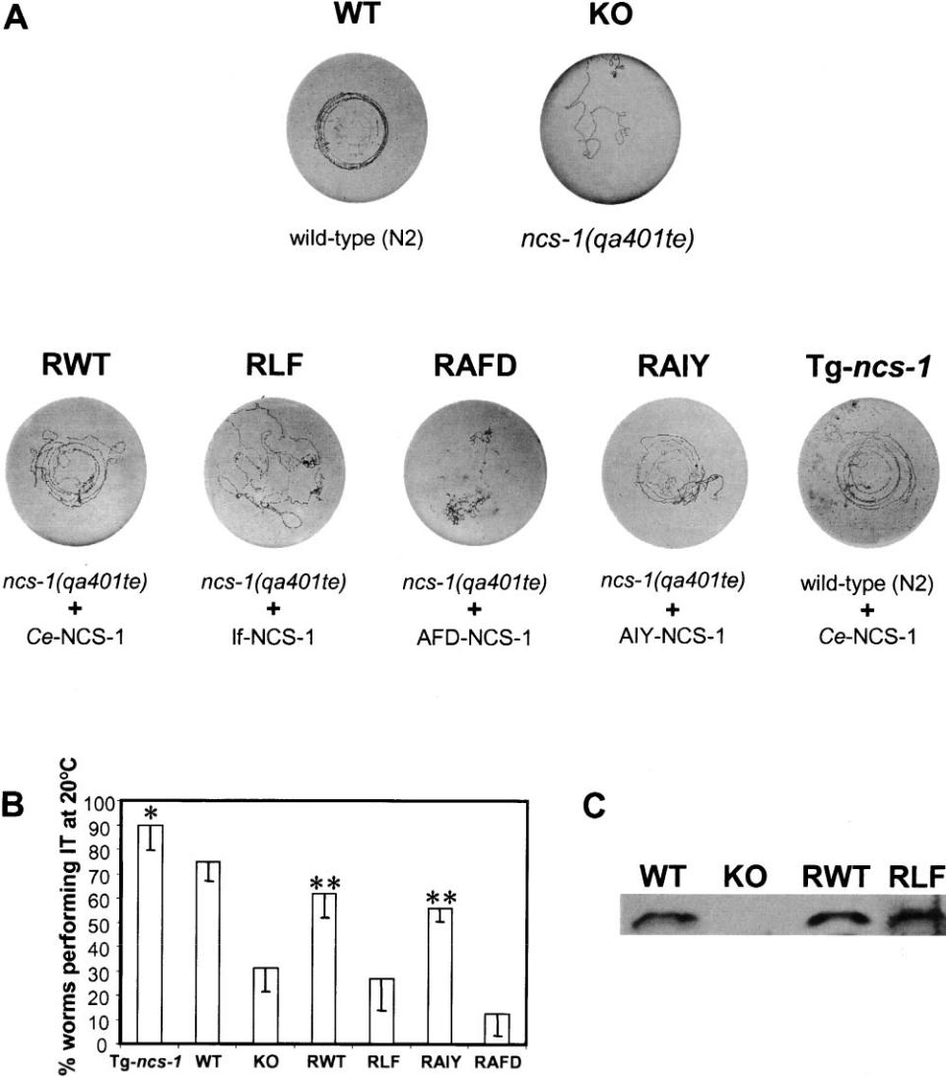

Figure 3. Ca2_ Signaling via NCS-1 in the AIY Interneuron Is Essential for Isothermal Tracking Behavior

1. Individual isothermal tracking (IT) records. Photographs of normal or disrupted isothermal behavior tracks of wild-type (WT), *ncs-1(qa401te)* knockout (KO), rescued *ncs-1(qa401te)* with wild-type *ncs-1* (RWT), or with loss-of-function *ncs-1* (RLF), or with AFD neuron–specific promoter (RAFD) driving *ncs-1* expression, or with AIY neuron–specific promoter (RAIY) driving *ncs-1* expression, and wild-type plus transgenic *ncs-1* (Tg-*ncs-1*) individual worms are shown. Thermotaxis assays were performed as described in Mori and Ohshima (1995) (see Experimental Procedures).
2. Percentage (group performance) of worms performing IT behavior after overnight feeding at 20_C. Each data point represents 4–10 independent assays using z10–20 animals per assay. At least 2–3 different lines were generated for each transgene construct. The chi-square distribution and t test were used to determine the significance of IT behavior performance between the different strains. The p value (asterisk, _0.02) indicates a significant difference between Tg-*ncs-1* animals as compared to wild-type worms. The p values (double asterisk, _0.002) represent significant differences of performance between KO animals and RWT or RAIY worms. For these experiments, standard deviations range from 7% to 14%. A trace is considered as isothermal if more than half of the trace length left on the agar surface by a single animal is circular or present an arc of circle near the isotherm of the growth temperature.
3. *Ce*-NCS-1 protein levels in the various WT, KO, RWT, RLF strains or lines. Western blot analysis using *Ce*-NCS-1 polyclonal antibodiesand 80 _g of total protein extract reveals the presence of the NCS-1 calcium sensor in the wild-type strain (WT), in the NCS-1 rescued wild-type lines (RWT), and in the rescue loss-of-function lines (RLF). Note the absence of NCS-1 in the knockout strain (KO).

entire *ncs-1* genomic coding region plus z3 kb of its 5_ upstream genomic sequence (data not shown) or a PCR fragment containing the *ncs-1* cDNA coding region plus z3 kb of the 5_ upstream genomic sequence (lines RWT; Figures 3A and 3B). Both transgenes were able to rescue the *ncs-1* mutant defective phenotype, resulting in re-stored IT behavior in 62% _ 9% of animals (n _ 92, p _ 0.00001).

To test whether the function of *Ce*-NCS-1 was calcium dependent, we generated a mutated form of NCS-1 un-able to bind calcium (loss-of-function or lf-NCS-1). Re-placement of the crucial Asp residues of the three EF-hand calcium binding sites (positions 73, 109, and 157; Figure 2B) with Ala prevented both Ca2_ binding (Figure 2C) and Ca2_-dependent conformational shift of lf-NCS-1 (Figure 2D). Lines obtained with the lf-*ncs-1* transgene

NCS-1 Regulates Associative Learning and Memory

245

Figure 4. Faster Acquisition (Learning) and Longer Retention (Memory) for NCS-1 Over-expressing Worms

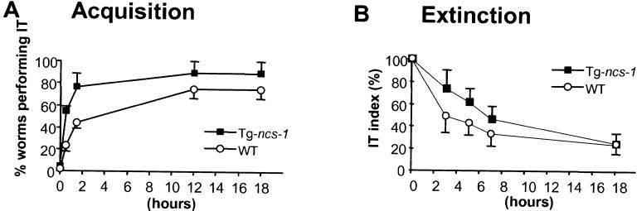

(A) The acquisition of the association of food at a given temperature was determined for wild-type (WT) and overexpressing NCS-1 (Tg-*ncs-1*) worms by measuring the percent-age of worms performing IT behavior at 20_C. Briefly, worms were grown on seeded plates at 25_C for at least 12 hr, and then shifted individually to a seeded plate at 20_C for dif-

ferent time intervals. For both strains, the maximal levels of IT behavior (absolute values) were reached after pairing the conditioning stimuli for at least 12 hr. Fifty percent of the maximum level was reached after 68 min for WT worms, and after only 28 min with Tg-*ncs-1* worms. As we scored half-maximal acquisition instead of the relative IT index (see definition below), the experiment was internally controlled for increased performance for each strain.

1. The extinction of this association (food at 20_C) was determined for wild-type (WT) and overexpressing NCS-1 (Tg-*ncs-1*) worms. Briefly, worms were grown at 20_C in presence of food for at least 18 hr, washed at 20_C, and transferred to unseeded plate at 20_C for different time intervals. Normalized IT values (IT index) were used to correct for the increased performance of Tg-*ncs-1* worms after conditioning and to only consider extinction of trained animals. One hundred percent correspond to the mean performance achieved after 18 hr at 20_C (see Figure 4A for absolute values). Half maximal extinction was obtained after 3 hr with WT worms, whereas Tg*-ncs-1* worms had a prolonged retention and reached half-maximal extinction after about 7 hr.

(RLF) were assayed for IT behavior (Figures 3A and 3B) and showed a defective IT phenotype (27% _ 13%, n _ 78), despite the expression of the lf-NCS-1 mutated protein (Figure 3C). This indicates that normal IT behav-ior is calcium dependent and requires a functional, cal-cium binding NCS-1 sensor.

To determine which cells require NCS-1, we per-formed a mosaic rescue of the KO animals using AFD (*gcy-8* [Yu et al., 1997]) or AIY (*ttx-3* [Hobert et al., 1997]) specific promoters driving the expression of *ncs-1*. We observed a rescued IT behavior (56% _ 5%) with the *ttx-3*::NCS-1 construct (RAIY animals, n_50, p_0.002),at a level similar to the rescue observed in RWT animals (Figures 3A and 3B). No rescue (12.5% _ 9%) in IT behavior was obtained with the *gcy-8*::NCS-1 construct (RAFD animals, n _ 40) (Figures 3A and 3B). These data strongly suggest that for normal IT behavior, NCS-1

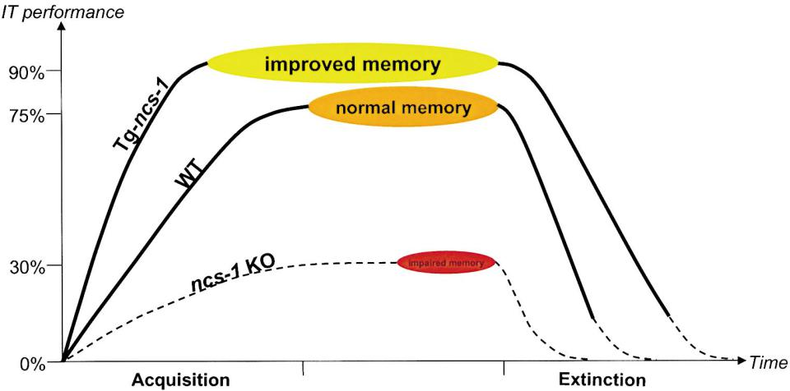

function is required in the AIY but not AFD or any other neurons.

Does an increased level of NCS-1 affect the IT behav-ior of WT animals? After generating transgenic lines overexpressing NCS-1 (Tg-*ncs-1*) using the *ncs-1* cDNA under the control of the *ncs-1* promoter (presence of the construct determined by PCR), we measured the effect in thermotaxis. Figure 3B shows remarkably that NCS-1 overexpression significantly (p _ 0.018) in-creases IT thermotaxis performance (90% _ 10%, n _

1. as compared to WT animal behavior (75% _ 8%). These results demonstrate that the level of NCS-1 activ-ity can determine the efficiency of IT performance and establish that NCS-1 is likely to be essential to the be-havior and not merely permissive for IT.

To further characterize Tg-*ncs-1* worms, we studied their IT behavior performance in greater details and

Figure 5. Regulation of Associative Learning and Memory by NCS-1

The schematic view indicates that the amount of NCS-1 directly regulates IT behavior. The absence of the neuronal calcium sensor-1 (*ncs-1* KO) impedes the majority of worms from performing isothermal tracking behavior, whereas its presence (WT) allows it. Overexpression of NCS-1 (Tg-*ncs-1*) enhances performance levels, accelerates learning, and produces a memory with slower extinction. Slower extinction might reflect increased responsiveness of the AIY integrative neurons to [Ca2_]i stimuli. The amount of NCS-1 in the AIY neurons and the strength of Ca2_ stimulation are linked together to modulate associative learning and memory in *C. elegans*. The dotted lines represent hypothetical IT responses.

Neuron

246

compared it with WT worms. We determined the time needed for the acquisition (learning) and determined the extinction period (memory) of the associative informa-tion (presence of food at the temperature of 20_C). For acquisition experiments (Figure 4A), the worms were grown for at least 12 hr in presence of food at 25_C, and then were shifted individually for different time intervals onto a seeded plate at 20_C, and their IT behavior at 20_C was determined. As shown in Figure 4A, WT worms needed about 68 min to reach 50% of their maximal performance level, whereas Tg-*ncs-1* worms reached their 50% level after only 24 min. Overexpressing NCS-1 worms were therefore 2–3 times faster than the WT to learn the novel conditioning paradigm (food at 20_C). For both strains, a maximal level of performance was already reached after about 12 hr. For extinction experi-ments (Figure 4B), the worms were grown on seeded plates at 20_C for at least 18 hr, and then individual young adult worms were washed at 20_C, transferred onto unseeded plates at 20_C for different time intervals, and their IT behavior at 20_C was determined. As shown in Figure 4B, trained WT worms needed about 3 hr to lose 50% of their maximal performance level, whereas Tg-*ncs-1* worms lost 50% of their maximal level only after about 7 hr. Therefore, the extinction period of the associative paradigm (food at 20_C) was prolonged for at least twice as long with the NCS-1-overexpressing worms as compared to WT worms. For both strains, the return to a baseline level was achieved after about 18 hr. Together, these data indicated that an elevated amount of the NCS-1 calcium sensor protein enhances not only performance, but also learning and memory functions, via faster acquisition and longer retention (Figure 5).

**Discussion**

Reinforcement via faster acquisition together with higher final performance, not surprisingly, leads to mem-ories that are more persistent, and therefore are consis-tent with a longer retention period (Milner et al., 1998). However, if extinction is also a learning mechanism, then Tg-*ncs-1* worms need more time to react to the absence of one conditioning stimulus (i.e., food) that is likely to be linked to the level of [Ca2_]i signaling (see Figures 5 and 6).

Our loss-of-function and mosaic rescue data clearly demonstrate that the presence and amount of the cal-cium sensor NCS-1 in AIY neurons plays a central role in influencing Ca2_-dependent associative learning in *C.* *elegans* as demonstrated by its direct regulatory effectson IT behavior. We have been able to determine that calcium signaling or binding by NCS-1 is critical for this activity and that the NCS-1 signaling pathway is essential for performing IT behavior. As shown on the schematic diagram (Figure 6), NCS-1 could have a pre-synaptic role at the AIY interneuron synapses with AIZ and RIA or a postsynaptic function at the AFD/AIY syn-apses. The presynaptic activity of NCS-1 is supported by preliminary data indicating that increased levels of NCS-1 in the mouse hippocampus enhance LTP via a presynaptic facilitation (P. N. et al., unpublished data). Similarly, the increase of IT behavior observed when

Figure 6. Model for a Pre- or Postsynaptic Role of the Neuronal Calcium Sensor-1

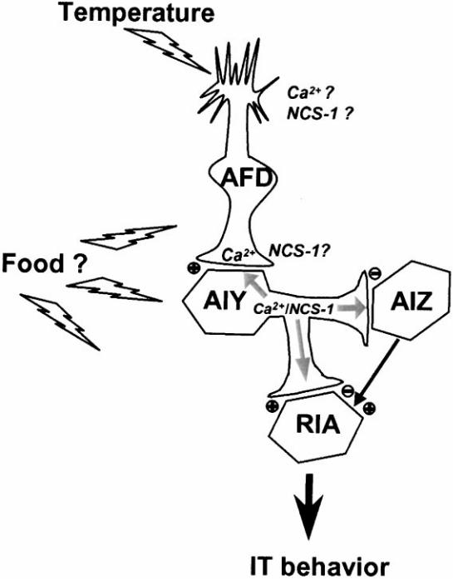

NCS-1 is present in the AFD and AIY neurons, either at the dendritic or axonal terminals, and its function in the AIY neurons is essential for IT behavior. In this model, the AIY interneuron serves as an integrator of food and temperature inputs, and the NCS-1 calcium sensor transduces calcium signals and regulates synaptic strength between AIY/AIZ and AIY/RIA cells at the presynaptic location or between AFD/AIY neurons in a postsynaptic location. The plus or minus sign indicates the presence of an excitatory or inhibitory synapse.

NCS-1 is overexpressed (Tg-*ncs-1* animals) may reflect a state where the AIY presynaptic terminals are maxi-mally stimulated. The observation of a presynaptic effect on overexpression of NCS-1 at the neuromuscular junc-tion of flies and frogs (Rivosecchi et al., 1994; Olafsson et al., 1995) supports this hypothesis and suggests a conserved function for NCS-1 through evolution. How-ever, the mechanisms by which NCS-1 regulates neuro-transmitter release and/or synaptic plasticity are not yet known. Clearly, the overall level of IT performance for the ncs-1 KO animals is still significant (30%), sug-gesting that other calcium sensors must be present.

Could the AIY interneuron serve as an integrator of food and temperature inputs in the form of Ca2_ signals provided by the AFD and surrounding cells? These sig-nals, detected by the neuronal calcium sensor NCS-1, could be transmitted to further downstream targets such as 3_:5_-cyclic nucleotide phosphodiesterase, calcineurin, nitric oxide synthase, potassium channels, or phospha-tidylinositol 4-OH kinase via mechanisms that could in-fluence AIY synaptic strength. Ca2_ signaling via NCS-1 therefore defines a novel pathway for the regulation of synaptic efficacy.

Together, these thermotaxis-enhanced or -deficient NCS-1 strains provide valuable tools to study synaptic plasticity at the molecular, cellular, and network levels

NCS-1 Regulates Associative Learning and Memory 247

using live animals, as well as a model that might well help to understand conserved functions such as long-term memory and associative learning across species.

**Experimental Procedures**

***Ce-ncs-1* Gene Expression**

The *ncs-1*::GFP reporter gene was constructed by subcloning a *ncs-1* 3100 bp promoter into the GFP expression vector pPD95.75(from A. Fire labs, Carnegie Institution of Washington, Department of Embryology, Baltimore, MD). Transgenic worms were generated as previously described (Mello et al., 1991). The marker *rol-6* (plas-mid pRF4) and the *ncs-1*::GFP construct were coinjected into go-nads of hermaphrodite animals. Aligning GFP fluorescence images with differential interference Nomarski images allowed the identifi-cation of *ncs-1*::GFP-positive cells (see Table 1).

**Preparation of the *ncs-1* Knockout Strain**

A homozygous mutant *ncs-1(pk242)* with a Tc1 insertion located at position 5231 relative to the *ncs-1* gene fragment was obtained by PCR screening of a Tc1 insertion library from R. Plasterk (Holland). Deletion derivatives were obtained as described in (Plasterk, 1995). A strain missing the genomic DNA region between exon 1 and 5 of the *ncs-1* gene was isolated (this deletion removed the first initiator ATG). This initial homozygous strain named XA401 *ncs-1(qa401te)* was backcrossed five times with N2 wild-type animals (final name XA406).

**Mutagenesis**

Site-directed mutagenesis was performed using the QuikChange Site–Directed Mutagenesis kit (Stratagene).

**Calcium Overlay**

45[Ca2_]-radioactive binding is readily detected with wild-type (WT) NCS-1, but not with the loss-of-function (lf) *Ce*-NCS-1. A protein control with Red Ponceau staining is shown. Five micrograms of recombinant purified WT NCS-1 or lf NCS-1 was run by electropho-resis on a 10% SDS–PAGE gel, blotted onto nitrocellulose mem-brane, and incubated with 45[Ca2_] followed by several washes, and were visualized by autoradiography for 48 hr (Maruyama et al., 1984).

**Electrophoretic Mobility of NCS-1**

Five micrograms of purified WT NCS-1 or lf NCS-1 were subjected to electrophoresis on 10% SDS–PAGE in the presence of 5 mM CaCl2 or 2 mM EGTA. Proteins were stained for visualization with Coomassie blue (Geiser et al., 1991).

**Thermotaxis Tracking Behavior Assay**

Briefly, 20–30 worms were grown overnight at a constant tempera-ture of 20_C (the conditioned stimulus) in presence of a fresh lawn of the bacteria strain OP50 (the unconditioned stimulus) on a 6 cm petri dish filled with a medium (NGM) consisting of 1.7% agar, 0.25% bacto peptone, 50 mM NaCl, 25 mM potassium phosphate, pH 6.0. Young adults were then transferred on to a fresh plate devoid of bacteria for 2 min. Individual worms were then deposited on a 9 cm petri dish containing 9 ml of NGM. A radial gradient of temperature was created by placing a vial containing frozen acetic acid on the bottom of the plate and incubating the plate at 26_C for 90 min in presence of a constant humidity of 60%. Upon removal of the animal from the plate, tracks left on the agar surface were photographed.

**Acknowledgments**

We are grateful to Thomas McKee and James R. Martin for critical reading of the manuscript. We would like to thank: Ralph Baumeister (Genzentrum, Munich) for providing the thermal avoidance experi-mental results; Oliver Hobert (Columbia University, New York) for providing the *ttx-3* AIY-specific promoter, Karin Brunschwig (Univer-sity of Fribourg) for *C. elegans* injection training; Ronald Plasterk (Hubrecht Laboratory, Netherlands) for providing the initial *ncs-1(pk242::Tc1)* mutant (NL748 strain), and the *Caenorhabditis* Genet-

ics Center (funded by the NIH National Center for Research Re-sources) for the wild-type *C. elegans* Bristol strain (N2).

Received January 10, 2001; revised February 15, 2001.

**References**

Bartlett, S.E., Reynolds, A.J., Weible, M., Jeromin, A., Roder, J., and Hendry, I.A. (2000). PtdIns 4-kinasebeta and neuronal calcium sensor-1 co-localize but may not directly associate in mammalian neurons. J. Neurosci. Res. *62*, 216–224.

Braunewell, K.H., and Gundelfinger, E.D. (1999). Intracellular neu-ronal calcium sensor proteins: a family of EF-hand calcium-binding proteins in search of a function. Cell Tissue Res. *295*, 1–12.

Cox, J.A., Durussel, I., Comte, M., Nef, S., Nef, P., Lenz, S.E., and Gundelfinger, E.D. (1994). Cation binding and conformational changes in VILIP and NCS-1, two neuron-specific calcium-binding proteins. J. Biol. Chem. *269*, 32807–32813.

De Castro, E., Nef, S., Fiumelli, H., Lenz, S.E., Kawamura, S., and Nef, P. (1995). Regulation of rhodopsin phosphorylation by a family of neuronal calcium sensors. Biochem. Biophys. Res. Commun. *216*, 133–140.

Fontana, G., and Blaustein, M.P. (1993). Calcium buffering and free Ca2_ in rat brain synaptosomes. J. Neurochem. *60*, 843–850.

Geiser, J.R., van Tuinen, D., Brockerhoff, S.E., Neff, M.M., and Davis, T.N. (1991). Can calmodulin function without binding calcium? Cell *65*, 949–959.

Hedgecock, E.M., and Russell, R.L. (1975). Normal and mutant ther-motaxis in the nematode Caenorhabditis elegans. Proc. Natl. Acad. Sci. USA *72*, 4061–4065.

Hendricks, K.B., Wang, B.Q., Schnieders, E.A., and Thorner, J. (1999). Yeast homolog of neuronal frequenin is a regulator of phos-phatidylinositol-4-OH kinase. Nat. Cell Biol. *1*, 234–241.

Hobert, O., Mori, I., Yamashita, Y., Honda, H., Ohshima, Y., Liu, Y., and Ruvkun, G. (1997). Regulation of interneuron function in the C. elegans thermoregulatory pathway by the ttx-3 LIM homeobox gene. Neuron *19*, 345–357.

Iacovelli, L., Sallese, M., Mariggio, S., and de Blasi, A. (1999). Regula-tion of G-protein-coupled receptor kinase subtypes by calcium sen-sor proteins. FASEB J. *13*, 1–8.

Martone, M.E., Edelmann, V.M., Ellisman, M.H., and Nef, P. (1999). Cellular and subcellular distribution of the calcium-binding protein NCS-1 in the central nervous system of the rat. Cell Tissue Res. *295*, 395–407.

Maruyama, K., Mikawa, T., and Ebashi, S. (1984). Detection of cal-cium binding proteins by 45Ca autoradiography on nitrocellulose membrane after sodium dodecyl sulfate gel electrophoresis. J. Bio-chem. *95*, 511–519.

McFerran, B.W., Graham, M.E., and Burgoyne, R.D. (1998). Neuronal Ca2_ sensor *1*, the mammalian homolog of frequenin, is expressed in chromaffin and PC12 cells and regulates neurosecretion from dense-core granules. J. Biol. Chem. *273*, 22768–22772.

Mello, C.C., Kramer, J.M., Stinchcomb, D., and Ambros, V. (1991). Efficient gene transfer in C.elegans: extrachromosomal mainte-nance and integration of transforming sequences. EMBO J. *10*, 3959–3970.

Milner, B., Squire, L.R., and Kandel, E.R. (1998). Cognitive neurosci-ence and the study of memory. Neuron *20*, 445–468.

Mori, I. (1999). Genetics of chemotaxis and thermotaxis in the nema-tode Caenorhabditis elegans. Annu. Rev. Genet. *33*, 399–422.

Mori, I., and Ohshima, Y. (1995). Neural regulation of thermotaxis in Caenorhabditis elegans. Nature *376*, 344–348.

Nef, P. (1996). Neuron specific calcium sensors: the NCS subfamily. In Guidebook to the Calcium-Binding Proteins, M.R. Celio, ed. (Ox-ford: Sambrook and Tooze Publication), pp. 94–98, 112–114.

Olafsson, P., Wang, T., and Lu, B. (1995). Molecular cloning and functional characterization of the Xenopus Ca(2_)-binding protein frequenin. Proc. Natl. Acad. Sci. USA *92*, 8001–8005.

Paterlini, M., Revilla, V., Grant, A.L., and Wisden, W. (2000). Expres-

Neuron

248

sion of the neuronal calcium sensor protein family in the rat brain.

Neuroscience *99*, 205–216.

Plasterk, R.H. (1995). Reverse genetics: from gene sequence to

mutant worm. Methods Cell Biol. *48*, 59–80.

Pongs, O., Lindemeier, J., Zhu, X.R., Theil, T., Engelkamp, D., Krah-

Jentgens, I., Lambrecht, H.G., Koch, K.W., Schwemer, J., Rivosec-

chi, R., et al. (1993). Frequenin, a novel calcium-binding protein

that modulates synaptic efficacy in the drosophila nervous system.

Neuron *11*, 15–28.

Putkey, J.A., Sweeney, H.L., and Campbell, S.T. (1989). Site-directed

mutation of the trigger calcium-binding sites in cardiac troponin C.

J. Biol. Chem. *264*, 12370–12378.

Rivosecchi, R., Pongs, O., Theil, T., and Mallart, A. (1994). Implication

of frequenin in the facilitation of transmitter release in Drosophila.

J. Physiol. Lond. *474*, 223–232.

Schaad, N.C., de Castro, E., Nef, S., Hegi, S., Hinrichsen, R., Mar-

tone, M.E., Ellisman, M.H., Sikkink, R., Rusnak, F., Sygush, J., and

Nef, P. (1996). Direct modulation of calmodulin targets by the neu-

ronal calcium sensor NCS-1. Proc. Natl. Acad. Sci. USA *93*, 9253–

9258.

Wittenburg, N., and Baumeister, R. (1999). Thermal avoidance in

Caenorhabditis elegans: an approach to the study of nociception.

Proc. Natl. Acad. Sci. USA *96*, 10477–10482.

Yazejian, B., Sun, X.P., and Grinnell, A.D. (2000). Tracking presynap-

tic Ca2_ dynamics during neurotransmitter release with Ca2_-acti-

vated K_ channels. Nat. Neurosci. *3*, 566–571.

Yu, S., Avery, L., Baude, E., and Garbers, D.L. (1997). Guanylyl cy-

clase expression in specific sensory neurons: a new family of che-

mosensory receptors. Proc. Natl. Acad. Sci. USA *94*, 3384–3387.