[Industrial Crops & Products 154 (2020) 112697](https://doi.org/10.1016/j.indcrop.2020.112697)



Contents lists available at [ScienceDirect](http://www.sciencedirect.com/science/journal/09266690)



Industrial Crops & Products

journal homepage: [www.elsevier.com/locate/indcrop](https://www.elsevier.com/locate/indcrop)

Coculture with two *Bacillus velezensis* strains enhances the growth of *Anoectochilus* plants via promoting nutrient assimilation and regulatingrhizosphere microbial community

[T](http://crossmark.crossref.org/dialog/?doi=10.1016/j.indcrop.2020.112697&domain=pdf)



Mi Weia,b,c, Meng Zhangd, Guobing Huanga,c, Yuanyuan Yuana,c, Chunhua Fua,c, Longjiang Yua,c,*

1. *Institute of Resource Biology and Biotechnology, Department of Biotechnology, College of Life Science and Technology, Huazhong University of Science and Technology, Wuhan, 430074, China*
2. *Key Laboratory for Quality Control of Characteristic Fruits and Vegetables of Hubei Province, College of Life Science and Technology, Hubei Engineering University, Xiaogan, 432000, China*
3. *Hubei Engineering Research Center for Both Edible and Medicinal Resources, Wuhan, 430074, China*
4. *College of Biology, Hunan Province Key Laboratory of Plant Functional Genomics and Developmental Regulation, Hunan University, Changsha, 410082, China*

ARTICLE INFO

*Keywords:*

*Anoectochilus* plants

*Bacillus velezensis*

Coculture

Growth

Bioactive compounds

ABSTRACT

The potentiality of PGPR and biocontrol bacteria in agriculture is steadily increased as it offers an attractive way to replace the use of chemical fertilizers, pesticides and other supplements. This study aimed to investigate the effects and potential mechanism of inoculation with two *Bacillus velezensis* strains on the growth and quality improvement of *Anoectochilus roxburghii* (Wall.) Lindl. (MRH) and *Anoectochilus formosanus* (Wall.) Lindl. (YYB). The control treatment was non-inoculated (CK) and the coculture treatments were inoculated with *Bacillus ve-lezensis* D2WM (D2), *Bacillus velezensis* ZJ-11 (ZJ-11), *Bacillus velezensis* D2WM and *Bacillus velezensis* ZJ-11(D2+ZJ-11). The fresh weight, plant length, amount of active compounds, as well as chlorophyll content were significantly increased under D2, ZJ-11, and D2+ZJ-11 treatments compared with MRH and YYB plants in CK. In particular, D2+ZJ-11 treatment resulted in the greatest growth promotion. In MRH and YYB plants, the fresh weight increased by 82.6 % and 106.6 %, the kinsenoside content increased by 9.33 % and 21.65 % per gram, and the flavonoid content increased by 44.70 % and 21.07 % per gram, respectively. D2WM and ZJ-11 were capable of secreting siderophore, phytase, indole-3-acetic acid (IAA), and zeatin to promote plant nutrient as-similation and growth. Moreover, when D2WM and ZJ-11 were both inoculated with *Anoectochilus roxburghii*, the rhizosphere soil enzyme activities of urease, phosphatase, and invertase were significantly higher than control, thus helped to provide more nutrients to *Anoectochilus*. Further, the analysis of microbial community diversity indicated the increase of abundance of beneficial microorganisms, such as nitrogen-fixing bacteria, Basidiomycota and Ascomycota both of which are known to fuel their plant partners with mineral nutrients from the soil. Additionally, the abundance of pathogens belonging to *Xanthobacteraceae* as well as *Cladophialophora* and *Penicillium* were reduced. Hence, coculture with beneficial microorganisms can improve the growth and quality of *Anoectochilus* plants via promoting nutrient assimilation and regulating rhizosphere microbial com-munity. This technique is of great application value in promoting the efficient cultivation and production of high-quality plant materials.

**1. Introduction**

*Anoectochilus roxburghii* (Wall.) Lindl. and *Anoectochilus formosanus* (Wall.) Lindl. are valued plant species in many Asian countries, known as *jinxianlian* in Chinese (Ye et al., 2017a, 2017b). Modern studies have shown that these species contain polysaccharides, flavones, organic acids, steroid compounds, alkaloids, and a variety of trace elements,



which have pharmacological activities, such as enhancing immunity, preventing liver injury and oxidation, and lowering blood sugar (Jiang et al., 2015; Kuan et al., 2011; Yang et al., 2017; Zeng et al., 2016). The domestic and international market demand for *Anoectochilus* increases because of its wide application in many fields, such as medicine, healthcare, beauty and drinking supplies; in this regard, industrial-scale application of *Anoectochilus* is expanding continuously, and it has

Corresponding author at: Institute of Resource Biology and Biotechnology, Department of Biotechnology, College of Life Science and Technology, Huazhong University of Science and Technology, Wuhan, 430074, China.

*E-mail address:* [yulongjiang@hust.edu.cn](mailto:yulongjiang@hust.edu.cn)(L.Yu).

<https://doi.org/10.1016/j.indcrop.2020.112697>

Received 21 January 2020; Received in revised form 9 June 2020; Accepted 11 June 2020

Available online 23 June 2020

0926-6690/ © 2020 Elsevier B.V. All rights reserved.

*M. Wei, et al.*

become one of the Chinese medicinal materials that are being rapidly developed in China (Jiang et al., 2015).

As a shade plant, *Anoectochilus* has strict requirements for its mi-croclimate environment. The plant is short, its root system is shallow, and it is located at the lowest layer of the community; as such, *Anoectochilus* has the lowest utilization rate of various ecological re-sources in its community. Soft rot, stem rot, grey mold, southern blight, and other diseases frequently occur during the cultivation of *Anoectochilus*. The death rate from stem rot is more than 90 %, causinghuge economic losses to growers (Chen et al., 2016). Chemical agents have long been used to prevent and control drug resistance, and pes-ticide residues have a serious impact on the edibility of *Anoectochilus*. This plant has low reproduction ability and poor survival competi-tiveness and can be easily infected by diseases and pests during growth. Thus, the excellent chemical constituents and pharmacological activ-ities of this species are difficult to be efficiently accumulated and uti-lized. Microorganisms in the rhizosphere are related to plant growth, reproduction, metabolism, and other activities. As the microenviron-ment at the root and soil interface, the rhizosphere is the region where soil, root, and microorganisms closely combine and interact (Butler et al., 2003). The rhizosphere of medicinal plants includes beneficial microorganisms that promote plant growth, such as in plant transfor-mation and absorption of soil nutrients. However, this region also in-cludes harmful microorganisms that inhibit plant growth; such micro-organisms reduce the yield of medicinal crops through continuous cropping by autotoxicity, changing soil physical and chemical proper-ties, and reducing soil fertility. Therefore, combining rhizosphere mi-crobiome, crop epidermis (leaf) microbiome, and endosymbiome has become a hot topic in studying the influence and regulatory mechanism of the microbiome on important agronomic and pharmacodynamic traits of crops, such as disease resistance, stress resistance, yield, quality, and other physiological activities (Bai et al., 2017).

At present, research on the relationship between medicinal plants and rhizosphere microorganisms is still in the initial stage. The rhizo-sphere microbiome during the growth of *Anoectochilus* is rarely re-ported. Most studies have focused on the symbiotic culture of inner fungi and *Anoectochilus* in the seedling and tissue culture stages. Guo et al. (2000) investigated the isolation and biological activity of my-corrhizal fungi from *Anoectochilus*. Twenty-one species of mycorrhizal fungi were isolated from the roots of *Anoectochilus*. Six species of my-corrhizal fungi promoted the seed germination of *Gastrodia elata* BL. and *Dendrobiun brymerianun* Lindl. Five fungal species significantly promoted the growth of *A. roxburghii* seedlings; among which, *Epu-lorhiza sp.* AR-18 led to the highest rhizome thickening and plantgrowth (Guo et al., 2000). However, few studies have been conducted on the coculture of endophytic fungi or bacteria with *Anoectochilus* in greenhouse or under forest planting to improve the growth and meta-bolism of this plant.

Gram-positive *Bacillus* species are attractive PGPR and beneficial endophyte. They can provide an effective and environmentally sus-tainable method to protect crops and promote plant growth (Cao et al., 2018). For example, *Bacillus velezensis* strain FZB42 (formerly referred to as *Bacillus amyloliquefaciens*) produced a wide range of antibiotic compounds and indole-3-acetic acid (IAA) (Idris et al., 2007; Dunlap et al., 2015). *Bacillus velezensis* (formerly referred to as *Bacillus subtilis*) and *Bacillus megaterium* produced cytokinin (Arkhipova et al., 2007). Bacillus *velezensis* BAC03 enhanced growth on nine selected types of plants (Meng et al., 2016). Other PGPRs had the ability including fixing nitrogen, releasing phosphate and potassium, and carrying iron. They are beneficial for the absorption of nutrients and mineral elements in medicinal plants to promote growth. Artificially adding a beneficial microbial community to coculture with *Anoectochilus*, and establishing a stable and sustainable coculture system should play a role in pre-venting disease, promoting growth, and improving metabolites of this plant species. Through long-term experiments, our group has screened and identified a number of beneficial microorganisms and their

*Industrial Crops & Products 154 (2020) 112697*

combinations that can promote the growth and accumulation of active ingredients of *Anoectochilus*. This study aimed to evaluate the effects of two *Bacillus* strains, namely, *B. velezensis* D2WM and *B. velezensis* ZJ-11, on the morphology, active components, and photosynthetic pigments of *A. roxburghii* and *A. formosanus* and investigate the underlying me-chanisms during coculture. Results provide a basis for developing a new and efficient method for cocultivation of microorganisms with *Anoec-tochilus* and other economically valuable crops. This work also lays thefoundation for protecting the germplasm resources of *Anoectochilus* and promoting the green and sustainable development of the *Anoectochilus* industry.

**2. Materials and methods**

*2.1. Chemicals and reagents*

Methanol, acetonitrile, and acetic acid used for HPLC were pur-chased from Merck (Darmstadt, Germany). Pure water was purified using a Milli-Q system. Methanol of analytical grade employed for ex-traction was purchased from DaMao Chemical Reagent Factory, Tian Jin, China. The D-glucose standard substance was purchased from Aladdin Biochemical Technology Co., Ltd (Shanghai, China). The quercetin, kaempferol, isorhamnetin and kinsenoside standard sub-stances were purchased from Sigma-Aldrich (St. Louis, MO, USA). All other reagents used in the experiments were of analytical grade.

*2.2. Plant materials, microorganisms, and culture conditions*

*A. roxburghii* (MRH) and *A. formosanus* (YYB) herbs were purchasedfrom Lincang Runxiang Jinxianlian Planting Co., Ltd. (23°88′ N; 100°08′ E) and identified by Prof. Maoteng Li at the Huazhong University of Science and Technology (Wuhan, China). The greenhouse conditions were set as photoperiod (day/night) of 12/12 h, air relative humidity of 75 %, and temperature of 22 °C – 28 °C. The soil used in the pot experiment was collected from the *Anoectochilus* planting base in Lincang city.

The strain D2WM, a plant growth-promoting rhizobacterium (PGPR) from the *Camellia oleifera* rhizosphere, was identified as *B. ve-lezensis* (formerly named *B. amyloliquefaciens* D2WM) (CCTCC NO.M2015623, China Center for Type Culture Collection) by 16S rRNA sequencing. The strain ZJ-11, an endophyte of walnut, was identified as *B. velezensis* (formerly named *B. methylotrophicus* ZJ-11) (CCTCC NO.M2018380, China Center for Type Culture Collection) by 16S rRNA sequencing. D2WM and ZJ-11 were grown on LB liquid medium in an artificial vibrating incubator at 30 °C and 180 rpm for 24 h prior to inoculation.

The plants were subjected to four different culture conditions for 60 days. For the D2 group, the rhizosphere of each *A. roxburghii* was in-oculated with 2 mL of D2WM suspension (1.0 × 108 CFU/mL). For the ZJ-11 group, the rhizosphere of each *A. roxburghii* was inoculated with 2 mL of ZJ-11 suspension (1.0 × 108 CFU/mL). For the D2+ZJ-11 group, the rhizosphere of each *A. roxburghii* was inoculated with 1 mL of D2WM suspension and 1 mL of ZJ-11 suspension (1.0 × 108 CFU/ mL). Finally, for the control (CK) group, the rhizosphere of *A. roxburghii* was inoculated with 2 mL of sterilized water. The same treatments were performed with *A. formosanus.* The roots were irrigated once at 30 days in accordance with the same method mentioned above. Each treatment consisted of 10 pots with three replicates. All plants were kept well-irrigated and protected from bacterial pathogens and weeds.

*2.3. Morphological parameter measurement*

Ten plants were randomly selected from each treatment for eva-luation of morphological features (Ye et al., 2017a, 2017b). Fresh weight (FW), plant length, and numbers of leaves were measured (Table 1).

2

*M. Wei, et al.* *Industrial Crops & Products 154 (2020) 112697*

**Table 1**

Effects of different treatments on morphological traits of MRH and YYB.

|  |  |  |  |  |  |  |  |  |  |  |
| --- | --- | --- | --- | --- | --- | --- | --- | --- | --- | --- |
| Parameter | Plant variety | Treatments | |  |  |  |  |  |  |  |
|  |  |  |  |  |  |  |  |  |  |  |
|  |  | CK |  | D2 |  | ZJ-11 |  | D2+ZJ-11 | |  |
|  |  |  |  |  |  |  |  |  | |  |
| Length(cm) | MRH | 12.23 | ± 0.643 ab | 13.80 | ± 0.100 b | 11.57 | ± 0.961 a | 13.77 ± 1.770 b | |  |
| Total fresh weight(g) | YYB | 12.00 | ± 0.700 a | 11.8 ± 0.2000 a | | 12.033 ± 1.531 a | | 14.57 ± 0.252 b | |  |
| MRH | 0.981 | ± 0.179 a | 1.611 | ± 0.147 ab | 1.210 | ± 0.204 ab | 1.792 ± 0.538 b | |  |
| Number of leaves | YYB | 1.256 | ± 0.278 a | 1.763 | ± 0.726 ab | 1.940 | ± 0.293 ab | 2.595 ± 0.436 b | |  |
| MRH | 4.330 | ± 0.757 a | 4.000 | ± 0.000 a | 3.666 | ± 0.577 a | 5.000 ± 1.000 a | |  |
|  | YYB | 4.667 | ± 0.577a | 5.000 | ± 1.000 a | 4.667 | ± 0.577 a | 5.333 ± 1.155 a | |  |

Note: Values are the means ± SE of ten repeat assays. Data in columns with the different letters are significantly different P < 0.05, the same below.

*2.4. Bioactive compounds*

*2.4.1. Extraction and detection of polysaccharides*

Polysaccharides were extracted using a previously described method with slight modifications (Shi, 2016). Polysaccharide content was determined by phenol–sulfuric acid method (Ye et al., 2017a, 2017b).

*2.4.2. Extraction and detection of quercetin, kaempferol, and isorhamnetin* Quercetin, kaempferol, and isorhamnetin were extracted and de-tected using a previously described procedure with slight modifications (Duy, 2018; Zhu et al., 2018). Analysis was performed using an Agilent HPLC (1260) and G6500 Series Q-TOF with a C18 column (4.6 × 150 mm, 5 μm) (Agilent Technologies Inc., USA). The solvent system consisted of methanol and 0.4 % acetic acid solution (50: 50, V/

1. with a flow rate of 0.5 mL/min over 30 min at 30 °C. Quercetin, kaempferol, and isorhamnetin were detected using a UV detector at 360 nm.

*2.4.3. Extraction and detection of kinsenoside*

Kinsenoside was extracted and detected using a previously de-scribed method with slight modifications (Cheng et al., 2015). Kinse-noside content was determined by methanol–ultrasonic method. The extract solutions were filtered through a 0.22 μm membrane filter and stored at 4 °C for HPLC analysis.

HPLC analysis was performed on a Dionex UltiMate 3000 HPLC system (Dionex UltiMate, USA) consisting of a quaternary pump, a vacuum degasser, a thermostatted column compartment, and a 20 μL automatic injector and equipped with an Alltech 2000 evaporative light-scattering detection (ELSD) detector (Alltech Associates, Deerfield, IL, USA) and an HP Chemstation for data analysis. The Hypersil NH2-column (4.6 mm × 250 mm, 5 μm) was employed, and the mobile phase consisted of acetonitrile and water (92:8 v/v) run in isocratic mode at a flow rate of 0.8 mL/min. The column temperature was maintained at 30 °C. The injection volume was 10 μL. The tem-perature of the heated drift tube was 80 °C. The carrier gas was high-purity nitrogen, and the gas flow rate was 2.5 mL/min for the ELSD.

*2.5. Photosynthetic pigment content*

The contents of photosynthetic pigment (i.e., Chl a, Chl b, Chl a + b, and Chl a/b) were determined according to the method of Ye and Porra. (Porra, 2002; Ye et al., 2017a, 2017b).

*2.6. Analysis of the functional metabolites of D2WM and ZJ-11*

Phosphorus dissolution, phytase secretion, and ferriophilic capacity of the two strains were characterized following a previously described method (Liu, 2014). Plant growth regulators such as indole-3-acetic acid (IAA), zeatin, and gibberellin were detected as follows: 0.5 mL of the fermentation liquor of D2WM and ZJ-11 was inoculated in 50 mL of LB medium. The cultures were incubated on a rotary shaker (180 rpm)

at 30 °C for 18 h. After centrifugation at 10,000×*g* for 5 min, the cul-ture supernatants were filtered through 0.22 μm microfiltration mem-brane and extracted with ethyl acetate. The ethyl acetate phase was vacuum dried using Sy-2,000 Rotavapor (Ya Rong Biochemical Instru-ment Factory, Shanghai, China) at 37 °C and dissolved with 1 mL of methanol.

HPLC analysis of IAA, zeatin, and gibberellin was performed on an Agilent 1200 system equipped with a C18 column (4.6 mm × 150 mm,

5 μm). The solvent system was methanol and 0.075 % acetic acid aqueous solution (45:55, v/v) with a flow rate of 0.7 mL/min at 30 °C for 20 min. Metabolites were detected using a UV detector at 218, 270, and 200 nm.

*2.7. The rhizosphere soil enzyme assay*

The urease, phosphatase and invertase assay were performed ac-cording to the method as described by Tabatabai and Bremner (1969) and (1972), and Chendrayan et al. (1980) respectively.

*2.8. Analysis of microbial diversity*

Rhizosphere was collected after the *A. roxburghii* plants had grown for 0 and 60 days under D2+ZJ-11 treatment. The samples were re-frigerated at −80 °C for further use. Total DNA of each sample was extracted and verified to be qualified. Primers 338 F (5′-ACTCCTACG GGAGGCAGCAG-3′) and 806R (5′-GGACTACHVGGGTWTCTAAT-3′) were used to amplify the V3–V4 region of the bacterial 16S rDNA (Zhang et al., 2016). Primers ITS1F (5′-CTTGGTCATTTAGAGGAAG TAA-3′) and ITS2R (5′- GCTGCGTTCTTCATCGATGC-3′) were used to amplify the ITS region sequence of the fungal rRNA. Then pooling, gel purification, library construction and sequencing was carried out in sequence using qualified DNA samples. Purified amplicons were pooled in equimolar and paired-end sequenced (2 × 300) on an Illumina MiSeq platform (Illumina, San Diego, USA) according to the standard proto-cols by Majorbio Bio-Pharm Technology Co. Ltd. (Shanghai, China). The raw 16S rRNA gene sequencing reads were demultiplexed, quality-filtered by Trimmomatic and merged by FLASH.

*2.9. Statistical analysis*

All measurements were performed three times and reported as means ± standard errors. ANOVA was performed, and mean ± standard errors were evaluated by Duncan’s multiple-range test by using SPSS version 22.0 (SPSS Inc., Chicago, IL, USA). A p-value of < 0.05 was considered statistically significant.

**3. Results**

*3.1. Morphological traits*

Different culture conditions affected the morphological traits of MRH and YYB (Fig. 1). For MRH plants, treatments with D2 and

3

*M. Wei, et al.* *Industrial Crops & Products 154 (2020) 112697*

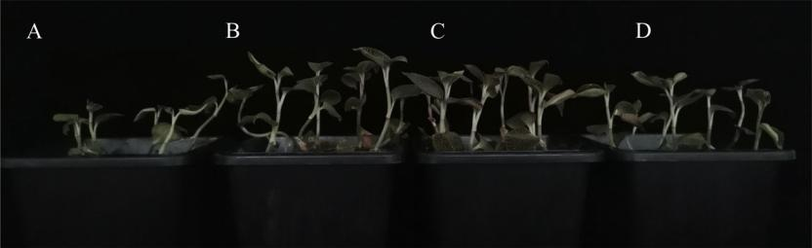

**Fig. 1.** Effects of different treatments on the morphological traits in*Anoectochilus roxburghii*(MRH). A: Control treatment; B: D2+ZJ-11 treatment; C: D2 treatment;

D: ZJ-11 treatment.

D2+ZJ-11 significantly increased the length (\**p* < 0.05) from 12.23 cm (CK) to 13.80 cm (D2) and 13.77 cm (D2+ZJ-11), respectively (Table 1). Moreover, D2, ZJ-11, and D2+ZJ-11 treatments significantly increased the total FW (\**p* < 0.05) from 0.981 g (CK) to 1.611 g (D2), 1.210 g (ZJ-11), and 1.792 g (D2+ZJ-11), respectively. For YYB plants, D2 and ZJ-11 treatments increased the total FW to a certain extent (\**p* < 0.05) from 1.256 g (CK) to 1.763 g (D2) and 1.940 g (ZJ-11), respectively. Furthermore, D2+ZJ-11 treatment significantly increased the fresh weight (\**p* < 0.05). Overall, the two *Bacillus* strains did not increase the number of leaves, and the combined treatment (D2+ZJ-

1. had stronger effect on the growth promotion of*Anoectochilus* plants than individual strain.

*3.2. Amount of bioactive compounds*

When the two *Bacillus* strains were cocultured with MRH and YYB, the contents of polysaccharides decreased and those of kinsenoside and the three flavonoids generally increased (Fig. 2). After D2, ZJ-11, and D2+ZJ-11 treatments, the polysaccharide content of MRH decreased from 12.348 % to 10.813 %, 10.214 %, and 7.959 %, respectively. The D2 treatment resulted in the least reduction in the polysaccharide content in MRH, whereas the D2+ZJ-11 treatment resulted in the highest reduction in the polysaccharide content. In YYB, under the ZJ-11 and D2+ZJ-11 treatments, the polysaccharide content decreased from 23.394 % to 18.113 % and 19.365 %, respectively. When D2WM was added, the polysaccharide content in YYB did not significantly decrease (\**p* < 0.05).

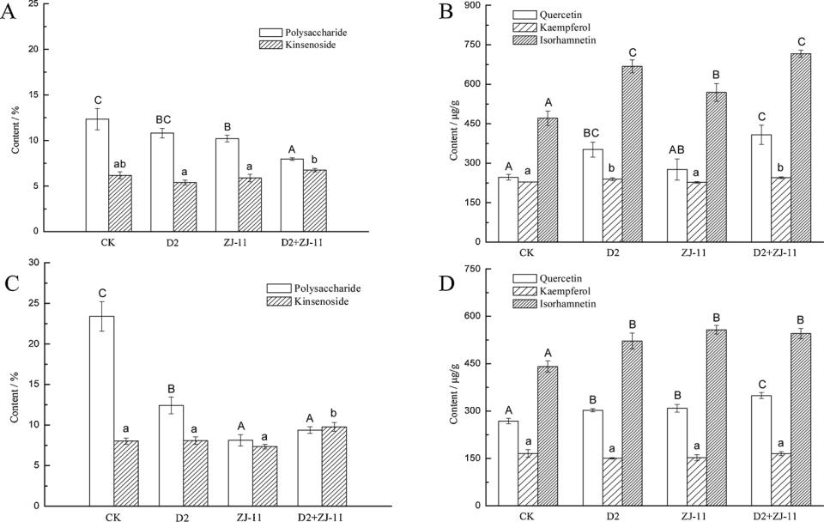

Coculture with D2WM and ZJ-11 in MRH and YYB resulted in the greatest increase in the kinsenoside content, with corresponding values of 9.33 % and 21.65 %. Among the three flavonoids, the change in the kaempferol content was consistent, and the increase in the iso-rhamnetin content was the largest. The isorhamnetin content of MRH treated with D2 and D2+ZJ-11 increased by 41.89 % and 52.10 %, compared with that in the control group. When YYB was cocultured with D2, ZJ-11, and D2+ZJ-11, the isorhamnetin content increased by 18.33 %–26.35 %. These results showed that the two *Bacillus* strains affected the accumulation of the active compounds in MRH and YYB.

*3.3. Photosynthetic pigment content*

The coculture of different microorganisms with MRH and YYB sig-nificantly affected the chlorophyll content (Table 2). The contents of Chl a, Chl b, and Chl a + b in MRH and YYB were higher in the D2+ZJ-11 treatment than that in the D2 and ZJ-11 treatments as well as CK. Moreover, the chlorophyll content in YYB was larger than that in MRH. The Chl a/b value increased when the microorganisms were cocultured with MRH but did not increase significantly in the coculture with YYB. This result indicated that the coculture of beneficial microorganisms more strongly affected the photosynthetic system of MRH than YYB.

*3.4. Analysis of the functional metabolites of D2WM and ZJ-11*

D2WM and ZJ-11 could secrete phytase and siderophore, and the former can also dissolve phosphorus (Table 3). The HPLC analysis

**Fig. 2.** Effects of different treatments on the active ingredients in*Anoectochilus roxburghii*(MRH) and*Anoectochilus formosanus*(YYB). A: polysaccharide and kin-

senoside of MRH; B: quercetin, kaempferol, and isorhamnetin of MRH; C: polysaccharide and kinsenoside of YYB; D: quercetin, kaempferol, and isorhamnetin of YYB.

4

*M. Wei, et al.* *Industrial Crops & Products 154 (2020) 112697*

**Table 2**

Effects of different treatments on photosynthetic pigments content of MRH and YYB leaves.

|  |  |  |  |  |  |  |  |  |  |  |
| --- | --- | --- | --- | --- | --- | --- | --- | --- | --- | --- |
| Parameter | Plant variety | Treatments |  |  |  |  |  |  |  |  |
|  |  |  |  |  |  |  |  | |  |  |
|  |  | CK | D2 |  | ZJ-11 |  | D2+ZJ-11 | | |  |
|  |  |  |  |  |  |  |  |  | |  |
| Chl a (mg g−1 FW) | MRH | 0.119 ± 0.002 a | 0.493 | ± 0.424 b | 0.722 | ± 0.101 c | 0.856 | ± 0.025 d | |  |
| Chl b (mg g−1 FW) | YYB | 0.859 ± 0.049 a | 0.948 | ± 0.074ab | 1.066 | ± 0.051 bc | 1.159 | ± 0.060 c | |  |
| MRH | 0.079 ± 0.004 a | 0.217 | ± 0.011 b | 0.326 | ± 0.015 c | 0.420 | ± 0.407 d | |  |
| Chl a+b(mg g−1 FW) | YYB | 0.353 ± 0.049 a | 0.418 | ± 0.034 a | 0.416 | ± 0.033 a | 0.423 ± 0.031 a | | |  |
| MRH | 0.197 ± 0.058 a | 0.717 | ± 0.041 b | 1.049 | ± 0.005 c | 1.277 | ± 0.027 d | |  |
| Chl a/b | YYB | 1.212 ± 0.098 a | 1.366 | ± 0.070 ab | 1.481 | ± 0.076 b | 1.582 | ± 0.087 b | |  |
| MRH | 1.515 ± 0.066 a | 2.265 | ± 0.107 b | 2.219 | ± 0.131 b | 2.055 | ± 0.025 b | |  |
|  | YYB | 2.449 ± 0.213 a | 2.280 | ± 0.295 a | 2.568 | ± 0.157 a | 2.744 ± 0.127 a | | |  |
|  |  |  |  |  |  |  |  |  |  |  |

**Table 3**

Functional metabolites analysis of D2WM and ZJ-11.

|  |  |  |
| --- | --- | --- |
|  | D2WM | ZJ-11 |
|  |  |  |
| Phytase | + | + |
| Soluble phosphorus ability | + | – |
| Siderophore | + | + |
| Indole -3- acetic acid | 3.027 mg/L | 1.06 mg/L |
| Zeatin | 0.247 mg/L | 4.41 mg/L |
| Gibberellin | – | – |

Note: “+” means it has the ability, “-” means it doesn't have the ability.

showed that D2WM and ZJ-11 secreted IAA and zeatin. The amounts of IAA produced in D2WM and ZJ-11 fermentation broth were 3.027 and 1.06 mg/L, respectively. ZJ-11 better produced zeatin than D2WM. Both strains did not produce gibberellin. Hence, D2WM and ZJ-11 produced various plant hormones for plant growth through their own metabolism. These hormones play a great role in promoting plant growth.

*3.5. Colonization characteristics of D2WM and ZJ-11 in rhizosphere of MRH*

An important prerequisite for functional microorganisms to play their roles is that they should colonize the rhizosphere or plants (Compant et al., 2010). In this regard, plasmids (p1300-35S-eGFP and pBROBE-TetR-mcherry) carrying green and red fluorescent protein genes were introduced into D2WM and ZJ-11, respectively. The colo-nization of D2WM-gfp and ZJ-11-mcherry was monitored in the root and rhizosphere soil of *A. roxburghii* (Fig. 3). After 21 days of coculture, D2WM-gfp and ZJ-11-mcherry successfully colonized the rhizosphere and root hairy area of *A. roxburgh*ii. D2WM was (5.27 ± 0.589) × 103 CFU/g after 28 days, whereas ZJ-11 was (5.73 ± 0.659) × 103 CFU/g after 21 days.

As shown in Fig. 3, the rings and borders with green fluorescence (arrows pointed to in C and D) and red fluorescence (arrows pointed to in E and F) are the aggregation state of D2WM-gfp and ZJ-11-mcherry around root hairs and the biofilm formed. Successful colonization en-sured that the two *Bacillus* strains could play a role in promoting growth and improving quality in the coculture system with *A. roxburghii*.

The ability of D2WM and ZJ-11 to form aggregates or biofilms in-dependently and mix together was analyzed. D2WM-gfp cultured alone formed a small number of aggregates (Fig. S1A and B), whereas ZJ-11-mcherry cultured alone did not form aggregates (Fig. S1C and D). Thus, D2WM was more capable of forming biofilms than ZJ-11. However, after reducing the number of D2WM-gfp and ZJ-11-mcherry to 50 % and then in the mixed culture, the number of D2WM-gfp and ZJ-11-mcherry aggregates increased significantly. In particular, the aggregate of D2WM-gfp under the coculture condition (Fig. S1E and F) increased more than that under the single culture condition (Fig. S1A and B). Moreover, the aggregate of ZJ-11-mcherry was significantly more than that under the single culture condition. This result suggested that the

mixed culture of the two bacterial strains easily formed aggregates or biofilms than the single culture. The presence of ZJ-11 significantly promoted the formation of aggregates or biofilms of D2WM.

*3.6. Effect of D2WM and ZJ-11 on the rhizosphere soil enzyme activity in the pot*

The rhizosphere soil of *A. roxburghii* cultured with and without the additional microorganisms for 60 days was collected and analyzed to determine the effects of the addition of beneficial microorganisms D2WM and ZJ-11 on the soil enzyme activity in the rhizosphere. The activities of urease, phosphatase, and invertase in D2+ZJ-11 treatment were significantly higher than that in the control (Table 4). Urease can catalyze urea to produce ammonia, which is one of the sources of ni-trogen needed for plant growth (Tabatabai and Bremner, 1972). The activities of urease suggested that the coculture of D2WM and ZJ-11 helped soil in fixing nitrogen and provided plants with adequate source of nitrogen. Phosphatase promotes the transformation of phosphorous organic compounds in soil (Nannipieri et al., 2011). In the present work, D2WM dissolved phosphorus, indicating that the soil added with beneficial microorganisms can provide P nutrients to plant. Sucrase plays an important role in increasing soluble nutrients in soil (Dick, 1994). The higher sucrase activity in the D2+ZJ-11 group (0.0153 ± 0.0007 mg/g) indicated higher soil fertility with the addi-tion of microorganisms. Thus, the coculture treatment increased the soil enzyme activity and fertility and promoted the growth of *A. roxburghii*.

*3.7. Effect of D2WM and ZJ-11 on the rhizosphere microbial community in the pot*

The rhizosphere soil of *A. roxburghii* cultured with and without additional microorganisms for 60 days was collected and analyzed to determine the effects of the addition of beneficial microorganisms D2WM and ZJ-11 on the microbial diversity. The coverages of samples were greater than 99 %. The sequencing results represented the real situation of microorganisms in the samples. The variation in the alpha diversity index indicated increased bacterial community richness and decreased fungal community richness after the addition of cocultured D2WM and ZJ-11 (Table S1). A previous study showed that the re-duction in fungal abundance was associated with increased ability to suppress *Fusarium* wilt, and the increase in bacterial abundance was beneficial to the inhibition of pathogenic bacteria (Fu et al., 2017). The diversity of bacterial and fungal communities declined slightly. This result indicated that the addition of beneficial microorganisms D2WM and ZJ-11 inhibited the number and species of fungi in rhizosphere soil.

Figs. 4 and S2 show the structure of bacterial communities and their difference between soil without any microorganisms (W) and soil in-oculated with D2WM and ZJ-11(W + Mic) for 60 days after planting *A.* *roxburghii*. Among the 15 phyla, Proteobacteria, Actinobacteria, andAcidobacteria were the most abundant. These results were similar to the rhizosphere bacterial microbiome of field-grown poplar trees (Beckers et al., 2017). Firmicutes accounted for less than 1% of the total

5

*M. Wei, et al.* *Industrial Crops & Products 154 (2020) 112697*

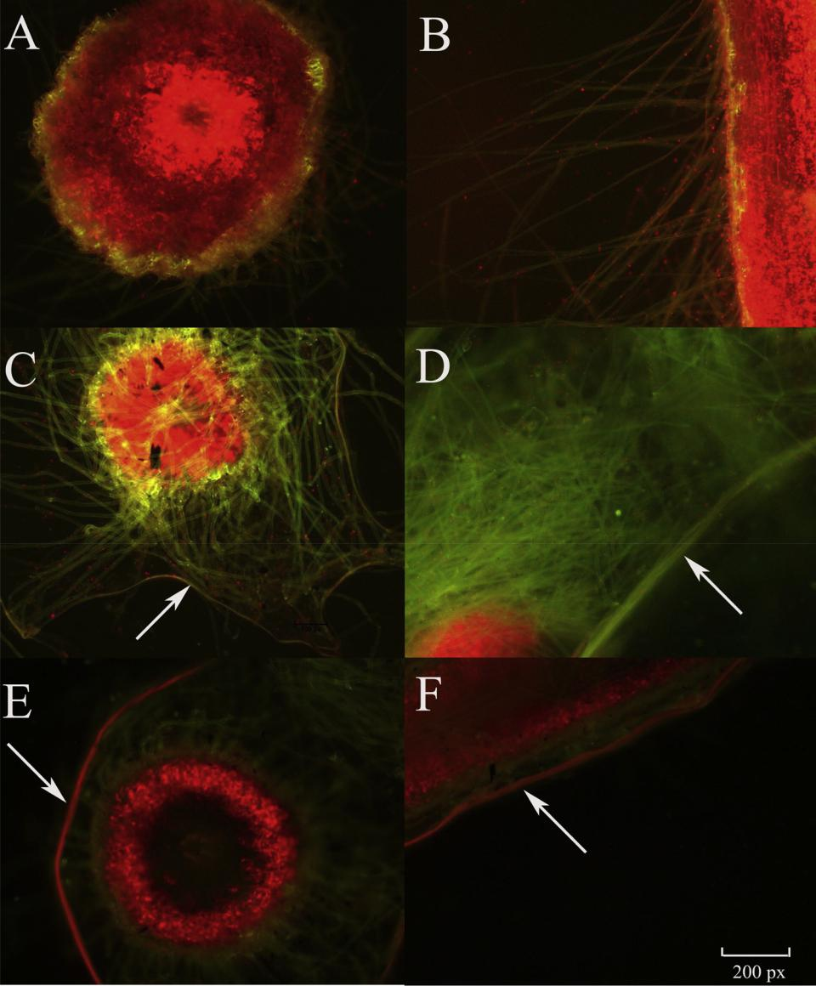

**Fig. 3.** The colonization effects of D2WM-gfp and ZJ-11-mcherry on the roots of*A. roxburghii.*A and B: Stem cross section and longitudinal section of*A. roxburghii*

without coculture; C and D: Stem cross section and longitudinal section of *A. roxburghii* cocultured with D2WM-gfp; E and F: Stem cross section and longitudinal section of *A. roxburghii* cocultured with ZJ-11-mcherry (40×).

**Table 4**

Effects of D2WM and ZJ-11 on the rhizosphere soil enzyme activity of MRH in the pot.

|  |  |  |  |
| --- | --- | --- | --- |
| Soil enzyme activity | Treatments |  |  |
|  |  |  |  |
|  | CK | D2+ZJ-11 | |
|  |  |  |  |
| Urease (mg/g) | 0.0082 ± 0.0028 | 0.0223 ± 0.0084 |  |
| Phosphatase (mg/g) | 0.3489 ± 0.0334 | 2.2000 ± 0.1072 |  |
| Invertase (mg/g) | 0.0082 ± 0.0013 | 0.0153 ± 0.0007 |  |
|  |  |  |  |

bacterial community. *Bacillus* belongs to Firmicutes, and the number of Firmicutes in the soil increased significantly after co-culture with D2WM and ZJ-11 (\*\*\**p* < 0.001). Chloroflexi is one of the phyla of bacteria that produce energy by photosynthesis and is formerly known as “Green non-sulfur bacteria.” These microorganisms have been re-cognized as a typical ubiquitous bacterial taxon containing a number of diverse environmental 16S rRNA gene clones and a limited number of cultured representatives (Rappé and Giovannoni, 2003). After the

addition of D2WM and ZJ-11, the abundance of this bacterium de-creased significantly (\*\*\**p* < 0.001) from 13.18 % to 2.922 %. Planctomycetes is important to the global nitrogen cycle and sewage treatment. The so-called “anammox” planctomycetes have a unique role in of oxidizing ammonium in anaerobic and autotrophic metabolism (Fuerst and Sagulenko, 2011). After 60 days of coculture with *A. rox-burghii* and D2WM + ZJ-11, the abundance of this bacterium increasedslightly from 3.851 % to 4.048 %. At the genus level, the addition of D2WM + ZJ-11 significantly increased the abundance of *Acidothermus* (\*\*\**p* < 0.001, Fig. 4B). This bacterium can secrete endo-1, 4-b-d-glucanase, which degrades cellulose (Biswas et al., 2006). By contrast, the abundance of *Xanthobacteraceae* was greatly reduced, which con-tained some pathogens. This phenomenon may be due to the fact that D2WM can produce polyketide that antagonizes pathogenic bacteria, thereby reducing their number (Chen et al., 2019).

Figs. 5 and S2 show the structure of the fungal communities and their difference between soil without any microorganisms (W) and soil inoculated with D2WM and ZJ-11 (W + Mic) after planting *A. roxbur-ghii* for 60 days. At the phylum level, the abundance of Basidiomycota,

6

*M. Wei, et al.* *Industrial Crops & Products 154 (2020) 112697*

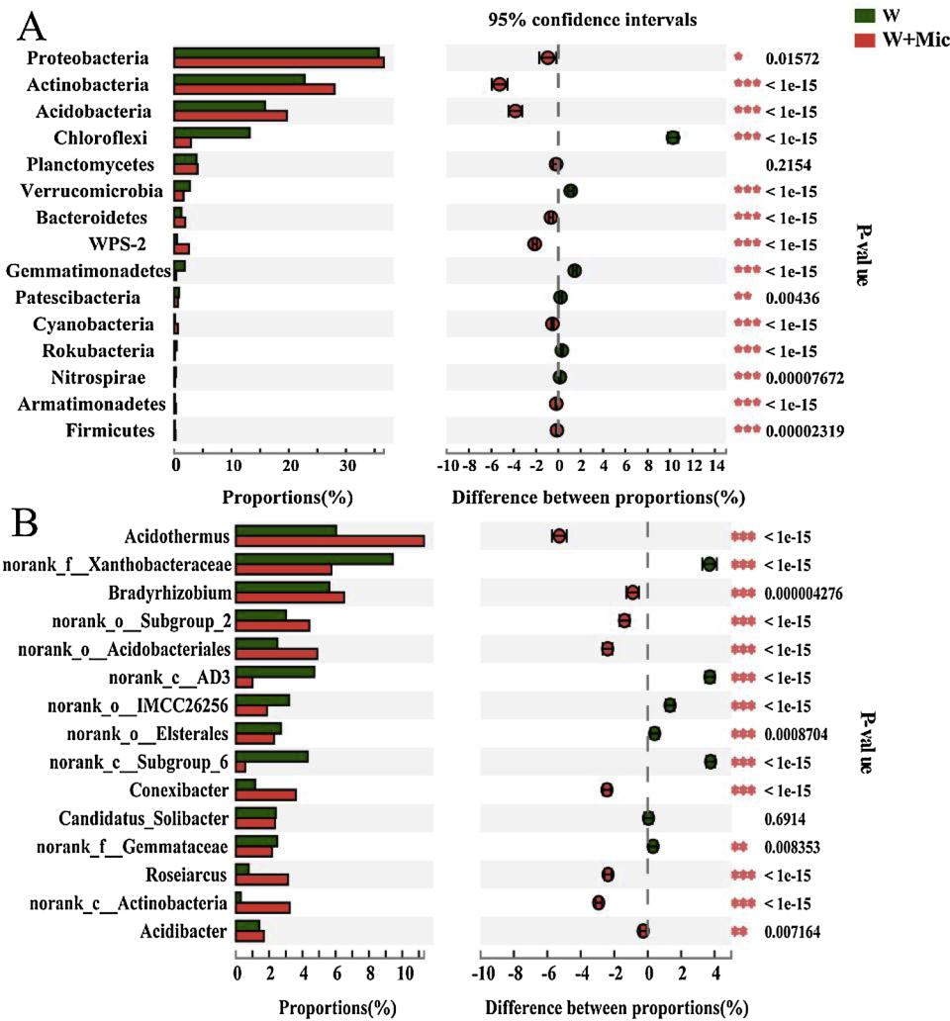

**Fig. 4.** Map of the composition of bacterial community in soil without addition of any microorganisms (W) and with the addition of D2WM and ZJ-11 after 60 days(W + Mic). A: phylum level; B: genus phylum level.

Ascomycota, and Mortierellomycota was absolutely dominant, similar to reports in literature (Li et al., 2019). Species belonging to the three groups occur in a wide range of habitats and are often dominant in soil fungal communities. Moreover, the number of Basidiomycota and As-comycota increased significantly after adding beneficial microorgan-isms (\*\*\**p* < 0.001, Fig. 5A). Studies reported that some Basidiomy-cota and Ascomycota formed ectomycorrhizae, which are associated with the roots of vascular plants (Smith and Read, 1997). Ectomycor-rhizal Basidiomycota help their plant partners to obtain mineral nu-trients from the soil, and in return they receive sugars produced by plants through photosynthesis. As such, the addition of D2WM and ZJ-11 further helped *A. roxburghii* plants to absorb mineral elements in soil by increasing the number of fungi that can form ectomycorrhizae. At the genus level, the addition of D2WM and ZJ-11 significantly increased the abundance of *Ruinenia* and *Saitozyma* and reduced the abundance of *Cladophialophora* and *Penicillium* (\*\*\**p* < 0.001,Fig. 5B)*. Cladophialo-phora bantiana* is the causative agent of numerous cases of cerebralphaeohyphomycosis; many of which occur in immunocompetent in-dividuals and are fatal (Kantarcioglu et al., 2016). *Pencillium* fungi are post-harvest pathogens. *Penicillium* is one of the most common causes of fungal spoilage in fruits and vegetables. This result might be due to the fact that certain secondary metabolites secreted by D2WM and ZJ-11 could inhibit such pathogens.

*3.8. Comparison of traditional cultivation and new planting pattern*

Traditional and new planting methods were compared on 1 ha pilot-scale land. The tested parameters are listed in Table 5. In China, the costs of 500 g of fresh *A. roxburghii* were approximately 420 USD for wild plants and 250 USD for cultivated plants in 2017 (Luo et al., 2018). At present, the price of 500 g of fresh *A. roxburghii* is adjusted to about 75 USD for wild plants and 30 USD for cultivated plants. Approximately 2.25–3.0 million plants can be planted per hectare. Hence, compared with the traditional process, the yields of MRH and YYB plants in-creased by 82.6 % and 106.6 % on 1 ha of land, generating at least an additional 114.8 × 103 USD and 189.4 × 103 USD in economic bene-fits, respectively. The corresponding active ingredients such as poly-saccharides, kinsenoside, and flavonoids were improved to different degrees. However, the proposed method involved small cost due to microbial fermentation. Overall, the economic benefits are consider-able, and the new method has a great value in agricultural applications.

**4. Discussion**

*Bacillus* species have been increasingly used in farming systemsbecause they can form stable endospores that can survive the pre-paration of bacterial formulations (Piggot and Hilbert, 2004). Many PGPRs have the potential to prevent diseases and promote plant growth (Silo-Suh et al., 1998). For example, *B. amyloliquefaciens* FZB42 could

7

*M. Wei, et al.* *Industrial Crops & Products 154 (2020) 112697*

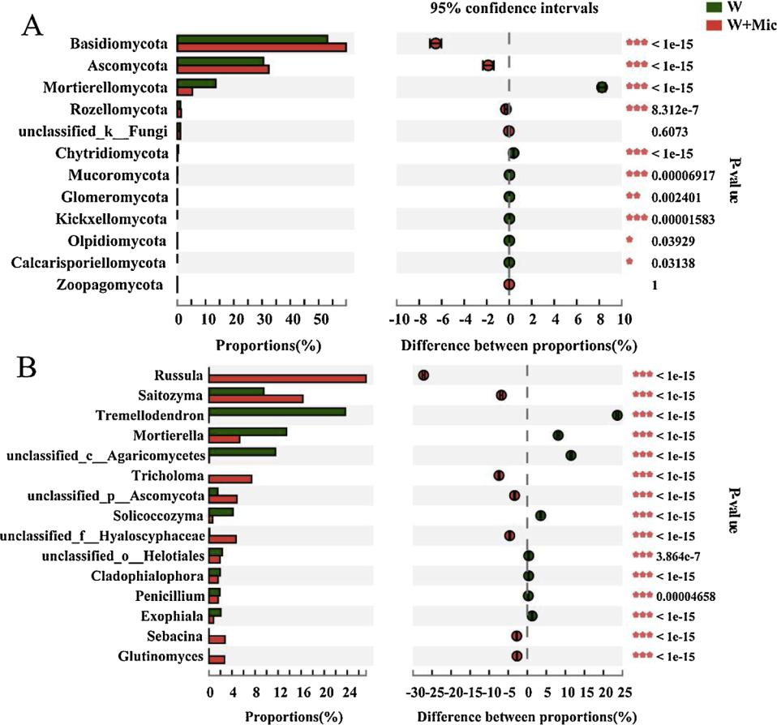

**Fig. 5.** Map of the composition of fungal community in soil without addition of any microorganisms (W) and with the addition of D2WM and ZJ-11 after 60 days(W + Mic). A: phylum level; B: genus phylum level.

**Table 5**

Comparison of parameters for the traditional and the new planting methods.

|  |  |  |  |  |  |  |  |
| --- | --- | --- | --- | --- | --- | --- | --- |
|  | Traditional method (CK) |  |  | New method (D2+ZJ-11) |  |  |  |
|  |  |  |  |  |  |  |  |
|  | MRH | YYB |  | MRH | YYB | |  |
|  |  |  |  | |  |  |  |
| Fresh weight (g/plant) | 0.981 | 1.256 | 1.792 | | 2.595 |  |  |
| The yield of fresh *Anoectochilus* (kg/ha) | 147.2−196.2 | 188.4−251.2 |  | 268.8−358.4 | 389.2−519.0 | |  |
| 3 | 138.6−185.0 | 177.6−236.8 |  | 253.4−337.8 | 367.0−489.3 | |  |
| Economic benefits (10 USD/ha) |  |  |
| Polysaccharide yield(kg/ha) | 27.25−36.34 | 66.11−88.15 |  | 32.09−42.79 | 113.1−150.8 | |  |
| Kinsenoside yield(kg/ha) | 13.63−18.18 | 22.69−30.25 |  | 27.22−36.30 | 57.02−76.03 | |  |
| Flavonoid yield (g/ha) | 208.8−278.4 | 247.4−329.9 |  | 551.8−735.8 | 617.1−822.8 | |  |
|  |  |  |  |  |  |  |  |

exhibit beneficial effects on plant growth and disease suppression in tomato, maize, and cotton (Gül et al., 2008; Idris et al., 2004; Yao et al., 2006). In the present work, two beneficial *Bacillus* strains were first used in coculture with *Anoectochilus* to improve plant yield.

The two *Bacillus* strains could promote the growth and photo-synthetic pigment synthesis of *A. roxburghii* and *A. formosanus* (Tables 1 and 2). The increased chlorophyll content could be due to enhanced stomatal conductance, photosynthesis, and transpiration (Levy and Krikun, 1980) coupled with effective synergism of various microbial inoculants (Baqual et al., 2005). Moreover, the combined treatment (D2+ZJ-11) had a stronger growth-promoting effect. Other studies reported that microbial combinations can perform tasks that are diffi-cult or impossible for a single microbe, and beneficial bacterial com-binations are superior to a single strain in preventing diseases and promoting the growth of host plants (Finkel et al., 2017; Ikeda-Ohtsubo et al., 2018). Therefore, research on the artificial synthesis of beneficial microbial communities is important and challenging.

When the two *Bacillus* strains were cocultured with MRH and YYB, the content of kinsenoside and three flavonoids generally increased, but the content of polysaccharides decreased (Fig. 2). *A. roxburghii* contains flavonoids, polysaccharides, kinsenoside, alkaloids, sterols, organic acids, amino acids, trace elements, cardiac glycosides, and other active ingredients (Ye et al., 2017b). All the active ingredients should be re-sponsible for the potency of the plant. Among the active ingredients, kinsenoside is a characteristic component of *A. roxburghii* and accounts for this herb’s medicinal and edible values. Thus, the loss of poly-saccharides was not a complete indication of loss of quality.

Plant polysaccharides act as an environmental cue that triggers biofilm formation by the bacterium around the plant roots. Plant polysaccharides can serve as a carbon source to produce an extra-cellular matrix (Beauregard et al., 2013). Thus, slightly reduced con-tents of polysaccharides in *Anoectochilus* may be used by D2WM and ZJ-11 to aid their colonization and growth. Moreover, the biomass of *Anoectochilus* increased under the coculture conditions. Thus, the total

8

*M. Wei, et al.* *Industrial Crops & Products 154 (2020) 112697*

amount of polysaccharides produced from *Anoectochilus* did not de-crease but increased to different degrees (Table 5). Rahman et al. (2018) reported that plant probiotic bacteria *Bacillus* and *Para-burkholderia* improved the content of antioxidants, such as phenolics,carotenoids, flavonoids, and anthocyanins, in strawberry fruit. Ochoa-Velasco et al. (2016) also reported the effect of nitrogen fertilization and the addition of *Bacillus licheniformis* biofertilizer on the antioxidant contents of greenhouse-cultivated tomato fruits. These studies provide sufficient evidence that the addition of beneficial microorganisms could improve some active ingredients of cocultured crops.

Analysis of the functional metabolites of D2WM and ZJ-11 showed that they could secrete phytase, siderophore, IAA, and zeatin; more-over, D2WM can dissolve phosphorus (Table 3). Soil microbes can provide nutrients for plant growth, dissolve hard-to-dissolve phos-phorus in soil, and fix nitrogen under nonsymbiotic conditions (Zhang et al., 2018). Moreover, the utilization rate of iron in soil is improved by the generation of iron carriers secreted by microorganisms (Goudjal et al., 2016). D2WM and ZJ-11 exerted such functions, thereby en-hancing soil fertility and assisting *Anoectochilus* plants in nutrient ab-sorption and growth.

Many studies have reported on the secretion of growth hormones by endophytes, PGPRs, and other biocontrol bacteria. Idris et al. (2007) found that IAA in the culture filtrates of*B. amyloliquefaciens* FZB42 was one of the pivotal plant growth-promoting substances produced by this bacterium. Other study reported that PGPR promotes plant growth by producing spermidine and gibberellin (Xie et al., 2014; Forchetti et al., 2007). However, spermidine and gibberellin were not detected in the fermentation broth of D2WM and ZJ-11, indicating that the types and contents of plant growth hormones secreted by different probiotics were different. In addition, our previous studies showed that D2WM exhibited strong antimicrobial activity and high capacity to secrete some antibiotics (Chen et al., 2019). Hence, D2WM exhibits potential to prevent *Anoectochilus* from diseases.

Our results indicated that *B. velezensis* D2WM and *B. velezensis* ZJ-11 could colonize well in the rhizosphere of *A. roxburghii* (Fig. 3), and the two strains could promote each other to form a biofilm (Fig. S1). As such, the two strains were selected as probiotics in the coculture system with *Anoectochilus* plants. Other studies observed that the synergistic effects of multi-species biofilms can promote the formation of com-munity biofilms (Burmølle et al., 2006). Biofilm is a site where different bacteria exchange metabolites, and some of these bacteria use the metabolites of other bacteria as electron acceptor or donor (McGlynn et al., 2015). Xu et al. (2019) reported that antibiotic bacillomycin D affected iron acquisition and biofilm formation in*Bacillus velezensis* through a Btr-mediated FeuABC-dependent pathway. ZJ-11 also has a good ability to antagonize pathogenic fungi. We speculated that ZJ-11 can produce bacillomycin D or its analogs. Moreover, the critical sub-stances from ZJ-11 that promote D2WM biofilm formation and the underlying mechanism will be further studied.

Soil enzyme activity is the core in promoting soil material trans-formation and energy flow and can represent the material metabolism in soil; thus, it is one of the important indicators of soil fertility (Dick, 1994). In the present work, the effect of the addition of beneficial mi-croorganism on soil enzyme activity was analyzed. The activities of the three important enzymes in the soil significantly increased in D2+ZJ-11 treatment compared with those in the control group. Hence, the two beneficial*Bacillus* strains could enhance soil fertility. Other studies with similar results reported that the addition of *B. methylotrophicus* strain CSY-F1 to ferulic acid-treated soil increased the activities soil enzymes, such as urease, phosphatase, and invertase (Zhang et al., 2015). This result suggested that the increase in the enzyme activity in rhizosphere soil was related not only to the proliferation of microorganisms but also to the promotion of root growth.

The regulation of microbial fertilizers on rhizosphere microbiome or plant microbiome has been widely studied in recent years. The rhizo-sphere microbial community encodes more genes than the host plant,

forms a stable community structure through cooperation and compe-tition, and is essential for plant health and growth. Changes in the microbial community structure under D2+ZJ-11 treatment were stu-died. The exogenous addition of D2WM and ZJ-11 improved the growth and health of *A. roxburghii* by increasing the abundance of beneficial microorganisms and decreasing the abundance of harmful micro-organisms. Zhang et al. (2019) also reported that colonization of PGPR or beneficial microorganism triggered rhizosphere microbiota succes-sion associated with crop yield enhancement. In the future, the re-lationship and mechanism between microbial community function and host growth and development should be further analyzed by metage-nomics.

**5. Conclusions**

In this study, a coculture system of two *Bacillus* strains and *Anoectochilus* plant was established. The effects of four different treat-ments on the growth and quality of *A. roxburghii* and *A. formosanus* were compared and analyzed. D2+ZJ-11 treatment had the most evi-dent promotion effect on the length and FW and was more conducive to the accumulation of kinsenoside and flavonoids. D2WM played a more advantageous role than ZJ-11. The results indicate that coculture with beneficial microorganisms could promote the growth and quality of *Anoectochilus* and other plants and crops. This technique exhibits theadvantages of low cost and sustainable development for large-scale cultivation. Further studies should be conducted to explore the key signaling molecules and specific mechanisms of beneficial micro-organisms in regulating the growth of *Anoectochilus*.

**CRediT authorship contribution statement**

**Mi Wei:** Conceptualization, Methodology, Formal analysis,Investigation, Writing - original draft, Writing - review & editing. **Meng** **Zhang:** Writing - review & editing. **Guobing Huang:** Investigation. **Yuanyuan Yuan:** Validation. **Chunhua Fu:** Writing - review & editing. **Longjiang Yu:** Supervision, Funding acquisition.

**Declaration of Competing Interest**

The authors bear all the ethical responsibilities of this manuscript. They declare that the research was conducted in the absence of any commercial or financial relationships that could be construed as a po-tential conflict of interest and that it does not include any animal and/ or human trials.

**Acknowledgments**

This work was supported by funds from the China Postdoctoral Science Foundation (General Program, No. 2018M642813), the Fundamental Research Funds for the Central Universities (No. 2019kfyXKJC049), the National Natural Science Foundation of China (No. 31671980).

**Appendix A. Supplementary data**

Supplementary material related to this article can be found, in the online version, at doi:<https://doi.org/10.1016/j.indcrop.2020.112697>.

**References**

Arkhipova, T.N., Prinsen, E., Veselov, S.U., Martinenko, E.V., Melentiev, A.I., Kudoyarova, G.R., 2007. Cytokinin producing bacteria enhance plant growth in [drying soil. Plant Soil 292, 305–315](http://refhub.elsevier.com/S0926-6690(20)30613-0/sbref0005).

Bai, Y., Qian, J.M., Zhou, J.M., 2017. Crop Microbiome: breakthrough technology for [agriculture. Bull. Chinese Acad. Sci. 32 (3), 260–265](http://refhub.elsevier.com/S0926-6690(20)30613-0/sbref0010).

Baqual, M.F., Das, P.K., Katiyar, R.S., 2005. Effect of *arbuscular mycorrhizal* fungi and other microbial inoculants on chlorophyll content of mulberry (Morus spp.).

9

*M. Wei, et al.*

[Mycorrhiza News 17 (3), 12–14](http://refhub.elsevier.com/S0926-6690(20)30613-0/sbref0015).

Beauregard, P.B., Chai, Y., Vlamakis, H., Losick, R., Kolter, R., 2013. *Bacillus subtilis* biofilm induction by plant polysaccharides. P. Natl. Acad Sci. USA. 110 (17), [E1621–E1630](http://refhub.elsevier.com/S0926-6690(20)30613-0/sbref0020).

Beckers, B., De Beeck, M.O., Weyens, N., Boerjan, W., Vangronsveld, J., 2017. Structural variability and niche differentiation in the rhizosphere and endosphere bacterial [microbiome of field-grown poplar trees. Microbiome. 5 (1),](http://refhub.elsevier.com/S0926-6690(20)30613-0/sbref0025) 25.

Biswas, G.C.G., Ransom, C., Sticklen, M., 2006. Expression of biologically active [*Acidothermus cellulolyticus* endoglucanase in transgenic maize plants. Plant Sci. 171](http://refhub.elsevier.com/S0926-6690(20)30613-0/sbref0030)

[(5), 617–623](http://refhub.elsevier.com/S0926-6690(20)30613-0/sbref0030).

Burmølle, M., Webb, J.S., Rao, D., Hansen, L.H., Sørensen, S.J., Kjelleberg, S., 2006. Enhanced biofilm formation and increased resistance to antimicrobial agents and bacterial invasion are caused by synergistic interactions in multispecies biofilms. [Appl. Environ. Microbiol. 72 (6), 3916–3923](http://refhub.elsevier.com/S0926-6690(20)30613-0/sbref0035).

Butler, J.L., Williams, M.A., Bottomley, P.J., Myrold, D.D., 2003. Microbial community dynamics associated with rhizosphere carbon flow. Appl. Environ. Microbiol. 69 (11), [6793–6800](http://refhub.elsevier.com/S0926-6690(20)30613-0/sbref0040).

Cao, Y., Pi, H., Chandrangsu, P., Li, Y., Wang, Y., Zhou, H., Xiong, H., Helmann, J., Cai, Y., 2018. Antagonism of two plant-growth promoting *Bacillus velezensis* isolates against [*Ralstonia solanacearum* and *Fusarium oxysporum*. Sci. Rep. 8 (1), 1–14](http://refhub.elsevier.com/S0926-6690(20)30613-0/sbref0045).

Chen, Q.H., Li, B.J., Liu, P.Q., Weng, Q.Y., 2016. First report of *anthracnose* caused by *colletotrichum gloeosporioides* on *Anoectochilus roxburghii* in China. Plant Dis. 100 (2),[531](http://refhub.elsevier.com/S0926-6690(20)30613-0/sbref0050).

Chen, J.M., Liu, T.L., Wei, M., Zhu, Z.Q., Liu, W.X., Zhang, Z.L., 2019. Macrolactin a is the key antibacterial substance of *Bacillus amyloliquefaciens* D2WM against the pathogen [*Dickeya chrysanthemi*. Eur. J. Plant Pathol. 1–12](http://refhub.elsevier.com/S0926-6690(20)30613-0/sbref0055).

Chendrayan, K., Adhya, T.K., Sethunathan, N., 1980. Dehydrogenase and invertase ac-[tivities of flooded soils. Soil Biol. Biochem. 12 (3),](http://refhub.elsevier.com/S0926-6690(20)30613-0/sbref0060) 271–273.

Cheng, K.T., Wang, Y.S., Chou, H.C., Chang, C.C., Lee, C.K., Juan, S.H., 2015. Kinsenoside-mediated lipolysis through an AMPK-dependent pathway in C3H10T1/2 adipocytes: roles of AMPK and PPARα in the lipolytic effect of kinsenoside. [Phytomedicine. 22 (6), 641–647](http://refhub.elsevier.com/S0926-6690(20)30613-0/sbref0065).

Compant, S., Clément, C., Sessitsch, A., 2010. Plant growth-promoting bacteria in the rhizo-and endosphere of plants: their role, colonization, mechanisms involved and [prospects for utilization. Soil Biol. Biochem. 42 (5), 669–678](http://refhub.elsevier.com/S0926-6690(20)30613-0/sbref0070).

Dick, R.P., 1994. Soil enzyme activities as indicators of soil quality. Defining Soil Quality [for A Sustainable Environment 35. pp. 107–124](http://refhub.elsevier.com/S0926-6690(20)30613-0/sbref0075).

Dunlap, A.C., Kim, S., Kwon, S., Rooney, P.A., 2015. Phylogenomic analysis shows that *Bacillus amyloliquefaciens* subsp. *plantarum* is a later heterotypic synonym of *Bacillus* [*methylotrophicus*. Int. J. Syst. Evol. Microbiol. 65, 2104–2109](http://refhub.elsevier.com/S0926-6690(20)30613-0/sbref0080).

Duy, H.K., 2018. Establishment of a chromatographic profile and analytical method for determination of key flavonoids in extract of Ginkgo biloba’s leaf. Vietnam. J. Chem. [56 (5), 579–586](http://refhub.elsevier.com/S0926-6690(20)30613-0/sbref0085).

Finkel, O.M., Castrillo, G., Herrera Paredes, S., Salas González, S., L Dangl, J., 2017. Understanding and exploiting plant beneficial microbes. Curr. Opin. Plant Biol. 38, [155–163](http://refhub.elsevier.com/S0926-6690(20)30613-0/sbref0090).

Forchetti, G., Masciarelli, O., Alemano, S., Alvarez, D., Abdala, G., 2007. Endophytic bacteria in sunflower (*Helianthus annuus* L.): isolation, characterization, and pro-[duction of jasmonates and abscisic acid in culture medium. Appl. Microbiol.](http://refhub.elsevier.com/S0926-6690(20)30613-0/sbref0095)

[Biotechnol. 76, 1145–1152](http://refhub.elsevier.com/S0926-6690(20)30613-0/sbref0095).

Fu, L., Penton, C.R., Ruan, Y., Shen, Z., Xue, C., Li, R., Shen, Q., 2017. Inducing the rhizosphere microbiome by biofertilizer application to suppress banana Fusarium [wilt disease. Soil Biol. Biochem. 104, 39–48](http://refhub.elsevier.com/S0926-6690(20)30613-0/sbref0100).

Fuerst, J.A., Sagulenko, E., 2011. Beyond the bacterium: planctomycetes challenge our [concepts of microbial structure and function. Nat. Rev. Microbiol. 9 (6), 403](http://refhub.elsevier.com/S0926-6690(20)30613-0/sbref0105).

Goudjal, Y., Zamoum, M., Sabaou, N., Mathieu, F., Zitouni, A., 2016. Potential of en-dophytic *Streptomyces spp*. for biocontrol of Fusarium root rot disease and growth [promotion of tomato seedlings. Biocontrol Sci. and Techn. 26 (12), 1691–1705](http://refhub.elsevier.com/S0926-6690(20)30613-0/sbref0110).

Gül, A., Kidoglu, F., Tüzel, Y., 2008. Effects of nutrition and*Bacillus amyloliquefaciens* on tomato (*Solanum lycopersicum*, L.) growing in perlite. Span. J. Agric. Res. 6 (3), [422–429](http://refhub.elsevier.com/S0926-6690(20)30613-0/sbref0115).

Guo, S., Chen, X., Yu, X., Fan, L., 2000. Investigation on the isolation of mycorrhizal fungi [from *Anoectochilus roxburghii* and its biological activity. Zhongguo Yao Xue Za Zhi 35](http://refhub.elsevier.com/S0926-6690(20)30613-0/sbref0120)

[(7), 443–445](http://refhub.elsevier.com/S0926-6690(20)30613-0/sbref0120).

Idris, E.E., Bochow, H., Ross, H., Borriss, R., 2004. Use of *Bacillus subtilis* as biocontrol agent. VI. Phytohormonelike action of culture filtrates prepared from plant growth-promoting *Bacillus amyloliquefaciens* FZB24, FZB42, FZB45 and *Bacillus subtilis* FZB37. [J. Plant Dis. Prot. (2006) 583–597](http://refhub.elsevier.com/S0926-6690(20)30613-0/sbref0125).

[Idris, E.E., Iglesias, D.J., Talon, M., Borriss, R., 2007. Tryptophan-dependent production](http://refhub.elsevier.com/S0926-6690(20)30613-0/sbref0130)

of indole-3-acetic acid (IAA) affects level of plant growth promotion by *Bacillus* [*amyloliquefaciens* FZB42. Mol. Plant Microbe Interact. 20 (6), 619–626](http://refhub.elsevier.com/S0926-6690(20)30613-0/sbref0130).

Ikeda-Ohtsubo, W., Brugman, S., Warden, C.H., Rebel, J.M.J., Folkerts, G., Pieterse, C.M.J., 2018. How can we define “optimal microbiota?”: a comparative review of structure and functions of microbiota of animals, fish, and plants in agriculture. [Front. Nutr. 5, 113](http://refhub.elsevier.com/S0926-6690(20)30613-0/sbref0135).

Jiang, J.H., Lee, Y.I., Cubeta, M.A., Chen, L.C., 2015. Characterization and colonization of endomycorrhizal *Rhizoctonia* fungi in the medicinal herb *Anoectochilus formosanus* [(Orchidaceae). Mycorrhiza. 25 (6), 431–445](http://refhub.elsevier.com/S0926-6690(20)30613-0/sbref0140).

Kantarcioglu, A.S., Guarro, J., De Hoog, S., Apaydin, H., Kiraz, N., 2016. An updated comprehensive systematic review of *Cladophialophora bantiana* and analysis of epi-[demiology, clinical characteristics, and outcome of cerebral cases. Med. Mycol. 55](http://refhub.elsevier.com/S0926-6690(20)30613-0/sbref0145)

(6), 579–604.

*Industrial Crops & Products 154 (2020) 112697*

Kuan, Y.C., Wu, T.J., Kuo, C.Y., Hsu, J.C., Chang, W.Y., Sheu, F., 2011. Molecular cloning of a new immunomodulatory protein from *Anoectochilus formosanus* which induces B [cell IgM secretion through a T-independent mechanism. PLoS One 6 (6), e21004](http://refhub.elsevier.com/S0926-6690(20)30613-0/sbref0150).

Levy, Y., Krikun, J., 1980. Effect of vesicular-arbuscular mycorrhiza on *Citrus jambhiri* [water relations. New Phytol. 85 (1), 25–31](http://refhub.elsevier.com/S0926-6690(20)30613-0/sbref0155).

Li, X., Ma, J., Yang, Y., Hou, H., Liu, G.J., Chen, F., 2019. Short-Term response of soil microbial community to field conversion from dryland to paddy under the land [consolidation process in north China. Agriculture. 9 (10), 216](http://refhub.elsevier.com/S0926-6690(20)30613-0/sbref0160).

Liu, C.Y., 2014. Effects and Mechanisms of*Bacillus amyloliquefaciens* SQRT3 on Biological [Control of Bacterial Wild in Tamato. Nanjing Agricultural University](http://refhub.elsevier.com/S0926-6690(20)30613-0/sbref0165).

Luo, W., Yang, F., Piao, X., Jin, M., Tian, W., Gao, Y., Lian, M., 2018. Promising strategy to efficiently improve the kinsenoside and polysaccharide production of rhizome [cultures of *Anoectochilus roxburghii* (Wall.) Lindl. Ind. Crop Prod. 125, 269–275](http://refhub.elsevier.com/S0926-6690(20)30613-0/sbref0170).

McGlynn, S.E., Chadwick, G.L., Kempes, C.P., Orphan, V.J., 2015. Single cell activity reveals direct electron transfer in methanotrophic consortia. Nature. 526 (7574), [531–535](http://refhub.elsevier.com/S0926-6690(20)30613-0/sbref0175).

Meng, Q., Jiang, H., Hao, J., 2016. Effects of*Bacillus velezensis* strain BAC03 in promoting [plant growth. Biol. Control 98, 18–26](http://refhub.elsevier.com/S0926-6690(20)30613-0/sbref0180).

Nannipieri, P., Giagnoni, L., Landi, L., Renella, G., 2011. Role of Phosphatase Enzymes in [Soil. In Phosphorus in Action. Springer, Berlin, Heidelberg, pp. 215–243](http://refhub.elsevier.com/S0926-6690(20)30613-0/sbref0185).

Ochoa-Velasco, C.E., Valadez-Blanco, R., Salas-Coronado, R., Sustaita-Rivera, F., Hernández-Carlos, B., García-Ortega, S., Santos-Sánchez, N.F., 2016. Effect of ni-trogen fertilization and *Bacillus licheniformis* biofertilizer addition on the antioxidants compounds and antioxidant activity of greenhouse cultivated tomato fruits (*Solanum* [*lycopersicum*L. var. Sheva). Sci. Horticulturae. 201, 338–345](http://refhub.elsevier.com/S0926-6690(20)30613-0/sbref0190).

[Piggot, P.J., Hilbert, D.W., 2004. Sporulation of *Bacillus subtilis*. Curr. Opin. Microbiol. 7](http://refhub.elsevier.com/S0926-6690(20)30613-0/sbref0195)

[(6), 579–586](http://refhub.elsevier.com/S0926-6690(20)30613-0/sbref0195).

Porra, R.J., 2002. The chequered history of the development and use of simultaneous equations for the accurate determination of chlorophylls a and b. Photosynth. Res. 73 [(1-3), 149–156](http://refhub.elsevier.com/S0926-6690(20)30613-0/sbref0200).

Rahman, M., Sabir, A.A., Mukta, J.A., Khan, M.M.A., Mohi-Ud-Din, M., Miah, M.G., Rahman, M., Islam, M.T., 2018. Plant probiotic bacteria *Bacillus* and *Paraburkholderia* improve growth, yield and content of antioxidants in strawberry fruit. Sci. Rep. 8 (1), [2504](http://refhub.elsevier.com/S0926-6690(20)30613-0/sbref0205).

[Rappé, M.S., Giovannoni, S.J., 2003. The uncultured microbial majority. Annu. Rev.](http://refhub.elsevier.com/S0926-6690(20)30613-0/sbref0210)

[Microbiol. 57 (1), 369–394](http://refhub.elsevier.com/S0926-6690(20)30613-0/sbref0210).

Shi, L., 2016. Bioactivities, isolation and purification methods of polysaccharides from [natural products: a review. Int. J. Biol. Macromol. 92, 37–48](http://refhub.elsevier.com/S0926-6690(20)30613-0/sbref0215).

Silo-Suh, L.A., Stabb, E.V., Raffel, S.J., Handelsman, J., 1998. Target range of zwitter-[micin A, an aminopolyol antibiotic from *Bacillus cereus*. Curr. Microbiol. 37 (1), 6–11](http://refhub.elsevier.com/S0926-6690(20)30613-0/sbref0220).

Smith, S.E., Read, D.J., 1997. Mycorrhizal Symbiosis. Academic Press, San Diego. [Tabatabai, M.A., Bremner, J.M., 1969. Use of p-nitrophenyl phosphate for assay of soil](http://refhub.elsevier.com/S0926-6690(20)30613-0/sbref0230)

[phosphatase activity. Soil Biol. Biochem. 1 (4), 301–307](http://refhub.elsevier.com/S0926-6690(20)30613-0/sbref0230).

[Tabatabai, M.A., Bremner, J.M., 1972. Assay of urease activity in soils. Soil Biol. Biochem.](http://refhub.elsevier.com/S0926-6690(20)30613-0/sbref0235)

[4 (4), 479–487](http://refhub.elsevier.com/S0926-6690(20)30613-0/sbref0235).

Xie, S.S., Wu, H.J., Zang, H.Y., Wu, L.M., Zhu, Q.Q., Gao, X.W., 2014. Plant growth promotion by spermidine-producing *Bacillus subtilis* OKB105. Mol. Plant Microbe In. [27 (7), 655–663](http://refhub.elsevier.com/S0926-6690(20)30613-0/sbref0240).

Xu, Z.H., Mandic-Mulec, I., Zhang, H.H., Liu, Y., Sun, X.L., Feng, H.C., Xun, W.B., Zhang, N., Shen, Q.R., Zhang, R.F., 2019. Antibiotic bacillomycin D affected iron acquisition and biofilm formation in*Bacillus velezensis* through a Btr-mediated FeuABC-depen-[dent pathway. Cell Rep. 29 (5), 1192-1202.e5](http://refhub.elsevier.com/S0926-6690(20)30613-0/sbref0245).

Yang, Z., Zhang, X., Yang, L., Pan, Q., Li, J., Wu, Y., Yu, J., 2017. Protective effect of *Anoectochilus roxburghii* polysaccharide against CCl[4](http://refhub.elsevier.com/S0926-6690(20)30613-0/sbref0250)-induced oxidative liver damage[in mice. Int. J. Biol. Macromol. 96, 442–450](http://refhub.elsevier.com/S0926-6690(20)30613-0/sbref0250).

Yao, A.V., Bochow, H., Karimov, S., Boturov, U., Sanginboy, S., Sharipov, A.K., 2006. Effect of FZB 24[®](http://refhub.elsevier.com/S0926-6690(20)30613-0/sbref0255)*Bacillus* *subtilis* as a biofertilizer on cotton yields in field tests. Arch [Phytopathol. Plant Prot. 39 (4), 323–328](http://refhub.elsevier.com/S0926-6690(20)30613-0/sbref0255).

Ye, S., Shao, Q., Xu, M., Li, S., Wu, M., Tan, X., Su, L., 2017a. Effects of light quality on morphology, enzyme activities, and bioactive compound contents in *Anoectochilus* [*roxburghii*. Front. Plant Sci. 8, 857](http://refhub.elsevier.com/S0926-6690(20)30613-0/sbref0260).

Ye, S., Shao, Q., Zhang, A.L., 2017b. *Anoectochilus roxburghii*: a review of its phy-tochemistry, pharmacology, and clinical applications. J. Ethnopharmacol. 209, [184–202](http://refhub.elsevier.com/S0926-6690(20)30613-0/sbref0265).

Zeng, B., Su, M., Chen, Q., Chang, Q., Wang, W., Li, H., 2016. Antioxidant and hepato-protective activities of polysaccharides from *Anoectochilus roxburghii*. Carbohydr. [Polym. 153, 391–398](http://refhub.elsevier.com/S0926-6690(20)30613-0/sbref0270).

Zhang, Y., Wang, X.J., Chen, S.Y., Guo, L.Y., Song, M.L., Feng, H., Chen, Li, Bai, J.G., 2015. *Bacillus methylotrophicus* isolated from the cucumber rhizosphere degrades ferulic acid in soil and affects antioxidant and rhizosphere enzyme activities. Plant [Soil 392 (1-2), 309–321](http://refhub.elsevier.com/S0926-6690(20)30613-0/sbref0275).

Zhang, Y., Chen, F.S., Wu, X.Q., Luan, F.G., Zhang, L.P., Fang, X.M., Wan, S.Z., Hu, X.F., Ye, J.R., 2018. Isolation and characterization of two phosphate-solubilizing fungi from rhizosphere soil of moso bamboo and their functional capacities when exposed [to different phosphorus sources and pH environments. PLoS One 13 (7),](http://refhub.elsevier.com/S0926-6690(20)30613-0/sbref0280) e0199625.

Zhang, Y., Gao, X., Shen, Z., Zhu, C., Jiao, Z., Li, R., Shen, Q., 2019. Pre-colonization of PGPR triggers rhizosphere microbiota succession associated with crop yield en-[hancement. Plant Soil 1–15](http://refhub.elsevier.com/S0926-6690(20)30613-0/sbref0285).

Zhu, J.X., Wen, L., Zhong, W.J., Xiong, L., Liang, J., Wang, H.L., 2018. Quercetin, Kaempferol and Isorhamnetin in *Elaeagnus pungens Thunb*. Leaf: pharmacological activities and quantitative determination studies. Chem. Biodivers. 15 (8), e1800129.

10