[Industrial Crops & Products 154 (2020) 112749](https://doi.org/10.1016/j.indcrop.2020.112749)



Contents lists available at [ScienceDirect](http://www.sciencedirect.com/science/journal/09266690)



Industrial Crops & Products

journal homepage: [www.elsevier.com/locate/indcrop](https://www.elsevier.com/locate/indcrop)

Data-based agroecological zoning of Acrocomia aculeata: GIS modeling and T ecophysiological aspects into a Brazilian representative occurrence area 



Rafael T. Resendea, Kacilda N. Kukib, Thais Roseli Corrêac,*, Úrsula R. Zaidanb,

Pedro Henrique S. Motad, Lucas Arthur A. Tellesd, Duberlí G.E. Gonzalese, Sergio Y. Motoikeb, Marcos Deon V. Resended, Helio G. Leited, Alexandre S. Lorenzond,*

* Universidade Federal de Goiás (UFG), School of Agronomy, 74.690-900, Goiânia, GO, Brazil
* Universidade Federal de Viçosa (UFV), Department of Plant Science, 36.570-900, Viçosa, MG, Brazil
* Universidade Estadual do Maranhão (UEMA), Departamento de Fitotecnia e Fitossanidade, 65066-310, São Luís, MA, Brazil d Universidade Federal de Viçosa (UFV), Department of Forestry, 36.570-900, Viçosa, MG, Brazil

e Universidad Científica del Sur, Department of Forestry, Panamericana Sur Km 19, Lima 42, Peru

ARTICLE INFO

Keywords:

Artificial intelligence

Random forest

Prediction

Plant physiology

Bioenergy

Environmental co-variables

Macaw palm

ABSTRACT

Macauba palm (Acrocomia aculeata (Jacq.) Lodd.) is an emergent oleaginous crop with undeniable economical potential that occurs naturally from south Mexico to south Brazil. Besides its oils, every biomass component from its fruit has a great manufacturing value, for either food or energy-based sectors. Thus, this paper main objective is to estimate the productive potential of eight fruit components (among oil content, weight, volume and internal structures dry mass) for a wide natural occurrence area of macauba trees, the Minas Gerais State, in Brazil. Prediction was based on six environmental attributes: terrain altitude; temperature; precipitation; solar radia-tion; distance from hydrography; and water deficit, utilizing Random Forest regression methodology, Geographic Information Systems (GIS) and ecophysiological assumptions. All eight fruit components presented high predictability. Temperature was the most influencing factor in almost all evaluated fruit components. The generated predictive maps can support decision making regarding planting orientation or industrial implanta-tion. It is worth mentioning that a given location may have good productivity for a specific fruit component while being disadvantageous for others. This indicates the need for proper planning, management and/or cul-tivation objective. The study area presents a broad variety of environmental features, suggesting a promising productive potential for the entire specie natural occurrence area. Crop cultivation in adapted ecophysiological areas require fewer resources, what leads to a more sustainable agricultural system, with reduced environmental stress and risk of economic loss.

1. Introduction

In the last decade, global demand for vegetable oils has increased more than 50 % and will continue so, driven by the growing needs from clean-energy and food sectors (Lu et al., 2011). However, most of ve-getable oils comes from few crops, including palm oil, soybean, corn and rapeseed (Fry and Fitton, 2010). To broaden agricultural options for oil sources around the world is paramount to lessen impacts and environmental conflicts from land use change. Facing this scenario, macauba palm (Acrocomia sp.), has been gaining prominence as an al-ternative oil crop due to its horticultural and industrial potential (Ciconini et al., 2013; Coimbra and Jorge, 2011; Evaristo et al., 2016b). Although macauba naturally occurs in most of the warm tropical



America, its ubiquitous presence is in the Brazilian territory (Abreu et al., 2012; Rencoret et al., 2018) with Minas Gerais state being claimed as the palm´s region of origin, diversity and dispersion (Lanes et al., 2016). The State hosts massive native populations, displaying phenotypic variability throughout its geographical distribution, which may create some taxonomic conflict. Nonetheless, literature cites Ac-rocomia aculeata (Jacq.) Lood., ex Mart. as the prevalent species within Minas Gerais (Lima et al., 2018).

Macauba palm can produce around 6.2 kg of oil per hectare (Motoike and Kuki, 2009), a raw matter that is mainly present on its pulp and seed/almond (Evaristo et al., 2016a). Besides its recognized potential for biofuel, food and cosmetics industries, trough extraction of diﬀerent fatty acids from its drupaceous fruit (Coimbra and Jorge,

Corresponding authors.

E-mail addresses: [thaiscorrea@professor.uema.br](mailto:thaiscorrea@professor.uema.br) (T.R. Corrêa), [alexandre.lorenzon@ufv.br](mailto:alexandre.lorenzon@ufv.br) (A.S. Lorenzon).

<https://doi.org/10.1016/j.indcrop.2020.112749>

Received 27 March 2020; Received in revised form 29 June 2020; Accepted 1 July 2020

Available online 10 July 2020

0926-6690/ © 2020 Elsevier B.V. All rights reserved.

R.T. Resende, et al.

2011; Evaristo et al., 2016a; Hiane et al., 2006), the palm also presents medicinal (Bora and Rocha, 2004; Ciconini et al., 2013), ecological and ornamental uses. The considerable amount of solid residues (husk, endocarp shell, pulp and almond brans) generated from fruit processing can yield a variety of commercial uses, adding market value to this marginal and unexploited crop (Evaristo et al., 2016c). In addition, diﬀerently from African oil palm (Elaeis guinensis Jacq.) – whose pro-duction is constrained to a restricted equatorial climatic zone (Ciconini et al., 2013) – macauba presents a broader edaphoclimatic distribution (Abreu et al., 2012; Evaristo et al., 2016a; Lanes et al., 2014) that can ensures greater resilience facing climate changing.

Yield of diﬀerent products from a single crop species will depend upon a variety of technical, genetic and environmental factors, often-times playing together (Machado et al., 2015; Resende et al., 2018). In special, physical and chemical environmental constituents are currently and widely investigated due to their influence in crops performance as reported for Coﬀea sp. (Ribeiro et al., 2016; Silva et al., 2016), Elaeis guinensis Jacq. (Legros et al., 2009), Jatropha curcas L. (Singh et al., 2013), Olea europea L. (Caretta et al., 2012), among others. These stu-dies show the importance of evaluating surroundings features (e.g. al-titude, continentality, precipitation and water availability) for agri-cultural crop implantation as well planning. According to Cheng et al. (2016) and Ribeiro et al. (2016), the same genotype cultivated under dissimilar environments can result on diﬀerent productivity and quality. Water, solar radiation, mineral nutrients, atmospheric tem-perature and humidity availability – the ecological abiotic components

– will concomitantly influence plant physiological performance, dic-tating its final yield. Due to this intimated relationship, crop success is directly linked to environmental eﬀect. However, the magnitude and direction that an edaphoclimatic factor aﬀects vegetative and re-productive growth may diﬀer in some physiological circumstances. This phenological boundary / sensitivity implies that an unsuitable match regarding site will outcome negative ecophysiological responses from the crop, meaning that it can fail to achieve potential yield, leading to increase production cost and economic loss (Fischer and Orduz-Rogríguez, 2012).

Despite macauba economic and agricultural appeal, its commercial plantations are still incipient due, in part, to the lack of proper in-formation, such as the species’ relationship with edaphoclimatic con-ditions. To assess whether or not abiotic components influence ma-cauba productivity, we (i) predicted, by applying artificial intelligence, the potential yield of eight components of its fruit and (ii) examined ecophysiological implications regarding environmental variables, ulti-mately by designing an agroclimatic zoning for this palm.

2. Material and methods

2.1. Plant material sampling approach

Throughout eighteen municipalities of Minas Gerais State, an im-portant region of macauba natural occurrence (Lima et al., 2018), 171 mother-trees were selected, with ages ranging from 7 to 25 years (field observation). Five hundred and forty mature fruits were collected (2–4 fruits per tree) directly from bunches, when they initiated their natural abscission, between November 2013 to February 2014. Fig. 1 presents biomes, climate and distribution of soil classes within State, as well as the location/provenances of aforementioned mother-trees.

The following eight fruit variables were considered for further analysis: POC: Pulp Oil Content; KOC: Kernel Oil Content; FFW: Fresh Fruit Weight; VOL: fresh fruit VOLume; HDW: Husk (or exocap) Dry Weight; PDW: Pulp (or mesocarp) Dry Weight; EDW: Endocarp Dry Weight; KDW: Kernel (or seed) Dry Weight. For the evaluations, fruits were separated into epicarp, pulp, endocarp, and kernel and oven-dried at 105 °C/24 h. After that, the epicarp, pulp, endocarp, and kernel dry matters of five fruits per plant were weighed on a precision scale. The evaluation of pulp oil content (%) of three fruits per plant was

*Industrial Crops & Products 154 (2020) 112749*

performed by Near Infrared Reflectance - NIR (Varian ® FT-IR 660), and the spectra were obtained in the pulp of each fruit (Costa et al., 2018). More details concerning fruit components data can be found in Castro et al., 2017, excepting for VOL, which was estimated by radial and longitudinal circumference of the fruit with posterior application of oblate ellipsoid volume equation, often used for volume estimates in many other fruits with similar morphology (Yunus et al., 2015) (Eq. [1]).

|  |  |  |  |  |  |  |  |
| --- | --- | --- | --- | --- | --- | --- | --- |
|  | 4 |  | ***a*** | 2 | ***b*** |  |  |
| **VOL** = | ***π*** |  |  |  |
|  |  | 2 | (1) |  |
| 3 | | 2 | | |  |

in which, ***a*** is the radial circumference measure; and ***b*** is the long-itudinal circumference measure. There is no similar application of this equation on literature for Acrocomia aculeata. However, results were validated by the magnitude found in Bottega et al. (2013).

2.2. Environmental data

The following six environmental variables were applied in this study: ENV1: Altitude, based on DEM (Digital Elevation Model), in meters; ENV2: Solar Incidence Area (in WH/m²); ENV3: Mean Annual Temperature (ºC); ENV4: Precipitation (mm); ENV5: Distance from Hydrographic Sources (km); ENV6: Water Deficit (mm/day).

Altitude variable (ENV1) was obtained from Digital Elevation Model (DEM), originated from the terrestrial surface-mapping mission Shuttle Radar Topography Mission (SRTM) with a 30 m spatial resolution and made available on ‘The United States Geological Survey’ website (Faundeen et al., 2014). Average direct solar radiation for 2013 (ENV2) was calculated based on DEM through Area Solar Radiation tool (Johnston et al., 2001). Hydrographic data in vector format was ob-tained on Instituto Brasileiro de Geografia e Estatística (IBGE), on 1:250.000 scale.

Temperature (ENV3) and precipitation (ENV4) were acquired on Global Climate Data (WorldClim) website, with approximately 1 km2 spatial resolution and a 30-year historical period surveillance (1960–1990) (Hijmans et al., 2005). ENV5 was calculated based on Euclidean distance from each pixel to water bodies (streams, rivers and lakes), by using Euclidean Distance ArcGIS’ tool. Since hydrographic basins influence the micro-site temperatures and local rainfall amounts, ENV5 was included as complementary to the other environmental variables, in order to support the region's environmental microclimate.

For water deficit (ENV6), real and potential evapotranspiration data were obtained from Moderate Resolution Imaging Spectoradiometer (MODIS – MOD16A3) images, which have 1 km² spatial resolution and are made available by Montana University (Running et al., 2017). ENV6 was calculated by the diﬀerence between Potential Evapotranspiration minus Real Evapotranspiration (PET – ET), values that correspond to the average of a 13-year period, from 200 to 2013.

Environmental variable values, in matrix format, were extracted for the 171 points corresponding to the macauba palms (73 pixels in the area), by Extract Multi-value to Points tool (Johnston et al., 2001), for model training. In order to ensure the same spatial resolution during prediction, data in matrix format were resampled for, approximately, 1 km² spatial resolution by Resample ArcGIS’ tool with nearest neighbor (NEAREST) as the resampling technique.

2.3. Data analysis

Prediction of macauba fruit components was made by Random Forest (RF) regression (Breiman, 2001), through ‘randomForest’ R package (Liaw and Wiener, 2014). 500 decision-trees were adopted for all eight fruit components. This amount was chosen after predictability tests with decision-trees varying from 10 to 2000 by intervals of 100 (results not shown).

Predictability was computed by Pearson correlation (*r*) between predicted and observed values, while Root Mean Square Error (RMSE)

2

R.T. Resende, et al. *Industrial Crops & Products 154 (2020) 112749*

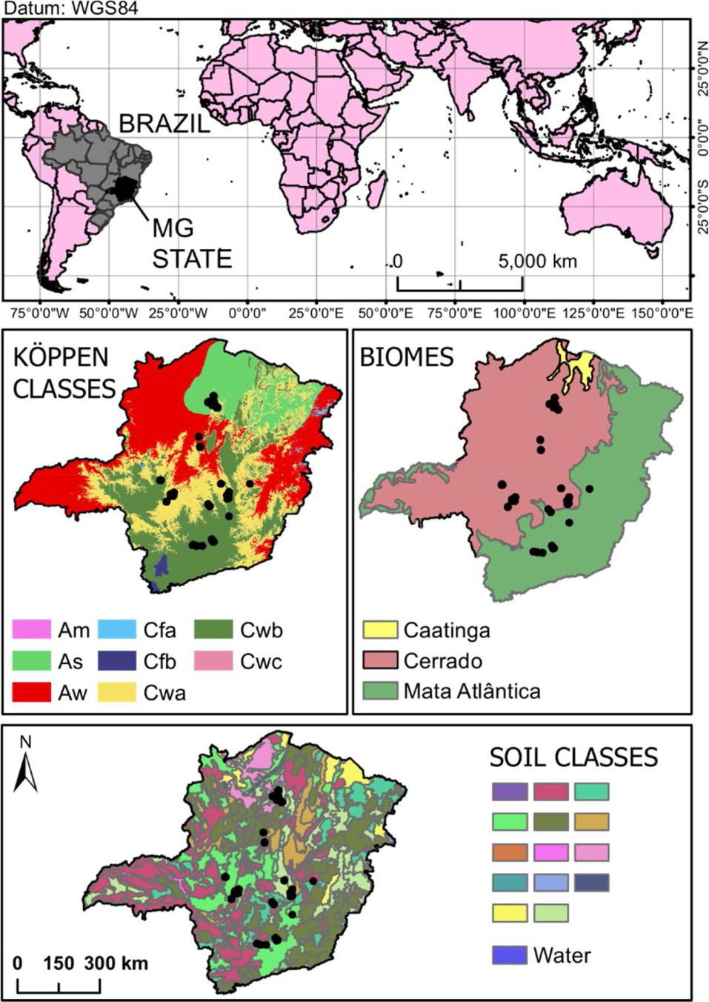

Fig. 1. Geographical location of the macauba mother-trees, Köppen climate, biomes and soil classes on Minas Gerais State, Brazil. Fruit sampling only occurred in two biomes and in seven soil classes ranges. The study area presents 17 soil classes, depicted in the color boxes at bottom of the figure (not in-depth evaluated in this work).

by equation: *RMSE* = ∑ (*PV* − *OV* ) 2 /*n* ; and RMSE% by RMSE di-vided by the average of the fruit component, multiplied by 100. *PV* and *OV* are, respectively, Predicted and Observed Values; *n* is the number ofobservations.



A 10-fold cross validation was made in the way that fruits from the same tree were never concomitantly in training and validation datasets. Thus, from 540 fruits, ten groups (without replacement) with 54 fruits each were sampled for validation dataset and the other 486 fruits composed the training dataset.

3. Results

RandomForest modeling was able to generate valuable predictions values for macauba fruit components. The best predictability was found for fresh weight (FFW, *r* = 0.92), and the worst ones for pulp and kernel oil contents, respectively *r* = 0.81 and *r* = 0.72. After cross validation, predictabilities had a reduction around 40 % compared to predictability without validation (overall). However, when doing the 10-fold sam-pling without obeying the “fruit-from-the-same-tree” prerequisite for training and validation datasets, this predictability was similar to the overall for all components (around 85 %) (Table 1).

For dry mass components (HDW, PDW, EDW, KDW) the RMSE was

3

R.T. Resende, et al. *Industrial Crops & Products 154 (2020) 112749*

Table 1

RandomForest model (RF model) quality parameters addressing the eight evaluated fruit components. It is also shown the Linear relation (by means of correlation coeﬃcient) between six environmental attributes (ENV1-6) and the eight macauba fruit components.

|  |  |  |  |  |  |  |  |  |  |  |  |  |  |  |  |  |  |
| --- | --- | --- | --- | --- | --- | --- | --- | --- | --- | --- | --- | --- | --- | --- | --- | --- | --- |
| Fruit Component |  | *x* | RMSE | RMSE (%) | Predictability (*r*) | |  | Explaned variance (%) | Linear relation | | |  |  |  |  |  |  |
|  |  |  |  |  |  |  |  |
|  |  |  |  |  |  |  | |  |  |  |  |  |  |  |  |  |  |
|  |  |  |  |  | Overall | 10-fold valid. | |  | ENV1 | | ENV2 | ENV3 | ENV4 | ENV5 | ENV6 |  |  |
|  |  |  |  |  |  |  |  |  |  | |  |  |  |  |  |  |  |
| POC | 60.37 | | 5.40 | 8.94 | 0.81 | 0.40 | ± 0.05 | 66.80 | –0.15 | | –0.08 | 0.24 | –0.06 | 0.18 | –0.09 |  |  |
| KOC | 64.77 | | 1.55 | 2.39 | 0.72 | 0.30 | ± 0.07 | 52.19 | –0.02 | | –0.05 | –0.03 | 0.03 | –0.06 | 0.04 |  |  |
| FFW | 43.15 | | 3.26 | 7.56 | 0.92 | 0.35 | ± 0.05 | 84.38 | 0.29 | | –0.03 | –0.32 | 0.25 | –0.12 | –0.19 |  |  |
| VOL | 46.10 | | 3.32 | 7.20 | 0.89 | 0.40 | ± 0.07 | 84.85 | 0.07 | | –0.08 | –0.20 | 0.24 | –0.11 | –0.26 |  |  |
| HDW | 6.97 | | 0.73 | 10.47 | 0.88 | 0.31 | ± 0.07 | 77.86 | 0.07 | | –0.01 | –0.14 | –0.03 | –0.07 | –0.09 |  |  |
| PDW | 10.96 | | 1.23 | 11.22 | 0.88 | 0.32 | ± 0.06 | 77.47 | 0.03 | | 0.12 | 0.00 | –0.07 | 0.09 | 0.01 |  |  |
| EDW | 8.91 | | 0.95 | 10.66 | 0.88 | 0.36 | ± 0.05 | 77.86 | 0.17 | | –0.05 | –0.24 | 0.22 | –0.22 | –0.23 |  |  |
| KDW | 2.10 | | 0.31 | 14.76 | 0.85 | 0.26 | ± 0.07 | 72.56 | 0.10 | | 0.04 | –0.13 | 0.03 | –0.07 | –0.06 |  |  |



RMSE: root mean of squared error. Environmental attributes: ENV1: Altitude (m); ENV2: Solar area (WH/m²); ENV3: Mean annual temperature (ºC); ENV4: Annual

precipitation (mm); ENV5: Distance to Hydrography (km); ENV6: Water Deficit (mm/day). Fruit components: POC: Pulp Oil Content; KOC: Kernel Oil Content; FFW:

Fresh Fruit Weight; VOL: fresh fruit VOLume; HDW: Husk Dry Weight; PDW: Pulp Dry Weight; EDW: Endocarp Dry Weight; KDW: Kernel Dry Weight.

always above 10 % (Table 1). For both, fresh fruit weight (FFW) and volume (VOL), RMSE% was around 7.5 %, while for pulp and kernel oil contents, it scored 8.9 and 2.4 %, respectively. In addition, within data variance - related to environmental attributes (RF model), most of the explained variance ranged from 72 to 85 %, except for variables related to oil content which was < 72 %.

The prevalent longitudinal arrangement of macauba matrices in MG state (Fig. 2) could cause some bias in the performed analysis. However, it is noteworthy the good representativeness of environmental variables regarding fruit data and sampled tree, which were acquired in Cerrado as well as Mata Atlântica biomes. The third biome, Caatinga, is a sa-vanic-desert like ecoregion where macauba is rather absent. Variables ENV2, ENV3, ENV5 and ENV6 demonstrated excellent representation of data originated from all pixels of the raster, while for ENV1 and ENV4, just a small portion of raster data is represented (see Supplementary Figure S1).

A significant fit between predicted and observed data is presented (Fig. 3), which is demonstrated by the correspondence between re-gression line and 45° line (*b*0 = 0 and *b*1 = 1). Another important measure is the correlation coeﬃcient between predicted and observed data (predictability coeﬃcient), which presented values of 0.72 and 0.93 for KOC and VOL fruit components, respectively.

The importance of each environmental variable in the RF model is presented in Fig. 4. ENV3 (temperature), was the most influential in five of eight evaluated fruit components, while ENV2 (solar area), was the least influent one for the same number of components. The linear relation coeﬃcient is presented to illustrate the correlation between environmental attributes and fruit components (Table 1).

A prediction reliability map (Fig. 5), i.e., a graphical visualization of places in which sampling space contemplates pixel data amplitude, was made according to Supplementary Figure S1. In this map, the level ‘6′ assigned regions (pixels) represent high reliability, which means that all six environmental variables utilized for prediction are contained in sampling space. In the other hand, the level ‘0′ assigned pixels represent low reliability, which means that none of the six variables is within sampling space. The same interpretation can be given to levels 1–5. The number of pixels on level 0 were approximately 0%; 1, 0.9 %; 2, 4.8 %; 3, 11.8 %; 4, 20.7 %; 5, 30.3 %; 6, 31.4 %. Thus, it can be noticed that 617% of Minas Gerais State presented regions of good or excellent prediction (levels 5 + 6).

Agroecological zoning for all eight components of macauba fruits is presented on Fig. 6. Red to blue scale represents lower and higher productivity, gradually. For oil content, it is observed high discrepancy among high yield areas; for instance, while for POC the best regions are northwest and west of the State, for KOC the best ones are south and southeast. On Supplementary Table S1 it is shown correlations among the eight fruit components (either when using 540 fruits – observed data, or 698,365 pixels – predicted data). Supplementary Figure S2

shows the relationship between these two types of correlation.

For FFW and VOL, which presented 0.88 of correlation for observed data, the best regions were center and northeast of the state (except for northeast coastal region for FFW). EDW and KDW presented similar results, supporting the high correlation between these two components (r = 0.68).

4. Discussion

4.1. Fruit biomass prediction

Prediction of components with easier or direct measurement, such as fruit fresh weight (FFW) and volume (VOL), presented the best predictabilities, probably by their higher residual control, what in-creases their data quality. In addition, these components often display the highest repeatability coeﬃcients, for instance, lower variation of fruits in the same tree as showed by Castro et al., 2017 and Pimentel et al. (2011). However, dry matter (HDW, PDW, EDW and KDW) and oil content (POC, KOC) fruit components also proportioned high values of predictability in our study, proving the prediction eﬃciency. The 10-fold cross validation confirmed these results, demonstrating 30 and 40

* predictabilities (Table 1). Although these results appear to be about medium to low reliability, it should be mentioned that the validation was done for approximately 700 thousand pixels, and several of them contain environmental information outside sample range. Nevertheless, through reliability map (Fig. 5) predictions for determined regions of interest can be ensured or discarded, approaching a reliable predict-ability between 70–90% (Table 1).

On 61.7 % of Minas Gerais State area, the model has at least five environmental variables within sampling interval (see Figs. 5 and S1), indicating good reliability for macauba fruit components prediction. Moreover, out-of-state predictions can also be made for regions in which environmental data is within sampled ranges (slightly discrepant regions). However, how much can be predicted for outside the state was not evaluated in this study.

Agroclimatic zoning based on species adaptation data tables, as traditionally done (Santos et al., 2016), often is unspecific for extra-polation areas. A recent A. aculeata study for southern Latin America (Falasca et al., 2017) was done based on optimal amplitudes made available by FAO (Ecocrop, 2007). Nevertheless, by zoning based on sampling data, it is possible to reckon up and address the complex in-teraction network that exists among employed variables, making the prediction trustworthy.

Minas Gerais State presents considerable dimensions, so the sam-pled mother-trees are located on diverse conditions of climate, soil and altitude (Fig. 1 and 2). Machado et al. (2015) and Cardoso et al. (2017) points out that there are several ecotypes or subspecies of A. aculeata throughout Minas Gerais State, such as totai and sclerocarpa, much due

4

R.T. Resende, et al. *Industrial Crops & Products 154 (2020) 112749*

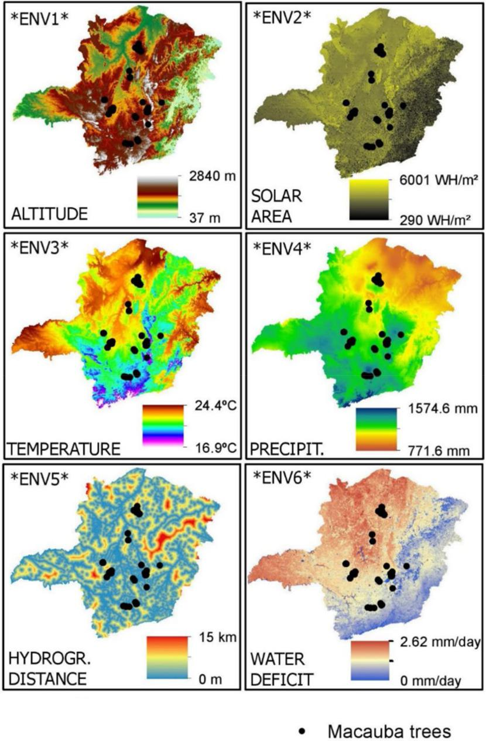

Fig. 2. The six environmental variables used to predict macauba fruit components (ENV1 to ENV6). ENV1: Altitude (m ASL), based on DEM (Digital Elevation

Model); ENV2: Solar Incidence Area (WH/m²); ENV3: Mean Annual Temperature (Celsius degrees); ENV4: Precipitation (mm); ENV5: Distance to Hydrography (m);

ENV6: Water Deficit (mm/day). Black points correspond to the 171 sampled macauba trees.

to the species’ morphological variability, as mentioned early. It is im-portant to note that the inferences made here were not able to distin-guish them, so a general inference was made for all the species’ varia-tion. This high ability in exploring diﬀerent environmental conditions is ensured by macauba natural occurrence, which ranges from south Mexico to south Brazil (Lima et al., 2018). Due to the specie’s plasticity and rusticity, it is possible to suppose that productivity of macauba crops will be little influenced by climate conditions. Moreover, in an optimistic view that perhaps contradicts Plath et al. (2016), it is plau-sible that, with climate changes, macauba will have an productivity increment, since it is suitable for regions with higher temperatures and prone to water deficit (Ciconini et al., 2013), which will became more frequent in the upcoming decades (Fernandes et al., 2013). In contrast, the only primarily oil crop “oil palm” (Elaeis guineensis) presents a re-stricted equatorial occurrence range, being cultivated on just few lo-cations of Bahia State (Brazil), Africa and Asia southeast region

(Jongschaap et al., 2007). Another tropical alternative crop for biofuel, Jathropa curcas, presents an equatorial occurrence range which is si-milar to A. aculeata, however their bio-products have lower physico-chemical as well economical characteristics (Lopes et al., 2011).

In Caatinga biome (Fig. 2), presumably due to the region extreme aridity, the natural occurrence of macauba trees would be negligible (Plath et al., 2016). In addition, it was not noticed natural occurrence for some soil classes and longitudes (at least for sampled trees). Al-though RF model is able to predict productive potential for those re-gions, care must be taken regarding crop operational usage into those areas (Pires et al., 2013). More studies need to be done in order to identify factors that prevent or hinder the specie occurrence in certain places.

Prediction maps are very important for the crop cultivation as well industries and refineries assembly (Costa et al., 2020), once they in-dicate the best locations for plantations according to diﬀerent goals and

5

R.T. Resende, et al. *Industrial Crops & Products 154 (2020) 112749*

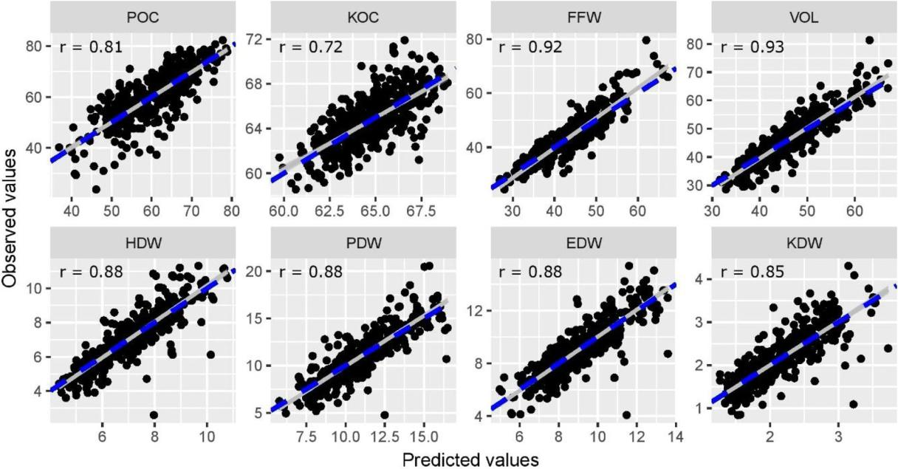

Fig. 3. Relation between predicted and observed values in the modeling of eight variables of macauba fruits. Dashed blue line is the perfect diagonal line (b0 = 0, b1 = 1); continuous gray line is a linear regression between predicted and observed values; *r* is the Predictability coeﬃcient between predicted and observed values. POC: Pulp Oil Content; KOC: Kernel Oil Content; FFW: Fresh Fruit Weight; VOL: fresh fruit VOLume; HDW: Husk Dry Weight; PDW: Pulp Dry Weight; EDW: Endocarp Dry Weight; KDW: Kernel Dry Weight.

uses. The entire State of Minas Gerais presents potential for producing macauba fruits and its components. However, some locations may present high yield potential for a certain component, while average or low potential for others (Fig. 6). This occurs due to the lower correla-tions among fruit components, as observed by Ciconini et al. (2013).

4.2. Ecophysiologycal aspects of macauba agroecological zoning

Macauba fruit displays a double sigmoid growth curve and supra-annual development (Montoya et al., 2016). Because of this required long period, fruit growth and development, in a same locality, occurs throughout all seasons, in a way that the fruit, in its life span, will undergo trough considerable variation of single climatic factors, espe-cially atmospheric temperature and precipitation / water availability. On average, the most suitable area for all macauba fruit components corresponds the central-southeast region of Minas Gerais State, on a transitional zone between Mata Atlântica and Cerrado biomes (Fig. 7, parts A and B). Despite that, through agroecological zoning estimates, it was possible to determine, with high prediction reliability (Fig. 6), the best cultivation areas for each macauba fruit component.

For five out of eight macauba fruit components, i.e., POC, HDW, EDW, PDW, KDW (Fig. 4), environmental temperature (ENV3) was the main influential factor. These five macauba fruit components are variables based on biomass, organic elements originated by the pho-tosynthesis and respiration complementary processes. Temperature – of a cropping site or year – is well known to aﬀect active enzymes as well to determine the rates of physiological and growth processes and de-velopment of the whole plant and its parts (Das, 2012; Di Vaio et al., 2013). High temperatures (> 30−35 °C) tend to restrict photosynthesis and enhance respiration rates due to diﬀerences in kinetics of enzymes involved in both processes (Fischer et al., 2016). Therefore accelerating photo-assimilate degradation will compromise fruit filling and compo-sition (Fischer and Orduz-Rogríguez, 2012). Not surprisingly, the best-predicted areas for those components are mainly located along Cerrado and Mata Atlântica in-between corridor (Fig. 1 and 6) especially in the central area of Minas Gerais State. This transition zone encompasses the borderline of Cwa/Aw and Cwb climates (Fig. 1), presenting overall

average temperatures of both biomes/climates (Fig. 2). For subtropical and tropical plants, optimum temperature for growth, i.e., dry matter increases or relative growth rate, occurs between 20 °C–30 °C. Tem-peratures below or above this range will compromise growth, by either hindering photosynthetic machinery function or delaying overall transport, uptake processes as well stomata opening (Saverimuttu and Westoby, 1996).

KDW represents seed mass, the least plastic component of re-productive yield. Diﬀerences in seed size / mass may be linked to species adaptation to local climate pressures, which can constrain physiology and resource availability for fruit or seed developing (Di Vaio et al., 2013). For this macauba fruit component, prediction map revealed that less fitted areas corresponded to Cerrado biome, where solar radiation, water deficit and temperature are the highest and precipitation is medium to low (Fig. 6 and 1). Those environmental factors are known to regulate photosynthesis rate, since it interferes in both stomatal conductance and CO2 assimilation (Saverimuttu and Westoby, 1996). However, elements that drive species traits or life-history evolution, i.e. genes and environment, should also be con-sidered for the smaller macauba seeds predicted to Cerrado biome: i) as a product of fertilization and a resource demanding-tissue, the en-dosperm growth is mostly influenced by genes expression in a parent-of-origin-manner (imprinting), particularly from paternal side, more than any other fruit parts, which are only maternal tissue (Huh et al., 2007) and, ii) as an evolutionary survival strategy, small oﬀspring is often found in species or populations that experience frequented dis-turbances like fire, a common and natural event in savannic-like Cer-rado biome (Hanley et al., 2003). On the other hand, larger seeds would favor survivor of plantlets in shaded environments, like in understory of forest ecosystems, (Saverimuttu and Westoby, 1996), as demonstrated by macauba greater KDW values for Mata Atlântica biome (Fig. 1 and 6).

The prediction map for macauba fruit PDW, on the other hand, showed that the best sites for this component are located at the east borderline of Cerrado biome, where climate is predominantly Cwb with rainy summers and dry winters. Macauba fruit pulp is composed by fibers (structural carbohydrates) and storage compounds, viz., fatty

6

R.T. Resende, et al. *Industrial Crops & Products 154 (2020) 112749*

Fig. 4. Variables importance according to MSE. Values were rescaled in order to the maximum value be the unit. POC: Pulp Oil Content; KOC: Kernel Oil Content; FFW: Fresh Fruit Weight; VOL: fresh fruit VOLume; HDW: Husk Dry Weight; PDW: Pulp Dry Weight; EDW: Endocarp Dry Weight; KDW: Kernel Dry Weight. ENV1: Altitude, based on DEM (Digital Elevation Model, in meters); ENV2: Solar Incidence Area (in WH/m²); ENV3: Mean Annual Temperature (ºC); ENV4: Precipitation (mm); ENV5: Distance from Hydrographic Sources (km); ENV6: Water Deficit (mm/day).

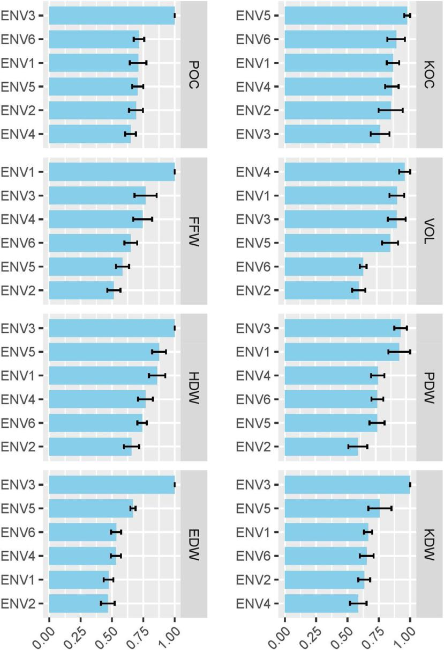

acids, starch and soluble sugar (Montoya et al., 2016). Therefore, lower temperatures, like the ones at higher altitudes of the Mata Atlântica biome, can have a negative eﬀect in the pulp dry weight gain as seen in prediction map. This is because, despite fruits being strong sinks, mass accumulation is highly depended on transport rates and membrane permeability to sugars, phenomena also dependent on temperature. It should not be disregarded that distribution or prediction maps for macauba fruits KDW and PDW were based in indigenous fruits. Therefore, other factors might be influencing geographical variation of seed and fruit mass, such as soil nutrients content and herbivores and/ or dispersal agents’ relationships.

Husk (exocarp) and hardened endocarp of drupaceous fruits are defense structures: the first protects pulp or fruit per se while the second the kernel or seed. In macauba fruit, both parts are composed by fibers and sclereids cells at diﬀerent proportions, and the endocarp layer is lignified (Montoya et al., 2016; Reis et al., 2012; Rencoret et al., 2018); consequently, these layers mainly consist of structural carbo-hydrates. The prediction map show that HDW is medium to high, for most of MG State (Fig. 6), except for the area near or corresponding to Caatinga biome (Fig. 1), where the climate is As, very dry tropical

savanna). Since it is neither fleshy nor strongly lignified layer, husk is less demanding as a sink structure, requiring fewer nutrients inputs than the endocarp, which demands much more biomolecules due to this unique composition and consistence (Rencoret et al., 2018); hence, EDW prediction map show that the best sites for this macauba fruit component are those where climate conditions are more favorable to resource generation by photosynthesis, i.e., areas with Cwb climate and transitional zone between Cerrado and Mata Atlântica biomes.

Altitude and, consequently, environmental temperature influence both content and composition of fatty acidy in oily fruits and seeds (Daymond and Hadley, 2008); (Ferreyra et al., 2016). Prediction maps for macauba fruit oil contents show almost opposite distribution in comparison to pulp and kernel. The total oil content within pulp (POC) is predicted to increase towards inland - and like fruit dry weight components – peaking in transitional sites biomes/climates, which present lower altitude, higher solar availability, mild to higher tem-peratures, mild precipitation and water deficit (Cwa and Aw climates) (Fig. 1 and 2). This result opposes those from other species that also accumulate oil in mesocarp, such as olive (Di Vaio et al., 2013) and avocado (Carvalho et al., 2015). In both crops, high oil content and

7

R.T. Resende, et al. *Industrial Crops & Products 154 (2020) 112749*

Fig. 5. Reliability scale for prediction within study area. The map was made according to extrapolation zones during prediction of ma-cauba fruit components (y): 0 is the least reli-able region, for instance, there is extrapolation for six predictive environmental variables; 6 is the most reliable region, meaning that there is no extrapolation. Zones quantification: 0 (ap-prox. 0%); 1 (0.9 %); 2 (4.8 %); 3 (11.8 %); 4 (20.7 %); 5 (30.3 %); 6 (31.4 %).

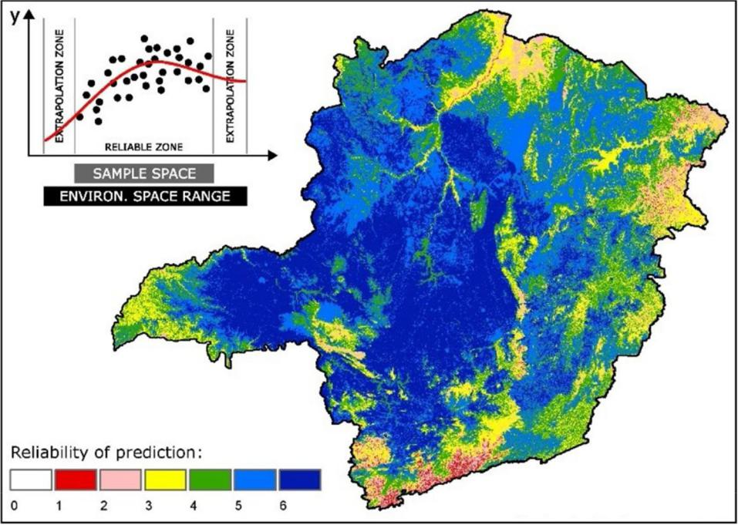

especially oleic acid – predominate fatty acid in macauba pulp – is found in fruit from orchards located at higher altitudes, i.e., with lower mean annual temperature. This apparent contradiction may be ex-plained by genotype vs environment eﬀect, which should not be dis-regarded for macauba palm at this early stage of domestication. All analyzed fruits in the study were from macauba natural populations, hence ecological and evolutionary pressures could strongly dictate pulp content and composition, more fitted as food reward for local dispersal

agents. Oily pericarps are highly consumed by omnivorous bird and mammals (Van der Pijl, 1982), fauna well represented in Cerrado biome before agricultural occupation. On the other hand, prediction map for macauba kernel/seed total oil content (KOC) revealed that the best sites for this component are located mainly in Mata Atlântica biome (Cwb climate), except for areas with higher altitude and lower temperature (Fig. 1 and 6). Oil yield from oily seeds will be negatively aﬀected by higher temperatures, as has been reported for sunflower, rape, mustard

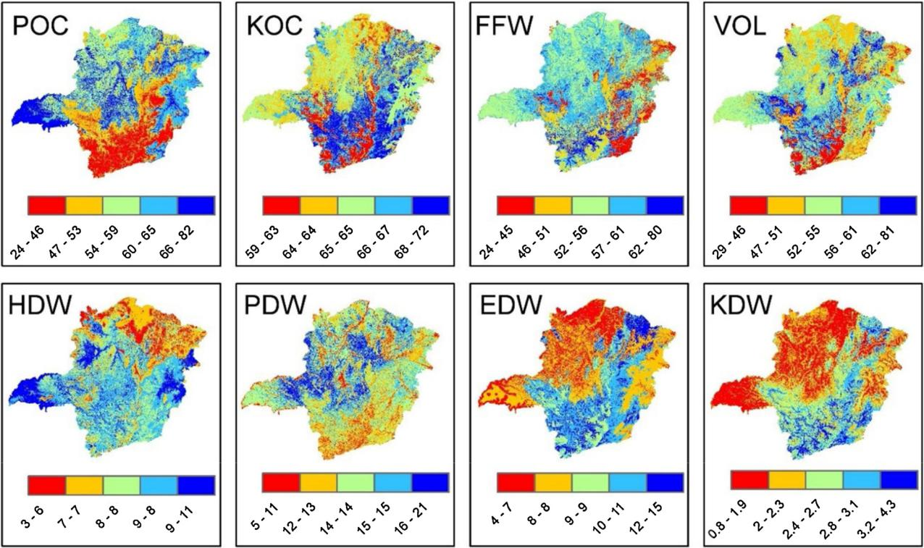

Fig. 6. Prediction maps for all eight evaluated fruit components of macauba. POC: Pulp Oil Content; KOC: Kernel Oil Content; FFW: Fresh Fruit Weight; VOL: fresh

fruit VOLume; HDW: Husk Dry Weight; PDW: Pulp Dry Weight; EDW: Endocarp Dry Weight; KDW: Kernel Dry Weight.

8

R.T. Resende, et al. *Industrial Crops & Products 154 (2020) 112749*

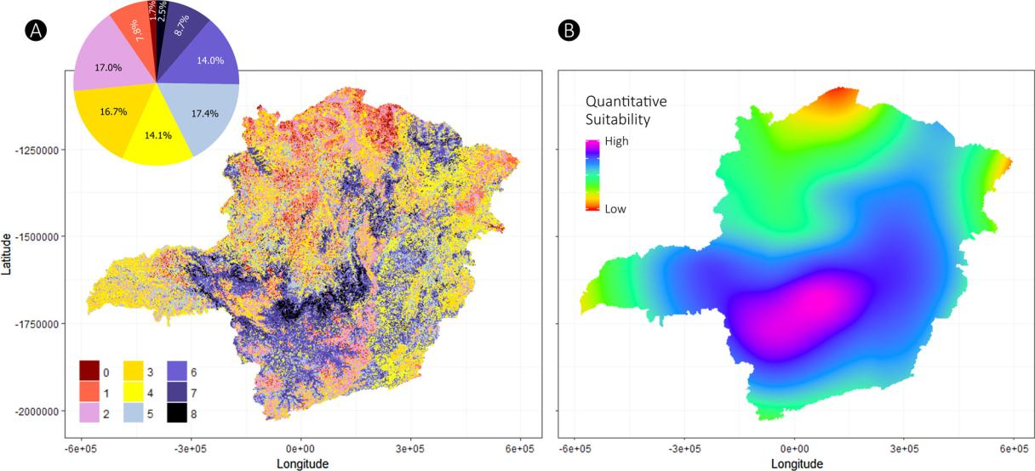

Fig. 7. Best locations and suitability for A. aculeata considering its eight fruit components. (A) Pixel by pixel suitability, the 0-8 levels (colors) correspond to how many fruit components are expected to be above average at site level. The upper circle gives a dimension of pixel distribution with fitness for more than one fruit component. (B) Quantitative suitability fitted based on Part A data using Locally Weighted Scatterplot Smoother (LOESS) regression.

and cocoa bean (Daymond and Hadley, 2008; Harris et al., 1978; Yaniv et al., 1995).

Rainfall, altitude and temperature were the main climate variables for macauba fruit volume and fresh weight components (FFW and VOL). These three climate variables largely influence atmospheric moisture and soil water availability, the most important factor for plant growth (Pimentel et al., 2011). Climatological Water deficit plant can impair growth by: i) halting carbohydrate synthesis; and/or ii) hin-dering cell, tissue and organs expansion (Tardieu et al., 2014). In Minas Gerais State, the best sites predicted for this two macauba fruit com-ponents were located in the transitional zone between Mata Atlântica and Cerrado biomes, areas where intensity or frequency of environ-mental factors tend to be intermediate between Cwb and Cwa/Aw, thus avoiding extremes (Fig. 6 and 1). In the particular case of FFW, the majority of Cerrado area was intermediated in prediction map. Al-though water scarcity may aﬀect both vegetative and fruit growth, the later seems to be less aﬀected by this environmental constrain (Yuan et al., 2009). The areas with higher altitude, lower temperature and low solar availability, despite lower water deficit and higher precipitation, were the least fitted sites for FFW and VOL. Environments with cooler temperature (< 25 °C), low solar radiation, high humidity and higher water availability tend to decrease transpiration rate. Consequently, under these circumstances, water uptake by plants and its further translocation to fruits might also slowdown in comparison to sites where high solar radiation and water deficit, driving forces for tran-spiration, are more pronounced (Yi et al., 2016).

For further studies we suggest evaluate fruit productivity data of macauba palms (in terms of amount and/or fruit weight per plant), and also evaluate using other artificial intelligence tools on zoning predic-tion. In addition, prospect the collection of new data onto national ei-ther continental scale to achieve a greater agroecological zoning range of the macauba fruit yield.

5. Conclusion

The model prediction reliability for macauba fruit components (*r* ≥ 0.72) can support a data-based agroecological zoning in Minas Gerais State. The state center and southeast domains were, on average, the mainly promising regions. Cultivation of macauba palm in these areas predicts the best results for all eight analyzed fruit components. These two geographic regions encompass the transition between

Atlantic Forest and Cerrado biomes, where Cwa, Cwb and Aw climates overlap (intersection zone), which creates favorable climate conditions for plant and fruit physiological, growing and developing processes. The temperature was the most important factor influencing six of eight fruit components, especially biomass (pulp oil content and dry weight).

Since cultivation in ecophysiological fitted areas request less agri-cultural inputs and naturally support yield, implanting macauba orch-ards in the right sites can provide a more sustainable agriculture system, due to reduced risks of environmental strains and economic losses.

Author contribution statement

KNK and SYM: Supervision of palms sampling and fruit data col-lection. RTR, PHSM, DGEG, MDVR, HGL and ASL: fruit and GIS data analysis. KNK, RTR, TRC, ÚRZ, LAAT and ASL: wrote the manuscript. KNK and LAAT: Language revision. All authors reviewed the manu-script.

Declaration of Competing Interest

There are no conflicts of interest to declare.

Acknowledgements

Acrotech Co. for providing the macauba fruit data; to doctors Nero L. de Castro (UFV) and Getulio Fonseca (UFV) for relevant suggestions; Professors Alexandre R. dos Santos (UFES), Cibele H. do Amaral (UFV) and Gustavo E. Marcatti (UFSJ) for technical and scientific support; the research group Geotechnology Applied to Global Environment (GAGEN); and the Brazilian fund agencies Conselho Nacional de Desenvolvimento Científico e Tecnológico (CNPq) and Coordenação de Aperfeiçoamento de Pessoal de Nível Superior (CAPES) for granting the scholarships.

Appendix A. Supplementary data

Supplementary material related to this article can be found, in the online version, at doi:<https://doi.org/10.1016/j.indcrop.2020.112749>.

9

R.T. Resende, et al.

References

[Abreu, A.G., Priolli, R.H.G., Azevedo-Filho, J.A., Nucci, S.M., Zucchi, M.I., Coelho, R.M.,](http://refhub.elsevier.com/S0926-6690(20)30666-X/sbref0005) [Colombo, C.A., 2012. The genetic structure and mating system of Acrocomia aculeata](http://refhub.elsevier.com/S0926-6690(20)30666-X/sbref0005) [(Arecaceae). Genet. Mol. Biol. 35, 116–121](http://refhub.elsevier.com/S0926-6690(20)30666-X/sbref0005).

Bora, P.S., Rocha, R.V.M., 2004. Macaiba Palm: Fatty and Amino Acids Composition of Fruits Macaíba: Composición De Aminoácidos Y Ácidos Grasos De Frutos Macaíba: Composición De Aminoácidos E Ácidos Graxos De Froitos. Cienc. y Tecnol. Aliment. 4, 158–162. <https://doi.org/10.1080/11358120409487755>.

[Bottega, E.L., Medeiros, W.N., Matsimbe, S., de Carvalho Pinto, F., de, A., de Queiroz,](http://refhub.elsevier.com/S0926-6690(20)30666-X/sbref0015) [D.M., 2013. Estimativa do volume de mesocarpo de frutos de macaúba utilizando](http://refhub.elsevier.com/S0926-6690(20)30666-X/sbref0015) [processamento de imagens digitais. Campo Digit., pp. 8](http://refhub.elsevier.com/S0926-6690(20)30666-X/sbref0015).

[Breiman, L., 2001. Random forests. Mach. Learn. 45, 5–32](http://refhub.elsevier.com/S0926-6690(20)30666-X/sbref0020).

[Cardoso, A., Laviola, B.G., Santos, G.S., de Sousa, H.U., de Oliveira, H.B., Veras, L.C.,](http://refhub.elsevier.com/S0926-6690(20)30666-X/sbref0025) [Ciannella, R., Favaro, S.P., 2017. Opportunities and challenges for sustainable pro-duction of A. aculeata through agroforestry systems. Ind. Crops Prod. 107, 573–580](http://refhub.elsevier.com/S0926-6690(20)30666-X/sbref0025).

[Caretta, A.I., Arjona, C., Rogé, M., Hernández, M.L., 2012. Meteorological characteriza-tion of olive tree areas in Mendoza, Argentina. VII International Symposium on Olive](http://refhub.elsevier.com/S0926-6690(20)30666-X/sbref0030) [Growing 1057. pp. 349–356](http://refhub.elsevier.com/S0926-6690(20)30666-X/sbref0030).

[Carvalho, C.P., Bernal, E.J., Velásquez, M.A., Cartagena V, J.R., 2015. Fatty acid content](http://refhub.elsevier.com/S0926-6690(20)30666-X/sbref0035) [of avocados (Persea americana Mill. cv. Hass) in relation to orchard altitude and fruit](http://refhub.elsevier.com/S0926-6690(20)30666-X/sbref0035) [maturity stage. Agron Colomb. 33 (2), 220–227](http://refhub.elsevier.com/S0926-6690(20)30666-X/sbref0035).

Castro, C.A.d.O., Resende, R.T., Kuki, K.N., Carneiro, V.Q., Marcatti, G.E., Cruz, C.D., Motoike, S.Y., 2017. High-performance prediction of macauba fruit biomass for agricultural and industrial purposes using Artificial Neural Networks. Ind Crops Prod. 108, 806–813. <https://doi.org/10.1016/j.indcrop.2017.07.031>.

[Cheng, B., Furtado, A., Smyth, H.E., Henry, R.J., 2016. Influence of genotype and en-vironment on coﬀee quality. Trends Food Sci. Technol. 57, 20–30](http://refhub.elsevier.com/S0926-6690(20)30666-X/sbref0045).

[Ciconini, G., Favaro, S.P., Roscoe, R., Miranda, C.H.B., Tapeti, C.F., Miyahira, M.A.M.,](http://refhub.elsevier.com/S0926-6690(20)30666-X/sbref0050) [Bearari, L., Galvani, F., Borsato, A.V., Colnago, L.A., 2013. Biometry and oil contents](http://refhub.elsevier.com/S0926-6690(20)30666-X/sbref0050) [of Acrocomia aculeata fruits from the Cerrados and Pantanal biomes in Mato Grosso](http://refhub.elsevier.com/S0926-6690(20)30666-X/sbref0050) [do Sul. Brazil. Ind. Crops Prod. 45, 208–214](http://refhub.elsevier.com/S0926-6690(20)30666-X/sbref0050).

[Coimbra, M.C., Jorge, N., 2011. Proximate composition of guariroba (Syagrus oleracea),](http://refhub.elsevier.com/S0926-6690(20)30666-X/sbref0055) [jerivá (Syagrus romanzoﬃana) and macaúba (Acrocomia aculeata) palm fruits. Food](http://refhub.elsevier.com/S0926-6690(20)30666-X/sbref0055) [Res. Int. 44, 2139–2142](http://refhub.elsevier.com/S0926-6690(20)30666-X/sbref0055).

[Costa, A.M., Motoike, S.Y., Corrêa, T.R., Silva, T.C., Coser, S.M., Resende, M.D.V., Teófilo,](http://refhub.elsevier.com/S0926-6690(20)30666-X/sbref0060) [R.F., 2018. Genetic parameters and selection of macaw palm (Acrocomia aculeata)](http://refhub.elsevier.com/S0926-6690(20)30666-X/sbref0060) [accessions: an alternative crop for biofuels. Crop Breed. App. Biotec. 18, 259–266](http://refhub.elsevier.com/S0926-6690(20)30666-X/sbref0060).

[Costa, F.R., Ribeiro, C.A.A.S., Marcatti, G.E., Lorenzon, A.S., Teixeira, T.R., Domingues,](http://refhub.elsevier.com/S0926-6690(20)30666-X/sbref0065) [G.F., de Castro, N.L.M., dos Santos, A.R., Soares, V.P., Mota, P.H.S., 2020. GIS applied](http://refhub.elsevier.com/S0926-6690(20)30666-X/sbref0065) [to location of bioenergy plants in tropical agricultural areas. Renew. Energy 153,](http://refhub.elsevier.com/S0926-6690(20)30666-X/sbref0065) [911–918](http://refhub.elsevier.com/S0926-6690(20)30666-X/sbref0065).

[Das, H.P., 2012. Agrometeorology in Extreme Events and Natural Disasters. CRC Press](http://refhub.elsevier.com/S0926-6690(20)30666-X/sbref0070) [Inc](http://refhub.elsevier.com/S0926-6690(20)30666-X/sbref0070).

[Daymond, A.J., Hadley, P., 2008. Diﬀerential eﬀects of temperature on fruit development](http://refhub.elsevier.com/S0926-6690(20)30666-X/sbref0075) [and bean quality of contrasting genotypes of cacao (Theobroma cacao). Ann. Appl.](http://refhub.elsevier.com/S0926-6690(20)30666-X/sbref0075) [Biol. 153, 175–185](http://refhub.elsevier.com/S0926-6690(20)30666-X/sbref0075).

[Di Vaio, C., Nocerino, S., Paduano, A., Sacchi, R., 2013. Influence of some environmental](http://refhub.elsevier.com/S0926-6690(20)30666-X/sbref0080) [factors on drupe maturation and olive oil composition. J. Sci. Food Agric. 93,](http://refhub.elsevier.com/S0926-6690(20)30666-X/sbref0080) [1134–1139](http://refhub.elsevier.com/S0926-6690(20)30666-X/sbref0080).

[Ecocrop, F.A.O., 2007. The Crop Environmental Requirements Database. L. water Digit.](http://refhub.elsevier.com/S0926-6690(20)30666-X/sbref0085)

[media Ser., pp. 4](http://refhub.elsevier.com/S0926-6690(20)30666-X/sbref0085).

[Evaristo, A.B., Grossi, J.A.S., Carneiro de, C.O.A., Pimentel, L.D., Motoike, S.Y., Kuki,](http://refhub.elsevier.com/S0926-6690(20)30666-X/sbref0090) [K.N., 2016a. Actual and putative potentials of macauba palm as feedstock for solid](http://refhub.elsevier.com/S0926-6690(20)30666-X/sbref0090) [biofuel production from residues. Biomass Bioenergy 85, 18–24](http://refhub.elsevier.com/S0926-6690(20)30666-X/sbref0090).

[Evaristo, A.B., Martino, D.C., Ferrarez, A.H., Donato, D.B., Carneiro de, C.O.A., Grossi,](http://refhub.elsevier.com/S0926-6690(20)30666-X/sbref0095) [J.A.S., 2016b. Energy potential of the macaw palm fruit residues and their use in](http://refhub.elsevier.com/S0926-6690(20)30666-X/sbref0095) [charcoal production. Ciência Florest 26, 571–577](http://refhub.elsevier.com/S0926-6690(20)30666-X/sbref0095).

[Evaristo, A.B., Martino, D.C., Ferrarez, A.H., Donato, D.B., Carneiro de, C.O.A., Grossi,](http://refhub.elsevier.com/S0926-6690(20)30666-X/sbref0100) [J.A.S., 2016c. Potencial energético dos resíduos do fruto da macaúba e sua utilização](http://refhub.elsevier.com/S0926-6690(20)30666-X/sbref0100) [na produção de carvão vegetal. Ciência Florest. 26, 571–577](http://refhub.elsevier.com/S0926-6690(20)30666-X/sbref0100).

[Falasca, S., Ulberich, A., Pitta-Alvarez, S., 2017. Development of agroclimatic zoning](http://refhub.elsevier.com/S0926-6690(20)30666-X/sbref0105) [model to delimit the potential growing areas for macaw palm (Acrocomia aculeata).](http://refhub.elsevier.com/S0926-6690(20)30666-X/sbref0105) [Theor. Appl. Climatol. 129, 1321–1333](http://refhub.elsevier.com/S0926-6690(20)30666-X/sbref0105).

[Faundeen, J.L., Burley, T.E., Carlino, J.A., Govoni, D.L., Henkel, H.S., Holl, S.L.,](http://refhub.elsevier.com/S0926-6690(20)30666-X/sbref0110) [Hutchison, V.B., Martín, E., Montgomery, E.T., Ladino, C., 2014. The United States](http://refhub.elsevier.com/S0926-6690(20)30666-X/sbref0110) [Geological Survey Science Data Lifecycle Model. US Geological Survey](http://refhub.elsevier.com/S0926-6690(20)30666-X/sbref0110).

[Fernandes, E., Pinto, H.S., Lundell, M., Assad, E., Nassar, A., Farinelli, B., Freitas, S.,](http://refhub.elsevier.com/S0926-6690(20)30666-X/sbref0115) [Harfuch, L., 2013. Impacts of Climate Change on Brazilian Agriculture](http://refhub.elsevier.com/S0926-6690(20)30666-X/sbref0115).

[Ferreyra, R., Sellés, G., Saavedra, J., Ortiz, J., Zúñiga, C., Troncoso, C., Rivera, S.A.,](http://refhub.elsevier.com/S0926-6690(20)30666-X/sbref0120) [González-Agüero, M., Defilippi, B.G., 2016. Identification of pre-harvest factors that](http://refhub.elsevier.com/S0926-6690(20)30666-X/sbref0120) [aﬀect fatty acid profiles of avocado fruit (Persea americana Mill) cv.‘Hass’ at harvest.](http://refhub.elsevier.com/S0926-6690(20)30666-X/sbref0120) [S. Afr. J. Bot. 104, 15–20](http://refhub.elsevier.com/S0926-6690(20)30666-X/sbref0120).

[Fischer, G., Orduz-Rogríguez, J.O., 2012. Ecofisiología en frutales](http://refhub.elsevier.com/S0926-6690(20)30666-X/sbref0125).

[Fischer, G., Ramírez, F., Casierra-Posada, F., 2016. Ecophysiological aspects of fruit crops](http://refhub.elsevier.com/S0926-6690(20)30666-X/sbref0130) [in the era of climate change. A review. Agron. Colomb. 34, 190–199](http://refhub.elsevier.com/S0926-6690(20)30666-X/sbref0130).

Fry, J., Fitton, C., 2010. The importance of the global oils and fats supply and the role that palm oil plays in meeting the demand for oils and fats worldwide. J. Am. Coll. Nutr. 29, 245S–252S. <https://doi.org/10.1080/07315724.2010.10719841>.

Hanley, M.E., Unna, J.E., Darvill, B., 2003. Seed size and germination response: a re-lationship for fire-following plant species exposed to thermal shock. Oecologia 134, 18–22. <https://doi.org/10.1007/s00442-002-1094-2>.

Harris, H.C., McWilliam, J.R., Mason, W.K., 1978. Influence of temperature on oil content and composition of sunflower seed. Aust. J. Agric. Res. 29, 1203–1212. [https://doi.](https://doi.org/10.1071/AR9781203) [org/10.1071/AR9781203](https://doi.org/10.1071/AR9781203).

[Hiane, P.A., Baldasso, P.A., Marangoni, S., Macedo, M.L.R., 2006. Chemical and nutri-tional evaluation of kernels of bocaiuva, Acrocomia aculeata (Jacq.) Lodd. Food Sci.](http://refhub.elsevier.com/S0926-6690(20)30666-X/sbref0150) [Technol. 26, 683–689](http://refhub.elsevier.com/S0926-6690(20)30666-X/sbref0150).

*Industrial Crops & Products 154 (2020) 112749*

[Hijmans, R.J., Cameron, S.E., Parra, J.L., Jones, P.G., Jarvis, A., 2005. Very high re-solution interpolated climate surfaces for global land areas. Int. J. Climatol. 25,](http://refhub.elsevier.com/S0926-6690(20)30666-X/sbref0155) [1965–1978](http://refhub.elsevier.com/S0926-6690(20)30666-X/sbref0155).

Huh, J.H., Bauer, M.J., Hsieh, T.F., Fischer, R., 2007. Endosperm gene imprinting and seed development. Curr. Opin. Genet. Dev. 17, 480–485. [https://doi.org/10.1016/j.](https://doi.org/10.1016/j.gde.2007.08.011) [gde.2007.08.011](https://doi.org/10.1016/j.gde.2007.08.011).

[Johnston, K., Ver Hoef, J.M., Krivoruchko, K., Lucas, N., 2001. Using ArcGIS](http://refhub.elsevier.com/S0926-6690(20)30666-X/sbref0165) [Geostatistical Analyst. Esri Redlands](http://refhub.elsevier.com/S0926-6690(20)30666-X/sbref0165).

[Jongschaap, R.E.E., Corré, W.J., Bindraban, P.S., Brandenburg, W.A., 2007. Claims and](http://refhub.elsevier.com/S0926-6690(20)30666-X/sbref0170) [Facts on Jatropha curcas L.Claims and Facts on Jatropha curcas L](http://refhub.elsevier.com/S0926-6690(20)30666-X/sbref0170).

Lanes, É.C.M.M., Motoike, S.Y., Kuki, K.N., Nick, C., Freitas, R.D., Jones, F.A., 2014. Molecular characterization and population structure of the macaw palm, Acrocomia aculeata (Arecaceae), ex situ germplasm collection using microsatellites markers. J. Hered. 106, 102–112. <https://doi.org/10.1093/jhered/esu073>.

Legros, S., Mialet-Serra, I., Caliman, J.-P.P., Siregar, F.A., Clement-Vidal, A., Dingkuhn, M., Clément-Vidal, A., Dingkuhn, M., 2009. Phenology and growth adjustments of oil palm (Elaeis guineensis) to photoperiod and climate variability. Ann. Bot. 1, 1–12. <https://doi.org/10.1093/aob/mcp214>.

[Liaw, A., Wiener, M., 2014. Classification and Regression by randomForest](http://refhub.elsevier.com/S0926-6690(20)30666-X/sbref0185).

[Lima, N.E., Carvalho, A.A., Meerow, A.W., Manfrin, M.H., 2018. A review of the palm](http://refhub.elsevier.com/S0926-6690(20)30666-X/sbref0190) [genus Acrocomia: neotropical green gold. Org. Divers. Evol. 18, 151–161](http://refhub.elsevier.com/S0926-6690(20)30666-X/sbref0190).

[Lopes, D.C., Neto, A.J.S., Lagoas, C.S., Lagoas, S., Gerais, M., 2011. Potential Crops for](http://refhub.elsevier.com/S0926-6690(20)30666-X/sbref0195) [Biodiesel Production in Brazil : A Review 7. pp. 206–217](http://refhub.elsevier.com/S0926-6690(20)30666-X/sbref0195).

[Lu, C., Napier, J.A., Clemente, T.E., Cahoon, E.B., 2011. New frontiers in oilseed bio-technology: meeting the global demand for vegetable oils for food, feed, biofuel, and](http://refhub.elsevier.com/S0926-6690(20)30666-X/sbref0200) [industrial applications. Curr. Opin. Biotechnol. 22, 252–259](http://refhub.elsevier.com/S0926-6690(20)30666-X/sbref0200).

[Machado, W., Guimarães, M.F., Lira, F.F., Santos, J.V.F., Takahashi, L.S.A., Leal, A.C.,](http://refhub.elsevier.com/S0926-6690(20)30666-X/sbref0205) [Coelho, G., 2015. Evaluation of two fruit ecotypes (totai and sclerocarpa) of macaúba](http://refhub.elsevier.com/S0926-6690(20)30666-X/sbref0205) [(Acrocomia aculeata). Ind. Crops Prod. 63, 287–293](http://refhub.elsevier.com/S0926-6690(20)30666-X/sbref0205).

[Montoya, S.G., Motoike, S.Y., Kuki, K.N., Couto, A.D., 2016. Fruit development, growth,](http://refhub.elsevier.com/S0926-6690(20)30666-X/sbref0210) [and stored reserves in macauba palm (Acrocomia aculeata), an alternative bioenergy](http://refhub.elsevier.com/S0926-6690(20)30666-X/sbref0210) [crop. Planta 244, 927–938](http://refhub.elsevier.com/S0926-6690(20)30666-X/sbref0210).

[Motoike, S.Y., Kuki, K.N., 2009. The potential of macaw palm (Acrocomia aculeate) as](http://refhub.elsevier.com/S0926-6690(20)30666-X/sbref0215) [source of biodiesel in Brazil. Int. Rev. Chem. Eng. 1, 632–635](http://refhub.elsevier.com/S0926-6690(20)30666-X/sbref0215).

[Pimentel, L.D., Manfio, C.E., Motoike, S.Y., Paes, J.M.V., Bruckner, C.H., 2011.](http://refhub.elsevier.com/S0926-6690(20)30666-X/sbref0220)

[Coeficientes técnicos e custos de produção do cultivo da macaúba. Inf. Agropecuário](http://refhub.elsevier.com/S0926-6690(20)30666-X/sbref0220)

[32, 61–69](http://refhub.elsevier.com/S0926-6690(20)30666-X/sbref0220).

[Pires, T.P., dos Santos Souza, E., Kuki, K.N., Motoike, S.Y., 2013. Ecophysiological traits](http://refhub.elsevier.com/S0926-6690(20)30666-X/sbref0225) [of the macaw palm: a contribution towards the domestication of a novel oil crop. Ind.](http://refhub.elsevier.com/S0926-6690(20)30666-X/sbref0225) [Crops Prod. 44, 200–210](http://refhub.elsevier.com/S0926-6690(20)30666-X/sbref0225).

[Plath, M., Moser, C., Bailis, R., Brandt, P., Hirsch, H., Klein, A.-M., Walmsley, D., von](http://refhub.elsevier.com/S0926-6690(20)30666-X/sbref0230) [Wehrden, H., 2016. A novel bioenergy feedstock in Latin America? Cultivation po-tential of Acrocomia aculeata under current and future climate conditions. Biomass](http://refhub.elsevier.com/S0926-6690(20)30666-X/sbref0230) [Bioenergy 91, 186–195](http://refhub.elsevier.com/S0926-6690(20)30666-X/sbref0230).

[Reis, S.B., Mercadante-Simões, M.O., Ribeiro, L.M., 2012. Pericarp development in the](http://refhub.elsevier.com/S0926-6690(20)30666-X/sbref0235) [macaw palm Acrocomia aculeata (Arecaceae). Rodrigusia 63, 541–549](http://refhub.elsevier.com/S0926-6690(20)30666-X/sbref0235).

[Rencoret, J., Kim, H., Evaristo, A.B., Gutiérrez, A., Ralph, J., del Río, J.C., 2018.](http://refhub.elsevier.com/S0926-6690(20)30666-X/sbref0240) [Variability in lignin composition and structure in cell walls of diﬀerent parts of](http://refhub.elsevier.com/S0926-6690(20)30666-X/sbref0240) [Macaúba (Acrocomia aculeata) palm fruit. J. Agric. Food Chem. 66, 138–153](http://refhub.elsevier.com/S0926-6690(20)30666-X/sbref0240).

[Resende, R.T., Soares, A.A.V., Forrester, D.I., Marcatti, G.E., dos Santos, A.R., Takahashi,](http://refhub.elsevier.com/S0926-6690(20)30666-X/sbref0245) [E.K., e Silva, F.F., Grattapaglia, D., Resende, M.D.V., Leite, H.G., 2018.](http://refhub.elsevier.com/S0926-6690(20)30666-X/sbref0245) [Environmental uniformity, site quality and tree competition interact to determine](http://refhub.elsevier.com/S0926-6690(20)30666-X/sbref0245) [stand productivity of clonal Eucalyptus. For. Ecol. Manage. 410, 76–83](http://refhub.elsevier.com/S0926-6690(20)30666-X/sbref0245).

[Ribeiro, D.E., Borem, F.M., Cirillo, M.A., Prado, M.V.B., Ferraz, V.P., Alves, H.M.R.,](http://refhub.elsevier.com/S0926-6690(20)30666-X/sbref0250) [Taveira da, S.J.H., 2016. Interaction of Genotype, Environment and Processing in the](http://refhub.elsevier.com/S0926-6690(20)30666-X/sbref0250) [Chemical Composition Expression and Sensorial Quality of Arabica Coﬀee. Embrapa](http://refhub.elsevier.com/S0926-6690(20)30666-X/sbref0250) [Café-Artigo em periódico indexado](http://refhub.elsevier.com/S0926-6690(20)30666-X/sbref0250).

[Running, S., Mu, Q., Zhao, M., 2017. MOD16A2 MODIS/Terra Net Evapotranspiration 8-Day L4 Global 500m SIN Grid V006. NASA EOSDIS L. Process. DAAC, pp. 6](http://refhub.elsevier.com/S0926-6690(20)30666-X/sbref0255).

[Santos, A.R., Teixeira, L.J.Q., Saraiva, S.H., Freitas, D.F., dos Santos Pereira Jr, O.,](http://refhub.elsevier.com/S0926-6690(20)30666-X/sbref0260) [Ribeiro, C.A.A.S., Lorenzon, A.S., Eugenio, F.C., Neves, A.A., de Queiroz, M.E.L.R.,](http://refhub.elsevier.com/S0926-6690(20)30666-X/sbref0260) [2016. GIS applied to agriclimatological zoning and agrotoxin residue monitoring in](http://refhub.elsevier.com/S0926-6690(20)30666-X/sbref0260) [tomatoes: a case study in Espírito Santo state, Brazil. J. Environ. Manage. 166,](http://refhub.elsevier.com/S0926-6690(20)30666-X/sbref0260) [429–439](http://refhub.elsevier.com/S0926-6690(20)30666-X/sbref0260).

[Saverimuttu, T., Westoby, M., 1996. Components of variation in seedling potential re-lative growth rate: phylogenetically independent contrasts. Oecologia 105, 281–285](http://refhub.elsevier.com/S0926-6690(20)30666-X/sbref0265).

[Silva, S., de, A., de Queiroz, D.M., Ferreira, W.P.M., Corrêa, P.C., Rufino, J.Ldos S., 2016.](http://refhub.elsevier.com/S0926-6690(20)30666-X/sbref0270) [Mapping the potential beverage quality of coﬀee produced in the Zona da Mata,](http://refhub.elsevier.com/S0926-6690(20)30666-X/sbref0270) [Minas Gerais, Brazil. J. Sci. Food Agric. 96, 3098–3108](http://refhub.elsevier.com/S0926-6690(20)30666-X/sbref0270).

[Singh, B., Singh, K., Rao, G.R., Chikara, J., Kumar, D., Mishra, D.K., Saikia, S.P., Pathre,](http://refhub.elsevier.com/S0926-6690(20)30666-X/sbref0275) [U.V., Raghuvanshi, N., Rahi, T.S., 2013. Agro-technology of Jatropha curcas for di-verse environmental conditions in India. Biomass Bioenergy 48, 191–202](http://refhub.elsevier.com/S0926-6690(20)30666-X/sbref0275).

[Tardieu, F., Parent, B., Caldeira, C.F., Welcker, C., 2014. Genetic and physiological](http://refhub.elsevier.com/S0926-6690(20)30666-X/sbref0280) [controls of growth under water deficit. Plant Physiol. 164, 1628–1635](http://refhub.elsevier.com/S0926-6690(20)30666-X/sbref0280).

[Van der Pijl, L., 1982. Principles of Dispersal. SpringerVerlag., Berlin](http://refhub.elsevier.com/S0926-6690(20)30666-X/sbref0285).

[Yaniv, Z., Schaﬀerman, D., Zur, M., 1995. The eﬀect of temperature on oil quality and](http://refhub.elsevier.com/S0926-6690(20)30666-X/sbref0290) [yield parameters of high-and low-erucic acid Cruciferae seeds (rape and mustard).](http://refhub.elsevier.com/S0926-6690(20)30666-X/sbref0290) [Ind. Crops Prod. 3, 247–251](http://refhub.elsevier.com/S0926-6690(20)30666-X/sbref0290).

[Yi, X.-P., Zhang, Y.-L., Yao, H.-S., Luo, H.-H., Gou, L., Chow, W.S., Zhang, W.-F., 2016.](http://refhub.elsevier.com/S0926-6690(20)30666-X/sbref0295) [Rapid recovery of photosynthetic rate following soil water deficit and re-watering in](http://refhub.elsevier.com/S0926-6690(20)30666-X/sbref0295) [cotton plants (Gossypium herbaceum L.) is related to the stability of the photo-systems. J. Plant Physiol. 194, 23–34](http://refhub.elsevier.com/S0926-6690(20)30666-X/sbref0295).

[Yuan, J.S., Himanen, S.J., Holopainen, J.K., Chen, F., Stewart Jr, C.N., 2009. Smelling](http://refhub.elsevier.com/S0926-6690(20)30666-X/sbref0300) [global climate change: mitigation of function for plant volatile organic compounds.](http://refhub.elsevier.com/S0926-6690(20)30666-X/sbref0300) [Trends Ecol. Evol. 24, 323–331](http://refhub.elsevier.com/S0926-6690(20)30666-X/sbref0300).

[Yunus, R., Zurina, Z.A., Syafiie, S., Chang, T.S., 2015. Modeling and simulation of heat](http://refhub.elsevier.com/S0926-6690(20)30666-X/sbref0305) [and mass transfer in oil palm fruit digestion process. J. Emerg. Trends Eng. Appl. Sci.](http://refhub.elsevier.com/S0926-6690(20)30666-X/sbref0305) [6, 136–143](http://refhub.elsevier.com/S0926-6690(20)30666-X/sbref0305).

10