[Phytomedicine 74 (2020) 152920](https://doi.org/10.1016/j.phymed.2019.152920)



Contents lists available at [ScienceDirect](http://www.sciencedirect.com/science/journal/09447113)



Phytomedicine

journal homepage: [www.elsevier.com/locate/phymed](https://www.elsevier.com/locate/phymed)

Metabolomics and proteomics profiles of some medicinal plants and correlation with BDNF activity

[T](http://crossmark.crossref.org/dialog/?doi=10.1016/j.phymed.2019.152920&domain=pdf)



Ekrem M. Gonulalana,1, Emirhan Nemutlub,1, Omer Bayazeida, Engin Koçakb, Funda N. Yalçına, L. Omur Demirezera,

1. *Department of Pharmacognosy, Faculty of Pharmacy, Hacettepe University, Ankara 06100, Turkey*
2. *Department of Analytical Chemistry, Faculty of Pharmacy, Hacettepe University, Ankara, Turkey*

ARTICLE INFO

*Keywords:*

Metabolomics

Proteomics

Medicinal plants

BDNF

GC–MS

LC-qTOF-MS

ABSTRACT

*Background:* Identification of the low abundance of phytochemicals in plant extracts is very difficult.Pharmacological activity observed in such plants is not due to a single compound. In most cases, plant extracts show activity based on synergistic or antagonistic effects. Therefore, the idea of a holistic approach is more rational.

*Purpose:* This study was planned to compare the metabolomics and proteomics profiles of*Valeriana officinalis* L.(Valerianaceae)*, Melissa officinalis* L. (Lamiaceae)*, Hypericum perforatum* L. (Hypericaceae) and *Passiflora in-carnata* L. (Passifloraceae) used in sedative anxiolytic and sleep disorders. Integrated omics analyses were used toprovide a better understanding of the effect of plant extracts on the brain-derived neurotrophic factor (BDNF) expression levels on the SH-SY5Y cell line by a holistic approach.

*Methods:* Metabolomic profiling of the plants was performed using the GC–MS and LC-qTOF-MS systems, and theproteomics analysis using the LC-qTOF-MS system after trypsin digestion. The Human BDNF Quantikine ELISA kit was utilized to test BDNF expression activity on the SH-SY5Y cell line.

*Results:* The investigated plant extracts showed a significant increase in BDNF expression (*p* < 0.05). *M. offi-cinalis* was found as the most active extract. According to the correlation analyses between BDNF activity andmetabolomics or proteomics level, 94 metabolites had a positive correlation while 23 metabolites had a highly negative correlation; those for proteins are 24 and 6, respectively.

*Conclusion:* The multivariate data analysis revealed a similar metabolomics profile of*H. perforatum* and *P. in-carnata*, which also had a similar activity profile. Remarkably, all the primary metabolites belonging to the KrebsCycle (citric acid, fumaric acid, succinic acid, pyruvic acid, malic acid and citramalic acid, an analog of malic acid) were positively correlated with BDNF activity. Secondary metabolites with a high BDNF expression be-longed to flavonoids, xanthone, coumarines, tannin, naphtalenes, terpenoids and carotenoid skeleton. Two proteins from the cytochrome P450 family (P450 71B11 and P450 94B3) were positively correlated with BDNF activity. Employing omics technologies in the plant research area will offer a better understanding of the role of plant extracts and may lead to the discovery of new compounds with specific activity.

**Introduction**

New approaches are developing day by day to shed light on the mode of action of plants and natural products. Studies published in



recent years show that the interest in omics technologies has increased. Detailed knowledge, converged in the integrated ``omics" (genomics, transcriptomics, proteomics, and metabolomics), holds immense po-tential to discover new or unexpected effects and targets

*Abbreviations:* ANOVA, Analysis of variance; AMDIS, Automated mass spectral seconvolution and identification System; BDNF, Brain-derived neurotrophic factor;DNA, Deoxyribonucleic acid; ESI, Electrospray ionization; FDR, False discovery rate; GABAA, Gamma-aminobutyric acid-A; GABAB, Gamma-aminobutyric acid-B; GC–MS, Gas chromatography-mass spectrometry; LC-qTOF-MS, Liquid chromatography quadrupole time-of-flight mass spectrometry; MSTFA,*N*-Methyl-*N*-(tri-methylsilyl)-trifluoroacetamide; *p*, Probability; PCA, Principal component analysis; r, Correlation coefficient; RNA, Ribonucleic acid; SDS, Sodium dodecyl sulfate; SEM, Standard error of the mean; SH-SY5Y, Human-derived cell line; TMCS, Trimethylchlorosilane; UniprotKB, UniProt knowledgebase

Corresponding author.

*E-mail address:* [omurd@hacettepe.edu.tr](mailto:omurd@hacettepe.edu.tr)(L.O.Demirezer).

1. These authors contributed equally.

<https://doi.org/10.1016/j.phymed.2019.152920>

Received 11 January 2019; Received in revised form 3 April 2019; Accepted 3 April 2019

0944-7113/ © 2019 Elsevier GmbH. All rights reserved.

*E.M. Gonulalan, et al.*

(Verpoorte et al., 2005; Nemutlu et al., 2012). Omics analysis provides a whole picture of the living organism, rather than focusing on a single known compound or compound group; *i.e*., these analyses represent a more holistic approach as opposed to the investigation of a single protein or metabolite (Ulrich-Merzenich et al., 2007). Metabolomics formation is a result of certain steps starting from DNA (Verpoorte et al., 2008). Variability in the metabolome occurs as a re-sult of those changes in the transcriptome, leading to differences in the levels or catalytic activities of enzymes. Therefore, metabolomics ana-lysis is a valuable tool to explore gene function (Sumner et al., 2003).

The search for new pharmacologically active agents obtained by screening natural sources, such as plant extracts has led to the discovery of many clinically useful drugs for the treatment of various diseases (Kamatou et al., 2008; Elwy and Tabl, 2012). The pharmacological activity observed in plant extracts may not be due to the effect of a major compound; it may occur as a result of synergistic or antagonistic mechanisms. Even a low amount of phytochemical components may have an effect on this activity, but their identification and contribution are very difficult to ascertain (Williamson, 2001). Plant metabolomics involves determination of the concentration of metabolites in cells by high technology (Fiehn, 2002; Trygg et al., 2006). Investigation of the correlation of plant metabolomics using bioactivity is a new approach. The metabolomes of medicinal plants are a particularly valuable nat-ural resource for the evidence-based development of new phytother-apeutics considering that natural sources, such as plant extracts have led to the discovery of many clinically useful drugs (Mahdi et al., 2013; Elwy and Tabl, 2012).

Proteomics is the global analysis of all encoded proteins in organ-isms. It has a central role to offer an understanding of cellular processes at molecular level and also contributes to genomics and metabolomics studies. In recent years, proteomics has emerged as a key tool to pro-vide data on plants’ survival and adaptation to external stress condi-tions (Baginsky, 2009). In addition, proteomics has been used to clarify the pharmacological mode of action of herbs (Hashiguchi et al., 2017).

BDNF is the most active growth factor in the neurotrophin family found in small amounts in the brain. By maintaining BDNF at a sa-tisfactory level, neurotransmission occurs at an optimal level and po-tential physical and mental illnesses are prevented. In many neurode-generative diseases, such as Alzheimer's, depression and even schizophrenia, low levels of BDNF are observed (Björkholm and Monteggia, 2016). Therefore, this protein is considered to have an important role in the functioning of the central nervous system (Hashimoto et al., 2004).

*V. officinalis* L.*, M. officinalis* L.*, H. perforatum* L. and *P. incarnata* L.are well-known medicinal plants used in cases of mild depression and insomnia. *V. officinalis* is used to treat sleep disorders and/or mild se-dative throughout the world (Houghton, 1999; ESCOP Monographs, 2003). *M. officinalis* was also traditionally used as a mild sedative and anxiolytic and but is currently more utilized in cases of anxiety, neu-rosis and nervous excitability nervous sleep disorders and functional gastrointestinal complaints due to stress (Ravindran and Pillai, 2012). *H. perforatum,* used against anxiety in ancient Greece, has standardpharmaceutical formulations that are prescribed for the treatment of anxiety, depression, insomnia, water retention and gastritis (Blumenthal et al., 1998; Castleman, 2001). *P. incarnata* (Passi-floraceae) is a well-known traditional medicinal plant commonly used as a sedative and anxiolytic (Dhawan et al., 2004). The extracts of the aerial parts of *P. incarnata* are included in many pharmaceutical pro-ducts in different forms (Zanoli et al., 2000).

Despite their similar purposes of use, these four plants have dif-ferent the chemical contents. *V. officinalis* contains valepotriates (Houghton, 1999). The putative biologically active compounds of *M.* *officinalis* are monoterpenoid aldehydes, flavonoids and polyphenoliccompounds (Petersen and Simmonds, 2003). The chemical content of *H. perforatum* includes naphthodianthrons, phloroglucinols, flavonoids,and essential oils (ESCOP, 2018). Flavonoids and alkaloids are the

*Phytomedicine 74 (2020) 152920*

major constituents of *P. incarnata* (Grandolini et al., 1997; Tsuchiya et al., 1999). The major compounds of these plants are valerenic acid (*V. officinalis*), rosmarinic acid (*M. officinalis*), hypericin/hyperforin (*H.* *perforatum*), and vitexin (*P. incarnata*) (Lutomski et al., 1981). Hyper-icin has been shown to have a strong affinity for sigma receptors, which regulate dopamine levels. It also acts as a receptor antagonist at ade-nosine, benzodiazepine, GABAA, GABAB, and inositol triphosphate re-ceptors, regulating action potentials caused by neurotransmitters (Chavez and Chavez 1997; Jellin et al., 2002). Hyperforin inhibits serotonin uptake by increasing intracellular sodium and calcium con-centrations (Müller 2003). Clinical studies have shown that the ther-apeutic effect of the *H. perforatum* extract is directly related to the hyperforin concentration (Laakmann et al., 1998). Preparations con-taining *H. perforatum* extracts were found superior to the placebo and as effective as standard antidepressants (Linde and Mulrow 1998).

Although major compounds are accepted responsible for an activity, the effect of a plant extract cannot be linked to a single metabolite. Plant extracts have a holistic effect, and synergism and antagonism play an important role in the formation of biological activity (Williamson, 2001). Therefore, we aimed to investigate the activity correlations of all metabolomics profiles. The anxiolytic mechanism of action of some medicinal plants has previously been studied on GABAA (Felgentreff et al., 2012; Dietz et al., 2005) receptors, but their effects on BDNF expression have not been adequately investigated.

In the present study, a new perspective to the systems pharmacology of traditional medicine was investigated. Our first goal was to study the effect of *V. officinalis, M. officinalis, H. perforatum and P. incarnata* ex-tracts on BDNF expression *in vitro*. Secondly, instead of detecting the activity of a single compound, it was aimed to determine the positive or negative correlation of each metabolite in the metabolomics or pro-teomics pool with BDNF expression.

**Materials and methods**

*Plant materials*

Leaves of *Melissa officinalis* L. (TBÇ-M-001), (Lamiaceae), herbs of *Hypericum perforatum* L. (TBÇ-H-001) (Hypericaceae), herbs of *Passiflora incarnata* L. (TBÇ-P-001) (Passifloraceae) and root of *Valeriana officinalis* L. (TBÇ-V-001) (Valerianaceae) were purchasedduring the flowering period from the cultural areas of Selcuk University Faculty of Agriculture Department of Medicinal Plants. The plant spe-cimens were stored in the medicinal and aromatic plants herbarium of the university.

*Extraction of plant materials*

All powdered crude drug materials weighed approximately 1.5 g and were extracted with 20 ml methanol using a reflux cooler at 30 °C for 30 min, and then filtered. Then, the residue was extracted with 20 ml methanol for 15 min and filtered again. The filtrates were com-bined, evaporated to dryness, and lyophilized.

*BDNF expression in SH-SY5Y cells*

The protocol used in this test was illustrated in paper (Gonulalan et al., 2018) with slight modifications. The final con-centrations of the plant extracts were 10, 30 and 100 µg/ml with a final concentration of 100 nM for the positive control 17*β*-estradiol. The results of each group were presented as a mean ± standard error of the mean (SEM, *n* = 3). The differences between the groups were compared using one-way analysis of variance (One-way ANOVA and non-para-metric), followed by the Tukey test for multiple comparisons (Prism 5.0 software, GraphPad San Diego, CA, USA). Values of *p* < 0.05 or less were regarded statistically significant.

2

*E.M. Gonulalan, et al.* *Phytomedicine 74 (2020) 152920*

*Metabolomics analysis*

*GC–MS based metabolomics studies*

1 mg lyophilized plant material was dissolved in 10 ml methanol (100 μg/ml). 200 μl of this solution was evaporated to dryness in a vacuum dryer concentrator. The residues were methoxyaminated using 20 μl of 20 mg/ml methoxyamine in pyridine and derivatized using 80 μl of MSTFA (*N*-Methyl-*N*-(trimethylsilyl) trifluoroacetamide with 1% TMCS (trimethylchlorosilane). After derivatization, the samples were transferred into GC–MS vials with 200 μl silanized insert.

Gas chromatography-mass spectrometry (GC–MS)*-*based metabo-lomic analysis was performed as described previously (Nemutlu et al., 2015). Briefly, metabolomic profiling was undertaken using GC–MS (Shimadzu GCMS-QP2010 Ultra) with a DB-5MS stationary phase column (30 m + 10 m DuraGuard × 0.25 mm i.d. and 0.25-µm film thickness). Once the analysis was completed, complex chromatograms were deconvoluted using AMDIS, and retention time correction and data matrix creation were performed using SpectConnect software. The correlation analysis was conducted using Microsoft Excel.

*LC-qTOF-MS-based metabolomics studies*

The metabolites were separated in the C18 column (Zorbax C18 column 1 × 50 mm, 1.8 μm, 100 Å) and analyzed in the LC-qTOF-MS system (Agilent 6530). The mobile phase included solvent A (water-0.1% formic acid) and solvent B (acetonitrile- 0.1% formic acid) with gradient elution (0–1 min, 10% B, 1–10 min 10%−90% B, 10–11 90% B, 11–20 min 90–10%, 20–30 10% B). The flow rate was adjusted to 0.2 ml/min. The injection volume was 2 μl. Positive mode was applied in the ESI source with the following parameters: capillary voltage 4000 V and capillary temperature 300 °C. The auto MS-MS data of metabolites were recorded between 100 and 1700 *m/z* above the 200-count threshold. The MS/MS fragmentation of the plant metabolites was performed using 20 eV collision energy.

The recorded raw MS data were processed using MS-Dial 2.56 for deconvolution, peak identification, and alignment (Tsugawa et al., 2015). For peak detection, the minimum peak height was selected as 2000 amplitude. MS1 and MS2 tolerance were adjusted to 0.01 and 0.025 Da.

Molecular formula and structure prediction was performed using MS-FINDER version 3.04 (Lai et al., 2018). In structure prediction, the MS/MS data were employed to accurately identify the metabolites. Natural product databases [Universal Natural Products Database (UNPD), KNAPpSAcK and PlantCyc] were selected for metabolite identification. Mass tolerance was fixed to 10 ppm. Only structures with a score of greater than 6 were accepted as being accurately identified.

*Proteomics analysis*

All plant samples (500 mg) were kept at −80 °C overnight; then, the manual grinding method was used to disrupt the plant cells. Methanol (sigma), chloroform (sigma) and water were added to each plant sample and vortexed for 1 min. The mixtures were kept on ice and so-nicated for 30 min. Finally, proteins were obtained by centrifugation at 15,000 g for 15 min at 4 °C.

The proteomics analysis was performed as described previously (Koçak, 2017). Briefly, the proteins were solubilized in buffer (100 mM tris pH: 6.8 including 4% SDS) and protein concentration was de-termined using a Bio-rad DC kit. After removing the detergent, the proteins were denatured using 200 mM dithiothreitol and 100 mM io-doacetamide (Sigma) Finally, the proteins were digested by Trypsin (1:100 (W/W) through incubation at 37 °C for 16 h. The tryptic peptides were dissolved in acetonitrile containing 0.1% formic acid and analyzed using the LC-qTOF-MS system.

20 μg tryptic peptides were injected to LC-qTOF-MS (Agilent 6530) for analysis. The peptides were separated in the C18 column (Zorbax C18 column 0.5 × 150 mm, 1.8 μm, 300 Å) at 55 °C. 0.1% formic acid

in water (A) and 0.1% formic acid in acetonitrile (B) were used as the mobile phase, and the flow rate was adjusted to 0.070 μl/min. The peptides were eluted with a gradient of 1%−55% mobile phase B over 80 min, followed by 55%−85% mobile phase B for 5 min, finally reaching the initial condition at 90 min. The post run was adjusted to 25 min.

The peptides were ionized in the positive mode of the ESI source. The capillary voltage was set at 4000 V with a drying temperature of 350 °C. The auto MS-MS data of the peptides were recorded between 300 and 1400 *m/z* above the 1500 count threshold. The most intense six ions were selected for MS/MS analysis. The ion charge states were +2, +3, and +4. The fragmentation energy was adjusted to 45 V.

The recorded MS/MS data were analyzed using the Maxquant pro-teomics platform. For the protein identification process, all protein sequence databases for plants were downloaded from UniprotKB. In addition, protein identification for all plants was conducted against the Arabidopsis thaliana database including sequences derived from Swiss-prot and TrEMBL. In the identification process, cysteine carbamido-methylation was set as fixed modification, whereas oxidation of me-thionine was included as variable modification. Trypsin was selected as the digestive enzyme with two missed cleavage sites. The FDR value was selected as 0.01 for a reliable identification. 20-ppm mass tolerance was used for the first and main search. The proteins were considered detected, if they were identified by at least two peptides.

*Functional classification analysis (Gene ontology)*

Panther Gene list software was used to classified the identified proteins according to their molecular function, biological process and cellular component. In this analysis, *A. thaliana* was selected as the organism.

**Results and discussion**

Natural organic compounds in the plants are produced by primary and secondary metabolism. All secondary metabolites are derived from primary metabolites (Dennis et al., 1997; Stitt, 1998). Secondary plant metabolites provide specific bioactivity related to their biochemical structures (Schauer and Fernie, 2006). Phylogenetically unrelated plants that are exposed to the same environmental effects can produce similar chemical compounds (Wink et al., 2010). Since the genes en-coding the enzymes of secondary metabolism are common in the plant kingdom, the same secondary metabolites also occur in non-phyloge-netic groups. However, there are only very few studies that applied metabolomic techniques to determine the common denominator of different species belonging to different genera for taxonomic purpose or activity correlation.

System biology research using genomics, proteomics and metabo-lomics approaches aims to investigate molecular signatures for disease diagnosis, prognosis, and therapeutics. Metabolomics is a vital com-ponent of this approach since it can simultaneously measure all meta-bolites (*i.e.*, metabolomes) (Kopka et al., 2004).

*BDNF expression effects of V. officinalis, M. officinalis, H. perforatum and P. incarnata methanolic extracts*

In this study, we examined the effect of plant extracts that are well known for their neuroactivity. To the best of our knowledge, the effects of these extracts on the changing BDNF level in human neuroblastoma are not reported in previous studies. SH-SY5Y cells were treated with methanolic extracts of *V. officinalis, M. officinalis, H. perforatum,* and *P.* *incarnata.* The methanolic extracts of the root of *V. officinalis* increasedthe BDNF level by 12.8%, 71.5% and 93.9% (*p* < 0.0001); the leaves of *M. officinalis* by 35.1%, 107.2% (*p* < 0.0001), and 140.9%(*p* < 0.0001); the aerial parts of *H. perforatum* by 40.8%, 102.02% (*p* < 0.0001) and 45.4% (*p* < 0.05); the aerial parts of *P. incarnata* by 35.6%, 74.1% (*p* < 0.05) and 56.6% (*p* < 0.05), at 100, 30 and 10 µg/

3

*E.M. Gonulalan, et al.* *Phytomedicine 74 (2020) 152920*

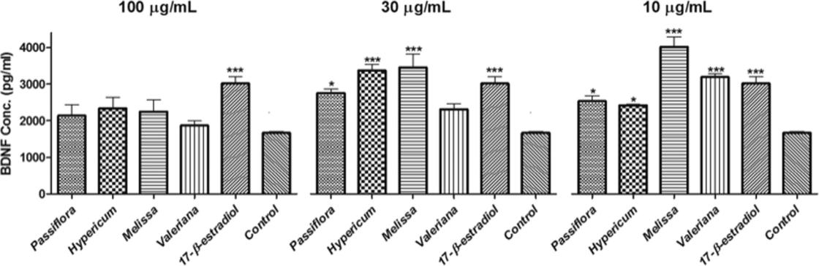

**Fig. 1.** Effect of extracts (10, 30 and 100 µg/ml) on the BDNF level. ***(*p*< 0.0001), * (*p*< 0.05) compared to the control (*n*= 3).

ml concentrations, respectively. Our results showed that the methanolic extract of the leaves from *M. officinalis* was the most active, and had almost greater activity than the positive control at 30 and 10 µg/ml concentrations. BDNF expression was found low at the 100 µg/ml concentration of all extracts (Fig. 1)*.*

When all the results were examined comparatively, it was de-termined that the investigated plant extracts had a significant effect on BDNF expression at two concentrations. First, the plant extracts studied at a concentration of 100 μg/ml showed low activity. The activity of *V.* *officinalis* and *M. officinalis* increased as their concentration decreased. *M. officinalis* at the 10 μg/ml concentration increased the BDNF levelthe highest at 140.90% in contrast to the mere 81.3% increase by the positive control 17*β*-estradiol. A high BDNF expression was observed in all samples at the concentration of 30 μg/ml. At the 10 μg/ml con-centration, the BDNF expression of the *H. perforatum* and *P. incarnata* extracts decreased while the activity of *V. officinalis* and *M. officinalis* continued to increase. *H. perforatum* had one of the weakest effects among all plant extracts, increasing the BDNF expression by 45.40% at 10 μg/ml (Fig. 1).

From these results, it can be suggested that plant extracts containing acidic group in the major compound (valerenic acid for *V. officinalis* and rosmarinic acid *for M. officinalis*) are more effective at lower con-centrations.

*H. perforatum* contains hyperforin, a cyclic terpene ketone that is aprenylated carbobicyclic acylphloroglucinol derivative, and hipericin, which is a naphtodianthron. We can conclude that the active metabo-lites in the *H. perforatum* and *P. incarnata* extracts are reduced at 10 μg/ ml while those in *V. officinali*s and *M. officinalis* are still present at this concentration.

*Metabolomics analysis*

In the present study, the correlation between comprehensive che-mical fingerprints and bioactivity was determined. We compared the metabolomic profiles of*V. officinalis, M. officinalis, H. perforatum* and *P.* *incarnata* in order to determine the metabolites with stimulating BDNFexpression activities. In order to identify the metabolites responsible for such activities in the extract, the metabolomic profiling of the plants was investigated using GC–MS and LC-qTOF-MS (Figs. 2 and 3). After deconvolution and alignment of the GC–MS chromatograms, 215 mass spectral features were detected, of which 68 were annotated using re-tention index libraries. For the LC-qTOF-MS data, 5270 peaks were found, of which 354 were identified using the MS/MS spectrum.

The score plot clarified that the differences and similarities of the metabolomic profiles can be used for classification and can explain the similar activities of different species. Metabolic fingerprints were ob-tained by accurate mass measurements, and multivariate analysis ap-proaches were adopted to determine the phytochemical similarities and differences between the species. The metabolomic fingerprints of the plant species belonging to four different genera were subsequently

classified by multivariate data analysis. The principal component ana-lysis (PCA) showed similar metabolomic profiles between*H. perfor-atum*, and *P. incarnata*, while *V. officinalis and M. officinalis* had differentmetabolomic profiles (Fig. 4). These similarities were also observed in the BDNF activity results (Fig. 2). All these results show a correlation between the plants’ metabolomic profile and BDNF activity.

A correlation analysis was applied to evaluate the correlation be-tween GC–MS metabolomic profiling and BDNF expression. We in-vestigated the correlations of metabolites with BDNF expression in order to identify the metabolites with a negative or positive effect on this activity. This analysis was undertaken to explore the synergistic and antagonistic effect of the metabolites compared to the search based on single metabolite analysis. Nine metabolites were found to have a negative correlation (*r* ≤ −0.65) with BDNF expression, while 16 me-tabolites showed a highly positive correlation (*r* ≥ 0.65) (Supplement Table 1).

The results based on correlation studies from GC–MS metabolomics profiling showed that BDNF expression activities were positively asso-ciated with phytochemicals; lipid (arachidic acid, octadecanol and pa-latinitol) and sugar (gentiobiose, galactinol, and 1-benzylglucopyr-anoside) mediator metabolites were found to be positively correlated with the BDNF activity. Myo-inositol-1-phosphate, which plays a cru-cial role in the phosphatidylinositol-signaling pathway, also showed a positive correlation. Remarkably, all the metabolites belonging to the Krebs Cycle (citric acid, fumaric acid, succinic acid, pyruvic acid, malic acid, and citramalic acid, an analog of malic acid) had a positive cor-relation with the BDNF activity. This may be an indication of the high metabolomic rate, which may also lead to higher secondary metabo-lomic rates in plants. Other metabolites positively correlated with BDNF activity were glycolic acid, galactonic acid, and caffeic acid. On the other hand, proline, galactosylglycerol, valine, sitosterol, benzoic acid, pyroglutamic acid, porphine, 2-O-glycerol-beta-D-galactopyranoside and threitol decreased the BDNF expression.

Based on the correlation studies of the LC-qTOF-MS analysis, 78 metabolites were found to have a positive correlation (*r* ≥ 0.65) with the BDNF expression, while 14 metabolites showed a highly negative correlation (*r* ≤ −0.65) (Supplement Table 2). The BDNF expression activities were positively associated with the secondary metabolites, namely aliphatic alcohol glycoside, cyclodipeptide pigment, flavonoids, flavonolignans, phytoestrogen, xanthone, coumarines, tannin, naph-thalenes, naphthofuran, dihydrophenanthrene, valepotriates, terpe-noids (iridoid, diterpenes, sesquiterpenes, sesterterpenes and tri-terpenes), alkaloids, phenolic acids, and carotenoid. Some primary metabolites, such as fatty acids were found to be positively correlated with the BDNF expression. On the other hand, some secondary meta-bolites (chroman, isoflavone, sesquiterpene lactone, alkaloid, xan-thone) decreased the BDNF expression. Consistent with the positive correlation revealed by our LC-qTOF analysis, there are studies in the literature referring to phenolic compounds, such as flavonoids, or ter-penoids partaken in the increase of BDNF levels (Sangiovanni et al.,

4

*E.M. Gonulalan, et al.* *Phytomedicine 74 (2020) 152920*

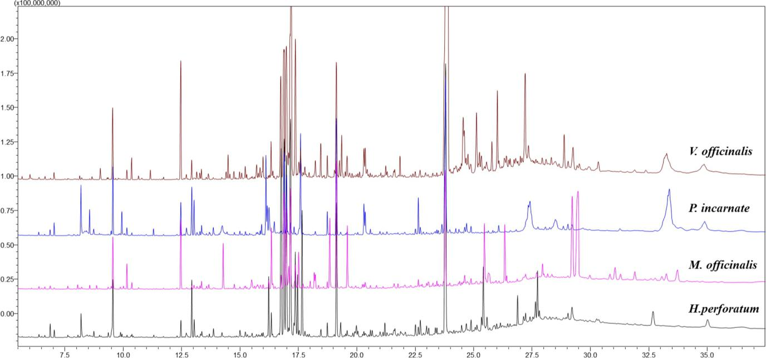

**Fig. 2.** Representative GC–MS chromatograms of the plants.

2017; Xu et al., 2013).

There were also unidentified metabolites from both metabolomics analysis that were highly correlated with BDNF activity. Current data-bases used in the study for metabolite identification were not able to identify these metabolites. These promising metabolites may belong to a secondary metabolism and can provide very important information when identified with developed libraries.

*Proteomics analysis*

In the proteomics analysis of the plants, we identified 76 proteins for *V. officinalis*, 300 proteins for *P. incarnata*, 337 proteins for *M. of-ficinalis,* and 92 proteins for *H. perforatum*. When we investigated theidentified proteins on the panther gene ontology platform, we observed that most were nucleic acid (DNA and RNA)-binding proteins involved in cellular processes. In addition, we analyzed these proteins in terms of the biological process in cells. Many were involved in metabolic pro-cesses; *e.g.*, primary metabolic process, and organic substance meta-bolic and biosynthetic process (Fig. 5).

In proteomics experiments, we used a label-free quantification al-gorithm to calculate protein intensity. The calculated protein intensities were used to investigate the correlation between protein abundance and activity. We found that 24 proteins were in a positive correlation and six in a negative correlation with BDNF activity (Supplement Table 3).

When we investigated the proteins, which correlated with BDNF activity, we found interesting results. We observed two proteins from the cytochrome P450 family (P450 71B11 and P450 94B3) to be in a positive correlation with BDNF activity. This family is essential for plant development and defence. These proteins have the ability to synthesize secondary bioactive metabolites and have been evaluated as a therapeutic agent in several studies (Takase et al., 2016; Peyser et al., 2017). Based on the results of the current work, we believe that the cytochrome P450 members contribute to BDNF activity.

We also observed that various abiotic stress proteins, such as elon-gator complex protein 1, DEAD-box ATP-dependent RNA helicase 51, and E3 ubiquitin-protein ligase UPL6 were positively correlated with BDNF expression. These proteins control the stress response mechanism through several pathways; *e.g.*, the antioxidant system (Ding et al.,

2015; Liu et al., 2013). They can increase bioactive metabolites directly or indirectly.

We determined that kinesin-like protein was positively correlated with BDNF expression. This protein is a member of the kinesin motor protein family, which is known to be very effective in plant growth and metabolism (Li et al., 2012). Increasing the expression level of these proteins can lead to the synthesis of bioactive molecules. In future work, we are planning to study these proteins with targeted experi-ments to determine their effects on BDNF activity.

**Conclusion**

This is the first study in which the metabolomics and proteomics profiles of neuroactive plants,*V. officinalis, M. officinalis, H. perforatum*, and *P. incarnata,* were correlated with BDNF expression by considering the contribution of all molecules to this activity. An integrated omics perspective was used to provide an understanding of how four different plants showed similar effects on BDNF activity. Mass spectrometry-based metabolomics and proteomics studies allowed detecting multiple components with high sensitivity even at very low concentrations. The whole metabolite and proteomic pool of the four different plants were identified, and the positive/negative correlations of the metabolites and proteins with BDNF expression were determined.

Generally, the focus of phytochemical research is on individual compounds. This "molecular reductionist" paradigm is based on the assumption that a single metabolite is only biologically active. However, due to the synergistic and antagonistic effects on the efficacy of plant extracts, a group of metabolites can play a role together, rather than as a single compound. Therefore, an omics approach is a more appropriate way of demonstrating the effect of plant extract on various activities.

Reverse omics or metabolomics-informed activity is a remarkable approach, in which determination of specific metabolite changes may lead to the discovery of new active compounds. Therefore, bringing new omics technologies into the plant research area will shed further light on the role of plant extracts and may lead to the discovery of new compounds with specific activities.

5

*E.M. Gonulalan, et al.* *Phytomedicine 74 (2020) 152920*

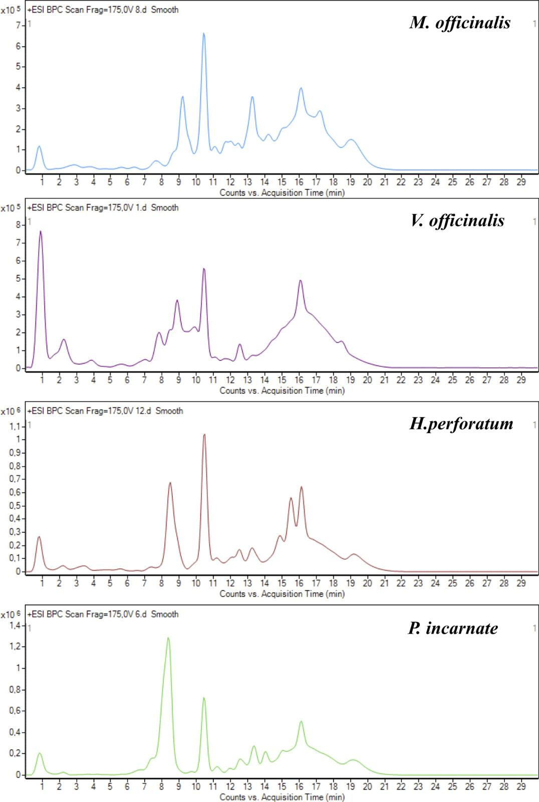

**Fig. 3.** Representative LC-qTOF-MS chromatograms of the plants.

6

*E.M. Gonulalan, et al.* *Phytomedicine 74 (2020) 152920*

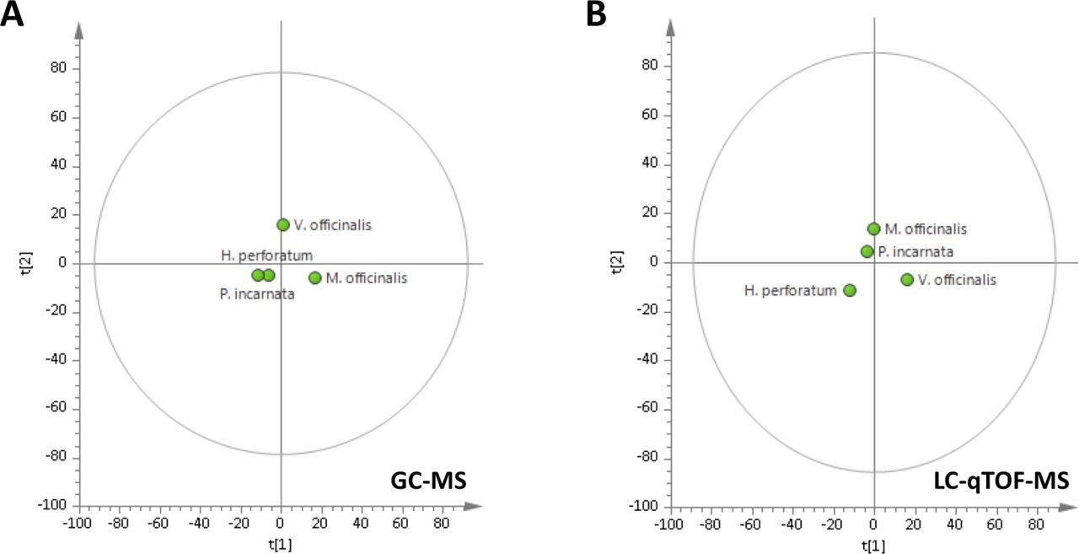

**Fig. 4.** Principal component score plot of the plants A) GC–MS based metabolomics profiling and B) LC-qTOF-MS based metabolomics profiling.

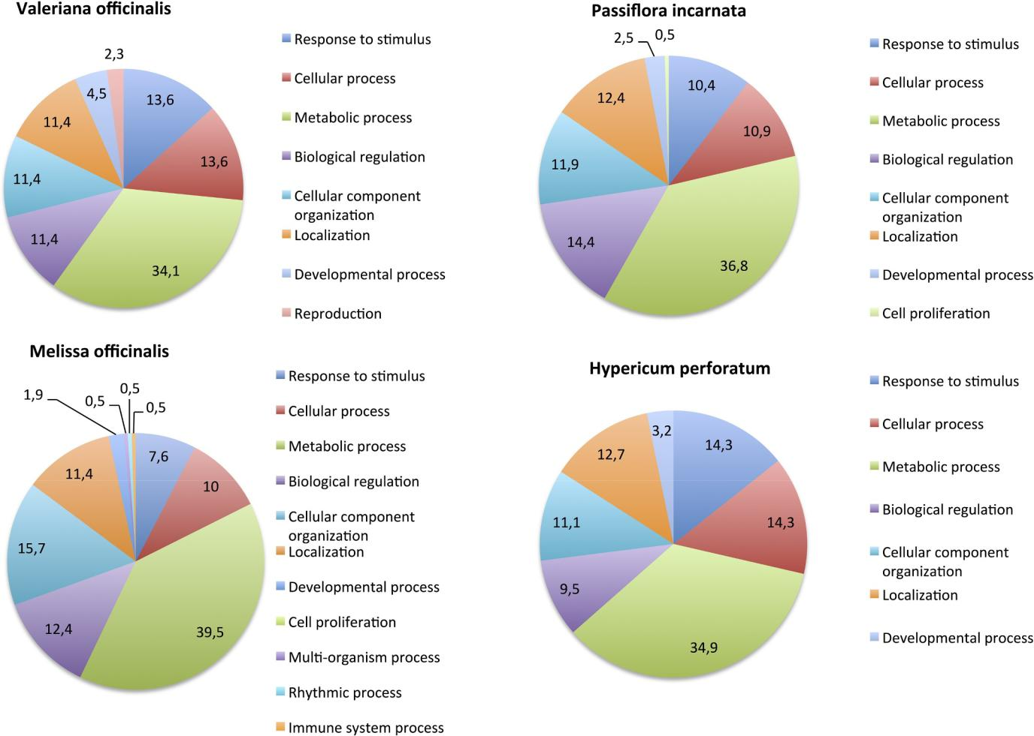

**Fig. 5.** Functional classification of the identified proteins according to biological processes.

7

*E.M. Gonulalan, et al.*

**Acknowledgments**

This study was financially supported by grants from Hacettepe University Scientific Research Projects(Project no: THD-2016-9171)

**Conflict of interest**

The authors report no conflict of interest.

**Supplementary materials**

Supplementary material associated with this article can be found, in the online version, at [doi:10.1016/j.phymed.2019.152920](https://doi.org/10.1016/j.phymed.2019.152920).

**References**

Baginsky, S., 2009. Plant proteomics: concepts, applications, and novel strategies for data [interpretation. Mass Spectrom. Rev. 28 (1), 93–120](http://refhub.elsevier.com/S0944-7113(19)30089-3/sbref0001).

[Björkholm, C., Monteggia, L.M., 2016. BDNF – a key transducer of antidepressant effects.](http://refhub.elsevier.com/S0944-7113(19)30089-3/sbref0002)

[Neuropharmacology 102, 72–79](http://refhub.elsevier.com/S0944-7113(19)30089-3/sbref0002).

Blumenthal, M, et al., 1998. The Complete German Commission E [Monographs–Therapeutic Guide to Herbal Medicines](http://refhub.elsevier.com/S0944-7113(19)30089-3/sbref0003).

Castleman, M., 2001. The New Healing Herbs: The Classic Guide to Nature's Best [Medicine Featuring the Top 100 Time-Tested Herbs. Rodale Press, Emmaus, PA](http://refhub.elsevier.com/S0944-7113(19)30089-3/sbref0004).

[Chavez, M.L., Chavez, P.I., 1997. Saint John's wort. Hosp Pharm. 32 (12), 1621–1632](http://refhub.elsevier.com/S0944-7113(19)30089-3/sbref0005).

[Dennis, D.T., 1997. Plant Metabolism, 2 edition. Longman](http://refhub.elsevier.com/S0944-7113(19)30089-3/sbref0006).

[Dhawan, K., Dhawan, S., Sharma, A., 2004. Passiflora: a review update.](http://refhub.elsevier.com/S0944-7113(19)30089-3/sbref0007) J.

[Ethnopharmacol. 94 (1), 1–23](http://refhub.elsevier.com/S0944-7113(19)30089-3/sbref0007).

Dietz, B.M., Mahady, G.B., Pauli, G.F., Farnsworth, N.R., 2005. Valerian extract and va-[lerenic acid are partial agonists of the 5-HT5a receptor *in vitro*. Mol. Brain Res. 138](http://refhub.elsevier.com/S0944-7113(19)30089-3/sbref0008)

[(2), 191–197](http://refhub.elsevier.com/S0944-7113(19)30089-3/sbref0008).

Ding, Y., Mou, Z., 2015. Elongator and its epigenetic role in plant development and re-[sponses to abiotic and biotic stresses. Front. Plant Sci. 6, 296](http://refhub.elsevier.com/S0944-7113(19)30089-3/sbref0009).

Elwy, A.M., Tabl, G., 2012. Anti-inflammatory and immune regulatory effects of Salvia [officinalis extract on ova-induced asthma in mice. Life Sci. J. 9 (25),](http://refhub.elsevier.com/S0944-7113(19)30089-3/sbref0010) 191–196.

[ESCOP, 2003. Monographs, second ed. Thieme, New York](http://refhub.elsevier.com/S0944-7113(19)30089-3/sbref0011).

[ESCOP, 2018. Monographs. Thieme, New York](http://refhub.elsevier.com/S0944-7113(19)30089-3/sbref0012).

Felgentreff, F., Becker, A., Meier, B., Brattström, A., 2012. Valerian extract characterized by high valerenic acid and low acetoxy valerenic acid contents demonstrates anxio-[lytic activity. Phytomedicine 19 (13), 1216–1222](http://refhub.elsevier.com/S0944-7113(19)30089-3/sbref0013).

[Fiehn, O., 2002. Metabolomics — the link between genotypes and phenotypes. Plant Mol.](http://refhub.elsevier.com/S0944-7113(19)30089-3/sbref0014)

[Biol. 48, 155–171](http://refhub.elsevier.com/S0944-7113(19)30089-3/sbref0014).

Gonulalan, E.M., Bayazeid, O., Yalcin, F.N., Demirezer, L.O., 2018. The roles of valerenic [acid on BDNF expression in the SH-SY5Y cell. Saudi Pharm. J. 26 (7), 960–964](http://refhub.elsevier.com/S0944-7113(19)30089-3/sbref0015).

Grandolini, G., Fardella, G., Mercati, V., Polenzani, P., Toja, E., 1997. New studies on the constituents of cultivated *Passiflora incarnata* L. In: International Joint Symposium: Chemistry, Biological and Pharmacological Properties of Medicinal Plants from the [America. Republic of Panama, Panama, pp. 23–26 B-27, February](http://refhub.elsevier.com/S0944-7113(19)30089-3/sbref0016).

Hashiguchi, A., Tian, J., Komatsu, S., 2017. Proteomic contributions to medicinal plant [research: from plant metabolism to pharmacological action. Proteomes 5 (4), 35](http://refhub.elsevier.com/S0944-7113(19)30089-3/sbref0017).

Hashimoto, K., Shimizu, E., Iyo, M., 2004. Critical role of brain-derived neurotrophic [factor in mood disorders. Brain Res. Rev. 45 (2), 104–114](http://refhub.elsevier.com/S0944-7113(19)30089-3/sbref0018).

[Houghton, P.J., 1999. The scientific basis for the reputed activity of valerian. J. Pharm.](http://refhub.elsevier.com/S0944-7113(19)30089-3/sbref0019)

[Pharmacol. 51, 505–512](http://refhub.elsevier.com/S0944-7113(19)30089-3/sbref0019).

Jellin, J.M., Gregory, P.J., Batz, F., Hitchen, K., 2002. Pharmacist's Letter/Prescriber's Letter Natural Medicines Comprehensive Database, 4th ed. Therapeutic Research [Faculty, Stockton, CA](http://refhub.elsevier.com/S0944-7113(19)30089-3/sbref0020).

Kamatou, G.P.P., Makunga, N.P., Ramogola, W.P.N., Viljoen, A.M., 2008. South African Salvia species: a review of biological activities and phytochemistry. J. Ethnopharm. [119, 664–672](http://refhub.elsevier.com/S0944-7113(19)30089-3/sbref0021).

Kocak, E., 2017. Faculty of Pharmacy, Ultra Performance Liquid Chromatography Mass Spectroscopy Based Proteomics Studies on CaCo2 Colon Cancer Cells Hacettepe University, Turkey.

Kopka, J., Schauer, N., Krueger, S., Birkemeyer, C., Usadel, B., Bergmuller, E., …, Steinhauser, D., 2004. GMD@CSB.DB: the Golm Metabolome Database. [Bioinformatics 21 (8), 1635–1638](http://refhub.elsevier.com/S0944-7113(19)30089-3/sbref0022).

Laakmann, G., Schule, C., Baghai, T., Keiser, M., 1998. St. John's wort in mild to moderate

*Phytomedicine 74 (2020) 152920*

depression: the relevance of hyperforin for the clinical efficacy. Pharmacopsychiatry [31, 54–59](http://refhub.elsevier.com/S0944-7113(19)30089-3/sbref0023).

Lai, Z., Tsugawa, H., Wohlgemuth, G., Mehta, S., Mueller, M., Zheng, Y., Ogiwara, A., Meissen, J., Showalter, M., Takeuchi, K., Kind, T., Beal, P., Arita, M., Fiehn, O., 2018. Identifying metabolites by integrating metabolome databases with mass spectrometry [cheminformatics. Nat. Methods 15, 53–56](http://refhub.elsevier.com/S0944-7113(19)30089-3/sbref0024).

[Li, J., Xu, Y., Chong, K., 2012. The novel functions of kinesin motor proteins in plants.](http://refhub.elsevier.com/S0944-7113(19)30089-3/sbref0025)

[Protoplasma 2, 95–100](http://refhub.elsevier.com/S0944-7113(19)30089-3/sbref0025).

[Linde, K., Mulrow, C.D., 1998. St. John's Wort for Depression. The Cochrane Library. 4.](http://refhub.elsevier.com/S0944-7113(19)30089-3/sbref0026)

[Oxford (Cochrane Review), pp. 1–15](http://refhub.elsevier.com/S0944-7113(19)30089-3/sbref0026).

Liu, J., Xia, Z., Wang, M., Zhang, X., Yang, T., Wu, J., 2013. Overexpression of a maize E3 ubiquitin ligase gene enhances drought tolerance through regulating stomatal aper-ture and antioxidant system in transgenic tobacco. Plant Physiol. Biochem. 73, [114–120](http://refhub.elsevier.com/S0944-7113(19)30089-3/sbref0027).

Lutomski, J., Segiet, E., Szpunar, K., Grisse, K., 1981. The importance of the passionflower [in medicine. Pharm. Unserer. Zeit. 10 (2), 45–49](http://refhub.elsevier.com/S0944-7113(19)30089-3/sbref0028).

Mahdi, J., Al-Musayeib, N., Mahdi, E., Pepper, C., 2013. Pharmacological importance of simple phenolic compounds on inflammatıon, cell proliferation and apoptosis with a special reference to beta-d-salicin and hydroxybenzoic acid. Eur. J. Inflamm. 11 (2), [327–336](http://refhub.elsevier.com/S0944-7113(19)30089-3/sbref0029).

Müller, W.E., 2003. Current St. John's wort research from mode of action to clinical ef-[ficacy. Pharmacol. Res. 47,](http://refhub.elsevier.com/S0944-7113(19)30089-3/sbref0030) 101–109.

Nemutlu, E., Zhang, S., Juranic, N.O., Terzic, A., Macura, S., Dzeja, P., 2012. 18 O-assisted dynamic metabolomics for individualized diagnostics and treatment of human dis-[eases. Croatian Med. J. 53 (6), 529–534](http://refhub.elsevier.com/S0944-7113(19)30089-3/sbref0031).

Nemutlu, E., Zhang, S., Xu, Y.Z., Terzic, A., Zhong, L., Dzeja, P.D., Cha, Y.M., 2015. Cardiac resynchronization therapy induces adaptive metabolic transitions in the [metabolomic profile of heart failure. J. Card. Fail. 21 (6),](http://refhub.elsevier.com/S0944-7113(19)30089-3/sbref9001) 460–469.

Petersen, M., Simmonds, M.S.J., 2003. Rosmarinic acid. Phytochemistry 62 (2), 121–125. Peyser, R.D., Lanno, S.M., Shimshak, S.J., Coolon, J.D., 2017. Analysis of cytochrome [P450 contribution to evolved plant toxin resistance in Drosophila sechellia. Insect](http://refhub.elsevier.com/S0944-7113(19)30089-3/sbref0033)

[Mol. Biol. 26 (6), 715–720](http://refhub.elsevier.com/S0944-7113(19)30089-3/sbref0033).

Ravindran, P.N., Pillai, G.S., 2012. second edition. Handbook of Herbs and Spices Vol. 2 [Chapter 7](http://refhub.elsevier.com/S0944-7113(19)30089-3/sbref0034).

Sangiovanni, E, Brivio, P, Dell'Agli, M, Calabrese, F., 2017. Botanicals as modulators of [neuroplasticity: focus on BDNF. Neural Plasticity 1–19](http://refhub.elsevier.com/S0944-7113(19)30089-3/sbref0035).

Schauer, N., Fernie, A.R., 2006. Plant metabolomics: towards biological function and [mechanism. Trends Plant Sci. 11, 508–516](http://refhub.elsevier.com/S0944-7113(19)30089-3/sbref0036).

[Stitt, M., 1998. Pyrophosphate as an alternative energy donor in the cytosol of plant cells:](http://refhub.elsevier.com/S0944-7113(19)30089-3/sbref0037)

[an enigmatic alternative to ATP. Bot. Acta. 111, 167–175](http://refhub.elsevier.com/S0944-7113(19)30089-3/sbref0037).

Sumner, L.W., Mendes, P., Dixon, R.A., 2003. Plant metabolomics: large-scale phy-[tochemistry in the functional genomics era. Phytochemistry 62 (6), 817–836](http://refhub.elsevier.com/S0944-7113(19)30089-3/sbref0038).

Takase, H., Sasaki, K., Shinmori, H., Shinohara, A., Mochizuki, C., Kobayashi, H., et al., 2016. . Cytochrome P450 CYP71BE5 in grapevine (Vitis vinifera) catalyzes the for-[mation of the spicy aroma compound (−)-rotundone. J. Exp. Bot. 67 (3), 787–798](http://refhub.elsevier.com/S0944-7113(19)30089-3/sbref0039).

[Trygg, J., Gullberg, J., Johansson, A.I., Jonsson, P., 2006. Plant Metabolomics:](http://refhub.elsevier.com/S0944-7113(19)30089-3/sbref0040)

[Biotechnology in Agriculture and Forestry 57. Springer Verlag, pp. 117–128 2006](http://refhub.elsevier.com/S0944-7113(19)30089-3/sbref0040).

[Tsuchiya, H., Shimizu, H., Iinuma, M., 1999. Beta-carboline alkaloids in crude drugs.](http://refhub.elsevier.com/S0944-7113(19)30089-3/sbref0041)

[Chem. Pharm. Bull. 47 (3), 440–443](http://refhub.elsevier.com/S0944-7113(19)30089-3/sbref0041).

Tsugawa, H., Cajka, T., Kind, T., Ma, Y., Higgins, B., Ikeda, K., Kanazaw, M., VanderGheynst, J., Fiehn, O, Arita, M., 2015. MS-DIAL: data-independent MS/MS [deconvolution for comprehensive metabolome analysis. Nat. Methods 12, 523–526](http://refhub.elsevier.com/S0944-7113(19)30089-3/sbref0042).

Ulrich-Merzenich, G., Zeitler, H., Jobst, D., Panek, D., Vetter, H., Wagner, H., 2007. Application of the “-Omic-” technologies in phytomedicine. Phytomedicine 14 (1), [70–82](http://refhub.elsevier.com/S0944-7113(19)30089-3/sbref0043).

Verpoorte, R., Choi, Y.H., Kim, H.K., 2005. Ethnopharmacology and systems biology: a [perfect holistic match. J. Ethnopharmacol. 100 (1–2), 53–56](http://refhub.elsevier.com/S0944-7113(19)30089-3/sbref0044).

[Verpoorte, R., Choi, Y.H., Mustafa, N., Kim, H.K., 2008. Metabolomics: back to basics.](http://refhub.elsevier.com/S0944-7113(19)30089-3/sbref0045)

[Phytochem. Rev. 7, 525–537](http://refhub.elsevier.com/S0944-7113(19)30089-3/sbref0045).

[Williamson, E.M., 2001. Synergy and other interactions in phytomedicines.](http://refhub.elsevier.com/S0944-7113(19)30089-3/sbref0046)

[Phytomedicine 8, 401–409](http://refhub.elsevier.com/S0944-7113(19)30089-3/sbref0046).

Wink, M., Botschen, F., Gosmann, C., Schäfer, H., Waterman, P.G., 2010. Chemotaxonomy Seen from a Phylogenetic Perspective and Evolution of Secondary Metabolism. Annual Plant Reviews Volume 40: Biochemistry of Plant Secondary [Metabolism, Second Edition.](http://refhub.elsevier.com/S0944-7113(19)30089-3/sbref0047) .

Xu, S.L., Bi, C.W., Choi, R.C., Zhu, K.Y., Miernisha, A., Dong, T.T., Tsim, K.W., 2013. Flavonoids induce the synthesis and secretion of neurotrophic factors in cultured rat astrocytes: a signaling response mediated by estrogen receptor. J. Evid. Based [Complement. Altern. Med. 127075](http://refhub.elsevier.com/S0944-7113(19)30089-3/sbref0048).

Zanoli, P., Avallone, R., Baraldi, M., 2000. Behavioral characterisation of the flavonoids apigenin and chrysin. Fitoterapia 71, 117–S123.

8