

Original Paper

Effects of viewing flowering plants on employees’ wellbeing in an office-like environment

Mohamed Elsadek1,2  and Binyi Liu1

**Indoor and Built**

**Environment**

Indoor and Built Environment 0(0) 1–12

* The Author(s) 2020 Article reuse guidelines: [sagepub.com/journals-permissions](http://uk.sagepub.com/en-gb/journals-permissions)

[DOI: 10.1177/1420326X20942572](http://dx.doi.org/10.1177/1420326X20942572) <journals.sagepub.com/home/ibe>



Abstract

Despite the existence of plentiful studies on how plants can positively affect human wellbeing, few have focused on the potential effects of flower colours on stressed people. The present study was designed to illustrate the psychophysiological relaxation impacts of seeing purple and blue hydrangea flowers among finance workers. Thirty employees were asked to view purple, blue flowers or an empty table for 3-min, during which we measured the participants’ brain activity, heart rate variability and skin conductance. We also assessed their emotions and mood states. Findings suggest that, compared with viewing the control, viewing blue and purple flowers resulted in a significant increase in alpha relative waves in the prefrontal and occipital lobes, and a significant increase in parasympathetic ner-vous activity. A significant increase in the sensation vote for ‘comfort’, ‘relaxation’ and ‘cheerfulness’, as well as a dramatic improvement in the mood state was observed. The results show clear evidence for the support of the use of blue and purple flowering plants in places where comfort and calmness are required. In addition, blue flowers were more favoured and had the greatest positive effects. Results indicate that viewing flowering plants would be a promising therapeutic approach for enhancing phys-iological functions and improving psychological relaxation for office workers.

Keywords

Flowering plants, Horticulture therapy, Indoor environment, Office workers, Relaxation, Stress reduction

Accepted: 25 June 2020

Introduction

Stress is one of the greatest barriers to employee engagement in the modern workplace. The adverse consequences of stress are so high that the World Health Organization has declared it to be a global epi-demic.1 Work stress can lead to both physical and mental illness.2 Additionally, current predictions sug-gest that stress will be the leading cause of disease burden worldwide by 2030.3

Exposure to the natural environment plays a vital role in minimizing the negative emotions such as depression, tension and anxiety, and there is consider-able scientific evidence indicating that contact with nature and greenery can promote a positive mood and aid relaxation in human beings,4,5 improve human wellbeing, and alleviate negative emotions such as stress and mental fatigue.6,7 Participants in

the forest environment showed lower pulse rates, dia-stolic blood pressure and systolic blood pressure than those in urban settings.8 Viewing a green fac¸ade caused relatively higher alpha waves, significantly increased parasympathetic activity and decreased skin conduc-tance (SC) whilst significantly increasing feelings of comfort and relaxation compared to the viewing a

1Department of Landscape Architecture, College of Architecture and Urban Planning, Tongji University, Shanghai, China

2Department of Horticulture, Faculty of Agriculture, Suez Canal University, Ismailia, Egypt

Corresponding author:

Binyi Liu, Department of Landscape Architecture, College of Architecture and Urban Planning, Tongji University, No. 1239 Siping Road, Shanghai, Yangpu District 200092, China. Email: [89098@tongji.edu.cn](mailto:89098@tongji.edu.cn)

2

building-wall.9 Several possible explanations in the Environmental Psychology for why viewing and/or being in contact with nature, both as plants and green spaces have a significant restorative impact on mental fatigue and stress, such as attention restoration theory (ART),10 which posits that exposure to natural environments can improve individual’ focus and ability to concentrate. Stress reduction theory (SRT)6 which posits that exposure to nature may have a direct restor-ative effect on cognition and may reduce stress.

The Environmental Protection Agency has stated that people spending most of their time indoors,11 lim-iting their exposure to the natural environments that are known to provide both physical and mental health benefits. Consequently, office workers have few oppor-tunities for contact with the natural environment during their working hours. Taking this into account and to help employees work in an appropriate environ-ment, previous research has assessed the levels of psy-chological stress among office workers12 and has shown that stressors in the workplace not only cause psycho-logical impacts but also raise the risk of heart and blood pressure disorders.13 A convenient way to get in contact with nature indoors is to see indoor plants, which are usually used to decorate houses or offices. Several physiological and psychological studies have been carried out to explore the impact of indoor plants on human health and wellbeing. Lohr et al.14 showed that in the presence of indoor plants, the par-ticipants were more productive and felt more attentive and less stressed. Also, patients with plants in their room showed lower systolic blood pressure and cardiac rates compared to rooms without plants.15

As stated, the beneficial impact of nature and plants on the physiology and psychology of individuals has been well documented. However, limited research has been conducted to investigate the physiological and psychological impacts of flowering plants with different colours. Colour is indeed an important part of our daily lives and has a profound impact on our mood, emotion and on our performance.16 Colour can change negative moods (sadness, confusion and fear) into pos-itive moods (happiness, intelligence and confidence), it can be used to ‘level out’ emotions or to create different moods.17 Previous studies have addressed the emotion-al impacts of the use of colour indoors.18,19 Recently, the visualization impact of plant colour has received more attention. Various variegation in the plantscape has been found to enhance various psychophysiological responses, including relaxation, pleasure and excite-ment.20,21 The relationship between humans and flow-ers is unique. For more than 5000 years, people have cultivated flowers although there are no known benefits for this costly behaviour.22 Several studies have indi-cated that the red colour improves mental functioning

Indoor and Built Environment 0(0)

compared to blue and green;23 however, others have shown the exact opposite.24 Consequently, understand-ing human physiological and psychological responses to different flower colours is imperative.

To the best of our knowledge, most previous studies were carried out with college students under laboratory conditions.25 Only indices of autonomic nervous activ-ity,26 SC27 and salivary cortisol concentration were used in these experiments.28 Surprisingly, however, little research has done on how flower colours affect office workers suffering from work stress. This study is the first of its kind to be conducted with office workers, in a real office environment and combining multiple measurements. Evidence-based studies examining the psychophysiological impact of flower colours on indi-viduals with stress levels are limited. Consequently, as a third of office employees in developed countries expe-rience work in extremely stressful environments,29 it could be argued that there is an urgent need to alleviate this situation.

The present study intends to address the following research questions: Do flowering plants have psycho-physiological relaxing effects on stressed people? Do/ can they change individuals’ moods and emotions? Which flower colour (purple or blue) is more preferred than the other? Despite the growing number of researchers studying human–plant interaction, these evidence gaps continue to exist. To address these ques-tions, the purpose of this research is to explore the visual stimulation impacts of two flower colours of Hydrangea, i.e., purple and blue, on the brain activity in the prefrontal and occipital lobes assessed using elec-troencephalography (EEG); the sympathetic and para-sympathetic autonomic nervous activity by measuring heart rate variability (HRV); and psychological relaxa-tion to build an evidence-base for the relaxation impacts and stress reduction attributable to indoor flowering plants. The findings could lead to a better understand-ing of how flowering plants can affect humans in indoor environments and provide scientific evidence for a healthy indoor environment construction that could help landscape designers to select suitable colours for various landscape decorations. We hypothesize that, through horticulture therapy, flowers can contribute to the reduction of stress levels in daily life.

Materials and methods

Participants

Having in mind our aim of assessing the physiological and psychological responses of stressed people, a review of the literature and the International Labour Office report30,31 have led to our selecting participants dealing with work-related stress in the financial services

|  |  |
| --- | --- |
| Elsadek and Liu | 3 |

Table 1. Descriptive data of the participants (n ¼ 30).

|  |  |  |
| --- | --- | --- |
| Variable | Average | Standard error (SE) |
|  |  |  |
| Age (years) | 29.42 | 1.52 |
| Height (cm) | 162.20 | 5.71 |
| Body weight (kg) | 56.70 | 4.82 |
|  |  |  |

industry, therefore, we can understand the effect of flower colours on stress reduction. The study took place in a finance office at Jin-Mao Tower, located in Shanghai’s central business district. Thirty female finance employees aged 29.42 1.52 years (mean SE) with normal visual acuity or corrected-to-normal vision were voluntarily recruited to participate in the present study. Participants currently undergoing treat-ment for any neurological illness, those having their menstrual period during the study were excluded. The participants were requested not to drink alcohol the day before the experiment to ensure physical and mental health during the experiment. Also, caffeine and tobacco consumption were prohibited during the study period. The personal information and character-istics of participants are shown in Table 1. The study was conducted in accordance with the ethics rules of Tongji University (no. 2015yxy103), and all subjects provided their written informed consent prior to experiments.

Visual stimuli

We wanted to find a plant that is popular worldwide and rich with flowers. However, it had to remain suit-able for indoor use, as well as in gardens and as cut flowers. Hydrangea macrophylla cultivars are one of the showiest plants famous for their rich foliage and impressively large, colourful inflorescences. Two widely known H. macrophylla flower colours (purple and blue) were used in the present study. One pot of each colour was prepared for the visual stimulation. The distance between the eyes of the participants and the visual stimuli was 40 cm, and this was adjusted according to the height of the participant. The control condition consisted of no experimental stimulus. Figure 1 displays the experimental setting.

Procedure

In an office environment, the experiment began at 3 p. m. on official working days to ensure that the office workers needed relaxation to promote the relaxation impacts. After clarification of the study objectives and procedures in the waiting room, each participant was moved to the test room for physiological measurements at a temperature of 21 C, 50% relative humidity and an illumination of 300 lux. Before the participants entered

Figure 1. Experimental setting and the physiological measurements during exposure to visual stimulation.

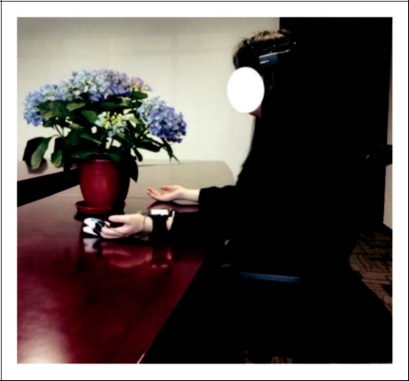

the office, the tested plants were covered. The partici-pant was instructed to sit on a chair, while the portable EEG electrodes and ErgoLAB sensors were installed for the physiological measurements. First, to test the elec-trode monitoring accuracy and stability, the participant was told to switch between eye opening and closing in four 1-min intervals. Subsequently, each participant was told to relax for 2 min with closed eyes to adapt the mood to the experimental environment, and then the participant was asked to open her eyes, to avoid motion of her body (to reduce the presence of irrelevant artefacts in the EEG records), and focus on the visual stimuli of either blue flowers or purple flowers or an empty table as a control (baseline) for 3 min each. Measurements of the physiological responses of partic-ipants were constantly performed during the testing procedure. After that, the participant was required to respond to self-reported emotion questionnaires, semantic differential (SD), and Profile of Mood States (POMS). The order of visual stimulations (i.e. blue flower vs. purple flowers vs. control) was randomized to eliminate the order effect. The experimental design and measuring procedures are summarized in Figure 2. A within-subject design experiment was used, and all visual stimuli were experienced by each subject. The total duration of the experiment was 30–35 min.

Measurements

Physiological measures

EEG data collection and analysis

Brain electrical activity was measured using the Emotiv EPOC wireless EEG headset (see Figure 3).

4 Indoor and Built Environment 0(0)

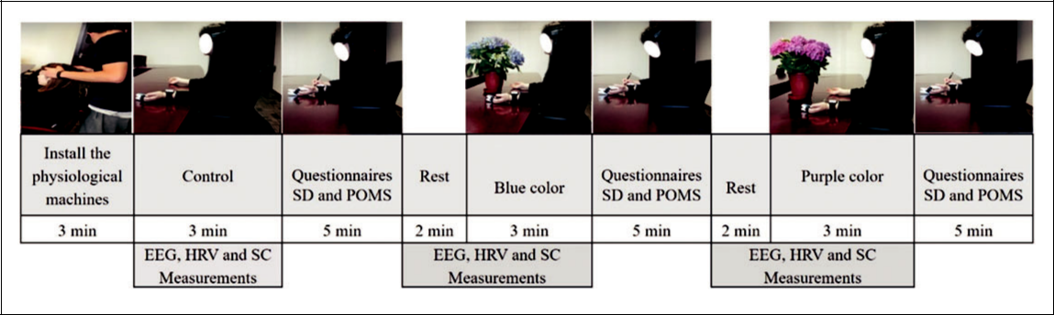

Figure 2. Experimental procedure.

13 Hz was derived by expressing absolute power in each frequency band as a per cent of the absolute power over the two frequency bands37 as equation (1)

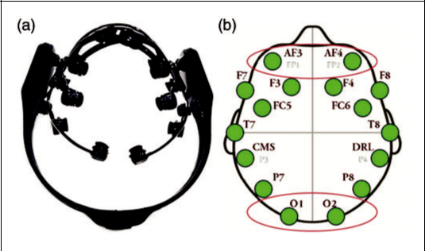

|  |  |  |  |  |  |
| --- | --- | --- | --- | --- | --- |
| RP f 1; f2 | Þ ¼ | Pð f1; f2Þ | 100 | (1) |  |
| ð | Pð8;13Þ |  |  |  |

Figure 3. (a) EEG headset; (b) electrode positions.

The reliability and validity of the EEG device have been confirmed in earlier landscape assessment stud-ies.32 The Emotiv EPOC headset comprises 14 sensors placed on the head of the participant in accordance with the international 10–20 electrode system,33 pre-frontal (AF3, AF4, F3, F4, F7, F8), frontocentral (FC5, FC6), occipital (O1, O2), parietal (P7, P8), and temporal (T7, T8). Before use, all felt pads on top of the sensors had to be fully moistened with a saline solution. During the experiment, participants’ recorded data were sent via bluetooth to a laptop using a pro-prietary USB dongle within the 2.4 GHz range. To ensure that no data was lost, the Emotiv Software Development Kit (SDK) was used to provide packet counting features and a real-time sensor contact dis-play to provide measurement accuracy. In this study, alpha relative power (8–12 Hz), which is the most influ-ential rhythm in the human scalp and often appears in a calm state, was evaluated according to previous research.34 Among the EEG channels, we used four channels from prefrontal (AF3, AF4) and occipital (O1, O2) brain lobes to capture alpha relative wave power. These channels were selected because the pre-frontal lobe regulates cognition and thinking,35 while the occipital lobe presents the visual information proc-essing.36 The relative power of alpha power from 8 to

where P ( ) indicates the power, RP ( ) indicates the relative power, and f1, f2 indicate the low and high frequency (HF), respectively. Figure 3 displays the Emotiv EPOC device and the electrode channel posi-tions for the prefrontal and occipital lobes.

Heart rate variability and skin conductance

The ErgoLAB synchronization platforms (Kingfar Inc. Beijing, China) were used to assess HRV and skin con-ductivity. ErgoLAB consists of wearable wireless sen-sors and a computer-based platform, connected by a wireless receiver. Researchers in related fields have con-firmed the validity of ErgoLAB.38

Heart rate variability

Based on the photoplethysmogram, a wearable wireless sensor was connected to each subject’s earlobe to mea-sure HRV at a 64 Hz sampling frequency. The HRV data were analysed in the frequency domains. Indices included HF power and LF/HF for the frequency domain. HF (0.15 to 0.40 Hz) would indicate the main influence was parasympathetic activity, while the LF/HF ratio represents the balance between sym-pathetic nervous activity and parasympathetic activi-ty.39 In this study, natural logarithmic transformed values were utilized to normalize HRV data across participants.

Elsadek and Liu

Skin conductance

Previous research has shown that SC is an effective physiological stress measure and is commonly used in stress recovery studies.40 SC is the dual-point conduc-tivity on the skin surface, which characterizes the skin’s electrodermal reaction and is one of the key indices for studying human body thermophysiology. The electro-dermal status of the skin induces the secretion from sweat glands around two reusable electrodes connected to two fingers of one hand. The SC was directly mea-sured using a wireless skin electrodermal sensor with a measurement range of 0–30 ms, a precision of 0.1 ms, and a sampling frequency of 32 Hz. Two sensor electro-des were connected to two fingertips of the left hand.

Psychological measures

As previously noted, the participants were required to fill in two psychological questionnaires, SD41 and POMS42 to measure their emotions and mood states. A Chinese version of a SD scale consisted of opposing adjectives, i.e. ‘comfortable to uncomfortable’; ‘natural to artificial’; and ‘relaxed to awakening’. Depending on the emotional level, each question has a 5-point score ( 2, 1, 0, 1, and 2) with higher scores representing higher emotional conditions. On the other hand, the participants ’ mood states were measured by using a short form with 25 questions from the POMS question-naire. POMS was divided into six dimensions: tension– anxiety (T–A), depression (D), anger–hostility (A–H), fatigue (F), confusion (C), vigour (V) and total mood disturbance (TMD). For T-A, D, A–H, F and C, a higher score for each dimension indicates a higher degree of the specified emotion. TMD was determined using equation (2)

|  |  |  |  |  |  |  |  |  |  |  |  |  |  |  |
| --- | --- | --- | --- | --- | --- | --- | --- | --- | --- | --- | --- | --- | --- | --- |
| TMD | ¼ |  | T A | Þ þ ð | D | Þ þ ð | A H | Þ þ ð | F | Þ þ ð | C | Þ | V |  |
|  | ð |  |  |  |  |  | ð Þ |  |

(2)

The TMD score is negatively correlated with the

mood state.

Statistical analysis and data processing

EEG data were transmitted for further treatment using Matlab (7.12.0.635 version, R2011a). Data were first processed and filtered by the EEG laboratory toolbox (<0.5 Hz or >50 Hz) to avoid offsets from DC and low-frequency skin prospective artefacts and to prevent high-frequency noise. The residual artefacts, such as eye blinks or movements, were omitted for each chan-nel. To remove signal artefacts, the automatic indepen-dent component analysis algorithm ADJUST was utilized. ADJUST uses stereotyped artefacts-specific spatial and temporal features to automatically recog-nize independent artefacts, which were then deleted.34

5

The HRV and SC data were processed on the ErgoLAB platform. HRV was processed using filters such as white de-noise, low-pass de-noise, baseline de-noise and band stop, then LF power, HF power and LF/HF of the fre-quency domain were used to compare differences in the visual stimulation. SC data were processed using a moving average filter. Data over the 3 min visual stimu-lation were expressed as mean standard error (SE). All of the data we tested were analysed by using SPSS 24.0 (IBM Corp, Armonk, NY, USA). One-way repeated measure ANOVA was used to compare the physiological and psychological responses of perceivers when exposed to two flower colours and control. Bonferroni correction multiple comparison was applied after ANOVA to iden-tify the specific differences among the three groups. A p value < 0.01 was considered statistically significant.

Results

We sought to investigate the effect of two Hydrangea flowers on the relaxation potential of stressed office workers. Our results support previous findings that indoor plants have beneficial effects on human well-being both physiologically and psychologically.

Physiological responses

Electroencephalography

The averages of alpha relative power obtained by

|  |  |  |  |  |  |  |  |
| --- | --- | --- | --- | --- | --- | --- | --- |
| four electrodes | | were compared (see Figure 4). | | | | |  |
|  |  |  |  |  |  |  |  |
|  |  |  |  |  | **Control** | |  |
|  |  |  |  |  |
| **0.30** | |  |  |  | **Purple** | |  |
|  |  |  |  |
|  |  |  |  |
|  |  |  |  |  | **Blue** | |  |

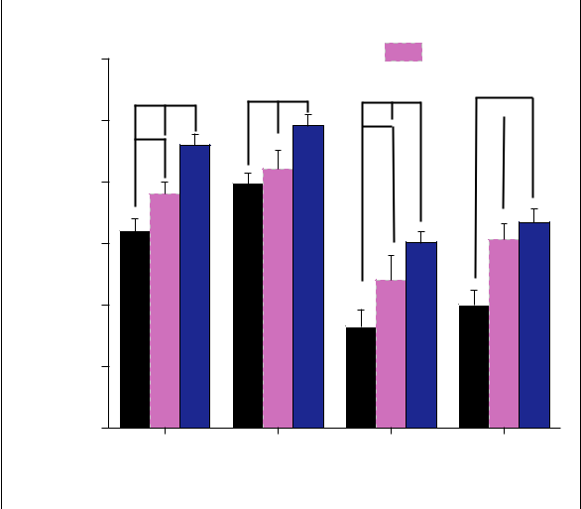

|  |  |  |  |  |  |  |
| --- | --- | --- | --- | --- | --- | --- |
|  |  | **\*\* \*\*** | **\*\* \*\*** | **\*\* \*\*** | **\*\*** |  |
|  |  | **0.25** |  | **\*\*** | **~~**~~** |  |
| **Power** |  | **\*\*** |  |  |  |  |
|  | **0.20** |  |  |  |  |
| **Relative** |  |  |  |  |  |
| µ()**V** | **0.15** |  |  |  |  |
|  |  |  |  |  |  |
| **Alpha** |  | **0.10** |  |  |  |  |
|  |  |  |  |  |  |
|  |  | **0.05** |  |  |  |  |
|  |  | **0.00** |  |  |  |  |
|  |  | **O1** | **O2** | **AF3** | **AF4** |  |

**EEG Electrodes**

Figure 4. Alpha relative power variability in O1, O2, AF3 and AF4 electrodes after viewing the control, purple and blue flowers. n ¼ 30, mean SE. **p < 0.01 determined by Bonferroni correction.

Note. Please refer to the online version of the article to view the figure in colour.

6 Indoor and Built Environment 0(0)

Bonferroni correction multiple comparison test for the control and the variable colours (purple and blue) showed a significant difference at the p < 0.01 level for alpha relative power in the prefrontal and occipital lobes. Significant emotional state effects were evident with the higher alpha relative power in the occipital lobe when participants viewed flowers compared with the control, as seen in Figure 4. Regarding the left hemi-sphere (O1), there were significant differences between purple: 0.19 0.01 vs. control: 0.16 0.01, p < 0.01 and between blue: 0.23 0.01 vs. control: 0.16 0.01, p < 0.01. Compared with the purple flower, the alpha relative changes in the left hemisphere (O1) were signif-icantly larger when participants viewed blue flowers. Compared with the control and purple flowers, the changes in the alpha relative power in the right hemi-sphere (O2) were significantly increased when partici-

|  |  |  |  |
| --- | --- | --- | --- |
| pants viewed the blue flowers (blue flower: 0.25 | | | 0.01 |
| vs. control: 0.19 | 0.01 p < 0.01), | and (blue flower: | |
| 0.25 0.01 vs. purple flowers: 0.21 | | 0.01 p < 0.01). | |
| On the other | hand, regarding | the prefrontal | lobe |

response, the alpha relative power in AF3 was signifi-cantly increased when participants viewed the blue and the purple flowers compared to the control (blue: 0.15

0.01 vs. control: 0.08 0.01, p < 0.01; purple: 0.12 0.02

vs. control: 0.08 0.01, p < 0.01). Furthermore, com-pared to purple flowers, the changes in the alpha relative power in AF3 were significantly increased when partic-

ipants were viewing the blue flowers (blue: 0.15 0.01 vs. purple: 0.12 0.02, p < 0.01). Compared with the control group, the alpha relative power was significantly increased in AF4 (blue: 0.17 0.01 vs. control: 0.1 0.01; purple: 0.15 0.01 vs. control: 0.1 0.01,

p < 0.01). However, there was no significant difference between these two colours of flowers. The Bonferroni correction revealed that viewing blue flowers as well as the purple ones could significantly increase the alpha relative power in the prefrontal lobe which controls cog-nitive actions, emotions and behaviour and in the occip-ital lobe which presents the visual information processing compared with when participants viewed the control. This outcome indicates that seeing the blue flowers as well as the purple one has positive asso-ciations with improving cerebral activity and relaxation.

|  |  |  |  |  |
| --- | --- | --- | --- | --- |
|  |  | **\*\*** | **\*\*** |  |
|  | **4.0** | **\*\*** |  |  |
|  | **3.5** |  |  |  |
|  | **3.0** |  |  |  |
| **)** | **2.5** |  |  |  |
| **2** |  |  |  |  |
| **(ms** | **2.0** |  |  |  |
| **lnHF** |  |  |  |
| **1.5** |  |  |  |
|  |  |  |  |
|  | **1.0** |  |  |  |
|  | **0.5** |  |  |  |
|  | **0.0** |  |  |  |
|  | **Control** | **Purple** | **Blue** |  |

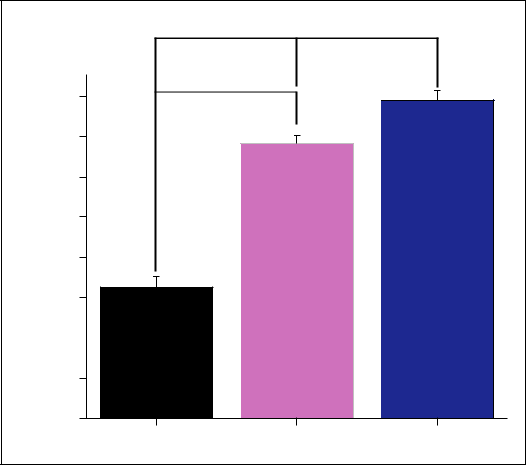

Figure 5. Mean of the natural logarithm of the high-fre-quency component (HF) of heart rate when viewing control, purple and blue flowers. The mean SE, n ¼ 30, **p < 0.01 according to Bonferroni correction.

Note. Please refer to the online version of the article to view the figure in colour.

|  |  |  |  |  |
| --- | --- | --- | --- | --- |
|  |  | **\*\*** |  |  |
|  | **0.7** | **\*\*** |  |  |
|  | **0.6** |  |  |  |
|  | **0.5** |  |  |  |
| **ln(LF/HF)** | **0.4** |  |  |  |
| **0.3** |  |  |  |
|  | **0.2** |  |  |  |
|  | **0.1** |  |  |  |
|  | **0.0** |  |  |  |
|  | **Control** | **Purple** | **Blue** |  |

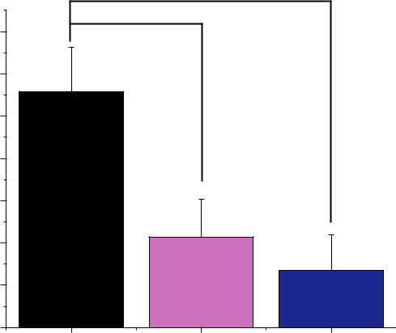

Figure 6. Ln (LF/HF) while viewing control, purple and blue flowers. The mean SE, n ¼ 30, **p < 0.01 according to Bonferroni correction.

Note. Please refer to the online version of the article to view the figure in colour.

Heart rate variability

The mean sum of the ln (HF) values as shown in Figure 5 reflects the parasympathetic nerve activity when participants are looking at control, purple and blue flowers. Viewing blue and purple flowers signifi-cantly enhanced the ln (HF) value compared to viewing the control (blue: 3.96 0.12 ms2 vs. control: 1.63 0.13 ms2, p < 0.01; purple: 3.42 0.15 ms2 vs. control: 1.63 0.13 ms2 p < 0.01). Compared with the purple flowers,

viewing of blue flowers had significantly increased the

ln (HF) value of participants (blue: 3.96 0.12 ms2 vs.

3.42 0.15 ms2 p < 0.01). Furthermore, the mean ln

(LF/HF) for the control was significantly higher than

for both the blue and the purple flowers (control:

0.56 0.11 vs. purple: 0.21 0.09, p < 0.01) and control

(control: 0.56 0.11 vs. blue: 0.13 0.08, p < 0.01), as

shown in Figure 6. However, no significant differences

Elsadek and Liu

were detected in ln (LF/HF) between viewing of the two flower colours. This indicates that the state of relaxation was higher when viewing blue flowers than purple ones and the control.

Skin conductance

Figure 7 shows the mean of the SC of participants during the 3-min experience period. When participants viewed the control, mean SC was significantly higher compared to viewing blue flowers. There was a signifi-cant difference in the mean SC between (control: 2.85

0.30 vs. blue: 1.15 0.23, p < 0.01). On the other hand, although the difference was not significant between viewing the control and viewing of the purple flowers (control: 2.85 0.30 vs. purple: 2.00 0.21, p ¼ 0.03), the SC was slightly higher while viewing the control than while viewing the purple flowers.Additionally, the SC for viewing the purple flowers (2.00 0.21) was a

little higher than the viewing of the blue flowers

(1.15 0.23), but the difference was not statistically sig-nificant (p ¼ 0.04). Although viewing the purple flowers was slightly effective in reducing the SC, viewing the blue flowers was more significantly effective. These results indicate that viewing of the blue flowers had a positive effect on the participants, as demonstrated by a noticeable decrease in their SC compared to the viewing of the purple flowers and the control.

Psychological responses

The Bonferroni correction tests showed that after view-ing the purple and blue flowers and the control, all POMS and SD scores indicated significant changes.

7

Semantic differential

Figure 8 demonstrates the results of the participants’ emotions as measured by the SD method. They felt more ‘comfortable’, ‘relaxed’, ‘natural’ and ‘cheerful’ after viewing blue and purple flowers respectively com-pared to the control. Additionally, the two flower col-ours were perceived as ‘bright’, ‘attractive’ and ‘beautiful’. Interestingly, these two flower colours were liked by participants compared to the control (p < 0.01). Given this feedback, the presence of flower-ing plants in the office was favourable. Meanwhile, the changes in psychological indices, as mentioned above, were the greatest values when participants viewed the blue flowers. The blue flowers were consistently rated more positively on the preference scales, i.e. comfort-able, relaxed and cheerful (p < 0.01) compared with the purple flowers. Thus, looking at the blue flowers can evoke more comfortable, relaxed and cheerful emo-tions than looking at the purple flowers or control.

Profile of mood states

The mood states of participants as reported in the POMS subscales are shown in Figure 9. Compared with the control, the negative subscale of POMS, ten-sion–anxiety (T–A; p < 0.01), depression (D; p < 0.01), A–H (p < 0.01), fatigue (F; p < 0.01) and confusion (C; p < 0.01) were significantly decreased after viewing the blue and purple flowers. Contrariwise, the vigour (V) subscale (p < 0.01) was significantly increased after the visual stimulation by the two flower colours.

|  |  |  |  |
| --- | --- | --- | --- |
|  |  | **\*\*** |  |
|  |  | **3.5** |  |
|  |  | **3.0** |  |
|  |  | **2.5** |  |
| **conductance** |  | **2.0** |  |
| µ**s** | **1.5** |  |
|  |  |
| **Skin** |  | **1.0** |  |
|  |  | **0.5** |  |

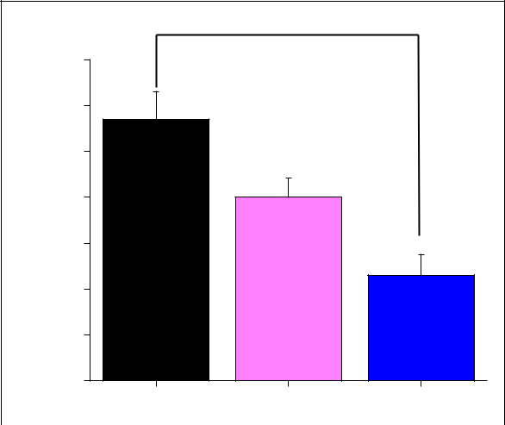

|  |
| --- |
| **SD Score** |

|  |  |  |
| --- | --- | --- |
| 2.0 |  |  |
|  | **\*\*** |  |
| 1.5 | **\*\*** |  |
| 1.0 | **\*\*** |  |
|  |  |
| 0.5 |  |  |
| 0.0 |  |  |
| -0.5 |  |  |

-1.0

-1.5

-2.0

|  |  |  |
| --- | --- | --- |
| **\*\*** | **\*\*** |  |
| **\*\*** | **\*\*** |  |
|  |  |
|  | **\*\*** |  |

|  |  |  |  |  |  |  |  |  |  |  |  |  |
| --- | --- | --- | --- | --- | --- | --- | --- | --- | --- | --- | --- | --- |
|  |  |  |  |  |  |  |  |  | **Control** | | |  |
|  |  |  |  |  |  |  |  |  | **Purple** | | |  |
|  |  |  |  |  |  |  |  |  |  |
| **\*\*** | |  | **\*\*** |  |  |  |  |  | **Blue** | | |  |
|  |  |  |  |  |  |  |
|  |  | **\*\*** |  | **\*\*** | |  |  | **\*\*** |  |
|  | **\*\*** |  |  |  |  |  |  |  |  |  | **\*\*** |  |
|  |  |  |  |  |  |  |  |  |  |  |  |  |

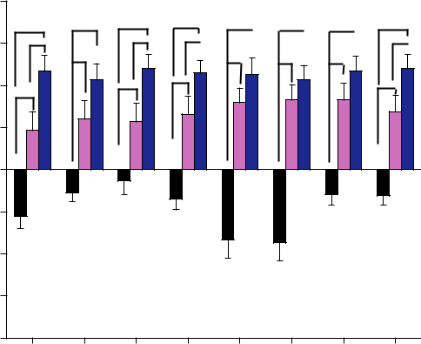

|  |  |  |  |
| --- | --- | --- | --- |
| **\*\*** | **\*\*** | **\*\*** |  |
| **\*\*** |  | **\*\*** |  |
|  |  |  |

**0.0**

**Control** **Purple** **Blue**

Figure 7. The mean skin conductance of subjects during the 3-min stimulation period. The mean SE, n ¼ 30, **p < 0.01 according to Bonferroni correction.

Note. Please refer to the online version of the article to view the figure in colour.

**Like** **Bright Comfortable Relax Natural Attractive Beautiful Cheerful**

Figure 8. The subjective reported feelings according to the semantic differential method after viewing the control, purple and blue flowers. Mean SE, n ¼ 30, **p < 0.01, determined by Bonferroni correction.

Note. Please refer to the online version of the article to view the figure in colour.

8 Indoor and Built Environment 0(0)

|  |  |
| --- | --- |
| (a) |  |
| **4.0** | Control |

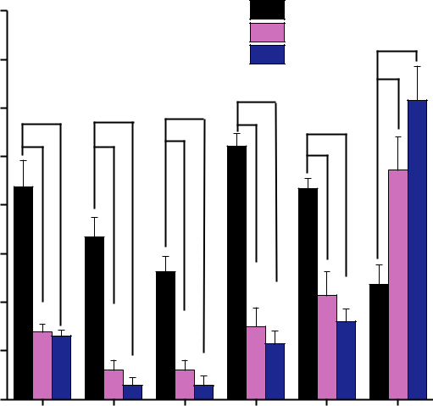

|  |  |  |  |  |  |  |  |  |
| --- | --- | --- | --- | --- | --- | --- | --- | --- |
|  |  |  |  |  |  | Purple | **\*\*** |  |
|  | **3.5** |  |  |  |  | Blue |  |
|  |  |  |  |  | **\*\*** |  | **\*\*** |  |
|  | **3.0** | **\*\*** | **\*\*** | **\*\*** | **\*\*** |  |  |
|  |  | **\*\*** |  |  |
| **Score** | **2.5** | **\*\*** | **\*\*** | **\*\*** |  | **\*\*** |  |  |
| **2.0** |  |  |  |  |  |  |  |
| **POMS** | **1.5** |  |  |  |  |  |  |  |
|  | **1.0** |  |  |  |  |  |  |  |
|  | **0.5** |  |  |  |  |  |  |  |
|  | **0.0** | **T-A** | **D** | **A-H** | **F** | **C** | **V** |  |
|  |  |  |
|  |  |  |  | **POMS Subscales** | |  |  |  |

|  |  |  |  |  |
| --- | --- | --- | --- | --- |
| (b) | |  |  |  |
|  |  | **\*\*** |  |  |
|  | **10** | **\*\*** |  |  |
|  | **8** |  |  |  |
| **Score** | **6** |  |  |  |
| **4** |  |  |  |
| **TMD** |  |  |  |
| **2** |  |  |  |
|  |  |  |  |
|  | **0** |  |  |  |
|  | **-2** | **Purple** | **Blue** |  |
|  | **Control** |  |

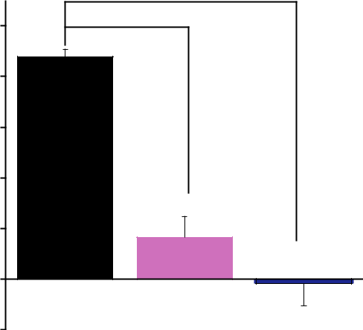

Figure 9. (a) POMS subscales, tension–anxiety (T–A), depression–dejection (D), anger–hostility (A–H), fatigue (F), con-fusion (C) and vigour (V) after viewing the control, purple and blue flowers; (b) Total mood disturbance (TMD) score. Mean SE (n ¼ 30). **p < 0.01 using the Bonferroni correction.

Note. Please refer to the online version of the article to view the figure in colour.

Additionally, the TMD score was significantly decreased after seeing the blue ( 0.18 0.85) and purple (1.65 0.82) flowers compared with the control (8.77 0.30; p < 0.01). However, there were no signifi-cant differences between the viewing of purple and blue flowers for all subscales of T–A, D, A–H, F, C and V. Our findings provide evidence that looking at blue and purple flowers could evoke positive feelings and improve the mood state.

Discussion

The modern urban lifestyle is associated with stress. The International Labour Organization has identified a number of worrying issues for office workers; includ-ing greater pressure on time, problems with ergonomics and a growing number of cases of stress.31 Although

several experiments focused on the human health– nature interactions,43,44 little is known about the posi-

tive associations between indoor flowering plants and office workers. In this study, the psychophysiological relaxation impacts of flower colours (purple and blue) and a control (no visual stimuli) on office workers were investigated. Furthermore, the present study combined multiple measurements, physiological measures (brain activity, HRV, and SC) and psychological wellbeing as evaluated using SD and POMS questionnaires. Compared with the control, viewing of both purple and blue flowers resulted in increased alpha relative

waves in the prefrontal and occipital lobes, stimulation of parasympathetic nervous activity and suppression of SC. Psychologically, viewing the flowers resulted in greater feelings of comfort, cheerfulness, relaxation, attractiveness and naturalness, as well as improved mood states, than when viewing the control. Taken together, the physiological and psychological results indicate that the presence of flowering plants may lead to relaxation and stress reduction, which is sup-ported by the results of previous studies.25,45

Results show systematic variations in alpha relative power between the three visual stimulations. Particularly, the alpha relative oscillations were nota-bly higher when participants viewed blue flowers com-pared to purple flowers and the control. Research investigating brain wave patterns in response to nature has shown that alpha power increases are cor-related with internal changes such as increased relaxa-tion, lower levels of anxiety and an increase in positive feelings.46 Notably, previous research has shown the involvement of alpha-band activity in cognitive pro-cesses as well as in calming, attentive and positive mood states.47 Viewing the blue and purple flowers increased alpha relative power, reflecting focused inter-nal attention.48 This would have made participants calmer, more alert and more concentrated on the sur-rounding indoor environment. Importantly, the increase in alpha relative waves when viewing flowering plants in the present study is in line with those of

Elsadek and Liu

previous relevant studies. Ulrich et al.6 compared phys-iological responses of two groups when looking at pho-tographs of natural spaces versus built spaces, and they observed a significant increase in the alpha ratio of the group that saw natural spaces more than others who saw the built spaces. Nakamura and Fujii49 studied the alpha wave activities caused by viewing a hedge fence versus a concrete fence. Higher alpha waves have been recorded in the presence of the hedge fence than the concrete fence. This outcome, therefore, supports the conclusion that participants felt more relaxed and calmer while looking at the blue and purple flowers as opposed to the empty table.

The region of the brain that reacts to stress is direct-ly linked to the autonomic nervous system which con-trols basic physiological and psychological functional status.50 HRV represents the state of sympathetic nerve activity associated with stress and anxiety and the para-sympathetic nerve activity is related to relaxation and calm conditions in the human body.51 Viewing the blue and purple flowers has led to a significantly higher parasympathetic autonomic nervous activity that results in relaxation, as well as a significantly lower sympathetic autonomic nervous activity whose func-tion reflects stress, compared to the control. The results suggest that viewing the blue and purple flowers for 3 min can promote the health of office workers by improving relaxation and reducing stress. The calming effects of viewing rose flowers were recorded in prior studies. Such studies have shown increases in parasym-pathetic activity, decreases in sympathetic activity, and significant improvements in physiological relaxation in the presence of the flowers.52 On the other hand, SC is an important indicator of stress. Compared to viewing blue and purple flowers, when participants looked at the control, the results showed a significant increment in their SC, reflecting their feelings of stress. Previous studies showed that SC is an indication of physiological arousal53 and negative emotions (stress).54 Additionally, Ulrich et al.6 have found that the positive impacts of viewing nature are reflected in HRV and SC.

Besides, the present findings provided scientific evi-dence of positive emotions of flower-viewing for stressed people. Based on the SD questionnaire results, the presence of blue and purple flowering plants induced feelings of ‘brightness’, ‘comfort’, ‘relaxation’, ‘natural’, ‘attractive’, ‘beautiful’ and ‘cheerful’ com-pared to the control. Interestingly, we found that par-ticipants felt more ‘likeable’, ‘comfortable’, ‘relaxed’ and ‘cheerful’ in the presence of blue flowering plants

than in the presence of purple ones. These results match those observed in earlier studies.20,21 On the

other hand, results showed that the mood state can be positively changed by the indoor flowering plants when the person watches them for a short time.55

9

Compared with participants’ responses to the flowering plants, the scores for the negative subscales of T–A, D, A–H, F and C were significantly high, and the positive mood status V was significantly low after viewing the control. Previous studies indicated that elevated work stress can be associated with an increased incidence of depressive disorders and suicide.56 Additionally, mood disorders have been well established to cause the great-est disease burden in people and loss of productivity in workers.57 Therefore, the psychological benefits of viewing flowering plants could be therapeutically important, and indoor flowering plants are expected to reduce stress, promote positive mood states and increase feelings of vigour, all of which are in agree-ment with observations made in earlier studies.52

The understanding, is important, of how indoor flowering plants can positively affect office workers and individuals who spend most of their time indoors. In the light of the results obtained from EEG, HRV, SC and the questionnaires, the participants tended to become relaxed during the visual stimulation with the flowering plants. The blue flowers were the most pre-ferred, followed by purple ones, this finding is in accor-dance with those obtained by Hula˚ and Flegr.58 The findings of our study are in part consistent with the theory of habitat selection59 as well as with the theory of ecological valence.60 These hypotheses sug-gest that people prefer the colour blue, which is usually associated with clear sky and water. According to ART,10 the restorative benefits of nature may be attrib-uted to the fact that contact with green spaces helps to restore direct attention in individuals, especially when they are attentionally fatigued. On the other hand, SRT6 suggests that visual stimuli of nature have a con-siderable impact on reducing mental stress. Ultimately, our findings are consistent with the model of an effec-tive response to nature suggested by Ulrich61 and later confirmed by other studies.62,63 We, therefore, support Ulrich’s theory that natural environments enhance both physiological and psychological responses to stress more than do environments not involving nature. Staring at the blue and purple flowers seems to be a good option to stimulate relaxation and reduce stress. This may help to improve the quality of life of office workers and people living or working indoors for a long time.

The major strength of our study is that we combined multiple measurements to record participants’ physio-logical and psychological states, as well as our recruit-ment of office workers as participants. The present study presents evidence that indoor flowering plants can substantially increase relaxation, reduce stress and improve individuals’ physiological and psycholog-ical states. Despite these findings, our study has some limitations. First, our study focused on females and

10

whether the results are applicable to other genders and age groups is unknown. Second, we compared only two flower colours, and future research should examine a greater variety of flowers with different colours and shapes. Third, stress level was not experimentally con-trolled or known, but only inferred from the type of work the subjects do. Finally, a useful follow-up study would be to have the flowers simply present in the office, and not directly in front of the subject. Notwithstanding these limitations, our study adds to the scientific evidence that suggests indoor flowering plants can enhance the physiological and psychological wellbeing of office workers and urban dwellers as well as allow interior designers to design sustainable and healthier indoor spaces using appropriate flower col-ours. Based on this study, there is an urgent need for follow-up work using different flower colours and shapes.

Conclusion

The current work suggests that taking a break to look at flowering plants for 3 min a day may provide strong immediate positive effects on human wellbeing. The findings provide experimental support for the notion that exposure to flowering plants can generate physio-logical and psychological benefits that reduce stress and improve wellbeing. Although the presence of indoor flowering plants has positive impacts on office workers, these positive impacts are also influenced by the colour of the flower. Notably, we found that the blue flowers had the greatest ability to enhance participants’ feelings of relaxation compared with the purple flowers and control. This has implications for promoting the use of specific colours of indoor flowering plants to enhance relaxation and reduce stress for office workers and indoor residents.

Authors’ contribution

All authors contributed equally in the preparation of this manuscript.

Acknowledgements

We would like to thank Dr Xie Junfang, Mr Zefang Lian and Mr Cundong Ma for their kind help during the experiment days.

Declaration of conflicting interests

The author(s) declared no potential conflicts of interest with respect to the research, authorship, and/or publication of this article.

Indoor and Built Environment 0(0)

Funding

The author(s) disclosed receipt of the following financial sup-port for the research, authorship, and/or publication of this article: This research was supported by key project of National Nature Science Foundation of China (NSFC) Urban Landscape Visual Spaces Network Perception and Reaction Assessment (No. 51678417).

ORCID iD

Mohamed Elsadek <https://orcid.org/0000-0001-5684-2061>

References

1. WHO. Stress at the workplace, [https://www.who.int/](https://www.who.int/occupational_health/topics/stressatwp/en/) [occupational_health/topics/stressatwp/en/](https://www.who.int/occupational_health/topics/stressatwp/en/) (accessed 13 March 2020).
2. Nieuwenhuijsen K and Bruinvels D. Psychosocial work environment and stress-related disorders, a systematic review. Occup Med 2010; 60: 277–286.
3. Board E. Global burden of mental disorders and the need for a comprehensive, coordinated response from health and social sectors at the country level. WHO Sixty-fifth World Heal Assembly, Provisional Agenda Item 13.2, A65/10, 16 March 2012, [https://apps.who.int/iris/bit](https://apps.who.int/iris/bitstream/handle/10665/78898/A65_10-en.pdf?sequence=1&isAllowed=y) [stream/handle/10665/78898/A65_10-en.pdf?sequence=](https://apps.who.int/iris/bitstream/handle/10665/78898/A65_10-en.pdf?sequence=1&isAllowed=y) [1&isAllowed=y](https://apps.who.int/iris/bitstream/handle/10665/78898/A65_10-en.pdf?sequence=1&isAllowed=y) (accessed 10 January 2020).
4. Ochiai H, Ikei H, Song C, Kobayashi M and Miura T. Physiological and psychological effects of a forest thera-py program on middle-aged females. Int J Environ Res Public Health 2015; 12: 15222–15232.
5. Elsadek M, Sun JH and Fujii ME. Brain activity and emotional responses of the Japanese people toward trees pruned using Sukashi technique. Int J Agric Environ Biotechnol 2013; 6: 344–350.
6. Ulrich RS, Simons RF, Losito BD, Fiorito E, Miles MA and Zelson M. Stress recovery during exposure to natural and urban environments. J Environ Psychol 1991; 11: 201–230.
7. Elsadek M, Liu B, Lian Z and Junfang X. The influence of urban roadside trees and their physical environment on stress relief measures: a field experiment in Shanghai.

Urban Urban Green 2019; 42: 51–60.

1. Yu CP, Lin CM, Tsai MJ, Tsai YC and Chen CY. Effects of short forest bathing program on autonomic nervous system activity and mood states in middle-aged and elder-ly individuals. IJERPH 2017; 14: 897.
2. Elsadek M, Liu B and Lian Z. Green fac¸ades: their con-tribution to stress recovery and well-being in high- den-sity cities. Urban Urban Green 2019; 46: 126446.
3. Kaplan S. The restorative benefits of nature: toward an integrative framework. J Environ Psychol 1995; 15: 169–182.
4. Klepeis NE, Nelson WC, Rott W, Robinson JP, Tsang AM, Switzer P, Behar J, Hern S and Engelmann W. The National Human Activity Pattern Survey (NHAPS): a resource for assessing exposure to environmental pollu-tants. J Expo Anal Environ Epidemiol 2001; 11: 231–252.

|  |  |
| --- | --- |
| Elsadek and Liu | 11 |

1. Kawakami N. Epidemiology of job stress and health in Japan: review of current evidence and future direction. Ind Health 1999; 37: 174–186.
2. Kang MG, Koh SB, Cha BS, Park JK and Baik SK. Job stress and cardiovascular risk factors in male workers. Prev Med 2005; 40: 583–588.
3. Lohr VI, Pearson-Mims CH and Goodwin GK. Interior plants may improve worker productivity and reduce stress in a windowless environment. J Ther Hortic 1996; 14: 97–100.
4. Park SH and Mattson RH. Effects of flowering and foliage plants in hospital rooms on patients recovering from abdominal surgery. Horttechnology 2008; 18: 536–568.
5. Birren F. Color psychology and color therapy: a factual study of the influence of color on human life. Whitefish, MT: Kessinger, 2006.
6. Aves M and Aves JC. Interior designers’ showcase of color. Gloucester, MA: Rockport Distributed by AIA Press, 1994.
7. Kurt S and Osueke K. The effects of color on the moods of college students. SAGE Open 2014; 4: 12.
8. Yildirim K, Akalin-Baskaya A and Hidayetoglu M. Effects of indoor color on mood and cognitive perfor-mance. Build Environ 2007; 42: 3233–3240.
9. Elsadek M, Sayaka S, Fujii E, Koriesh E, Moghazy E and ElFatah Y. Human emotional and psycho-physiological responses to plant color stimuli. J Food Agric Environ 2013; 11: 1584–1591.
10. Elsadek M, Sun M and Fujii E. Psycho-physiological responses to plant variegation as measured through eye movement, self-reported emotion and cerebral activity.

Indoor Built Environ 2017; 26: 758–770.

1. Haviland-Jones J, Rosario HH, Wilson P and McGuire TR. An environmental approach to positive emotion. Evol Psychol 2005; 3: 104–132.
2. Andrew J, Markus A, Arlen C and Jorg€ M. Color and psychological functioning: the effect of red on perfor-mance attainment. J Exp Psychol Gen 2007; 136: 154–168.
3. Soldat AS, Sinclair RC and Mark M. Color as an envi-ronmental processing cue: external affective cues can directly affect processing strategy without affecting mood. Soc Cogn 1997; 15: 55–71.
4. Elsadek M and Fujii E. People’s psycho-physiological responses to plantscape colors stimuli: a pilot study. Int J Psychol Behav Sci 2014; 4: 70–78.
5. Ikei H, Komatsu M, Song C, Himoro E and Miyazaki Y. The physiological and psychological relaxing effects of viewing rose flowers in office workers. J Physiol Anthropol 2014; 33: 5.
6. Hedblom M, Gunnarsson B, Iravani B, Knez I, Schaefer M, Thorsson P and Lundstrom€ J. Reduction of physio-logical stress by urban green space in a multisensory vir-tual experiment. Sci Rep 2019; 9: 11.
7. Tyrv€ainen L, Ojala A, Korpela K, Lanki T, Tsunetsugu Y and Kagawa T. The influence of urban green environ-ments on stress relief measures: a field experiment. J Environ Psychol 2014; 38: 1–9.
8. Hoel H, Sparks K and Cooper CL. The cost of violence/ stress at work and the benefits of a violence/stress-free working environment. Geneva: University of Manchester Institute of Science and Technology for Geneva International Labour Organization, 2001, pp.1–81.
9. Giorgi G, Arcangeli G, Perminiene M, Lorini C, Ariza-Montes A, Fiz-Perez J, Fabio A and Mucci N. Work-related stress in the banking sector: a review of incidence, correlated factors, and major consequences. Front Psychol 2017; 8: 1–17.
10. Giga SI and Hoel H. Violence and stress at work in finan-cial services. Working paper. International Labour Organization, Geneva, [www.ilo.org/publns](http://www.ilo.org/publns) 2003 (accessed 10 July 2019).
11. Kim M, Cheon S and Kang Y. Use of electroencepha-lography (EEG) for the analysis of emotional perception and fear to nightscapes. Sustainability 2019; 11: 233.
12. Homan RW, Herman J and Purdy P. Cerebral location of international 10–20 system electrode place-ment. Electroencephalogr Clin Neurophysiol 1987; 66: 376–382.
13. Shan X, Yang EH, Zhou J and Chang VC. Human-build-ing interaction under various indoor temperatures through neural-signal electroencephalogram (EEG) methods. Build Environ 2018; 129: 46–53.
14. Bak K-J. A study on the effect prefrontal lobe neurofeed-back training on kids about master ability. J Korea Acad Coop Soc 2011; 12: 2548–2553.
15. Carter R and Frith CD. Mapping the mind. Los Angeles: University of California Press. 1998.
16. Bian Z, Li Q, Wang L, Lu C, Yin S and Li X. Relative power and coherence of EEG series are related to amnes-tic mild cognitive impairment in diabetes. Front Aging Neurosci 2014; 6: 1–9.
17. Zou H, Li N and Cao L. Emotional response-based approach for assessing the sense of presence of subjects in virtual building evacuation studies. J Comput Civ Eng 2017; 31: 04017028.
18. Zhu H, Wang H, Liu Z, Li D, Kou G and Li C. Experimental study on the human thermal comfort based on the heart rate variability (HRV) analysis under different environments. Sci Total Environ 2018;
    1. 1124–1133.
19. Li D and Sullivan WC. Impact of views to school land-scapes on recovery from stress and mental fatigue. Landsc Urban Plann 2016; 148: 149–158.
20. Osgood CE. The nature and measurement of meaning. Psychol Bull 1952; 49: 197–237.
21. McNair D, Heuchert M and Shilony E. Profile of mood states manual: bibliography 1964–2002. New York, NY: Multi- Health Systems Inc., 2003.
22. Douglas O, Lennon M and Scott M. Green space benefits for health and well-being: a life-course approach for urban planning, design and management. Cities 2017;
    1. 53–62.
23. Hartig T, Mitchell R, de Vries S and Frumkin H. Nature and health. Annu Rev Public Health 2014; 35: 207–228.
24. Li F, Li S, Liu G, Kang N and Hu L. Effects of visual activities of viewing flowers and leaves of apple trees on

12 Indoor and Built Environment 0(0)

human electroencephalograms. J Northwest Univ 2008;

23: 62–68.

1. Neale C, Aspinall P, Roe J, Tilley S, Mavros P, Cinderby S, Coyne R, Thin N, Bennett G and Thompson C. The aging urban brain: analyzing outdoor physical activity using the emotiv affectiv suite in older people. J Urban Health 2017; 94: 869–880.
2. Kim SC, Lee MH, Jang C, Kwon JW and Park JW. The effect of alpha rhythm sleep on EEG activity and indi-viduals’ attention. J Phys Ther Sci 2013; 25: 1515–1518.
3. Benedek M, Schickel RJ, Jauk E, Fink A and Neubauer AC. Alpha power increases in right parietal cortex reflects focused internal attention. Neuropsychologia 2014; 56: 393–400.
4. Nakamura R and Fujii E. A comparative study on the characteristics of electroencephalogram inspecting a hedge and a concrete block fence. J Jpn Inst Landsc Arch 1992; 55: 139–144.
5. Grahn P and Stigsdotter U. Landscape planning and stress. Urban Urban Green 2003; 2: 1–18.
6. Malik M, John C, Thomas B, Gu¨nter B, Sergio C, Richard J, Philippe C, Ernest L and Robert E. Guidelines heart rate variability standards of measure-ment, physiological interpretation, and clinical use. Eur Heart J 1996; 17: 354–381.
7. Tomi K, Sakaguchi E, Ueda S, Matsumura Y and Hayashi T. Physiological and psychological effects of rose ‘Wishing’ flowers and their hydrosols on the human autonomic nervous system and mood state. Hortic J 2016; 86: 105–112.
8. Rosebrock LE, Hoxha D, Norris C, Cacioppo JT and Gollan JK. Skin conductance and subjective arousal in anxiety, depression, and comorbidity: Implications for affective reactivity. J Psychophysiol 2017; 31: 145–157.
9. Setz C, Arnrich B, Schumm J, Marca R, La Tr G and Ehlert U. Discriminating stress from cognitive load using

a wearable EDA device. IEEE Trans Inf Technol Biomed 2010; 14: 410–417.

1. Park BJ, Furuya K, Kasetani T, Takayama N, Kagawa T and Miyazaki Y. Relationship between psychological responses and physical environments in forest settings.

Landsc Urban Plann 2011; 102: 24–32.

1. Melchior M, Caspi A, Milne BJ, Danese A, Poulton R and Moffitt T. Work stress precipitates depression and anxiety in young, working women and men. Psychol Med 2007; 37: 1119–1129.
2. Greenberg PE, Kessler RC, Birnbaum HG, Leong SA, Lowe SW, Berglund PA and Corey-Lisle PK. The eco-nomic burden of depression in the United States: how did it change between 1990 and 2000? J Clin Psychiatry 2003; 64: 1465–1475.
3. Hula˚ M and Flegr J. What flowers do we like? The influ-ence of shape and color on the rating of flower beauty. Peer J 2016; 4: e2106.
4. Heerwagen JH. and Orians GH. Humans, habitats, and aesthetics. In: Kellert SR (ed.) The biophilia hypothesis. Washington, DC: Island Press/Shearwater Books, 1993.
5. Palmer SE and Schloss K. An ecological valence theory of human color preference. Proc Natl Acad Sci USA 2010; 107: 8877–8882.
6. Ulrich RS. Aesthetic and affective response to natural environment. In: Behavior and the natural environment. New York, NY: Springer, 1983, pp.85–125.
7. Elsadek M, Sun M, Sugiyama R and Fujii E. Cross-cultural comparison of physiological and psychological responses to different garden styles. Urban Urban Green 2019; 38: 74–83.
8. Hartig T, Evans GW, Jamner LD, Davis DS and G€arling T. Tracking restoration in natural and urban field set-tings. J Environ Psychol 2003; 23: 109–123.