*Article*

**Volume 10, Issue 5, 2020, 6101 - 6111**

<https://doi.org/10.33263/BRIAC105.61016111>

**The Migration Study of Nanoparticles from Soil to the Leaves of Plants**

**Ismat S. Ahmadov 1,\*****, Mahammadali A. Ramazanov 1****, Eldar K. Gasimov 2****, Fuad H. Rzayev 2****, Solmaz B. Veliyeva 1**

1. Baku State University, Nano research Center ,Baku, AZ1148, Z.Khalilov str.23, Azerbaijan
2. Azerbaijan Medical University, Department of Histology, Embryology and Cytology, Baku, AZ1022, Samed Vurgun str.167, Azerbaijan
3. Azerbaijan Medical University, Electron Microscopy Laboratory, Baku, AZ1022, Samed Vurgun str.167, Azerbaijan

* Correspondence: ismetahmadov@mail.ru;

Scopus Author ID [6505822305](https://www.scopus.com/authid/detail.uri?authorId=6505822305)

**Received: 20.03.2020; Revised: 22.04.2020; Accepted: 25.04.2020; Published: 2.05.2020**

**Abstract:** In this work by the UV-vis and TEM analysis were investigated the transport of nanoparticles(Ag and Au) in soil, their migration from seeds to the roots and from roots to the stem and leaves of pea plants. Nanoparticles depending on the types and sizes may diffuse and distribution in soil. The transport of nanoparticles in soil dependance on the structure and soil thickness. According to the results of experiments were identified that nanoparticles may diffuse into the seeds and changes the imbibition (water uptake). Nanoparticles may pass on from seeds to the roots and localization in the xylem and epidermal cells. By the development of seedling nanoparticles may transport from roots to the stem and from stem to the leaves. Nanoparticles may localization in different cells of plant organs and inside of cell mostly in the mitochondria.

**Keywords:** Nanoparticles; Soil; Plants; Seeds; Migration; Localization of nanoparticles.



© 2020 by the authors. This article is an open access article distributed under the terms and conditions of the Creative Commons Attribution (CC BY) license [(https://creativecommons.org/licenses/by/4.0/)](https://creativecommons.org/licenses/by/4.0/).

**1. Introduction**

Once in the soil, nanoparticles may penetrate into the seeds, uptake by roots and transport to the organs of plants. Therefore to study the movement, localization, and accumulation of nanoparticles (NPs) in plants is crucial for identifying the environmental consequences of nanotechnology. Important studies are currently underway on the distribution of nanoparticles in soil and their absorption by plants, which creates phytotoxic and physiological effects.

Although plants can resist the existence of nanoparticles, an important question must be answered, how accumulated nanoparticles in the roots, shoots, stems or leaves of plants affect plant growth and productivity? Can nanoparticles penetrate plant seeds, roots, stems, leaves, and finally cells? Information on the movement, absorption, and physiological effects of nanoparticles on plants is becoming more extensive, and require different field experiments. It is also known that plants are most exposed to environmental factors in nature.

Plants are in direct contact with the waste of nanotechnology. Since plants feed from the soil, the likelihood of nanomaterial, especially nanoparticles, entering the plant organs from the soil is very high. Thus, the main studies in this area are aimed at studying the absorption of nanoparticles from the soil. The results of research in this area show that the interaction of plants with nanoparticles is a complex process. In this process, the flow of nanoparticles in the

|  |  |
| --- | --- |
| <https://biointerfaceresearch.com/> | **6101** |

<https://doi.org/10.33263/BRIAC105.61016111>



soil, absorption by the roots, their movement in the stem, distribution and localization in organs, and, finally, the physiological effects of nanoparticles in plants require basic research. Experiments show that nanoparticles can move through the soil, and their distribution depends on the type of soil, structure and thickness. For example, Fang et al. [1] found that TiO2 nanoparticles propagate in soil. He and his co-workers showed that the mobility of silver nanowires is very small, which suggests that the surface area of the nanowire particles is large and easily absorbed by soil structures. With increasing concentration and decreasing size, silver nanoparticles flow faster through the soil. Experiments by Shamshad Khan and Hatice Sengul

1. show that TiO2 nanoparticles can move in soil and estimated travel distances are from 45.03 to 625.86 cm. The experimental results of Rahmatpour S. and et al.[3] showed that the degree of saturation had little eﬀect on the mobility of AgNPs through undisturbed soil columns. Their results suggested the limited transport of AgNPs in neutral/alkaline calcareous soils under both saturated and unsaturated conditions.

İn the experiments of Ahmadov İ.S and Ramazanov M.A. [4-6] the diffusion of nanoparticles into plant organs and their localization studied the use of higher aquatic plants *Elodea canadensis*. Applying the EPR method, they have found that iron nanoparticlespenetrate into the seeds of bean plants, spread to their roots and from there, and can be transported to the stem and leaves of elodea and localize in their cells.

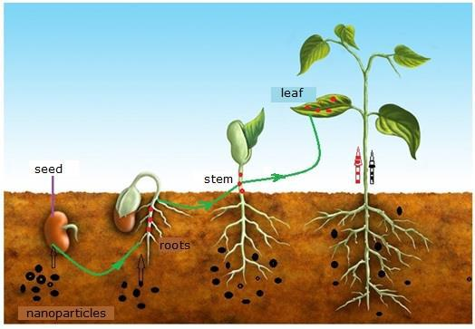

**Figure 1.** Migration of nanoparticles from soil to the leaves.

The experiments of Lv, J., Christie, P., & Zhang, S [7] showed that nanoparticles penetrate the seeds and improve their absorption, which leads to an increase in seed germination. Nanohydrates can penetrate plant roots due to osmotic pressure, capillary forces and pores in the cell wall with a thickness of 5 to 20 nm, determining its diffusion properties [8-11] and intercellular plasmas (50-60 mm at the midpoint) or strictly regulated simplified paths [13,].

Thus, nanoparticles can penetrate plants through air, soil, and water. The airborne nanoparticles are adsorbed to the leaves of the plants and are then absorbed into the epidermis cells. The nanoparticles that enter the epidermis cells can be transported in different organs through the symplastic ways or by apoplast.

Nanoparticles from the soil first diffuse into the seeds of the plants and can then spread to the root and then to their organs. The second path can be absorbed directly from the soil to the roots of plants, and can spread to their organs (Fig.1). Another way is to move the nanoparticles contained in the soil or irrigation water to the plant organs. In one way or another,

https://biointerfaceresearch.com/ **6102**



<https://doi.org/10.33263/BRIAC105.61016111>



the nanoparticles that enter the plant organs can move in their organs. Nanoparticles moving in the organs can be localized in their cells. How long are the nanoparticles remain in the organs of plants and are removed from the plants? Nanoparticles localized throughout the plant's organs may produce different physiological effects [14- 23].

**2. Materials and Methods**

*2.1. Materials for the synthesis of silver nanoparticles.*

For the synthesis of silver nanoparticles (AgNPs) were used both root and leaves of wormwood (Artemisia absinthium**).** Wormwoods are spread wild in the roadside, along the river and lake shores. In dry conditions, it is used as spices. It contains 0.026-0.2 percent of essential oils. Wormwood’s medicinal, nutritious, essential oily, dye and decoration-suitable species are cultivated in most countries cultured form. There are 13.6% of ash, 15.6% protein, 5.1% fat, 34.1% cellulose, and 31.6% non-nitrogenous substances in the composition of ordinary wormwood (Fig.2).

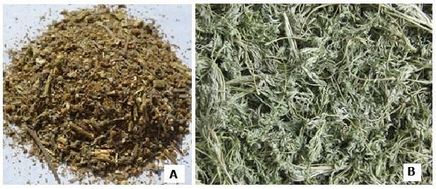

**Figure 2.** *Artemisia absinthium*dried (A) and wet (B) forms.

*2.2. Preparation of extracts from wormwoods.*

*Artemisia absinthium L*. plants were gathered from different regions of Azerbaijan. Theroots, leaves and flowers were dried and powdered using a grinder. The aqueous extract of Artemisia prepared using 500 ml Erlenmeyer flask containing 1,6 g powder and 100 ml deionized water and heated at 70 0C using a hot plate for 2 h. The extract was obtained by centrifuge the mixture at 5 000 rpm for 3 min followed the filtration using whatman no.1 filter paper. These filtrates were stored in the refrigerator for 24 hours.

*2.3. Nanoparticles.*

For the study of the migration of nanoparticles from soil to plant seeds and organisms were used Ag, Au, Fe2O3 nanoparticles. These nanoparticles Ag, Au, were synthesized in the nanolaboratory of BSU and Fe2O3 nanoparticles were purchased from Sky. Inc. American Company.

2.3.1. Synthesis of nanoparticles.

Ag, Au nanoparticles were synthesized by wormwood extract. For this purpose was taken 50 ml prepared extract of roots or aerial parts of wormwood and has been added to 200 ml AgNO3 or HAuCl4 solutions (5.10-3M) in 500 ml volumetric flask, heated 10 minutes at 70 C with stirred using a magnetic stirrer at room temperature in the flask of 500 ml. The change in color of the solution after 10 -30 minutes indicated the reduction of silver nitrate.

https://biointerfaceresearch.com/ **6103**



<https://doi.org/10.33263/BRIAC105.61016111>



The solution achieved is stored under the room temperature for 24 hours, and its UV-vis analysis has been performed.

2.3.2. Characterization of nanoparticles.

The absorption spectrum of AgNPs solution was taken in UV-Vis spectrum (SPECORD 250 PLUS, Analytic Jena, Germany). The AgNPs were powdered and characterized by Scanning Electron Microscopy (SEM, JEOL-MODEL 7600F ), images from samples of seeds and plants were taken by Transmission Electron Microscopy (TEM-1400 , JOEL-Japan).

2.3.3. Preparation of plant samples for the optic microscopes and TEM.

To study the ultrastructure of pea samples absorbed the AgNPS, a 2.5% glutar-aldehyde and 2% paraformal-aldehyde were prepared in 0.1M phosphate buffer (pH = 7.4). General methods for TEM studies - post fixation were developed in OsO4, dehydration at 500, 700, 800, 960 alcohols, and blocks on Epon Araldite (Wickley, 1974; Kuo, 2007). The semiconductor (1–2 µ) incisions obtained from the respective blocks on the Leica EM UC7 ultrasound were colored with methylene abductor, azur II, and basic fuxin (D'Amico, 2007), while scanning the necessary sections on a Zeiss microscope with a Canon D-650 digital camera. For TEM images samples with 50-100 nm cross sections were first colored with 2% uranium acetate solution and then 0.6% pure lead-citrate prepared in 0.1M NaOH solution ( Kuo, 2007). Ultrathin cuts were investigated and recorded on an electron microscope JEM-1400 (JOEL-Japan) at 80-120 KV. Microphotos and electrograms in TIF format were determined by computer morphometric analysis (The TEM imaging platform) developed by Olympus Soft Imaging Solutions Gmbh (Germany).

**3. Results and Discussion**

*3.1. The characteristics of Ag and Au nanoparticles.*

After 24 hours, the UV-vis absorbance spectrum of the solutions of AgNPs and AuNPs was drawn. Figure 2 shows the UV spectra of AgNPs and AuNPs synthesized by wormwood extract.

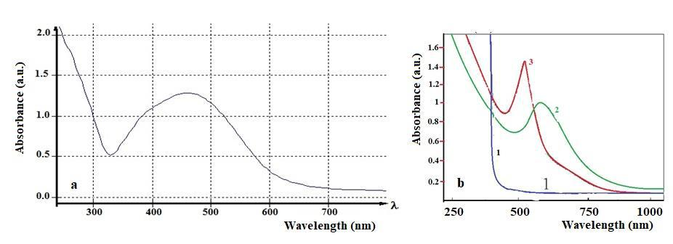

**Figure 3 .** UV-vis spectra of AgNPs (a) and AuNPs (b) synthesized by wormwood extracts.

As shown in the absorption spectrum of AgNPs after being stored at room temperature for 24 h, the spectrum belongs to the maximum observed in wavelength 455 nm (fig.3a). The

https://biointerfaceresearch.com/ **6104**



<https://doi.org/10.33263/BRIAC105.61016111>



UV-vis spectrum for AuNPs showed that he maximum absornace wavelenth observed in wavelength 510 - 520 nm. The exact sizes and the shapes of nanoparticles were determined by SEM analysis. Figure 4 presents the SEM image and EDS analysis of AgNPs It was found that the average nanoparticles of AgNPs in the synthezied by wormwood extracts are 18-35 nm, the forms are mostly spherical. The EDS spectrum confirmed the presence of silver nanoparticles.

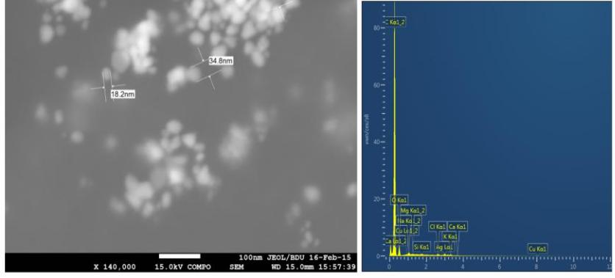

**Figure 4**. SEM image (A) and elemental analysis (B) of AgNPs synthesized by wormwood extracts.

*3.2. The migration of nanoparticles in the soil.*

The question is interesting , if the nanoparticles enter the soil how they will distribute, will occur their movement and migration? Therefore, have been conducted an experiment to study the movement of nanoparticles in the soil.

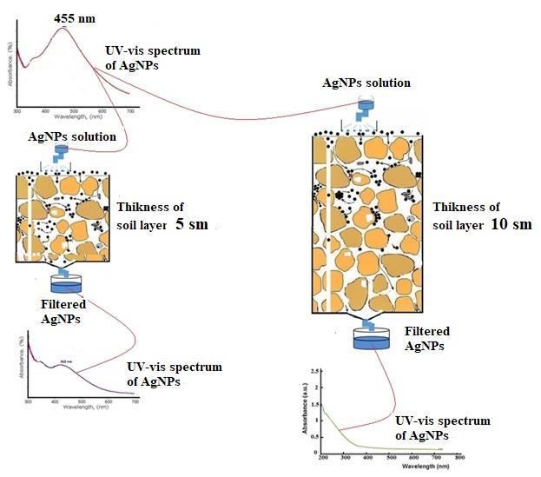

**Figure 5.** The vertical movement of AgNPs in the soil depends on the thickness of them.

It is known that the movement of nanoparticles in the soil will depend on their size, physical and chemical properties of their surface, soil type, thickness and structure of soil. In the presented experiments it was investigated the movement of Ag nanoparticles in the fertile, structured, granular soil, depending on its thickness. For this purpose, UV-vis spectrum of AgNPs solution was first taken up. Then, a 5 cm thick layer of soil was prepared in a glass tube. The AgNPs solution is introduced from the upper part of the soil layer. The volume of the solution was 20 ml. Through 10 minutes, the filtered solution of AgNPs in the flask. The UV-vis spectrum of this filtered solution was analysed again. The UV-vis spectrum is still

https://biointerfaceresearch.com/ **6105**



<https://doi.org/10.33263/BRIAC105.61016111>



observed at a wavelength of 455 nm belonging to AgNPs. However, the amplitude of absorbance was decreased. UV-vis spectrum observation showed that silver nanoparticles could penetrate 5 cm of soil. The decrease of absorbance intensity indicates that some of the nanoparticles are deposited on the soil surface.

Then we repeated the experiment by increasing the thickness of the soil layer to 10 cm. At this time, a silver wavelength of 455 nm was not observed when the UV-vis spectrum of Ag solution was filtered from a 10 cm layer.

This proved to him that silver nanoparticles were not able to cross a 10 cm thick layer. The results of these experiments are shown in Figure 5 As can be seen from the figure, Ag nanoparticles can move vertically in the soil layer, and its movement depends on the thickness of the soil layer.

*3.3. Diffusion of nanoparticles to plant seeds.*

The issue of whether or not nanoparticles in soil diffuse into plant seeds is the basis of the changes development of plants in the future? Therefore, it was interesting to investigate the diffusion of nanoparticles into the seeds. For the study the diffusion of nanoparticles to the plant seeds was used seeds of beans and pea. For this purpose, such an experiment was conducted. Bean seeds were stored for 24 h in dispersion solution of AgNPs or AuNPs at room temperature. After 24 hours, the bean seeds were removed from the solution and washed with distilled water. The bark was extracted and cut from the endosperm section at different depths (adjacent to the brush) and samples were prepared for TEM analysis from its endosperm. Sample preparation is given in the methodology. A TEM description of a sample from the pea seed endosperm is shown in Figure 6. As you can see from the picture, AgNPs and AuNPs appear as clusters inside the endosperm. The deepest peak of the diagram confirms that AgNPs are collected in the scanned area.

*3.4. Migration of nanoparticles from seed to root.*

Nanoparticles that enter the soil can be absorbed into the seeds in any case, and this process is being intensively studied. It is wonder if nanoparticles that penetrate seed tissues can migrate to the root during germination?

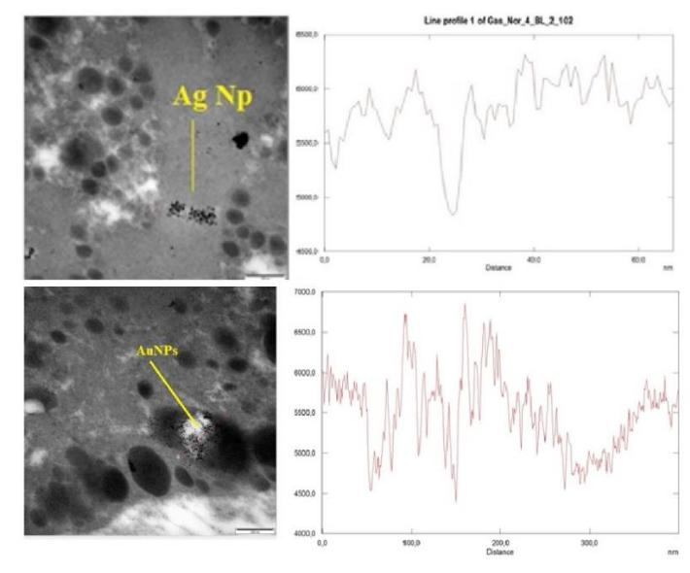

**Figure 6**. The TEM images of samples from endosperms of pea. AgNPs and AuNPs seen as clusters.

|  |  |
| --- | --- |
| <https://biointerfaceresearch.com/> | **6106** |

<https://doi.org/10.33263/BRIAC105.61016111>

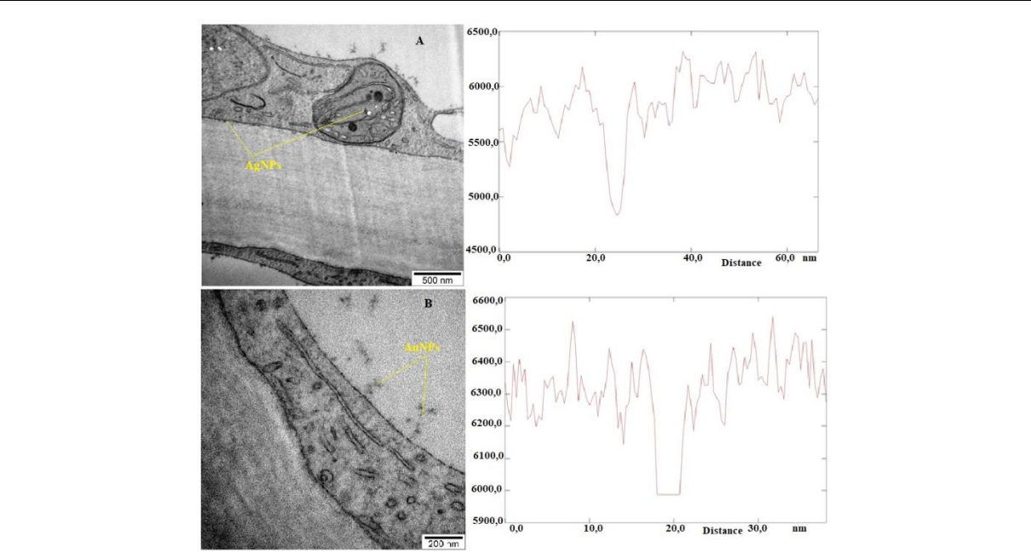

**Figure 7.** The TEM images of samples from root cell of pea. AgNPs in mitochondri (A) and AuNPs (B) inthe vacuole of root cell of pea.

To investigate this problem, pea seeds were stored at room temperature in AgNP and AuNP solutions for 48 hours. During this time, the diffusion of nanoparticles into pea seeds was confirmed by TEM analysis. Then, pea seeds stored in nanoparticles solutions were planted in fertile soil. The presence of nanoparticles in the soil was ruled out. Samples were taken from 10-day-old pea plant roots and preparations were prepared for TEM analysis. Figure 7,8 presents the TEM images of localized AgNPs in the root xylem of pea plants. The graphics were taken from the scanned areas where the AgNPs were collected and confirmed their localization in samples.

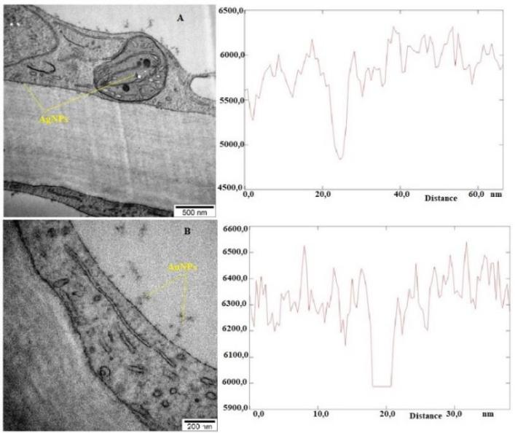

**Figure 8 .** The TEM images of samples from root cell of pea. AgNPs in mitochondri (A) and AuNPs (B)in the vacuole of root cell of pea.

*3.5. Migration of nanoparticles from seed to stem and leaves.*

Nanoparticles that diffuse into plant seeds can migrate to the roots, stems, and leaves during germination. TEM analysis showed that AgNPs and AuNPs, which are localized in the

https://biointerfaceresearch.com/ **6107**



<https://doi.org/10.33263/BRIAC105.61016111>



seed, can also penetrate the root. Can nanoparticles migrate from the roots to the stem and from there to the leaves?

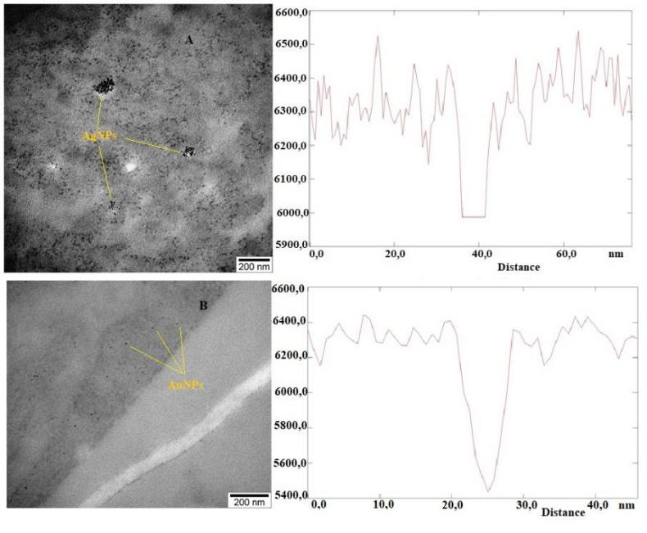

**Figure 9 .** The TEM images of samples from stem cell of pea. AgNPs clusters in the cytoplasm (A) andAuNPs (B) in the xylem of stem cell of pea.

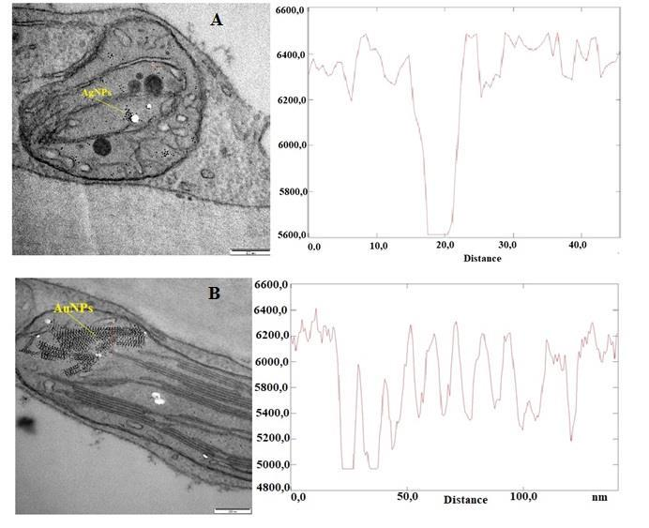

**Figure 10 .** The TEM images of samples from leaf cell of pea. AgNPs in the mitochondri (A) and AgNPs inthe chloroplasts of cell of leaf cell.

To answer this question, seeds which are stored in Ag and Au nanoparticle solutions for 48 hours were planted in fertile soil. Through 20 days for the TEM analysis were prepared samples from these seedlings by sampling from epidermal, xylem and phloem cells, as well as from epidermal cells of leaves. From these preparations were made the ultrathin sections and were taken TEM images. In figure 9 was showed the localization of Ag and Au nanoparticles in cells of the stem of pea plants. The localization of AgNPs in the cytoplasm of epidermal cells seen from figure 9 A. The localization of AuNPs has been confirmed by images TEM (fig. 9B) which was made from xylem cells of stem of pea seedling. TEM images from a

https://biointerfaceresearch.com/ **6108**



<https://doi.org/10.33263/BRIAC105.61016111>



number of cells of the stem also confirm migration of nanoparticles to the stem. Figure 8 shows the localization of Ag and Au nanoparticles in leaf cells. These images were made from ultrathin slices preparations obtained from the leaves of pea seedlings. The localization of Ag and Au nanoparticles in the chloroplasts (fig.10 A) and in the mitochondria (fig,10B) was given in TEM images. In TEM images made from different cell regions, we can determined that nanoparticles are more concentrated in mitochondria. More detailed experiments are needed to determine if nanoparticles accumulate inside or on the surface of mitochondria. Thus, nano sized particles practically can migrate from the seeds of a pea plant to all its organs during development.

**4. Conclusions**

The results of our experiments show that nanoparticles can spread in the soil, diffuse from soil to plant seeds, and migrate from the seeds to the root of growing seeds and from there to its aerial organs. Obviously, nanoparticles that enter the soil will be distributed differently depending on its fertility, structure and composition. In our experiments, we have studied the behavior of nanoparticles depending on the soil thickness. Further experiments are needed to study the distribution of nanoparticles depending on other soil parameters. Of course, vertical movement of nanowires in the soil plays an important role, because depending on the type of plants, the roots of some of them (for example, plants with fibrous roots) do not develop deeper into the soil and grow to 5-10 cm of soil. It is assumed that the roots of such plants are more in contact with nanoparticles. However, plants whose roots develop deeper into the soil (for example, taproots plants) are less likely to be exposed to nanoparticles. The main result of our experiments is that plants with fibrous roots are more susceptible to soil contaminated by nanoparticles.

Another result of our experiments is that nanoparticles dissolve into the endosperm layer by penetrating through the bark of plant seeds, thereby altering their water absorption capacity, while some nanoparticles reduce the seeds' ability to absorb, and some increase. How can nanoparticles change the process of seed germination? It is possible that nanoparticles change the imbibition of seeds (water uptake) and structure of substances in the endosperm layer of the seed, possibly altering the mechanism of water diffusion. This is an important result, indicating that the timing of germination, which depends on the ability of the seeds to absorb water, can be controlled by nanoparticles. Another important consequence is the confirmation of the absorption of nanoparticles into the plant organs. This is important both from an environmental and practical point of view, as the growth efficiency of plants in contaminated soil with nanoparticles is relevant. As nanoparticles move in the body of plants, they interact with a number of biologically active molecules in the cells and in the intercellular space. As a result of these interactions, a number of physiological effects may occur. The results of our experiments show that nanoparticles can penetrate all plant organs, penetrate into cells and accumulate in their organisms. These results indicate that nanoparticles can move freely in plants and migrate from one organ to another. Based on the interaction of nanoparticles with plants, it is possible to evaluate the environmental risks that occur during the dissemination of nanoparticles into the environment.

**Funding**

This research received no external funding.

https://biointerfaceresearch.com/ **6109**



<https://doi.org/10.33263/BRIAC105.61016111>



**Acknowledgments**

This research has no acknowledgments.

**Conflicts of Interest**

The authors declare no conflict of interest.

**References**

1. Fang, J.; Shan, X.-q.; Wen, B.; Lin, J.-m.; Owens, G. Stability of titanium nanoparticles in soil suspensions and transport in saturated homogeneous soil columns. *Environmental Pollution* **2009**, *157*, 1101-1109, [https://doi.org/10.1016/j.envpol.2008.11.006.](https://doi.org/10.1016/j.envpol.2008.11.006)
2. Khan, S.; Şengül, H. Experimental investigation of stability and transport of TiO2 nanoparticles in real soil

columns. *Desalination and Water Treatment* **2016**, *57*, 26196-26203, [https://doi.org/10.1080/19443994.2016.1163513.](https://doi.org/10.1080/19443994.2016.1163513)

1. Rahmatpour, S.; Mosaddeghi, M.R.; Shirvani, M.; Šimůnek, J. Transport of silver nanoparticles in intact columns of calcareous soils: The role of flow conditions and soil texture. *Geoderma* **2018**, *322*, 89-100, [https://doi.org/10.1016/j.geoderma.2018.02.016.](https://doi.org/10.1016/j.geoderma.2018.02.016)
2. Jassby, D., Su, Y.; Kim, C.; Ashworth, V.; Adeleye, A. S.; Rolshausen, P.; White, J.. Delivery. Uptake, Fate, and Transport of Engineered Nanoparticles in Plants: A Critical Review and Data Analysis. *Environmental Science: Nano.* **2019**, https://doi:10.1039/c9en00461k .
3. Ahmadov, I.; Ramazanov, M.; Sienkiewicz, A.; Forro, L. Uptake and intracellular trafficking of superparamagnetic iron oxide nanoparticles (SPIONs) in plants. *Digest Journal of Nanomaterials and* *Biostructures* **2014**, *9*, 1149-1157.
4. Lohse, S. E.; Abadeer, N. S.; Zoloty, M.; White, J. C.; Newman, L. A.; Murphy, C. J.. Nanomaterial Probes in the Environment: Gold Nanoparticle Soil Retention and Environmental Stability as a Function of Surface

|  |  |
| --- | --- |
| Chemistry. *ACS Sustainable Chemistry & Engineering* | **2017**,*5(12), 11451 11458,* |
| https://doi:10.1021/acssuschemeng.7b02622 . |  |

1. Lv, J.; Christie, P.; Zhang, S. Uptake, translocation, and transformation of metal-based nanoparticles in plants: recent advances and methodological challenges. *Environmental Science: Nano.* **2018**, https://doi:10.1039/c8en00645h .
2. Pérez-de-Luque, A. Interaction of Nanomaterials with Plants: What Do We Need for Real Applications in Agriculture. *Frontiers in Environmental Science* **2017**. 5, https://doi:10.3389/fenvs.2017.00012 .
3. Deng, Y.; Petersen, E.J.; Challis, K.E.; Rabb, S.A.; Holbrook, R.D.; Ranville, J.F.; Nelson, B.C.; Xing, B. Multiple Method Analysis of TiO2 Nanoparticle Uptake in Rice (Oryza sativa L.) Plants. *Environmental* *Science & Technology* **2017**, 51, 10615-10623, [https://doi.org/10.1021/acs.est.7b01364.](https://doi.org/10.1021/acs.est.7b01364)
4. He, J.; Wang, D.; Zhou, D. Transport and retention of silver nanoparticles in soil: Effects of input concentration, particle size and surface coating. *Science of The Total Environment* **2019**, 648, 102-108, [https://doi.org/10.1016/j.scitotenv.2018.08.136.](https://doi.org/10.1016/j.scitotenv.2018.08.136)
5. Li, C.C.; Dang, F.; Li, M.; Zhu, M.; Zhong, H.; Hintelmann, H.; Zhou, D.M. Effects of exposure pathways on the accumulation and phytotoxicity of silver nanoparticles in soybean and rice. *Nanotoxicology* **2017**, 11, 699-709, [https://doi.org/10.1080/17435390.2017.1344740.](https://doi.org/10.1080/17435390.2017.1344740)
6. Lin, S.; Reppert, J.; Hu, Q.; Hudson, J.S.; Reid, M.L.; Ratnikova, T.A.; Rao, A.M.; Luo, H.; Ke, P.C. Uptake, translocation, and transmission of carbon nanomaterials in rice plants. *Small* **2009**, 5, 1128-1132, [https://doi.org/10.1002/smll.200801556.](https://doi.org/10.1002/smll.200801556)
7. Wagener, S.; Jungnickel, H.; Dommershausen, N.; Fischer, T.; Laux, P.; Luch, A. Determination of nanoparticle uptake, distribution and characterization in plant root tissue after realistic long term exposure to sewage sludge using information from mass spectrometry. *Environmental Science & Technology* **2019**, 53, 5416−5426, https://doi:10.1021/acs.est.8b07222 .
8. Shrivastava, M. Monitoring of engineered nanoparticles in soil-plant system: A review. *Environmental* *nanotechnology, monitoring & management* **2019**, 11, [https://doi.org/10.1016/j.enmm.2019.100218.](https://doi.org/10.1016/j.enmm.2019.100218)
9. Shukla, P.K.; Misra, P.; Kole, C. Uptake, Translocation, Accumulation, Transformation, and Generational

|  |  |  |  |  |
| --- | --- | --- | --- | --- |
| TransmissionofNanoparticlesinPlants.PlantNanotechnology | **2016**, 183–218, | | |  |
| [https://doi.org/10.1007/978-3-319-42154-4_8.](https://doi.org/10.1007/978-3-319-42154-4_8) |  |  |  |  |
| <https://biointerfaceresearch.com/> |  |  |  |  |
| **6110** | |  |  |

<https://doi.org/10.33263/BRIAC105.61016111>



1. Singh, A.; Singh, N.B.; Afzal, S.; Singh, T.; Hussain, I. Zinc oxide nanoparticles: a review of their biological synthesis, antimicrobial activity, uptake, translocation and biotransformation in plants. *Journal of Materials* *Science* **2018**, *53*, 185-201, [https://doi.org/10.1007/s10853-017-1544-1.](https://doi.org/10.1007/s10853-017-1544-1)
2. Tripathi, D.K.; Shweta; Singh, S.; Singh, S.; Pandey, R.; Singh, V.P.; Sharma, N.C.; Prasad, S.M.; Dubey, N.K.; Chauhan, D.K. An overview on manufactured nanoparticles in plants: Uptake, translocation, accumulation and phytotoxicity. *Plant Physiology and Biochemistry* **2017**,110,2-12, [https://doi.org/10.1016/j.plaphy.2016.07.030.](https://doi.org/10.1016/j.plaphy.2016.07.030)
3. Yan, A.; Chen, Z. Impacts of Silver Nanoparticles on Plants: A Focus on the Phytotoxicity and Underlying Mechanism. *Int J Mol Sci* **2019**, *20*, [https://doi.org/10.3390/ijms20051003.](https://doi.org/10.3390/ijms20051003)
4. Fazeli Sangani, M.; Owens, G.; Fotovat, A. Transport of Engineered Nanoparticles in Soils and Aquifers. *Environmental Reviews* **2018**, [https://doi.org/10.1139/er-2018-0022.](https://doi.org/10.1139/er-2018-0022)
5. Mahdi, K.N.M.; Peters, R.; van der Ploeg, M.; Ritsema, C.; Geissen, V. Tracking the Transport of Silver Nanoparticles in Soil: a Saturated Column Experiment*. Water, Air, & Soil Pollution* **2018**, 229(10), [https://doi.org/10.1007/s11270-018-3985-9.](https://doi.org/10.1007/s11270-018-3985-9)
6. Divya Kumar M.; Raji P.; Bennet Rohan D.; Ratna Geethika Gandham; Kripu Sharma V.; Keerthana D.; Karishma S.; Antony V Samrot; Paulraj Ponnaiah; Thirumurugan R.; Sajeesh Pattammadath; Jenifer Selvarani A.; Prakash P. Green Synthesis and antibacterial activity studies of silver nanoparticles from the aqueous extracts of Thespesia populnea. *Letters in Applied NanoBioScience,* **2020**,9, 1, 931 – 934, [https://doi.org/10.33263/LIANBS91.931934.](https://doi.org/10.33263/LIANBS91.931934)
7. Jainendra Pathak; Arun S. Sonker; Rajneesh Vidya Singh; Deepak Kumar; Rajeshwar P. Sinha. Synthesis of

silver nanoparticles from extracts of Scytonema geitleri HKAR-12 and their in vitro antibacterial and

antitumor potentials. *Letters in Applied NanoBioScience* **2019**, 8, 3, 576 – 585, [https://doi.org/10.33263/LIANBS83.576585.](https://doi.org/10.33263/LIANBS83.576585)

1. Chen H. Metal based nanoparticles in agricultural system: behavior, transport, and interaction with plants. *Chemical Speciation & Bioavailability* **2018**, 1–12, [https://doi.org/10.1080/09542299.2018.1520050.](https://doi.org/10.1080/09542299.2018.1520050)

https://biointerfaceresearch.com/ **6111**

