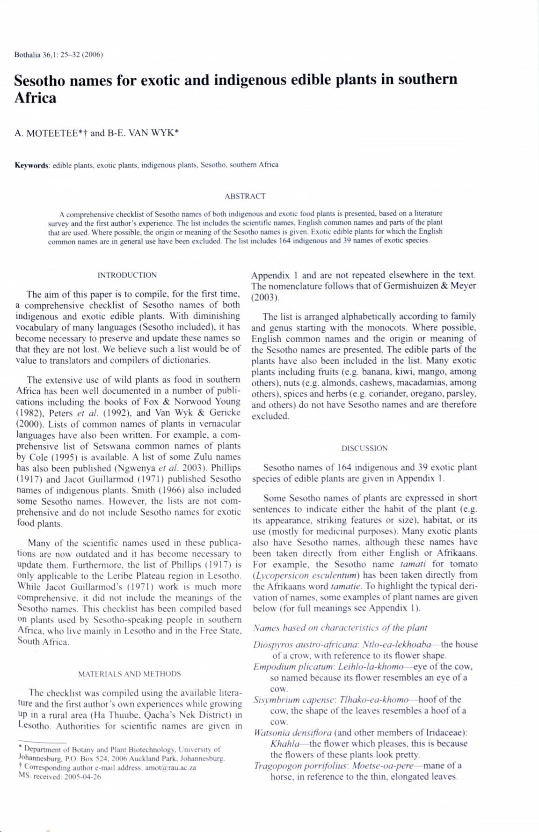Bothalia 36,1:25 -32 (2006)

**Sesotho names for exotic and indigenous edible plants in southern Africa**

A. MOTEETEE*t and B-E. VAN WYK*

**Keywords:** edible plants, exotic plants, indigenous plants, Sesotho. southern Africa

ABSTRACT

A comprehensive checklist o f Sesotho names of both indigenous and exotic food plants is presented, based on a literature survey and the first author's experience. The list includes the scientific names. English common names and parts o f the plant that are used. Where possible, the origin or meaning o f the Sesotho names is given. Exotic edible plants for which the English common names are in general use have been excluded. The list includes 164 indigenous and 39 names o f exotic species.

INTRODUCTION

The aim of this paper is to compile, for the first time, a comprehensive checklist of Sesotho names of both indigenous and exotic edible plants. With diminishing vocabulary of many languages (Sesotho included), it has become necessary' to preserve and update these names so that they are not lost. We believe such a list would be of value to translators and compilers of dictionaries.

The extensive use of wild plants as food in southern Africa has been well documented in a number of publi­ cations including the books of Fox & Norwood Young (1982), Peters *et al.* (1992), and Van Wyk & Gericke (2000). Lists of common names of plants in vernacular languages have also been written. For example, a com­ prehensive list of Setswana common names of plants by Cole (1995) is available. A list of some Zulu names has also been published (Ngwenya *et al.* 2003) Phillips (1917) and Jacot Guillarmod (1971) published Sesotho names of indigenous plants. Smith (1966) also included some Sesotho names. However, the lists are not com­ prehensive and do not include Sesotho names for exotic food plants.

Many of the scientific names used in these publica­ tions are now outdated and it has become necessary to update them. Furthermore, the list of Phillips (1917) is only applicable to the Leribe Plateau region in Lesotho. While Jacot Guillarmod's (1971) work is much more comprehensive, it did not include the meanings of the Sesotho names. This checklist has been compiled based °n plants used by Sesotho-speaking people in southern Africa, who live mainly in Lesotho and in the Free State, South Africa.

MATERIALS AND METHODS

The checklist was compiled using the available litera­ ture and the first author’s own experiences while growing up in a rural area (Ha Thuube. Qacha's Nek District) in Lesotho. Authorities for scientific names are given in

* Department of Botany and Plant Biotechnology, University of Johannesburg. P.O. Box 524. 2006 Auckland Park. Johannesburg
* Corresponding author e-mail address: am otfarau.ac.za

MS. received: 2005-04-26.

Appendix 1 and are not repeated elsewhere in the text. The nomenclature follows that of Germishuizen & Meyer (2003).

The list is arranged alphabetically according to family and genus starting with the monocots. Where possible, English common names and the origin or meaning of the Sesotho names are presented. The edible parts of the plants have also been included in the list. Many exotic plants including fruits (e.g. banana, kiwi, mango, among others), nuts (e.g. almonds, cashews, macadamias. among others), spices and herbs (e.g. coriander, oregano, parsley, and others) do not have Sesotho names and are therefore excluded.

DISCUSSION

Sesotho names of 164 indigenous and 39 exotic plant species of edible plants are given in Appendix 1.

Some Sesotho names of plants are expressed in short sentences to indicate either the habit of the plant (e.g. its appearance, striking features or size), habitat, or its use (mostly for medicinal purposes). Many exotic plants also have Sesotho names, although these names have been taken directly from either English or Afrikaans. For example, the Sesotho name *tamati* for tomato *(Lycopersicon esculentum*) has been taken directly fromthe Afrikaans word *tamatie.* To highlight the typical deri­ vation of names, some examples of plant names are given below (for full meanings see Appendix 1).

*Names based on characteristics o f the plant*

*Diospvros austro-africana*: *Xtlo-ea-lekhoaha*— the houseof a crow, with reference to its flower shape.

*Empodium plicatum. Leihlo-la-khomo*— eye of the cow,so named because its flower resembles an eye of a cow.

*Sisymbrium capense: Tlhako-ea-khomo*— hoof of thecow, the shape of the leaves resembles a hoof of a cow.

*Watsonia densiflora* (and other members of lndaceae): *Khahla*— the flower which pleases, this is becausethe flowers of these plants look pretty.

*Tragopogon porrifolius: Moetse-oa-pere*— mane of ahorse, in reference to the thin, elongated leaves.

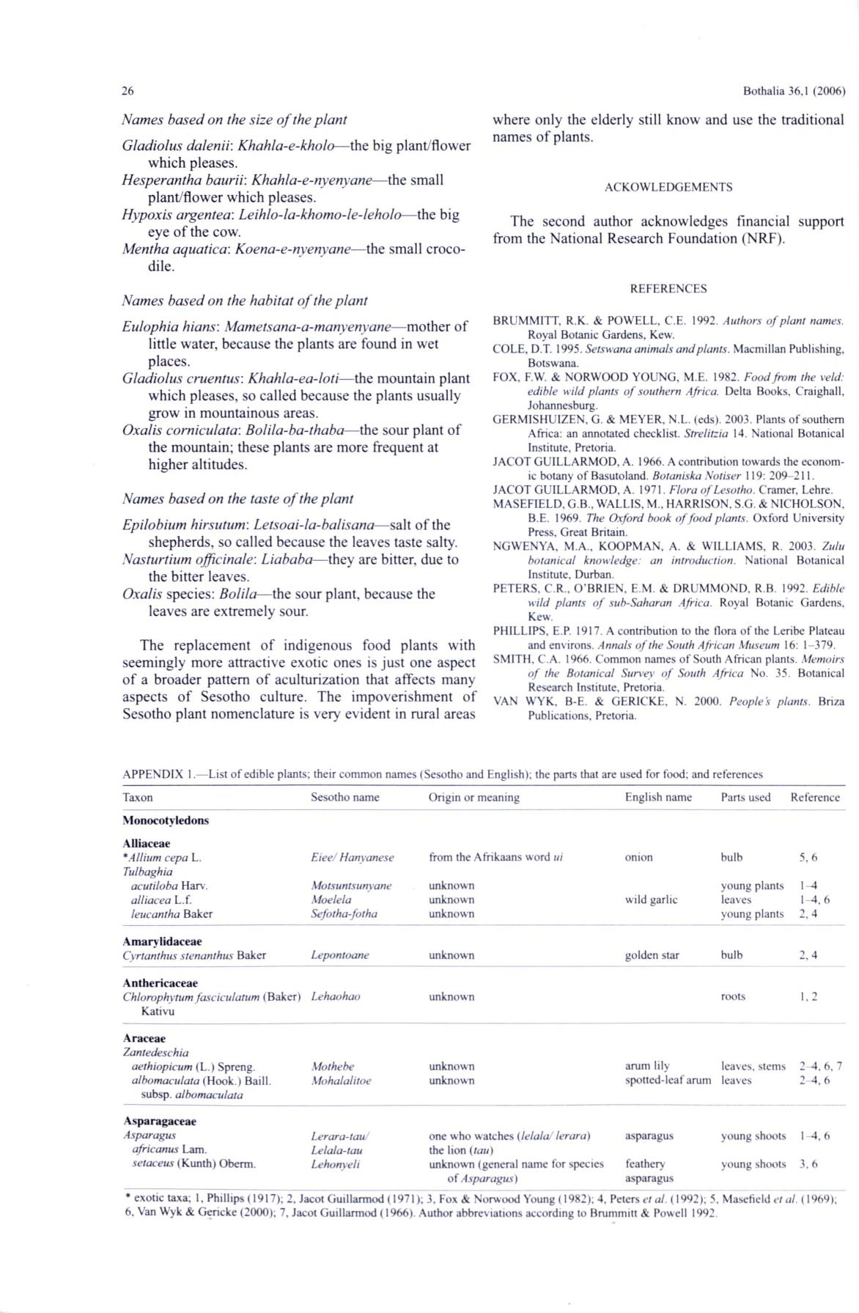26

*Names based on the size o f the plant*

*Gladiolus dalenii: Khahla-e-kholo*— the big plant/flowerwhich pleases.

*Hesperantha baurii*: *Khahla-e-nyenyane*— the smallplant/flower which pleases.

*Hypoxis argentea*: *Leihlo-la-khomo-le-leholo*— the bigeye of the cow.

*Mentha aquatica*: *Koena-e-nvenyane*— the small croco­dile.

Bothalia 36,1 (2006)

where only the elderly still know and use the traditional names of plants.

ACKOWLEDGEMENTS

The second author acknowledges financial support from the National Research Foundation (NRF).

REFERENCES

*Names based on the habitat o f the plant*

*Eulophia hians: Mametsana-a-manyenyane*— mother oflittle water, because the plants are found in wet places.

*Gladiolus cruentus: Khahla-ea-loti*— the mountain plantwhich pleases, so called because the plants usually grow in mountainous areas.

*Oxalis corniculata: Bolila-ba-thaba*— the sour plant ofthe mountain; these plants are more frequent at higher altitudes.

*Names based on the taste o f the plant*

*Epilobium hirsutum*: *Letsoai-la-balisana*— salt of theshepherds, so called because the leaves taste salty.

*Nasturtium officinale*: *Liababa*— they are bitter, due tothe bitter leaves.

*Oxalis* species: *Bolila*— the sour plant, because theleaves are extremely sour.

The replacement of indigenous food plants with seemingly more attractive exotic ones is just one aspect of a broader pattern of aculturization that affects many aspects of Sesotho culture. The impoverishment of Sesotho plant nomenclature is very evident in rural areas

BRUMMITT. R.K. & POWELL, C.E. 1992. *Authors o f plant names.*

Royal Botanic Gardens, Kew.

COLE, D.T. 1995. *Setswana animals and plants.* Macmillan Publishing, Botswana.

FOX, F.W' & NORWOOD YOUNG, M.E. 1982. *Food from the veld:* *edible w ild plants o f southern Africa.* Delta Books, Craighall,Johannesburg.

GERMISHUIZEN . G. & MEYER. N.L. (eds). 2003. Plants o f southern Africa: an annotated checklist. *Strelitzia* 14. National Botanical Institute, Pretoria.

JACOT GUILLARMOD, A. 1966. A contribution towards the econom ­ ic botany of Basutoland. *Botaniska Notiser* 119: 209-211.

JACOT GUILLARMOD. A. 1971. *Flora o f Lesotho.* Cramer, Lehre. MASEFIELD. G.B.. WALLIS, M.. HARRISON, S.G. & NICHOLSON,

B.E. 1969. *The Oxford hook o f fo o d plants.* Oxford University Press. Great Britain.

NGWENYA, M.A., KOOPMAN. A. & WILLIAMS. R. 2003. *Zulu* *botanical knowledge: an introduction.* National BotanicalInstitute, Durban.

PETERS, C.R.. O ’BRIEN. E.M. & DRUMMOND. R.B 1992. *Edible* *wild plants o f sub-Saharan Africa.* Royal Botanic Gardens,Kew.

PHILLIPS, E.P 1917. A contribution to the flora o f the Lenbe Plateau and environs. *Annals o f the South African Museum* 16: 1-379.

SMITH. C.A. 1966. Common names o f South African plants. *Memoirs* *o f the Botanical Survey o f South Africa* No. 35. BotanicalResearch Institute. Pretoria.

VAN WYK. B-E. & GER1CKE, N. 2000. *People's plants.* Briza Publications, Pretoria.

APPENDIX 1.— List o f edible plants; their common names (Sesotho and English); the parts that are used for food; and references

|  |  |  |  |  |  |  |
| --- | --- | --- | --- | --- | --- | --- |
| Taxon | Sesotho name | Origin or meaning | English name | Parts used | Reference |  |
| **M onocotyledons** |  |  |  |  |  |  |
| **Alliaceae** |  | from the Afrikaans word *ui* |  |  |  |  |
| \**Allium cepa* L. | *Eiee/ Hanyanese* | onion | bulb | 5 ,6 |  |
| *Tulbaghia* | *Motsuntsunyane* | unknown |  |  |  |  |
| *acutiloba* Harv . |  | young plants | 1-4 |  |
| *alliacea* L.f. | *Moelela* | unknown | wild garlic | leaves | 1-4. 6 |  |
| *leucantha* Baker | *Sefotha-fotha* | unknown |  | young plants | 2 .4 |  |
| **A m arylidaceae** | *Lepontoane* | unknown | golden star | bulb | 2 ,4 |  |
| *Cyrtanthus stenanthus* Baker |  |
| **A nthericaceae** | *Lehaohao* |  |  | roots |  |  |
| *Chlorophytum fasciculatum* (Baker) | unknown |  | 1.2 |  |
| Kativu |  |  |  |  |  |  |
| **Araceae** |  |  |  |  |  |  |
| *Zantedeschia* | *Mothebe* | unknown | arum lily | leaves, stems | 2^4. 6. 7 |  |
| *aethiopicum* (L.) Spreng. |  |
| *albomaculata* (Hook.) Baill. | *Mohalalitoe* | unknown | spotted-leaf arum | leaves | 24,6 |  |
| subsp. *albomaculata* |  |  |  |  |  |  |
| **Asparagaceae** |  |  |  |  |  |  |
| *Asparagus* | *Lerara-tau/* | one who watches (*lelala/ lerara)* | asparagus | young shoots | 1-4.6 |  |
| *africanus* Lam. | *Lelala-tau* | the lion (*tau)* |  |  |  |  |
| *setaceus* (Kunth) Oberm. | *Lehonyeli* | unknown (general name for species | feathery | young shoots | 3 .6 |  |
|  |  | o f *Asparagus)* | asparagus |  |  |  |

* exotic taxa; 1, Phillips (1917); 2. Jacot Guillarmod (1971); 3. Fox & Norwood Young (1982); 4, Peters *et al.* (1992); 5. Masefield *et al.* (1969); 6. Van Wyk & Gericke (2000); 7, Jacot Guillarmod (1966). Author abbreviations according to Brummitt & Powell 1992.

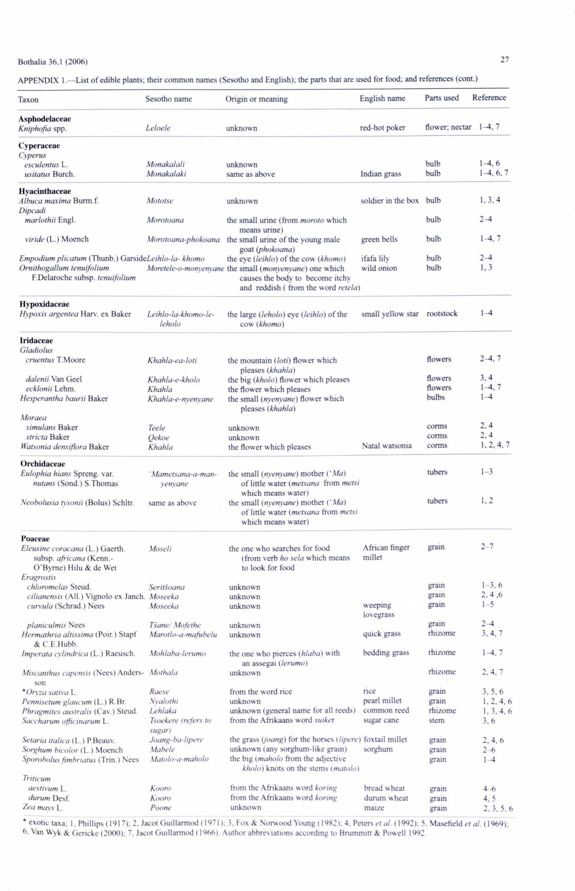Bothalia 36,1 (2006)

APPENDIX 1.— List o f edible plants; their common names (Sesotho and English); the parts that are used for food; and references (cont.)

|  |  |  |  |  |
| --- | --- | --- | --- | --- |
| Taxon | Sesotho name | Origin or meaning | English name |  |
| A sphodelaceae | *Leloele* | unknown | red-hot poker |  |
| *Kniphofia* spp. |  |
| Cyperaceae |  |  |  |  |
| *Cyperus* | *M onakalali* |  |  |  |
| *esculentus* L. | unknown |  |  |
| *usitatus* Burch. | *M onakalaki* | same as above | Indian grass |  |

Parts used Reference

|  |  |
| --- | --- |
| flower; nectar | 1-4, **7** |
| bulb | 1-4,**6** |
| bulb | 1-4. **6 ,7** |

|  |  |  |  |
| --- | --- | --- | --- |
| H yacinthaceae | *Mototse* |  |  |
| *Albuca maxima* Burm.f. | unknown |  |
| *Dipcadi* |  |  |  |
| *marlothii* Engl. | *Morotoana* | the small urine (from *moroto* which |  |
| *viride* (L.) Moench | *Morotoana-phokoana* | means urine) |  |
| the small urine o f the young male |  |
| *Empodium plicatum* (Thunb.) *GarsideLeihlo-la- khomo* | | goat *(phokoana)* |  |
| the eye (*leihlo*) o f the cow *(khomo)* |  |
| *Ornithogallum tenuifolium* | *Moretele-o-monyenyane* the small *(monyenyane)* one which | |  |
| F.Delaroche subsp. *tenuifolium* |  | causes the body to become itchy |  |
|  |  | and reddish ( from the word *retela*) |  |

soldier in the box

green bells

ifafa lily w ild onion

|  |  |
| --- | --- |
| bulb | 1,3,4 |
| bulb | 2^4 |
| bulb | 1-4, **7** |
| bulb | 2-4 |
| bulb | 1,3 |

|  |  |  |  |
| --- | --- | --- | --- |
| H ypoxidaceae |  |  |  |
| *Hypoxis argentea* Harv. ex Baker | *Leihlo-la-khomo-le-* | the large (*leholo*) eye (*leihlo*) o f the |  |
|  | *leholo* | cow *(khomo)* |  |
| Iridaceae |  |  |  |
| *Gladiolus* |  |  |  |
| *cruentus* T.Moore | *Khahla-ea-loti* | the mountain *(loti)* flower which |  |
| *dalenii* Van Geel |  | pleases *(khahla)* |  |
| *Khahla-e-kholo* | the big *(kholo)* flower which pleases |  |
| *ecklonii* Lehm. | *Khahla* | the flower which pleases |  |
| *Hesperantha baurii* Baker | *Khahla-e-nyenyane* | the small (*nyenvane)* flower which |  |
| *Moraea* |  | pleases *(khahla)* |  |
|  |  |  |
| *simulans* Baker | *Teele* | unknown |  |
| *stricta* Baker | *Qekoe* | unknown |  |
| *Watsonia densiflora* Baker | *Khahla* | the flower which pleases |  |
| O rchidaceae |  |  |  |
| *Eulophia hians* Spreng. var. | *'Mametsana-a-man-* | the small *(nyenvane)* mother ( *'M a* ) |  |
| *nutans* (Sond.) S.Thomas | *yenyane* | o f little w ater *{metsana* from *metsi* |  |
|  |  | which means water) |  |
| *Neobolusia tysonii* (Bolus) Schltr. | same as above | the small *(nyenvane)* mother *('M a)* |  |
|  |  | o f little water (*metsana* from *metsi* |  |
|  |  | which means water) |  |

|  |  |  |
| --- | --- | --- |
| small yellow star | rootstock | 1^1 |
|  | flowers | 2-4, **7** |
|  | flowers | 3, 4 |
|  | flowers | **1-4, 7** |
|  | bulbs | **1-4** |
|  | corms | **2 .4** |
|  | corms | **2 .4** |
| Natal w atsonia | corms | **1,2, 4 ,7** |
|  | tubers | **1-3** |
|  | tubers | **1,2** |

Poaceae

*Eleusine coracana* (L.) Gaerth.

subsp. *africana* (Kenn.-O 'B ym e) Hilu & de Wet

*Eragrostis*

*chloromelas* Steud.

*cilianensis* (All.) Vignolo ex Janch *. curvula* (Schrad.) Nees

*planiculmis* Nees

*Hermathria altissima* (Poir.) Stapf

& C.E.Hubb.

*Imperata cylindrica* (L.) Raeusch

*Miscanthus capensis* (Nees) Anders-son

*\*Oryza saliva* L.

*Pennisetum glaucum* (L.) R.Br.

*Phragmites australis* (Cav.) Steud.

*Saccharum officinarum* L..

*Setaria italica* (L.) P. Beau v. *Sorghum bicolor* (L.) Moench *Sporobolusftmbriatus* (Trin.) Nees

|  |  |  |  |
| --- | --- | --- | --- |
| *Moseli* | the one who searches for food | African finger |  |
|  | (from verb *ho sela* which means | millet |  |
|  | to look for food |  |  |
| *Seritsoana* | unknown |  |  |
| *Moseeka* | unknown | weeping |  |
| *Moseeka* | unknown |  |
|  |  | lovegrass |  |
| *Tsane/ Mofethe* | unknown | quick grass |  |
| *Marotlo-a-mafubelu* | unknown |  |
| *Mohlaba-lerumo* | the one who pierces *(hlaba)* with | bedding grass |  |
| *Mothala* | an assegai (*lerum o* ) |  |  |
| unknown |  |  |
| *Raese* | from the word rice | rice |  |
| *Nyalothi* | unknown | pearl millet |  |
| *Lehlaka* | unknown (general name for all reeds) | common reed |  |
| *Tsoekere (refers to* | from the Afrikaans word *suikex* | sugar cane |  |
| *sugar)* | the grass *(joang)* for the horses *(lipere* ) foxtail millet | |  |
| *Joang-ba-lipere* |  |
| *Mabele* | unknown (any sorghum-like grain) | sorghum |  |
| *Matolo-a-maholo* | the big *(maholo* from the adjective |  |  |
|  | *kholo)* knots on the stems (*matolo*) |  |  |

|  |  |
| --- | --- |
| grain | **2 -7** |
| grain | **1-3, 6** |
| grain | **2.4,6** |
| grain | **1-5** |
| grain | *2 ~ * |
| rhizome | **3.4. 7** |
| rhizome | **1-4.7** |
| rhizome | **2.4, 7** |
| gram | **3.5.6** |
| grain | **1,2. 4 .6** |
| rhizome | 1.3.4. 6 |
| stem | **3 .6** |
| grain | **2,4.6** |
| grain | **2 -6** |
| grain | 1-4 |

|  |  |  |  |  |
| --- | --- | --- | --- | --- |
| *Triticum* | *Kooro* | from the Afrikaans w ord *koring* | bread w heat |  |
| *aestivum* L. |  |
| *durum* Desf. | *Kooro* | from the Afrikaans w ord *koring* | durum wheat |  |
| *Zea mays* L. | *Poone* | unknown | maize |  |

|  |  |  |
| --- | --- | --- |
| grain | 4 -6 | |
| gram | 4. | 5 |
| grain | 2. | **3.5.6** |

* exotic taxa; 1, Phillips (1917); 2. Jacot Guillarmod (1971); 3. Fox & Norwood Young (1982); 4. Peters *et al.* (1992); 5. Masefield *et al.* (1969); 6, Van Wyk & Gericke (20(H)); 7, Jacot Guillarmod (1966) Author abbreviations according to Brummitt & Powell 1992

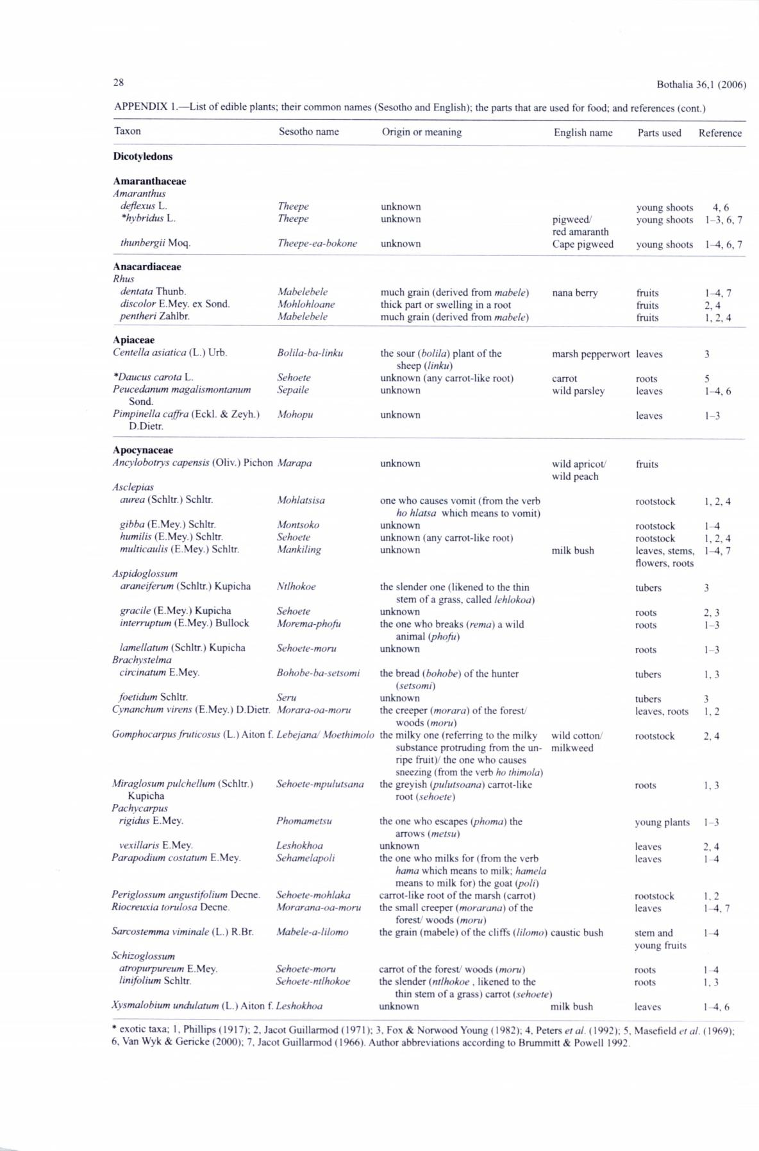28 Bothalia 36,1 (2006)

APPENDIX 1.— List o f edible plants; their common names (Sesotho and English); the parts that are used for food; and references (cont.)

Taxon

Dicotyledons

A m aranthaceae

*Am aranthus*

*deflexus* L.

*\*hybridus* L.

*thunbergii* Moq.

1. nacardiaceae *Rhus*

*den tala* Thunb.

*discolor* E.Mey. ex Sond. *pentheri* Zahlbr.

A piaceae

*Centella asiatica* (L.) Urb.

*\*Daucus carota* L. *Peucedanum magalismontanum*

Sond.

*Pimpinella caffra* (Eckl. & Zeyh.)D.Dietr.

A pocynaceae

Sesotho name

*Theepe*

*Theepe*

*Theepe-ea-bokone*

*Mabelebele*

*Mohlohloane*

*Mabelebele*

*Bolila-ba-linku*

*Sehoele*

*Sepaile*

*Mohopu*

Origin or meaning

unknown

unknown

unknown

much grain (derived from *mabele)* thick part or swelling in a root much grain (derived from *mabele)*

the sour (*bolila*) plant o f the sheep *(linku)*

unknown (any carrot-like root)

unknown

unknown

English name Parts used Reference

|  |  |  |  |
| --- | --- | --- | --- |
| pigweed/ | young shoots | 4 ,6 |  |
| young shoots | 1-3, 6, 7 |  |
| red amaranth |  |  |  |
| Cape pigweed | young shoots | 1-4, 6, 7 |  |
| nana berry | fruits | 1-4, 7 |  |
|  | fruits | 2 ,4 |  |
|  | fruits | 1,2,4 |  |
| marsh pepperwort | leaves | 3 |  |
| carrot | roots | 5 |  |
| wild parsley | leaves | 1-4,6 |  |
|  | leaves | 1-3 |  |

*Ancylobotrys capensis* (Oliv.) Pichon

*Asclepias*

*aurea* (Schltr.) Schltr.

*gibba* (E.Mey.) Schltr.

*humilis* (E.Mey.) Schltr.

*multicaulis* (E.Mey.) Schltr.

*Aspidoglossum*

*araneiferum* (Schltr.) Kupicha

*gracile* (E.Mey.) Kupicha *interruptum* (E.Mey.) Bullock

*lamellatum* (Schltr.) Kupicha *Brachystelma*

*cireinaturn* E.Mey.

*foetidum* Schltr.

*Cynanchum virens* (E.Mey.) D.Dietr.

*Marapa*

*Mohlatsisa*

*Montsoko*

*Sehoete*

*Mankiling*

*Ntlhokoe*

*Sehoete Morema-phofu*

*Sehoete-moru*

*Bohobe-ba-setsomi*

*Seru*

*Morara-oa-moru*

unknown

one who causes vomit (from the verb *ho hlatsa* which means to vomit)

unknown

unknown (any carrot-like root)

unknown

the slender one (likened to the thin stem of a grass, called *lehlokoa)*

unknown

the one who breaks (*rema*) a wild animal *(phofu)*

unknown

the bread (*bohobe*) o f the hunter (*setsom i*)

unknown

the creeper (*morara*) o f the forest/ woods *(moru)*

wild apricot/ wild peach

milk bush

|  |  |
| --- | --- |
| fruits |  |
| rootstock | 1, 2,4 |
| rootstock | 1-4 |
| rootstock | 1,2,4 |
| leaves, stems, | 1-4, 7 |
| flowers, roots |  |
| tubers | 3 |
| roots | 2 .3 |
| roots | 1-3 |
| roots | 1-3 |
| tubers | 1,3 |
| tubers | **3** |
| leaves, roots | 1,2 |

*Gomphocarpus fruticosus* (L.) Aiton f. *LebejanaJ Moethimolo*

*Miraglosum pulchellum* (Schltr.) *Sehoete-mpulutsana*

Kupicha

*Pachycarpus*

*rigidus* E.Mey. *Phomametsu*

*vexillaris* E.Mey. *Leshokhoa*

the milky one (referring to the milky substance protruding from the un­ ripe fruit)/ the one who causes sneezing (from the verb *ho thimola*)

the greyish (*pulutsoana* ) carrot-like root (*sehoete*)

the one who escapes *(phoma)* the arrows (*metsu)*

unknown

wild cotton/ milkweed

|  |  |
| --- | --- |
| rootstock | 2 ,4 |
| roots | **1.3** |
| young plants | **1-3** |
| leaves | 2 ,4 |

|  |  |
| --- | --- |
| *Parapodium costatum* E.Mey. | *Sehamelapoli* |
| *Periglossum angustifolium* Decne. | *Sehoete-mohlaka* |
| *Riocreuxia torulosa* Decne. | *Morarana-oa-moru* |
| *Sarcoslemma viminale* (L.) R.Br. | *Mabele-a-lilomo* |
| *Schizoglossum* |  |
| *atropurpureum* E.Mey. | *Sehoete-moru* |
| *linifolium* Schltr. | *Sehoete-ntlhokoe* |

*Xysmalobium undulatum* (L.) Aiton f. *Leshokhoa*

the one who milks for (from the verb *hama* which means to milk; *hamela* means to milk for) the goat *(poli)*

carrot-like root o f the marsh (carrot)

the small creeper *(morarana)* of the

forest/ woods *(moru)*

the grain (mabele) of the cliffs (*lilomo*) caustic bush

carrot o f the forest' woods *(moru)* the slender *(ntlhokoe* , likened to the

thin stem o f a grass) carrot *(sehoete)*

unknown milk bush

|  |  |
| --- | --- |
| leaves | 1 4 |
| rootstock | 1. 2 |
| leaves | 1-4, 7 |
| stem and | 1-4 |
| young fruits |  |
| roots | 1 4 |
| roots | 1. 3 |
| leaves | 14.6 |

* exotic taxa; 1, Phillips (1917); 2, Jacot Guillarmod (1971); 3. Fox & Norwood Young (1982); 4. Peters *et al.* (1992); 5, Masefield *et al.* (1969); 6. Van Wyk & Gericke (2000); 7. Jacot Guillarmod (1966). Author abbreviations according to Brummitt & Powell 1992.

|  |  |
| --- | --- |
| Bothalia 36,1 (2006) | 29 |

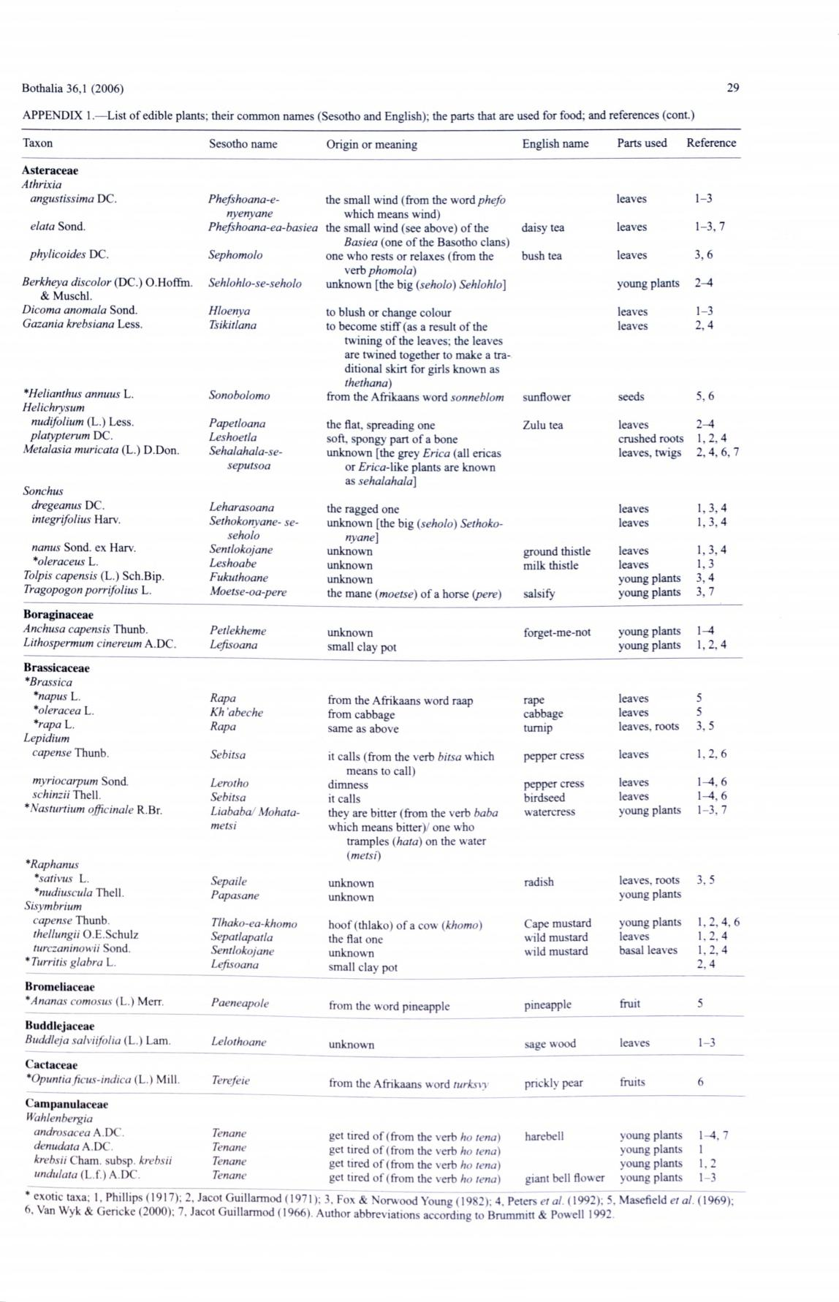

APPENDIX 1.— List o f edible plants; their common names (Sesotho and English); the parts that are used for food; and references (cont.)

Taxon

**Asteraeeae**

*Athrixia*

*angustissim a* DC.

*elata* Sond.

*phylicoides* DC.

*Berkheya discolor* (DC.) O.Hoffm.

& Muschl.

*Dicoma anomala* Sond.

*Gazania krebsiana* Less.

*\*Helianthus armuus* L.

*Helichrysum*

*nudifolium* (L.) Less.

*platypterum* DC.

*Metalas ia muricata* (L.) D.Don.

*Sonchus*

*dregeanus* DC.

*integrifolius* Harv.

*nanus* Sond. ex Harv.

*\*oleraceus* L.

*Tolpis capensis* (L.) Sch.Bip.

*Tragopogon porrifolius* L.

**Boraginaceae**

*Anchusa capensis* Thunb.

*Lithospermum cinereum* A.DC.

**Brassicaeeae**

*\*Brassica*

*\*napus* L.

*\*oleracea* L.

*\*rapa* L.

*Lepidium*

*capense* Thunb.

*myriocarpum* Sond.

*schinzii* Thell.

\**Nasturtium officinale* R.Br.

Sesotho name

*Phefshoana-e-nyenyane*

1. *hefshoana-ea-basiea Sephom olo Sehlohlo-se-seholo*

*Hloenya*

*Tsikitlana*

*Sonobolomo*

*Papetloana*

*Leshoetla*

*Sehalahala-se-*

*seputsoa*

*Leharasoana Sethokonyane- se-*

*seholo*

*Sentlokojane*

*Leshoabe*

*Fukuthoane*

*Moetse-oa-pere*

*Petlekheme*

*Lefisoana*

*Rapa*

*Kh abeche*

*Rapa*

*Sebitsa*

*Lerotho*

*Sebitsa*

*Liababa/ Mohata-*

*metsi*

Origin or meaning

the small wind (from the word *phefo* which means wind)

the small wind (see above) o f the

*B asiea* (one o f the Basotho clans)one who rests or relaxes (from the

verb *phomola)*

unknown [the big (*seholo*) *Sehlohlo]*

to blush or change colour

to become stiff (as a result o f the twining o f the leaves; the leaves are twined together to make a tra­ ditional skirt for girls known as *thethana)*

from the Afrikaans word *sonneblom*

the flat, spreading one soft, spongy part o f a bone unknown [the grey *Erica* (all ericas

or *Erica-Wko.* plants are known as *sehalahala]*

the ragged one

unknown [the big (*seholo*) *Sethoko­* *nyane]*

unknown

unknown

unknown

the mane *(moetse)* o f a horse *{pere*)

unknown

small clay pot

from the Afrikaans word raap

from cabbage

same as above

it calls (from the verb *bitsa* which means to call)

dimness

it calls

they are bitter (from the verb *baba* which means bitter)/ one who

tramples (*hata*) on the water (*metsi)*

English name

daisy tea

bush tea

sunflower

Zulu tea

ground thistle milk thistle

salsify

forget-me-not

rape

cabbage

turnip

pepper cress

pepper cress birdseed watercress

Parts used

leaves

leaves

leaves

young plants

leaves

leaves

seeds

leaves

crushed roots

leaves, twigs

leaves

leaves

leaves

leaves

young plants

young plants

young plants young plants

leaves

leaves

leaves, roots

leaves

leaves

leaves

young plants

Reference

1-3

1-3,7

1. ,6
2. -4

1-3

2 ,4

5 ,6

2 -4

1,2.4

2,4.6,7

1,3,4

1,3,4

1,3,4

1,3

1. ,4
2. ,7

1-4

1,2,4

5

5

1. 5

1,2,6

1-4. 6

1-4. 6

1-3,7

*\*Raphanus *sativus* L. *\*nudiuscula* Thell.

*Sisymbrium*

*capense* Thunb.

*thellungii* O.E.Schulz

*turczaninowii* Sond.

*\* Turritis glabra* L.

**Bromeliaceae**

*\*Ananas comosus* (L.) Merr.

**Buddlejaceae**

*Buddiej a salviifolia* (L.) Lam.

**Cactaceae**

*\*Opuntiaficus-indica* (L.) Mill.

**Cam panulaceae**

*Wahlenbergia androsacea A .* DC . *denudata* A.DC

*krebsii* Cham, subsp. *krebsii undulata* (L.f.) A.DC.

*Sepaile*

*Papasane*

*Tlhako-ea-khomo Sepatlapatla Sentlokojane Lefisoana*

*Paeneapole*

*Lelothoane*

*Terefeie*

*Tenane*

*Tenane*

*Tenane*

*Tenane*

unknown

unknown

hoof (thlako) o f a cow (*khom o*)

the flat one

unknown

small clay pot

from the word pineapple

unknown

from the Afrikaans w ord *turks\y*

get tired o f (from the verb *ho tena*)

get tired o f (from the verb *ho tena)*

get tired o f (from the verb *ho tena)*

get tired o f (from the verb *ho tena*)

|  |  |  |
| --- | --- | --- |
| radish | leaves, roots | 3 ,5 |
|  | young plants |  |
| Cape mustard | young plants | 1,2, 4, 6 |
| wild mustard | leaves | 1,2.4 |
| wild mustard | basal leaves | 1,2,4 |
|  |  | 2 .4 |
| pineapple | fruit | 5 |
| sage wood | leaves | 1-3 |
| prickly pear | fruits | 6 |
| harebell | young plants | 1—4. 7 |
|  | young plants | 1 |
|  | young plants | 1.2 |
| giant bell flower | young plants | 1-3 |

* exotic taxa; 1. Phillips (1917); 2, Jacot Guillarmod (19 7 1); 3. Fox & Norwood Youne (1982); 4. Peters *et al.* (1992); 5. Masefield *et al.* (1969);
  + an Wyk & Gerickc (2000); 7, Jacot Guillarmod (1966). Author abbreviations according to Brummitt & Powell 1992.

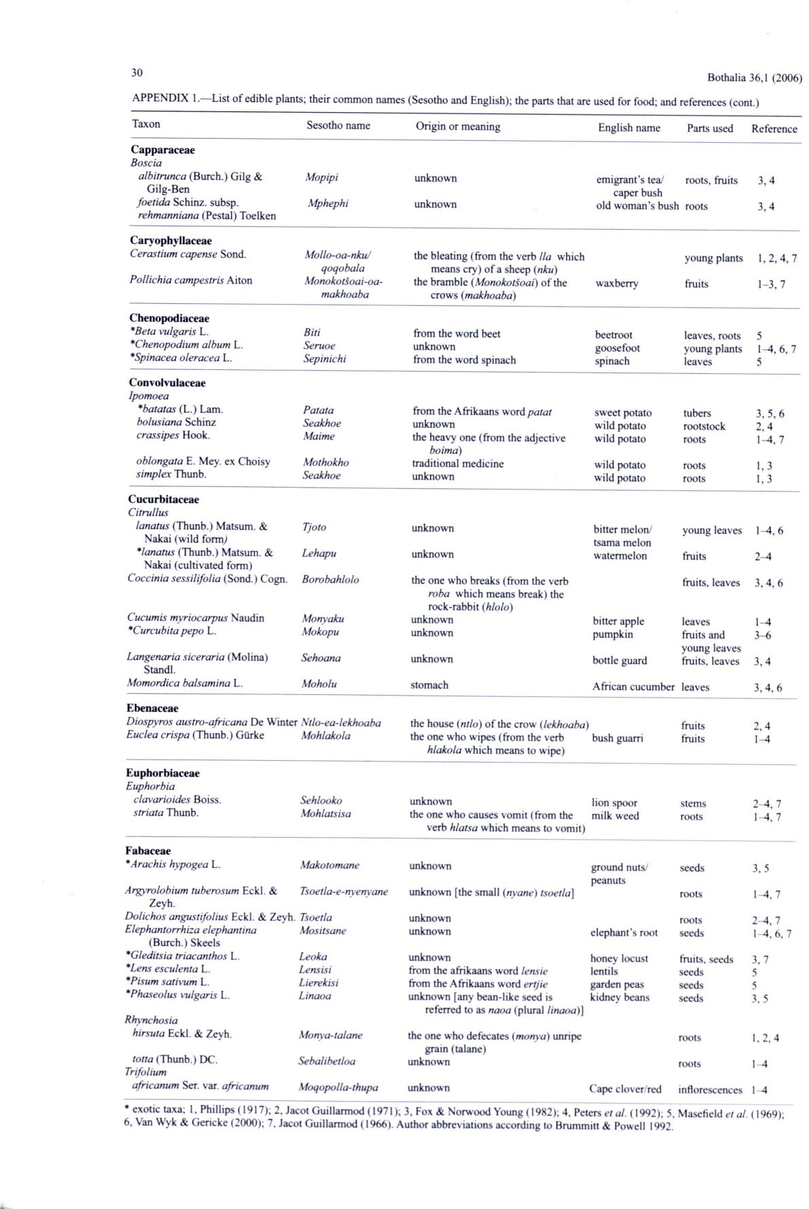Bothalia 36,1 (2006)

APPENDIX 1,— List o f edible plants; their common names (Sesotho and English); the parts that are used for food; and references (cont.)

Taxon

**Capparaceae**

1. *oscia*

*albitrunca* (Burch.) Gilg &Gilg-Ben

*fo e tid a* Schinz. subsp.

*rehm anniana* (Pestal) Toelken

**Caryophyllaceae** *Cerastium capense* Sond.

*Pollichia campestris* Aiton

**Chenopodiaceae**

Sesotho name

1. *opipi M phephi*
2. *ollo-oa-nku/*

*qoqobala*

*Monokotsoai-oa-makhoaba*

Origin or meaning

unknown

unknown

the bleating (from the verb *lla* which means cry) o f a sheep *(nku)*

the bramble (*Monokotsoai*) of the crows (*makhoaba*)

English name

em igrant’s tea/ caper bush

old wom an’s bush

wax berry

Parts used

roots, fruits

roots

young plants

fruits

Reference

1. .4
2. .4

1,2,4, 7

1-3,7

|  |  |
| --- | --- |
| *\*Beta vulgaris* L. | *Biti* |
| *\*Chenopodium album* L. | *Seruoe* |
| *\*Spinacea oleracea* L. | *Sepinichi* |
| **Convolvulaceae** |  |
| *Ipomoea* |  |
| *\*batatas* (L.) Lam. | *Patata* |
| *bolusiana* Schinz | *Seakhoe* |
| *crassipes* Hook. | *Maime* |
| *oblongata* E. Mey. ex Choisy | *Mothokho* |
| *simplex* Thunb. | *Seakhoe* |
| **Cucurbitaceae** |  |
| *Citrullus* |  |
| *lanatus* (Thunb.) Matsum. & | *Tjoto* |
| Nakai (wild form,) |  |
| *\*lanatus* (Thunb.) Matsum. & | *Lehapu* |
| Nakai (cultivated form) |  |
| *Coccinia sessilifolia* (Sond.) Cogn. | *Borobahlolo* |
| *Cucumis myriocarpus* Naudin | *Monyaku* |
| *\*Curcubitapepo* L. | *Mokopu* |
| *Langenaria siceraria* (Molina) | *Sehoana* |
| Standi. |  |
| *Momordica balsamina* L. | *Moholu* |

**Ebenaceae**

*Diospyros austro-africana* De Winter *Ntlo-ea-lekhoaba*

|  |  |
| --- | --- |
| *Euclea crispa* (Thunb.) Giirke | *Mohlakola* |
| **Euphorbiaceae** |  |
| *Euphorbia* |  |
| *clavarioides* Boiss. | *Sehlooko* |
| *striata* Thunb. | *Mohlatsisa* |
| **Fabaceae** |  |
| *\*Arachis hypogea* L. | *Makotomane* |

from the word beet

unknown

from the word spinach

from the Afrikaans word *patat* unknown

the heavy one (from the adjective *boima)*

traditional medicine

unknown

unknown

unknown

the one who breaks (from the verb *roba* which means break) therock-rabbit (*hlolo*)

unknown

unknown

unknown

stomach

the house *(ntlo)* o f the crow (*lekhoaba*) the one who wipes (from the verb

*hlakola* which means to wipe)

unknown

the one who causes vomit (from the verb *hlatsa* which means to vomit)

unknown

beetroot

goosefoot

spinach

sweet potato wild potato wild potato

wild potato wild potato

bitter melon/ tsama melon watermelon

bitter apple pumpkin

bottle guard

African cucumber

bush guarri

lion spoor milk weed

ground nuts/ peanuts

leaves, roots young plants leaves

tubers rootstock roots

roots

roots

young leaves

fruits

fruits, leaves

leaves

fruits and

young leaves

fruits, leaves

leaves

fruits

fruits

stems

roots

seeds

5

1^, 6,7

5

3,5,6

2 ,4

1-4, 7

1,3

1,3

1-4, 6

2 -4

3,4,6

1-4

1. -6
2. ,4
3. ,4 ,6
4. ,4

1-4

2-4, 7

1-4, 7

3,5

|  |  |
| --- | --- |
| *Argyrolobium tuberosum* Eckl. & | *Tsoetla-e-nyenyane* |
| Zeyh. |  |
| *Dolichos angustifolius* Eckl. & Zeyh. *Tsoetla* | |
| *Elephantorrhiza elephantina* | *Mositsane* |
| (Burch.) Skeels |  |
| *\*Gleditsia triacanthos* L. | *Leoka* |
| *\*Lens esculenta* L. | *Lensisi* |
| *\*Pisum sativum* L. | *Lierekisi* |
| *\*Phaseolus vulgaris* L. | *Linaoa* |
| *Rhynchosia* |  |
| *hirsuta* Eckl. & Zeyh. | *Monya-talane* |
| *totta* (Thunb.) DC. | *Sebalibetloa* |
| *Trifolium* |  |
| *africanum* Ser. var. *africanum* | *Moqopolla-thupa* |

unknown [the small *(nyane) tsoetla]*

unknown

unknown

unknown

from the afrikaans word *lensie* from the Afrikaans word *ertjie* unknown [any bean-like seed is

referred to as *naoa* (plural *linaoa)]*

the one who defecates (*m onya)* unripe grain (talane)

unknown

unknown

|  |  |  |
| --- | --- | --- |
|  | roots |  |
| elephant’s root | roots |  |
| seeds |  |
| honey locust | fruits, seeds |  |
| lentils | seeds |  |
| garden peas | seeds |  |
| kidney beans | seeds |  |
|  | roots |  |
|  | roots |  |
| Cape clover/red | inflorescences |  |

1-4, 7

2-4, 7

14, 6, 7

3, 7

5

5

3. 5

1. ,2 .4
2. 4
3. 4

* __ i nu:ii:___^
* exotic taxa; 1, Phillips (1917); 2. Jacot Guillarmod (1971); 3, Fox & Norwood Young (1982); 4, Peters *et al.* (1992); 5, Masefield *et al.* (1969); 6, Van Wyk & Gericke (2000); 7, Jacot Guillarmod (1966). Author abbreviations according to Brummitt & Powell 1992.

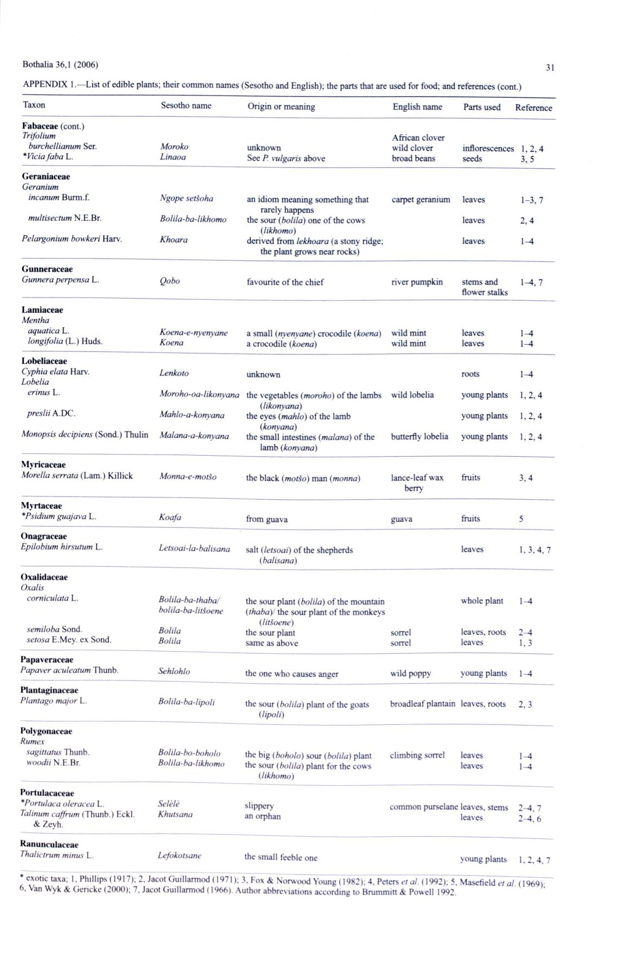Bothalia 36,1 (2006)

APPENDIX 1 —List o f edible plants; their common names (Sesotho and English); the parts that are used for food; and references (cont.)

Taxon

**Fabaceae** (cont.)

*Trifolium*

*burchellianum* Ser.

*\*Vicia faba* L.

**Geraniaceae**

*Geranium*

*incanum* Burm.f.

*multisectum* N.E.Br.

*Pelargonium bowkeri* Harv.

**Gunneraceae** *Gunnera perpensa* L.

**Lamiaceae**

*Mentha*

*aquatica* L.

*longifolia* (L.) Huds.

**Lobeliaceae**

*Cyphia elata* Harv.

*Lobelia*

*erinus* L.

*preslii* A.DC.

*Monopsis decipiens* (Sond.) Thulin

**Myricaceae**

*Morelia serrata* (Lam.) Killick

**Myrtaceae** *\*Psidium guajava* L.

**Onagraceae** *Epilobium hirsutum* L.

**Oxalidaceae**

*Oxalis*

*corn iculata* L.

*semiloba* Sond.

*setosa* E.Mey. ex Sond.

**Papaveraceae**

*Papaver aculeatum* Thunb.

**Plantaginaceae**

*Plantago major* L.

**Polygonaceae**

*Rumex*

*sagittatus* Thunb.

*woodii* N.E.Br.

**Portulacaceae**

*\*Portulaca oleracea* L.

*Talinum caffrum* (Thunb.) Eckl.

& Zeyh.

**Ranunculaceae** *Thalictrum minus* L.

Sesotho name

*Moroko*

*Linaoa*

*Ngope setsoha*

*Bolila-ba-likhomo*

*Khoara*

*Qobo*

*Koena-e-nyenyane Koena*

*Lenkoto*

*Moroho-oa-likonyana*

*Mahlo-a-konyana*

*Malana-a-konyana*

*M onna-e-motso*

*Koafa*

*Letsoai-la-balisana*

*Bolila-ba-thaba/ bolila-ba-litsoene*

*Bolila*

*Bolila*

*Sehlohlo*

*Bolila-ba-Iipoli*

*Bolila-bo-boholo Bolila-ba-likhomo*

*Selêlê*

*Khutsana*

*Lefokotsane*

Origin or meaning

unknown

See *P. vulgaris* above

an idiom meaning something that rarely happens

the sour (*bolila*) one o f the cows *(likhomo*)

derived from *lekhoara* (a stony ridge; the plant grows near rocks)

favourite o f the chief

1. small (*nyenyane*) crocodile *(koena)* a crocodile *(koena)*

unknown

the vegetables *(moroho)* o f the lambs *(likonyana)*

the eyes *(mahlo)* o f the lamb V*Konyana)*

the small intestines *(malana)* of the lamb (*konyana*)

the black *(motso)* man (*monna*)

from guava

salt (*letsoai)* o f the shepherds *(balisana)*

the sour plant (*bolila*) o f the mountain *(thaba)/* the sour plant o f the monkeys

*(litsoene)*

the sour plant

same as above

the one who causes anger

the sour *(bolila)* plant o f the goats (*lipoli)*

the big *(boholo)* sour (*bolila*) plant the sour *(bolila)* plant for the cows

*(likhomo)*

slippery

an orphan

the small feeble one

|  |  |
| --- | --- |
| English name | Parts used |
| African clover |  |
| wild clover | inflorescences |
| broad beans | seeds |
| carpet geranium | leaves |
|  | leaves |
|  | leaves |
| river pumpkin | stems and |
|  | flower stalks |
| wild mint | leaves |
| w ild mint | leaves |
|  | roots |
| wild lobelia | young plants |
|  | young plants |
| butterfly lobelia | young plants |
| lance-leaf wax | fruits |
| berry |  |
| guava | fruits |
|  | leaves |
|  | whole plant |
| sorrel | leaves, roots |
| sorrel | leaves |
| wild poppy | young plants |
| broadleaf plantain | leaves, roots |
| climbing sorrel | leaves |
|  | leaves |

common purselane leaves, stems leaves

young plants

Reference

1. ,2 .4

3 ,5

1. -3 ,7

2 ,4

1 -4

1-4,7

1-4

1-4

1-4

1. .2 .4
2. .2 .4
3. ,2 ,4

3 .4

5

1,3,4. 7

1^4

1. -4 1,3

1-4

2 ,3

1-4

1-4

2—4, 7 2-4, 6

1,2,4, 7

exotic taxa; 1, Phillips ( 1917); 2. Jacot Guillarmod (1971); 3. Fox & Norwood Young (1982); 4. Petens *et al.* (1992); 5. Masefield *et al.* (1969); . Van Wyk & Gericke (2000); 7, Jacot Guillarmod (1966). Author abbrev iations according to Brummitt & Powell 1992.

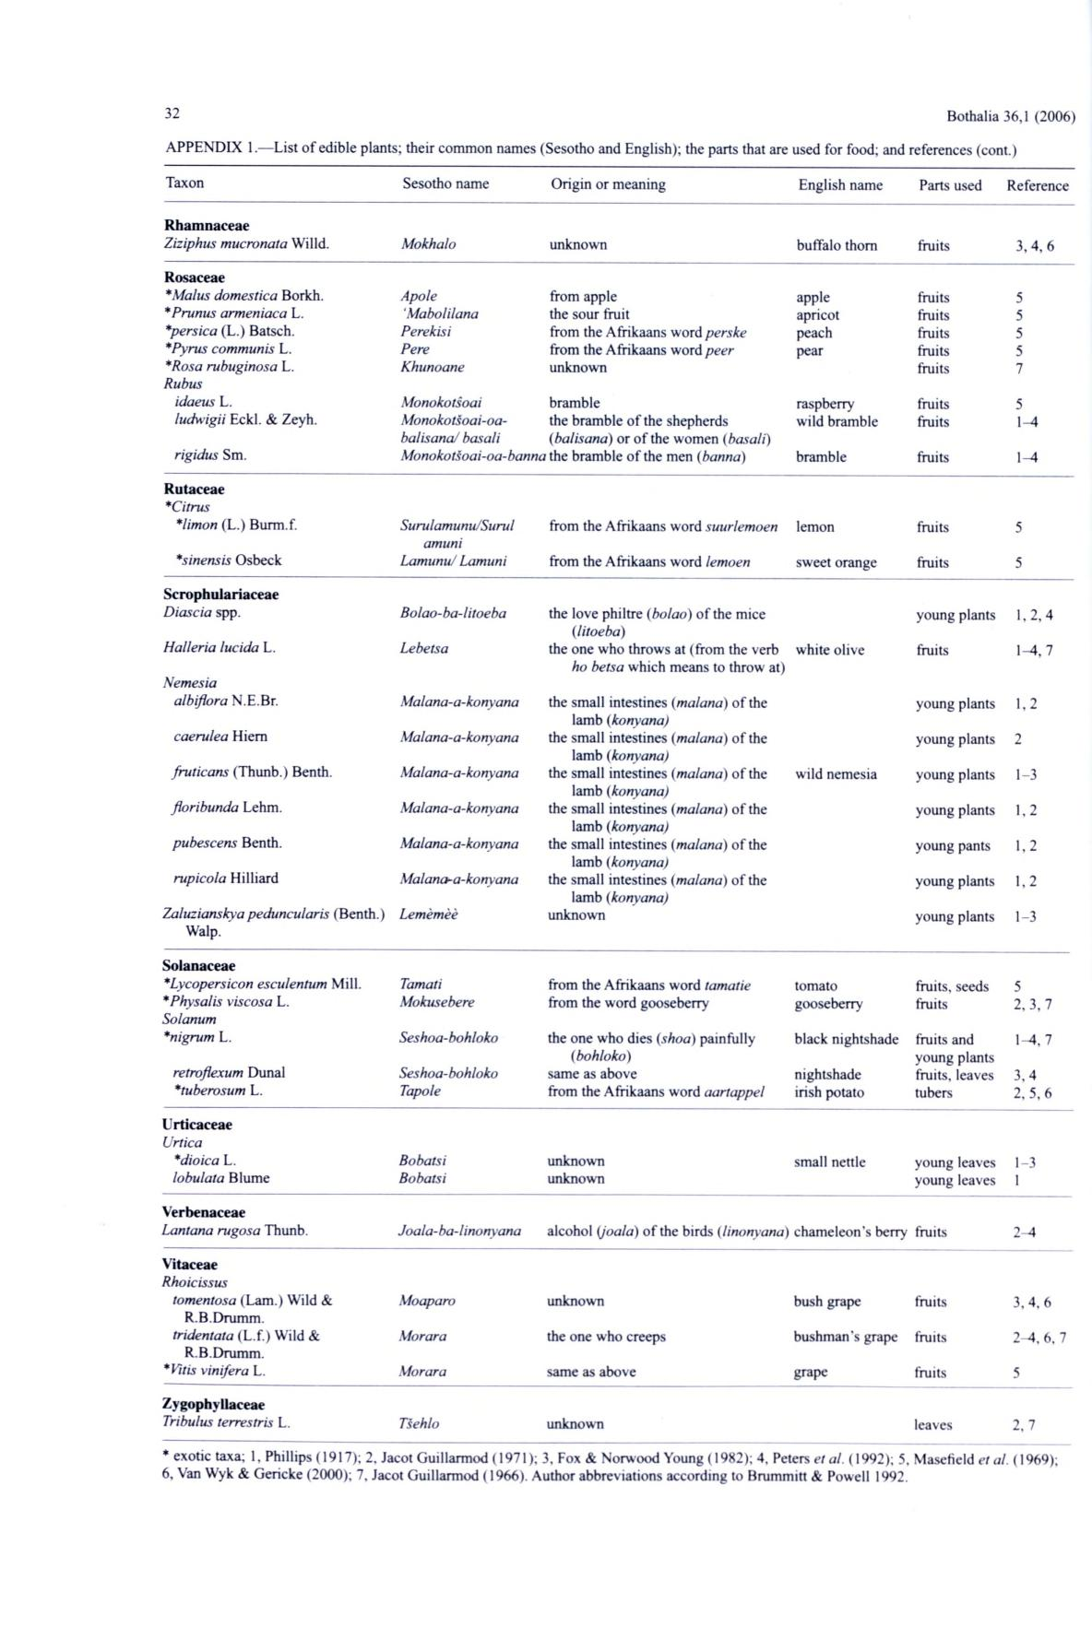32 Bothalia 36,1 (2006)

APPENDIX 1.— List o f edible plants; their common names (Sesotho and English); the parts that are used for food; and references (cont.)

Taxon

**Rham naceae**

*Ziziphus mucronata* Willd.

**Rosaceae**

*\*Malus domestica* Borkh. *\*Prunus armeniaca* L. *\*persica* (L.) Batsch. *\*Pyrus communis* L. *\*Rosa rubuginosa* L. *Rubus*

Sesotho name

*Mokhalo*

*Apole*

*‘M abolilana*

*Perekisi*

*Pere*

*Khunoane*

Origin or meaning

unknown

from apple

the sour fruit

from the Afrikaans word *perske* from the Afrikaans word *peer* unknown

English name

buffalo thorn

apple

apricot

peach

pear

|  |  |
| --- | --- |
| Parts used | Reference |
| fruits | **3,4,6** |
| fruits | **5** |
| fruits | **5** |
| fruits | **5** |
| fruits | **5** |
| fruits | 7 |

*idaeus* L.

*ludwigii* Eckl. & Zeyh.

*rigidus* Sm.

**Rutaceae**

*\*Citrus*

|  |  |
| --- | --- |
| *Monokotsoai* | bramble |
| *Monokotsoai-oa-* | the bramble of the shepherds |
| *balisanaJ basali* | *(balisana*) or o f the women (*basali)* |

*M onokotsoai-oa-banna* the bramble o f the men (*banna)*

raspberry wild bramble

bramble

|  |  |
| --- | --- |
| fruits | **5** |
| fruits | **1-4** |
| fruits | **1-4** |

*\*limon* (L.) Burm.f.

*\*sinensis* Osbeck

**Scrophulariaceae**

*Diascia* spp.

*Halleria lucida* L.

*Nemesia*

*albiflora* N.E.Br.

*caerulea* Hiem

*fruticans* (Thunb.) Benth.

*floribunda* Lehm.

*pubescens* Benth.

*rupicola* Hilliard

*Zaluzianskya peduncularis* (Benth.)Walp.

**Solanaceae**

*\*Lycopersicon esculentum* Mill.

*\*Physalis viscosa* L.

*Solanum*

*\*nigrum* L.

*retroflexum* Dunal

*\*tuberosum* L.

**Urticaceae**

*Urtica*

*Surulamunu/Surul*

*amuni*

*Lamunu/ Lamuni*

*Bolao-ba-litoeba*

*Lebetsa*

1. *alana-a-konyana Malana-a-konyana M alana-a-konyana M alana-a-konyana Malana-a-konyana Malana-a-konyana Lemêmêê*

*Tamati*

*Mokusebere*

*Seshoa-bohloko*

*Seshoa-bohloko Tapole*

from the Afrikaans word *suurlemoen*

from the Afrikaans word *lemoen*

the love philtre (*bolao*) of the mice *(litoeba)*

the one who throws at (from the verb *ho betsa* which means to throw at)

the small intestines (*m alana*) o f the lamb (*konyana)*

the small intestines (*malana*) o f the lamb *(konyana)*

the small intestines (*malana*) o f the lamb *(konyana)*

the small intestines *(malana)* of the lamb *(konyana)*

the small intestines *(malana)* of the lamb *(konyana)*

the small intestines *(malana)* o f the lamb (*konyana)*

unknown

from the Afrikaans word *tamatie* from the word gooseberry

the one who dies *(shoa)* painfully *(bohloko)*

same as above

from the Afrikaans word *aartappel*

lemon

sweet orange

white olive

wild nemesia

tomato gooseberry

black nightshade

nightshade irish potato

|  |  |  |
| --- | --- | --- |
| fruits | **5** |  |
| fruits | **5** |  |
| young plants | **1,2,4** |  |
| fruits | **1-4,** 7 |  |
| young plants | **1,2** |  |
| young plants | **2** |  |
| young plants | **1-3** |  |
| young plants | **1,2** |  |
| young pants | **1,2** |  |
| young plants | **1,2** |  |
| young plants | **1-3** |  |
| fruits, seeds | **5** |  |
| fruits | **2,** 3,7 |  |
| fruits and | **1-4,** 7 |  |
| young plants | **3 ,4** |  |
| fruits, leaves |  |
| tubers | **2,5,6** |  |

*\*dioica* L.

*lobulata* Blume

**Verbenaceae**

*Bobatsi* unknown

*Bobatsi* unknown

|  |  |  |  |
| --- | --- | --- | --- |
| small nettle | young | leaves | **1-3** |
|  | young | leaves | **1** |

*Lantana rugosa* Thunb.

**Vitaceae**

*Rhoicissus*

*tomentosa* (Lam .) Wild &R.B.Drumm.

*tridentata* (L.f.) Wild &R.B.Drumm.

* *Vitis vinifera* L.

**Zygophyllaceae**

*Tribulus terrestris* L.

|  |  |  |  |  |
| --- | --- | --- | --- | --- |
| *Joala-ba-linonyana* | alcohol *(joala)* o f the birds (*linonyana*) cham eleon’s berry | | fruits | **2-4** |
| *Moaparo* | unknown | bush grape | fruits | **3,4.6** |
| *Morara* | the one who creeps | bushm an’s grape | fruits | **2-4,** 6, 7 |
| *Morara* | same as above | grape | fruits | 5 |
| *Tsehlo* | unknown |  | leaves | 2 ,7 |

* exotic taxa; 1, Phillips (1917); 2, Jacot Guillarmod (1971); 3, Fox & Norwood Young (1982); 4, Peters *et al.* (1992); 5, Masefield *et al.* (1969); 6, Van Wyk & Gericke (2000); 7, Jacot Guillarmod (1966). Author abbreviations according to Brummitt & Powell 1992.