

Herbivory, Time since Introduction and the Invasiveness of Exotic Plants Author(s): David Carpenter and Naomi Cappuccino

Source: *Journal of Ecology,* Vol. 93, No. 2 (Apr., 2005), pp. 315-321

Published by: British Ecological Society

Stable URL: https://www.jstor.org/stable/3599398

Accessed: 27-08-2020 02:05 UTC

**REFERENCES**

Linked references are available on JSTOR for this article: https://www.jstor.org/stable/3599398?seq=1&cid=pdf-reference#references_tab_contents You may need to log in to JSTOR to access the linked references.

JSTOR is a not-for-profit service that helps scholars, researchers, and students discover, use, and build upon a wide range of content in a trusted digital archive. We use information technology and tools to increase productivity and facilitate new forms of scholarship. For more information about JSTOR, please contact support@jstor.org.

Your use of the JSTOR archive indicates your acceptance of the Terms & Conditions of Use, available at https://about.jstor.org/terms



*British Ecological Society* is collaborating with JSTOR to digitize, preserve and extend accessto *Journal of Ecology*

This content downloaded from 129.94.142.234 on Thu, 27 Aug 2020 02:05:39 UTC

All use subject to https://about.jstor.org/terms

Journal of

Ecology 2005 93, 315-321

Herbivory, time since introduction and the invasiveness

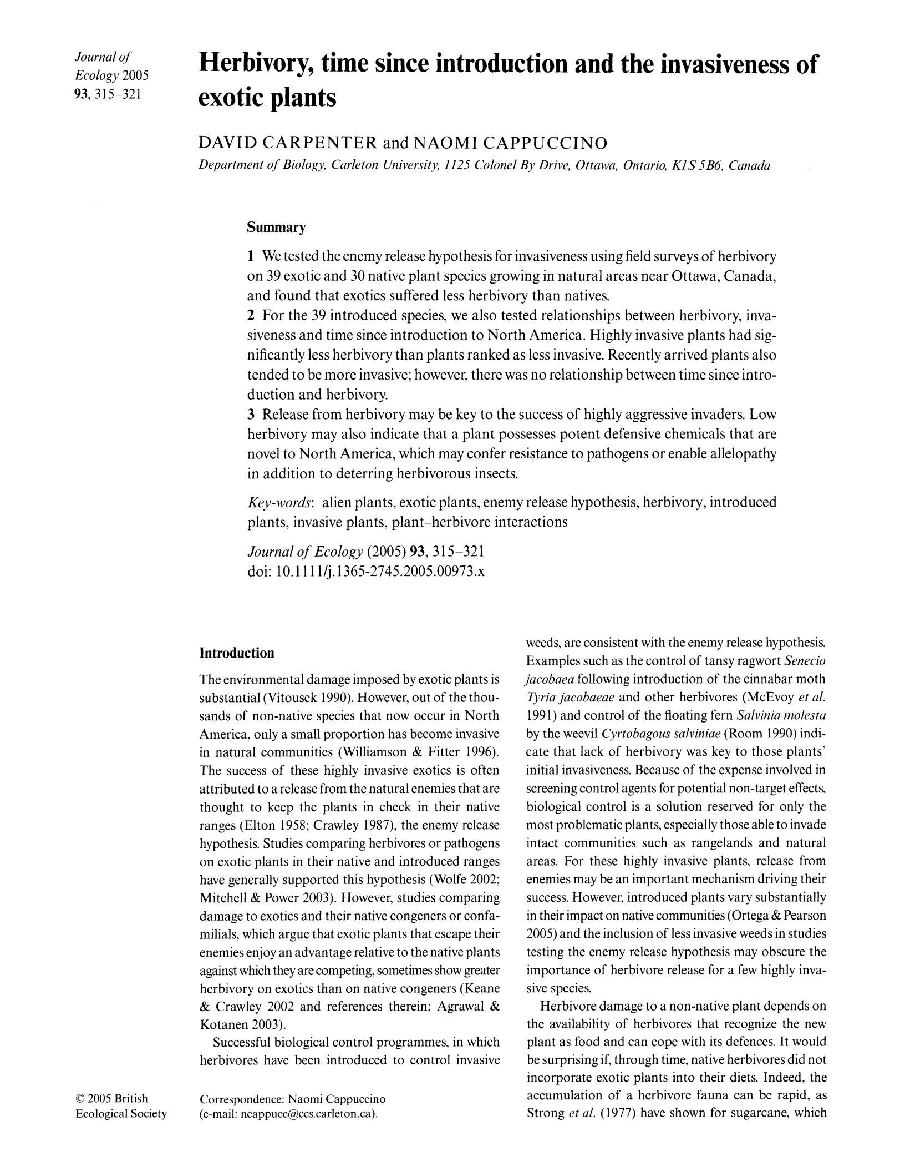

exotic plants

DAVID CARPENTER and NAOMI CAPPUCCINO

Department of Biology, Carleton University, 1125 Colonel By Drive, Ottawa, Ontario, K1S SB6, Canada

Summary

1 We tested the enemy release hypothesis for invasiveness using field surveys of herbivory

on 39 exotic and 30 native plant species growing in natural areas near Ottawa, Canada,

and found that exotics suffered less herbivory than natives.

2 For the 39 introduced species, we also tested relationships between herbivory, inva-siveness and time since introduction to North America. Highly invasive plants had sig-

nificantly less herbivory than plants ranked as less invasive. Recently arrived plants also tended to be more invasive; however, there was no relationship between time since intro-

duction and herbivory.

3 Release from herbivory may be key to the success of highly aggressive invaders. Low herbivory may also indicate that a plant possesses potent defensive chemicals that are

novel to North America, which may confer resistance to pathogens or enable allelopathy in addition to deterring herbivorous insects.

Key-words: alien plants, exotic plants, enemy release hypothesis, herbivory, introduced

plants, invasive plants, plant-herbivore interactions

Journal of Ecology (2005) 93, 315-321

doi: 10.1111/j.1365-2745.2005.00973.x

weeds, are eonsistent with the enemy release hypothesis.

Introduction

Examples sueh as the control of tansy ragwort Senecio

The environmental damage imposed by exotic plants isjacobaea following introduction of the cinnabar moth substantial (Vitousek 1990). However, out of the thou- Tyria jacobaeae and other herbivores (McEvoy et al.

sands of non-native species that now occur in North 1991) and control of the floating fern Salvinia molesta

America, only a small proportion has become invasive by the weevil Cyrtobagous salviniae (Room 1990) indi-

in natural communities (Williamson & Fitter 1996). cate that lack of herbivory was key to those plants'

The success of these highly invasive exotics is often initial invasiveness. Because of the expense involved in

g 2005 British Ecological Society

attributed to a release from the natural enemies that are

thought to keep the plants in check in their native ranges (Elton 1958; Crawley 1987), the enemy release hypothesis. Studies comparing herbivores or pathogens on exotic plants in their native and introduced ranges have generally supported this hypothesis (Wolfe 2002; Mitchell & Power 2003). However, studies comparing damage to exotics and their native congeners or confa-milials, which argue that exotic plants that escape their enemies enjoy an advantage relative to the native plants

against which they are competing, sometimes show greater

herbivory on exotics than on native congeners (Keane & Crawley 2002 and references therein; Agrawal &

Kotanen 2003).

Successful biological control programmes, in which herbivores have been introduced to control invasive

Correspondence: Naomi Cappuccino

(e-mail: ncappuccgccs.carleton.ca).

sereening eontrol agents for potential non-target effeets,

biologieal control is a solution reserved for only the most problematic plants, espeeially those able to invade intact eommunities sueh as rangelands and natural areas. For these highly invasive plants? release from enemies may be an important meehanism driving their success. However, introduced plants vary substantially

in their impaet on native communities (Ortega & Pearson

2005) and the inelusion of less invasive weeds in studies testing the enemy release hypothesis may obscure the importanee of herbivore release for a few highly inva-

. .

slve specles.

Herbivore damage to a non-native plant depends on the availability of herbivores that recognize the new

plant as food and can cope with its defenees. It would

be surprising if, through time, native herbivores did not

incorporate exotic plants into their diets. Indeed, the accumulation of a herbivore fauna can be rapid, as Strong et al. (1977) have shown for sugarcane, which

This content downloaded from 129.94.142.234 on Thu, 27 Aug 2020 02:05:39 UTC

All use subject to https://about.jstor.org/terms

316

D. Carpenter & At Cappuccino

was introduced throughout the tropics. Although area For the introduced species, dates of introduction were planted, and not time since introduction, was the primary obtained from a variety of sources (Appendix Sl). For

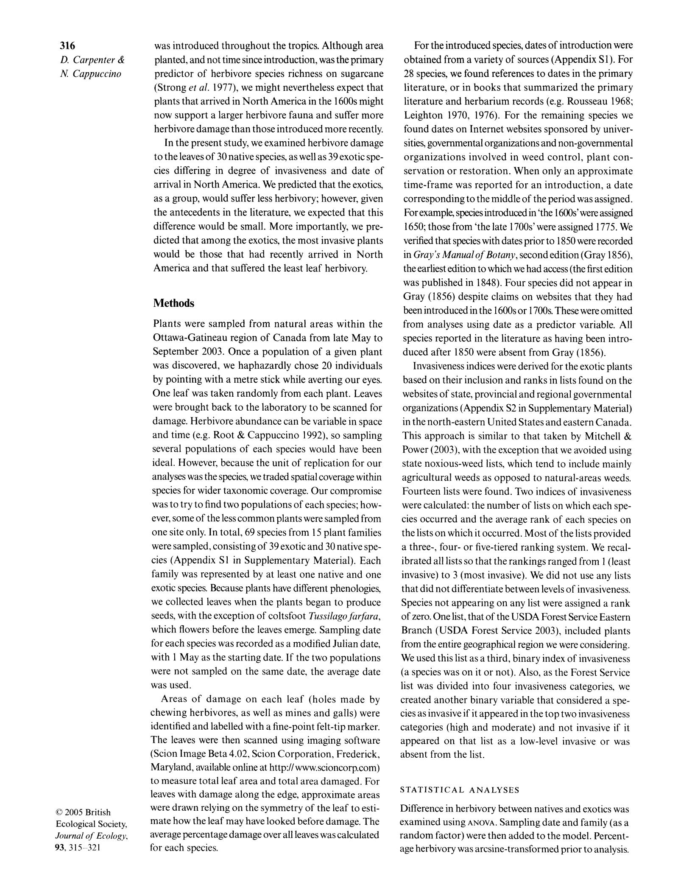

predictor of herbivore species richness on sugarcane 28 species, we found references to dates in the primary (Strong et al. 1977), we might nevertheless expect that literature, or in books that summarized the primary plants that arrived in North America in the 1 600s might literature and herbarium records (e.g. Rousseau 1968; now support a larger herbivore fauna and suffer more Leighton 1970, 1976). For the remaining species we herbivore damage than those introduced more recently. found dates on Internet websites sponsored by univer-

In the present study, we examined herbivore damage sities, governmental organizations and non-governmental to the leaves of 30 native species, as well as 39 exotic spe- organizations involved in weed control, plant con-

cies differing in degree of invasiveness and date of servation or restoration. When only an approximate

arrival in North America. We predicted that the exotics,time-frame was reported for an introduction, a date

as a group, would suffer less herbivory; however, given corresponding to the middle of the period was assigned.

the antecedents in the literature, we expected that this Forexample, species introduced in 'the 1600s'were assigned

difference would be small. More importantly, we pre- 1650; those from 'the late l 700s' were assigned 1775. We

dicted that among the exotics, the most invasive plants verified that species with dates prior to 1850 were recorded

|  |  |
| --- | --- |
| would be those that had recently arrived in North | in Gray's Manual of Botany, second edition (Gray 1856), |
| America and that suffered the least leaf herbivory. | the earliest edition to which we had access (the first edition |

Methods

Plants were sampled from natural areas within the

Ottawa-Gatineau region of Canada from late May to

September 2003. Once a population of a given plant was discovered, we haphazardly chose 20 individuals

by pointing with a metre stick while averting our eyes. One leaf was taken randomly from each plant. Leaves were brought back to the laboratory to be scanned for damage. Herbivore abundance can be variable in space and time (e.g. Root & Cappuccino 1992), so sampling

several populations of each species would have been

ideal. However, because the unit of replication for our

was published in 1848). Four species did not appear in Gray (1856) despite claims on websites that they had beenintroducedinthe 1600sor 1700s. Thesewereomitted from analyses using date as a predictor variable. All species reported in the literature as having been intro-duced after 1850 were absent from Gray (1856).

Invasiveness indices were derived for the exotic plants based on their inclusion and ranks in lists found on the websites of state, provincial and regional governmental

organizations (Appendix S2 in Supplementary Material)

in the north-eastern United States and eastern Canada. This approach is similar to that taken by Mitchell & Power (2003), with the exception that we avoided using state noxious-weed lists, which tend to include mainly

analyses was the species, we traded spatial coverage withinagricultural weeds as opposed to natural-areas weeds. species for wider taxonomic coverage. Our compromise Fourteen lists were found. Two indices of invasiveness was to try to find two populations of each species; how- were calculated: the number of lists on which each spe-ever, some of the less common plants were sampled fromcies occurred and the average rank of each species on

one site only. In total, 69 species from 15 plant families were sampled, consisting of 39 exotic and 30 native spe-cies (Appendix Sl in Supplementary Material). Each family was represented by at least one native and one exotic species. Because plants have different phenologies, we collected leaves when the plants began to produce seeds, with the exception of coltsfoot Tussilagofarfara, which flowers before the leaves emerge. Sampling date for each species was recorded as a modified Julian date,

the lists on which it occurred. Most of the lists provided

a three-, four- or five-tiered ranking system. We recal-

ibrated all lists so that the rankings ranged from l (least

invasive) to 3 (most invasive). We did not use any lists

that did not differentiate between levels of invasiveness.

Species not appearing on any list were assigned a rank

of zero. One list, that of the USDA Forest Service Eastern

Branch (USDA Forest Service 2003), included plants

from the entire geographical region we were considering.

with 1 May as the starting date. If the two populations We used this list as a third, binary index of invasiveness

|  |  |
| --- | --- |
| were not sampled on the same date, the average date | (a species was on it or not). Also, as the Forest Service |
| was used. | list was divided into four invasiveness categories, we |
| Areas of damage on each leaf (holes made by | created another binary variable that considered a spe- |
| chewing herbivores, as well as mines and galls) were | cies as invasive if it appeared in the top two invasiveness |

identified and labelled with a fine-point felt-tip marker. categories (high and moderate) and not invasive if it

1. 2005 British Ecological Society, Journal of Ecology, 93, 315-321

The leaves were then scanned using imaging software

(Scion Image Beta 4.02, Scion Corporation, Frederick, Maryland, available online at http://www.scioncorp.com) to measure total leaf area and total area damaged. For leaves with damage along the edge, approximate areas were drawn relying on the symmetry of the leaf to esti-mate how the leaf may have looked before damage. The average percentage damage over all leaves was calculated

for each species.

appeared on that list as a low-level invasive or was absent from the list.

STATISTICAL ANALYSES

DiiTerence in herbivory between natives and examined using ANOVA. Sampling date and family (as a

random factor) were then added to the model. Percent-age herbivory was arcsine-transformed prior to analysis.

This content downloaded from 129.94.142.234 on Thu, 27 Aug 2020 02:05:39 UTC

All use subject to https://about.jstor.org/terms

317

Leaf herbivory on exotic plants

Linear regression was used to determine the relation-ship between time since introduction of the exotic spe-

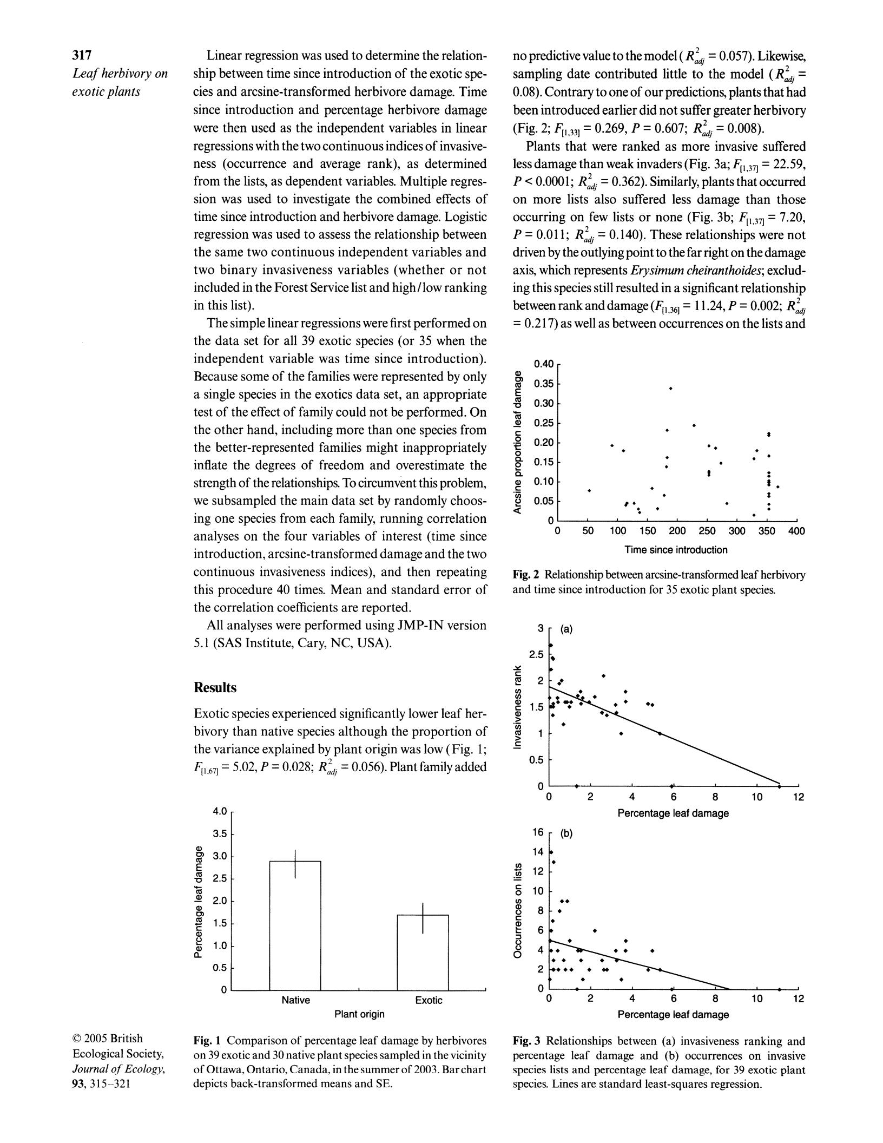

cies and arcsine-transformed herbivore damage. Time

since introduction and percentage herbivore damage

were then used as the independent variables in linear

regressions with the two continuous indices of invasive-

ness (occurrence and average rank), as determined

from the lists7 as dependent variables. Multiple regres-

sion was used to investigate the combined effects of

time since introduction and herbivore damage. Logistic

regression was used to assess the relationship between

the same two continuous independent variables and two binary invasiveness variables (whether or not

included in the Forest Service list and high/low ranking

in this list).

The simple linear regressions were first performed on

the data set for all 39 exotic species (or 35 when the

independent variable was time since introduction).

Because some of the families were represented by only

a single species in the exotics data set? an appropriate

no predictive value to the model ( Ra2dj = 0.057). Like

sampling date contributed little to the model (R2

0.08). Contrary to one of our predictions, plants that been introduced earlier did not suffer greater herbi

(Fig 2; F[, 33] = 0.269, P = 0.607; R2d; = 0.008). Plants that were ranked as more invasive suffe

less damage than weak invaders (Fig. 3a; F1, 37] = 2 P < 0.0001; Ra2dj = 0.362). Similarly,plantsthatoccu

on more lists also suffered less damage than t

occurring on few lists or none (Fig. 3b; F[, 371 =

P = 0.011; Ra2d; = 0.140). These relationships were

driven by the outlying point to the far right on the da

axis, which represents Erysimum cheiranthoides; ex ing this species still resulted in a significant relatio between rank and damage (Ftl 36] = 1 1.24, P = 0.002;

= 0.217) as well as between occurrences on the lists

0.40

a

cn

1. 0.35

50.30 -

test of the effect of family could not be performed. On s

a)

the other hand including more than one species from the better-represented families might inappropriately inflate the degrees of freedom and overestimate the

strength of the relationships. To circumvent this problem,

|  |  |  |  |
| --- | --- | --- | --- |
| o | 0.25 - |  |  |
| 0.20 |  |  |
| .t | *+*+ |  |
| o |  |  |  |

0.15

* +

a) 0.10

c * * i.

we subsampled the main data set by randomly choos-ing one species from each family, running correlation analyses on the four variables of interest (time since

introduction, arcsine-transformed damage and the two

0.05

o

t * -

+ * +

0 50 100 150 200 250 300 350 400

Time since introduction

continuous invasiveness indices), and then repeating this procedure 40 times. Mean and standard error of

the correlation coefficients are reported.

All analyses were performed using JMP-IN version

5.1 (SAS Institute, Cary, NC, USA).

Results

Fig. 2 Relationship between arcsine-transformed lea

and time since introduction for 35 exotic plant sp

y

2 vs

U)

|  |  |  |  |
| --- | --- | --- | --- |
| Exotic species experienced significantly lower leaf her- | o |  |  |
| 5.1 @ | *+*+ |  |

bivory than native species although the proportion of 2.

oo

the variance explained by plant origin was low (Fig. 1; 0.5

ft1 67] = 5.02, P = 0.028; R2dj = 0.056). Plant family added

|  |  |  |  |  |  |  |  |  |
| --- | --- | --- | --- | --- | --- | --- | --- | --- |
|  |  |  |  | o |  |  |  |  |
|  |  |  |  |  | 02468 | | 10 12 |  |
|  |  |  |  |  |  | Percentage leaf damage |  |  |
|  | 4.0 |  |  |  | - (b) |  |  |  |
|  |  |  |  |  |  |  |  |
|  |  |  |  |  | 16 - |  |  |  |
|  | 3.5 |  |  |  |  |  |  |  |
|  |  |  |  |  | 14 4 |  |  |  |
|  | 3.0 |  |  | en |  |  |  |  |
|  |  |  |  |  | 12 |  |  |  |
| ir | 2. 5 |  |  | o | 10 - |  |  |  |
|  |  |  |  |  |  |  |
|  |  |  |  | u) |  |  |  |  |
|  |  |  |  |  | . |  |  |  |
|  |  | 0.2 |  |  | 8 - |  |  |  |
|  |  |  |  |  | . |  |  |  |
| c |  |  |  |  |  | + |  |  |
| a) |  |  |  |  | 6 |  |  |
|  | 5.1 |  |  |  |  |  |
| cD |  |  |  | :5 |  |  |  |
|  |  |  |  | 4 4.. .. | |  |  |
|  |  | 0.1 |  | o |  |  |
|  |  |  |  | .++* | |  |  |
|  |  |  |  |  | ++++ * " | |  |  |
|  |  |  |  |  | 2; | *+ |  |  |
|  |  | 5.0 |  |  |  | * |  |
|  |  |  |  | - |  | iS. |  |  |
|  |  |  | o Native Exotic | o | o2 4 6 8 | | 10 12 |  |
|  |  |  |  |  | Percentage leaf damage |  |  |
|  |  |  | Plant origin |  |  |  |  |

t) 2005 British Fig. 3 Relationships between (a) invasiveness ranking and Fig. 1 Comparison of percentage leaf damage by herbivores

Ecological Society,

Journal of Ecology, 93, 315-321

percentage leaf damage and (b) occurrences on invasive

on 39 exotic and 30 native plant species sampled in the vicinity

species lists and percentage leaf damage, for 39 exotic plant

of Ottawa, Ontario, Canada, in the summer of 2003. Bar chart

specles. Lines are standard least-squares regression.

depicts back-transformed means and SE.

This content downloaded from 129.94.142.234 on Thu, 27 Aug 2020 02:05:39 UTC

All use subject to https://about.jstor.org/terms

318

D. Carpenter & 19 Cappuccino

1. 2005 British Ecological Society,

Journal of Ecology, 93, 315-321

1. - (a)

2.5

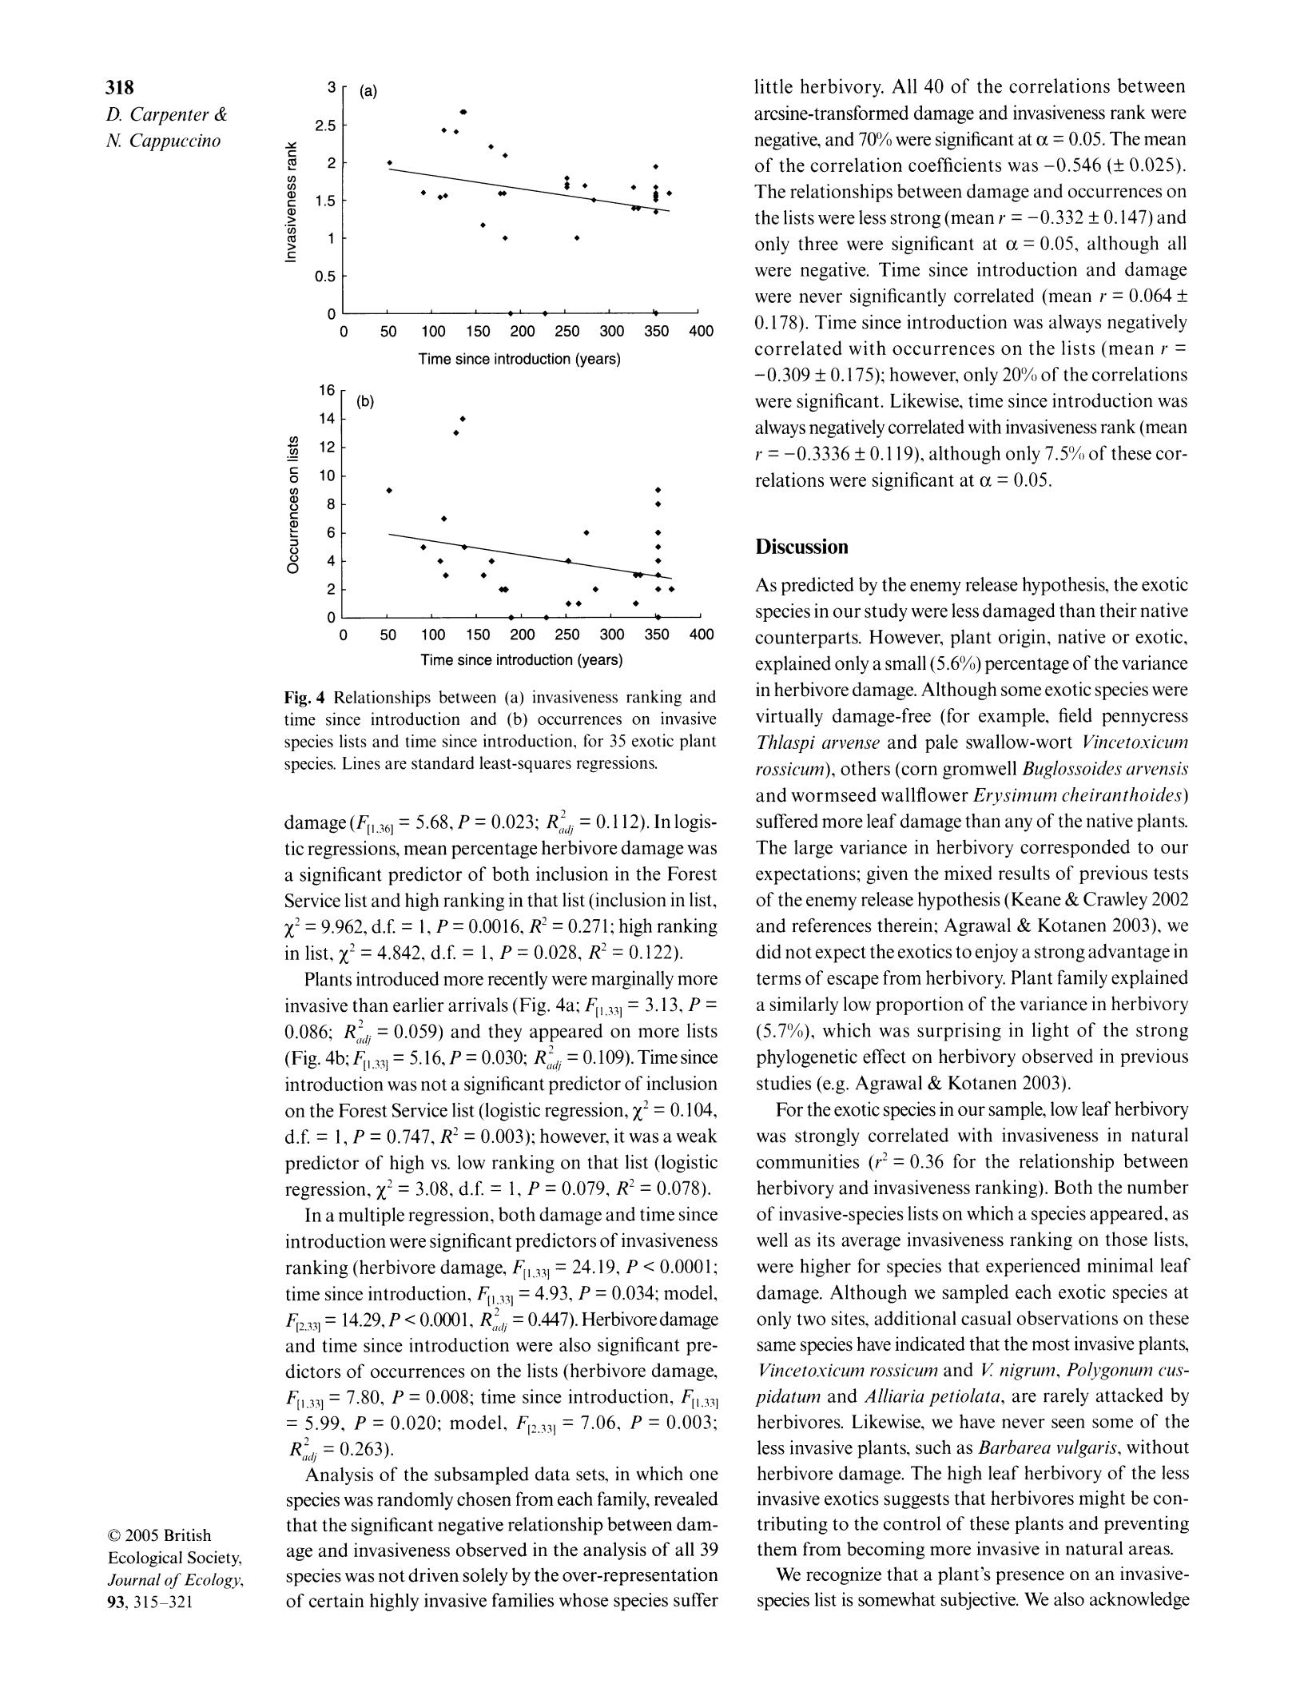

y

2

n

en

1.5

>

n

>

0.5

|  |  |  |
| --- | --- | --- |
| o | E||.|w |  |
|  |  |

0 50 100 150 200 250 300 350 400 Time since introduction (years)

1. (b)

|  |  |  |
| --- | --- | --- |
| en |  |  |
| X | 12 |  |
|  |  |
| o | 10 |  |
| en |  |
| a) |  |  |
|  | 8 |  |

|  |  |  |  |
| --- | --- | --- | --- |
| 6 | * * | * + |  |
| cD |  |  |
| o4 | ** | |  |
| 2 |  | ***+ |  |
|  | *++ |  |

+ l ¢ l ' W

o 0 50 100 150 200 250 300 350 400

Time since introduction (years)

Fig. 4 Relationships between (a) invasiveness ranking and time since introduction and (b) occurrences on invasive species lists and time since introduction, for 35 exotic plant species. Lines are standard least-squares regressions.

damage (F[l 36] = 5.68, P = 0.023; R(,2Ji = 0.1 12). In logis-tic regressions, mean percentage herbivore damage was a significant predictor of both inclusion in the Forest Service list and high ranking in that list (inclusion in list, X2 = 9.962, d.f. = 1, P = 0.0016, R2 = 0.271; high ranking in list, %2 = 4.842, d.f. = 1, P = 0.028, R2 = 0.122).

Plants introduced more recently were marginally more invasive than earlier arrivals (Fig. 4a; F[, ,] = 3. 13, P = 0.086; R,,blj = 0.059) and they appeared on more lists (Fig. 4b;F[, 3] = 5.16,P = 0.030; Rt,blj = O.lO9).Timesince introduction was not a significant predictor of inclusion on the Forest Service list (logistic regression, X2 = 0.104, d.f. = 1, P = 0.747, R2 = 0.003); however, it was a weak predictor of high vs. low ranking on that list (logistic regression, x2 = 3.08, d.f. = 1, P = 0.079, R2 = 0.078).

In a multiple regression, both damage and time since introduction were significant predictors of invasiveness ranking (herbivore damage, F[, ,] = 24.19, P < 0.0001; time since introduction, F[1 ,,1 = 4.93, P = 0.034; model,

F[2 33] = 14.29, P < 0.0m1, Rb2J,j = 0.X7). Herbivoredamage and time since introduction were also significant pre-dictors of occurrences on the lists (herbivore damage, F[l ,3,] = 7.80, P = 0.008; time since introduction, F[, ,]

* 5.99, P = 0.020; model, F[2A,] = 7.06, P = 0.003; Rb2tli = 0.263).

Analysis of the subsampled data sets, in which one species was randomly chosen from each family, revealed that the significant negative relationship between dam-age and invasiveness observed in the analysis of all 39 species was not driven solely by the over-representation of certain highly invasive families whose species suffer

little herbivory. All 40 of the correlations between

arcsine-transformed damage and invasiveness rank were negative, and 70% were significant at oc = 0.05. The mean of the correlation coefficients was -0.546 (+ 0.025). The relationships between damage and occurrences on the lists were less strong (mean r = -0.332 + 0.147) and only three were significant at oc = 0.05, although all were negative. Time since introduction and damage were never significantly correlated (mean r = 0.064 + 0.178). Time since introduction was always negatively correlated with occurrences on the lists (mean r = -0.309 + 0. 175); however, only 20% of the correlations were significant. Likewise? time since introduction was always negatively correlated with invasiveness rank (mean r = -0.3336 + 0.1 19), although only 7.5"S, of these cor-relations were significant at oc = 0.05.

Discussion

As predicted by the enemy release hypothesis? the exotic species in our study were less damaged than their native counterparts. However, plant origin, native or exotic, explained only a small (5.6%) percentage of the variance in herbivore damage. Although some exotic species were virtually damage-free (for example, field pennycress Thlaspi arvense and pale swallow-wort Vin1cetoxicum rossicum), others (corn gromwell Buglossoides arvensis

and wormseed wallflower Erysimum cheiranthoicks) suffered more leaf damage than any of the native plants. The large variance in herbivory corresponded to our expectations; given the mixed results of previous tests of the enemy release hypothesis (Keane & Crawley 2002 and references therein; Agrawal & Kotanen 2003), we did not expect the exotics to enjoy a strong advantage in terms of escape from herbivory. Plant family explained a similarly low proportion of the variance in herbivory (5.7%), which was surprising in light of the strong phylogenetic effect on herbivory observed in previous studies (e.g. Agrawal & Kotanen 2003).

For the exotic species in our sample, low leaf herbivory was strongly correlated with invasiveness in natural communities (r2 = 0.36 for the relationship between herbivory and invasiveness ranking). Both the number of invasive-species lists on which a species appeared, as well as its average invasiveness ranking on those lists, were higher for species that experienced minimal leaf damage. Although we sampled each exotic species at only two sites, additional casual observations on these same species have indicated that the most invasive plants, Vincetoxicum rossicum and Z nigrum, Polygonum cus-pidatum and Alliaria petiolata, are rarely attacked by herbivores. Likewise, we have never seen some of the less invasive plants, such as Barbarea vulgaris, without herbivore damage. The high leaf herbivory of the less invasive exotics suggests that herbivores might be con-tributing to the control of these plants and preventing them from becoming more invasive in natural areas.

We recognize that a plant's presence on an invasive-species list is somewhat subjective. We also acknowledge

This content downloaded from 129.94.142.234 on Thu, 27 Aug 2020 02:05:39 UTC

All use subject to https://about.jstor.org/terms

319

Leczf herbivor on exotic plants

that the lists we used may not be independently derived;introduced crop plants. For example, Andow & Imura presence of a species on one list might prompt a neigh-( 1994) found that the number of herbivores on crop plants bouring state or province to include that species as wellintroduced to Japan was not related to time since intro-

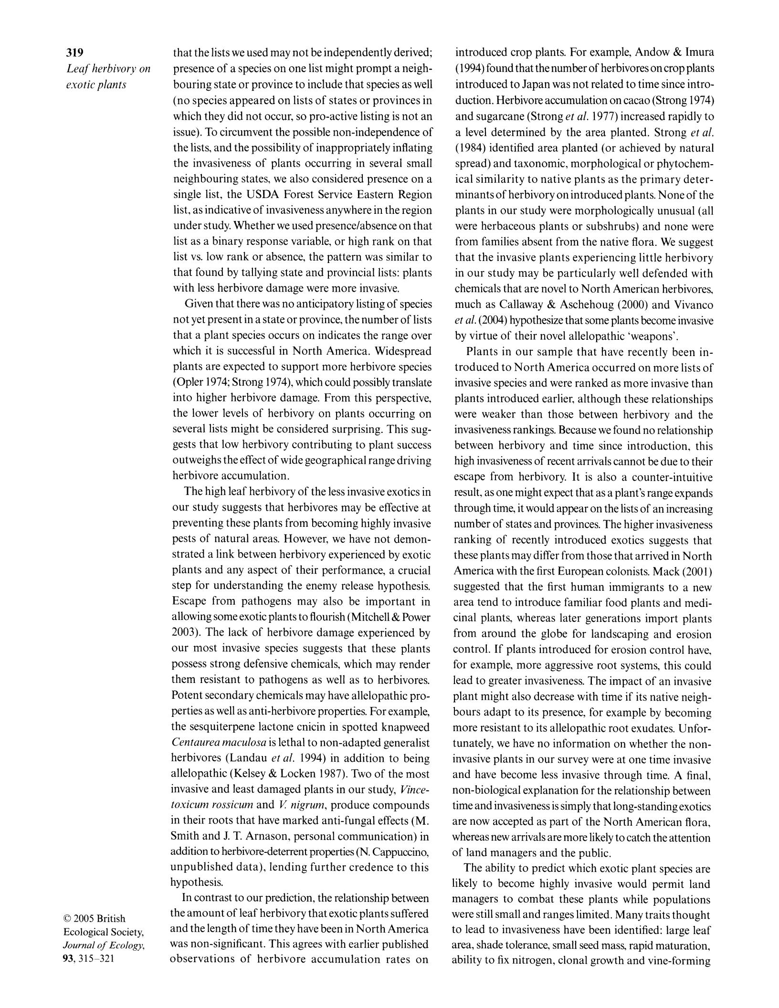

(no species appeared on lists of states or provinces in duction. Herbivore accumulation on cacao (Strong 1974) which they did not occur, so pro-active listing is not an and sugarcane (Strong et al. 1977) increased rapidly to

issue). To circumvent the possible non-independence of a level determined by the area planted. Strong et al. the lists, and the possibility of inappropriately inflating (1984) identified area planted (or achieved by natural

|  |  |
| --- | --- |
| the invasiveness of plants occurring in several small | spread) and taxonomic1 morphological or phytochem- |
| neighbouring states, we also considered presence on a | ical similarity to native plants as the primary deter- |
| single list the USDA Forest Service Eastern Region | minants of herbivory on introduced plants. None of the |

list as indicative of invasiveness anywhere in the regionplants in our study were morphologically unusual (all under study. Whether we used presencelabsence on thatwere herbaceous plants or subshrubs) and none were list as a binary response variable, or high rank on that from families absent from the native flora. We suggest list vs. low rank or absence, the pattern was similar to that the invasive plants experiencing little herbivory that found by tallying state and provincial lists: plants in our study may be particularly well defended with

with less herbivore damage were more invasive.

Given that there was no anticipatory listing of species not yet present in a state or province, the number of lists that a plant species occurs on indicates the range over which it is successful in North America. Widespread plants are expected to support more herbivore species (Opler 1974; Strong 1974), which could possibly translate into higher herbivore damage. From this perspective the lower levels of herbivory on plants occurring on several lists might be considered surprising. This sug-gests that low herbivory contributing to plant success outweighs the effect of wide geographical range driving herbivore accumulation.

chemicals that are novel to North American herbivores, much as Callaway & Aschehoug (2000) and Vivanco

et al. (2004) hypothesize that some plants become invasive by virtue of their novel allelopathic 'weapons'.

Plants in our sample that have recently been in-troduced to North America occurred on more lists of invasive species and were ranked as more invasive than plants introduced earlier, although these relationships were weaker than those between herbivory and the invasiveness rankings. Because we found no relationship between herbivory and time since introduction, this high invasiveness of recent arrivals cannot be due to their escape from herbivory. It is also a counter-intuitive

g 2005 British Ecological Society,

Journal of Ecology7

93, 315-321

The hiqgh leaf herbivory of the less invasive exotics inresult, as one might expect that as a plant's range expands our study suggests that herbivores may be effective at through time? it would appear on the lists of an increasing preventing these plants from becoming highly invasive number of states and provinces. The higher invasiveness

pests of natural areas. However we have not demon- ranking of recently introduced exotics suggests that strated a link between herbivory experienced by exotic these plants may differ from those that arrived in North

plants and any aspect of their performance, a crucial America with the first European colonists. Mack (2001 )

step for understanding the enemy release hypothesis. suggested that the first human immigrants to a new

Escape from pathogens may also be important in area tend to introduce familiar food plants and medi-

allowing some exotic plants to flourish (Mitchell & Powercinal plants, whereas later generations import plants

2003). The lack of herbivore damage experienced by from around the globe for landscaping and erosion

our most invasive species suggests that these plants control. If plants introduced for erosion control have,

possess strong defensive chemicals, which may render for example? more aggressive root systemst this could

them resistant to pathogens as well as to herbivores. lead to greater invasiveness. The impact of an invasive

Potent secondary chemicals may have allelopathic pro- plant might also decrease with time if its native neigh-

perties as well as anti-herbivore properties. For example, bours adapt to its presence, for example by becoming

the sesquiterpene lactone cnicin in spotted knapweed more resistant to its allelopathic root exudates. Unfor-

Centaarea mclculosu is lethal to non-adapted generalist tunately, we have no information on whether the non-

herbivores (Landau et al. 1994) in addition to being invasive plants in our survey were at one time invasive

allelopathic (Kelsey & Locken 1987). Two of the most and have become less invasive through time. A final,

invasive and least damaged plants in our study, Vince- non-biological explanation for the relationship between

toxicum rossicum and Z nigram, produce compounds time and invasiveness is simply that long-standing exotics

in their roots that have marked anti-fungal effects (M. are now accepted as part of the North American flora,

Smith and J. T. Arnason, personal communication) in whereas new arrivals are more likely to catch the attention

addition to herbivore-deterrent properties (N. Cappuccino, of land managers and the public.

unpublished data), lending further credence to this The ability to predict which exotic plant species are

hypothesis. likely to become highly invasive would permit land

In contrast to our prediction, the relationship between managers to combat these plants while populations

the amount of leaf herbivory that exotic plants suffered were still small and ranges limited. Many traits thought and the length of time they have been in North America to lead to invasiveness have been identified: large leaf

was non-signifieant. This agrees with earlier published area, shade tolerance, small seed mass, rapid maturation,

observations of herbivore accumulation rates on ability to fix nitrogen, clonal growth and vine-forming

This content downloaded from 129.94.142.234 on Thu, 27 Aug 2020 02:05:39 UTC

All use subject to https://about.jstor.org/terms

320

D. Carpenter & 1\t Cappuccino

|  |  |  |
| --- | --- | --- |
| habit (Rejmanek & Riehardson 1996; Reichard & | Gray, A. (1856) Manual of the Botan of the Northern United |  |
| Hamilton 1997; Daehler 1998; Goodwin et al. 1999; | States. Including Virginia, Kentucky and All East of the |  |
| Smith & Knapp 2001). If laek of natural enemies in | Mississippi, Arranged According to the Natural System. G. |  |
| P. Putnam, New York. |  |
| North America indeed reflects novel defensive chemis- |  |
| Keane, R.M. & Crawley, M.J. (2002) Exotic plant invasions |  |
| try, rather than the stochastic process of losing enemies | and the enemy release hypothesis. Trends in Ecology and |  |
|  |  |
| during the move, the ability to resist non-adapted North | Evolution, 17, 164-170. |  |

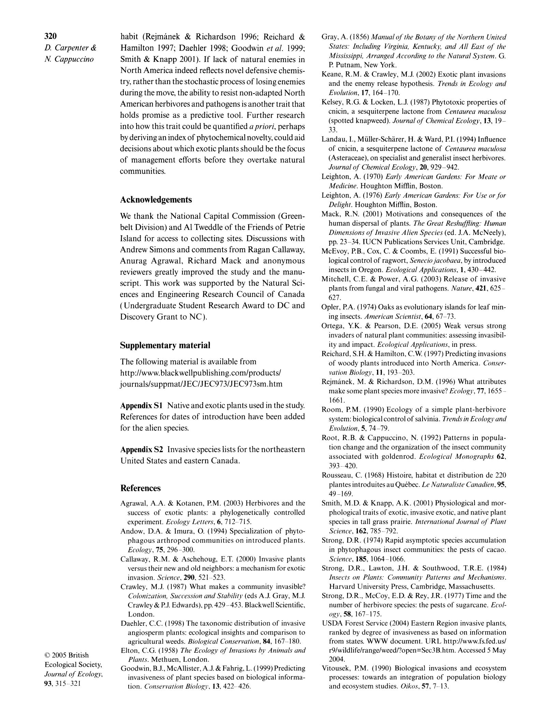

American herbivores and pathogens is another trait that Kelsey, R.G. & Locken, L.J. (1987) Phytotoxic properties of

holds promise as a predictive tool. Further research cnicin, a sesquiterpene lactone from Centaurea maculosa (spotted knapweed). Journal of Chemical Ecology, 13, 19-

into how this trait could be quantified a priori, perhaps 33.

by deriving an index of phytochemical novelty, could aid

decisions about which exotic plants should be the focus

of management efforts before they overtake natural

communities.

Acknowledgements

We thank the National Capital Commission (Green-

Landau, I., Muller-Scharer, H. & Ward, P.I. (1994) Influence of cnicin, a sesquiterpene lactone of Centaurea maculosa (Asteraceae), on specialist and generalist insect herbivores.

Journal of Chemical Ecology, 20, 929-942.

Leighton, A. (1970) Early American Gardens. For Meate or

Medicine. Houghton Mifflin, Boston.

Leighton, A. (1976) Early American Gardens. For Use or for

Delight. Houghton Mifflin, Boston.

Mack, R.N. (2001) Motivations and consequences of the

t 2005 British

Ecological Society,

Journal of Ecology,

93, 315-321

|  |  |  |
| --- | --- | --- |
| belt Division) and A1 Tweddle of the Friends of Petrie | human dispersal of plants. The Great ReshufjQing. Human |  |
| Dimensions of Invasive Alien Species (ed. J.A. McNeely), |  |
| Island for access to collecting sites. Discussions with |  |
| pp. 23-34. IUCN Publications Services Unit, Cambridge. |  |
|  |  |
| Andrew Simons and comments from Ragan Callaway, McEvoy, P.B., Cox, C. & Coombs, E. (1991) Successful bio- | |  |
| Anurag Agrawal, Richard Mack and anonymous | logical control of ragwort, Senecio jacobaea, by introduced |  |
| reviewers greatly improved the study and the manu- insects in Oregon. Ecological Applications, 1, 430-442. | |  |
| script. This work was supported by the Natural Sci- Mitchell, C.E. & Power, A.G. (2003) Release of invasive | |  |
| ences and Engineering Research Council of Canada | plants from fungal and viral pathogens. Nature, 421, 625- |  |
| 627. |  |
| ( Undergraduate Student Research Award to DC and |  |
| Opler, P.A. (1974) Oaks as evolutionary islands for leaf min- |  |
| Discovery Grant to NC ). | ing insects. American Scientist, 64, 67-73. |  |
|  | Ortega, Y.K. & Pearson, D.E. (2005) Weak versus strong |  |
|  | invaders of natural plant communities: assessing invasibil- |  |
| Supplementary material | ity and impact. Ecological Applications, in press. |  |
| The following material is available from | Reichard, S.H. & Hamilton, C.W (1997) Predicting invasions |  |
| of woody plants introduced into North America. Conser- |  |
|  |  |
| http :llwww. blackwellpublishing . com/products/ | ^ation Biology, 11, 193 -203. |  |
| journals/suppmat/JEC/JEC973/JEC973sm.htm | Rejmanek7 M. & Richardson, D.M. (1996) What attributes |  |
|  | make some plant species more invasive? Ecology, 77, 1655- |  |
| Appendix S1 Native and exotic plants used in the study. | 1661. |  |
| Room7 P.M. (1990) Ecology of a simple plant-herbivore |  |
| References for dates of introduction have been added |  |
|  | system: biological control of salvinia. Trends in Ec ology und |  |
| for the alien species. | Evolution, 5, 74-79. |  |
|  | Root, R.B. & Cappuccino, N. (1992) Patterns in popula- |  |
| Appendix S2 Invasive species lists for the northeastern | tion change and the organization of the insect community |  |
| United States and eastern Canada. | associated with goldenrod. Ecological Monographs 62, |  |
| 393-420. |  |
|  |  |
|  | Rousseau, C. (1968) Histoire, habitat et distribution de 220 |  |
| References | plantes introduites au Quebec. Le Naturaliste Canadien, 95, |  |
| 49-169. |  |
|  |  |
| Agrawal, A.A. & Kotanen, P.M. (2003) Herbivores and the | Smith, M.D. & Knapp, A.K. (2001) Physiological and mor- |  |
| success of exotic plants: a phylogenetically controlled | phological traits of exotic, invasive exotic, and native plant |  |
| experiment. Ecology Letters, 6, 712-715. | species in tall grass prairie. International Journal of Plant |  |
| Andow, D.A. & Imura, O. (1994) Specialization of phyto- | Science, 162, 785-792. |  |
| phagous arthropod communities on introduced plants. | Strong, D.R. (1974) Rapid asymptotic species accumulation |  |
| Ecology, 75, 296-300. | in phytophagous insect communities: the pests of cacao. |  |
| Callaway, R.M. & Aschehoug, E.T. (2000) Invasive plants | Science, 185, 1064-1066. |  |

versus their new and old neighbors: a mechanism for exotic Strong, D.R., Lawton, J.H. & Southwood, T.R.E. (1984)

|  |  |
| --- | --- |
| invasion. Science, 290, 521-523. | Insects on Plants. Community Patterns and Mechcmisms. |
| Crawley, M.J. (1987) What makes a community invasible? | Harvard University Press, Cambridge, Massachusetts. |
| Colonization, Succession and Stability (eds A.J. Gray, M.J. | Strong, D.R., McCoy, E.D. & Rey, J.R. (1977) Time and the |
| Crawley & P.J. Edwards), pp. 429-453. Blackwell Scientific, | number of herbivore species: the pests of sugarcane. Ecol- |
| London. | ogy, 58, 167-175. |

Dachler, C.C. (1998) The taxonomic distribution of invasiveUSDA Forest Service (02004) Eastern Region invasive plants,

|  |  |
| --- | --- |
| angiosperm plants: ecological insights and comparison to | ranked by degree of invasiveness as based on information |
| agricultural weeds. Biological Conservation, 84, 167-180. | from states. WWW document. URL http://www.fs.fed.us/ |
| Elton, C.G. (1958) The Ecology of Invasions by Animals and | r9/wildlife/range/weed/?open=Sec3B.htm. Accessed 5 May |
| Plants. Methuen, London. | 2004. |

Goodwin, B.J., McAllister, A.J. & Fahrig, L. ( 1999) PredictingVitousek, P.M. (1990) Biological invasions and ecosystem

|  |  |
| --- | --- |
| invasiveness of plant species based on biological informa- | processes: towards an integration of population biology |
| tion. Conservation Biologv, 13, 422-426. | and ecosystem studies. Oikos, 57, 7-13. |

This content downloaded from 129.94.142.234 on Thu, 27 Aug 2020 02:05:39 UTC

All use subject to https://about.jstor.org/terms

321

Leaf herbivory on exotic plants

1. 2005 British Ecological Society, Journal of Ecology, 937 315-321

Vivanco, J.M., Bais, H.P., Stermitz, F.R. & Callaway, R.M. (2004) the escape-from-enemy hypothesis. American Naturalist, Root allelochemistry strongly contributes to Centaurea 160, 705-71 l .

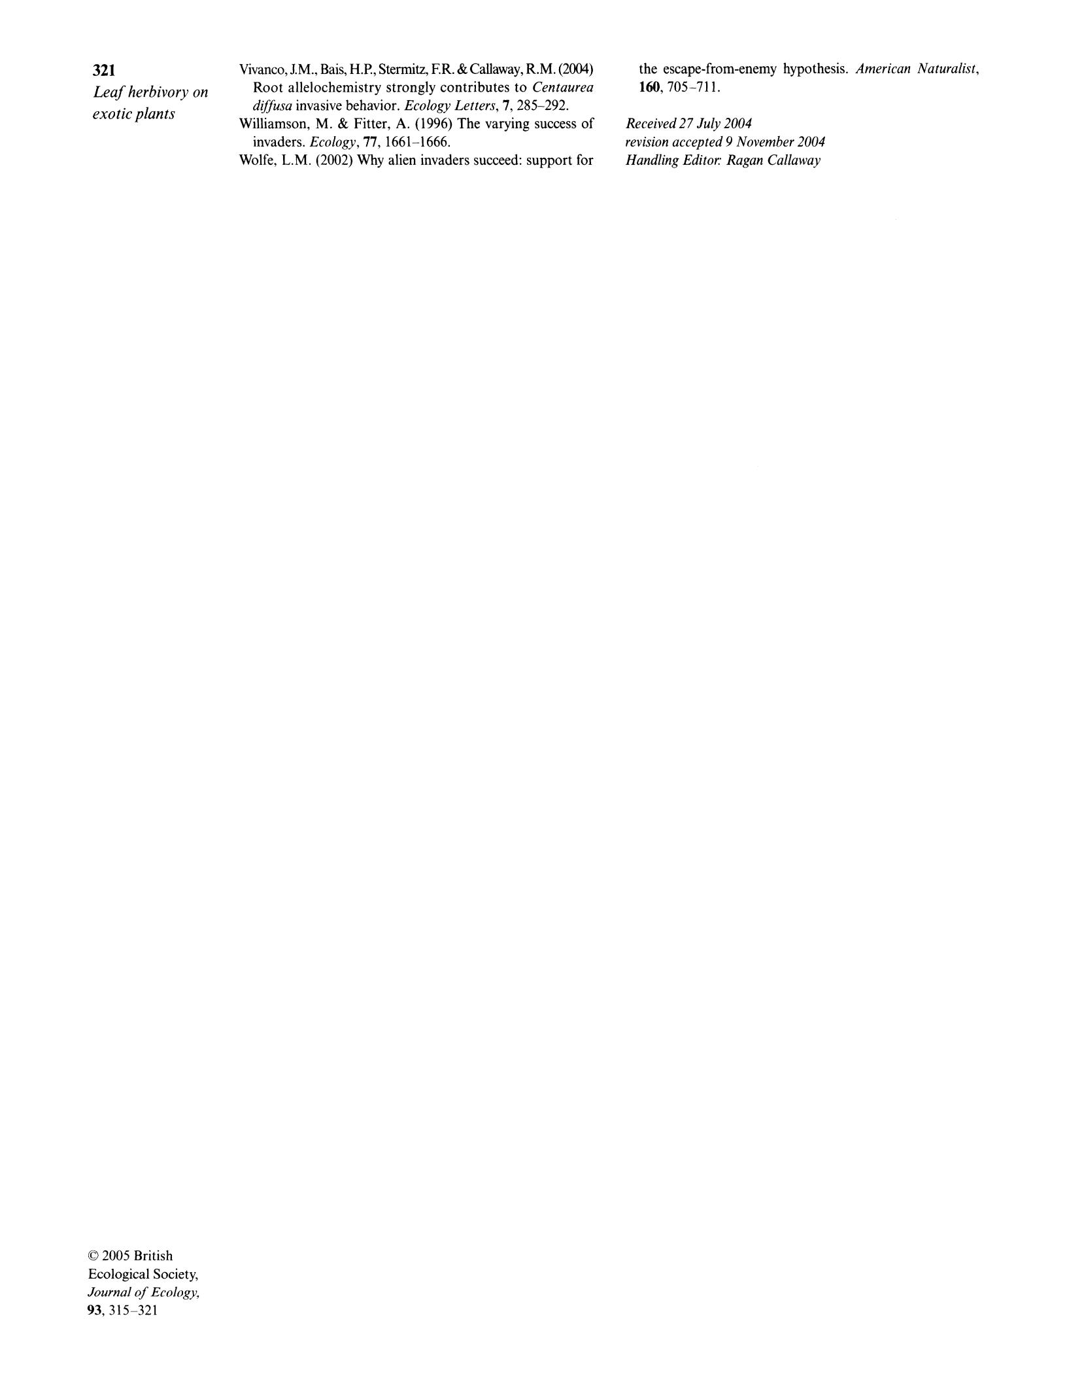

diffusa invasive behavior. Ecology Letters, 7, 285-292.

Williamson, M. & Fitter, A. (1996) The varying success of Received 27 July 2004 invaders. Ecology, 77, 1661-1666. revision accepted 9 November 2004

Wolfe, L.M. (2002) Why alien invaders succeed: support for Handling Editor: Ragan Callaway

This content downloaded from 129.94.142.234 on Thu, 27 Aug 2020 02:05:39 UTC

All use subject to https://about.jstor.org/terms