*Zootaxa* 4819 (3): 582–588https://www.mapress.com/j/zt/ Copyright © 2020 Magnolia Press



ISSN 1175-5326 (print edition)

**Article** **ZOOTAXA**

ISSN 1175-5334 (online edition)

https://doi.org/10.11646/zootaxa.4819.3.9

http://zoobank.org/urn:lsid:zoobank.org:pub:9B0522CD-1F51-4C18-B8C4-A7BE689FEE4F

**A new species of the genus *Limassolla* Dlabola (Hemiptera: Auchenorrhyncha:**

**Cicadellidae: Typhlocybinae) from Korea, with a new record and new synonymy**

SUMIN OH1, JONGOK LIM2, GWAN-SEOK LEE3, IL-KWON KIM4 & SUNGHOON JUNG1,5,6

*1Laboratory of Systematic Entomology, Department of Applied Biology, College of Agriculture and Life Sciences, Chungnam National University, Daejeon 34134, Korea*

1. [�](mailto:suminoh87@gmail.com)*suminoh87@gmail.com; https://orcid.org/0000-0003-2674-0069*

*1,5* [�](mailto:jung@cnu.ac.kr)*jung@cnu.ac.kr; http://orcid.org/0000-0001-6086-0326*

*2Division of Forest Biodiversity, Korea National Arboretum, Pocheon 11186, Korea*

1. [�](mailto:jolim79@korea.kr)*jolim79@korea.kr; https://orcid.org/0000-0001-5700-3024*

*3Department of Plant Protection, National Institute of Agricultural Science, Rural Development Administration, Wanju-gun, Jeollabuk-do 55365, Republic of Korea*

1. [�](mailto:gslee12@korea.kr)*gslee12@korea.kr; https://orcid.org/0000-0003-3391-5701*

*4National DMZ Native Botanical Garden, 916-70 Punchbowl-ro, Yanggu-gun, Gangwon-do 24564, Korea*

1. [�](mailto:ilkwons91@gmail.com)*ilkwons91@gmail.com; https://orcid.org/0000-0002-3805-6590*

*5Department of Smart Agriculture Systems, College of Agriculture and Life Science, Chungnam National University, Daejeon 34134, Korea*

*6Corresponding author*

**Abstract**

One new leafhopper species, *L. dangjinensis* **sp. nov.** is described, and *L. hebeiensis* Cai, Liang & Wang, 1992 is reported from Korea for the first time. Descriptions, photographs, illustrations and biological information of the new species are provided. A key to the Korean *Limassolla* species is also given. *Limassolla macrobipunctata* Hossain, Kwon, Suh & Kwon, 2019 is synonymised with *L*. *ishiharai* Dworakowska, 1972.

**Key words**: Typhlocybini, host plants, key, morphology, distribution

**Introduction**

The genus *Limassolla* Dlabola, 1965 belongs to the tribe Typhlocybini of the subfamily Typhlocybinae (Hemiptera: Auchenorrhyncha: Cicadellidae). The genus contains two subgenera, *Czecza* Dworakowska, 1981 and *Limassolla* Dlabola, 1965. In the subgenus *Czecza*, there are seven valid species from the Afrotropical region, and a total of 35 species of the subgenus *Limassolla* have been described in the eastern hemisphere including the Afrotropical, Oriental, southern Palaearctic and Australia (Song & Lee 2011). So far, four species were recorded in the Korean Peninsula (Hossain et al 2019): *L. ishiharai* Dworakowska, 1972., *L*. *koreana* Hossain, Kwon, Suh & Kwon, 2019., *L*. *macrobipunctata* Hossain, Kwon, Suh & Kwon, 2019., *L*. *multipunctata* (Matsumura, 1920). In this study, we de-scribe one new species, *L. dangjinensis* **sp. nov.**, and re-describe one newly record species, *L*. *hebeiensis* Cai, Liang & Wang, 1992 from Korea. We also provide a key to the Korean *Limassolla* species and new species synonymy.

**Materials and Methods**

The specimens were collected using a sweeping net and examined under LEICA M165C and LEICA DMC2900 mi-croscopes. Morphological terminology follows Dietrich (2005). The genital segment was detached from the abdo-men and macerated in 10% KOH for about 30min. in 70℃ for dissection to examine male genitalia. All specimens are deposited at the Laboratory of Systematic Entomology, Chungnam National University (CNU), Daejeon, Korea. New distributional and host records are marked with an asterisk (*).

**

1. *Accepted by C. Dietrich: 11 Jun. 2020; published: 24 Jul. 2020*

**Subgenus *Limassolla* Dlabola, 1965**

*Limassolla* Dlabola, 1965: 663 (**Type species**: *Zyginella pistaciae* Linnavuori, 1962)

*Pruthius* Mahmood, 1967: 33 (**Type species**: *Pruthius aureata* Mahmood, 1967)

**Diagnosis**

Dorsal coloration yellow with small to large black symmetrically arranged spots. Male abdominal apodemes long and well developed. Pygofer lobe with long appendage and thin microsetae on adjacent part of lobe. Subgenital plate with 1~2 macrosetae, occasionally with several macrosetae. Style with foot-shaped apex.

**Key to the *Limassolla* species of the Korean Peninsula**

|  |  |  |  |  |  |  |  |  |  |  |
| --- | --- | --- | --- | --- | --- | --- | --- | --- | --- | --- |
| 1. Subgenital plate with more than 3 macrosetae . . . . . . . . . . . . . . . . . . . . . . . . | . | . | . | . | . | . | ....2 | | | |
| - Subgenital plate with 1-2 macrosetae . . . . . . . . . . . . . . . . . . . . . . . . . . . . | . | . | . | . | . | . | . | . | . | . 4 |
| 2. Aedeagus with three processes at apex . . . . . . . . . . . . . . . . . . . . . . . . . . . |  | *L*. (*Limassolla*) *koreana* | | | | | | | | |
| - Aedeagus with two pairs of processes at apex. . . . . . . . . . . . . . . . . . . . . . . . . | . | . | . | . | . | . | . | . | . | . 3 |

|  |  |  |  |  |  |  |  |  |  |  |  |  |  |  |  |  |  |  |  |  |  |
| --- | --- | --- | --- | --- | --- | --- | --- | --- | --- | --- | --- | --- | --- | --- | --- | --- | --- | --- | --- | --- | --- |
| 3. | Aedeagus apical processes length similar to preapical processes .. . | . |  | . |  | . |  | . |  | . |  | . |  | . |  | . |  | . |  | . | . . . . . *L*. (*Limassolla*) *hebeiensis* |
| - Aedeagus apical processes shorter than preapical processes . . . . | | . | . |  | . |  | . |  | . |  | . |  | . |  | . |  | . |  | . |  | . *L*. (*Limassolla*) *dangjinensis* **sp. nov.** |
| 4. | Aedeagus compressed, broad in lateral view.. . . . . . . . . . | . . | | |  | . |  | . |  | . |  | . |  | . |  | . |  | . |  | . | . . . . *L*. (*Limassolla*) *multipunctata* |
| - Aedeagus cylindrical, narrow in lateral view. . . . . . . . . . | | . | . |  | . |  | . |  | . |  | . |  | . |  | . |  | . |  | . |  | . . . . . . *L.* (*Limassolla*) *ishiharai* |

***L.* (*Limassolla*) *hebeiensis* Cai, Liang & Wang, 1992**

(Figs 1~11)

*Limassolla hebeiensis* Cai, Liang & Wang, 1992: 324

**Description.** Vertex yellow with orange pattern and pronotum orange with small yellow round sopts. Mesonotumorange with yellow pattern and scutellum yellow (Fig. 1, 2). Forewing pale yellow with complex pattern including orange maculae and dark brown spots (Fig. 4). Male abdominal apodemes extended to half of sternite 5th (Fig. 9).

**Male genitalia.** Pygofer lobe narrow and long distally, appendage sharp distally (Fig. 7). Subgenital plate nar-row with five macrosetae on middle part and several microsetae on apical margin (Fig. 11). Style with distal margin little convex (Fig. 8). Aedeagus shaft slender, tubular in caudal view. and embowed lateral view, apex with two pairs of X shaped processes in caudal view (Fig. 5, 6). Connective Y shaped with central lobe, stem broad (Fig. 10).

**Measurements.** Body length male 3.01~3.43mm, female 3.49~3.61mm.

**Specimens examined.** [CNU] 2♂♂, 1♀, Korea, Chungcheongbuk-do, Yeongdong-gun, Hwanggan-myeon,Geumgye-ri on *Diosyros kaki* THUNB, 17.ⅶ.2016, coll. S. Oh; [CNU] 2♂♂, 9♀♀, Korea, Gyeongsangbuk-do, Sangju-si, Moseo-myeon, Deuksu-ri on *Diosyros kaki* THUNB, 17.ⅷ.2016, coll. S. Oh; [CNU] 5♀♀, Korea, Jeol-labuk-do, Muju-gun, Anseong-myeon, Gongjeong-ri, on *Diosyros kaki* THUNB, 11.ⅶ.2015, coll. S.Oh; [CNU] 8♂♂, 21♀♀, Korea, Gyeongsangbuk-do, Sangju-si, Moseo-myeon, Doan-ri, on *Diosyros kaki* THUNB, 11.ⅶ.2015, coll. S.Oh.

**Host plants.** *Diospyros kaki*THUNB (Ericales: Ebenaceae) (Cai, Liang & Wang, 1992). **Bionomics.** This species appears from July to August as in both nymphs and adults (Fig. 23–A). **Distribution.** China, Korea*

***L*. (*Limassolla*) *dangjinensis* sp. nov. Oh et Jung**

(Figs. 12~22)

**Description.** Vertex and pronotum yellowish orange with pale yellow patterns, vertex with 3 pale yellow spots andpronotum with five round pale yellow spots. Mesonotum yellowish orange with small and narrow pale yellow pat-tern, scutellum pale yellow (Fig. 12). Face pale yellow and gena almost white. Legs whitish yellow and abdomen



A new species and new record of Limassolla from Korea *Zootaxa* 4819 (3) © 2020 Magnolia Press**·**583

yellow with pale yellow strips (Fig. 13). Forewing with complex pattern including yellowish orange maculae and dark brown lines (Fig. 14). Male abdominal apodemes large and extended to 6th segment (Fig. 20).

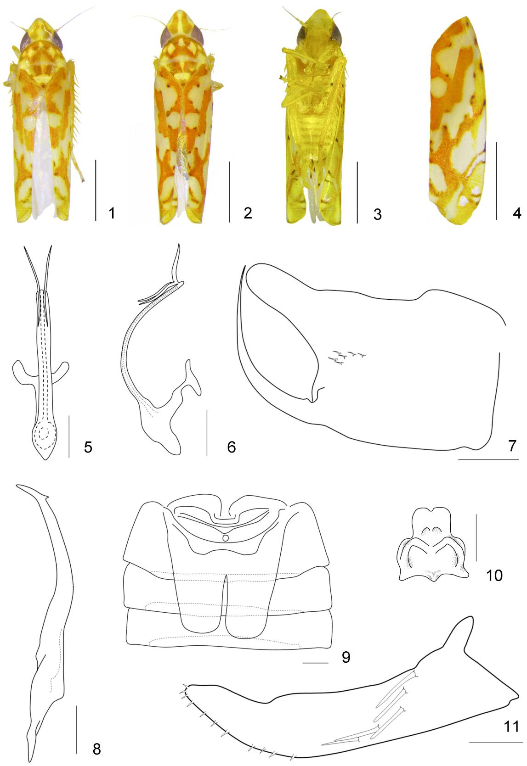

**Figures 1**–**11.** *L.*(*Limassolla*)*hebeiensis*Cai, Liang & Wang, 1992: 1~2 Habitus. 3. Ventral view. 4. Forewing. 5. Aedeaguscaudal view. 6. Aedeagus lateral view. 7. Pygofer lobe lateral view. 8. Style. 9. Male abdominal apodemes. 10. Connective. 11. Subgenital plate. Scales: 1mm (Fig. 1~4), 0.1mm (Fig. 5~11)



584 **·** *Zootaxa* 4819 (3) © 2020 Magnolia Press Oh *et al.*

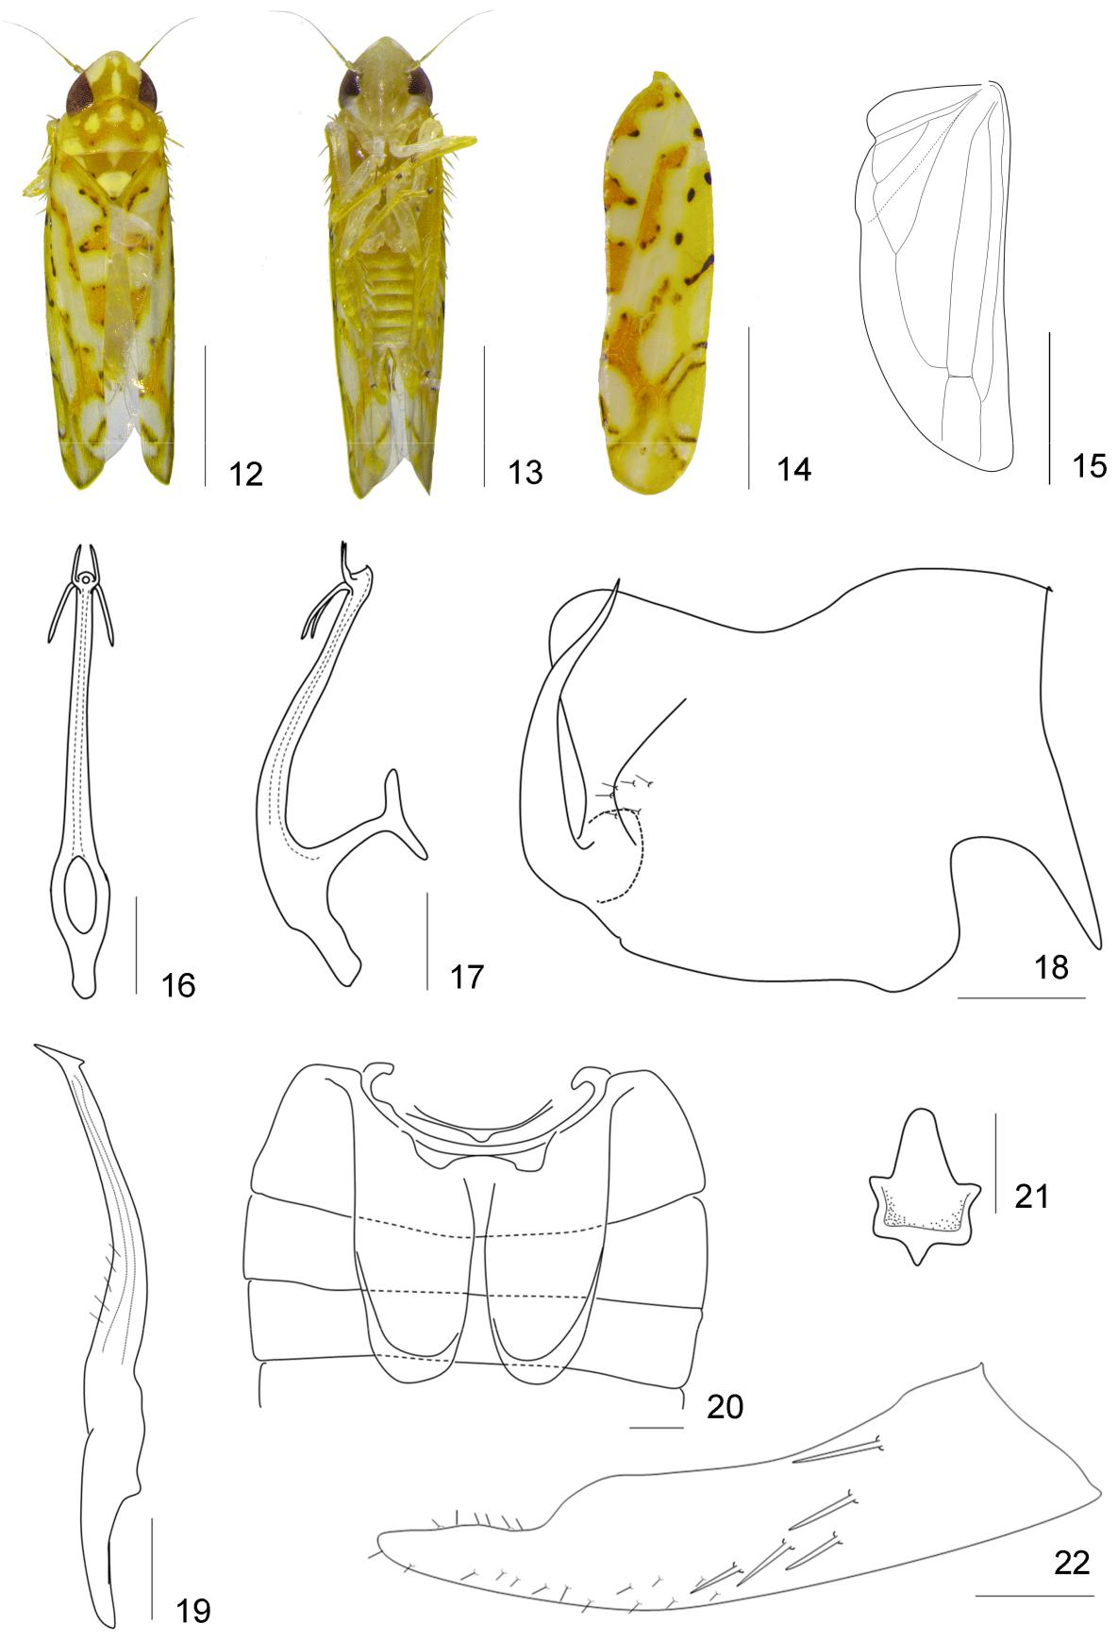

**Figures 12-22.** *L.*(*Limassolla*)*dangjinensis* **sp. nov.** Oh et Jung: 12. Habitus. 13. Ventral view. 14. Forewing. 15. Hind wing.

1. Aedeagus caudal view. 17. Aedeagus lateral view. 18. Pygofer lobe lateral view. 19. Style. 20. Male abdominal apodemes.
2. Connective. 22. Subgenital plate. Scales: 1mm (Fig. 12~15), 0.1mm (Fig. 16~22)



A new species and new record of Limassolla from Korea *Zootaxa* 4819 (3) © 2020 Magnolia Press**·**585

**Male genitalia.** Pygofer lobe wide truncate distally, appendage relatively wide basally, sinuate distally (Fig.

18). Subgenital plate narrow with several macrosetae on middle part and several microsetae on apical margin (Fig.

22). Style with several microsetae on middle of outer margin and distal margin of apex flat (Fig. 19). Aedeagus shaft slender and elongate in lateral and posterior view, apex with two pairs of short processes, one extending distad and the other extending basad and bent inward (Fig. 16, 17). Connective small and star-shaped with six lobes, including thin anterior median lobe (Fig. 21).

**Measurements.** Body length male 3.14~3.28mm, female 3.22~3.56mm.

**Type materials.** Holotype: [CNU] ♂, Korea, Chungcheongnam-do, Dangjin-si, Sunseong-myeon, Seonguk-ri

on *Diospyros kaki* THUNB, 11.ⅸ. 2015, coll. S. Oh. Paratype: [CNU] 2♂♂, 22♀♀, same data as holotype.

**Host plants.** *Diospyros kaki*THUNB* (Ericales: Ebenaceae).

**Bionomics.** This species was not found in persimmon orchards, but was found on a persimmon tree in nativeforest and caused feeding injury to the tree (Fig. 23–B).

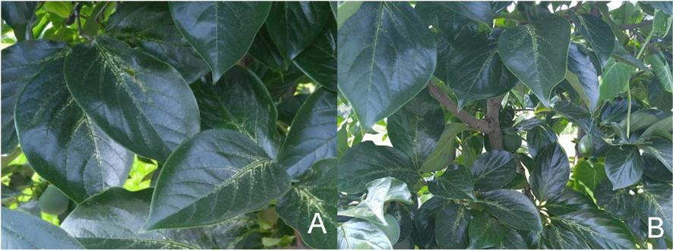

**Figures 23.** Symptom of damage according to species: A. Symptom of damage on*Diospyros kaki*THUNB by*L*.*hebeiensis*Cai, Liang & Wang, 1992. B. Symptom of damage on *Diospyros kaki* THUNB by *L*. *dangjinensis* **sp. nov.** Oh et Jung.

**Distribution.** Korea*.

**Remarks.** This new species is similar to two previously described*Limassolla*species in general appearance. Itdiffers from *L. hebeiensis* Cai, Liang & Wang, 1992 as follows: 1) pygofer appendage sinuate, 2) style curved gently with several microsetae on outer margin, 3) aedeagus processes short and lower process bent inward, 4) connec-tive with six lobes, 5) male abdominal apodemes extended to 6th segment. It differs from *L. diospyri* Chou & Ma, 1981 as follows: 1) pygofer appendage sinuate, 2) aedeagus processes curved in caudal view, 3) aedeagus processes branched below apex, 4) connective with six lobes, 5) male abdominal apodemes extended to 6th segment.

**Etymology.** The specific name is derived from that of the type locality.

***L.* (*Limassolla*) *ishiharai* Dworakowska, 1972**

(Figs 24~36)

*Limassolla ishiharai* Dworakowska, 1972: 865.

*Limassolla macrobipunctata* Choe 1986: 36,**(nom. nud.) syn. nov.**

*Limassolla macrobipunctata* Hossain, Kwon, Suh & Kwon 2019: 552**syn. nov.**

**Specimens examined.** [CNU] 4♂♂, 3♀♀, Korea, Gangwon-do, Sokcho-si, Mt. Seolak, 1974. coll. K.Y.Choe;[CNU] 2♂♂, 3♀♀, Korea, Gyeonggi-do, Anseong-si, Gosam-myeon, Sangji-ri on *Rhus javanica* L, 9.ⅵ.2015. coll. S.Oh; [CNU] 15♂♂, 4♀♀, Korea, Chungcheongbuk-do, Yeongdong-gun, Yongsan-myeon, Yul-ri on *Rhus javanica* L, 19.ⅵ.2015. coll. S.Oh; [CNU] 1♂, 13♀♀, Korea, Chungcheongnam-do, Boryeong-si, Cheongso-myeon, Seong-yeon-ri on *Rhus javanica* L, 27.ⅶ.2015. coll. S.Oh; [CNU] 1♀, Korea, Chungcheongbuk-do, Yeongdong-gun, Yanggang-myeon, Jichon-ri on *Rosa multiflora* Thunb. var. *multiflora* 17.ⅵ.2015. coll. S.Oh.

**Remarks.** *L*.*macrobipunctata*was previously described by Choe (1986) in his Ph.D. thesis, but it was notpublished. Hossain et al. (2019) validated this taxon by providing a description and illustration adopting the same species name. Comparison of the original description and illustrations of *L*. *macrobipunctata* Hossain et al., 2019 (Choe, 1986 **nom. nud.** & Hossain et al., 2019) and the specimens of the Choe’s collection at CNU with the de-scriptions and illustrations of *L*. *ishiharai* Dworakowska, 1972 (Dworakowska, 1972) indicates that these two taxa



586 **·** *Zootaxa* 4819 (3) © 2020 Magnolia Press Oh *et al.*

are synonyms. Based on our examinations, this species vary intraspecifically in spotted patterns of forewings (Figs 24-31) and male aedeagus apex (Figs 32–35). Pygofer lobe of the species do not vary (Fig 36).

**Distribution.** China, Japan, Korea.

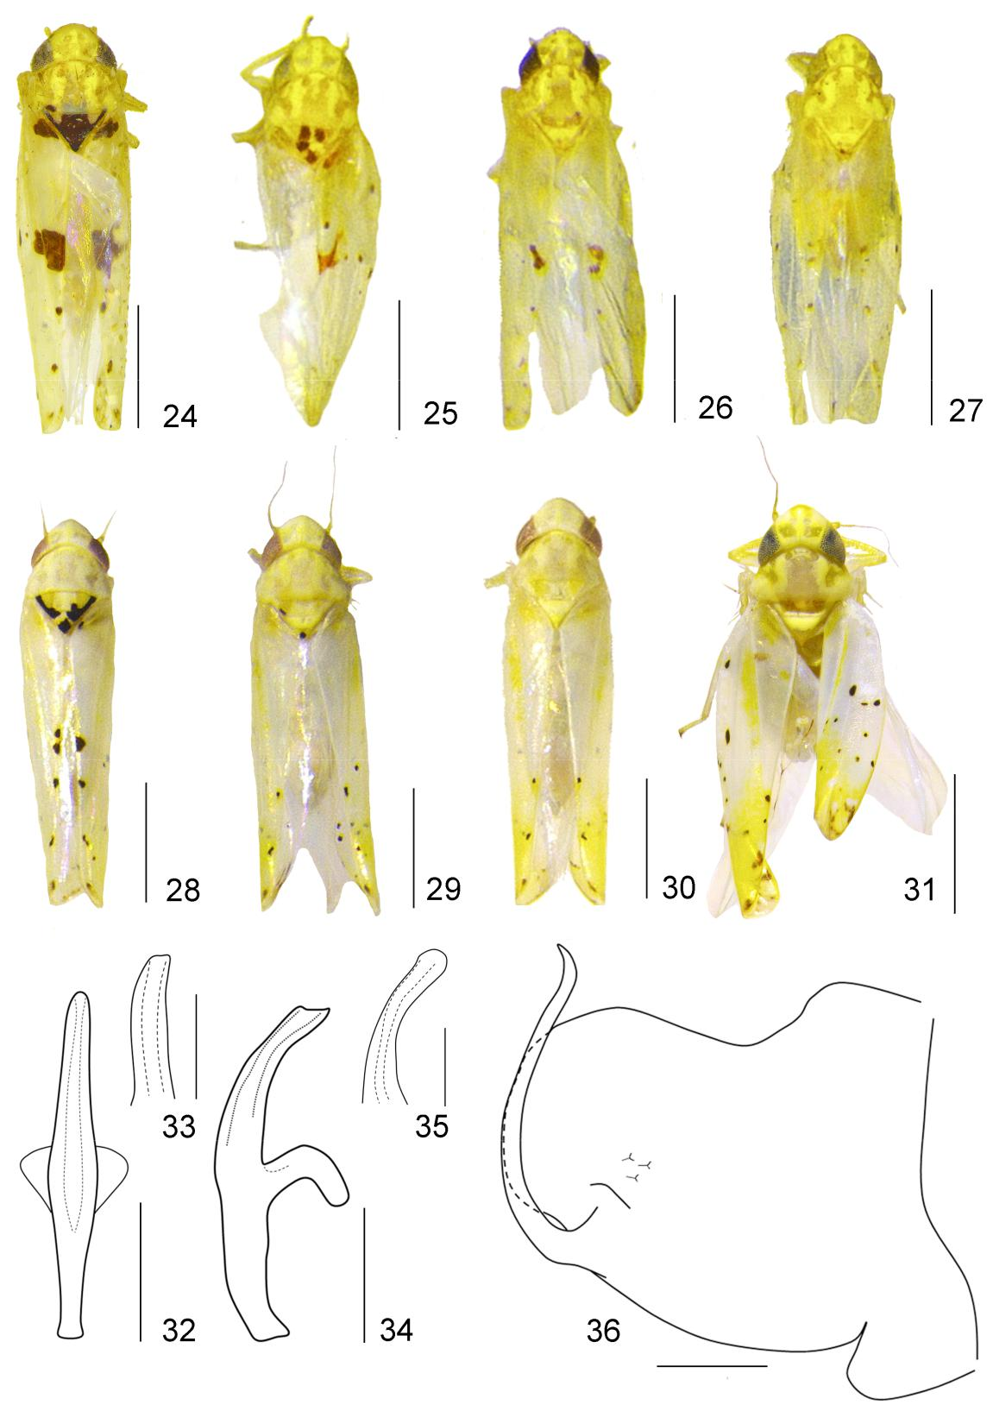

**Figures 24-36.** *L.*(*Limassolla*)*ishiharai*(=*L*.*macrobipunctata*): 24~27. Habitus of*L. macrobipunctata*(coll. Choe). 28~31.

Habitus of *L. ishiharai* (coll. Oh). 32~33. Aedeagus caudal view. 34~35. Aedeagus lateral view. 36. Pygofer lobe lateral view.

Scales: 1mm (Fig. 24~31), 0.1mm (Fig. 32~36)



A new species and new record of Limassolla from Korea *Zootaxa* 4819 (3) © 2020 Magnolia Press**·**587

**Acknowledgments**

We thank Junhee Gu (Chungnam National University) for collecting *Limassolla multipunctata* from Jeju-do. This research was supported by a grant from the National Institute of Biological Resources (NIBR), funded by the Min-istry of Environment (MOE) of the Republic of Korea (NIBR201601203 and NIBR201701203). And this work was supported by the Korea National Arboretum (KNA-20-C -11) and Basic Science Research Program through the National research Foundation of Korea (NRF) funded by the Ministry of Science, ICT and Future Planning (NRF-2019R1A6A3A13094310) and “Cooperative Research Program for Agricultural Science & Technology Develop-ment (Project No. PJ0134642018)”, Rural Development Administration, Republic of Korea.

**References**

Choe, K.R. (1986) *Taxonomic study on Typhlocybinae (Homoptera, Cicadellidae) in Korean Peninsula*. Ph.D. Thesis, Seoul National University, Seoul, 89 pp.

Cai, P., Liang, L. & Wang, F. (1992) A new species of *Limassolla*, pest of *Diospyros Kaki* (Homoptera: Cicadellidea: Typhlocy-bidae). *Journal of Anhui Agricultural University*, 19 (4), 324–326.

Chou, I. & Ma, N. (1981) On some new species and new records of Typhlocybinae from China (Homoptera: Cicadellidae).

*Entomotaxonomia*, 3 (3), 191–210.

Dietrich, C.H. (2005) Keys to the families of Cicadomorpha and subfamilies and tribes of Cicadellidea (Hemiptera: Auchenor-

rhyncha). *Florida Entomologist*, 88 (4), 502–517.

<https://doi.org/10.1653/0015-4040(2005)88[502:KTTFOC]2.0.CO;2>

Dlabola, J. (1965) Neue Zikadenarten aus Südeuropa (Homoptera - Auchenorrhyncha). *Sborník entomologického oddelení* *Národního Musea v Praze*, 36, 657–669.

Dworakowska, I. (1972) *Zyginoides* Mats. and some other Typhlocybinae (Auchenorrhyncha, Cicadellidae). *Bulletin de* *l’Academie Polonaise des Sciences*, 20 (12), 857–866.

Dworakowska, I. (1981) The genus *Wiata* Dwor. (Auchenorrhyncha, Cicadellidae, Typhlocybinae) in the Ethiopian Region.

*Acta Zoologica Cracoviensia*, 25 (20), 519–544.

Hossain, M.S., Kwon, J.H., Suh, S.J. & Kwon, Y.J. (2019) Taxonomic revision of the microleafhopper genus Limassolla Dlabola from Korea (Hemiptrea: Cicadellidae: Typhlocybinae). *Zootaxa*, 4603 (3), 549–558. https://doi.org/10.11646/zootaxa.4603.3.7

Linnavuori, R. (1962) Hemiptera of Israel. 3. *Annales Zoologici Societatis Zoologicae-Botanicae Fennicae ‘Vanamo’*, Series 3, 24, 1−108.

Mahmood, S.H. (1967) A study of the typhlocybine genera of the Oriental region (Thailand, the Philippines and adjoining ar-eas). *Pacific Insects Monographs*, 12, 1–52.

Matsumura, S. (1920) s.n. *Dainippon Gaichu Zensho [Manual of Japanese Injurious Insects. 2nd* *Edition]*, 1, 1–34 + 1–857. Song, Y. & Li, Z. (2011) Five new species of the leafhopper genus *Limassolla* Dlabola (Hemiptera: Cicadellidae: Typhlocybi-

nae) from China. *Zootaxa*, 3127, 53–53.

https://doi.org/10.11646/zootaxa.3127.1.3



588 **·** *Zootaxa* 4819 (3) © 2020 Magnolia Press Oh *et al.*