**Publication history**

**Handling editor**

**Authors’ contributions**

**Funding**

f

**Competing interests** ŁŁ

*Acta Societatis Botanicorum Poloniae*

**Copyright notice**

©

**Citation**

f

Acta Societatis Botanicorum Poloniae 



**ORIGINAL RESEARCH PAPER**

ó

ó

**Abstract**

**Keywords**

**Introduction**

]

]

]] ]

]

]

Published by Polish Botanical Society

Varga et al. / Plant use in the Knin area

]

– ]

]

**Material and methods**

–

––––

]

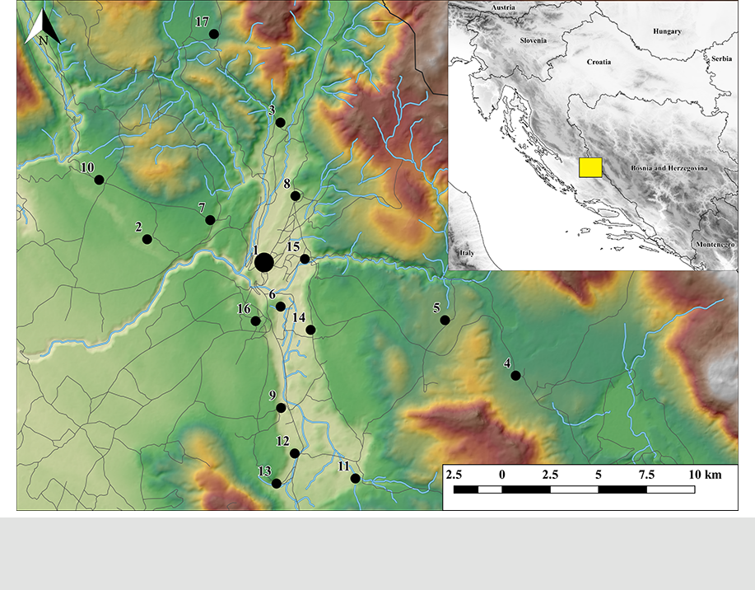

**Fig. 1**

© The Author(s) 2019  Published by Polish Botanical Society  Acta Soc Bot Pol 88(2):3622

Varga et al. / Plant use in the Knin area

š]

]

]

]

]

]

]

]

==

–]

] *’* ]

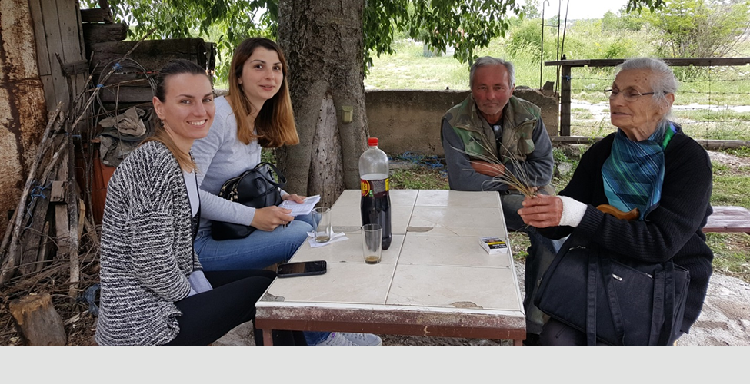

**Fig. 2**

© The Author(s) 2019  Published by Polish Botanical Society  Acta Soc Bot Pol 88(2):3622

Varga et al. / Plant use in the Knin area

***i***

]

]***ii***

]***iii***

] ***iv***

]

**Results**

]

]

© The Author(s) 2019  Published by Polish Botanical Society  Acta Soc Bot Pol 88(2):3622

Varga et al. / Plant use in the Knin area



|  |
| --- |
| **Fooduses(*N*=40)** |

|  |
| --- |
| **RFC** |



|  |
| --- |
| **Medicinal uses** |



|  |
| --- |
| **Englishnameused** |

|  |
| --- |
| **Parts** |



|  |  |  |
| --- | --- | --- |
| **Local name(s)** | š Š | Š |
|  | š |  |



|  |
| --- |
| **Family** |



|  |  |  |
| --- | --- | --- |
|  | **Species\*** |  |
| **Tab. 1** | ä | *f* |

© The Author(s) 2019  Published by Polish Botanical Society  Acta Soc Bot Pol 88(2):3622

Varga et al. / Plant use in the Knin area



|  |
| --- |
| **Fooduses(*N*=40)** |

|  |
| --- |
| **RFC** |



|  |
| --- |
| **Medicinal uses** |



|  |
| --- |
| **Englishnameused** |

|  |
| --- |
| **Parts** |



|  |
| --- |
| **Local name(s)** |

|  |  |
| --- | --- |
| Š | šš |



|  |
| --- |
| **Family** |



|  |
| --- |
| **Species\*** |

|  |
| --- |
| **Tab. 1** |

© The Author(s) 2019  Published by Polish Botanical Society  Acta Soc Bot Pol 88(2):3622

Varga et al. / Plant use in the Knin area



|  |
| --- |
| **Fooduses(*N*=40)** |

|  |
| --- |
| **RFC** |



|  |
| --- |
| **Medicinal uses** |



|  |
| --- |
| **Englishnameused** |

|  |
| --- |
| **Parts** |



|  |
| --- |
| **Local name(s)** |



|  |
| --- |
| **Family** |



|  |
| --- |
| **Species\*** |

|  |
| --- |
| **Tab. 1** |

© The Author(s) 2019  Published by Polish Botanical Society  Acta Soc Bot Pol 88(2):3622

Varga et al. / Plant use in the Knin area



|  |
| --- |
| **Fooduses(*N*=40)** |

|  |
| --- |
| **RFC** |



|  |
| --- |
| **Medicinal uses** |



|  |
| --- |
| **Englishnameused** |

|  |
| --- |
| **Parts** |



|  |
| --- |
| **Local name(s)** |

|  |
| --- |
| š |



|  |
| --- |
| **Family** |



|  |
| --- |
| **Species\*** |

|  |
| --- |
| **Tab. 1** |

© The Author(s) 2019  Published by Polish Botanical Society  Acta Soc Bot Pol 88(2):3622

Varga et al. / Plant use in the Knin area



|  |
| --- |
| **Fooduses(*N*=40)** |

|  |
| --- |
| **RFC** |



|  |
| --- |
| **Medicinal uses** |



|  |
| --- |
| **Englishnameused** |

|  |
| --- |
| **Parts** |



|  |  |  |
| --- | --- | --- |
| **Local name(s)** | š | Š |

|  |
| --- |
| š |



|  |
| --- |
| **Family** |



|  |
| --- |
| **Species\*** |

|  |
| --- |
| **Tab. 1** |

© The Author(s) 2019  Published by Polish Botanical Society  Acta Soc Bot Pol 88(2):3622

Varga et al. / Plant use in the Knin area



|  |
| --- |
| **Fooduses(*N*=40)** |

|  |
| --- |
| **RFC** |



|  |
| --- |
| **Medicinal uses** |



|  |
| --- |
| **Englishnameused** |

|  |
| --- |
| **Parts** |



|  |  |  |  |
| --- | --- | --- | --- |
| **Local name(s)** | šš |  | Š |
|  | š | šš | š |



|  |
| --- |
| **Family** |



|  |
| --- |
| **Species\*** |

|  |
| --- |
| **Tab. 1** |

© The Author(s) 2019  Published by Polish Botanical Society  Acta Soc Bot Pol 88(2):3622

Varga et al. / Plant use in the Knin area



|  |
| --- |
| **Fooduses(*N*=40)** |

|  |
| --- |
| **RFC** |



|  |
| --- |
| **Medicinal uses** |



|  |  |
| --- | --- |
| **Partsused** | f |
| **English name** |  |



|  |  |  |
| --- | --- | --- |
| **Local name(s)** | š | š |

|  |
| --- |
| Š |

|  |
| --- |
| Š |



|  |
| --- |
| **Family** |



|  |
| --- |
| **Species\*** |

|  |
| --- |
| **Tab. 1** |

© The Author(s) 2019  Published by Polish Botanical Society  Acta Soc Bot Pol 88(2):3622

Varga et al. / Plant use in the Knin area



|  |
| --- |
| **Fooduses(*N*=40)** |

|  |
| --- |
| **RFC** |



|  |
| --- |
| **Medicinal uses** |



|  |
| --- |
| **Englishnameused** |

|  |
| --- |
| **Parts** |



|  |  |  |  |  |
| --- | --- | --- | --- | --- |
| **Local name(s)** |  |  | š |  |
| š | Čš | ššš | šš | šš |



|  |
| --- |
| **Family** |



|  |
| --- |
| **Species\*** |

|  |
| --- |
| **Tab. 1** |

© The Author(s) 2019  Published by Polish Botanical Society  Acta Soc Bot Pol 88(2):3622

Varga et al. / Plant use in the Knin area



|  |
| --- |
| **Fooduses(*N*=40)** |

|  |
| --- |
| **RFC** |



|  |
| --- |
| **Medicinal uses** |



|  |
| --- |
| **Englishnameused** |

|  |
| --- |
| **Parts** |



|  |  |
| --- | --- |
| **Local name(s)** | š |
|  | š |



|  |
| --- |
| **Family** |



|  |
| --- |
| *Z* |

|  |
| --- |
| **Species\*** |

|  |
| --- |
| **Tab. 1** |

© The Author(s) 2019  Published by Polish Botanical Society  Acta Soc Bot Pol 88(2):3622

Varga et al. / Plant use in the Knin area

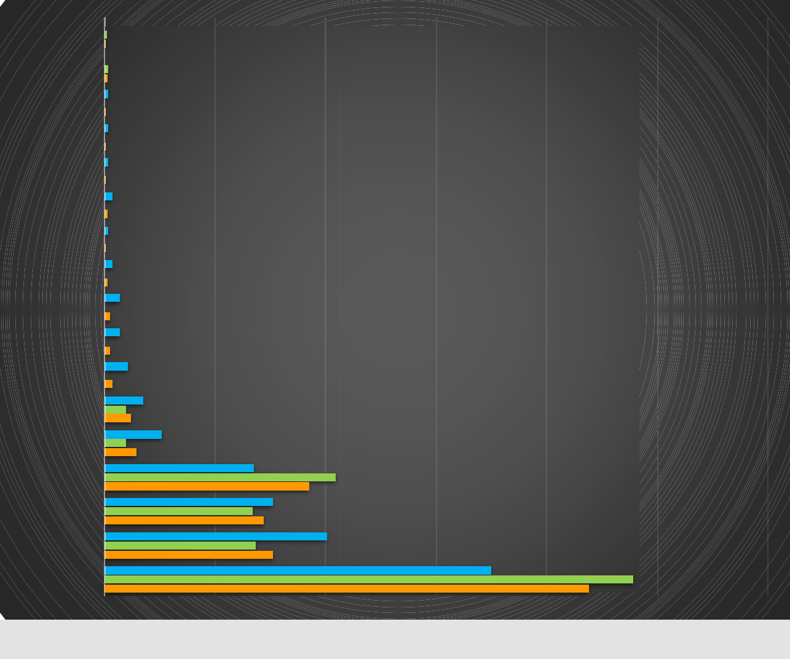

**whole plant**

**tuber**

**silk**

**fruit husk**

**bark**

**seed**

**petiole**

**nut shell**

**sap**

**bulb**

**young fruit**

**shoot**

**root**

**fruit**

**0.1%**

**0.1%**

**0.3%**

**0.2%**

**0.3%**

**0.1%**

**0.3%**

**0.1%**

**0.3%**

**0.1%**

**0.7%**

**0.2%**

**0.3%**

**0.0%**

**0.1%**

**0.7%**

**0.2%**

**1.4%**

**0.5%**

**1.4%**

**0.5%**

**2.1%**

**0.7%**

**3.5%**

**1.9%**

**2.4%**

**5.2%**

**1.9%**

**2.9%**

**13.5%**

**20.9%**

**18.5%**

 **Medicinal**

 **Food**

 **Total**

**aerial part**

**15.2%**

**13.4%**

**14.4%**

**flower**

**20.1%**

**13.6%**

**15.2%**

|  |  |  |  |  |  |  |  |  |
| --- | --- | --- | --- | --- | --- | --- | --- | --- |
| **leaf** |  |  |  | **34.9%** |  | **47.8%** |  |  |
|  |  |  |  | **43.8%** |  |  |
|  |  |  |  |  |  |  |  |
| **0%** | **10%** | **20%** | **30%** | **40%** |  | **50%** | **60%** |  |

**Fig. 3**

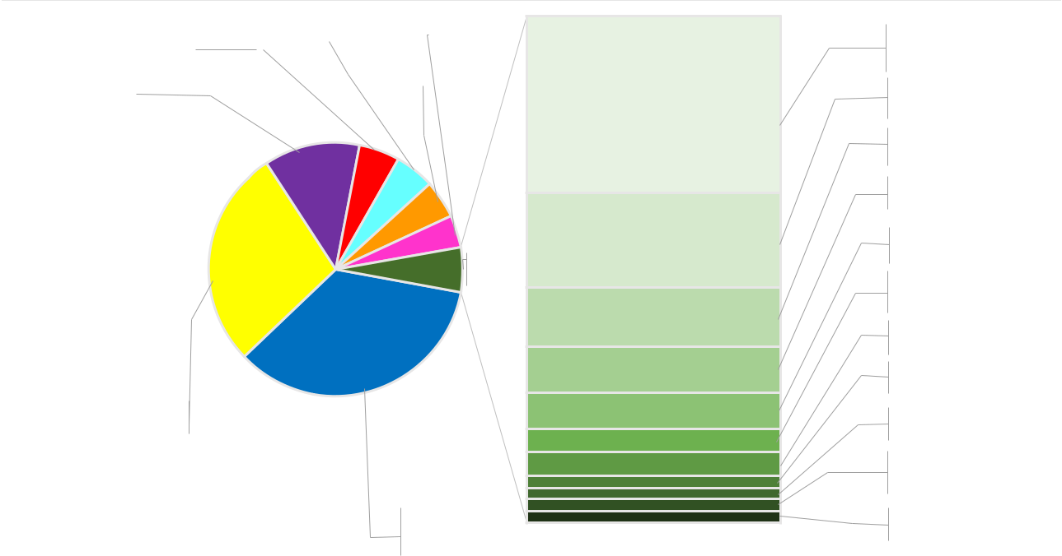

|  |  |  |  |  |  |  |  |  |  |
| --- | --- | --- | --- | --- | --- | --- | --- | --- | --- |
| **Salad (11 sp.)** | |  | **Raw (19 sp.)** |  |  |  |  | **Boiled (15 sp.)** |  |
|  | **5.06%** |  | | |  | **4.13%** |  |
| **5.19%** | |  |  |  |  |  |  |  |  |
|  |  |  | **Jam (7 sp.)** |  |  |  |  |
|  |  |  |  |  |  |  |  |  |
| **Syrup (19 sp.)** |  |  |  |  | **4.79%** |  |  |  |  |
|  |  |  |  |
|  |  |  |  |  |  |  |  |  |
| **12.12%** |  |  |  |  |  |  |  |  |  |

**Other**

**5.73%**

**Boiled wild vegetable mix (37 sp.)**

**27.96%**

**Infusion (36 sp.)**

**35.02%**



**Liqueur (7 sp.)**

**2.00%**

**Herbal grappa (8 sp.)**

**1.07%**

**Spice (3 sp.)**

**0.67%**

**Children's snack (4 sp.)**

**Wine (2 sp.)**

**0.40%**

**Soup (1 sp.)**

**0.27%**

**Vinegar (1 sp.)**

**0.27%**

**Made into fritters (1 sp.)**

**Fried with eggs (1 sp.)**

**0.13%**

**Roasted (1 sp.)**

**0.13%**

**Sarma (rolls) (1 sp.)**

**0.13%**

**Fig. 4**

© The Author(s) 2019  Published by Polish Botanical Society  Acta Soc Bot Pol 88(2):3622

Varga et al. / Plant use in the Knin area

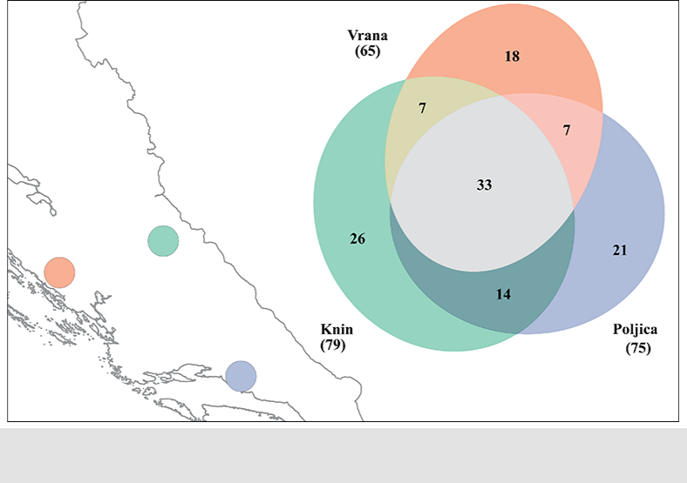

**Fig. 5**

**Tab. 2**

|  |  |  |  |  |
| --- | --- | --- | --- | --- |
|  |  |  | **No. of** |  |
|  | **No. of unique** | **No. of species** | **informants that** | **No. of total use** |
| **Use category** | **uses** | **used** | **treat category** | **reports** |
|  |  |  |  |  |



© The Author(s) 2019  Published by Polish Botanical Society  Acta Soc Bot Pol 88(2):3622

Varga et al. / Plant use in the Knin area

**Tab. 3**

**Medical condition** **Taxa** **Fidelity level**



ä



**Discussion**

– ]

]

© The Author(s) 2019  Published by Polish Botanical Society  Acta Soc Bot Pol 88(2):3622

Varga et al. / Plant use in the Knin area

]

]

]

]š

š]

]

]

]

]

]

]

]

© The Author(s) 2019  Published by Polish Botanical Society  Acta Soc Bot Pol 88(2):3622

Varga et al. / Plant use in the Knin area

]

]

**Acknowledgments**

Š

**References**

© The Author(s) 2019  Published by Polish Botanical Society  Acta Soc Bot Pol 88(2):3622

Varga et al. / Plant use in the Knin area

Ł

© The Author(s) 2019  Published by Polish Botanical Society  Acta Soc Bot Pol 88(2):3622

Varga et al. / Plant use in the Knin area

Ł

õ

õ

õ

Š

Ł

Ł

© The Author(s) 2019  Published by Polish Botanical Society  Acta Soc Bot Pol 88(2):3622