

|  |  |  |
| --- | --- | --- |
| www.bioinformation.net | **Research Article** |  |
| **Volume 16(8)** |  |
|  |  |
|  |  |  |



**A short review on pharmacological activity of *Cissus* *quadrangularis***

**Jeganath Sundaran1*, Raleena begum1, Vasanthi1, Manjalam Kamalapathy1, Giridharan Bupesh2,4*, Uttamkumar Sahoo3**

1Department of Pharmaceutics, School of Pharmaceutical Sciences, Vels Institute of Science, Technology and Advanced Studies (VISTAS), Pallavaram, Chennai-600117, India; 2Research and Development Wing, Central Research Laboratory, Sree Balaji Medical College and Hospital (SBMCH), BIHER, Chennai-600044, India; 3Department of Forestry, Mizoram University, Aizawl, Mizoram -796004; 4Department of Forest Science, Central University of Nagaland, Lumami, India; Dr. S. Jeganath, Phone: +91 9442302356, Email Id: jeganaths@gmail.com, bupeshgiri55@gmail.com; *Corresponding author:



Submitted on January 2, 2020; Revision June 12, 2020; Accepted June 12, 2020; Published August 31, 2020

**DOI:** 10.6026/97320630016579

**The authors are responsible for the content of this article. The Editorial and the publisher has taken reasonable steps to check the content of the article with reference to publishing ethics with adequate peer reviews deposited at PUBLONS.**

**Declaration on official E-mail:**

The corresponding author declares that official e-mail from their institution is not available for all authors

**Declaration on Publication Ethics:**

The authors state that they adhere with COPE guidelines on publishing ethics as described elsewhere at https://publicationethics.org/. The authors also undertake that they are not associated with any other third party (governmental or non-governmental agencies) linking with any form of unethical issues connecting to this publication. The authors also declare that they are not withholding any information that is misleading to the publisher in regard to this article.

**Abstract:**

*Cissus quadrangularis* L. is a succulent plant of family Vitaceae usually found in tropical and subtropical xeric wood. It is a beefy, desertplant like liana generally utilized as a typical nourishment thing in India. In flow situation center around plant look into has expanded all through the world and an enormous measure of confirmations have been gathered to show monstrous capability of therapeutic plants utilized in different conventional frameworks. In excess of 15000 plants have been contemplated during the most recent multiyear time span. As of late researchers are utilizing these sustainable assets to create another age of restorative arrangements. Considering various claims by society to cure specific problems, experts have made efforts to test the plant's suitability through rational natural testing. Assessment of the writing showed some extraordinary pharmacological exercises of the plant, such as cell reinforcement, free radical search, hostile to microbials, towards bacterial, bone regeneration, ulceration, pain relief, mitigation and diuretics, shown in this questionnaire with the ultimate objective that the possible use of the plant in pharmaceuticals or as an agri business asset can be assessed. This research is an attempt to highlight the numerous standard uses just like pharmacological studies on *Cissus quadrangularis* L.

**Keywords:** *Cissus quadrangularis*L, pharmacology, medicinal plants, phyto-chemistry

|  |  |  |
| --- | --- | --- |
| ISSN 0973-2063 (online) 0973-8894 (print) | 579 |  |
| Bioinformation 16(8): 579-585 (2020) | ©Biomedical Informatics (2020) |  |
|  |  |



**Background:**

*Cissus quadrangularis*is an annual or perennial herb with hugemedicinal properties distributed throughout the tropical world. It is one of the most frequently used medicinal plants in India. It is believed that the plant is native to India, Sri Lanka, Malaysia, Java and West Africa. This plant was studied for its phytochemical constitution pharmacological activities and also toxicological evaluation studies reveals that this plant is rich in and remarkable bone healing activity **[1-3]**. Ayurveda physicians prescribe this drug for several medicinal ailments. It is a time-tested drug. *Cissus* *quadrangularis* synonym Cissus succulent popularly known asHorjora in hindi and Pirandai in tamil belongs to the family Vitaceae. The plant is widely seen in tropical forest regions of Asia and Africa and also widely believed to be native of India, subcontinent **[4-6]**.

**Methodology:**

It requires warm tropical climate and propagated by stem cuttings in months of June to July. The plant is efficiently reproducing using its mature stem cuttings. A diseases free, healthy and mature plant *Cissus quadrangularis* L. was used as a source of stem cuttings forfurther development of the new individuals like their parental ones. It can be directly grown in prepared beds with moderate supply of water and suitable substratum to climb it.30 cm long, mature stems was removed from their mother plant without damaging it.

Take one poly bags of size 13 cm length and 8 cm width were selected and filled with fertile soil, manure and sand equally which acts as a medium for its regeneration using their stems (10 cm deep in poly bag individually) in Herbal Garden. Well-prepared soil, manure and sand mixture was made to support the further growth of new shoots and roots. It is a succulent nature plant so excess water is leading its adverse effect on the growth. In initial stage light irrigation only supplied for their growth and further water supplied as per need of the plants. After few days of stem cutting propagation new buds development starts and gradually plant convert in to the field as a new plant like their mother plant (**Figure** **1 and 2**). A developed plant of*Cissus quadrangularis*L. was found tobe helpful to transfer the plants easily from one place to another as per need. Above activities not only support the plants rapid multiplication but also for their dissemination (**Figure 3 and 4**).

**Microscope characters:**

Transversely cut surface of young stem is rectangular in outline with discontinuous rings of vascular bundles, parallel to the under

surface of the epidermis 3 to 4 vascular bundles under the wings more developed than the ones at the flat sides, conjoint, collateral with a cap of bast fibres encircled by idio-blast containing cluster crystals of calcium oxalate, with numerous air cavities throughout the section. In oldest stem, a complete ring of vascular strand with well-developed cambium ring is seen except at the flat broad side of the stem.



Actinocytic stomata transverse throughout the epidermis which, in surface view, are seen encircled by small cells forming a girdle like sheath, epidermal cells thick-walled rectangular to pent angular in surface view. Cortex is composed of thin-walled parenchymatous cells containing chloroplasts, starch grains and rap hides of calcium oxalate. A colleen chymatous arc is present outside the vascular bundles in the cortex beneath each of the four angles (**Figure 5 and** **6**).

**Powder character:**

Creamish brown, shows actinocytic stomata of stem; clusters; rosettes, and crystals of calcium oxalate in bundles and scattered; starch grains mostly simple; vessels spiral, annular and pitted; mucilage cavities encircled by a layer of epithelium fragments of pericyclic fibers associated with idioblast containing cluster crystals of calcium oxalate **[7,8].**

**Chemical constituent:**

The plant consists various constituents (**Table 1**) such as flavanoides like quercetin, daidzein and genistein, triterpenoids like friedelin, vitamin ‘C’, stilbene derivatives like quadrangularin-A, resveratrol and piceatannol, iridoids like 6-0-meta-methoxy-benzozyl catapol, picroside and pallidol and phytosterols like β-sitosterol and calcium were identified as major constituents of the plant. (9,10). The stem parts of plant contains A and β-amyrins, β-sitosterol, ketosetosterol, phenols, tannins, vitamin, carotene, Calcium oxalate, 31 methyl tritiacontanoic acid, taraxeryl acetate, taraxeroliso-pentadecanoic acid, Calcium ions and phosphorus. The Aerial parts of the plant contain new asymmetric tetracyclic triterpenoid 7-Oxo-Onocer-8-ene-3 β 21 α diol. Leaves contain Resveratrol, piceatanon, pallidol, parthenocissus and alicyclic lipids. Root powder often provides a steady source of mineral resources including potassium 67.5mg; calcium 39.5mg, zinc 3.0mg, sodium 22.5mg, Iron 7.5mg, lead 3.5mg, cadmium 0.25mg, copper 0.5mg and magnesium; 1.15 mg **[13, 14, 15, 16, 17].**

|  |  |  |
| --- | --- | --- |
| ISSN 0973-2063 (online) 0973-8894 (print) | 580 |  |
| Bioinformation 16(8): 579-585 (2020) | ©Biomedical Informatics (2020) |  |
|  |  |



**Table 1:** Bioactive constituents of*Cissus quadrangularis*L.



S. No Name of compounds



1. Alpha amyrin
2. Beta amyrin
3. Beta sitosterol
4. Friedelin
5. Quercetin
6. Genistein
7. Daidzein



**Utility:**

*Cissusquadrangularis* is used for diabetes, obesity, high cholesterol,bone fractures, allergies, cancer, upset stomach, painful menstrual periods, asthma, malaria, wound healing, peptic ulcer disease, weak bones, weak bones (osteoporosis), body building supplements as an alternative to anabolic steroids

1. In Ayurveda, the herb has been documented for diagnosis of osteoarthritis, rheumatoid arthritis and osteoporosis.
2. The roots and stems are most useful in fractures of the bones
3. The stem paste boiled in lime water is given in asthma
4. Powder is administered in treatment of hemorrhoids and certain bowl infections
5. Stem juice Plant is used for the diagnosis of scurvy, debilitating menstrual disorders, otorrhoea and epistaxis.
6. The herb is fed to cattle to stimulate milk flow.
7. The strong fleshy quadrangular stem is traditionally used to treat acid reflux of gastritis, eye disorders, piles and anemia

**Pharmacological uses:**

**Bone healing activity:**

The anabolic steroid principles from *Cissus quadrangularis* plant showed a marked influence in the rate of fracture healing by influence early generation of all connective tissue. *Cissus* *quadrangularis* contains vitamins and steroids, which are found tohave specific effect on bone fracture healing **[7]**.

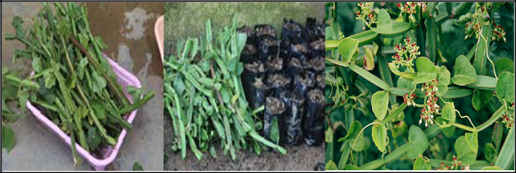

**Figure 1:** On starting day 0

|  |  |
| --- | --- |
| ISSN 0973-2063 (online) 0973-8894 (print) | 581 |

Bioinformation 16(8): 579-585 (2020)

**Figure 2:** Variation in Stem cutting after 20 Days

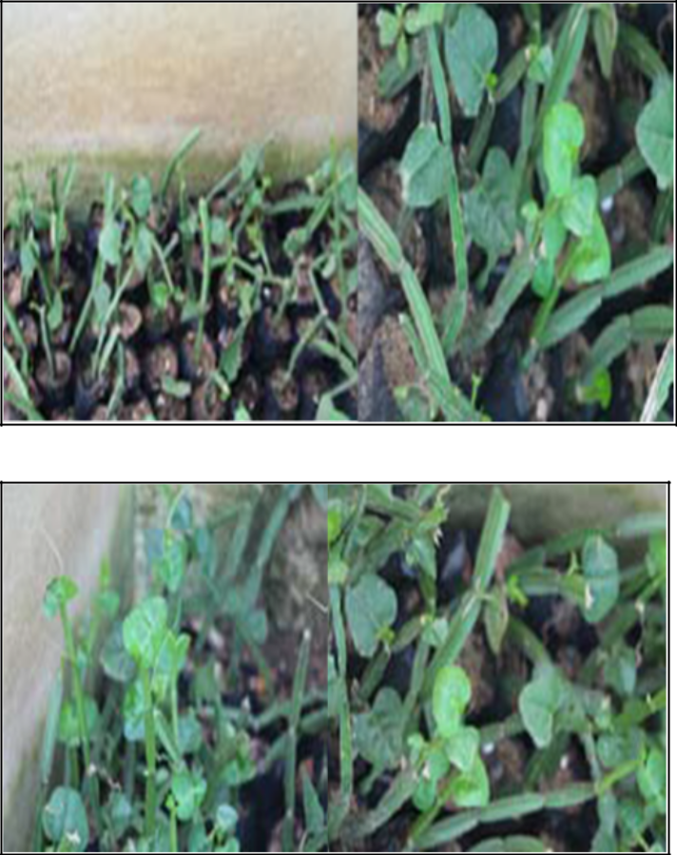

**Figure 3:** Variation in Stem cutting after 30 Days

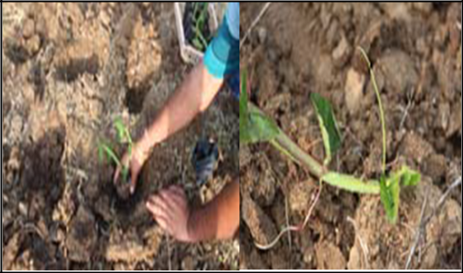

**Figure 4:** Transfer into the open field

©Biomedical Informatics (2020)

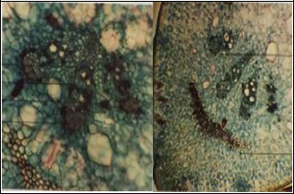

**Figure 5:** TS of stem showing one of the four corners

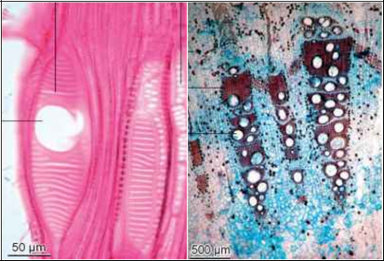

**Figure 6:** TS of stem showing parts of vascular bundle

**Anti obesity activity:**

A study was performed using a *Cissus quadrangularis* formulation called cylaris. The study had a double blind, placebo-control design. Results showed test subject had decreased waist circumference body mass index reduced serum lipid levels **[8]**.

**Anti-ulcerative activity:**

Anti-ulcerative the effect of *Cissus quadrangularis* extract on enzyme H+K+-ATPase that is deemed responsible for producing acidity in stomach.

**Anti-diabetic activity:**



Anti diabetic property of *Cissus quadrangularis* was established in a study where dry powder of *Cissus quadrangularis* is obatained through ethyl acetate extraction was administered. Diabetes was induced in wister albino rats by administering alloxan **[9, 10]**.

**Antioxidant and free radical scavenging activity:**

Methanol extract of *Cissus quadrangularis* exhibits strong antioxidant and free radical scavenging activity in vitro and *in vivo* systems mainly due to the presence of β-carotene **[11, 12]**.

**Gastro protective Activity:**

Because of its significant source of carotenoids, triterpenoids and ascorbic acid, *Cissus quadrangularis* has been well established for the diagnosis of gastrointestinal diseases in traditional medicine, and has gained significant recognition about its impact on human nutrition. A numerous studies examined and demonstrated the impact of *Cissus quadrangularis* extract (CQE) on gastrointestinal toxicity and gastro-protective effect, together with its function underpinning the clinical intervention toward aspirin-induced gastric mucosal damage **[13]**.

**Central nervous system activity:**

The root extract possesses stimulant CNS function suggested by decreasing exploratory actions. Methanol root extract comprises saponins that exhibit powerful sedative action and also suppress spontaneous motor action in mice **[14-16]**.

**Analgesic, anti-inflammatory and stimulatory activity:**

Methanol extract has analgesic, non-inflammatory and venotonic impacts involved with hemorrhoids, non-inflammatory activity attributable to flavonoids and β-sitosterol in particular. β-sitosterol in methanol extract does have the potential to reduce MPO enzymes, which indicate a significant decrease in the influx of neutrophils into the inflamed tissue. Ethanol extract has beneficial effect on neutrophils triggered by aspirin-induced tissue damage in rats **[17]**.

**Conclusion:**

Conventional plants for treatment of physical and mental infirmities exist in all significant antiquated civic establishments of the world. For its essential regenerative uses, the plant is known as a responsive therapeutic plant in both Ayurvedic and recent drug development environments. It is an extremely rich source of some minerals, essential for the legitimate functioning of the human body. In the present outline the Emphasis has been laid on the phytochemical constituents and pharmacological action of the plant

|  |  |  |
| --- | --- | --- |
| ISSN 0973-2063 (online) 0973-8894 (print) | 582 |  |
| Bioinformation 16(8): 579-585 (2020) | ©Biomedical Informatics (2020) |  |
|  |  |



*Cissus quadrangularis* Linn. Comprehensive screening of accessiblewriting on *Cissus quadrangularis* has an amazing fact that although the plant is a popular remedy for a variety of diseases and a number of meanings was shown, little effort has been made to test its immaculacy, consistency and appropriateness through logical screening. In future investigation, the separated standards from *Cissus quadrangularis* should be assessed in logical way utilizingexplicit test creature models and clinical preliminaries to comprehend the mechanism of activity, looking for lead particle from natural elements.

**References:**

1. Reddy BS *et al. African Journal of Traditional, Complementary* *and Alternative Medicine* 2017**14:**105. [PMID: 28480421].
2. Shirwaikar A *et al. Journal of Ethnopharmacology* 2003 **89:**245.

[PMID: 14611887].

1. Singh N *et al. National Journal of Maxillofacial Surgery* 2013 **4:**52. [PMID: 24163553].
2. Chopra SS *et al. Indian Journal of Medical Research* 1975 **63:**824-

828. [PMID: 1213779].

1. Oben J *et al. Lipids Health Diseases* 2006 **5:**24. [PMID: 16948861].
2. Mehta M *et al. Phytochemical Analysis* 2001 **12:**91. [PMID: 11705245].
3. Chidambara Murthy KN *et al. Journal of Medicinal Food* 2003 **6:**99. [PMID: 12935320].
4. Udupa KN & Prasad GC, *Indian Journal of Medicinal Research* 1964 **52:**26. [PMID: 14112159].
5. Prasad GC & Udupa KN, *Indian Journal of Medicinal Research* 1963 **51:**667. [PMID: 14073618].
6. Day NL *et al. Alcoholism: Clinical and Experimental Research*.

2002 **26:**1584. [PMID: 12394293].

1. Potu BK *et al. Clinics* 2008 63:815. [PMID: 19061006].
2. Austin A *et al. Ancient Science Life* 2004 **23:**33. [PMID: 22557140].
3. Jainu M & Devi CS, *Chemico-Biological Interactions*2006 **161:**262. [PMID: 16797507].
4. Jainu M *et al. Journal of Ethnopharmacology* 2006 **104:**302.

[PMID: 16797507].

1. Panthong A *et al. Journal of Ethnopharmacology* 2007 110:264. [PMID: 17095173].
2. Jain A *et al. Journal of the International Academy of* *Periodontology* 2008**10:**59. [PMID: 18564730].
3. Sen MK *International Journal of Green Pharmacy* 2019 **6: [**DOI: 10.4103/0973-8258.104924]



**Edited by P Kangueane**

**Citation**: Sundaran ***et al.*** Bioinformation 16(8): 579-585 (2020)

**License statement**: This is an Open Access article which permits unrestricted use, distribution, and reproduction in any medium, providedthe original work is properly credited. This is distributed under the terms of the Creative Commons Attribution License



|  |  |  |
| --- | --- | --- |
| ISSN 0973-2063 (online) 0973-8894 (print) | 583 |  |
| Bioinformation 16(8): 579-585 (2020) | ©Biomedical Informatics (2020) |  |
|  |  |



Articles published in BIOINFORMATION are open for relevant post publication comments and criticisms, which will be published immediately linking to the original article for FREE of cost without open access charges. Comments should be concise, coherent and critical in less than 1000 words.

|  |  |  |
| --- | --- | --- |
| ISSN 0973-2063 (online) 0973-8894 (print) | 584 |  |
| Bioinformation 16(8): 579-585 (2020) | ©Biomedical Informatics (2020) |  |
|  |  |

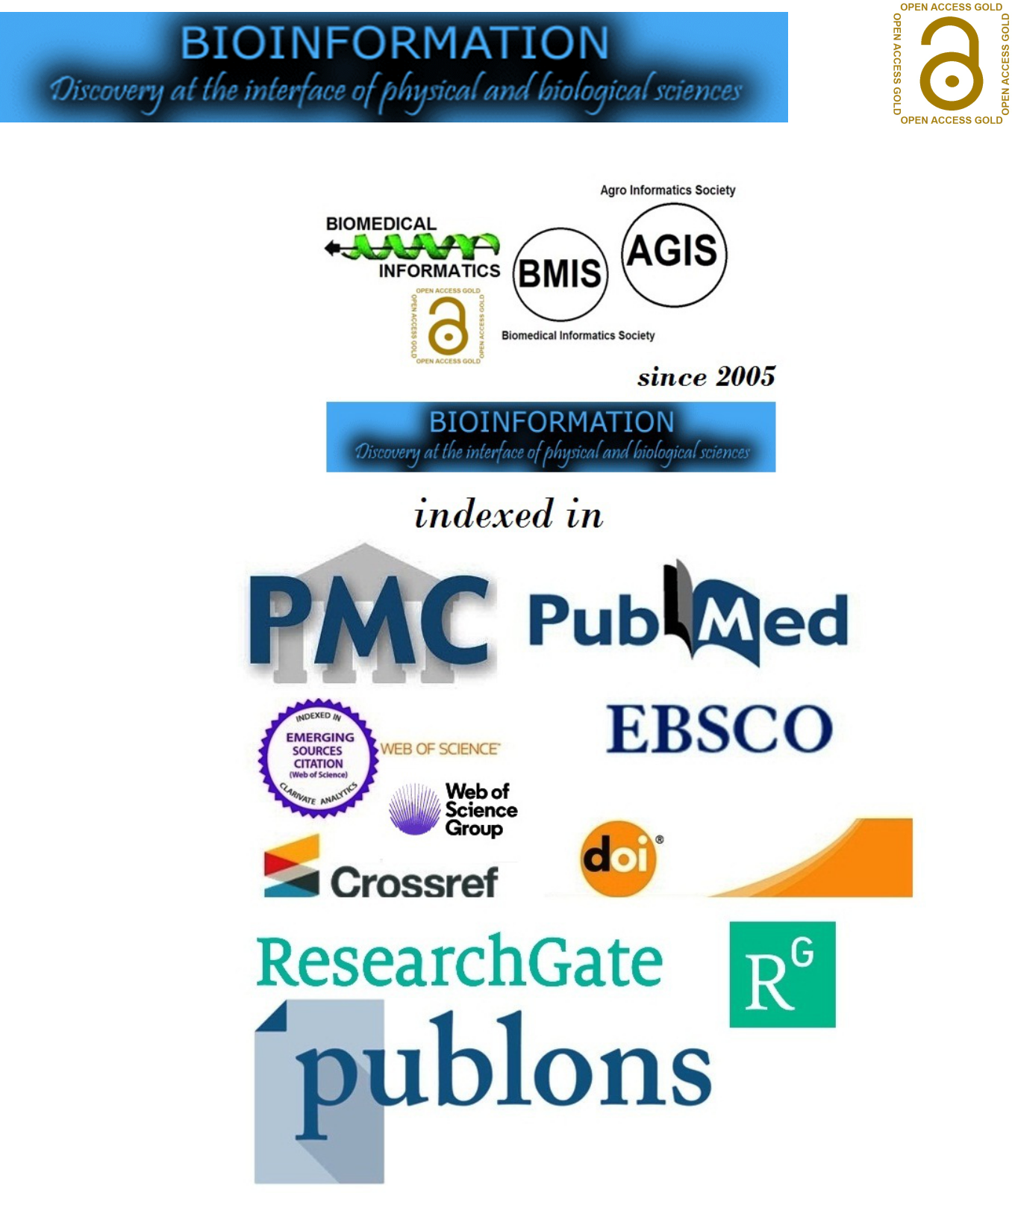

|  |  |  |
| --- | --- | --- |
| ISSN 0973-2063 (online) 0973-8894 (print) | 585 |  |
| Bioinformation 16(8): 579-585 (2020) | ©Biomedical Informatics (2020) |  |
|  |  |