Mine Water and the Environment (2020) 39:603–617

https://doi.org/10.1007/s10230-020-00707-5

**TECHNICAL COMMUNICATION**



**In‑lake Neutralization of East German Lignite Pit Lakes: Technical History and New Approaches from LMBV**

**Friedrich‑Carl Benthaus1 · Oliver Totsche1 · Ludwig Luckner2**

Received: 22 June 2020 / Accepted: 11 July 2020 / Published online: 23 July 2020 © Springer-Verlag GmbH Germany, part of Springer Nature 2020

**Keywords**

**\***

1 3

\604 Mine Water and the Environment (2020) 39:603–617

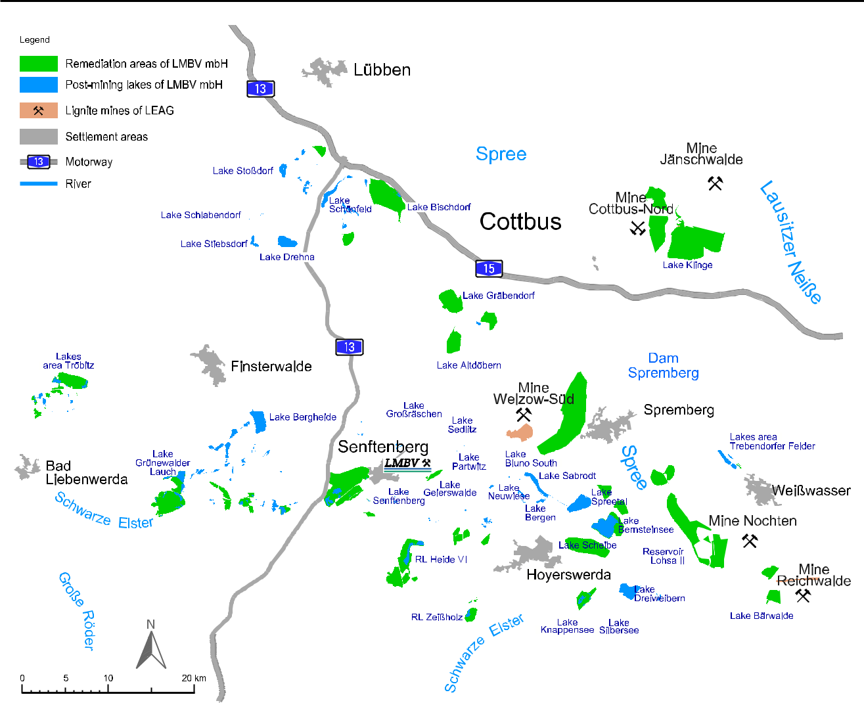

**Fig. 1**

**I**

f

·

1 3

|  |  |
| --- | --- |
| Mine Water and the Environment (2020) 39:603–617\ | 605 |
|  |  |

**G**

*K*

−

−

**Fig. 2**

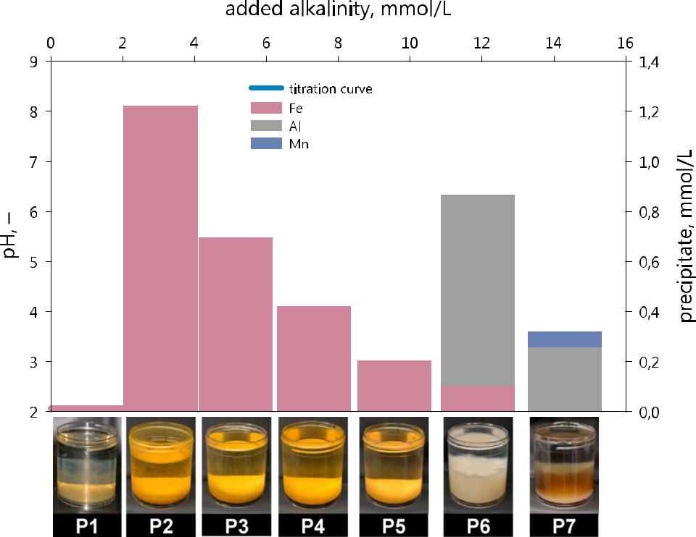

1 3

\606 Mine Water and the Environment (2020) 39:603–617

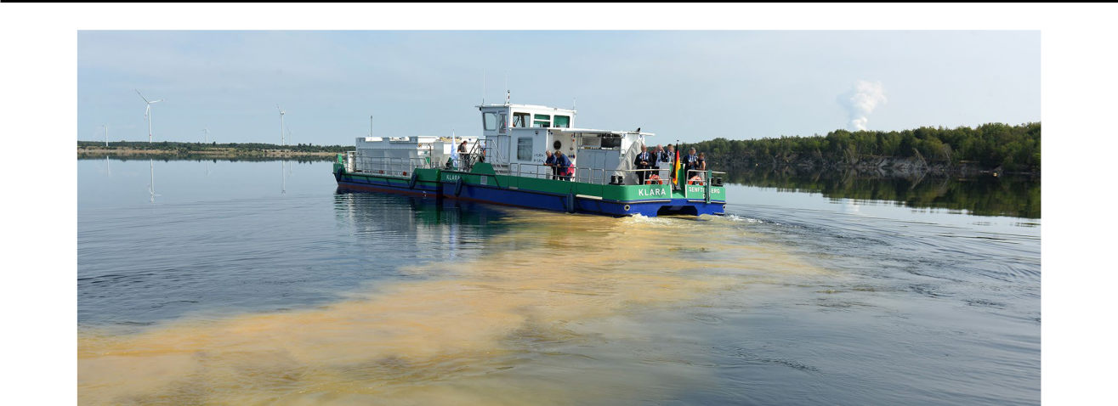

**Fig. 3**

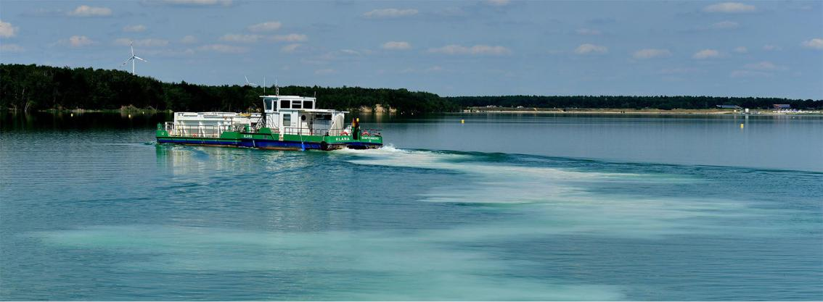

**Fig. 4**

1 3

|  |  |
| --- | --- |
| Mine Water and the Environment (2020) 39:603–617\ | 607 |
|  |  |

* μ

μ

*K*

1 3

\608 Mine Water and the Environment (2020) 39:603–617

**Fig. 5**

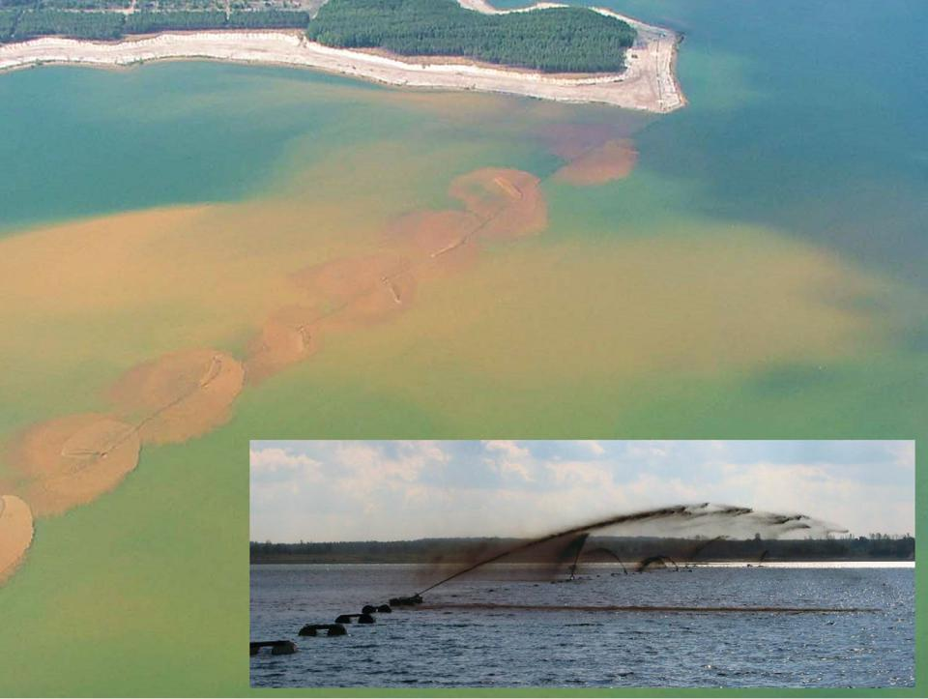

*K*

*K*

1 3

|  |  |
| --- | --- |
| Mine Water and the Environment (2020) 39:603–617\ | 609 |
|  |  |

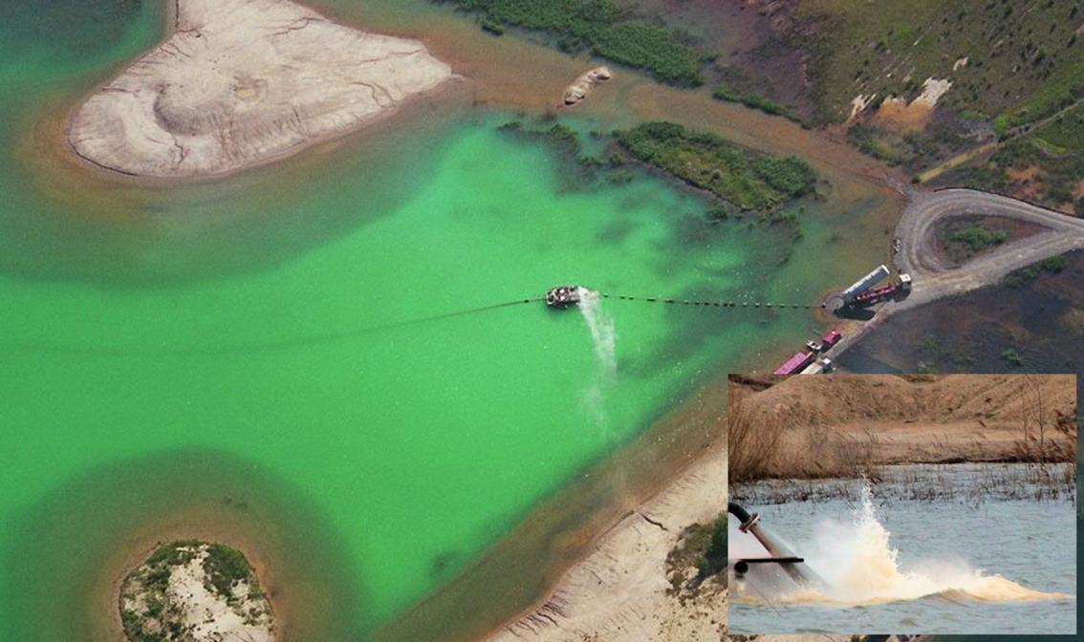

**Fig. 6**

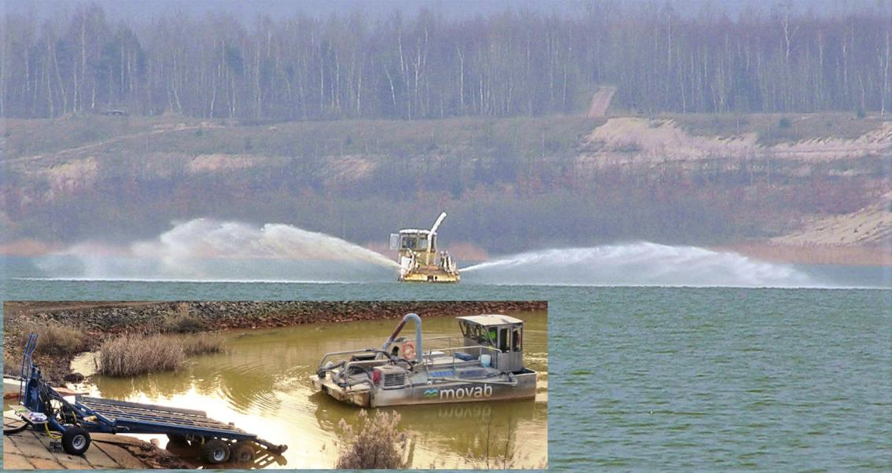

**Fig. 7**

1 3

\610 Mine Water and the Environment (2020) 39:603–617

·

·

f

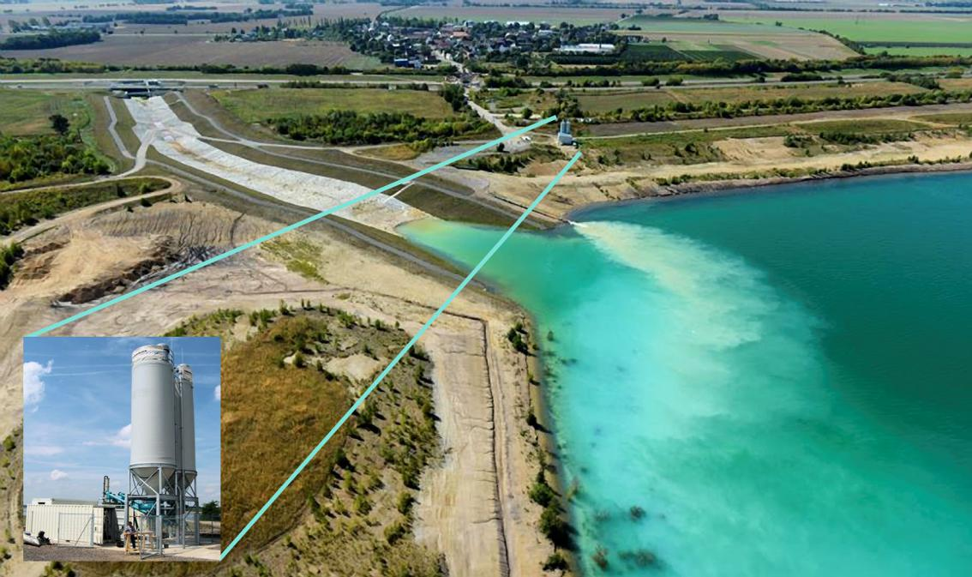

**Fig. 8**

1 3

|  |  |  |  |  |  |  |  |  |  |  |  |  |  |  |  |  |  |  |  |  |  |  |  |  |  |  |  |  |  |  |  |  |  |  |  |  |  |  |  |  |  |  |  |  |  |  |  |  |  |  |  |  |  |  |  |  |  |  |  |  |
| --- | --- | --- | --- | --- | --- | --- | --- | --- | --- | --- | --- | --- | --- | --- | --- | --- | --- | --- | --- | --- | --- | --- | --- | --- | --- | --- | --- | --- | --- | --- | --- | --- | --- | --- | --- | --- | --- | --- | --- | --- | --- | --- | --- | --- | --- | --- | --- | --- | --- | --- | --- | --- | --- | --- | --- | --- | --- | --- | --- | --- |
| Mine Water and the Environment (2020) 39:603–617\ | | | | | | | | | | | | | | | 611 | | | | | | | | | | | | | | | | | | | | | | | | | | | | | | | | | | | | | | | | | | | | | |
|  | | | | | | | | | | | | | | | | | | | | | | | | | | | | | | | | | | | | | | | | | | | | | | | | | | | | | | | | | | | | |
|  | | | | | | | | | | | | | | | | | | | | | | | | | | | | | | | | | | | | | | | | | | | | | | | | | | | | | | | | | | | | |
|  |  | | | | | | | | | | | | | | | | | | | | | | | | | | | | | | | | | | | | | | | | | | | | | | | | | | | | | | | | | | |  |
|  |  |  | | | | | | | | | | | | | | | | | | | | | | | | | | | | | | | | | | | | | | | | | | | | | | | | | | | | | | | | | |  |
|  |  | | | | | | | | | | | | | | | | | | | | | | | | | | | | | | | | | | | | | | | | | | | | | | | | | | | | | | | | | | |  |
|  |  | | | |  | | | | | | | | | | | | | | | | | | | | | | | | | | | | | | | | | | | | | | | | | | | | | | | | | | | | | | |  |
|  |  | | | | | | | | | | | | | | | | | | | | | | | | | | | | | | | | | | | | | | | | | | | | | | | | | | | | | | | | | | |  |
|  |  | | | | |  | | | | | | | | | | | | | | | | | | | | | | | | | | | | | | | | | | | | | | | | | | | | | | | | | | | | | |  |
|  |  | | | | | | | | | | | | | | | | | | | | | | | | | | | | | | | | | | | | | | | | | | | | | | | | | | | | | | | | | | |  |
|  |  | | | | | |  | | | | | | | | | | | | | | | | | | | | | | | | | | | | | | | | | | | | | | | | | | | | | | | | | | | | |  |
|  |  | | | | | | |  |  | | | | | | | | | | | | | | | | | | | | | | | | | | | | | | | | |  |  | |  |  | | | | | | | | | | | | | |  |
|  |  | | | | | | | | | | | | | | | | | | | | | | | | | | | | | | |  |  |  |  |  |  |  |  |  |  | | | | | | |  |  |  |  |  |  |  |  |  |  |  |  |  |
|  |  | | | | | | | | | | | | | | | | | | | | | | | | | | | | | | | | | | | | | | | | | | | | | | | | | | | | | | | | | | |  |
|  |  | | | | | | | | | |  | | | | | | | | | | | | | | | | |  |  |  |  | | | | | | | | | | | | | | | | | | | | | | | | | | | | |  |
|  |  | | | | | | | | | | | | | | | | | | | |  |  | |  |  |  |  | | | | | | | | | | | | | | | | | | | | | | | | | | | | | | | | |  |
|  |  | | | | | | | | | | |  |  | | | | | |  |  | | | | | | | | | | | | | | | | | | | | | | | | | | | | | | | | | | | | | | | |  |
|  |  | | | | | | |  |  | | | | |  |  |  |  | | | | | | | | | | | | | | | | | | | | | | | | | | | | | | | | | | | | | | | | | | |  |
|  |  | | | | | | |  |  | | |  |  |  |  |  |  | | | | | | | | | | | | | | | | | | | | | | | | | | | | | | | | | | | | | | | | | | |  |
|  |  | | | | | | | | |  | | | | | | | | | | | | | | | | | | | | | | | | | | | | | | | | | | | | | | | | | | | | | | | | | |  |
|  |  | | | | |  | | | | | | | | | | | | | | | | | | | | | | | | | | | | | | | | | | | | | | | | | | | | | | | | | | | | | |  |
|  |  | | | | | | | | | | | | | | | | | | | | | | | | | | | | | | | | | | | | | | | | | | | | | | | | | | | | | | | | | | |  |
|  |  | | | | | | | | | | | | | | | | |  |  |  |  |  | | | | | | | | | | | | | | | | | | | | | | | | | | | | | | | | | | | | | |  |
|  |  | | | | | | | | | | | | | | | | | | | |  |  | | | | | | | | | | | | | | | | | | | | | | | | | | | | | | | | | | | | | |  |
|  | | | |  | | | | | | | | | | | | | | | | | |  |  |  | | | | | | | | | | | | | | | | | | | | | |  | | | | | | | | | | | | | | |
|  | | | | | | | | | | | | | | | | | | | | | | | | | | | | | | | | | | | | | | | | | | | | | | | | | | | | | | | | | | | | |
|  | | | | | | | | | | | | | | | | | | | | | | |  | | | | | | | | | | | | | | | | | | | | | | |  | | | | | | | | | | | | | | |

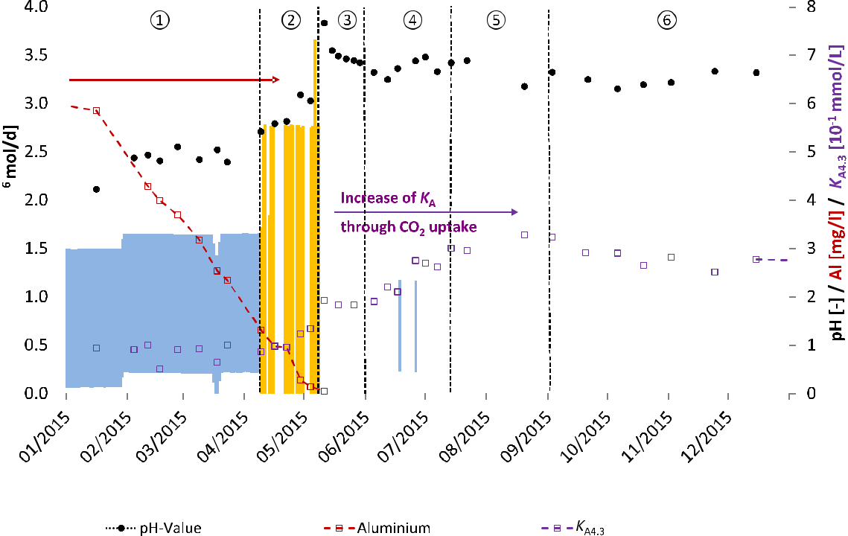

**Fig. 9**

*K*

* *K*

**Fig. 10**

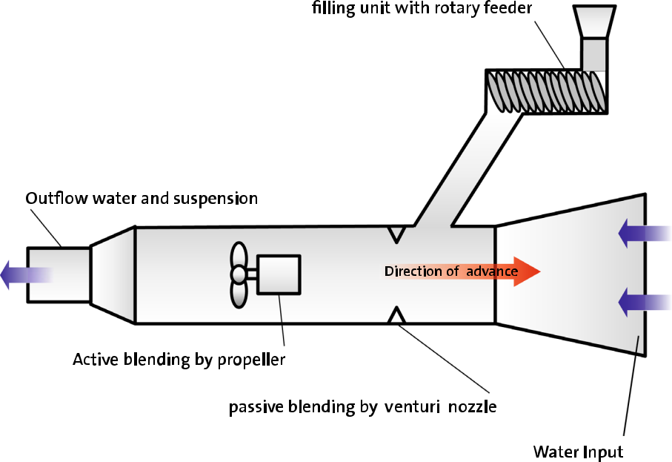

1 3

\612 Mine Water and the Environment (2020) 39:603–617

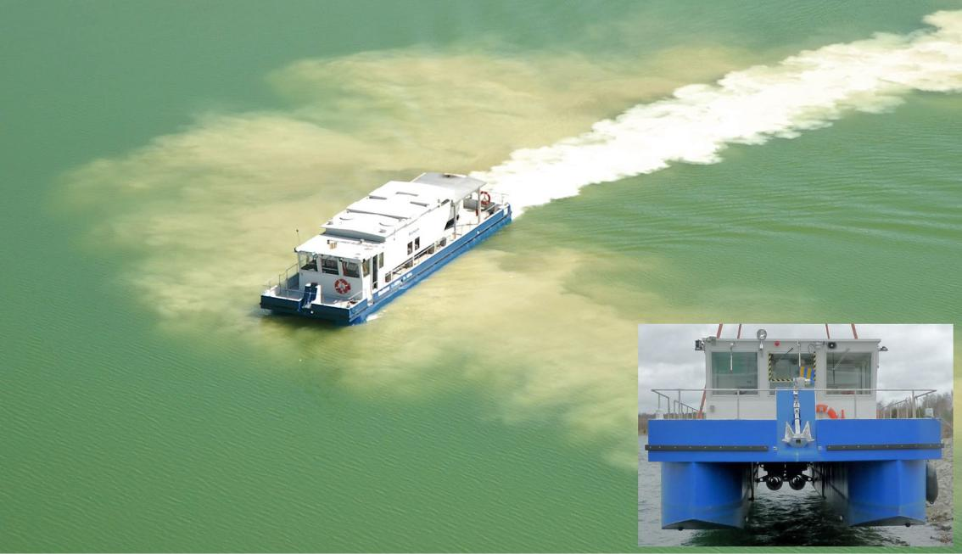

**Fig. 11**

1 3

|  |  |  |  |  |  |  |  |  |  |  |  |  |  |  |  |  |
| --- | --- | --- | --- | --- | --- | --- | --- | --- | --- | --- | --- | --- | --- | --- | --- | --- |
| Mine Water and the Environment (2020) 39:603–617\ | | | | | | | | | | | 613 | | | | | |
|  |  |  |  |  |  |  |  |  |  |  |  |  |  |  |  |  |
|  |  |  |  |  |  |  |  |  |  |  |  |  |  |  |  |  |
|  |  |  |  |  |  |  |  |  |  |  |  |  |  |  |  |  |
|  |  |  |  |  |  |  |  |  |  |  |  |  |  |  |  |  |
|  |  |  |  |  |  |  |  |  |  |  |  |  |  |  |  |  |
|  |  |  |  |  |  |  |  |  |  |  |  |  |  |  |  |  |
|  |  |  |  |  |  |  |  |  |  |  |  |  |  |  |  |  |
|  |  |  |  |  |  |  |  |  |  |  |  |  |  |  |  |  |
|  |  |  |  |  |  |  |  |  |  |  |  |  |  |  |  |  |
|  |  |  |  |  |  |  |  |  |  |  |  |  |  |  |  |  |
|  |  |  |  |  |  |  |  |  |  |  |  |  |  |  |  |  |
|  |  |  |  |  |  |  |  |  |  |  |  |  |  |  |  |  |
|  |  |  |  |  |  |  |  |  |  |  |  |  |  |  |  |  |
|  |  |  |  |  |  |  |  |  |  |  |  |  |  |  |  |  |
|  |  |  |  |  |  |  |  |  |  |  |  |  |  |  |  |  |
|  |  |  |  |  |  |  |  |  |  |  |  |  |  |  |  |  |
|  |  |  |  |  |  |  |  |  |  |  |  |  |  |  |  |  |
|  |  |  |  |  |  |  |  |  |  |  |  |  |  |  |  |  |
|  |  |  |  |  |  |  |  |  |  |  |  |  |  |  |  |  |
|  |  |  |  |  |  |  |  |  |  |  |  |  |  |  |  |  |
|  |  |  |  |  |  |  |  |  |  |  |  |  |  |  |  |  |

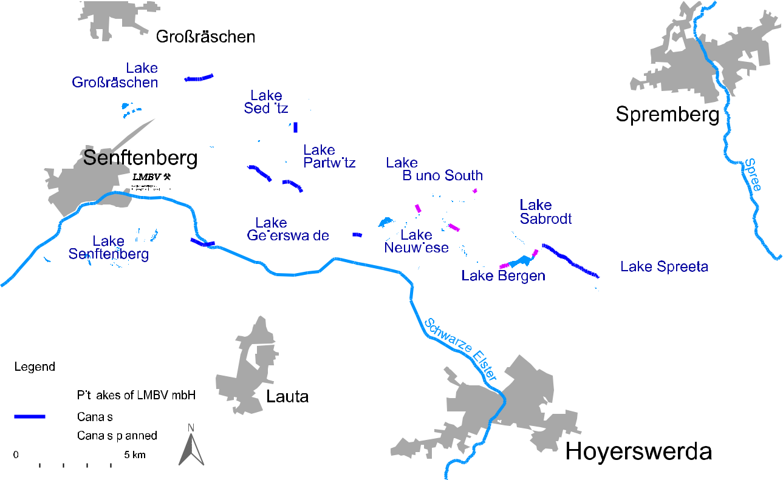

**Fig. 12**

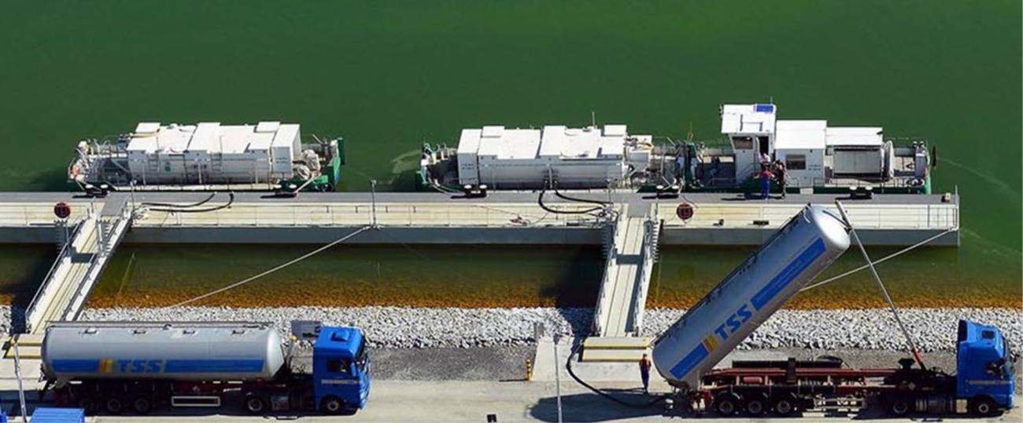

**Fig. 13**

*K*

1 3

\614 Mine Water and the Environment (2020) 39:603–617

CA(OH)2 + CO2 → CA2+ + OH− + HCO−3

f

*K*

**2**

|  |  |  |  |
| --- | --- | --- | --- |
| − | CACO3 + H2O → CA2+ | + OH− + HCO3− |  |
|  |  |  |

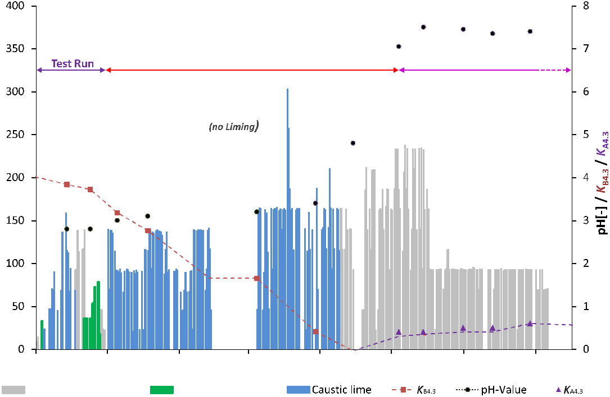

**Fig. 14**

1 3

|  |  |
| --- | --- |
| Mine Water and the Environment (2020) 39:603–617\ | 615 |
|  |  |

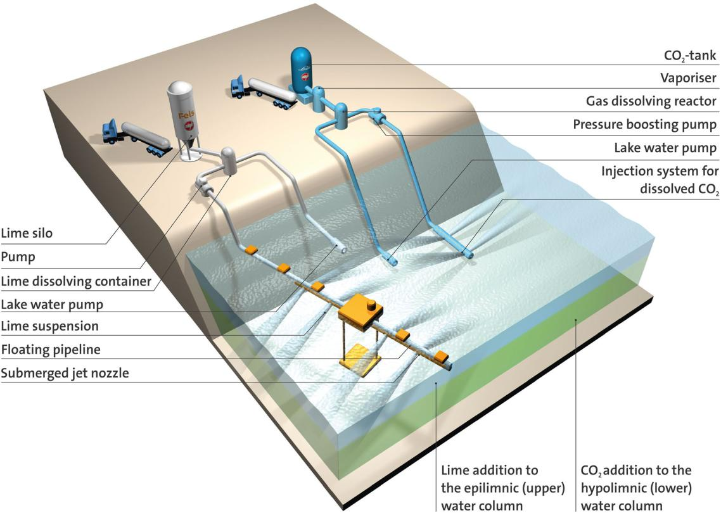

**Fig. 15**

*K*

·

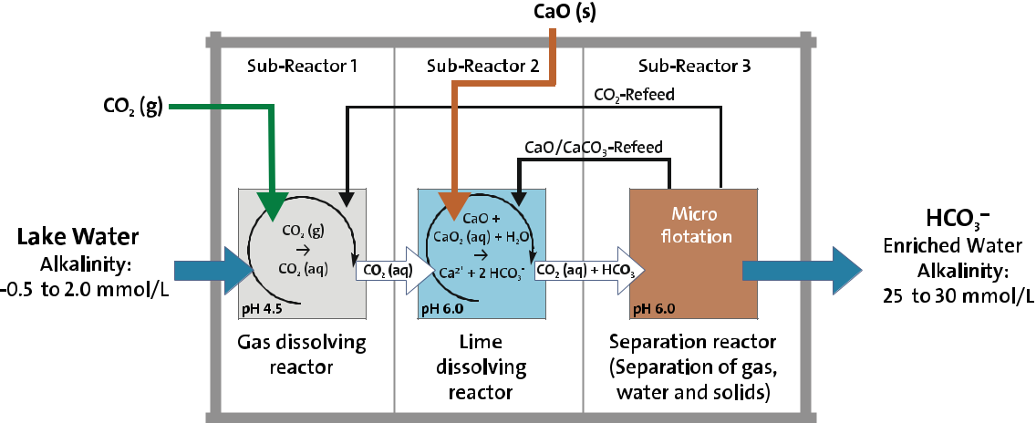

**Fig. 16**

1 3

\616 Mine Water and the Environment (2020) 39:603–617

−

−

*K*

*K*

*K* ≥

**Acknowledgements**

**W**

1 3

|  |  |
| --- | --- |
| Mine Water and the Environment (2020) 39:603–617\ | 617 |
|  |  |

ö

ää

]

1 3