Hydrobiologia

<https://doi.org/10.1007/s10750-020-04369-w>

AQUATIC HOMOGENOCENE

Biological control of water lettuce, Pistia stratiotes L., facilitates macroinvertebrate biodiversity recovery: a mesocosm study

J. A. Coetzee  . S. D. F. Langa . S. N. Motitsoe . M. P. Hill

Received: 5 September 2019 / Revised: 21 July 2020 / Accepted: 28 July 2020

Springer Nature Switzerland AG 2020

Abstract Floating aquatic weed infestations have negative socio-economic and environmental conse-quences to the ecosystems they invade. Despite the long history of invasion by macrophytes, only a few studies focus on their impacts on biodiversity, while the ecological benefits of biological control pro-grammes against these species have been poorly quantified. We investigated the process of biotic homogenization following invasion by Pistia stra-tiotes on aquatic biodiversity, and recovery provided by biological control of this weed. Biotic homoge-nization is the increased similarity of biota as a result of introductions of non-native species. The study quantified the effect of P. stratiotes, and its biological

Guest editors: Andre´ A. Padial, Julian D. Olden & Jean R. S. Vitule / The Aquatic Homogenocene

J. A. Coetzee (&)

Centre for Biological Control, Botany Department,

Rhodes University, P.O. Box 94, Grahamstown 6140,

South Africa

e-mail: Julie.coetzee@ru.ac.za

S. D. F. Langa

Departamento de Cieˆncias Biologicas, Faculdade de Ciceˆncias, Universidade Eduardo Mondlane,

C. Postal 257 Maputo, Mozambique

S. D. F. Langa S. N. Motitsoe M. P. Hill

Centre for Biological Control, Department of Zoology and Entomology, Rhodes University,

P.O. Box 94, Grahamstown 6140, South Africa

control through the introduction of the weevil, Neo-hydronomus affinis on recruitment of benthic macroin-vertebrates to artificial substrates. Mats of P. stratiotes altered the community composition and reduced diversity of benthic macroinvertebrates in comparison to an uninvaded control. However, reduction in percentage cover of the weed through biological control resulted in a significant increase in dissolved oxygen, and recovery of the benthic macroinvertebrate community that was comparable to the uninvaded state. This highlights the process of homogenization by an invasive macrophyte, providing a justification for sustained ecological and restoration efforts in the biological control of P. stratiotes where this plant is problematic.

Keywords Benthic macroinvertebrate diversity

Invasive aquatic plants Community recovery

Neohydronomus affinis

Introduction

Freshwater ecosystems are particularly susceptible to invasions by non-native species across a range of floral and faunal taxa, largely as a consequence of anthro-pogenic pressures on these systems (Dudgeon et al., 2006; Ricciardi & MacIsaac, 2011). The alteration of hydrological flows, trade, and intentional stocking

123



Hydrobiologia

have resulted in homogenous flora and fauna (Rahel, 2002) with ecological and socio-economic impacts to these ecosystems. The homogenization of biotas is the process whereby introductions of non-native species, extirpation of native species, and habitat alterations that facilitate these two processes, result in their increased similarity over time, usually as a result of anthropogenic disturbance (Rahel, 2002). Arguably, freshwater communities have been altered to a greater magnitude than terrestrial communities (Dudgeon et al., 2006). Studies and reviews on homogenization of aquatic ecosystems by faunal invasions, particularly fish invasions, populate the literature (e.g. Ricciardi & MacIsaac, 2011), with relatively fewer general reviews on homogenization by aquatic plant invasions (e.g. Thomaz et al., 2015), even though invasive aquatic macrophytes often degrade aquatic ecosys-tems and limit their utilization, threatening food security and economic development (Hill, 2003).

The negative effects of invasive macrophytes are considerable and have been fairly well reviewed (e.g. Villamagna & Murphy (2010) for water hyacinth (Pontederia (= Eichhornia) crassipes (Mart.) Solms-Laub. (Pontederiaceae)), Doeleman (1989) for salvi-nia (Salvinia molesta D.S. Mitch. (Salviniaceae)), Neuenschwander et al. (2009) for water lettuce (Pistia stratiotes L. (Araceae)), Hill & McConnachie (2009) for red water fern (Azolla filiculoides Lam. (Azol-laceae)), and Cilliers (1999) for parrot’s feather (Myriophyllum aquaticum (Vell. Conc.) Verd. (Halor-agaceae)). While the direct and indirect (cost of control) economic effects of aquatic weeds are rela-tively easy to measure (e.g. Mailu, 2001), quantifying their impacts on biodiversity is more difficult, although, studies on notorious aquatic invaders such as P. crassipes and Phragmites australis (Cav.) Trin. ex Steud. (Poaceae) do highlight the consequences of their invasion on biodiversity (e.g. Villamagna & Murphy, 2010; Lambert et al., 2010). For example, P. crassipes invasions result in lowered dissolved oxygen concentrations beneath the mats, as a result of reduced light available for photosynthesis by phytoplankton communities, which has knock-on higher trophic level effects (Rommens et al., 2003; Mangas-Ramirez & Elias-Gutierrez, 2004; Perna & Burrows, 2005). The ecological impacts of less notorious invasive macro-phytes, such as P. stratiotes, on aquatic communities are not obvious from the literature.

Given the widespread distribution and subsequent socio-economic impacts of invasive macrophytes, a number of these species have been targeted for biological control. It has often been suggested that biological control, or the release of host specific natural enemies, is the only option that offers economical and sustainable control of weeds (McFa-dyen, 1998). Biological control programmes against floating macrophytes such as water hyacinth, salvinia, and water lettuce, have been ongoing since the release of the first biological control agent on water hyacinth in the early 1970s in the USA and South Africa. The practice of biological control of weeds is considered safe and sustainable due to the rigorous host-speci-ficity testing of each agent which ensures that no non-target plants will be compromised; confirmation that the agent will indeed be damaging; and intense screening by panels of experts prior to application for release. Globally, biological control has led to a significant reduction in the invasiveness of these species (Winston et al., 2014). But studies on quan-tifying the benefits in terms of biodiversity recovery and ecosystem restoration are lacking.

Historically, weed biological control has suffered from a lack of empirical data to prove causation of control, relying on ‘before and after’ application of biological control data to show efficacy. Where effects of the agents are quantified, these are usually mea-surements of agent establishment and plant growth, and seldom plant population dynamics, and where the benefits of a biological control programme have been measured, they have most often focussed on economic benefits. For example, McConnachie et al. (2003) quantified the benefits of the biological control programme against red water fern (Azolla filiculoides) using the weevil, Stenopelmus rufinasus Gyllenhal (Coleoptera: Curculionidae) in South Africa and showed that the agent reduced the negative effect of the weed on water supply, stock health and recre-ational activities. Further, De Groote et al. (2003) demonstrated that the successful biological control of water hyacinth in southern Benin significantly increased the yearly income of the population of this region through increased crop and fish production. More recently, an economic analysis of the cost– benefit of controlling water hyacinth in Louisiana, USA, over a 38-year time period by Wainger et al. (2018) demonstrated a benefit–cost ratio of about 34:1 derived from the costs of $124 million ($2013)

123

Hydrobiologia

compared to the $4.2 billion ($2013) in benefits to anglers, waterfowl hunters, boating-dependent busi-nesses, and water treatment facilities. In these studies, there is no quantification of how ecosystem function-ing returns with the reverse of biotic homogenization, and thus there are few studies of the biodiversity and ecological benefits of aquatic weed biological control (for an exception, see Hill & Coetzee, 2017a).

The aim of this study was to measure the effect of P. stratiotes invasion on benthic macroinvertebrate bio-diversity, and its recovery after the introduction of the water lettuce biological control agent, Neohydrono-mus affinis Hustache (Coleoptera: Curculionidae). We hypothesized that the introduction of P. stratiotes would reduce dissolved oxygen concentration, leading to a decrease in macroinvertebrate biological and functional diversity, resulting in biotic homogeniza-tion. We further hypothesized that the reduction in water lettuce biomass and cover through biological control would reverse these effects, allowing the recovery of biological and functional diversity of the macroinvertebrate communities.

Materials and methods

Description of the weed and agent

Pistia stratiotes (water lettuce, Nile cabbage) origi-nates in South America and is the only species in the Araceae that floats freely on still or slow moving water bodies. The undersides of the leaves contain spongy parenchyma and the leaves are covered with dense hairs on both surfaces. This plant reproduces vegeta-tively through the formation of stolons and daughter plants (Neuenschwander et al, 2009). The role of sexual reproduction is considered less important than that of vegetative reproduction, although seed germi-nation is an important factor in the dynamics of water lettuce populations (Diop et al., 2010). Pistia stratiotes has a global distribution, dominating water bodies in the tropics and subtropics where it responds to eutrophication. It is also becoming more widely distributed in temperate regions, including Europe where it was first recorded from the Netherlands in 1973, but did not establish permanent populations, while it has remained permanently established in thermal sections of the River Erft since 2008 (Hussner, 2014).

The South American weevil, Neohydronomus affinis, has been released throughout the world where water lettuce is a problem (Winston et al., 2014). The adults are brown to bluish grey, and make character-istic shot-hole scars in the mesophyll of the leaves. The eggs are deposited singly below the epidermis, and the larvae mine the spongy leaf tissue causing significant damage to the plant (De Loach et al., 1976). It was first introduced to Australia in 1982, and then to South Africa from Australia in 1985 (Cilliers, 1987). Since then, it has been intentionally released into 16 other countries around the world, where it is regarded as a successful biological control agent (Winston et al., 2014).

Experimental design

This study was conducted at the Department of Zoology and Entomology, Rhodes University (-33.310453, 26.517438, Makhanda, South Africa) in large outdoor mesocosms (PVA pools measuring 265 cm in diameter with a depth of 67.5 cm). The experimental setup included three treatments, repli-cated three times: an open water control treatment (no water lettuce); a treatment completely covered with water lettuce (1500 plants obtained from stock cultures maintained at the Waainek Mass Rearing Facility, Rhodes University); and a biological control treatment in which 250 adult N. affinis weevils (1 weevil/6 plants obtained from cultures maintained at the Waainek Mass Rearing Facility) were placed onto pools completely covered with water lettuce (1500 plants). Benthic macroinvertebrate biodiversity was measured using a standard technique of deploying artificial substrate, comprising approximately 90 peb-bles (* 2 kg) enclosed in a mesh bag (20 cm 9 50 cm, 2 mm mesh size), onto the floor of the mesocosm (Thirion, 2000; Midgley et al., 2006; Coetzee et al., 2014). For each sample event, the substrates were left for 6 weeks in each treatment, the time required for complete recruitment by invertebrates (Thirion, 2000), after which they were collected and evaluated.

At the outset of the study, nine mesocosms were filled with borehole (well) water, and 1 bag of artificial substrate was placed into each pool. 6 weeks later, the bags were retrieved and evaluated for macroinverte-brate colonization (see below). This was designated Sample Event 0 (i.e. the ‘before’ treatment). New artificial substrate bags were then replaced into all of

123

Hydrobiologia

the pools, and six of the pools were randomly selected and completely covered with water lettuce, while three remained as the open water controls. Then three of the pools covered with water lettuce were randomly selected and each treated with 250 adult weevils. The mesocosms were not caged as this would prevent recruitment of macroinvertebrates. This setup resulted in the three experimental treatments, an open water control, a water lettuce treatment and a biocontrol treatment. After 6 weeks, the artificial substrate bags were removed, evaluated and replaced every 6 weeks, during six sampling events over 36 weeks.

For each sample event, colonization by benthic macroinvertebrates on the artificial substrates was determined by emptying the contents of each bag, and the bag itself into a sorting tray. Each pebble was cleaned with fresh water and a small paint brush, while the bag was washed with water. Both the sample bag and individual pebbles were examined for macroin-vertebrates before being removed from the sorting tray. The contents of the sorting tray (water and substrate) were then drained through a sieve

(1 9 1 mm), and all macroinvertebrates were removed with forceps and placed into glass vials, containing 75% ethanol for later identification. Spec-imens were identified to family level, under a dissect-ing stereomicroscope, using a series of identification keys (Day & De Moor, 2002; Day et al., 2003; De Moor et al., 2003a, b). Macroinvertebrate family-level identification is considered an efficient, easy-to-use, reliable rapid assessment method for monitoring aquatic ecosystems impacts (McDermond-Spies et al., 2014). In some instances, individuals were only identified down to sub-class, e.g. Hirudinea and Oligochaeta and class, e.g. Ostracoda, as keys to families in these taxa were not available. Numerical abundance of each taxon per sample bag, per treatment was quantified.

In addition to macroinvertebrate diversity data, dissolved oxygen content (DO) (mg/l) was measured for all of the pools on every second sampling occasion (every 12 weeks), using a portable YSI 550A multi-parameter probe (YSI, OH, USA) directly in the pools. DO was measured because the maintenance of adequate dissolved oxygen concentrations is critical for the survival and functioning of aquatic biota, and mats of floating aquatic weeds are known to reduce DO concentration in the water column. Therefore, the % water lettuce cover for the water lettuce and

biocontrol treatments was also recorded every

1. weeks. Statistical analyses

To determine if the study sampled sufficient macroin-vertebrate families, individual-based rarefaction curves were compiled from the abundances of each sample bag, per treatment over the 36-week sample period, using the analytically calculated Sobs (Mao Tao) (number of species expected), using EstimateS V9.1.0 (Colwell, 2013). Significant differences in curves (i.e. treatments) were indicated by non-over-lapping 95% CI bands.

A number of measures of diversity were calculated in EstimateS V9.1.0 to determine differences in macroinvertebrate diversity indices of the three treat-ments, over time, including total taxon richness (S), individual abundance (N), and Shannon’s diversity

1. (Magurran, 2004). Repeated Measures ANOVAs followed by Bonferroni post hoc tests in Statistica V13.4, compared differences in diversity measures between the treatments, across the sample period, including the ‘before’ treatments.

Differences in % water lettuce cover and dissolved oxygen (DO) between the treatments over the sample period were analysed using a Repeated Measures ANOVA, followed by Fisher’s LSD post hoc tests. The influence of % water lettuce cover and DO on macroinvertebrate abundance was also analysed using a Generalized Linear Model (GLZ) multiple regres-sion, with a Poisson distribution and log-link function, in Statistica V13. Model building using best subsets and Akaike Information Criteria (AIC) determined which variables to include in the analysis.

Unconstrained ordinations were completed using principal coordinate ordination (PCO) on the Bray– Curtis similarity matrix to visualize aquatic macroin-vertebrate assemblages. This was followed by a constrained canonical analysis of principal coordi-nates (CAP) to emphasize assemblage differences between treatments at the end of the study (i.e. the open water control, water lettuce treatment and biocontrol treatment). Aquatic macroinvertebrate abundances were fourth-root transformed to meet

normality and to recognize the abundance of rare taxa. Pearson’s correlation (r [ 0.5) with the canonical axes of the CAP was used to identify taxa driving the

123

Hydrobiologia

differences in assemblage structure (R = 0.7) between treatments.

Additionally, Analysis of similarity (ANOSIM, 9999 permutation) with a pairwise comparison test was used to test similarity in macroinvertebrate assemblage composition between treatments at the end of the study; open water control, and the water lettuce and biocontrol treatments. A permutational analysis of multivariate dispersions (PERMDISP; 9999 permutations) based on the mean distance to the centroid was also performed on macroinvertebrate assemblage composition for homogeneity of vari-ances, followed by permutational analysis of variance (PERMANOVA) to test if macroinvertebrate assem-blages varied across treatments and over time. Sim-ilarity Percentage (SIMPER) for species contribution analysis was computed using a Bray–Curtis similarity matrix to provide macroinvertebrate assemblage per-centage similarity between treatments. These analyses were performed using PRIMER v6 with the PERMA-NOVA add-on (PRIMER-E Ltd, Plymouth; Clarke & Gorley, 2006; Anderson et al., 2008).

Results

A total of 11,098 individuals from 16 taxa were collected over the duration of the experiment (Table 1). 9787 (88.2%) of the individuals were collected from the open water treatment, in compar-ison to 1007 (9.1%) from the biocontrol treatment, and only 304 (2.7%) from the covered water lettuce treatment, clearly demonstrating the negative associ-ation between water lettuce and macroinvertebrate biodiversity. The most abundant taxa were the Chironomidae and Ostracoda, while the least abundant taxa were the Oligochaeta and the Hydracarina. Even though abundance was higher from open water pools, projected family richness (Sobs) was not significantly different between open water pools (O) and the biocontrol treatment pools (N), indicated by the overlapping confidence interval bands of the rarefac-tion curves (P [ 0.05), suggesting that biodiversity in terms of richness benefits from biological control. However, projected macroinvertebrate richness beneath water lettuce covered pools was significantly less than both the open water and biocontrol treat-ments, indicated by the non-overlapping confidence interval bands (P \ 0.05) (Fig. 1). These results show

that the presence of water lettuce significantly reduced family richness of the benthic macroinvertebrate communities, while the action of biological control agents allowed significant colonization by this guild of invertebrates.

At the onset of the experiment, there was no significant difference in observed taxonomic richness (S) in any of the ‘before’ treatments, but over the sample period, S increased significantly after the first sample event, and was consistently significantly higher, in the open water pools, followed by the pools treated with the biocontrol agent, while the lowest richness was observed in the pools with 100% water lettuce cover (W) (F12,36 = 3.57, P =0.002) (Fig. 2). There was no significant difference in Abundance (N) in any of the ‘before’ treatments at the beginning of the experiment, but it was significantly higher in the open water treatment, than both the water lettuce and biocontrol treatments, over time (F12,36= = 2.20, P = 0.033). Shannon’s Index of Diversity (H) was mostly lowest for the water lettuce treatment, while no clear pattern between the open water and biocontrol treatments emerged, although both were significantly higher than the water lettuce treatment at the end of the study (F12,36 = 2.99, P =0.005). These results com-plement the rarefaction curves, indicating a significant effect on biodiversity in the presence of a floating mat of weed, while significant recovery was evident in the presence of biological control.

Over time, herbivory by the weevil significantly reduced water lettuce cover in the biocontrol treat-ment, to 60% (F5,20 = 14.48, P [ 0.00001) (Fig. 3A). The dissolved oxygen (DO) content (mg/l) was significantly higher in water from the open water treatment, over the sample period, followed by the biocontrol treatment, and then the water lettuce treatment W (F4,12 = 5.567, P = 0.009) (Fig. 3A). There was a decline in DO over time for the biocontrol treatment which was likely related to rotting plant material as a result of herbivory by the weevil, N. affinis. Correspondingly, as % water lettuce cover increased, and DO decreased, macroinvertebrate abundance significantly decreased exponentially (Wald v2 = 4.544, P =0.033) (Fig. 3C). The best subsets included all three variables, i.e. treatment, % cover and DO (AIC = 4644.084, P \0.0001). Thus, the combined effect of plant cover and a correspond-ing decrease in DO acted together to reduce benthic macroinvertebrate abundance, while the action of

123

Hydrobiologia

Table 1 Mean numerical abundance ± SE of benthic macroinvertebrate taxa, in order of dominance, from samples that inhabited artificial substrates placed in open ponds, placed

under water lettuce mats treated with the biological control agent, Neohydronomus affinis, and from ponds completely covered with water lettuce

|  |  |  |  |  |  |  |
| --- | --- | --- | --- | --- | --- | --- |
| Taxon (common | Open water | | Biological | 100% water lettuce | Functional | Ecological niche (e.g. |
| name) | control | | control treatment | cover treatment | feeding group | sensitivity, behaviour) |
|  |  |  |  |  |  |  |
| Chironomidae | 4096 | ± 50.25 | 214 ± 6.10 | 6 ± 0.18 | Gathering- | Tolerant to low [DO] |
| (midges) |  |  |  |  | collector |  |
| Ostracoda (seed | 3373 | ± 64.38 | 64 ± 0.93 | 122 ± 4.33 | Filtering- | Found in muddy-sediments |
| shrimps) |  |  |  |  | collector |  |
| Ceratopogonidae | 850 | ± 10.81 | 72 ± 1.75 | 0 | Gathering- | Found in mud, debris, |
| (sand flies) |  |  |  |  | collector | rotting vegetation |
| Dytiscidae (diving | 433 | ± 8.89 | 136 ± 3.80 | 12 ± 0.42 | Predator | Air-breathers |
| beetles) |  |  |  |  |  |  |
| Physidae (bladder | 276 | ± 6.48 | 295 ± 9.56 | 110 ± 3.54 | Scraper | Feed on periphyton and |
| snails) |  |  |  |  |  | diatoms |
| Libellulidae | 248 | ± 3.90 | 22 ± 0.59 | 0 | Predator | Found in gravel, vegetation, |
| (dragonflies) |  |  |  |  |  | detritus and mud |
| Baetidae (mayflies) | 199 | ± 4.81 | 30 ± 0.83 | 0 | Scraper | Sensitive to low [DO] |
| Dryopidae (long-toed | 83 | ± 1.83 | 19 ± 0.41 | 0 | Herbivore | NA |
| water beetles) |  |  |  |  |  |  |
| Caenidae (mayflies) | 65 | ± 1.37 | 21 ± 0.68 | 0 | Scraper | Sensitive to low [DO] |
| Gomphidae | 62 | ± 1.84 | 11 ± 0.31 | 0 | Predator | Burrowing dragonfly |
| (dragonflies) |  |  |  |  |  |  |
| Pleidae (pygmy | 34 | ± 0.50 | 33 ± 0.94 | 0 | Predator | Vegetated habitats |
| backswimmers) |  |  |  |  |  |  |
| Corixidae (water | 29 | ± 0.32 | 9 ± 0.31 | 0 | Predator | Vegetated habitats |
| boatmen) |  |  |  |  |  |  |
| Coenagrionidae | 18 | ± 0.28 | 20 ± 0.94 | 0 | Predator |  |
| (damselflies) |  |  |  |  |  |  |
| Hirudinea (leeches) | 13 | ± 0.39 | 27 ± 0.65 | 21 ± 0.41 | Predator | Tolerant to low [DO] and |
|  |  |  |  |  |  | water clarity |
| Oligochaeta (annelid | 7 | ± 0.16 | 34 ± 0.75 | 33 ± 0.66 | Gathering- | Tolerant to low [DO] and |
| worms) |  |  |  |  | collector | water clarity |
| Hydracarina (water | 1 | ± 0.06 | 0 | 0 | Predator | Sheltered and shallow water |
| mites) |  |  |  |  |  | bodies |

Functional Feeding Groups and ecological niche assigned following Cummins and Klug (1979), Palmer et al. (1996), Merritt et al. (2008) and Hawking et al. (2013)

biological control agents significantly increased this measure of diversity.

CAP ordination revealed three distinct macroin-vertebrate assemblage clusters, each representing one of the three experimental treatments (CAP axis 1 and 2 explained 94.7% and 61.4% macroinvertebrate assem-blage total variation, respectively) (Fig. 4). Six macroinvertebrate taxa including Chironomidae, Corixidae, Ceratopogonidae, Baetidae, Libellulidae and Dryopidae were positively associated with the open water treatment, but not with the water lettuce

and biocontrol treatments. When this was investigated further, ANOSIM returned a Global R of 0.37 (P = 0.001), indicating some degree of separation between the treatments. According to the pairwise test, there were no distinguishable differences in macroin-vertebrate assemblages between the water lettuce and biocontrol treatments, or between the biocontrol and open water treatments (Table 2), while the macroin-vertebrate assemblages from the water lettuce and open water treatments were completely separate. PERMANOVA supported ANOSIM results, and

123

Hydrobiologia

|  |  |  |  |  |  |  |  |
| --- | --- | --- | --- | --- | --- | --- | --- |
|  | 18 |  |  |  |  |  |  |
|  | 16 |  |  |  |  |  |  |
| (S(obs) | 14 |  |  |  |  |  |  |
| 10 |  |  |  |  | N 95% CI |  |
|  | 12 |  |  |  |  | N |  |
| families |  |  |  |  |  |  |
| 8 |  |  |  |  | O 95% CI |  |
|  |  |  |  |  |  | O |  |
| of |  |  |  |  |  | W |  |
| No. | 6 |  |  |  |  |  |
|  |  |  |  |  |  |
|  |  |  |  |  | W 95% CI |  |
|  |  |  |  |  |  |  |
|  | 4 |  |  |  |  |  |  |
|  | 2 |  |  |  |  |  |  |
|  | 0 |  |  |  |  |  |  |
|  | 0 | 2000 | 4000 | 6000 | 8000 | 10000 |  |

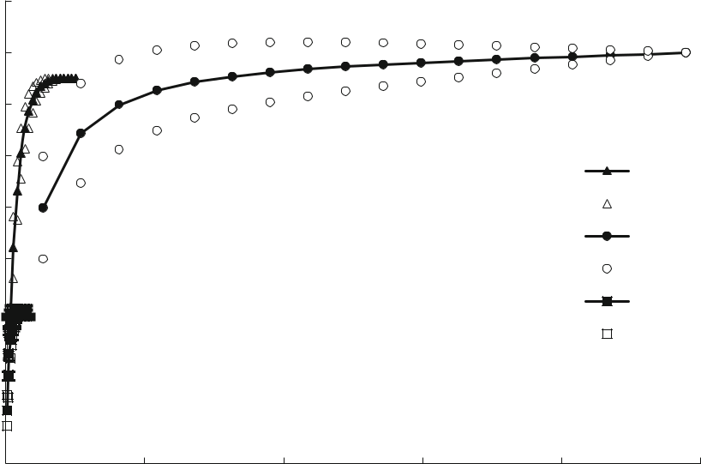

No. of individuals

Fig. 1 Rarefaction curves, scaled by number of individuals, comparing observed family richness of benthic macroinverte-brates between open water samples (O) and under water lettuce canopy treated with the agent N. affinis (N) and left at 100%

cover (W). Non-overlapping 95% confidence interval bands indicate significant differences (P \ 0.05) between the three curves

further indicated that the macroinvertebrate assem-blages were varied between treatments over time (Pseudo-F10,65 = 1.766, P =0.0021). There was evi-dence of macroinvertebrate assemblage homogeniza-tion during the study, where treatments inoculated by water lettuce (both the water lettuce and biocontrol) revealed similarity in macroinvertebrate composition (or no taxa difference) (PERMDISP, P [ 0.05) (Table 2). Macroinvertebrate assemblages between the water lettuce and biocontrol treatments together with the open water treatment were heterogeneous (PERMDISP, P \ 0.05). In terms of similarity per-centages of species contributions, the SIMPER anal-ysis indicated that the least similar assemblages were between the water lettuce and open water treatment, followed by the water lettuce and biocontrol treat-ments, while the most similar were between the biocontrol and open water treatments (Table 2).

Discussion

This study has shown that the invasion by the alien aquatic weed, P. stratiotes, significantly reduced water quality through a reduction in dissolved oxygen

concentration, and consequently benthic biodiversity, supporting the findings of Midgley et al. (2006), Coetzee et al. (2014) and Motitsoe et al. (2020) who showed similar results with water hyacinth and salvinia in South Africa. In addition, Stiers et al. (2011) reported the negative effects of three alien invasive macrophytes in Europe (i.e. Hydrocotyle ranunculoides L.f. (Araliaceae), Ludwigia grandiflora (Michx.) Greuter & Burdet (Onagraceae) and M. aquaticum) on both native plant and macroinverte-brate diversity. Although these findings might seem intuitive, there are very few studies that have quan-tified the impacts of floating macrophytes empirically. The review by Kettenring and Adams (2011) high-lighted that the majority of alien aquatic weed management studies lack evaluation of native biodi-versity recovery following removal of the weeds. The results of this study have demonstrated the recovery of macroinvertebrate assemblage diversity as a result of biological control, and thus, biological control of floating alien aquatic weeds is a reliable option for aquatic ecosystem recovery when implementing inte-grated alien aquatic weed management that includes post-control restoration, as proposed by Prior et al. (2018). The significance of this study is that it justifies,

123

Hydrobiologia

|  |  |  |  |  |  |  |  |  |  |
| --- | --- | --- | --- | --- | --- | --- | --- | --- | --- |
| **A** 14 | |  |  |  |  |  |  |  |  |
|  | 12 |  |  |  |  |  |  |  |  |
| (S) | 10 |  |  |  |  |  |  | b |  |
|  |  |  |  |  |  |  |  |  |
| of families | 8 |  |  |  |  |  |  |  |  |
| 6 |  |  |  |  |  |  |  |  |
| No. | 4 | a { |  |  |  |  |  | a |  |
|  |  |  |  |  |  |  |
|  |  |  |  |  |  |  |  |
|  | 2 |  |  |  |  |  |  | c |  |
|  | 0 | 31 Jan | 7 March | 25 April | 6 June | 18 July | 1 Sept | 15 Oct |  |
|  |  |  |
| **B** 1000 | |  |  |  |  |  |  |  |  |
|  | 900 |  |  |  |  |  |  |  |  |
|  | 800 |  |  |  |  |  |  |  |  |
|  | 700 |  |  |  |  |  |  |  |  |
| Abundance | 600 |  |  |  |  |  |  |  |  |
| 500 |  |  |  |  |  |  |  |  |
| 400 |  |  |  |  |  |  |  |  |
|  |  |  |  |  |  |  |  |  |
|  | 300 |  |  |  |  |  |  |  |  |
|  | 200 |  |  |  |  |  |  | b |  |
|  |  |  |  |  |  |  |  |  |
|  | 100 | a { |  |  |  |  |  | } a |  |
|  | 0 |  |  |  |  |  |  |
|  |  |  |  |  |  |  |  |
|  |  | 31 Jan | 7 March | 25 April | 6 June | 18 July | 1 Sept | 15 Oct |  |
| **C** |  |  |  |  |  |  |  |  |  |

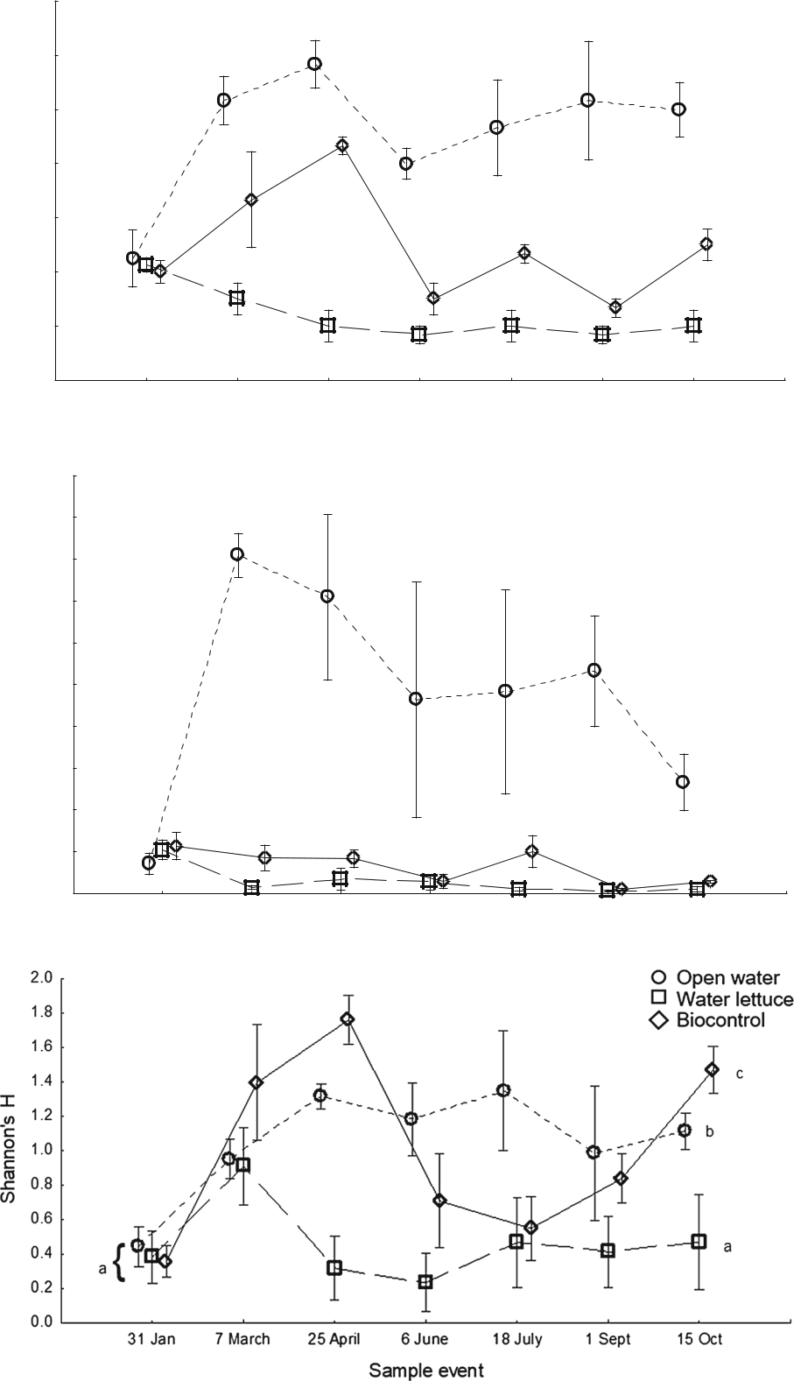

123

Hydrobiologia

|  |  |  |
| --- | --- | --- |
| bFig. 2 Comparison of measures of diversity of aquatic | to detect the effects of P. stratiotes and its subsequent |  |
| macroinvertebrate communities between open water samples | biological control. The lower abundance and diversity |  |
| (circle), and under Pistia stratiotes canopy treated with the agent |  |
| of the benthic macroinvertebrate community under a |  |
| Neohydronomus affinis (Biocontrol-square) and left at 100% |  |
| total coverage of P. stratiotes were the result of |  |
| cover (Water lettuce-diamond). A Family richness (S), B abun- |  |
| dance (N), C Shannon’s Diversity Index (H). Means compared | reduced light penetration into the water column, and |  |
| by Repeated Measures ANOVAs, error bars represent S.E., | subsequent lower levels of dissolved oxygen concen- |  |
| different letters represent significant differences (P \ 0.05) |  |
| trations. The shading effect of the invasive mats was |  |
| (only ‘before’ and final sample event differences are indicated |  |
| an important abiotic barrier that contributed to poor |  |
| by the letters to reduce clutter) |  |
|  | water quality, reduced system productivity and aquatic |  |
| ecologically, the necessity to control floating aquatic | biodiversity, leading to biotic homogenization. Only |  |
| disturbance tolerant groups such as the ostracods, |  |
| weeds in South Africa and globally where they have |  |
| Physidae (bladder snails) and annelid worms were |  |
| been introduced. |  |
| present under mats, while more sensitive groups such |  |
| The use of macroinvertebrate diversity indices and |  |
| as the mayflies and dragonflies were excluded (Day & |  |
| assemblage similarity analyses were sensitive enough |  |
|  |  |

**A**

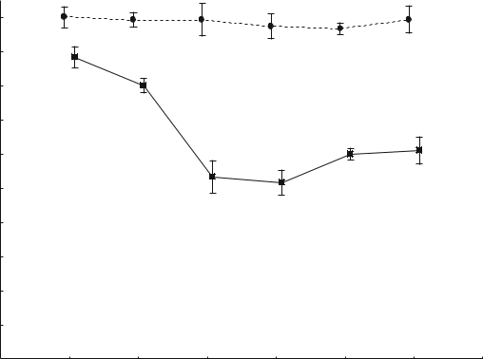

|  |  |  |  |  |  |
| --- | --- | --- | --- | --- | --- |
|  | 100 |  |  | } a |  |
|  | a |  |  |  |  |
|  | 90 |  |  |  |  |
|  | a |  |  |  |  |
| cover | 80 |  |  |  |  |
| 70 |  | b | b |  |
| lettuce | 50 | b |  |  |
|  | 60 | b |  |  |
|  |  |  |  |
| water | 40 |  |  |  |  |
|  |  |  |  |  |
| % | 30 |  |  |  |  |
| 20 |  |  |  |  |
|  |  |  |  |  |
|  | 10 |  |  |  |  |
|  | 0 | 6 June 18 July 1 Sept | | 15 Oct |  |
|  | 7 March 25 April |  |
|  |  | Sample event | | Water lettuce |  |
|  |  | Biocontrol |  |



1. 12

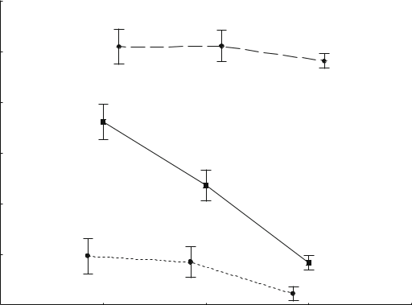

|  |  |  |  |  |  |  |
| --- | --- | --- | --- | --- | --- | --- |
|  |  | a | a |  |  |  |
|  | 10 |  |  | a |  |  |
|  |  |  |  |  |  |
|  | 8 | b |  |  |  |  |
|  |  |  |  |  |  |
| mg/l | 6 |  |  |  |  |  |
| DO |  | b |  |  |  |
|  |  |  |  |  |
|  |  |  |  |  |  |
|  | 4 |  |  |  |  |  |
|  |  | c | c |  |  |  |
|  | 2 |  | c |  |  |
|  |  |  |  |  |
|  |  |  |  |  |  |
|  |  |  |  | c |  |  |
|  | 0 | 7 March | 6 June | 1 Sept | Water lettuce |  |
|  |  |  |
|  |  | Biocontrol |  |
|  |  |  | Sample Event |  |  |
|  |  |  |  | Open water |  |



**C**

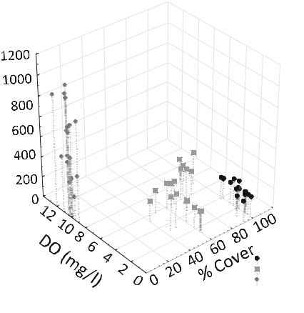

Water lettuce

Biocontrol

Open water

Fig. 3 A Percent water lettuce cover over six, 6-week sample events. B Dissolved oxygen (DO) content (mg/l) of water from three treatments, recorded every second sampling event. Means compared by Repeated Measures ANOVA, error bars represent

S.E. Different letters indicate significant differences, P \ 0.05. C Positive exponential relationship between DO (mg/l), and a negative exponential relationship between water lettuce cover and macroinvertebrate abundance, from three treatments

123

Hydrobiologia

de Moor, 2002). Reductions in dissolved oxygen as a consequence of floating plant infestations are not only reported to decrease macroinvertebrate abundance but also reduce ecosystem productivity (Rommens et al., 2003; Mangas-Ramirez & Elias-Gutierrez, 2004; Perna & Burrows, 2005), which has consequences for higher trophic level structure and functioning. By quantifying the changes in biodiversity indices and assemblage structures as a result of macrophyte invasion, and subsequent biological control which eliminated an abiotic barrier (i.e. shade), we have

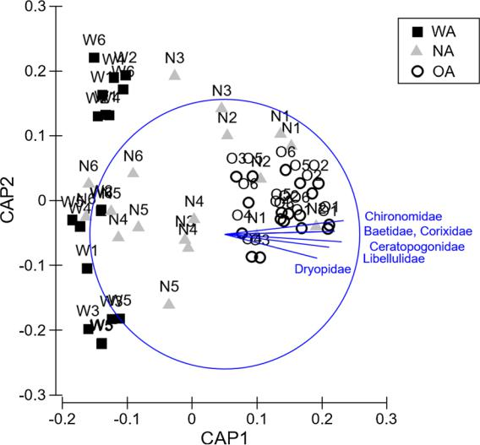

Fig. 4 Canonical analysis of principal coordinates (CAP) ordinations indicating distinct differences in macroinvertebrate assemblages found beneath water lettuce mats (WA), beneath mats treated with the biological control agent N. affinis (NA) and those from open water (OA), over seven 6-week sampling events (0–6). CAP1 eigenvector r 2 = 0.94, CAP2 eigenvector r 2 = 0.61, where r 2 = the amount of variation explained by the canonical axis. The four taxa that contributed to the differences in assemblage structure, with R = 0.7, are indicated

Table 2 Macroinvertebrate assemblage ANOSIM and PERM-DISP pairwise comparison tests between treatments at the end of the study period (significant R and t statistics in bold), and

demonstrated that biotic homogenization as a result of invasion can be reversed.

Macrophytes play an important role in ecosystem structure and functioning, thus changes in their composition and structural complexity directly influ-ence macroinvertebrate assemblage composition (Schultz & Dibble, 2012). In the case of alien macrophyte invasion and associated knock-on effects, macroinvertebrate assemblage compositions shift towards dominance by more tolerant taxa, reducing functional diversity. In this study, macroinvertebrate assemblage composition between the open water and invaded treatments were completely different, in comparison to the biocontrol and open water treat-ments, which shared more taxa and were more similar in assemblage composition. In comparison, Stiers et al. (2011) showed that three invaded systems were similar in terms of macroinvertebrate composition, in contrast to the control site. Furthermore, Oligochaeta and Chironomidae contributed more than 50% and 15% of the total macroinvertebrate abundance in the invaded sites, respectively (Stiers et al., 2011), while Oligochaeta and Hirudinea were more abundant in both the water lettuce and biocontrol treatments in this study, indicating the lowered quality of the invaded habitat. On the other hand, the abundance of Baetidae, Caenidae, Libellulidae and Gomphidae in the open water treatment is explained by their ecology, these taxa are sensitive to low DO concentration and are widely accepted as biological indicators for poor water quality (Dickens & Graham, 2002). Additionally, Dytiscidae and Physidae are air-breathers, explaining their abundance in the open water treatment where they had access to oxygen at the water’s surface.

While the presence of large mats of invasive floating aquatic plants such as P. stratiotes are known

the similarity percentages of species contributions computed in SIMPER analysis

|  |  |  |  |  |  |
| --- | --- | --- | --- | --- | --- |
| Treatments | R statistic (significance | | Pairwise PERMDISP test t value (significance | | Average similarity |
|  | level) |  | level) |  | % |
|  |  |  |  | |  |
| Water | 0.153 | (0.003) | 0.297 (0.776) | | 22.12 |
| lettuce 9 biocontrol |  |  |  |  |  |
| Water lettuce 9 open | 0.613 | (0.001) | 7.078 | (0.001) | 13.6 |
| water |  |  |  |  |  |
| Biocontrol 9 open water | 0.293 | (0.001) | 9.239 | (0.001) | 35.1 |
|  |  |  |  |  |  |

123

Hydrobiologia

to reduce aquatic ecosystem diversity, to date, the only study we are aware of that has categorically demon-strated the biodiversity benefits of reductions in standing cover due to the action of biological control agents is Motitsoe et al. (2020) who investigated biodiversity recovery following biological control of S. molesta. The biological control programme against P. stratiotes using the weevil, N. affinis, has been successful in many parts of the world (Diop & Hill, 2009; Neuenschwander et al., 2009; Moore & Hill, 2012), thereby contributing to improving aquatic ecosystem functioning through biodiversity recovery. In this study, although the introduction of N. affinis only resulted in a maximum of 50% reduction in cover of P. stratiotes over the duration of this study, there was a significant recovery of benthic macroinverte-brate biodiversity in comparison to the 100% covered treatment, but not to the level of the open control. This is likely to be due to the increase in allochthonous detritus rain as a result of plant death caused by biological control, which reduced dissolved oxygen concentrations in the pools. This suggests that the experiment should have been run for far longer to attain a higher level of control before the ecosystem could fully recover. However, even though biological control resulted in only a 50% reduction of the P. stratiotes mat over a 10-month period, many of the more sensitive groups such as mayflies, dragonflies and hemipterans had returned. Paterson et al. (2011) showed that in the case of the invasive vine, Pereskia aculeata Miller (Cactaceae), an 80% reduction in canopy cover was required before plant biodiversity had recovered in comparison to uninvaded sites. Similarly, it is possible that the threshold level for complete restoration of the aquatic ecosystem, post-control of P. stratiotes, is higher than 50%.

Samways & Sharratt (2010) showed that dragonfly assemblages that had been impacted by alien invasive riparian vegetation in rivers in the Western Cape of South Africa recovered quickly once the vegetation had been removed. Similarly, here we have shown that aquatic ecosystems can recover after effective biolog-ical control of floating alien macrophytes. Macroin-vertebrates were once again reliable biological indicators able to detect abiotic filters, thereby demonstrating the homogenization effect by P. stra-tiotes. The application of biological control by the weevil, N. affinis facilitated ecosystem biological and functional diversity recovery, supporting this control

method in invasive aquatic species management. The important point is that while biological control does enhance biodiversity recovery, the process is a long-term intervention (Neuenschwander et al., 2009), and although the biological control of waterweeds has historically occurred in much shorter time frames (2–5 years) (Hill & Coetzee, 2017b) than terrestrial weeds, these biodiversity benefits will be short-lived in impacted ecosystems unless an integrated catch-ment management approach is adopted which addresses eutrophication and changes in hydrological flow regimes. If the primary driver of disturbance in aquatic ecosystems is not addressed, we anticipate, rather than control and restoration, a succession of invasions by a suite of waterweeds (Coetzee et al., 2011; Strange et al., 2019), which will further drive biotic homogenization of aquatic ecosystems.

Acknowledgements This research was funded through the Department of Environmental Affairs, Natural Resource Management Programme’s Working for Water programme. Further funding for this work was provided by the South African Research Chairs Initiative of the Department of Science and Technology and the National Research Foundation of South Africa. Any opinion, finding, conclusion or recommendation expressed in this material is that of the authors and the NRF does not accept any liability in this regard.

References

Anderson, M. J., R. N. Gorley & K. R. Clarke, 2008. PER-MANOVA ? for PRIMER: guide to software and statis-tical methods. PRIMER-E, Plymouth.

Cilliers, C. J., 1987. First attempt at and early results on the biological control of Pistia stratiotes L. in South Africa. Koedoe 30: 35–40.

Cilliers, C.J., 1999. Biological control of parrot’s feather, Myriophyllum aquaticum (Vell.) Verdc. (Haloragaceae), in South Africa, in Olckers, T., Hill, M.P. (Eds), Biological Control of Weeds in South Africa (1990–1998). African Entomology Memoir 1: 113–118.

Clarke, K. R. & R. N. Gorley, 2006. PRIMER v6: user manual.

PRIMER-E, Plymouth.

Coetzee, J. A., M. P. Hill, M. J. Byrne & A. Bownes, 2011. A review of the biological control programmes on Eichhor-nia crassipes (C. Mart.) Solms (Pontederiacaeae), Salvinia molesta D.S.Mitch. (Salviniaceae), Pistia stratiotes L. (Araceae), Myriophyllum aquaticum (Vell.) Verdc. (Haloragaceae) and Azolla filiculoides Lam. (Azollaceae) in South Africa. African Entomology 19: 451–468.

Coetzee, J. A., R. W. Jones & M. P. Hill, 2014. Water hyacinth, Eichhornia crassipes (Mart.) Solms-Laub. (Pontederi-aceae), reduces benthic macroinvertebrate diversity in a

123

Hydrobiologia

protected subtropical lake in South Africa. Biodiversity Conservation 23: 1319–1330.

Colwell, R.K., 2013. EstimateS: Statistical estimation of species richness and shared species from samples. Version 9. Persistent URL <http://purl.oclc.org/estimates>.

Cummins, K. W. & M. J. Klug, 1979. Feeding ecology of stream invertebrates. Annual Review in Ecology and Systematics 10: 147–172.

Day, J.A., & I.J. De Moor, 2002. Guides to the Freshwater Invertebrates of Southern Africa. Volume 6: Arachnida and Mollusca, WRC Report No. TT 182/02.

Day, J.A., A.D. Harrison, & I.J. De Moor, 2003. Guides to the Freshwater Invertebrates of Southern Africa. Volume 9: Diptera. WRC Report No. TT 201/02.

De Groote, H., O. Ajuonu, S. Attignon, R. Djessou & P. Neuenschwander, 2003. Economic impact of biological control of water hyacinth in Southern Benin. Ecological Economics 45: 105–117.

DeLoach, C. J., A. D. DeLoach & H. A. Cordo, 1976. Neohy-dronomus pulchellus, a weevil attacking Pistia stratiotes in South America: biology and host specificity. Annals of the Entomological Society of America 69: 830–834.

De Moor, I.J., J.A. Day & F.C. De Moor, 2003a. Guides to the Freshwater Invertebrates of Southern Africa. Volume 7: Insecta I. WRC Report No. TT 207/03.

De Moor, I.J., J.A. Day & F.C. De Moor, 2003b. Guides to the Freshwater Invertebrates of Southern Africa. Volume 7: Insecta II. WRC Report No. TT 207/03.

Dickens, C. W. & P. M. Graham, 2002. The South African Scoring System (SASS) Version 5 Rapid Bioassessment Method for Rivers. African Journal of Aquatic Science 27: 1–10.

Diop, O. & M. P. Hill, 2009. Quantitative post-release evalua-tion of biological control of Pistia stratiotes Linnaeus (Araceae) by the weevil Neohydronomus affinis Hustache (Coleoptera: Curculionidae) in Senegal. African Journal of Aquatic Science 34: 35–44.

Diop, O., J. A. Coetzee & M. P. Hill, 2010. Impact of different densities of Neohydronomus affinis (Coleoptera: Cuculionidae) on Pistia stratiotes (Araceae) under labo-ratory conditions. African Journal of Aquatic Science 32: 267–271.

Doeleman, J. A., 1989. Biological control of Salvinia molesta in Sri Lanka: an assessment of costs and benefits. ACIAR Technical Reports 12: 1–14.

Dudgeon, D., A. H. Arthington, M. O. Gessner, Z.-I. Kawabata, D. J. Knowler, C. Le´veˆque, R. J. Naiman, A. H. Prieur-Richard, D. Soto, M. L. J. Stiassny & C. A. Sullivan, 2006. Freshwater biodiversity: importance, threats, status and conservation challenges. Biological Reviews 81: 163–182.

Hawking, J.H., L.M. Smith, & K. Le Busque, 2013. Identifica-tion and Ecology of Australian Freshwater Invertebrates. Murray-Darling Freshwater Research Centre. Retrieved from <http://www.mdfrc.org.au/bugguide>, Version January 2009, Accessed August 10, 2019.

Hill, M. P., 2003. The impact and control of alien aquatic veg-etation in South African aquatic ecosystems. African Journal of Aquatic Science 28: 19–24.

Hill, M.P. & J.A. Coetzee, 2017a. Chapter 7. Biological control of waterhyacinth restores ecosystem functioning to an impoundment in South Africa. In: van Driesche, & R.C.

Reardon (eds). Suppressing Over-abundant Invasive Plants and Insects in Natural Areas by Use of Their Specialized Natural Enemies. The Forest Health Technology Enter-prise Team (FHTET), FHTET-2017-02. Pp. 48–52.

Hill, M. P. & J. A. Coetzee, 2017b. The biological control of aquatic weeds in South Africa: current status and future challenges. Bothalia 47: 1–12.

Hill, M. P. & A. J. McConnachie, 2009. Azolla filiculoides. In Muniappan, R., G. V. P. Reddy, A. Raman & V. P. Gandhi (eds.), Weed Biological Control with Arthropods in the Tropics. Cambridge University Press, Cambridge: 74–87.

Hussner, A., 2014. Long-term macrophyte mapping documents a continuously shift from native to non-native aquatic plant dominance in the thermally abnormal River Erft (North Rhine-Westphalia, Germany). Limnologica 48: 39–45.

Kettenring, K. M. & C. R. Adams, 2011. Lessons learned from invasive plant control experiments: a systematic review and meta-analysis. Journal of Applied Ecology 48: 970–979.

Lambert, A. M., T. L. Dudley & K. Saltonstall, 2010. Ecology and impacts of the large-statured invasive grasses Arundo donax and Phragmites australis in North America. Inva-sive Plant Science and Management 3: 489–494.

Magurran, A. E., 2004. Measuring Biological Diversity.

Blackwell Science Ltd., Oxford.

Mailu, A.M., 2001. Preliminary Assessment of the Social, Economic and Environmental Impacts of Water Hyacinth in the Lake Victoria Basin and the Status of Control. In Julien, M.H., M.P. Hill, T.D. Center & D. Jianqing (eds), Biological and Integrated Control of Water Hyacinth, Eichhornia crassipes. ACIAR Proceedings 102: 130-139.

Mangas-Ramirez, E. & M. Elias-Gutierrez, 2004. Effect of mechanical removal of water hyacinth (Eichhornia cras-sipes) on the water quality and biological communities in a Mexican reservoir. Journal of Aquatic Health Management 7: 161–168.

McConnachie, A. J., M. P. de Wit, M. P. Hill & M. J. Byrne, 2003. Economic evaluation of the successful biological control of Azolla filiculoides in South Africa. Biological Control 28: 25–32.

McDermond-Spies, N., D. Broman, A. Brantner & K. Larsen, 2014. Family-level benthic macroinvertebrate communi-ties indicate successful relocation and restoration of a Northeast Iowa stream. Ecological Restoration 32: 161–170.

McFadyen, R. E., 1998. Biological control of weeds. Annual Review of Entomology 43: 369–393.

Merritt, R. W., K. W. Cummins & M. Berg, 2008. An intro-duction to the aquatic insects of North America. Kendall/ Hunt Publishing Company, Iowa.

Midgley, J. M., M. P. Hill & M. H. Villet, 2006. The effect of water hyacinth, Eichhornia crassipes (Martius) Solms-Laubach (Pontederiaceae), on benthic biodiversity in two impoundments on the New Year’s River, South Africa. African Journal of Aquatic Science 31: 25–30.

Moore, G. R. & M. P. Hill, 2012. A quantitative post-release evaluation of biological control of water lettuce, Pistia stratiotes L. (Araceae) by the weevil Neohydronomus affinis Hustache (Coleoptera: Curculionidae) at Cape Recife Nature Reserve, Eastern Cape Province. South Africa. African Entomology 20: 380–385.

123

Hydrobiologia

Motitsoe, S. N., J. A. Coetzee, M. J. Hill & M. P. Hill, 2020. Biological control of Salvinia molesta (D.S. Mitchell) drives aquatic ecosystem recovery. Diversity 12: 204.

Neuenschwander, P., M. H. Julien, T. D. Center & M. P. Hill, 2009. Pistia stratiotes. In Muniappan, R., G. V. P. Reddy, A. Raman & V. P. Gandhi (eds.), Weed Biological Control with Arthropods in the Tropics. Cambridge University Press, Cambridge: 332–352.

Palmer, C. G., B. Maart, A. R. Palmer & J. H. O’Keeffe, 1996. An assessment of macroinvertebrate functional feeding groups as water quality indicators in the Buffalo River, eastern Cape Province, South Africa. Hydrobiologia 318: 153–164.

Paterson, I. D., J. A. Coetzee, M. P. Hill & D. A. Downie, 2011. A pre-release assessment of the relationship between the invasive alien plant Pereskia aculeata Miller (Cactaceae), and native plant biodiversity in South Africa. Biological Control 57: 59–65.

Perna, C. & D. Burrows, 2005. Improved dissolved oxygen status following removal of exotic weed mats in important fish habitat lagoons of the tropical Burdekin River flood-plain, Australia. Marine Pollution Bulletin 51: 138–148.

Prior, K. M., D. C. Adams, K. D. Klepzig & J. Hulcr, 2018. When does invasive species removal lead to ecological recovery? Implications for management success. Biologi-cal Invasions 20: 267–283.

Rahel, F. J., 2002. Homogenization of freshwater faunas.

Annual Review of Ecology and Systematics 33: 291–315.

Ricciardi, A. & H. J. MacIsaac, 2011. Impacts of Biological Invasions on Freshwater Ecosystems. In Richardson, D. M. (ed.), Fifty Years of Invasion Ecology: The Legacy of Charles Elton. Wiley-Blackwell, New Jersey: 456.

Rommens, W., J. Maes, N. Dekeza, P. Inghelbrecht, T. Nhi-watiwa, E. Holsters, F. Ollevier, B. Marshall & L. Bren-donck, 2003. The impact of water hyacinth (Eichhornia crassipes) in a eutrophic subtropical impoundment (Lake Chivero, Zimbabwe). I. Water quality. Archiv fur Hydro-biologie 158: 373–388.

Samways, M. J. & N. J. Sharratt, 2010. Recovery of endemic dragonflies after removal of invasive alien trees. Conser-vation Biology 24(1): 267–277.

Schultz, R. & E. Dibble, 2012. Effects of invasive macrophytes on freshwater fish and macroinvertebrate communities: the role of invasive plant traits. Hydrobiologia 684: 1–14.

Stiers, I., N. Crohain, G. Josens & L. Triest, 2011. Impact of three aquatic invasive species on native plants and macroinvertebrates in temperate ponds. Biological Inva-sions 13: 2715–2726.

Strange, E. F., P. Landi, J. M. Hill & J. A. Coetzee, 2019. Modelling top-down and bottom-up drivers of a regime shift in invasive aquatic plant stable states. Frontiers in Plant Science 10: 889. [https://doi.org/10.3389/fpls.2019.](https://doi.org/10.3389/fpls.2019.00889) [00889](https://doi.org/10.3389/fpls.2019.00889).

Thirion, C., 2000. A new biomonitoring protocol to determine the ecological health of impoundments, using artificial substrates. African Journal of Aquatic Science 25: 123–133.

Thomaz, S. M., R. P. Mormul & T. S. Michelan, 2015. Propagule pressure, invasibility of aquatic ecosystems by non-native macrophytes and their impacts on populations, communities and ecosystems: a review of tropical fresh-water ecosystems. Hydrobiologia 746: 39–59.

Villamagna, A. M. & B. R. Murphy, 2010. Ecological and socio-economic impacts of invasive water hyacinth (Eichhornia crassipes): a review. Freshwater Biology 55: 282–298.

Wainger, L. A., N. E. Harms, C. Magen, D. Liang, G. M. Nesslage, A. M. McMurray & A. F. Cofrancesco, 2018. Evidence-based economic analysis demonstrates that ecosystem service benefits of water hyacinth management greatly exceed research and control costs. PeerJ 6: e4824.

Winston, R.L., M. Schwarzla¨nder, H.L. Hinz, M.D. Day, M.J.W. Cock, & M.H. Julien (eds), 2014. Biological Control of Weeds: A World Catalogue of Agents and Their Target Weeds, 5th edition. USDA Forest Service, Forest Health Technology Enterprise Team, Morgantown, West Virginia. FHTET-2014-04. 838 pp.

Publisher’s Note Springer Nature remains neutral with regard to jurisdictional claims in published maps and institutional affiliations.

123