Biodiversity and Conservation

<https://doi.org/10.1007/s10531-020-02029-y>

ORIGINAL PAPER



Geospatial analysis to assess distribution patterns and predictive models for endangered plant species to support management decisions: a case study in the Balearic Islands

Joana Cursach1  • Antoni Josep Far1 • Maurici Ruiz2

Received: 18 December 2019 / Revised: 25 July 2020 / Accepted: 30 July 2020

Springer Nature B.V. 2020

Abstract

Species distribution modelling (SDM) has been used to support biodiversity management in recent years. However, the use of SDM at small scales with geolocation systems to obtain high-accuracy location data remains unexplored. In this study, we focused on Euphorbia fontqueriana, an endangered species to Mallorca (western Mediterranean basin), and we aimed to assess the spatial distribution patterns, and to generate a distri-bution map of the habitat suitability in a wider area. A differential GPS was used to geolocate all the ramets. We used the global Moran’s I index and local Getis Ord-Gi* method to assess the spatial patterns. We pre-selected derived topographic variables that were generated from LiDAR data (elevation, slope, northness and eastness), the connec-tivity index, normalised difference vegetation index, and soil type, as the environmental (predictor) variables. In addition, we ran the Maxent model using 1603 occurrence loca-tions and seven environmental variables at a resolution of 2 9 2 m in grid size. The population consisted of 1625 ramets that were clustered (global Moran’s I index = 0.161, z score = 16.599, p value \ 0.001) in several hotspots (i.e. areas with high plant density that were surrounded by areas with high plant densities). The Maxent model, which showed a good performance (AUC training score = 0.977), generated a habitat suitability map that displayed zones of high suitability in other areas away from the natural geographical area. Finally, we discuss the usefulness of this study to guide management purposes.

Keywords Narrow endemic plants Western Mediterranean basin Euphorbia fontqueriana Real-time kinematic global positioning systems Spatial autocorrelation Maxent Species distribution modelling LiDAR Threatened plant management

Communicated by Daniel Sanchez Mata.

* Joana Cursach joana.cursach@uib.es

1

2

Department of Biology, Laboratory of Botany, Research Group on Plant Biology under Mediterranean Conditions, University of the Balearic Islands, Cra. Valldemossa, km 7.5, 07122 Palma, Balearic Islands, Spain

Department of Geography/Geographical Information Systems and Remote Sensing Service, University of the Balearic Islands, Cra. Valldemossa, km 7.5, 07112 Palma, Spain

123



Biodiversity and Conservation

Introduction

Assessments of the distributions of threatened plant species are of critical importance for improving the efficiency of conservation efforts (Williams et al. 2009), and species dis-tribution models (SDMs) are a valuable aid in the optimisation of these efforts (Fois et al. 2015). SDMs are currently the main tools that predict the spatial distribution of the environmental suitability for species, and they have been recently used in a large number of scientific studies (Guisan and Zimmermann 2000; Guisan et al. 2013; Booth 2018). Indeed, SDMs have been used as tools for exploring ecological characteristics as well as providing support for conservation decision-making: e.g., guiding field surveys to search for new populations (Williams et al. 2009; Fois et al. 2015; Papes¸ et al. 2016), modelling suitable habitats to consider in translocation programmes (Borthakur et al. 2018; Swart et al. 2018) or defining the limits of protected areas (Salinas-Rodrı´guez et al. 2018; Spiers et al. 2018).

Among the SDM techniques, Maxent is one of the best options when working with species with narrow distribution ranges. Maxent, which is a self-contained Java application for SDMs based on occurrence records along with environmental variables, estimates the potential distribution of a species by identifying the distribution that has the maximum entropy (i.e., is closest to geographically uniform) and is constrained in such a way that the expected values for the predictor variables match their averages at the recorded occurrence locations (Elith et al. 2011; Phillips et al. 2006; Phillips and Dudı´k 2008). Modelling techniques based on presence-only records have limitations due to some factors that affect absences: the proportion of occupied sites (that is, the prevalence) is not identifiable from the presence-only data, and the sample selection bias (that is, some areas are sampled more intensively than others) has a stronger effect on the presence-only models (Elith et al. 2011; Phillips and Dudı´k 2008). Thus, the use of Maxent is a good modelling technique for rare species for which data tend to be scarce. Indeed, the Maxent modelling technique has consistently performed well in comparison with alternative modelling methods, and it is an appropriate model choice when the sample size is small and the locality records are relatively few (Fois et al. 2015; Swart et al. 2018). Nevertheless, the lack of a surveyed locality would still affect model performance (Pearson et al. 2007; Wisz et al. 2008).

Censuses of plant species in constrained environments are highly demanding regarding the geographic accuracy of the information. In this sense, it is necessary to use geo-positioning systems based on satellites (global navigation satellite systems, GNSS) to capture the presence of species. Many studies dealing with species distribution modelling have used geolocation systems to geolocate the individuals of the target species (Williams et al. 2009; Gogol-Prokurat 2011; West et al. 2016; Borthakur et al. 2018) but with geolocation systems that have error levels of several metres in the geolocation. In this field, it is relevant to highlight the use of real-time kinematic global positioning systems (RTK-GPS), which provide an error level of centimetres that allows individuals to be accurately located (Leica Geosystems 2013). This technology would be especially interesting for species with narrow distribution ranges or with specific habitat requirements. To our knowledge, no studies have focused on a small scale modelling nor using geolocation systems to obtain occurrence data with such accuracy.

In this study, we focused on Euphorbia fontqueriana, a narrow endemic species to Mallorca (Balearic Islands, western Mediterranean basin), that is catalogued as being in danger of extinction (BOIB no. 131, 26/10/2017). There is only one natural population located on Mac¸anella mountain in the Serra de Tramuntana, a protected region that has

123

Biodiversity and Conservation

been catalogued as cultural landscape and was declared a World Heritage site (UNESCO 2011). Albert and Iriondo (2009) reported a weak declining trend (the mean k for 2001–2006 was 0.969), a small number of reproductive individuals (117 in 2001) and no seedling recruitment. However, there are no data about the population size or the accurate distribution of the population. Due to the conservation status of the species, the environ-mental authority performed a pilot conservation translocation in 2014 in the Puig Major area, a few kilometres away from the natural location (Sa´ez et al. 2017).

The main aims of this study were (i) to generate a distribution map of the whole population of E. fontqueriana with accurate geolocation (error \ 0.05 m) of all individ-uals, (ii) to characterise the population in terms of the biological status and sizes of the individuals, (iii) to detect the geographic distribution patterns of the species and their relationships with the environmental variables of the biotope, and (iv) to predict the presence of the species in a wider area of Mallorca for management purposes. The development of this study required highly demanding fieldwork and the design of a GIS database to store geographic data related to the geolocation of all individuals to generate environmental predictor variables in the study area to support the geostatistical analysis and predictive models as well as a mapping tool.

Materials and methods

Study species

Euphorbia fontqueriana is a small perennial rhizomatous plant that is approximately 5–10 cm in high, with several slender and often procumbent branches (Greuter 1968). It has glaucous, smooth-edged, suborbicular and sessile leaves and up to 3 levels of branching (1–5 branches per level). The species blooms in mid-spring and disperses seeds in early summer and has distinctive purple nectariferous glands on the cyathium (Far 2019). The species was included in the community Arenario bolosii-Euphorbietum maresii Romo 1990, which occupy mountain scrub clearings and dry stony slopes where material is accumulated by geological agents (Llorens et al. 2007). Euphorbia fontqueriana is subject to two main threats: (i) the biotic threats are related to the small distributional area, demographic weakness and predation by goats, and (ii) the anthropogenic threats are related to the fact that the area is highly frequented by hikers (Sa´ez et al. 2017). In this regard, an official hiking route crosses the natural population.

Study area

Two geographical areas of study were defined: a small study area and a large study area (Fig. 1). The small study area, which had a dimension of approximately 400 9 400 m, corresponded to the geographical area of the natural population of the species. In this area, we analysed the distribution patterns of the species and the relationships with environ-mental variables. On the other hand, the large study area comprised a wider area of the Serra de Tramuntana, which included the summits (defined as zones above 1000 m asl) of the two highest mountains on Mallorca (Puig Major and Puig de Mac¸anella). In this large area, we developed a species distribution model to locate the potential areas of new populations (i.e., extant populations that have not been detected before) or suitable re-ception sites for the conservation translocations. The conceptual framework of the whole study is graphically represented in Fig. 2.

123

Biodiversity and Conservation

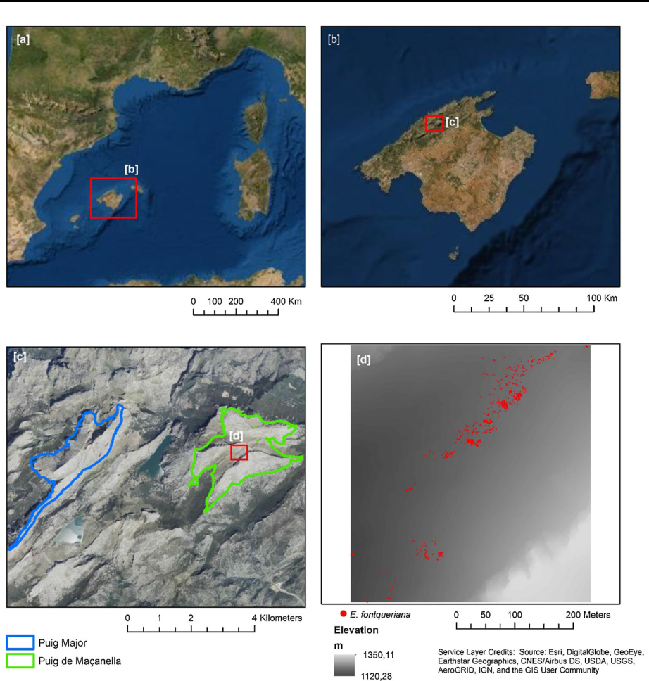

Fig. 1 Location of the study areas. Mallorca is an island located in the western Mediterranean basin (a); the large study area was located in the centre of the Serra de Tramuntana of Mallorca (b) and comprised the zones above 1000 m asl on the Puig Major and Mac¸anella mountains (c); and the small study area corresponded to the geographical area of the natural population, which was approximately 400 9 400 m (d). Due to the threatened status of the species and its concentration in a small but easily recognisable geographical area, we avoided showing precise coordinates of its location

Exhaustive census of the population

The natural population of E. fontqueriana was georeferenced integrally with high accuracy (error \ 0.05 m) using a differential GPS (Leica RX1200 RTK GPS) during the repro-ductive seasons of 2017 (3 sampling days) and 2018 (4 sampling days) (Fig. 2). Sampling in 2017 was performed during the fruiting period of the species (June–July), and sampling in 2018 was performed to complete the census of the population with individuals that have missed in 2017. Due to the rhizomatous character of the target species and the small scale used in this study, it was not possible to discriminate at the individual level, and we thus work at the ramet level (sensu Cook 1985). On each sampling day, we first marked the

123

Biodiversity and Conservation

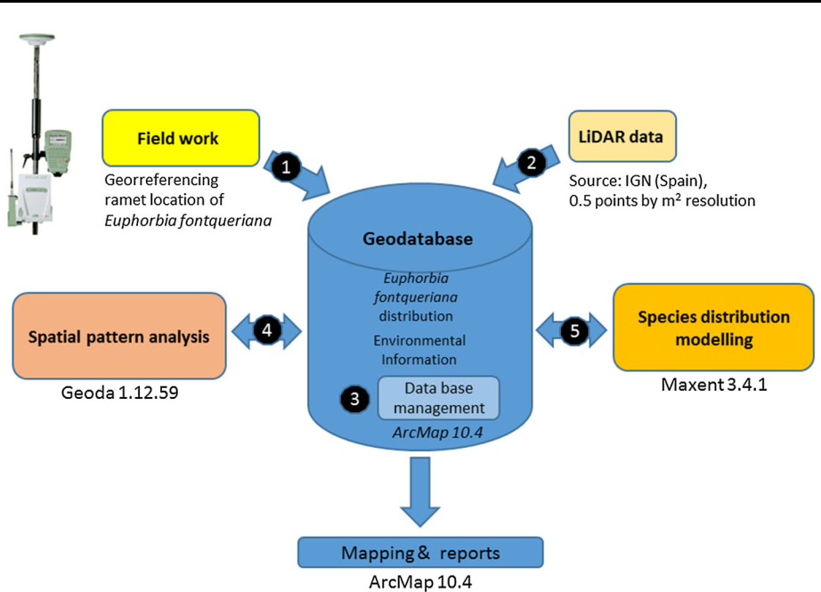

Fig. 2 Conceptual framework of the study. IGN: Spanish National Geographic Institute

ramets with visible labels, and we returned to take GPS points and data about their biological status (vegetative or reproductive) and plant size (no. of branches and length of the longest branch). Reproductive ramets were categorised into fructified and non-fructi-fied ramets (i.e., those that flowered but did not set fruit) as it is easy to recognise aborted cyathia and fructified or even dispersed cyathia in this species. We removed the label as the final step after each census. Data about the biological status and plant size were collected for each ramet on all census days in 2017 (which represented 77.8% of the all ramets of the population). All the geographic data about the locations of the ramets were stored in the GIS database for the study.

Geospatial pattern analysis

The analysis of the geographical pattern was performed with the location data collected in the small study area (Fig. 2). The software used for all statistical analyses and graphic representations was ArcMap version 10.4 (ESRI 2017). We first calculated the global Moran’s I index to test if the distribution pattern of E. fontqueriana was clustered, dis-persed or random. Moran’s statistic is an indicator of the global spatial autocorrelation, and it is a cross-product statistic between a variable and its spatial lag, with the variable expressed as the deviation from its mean (Anselin et al. 2006). The values range from - 1 (indicating perfect dispersion) to 1 (perfect correlation), and a value of 0 indicates a random spatial pattern. This index measures the spatial correlations based on the feature locations and attribute values. In this case, the attribute values were the numbers of ramets in a grid of 2 9 2 m. Moreover, the local Getis_Ord Gi* method (Getis and Ord 1992; Ord and Getis 1995) was used to analyse the clustering locations in the spatial distribution of the species. The method consists of comparing the local mean values and the global mean

123

Biodiversity and Conservation

values to assess the presence of spatial clusters with high or low values with respect to the mean value of the analysed series. Thus, significant positive z scores indicate a hot spot (i.e., clustering of high values), whereas negative z scores indicate a cold spot (i.e., clustering of low values).

Environmental variables as predictors of species presence

The biotope of the study area have limited environmental variability due to their small size and the occurrence locations in a relatively uniform environment. For this reason, it was challenging to find environmental variables that could determine the presence of the species. In this sense, we first considered that all the variables linked to the topography could be determinant in the differentiation of the geospatial units. To this end, LiDAR data from a Spanish National Geographic Institute (IGN) (average values at a resolution of 2 9 2 m) mapping initiative were used to generate derived topographic variables: eleva-tion, slope, aspect (see below), solar radiation, and a sediment connectivity index (index of connectivity, IC) (Cavalli et al. 2013) (Table 1). The IC is a unitless variable that allows the identification of areas with sediment deposition (high IC values) or flow (low IC values) in a watershed.

We converted the categorical variable of aspect into numerical variable (on a unitless scale of - 1 to 1) for analysis by transforming it into ‘‘northness’’ using the cosine function (northness = cosine (aspect in radians)) (positive values facing north, negative values facing south) and into ‘‘eastness’’ using the sinus function (eastness = sinus (aspect in

Table 1 Pre-selected environmental variables (predictors)

|  |  |  |  |  |  |
| --- | --- | --- | --- | --- | --- |
| Category | Predictor | Unit | Data | Grain | Data source |
|  |  |  | format |  |  |
|  |  |  |  |  |  |
| Climate | Solar radiation | Wh/m2 | Raster | 2 9 2 m | IGNa |
|  |  |  |  |  | (LiDAR |
|  |  |  |  |  | data) |
| Terrain | Elevation | m asl | Raster | 2 9 2 m IGN (LiDAR | |
|  |  |  |  |  | data) |
|  | Slope | Degrees | Raster | 2 9 2 m IGN (LiDAR | |
|  |  |  |  |  | data) |
|  | Aspect (northness and eastness) | Unitless scale of - 1 | Raster | 2 9 2 m IGN (LiDAR | |
|  |  | to 1 |  |  | data) |
|  | Index of connectivity (IC) | Unitless | Raster | 2 9 2 m Cavalli et al. | |
|  |  |  |  |  | (2013) |
| Vegetation | Normalized difference | Unitless | Raster | 2 9 2 m | IGN |
|  | vegetation index (NDVI) |  |  |  | PNOA2012 |
| Soil | Soil type | Categorical | Raster | 2 9 2 m | Vadell |
|  |  | (leptosol ? regosol |  |  | (2011) |
|  |  | vs. lithic leptosol) |  |  |  |

Abbreviation of the variables are given in brackets

aIGN: Spanish National Geographic Institute

123

Biodiversity and Conservation

radians)) (positive values facing east, negative values facing west) (Roberts 1986; Gogol-Prokurat 2011).

On the other hand, we considered that the presence of other vegetation in the study area could have relevance for the presence and abundance of the species. Thus, we calculated the normalised difference vegetation index (NDVI) (Pettorelli et al. 2005) from aerial photography of the study area provided by the IGN PNOA2012 (25 9 25 cm pixel res-olution), which included the four bands (red, blue, green and near-infrared bands). The NDVI is a greenness index obtained by dividing the divergence between the near-infrared and red reflectance measurements by their sums and is a measure of the photosynthetic capacity (Sellers 1985). Very low values of NDVI (0.1 and below) correspond to barren areas of rock, sand, or snow; moderate values represent shrubs and grassland (0.2 to 0.3); and high values indicate temperate and tropical rainforests (0.6 to 0.8) (Xie et al. 2010).

Finally, we also included the soil type as a predictor variable. A high-accuracy map of the soil types was not available for the study area, which was why we used a map with an original geographical scale of approximately 1:50.000 (Vadell 2011). This database con-tained soil type data according the soil typological unit (STU) codes of the World Ref-erence Base for Soil Resources. Due to the discrepancies in the resolutions and accuracies of the analysed environmental variables, the geographic base of the GIS data for all the variables was unified into a raster representation with a resolution of 2 9 2 m.

Multicollinearity analysis

We checked the multicollinearity between the predictor variables to eliminate the redun-dancies between the variables that would lead to collinearity problems in the predictive power (Fox 1997). We performed simple correlations tests in SPSS v. 25 (IMB Corp. 2016), and if the two predictor variables were found to be highly correlated (r [ 0.7), only one was included. The categorical variable (soil type) was excluded from the correlation tests because it could not be tested for collinearity.

Species distribution modelling

SDM was performed with Maxent version 3.4.1 (Phillips et al. 2006; Phillips et al. 2017; Phillips and Dudı´k 2008) (Fig. 2). We ran Maxent for the large study area for the envi-ronmental (predictor) variables (see above) with a 25% random test percentage and 1000 background points to create favourable model results (Phillips and Dudı´k 2008). We used a total of 1603 occurrence locations to run the Maxent model. We used the complementary logistic format, which was most suitable for calibrating the model, and its output can be interpreted as the relative environmental suitability of each pixel in relation to the back-ground of the study area (i.e., sites without presence information) (Phillips and Dudı´k 2008). For the model evaluation, Maxent ranks the importance of the environmental variables (i.e., the contributions of each variable to the overall model accuracy gain are expressed as the proportion of the contributions of all variables), and the accuracy of the model prediction is evaluated with the area under the receiver operating characteristic (AUC) curve (Elith et al. 2006; Phillips et al. 2006). AUC values range from 0 to 1, where the AUC values B 0.5 indicate models that are no better than would be expected from random chance, and AUC values that are close to 1 indicate high model accuracy.

123

Biodiversity and Conservation

Results

Demographic status of the natural population

The natural population consisted of 1625 ramets. In 2017, only 129 out of 1264 ramets were reproductive (10.2%), and 42 set fruit (3.3%). The mean numbers of branches were 1.81 ± 0.03 (n = 1264) (Fig. 3a), and the length of the longest branch was 4.15 ± 0.07 (n = 1264) (Fig. 3b).

Geospatial pattern analysis

A GIS database with 1603 high-accuracy locations of occurrence (error \ 0.05 m) was obtained, and a density map of the population of E. fontqueriana was generated (Fig. 4) (22 out of 1625 locations were not available due to an error during the sampling). The locations of the occurrences of the species were distributed in 581 grids of 2 9 2 m; 510 grids had 1–5 ramets, 58 had 6–10, 9 had 11–15, 3 had 16–20, and 1 had 24.

The global Moran’s I index was 0.161 (z score = 16.599, p value \ 0.001), which indicated that the ramets were clustered, and the hotspot analysis through the Getis-Ord Gi* method showed the presence of several hotspots (i.e., areas with high plant density that were surrounded by areas with high plant densities) (Fig. 5).

Fig. 3 Histogram of the frequencies for the number of branches per ramet (a) and the longest branch length (b) of Euphorbia fontqueriana. Data correspond to the ramets sampled in 2017 (1264 out of 1625)

|  |
| --- |
| Frequency |

700

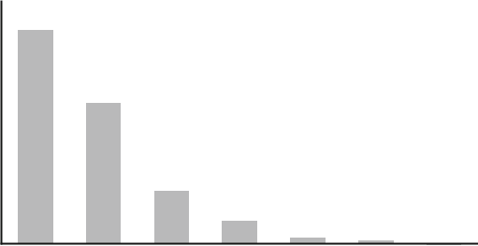

**(a)**

600

500

400

300

200

100

0

1 2 3 4 5 6 7

|  |
| --- |
| Frequency |

Number of branches

700

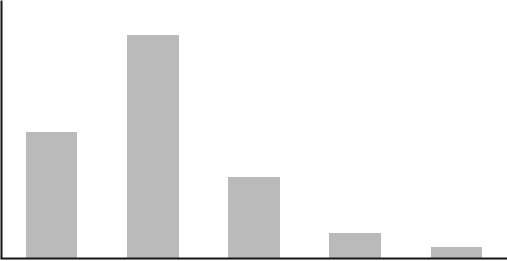

**(b)**

600

500

400

300

200

100

0

0.5-2.5 2.6-5 5.1-7.5 7.6-10 >10.1

Longest branch length (cm)

123

Biodiversity and Conservation

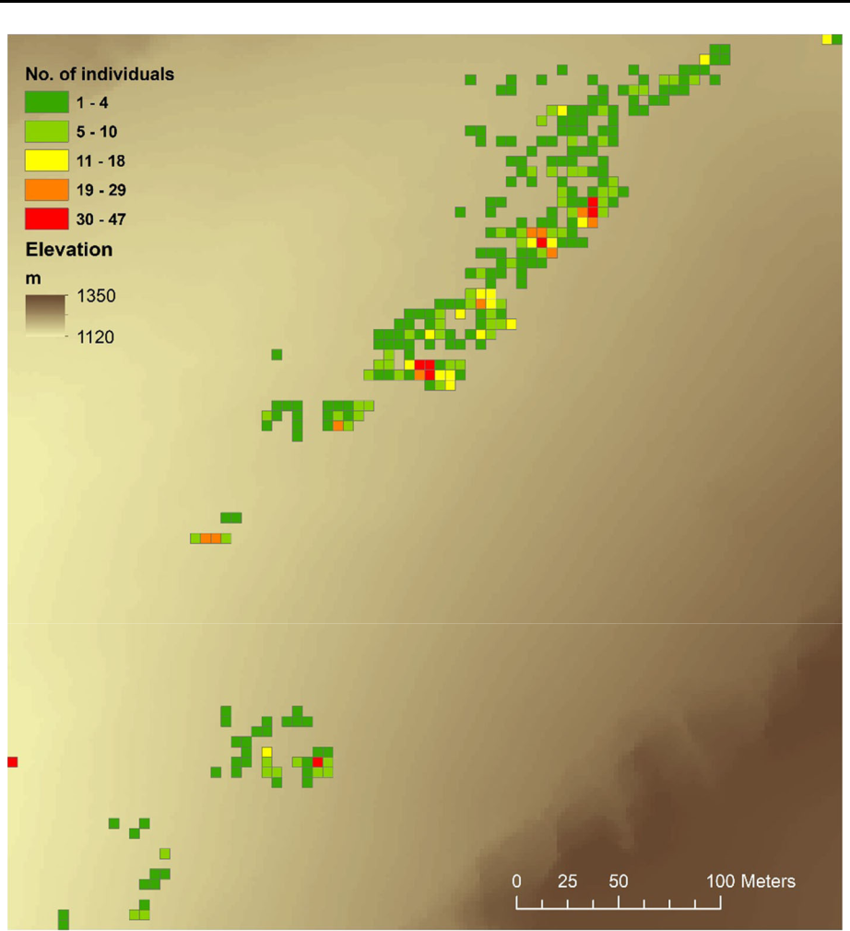

Fig. 4 Distribution of Euphorbia fontqueriana in the natural population. The number of ramets in a grid size of 5 9 5 m is shown. We graphically represented the distribution in a grid size of 5 9 5 m instead of 2 9 2 m as was used in the analyses to provide a better visualisation

Environmental description at the occurrence locations

To describe the environmental variables at the occurrence locations, boxplots and thematic maps were generated (Figs. 6, 7). Euphorbia fontqueriana was distributed at a mean elevation of 1184 ± 15 m asl (range 1121 –1206) and occurred in very steep areas with a mean value of 20.5 ± 5.6 degrees (range 6–35). The mean values of northness and east-ness were 0.356 ± 0.396 and - 0.829 ± 0.229, respectively, which indicated a preference for the northwestern and western directions. The NDVI mean values were - 0.017 ± 0.014 (range - 0.043 to 0.081), which indicated a preference for areas without vegetation. The mean IC values were 3.682 ± 0.718 (range 0 - 6.780), which indicated a

123

Biodiversity and Conservation

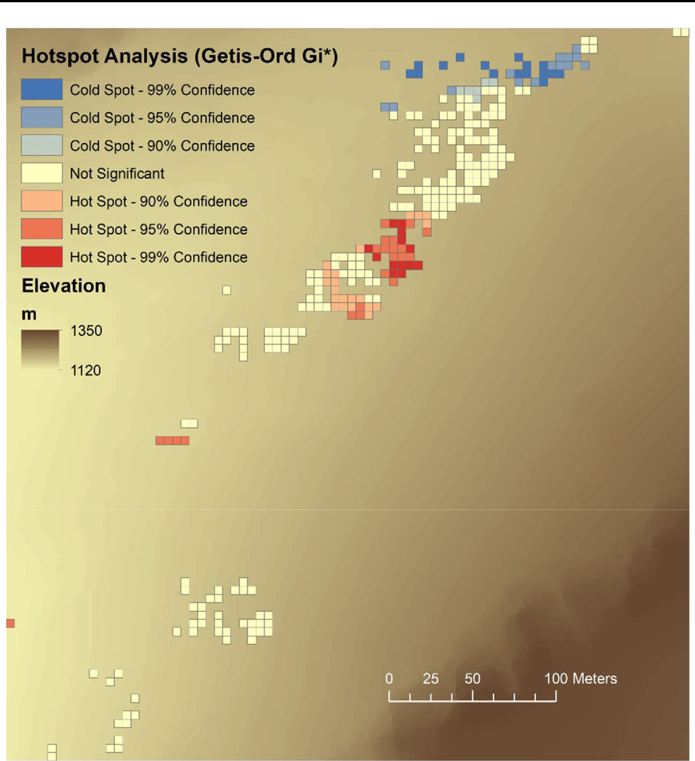

Fig. 5 Cluster map of the Euphorbia fontqueriana in the natural population as a result of the hotspot analysis through the Getis-Or Gi* method. Plant density was assessed in a grid size of 5 9 5 m. We graphically represented the distribution in a grid size of 5 9 5 m instead of 2 9 2 m as used in the analyses to provide a better visualisation

preference for areas of sediment deposition in the drainage basin. Finally, the soil types at the occurrence locations were leptsol plus regosol or lithic leptosol, and the species showed a clear preference for lithic leptosol, which is a very shallow soil of less than 10 cm in depth.

Predicting habitat suitability in a wider area

As a result of the correlation analysis, solar radiation was eliminated as a predictor variable due to its high correlation with the slope (r = - 0.803, p \ 0.001) and northness (r = -

123

Biodiversity and Conservation

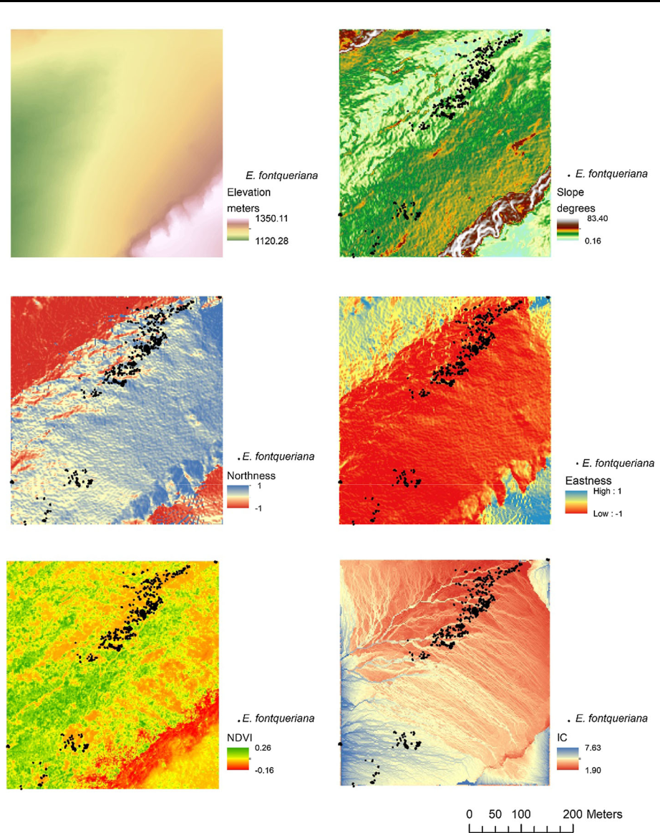

Fig. 6 Environmental variables in the small study area: elevation, slope, northness, solar radiation, normalised difference vegetation index (NDVI) and index of connectivity (IC). Black dots represent the locations of the ramets of Euphorbia fontqueriana in the natural population

0.718, p \ 0.001) (Table 2). Thus, a total of 7 variables were selected for species distri-bution modelling in the large study area: elevation, slope, northness, eastness, NDVI, IC and soil type (Fig. 8). The Maxent results showed a good performance model in terms of the AUC values (AUC training score = 0.977; AUC test score = 0.976). The environ-mental variables that contributed the most to the Maxent model were the IC and elevation (Table 3); these two variables each lowered the training gain when excluded from the model and showed the highest training gains when used as the only variables (Fig. 9). The

123

Biodiversity and Conservation

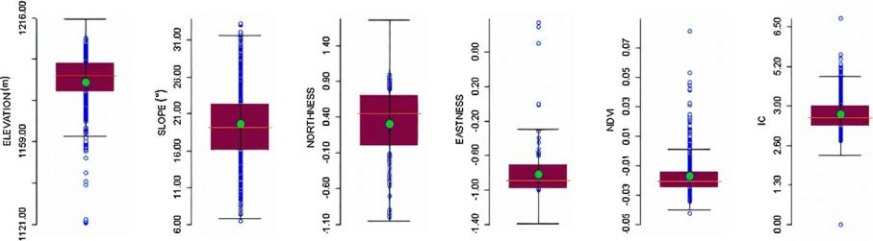

Fig. 7 Boxplot diagram of the environmental variables at the occurrence locations of Euphorbia fontqueriana. The green dots represent the mean value of each environmental variable

Table 2 Correlations between the pre-selected environmental variables

|  |  |  |  |  |  |  |  |
| --- | --- | --- | --- | --- | --- | --- | --- |
|  | Elevation | Slope | Solar radiation | Northness | Eastness | NDVI | IC |
|  |  |  |  |  |  |  |  |
| Elevation | 1 | 2 0.335 | 0.317 | 2 0.106 | 0.016 | 2 0.329 | 2 0.423 |
| Slope |  | 1 | 2 0.803 | 0.347 | 0.052 | 0.040 | 0.461 |
| Solar radiation |  |  | 1 | 2 0.718 | 2 0.236 | 0.036 | 2 0.258 |
| Northness |  |  |  | 1 | 0.238 | 2 0.111 | 2 0.009 |
| Eastness |  |  |  |  | 1 | - 0.022 | 2 0.347 |
| NDVI |  |  |  |  |  | 1 | 0.187 |
| IC |  |  |  |  |  |  | 1 |

Bold values were statistically significant (p \ 0.001). Highlighted cells represent higher correlations among environmental variables

NDVI normalised difference vegetation index, IC index of connectivity

soil type was the predictor variable that contributed the least to the model (Table 3; Fig. 9). The predictive distribution model showed areas with high habitat suitability, especially in the Mac¸anella zone, both in the geographical areas closest to the location of the natural population and in other areas to the north (Fig. 10).

Discussion

In this study, we integrally georeferenced the population of E. fontqueriana, an endangered narrow endemic species from the Balearics (western Mediterranean basin) with only one natural known locality, using geolocation systems with high-accuracy (RTK-GPS) to obtain a high-accuracy map (error \ 0.05 m). We also developed a predictive model for a wider distributional area to obtain a distribution map of the high habitat suitability with management purposes.

The population of E. fontqueriana consisted of 1625 ramets located in a very small area (approximately 15 ha), and only 10% of the ramets were reproductive. This low number of

123

Biodiversity and Conservation

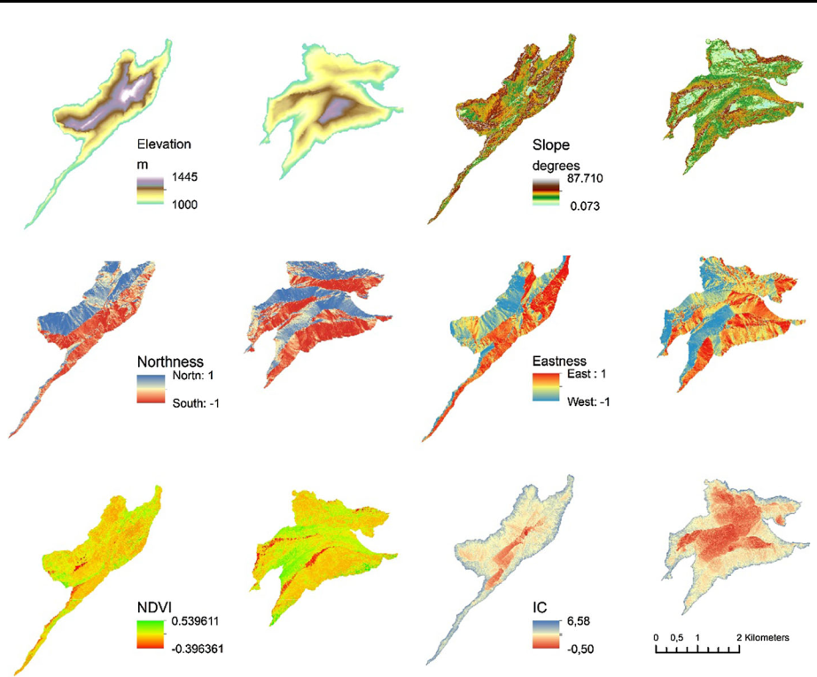

Fig. 8 Environmental variables in the large study area: elevation, slope, northness, eastness, normalised difference vegetation index (NDVI) and index of connectivity (IC)

Table 3 Contributions of the environmental variables to the Maxent model

|  |  |  |
| --- | --- | --- |
| Environmental variable | Percent contribution | Permutation importance |
|  |  |  |
| IC | 35.3 | 37.8 |
| Elevation | 29.9 | 49.2 |
| Eastness | 26.5 | 5.5 |
| NDVI | 4.5 | 3.3 |
| Slope | 2.0 | 1.4 |
| Northness | 1.8 | 2.8 |
| Soils | 0.1 | 0.0 |
|  |  |  |

reproductive ramets aligned with the number reported for 2001 by Albert and Iriondo (2009). Thus, these data highlight the weak demography of the species and the real necessity for a long-term demographic study to assess the demographic trends. Regarding the spatial patterns, ramets of the population were clustered and concentrated in a few hotspots (i.e., areas with high plant density that were surrounded by areas with high plant density). Thus, these areas would be particularly interesting for the establishment of

123

Biodiversity and Conservation

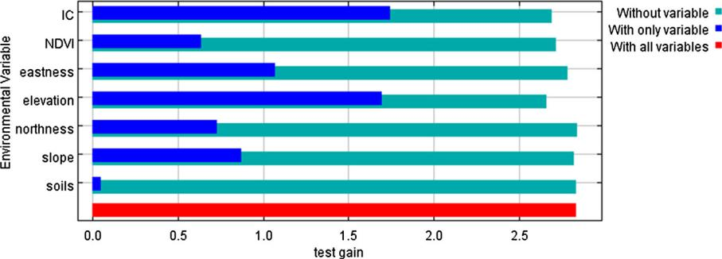

Fig. 9 Jackknife test results for the seven environmental variables selected for the Maxent model of Euphorbia fontqueriana

permanent plots for a demographic study. Moreover, the GIS database generated from this study will be very useful for species monitoring in the future.

We used the elevation, slope, northness, eastness, NDVI, IC and soil type to develop a predictive model for the Mac¸anella and Puig Major zones above 1000 m asl; these are the two highest mountains on Mallorca. We considered that the soil mineralogical composition could also play a crucial role in the distribution of the species because of the dolomitic nature of the soil in the area where the endangered species occurred (Far 2019). Unfor-tunately, these data are not currently available at the scale of this case study. Although we were not able to include other important factors, such as climatic factors (temperature and precipitation) and geology into the predictive model (Braun-Blanquet 1979) due to the micro-scale of our study system, we obtained a good performance of the prediction model in accordance with the AUC values (very close to 1: Elith et al. 2006; Phillips et al. 2006) using the environmental variables cited above. Indeed, the predictor variables that con-tributed most to the model performance were the IC and elevation, in accordance with both the percentage contribution and the jackknife test (Phillips et al. 2006, Phillips and Dudı´k 2008). According to the predictive model, the suitable areas were mainly distributed throughout the Mac¸anella zone to the north of the natural population, whereas the less suitable areas were predicted in the Puig Major zone. Interestingly, the location of the introduced population in Puig Major showed high values of habitat suitability in the surrounding area. Thus, this study provides insight that could help in future conservation actions, such as prioritising the areas as reception sites in conservation translocations or with new potential populations to prospect.

Beyond the small scale modelling and the use of geolocation systems to obtain highly accuracy occurrence data, the main advantages of the model generated here reside in the use of environmental data obtained from remote sensing. Thus, still considering the sim-plicity in obtaining environmental data, the model provides relatively positive outcomes. On the other hand, the limitation lies in the environmental data resolution, which could be markedly improved by means of using airborne radar and laser scanning that allows an accurate estimation of surface derivatives on a fine scale (Lassueur et al. 2006).

Habitat suitability is not a guarantee of species occupancy because other environmental factors may influence the distributions of species, such as biotic interactions and biogeo-graphical barriers (Peterson 2003; Bayly and Angert 2019; Draper et al. 2019). Draper et al. (2019) have emphasised the importance of biological validation of the species dis-tribution models in the field, such as by performing germination trials in the reception sites,

123

Biodiversity and Conservation

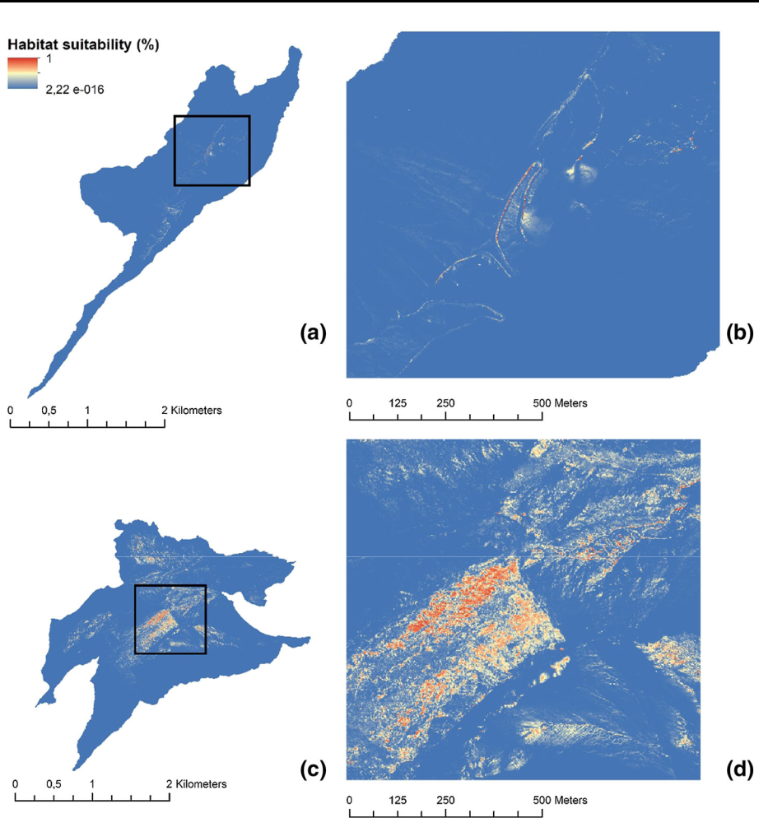

Fig. 10 Map showing the areas with high probabilities of habitat suitability for Euphorbia fontqueriana (red areas) in the Puig Major zone (superior) and Mac¸anella zone (inferior). A zoomed-out image of the geographical natural area of Euphorbia fontqueriana is shown, separating the training data (black dots, n = 1202 presence records) and the test data (green dots, n = 401 presence records) used for running Maxent

to guarantee success in conservation translocations, which is particularly interesting as they are time-consuming and economically expensive activities (Fenu et al. 2019). In the next future, we will assess the presence of the species in those areas with high habitat suitability

1. to look for new locations of E. fontqueriana and complete the population census of the species and (2) to validate the prediction model generated by Maxent.

SDMs can also provide useful information under scenarios of climate change by using the known population occurrence locations and their associated climate factor data (Schipper et al. 2014; Xing-zhuang et al. 2020). The model performed here could be very useful in modelling environmental variables related to climate change in insular ecosys-tems as both soil erosion and NDVI are expected to change under global warming (Nearing et al. 2019; Mulder et al. 2019; Gianinetto et al. 2020).

123

Biodiversity and Conservation

Overall, we consider that this study constitutes a pioneering experience in the man-agement of endemic plant species in the Balearic Islands, which results are relevant at a methodological and experimental level. Therefore, we strongly suggest utilising these methods for endemic species management in other areas. These methods would be par-ticularly interesting to the management of narrow endemic species or species restricted to a very small areas, i.e. showing narrow ecological ranges.

Acknowledgements We thank Miquel Capo´, Joshua Borra`s, Sebastia` Perello´, Carles Cardona and Maite Bover for their collaboration in the fieldwork. We also thank the three anonymous reviewers for their valuable contributions that have allowed to improve an earlier version of the manuscript. This research was supported by Fundacio´n Biodiversidad of the Ministerio para la Transicio´n Ecolo´gica (call 2018).

Author contributions JC and MR designed the study; JC and AJF collected field data; JC and MR analysed the data; JC wrote a first draft of the manuscript; all the authors contributed to the final version.

References

Albert MJ, Iriondo JM (2009) Euphorbia fontqueriana Greuter. In: Iriondo JM, Albert MJ, Gime´nez Benavides L, Domı´nguez Lozano F, Escudero A (eds) Poblaciones en peligro: viabilidad demogra´fica de la flora vascular amenazada de Espan˜a, Direccio´n General de Medio Natural y Polı´tica Forestal. Ministerio de Medio Ambiente, y Medio Rural y Marino), Madrid, pp 89–92

Anselin L, Syabri I, Kho Y (2006) GeoDa: An Introduction to Spatial Data Analysis. Geogr Anal 38:5–22 Bayly MJ, Angert AL (2019) Niche models do not predict experimental demography but both suggest dispersal limitation across the northern range limit of the scarlet monkeyflower (Erythranthe cardi-

nalis). J Biogeogr 46(7):1316–1328

Booth TH (2018) Species distribution modelling tools and databases to assist managing forests under climate change. For Ecol Manag 430:196–203

Borthakur SK, Sharma Baruah P, Deka K, Das P, Sarma B, Adhikari D, Tanti B (2018) Habitat distribution modelling for improving conservation status of Brucea mollis Wall. ex Kurz.—An endangered potential medicinal plant of Northeast India. J Nat Conserv 43:104–110

Braun-Blanquet J (1979) Fitosociologı´a. Bases para el estudio de las comunidades vegetales. H. Blume Ediciones, Madrid

Cavalli M, Trevisani S, Comiti F, Marchi L (2013) Geomorphometric assessment of spatial sediment connectivity in small Alpine catchments. Geomorphology 188:31–41

Cook RE (1985) Growth and development in clonal plant populations. In: Jackson JBC, Buss LW, Cook RE (eds) Population biology and evolution of clonal organisms. Yale University Press, New Haven, pp 259–296

Draper D, Marques I, Iriondo J (2019) Species Distribution models with field validation, a kew approach for successful selection of receptor sites in conservation translocations. Global Ecol Conserv. [https://doi.](https://doi.org/10.1016/j.gecco.2019.e00653) [org/10.1016/j.gecco.2019.e00653](https://doi.org/10.1016/j.gecco.2019.e00653)

Elith J, Graham C, Anderson R, Dudı´k M, Ferrier S, Guisan A, Hijmans R, Huettmann F, Leathwick J, Lehmann A, Li J, Lohmann L, Loiselle B, Manion G, Moritz C, Nakamura M, Nakazawa Y, Overton J, Peterson A, Zimmermann N (2006) Novel methods improve prediction of species’ distributions from occurrence data. Ecography 29:129–151

Elith J, Phillips SJ, Hastie T, Dudı´k M, Chee YE, Yates CJ (2011) A statistical explanation of MaxEnt for ecologists. Divers Distrib 17(1):43–57

Environmental Systems Research Institute (ESRI) (2017) ArcGIS Release 10.6

Far JA (2019) Reproductive biology and habitat characterization of Euphorbia fontqueriana Greuter, an endangered endemism from Mallorca. Master Thesis dissertation, University of the Balearic Islands Fenu G, Bacchetta G, Christodoulou C, Fournaraki C, Pietro G, Gotsiou P, Kyratzis A, Carole P, Vicens M, Pinna M, Montmollin B (2019) An early evaluation of translocation actions for endangered plant

species on Mediterranean islands. Plant Divers 41(2):94–104

Fois M, Fenu G, Cuena Lombran˜a A, Cogoni D, Bacchetta G (2015) A practical method to speed up the discovery of unknown populations using Species Distribution Models. J Nat Conserv 24(C):42–48

Fox J (1997) Applied regression analysis, linear models, and related methods. SAGE Publications, Thousand Oaks

123

Biodiversity and Conservation

Getis A, Ord JK (1992) The Analysis of Spatial Association by Use of Distance Statistics. Geogr Anal 24:189–206

Gianinetto M, Aiello M, Vezzoli R, Polinelli F, Rulli MC, Chiarelli D, Bocchiola D, Ravazzani G, Soncini A (2020) Future scenarios of soil erosion in the Alps under climate change and land cover transfor-mations simulated with automatic machine learning. Climate 8:28

Gogol-Prokurat M (2011) Predicting habitat suitability for rare plants at local spatial scales using a species distribution model. Ecol Appl 21(1):33–47

Greuter W (1968) Une espe`ce me´connue ede´mique des Illes Bale´ares: Euphorbia fontqueriana. Coll Bot (Barcelona) 7(1):531–537

Guisan A, Zimmermann NE (2000) Predictive habitat distribution models in ecology. Ecol Model 135(2–3):147–186

Guisan A, Tingley R, Baumgartner JB, Naujokaitis-Lewis I, Sutcliffe PR, Tulloch A, Regan T, Brotons L, McDonald-Madden E, Mantyka-Pringle C, Martin T, Rhodes J, Maggini R, Setterfield S, Elith J, Schwartz M, Wintle B, Broennimann O, Austin M, Buckley Y (2013) Predicting species distributions for conservation decisions. Ecol Lett 16(12):1424–1435

IBM Corp (2016) IBM SPSS Statistics for Windows, Version 25.0. Armonk. IBM Corp, New York. Released 2016

Lassueur T, Joost S, Randin C (2006) Very high resolution digital elevation models: do they improve models of plant species distribution? Ecol Model 198:139–153

Leica Geosystems (2013) Leica RX1200 user manual. [http://www.geoaxxis.de/manuals/tps1200/rx1220_](http://www.geoaxxis.de/manuals/tps1200/rx1220_user_en.pdf) [user_en.pdf](http://www.geoaxxis.de/manuals/tps1200/rx1220_user_en.pdf)

Llorens L, Gil L, Te´bar FJ (2007) La vegetacio´ de l’Illa de Mallorca: bases per a la interpretacio´ i gestio´ d’ha`bitats. Associacio´ Jardı´ Bota`nic de Palma, Palma

Mulder VL, van Eck CM, Friedlingstein P, Arrouays D, Regnier P (2019) Controlling factors for land productivity under extreme climatic events in continental Europe and the Mediterranean Basin. Catena

1. [104124]

Nearing MA, Jetten V, Baffaut C, Cerdan O, Couturier A, Hernandez M, Le Bissonnais Y, Nichols MH, Nunes JP, Renscheler CS et al (2019) Modeling response of soil erosion and runoff to changes in precipitation and cover. Catena 61:131–154

Ord JK, Getis A (1995) Local spatial autocorrelations statistics: distributional issues and an application. Geogr Anal 27(4):286–306

Papes¸ M, Havel JE, Vander Zanden MJ (2016) Using maximum entropy to predict the potential distribution of an invasive freshwater snail. Freshwater Biol 61(4):457–471

Pearson RG, Raxworthy CJ, Nakamura M, Peterson AT (2007) Predicting species distributions from small numbers of occurrence records: A test case using cryptic geckos in Madagascar. J Biogeogr 34:102–117

Peterson AT (2003) Predicting the geography of species’ invasions via ecological niche modeling. Q Rev Biol 78:419–433

Pettorelli N, Vik JO, Mysterud A, Gaillard JM, Tucker CJ, Stenseth NC (2005) Using the satellite-derived NDVI to assess ecological responses to environmental change. Trends Ecol Evol 20(9):503–510

Phillips SJ, Dudı´k M (2008) Modeling of species distribution with Maxent: new extensions and a com-prehensive evalutation. Ecograpy 31:161–175

Phillips SJ, Anderson RP, Schapire RE (2006) Maximum entropy modeling of species geographic distri-butions. Ecol Model 190(3–4):231–259

Phillips SJ, Anderson RP, Dudı´k M, Schapire RE, Blair ME (2017) Opening the black box: an open-source release of Maxent. Ecography 40:887–893

Roberts DW (1986) Ordination on the basis of fuzzy set theory. Vegetatio 66:123–131

Romo AM (1990) Observacions fitocenolo`giques a l’illa de Mallorca. Collect Bot 18:162–165

Sa´ez L, Rosello´ JA, Fraga P (2017) Llibre vermell de la flora vascular de les Illes Balears, 2n edn. Conselleria de Medi Ambient, Agricultura i Pesca, Palma

Salinas-Rodrı´guez MM, Sajama MJ, Gutie´rrez-Ortega JS, Ortega-Baes P, Estrada-Castillo´n AE (2018) Identification of endemic vascular plant species hotspots and the effectiveness of the protected areas for their conservation in Sierra Madre Oriental, Mexico. J Nat Conserv 46:6–27

Schipper A, Posthuma L, Zwart D, Huijbregts M (2014) Deriving Field-Based Species Sensitivity Distri-butions (f-SSDs) from Stacked Species Distribution Models (S-SDMs). Environ Sci Technol 48(24):14464–14471

Sellers PJ (1985) Canopy reflectance, photosynthesis and transpiration. Int J Remote Sens 6(8):1335–1372 Spiers JA, Oatham MP, Rostant LV, Farrell AD (2018) Applying species distribution modelling to improving conservation based decisions: a gap analysis of trinidad and tobago’s endemic vascular

plants. Biodivers Conserv 27(11):2931–2949

123

Biodiversity and Conservation

Swart C, Donaldson J, Barker N (2018) Predicting the distribution of Encephalartos latifrons, a critically endangered cycad in South Africa. Biodivers Conserv 27(8):1961–1980

UNESCO (2011) UNESCO World Heritage Centre. <http://whc.unesco.org/en/list/1371>. Accessed 13 Dec 2013

Vadell J (2011) Classificacio´ dels so`ls a les Balears. Cartographic web viewer. [https://ssigt.uib.cat/serveis/](https://ssigt.uib.cat/serveis/IDE/Visors/) [IDE/Visors/](https://ssigt.uib.cat/serveis/IDE/Visors/)

Xie Y, Zhao X, Li L, Wang H (2010) Calculating NDVI for landsat7-etm data after atmospheric Correction using 6 s model: a case study in Zhangye City, China. In: 18th International Conference on Geoin-formatics, Geoinformatics, pp 1–4

Xing-zhuang Y, Zhao G, Zhang M, Cui X, Fan H, Liu B (2020) Distribution pattern of endangered plant Semiliquidambar cathayensis (Hamamelidaceae) in response to climate change after the last inter-glacial period. Forests 11(4):434

West AM, Kumar S, Brown CS, Stohlgren TJ, Bromberg J (2016) Field validation of an invasive species Maxent model. Ecol Inform 36:126–134

Williams JN, Seo C, Thorne J, Nelson JK, Erwin S, O’Brien JM, Schwartz MW (2009) Using species distribution models to predict new occurrences for rare plants. Divers Distrib 15(4):565–576

Wisz MS, Hijmans RJ, Li J, Peterson AT, Graham CH, Guisan A (2008) Effects of sample size on the performance of species distribution models. Divers Distrib 14:763–773

Publisher’s Note Springer Nature remains neutral with regard to jurisdictional claims in published maps and institutional affiliations.

123