Ecotoxicology (2020) 29:707–717

https://doi.org/10.1007/s10646-020-02204-5



Molecular cloning and expression of AmCDPK from mangrove Avicennia marina under elevated temperature

Jin Liu1,2,3 ● You-Shao Wang1,2,3 ● Hao Cheng1,3

Accepted: 23 March 2020 / Published online: 16 April 2020

© Springer Science+Business Media, LLC, part of Springer Nature 2020

Abstract

Considered as an essential calcium sensor, the calcium-dependent protein kinase (CDPK) family plays a critical part in terrestrial plants’ responses to both biotic and abiotic stresses. In the study, Avicennia marina was proved to have better heat tolerance than other species. A CDPK gene was cloned from mangrove species A. marina using RACE-PCR and designated as AmCDPK. By predicting and analyzing its properties, structures and expression patterns, we found that the amino acid sequence, containing a kinase domain and four EF-hand Ca2+-binding sites, shared high identity with Handroanthus impetiginosus and Sesamum indicum. Quantitative real-time PCR data analysis suggested that AmCDPK demonstrated significant up-regulation under heat stress. It is likely that AmCDPK is a versatile gene involved in various stresses, including dehydration, cold, light, defense and ABA stress responses by analyzing cis-elements. It is the first time that CDPKs from mangroves have been cloned and our results brought evidence to the effect of AmCDPK on heat stress, which is particularly important under the background of global warming.

Keywords Mangrove plants ● Calcium-dependent protein kinase ● Avicennia marina ● Heat stress

Introduction

Grow along tropical and subtropical coast from the latitudes of 25 °N to 25 °S, mangroves are ever-green plant com-munities that provide great ecological resources and eco-nomic products because of its biological and genetic diversity (Huang and Wang 2010; Fei et al. 2015; Peng et al. 2013; Wang et al. 2015; 2019), and have as high productivity, high restitution rate, high decomposition rate and high resistance in the world (Wang 2019). According to the 5th IPCC (i.e., Intergovernmental Panel on Climate Change) report, global warming since 1950s is strongly evident at all latitudes in sea surface temperature (SST).

* You-Shao Wang [yswang@scsio.ac.cn](mailto:yswang@scsio.ac.cn)

1. State Key Laboratory of Tropical Oceanography, South China Sea Institute of Oceanology, Chinese Academy of Sciences, 510301 Guangzhou, China
2. Daya Bay Marine Biology Research Station, Chinese Academy of Sciences, 518121 Shenzhen, China
3. Innovation Academy of South China Sea Ecology and Environmental Engineering, Chinese Academy of Sciences, 510301 Guangzhou, China

With land and ocean temperature data combined, the global temperature has been shown to increase by about 0.89 °C during the period of 1901–2012, and an increase of about 0.72 °C was observed over the period of 1951–2012. Therefore, it may have had an impact on the growth and development of mangroves.

Ca2+, serving as the second messenger in plants, is related to various stimuli including both biotic and abiotic stresses. These Ca2+ fluxes can be recognized and decoded by four kinds of Ca2+ sensors, namely, calcineurin B-like protein/CBL-interacting protein kinase (CBL/CIPK) (Liu and Zhu 1998), calmodulin-like proteins (CaML) (Snedden and Fromm 1998), calmodulin (CaM) (Luan et al. 2002) and calcium-dependent protein kinase (CDPK) (Sanders et al. 2002), which subsequently transduce Ca2+ signal to regulate downstream biological processes and gene expression patterns (Rudd and Franklin-Tong 2001; San-ders et al. 1999). As one of the greatest subfamilies of protein kinases in plants (Ludwig et al. 2004), CDPKs are designated to be able to bind calcium directly, possess a variable N-terminal domain, a protein kinase domain con-taining an ATP-binding site and several conserved sub-domains of eukaryotic Ser/Thr protein kinases (Hanks and Hunter 1995), an autoinhibitory domain and a calmodulin-like domain containing EF-hand Ca2+-binding sites which



708 J. Liu et al.



Fig. 1 The structure diagram of CDPK. N indicates N-terminal variable domain; A, autoinhibitory domain; CaM-like, calmodulin-like domain. The four black bars within the CaM-like domain represent EF-hand Ca2+-binding sites (Cheng et al. 2002)

are required for binding to calcium (Fig. 1) (Cheng et al.

2002).

After CDPK was first reported in pea (Pisum sativum) in 1982 (Hetherington and Trewavas 1982), more CDPKs were then identified from green algae to angiosperms, such as green algae (Yuasa et al. 1995), tobacco (Yoon et al. 1999), Arabidopsis thaliana (Arabidopsis Genome Initia-tive 2000), rice (Asano et al. 2005) and maize (Kong et al. 2013). CDPKs were found to be able to regulate a number of signaling pathways, including hormones, growth and development, guard cells and stomatal movements, carbon and nitrogen metabolism (Cheng et al. 2002). Therefore, CDPKs are sensitive to various stimuli, such as salt, cold, drought, invasion of pathogens and mechanical damage (Lee and Rudd 2002; Nagamangala et al. 2013; Wei et al. 2014; Weckwerth et al. 2015; Zhao et al. 2015). In addition, transgenic plants over-expressing CDPKs increased the extent of tolerance to diseases and environmental stresses (Saijo et al. 2000; Asano et al. 2010). However, the role calcium-dependent protein kinases play in heat stress response is relatively less understood (Chang et al. 2009; Goswami et al. 2015).

Mangroves are well adapted to multiple external stress, such as strong tides, hypoxia, high salinity and heavy metals (Kathiresan and Bingham 2001). Many studies have reported on their defense mechanism (Medina 1999), mainly focusing on physiological and biochemical indexes. In recent years, several stress-related genes have also been identified, such as genes encoding dehydrin (Mehta et al. 2009), metallothionein (Huang and Wang 2010), CBF (Peng et al. 2013), chitinase (Wang et al. 2015) and HSP (Fei et al. 2015). Nevertheless, no data regarding CDPK and heat stress response have been collected in mangroves.

The present study aimed to clone and characterize the full-length cDNA of CDPK gene from Avicennia marina, and explore the potential function of CDPK under heat stress. The result shed light on the role protein kinases played in stress resistance of mangrove plants.

propagules of mangroves were collected from a local commercial plantation near Huizhou, Guangdong Province, China, disinfected as described previously (Wang et al. 2015) and then planted in clean sands under greenhouse conditions in the laboratory. All seedlings were irrigated every day and fertilized with 1/2 Hoagland’s solution every other 2 days. After 6-month incubation, uniform seedlings free from visual symptoms of diseases or mechanical damage were randomly selected and transferred to a con-trolled incubator for 7 days prior to all experiments, with the temperature of 25 ± 1 °C, the relative humidity of 75% and a 12 h light/12 h dark photoperiod (12 h/light = 20,000 lux).

Heat treatment

Mangrove seedlings were transferred to a growth chamber, setting the temperatures as 25 °C, 30 °C, 35 °C, 40 °C and 45 °C respectively to count survival rates. Then heat-resistant mangroves were treated at a specific temperature and the exposure experiment lasted for 7 days. Fresh leaves were randomly harvested at 0, 1, 3, 6, 9, 12, 24, 48, 72, 120 and 168 h, immersed into liquid nitrogen promptly and stored at –80 °C. The leaves sampled at 25 °C (0 h at 40 °C) were served as control subjects. All experiments were per-formed in biological triplicates.

RNA extraction and cDNA synthesis

The stored samples were ground into powders using liquid nitrogen and plant total RNA was extracted from 100 mg leaves with RNAprep Pure Plant Kit (Tiangen, China) as recommended by the manufacturer’s instructions. The concentration and purity of total RNA were checked by NanoDrop Lite Spectrophotometer (Thermo Fisher Scien-tific, USA) and 1% agarose gel electrophoresis. High-quality RNA samples were refrigerated at –80 °C for further use (RACE and quantitative analysis). And then cDNA was synthesized from RNA using PrimeScript™ RT reagent Kit with gDNA Eraser (Takara, China).

Materials and methods

Plant materials

There were five mangrove species in this study, including A. marina, Aegiceras corniculatum, Bruguiera gymnor-rhiza, Rhizophora stylosa and Kandelia obovata. Mature



Cloning of the full-length cDNA of AmCDPK

Cloning of CDPK fragment

The degenerate primers dF and dR (described in attached Table 1) were used for CDPK gene fragment cloning, which were designed by CODEHOP (Consensus Degenerate

|  |  |  |  |
| --- | --- | --- | --- |
| Molecular cloning and expression of AmCDPK from mangrove Avicennia marina under elevated temperature | | | 709 |
|  | |  |  |
| Table 1 List of primers for PCR, RACE and qPCR experiments | |  |  |
|  |  |  |  |
| Primer | Sequence (5′ → 3′) | Note |  |
|  |  |  |  |
| dF | GCATTCTGTTCATCTGGTTATGGAGTTTTGCGC | Degenerate forward primer for CDPK |  |
| dR | ATAATGATGGCCGAATTAATTATGATGAATTTGTTGCTATGA | Degenerate reverse primer for CDPK |  |
| GSP-5′ | GATTACGCCAAGCTTAGCCAGCAATCTCCTCTTCT | Gene-specific primer for 5′ ends of CDPK cDNA | |
| GSP-3′ | GATTACGCCAAGCTTGGCACTACAGTGAGCGAAAG | Gene-specific primer for 3′ ends of CDPK cDNA | |
| NGSP-5′ | GATTACGCCAAGCTTCCAGGGCTCTATCAGGTGC | Nested gene-specific primer for 5′ ends of |  |
|  |  | CDPK cDNA |  |
| NGSP-3′ | GATTACGCCAAGCTTTGTTGAGGCGTGCCATTC | Nested gene-specific primer for 3′ ends of |  |
|  |  | CDPK cDNA |  |
| UPM | CTAATACGACTCACTATAGGGCAAGCAGTGGTATCAACGCAGAGT | Universal primer mix |  |
| UPM short | CTAATACGACTCACTATAGGGC | Universal primer short |  |
| qF | TGTTGAGGCGTGCCATTC | Forward primer for qPCR of CDPK |  |
| qR | TGGGCTTCCAACCACATCC | Reverse primer for qPCR of CDPK |  |
| q18S-F | ACCATAAACGATGCCGACCAG | Forward primer for qPCR of 18S (reference gene) | |
| q18S-R | CCTTTAAGTTTCAGCCTTGCG | Reverse primer for qPCR of 18S (reference gene) | |
| M13-47 | CGCCAGGGTTTTCCCAGTCACGAC | Forward primer for sequencing |  |
| RV-M | GAGCGGATAACAATTTCACACAGG | Reverse primer for sequencing |  |
|  |  |  |  |

Hybrid Oligonucleotide Primers) based on conserved regions of CDPK amino acid sequences (National Center for Biotechnology Information, NCBI, USA) after align-ment using DNAMAN software (version 7). A fragment of almost 1100 bp in length was amplified with the program of denaturation (94 °C, 5 min), 35 cycles of denaturation (94 °C, 30 s), annealing (50 °C, 30 s), and extension (72 °C, 1 min), and final extension (72 °C, 10 min). PCR products were purified, ligated into pMD 18-T vector (Takara, China), transformed into competent Escherichia coli DH5α cells, verified by PCR screening (primers were described in Table 1) and then sent to be sequenced by Beijing Geno-mics Institute (BGI, China).

Cloning of the 5′ and 3′ ends of cDNA

The isolation of a full length cDNA sequence was obtained by using the SMARTer® RACE 5′/3′ Kit (Clontech, USA) as recommended by manufacturer’s instructions. PCR reactions were performed in Mastercycler® nexus (Eppen-dorf, Germany) with the following program: 25 cycles of 94 °C for 30 s, 69 °C for 30 s and 72 °C for 3 min. PCR products were gel-purified by NucleoSpin Gel and PCR Clean-Up Kit, cloned into lineareized pRACE vector and then transformed into Stellar™ Competent Cells. Positive clones were picked and sent to be sequenced.

Sequence analysis

After aligning and assembling the sequences of the 5′ and 3′ end sequences by SeqMan (Version7.1.0), the full-length of cDNA sequence was obtained. The homology analysis was

performed using BLAST tools (Altschul et al. 1997) from NCBI. The molecular weight (MW) and theoretical iso-electric point (pI) of the deduced protein were computed by ExPASy ProtParam (Harmon et al. 2000; Gasteiger et al. 2003). The conserved domain was analyzed by ScanProsite and SMART. The secondary structure was forecasted using PSIpred and SOPMA. The prediction of transmembrane regions and orientation was conducted by TMpred. The subcellular localization was predicted by ESLpred, and three-dimensional structure was built by the SWISS-MODEL. Multiple sequence alignment was conducted by ClustalX 2.0 (Thompson et al. 1997) and the results were edited by DNAMAN. The phylogenetic tree was con-structed by MEGA (Version 6.06) using neighbor-joining method (Kumar et al. 2004).

Quantitative analysis of AmCDPK mRNA expression

To assess the mRNA expression of CDPK under 40 °C heat stress, quantitative real-time PCR was performed in iQTM5 (Bio-Rad, USA) using SYBR® Premix Ex TaqTM II (Tli RNaseH Plus) (Takara, China) as recommended by manu-facturer’s instructions. The primers (qF, qR, q18S-F, q18S-R), described in Table 1, were designed based on the full-length cDNA of A. marina CDPK and 18S rRNA (Gen-Bank accession No.EU528879). The program for PCR amplification was as follows: 95 °C for 30 s, 40 cycles of 95 °C for 5 s, 54 °C for 30 s, and 72 °C for 30 s. We cap-tured the fluorescence signal at the end of each cycle at 72 °C, and performed melting curve analysis from 55 °C to 95 °C, with data capture of every 0 °C during a 30 s-holding period. We chose A. marina 18S rRNA as housekeeping



710 J. Liu et al.

reference gene in order to normalize expression levels between samples using 2− CT method (Livak and Schmittgen 2001).

Statistical analysis

All experiments were performed in biological triplicates. The data of mRNA expression were indicated as mean ± SD (standard deviation) and the statistical significance was assessed by SPSS software (Version 22), which was based on analysis of variance (ANOVA). Significant difference was indicated by an asterisk (p < 0.05).

Results

Comparison of heat resistance among mangroves

At the temperature of 25 °C, 30 °C and 35 °C, all seedlings grew up as normal or even better than that. However, at 40 °C, only A. marina survived and other species showed different death rates respectively (Fig. 2). At 45 °C, all plants died gradually but A. marina lived longer than others (Fig. 3). A. marina was chosen to do the following heat resistance research and 40 °C as experimental temperature.

Characterization and sequence analysis of AmCDPK

We cloned a partial cDNA sequence of 1094 bp from A. marina using degenerate primers. Based on this fragment (as shown in Fig. 4), the corresponding full-length cDNA sequence was subsequently amplified by RACE and named

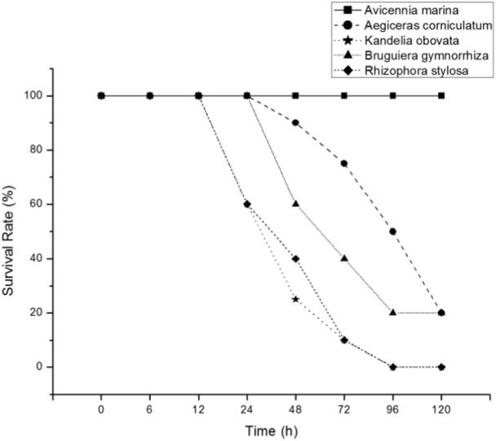

for AmCDPK, which was 2232 bp in length, including a 229 bp 5′-UTR (untranslated region), a 299 bp 3′-UTR with a poly(A) tail and a 1704 bp ORF (open reading frame), which encoded a predicted protein of 567 amino acids with a deduced molecular weight of 63.11 kDa and a theoretical pI of 5.60. The AmCDPK protein was rich in Leu (9.0%), Gly (7.8%), Asp (7.6%) and Ser (7.6%).

Multiple sequence analysis revealed that AmCDPK shared high identity with Handroanthus impetiginosus and Sesamum indicum, which was 94% and 92%, respectively. Amino acid alignment analysis showed that AmCDPK contained a protein kinase domain (Y104-I362) including an ATP-binding region signature (L110-K137), a Serine/ Threonine protein kinases active-site signature (V224-L236), and four EF-hand calcium-binding motifs (E405-T440, L441-L476, E477-E512 and L516-G546), which defined it as a plant CDPK (Fig. 5). Moreover, it contained polypeptide substrate binding site (Q114-V272) and acti-vation loop (A-loop, I248-Y270).

Based on 33 amino acid sequences of CDPKs from NCBI database, a neighbor-joining (NJ) phylogenetic tree was generated to analyze the evolutionary relationship of the AmCDPK protein with the CDPK proteins from other species (Fig. 6). AmCDPK showed very close homology to CDPKs from H. impetiginosus, Dorcoceras hygrometricum,

Olea europaea var. sylvestris and S. indicum, which all belonged to Asteridae, Dicotyledoneae.

Predicted structures of AmCDPK protein

The secondary structure of AmCDPK protein, predicted by SOPMA, showed that it contained 41.45% alpha-helix, 13.93% beta-sheet (extended strand), 10.58% beta-turn and

34.04% random coil. PSIpred predicted that AmCDPK protein contained 18 helixes and 7 sheets. The predicted

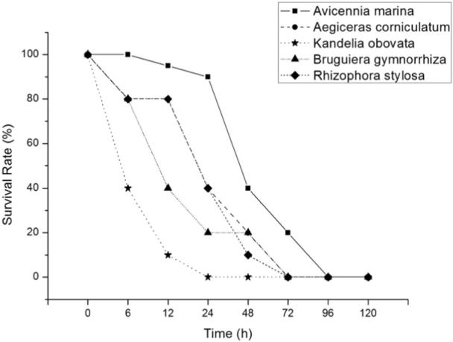

Fig. 2 Survival rate of mangroves under heat stress at 40 °C Fig. 3 Survival rate of mangroves under heat stress at 45 °C



|  |  |
| --- | --- |
| Molecular cloning and expression of AmCDPK from mangrove Avicennia marina under elevated temperature | 711 |
|  |  |



Fig. 4 Nucleotide and amino



acid sequence of AmCDPK

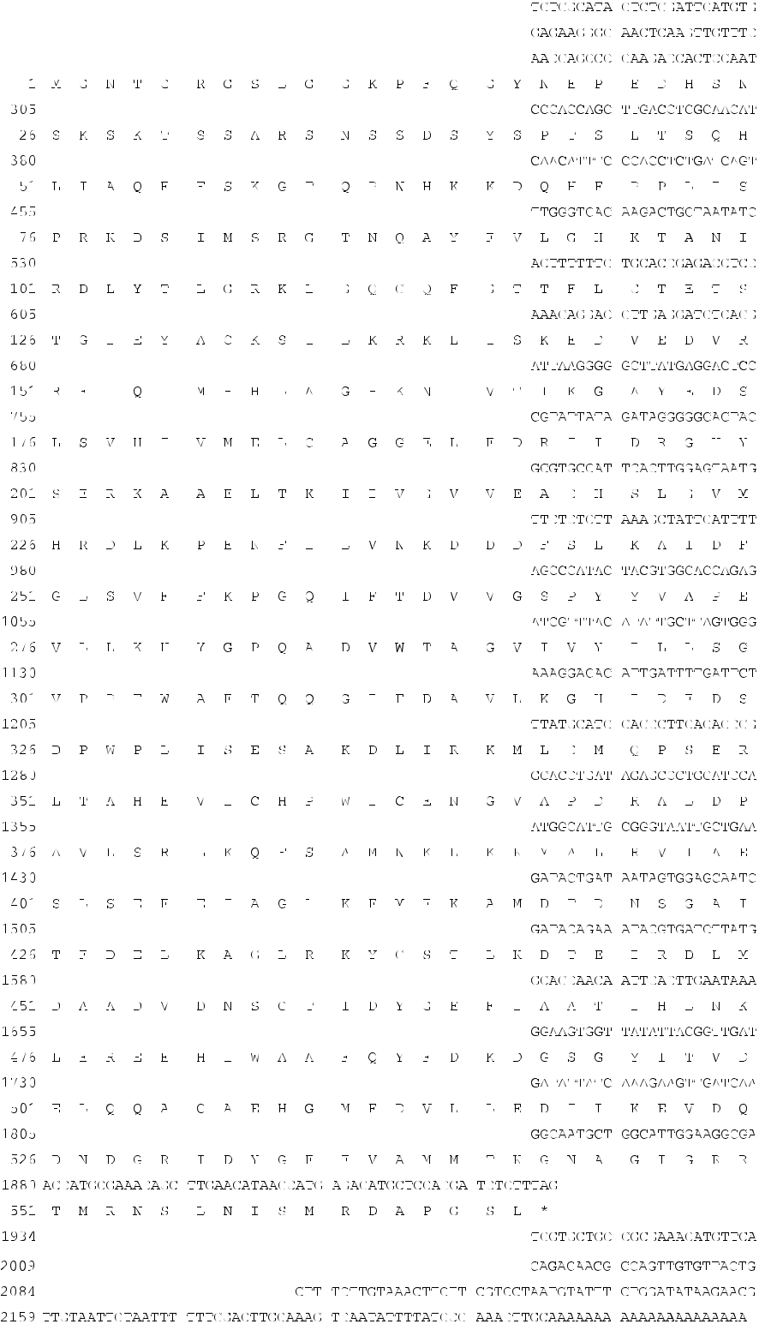

|  |  |  |
| --- | --- | --- |
| three-dimensional structure of AmCDPK was based | on | template (Fig. 7a). AmCDPK protein was a monomer, the |
| homology modeling with apo crystal structure of CDPK4 | | surface properties of which showed that it was a hydrophilic |
| from Plasmodium falciparum (SMTL id: 4rgj.1.A) as | the | protein (Fig. 8). |



712 J. Liu et al.

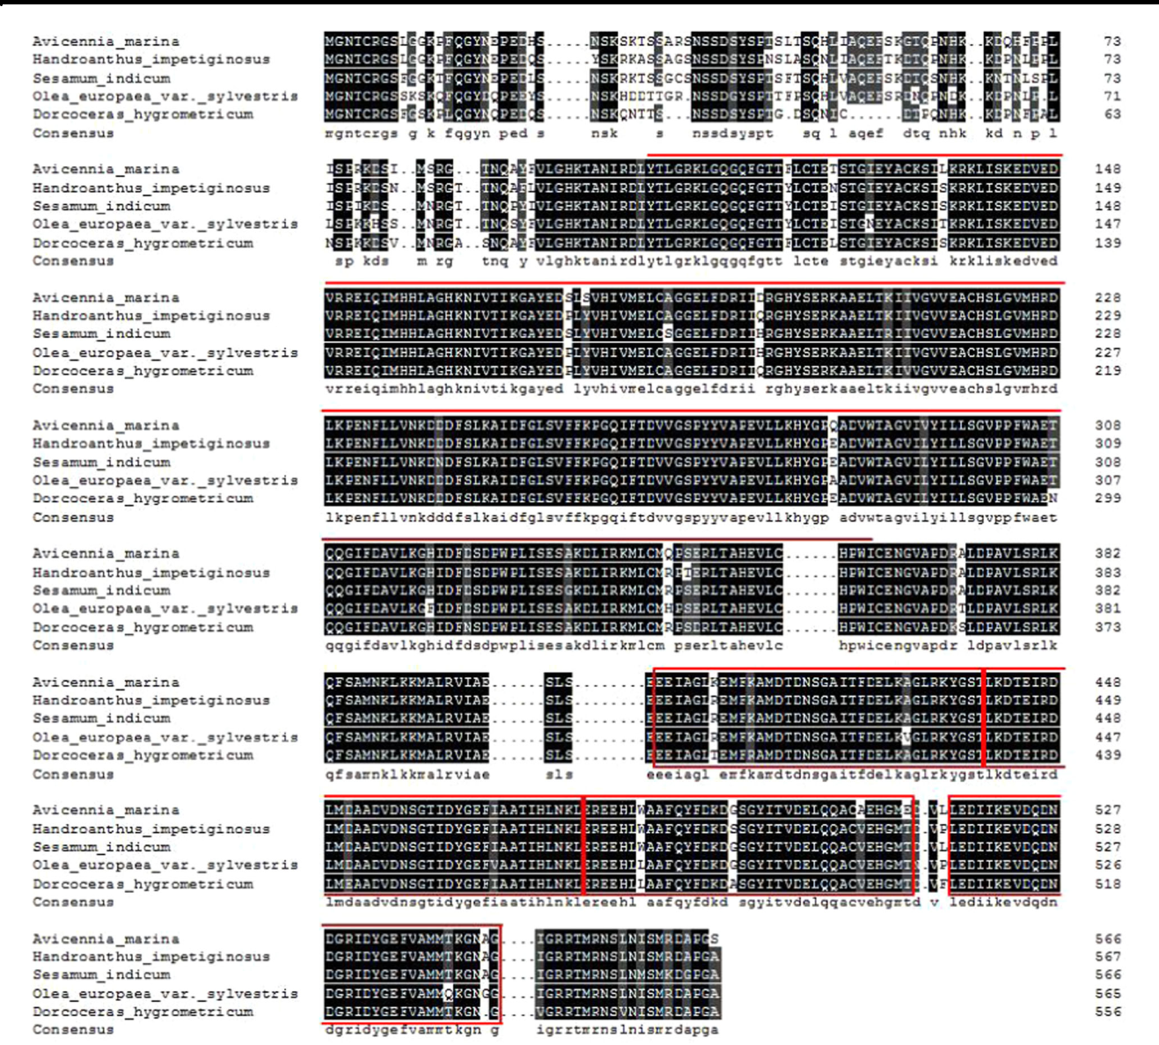

Fig. 5 Multiple sequence analysis of AmCDPK and other CDPK homologs from different plants. Protein kinase domain is marked with upper lines. Four EF-hand Ca2+-binding motifs are labeled with squares

Expression of AmCDPK in response to heat stress Discussion

To analyze the expression of AmCDPK responding to heat treatment, changes of relative transcript levels of AmCDPK in leaves were assessed over 168 h exposure after heat shock in biological triplicates. The expression slightly increased from the very beginning to 24 h, sig-nificantly up-regulated after that, and peaked at the value of 12.90-fold on the 48th hour, then dropped to the level of 7-fold compared to the control and remained relatively stable (Fig. 9). Overall, heat stress triggered the expres-sion of AmCDPK in leaves and the expression pattern suggested that AmCDPK was an heat stress-response gene in A. marina.



From the result of survival rates under heat stress, we could infer that A. marina had the best heat-resistant ability among these five mangrove species while K. obovata was the weakest. The result brought into correspondence with natural distributions of mangroves.

Existing exclusively in plants and several protozoans, CDPKs were found to assist with the development and stress-tolerance (DeFalco et al. 2010). Although several CDPK genes from terrestrial plants have been detected, CDPKs in mangroves and their functions in stress response remain unknown. In this experiment, we isolated and characterized AmCDPK gene, which

|  |  |
| --- | --- |
| Molecular cloning and expression of AmCDPK from mangrove Avicennia marina under elevated temperature | 713 |
|  |  |

|  |  |  |  |  |  |  |  |  |  |  |  |  |  |  |  |  |  |  |  |  |  |  |  |
| --- | --- | --- | --- | --- | --- | --- | --- | --- | --- | --- | --- | --- | --- | --- | --- | --- | --- | --- | --- | --- | --- | --- | --- |
|  |  |  |  |  |  |  |  |  |  |  |  |  |  |  |  |  |  |  | O |  |  |  |  |
|  |  |  |  |  |  |  |  |  |  |  |  |  |  |  |  |  |  |  | r |  |  |  |  |
|  |  |  |  |  |  |  |  |  |  |  |  |  |  |  |  |  |  |  | y | |  |  |  |
|  |  |  |  |  |  |  |  |  |  |  |  |  |  |  |  |  |  |  | za | |  |  |  |
|  |  |  |  |  |  |  |  |  |  |  |  |  |  |  |  |  |  |  | _ | |  |  |  |
|  |  |  |  |  |  |  |  |  |  |  |  |  |  |  |  |  |  |  |  | s |  |  |  |
|  |  |  |  |  |  |  |  |  |  |  |  |  |  |  |  |  |  |  |  | a |  |  |  |
|  |  |  |  |  |  |  |  |  |  |  |  |  |  |  |  |  |  |  |  | t |  |  |  |
|  |  |  |  |  |  |  |  |  |  |  |  |  |  |  |  |  |  |  |  | i |  |  |  |
|  |  |  |  |  |  |  |  |  |  |  |  |  |  |  |  |  |  |  |  | v | Ho | |  |
|  |  |  |  |  |  |  |  |  |  |  |  |  |  |  |  |  |  |  |  | _ |  |
|  |  |  |  |  |  |  |  |  |  |  |  |  |  |  |  |  |  |  |  | a |  |  |  |
|  |  |  |  |  |  |  |  |  |  |  |  |  |  |  |  |  |  |  |  | Ja | r | |  |
|  |  |  |  |  |  |  |  |  |  |  |  |  |  |  |  |  |  |  |  | d | |  |
|  |  |  |  |  |  |  |  |  |  |  |  |  |  |  |  |  |  |  |  | o | eu | |  |
|  |  |  |  |  |  |  |  |  |  |  |  |  |  |  |  |  |  |  |  | p |  |  |  |
|  |  |  |  |  |  |  |  |  |  |  |  |  |  |  |  |  |  |  |  | i | | m |  |
|  |  |  |  |  |  |  |  |  |  |  |  |  |  |  |  |  |  |  |  | n | |  |  |
|  |  |  |  |  |  |  |  |  |  |  |  | S | |  |  |  |  |  |  | ca | | _ |  |
|  |  |  |  |  |  |  |  |  |  |  |  |  |  |  |  |  | Z | | _ | v |  |
|  |  |  |  |  |  |  |  |  |  |  |  | o | | |  |  |  |  |  | e | G | u |  |
|  |  |  |  |  |  |  |  |  |  |  |  |  |  | r | |  |  |  |  | a |  |  |
|  |  |  |  |  |  |  |  |  |  |  |  |  |  | g | | | |  |  | _ |  | l |  |
|  |  |  |  |  |  |  |  |  |  |  |  |  |  |  | h | | |  |  | r | g |  |
|  |  |  |  |  |  |  |  |  |  |  |  |  |  |  |  |  | m | o | a |  |
|  |  |  |  |  |  |  | A | |  |  |  |  |  |  |  |  | u | |  |  |  |
|  |  |  |  |  |  |  |  |  |  |  |  |  |  |  | m | | | a | u | r |  |
|  |  |  |  |  |  |  |  | v | |  |  |  |  |  |  |  |  | _ | | y | p | e |  |
|  |  |  |  |  |  |  |  |  | i | |  |  |  |  |  |  |  |  |  |  |
|  |  |  |  |  |  |  |  |  |  | c | |  |  |  |  |  |  |  | i |  |  |  |  |
|  |  |  |  |  |  |  |  |  |  |  | e |  |  |  |  |  |  |  | s |  |  |  |
|  |  |  |  |  |  |  |  |  |  |  | n | |  |  |  |  |  |  | b |  |  |  |
|  |  |  |  |  |  |  |  |  |  |  |  |  |  |  |  |  | c |  |  |  |  |
|  | Ha | |  |  |  |  |  |  |  |  |  | ni | _ | |  |  |  |  | o | |  |  |  |
|  |  |  |  |  |  |  |  |  |  |  |  |  |  |  |  | o |  |  |  |
|  |  |  | ndr | |  |  |  |  |  |  |  | a | | m | | |  |  |  | l |  |  |  |
|  |  |  |  |  |  |  |  |  |  |  |  |  |  |  | r |  |  |  |
|  |  |  |  | o | a |  |  |  |  |  |  |  |  |  |  | a | |  |  |  |  |  |
|  |  |  |  |  | nt |  |  |  |  |  |  |  |  |  |  | ri | |  |  |  |  |  |
|  |  |  |  |  |  |  |  |  |  |  |  |  |  |  |  |  | n | |  |  |  |  |
|  |  |  |  |  |  | h | u |  |  |  |  |  |  |  |  |  |  |  |  |  |  |
|  |  |  |  |  |  |  | s_i | | | |  |  |  |  |  |  |  | a |  |  |  |  |
|  |  |  |  |  |  |  |  |  |  |  | mpe | |  |  |  |  |  |  |  |  |  |  |  |
|  |  |  |  |  |  |  |  |  |  |  |  | ti | | |  |  |  |  |  |  |  |  |  |
|  |  |  |  |  |  |  |  |  |  |  |  |  |  | gi | | |  |  |  |  |  |  |  |
|  |  |  |  |  |  |  |  |  |  |  |  |  |  |  | n | | |  |  |  |  |  |  |
| D | or | co | | ceras | | |  |  |  |  |  |  |  |  |  |  | o | s | us |  |  |  |  |
|  |  |  |  |  |  |  |  |  |  |  |  |  |  |  |  |  |  |  |  |
|  |  |  |  |  |  | _hygro | | | | | |  |  |  |  |  |  |  |  |  |  |  |  |
|  |  |  |  |  |  |  |  |  |  |  | metri | | | |  |  |  |  |  |  |  |  |  |
|  |  |  |  |  |  |  |  |  |  |  |  |  |  | cum | | | | |  |  |  |  |  |
| Olea_europaea_var._sylvestris | | | | | | | | | | | | | | | | | | | |  |  |  |  |

A

e

g

i

l

o

p

s

_

t

a

u

s

ch

i

i

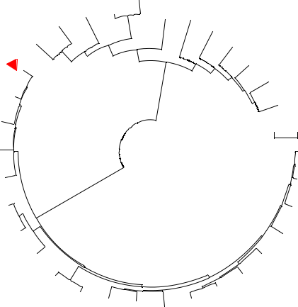

|  |  |  |  |  |  |  |  |  |  |  |  |  |  |  |  |  |  |  |  |  |  |  |  |  |  |  |  |  |  |  |  |  |  |  |  |  |  |  |  |
| --- | --- | --- | --- | --- | --- | --- | --- | --- | --- | --- | --- | --- | --- | --- | --- | --- | --- | --- | --- | --- | --- | --- | --- | --- | --- | --- | --- | --- | --- | --- | --- | --- | --- | --- | --- | --- | --- | --- | --- |
| A |  |  |  |  |  |  |  |  |  |  |  |  |  |  |  |  |  |  |  |  |  |  |  |  |  |  |  |  |  |  |  |  |  |  |  |  |  |  |  |
| n |  |  |  |  |  |  |  |  |  |  |  |  |  |  |  |  |  |  |  |  | a |  |  |  |  |  |  |  |  |  |  |  |  |  |  |  |  |  |  |
| a |  | a | |  |  |  |  |  |  |  |  |  |  |  |  |  |  |  |  | n |  |  |  |  |  |  |  |  |  |  |  |  |  |  |  |  |  |  |
| n |  |  |  |  |  |  |  |  |  |  |  |  |  |  |  |  | a |  |  |  |  |  |  |  |  |  |  |  |  |  |  |  |  |  |  |  |
| a |  | n | |  |  |  |  |  |  |  |  |  |  |  |  |  |  | i |  |  |  |  |  |  |  |  |  |  |  |  |  |  |  |  |  |  |  |  |
|  |  | i |  |  |  |  |  |  |  |  |  |  |  |  |  | a | l | |  |  |  |  |  |  |  |  |  |  |  |  |  |  |  |  |  |  |  |  |  |
| s |  | r |  |  |  |  |  |  |  |  |  |  |  | t |  |  |  |  |  |  |  |  |  |  |  |  | s |  |  |  |  |  |  |  |  |  |  |  |
| c |  | ma |  |  |  |  |  |  |  |  |  |  |  | h |  |  |  |  |  |  |  |  |  |  |  |  |  |  |  |  |  |  |  |  |  |  |  |
| _ |  |  |  |  |  |  |  |  |  |  |  |  | _ |  |  |  |  |  |  |  |  |  |  |  |  | i | |  |  |  |  |  |  |  |  |  |  |  |
| o | _ |  |  |  |  |  |  |  |  |  |  | s |  |  |  |  |  |  |  |  |  |  |  |  |  |  |  |  |  |  |  |  |  |  |  |  |
|  |  |  |  |  |  |  |  |  | i |  |  |  |  |  |  |  |  |  |  |  |  |  | s | |  |  |  |  |  |  |  |  |  |  |  |  |
| m | a |  |  |  |  |  |  |  |  | s |  |  |  |  |  |  |  |  |  |  |  | e | | n |  |  |  |  |  |  |  |  |  |  |  |  |  |  |
| r |  |  |  |  |  |  |  | p |  |  |  |  |  |  |  |  |  |  |  | in |  |  |  |  |  |  |  |  |  |  |  |  |  |  |  |
| o | e |  |  |  |  |  |  | o |  |  |  |  |  |  |  |  |  |  |  |  |  |  |  |  |  |  |  |  |  |  | o | | |  |  |  |  |
| s | t |  |  |  |  |  | d |  |  |  |  |  |  |  |  |  |  |  |  |  | s |  |  |  |  |  |  |  |  |  |  |  |  |  |  |
| u | s |  |  |  |  | i |  |  |  |  |  |  |  |  |  |  |  | a _ | | |  |  |  |  |  |  |  |  |  | a | | |  |  |  |  |  |
| s | o |  |  |  | b |  |  |  |  |  |  |  |  |  |  |  |  |  |  |  |  |  |  |  |  |  | ac | |  |  |  |  |  |  |  |
|  | Z |  |  | a |  |  |  |  |  |  |  |  |  |  | lli | | |  |  |  |  |  |  |  |  |  |  |  | c | |  |  |  |  |  |  |  |  |
|  |  | r |  |  |  |  |  |  |  |  |  |  | e |  |  |  |  |  |  |  |  |  |  | _ | |  |  |  |  |  |  |  |  |  |
|  |  | A |  |  |  |  |  |  |  |  |  | m | |  |  |  |  |  |  |  |  |  |  |  |  | a | |  |  |  |  |  |  |  |  |  |  |
|  |  |  |  |  |  |  |  |  |  | a | |  |  |  |  |  |  |  | rom | | | | | | |  |  |  |  |  |  | il | | | |  |
|  |  |  |  |  |  |  |  |  | C |  |  |  |  |  |  | heob | | | | | | |  |  |  |  |  |  |  |  |  | a | | | |  | is | |  |
|  |  |  |  |  |  |  |  |  |  |  |  |  |  |  |  |  |  |  |  |  |  | _ | |  | t | | b | | |  |  |  |
|  |  |  |  |  |  |  |  |  |  |  |  |  |  |  |  |  |  |  |  |  |  |  |  |  |  |  |  |  |  |  |  |  |  |  |
|  |  |  |  |  |  |  |  |  |  |  |  |  |  |  |  |  |  |  |  |  |  |  |  |  |  |  |  |  |  |  | o | |  |  |  |  |  |  |  |
|  |  |  |  |  |  |  |  |  |  |  |  |  |  | T | | | |  |  |  |  |  |  |  |  |  |  | s | | n | |  |  |  |  |  |  |  |  |
|  |  |  |  |  |  |  |  |  |  |  |  |  |  |  |  |  |  |  |  |  |  |  |  |  | u | | | |  |  |  |  |  |  |  |  |  |  |  |
|  |  |  |  |  |  |  |  |  |  |  |  |  |  |  |  |  |  |  |  |  |  |  |  | r | | |  |  |  |  |  |  |  |  |  |  |  |  |  |
|  |  |  |  |  |  |  |  |  |  |  |  |  |  |  |  |  |  |  |  |  |  | o | | | |  |  |  |  |  |  |  |  |  |  |  |  | m |  |
|  |  |  |  |  |  |  |  |  |  |  |  |  |  |  |  |  |  |  |  |  | M | | |  |  |  |  |  |  |  |  |  |  |  |  |  |  |  |
|  |  |  |  |  |  |  |  |  |  |  |  |  |  |  |  |  |  |  |  |  |  |  |  |  |  |  |  |  |  |  |  |  | iu | | |  |
|  |  |  |  |  |  |  |  |  |  |  |  |  |  |  |  |  |  |  |  |  |  |  |  |  |  |  |  |  |  |  |  |  |  |  | v | | |  |  |
|  |  |  |  |  |  |  |  |  |  |  |  |  |  |  |  |  |  |  |  |  |  |  |  |  |  |  |  |  |  |  |  |  | a | | |  |  |  |  |
|  |  |  |  |  |  |  |  |  |  |  |  |  |  |  |  |  |  |  |  |  |  |  |  |  |  |  |  |  |  |  |  | _ | |  |  |  |  |  |  |
|  |  |  |  |  |  |  |  |  |  |  |  |  |  |  |  |  |  |  |  |  |  |  |  |  |  |  |  |  |  |  | s | |  |  |  |  |  |  |  |
|  |  |  |  |  |  |  |  |  |  |  |  |  |  |  |  |  |  |  |  |  |  |  |  |  |  |  |  |  |  | u | |  |  |  |  |  |  |  |  |
|  |  |  |  |  |  |  |  |  |  |  |  |  |  |  |  |  |  |  |  |  |  |  |  |  |  |  |  | n | | |  |  |  |  |  |  |  |  |  |
|  |  |  |  |  |  |  |  |  |  |  |  |  |  |  |  |  |  |  |  |  |  |  |  |  | ru | | | | |  |  |  |  |  |  |  |  |  |  |
|  |  |  |  |  |  |  |  |  |  |  |  |  |  |  |  |  |  |  |  |  |  | P | | | |  |  |  |  |  |  |  |  |  |  |  |  |  |  |
|  |  |  |  |  |  |  |  |  |  |  |  |  |  |  |  |  |  |  |  |  |  |  |  | 05.0 | |  |  |  |  |  |  |  |  |  |  |  |  |  |  |

Herrania_umbratica

|  |  |  |  |  |  |  |  |  |  |  |  |  |  |  |  |  |  |  |  |  |  |  |  |  |  |  |  |  |  |  |  |  |  |  |
| --- | --- | --- | --- | --- | --- | --- | --- | --- | --- | --- | --- | --- | --- | --- | --- | --- | --- | --- | --- | --- | --- | --- | --- | --- | --- | --- | --- | --- | --- | --- | --- | --- | --- | --- |
|  |  |  |  |  |  |  |  |  |  |  |  |  |  |  |  |  | um | | | |  |  |  |  |  |  |  |  |  |  |  |  |  |  |
|  |  |  |  |  |  |  |  |  |  |  |  |  | dic | | | | |  |  |  |  |  |  |  |  |  |  |  |  |  |  |  |  |  |
|  |  |  |  |  |  |  |  |  | _in | | | | |  |  |  |  |  |  |  |  |  |  |  |  |  |  |  |  |  |  |  |  |  |
|  |  |  |  | um | | | | | |  |  |  |  |  |  |  |  |  |  |  |  |  |  |  |  |  |  |  |  |  |  |  |  |  |
|  |  |  | m | |  |  |  |  |  |  |  |  |  |  |  |  |  |  |  |  |  |  |  |  |  |  |  |  |  |  |  |  |  |  |
|  | sa | | |  |  |  |  |  |  |  |  |  |  |  |  |  |  |  |  |  |  |  |  |  |  |  |  |  |  |  |  |  |  |  |
| Se | |  |  |  |  |  |  |  |  |  |  |  |  |  |  |  |  |  | m | | | |  |  |  |  |  |  |  |  |  |  |  |  |
|  |  |  |  |  |  |  |  |  |  |  |  |  |  |  |  |  |  | u | |  |  |  |  |  |  |  |  |  |  |  |  |  |  |  |
|  |  |  |  |  |  |  |  |  |  |  |  |  |  |  |  | s | | |  |  |  |  |  |  |  |  |  |  |  |  |  |  |  |  |
|  |  |  |  |  |  |  |  |  |  |  |  |  |  | ro | | | |  |  |  |  |  |  |  |  |  |  |  |  |  |  |  |  |  |
|  |  |  |  |  |  |  |  |  |  |  |  | e | | |  |  |  |  |  |  |  |  |  |  |  |  |  |  |  |  |  |  |  |  |
|  |  |  |  |  |  |  |  |  |  | b | | | |  |  |  |  |  |  |  |  |  |  |  |  |  |  |  |  |  |  |  |  |  |
|  |  |  |  |  |  |  |  | tu | | | |  |  |  |  |  |  |  |  |  |  |  |  |  |  |  |  |  |  |  |  |  |  |  |
|  |  |  |  |  |  | _ | | | |  |  |  |  |  |  |  |  |  |  |  |  |  |  |  |  |  |  |  |  |  |  |  |  |  |
|  |  |  |  | m | | | |  |  |  |  |  |  |  |  |  |  |  |  |  |  |  | e | | | | |  |  |  |  |  |  |  |
|  |  |  | u | |  |  |  |  |  |  |  |  |  |  |  |  |  |  |  |  |  |  |  |  |  |  |  |  |  |
|  |  | n | |  |  |  |  |  |  |  |  |  |  |  |  |  |  |  |  |  | s | | | |  |  |  |  |  |  |  |  |  |  |
|  | la | |  |  |  |  |  |  |  |  |  |  |  |  |  |  |  |  | n | | | |  |  |  |  |  |  |  |  |  |  |  |  |
| o | |  |  |  |  |  |  |  |  |  |  |  |  |  |  |  |  | e | | |  |  |  |  |  |  |  |  |  |  |  |  |  |  |
| S |  |  |  |  |  |  |  |  |  |  |  |  |  |  |  |  | n | | |  |  |  |  |  |  |  |  |  |  |  |  |  |  |  |
|  |  |  |  |  |  |  |  |  |  |  |  | _ | | | hi | | | |  |  |  |  |  |  |  |  |  | m | | | | |  |  |
|  |  |  |  |  |  |  |  |  |  | m | | | | c | | |  |  |  |  |  |  |  |  |  |  | u | |  |  |  |  |  |  |
|  |  |  |  |  |  |  |  | u | | |  |  |  |  |  |  |  |  |  |  |  |  |  |  | c | | |  |  |  |  |  |  |  |
|  |  |  |  |  |  | ic | | | |  |  |  |  |  |  |  |  |  |  |  |  |  | a | | | |  |  |  |  |  |  |  |  |
|  |  |  |  | ps | | | |  |  |  |  |  |  |  |  |  |  |  |  |  | b | | | |  |  |  |  |  |  |  |  |  |  |
|  |  |  |  |  |  |  |  |  |  |  |  |  |  |  | ta | | |  |  |  |  |  |  |  |  |  |  |  |  |  |
|  |  |  | a | |  |  |  |  |  |  |  |  |  |  |  |  |  |  |  |  |  |  |  |  |  |  |  |  |  |  |  |
|  |  | C | |  |  |  |  |  |  |  |  |  |  |  |  |  |  | _ | |  |  |  |  |  |  |  |  |  |  |  |  |  |  |  |
|  |  |  |  |  |  |  |  |  |  |  |  |  |  |  |  |  | a | |  |  |  |  |  |  |  |  |  |  |  |  | ly | |  |  |
|  |  |  |  |  |  |  |  |  |  |  |  |  |  |  |  | n | |  |  |  |  |  |  |  |  |  |  |  |  | o |  |  |
|  |  |  |  |  |  |  |  |  |  |  |  |  |  | ia | | |  |  |  |  |  |  |  |  |  |  |  | c |  |  |  |  |  |
|  |  |  |  |  |  |  |  |  |  |  |  |  | t | |  |  |  |  |  |  |  |  |  |  |  |  | s |  |  |  |  |  |
|  |  |  |  |  |  |  |  |  |  | ico | | | | |  |  |  |  |  |  |  |  |  |  |  | _ |  |  |  |  |  |  |
|  |  |  |  |  |  |  |  |  |  |  |  |  |  |  |  |  |  |  | . | |  |  |  |  |  |  |  |
|  |  |  |  |  |  |  |  |  | N | |  |  |  |  |  |  |  |  |  |  |  |  |  |  |  |  |  |  |  |  |  |
|  |  |  |  |  |  |  |  |  |  |  |  |  |  |  |  |  |  |  |  |  |  |  |  |  |  |  |  |  |  |  |
|  |  |  |  |  |  |  |  |  |  |  |  |  |  |  |  |  |  |  |  |  | v | a | | r |  |  |  |  |  |  |  |  |  |  |
|  |  |  |  |  |  |  |  |  |  |  |  |  |  |  |  |  |  |  |  | _ |  |  |  |  |  |  |  |  |  |  |  |
|  |  |  |  |  |  |  |  |  |  |  |  |  |  |  |  |  |  |  | s |  |  |  |  |  |  |  |  |  |  |  |  |  |
|  |  |  |  |  |  |  |  |  |  |  |  |  |  |  |  |  |  | lu |  |  |  |  |  |  |  |  |  |  |  |  |  |  |
|  |  |  |  |  |  |  |  |  |  |  |  |  |  |  |  |  | u |  |  |  |  |  |  |  |  |  |  |  |  |  |  |  |
|  |  |  |  |  |  |  |  |  |  |  |  |  |  |  |  | c |  |  |  |  |  |  |  |  |  |  |  |  |  |  | a |  |
|  |  |  |  |  |  |  |  |  |  |  |  |  |  |  | n |  |  |  |  |  |  |  |  |  |  |  |  |  |  | i |  |
|  |  |  |  |  |  |  |  |  |  |  |  |  |  |  |  |  |  |  |  |  |  |  |  |  |  |  |  |  |  |  |
|  |  |  |  |  |  |  |  |  |  |  |  |  | d | u |  |  |  |  |  |  |  |  |  |  |  |  |  | H |  | e | l |  |  |
|  |  |  |  |  |  |  |  |  |  |  |  |  |  |  |  |  |  |  |  |  |  |  |  |  |  |  |  |  |  |
|  |  |  |  |  |  |  |  |  |  |  | a | r |  |  |  |  |  |  |  |  |  |  |  |  |  |  |  |  |  |  |
|  |  |  |  |  |  |  |  |  |  | c |  |  |  |  |  |  |  |  |  |  |  |  |  |  |  |  |  |  |  |  |
|  |  |  |  |  |  |  |  |  | _ |  |  |  |  |  |  |  |  |  |  |  |  |  |  |  |  |  |  |  |  |  |  |  |
|  |  |  |  |  |  |  | ra | |  |  |  |  |  |  |  |  |  |  |  |  |  |  |  |  |  |  |  |  |  |  |  |  |
|  |  |  |  |  |  |  |  |  |  |  |  |  |  |  |  |  |  |  |  |  |  |  |  |  |  |  |  |  |  |  |  |
|  |  |  |  |  | n | a |  |  |  |  |  |  |  |  |  |  |  |  |  |  |  |  |  |  |  |  |  |  |  |  |  |  |
|  |  |  |  | y |  |  |  |  |  |  |  |  |  |  |  |  |  |  |  |  |  |  |  |  |  |  |  |  |  |  |  |  |
|  |  |  | C |  |  |  |  |  |  |  |  |  |  |  |  |  |  |  |  |  |  |  |  |  |  |  |  |  |  |  |  |  |
|  |  |  |  |  |  |  |  |  |  |  |  |  |  |  |  |  |  |  |  |  |  |  |  |  |  |  |  |  |  |  |  |  |
|  |  |  |  |  |  |  |  |  |  |  |  |  |  |  |  |  |  |  |  |  |  |  |  |  |  |  |  |  |  |  |  |  |  |

1. u

|  |  |  |  |  |  |  |  |
| --- | --- | --- | --- | --- | --- | --- | --- |
|  |  |  |  | s | _ | a |  |
|  |  |  | u |  |  |
|  |  | h |  |  |  |
| n | t |  |  |  |  |
|  |  |  |  |  |
|  |  |  |  |  |  |
|  |  |  |  |  |  |  |

|  |  |  |
| --- | --- | --- |
| n | n |  |
|  |  |

u

1. s

a

c

si

s_per

u

un

Pr

a

y

a

p

a

p

_

a

c

ri

a

C

|  |  |  |  |  |  |  |  |  |  |  |  |  |  |  |  |  |  |  |  |  |  |  |  |  |  |  |
| --- | --- | --- | --- | --- | --- | --- | --- | --- | --- | --- | --- | --- | --- | --- | --- | --- | --- | --- | --- | --- | --- | --- | --- | --- | --- | --- |
|  |  |  |  |  |  |  |  | D | |  |  |  |  |  |  |  |  |  |  |  |  |  |  |  |  |  |
|  |  |  |  |  |  |  |  |  | ur | | | |  |  |  |  |  |  |  |  |  |  |  |  |  |  |
|  |  |  |  |  |  |  |  |  |  |  |  | io | |  |  |  |  |  |  |  |  |  |  |  |  |  |
|  |  |  |  |  |  |  |  |  |  |  |  |  | _z | | | |  |  |  |  |  |  |  |  |  |  |
|  |  |  |  |  |  |  |  |  |  |  |  |  |  |  |  | ibeth | | | | | |  |  |  |  |  |
|  |  |  |  |  |  |  | G | |  |  |  |  |  |  |  |  |  |  |  |  | inus | | | |  |  |
|  |  |  |  |  |  |  |  | os | | | |  |  |  |  |  |  |  |  |  |  |  |  |  |  |  |
|  |  |  |  |  |  |  |  |  |  |  | s | |  |  |  |  |  |  |  |  |  |  |  |  |  |  |
|  |  |  |  |  |  |  |  |  |  |  |  | ypi | | | |  |  |  |  |  |  |  |  |  |  |  |
|  |  |  |  |  |  |  |  |  |  |  |  |  |  |  | um | | | |  |  |  |  |  |  |  |  |
|  |  |  |  |  |  |  |  |  |  |  |  |  |  |  |  |  |  | _ | |  |  |  |  |  |  |  |
|  |  |  |  |  |  | Po | |  |  |  |  |  |  |  |  |  |  |  | h | | s | |  |  |  |  |
|  |  |  |  |  |  |  | p | |  |  |  |  |  |  |  |  |  |  |  | ir | |  | ut | u |  |  |
|  |  |  |  |  |  |  |  | u | |  |  |  |  |  |  |  |  |  |  |  |  |  |  | m |  |
|  |  |  |  |  | J |  |  |  | l | |  |  |  |  |  |  |  |  |  |  |  |  |  |  |  |
|  |  |  |  |  |  |  |  |  | u | |  |  |  |  |  |  |  |  |  |  |  |  |  |  |  |
|  |  |  |  |  | a |  |  |  |  |  | s | |  |  |  |  |  |  |  |  |  |  |  |  |  |  |
|  |  |  |  |  | t |  |  |  |  |  |  | _ | |  |  |  |  |  |  |  |  |  |  |  |  |  |
|  |  |  |  |  |  |  |  |  |  |  |  | t | |  |  |  |  |  |  |  |  |  |  |  |  |
|  |  |  |  |  | r |  |  |  |  |  |  |  |  | ri | |  |  |  |  |  |  |  |  |  |  |  |
|  |  |  |  | R | o | |  |  |  |  |  |  |  |  | c | |  |  |  |  |  |  |  |  |  |  |
|  |  |  |  | p | | |  |  |  |  |  |  |  |  | h | |  |  |  |  |  |  |  |  |  |
|  |  |  |  | i | | h | | |  |  |  |  |  |  |  |  | o | |  |  |  |  |  |  |  |  |
|  |  | H | |  |  |  |  |  |  |  |  |  |  |  |  | c | |  |  |  |  |  |  |  |
|  |  |  |  | c | |  | a | |  |  |  |  |  |  |  |  |  |  |  |  | r |  |  |  |  |  |
|  |  |  |  | i | |  |  | _ | |  |  |  |  |  |  |  |  |  |  |  |  |  |  |  |  |
|  |  | e | | n | |  |  | c | | |  |  |  |  |  |  |  |  |  |  | p | |  |  |  |  |
|  |  |  | u |  |  |  |  |  |  |  |  |  |  |  |  |  | a | |  |  |  |
|  | M | v | |  |  |  |  | u | | |  |  |  |  |  |  |  |  |  |  |  |  |  |
|  | e | |  | s |  |  |  |  | r | | |  |  |  |  |  |  |  |  |  |  |  |  |  |  |
|  | a |  |  |  |  |  |  |  | c | |  |  |  |  |  |  |  |  |  |  |  |  |  |  |
| a |  |  | a | | _ |  |  |  |  |  |  | s | | | |  |  |  |  |  |  |  |  |  |  |  |
| n |  | c |  |  |  |  |  |  |  |  |  |  |  |  |  |  |  |  |  |
| i |  | _ | | o | |  |  |  |  |  |  |  |  |  |  |  |  |  |  |  |  |
| t | i |  |  |  |  |  |  |  |  |  |  |  |  |  |  |  |  |  |  |  |  |  |
| n | h | | b | | m | | |  |  |  |  |  |  |  |  |  |  |  |  |  |  |  |  |  |  |  |
| a |  |  |  | m | | |  |  |  |  |  |  |  |  |  |  |  |  |  |  |  |  |  |  |
|  |  |  | a |  |  |  |  |  |  |  |  |  |  |  |  |  |  |  |  |  |  |  |
| r | o | |  | r |  |  |  |  |  |  |  |  |  |  |  |  |  |  |  |  |  |  |  |  |  |  |
| t | |  | s |  |  | u | |  |  |  |  |  |  |  |  |  |  |  |  |  |  |  |  |  |  |
| a | _ | |  |  |  |  |  |  |  |  |  |  |  |  |  |  |  |  |  |  |  |  |  |
|  |  |  | i | |  | n | | |  |  |  |  |  |  |  |  |  |  |  |  |  |  |  |  |  |
| h | e | |  |  |  |  |  |  |  |  |  |  |  |  |  |  |  |  |  |  |  |
|  | i | |  |  | i | | |  |  |  |  |  |  |  |  |  |  |  |  |  |  |  |  |
| c | s | |  | e | |  |  | s | | |  |  |  |  |  |  |  |  |  |  |  |  |  |  |  |  |
| _ |  | c |  | n | |  |  |  |  |  |  |  |  |  |  |  |  |  |  |  |  |  |  |  |  |  |
|  | u |  |  | s |  |  |  |  |  |  |  |  |  |  |  |  |  |  |  |  |  |  |  |  |  |
| a |  |  |  | i |  |  |  |  |  |  |  |  |  |  |  |  |  |  |  |  |  |  |  |  |  |
|  | l |  |  |  |  |  |  |  |  |  |  |  |  |  |  |  |  |  |  |  |  |  |  |  |
| c |  | e |  |  | s |  |  |  |  |  |  |  |  |  |  |  |  |  |  |  |  |  |  |  |  |  |
| i |  | n |  |  |  |  |  |  |  |  |  |  |  |  |  |  |  |  |  |  |  |  |  |  |  |
| d |  |  |  |  |  |  |  |  |  |  |  |  |  |  |  |  |  |  |  |  |  |  |  |  |  |
|  | t | |  |  |  |  |  |  |  |  |  |  |  |  |  |  |  |  |  |  |  |  |  |  |  |
| r |  | a | |  |  |  |  |  |  |  |  |  |  |  |  |  |  |  |  |  |  |  |  |  |  |  |
| o |  |  |  |  |  |  |  |  |  |  |  |  |  |  |  |  |  |  |  |  |  |  |  |  |
| m |  |  |  |  |  |  |  |  |  |  |  |  |  |  |  |  |  |  |  |  |  |  |  |  |  |  |
| o |  |  |  |  |  |  |  |  |  |  |  |  |  |  |  |  |  |  |  |  |  |  |  |  |  |  |
| M |  |  |  |  |  |  |  |  |  |  |  |  |  |  |  |  |  |  |  |  |  |  |  |  |  |  |

Fig. 6 Phylogenetic tree of AmCDPK. AmCDPK showed very close homology to CDPKs from Handroanthus impetiginosus, Dorcoceras hygrometricum, Olea europaea var. sylvestris and Sesamum indicum, which all belonged to Asteridae, Dicotyledoneae. GenBank assesion number: Handroanthus impetiginosus, PIN15711.1; Sesamum indi-cum, XP_011092924.1; Olea europaea var. sylvestris, XP_022863558.1; Herrania umbratical, XP_021291369.1; Dorco-

ceras hygrometricum, KZV41543.1; Carica papaya, XP_021896854.1; Durio zibethinus, XP_022727351.1; Gossypium hirsutum, NP_001314371.1; Populus trichocarpa, XP_006384859.1; Helianthus annuus, XP_022018141.1; Ricinus communis, NP_001310655.1; Hevea brasiliensis, XP_021660413.1; Prunus

persica, XP_007199654.1; Capsicum chinense, PHU04854.1; Momordica charantia, XP_022135979.1; Manihot esculenta, XP_021594179.1; Cynara cardunculus var. scolymus, KVH88577.1; Solanum tuberosum, NP_001274806.1; Jatropha curcas, XP_020535061.1; Nicotiana tabacum, ADM88045.1; Oryza sativa L., Q2RAV0.1; Hordeum vulgare, ASL69963.1; Sorghum bicolor, XP_002442700.1; Zea mays, XP_008671573.1; Ananas comosus, XP_020113644.1; Aegilops tauschii, EMT23982.1; Morus notabilis, XP_010106395.1; Prunus avium, XP_021806486.1; Zostera marina, KMZ62644.1; Camellia sinensis, ARJ54929.1; Theobroma cacao, XP_007015253.1; Arabidopsis thaliana, NP_196779.1

maybe play a crucial part in heat stress response in A. marina.

Sequence and structure analysis of AmCDPK

CDPKs are located at multiple places in plants, which includes cytosol, nucleus, plasma membrane, endoplasmic reticulum, peroxisomes, mitochondrial outer membrane, and oil bodies (Pical et al. 1993; Patharkar and Cushman 2000; Yoo et al. 2002; Lu and Hrabak 2002; Dammann et al. 2003; Anil et al. 2003). AmCDPK is a cytoplasmic protein, with two transmembrane helices (F243-F262; V287-W305). The connection with plasma membrane is important because calcium-signaling transductions are

generally initiated by the transmembrane transport of Ca2+ fluxes (Rudd and Franklin-Tong 2001; Malho 1998).

Obviously typical structures could be found in CDPKs after multiple sequence alignments, including variable N-terminal region, kinase domain, self-inhibition domain and calmodulin-like domain with four EF-hand Ca2+-binding sites. N-terminal domain is variable both in length and amino acid sequences. Little is known of its function, the region was, however, reported to contain subcellular tar-geting information (Harper et al. 1994). The high con-servation of C-terminal structure indicates the way how AmCDPK perform the function may be as similar as other plants. The regulatory mechanism of CDPK activity is mainly commanded by the interactions among the kinase,



714 J. Liu et al.

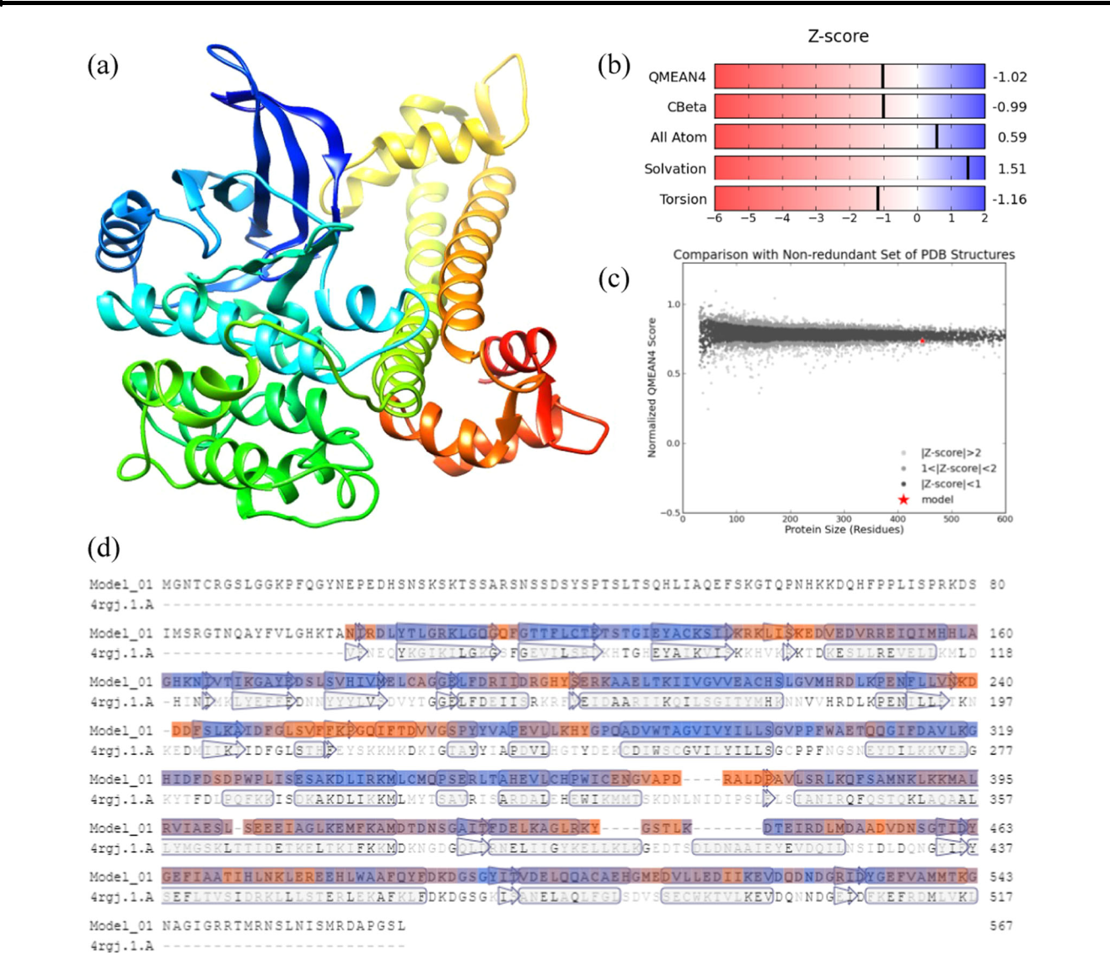

Fig. 7 Predicted three-dimensional structure of AmCDPK protein (SWISS-MODEL), based on homology modeling with apo crystal structure of CDPK4 from Plasmodium falciparum (SMTL id: 4rgj.1.A) as the template

autoinhibitory and CaM-like domain. When the concentra-tion of Ca2+ keeps low and stable, autoinhibitory domain is tightly bound to kinase domain in order to keep substrate phosphorylation activity low. However, once EF-hand motifs bind Ca2+, CDPKs will undergo conformational changes to release the pseudosubstrate and activate the protein (Cheng et al. 2002; Harmon et al. 1994; Harper et al. 1994). However, the distinct differences detected in N-terminal and the whole amino acid sequences indicate that CDPKs may be a little different among plants.

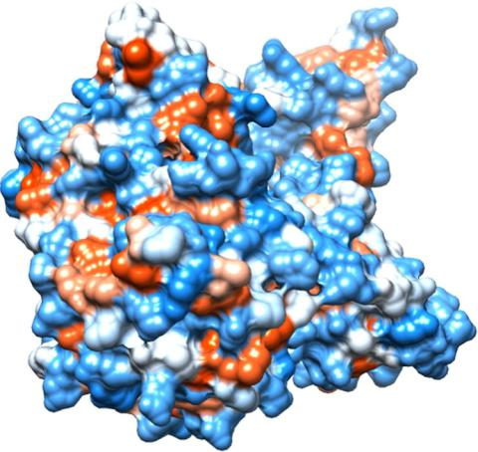

Expression of AmCDPK in response to heat stress

Many CDPKs were reported to induced or repressed rapidly under different stimuli. In Arabidopsis thaliana, AtCPK6,

Fig. 8 Surface properties of AmCDPK protein AtCPK10 and AtCPK11 were proved to serve as positive



|  |  |
| --- | --- |
| Molecular cloning and expression of AmCDPK from mangrove Avicennia marina under elevated temperature | 715 |
|  |  |

Fig. 9 Expression patterns of CDPK gene at 40 °C. All values were expressed as mean ± SD (bars). * above the bars indicates significant difference compared to the control (P < 0.05)

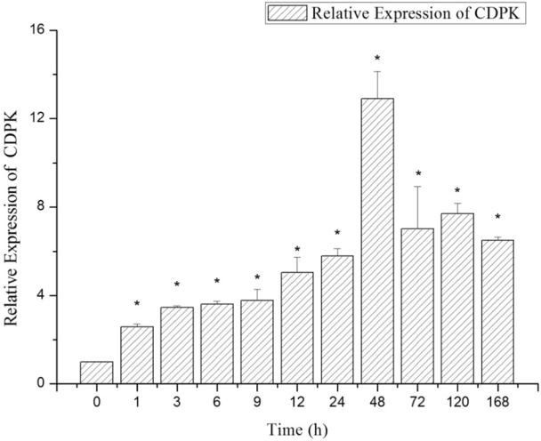

regulators responding to salt and drought stresses (Das and Pandey 2010; Xu et al. 2010). LeCPK2 was significantly induced by heat, EH, JA and ABA in Lycopersicon escu-lentum (Chang et al. 2009). OsCPK6 was up-regulated under drought stress (Wan et al. 2007). Transgenic rice over-expressing OsCDPK7 increased survival rate and enhanced endurance to drought, cold and salt stresses (Abbasi et al. 2004; Saijo et al. 2000).

To confirm whether AmCDPK possess anti-heat activity, we detected the expression patterns. The fast and durable response of AmCDPK to heat stress, as shown in our results, proved AmCDPK was involved in heat signaling pathway of A. marina. Similarly, LeCPK2 expressed remarkably in the flowers of Lycopersicon esculentum and distinct mRNA accumulation was detected at 4 h after heat stress at 42 °C (Chang et al. 2009). OsCPK25 was significantly up-regulated by heat shock in the rice seedlings (Wan and Mou 2007).

To confirm the function of AmCDPK related to heat stress response, we analyzed AmCDPK cDNA sequence in the Plant cis-acting Regulatory DNA Elements database to identify cis-elements. cis-elements could interact with cor-responding transregulatory factors to regulate gene expres-sions, thus the information is essential to figure out mechanisms and functions of genes. We found heat-responsive element CCAATBOX supporting anti-heat activity of AmCDPK (Haralampidis et al. 2002; Rieping and Schöffl 1992). Furthermore, several other previously-identified putative stress-response cis-elements existed in upstream regions of AmCDPK, including dehydration-responsive element MYBCORE (Urao et al. 1993) and DRE1COREZMRAB17 (Muthamilarasan et al. 2016), cold-induced elements MYCCONSENSUSAT (Peng et al. 2013), light-regulated IBOXCORE (Terzaghi and

Cashmore 1995) and GATABOX (Kawoosa et al. 2014), defense-responsive WBOXATNPR1 (Yu et al. 2001) and ABA-reponsive EBOXBNNAPA (Stålberg et al. 1996). The findings suggested that AmCDPK may be a versatile gene, which aligns with previous studies of other plants. To confirm these functions of AmCDPK, it would be necessary to conduct in vitro and over-expression studies to detect the quantitative expression patterns.

Conclusions

A. marina has better heat tolerance than A. corniculatum, B. gymnorrhiza and R. stylosa, while K. obovata is the weakest one among these five. In the study, a CDPK gene was cloned from A. marina and named for AmCDPK, the properties, structures and functions of which were analyzed. Amino acid sequence contained a kinase domain and four EF-hand Ca2+-binding sites, and depending on these structures, it was identified as a CDPK. The results demonstrated that AmCDPK played a significant role in heat stress response and may be also important under dehydration, cold, light, defense and ABA stresses. To confirm the deduction that AmCDPK may be a versatile gene, further studies are need. Our results provided the evidence that AmCDPK could function as positive regulators against heat stress. It was the first step to recognize heat stress response of A. marina, which is much more significant under the background of global warming.

Acknowledgements This research was supported by the National Natural Science Foundation of China (Nos. U1901211, 41430966 and 41876126), the National Key Research and Development Plan (No. 2017FY100700), the International Partnership Program of Chinese Academy of Sciences (No. 133244KYSB20180012) and the Strategic Priority Research Program of the Chinese Academy of Sciences (Nos. XDA23050200, XDA13010500 and XDA13020503).

Compliance with ethical standards

Conflict of interest The authors declare that they have no conflict of interest.

Ethical approval All the related authors confirmed there were no conflict of ethical approval.

Informed consent All the related authors have known the informed consent.

Publisher’s note Springer Nature remains neutral with regard to jurisdictional claims in published maps and institutional affiliations.

References

Abbasi F, Onodera H, Toki S, Tanaka H, Komatsu S (2004) OsCDPK13, a calcium-dependent protein kinase gene from rice,



716 J. Liu et al.

is induced by cold and gibberellin in rice leaf sheath. Plant Mol Biol 55(4):541–552

Altschul SF, Madden TL, Schäffer AA, Zhang J, Zhang Z, Miller W, Lipman DJ (1997) Gapped BLAST and PSI-BLAST: a new generation of protein database search programs. Nucleic Acids Res 25(17):3389–3402

Anil VS, Harmon AC, Rao KS (2003) Temporal association of Ca2+-dependent protein kinase with oil bodies during seed development in Santalum album L.: its biochemical character-ization and significance. Plant Cell Physiol 44(4):367–376

Arabidopsis Genome Initiative (2000) Analysis of the genome sequence of the flowering plant Arabidopsis thaliana. Nature 408 (6814):796

Asano T, Tanaka N, Yang G, Hayashi N, Komatsu S (2005) Genome-wide identification of the rice calcium-dependent protein kinase and its closely related kinase gene families: comprehensive ana-lysis of the CDPKs gene family in rice. Plant Cell Physiol 46

(2):356–366

Asano T, Wakayama M, Aoki N, Komatsu S, Ichikawa H, Hirochika H, Ohsugi R (2010) Overexpression of a calcium-dependent protein kinase gene enhances growth of rice under low-nitrogen conditions. Plant Biotechnol 27(4):369–373

Chang WJ, Su HS, Li WJ, Zhang ZL (2009) Expression profiling of a novel calcium-dependent protein kinase gene, LeCPK2, from tomato (Solanum lycopersicum) under heat and pathogen-related hormones. Biosci, Biotechnol Biochem 73(11):2427–2431

Cheng SH, Willmann MR, Chen HC, Sheen J (2002) Calcium sig-naling through protein kinases. The Arabidopsis calcium-dependent protein kinase gene family. Plant Physiol 129

(2):469–485

Dammann C, Ichida A, Hong B, Romanowsky SM, Hrabak EM, Harmon AC, Harper JF (2003) Subcellular targeting of nine calcium-dependent protein kinase isoforms from Arabidopsis. Plant Physiol 132(4):1840–1848

Das R, Pandey GK (2010) Expressional analysis and role of calcium regulated kinases in abiotic stress signaling. Curr Genom 11

(1):2–13

DeFalco TA, Bender KW, Snedden WA (2010) Breaking the code:

+

Fei J, Wang YS, Zhou Q, Gu JD (2015) Cloning and expression analysis of HSP70 gene from mangrove plant Kandelia obovata under cold stress. Ecotoxicology 24(7-8):1677–1685

Gasteiger E, Gattiker A, Hoogland C, Ivanyi I, Appel RD, Bairoch A (2003) ExPASy: the proteomics server for in-depth protein knowledge and analysis. Nucleic Acids Res 31(13):3784–3788

Goswami S, Kumar RR, Sharma SK, Kala YK, Singh K, Gupta R, Rai RD (2015) Calcium triggers protein kinases-induced signal transduction for augmenting the thermotolerance of developing wheat (Triticum aestivum) grain under the heat stress. J Plant Biochem Biotechnol 24(4):441–452

Hanks SK, Hunter T (1995) Protein kinases 6. The eukaryotic protein kinase superfamily: kinase (catalytic) domain structure and clas-sification. FASEB J 9(8):576–596

Haralampidis K, Milioni D, Rigas S, Hatzopoulos P (2002) Combi-natorial interaction of cis elements specifies the expression of the Arabidopsis AtHsp90-1gene. Plant Physiol 129(3):1138–1149

Harmon AC, Gribskov M, Harper JF (2000) CDPKs - a kinase for every Ca2+ signal? Trends Plant Sci 5(4):154–159

Harmon AC, Yoo BC, McCaffery C (1994) Pseudosubstrate inhibition of CDPK, a protein kinase with a calmodulin-like domain. Bio-chemistry 33(23):7278–7287

Harper JF, Huang JF, Lloyd SJ (1994) Genetic identification of an autoinhibitor in CDPK, a protein kinase with a calmodulin-like domain. Biochemistry 33(23):7267–7277

Hetherington A, Trewavas A (1982) Calcium-dependent protein kinase in pea shoot membranes. FEBS Lett 145(1):67–71



Huang GY, Wang YS (2010) Expression and characterization analysis of type 2 metallothionein from grey mangrove species (Avicennia marina) in response to metal stress. Aquat Toxicol 99(1):86–92 Kathiresan K, Bingham BL (2001) Biology of mangroves and man-

grove ecosystems. Adv Mar Biol 40:81–251

Kawoosa T, Gahlan P, Devi AS, Kumar S (2014) The GATA and SORLIP motifs in the 3-hydroxy-3-methylglutaryl-CoA reduc-tase promoter of Picrorhiza kurrooa for the control of light-mediated expression. Funct Integr Genom 14(1):191–203

Kong X, Lv W, Jiang S, Zhang D, Cai G, Pan J, Li D (2013) Genome-wide identification and expression analysis of calcium-dependent protein kinase in maize. BMC Genom 14(1):433

Kumar S, Tamura K, Nei M (2004) MEGA3: integrated software for molecular evolutionary genetics analysis and sequence alignment. Brief Bioinform 5(2):150–163

Lee J, Rudd JJ (2002) Calcium-dependent protein kinases: versatile plant signalling components necessary for pathogen defence. Trends Plant Sci 7(3):97–98

Liu J, Zhu JK (1998) A calcium sensor homolog required for plant salt tolerance. Science 280(5371):1943–1945

Livak KJ, Schmittgen TD (2001) Analysis of relative gene expression data using real-time quantitative PCR and the 2− CT method. Methods 25(4):402–408

Lu SX, Hrabak EM (2002) An Arabidopsis calcium-dependent protein kinase is associated with the endoplasmic reticulum. Plant Phy-siol 128(3):1008–1021

Luan S, Kudla J, Rodriguez-Concepcion M, Yalovsky S, Gruissem W (2002) Calmodulins and calcineurin B-like proteins: Calcium sensors for specific signal response coupling in plants. Plant Cell 14(suppl 1):S389–S400

Ludwig AA, Romeis T, Jones JD (2004) CDPK‐mediated signalling pathways: specificity and cross-talk. J Exp Bot 55(395):181–188 Malho R (1998) Spatial characteristics to calcium signalling; the cal-cium wave as a basic unit in plant cell calcium signalling. Philos

Trans R Soc Lond B: Biol Sci 353(1374):1463–1473

Medina E (1999) Mangrove physiology: the challenge of salt, heat, and light stress under recurrent flooding. Ecosistemas de manglar en América tropical 109–126

Mehta PA, Rebala KC, Venkataraman G, Parida A (2009) A diurnally regulated dehydrin from Avicennia marina that shows nucleo-cytoplasmic localization and is phosphorylated by Casein kinase

1. in vitro. Plant Physiol Biochem 47(8):701–709 Muthamilarasan M, Mangu VR, Zandkarimi H, Prasad M, Baisakh N

(2016) Structure, organization and evolution of ADP-ribosylation factors in rice and foxtail millet, and their expression in rice. Scientific Reports 6:24008

Nagamangala Kanchiswamy C, Kumar Mohanta T, Capuzzo A, Occhipinti A, Verrillo F, Maffei M, Malnoy M (2013) Role of Ca2+ and CDPKs in resistant and susceptible cultivars of apple (Malus x domestica) in response to the pathogen Erwinia amylovora and mechanical wounding. BMC Genom 144 (760):1–14

Patharkar OR, Cushman JC (2000) A stress-induced calcium-depen-dent protein kinase from Mesembryanthemum crystallinum phosphorylates a two-component pseudo-response regulator. Plant J 24(5):679–691

Peng HH, Shan W, Kuang JF, Lu WJ, Chen JY (2013) Molecular characterization of cold-responsive basic helix-loop-helix tran-scription factors MabHLHs that interact with MaICE1 in banana fruit. Planta 238(5):937–953

Peng YL, Wang YS, Cheng H, Sun CC, Wu P, Wang LY, Fei J (2013) Characterization and expression analysis of three CBF/DREB1 transcriptional factor genes from mangrove Avicennia marina. Aquat Toxicol 140:68–76

Pical C, Fredlund KM, Petit PX, Sommarin M (1993) The outer membrane of plant mitochondria contains a calcium-dependent

|  |  |
| --- | --- |
| Molecular cloning and expression of AmCDPK from mangrove Avicennia marina under elevated temperature | 717 |
|  |  |

protein kinase and multiple phosphoproteins. FEBS Lett 336 (2):347–351

Rieping M, Schöffl F (1992) Synergistic effect of upstream sequences, CCAAT box elements, and HSE sequences for enhanced expression of chimaeric heat shock genes in transgenic tobacco. Mol Gen Genet 231(2):226–232

Rudd JJ, Franklin-Tong VE (2001) Unravelling response-specificity in Ca2+ signalling pathways in plant cells. New Phytologist 151(1):7–33 Saijo Y, Hata S, Kyozuka J, Shimamoto K, Izui K (2000) Over-expression of a single Ca2+-dependent protein kinase confers both cold and salt/drought tolerance on rice plants. Plant J 23

(3):319–327

Sanders D, Brownlee C, Harper JF (1999) Communicating with cal-cium. Plant Cell 11(4):691–706

Sanders D, Pelloux J, Brownlee C, Harper JF (2002) Calcium at the crossroads of signaling. Plant Cell 14(suppl 1):S401–S417

Snedden WA, Fromm H (1998) Calmodulin, calmodulin-related pro-teins and plant responses to the environment. Trends Plant Sci 3

(8):299–304

Stålberg K, Ellerstöm M, Ezcurra I, Ablov S, Rask L (1996) Disrup-tion of an overlapping E-box/ABRE motif abolished high tran-scription of the napA storage-protein promoter in transgenic Brassica napus seeds. Planta 199(4):515–519

Terzaghi WB, Cashmore AR (1995) Light-regulated transcription. Annu Rev Plant Biol 46(1):445–474

Thompson JD, Gibson TJ, Plewniak F, Jeanmougin F, Higgins DG (1997) The CLUSTALx windows interface: flexible strategies for multiple sequence alignment aided by quality analysis tools. Nucleic Acids Res 25(24):4876–4882

Urao T, Yamaguchi-Shinozaki K, Urao S, Shinozaki K (1993) An Arabidopsis MYB homolog is induced by dehydration stress and its gene product binds to the conserved MYB recognition sequence. Plant Cell 5(11):1529–1539

Wan B, Lin Y, Mou T (2007) Expression of rice Ca2+-dependent protein kinases (CDPKs) genes under different environmental stresses. FEBS Lett 581(6):1179–1189

Wang LY, Wang YS, Zhang JP, Gu JD (2015) Molecular cloning of class III chitinase gene from Avicennia marina and its expression analysis in response to cadmium and lead stress. Ecotoxicology 24(7-8):1697–1704

Wang YS (2019) Molecular ecology of mangroves. The Science Publishing Company, Beijing, China

Weckwerth P, Ehlert B, Romeis T (2015) ZmCPK1, a calcium-independent kinase member of the Zea mays CDPK gene family, functions as a negative regulator in cold stress signalling. Plant Cell Environ 38(3):544–558

Wei S, Hu W, Deng X, Zhang Y, Liu X, Zhao X, Sun T (2014) A rice calcium-dependent protein kinase OsCPK9 positively regulates drought stress tolerance and spikelet fertility. BMC Plant Biol 14

(1):133

Xu J, Tian YS, Peng RH, Xiong AS, Zhu B, Jin XF, Yao QH (2010) AtCPK6, a functionally redundant and positive regulator involved in salt/drought stress tolerance in Arabidopsis. Planta 231

(6):1251–1260

Yoo BC, Lee JY, Lucas WJ (2002) Analysis of the complexity of protein kinases within the phloem sieve tube system character-ization of Cucurbita Maxima calmodulin-like domain protein kinase 1. J Biol Chem 277(18):15325–15332

Yoon GM, Cho HS, Ha HJ, Liu JR, Lee HSP (1999) Characterization of NtCDPK1, a calcium-dependent protein kinase gene in Nicotiana tabacum, and the activity of its encoded protein. Plant Mol Bioly 39(5):991–1001

Yuasa T, Takahashi K, Muto S (1995) Purification and characteriza-tion of a Ca2+-dependent protein kinase from the halotolerant green alga Dunaliella tertiolecta. Plant Cell Physiol 36

(4):699–708

Yu D, Chen C, Chen Z (2001) Evidence for an important role of WRKY DNA binding proteins in the regulation of NPR1 gene expression. Plant Cell 13(7):1527–1540

Zhao R, Sun H, Zhao N, Jing X, Shen X, Chen S (2015) The Arabidopsis Ca2+-dependent protein kinase CPK27 is required for plant response to salt-stress. Gene 563(2):203–214

