Biol Invasions

<https://doi.org/10.1007/s10530-020-02326-1>

ORIGINAL PAPER

Citizen scientists record novel leaf phenology of invasive shrubs in eastern U.S. forests

Erynn Maynard-Bean  . Margot Kaye  . Tyler Wagner  . Eric P. Burkhart

Received: 2 May 2020 / Accepted: 23 July 2020

Springer Nature Switzerland AG 2020

Abstract Invasive shrubs are an emergent concern in deciduous forests of eastern North America. Their extended leaf phenology (ELP)—earlier leaf emer-gence and later leaf off compared to native shrubs and the overstory canopy—can simultaneously provide photosynthetic benefits to invasive shrubs while negatively affecting native flora and fauna through producing novel understory shade when the overstory canopy is leafless. However, phenology varies geo-graphically, and the degree to which ELP from local-scale studies applies across the range of forests experiencing shrub invasion is unknown. In partner-ship with the USA National Phenology Network, we developed a citizen science campaign to record broad

E. Maynard-Bean (&) M. Kaye E. P. Burkhart Department of Ecosystem Science and Management, The Pennsylvania State University, University Park, PA, USA

e-mail: eem212@psu.edu

E. Maynard-Bean M. Kaye T. Wagner

Intercollege Graduate Degree Program in Ecology, The

Pennsylvania State University, University Park,

PA, USA

T. Wagner

U.S. Geological Survey, Pennsylvania Cooperative Fish

and Wildlife Research Unit, The Pennsylvania State

University, University Park, PA, USA

E. P. Burkhart

Shaver’s Creek Environmental Center, The Pennsylvania

State University, University Park, PA, USA

patterns of species-specific ELP—an otherwise pro-hibitively large effort. Using 1500 observations of 14 species spanning 4 years, we found that the difference in leaf phenology between native and invasive shrubs can exceed 77 days within a growing season, a gap that decreases with increasing latitude by 2.9 [1.6, 4.2] days per degree latitude in the spring, and 2.2 [0.6, 1.9] in the fall. Geographic trends in ELP provide a context for interpreting local scale phenol-ogy research while bridging inconsistent findings between existing studies and can streamline manage-ment by targeting detection and removal of invasive shrubs with leaves while natives are dormant. Fur-thermore, even small changes to seasonal phenology can impact forest communities, especially if there is a differential response to climate cues by nativity. After exploring broad-scale environmental variables asso-ciated with leaf phenology, we find a similar correla-tion with pre-growing season warmth for native and invasive shrubs, but a different relationship with dormant chill days—a variable less frequently con-sidered for modeling spring phenology for forest productivity.

Keywords Leaf emergence Leaf off Invasive plants Extended leaf phenology

123



E. Maynard-Bean et al.

Introduction

Invasion biology is no stranger to citizen science data, which is information collected by the public to improve our scientific understanding of the world. Successful early detection programs are fueled by the observations of citizen scientists (also called commu-nity scientists), and such observations help inform models of current and potential distributions of invasive species (Wallace et al. 2014; Crall et al. 2015). Furthermore, repeat visits to plants by obser-vers have documented seasonal plant activity used to time the chemical treatment of invasive species (e.g. buffelgrass, Wallace et al. 2016). The seasonal plant activity, or phenology, of invasive species is important not only for effective management, but also for understanding the success and ecological impacts of phenologically novel species (Wolkovich and Cleland 2011). The timing of deciduous leaf emergence and senescence (i.e. leaf phenology) influences competi-tion and community dynamics (Grime 2006) and scales up to ecosystem processes such as carbon sequestration and water movement (Hanes et al. 2013; Polgar and Primack 2011).

Invasive shrub richness and abundance continue to increase in temperate deciduous forests of eastern North America (Webster et al. 2006; Schulz and Gray 2013; Rejma´nek 2014). Their extended leaf phenology (ELP) compared to the forest overstory (Dlugos et al. 2015) and to native shrubs can provide photosynthetic benefits (Harrington et al. 1989; Xu et al. 2007; Fridley 2012; O’Connell and Savage 2020). Moreover, ELP creates shade in the spring and fall when native species are adapted for open understory conditions in a deciduous forest. Seasonally novel understory shade decreases tree seedling success (Augspurger 2008), insect pollination and seed-set of a native herb (McKinney and Goodell 2010), and understory plant diversity (Gilliam 2014). Additionally, the novel shade produced from ELP could elucidate the negative impacts of invasive shrubs to ectothermic species that are sensitive to light and temperature in the understory (e.g. communities of amphibians, Watling et al. 2011, bees, Hanula and Horn 2011a, and butterflies, Hanula and Horn 2011b). On an ecosystem scale, modest changes to plant activity in the spring and fall can dramatically influence forest productivity (Hanes et al. 2013).

Woody species from East Asia and Europe invad-ing North American forests have longer growing seasons than those native to North America, empha-sizing the potential for invasive plants to seasonally alter forest productivity and to create novel understory shade (Zohner and Renner 2017). Changes to under-story light and temperature through novel shading also influence ecological processes such as litter decom-position and nutrient cycling. However, phenological response—and with it the benefits and impacts of ELP—vary by species and across space according to species-specific responses to environmental cues. Studies quantifying the ELP of invasive shrubs compared to native shrubs have found leaf emergence for invasive shrubs from 4 weeks earlier (Xu et al. 2007) to no difference from native shrubs (Fridley

2012). Similarly, leaf off has been found to range from 2 to 6 weeks later for invasive shrubs (Harrington et al. 1989; Fridley 2012; O’Connell and Savage 2020). This variability makes it difficult to infer the magni-tude of ELP beyond the local-scale research, high-lighting the need to understand spatial trends in leaf phenology as well as the underlying phenological cues.

More is known about the cues for leaf emergence than for senescence of temperate, deciduous, woody species (Hanes et al. 2013; Gallinat et al. 2015). The cues for leaf emergence include pre-growing season warmth, dormant-season chill days, daylength, and winter precipitation. Leaf emergence generally occurs earlier with warmer pre-growing season temperatures. However, early warmth only influences emergence after the leaf buds of most temperate, woody species have been adequately cold stratified—presumably as a safe guard against unseasonably early, warm temper-atures preceding additional frosts (Dennis 2003; Polgar and Primack 2011; Zohner and Renner 2017). This cold stratification, or bud chilling requirement, generally occurs on dormant season days where the average temperature is above 0 LC and below 10 LC (Hanes et al. 2013; Dennis 2003; Polgar and Primack 2011). Bud chilling requirements have been deter-mined experimentally and found to vary among and within species (Dennis 2003; Polgar and Primack 2011; Hanes et al. 2013). Experimental research has identified stronger bud chilling requirements for many North American woody deciduous species compared to those from Europe and East Asia, the native ranges of the invasive shrubs succeeding in North American

123

Citizen scientists record novel leaf phenology

forests (Polgar et al. 2014; Zohner et al. 2016; Nanninga et al. 2017). Another variable controlling leaf emergence for many species is daylength, which can override chilling requirements (Hunter and Lechowicz 1992; Dennis 2003; Polgar and Primack 2011; Hanes et al. 2013) in at least one-third of woody, temperate species studied (Laube et al. 2014; Zohner et al. 2016). Finally, recent work indicates that greater accumulated winter precipitation may delay leaf emergence (Fu et al. 2014).

Leaf off is less mechanistically understood than leaf emergence (Hanes et al. 2013; Gallinat et al. 2015). Earlier leaf off is associated with decreasing day-length, greater accumulated growing season or sum-mer precipitation, higher mean daily maximum summer temperatures, and lower mean daily minimum fall temperatures prior to senescence (Estrella and Menzel 2006; Vitasse et al. 2009; Hanes et al. 2013; Gallinat et al. 2015; Liu et al. 2018). Phenological observations combined with environmental data are required to understand how drivers of leaf phenology may apply to native and invasive shrubs, and how phenology differs across a region.

Measuring species-specific leaf phenology across a large area is challenging because it requires data collectors to make frequent visits to geographically dispersed sites to record dates of leaf emergence and leaf off. Fortunately, phenology data collection can be straight-forward (Denny et al. 2014), allowing a citizen scientist network to resolve this problem. We developed and promoted a citizen science campaign in partnership with the USA National Phenology Net-work (USA-NPN) to observe eight native and six invasive shrub taxa commonly found in eastern deciduous forest understories (Table 1). We supple-mented the citizen observations from 153 locations between Maine and North Carolina with our own observations from three sites in central Pennsylvania to explore (1) latitudinal patterns of leaf phenology to provide a geographic context for differences between native and invasive shrubs. We then explored (2) the relative importance of environmental variables known to influence leaf phenology in woody, temperate, deciduous species. The results facilitate an application of local phenology research to regional extents including the adaptive benefits of ELP to invasive shrubs, and the impacts on native ecosystems from competition and community dynamics to ecosystem

processes such as carbon sequestration and water movement.

Methods

Phenology observations

We collaborated with the USA-NPN to leverage a large network of citizen scientists through the Na-ture’s Notebook program ([https://www.usanpn.org/](https://www.usanpn.org/natures_notebook) [natures_notebook](https://www.usanpn.org/natures_notebook)). Over 270 organizations, including schools, arboreta, federal agencies, and extension programs have partnered with the USA-NPN to take advantage of teaching and training materials, data collection guidelines, and its online infrastructure for data entry and visualization via Nature’s Notebook. For this project, citizen scientists were trained and motivated through webinars, online training material, and monthly eNewsletters that included research updates and identification tips derived from the author’s concurrent experience observing phenology from 3 sites in central PA. With the goal of under-standing on-the-ground implications for eastern deciduous forest ecosystems, we chose common, widespread species that co-occur in forest understories (Table 1). We avoided rare native species that could have better balanced invasive species phylogeny in favor of the goal of understanding patterns influential to species interactions and ecological processes. Not including author-led, local observations at three sites in PA, citizen scientists representing 784 observer IDs collected over 8000 observations of various pheno-logical phases for 804 shrubs at 384 sites from 2015 through 2018 (USA-NPN 2019). We used terminology as defined by the USA-NPN (Denny et al. 2014). A ‘yes’ for the presence of leaves occurs when: ‘‘One or more live, unfolded leaves are visible on the plant. A leaf is considered ‘unfolded’ once its entire length has emerged from a breaking bud, stem node or growing stem tip, so that the leaf stalk (petiole) or leaf base is visible at its point of attachment to the stem. Do not include fully dried or dead leaves.’’ Nonsensical out-liers that may have indicated plant disease, pest out-break or observer error were removed prior to analysis, such as leaf emergence after the beginning of June and leaf off before September of a given year. Observa-tions of first (i.e. leaf emergence) or last (i.e. leaf off) ‘yes’ for the ‘leaves’ phenological phase were

123

E. Maynard-Bean et al.

Table 1 Shrub species included in the citizen science campaign

|  |  |  |  |  |
| --- | --- | --- | --- | --- |
| Scientific name | Common name | Code (Fig. 3) | n, leaf on | n, leaf off |
|  | |  |  |  |
| Native shrub species (eastern North America) | |  |  |  |
| Cornus alternifolia | Alternate-leaf dogwood | CoAl | 9 | 6 |
| Cornus florida | Flowering dogwood | CoFl | 207 | 65 |
| Cornus racemosa | Gray dogwood | CoRa | 15 | 35 |
| Lindera benzoin | Spicebush | LiBe | 115 | 83 |
| Viburnum acerifolium | Mapleleaf viburnum | ViAc | 52 | 55 |
| Viburnum dentatum | Southern arrowwood | ViDe | 34 | 7 |
| Viburnum lantanoides | Hobble-bush | ViLa | 88 | 37 |
| Viburnum prunifolium | Black haw | ViPr | 56 | 48 |
| Invasive shrub species native to Asia or Europe | |  |  |  |
| Berberis thunbergii | Japanese barberry | BeTh | 52 | 49 |
| Euonymus alatus | Burning bush | EuAl | 50 | 47 |
| Lonicera maackii | Amur honeysuckle | LoMa | 111 | 75 |
| Lonicera morrowii, L. tataricaa | Bush honeysuckles | LoMT | 32 | 23 |
| Ligustrum spp.b | Privet | LiSpp | 52 | 43 |
| Rosa multiflora | Multiflora rose | RoMu | 38 | 16 |

aThe bush honeysuckles were combined because of their propensity to hybridize and difficulty distinguishing the species and hybrids without flower (Rhoads and Block 2007)

bThe privet species were combined because they cannot be reliably distinguished without flower (Rhoads and Block 2007)

preceded or proceeded, respectively, by a ‘no’ within

1. days to be included in the analyzed dataset. The final number of observations for modeling leaf emergence was 911 across 153 sites, and for leaf off was 589 observations across 72 sites (Fig. 1, Table 1).

Environmental data

Latitude covaries with daylength and climate (For-sythe et al. 1995) and provides a spatial context for differences in leaf phenology. Therefore, latitude was used to model both leaf emergence and leaf off. In separate models, we also investigated the climate variables known to influence leaf phenology in woody, temperate, deciduous species to understand any lati-tudinal patterns and whether native and invasive shrubs may be responding to the same cues differently or to entirely different cues. These climate variables were calculated from daily values of Parameter-elevation Regressions on Independent Slopes Model data on a 4 km grid, georeferenced with the latitude and longitude of each site (PRISM 2019). Because our response variables of interest are the dates of leaf emergence and leaf off, we avoid the use of predictor

variables directly requiring the response variable in their calculation (e.g. daylength, annual warmth to the date of leaf emergence). However, daylength is calculated from latitude and day of the year (Forsythe et al. 1995), so models with latitude as the predictor variable indirectly incorporate daylength along with the other factors that vary with latitude. Furthermore, Hunter and Lechowicz (1992) found that daylength does not improve prediction when incorporated into models to understand the environmental variables influencing leaf phenology spanning years. For the latitudinal range covered here (i.e. * 37 to 47LN), the difference in daylength between the northern- and southern-most sites increases from the beginning of the growing season to a peak of 1.35 additional hours of daylength at the summer equinox, and dwindles to no difference by the fall equinox. Two established environmental cues for leaf emergence in temperate, woody species were calculated from PRISM data for modeling: (1) accumulated pre-growing season warmth as annual growing degree days, the sum of the maximum daily temperature for days exceeding 0 LC from January 1st to the 90th day of the year (Polgar and Primack 2011; Piao et al. 2015); and (2)

123

Citizen scientists record novel leaf phenology

Fig. 1 The location of observations used for modeling leaf emergence (leaf on) and leaf off. The final number of observations used to model leaf emergence was 911 across 153 sites, and for leaf off was 589 observations across 72 sites

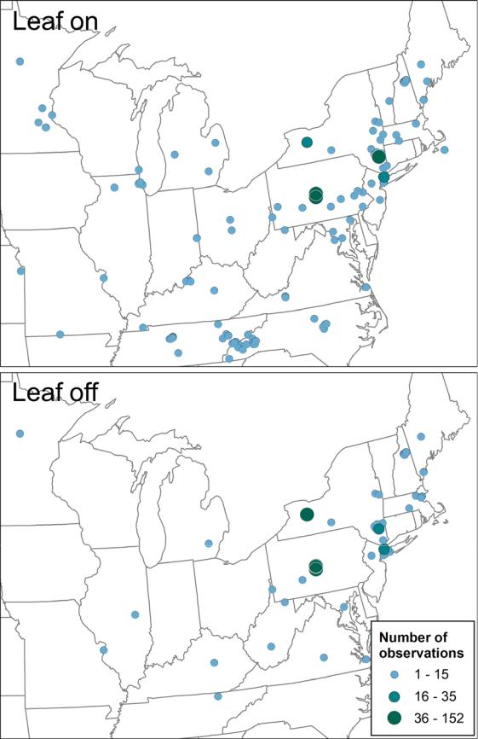

leaf bud chilling as chill days, the number of days with an average temperature between 0 and 10 LC from December to February prior to leaf emergence (Polgar and Primack 2011; Hanes et al. 2013). We also included (3) accumulated winter precipitation in the leaf emergence model—a variable more recently associated with the spring phenology of temperate, woody species (Fu et al. 2014). The variable used here for pre-growing season warmth is highly correlated with other metrics of spring warmth. As examples, the Pearson’s correlation coefficient [95% confidence interval] for annual growing degree days to 90 and to 120 days is 0.98 [0.980, 0.984], and annual degree growing days to 90 and average daily spring (i.e. March through May) temperature is 0.92 [0.91, 0.93].

The cues for leaf off are less well-established, so environmental variables that have been associated

with leaf off were used: (1) accumulated summer precipitation (June through August); (2) mean daily maximum summer temperatures (June through August); and (3) mean daily minimum fall tempera-tures (September through October)(Vitasse et al. 2009; Hanes et al. 2013; Gallinat et al. 2015; Liu et al. 2018). Because leaf off did not differ by seasonal temperature as expected, a model that used (1) temperature (mean daily maximum) and (2) accumu-lated precipitation across the growing season (May through September) is also presented.

Data analysis

To determine whether phenology differs across space by nativity and to understand what environmental cues may drive these differences, we used a Bayesian hierarchical modeling framework. This approach incorporates partial pooling so that the sample size as well as within and among species variances are taken into account. Species with fewer observations are pulled toward the overall group mean, and those with small latitudinal coverage or other dependent variable ranges have greater uncertainty (i.e. credible intervals) surrounding their estimation. A partial pooling approach is more conservative, and less likely to inflate differences based on community turnover across latitude or species with smaller sample sizes that diverge from the remainder of the group. The following varying intercepts and varying slopes model for leaf emergence and latitude was as follows, but similar model structure was used for the leaf off model and models including environmental covariates in place of latitude:

yi N aj ði Þ þ bj ð iÞ latitudei þ gk ð iÞ; r2j ; for i

* 1. . .n observations

|  |  |  |  |  |  |  |  |  |
| --- | --- | --- | --- | --- | --- | --- | --- | --- |
| gk | N 0; rg2 ; for k ¼ 1. . .K years | | | | | | |  |
| aj |  | MVN | c0a | þ | c1a Zj | | ; for j |  |
|  | b | b | ; R |  |
| bj |  |  | c0 | þ c1 | | Zj |  |  |

* 1. . .J species

log rj N lr; x2 ; for j ¼ 1. . .J species

where yi is the day of year for leaf emergence for observation i, aj and bj are the intercepts and slopes

123

E. Maynard-Bean et al.

that describe the relationship between day of year for leaf emergence and latitude for species j and r2j is the residual variance, which was also allowed to vary by species. The species-specific intercepts and slopes were modeled as a function nativity (Zj, native = 0, invasive = 1). The parameters cxn describe the effects of nativity on the species-specific intercepts and slopes. The parameter gk is a year random effect, assumed to be normally distributed with a mean of zero and variance r2g. We assumed a normal proba-bility distribution for loge-transformed rj (species-specific residual standard deviation), with mean lr and variance x2. We modeled the variance–covari-ance matrix ð RÞ of the multivariate normal distribution for the varying slopes and intercepts using the scaled inverse-Wishart distribution (Gelman and Hill 2006). Diffuse normal priors were used for lr and cxn (i.e., N[0, 1000]), and diffuse uniform priors were used for rg and x (i.e., U[0, 100]). We ran three parallel Markov chains beginning each chain with random starting values. Each chain was run for 120,000 iterations, from which the first 90,000 were discarded. This resulted in 30,000 samples used to summarize the posterior distributions used for calculating posterior means, 95% credible intervals, and probabilities. Convergence was assessed visually through inspection of trace plots and quantitatively using the Brooks-Gelman-Rubin statistic (Brooks and Gelman 1998). Models were fitted by calling the program JAGS (Plummer 2012) using the jagsUI package (Kellner 2019). The programming environment R (version 3.4.4) was used for all data analyses (R Core Team

2020). The data and modeling code are available here:

<https://doi.org/10.5281/zenodo.3939230>.

For models that included greater than one covariate (i.e. the environmental models), multicollinearity of predictors was tested using correlation values and variance inflation factors (VIFs) with the R package ‘HH’ (version 3.1-35, Heiberger 2019). The highest correlation for environmental variables across all models was 0.62, and the highest VIF was 2.09, well below the accepted threshold of 5, indicating sufficient independence among predictor variables (Heiberger and Holland 2015). All continuous predictors were standardized by mean-centering and dividing by the standard deviation to facilitate model convergence (e.g. 0 = mean, 2 = mean ? 2SD). For all models, we calculated the overall model R2 value (Gelman and

Pardoe 2006), as well as the root mean squared predictive error (RMSPE) using 5-fold cross valida-tion with 20% retained each time for out-of-sample prediction. Figures were created using the R packages ‘ggplot2’ (version 3.1.0, Wickham 2016) and ‘Hmisc’ (version 4.1-1, Harrell 2019).

Results

The posterior probability that invasive shrubs have earlier leaf emergence or later leaf off compared to native shrubs exceeds 0.86 across the sampled range (derived from the posterior distributions of the estimated slope parameters, Fig. 2b, d). The differ-ence between these groups decreases with increasing latitude (Fig. 2): From 36.45LN to 44.50LN within the study region, the predicted effect of being an invasive shrub is leaf emergence from 38.1 [24.3, 52.2] days earlier at the lowest latitude to 15.2 [1.9, 28.8] days earlier at the highest latitude, and leaf off 38.9 [16.0, 59.2] to 21.8 [0.39, 42.84] days later ([95% credible intervals], hereinafter). The conservative nature of the statistical methods used (i.e. partial pooling) reduces the likelihood that species with smaller sample sizes or species within a smaller latitudinal range drive the relationships for native and invasive shrubs found here. Variability among species is greater for leaf off than for leaf emergence (Fig. 3), and this is captured by the larger estimated uncertainty in the relationship between leaf off and latitude (i.e. the larger credible intervals for leaf off compared to leaf on; Fig. 2a, c). Taxa largely followed the patterns of leaf phenology across latitude observed for their respective native or invasive species groups. Although, the leaf on of the invasive burning bush (Euonymus alatus) more closely aligned with that of native species (Fig. 3a), and the leaf off the invasive Japanese barberry (Berberis thunbergii) and the native gray dogwood (Cornus racemosa) fall in between the groupings for the remaining native and invasive taxa.

Both native and invasive shrubs have earlier leaf emergence with greater accumulated spring warmth (Fig. 4a-c) following patterns of leaf emergence for most temperate, woody species. Although the responses across the range of pre-growing season warmth values do not differ (i.e. slopes), invasive shrubs generally respond earlier to a given warmth relative to native shrubs (i.e. intercepts differ, Fig. 4b).

123

Citizen scientists record novel leaf phenology

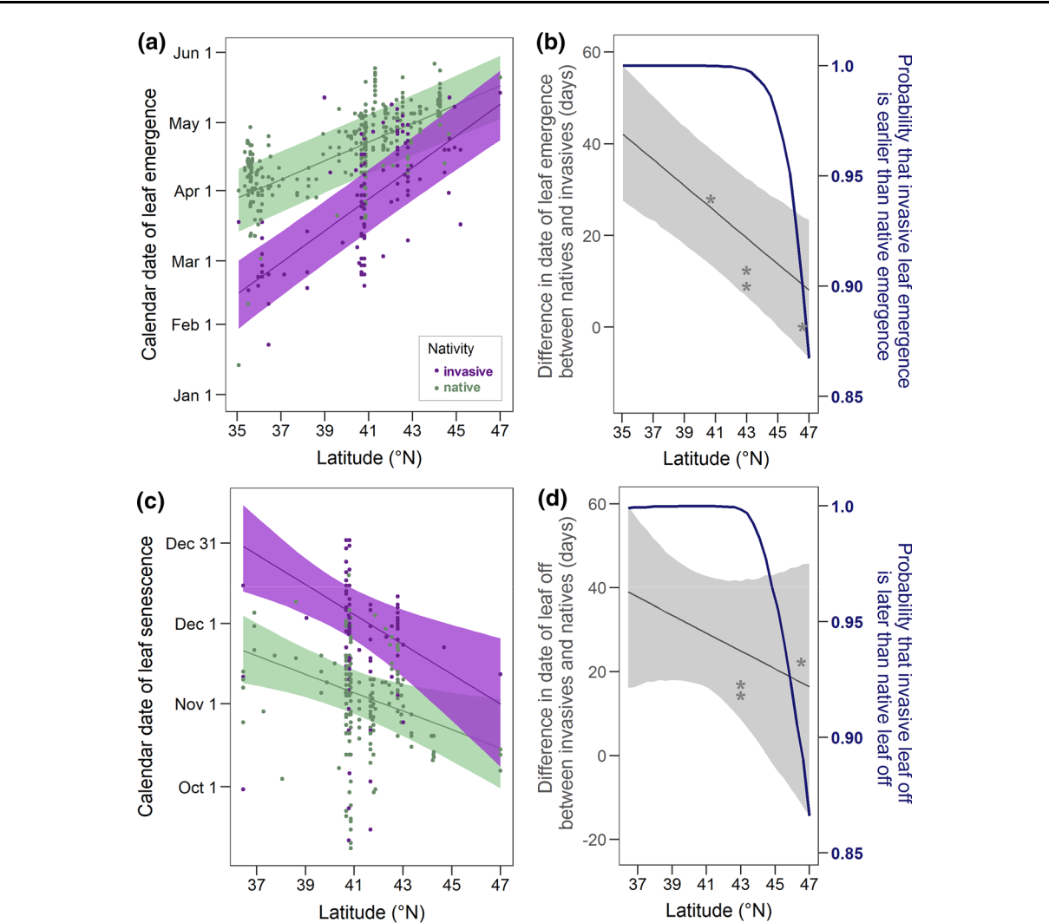

Fig. 2 Leaf emergence and leaf off with latitude for native and invasive shrubs. The purple and green lines are the posterior means for invasive and native shrubs, respectively, across latitude with shaded 95% credible regions (CR). The coefficient estimates for latitude a on leaf emergence (slopes) and corresponding 95% credible intervals are 4.13 days/LN [3.41, 4.87] for natives and 6.98 days/LN [5.91, 8.09] for invasives and c on leaf off are - 3.43 days/LN [- 5.53, - 0.94] for natives and

* 5.61 days/LN [- 9.00, - 2.15] for invasives. The posterior mean predicted difference (grey lines) and prediction

uncertainty (grey 95% CR) between the groups from a, c is shown with the corresponding posterior probability of earlier b or later d leaf phenology (blue). The asterisks indicate the differences documented in prior studies: Harrington et al. (1989), Xu et al. (2007), Fridley (2012) and O’Connell and Savage (2020). The Bayesian models were based on a, b 911 and c, d 589 observations of leaf emergence and leaf off, respectively. The R2 value for each model is a, b 0.73 with a RMSPE of 12.2 days and c, d 0.53 with a RMSPE of 17.7 days

In contrast, invasive shrubs have earlier emergence in response to increasing bud chill days while native shrubs show no response (Fig. 4a, c). Both groups lack a response to winter precipitation. For leaf off, shrubs do not exhibit a significant response to the summer and fall temperature variables, nor to temperature com-bined across the growing season (Fig. 2d, e). In both leaf off models, native species have no response to

accumulated precipitation while invasive shrubs exhibit later leaf off with greater precipitation, although there is overlap in the response of these groups.

123

E. Maynard-Bean et al.

Fig. 3 The relationships by taxa across latitude for the models presented in Fig. 2. The purple and green lines are the posterior means for individual taxa within the invasive and native shrub groups, respectively, across latitude with shaded 95% credible regions (CR). To improve clarity, native and invasive taxa are labeled to the left and right, respectively, of their relationships with latitude

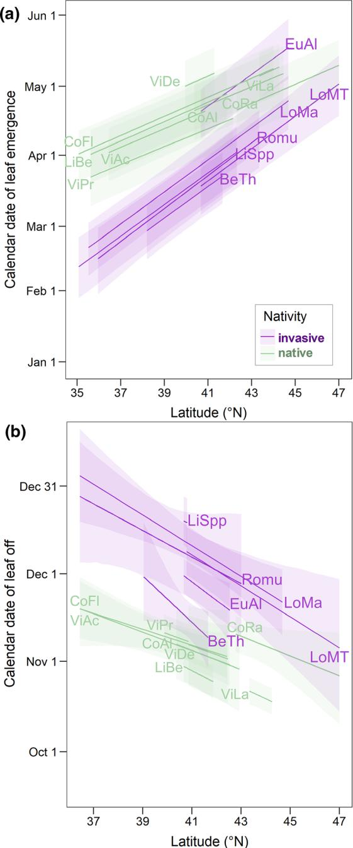

Discussion

Using citizen scientist observations, we found inva-sive shrubs to have leaves on average from 77 days longer to no difference from native shrubs, varying predictably with latitude. Invasive shrubs are a growing component of eastern deciduous forests (Schulz and Gray 2013; Rejma´nek 2014), which has been attributed to their extended leaf phenology (ELP, Smith 2013). Indeed, the ELP of invasive shrubs can provide photosynthetic benefits in both the spring and fall (Harrington et al. 1989; Xu et al. 2007), and understory shade at a novel time of the year can decrease pollinator services (McKinney and Goodell 2010), canopy tree regeneration (Augspurger 2008), and understory plant diversity (Gilliam 2014). How-ever, studies from more northern sites that document photosynthetic benefits of ELP in the fall have failed to detect benefits in the spring (upstate New York, Fridley 2012; northern Minnesota, O’Connell and Savage 2020). We found that the magnitude of ELP decreases by 2.9 [1.6, 4.2] days per degree northward in the spring, and 2.2 [0.6,1.9] in the fall, providing a unified framework for inconsistent results among local scale studies (see asterisks in Fig. 2b, d). Additionally, some species-level variation in phenology was detected (Fig. 3). For example, burning bush (E. alatus) is the only invasive shrub with spring phenol-ogy similar to native species with leaf emergence later than other invasive taxa. This species has green, photosynthetically active branches in the spring (un-published data from LiCor 6400XT Portable Photo-synthesis System), which may preclude the advantage and potential risk of leafing out early. However, other invasive and native taxa that do align with their respective group phenology can have green branches in the spring as well (e.g. multiflora rose, Rosa multiflora, and spicebush, Lindera benzoin, respectively).

The patterns of ELP for invasive compared to native shrubs found here have important implications for policy and management. Invasive shrubs included in this study are still commonly used for horticultural purposes in some areas, while their use is banned elsewhere in the U.S. For example, burning bush (E. alatus), privet (Ligustrum spp.), bush honeysuckles (Lonicera morrowii, L. tatarica), and Japanese bar-berry (Berberis thunbergii) are regulated in New York state (NYSDEC 2020), but remain unregulated

123

Citizen scientists record novel leaf phenology

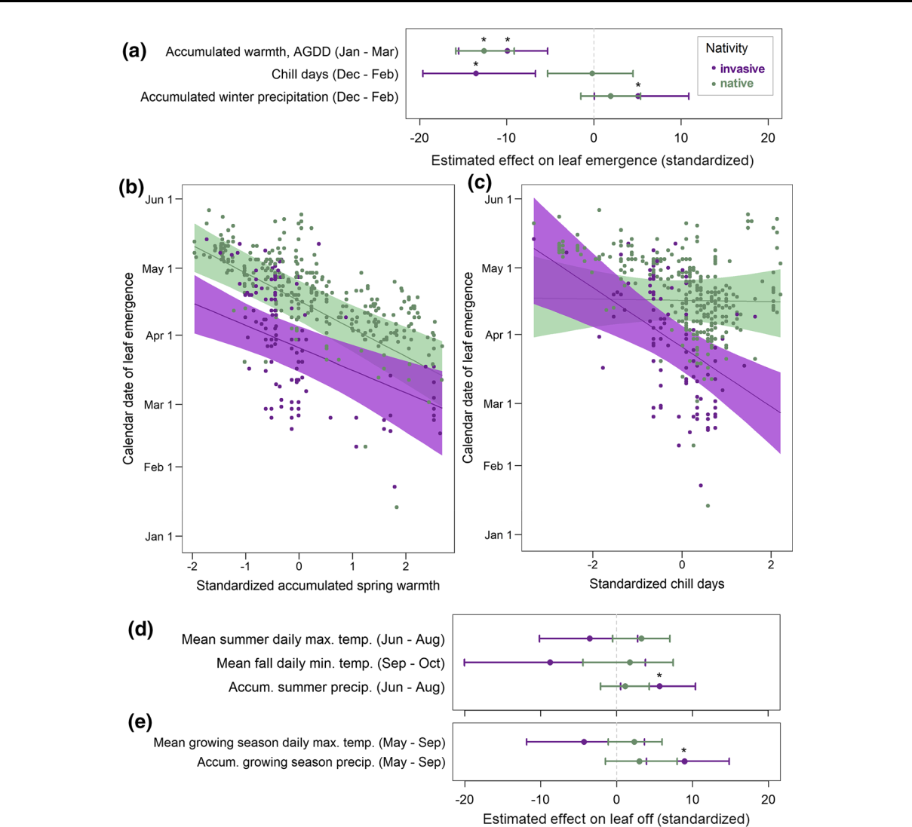

Fig. 4 Leaf emergence and leaf off with environmental variables. a, d, e The circles represent the posterior mean coefficient effects (slopes). The horizontal lines are correspond-ing 95% credible intervals. An asterisk indicates that the effect differs from zero. b, c The points are individual observations for

leaf emergence (n = 911). The lines are posterior means, and shaded areas represent 95% credible regions. The R2 value for each model is a–c 0.75, d 0.57 and e 0.58 with root mean square predictive errors of 12.0, 17.3 and 16.9 days, respectively

directly south in Pennsylvania where we predict greater ELP. At mid-latitudes of these adjacent states, ELP of invasive shrubs is roughly 6 and 5 additional days in the spring and fall, respectively, and at the most extreme latitudinal differences, 15 and 11.5 more days for invasive shrubs. Although more research is warranted, we know that novel shade negatively impacts native ecosystems (Augspurger 2008; McKin-ney and Goodell 2010; Gilliam 2014), and the pattern of ELP for invasive shrubs could encourage state and local policy limiting the sale and distribution of these

taxa. Furthermore, the presence of this phenomenon may serve as a predictive trait for the invasion potential of new horticultural specimens. From a management perspective, ELP makes invasive shrubs an easier ‘‘green target’’ in the spring and fall for detection, removal, and treatment, which can protect dormant, non-target species.

The environmental correlates of leaf phenology help to clarify the drivers of greater ELP at lower latitudes and whether the potential exists for climate change to exacerbate or diminish ELP. We find that

123

E. Maynard-Bean et al.

although invasive shrubs tend to respond earlier to a given pre-growing season warmth than native shrubs, the groups do not differ in their response across the range of warmth studied here (Fig. 2a, b). Pre-growing season warmth is commonly used to model phenology for forest productivity estimates but given no differ-ence in response between native and invasive shrubs, no change would be predicted between native and invasive shrubs with warmer/earlier spring tempera-tures. However, the groups do differ in response to bud chill days: dormant season days where the average temperature is between 0 and 10 LC (Fig. 2a, c). Chill days contribute to meeting chilling requirements for a plant. They are seldom considered because chilling requirements are usually met for locally adapted populations of temperate, woody species (Dennis 2003; Hanes et al. 2013), as was found for native shrubs here. In contrast, invasive shrub populations arrived more recently into North American forests from horticultural subsets of their native populations and are not likely to be locally adapted. Indeed, invasive shrubs exhibited later leaf emergence with fewer chill days (Fig. 2a, c), suggesting that chilling requirements may not be met. Under future climate scenarios, only the more northern temperate sites are expected to increase in chill days (Luedeling 2012), which would expand the spring ELP of invasive shrubs where it is currently minimal. However, the potential that chilling requirements are unfulfilled for invasive shrubs appears contrary to recent experimental work: Lower chilling requirements were found for species native to Europe or Asia as compared to those originating in North America (Polgar et al. 2014), possibly driven by comparatively greater interannual variability in North American spring temperatures (Zohner and Renner 2017).

There are several potential factors contributing to the discrepancy between our observational results and expectations from experimental research for chilling requirement. First, the experimental work does not cover a latitudinal gradient, as is covered here. Our research spans both locally adapted native populations that likely differ in chill requirements (Dennis 2003; Hanes et al. 2013), as well as the more recently added populations of invasive shrubs that are less locally-adapted and more likely to be genetically bottlenecked (Puillandre et al. 2008). Second, it is important to highlight that daylength can overcome chilling requirements (Hunter and Lechowicz 1992; Dennis

2003; Polgar and Primack 2011; Hanes et al. 2013; Laube et al. 2014; Zohner et al. 2016). By exposing the plants to daylengths of 14 or 16 h to control for spring-like conditions, experimental studies have used meth-ods that functionally defined ‘chilling requirements’ as the chilling level required for spring warmth and/or extended daylength to impact leaf emergence (Polgar et al. 2014, Laube et al. 2014; Zohner et al. 2016; Nanninga et al. 2017). It is possible that these groups of species with different regions of evolutionary origin differ in the potential for daylength to overcome chilling requirements.

Finally, it is also possible given our observational methods that an unknown physiological mechanism related to chill days or inversely to winter coldness could be driving delayed leaf emergence for invasive compared to native shrubs. However, chill days, an established cue for leaf emergence, is more likely to drive leaf phenology than correlated variables such as winter coldness (Pearson correlation for our sites, - 0.89 [- 0.91, - 0.88]). Especially given that at the highest latitude in our study region invasive and native shrubs do not differ in freezing tolerance (O’Connell and Savage 2020), and invasive shrubs were more tolerant than native shrubs at lower latitudes (McEwan et al. 2009). Experimental methods that mimic the natural light regime and incorporate individuals from across the range are needed for a mechanistic under-standing of chilling requirements and the implications of unmet chilling requirements under future climate change scenarios.

The importance of environmental correlates for predicting leaf off was more uncertain than for leaf emergence in the taxa studied, which may be for several reasons. First, leaf off is inherently more stochastic, with punctuated weather events (e.g. high winds, precipitation) altering the date of leaf off at very local scales irrespective of the cues initiating leaf senescence. These factors contribute to our limited understanding of the mechanistic nature of the rela-tionship between cues and leaf off (Estrella and Menzel 2006; Vitasse et al. 2009; Gallinat et al. 2015). Second, there are nearly half of the observations as compared to leaf emergence, perhaps due to spring being a more pleasant and exciting time for citizen scientists to make observations than fall. Even with training and encouragement, time increased between visitation rates as the season progressed, limiting the

123

Citizen scientists record novel leaf phenology

number of usable observations for leaf off (i.e. a ‘no’ for the presence of leaves within 9 days of a ‘yes’).

Species-specific phenology data collection requires high frequency visits to accurately capture the pheno-logical phase of interest. Regular weekly visits are ideally increased to every 3 to 4 days to observe leaf emergence and leaf off. Moreover, we were interested specifically in extended leaf phenology, which equally extends the date range needed for observations. This data collection is much more time intensive than other forms of citizen science data, such as one-time presence/absence observations. Nevertheless, the efforts of citizen scientists shone through. We could not have answered species-specific phenology ques-tions across such a broad geographic range on our own.

Citizen science can advance our understanding of the world more quickly than traditional research, but requires effort spent in non-traditional ways: soliciting volunteers, providing training, anticipating pitfalls to participation and maintaining engagement through regular communication (e.g. eNewsletters). However, these efforts can be facilitated immensely by partner-ing with an existing citizen science network, espe-cially one as established and supportive as the USA-NPN. Contributions from the USA-NPN that were instrumental to the success of this project included the existence of a pool of observers, basic training materials, a data collection platform with an associ-ated phone app, and regular contact and encourage-ment from the USA-NPN staff to produce additional training and support materials made available for participants. The author’s social media outreach efforts increased participant numbers, adding to the pool of citizen scientists for the USA-NPN. Interacting closely and frequently with the public is incredibly rewarding and it improves our skill at conveying science both outside and within the field. The ability to break down ecological theory and scientific results into digestible components and organize those com-ponents into a compelling story facilitates communi-cation across fields.

Conclusions

Invasive shrubs can maintain leaves 77 days longer than native shrubs in a growing season, on average using 22% more days of the year than natives at the

lowest latitudes studied (e.g. northern Tennessee and North Carolina). The difference decreases linearly to about 30 days at the highest latitude (e.g. southern Maine, mid-Minnesota). At the lowest latitudes the difference is equivalently distributed between the spring and fall, while at the highest latitudes two-thirds of the difference between native and invasive growing seasons occurs in fall. The geographic relationships found here provide a more unified framework to move ELP research from across the eastern U.S. forward together. Furthermore, a better understanding of ELP in invasive shrubs across geographic gradients can focus early detection and removal efforts and inform policy limiting the sale and use of invasive shrubs for horticultural purposes.

Small changes to spring and fall phenology can have dramatic impacts to temperate, deciduous forest carbon budgets. Pre-growing season warmth, a metric commonly used for modeling spring leaf phenology and predicted to increase with climate change, influ-ences native and invasive shrubs similarly. However, chill days influence these groups very differently and is predicted to increase only at northern temperate sites where it would expand the ELP of invasive shrubs. Chill days may play an increasingly important role in forest productivity and carbon budgets especially at more northern sites and where invasive understory vegetation with novel leaf phenology is a growing component of the forest community.

Acknowledgements The platform and technical assistance of the USA-NPN was instrumental for this research. We thank the USA-NPN Outreach Coordinator, Erin Posthumus, the many participants who contributed to the USA-NPN Nature’s Notebook program, and the Arbortetum at Penn State and Shaver’s Creek Environmental Center for allowing data collection at their sites. Any use of trade, firm, or product names is for descriptive purposes only and does not imply endorsement by the U.S. Government.

Funding Funding was provided by NSF DDIG proposal number 1701470.

Availability of data and material While publicly available for download via USA-NPN and PRISM, the specific data used herein are available at <https://doi.org/10.5281/zenodo.3939230>.

Compliance with ethical standards

Conflict of interest None.

123

E. Maynard-Bean et al.

Code availability The custom modeling code is available at <https://doi.org/10.5281/zenodo.3939230>, and any additional R code is available upon request.

References

Augspurger CK (2008) Early spring leaf out enhances growth and survival of saplings in a temperate deciduous forest. Oecologia 156:281–286

Brooks SP, Gelman A (1998) General methods for monitoring convergence of iterative simulations. J Comput Graph Stat 7:434–455

Crall AW, Jarnevich CS, Young NE, Panke BJ, Renz M, Stohlgren TJ (2015) Citizen science contributes to our knowledge of invasive plant species distributions. Biol Invasions 17:2415–2427

Dennis FG (2003) Problems in standardizing methods for evaluating the chilling requirements for the breaking of dormancy in buds of woody plants. Hort Science 38:347–350

Denny EG, Gerst KL, Miller-Rushing AJ, Tierney GL, Crim-mins TM, Enquist CA, Guertin P, Rosemartin AH, Schwart MD, Thomas KA, Weltzin JF (2014) Standardized phe-nology monitoring methods to track plant and animal activity for science and resource management applications. Int J Biometeorol 58:591–601

Dlugos DM, Collins H, Bartelme EM, Drenovsky RE (2015) The non-native plant Rosa multiflora expresses shade avoidance traits under low light availability. Am J Bot 102:1323–1331

Estrella N, Menzel A (2006) Responses of leaf colouring in four deciduous tree species to climate and weather in Germany. Clim Res 32:253–267

Forsythe WC, Rykiel EJ, Stahl RS, Wu HI, Schoolfield RM (1995) A model comparison for daylength as a function of latitude and day of year. Ecol Model 80:87–95

Fridley JD (2012) Extended leaf phenology and the autumn niche in deciduous forest invasions. Nature 485:359–362 Fu YH, Piao S, Zhao H, Jeong SJ, Wang X, Vitasse Y, Ciais P, Janssens IA (2014) Unexpected role of winter precipitation in determining heat requirement for spring vegetation green-up at northern middle and high latitudes. Glob Chang

Biol 20:3743–3755

Gallinat AS, Primack RB, Wagner DL (2015) Autumn, the neglected season in climate change research. Trends Ecol Evol 30:169–176

Gelman A, Hill J (2006) Data analysis using regression and multilevel/hierarchical models. Cambridge University Press, Cambridge

Gelman A, Pardoe I (2006) Bayesian measures of explained variance and pooling in multilevel (hierarchical) models. Technometrics 48:25–41

Gilliam FS (ed) (2014) The herbaceous layer in forests of eastern North America. Oxford University Press, Oxford

Grime JP (2006) Plant strategies, vegetation processes, and ecosystem properties. Wiley, Chichester

Hanes JM, Richardson AD, Klosterman S (2013) Mesic tem-perate deciduous forest phenology. In: Schwartz MD (ed)

Phenology: an integrative environmental science, 2nd edn. Springer, Dordrecht, pp 211–224

Hanula JL, Horn S (2011a) Removing an invasive shrub (Chi-nese privet) increases native bee diversity and abundance in riparian forests of the southeastern United States. Insect Conserv Divers 4:275–283

Hanula JL, Horn S (2011b) Removing an exotic shrub from riparian forests increases butterfly abundance and diver-sity. Forest Ecol Man 262:674–680

Harrell FE (2019) Hmisc: Harrell miscellaneous. R package version 4.2-0. [https://CRAN.R-project.org/package=](https://CRAN.R-project.org/package%3dHmisc) [Hmisc](https://CRAN.R-project.org/package%3dHmisc)

Harrington RA, Brown BJ, Reich PB, Fownes JH (1989) Eco-physiology of exotic and native shrubs in southern Wis-consin. II. Annual growth and carbon gain. Oecologia 80:368–373

Heiberger RM (2019) HH: statistical analysis and data display: Heiberger and Holland. R package version 3.1-37. [https://](https://CRAN.R-project.org/package%3dHH) [CRAN.R-project.org/package=HH](https://CRAN.R-project.org/package%3dHH)

Heiberger RM, Holland B (2015) Statistical analysis and data display: an intermediate course with examples in R. Springer, Berlin

Hunter AF, Lechowicz MJ (1992) Predicting the timing of budburst in temperate trees. J Appl Ecol 29:597–604

Kellner K (2019) jagsUI: a wrapper around ‘rjags’ to streamline ‘JAGS’ analyses. R package version 1.5.1. [https://CRAN.](https://CRAN.R-project.org/package%3djagsUI) [R-project.org/package=jagsUI](https://CRAN.R-project.org/package%3djagsUI)

Laube J, Sparks TH, Estrella N, Ho¨fler J, Ankerst DP, Menzel A (2014) Chilling outweighs photoperiod in preventing precocious spring development. Glob Chang Biol 20: 170–182

Liu G, Chen X, Zhang Q, Lang W, Delpierre N (2018) Antag-onistic effects of growing season and autumn temperatures on the timing of leaf coloration in winter deciduous trees. Global Change Biol 24:3537–3545

Luedeling E (2012) Climate change impacts on winter chill for temperate fruit and nut production: a review. Sci Hortic 144:218–229

McEwan RW, Birchfield MK, Schoergendorfer A, Arthur MA (2009) Leaf phenology and freeze tolerance of the invasive shrub Amur honeysuckle and potential native competitors. J Torrey Bot Soc 136:212–220

McKinney AM, Goodell K (2010) Shading by invasive shrub reduces seed production and pollinator services in a native herb. Biol Invasions 12:2751–2763

Nanninga C, Buyarski CR, Pretorius AM, Montgomery RA (2017) Increased exposure to chilling advances the time to budburst in North American tree species. Tree Physiol 37:1727–1738

New York State Department of Environmental Conservation (2020) Part 575 Prohibited and Regulated Invasive Spe-cies. Thomson Reuters Westlaw. [https://govt.westlaw.](https://govt.westlaw.com/nycrr/Document/Ia2581e1538fe11e483ae0000845b8d3e%3fviewType%3dFullText%26originationContext%3ddocumenttoc%26transitionType%3dCategoryPageItem%26contextData%3d(sc.Default)%26bhcp%3d1) [com/nycrr/Document/Ia2581e1538fe11e483ae0000845b8d](https://govt.westlaw.com/nycrr/Document/Ia2581e1538fe11e483ae0000845b8d3e%3fviewType%3dFullText%26originationContext%3ddocumenttoc%26transitionType%3dCategoryPageItem%26contextData%3d(sc.Default)%26bhcp%3d1) [3e?viewType=FullText&originationContext=documenttoc](https://govt.westlaw.com/nycrr/Document/Ia2581e1538fe11e483ae0000845b8d3e%3fviewType%3dFullText%26originationContext%3ddocumenttoc%26transitionType%3dCategoryPageItem%26contextData%3d(sc.Default)%26bhcp%3d1) [&transitionType=CategoryPageItem&contextData=(sc.](https://govt.westlaw.com/nycrr/Document/Ia2581e1538fe11e483ae0000845b8d3e%3fviewType%3dFullText%26originationContext%3ddocumenttoc%26transitionType%3dCategoryPageItem%26contextData%3d(sc.Default)%26bhcp%3d1) [Default)&bhcp=1](https://govt.westlaw.com/nycrr/Document/Ia2581e1538fe11e483ae0000845b8d3e%3fviewType%3dFullText%26originationContext%3ddocumenttoc%26transitionType%3dCategoryPageItem%26contextData%3d(sc.Default)%26bhcp%3d1)

O’Connell E, Savage J (2020) Extended leaf phenology has limited benefits for invasive species growing at northern latitudes. Biol Invas 2020:1–8

123

Citizen scientists record novel leaf phenology

Piao S, Tan J, Chen A, Fu YH, Ciais P, Liu Q, Janssens IA, Vicca S, Zeng Z, Jeong SJ, Li Y (2015) Leaf onset in the northern hemisphere triggered by daytime temperature. Nat Commun 6:6911

Plummer M (2012) JAGS version 3.3.0 user manual. Interna-tional Agency for Research on Cancer, Lyon, France

Polgar CA, Primack RB (2011) Leaf-out phenology of tem-perate woody plants: from trees to ecosystems. New Phytol 191:926–941

Polgar CA, Gallinat A, Primack RB (2014) Drivers of leaf-out phenology and their implications for species invasions: insights from Thoreau’s Concord. New Phytol 202:106–115

PRISM Climate Group, Oregon State University (2019) Data set accessed 02/10/2019 at <http://prism.oregonstate.edu> Puillandre N, Dupas S, Dangles O, Zeddam JL, Capdevielle-

Dulac C, Barbin K, Torres-Leguizamon M, Silvain JF (2008) Genetic bottleneck in invasive species: the potato tuber moth adds to the list. Biol Invas 10:319–333

R Core Team (2020) R: a language and environment for sta-tistical computing. R Foundation for Statistical Comput-ing, Vienna, Austria <http://www.R-project.org/>

Rejma´nek M (2014) Invasive trees and shrubs: Where do they come from and what we should expect in the future? Biol Invasions 16:483–498

Rhoads AF, Block TA (2007) The plants of Pennsylvania: an illustrated manual. University of Pennsylvania Press, Philadelphia

Schulz BK, Gray AN (2013) The new flora of northeastern USA: quantifying introduced plant species occupancy in forest ecosystems. Environ Monit Assess 185:3931–3957

Smith LM (2013) Extended leaf phenology in deciduous forest invaders: mechanisms of impact on native communities. J Veg Sci 24:979–987

USA National Phenology Network (2019) Plant Phenology Data. Data type: Individual Phenometrics. 01/01/2015–01/ 04/2019 for Region: 51.1543L, -51.4386L (UR); 22.5568L, - 99.9543L (LL). (USA-NPN, Tucson, Arizona, USA). Data set accessed 01/04/2019 at [http://doi.org/10.5066/](http://doi.org/10.5066/F78S4N1) [F78S4N1](http://doi.org/10.5066/F78S4N1)

Vitasse Y, Porte´ AJ, Kremer A, Michalet R, Delzon S (2009) Responses of canopy duration to temperature changes in

four temperate tree species: relative contributions of spring and autumn leaf phenology. Oecologia 161:187–198

Wallace RD, Bargeron CT, Ziska L, Dukes J (2014) Identifying invasive species in real time: early detection and distribu-tion mapping system (EDDMapS) and other mapping tools. In: Ziska L, Dukes JS (eds) Invasive species and global climate change. CAB International, Oxfordshire, pp 219–231

Wallace CS, Walker JJ, Skirvin SM, Patrick-Birdwell C, Weltzin JF, Raichle H (2016) Mapping presence and pre-dicting phenological status of invasive buffelgrass in southern Arizona using MODIS, climate and citizen sci-ence observation data. Remote Sens 8:524

Watling JI, Hickman CR, Orrock JL (2011) Invasive shrub alters native forest amphibian communities. Biol Conserv 144:2597–2601

Webster CR, Jenkins MA, Jose S (2006) Woody invaders and the challenges they pose to forest ecosystems in the eastern United States. J For 104:366–374

Wickham H (2016) ggplot2: elegant graphics for data analysis. Springer, New York

Wolkovich EM, Cleland EE (2011) The phenology of plant invasions: a community ecology perspective. Front Ecol Environ 9:287–294

Xu CY, Griffin KL, Schuster WSF (2007) Leaf phenology and seasonal variation of photosynthesis of invasive Berberis thunbergii (Japanese barberry) and two co-occurring native understory shrubs in a northeastern United States decidu-ous forest. Oecologia 154:11–21

Zohner CM, Renner SS (2017) Innately shorter vegetation periods in North American species explain native–non-native phenological asymmetries. Nat Ecol Evol 1:1655–1660

Zohner CM, Benito BM, Svenning JC, Renner SS (2016) Day length unlikely to constrain climate-driven shifts in leaf-out times of northern woody plants. Nat Clim Chang 6:1120–1123

Publisher’s Note Springer Nature remains neutral with regard to jurisdictional claims in published maps and institutional affiliations.

123