Extremophiles

https://doi.org/10.1007/s00792-020-01189-7

**ORIGINAL PAPER**



**Root endophytic *Penicillium* promotes growth of Antarctic vascular plants by enhancing nitrogen mineralization**

**Rómulo Oses‑Pedraza1,2 · Cristian Torres‑Díaz3 · Paris Lavín4 · Patricio Retamales‑Molina5 · Cristian Atala6 · Jorge Gallardo‑Cerda7 · Ian S. Acuña‑Rodríguez7 · Marco A. Molina‑Montenegro2,7,8,9**

Received: 28 January 2020 / Accepted: 6 July 2020

© Springer Japan KK, part of Springer Nature 2020

**Abstract**

*Colobanthus quitensis* *Deschampsia*

*antarctica*

*Penicillium chrysogenumPenicillium brevicompactum*

*C. quitensisD. antarctica*

*C. quitensisD. antarctica*

**Keywords** *Penicillium*

**Introduction**

* ó

ó

ó

ó

1 3



\ Extremophiles

*D.*

*antarctica*

*D. antarctica*

*C. quitensis*

|  |  |  |  |  |  |
| --- | --- | --- | --- | --- | --- |
|  | *C. quitensis* | | *D. antarctica* |  |  |
|  | **Methods** |  |  |  |  |
| *Colobanthus quitensis* | **P** |  |  |  |  |
|  |  |  |  |  |
| *Deschampsia antarctica* | *D. ant-* |  |  |  |  |
|  | *arctica* | *C. quitensis* | |  |  |
|  | ʹ |  | ʺ | ʹ |  |

1 3

Extremophiles\

ʺ

µ

*Pygoscelis papua*

1. *antarctica C. quitensis*

**I**

*D. antarcticaC. quitensis*

×

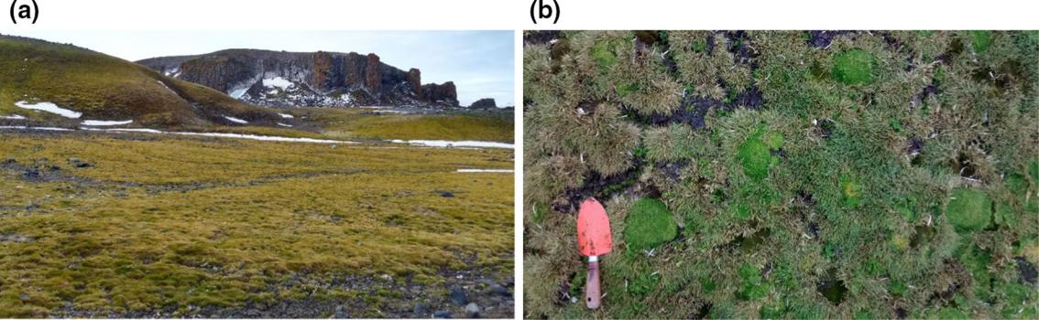

**Fig. 1  a** ʹʺ **b***Deschampsia antarctica* *Colobanthus quitensis*

ʹʺ

1 3

\ Extremophiles

×

×

1. *antarctica C. quitensis*

′ ′

′ ′

′

′ ′ ′

**I**

1. *quitensis*
2. *antarctica*

1 3

Extremophiles\

**A**

*C.*

*quitensisD. antarctica*

*n*

1. *antarctica*

*C. quitensis*

*D. antarcticaC. quitensis*

**P**

*n*

*t* *p*

*n*

*t* *C.*

*quitensisD. antarctica*

*t*

1 3

\ Extremophiles

**Results**

**I**

*D. antarcticaC. quitensis*

*Penicillium*

*Alternaria* *Phaeosphaeria*

*Penicillium*

*Geomyces* *Microdochium*

*C. quitensis*

*C. quitensisD. ant-*

*arctica*

*C. quitensis*

*D. antarctica*

*Penicillium chrysogenum*

*P. chrysogenum*

*Penicillium brevicompactum*

*P. brevicompactum*

|  |  |  |
| --- | --- | --- |
| *t* | *P. chrysogenumP. brevicompactum* |  |
| *C. quitensisD. antarctica* |  |

*P. chrysogenumP. brevicompactum*

*P. chrysogenum*

1 3

Extremophiles\

**Table 1**

*Penicillium chrysogenum Penicillium brevicompactum*

*Colobanthus quitensisDeschampsia antarctica*

|  |  |  |  |  |  |  |  |
| --- | --- | --- | --- | --- | --- | --- | --- |
|  | *P. chrysogenum* | |  | *P. brevicompactum* | | | |
|  |  |  |  |  |  |  |  |
|  |  |  |  |  |  |  |  |
|  | **+ 琠+** | **+ 琠+ 琠+** | **+** |  | **+** | **+ 琠+ 琠+** | **−** |
|  | **+ 琠+** | **+ 琠+ 琠+** | **+** |  | **+ 琠+** | **+ 琠+ 琠+** | **−** |
|  | **+** | **+ 琠+** | **+** |  | **+** | **+** | **−** |
|  | **+ 琠+ 琠+** | **+ 琠+ 琠+ 琠+** | **+** |  | **+ 琠+** | **+ 琠+ 琠+** | **+** |
|  | **−** | **−** | **−** |  | **−** | **−** | **−** |
|  | **−** | **−** | **−** |  | **−** | **−** | **−** |
|  | **+** | **+** | **−** |  | **+** | **+** | **−** |
|  | **+ 琠+** | **+ 琠+ 琠+** | **+** |  | **+ 琠+** | **+ 琠+ 琠+** | **+** |
|  | **+ 琠+** | **+ 琠+** | **+** |  | **+** | **+** | **+** |
|  | **+ 琠+** | **+ 琠+ 琠+** | **+** |  | **+ 琠+** | **+ 琠+ 琠+** | **+** |

*Cellulose Azure assay*

*Hemicellulase assay*

*Esterase assay*

*Phenoloxidase assay*

*Trametes versicolor*

*Gelatinase assay*

*Phosphate-solubilizing assay*

*Urease-assay*

*P.* *C. quitensisD. antarctica*

*chrysogenumP. brevicompactum*

|  |  |  |  |  |
| --- | --- | --- | --- | --- |
| *P.* |  |  |  |  |
| *chrysogenumP. brevicompactum* |  |  |  |  |
| *P. chrysogenumP. brevi-* | *t* |  |  |  |
| *compactumP. chrysogenumP.* |  |  |  |
| *brevicompactum* | *C. quitensisP. chrys-* | |  |  |
|  | *ogenum* |  | *D. antarctica* |  |
|  |  | *P. brevicompactum* | |  |
| **P** | *C. quitensisD.* |  |  |  |
|  | *antarctica* |  |  |  |
| *t* | *t* |  |  |  |
|  | *p* | *t* | *p* |  |

1 3

\ Extremophiles

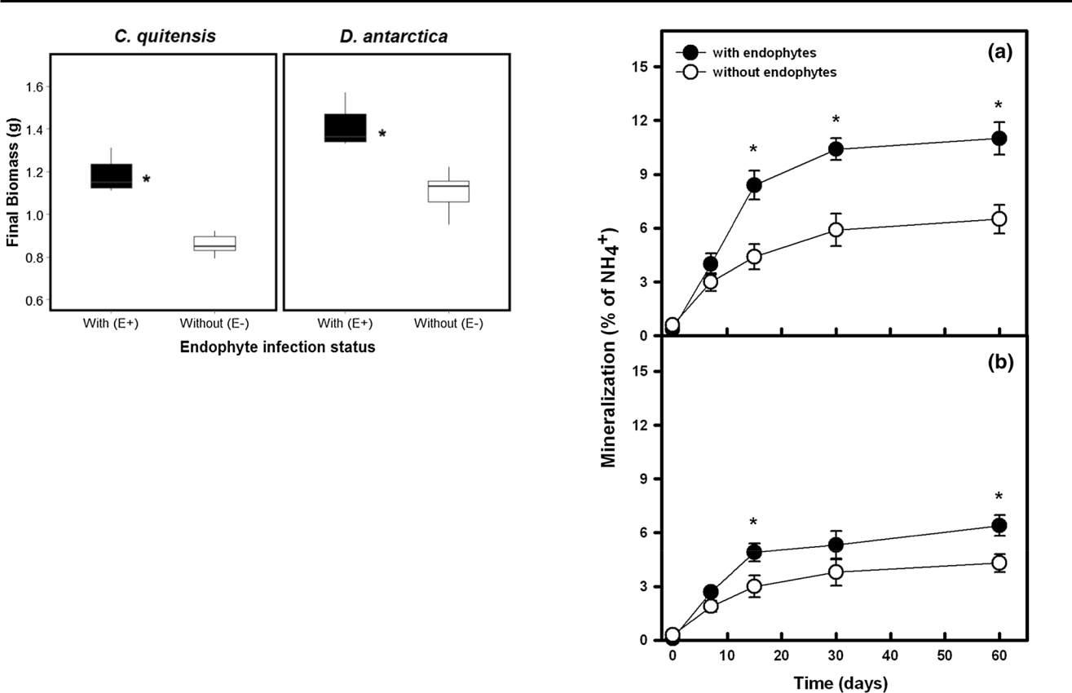

**Fig. 2** *Coloban-*

*thus quitensisDeschampsia antarctica*

*Penicillium chrysosgenumPeni-*

*cillium brevicompactumC.*

*quitensisD. antarctica*

*C. quitensisD. antarctica*

*t*

*n*

*p*

*t-*

*C. quitensisP. chrysogenum*

|  |  |  |
| --- | --- | --- |
| *t* | *p* | **Fig. 3** |
|  |  | *Colobanthus quitensis***a***Deschampsia* |
|  |  | *antarctica***b** |
| *F* | *p* | *n* |

|  |  |  |  |
| --- | --- | --- | --- |
| *F* | *p* | *D. antarc-* |  |
| *ticaP. brevicompactum* | |  |  |
| *t* | *p* | *P. chrysogenum* |  |
|  |  |  |
|  |  | *P. brevicompactum* |  |
| *F* | *p* | *F* |  |
| *p* |  |  |  |

**Discussion**

1 3

Extremophiles\

*P. chrysogenumP. brevicompac-*

*tum*

*Penicillium chrysogenumPenicillium*

*brevicompactumDeschampsia antarctica*

|  |  |  |
| --- | --- | --- |
| *Colobanthus quitensis* |  |  |
| *P. chry* | *-* |  |
| *sogenum* |  |  |
| *Adenocys-* |  |  |
| *tis utricularis, Desmarestia ancepsMonostroma hariotii* |  |  |
| *P. brevicompactum* |  |  |
| *Hevea* |  |  |
| *brasilensisCofea arabica* | *D.* |  |
|  |  |
| *Penicillium* | *antarctica* |  |
| *Penicillium* |  |  |
| *, Penicillium* |  |  |
| *Cephaloziella varians* | *crops* |  |
| *Bryum argenteum* |  |  |
| *Penicillium* |  |  |
| *Penicillium* |  |  |

1 3

\ Extremophiles

*Embellisia*

*Bryum argenteum*

š

*Colobanthus quitensisDeschampsia antarctica*

*Arabidopsis*

*Hevea brasiliensis*

**Acknowledgments**

†

**References**

*Beauveria bassiana* *Metarhizium anisopliae*

1 3

Extremophiles\

*Penicillium antarcticum*

*Pseudotsuga menziesiiPinus pon-*

*derosa*

*Penicillium*

*Phialocephala fortiniiPinus contorta* *Cepha-*

*loziella varians*

ö

*Staphylococcus aureus*

*Penicillium*

*Deschamp-*

*sia antarctica*

*Colobanthus quitensis*

*Penicillium*

1 3

\ Extremophiles

*Neotyphodium lolii*

*Lolium perenne*

*Colobanthus quitensisDeschampsia antarctica*

[]](https://doi.org/10.1657/1523-0430(07-057)[UPSON]2.0.CO;2)

*Deschampsia antarctica*

**Publisher’s Note**

*Crypto-*

*coccus*

1 3