Journal of Plant Biology

https://doi.org/10.1007/s12374-020-09271-5

**RESEARCH ARTICLE**



**Exogenous Gibberellin GA­3 Enhances Defense Responses in Rice to the Brown Planthopper *Nilaparvata lugens* (Stål)**

**Wanwan Wang1,2 · Nuo Jin1 · Xiaochang Mo1 · Jun Wu2 · Jing Lu1 · Yonggen Lou1**

Received: 12 February 2020 / Revised: 24 July 2020 / Accepted: 28 July 2020

© Korean Society of Plant Biologist 2020

**Abstract**

*Oryza sativa*

*Nilaparvata lugens*å

**Keywords** *Nilaparvata lugens*å

**Abbreviations** **Introduction**

ö

**Electronic supplementary material**

**\***

*cis*

1 3



\ Journal of Plant Biology

*Nilaparvata*

*lugens*å

*cis*

’

*Arabidopsis thaliana*

*Oryza sativa*

**Fig. 1**

**a**

**b**

*n*

*p*’ *t*

**Results**

**GA3 Enhances Rice Growth and Resistance to BPH**

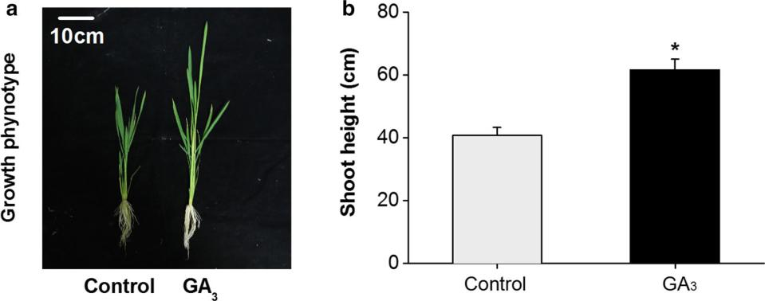

1 3

Journal of Plant Biology\

**Fig. 2**

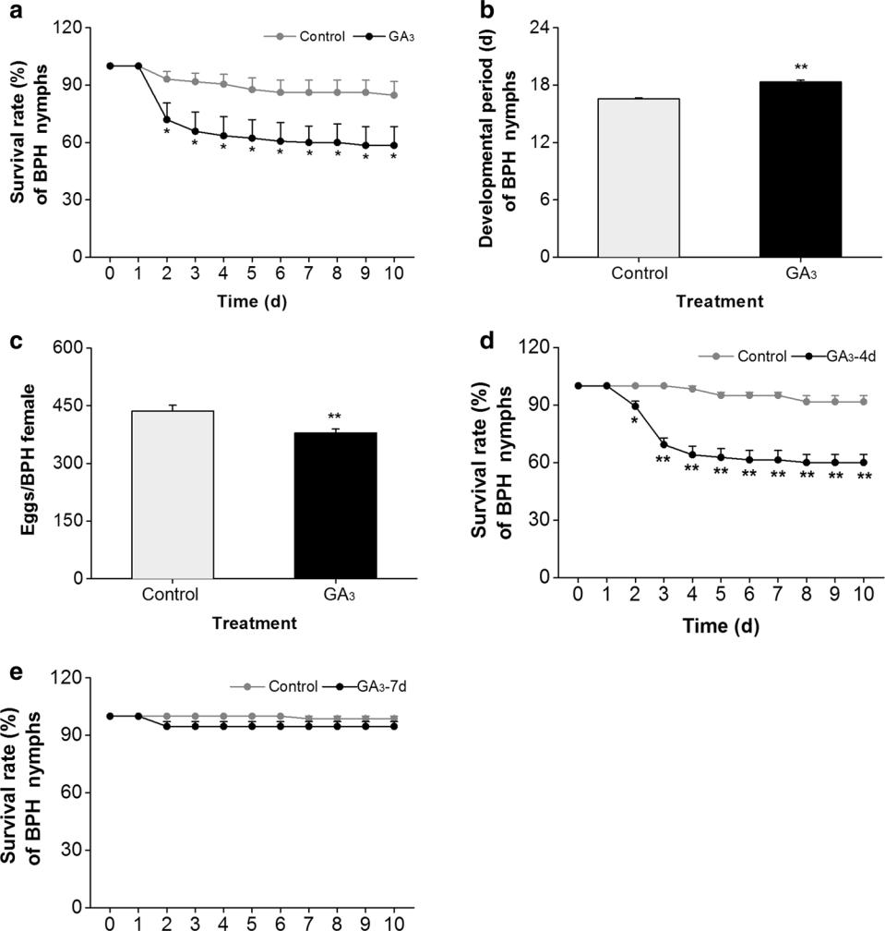

**a**

*n*

**b**

*n*

**c**

*n*

**d**

*n*

**e**

*n*

1. *p*’

*t*

**GA3 Negatively Regulates the Expression of *MAPK***

**and *WRKY* Genes**

*OsMPK6* *OsWRKY13*

*OsWRKY30OsWRKY33,*

**GA3 Modulates the Biosynthesis of JA and ET**

1 3

\ Journal of Plant Biology

**Fig. 3**

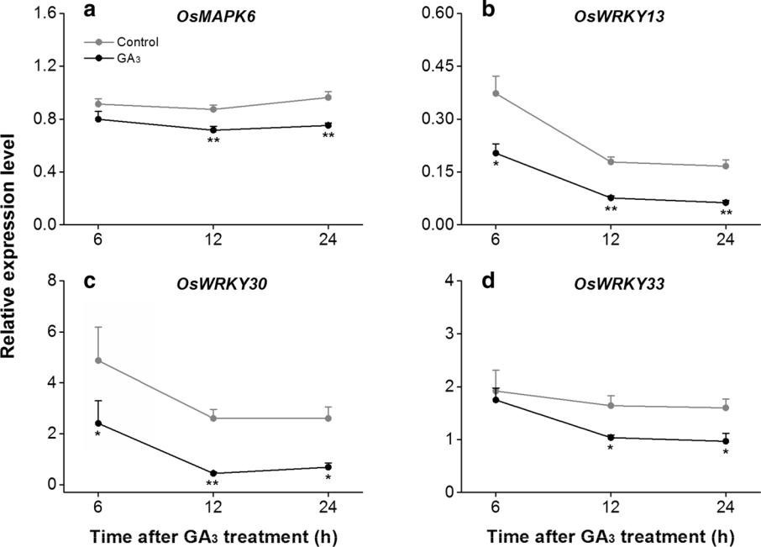

*n*

*OsMPK6***a***OsWRKY13***b**

*OsWRKY30***c***OsWRKY33*

**d**

1. *P*

’*t*

**Fig. 4**

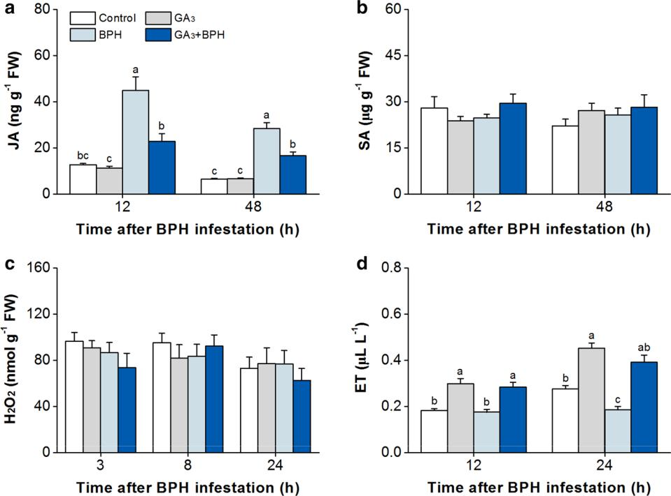

**a**–**c**

1. **a**
2. **c**

**d**

*P*

’

**GA3 Modulates the Production of Phenolic Acids**

f

1 3

Journal of Plant Biology\

*OsMPK3*

*OsSLR1*

*OsMPK6*

**Discussion**

*OsGID1*

*OsWRKY13 OsWRKY30OsWRKY33*

*WRKY33*

*OsWRKY33*

*OsMPK6*

*OsSLR1*

**Fig. 5**

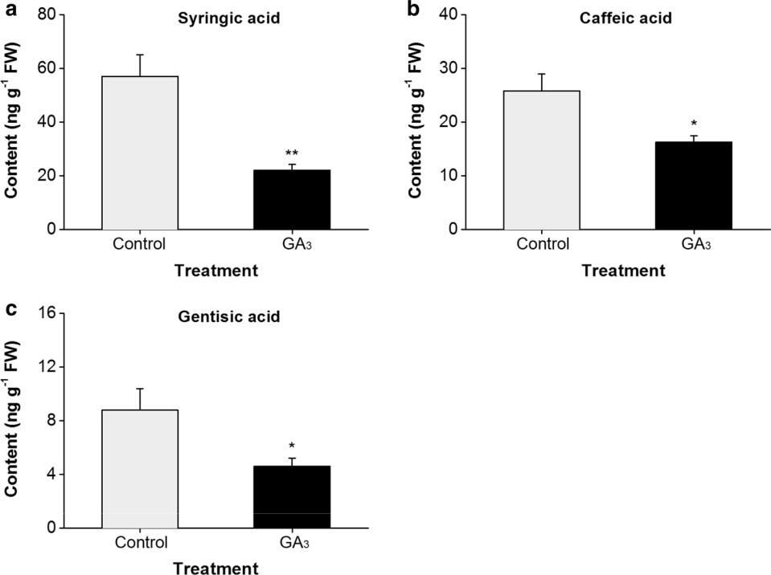

*n*

**ab**

**c**

*P*

*P*’ *t*

1 3

\ Journal of Plant Biology

*Alternaria brassicicola*

*Pseudomonas syringaetomato strain*

’

*ACS2ACS6*

’

*OsMPK6* *OsWRKY13*

**Materials and Methods**

**Plants**

**Insects**

1 3

Journal of Plant Biology\

**Plant Treatments**

µ

µ

**Measurement of Shoot Height**

’

**BPH Performance Experiments**

µ

µ

**Quantitative Real‑Time PCR**

™

*OsACT​*

*OsMPK6* *OsWRKY13 OsWRKY30OsWRKY33*

**JA and SA Analysis**

] ]

℃

℃

**ET Measurement**

**H2O2 Analysis**

1 3

\ Journal of Plant Biology

**Analysis of Phenolic Acids**

**Data Analysis**

’*t*

’

*p*

’*p*

**Acknowledgements**

**References**

*Galleria mellonella*

*Pimpla turionel-*

*lae*

*Sitodiplosis mosellana*

*Botrytis*

*cinereaArabidopsis*

*OsWRKY30*

*Xanthomonas oryzae* *oryzae*

*MPK4Nico-*

*tiana attenuata*

*Pseudomonas syringaetomato*

*OsWRKY53*

–

*OsGID1*

*rvata lugens*

*Fusarium oxysporum*

*Nilapa-*

*Bactrocera cucurbitae*

*OsBWMK1*

*OsWRKY33*

*Arabidopsis*

1 3

Journal of Plant Biology\

*OsWRKY13*

*Arabidopsis*

*Arabidopsis*

*WRKY12WRKY13*

*Arabidopsis*

*Gossypium hirsu-*

*tum*

*Spodoptera litura*

*Salvia miltiorrhiza*

*Arabidopsis*

*Arabidopsis*

*cis*

*Triticum aestivum*

*OsMPK6*

*OsSLR1*

*Nilapar* *-*

*cis* *vata lugens*

*OsWRKY13* *OsHI-LOX*

1 3