*Ecological Entomology* (2020),**45**, 831–839 DOI: 10.1111/een.12858

**Assessment of the biocontrol effects of three aromatic plants on multiple trophic levels of the arthropod community in an agroforestry ecosystem**

B E I Z H O U S O N G and Z H E N H A I H A N College of Horticulture, China Agricultural University, Beijing, China

**Abstract.** 1. Studies have shown that plant diversity plays a major role in influencingarthropod community composition. However, the effects of increasing plant species diversity on arthropod abundance at multiple trophic levels in the presence of aromatic plants have not been well documented.

1. To explore the potential of using aromatic plants to biocontrol arthropods at multiple trophic levels, three aromatic plant species – French marigold (*Tagetes patula* L.), Ageratum (*Ageratum houstonianum* Mill.) and Catnip (*Nepeta cataria* L.) – were introduced into an apple orchard to increase ground plant species composition.
2. The aromatic plants influenced the structure of arthropod communities at multiple trophic levels, particularly the herbivores in the tree canopy and predators in ground covers. Aromatic plants negatively influenced total arthropod community abundance. Compared with the control treatment, the total arthropod community abundance in the treated areas declined 24.99– 33.84% and 14.35–24.65% in the tree canopy and ground covers, respectively.
3. Aromatic plants negatively influenced herbivore abundance, both overall and relative to the total community. By contrast, aromatic plants positively influenced predator abundance, both overall and relative to the total community, in the treatments containing both ageratum and catnip. However, aromatic plants had no effect on species richness at each trophic level or on parasitoid abundance.
4. These results suggest that increasing ground plant species diversity by introducing aromatic plants into apple orchards may considerably affect arthropod community composition, and that aromatic plants are potentially effective for the biocontrol of herbivore pests in agroforestry ecosystems.

**Key words.** Aromatic plants, biocontrol, herbivore, predator, trophic level.

**Introduction**

It is widely recognised that high plant diversity stabilises the dynamics of multi-trophic arthropod communities (Haddad *et al.*, 2011; Moreira *et al.*, 2012) and that plant diversity deter-mines the abundance of herbivores in a food web (Haddad *et al.*, 2009; Cook-Patton *et al.*, 2011; Moreira *et al.*, 2012). There is also growing evidence that plant diversity is positively corre-lated with herbivore diversity (Jetz *et al.*, 2008; Haddad *et al.*, 2009; Kanaga *et al.*, 2009). Hypotheses such as the ‘resource

Correspondence: Zhenhai Han, College of Horticulture, China Agricultural University, Yuanmingyuan West Road 2#, Haidian District, Beijing 100193, China. E-mail: rschan@cau.edu.cn

specialisation hypothesis’ and the ‘more individuals hypothesis’ state that a greater diversity of plant species will increase net primary production and support a greater diversity of herbivores, thus having a bottom-up effect on higher trophic levels (Keddy, 1984; Srivastava & Lawton, 1998; Hurlbert, 2004). Most of the research and debate in this area have focused on the relationship between plant diversity and high-trophic-level consumer com-munities. Increasing plant biodiversity as an important approach to habitat management can enhance the biological control of her-bivores and improve pest management by providing resources such as food, alternative prey and hosts for parasitoids and predators (Landis *et al.*, 2000; Lee *et al.*, 2006; Pumariño *et al.*, 2012). However, a factor that is often overlooked when consid-ering the use of plant species diversity to reduce herbivorous

© 2020 The Royal Entomological Society 831

1. *Beizhou Song and Zhenhai Han*

pest pressure is the specific identity of the species under consid-eration, which could potentially have wide-ranging effects on arthropod community structure and diversity. Previous empiri-cal studies have reported that plant genotypic (species) diversity could have consequences that extend to communities and whole ecosystems (Kanaga *et al.*, 2009; Cook-Patton *et al.*, 2011). In addition, numerous studies have shown that plant genotypic diversity and species diversity had interactive controls on asso-ciated communities, and that the relative importance of plants of different genotypes may vary among higher trophic levels (Shoffner & Tooker, 2013; Campos-Navarrete *et al.*, 2015; Barantal *et al.*, 2019). Therefore, the key to reducing herbivo-rous pest pressure by increasing plant species diversity is the proper selection of plant species in agricultural ecosystems. These plants, whether planted alone or in combination, should be identified to improve the diversity and abundance of beneficial arthropods (Pumariño *et al.*, 2012) or have negative effects on herbivorous pests.

Classes of plants with particular functional traits have been reported to have important effects on the diversity of arthropods. For example, the presence of C4 grasses had a strong effect across trophic levels as these plants’ low nutritional value reduced the abundance of herbivores (Haddad *et al.*, 2009). However, predator abundance increased in the presence of C4 grasses which increased the biomass and habitat structure of plots (Haddad *et al.*, 2009). In addition, plants that contain certain volatile organic compounds (VOCs) are used for infor-mation transmission in ecological systems and, as such, play vital roles in insect behaviour and physiological regulation, including by attracting insects to the plant, disturbing insects in search of host plants, repelling insects, acting as antifeedants, and inhibiting insect growth and reproduction (Bukovinszky *et al.*, 2005; Schader *et al.*, 2005; Carrubba & Catalano, 2009;Macel *et al.*, 2010; Song *et al.*, 2013). Therefore, plant chem-ical and structural complexity together appear to affect the location of hosts, foraging, mating, and ovipositing success of arthropods, affecting the individual number of insects and, ulti-mately, changing the composition and structure of a community (Randlkofer *et al.*, 2010).

Aromatic plant is a general term used for cultivated plants and wild plants that have a fragrance and from which aromatic oil can be extracted. These plants are often used to regulate insect behaviour as they can release a large amount of odorous VOCs in the agroecosystem (Song *et al.*, 2010). Cook *et al.* (2007) found that *Rosmarinus officinalis* has repellent effects on *Franklin-iella occidentalis*. Additionally, the inclusion of four Asteraceaespecies, namely *Tanacetum vulgare*, *Chrysanthemum maximum*, *Aster tongolensis*, and *Achillea millefolium*, in a Quebec appleorchard system attracted Microgastrinae and enhanced their abundance and diversity (Fernández-Triana *et al.*, 2009). Nev-ertheless, the results of studies on the regulatory mechanisms by which aromatic plants control arthropod communities are inconsistent because of the differences in the aromatic plant species and types used, and this difference may be explained by the ‘repellent chemicals hypothesis’ (Uvah & Coaker, 1984), the ‘trap crop hypothesis’ (Vandermeer, 1989) or the ‘natural enemies hypothesis’ (Root, 1973; Russell, 1989). Indeed, the complexity of VOCs released by mixed sets of plants and the

different effects of specific aromatic plants on the structure and composition of arthropods at different trophic levels remain rel-atively unexplored.

In the present study, we introduced three aromatic plant species into an apple orchard to increase ground plant species composition in order to investigate the biocontrol effects of aromatic plants on the arthropod community at multiple trophic levels. We intended to identify the aromatic plant combination treatment with the greatest influence on the composition and structure characteristics of arthropods at different trophic levels and the mechanisms related to this influence.

**Materials and methods**

*Treatments and management*

The experiment was performed in an organic apple (*Malus* *domestica* Borkh. cv. Red Fuji) orchard in the Changping Dis-trict, north of Beijing, China. From March 2012 to October 2015, three aromatic plant species (ageratum, French marigold, and catnip) were sown at ratios of 1:1 and 1:1:1 in an area between two rows of apple trees at the basis of native vegeta-tion. The experiment involved a randomised block design with three replicates, and 15 plots in total were created. The follow-ing five treatments were used: French marigold + catnip (KB); French marigold + ageratum (KH); ageratum + catnip (HB); French marigold + catnip + ageratum (KBH); and native vegeta-tion control (CK). Each plot size was 18 × 40 m, and plots were spaced 18 m apart, separated by three clean tillage lines (with only apple trees). Each plot contained four rows of fruit trees, and each row had eight fruit trees. The test plants were planted on

* 80% of the area between two rows of apple trees in each plot; the other 20% of the area, between the aromatic plant margins and the fruit trees, was covered by native vegetation. In the CK treatment plots, the native vegetation consisted mainly of seven species: slender amaranth, *Amaranthus viridis* L. (Amaran-thaceae); viola, *Viola philippica* Cav. var. philippica (Violaceae); plantain, *Plantago asiatica* L. (Plantaginaceae); dandelion, *Taraxacum officinale* (L.) [Weber] ex Wigg. (Asteraceae); greenbristlegrass, *Setaria viridis* (L.) P. Beauv. (Poaceae); petunia, *Petunia hybrida* (Hook f.) Vilm. (Solanaceae); and shepherd’spurse, *Capsella bursa-pastoris* (L.) Medik. (Brassicaceae).

*Arthropod sampling*

From April to October 2013, 2014, and 2015, the numbers of arthropods collected from a series of sampling points in the apple tree canopy and ground covers were determined using direct observation and sweeping methods, respectively. The specific methods used for sampling were as follows. Apple tree canopy surveys were performed by collecting samples on 1 day of each month from April to October each year. Within each plot, four apple trees were selected at random as sampling points, and each tree was sampled from four directions (east, south, west, and north). On each side of the tree, three 30-cm twigs from high, middle, and low points of the tree were chosen and checked for the presence of arthropods. Sweeping was used

© 2020 The Royal Entomological Society, *Ecological Entomology*, **45**, 831–839

to sample arthropods present in the ground covers, more specif-ically to collect arthropods on aromatic plants in the KB, KH, HB, and KBH treatments and arthropods on native vegetation in the CK treatment. In the centre of each plot, a 10-m-long area was selected as a sampling point, and each plot received five sweeps. All collected arthropods were taken to the laboratory for identification and counting. In the laboratory, all collected arthropod specimens were identified by optical microscopy to the least inclusive level possible – order, family, or species – on the basis of morphological characteristics (mouthparts, wings, feet, brindle, etc.). Identified museum materials from Bei-jing University of Agriculture and the classification retrieval book *Agricultural insects of China (I, II)* (Institute of Zool-ogy, Chinese Academy of Sciences, 1986) were also used for arthropod identification and classification. Some species were difficult to identify, so they were identified only to the family level.

*Statistical analysis*

The data obtained by the two sampling methods were used separately in the analysis of the arthropod community response to the different treatments. To test the species diversity of each arthropod community in response to the different treatments, the abundance, species richness, and Simpson’s diversity index (Simpson & Cracraft, 1995) of the total arthropod community, herbivores, predators, and parasitoids were calculated for the two sampling methods separately. The relative abundance of herbivores and predators with regard to the total community and the relative abundance of predators in relation to herbivores were analysed to compare the changes of arthropod community composition with trophic level among different treatments. Principal coordinates analysis (PCoA) and clustering heatmap of the operational taxonomic units (OTUs) analysis were also

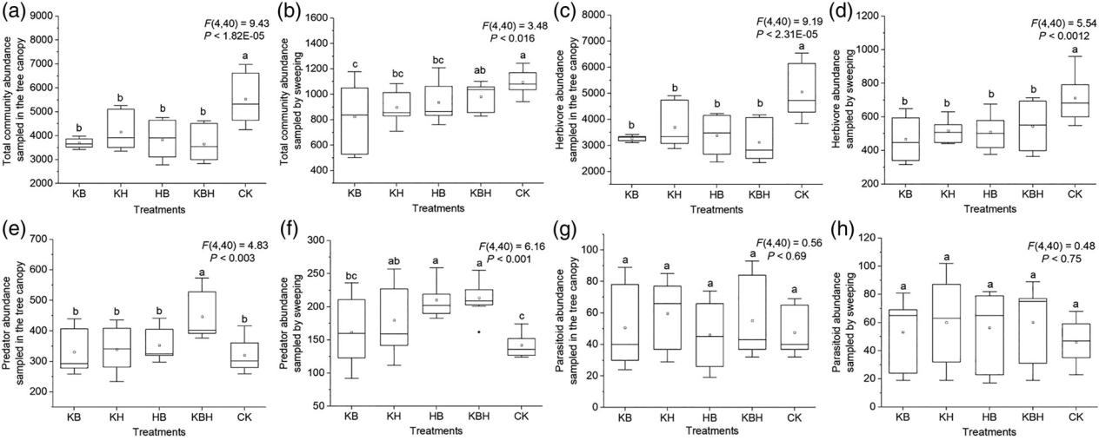

*Biocontrol of arthropods by aromatic plants* 833

used to test the structure characteristics of arthropods among different treatments. The number of arthropods at the family level was used as the basic data to analyse arthropod species composition. In addition, the individual number dynamics of the total arthropod community and of the dominant herbivo-rous Aphididae were calculated to compare the difference of occurrence peaks among different treatments. The differences of these indexes among different treatments were tested using one-way anova. origin pro 2017, canoco 5.0, R v.3.5.2, and spss 22.0 software were used for data analysis.

**Results**

*Abundance of arthropod community*

The abundance of the total arthropod communities sampled in the tree canopy was lower in the aromatic plant treatments than in the CK treatment (Fig. 1a). Compared with the CK treatment, the abundance of the total arthropod communities sampled in the tree canopy declined by 33.14%, 24.99%, 30.75%, and 33.84% in the KB, KH, HB, and KBH treatments, respectively. The abundance of the total arthropod communities sampled by sweeping was also lower in the aromatic plant treatments than in the CK treatment, except for the KBH treatment (Fig. 1b). Compared with the CK treatment, the abundance of the total arthropod communities sampled by sweeping declined by 24.65%, 17.89%, and 14.35% in the KB, KH, and HB treat-ments, respectively. The abundance of herbivores sampled by the two sampling methods was lower in the aromatic plant treat-ments than in the CK treatment (Fig. 1C,D). Compared with the CK treatment, the abundance of herbivores sampled in the tree canopy declined by 35.20%, 26.96%, 33.19%, and 38.31% in the KB, KH, HB, and KBH treatments, respectively. Moreover, the abundance of herbivores sampled by sweeping declined by 34.50%, 27.35%, 28.65%, and 23.66% in the KB, KH, HB,

**Fig. 1.** Abundance of the total arthropod community, herbivores, predators, and parasitoids sampled in the tree canopy (a, c, e, g) and sampled bysweeping (b, d, f, h). Lowercase letters represent statistical significance (*P* *<* 0.05). KB, French marigold + catnip; KH, French marigold + ageratum; HB, ageratum + catnip; KBH, French marigold + catnip + ageratum; and CK, native vegetation.

© 2020 The Royal Entomological Society, *Ecological Entomology*, **45**, 831–839

1. *Beizhou Song and Zhenhai Han*

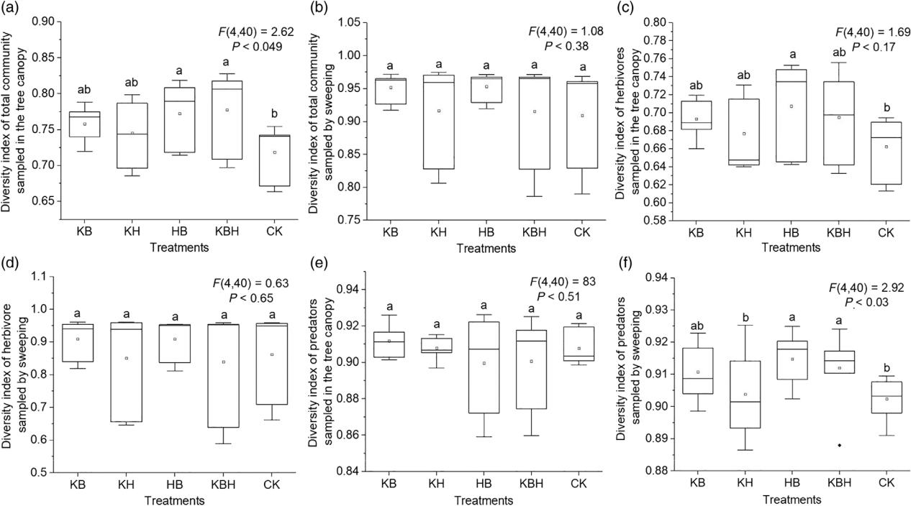

**Fig. 2.** Simpson’s diversity index of the total arthropod community, herbivores, predators, and parasitoids sampled in the tree canopy (A, C, E) andsampled by sweeping (B, D, F). Lowercase letters represent statistical significance (*P* *<* 0.05). KB: French marigold + catnip; KH: French marigold + ageratum; HB: ageratum + catnip; KBH: French marigold + catnip + ageratum; and CK: native vegetation.

and KBH treatments, respectively. However, the abundance of predators sampled in the tree canopy was higher only in the KBH treatment than in the CK treatment (Fig. 1e), with an increase of 39.40%. The abundance of predators sampled by sweeping was higher in the KH, HB, and KBH treatments than in the CK treat-ment (Fig. 1F), with increases of 26.48%, 47.89%, and 49.92%, respectively. In addition, the abundance of parasitoids sampled by the two sampling methods in the aromatic plant treatments was not significantly different from that of the CK treatment (Fig. 1g,h).

*Diversity indices of arthropod communities*

The Simpson’s diversity indices of the total arthropod com-munity sampled in the tree canopy in the HB and KBH treat-ments were higher than that of the CK treatment (Fig. 2a). The Simpson’s diversity index of herbivores sampled in the tree canopy was higher in the HB treatment than in the CK treat-ment (Fig. 2c). However, the Simpson’s diversity indices of the total arthropod community and herbivores sampled by sweeping in the aromatic plant treatments were not significantly differ-ent from those of the CK treatment (Fig. 2b,d). The Simpson’s diversity indices of predators sampled by sweeping in the HB and KBH treatments was higher than that of the CK treatment (Fig. 2f). However, the Simpson’s diversity indices of predators sampled in the tree canopy and species richness of all trophic levels in the aromatic plant treatments were not significantly dif-ferent from those of the CK treatment (Figs 2e, 3).

*Composition and structure characteristics of arthropods at the family level*

In the samples collected over 3 years, 79 taxonomic species were identified and recorded. Considering trophic levels, 49, 22, and four taxa were identified as belonging to the herbivore, predator, and parasitoid categories, respectively. The propor-tions of the total arthropod community abundance sampled in the tree canopy to the abundance of the total arthropod community sampled by the two sampling methods in the KB, KH, HB, KBH, and CK treatments were 81.79%, 82.22%, 80.36%, 78.87%, and 83.50%, respectively. The PCoA showed that the presence of aromatic plants mainly changed the composition and structure of the total arthropod communities sampled in the tree canopy (Fig. 4). Although the composition and structure characteristics of the arthropod community in the aromatic plant treatments were significantly different from each other among the differ-ent sampling years, the differences were not clear in the same sampling years. However, the composition and structure char-acteristics of arthropods in the aromatic plant treatments were significantly different from that of the CK treatment, and they were also significantly different among the different sampling years in the CK treatment (Fig. 4a). In addition, the presence of aromatic plants changed the trophic level proportions in the total community. For both sampling methods, the relative abundances of herbivores compared with the total arthropod community in the HB and KBH treatments were lower than in the CK treat-ment (Fig. 5a,b). However, the abundance of predators relative to the total arthropod community and that of predators relative

© 2020 The Royal Entomological Society, *Ecological Entomology*, **45**, 831–839

*Biocontrol of arthropods by aromatic plants* 835

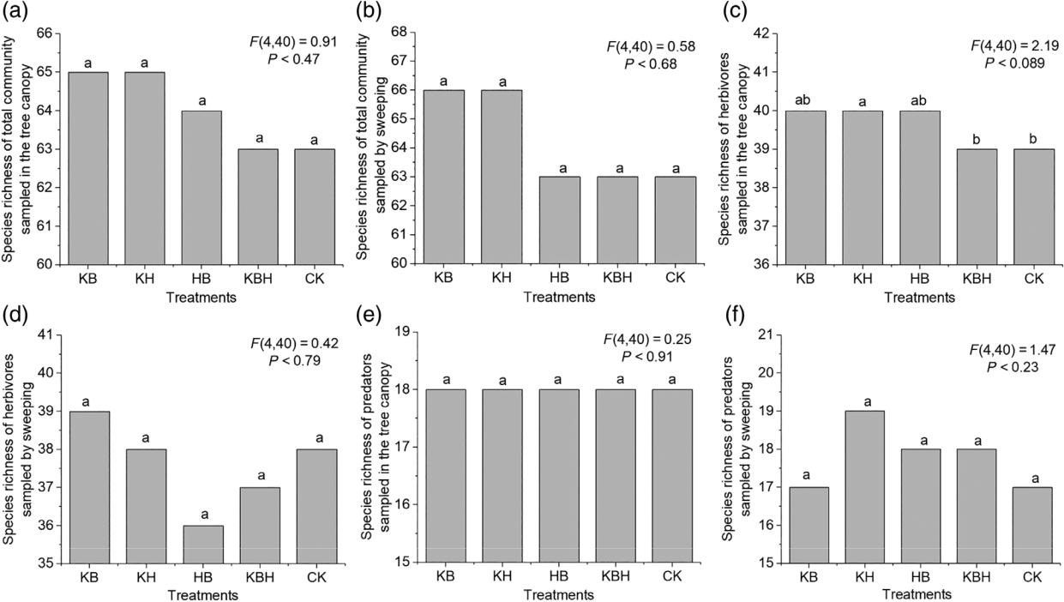

**Fig. 3.** Species richness of the total arthropod community, herbivores, predators, and parasitoids sampled in the tree canopy (A, C, E) and sampled bysweeping (B, D, F). Lowercase letters represent statistical significance (*P* *<* 0.05). KB: French marigold + catnip; KH: French marigold + ageratum; HB: ageratum + catnip; KBH: French marigold + catnip + ageratum; and CK: native vegetation.

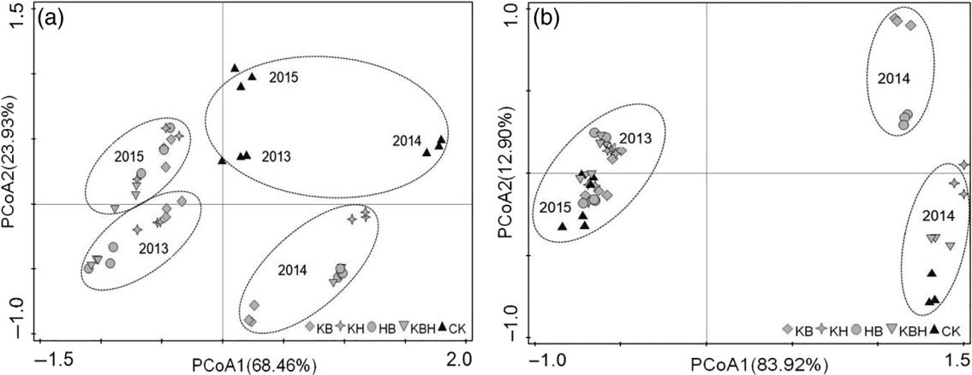

**Fig. 4.** Principal coordinates analysis (PCoA) of the total arthropod communities sampled in the tree canopy (a) and by sweeping (b). KB, Frenchmarigold + catnip; KH, French marigold + ageratum; HB, ageratum + catnip; KBH, French marigold + catnip + ageratum; and CK, native vegetation.

to herbivores were higher in the KB, KH, HB, and KBH treat-ments than in the CK treatment, being especially high in the HB and KBH treatments (Fig. 5c–f).

*Abundance dynamics of the total arthropod community and of Aphididae arthropods*

The top three most dominant families of herbivores in all treatments were Aphididae, Tetranychidae, and Tortricidae. In

particular, the ratio of Aphididae abundance to the total arthro-pod community abundance ranged from 51.92% to 62.22% (Fig. S1). The top two most dominant families of predators in all treatments were Coccinellidae and Chrysopidae (Fig. S1). The clustering heatmap of OTUs also showed that Aphididae was the dominant group in the total arthropod community in all treatments and indicated the differences of the composition of arthropods among the different treatments (Fig. S2).

Individual peaks of the total arthropod community and Aphididae appeared from May to August of each sampling

© 2020 The Royal Entomological Society, *Ecological Entomology*, **45**, 831–839

1. *Beizhou Song and Zhenhai Han*

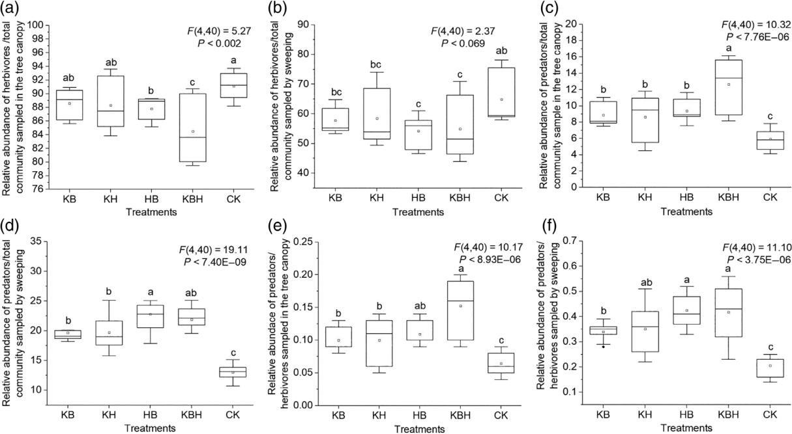

**Fig. 5.** Relative abundance of herbivores to total community, predators to total community, and predators to herbivores sampled in the tree canopy (A,C, E) and sampled by sweeping (B, D, F). Lowercase letters represent statistical significance (*P* *<* 0.05). KB: French marigold + catnip; KH: French marigold + ageratum; HB: ageratum + catnip; KBH: French marigold + catnip + ageratum; and CK: native vegetation.

year in all treatments, but the peaks from the aromatic plant treatments were lower than in the CK treatment (Fig. 6a,b). The peak period of Aphididae occurrence was consistent with the peak period of the total arthropod community. Two Aphididae species, *Aphis citricola* van der Goot and *Myzus malisuctus* (Matsumura), were less abundant in the KB, KH, HB, and KBH treatments than in the CK treatment, especially in the HB and KBH treatments (Fig. 6c,d). Compared with the CK treatment, the abundance of *A. citricola* van der Goot and *M. malisuctus* (Matsumura) declined by 37.95%, 27.01%, 39.87%, 41.96%, and 42.62%, 32.41%, 36.44% and 41.10% in the KB, KH, HB, and KBH treatments, respectively.

**Discussion**

Our analyses demonstrated that plant species diversity was an important driver of arthropod community structure. In the present study, increasing ground plant species diversity by introducing aromatic plants into an orchard had a significant influence on the composition of the total arthropod community. These effects were different at the herbivore and predator trophic levels, as they resulted from different mechanisms. Our results indicated that increasing orchard ground plant species diversity by introducing aromatic plants had negative effects on herbivore abundance, both overall and relative to the total community (Figs 1c,d, 5a,b). Ecological (Borer *et al.*, 2012) and field exper-iments (Siemann *et al.*, 1998) have shown that a diversity of resources should support a diversity of consumers. For example, the increase in plant species diversity and in *Oenothera biennis*

genotypic diversity led to an increase in arthropod abundance and richness in field experiments (Cook-Patton *et al.*, 2011). According to the ‘more individuals hypothesis’ (Srivastava & Lawton, 1998), a coupled increase in plant and arthropod abun-dance would be expected. Based on this hypothesis, in the case herein presented, we could suggest that the higher productivity may have resulted from an increase in plant species richness. However, our results showed that the species richness of her-bivores in all aromatic plant treatments was not significantly different from that of the CK treatment (Fig. 2c,d), which does not agree with the ‘more individuals hypothesis’. Therefore, this common mechanism does not explain the decrease of her-bivores in this experiment. Some previous studies have reported that aromatic plants seemed to reduce the number of primary herbivores through a chemical repellent effect (Tang *et al.*, 2013; Wan *et al.*, 2015). Similarly, Zhang *et al.* (2017) showed that intercropping aromatic plants (*Cassia tora*) with tea plants significantly reduced tea green leafhopper (*Empoasca onukii* Matsuda) population levels in the tea plantation, as the VOCs derived from *C. tora* could significantly affect the behaviour of *E. onukii*. Therefore, in the present study, we conclude that thedecrease in herbivore abundance related to the aromatic plants can be mainly explained by the repellent chemical hypothesis.

In contrast to the herbivore responses, increasing orchard ground plant species diversity by introducing aromatic plants significantly increased the abundance of predators in the ground covers and the relative abundance of predators to that of total community, especially in the HB and KBH treatments (Figs 1c,d, 5a,b). In general, predator species are positively linked to plant diversity through a bottom-up effect, i.e. an

© 2020 The Royal Entomological Society, *Ecological Entomology*, **45**, 831–839

*Biocontrol of arthropods by aromatic plants* 837

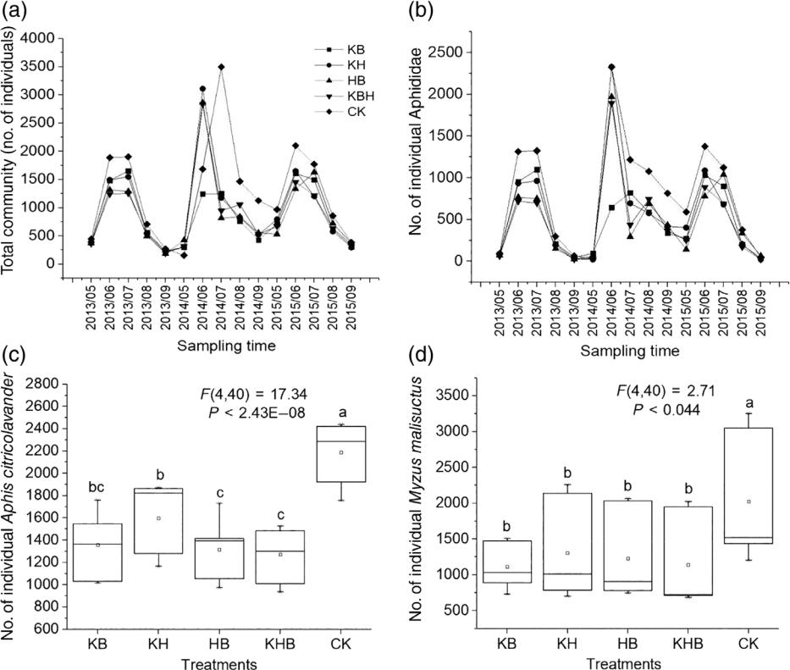

**Fig. 6.** Temporal dynamics of individual number of the total arthropod communities (a) and Aphididae arthropods (b), and abundance of*Aphis**citricola van der* Goot (c) and *Myzus malisuctus* (Matsumura) (d) in different treatments. Lowercase letters represent statistical significance (*P <* 0.05).KB, French marigold + catnip; KH, French marigold + ageratum; HB, ageratum + catnip; KBH, French marigold + catnip + ageratum; and CK, native vegetation.

increase in plant species provides more diversity of resources and /or productivity for the herbivore species that feed upon them, which, in turn, will have an increased abundance that ben-efits the predators that feed on these herbivores (Dinnage*et al.*, 2012). However, the abundance of herbivores in the aromatic plant treatments was lower than in the CK treatment. Therefore, other mechanisms may have caused the increase in the number of predators. Many studies have stated that plants with extraflo-ral nectaries may attract predator species that use pollen, nectar or honeydew as a food source, thus resulting in a significant increase in the number of predator individuals (Begum *et al.*, 2006; Lee *et al.*, 2006; Mathews *et al.*, 2009). For example, the abundance of bumble-bees (*Bombus hortorum*) and honeybees (*Apis mellifera*) significantly increased when phacelia were provided as floral resources in two agricultural agroecosystems (broccoli and lucerne crops) (Pontin *et al.*, 2006).

In the present work, an increase in the number of main preda-tors possibly reflects that these predators needed or benefited from the nectar and/or pollen of these three aromatic plants during the flowering period. In addition, the abundance and diversity of predators and parasitoids are higher in diverse habitats than in monoculture habitats, which is mainly a result of the greater availability of refuges or resources found with increased diversity, and which results in a more effective control of herbivore populations, as stated in the ‘enemies hypothesis’

(Russell, 1989). Aromatic plants may provide a favourable habitat or intermediate hosts for natural predator enemies while increasing the species of plants on the ground. This assumption is in accordance with our result that aromatic plants mainly increased the abundance of predators in the ground covers. Sim-ilarly, Lee *et al.* (2001) showed that planting flowering plants with corn as refuges increased the density of beetles in adjacent fields. Hence, we suggest that increasing orchard ground plant species diversity by introducing aromatic plants could provide more nectar, pollen, or both within the flowering period and an alternate habitat for natural predator enemies; this, in turn, would enable natural enemies to survive and reproduce more easily, thus leading to an overall increase in predator numbers.

Many researchers have stated that plant species, genotypic diversity, and functional groups could have significant effects on arthropod diversity (Crutsinger *et al.*, 2006; Kanaga *et al.*, 2009; Cook-Patton & Bauerle, 2012; Pumariño *et al.*, 2012). For instance, the presence of C4 graminoids had a negative effect on the richness of herbivorous Hemiptera species and on the diversity of Hemiptera as a whole, possibly because of the low nutritional quality of the C4 graminoids (Symstad, 2000). In this study, our results indicated that the Simpson’s diversity indices of the total arthropod community and of herbivores in the tree canopy as well as predators in ground covers were sig-nificantly increased in the HB and KBH treatments (Fig. 2a,c,f),

© 2020 The Royal Entomological Society, *Ecological Entomology*, **45**, 831–839

1. *Beizhou Song and Zhenhai Han*

but there was no significant difference in species richness at all trophic levels between the aromatic plant treatments and the CK treatment (Fig. 3). The mechanism ‘abundance-driven diversity change’ may potentially explain this phenomenon. Within a population, when one or several species occupy a comparatively dominant position, the community diversity index also changes. For example, the evenness and proportional diversity of arthro-pods decreased with genotypic richness of common evening primrose (*O. biennis*), because of a nonadditive increase in the individual number of a dominant generalist arthropod, *Plagiog-nathas politus* (Miridae) (McArt *et al.*, 2012). Furthermore,Medeiros *et al.* (2009) suggested that coriander (*Coriandrum* *sativum* L., Apiaceae) and Gallant soldier (*Galinsoga parviflora* Cav., Asteraceae) planted with tomato reduced the abundance but increased the diversity of herbivorous pests. In this exper-iment, the inclusion of aromatic plants mainly significantly influenced the composition and abundance of the total arthro-pod community, herbivores in the tree canopy, and predators in the ground covers, which was consistent with the change of arthropod diversity. The significant changes in the abundance of the dominant arthropod groups – i.e. Aphididae, Tetrany-chidae, Tortricidae, Coccinellidae, and Chrysopidae – may have affected the diversity of relevant arthropod communities. Therefore, we speculate that the increase in arthropod commu-nity diversity at multiple trophic levels was mainly caused by a significant increase or reduction in the number of dominant arthropod species.

Taken together, our results indicate that increasing plant species diversity by introducing aromatic plants significantly reduced the total arthropod community and herbivore abun-dance in both the tree canopy and ground covers, and increased predator abundance in ground covers, especially in the HB and KBH treatments. Moreover, we propose that the arthropods’ response to plant species diversity in the orchard ecosystem was related to the ‘repellent chemical hypothesis’ and ‘natural ene-mies hypothesis’, with the reduction in the dominant herbivore species abundance and the increase in dominant predator species driving the increase in the arthropod community diversity at multiple trophic levels. In addition, the relative abundance of predators to herbivores significantly increased in the aromatic plant treatments, thus indicating that predators control herbi-vore abundance in diverse plant agroforestry ecosystems and contribute to maintaining the whole arthropod community in a relatively stable state. Our results suggest that increasing ground plant species diversity by introducing aromatic plants into apple orchards can have large effects on arthropod community com-position and diversity, and that aromatic plants are potentially effective tools for the biocontrol of herbivore pests in an agro-forestry ecosystem.

**Acknowledgements**

Financial support was provided by a National Natural Science Foundation of China grant (31301736). The authors declare that there are no conflicts of interest. We thank Wiley Editing Services [(https://wileyeditingservices.com/en/)](https://wileyeditingservices.com/en/) for editing this manuscript.

**Author contributions**

Z.H. and B.S. developed the plan for this study. B.S. per-formed the analysis (Figs 1–6, S1, S2) and wrote the original manuscript. Z.H. and B.S. discussed the results and edited the manuscript.

**Supporting Information**

Additional supporting information may be found online in the Supporting Information section at the end of the article.

**Fig. S1.** Composition and structure characteristics at the familylevel of the arthropod community. KB, French marigold + catnip; KH, French marigold + ageratum; HB, ageratum + catnip; KBH, French marigold +catnip + ageratum; and CK, native vegetation.

**Fig. S2.** Clustering heatmap of the operational taxonomic unit(OTU) analysis of the arthropod community considering relative abundance at the family level. KB, French marigold + catnip; KH, French marigold + ageratum; HB, ageratum + catnip; KBH, French marigold +catnip + ageratum; and CK, native vegetation.

**References**

Barantal, S., Castagneyrol, B., Durka, W., Iason, G., Morath, S. & Koricheva, J. (2019) Contrasting effects of tree species and genetic diversity on the leaf-miner communities associated with silver birch. *Oecologia*,**189**, 687–697.

Begum, M., Gurr, G.M., Wratten, S.D., Hedberg, P.R. & Nicol, H.I. (2006) Using selective food plants to maximize biological control of vineyard pests. *Journal of Applied Ecology*, **43**, 547–554.

Borer, E.T., Seabloom, E.W. & Tilman, D. (2012) Plant diversity controls arthropod biomass and temporal stability. *Ecology Letters*, **15**, 1457–1464.

Bukovinszky, T., Gols, R., Posthumus, M.A., Vet, L.E.M. & Van Lenteren, J.C. (2005) Variation in plant volatiles and attraction of the parasitoid *Diadegma semiclausum* (Hellén). *Journal of Chemical* *Ecology*,**31**, 461–480.

Campos-Navarrete, M.J., Munguía-Rosas, M.A., Abdala-Roberts, L., Quinto, J. & Parra-Tabla, V. (2015) Effects of tree genotypic diversity and species diversity on the arthropod community associated with big-leaf Mahogany. *Biotropica*, **47**, 579–587.

Carrubba, A. & Catalano, C. (2009) Sustainable agriculture reviews: essential oil crops for sustainable agriculture - a review. In: Lichtfouse E. (eds) *Climate Change, Intercropping, Pest Control and Beneficial* *Microorganisms*, Springer, Dordrecht, 2, 137–188.

Cook, S.M., Khan, Z.R. & Pickett, J.A. (2007) The use of push-pull strategies in integrated pest management. *Annual Review of Entomol-ogy*,**52**, 375–400.

Cook-Patton, S.C. & Bauerle, T.L. (2012) Potential benefits of plant diversity on vegetated roofs: a literature review. *Journal of Environ-mental Management*,**106**, 85–92.

Cook-Patton, S.C., McArt, S.H., Parachnowitsch, A.L., Thaler, J.S. & Agrawal, A.A. (2011) A direct comparison of the consequences of plant genotypic and species diversity on communities and ecosystem function. *Ecology*, **92**, 915–923.

Crutsinger, G.M., Collins, M.D., Fordyce, J.A., Gompert, Z., Nice, C.C.

* Sanders, N.J. (2006) Plant genotypic diversity predicts community structure and governs an ecosystem process. *Science*, **313**, 966–968.

© 2020 The Royal Entomological Society, *Ecological Entomology*, **45**, 831–839

Dinnage, R., Cadotte, M.W., Haddad, N.M., Crutsinger, G.M. & Tilman, D. (2012) Diversity of plant evolutionary lineages promotes arthropod diversity. *Ecology Letters*, **15**, 1308–1317.

Fernández-Triana, J., Goulet, H., Bostanian, N.J. & Boudreault, C. (2009) Diversity of Microgastrinae (Hymenoptera: Braconidae) in apple orchards of southern Quebec, Canada. *Biocontrol Science and* *Technology*,**19**, 237–248.

Haddad, N.M., Crutsinger, G.M., Gross, K., Haarstad, J., Knop, J.M.H.

* Tilman, D. (2009) Plant species loss decreases arthropod diversity and shifts trophic structure. *Ecology Letters*, **12**, 1029–1039.

Haddad, N.M., Crutsinger, G.M., Gross, K., Haarstad, J. & Tilman, D. (2011) Plant diversity and the stability of foodwebs. *Ecology Letters*, **14**, 42–46.

Hurlbert, A.H. (2004) Species–energy relationships and habitat com-plexity in bird communities. *Ecology Letters*, **7**, 714–720.

Institute of Zoology, Chinese Academy of Sciences (1986) *Agricultural* *insects of China (I, II)*. Agriculture University Press, Beijing, China.

Jetz, W., Kreft, H., Ceballos, G. & Mutke, J. (2008) Global associations between terrestrial producer and vertebrate consumer diversity. *Pro-ceedings of the Royal Society B: Biological Sciences*,**276**, 269–278.

Kanaga, M.K., Latta, L.C. IV, Mock, K.E., Ryel, R.J., Lindroth, R.L. & Pfrender, M.E. (2009) Plant genotypic diversity and environmental stress interact to negatively affect arthropod community diversity. *Arthropod-Plant Interactions*,**3**, 249–258.

Keddy, P.A. (1984) Plant zonation on lakeshores in Nova Scotia: a test of the resource specialization hypothesis. *Journal of Ecology*, **72**, 797–808.

Landis, D.A., Wratten, S.D. & Gurr, G.M. (2000) Habitat management to conserve natural enemies of arthropod pests in agriculture. *Annual* *Review of Entomology*,**45**, 175–201.

Lee, J.C., Menalled, F.D. & Landis, D.A. (2001) Refuge habitats modify impact of insecticide disturbance on carabid beetle communities. *Journal of Applied Ecology*,**38**, 472–483.

Lee, J.C., Andow, D.A. & Heimpel, G.E. (2006) Influence of floral resources on sugar feeding and nutrient dynamics of a parasitoid in the field. *Ecological Entomology*, **31**, 470–480.

Macel, M., Van Dam, N.M. & Keurentjes, J.J.B. (2010) Metabolomics: the chemistry between ecology and genetics. *Molecular Ecology* *Resources*,**10**, 583–593.

Mathews, C.R., Bottrell, D.G. & Brown, M.W. (2009) Extrafloral nec-taries alter arthropod community structure and mediate peach (*Prunus* *persica*) plant defense. *Ecological Applications*,**19**, 722–730.

McArt, S.H., Cook-Patton, S.C. & Thaler, J.S. (2012) Relationships between arthropod richness, evenness, and diversity are altered by complementarity among plant genotypes. *Oecologia*, **168**, 1013–1021.

Medeiros, M.A., Sujii, E.R. & Morais, H.C. (2009) Effect of plant diversification on abundance of South American tomato pinworm and predators in two cropping systems. *Horticultura Brasileira*, **27**, 300–306.

Moreira, X., Mooney, K.A., Zas, R. & Sampedro, L. (2012) Bottom-up effects of host-plant species diversity and top-down effects of ants interactively increase plant performance. *Proceedings of the Royal* *Society B: Biological Sciences*,**279**, 4464–4472.

Pontin, D.R., Wade, M.R., Kehrli, P. & Wratten, S.D. (2006) Attractive-ness of single and multiple species flower patches to beneficial insects in agroecosystems. *Annals of Applied Biology*, **148**, 39–47.

Pumariño, L., Alomar, O. & Lundgren, J.G. (2012) Effects of floral and extrafloral resource diversity on the fitness of an omnivorous

*Biocontrol of arthropods by aromatic plants* 839

bug, *Orius insidiosus*. *Entomologia Experimentalis et Applicata*, **145**, 181–190.

Randlkofer, B., Obermaier, E., Hilker, M. & Meiners, T. (2010) Vegetation complexity–the influence of plant species diversity and plant structures on plant chemical complexity and arthropods. *Basic* *and Applied Ecology*,**11**, 383–395.

Root, R.B. (1973) Organization of a plant-arthropod association in simple and diverse habitats: the fauna of collards (*Brassica oleracea*). *Ecological Monographs*,**43**, 95–118.

Russell, E.P. (1989) Enemies hypothesis: a review of the effect of vege-tational diversity on predatory insects and parasitoids. *Environmental* *Entomology*,**18**, 590–599.

Schader, C., Zaller, J.G. & Köpke, U. (2005) Cotton-basil intercropping: effects on pests, yields and economical parameters in an organic field in Fayoum, Egypt. *Biological Agriculture & Horticulture*, **23**, 59–72.

Shoffner, A.V. & Tooker, J.F. (2013) The potential of genotypically diverse cultivar mixtures to moderate aphid populations in wheat (*Triticum aestivum* L.). *Arthropod-Plant Interactions*, **7**, 33–43.

Siemann, E., Tilman, D., Haarstad, J. & Ritchie, M. (1998) Experimental tests of the dependence of arthropod diversity on plant diversity. *The* *American Naturalist*,**152**, 738–750.

Simpson, B.B. & Cracraft, J. (1995) Systematics: the science of biodiversity: use of a systematic perspective is burgeoning, and the need for the field is becoming ever greater. *BioScience*, **45**, 670–672.

Song, B.Z., Wu, H.Y., Kong, Y., Zhang, J., Du, Y.L., Hu, J.H. *et al.* (2010) Effects of intercropping with aromatic plants on diversity and structure of an arthropod community in a pear orchard. *BioControl*, **55**, 741–751.

Song, B.Z., Tang, G.B., Sang, X.S., Zhang, J., Yao, Y.C. & Wiggins, N.L. (2013) Intercropping with aromatic plants hindered the occurrence of *Aphis citricola* in an apple orchard system by shifting predator–preyabundances. *Biocontrol Science and Technology*, **23**, 381–395.

Srivastava, D.S. & Lawton, J.H. (1998) Why more productive sites have more species: an experimental test of theory using tree-hole communities. *American Naturalist*, **152**, 510–529.

Symstad, A.J. (2000) A test of the effects of functional group richness and composition on grassland invasibility. *Ecology*, **81**, 99–109.

Tang, G.B., Song, B.Z., Zhao, L.L., Sang, X.S., Wan, H.H., Zhang, J. *et al.* (2013) Repellent and attractive effects of herbs on insects in pearorchards intercropped with aromatic plants. *Agroforestry Systems*, **87**, 273–285.

Uvah, I.I.I. & Coaker, T.H. (1984) Effect of mixed cropping on some insect pests of carrots and onions. *Entomologia Experimentalis et* *Applicata*,**36**, 159–167.

Vandermeer, J.H. (1989) *The Ecology of Intercropping*. Cambridge University Press, Cambridge, U.K.

Wan, H.H., Song, B.Z., Tang, G.B., Zhang, J. & Yao, Y.C. (2015) What are the effects of aromatic plants and meteorological factors on *Pseudococcus comstocki* and its predators in pear orchards? *Agroforestry Systems*,**89**, 537–547.

Zhang, Z.Q., Zhou, C., Xu, Y.Y., Huang, X.Q., Zhang, L.X. & Mu, W. (2017) Effects of intercropping tea with aromatic plants on population dynamics of arthropods in Chinese. *Journal of Pest Science*, **90**, 227–237.

Accepted 17 February 2020

First published online 11 March 2020

Associate Editor: Andre Kessler

© 2020 The Royal Entomological Society, *Ecological Entomology*, **45**, 831–839