Received: 7 November 2019 | Revised: 23 June 2020 | Accepted: 26 June 2020

DOI: 10.1002/med.21707



REVIEW ARTICLE

Development of anti‐influenza agents from natural products

Zhi‐Jun Zhang1 | Susan L. Morris‐Natschke2 | Yung‐Yi Cheng2 | Kuo‐Hsiung Lee2,3  | Rong‐Tao Li1

1Faculty of Life Science and Technology, Kunming University of Science and Technology, Kunming, China

2Natural Products Research Laboratories, UNC Eshelman School of Pharmacy, University of North Carolina at Chapel Hill, Chapel Hill, North Carolina, USA

3Chinese Medicine Research and Development Center, China Medical University and Hospital, Taichung, Taiwan

Correspondence

Kuo‐Hsiung Lee, Natural Products Research Laboratories, UNC Eshelman School of Pharmacy, University of North Carolina at Chapel Hill, Chapel Hill, NC 27599‐7568, USA. Email: [khlee@unc.edu](mailto:khlee@unc.edu)

Rong‐TaoLi, Faculty of Life Science and Technology, Kunming University of Science and Technology, Kunming 650500, China. Email: [rongtaolikm@163.com](mailto:rongtaolikm@163.com)

Funding information

National Natural Science Foundation of China, Grant/Award Numbers: 31960092, 81860618, U1602222; China Postdoctoral Science Foundation, Grant/Award Number: 2019M653498

Abstract

The influenza pandemic continues to threaten public health due to its high morbidity and mortality rates, despite some successes in antiviral research. Natural drugs are im-portant alternative therapies in the treatment of and re-covery from influenza and have been the subjects of intense investigation during the last few decades. Many reports have shown that the development of novel bioac-tive chemicals extracted from natural drugs has significant advantages. Oseltamivir is a successful case of an anti‐ influenza drug synthesized using two natural products, quinic acid, and shikimic acid, as starting materials. In China, traditional Chinese medicine (TCM) plays an im-portant role in the treatment of influenza. TCM herbal extracts and prescriptions or their isolated bioactive con-stituents have shown significant therapeutic and pre-ventive effects against influenza. For example, the roots of Isatis indigotica (Banlangen) fight viral infection by tar-geting both the virus and the host and have significantly different effects than those of synthetic chemicals. Lian-huaqingwen capsule exerts its anti‐influenza activity by regulating the immune response to interfere with both viral and host reactions and might well be an alternative therapeutic option to treat influenza virus infection. This paper reviews the chemical ingredients, crude extracts, and TCM prescriptions with anti‐influenza activity reported during the period of 2010–September 2019. We hope that

Med Res Rev. 2020;1–49. wileyonlinelibrary.com/journal/med © 2020 Wiley Periodicals LLC | 1

2 | ZHANG ET AL.



this comprehensive review will not only fuel research on anti‐influenza active natural products and TCM research but also provide a promising alternative candidate for further anti‐influenza drug development.

KEYWORDS

anti‐influenza agents, medicinal plants, natural products, TCM prescriptions

1 | INTRODUCTION

One hundred years ago, the world was afflicted by three consecutive surges (spring 1918, autumn 1918, and winter 1918–1919) of a mysterious and deadly pandemic. One‐third of the world's population was infected and an estimated 50 million people died.1,2 Clinical manifestations were unusually severe in previously healthy young adults.3,4 While the etiological agent causing this disease was not then known, we now know that these tragic events signified the largest influenza virus pandemic on record: the calamitous 1918 influenza pandemic.5 Since 1918, the world has undergone three more influenza pandemics: the 1957 “Asian” influenza pandemic, the 1968 “Hong Kong” influenza pandemic and the 2009 purported “swine flu” (H1N1) pandemic. Another influenza pan-demic H5N1, called avian or bird flu, initially caused a severe respiratory disease only in birds. However, in 2003, the H5N1 virus was transmitted to humans resulting in an about 60% mortality rate. Although these latter pandemics were relatively mild compared with the 1918 pandemic, they highlight the persistent risk that influenza virus presents to human health. Therefore, it is essential to increase our knowledge of the features that determine viral etiology or transmission to assist in the development of new antiviral vaccines and drugs for controlling influenza outbreaks in the future.6

2 | THE CLASSIFICATION OF INFLUENZA

Influenza is classified into four types (Figure 1): influenza A–D virus according to the different antigenic de-terminants on the matrix protein 1 (M1) and nucleoprotein (NP).7‐9 Highly infectious influenza A virus (IAV) can spread from person to person via direct contact with respiratory droplets or indirect contact with fomites. IAV is associated with high morbidity and mortality rates.10 Compared with IAV, influenza B virus (IBV) has fewer subtypes and less antigenic variation.11 Although considered a lower public health threat than IAV, IBV has been found in up to 82.4% of persons reporting influenza‐like illness and is associated with symptoms such as en-cephalitis, myositis, and even death.12,13 Humans are the most common hosts of influenza C virus (ICV); up to 80% of people acquire antibodies to ICV by the age of 7–10 years. Therefore, ICV infections are rarely reported.14 Influenza D virus (IDV) is a newly characterized addition to the family Orthomyxoviridae and its zoonotic potential remains unclear. IDV can replicate in ferrets (a model for human influenza infection), and people working closely with cattle show a 91% seroprevalence of IDV.15

Among the four types, IAV is further classified into different subtypes, based on the difference in the two surface proteins, hemagglutinin (HA) and neuraminidase (NA). At present, the known subtypes of IAV are 18 HAs (H1−H18) and 11 NAs (N1−N11), but new HxNy subtypes may be produced by reassortment between the HA and NA genes, theoretically leading to 198 potential combinations.16,17 Therefore, humans will likely not have the needed immunity to combat new antigen combinations, and a new subtype of the influenza virus may cause a pandemic.

ZHANG ET AL. | 3

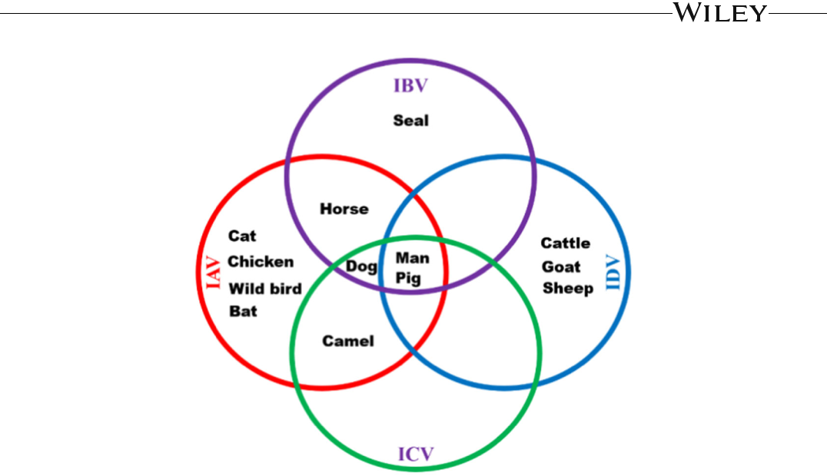

F I G U R E 1 The general summary of various viruses (influenza A, B, C, and D viruses) infecting humans and animals. [Color figure can be viewed at [wileyonlinelibrary.com](http://wileyonlinelibrary.com)]

3 | PRESENT ANTI‐INFLUENCE THERAPY

Vaccines are the backbone of prophylactic treatment for influenza but must be reformulated annually, because of the viral tendency to mutate to escape the immune system.18 Furthermore, vaccine supplies are generally in-sufficient, and rapidly emerging influenza pandemics and outbreaks cannot be contained by vaccination.19 Before vaccines are developed, anti‐influenza virus agents, especially active small molecule inhibitors, must play important roles in the treatment of influenza. Currently, only a few drugs can inhibit the influenza M2 ion channel protein, while several influenza NA, RNA‐dependent, RNA polymerase, and protease inhibitors are approved for clinical use or investigation (Figure 2). However, the emerging mutation of IAV and corresponding resistance against current drugs still challenge the treatment of influenza. Therefore, the discovery of novel anti‐influenza agents is highly imperative.20

Nature provides a large number of structurally diverse chemical scaffolds, representing a rich resource for lead compounds in new drug discovery.21,22 Regarding antiviral drugs, 37% of the 98 entities registered from January 1981 to September 2019 can be divided into natural product botanical medicines, synthetic but natural product imitations, or a combination of the latter two.23 Oseltamivir (Tamiflu), an oral NA inhibitor, is a successful case of an anti‐influenza drug synthesized from natural products. Quinic acid (1) and shikimic acid (2) (Figure 3), obtained in high content from plants, were used as starting materials in the research and development of oseltamivir.24 During the past decades, scientific researchers have performed extensive research to isolate various compounds with antiviral and anti‐influenza activity from natural sources (Figure 4).25‐28

In addition, traditional Chinese medicine (TCM) is a complementary and alternative approach that can provide knowledge about anti‐influenza herbals based on several thousands of years of TCM practice. TCM remedies with many components often act via multiple mechanisms and target not only the virus but also the host's immune response to provide a synergistic effect. Although the modes of action of TCM herbs are sometimes not clear, numerous reports in the literature have established that TCMs can inhibit influenza virus.29‐31 Over the long history of TCM practice, the roots of Isatis indigotica (Banlangen [BLG]) have been widely used to treat regular seasonal influenza. BLG extract exhibited obvious inhibitory activities against various

4 | ZHANG ET AL.

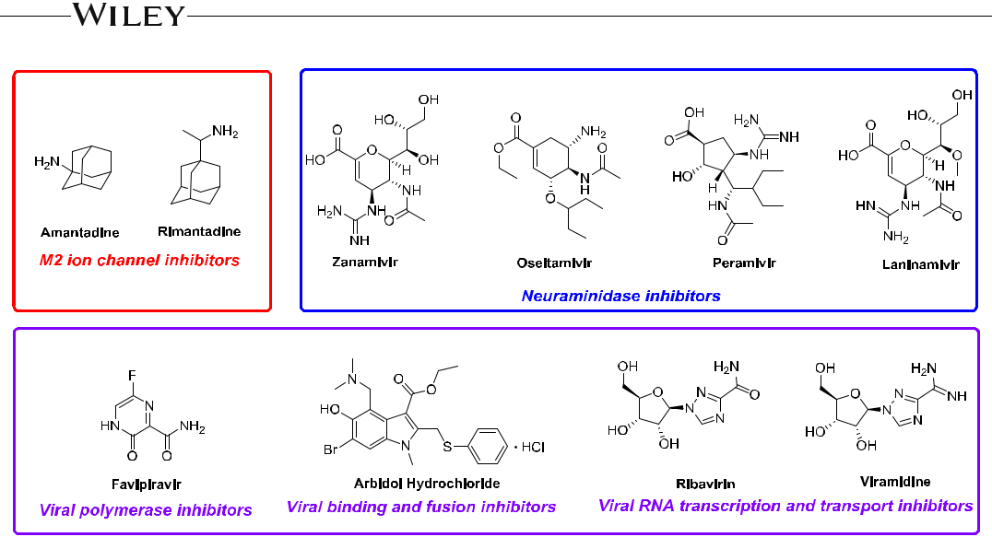

F I G U R E 2 New drugs currently used or in the research and development stage [Color figure can be viewed at [wileyonlinelibrary.com](http://wileyonlinelibrary.com)]

subtypes of human or avian influenza viruses (IC50 = 0.39−4.3 mg/ml) and also inhibited degradation of Iκ‐Bα and production of PGE2, NO, and interleukin 16 (IL‐6) in LPS‐stimulated RAW264.7, indicating that BLG plays an immune regulatory role in vitro and in vivo.32,33 Yang and co‐workers postulated that BLG fights viral infection by targeting both the virus and the host and has significantly different effects than those of synthetic chemicals in the market.34 Lianhuaqingwen capsule exerts a broad‐spectrum effect on several influenza subtypes, including H7N9, and particularly modulates the immune response of virus infection.35 Furthermore, the TCM philosophy encourages holistic treatment of a patient through a systematic approach that leads to better therapeutic outcomes and fewer side effects.36

4 | ANTI‐INFLUENZA NATURAL PRODUCTS AND DERIVATIVES

Natural products are biologically active compounds derived from natural sources such as plants, animals, and micro‐organisms and have been used by humans for millennia. Before the mid‐20th century, pharmaceutical companies utilized botanical crude extract as sources of drugs. With the advancement of antibiotics, drug for-mulations of fairly purified compounds became more typical.37 Over the past century, successful pharmaceutical discovery has been dominated by natural leads, and natural products have been the major sources of chemical diversity. In almost all therapeutic areas, natural products and their synthetically modified derivatives have been successfully developed to treat human diseases.23

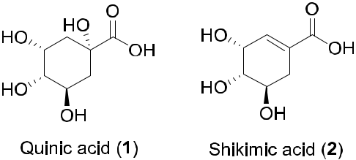

F I G U R E 3 Structures of quinic acid and shikimic acid [Color figure can be viewed at [wileyonlinelibrary.com](http://wileyonlinelibrary.com)]

ZHANG ET AL. | 5

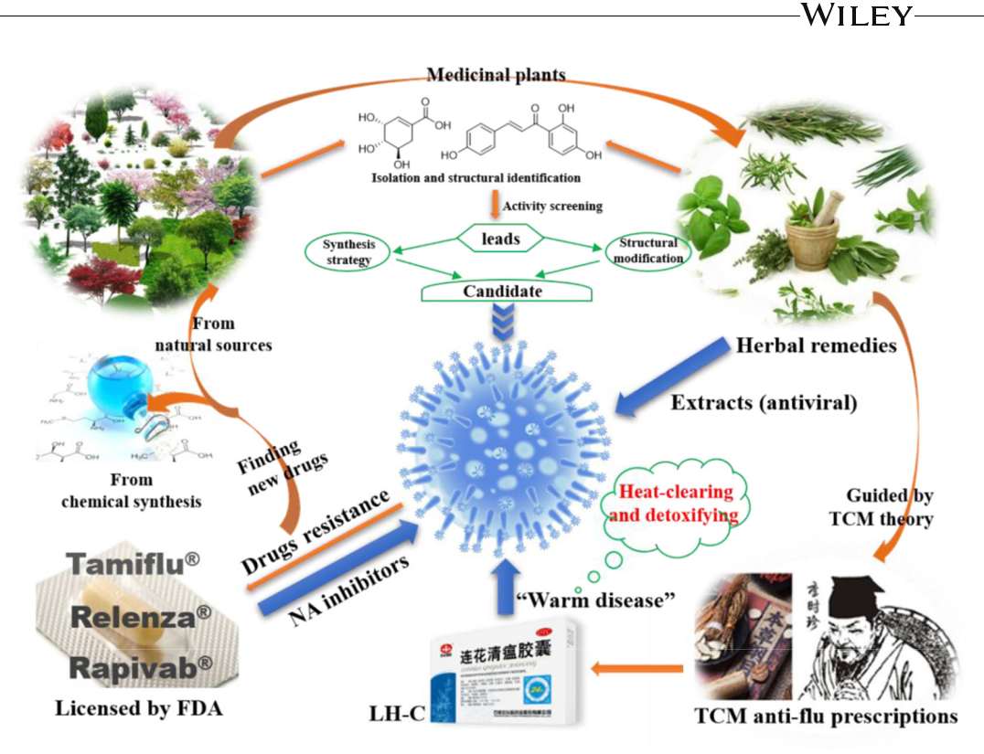

F I G U R E 4 Development of anti‐influenza agents from natural products. TCM, traditional Chinese medicine [Color figure can be viewed at [wileyonlinelibrary.com](http://wileyonlinelibrary.com)]

Influenza presents a dangerous threat to human health around the world, and its control and treatment depend mainly on chemical or biochemical drugs. Through chemical and pharmacological studies, many anti‐ influenza agents, including various terpenoids, quinones, diarylheptanoids, phenylpropanoids, polyphenols, flavo-noids, and alkaloids, have been isolated from traditional herbs. We will summarize the phytochemical progress and list all biologically active anti‐influenza natural constituents (IC50 or EC50 values below 50 μM). Meanwhile, the modification of natural products in an effort to alter their biochemical capacity is a common technique utilized by synthetic and medicinal chemists. Therefore, we will also summarize the active modified derivatives from natural products.

4.1 | Terpenoids

4.1.1 | Iridoids

Valtrate (3), an epoxy iridoid ester from Valerianae officinalis, was reported as a new Rev‐transport inhibitor with anti‐ HIV activity.38,39 It also prevented the propagation of influenza virus by inhibiting the nuclear export of influenza viral ribonucleoprotein (RNP) with an IC50 of 0.19 μM, CC50 of 36 μM, and selective index (SI) of 180.40 Geniposide (4) effectively inhibited the cell damage induced by A/Jiangsu/1/2009 (H1N1) influenza virus and mitigated virus‐induced acute inflammation with little cytotoxicity toward Madin‐Darby Canine Kidney (MDCK) cells. Treatment of infected mice with compound 4 significantly restored body weights, decreased mortality, and alleviated viral titers and virus‐ induced lung lesions. In addition, compound 4 substantially inhibited the virus‐induced alveolar wall changes, alveolar

6 | ZHANG ET AL.



haemorrhage, and neutrophil‐infiltration in lung tissues.41 Gentiopicroside (5), a seco‐iridoid compound from Gentiana lutea, showed choleretic, anti‐hepatotoxic, adaptogenic, and anti‐inflammatory activities.42 Several derivatives of 5 were designed, synthesized, and evaluated for anti‐IAV activities in vitro. Among them, compounds 6−8 showed interesting antiviral activities against H1N1 (A/WSN/33) with IC50 values of 39.5, 45.2, and 44.0 μM, respectively. The preliminary results indicated that modification of the sugar moiety on 5 was essential for the enhanced biological potency.43

The chemical structures of 3−8 are shown in Figure 5.

4.1.2 | Sesquiterpenoids

Patchouli alcohol (9), a major constituent of the pungent oil from Pogostemon cablin (Blanco) Benth, exhibited anti‐ influenza A (H2N2) virus activity with an IC50 of 4.03 ± 0.23 μM and CC50 above 20 μM (oseltamivir: IC50 = 0.031 ± 0.012 μM).44 Compound 9 also showed anti‐influenza activity against A/PR/8/34 (H1N1) and B/Ibaraki/2/ 85 with IC50 values of 2.635 and 40.82 μM, respectively.45 In the mechanism of action studies against the H1N1 virus, compound 9 interfered with the function of the influenza NA by cleaving the α‐glycosidic bond between sialic acid and the glycoconjugate, suppressing the expression of cytokines, and regulating the RIG‐1‐like helicases (RLH) signal pathway.46

Rupestonic acid (10), isolated from Artemisia rupestris, is effective as an anti‐allergic, antitumor, anti‐ inflammatory, antibacterial, and antidote agent.47 It also displayed high inhibitory activity against influenza B/jifang/97/13 viruses. Several phenyl rupestonates were synthesized, and compound 11 was the most active against influenza A3/jifang/90/15 virus (IC50 = 0.5 µM, TC50 = 18.9 µM), showing 10‐fold better efficacy than oseltamivir (IC50 = 5.1 µM). However, derivatives of 10 with halogenated phenyl rings were not active. Based on the preliminary results, the introduction of a large hydrophobic group at the 4‐position of the phenyl ring was essential for the enhanced biological activity.48 In addition, rupestonate derivatives containing a 1,2,4‐triazole moiety were synthesized. Compound 12 showed the highest inhibition toward the H3N2 and H1N1 strains with IC50 values of 0.97 and 0.42 µM (TC50 = 27.1 µM), respectively, which were comparable or smaller than those of oseltamivir (IC50 = 1.1 and 15.5 µM, respectively).49 In the case of IBV (B/jifang/97/13), the synthesized fatty ester derivatives 13−19 showed better activity than ribavirin; the IC50 values of 13, 16, and 18 were 3.77, 5.17, and 8.98 µM, respectively (ribavirin: IC50 = 32.1 µM). A structure–activity relationship (SAR) analysis of 13−19 suggested that an electron‐withdrawing group on the phenyl ring, particularly at C‐3 or C‐4, benefits the activity against IBV.50

Eleven sesquiterpenoids from Curcuma wenyujin showed obvious antiviral activity against IAV (H1N1/ Guangdong/219/2006) in vitro with IC50 values from 6.80 to 39.97 µM and SI values from 6.35 to 37.25. In particular, 20 exhibited the greatest activity with an IC50 value of 6.80 ± 0.13 µM (TC50 = 65.35 ± 3.97 µM), eight‐fold lower than that of oseltamivir (47.42 ± 1.96 µM) and similar to that of ribavirin (8.06 ± 0.64 µM), suggesting that the peroxyl functional group and α,β‐unsaturated γ‐lactone moiety may dramatically increase

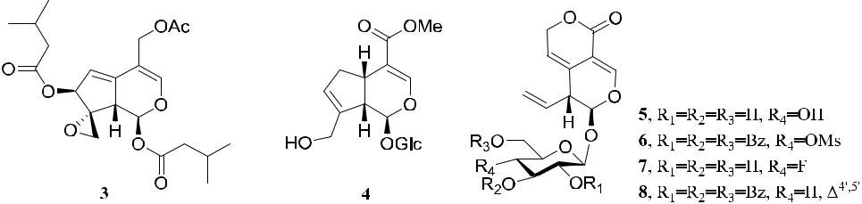

F I G U R E 5 Structures of iridoids and derivatives 3–8

ZHANG ET AL. | 7



antiviral activity.51 Reynoudiol (21) from Reynoutria japonica showed significant anti‐influenza H1N1 (A/PR/8/

1. virus activity (IC50 = 0.29 ± 0.01 μM, CC50 > 50 µM, TI = 172.4; oseltamivir phosphate as the positive con-trol, IC50 = 5.85 ± 1.41 μM). Its potent anti‐influenza virus activity in vitro warrants further studies to evaluate whether it also shows antiviral activity in vivo.52 Eudesm‐1β,6α,11‐triol (22) from Phellinus ignarius significantly

inhibited H5N1 (IC50 = 0.657 μM, CC50 = 85.39 µM, SI = 609; zanamivir [ZA]: IC50 = 0.0035 μM, CC50 > 100 µM, SI > 6.7).53

Pterodontic acid (23) from Laggera pterodonta showed selective anti‐influenza activity against the H1 subtype. It inhibited the replication of IAV by blocking nuclear export of viral RNP complexes and attenuated the in-flammatory response by impeding the activation of the nuclear factor κB (NF‐κB) pathway.54 Three sesquiterpenes (24–26) from the roots of Artabotrys hexapetalus exhibited activity against IAV H3N2 (A/Hanfang/359/95; IC50 = 19.24−33.33 μM, SI > 3.0).55

Recently, phomanolide (27), a rare 14‐nordrimane‐type sesquiterpenoid, was purified from the culture broth of an endophytic fungus Phoma sp. isolated from the roots of Aconitum vilmorinianum. It exhibited antiviral activity against IAV (A/Puerto Rico/8/34, H1N1) with an IC50 value of 12.5 ± 2.7 μM, and CC50 value of 438.00 ± 9.12 µM).56 Cryptoporic acid E (28), a dimeric drimane sesquiterpenoid obtained from Cryptoporus volvatus, exerted broad‐spectrum anti‐influenza activity. Further studies showed that it mainly blocks the replication cycle of influenza virus midterm, inhibits the activity of influenza virus RNA polymerase, and blocks viral RNA replication and transcription in MDCK cells. In addition, compound 28 impeded the infectivity of influenza virus by directly targeting virus particles.57

The chemical structures of 9−28 are shown in Figure 6. In terms of structure type, guaiane‐ and eudesmane‐ type sesquiterpenes and their derivatives show good anti‐influenza potential. Meanwhile, the carboxyl group, lactone, and amide of C‐15 may enhance the anti‐influenza activities.

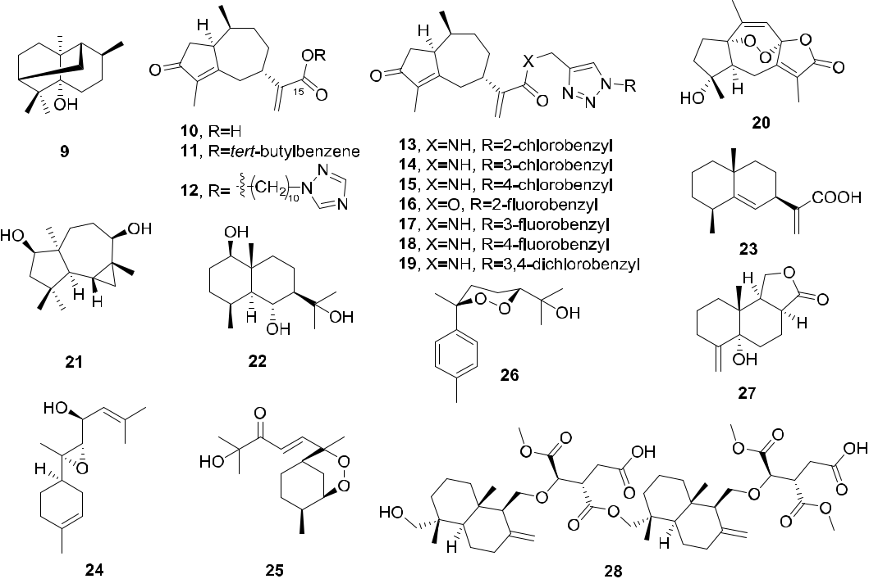

F I G U R E 6 Structures of sesquiterpenes and derivatives 9–28

|  |  |  |  |  |
| --- | --- | --- | --- | --- |
| 8 | | |  | ZHANG ET AL. |  |
|  |  |
|  | |  |  |  |
| 4.1.3 | | | Diterpenoids | |  |



7‐Dehydroabietanone (29), a C20‐norabietane diterpene from Fraxinus sieboldiana, exhibited inhibitory activity against H5N1 (A/Viet Nam/1203/2004) with an IC50 value of 4.8 μM (zidovudine as the positive control, IC50 = 0.048 μM).58 Dugesin F (30) from Salvia dugesii exhibited an inhibitory effect against the influenza virus FM1 strain (IC50 = 26.4 μM, TC50 = 128.3 μM, and TI = 4.84).59

Wickerols A (31) and B (32), two microbial metabolites with a novel fused 6/5/6/6 ring skeleton produced by the fungus Trichoderma atroviride FKI‐3849, showed antiviral effects against H1N1. Wickerol A (31) showed potent antiviral activity (IC50 = 0.24 μM, CC50 = 240 μM, SI = 100) against A/PR/8/34 and A/WSN/33 strains (A/H1N1 flu virus), but was not active against the A/H3N2 virus; while wickerol B (32) exhibited anti‐influenza virus activity against A/PR/8/34 virus (IC50 = 16.3 μM) but did not inhibit the proliferation of other flu viruses at 100 µg/ml. No cytotoxic activity was observed against MDCK cells at 100 μg/ml. Although the structures of 31 and 32 are similar, their anti‐influenza virus activity and antiviral spectrum differed in vitro. Thus, the modification at C‐8 may be an important determinant of the antiviral properties and spectra.60

The inhibition percentages of four diterpenes (33–36) from the brown alga Dictyota plectens on HA‐mediated viral entry of influenza virus strain A/Viet Nam/1203/2004 (H5N1) were 50% to 62% at 30.0 μM (CC50 > 60 µM).61 Podocarpic acid (37), an abietane‐type diterpenoid found in resins from the New Zealand conifers Podocarpus totara and Dacrydium cupressinum, exhibited moderate inhibitory activity against PR8 virus (A/Puerto Rico/8/34) with an EC50 value of 18.2 μM and CC50 > 40 μM (oseltamivir and amantadine as positive controls, EC50 > 20 μM). Several diterpenoid analogs of 37 were synthesized and evaluated for anti‐influenza A activities. Among them, the methyl podocarpate (38) and its O‐acetyl derivative (39) (EC50 = 0.16 and 0.14 μM, respectively) were about 100‐fold more potent than 37 against IAV, and the benzyl ester 40 was 10‐fold more potent than 37 (EC50 = 1.59 μM). In terms of mechanism of action, these derivatives appear to target the viral HA‐mediated membrane fusion.62

The chemical structures of 29−40 are shown in Figure 7.

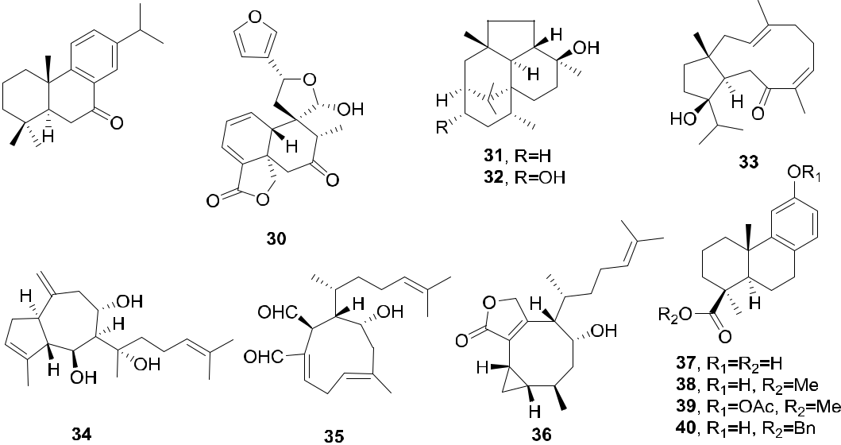

F I G U R E 7 Structures of diterpenoids and derivatives 29–40

ZHANG ET AL. | 9



4.1.4 | Triterpenoids

Betulinic aldehyde (41), a lupane triterpene from Alnus japonica, exhibited significant anti‐influenza activity against strain KBNP‐0028 (H9N2) with an EC50 value of 28.4 μM and CC50 = 53.1 μM (oseltamivir: EC50 = 0.14 μM). Structurally, the presence of 3β‐OH and 28‐CHO groups in the lupane‐type triterpenes might be necessary for anti‐KBNP‐0028 activity.63 Betulinic acid (42), isolated from Zizyphusjujuba, showed high antiviral activity of ap-proximately 98% against IAV (A/PR/8/34, H1N1) at a concentration of 50 μM, without significant cytotoxicity. In mice treated with 41, IFN‐γ levels were downregulated and the pulmonary pathologies, including necrosis, num-bers of inflammatory cells, and pulmonary edema, induced by influenza A/PR/8 virus infection were significantly reduced. Thus, compound 42 might be a potential therapeutic anti‐influenza agent exerting anti‐inflammatory activities.64

Two natural triterpenoid acids, meristotropic acid (43) and its methyl ester (44), as well as their synthetic deri-vatives, were tested for activities against influenza viruses A and B in MDCK cell cultures and a mouse model of lethal influenza pneumonia. Among them, compounds 43 and 44 were the most active against H1N1 rimantadine‐resistant virus A/PR/8/34 (CTD50 = 683.7 μM), more potent than the reference rimantadine (CTD50 = 379.8 μM), suggesting that they might have potential for further development as new effective anti‐influenza drugs.65

The bioactive triterpene saponin saikosaponin A (45) from Bupleurum chinense effectively attenuated IAV replication, including that of the highly pathogenic H5N1 strain, in human alveolar epithelial A549 cells via down regulation of both IAV‐induced NF‐κB activation and caspase 3‐dependent NP nuclear translocation. Critically, it also protected against lethal PR8‐induced mortality and morbidity in vivo through the reduction but not complete elimination of lung neutrophil and monocyte recruitment. Also, it decreased IAV replication and lung tissue proinflammatory cytokine production. This triterpene could have novel therapeutic potential, particularly to treat highly pathogenic influenza virus infections.66

Ganoderic acids T‐Q (46) and TR (47), two triterpenoids from the medicinal mushroom Ganoderma lingzhi, were reported as inhibitors of H1N1 (46: IC50 = 5.6 ± 1.9 μM; 47: IC50 = 4.6 ± 1.7 μM) and H5N1 (46: IC50 = 1.2 ± 1.0 μM; 47: IC50 = 10.9 ± 6.4 μM), and the CC50 values of 46 and 47 were 28.2 ± 0.8 and 91.6 ± 3.4, respectively. SAR analysis suggested that the corresponding triterpenoid structure is a potential scaffold for the design of NA inhibitors. Using these compounds as probes, Zhu and coworkers found that their interactions with the amino‐acid residues Arg292 and/or Glu119 of NA are critical for the inhibition of H5N1 and H1N1. These findings provide valuable information for the design and development of NA inhibitors.67

Four 9,10‐seco‐cycloartan triterpene glycosides (48–51) from Lyonia ovalifolia exerted significant activity against A/95–359 with IC50 values from 2.1 to 11.1 μM.68 Nepasaikosaponin k (52), saikosaponin n (53), and saikosaponin h (54) were isolated from the roots of Bupleurum marginatum var. stenophyllum. In antiviral testing against IAV A/WSN/33 (H1N1) in 293T Gluc cells, these three compounds (EC50 = 17.9, 7.67, and 10.1 μM, SI > 11.2, 26.1, and 19.8, respectively) were more potent and selective than the positive control ribavirin (EC50 = 17.9 μM, SI > 11.4). This report was the first to describe the anti‐influenza activity of saikosaponins. SAR studies suggested that the 13,28‐epoxy group, the type of sugar chain, and olefinic bonds are significant for antiviral activity and selectivity.69

Two new triterpene saponins (55 and 56) with four undescribed aglycone structures, which were purified from the bark of Burkea Africana, showed significant effects against H3N2 (HK/68) and the 2009 pandemic H1N1 (A/Jena/8178/09) with IC50 values between 0.05 and 0.27 μM, and CC50 = 1.5 ± 0.80 μM.70 Compounds 57 and 58 from Rhododendron latoucheae showed significant activity against H1N1 (A/95‒359) with IC50 values of 3.70 and 2.87 μM, respectively.71 Following activity‐oriented separation, eight lanostane triterpenes were isolated from Gloeophyllum odoratum. Among them, trametenolic acid B (59), the most active compound, dis-played potent inhibitory activity against H3N2 (HK/68) and H1N1 (A/Jena/8178/09) with IC50 values of 14.1 and 11.3 μM (CC50 > 100 μM), respectively. In a plaque reduction assay, this compound bound to cell‐free viruses and neutralized their infectivity.72

10 | ZHANG ET AL.



Chlorogenin 3‐O‐β‐chacotrioside (60) and chlorogenin 6‐α‐O‐actyl‐3‐O‐β‐ chacotrioside (61) were discovered as the first novel small molecule inhibitors to effectively block H5N1 viral entry. They exhibited significant in-hibitory activity against H5N1 (Goose/Qinghai/59/05 and A/Viet Nam/1203/2004) with IC50 values between 7.22 and 9.25 μM.73 Intensive SAR studies of 60 regarding the sugar chain and aglycone showed that both the cha-cotriosyl residue and the chlorogenin moiety are important for the antiviral activity. The aglycone structure could also affect the activity, although several subtle modifications could be made at particular positions.74 In 2015, several 3‐O‐β‐chacotriosylursane‐ and oleanane‐type triterpenes were designed and synthesized. Among them, the amidated compounds 62−65 exerted potent inhibitory activities with IC50 values ranging from 0.98 to 2.48 μM. SAR analysis suggested that either the introduction of a disubstituted amide structure at the 17‐COOH of ursolic acid or alteration of the C‐3 configuration of ursolic acid from the 3β‐ to 3α‐form helped to significantly improve the selective index while retaining the antiviral activities.75‐77

Glycyrrhizic acid (GL, 66) and its aglycone glycyrrhetic acid (GLA), the principal triterpene glycosides from the roots of Glycyrrhiza glabra and Glycyrrhiza uralensis, are leading antiviral natural glycosides with a promising scaffold for creating new antiviral agents. Some semisynthetic GL derivatives displayed potent immunomodulatory and antiviral effects. Correspondingly, Baltina and co‐workers synthesized and evaluated some GL derivatives against the pandemic influenza A/H1N1/pdm09 virus. Compound 67, the conjugate of GLA with phenylalanine, exhibited significant inhibitory activity (EC50 = 5.3 μM, CTD50 = 860.0 μM, SI = 161) against this virus.78 Compounds 68–73 are the synthetic amino acid methyl ester derivatives of GL, and the most active inhibitors against influenza A/H1N1/pdm09 were 71 (phenylalanine, EC50 = 4.3 µM, SI = 61), 72 (tyrosine, EC50 = 6.8 µM, SI = 38), and 73 (S‐benzyl‐cysteine, EC50 = 3.5 µM, SI = 71). The CC50 values were more than 200 µM. Compounds 68 with three phenylalanine residues (SI = 28) and 69 with three tyrosine residues (SI = 18) were less potent than the corre-sponding 71 and 72 with amino acids linked only to the two carboxylic acids of the sugar moieties and not to the carboxylic acid on the E‐ring. SAR studies suggested that conjugation of GL with amino acids or their methyl esters, and amino sugars dramatically changed the activity. The introduction of cysteine or phenylalanine moieties into the carbohydrate part of GA appeared to be most efficient in terms of antiviral activity in relation to the influenza A/H1N1/pdm09 virus. Therefore, in the search for new antiviral agents, some modified GL derivatives are potent anti‐influenza A/H1N1 agents.79

Recently, virus entry inhibitors have received considerable attention from many synthetic chemists and bio-chemists as a new class of antiviral agents that can successfully prevent virus from attaching to host cells. Zhou and coworkers found that plant‐derived pentacyclic triterpenes act as highly potent antiviral agents by efficiently preventing viral attachment to host cells. They systemically explored certain structure modifications on the lead pentacyclic triterpenoids to clarify what structures are required to maintain activity comparable or greater than that of oseltamivir; oleanolic acid (OA) and acetyl galactose moieties emerged as the optimized aglycone and glycoside. These studies support the importance of pentacylic triterpenoids as leads to be developed as potential influenza virus entry inhibitors.

The echinocystic‐galactose conjugate Q8 (74) significantly reduced the viral cytopathic effect (CPE) in MDCK cells and exhibited a well‐defined dose‐dependent response against the A/WSN/33 (H1N1) virus (EC50 = 5 μM), which was twofold lower than that of oseltamivir. To explore the structural requirements to maintain high anti‐ influenza activity, Zhou and coworkers focused on the lead compound 74, including modifying the aglycone, glycoside, and linker moieties. Some of the synthetic analogs exhibited broad spectrum activity even against amantadine‐ and oseltamivir‐resistant viruses. Among them, Y3 (75) and Y5 (76), the conjugates of an acetylated galactose moiety with OA and ursolic acid aglycones, exhibited the highest inhibitory activity against influenza A/WSN/33 virus (EC50 = 14.2 and 15.1 μM, respectively, CC50 > 200 μM), in the CPE study. In addition, compound 77 showed broad‐spectrum anti‐influenza activity, including the H1N1 subtype (oseltamivir‐resistant LN/1109), H3N2 subtype (amantadine‐resistant HN/1222), and IBV (B/SZ/155), with EC50 values of 6.58, 3.18, and 2.80 μM, respectively. Mechanistic studies of 77 indicated that it blocked the HA‐sialic acid receptor interaction as well as the viral attachment to cells, due to its high affinity for HA protein. The lead triterpenoids Q8 (74) and Y4 (77)

|  |  |  |  |
| --- | --- | --- | --- |
| ZHANG ET AL. |  | | 11 |  |
|  |  |
|  |  |  |  |



displayed moderate inhibitory activity against the above‐mentioned strains; 74 was somewhat better than 77. In addition, docking studies suggest that these compounds occupy the conserved pocket for sialic acid receptor, consistent with the SAR data.80

Several conjugated sialic acids and pentacyclic triterpene analogs were synthesized and evaluated for antiviral activity against influenza A/WSN/33 (H1N1) virus in MDCK cell culture. Betulinic acid derivative 78 was the most potent compound. Its IC50 of 41.2 ± 2.9 μM was comparable to that of oseltamivir (IC50 = 46.5 ± 3.3 μM).81 In addition, compounds 79–81 showed obvious effects against A/WSN/33 virus, with IC50 values of 8.3 μM (CC50 = 188.1 ± 10.1, SI = 22.7) and 15.5 μM (CC50 > 200 μM, SI > 32.3) for 79 and 80, and EC50 value of 8.7 μM for 81. In various antiviral assays, including time‐of‐addition, hemagglutination inhibition, surface plasmon resonance, and in silico docking, compounds 78–81 exhibited promising anti‐influenza entry inhibitory effects acting by interference with the binding of the viral HA protein to the host cells.82,83

Among synthesized polyphenol‐pentacyclic triterpene conjugates, four compounds (82–85) displayed robust A/WSN/33 potency with average IC50 values at the low‐micromolar level (IC50 = 5.80 to 9.55 μM), exceeding the potency of oseltamivir (IC50 = 16.5 μM), and with no toxicity at 100 μM in MDCK cells. Compound 85, the best representative conjugate, had an IC50 value of 5.80 μM and SI of 17.2. The me-chanistic studies showed that conjugate 85 bound tightly to the viral envelope HA (KD = 15.6 μM), blocked the HA–sialic acid receptor interaction, and thus prevented the attachment of influenza viruses to cells. SAR studies indicated the importance of 2‐hydroxybenzoic acid on the anti‐influenza activity. In contrast, the shift of the hydroxyl from C‐2 to C‐4 of the benzoic acid or introduction of an extra hydroxyl at C‐4 led to no improvement in potency.84

Two simplified OA derivatives with a glycosyl ester moiety at C‐28 (86 and 87) were synthesized and eval-uated for their effects on nasal anti‐influenza virus antibody titer against secondary nasal inoculation of the influenza split vaccine. The synthetic saponins produced by the introduction of the C28 4‐O‐cinnamoyl glucosyl ester moiety were efficacious as vaccine adjuvants.85

Cyclodextrins (CDs) are cyclic oligosaccharides that contain a comparatively hydrophobic central cavity with a hydrophilic outer surface. Various synthesized multivalent conjugates based on the CD scaffold are effective modulators of carbohydrate‐protein interactions. Therefore, multivalent pentacyclic triterpenes grafted on a CD core were prepared by Zhou and co‐workers and were evaluated for potency against influenza A/WSN/33 (H1N1) virus in MDCK cell culture. Some multimers exhibited significant antiviral activity against H1N1 virus, equivalent to or greater than that of oseltamivir. Among them, three OA‐β‐cyclodextrin conjugates (88–90) showed significant inhibitory activities against IAV with IC50 values ranging from 1.6 to 2.8 μM (CC50 > 100 μM). The most active 88 showed up to 125‐fold potency enhancement based on its IC50 value over the corresponding monovalent con-jugate and OA, disclosing a clear multivalent effect. In further studies, compounds 88–90 exerted broad‐spectrum inhibitory activity against two H3N2 virus strains (A/JX/312 and A/HN/1222) with IC50 values between 2.47 and 14.90 μM. Most notably, compound 88 bound tightly to the viral envelope HA and disrupted the interaction of HA with the sialic acid receptor and, thus, the attachment of viruses to host cells.86 Furthermore, due to better solubility in water and organic solvents, multivalent pentacyclic triterpene‐functionalized per‐O‐methylated CD derivatives were designed and synthesized. The heptavalent OA‐per‐O‐methylated‐β‐cyclodextrin conjugates 89–93 also showed strong inhibitory effects against influenza A/WSN/33 (H1N1) virus with IC50 values ranging from 4.7 ± 0.52 to 9.9 ± 0.79 μM (oseltamivir: IC50 = 16.5 μM).87

The chemical structures of 41−93 are shown in Figures 8−10. The above systematic exploration of the lead compounds clarified that OA and its derivatives display comparable and even higher anti‐influenza virus activity than that of oseltamivir. Structural optimization of aglycone and glycoside at C‐3 and C‐29, especially sialic acid‐ triterpene conjugates, effectively enhanced the anti‐influenza activity. These compounds exerted broad spectrum activity even against oseltamivir‐ and amantadine‐resistant viruses with diminished induction of viral resistance. These studies establish the importance of triterpenes as a new class of lead compounds for the development of potential influenza virus entry inhibitors.

12 | ZHANG ET AL.

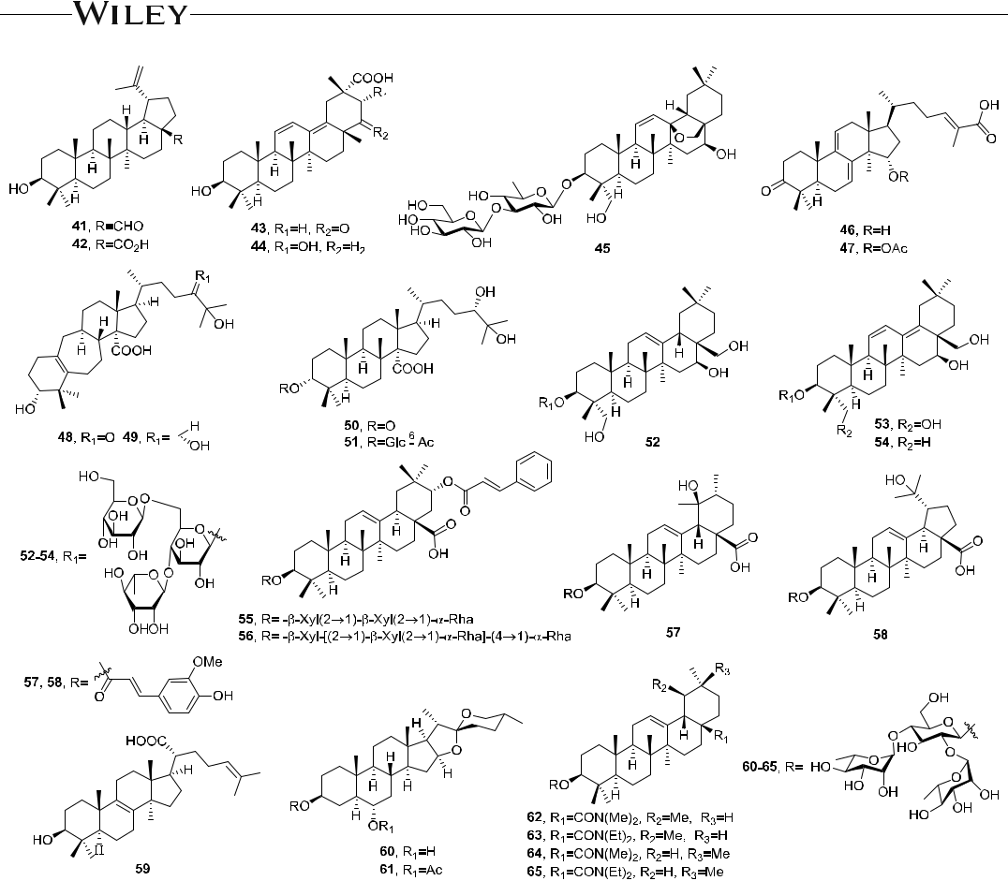

F I G U R E 8 Structures of triterpenes and derivatives 41–65

4.2 | Quinones

Some anthraquinone derivatives (Figure 11) show significant anti‐influenza activity. The anthraquinones aloe‐emodin (94) and aloe‐emodin acetate (95) were isolated from Cassia roxburghii. Compound 94 was more potent than 95 against IAV (H1N1, A/WSN/33) with IC50 values of 8.4 and 36.5 μM, while the corresponding CC50 values were 1.9 and 4.7 μM, respectivly.88 Mechanism of action investigations indicated that 94 reduced the virus‐induced CPE in a concentration‐ dependent manner and inhibited the replication of influenza A. Also, it upregulated galectin‐3 expression, recombined galectin‐3 augmented expression of antiviral genes, and downregulated nucleoside diphosphate kinase A. In addition, the anthraquinone derivatives emodin (96) and chrysophanol (97) exhibited antiviral activity.89

Compounds 98–101 from the culture broth of Nigrospora sp. YE3033 (an endophytic fungus obtained from Aconitum carmichaeli) showed inhibitory activity against the influenza viral strain A/Puerto Rico/8/34with IC50 values of 8.46, 26.1, 25.7, and 2.53 μM, respectively (arbidol hydrochloride as positive control, IC50 = 1.96 ± 1.03 μM). In addition, the low cytotoxicity of 101 (CC50 = 584 μM) indicated its rich potential for the de-velopment of anti‐IAV drugs.90

As the derivatives of aloesaponarin‐I (102) and aloesaponarin‐II (103), compounds 104 and 105 showed good inhibitory effects against influenza virus A/Yucatán/2370/09 (IC50 = 30.77 ± 2.10 and 13.70 ± 3.80 μM, respec-tively; oseltamivir carboxylate as positive control, IC50 = 0.025 ± 0.05 μM). The plaque reduction assay and time‐of‐ addition results suggested that the antiviral activities of 104 and 105 increase at the posttreatment level. The SAR

|  |  |  |  |  |  |  |  |  |  |  |  |  |  |  |  |  |  |  |  |  |  |  |  |  |  |  |  |  |  |  |  |  |  |  |  |  |  |  |  |  |  |  |  |  |  |  |  |  |  |  |  |
| --- | --- | --- | --- | --- | --- | --- | --- | --- | --- | --- | --- | --- | --- | --- | --- | --- | --- | --- | --- | --- | --- | --- | --- | --- | --- | --- | --- | --- | --- | --- | --- | --- | --- | --- | --- | --- | --- | --- | --- | --- | --- | --- | --- | --- | --- | --- | --- | --- | --- | --- | --- |
| ZHANG ET AL. | | | | | | | | | | | | | | | | | |  | | |  |  |  |  |  |  |  | | |  |  |  |  |  |  | |  | |  |  |  | | |  | | | | | 13 | | |  |
|  | | | |  |
|  |  |  |  |  |  |  |  |  |  |  |  |  |  |  |  |  |  |  |  |  |  |  |  |  |  |  |  |  |  |  |  |  |  |  |  |  |  |  |  |  |  |  |  |  |  |  |  |  |  |  |  |
|  |  |  |  |  |  |  |  |  |  |  |  |  |  |  |  |  |  |  |  |  |  |  |  |  |  |  |  |  |  |  |  |  |  |  |  |  |  |  |  |  |  |  |  |  |  |  |  |  |  |  |  |
|  |  |  |  |  |  |  |  |  |  |  |  |  |  |  |  |  |  |  |  |  |  |  |  |  |  |  |  |  |  |  |  |  |  |  |  |  |  |  |  |  |  |  |  |  |  |  |  |  |  |  |  |
|  |  |  |  |  |  |  |  |  |  |  |  |  |  |  |  |  |  |  |  |  |  |  |  |  |  |  |  |  |  |  |  |  |  |  |  |  |  |  |  |  |  |  |  |  |  |  |  |  |  |  |  |
|  |  |  |  |  |  |  |  |  |  |  |  |  |  |  |  |  |  |  |  |  |  |  |  |  |  |  |  |  |  |  |  |  |  |  |  |  |  |  |  |  |  |  |  |  |  |  |  |  |  |  |  |
|  |  |  |  |  |  |  |  |  |  |  |  |  |  |  |  |  |  |  |  |  |  |  |  |  |  |  |  |  |  |  |  |  |  |  |  |  |  |  |  |  |  |  |  |  |  |  |  |  |  |  |  |
|  |  |  |  |  |  |  |  |  |  |  |  |  |  |  |  |  |  |  |  |  |  |  |  |  |  |  |  |  |  |  |  |  |  |  |  |  |  |  |  |  |  |  |  |  |  |  |  |  |  |  |  |
|  |  |  |  |  |  |  |  |  |  |  |  |  |  |  |  |  |  |  |  |  |  |  |  |  |  |  |  |  |  |  |  |  |  |  |  |  |  |  |  |  |  |  |  |  |  |  |  |  |  |  |  |
|  |  |  |  |  |  |  |  |  |  |  |  |  |  |  |  |  |  |  |  |  |  |  |  |  |  |  |  |  |  |  |  |  |  |  |  |  |  |  |  |  |  |  |  |  |  |  |  |  |  |  |  |
|  |  |  |  |  |  |  |  |  |  |  |  |  |  |  |  |  |  |  |  |  |  |  |  |  |  |  |  |  |  |  |  |  |  |  |  |  |  |  |  |  |  |  |  |  |  |  |  |  |  |  |  |
|  |  |  |  |  |  |  |  |  |  |  |  |  |  |  |  |  |  |  |  |  |  |  |  |  |  |  |  |  |  |  |  |  |  |  |  |  |  |  |  |  |  |  |  |  |  |  |  |  |  |  |  |
|  |  |  |  |  |  |  |  |  |  |  |  |  |  |  |  |  |  |  |  |  |  |  |  |  |  |  |  |  |  |  |  |  |  |  |  |  |  |  |  |  |  |  |  |  |  |  |  |  |  |  |  |
|  |  |  |  |  |  |  |  |  |  |  |  |  |  |  |  |  |  |  |  |  |  |  |  |  |  |  |  |  |  |  |  |  |  |  |  |  |  |  |  |  |  |  |  |  |  |  |  |  |  |  |  |
|  |  |  |  |  |  |  |  |  |  |  |  |  |  |  |  |  |  |  |  |  |  |  |  |  |  |  |  |  |  |  |  |  |  |  |  |  |  |  |  |  |  |  |  |  |  |  |  |  |  |  |  |
|  |  |  |  |  |  |  |  |  |  |  |  |  |  |  |  |  |  |  |  |  |  |  |  |  |  |  |  |  |  |  |  |  |  |  |  |  |  |  |  |  |  |  |  |  |  |  |  |  |  |  |  |
|  |  |  |  |  |  |  |  |  |  |  |  |  |  |  |  |  |  |  |  |  |  |  |  |  |  |  |  |  |  |  |  |  |  |  |  |  |  |  |  |  |  |  |  |  |  |  |  |  |  |  |  |
|  |  |  |  |  |  |  |  |  |  |  |  |  |  |  |  |  |  |  |  |  |  |  |  |  |  |  |  |  |  |  |  |  |  |  |  |  |  |  |  |  |  |  |  |  |  |  |  |  |  |  |  |
|  |  |  |  |  |  |  |  |  |  |  |  |  |  |  |  |  |  |  |  |  |  |  |  |  |  |  |  |  |  |  |  |  |  |  |  |  |  |  |  |  |  |  |  |  |  |  |  |  |  |  |  |
|  |  |  |  |  |  |  |  |  |  |  |  |  |  |  |  |  |  |  |  |  |  |  |  |  |  |  |  |  |  |  |  |  |  |  |  |  |  |  |  |  |  |  |  |  |  |  |  |  |  |  |  |
|  |  |  |  |  |  |  |  |  |  |  |  |  |  |  |  |  |  |  |  |  |  |  |  |  |  |  |  |  |  |  |  |  |  |  |  |  |  |  |  |  |  |  |  |  |  |  |  |  |  |  |  |
|  |  |  |  |  |  |  |  |  |  |  |  |  |  |  |  |  |  |  |  |  |  |  |  |  |  |  |  |  |  |  |  |  |  |  |  |  |  |  |  |  |  |  |  |  |  |  |  |  |  |  |  |
|  |  |  |  |  |  |  |  |  |  |  |  |  |  |  |  |  |  |  |  |  |  |  |  |  |  |  |  |  |  |  |  |  |  |  |  |  |  |  |  |  |  |  |  |  |  |  |  |  |  |  |  |
|  |  |  |  |  |  |  |  |  |  |  |  |  |  |  |  |  |  |  |  |  |  |  |  |  |  |  |  |  |  |  |  |  |  |  |  |  |  |  |  |  |  |  |  |  |  |  |  |  |  |  |  |
|  |  |  |  |  |  |  |  |  |  |  |  |  |  |  |  |  |  |  |  |  |  |  |  |  |  |  |  |  |  |  |  |  |  |  |  |  |  |  |  |  |  |  |  |  |  |  |  |  |  |  |  |
|  |  |  |  |  |  |  |  |  |  |  |  |  |  |  |  |  |  |  |  |  |  |  |  |  |  |  |  |  |  |  |  |  |  |  |  |  |  |  |  |  |  |  |  |  |  |  |  |  |  |  |  |
|  |  |  |  |  |  |  |  |  |  |  |  |  |  |  |  |  |  |  |  |  |  |  |  |  |  |  |  |  |  |  |  |  |  |  |  |  |  |  |  |  |  |  |  |  |  |  |  |  |  |  |  |

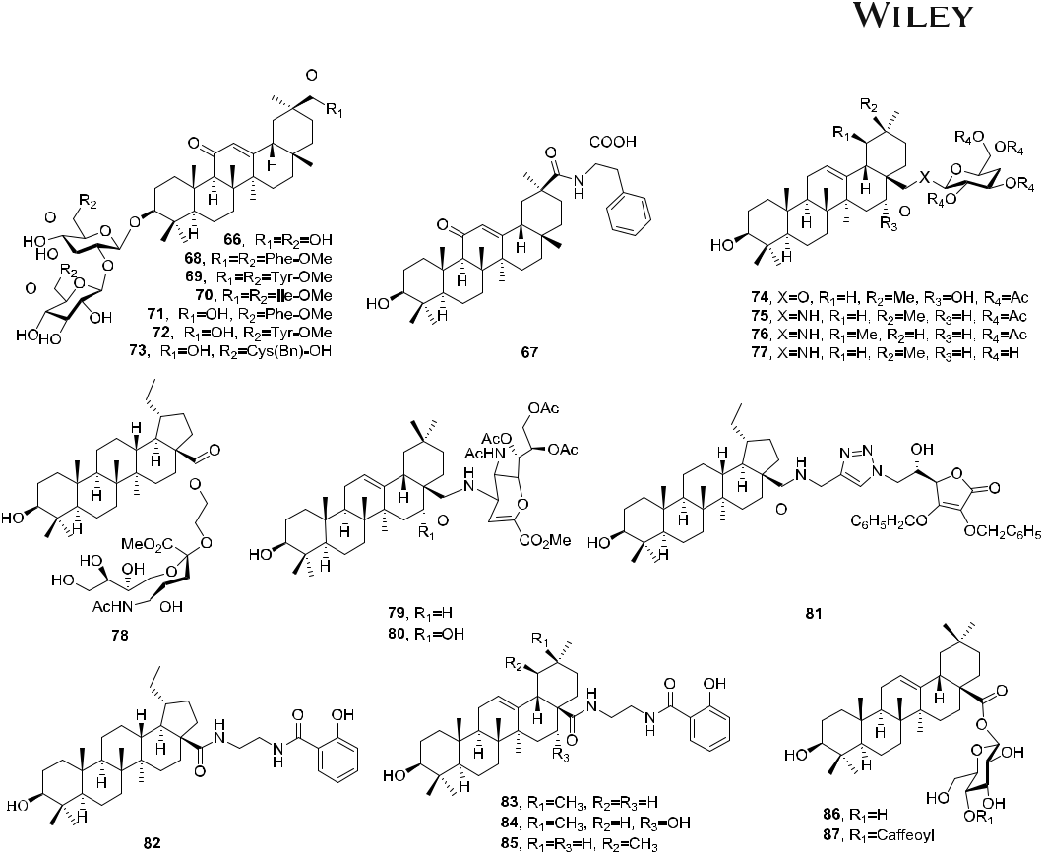

F I G U R E 9 Structures of triterpenes and derivatives 66–87

analysis suggested that acetylation, methylation and O‐glycosyl addition did not improve the antiviral activities; however, if an acetyl sugar was added, a moderate antiviral effect was observed. The acetylated glucose by itself was unable to cause a CPE reduction against influenza viruses.91

4.3 | Diarylheptanoids

Curcumin (106), a diferuloylmethane widely used as a spice and coloring agent in food, reduced influenza virus production via inhibition of HA with an EC50 value of 0.47 μM, and SI of 92.5. Meanwhile, in contrast to

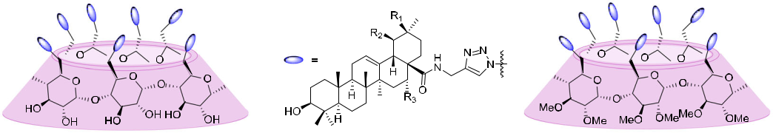

F I G U R E 10 Structures of cyclodextrin conjugates 88–93 [Color figure can be viewed at [wileyonlinelibrary.com](http://wileyonlinelibrary.com)]

14 | ZHANG ET AL.

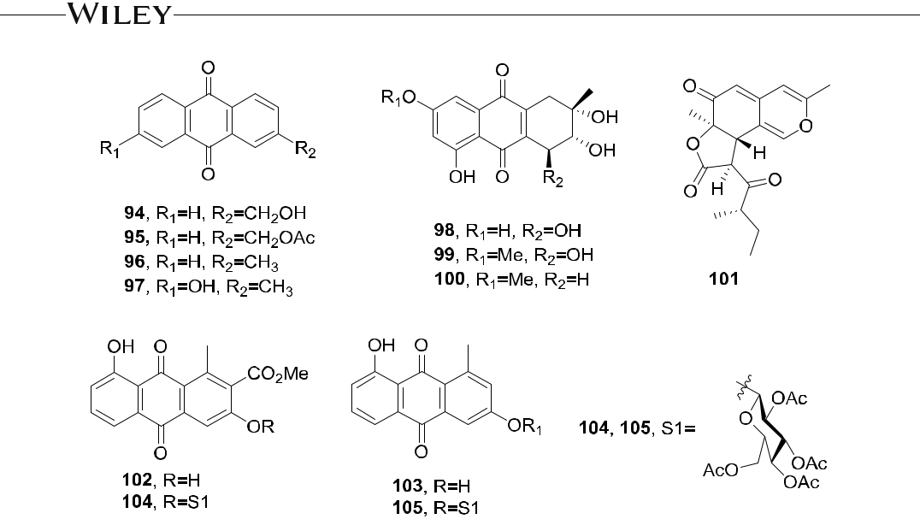

F I G U R E 11 Structures of quinones and derivatives 94–105

amantadine, viruses did not develop resistance to curcumin.92 Katsumadain A (107) from the seeds of Alpinia katsumadai exhibited inhibitory effects against human influenza virus A/PR/8/34 of subtype H1N1 (IC50 = 1.05 ± 0.42 μM, CC50 = 66.9 μM), as well as four swine influenza viruses with IC50 values between 0.9 and 1.64 μM. To study the putative binding mechanism, Grienke and co‐workers performed an extensive molecular dynamics simulation, and the docking results showed well‐established interactions between the protein and the core of this novel NA‐inhibiting natural scaffold, excellent surface complementarity to the simulated binding pocket, and concordance with experimentally derived SAR data.93

Ten diarylheptanoids from Alpinia officinarum exhibited inhibitory effects against H1N1 (A/PR/8/34) with EC50 values between 2.35 and 113.63 μM. In particular, the influenza virus was more susceptible to 108 (EC50 = 9.35 ± 0.96 μM, CC50 = 199.5 ± 10.0 μM) and 109 (EC50 = 2.35 ± 1.00 μM) than eight other tested diarylheptanoids.94 Further investigations showed that 108 had broad‐spectrum inhibitory activity against the wild types of influenza A and B viruses with EC50 values between 16.45 ± 0.10 and 69.67 ± 3.23 μM, which were similar to that of ribavirin (72.95 ± 3.27 μM). In addition, it is probable that 108 selectively suppressed viral mRNA synthesis in infected cells without cytotoxicity. The mode of anti‐influenza virus action of 108 is likely different from that of oseltamivir and requires further study.95

Eleven diarylheptanoids from Alnus japonica were examined for inhibitory activities against influenza virus H9N2 (KBNP‐0028). Among them, the most active was platyphyllone (110) with an EC50 value of 29.9 ± 2.5 μM, CC50 > 796 μM, and SI > 26.6 (ZA as positive control, EC50 = 16.9 ± 1.2 μM, SI > 44). SAR studies suggested that the presence of two 4‐hydroxyphenyl moieties in the diarylheptanoids might be important for the anti KBNP‐0028 activity.96

The chemical structures of 106−110 are shown in Figure 12.

4.4 | Phenylpropanoids

4.4.1 | Phenylpropanes

Several ZA conjugates linked with anti‐inflammatory agents were synthesized. Among them, ZA‐7‐CA (111) and ZA‐7‐CA‐amide (112), two ZA‐bearing caffeic acid (CA) conjugates, exhibited both inhibition of influenza virus NA

|  |  |  |  |
| --- | --- | --- | --- |
| ZHANG ET AL. |  | | 15 |  |
|  |  |
|  |  |  |  |

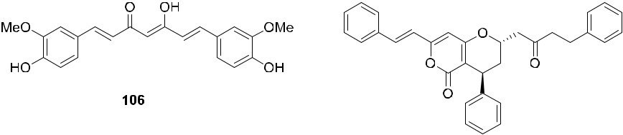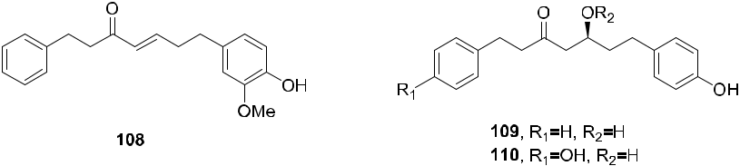

F I G U R E 12 Structures of diarylheptanoids and derivatives 106–110

and suppression of proinflammatory cytokines. Furthermore, following treatment with 111 and 112 at low dosage (<1.2 μM/kg/day) by intranasal administration, the survival rates of mice infected with H1N1 or H5N1 were greatly improved in comparison with the combination treatments using ZA and anti‐inflammatory drugs.97 In another study, Xie and coworkers used CA as a lead compound to synthesize possible antiviral CA analogs. In enzyme inhibition assays, some derivatives exhibited moderate activities against N2 and N1 NAs, and 113 was the best inhibitor (IC50 = 7.2 and 8.5 µM, respectively). In addition, the 3,4‐dihydroxyphenyl group from CA was important for the activity according to the docking analysis.98

In 2015, 13 caffeoylquinic acid derivatives were synthesized by Tian and coworkers. In pharmacological studies, compounds 114–116 inhibited the replication of influenza virus (A/Beijing/7/2009 (BJ09)) with EC50 values of 2.34, 1.06, and 19.9 μM, respectively. The most active compound was 114 with lower cytotoxicity (CC50 = 138 μM) and higher therapeutic index (TI = 27.3). The preliminary SAR studies showed that the 7′ carboxyl group of caffeinylquinic acid was not the essential active group. Long fatty chains and 4'‐ and 5'‐hydroxyl groups were not conducive to increased activity, while amino groups with shorter fatty chains, such as cyclopentamine and n‐pentamine, significantly enhanced activity.99

Forsythoside A (117), a CA acyl glycoside from Forsythia suspense, displayed broad‐spectrum inhibitory activity against different influenza virus subtypes, including H1N1, pandemic H1N1 (A/HK/415742/09), oseltamivir‐ resistant H1N1 (A/Vicotria/07159200/07), H3N2 (A/H3N2/1174/99), and H9N2 (A/Quail/HK/G1/97). In an in vivo influenza virus infection model, 117 reduced the titers of all tested virus strains by more than 98% and increased the survival rate of the mice. Additional research found that 117 reduced the influenza M1 protein level, which inhibited the virus replication and limited the virus spread.100

The chemical structures of 111−117 are shown in Figure 13.

4.4.2 | Lignans

Arctigenin (118), obtained from Arctium lappa, exhibited significant antiviral activity against IAV (A/NWS/33, H1N1) in vitro with an IC50 value of 2.9 μM and SI of 16 (oseltamivir as positive control, IC50 = 0.14 μM, SI = 4600). In a mechanism study, compound 118 interfered with early stages of virus replication, suppressed the release of progeny viruses from the host cells, decreased the frequency of drug resistant virus generation, and increased the immune response to antiviral efficacy, suggesting that 118 offers a new option for influenza treatment.101,102

16 | ZHANG ET AL.

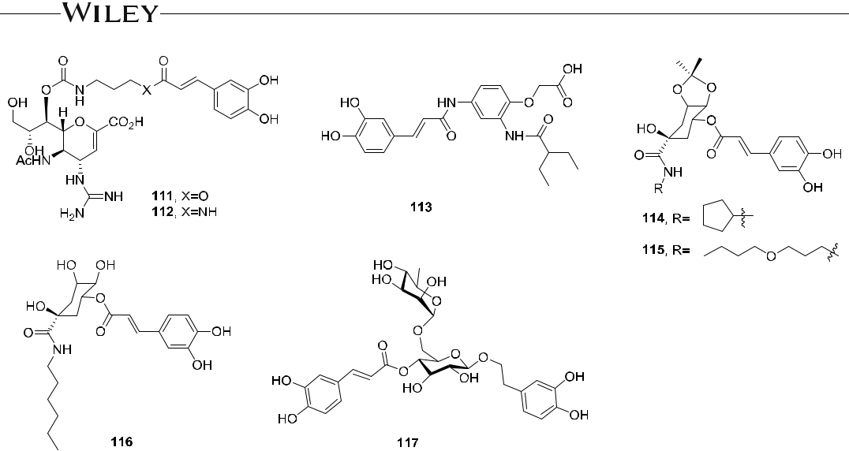

F I G U R E 13 Structures of phenylpropanes and derivatives 111–117

A new lignan glycoside 119, isolated from Calotropis gigantea, exhibited antiviral activities against IAV H1N1 (A/PR/8/34 and A/FM/1/47), H3N2 (A/Aichi/2/68), and IBV (B/Lee/1940) with IC50 values between 13.4 and 39.8 µM, and SI values between 3.7 and 11.4 (rimantadine as positive control, IC50 = 21.9–81.6 μM, SI = 11.9–47.0). In a mechanism study, compound 119 efficiently blocked nuclear translocation of transcription factor NF‐κB induced by influenza virus and inhibited nuclear export of viral RNP. In addition, the results from a time course assay indicated that 119 exerts its antiviral activity at an early stage of viral replication.103

The chemical structures of 118 and 119 are shown in Figure 14.

4.4.3 | Coumarins

Through the high throughput screening (HTS) of about 20 000 compounds, Yeh and coworkers found that the angelicin derivative 120 inhibited the CPE induced by H1N1 (IC50 = 4.5 μM, CC50 > 25 μM). Separate optimization of pharmacophores A−C of 120 ascertained the crucial structural features important for optimal anti‐influenza activity in that area. The SAR investigation revealed that pharmacophore B, which is the angelicin scaffold, had a critical role in maintaining activity, while meta‐substituted phenyl/2‐thiophene rings in pharmacophores A and C were optimal for activity. Thus, the optimized lead compound 121 (IC50 = 70 nM) showed 64‐fold enhanced po-tency compared to 120 and, like the approved anti‐influenza drug ZA, inhibited the activity of both IAV (H3N2) and

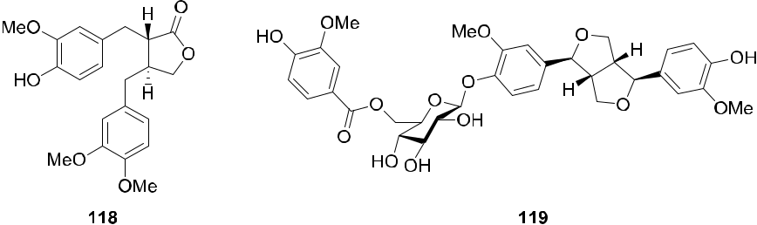

F I G U R E 14 Structures of lignans and derivatives 118 and 119

|  |  |  |  |
| --- | --- | --- | --- |
| ZHANG ET AL. |  | | 17 |  |
|  |  |
|  |  |  |  |



IBV (IC50 40–150 nM). The initial mechanistic studies suggested that viral RNP was a probable molecular target. The identified lead 121 would provide different opportunities to find a new anti‐influenza drug since angelicin derivatives are rarely reported as antiviral agents104 In addition, BPR2‐D2 (122) was another compound obtained from the same high throughput screening. It not only exhibited a broad range of antiviral activity against various strains of influenza A and B viruses, including H1N1 (EC50 = 0.043 ± 0.001 μM), but also showed significant anti-viral activity against oseltamivir‐resistant virus (EC50 = 0.021−0.040 μM). Mechanistically, compound 122 inhibited the viral RNA production controlled by influenza viral RNP in a transfection assay and, thus, may not target the viral NA.105

Eighteen compounds with NA inhibitory activity were isolated from the roots of Glycyrrhiza uralensis. Among them, glycyrol (123) showed the greatest activity with an IC50 value of 3.1 μM. In an SAR study, compounds with a five‐membered ring showed higher NA inhibitory activity than ones with the ring‐closed coumarin. The furan rings of the polyphenols were essential for NA inhibitory activity, an apioside group on the chalcone and a flavanone backbone enhanced the activity, and a five‐membered ring between C‐4 and C‐2′ in coumestan was critical for NA inhibition.106 Strobilanthe A (124), a novel isocoumarin, exerted moderate inhibitory activity against H1N1 (A/PR/ 8/34) with IC50 = 29.2 ± 5.8 μM, CC50 = 474.0 ± 6.4 μM, and SI = 16.2 (ribavirin as positive control, IC50 = 32.8 ± 4.3 μM, CC50 = 797.0 ± 14.6 μM, and SI = 24.3).107

The chemical structures of 120−124 are shown in Figure 15.

4.5 | Polyphenols

Along with a broad spectrum of biological activities, pentagalloylglucose (125) inhibited influenza virus strain A/WSN/33 (H1N1) with an EC50 value of 2.51 ± 0.31 μM and SI of 12.54. In mechanistic studies in vitro, compound 125 inhibited the productive replication of IAV both by interfering with the viral budding and by releasing inhibiting virus infection.108 In another study, 125 and its mono‐deacylated isomer 126 from exhibited inhibitory activity against H2N2 (A/RI/5+/1957) with IC50 values of 11.9 and 9.2 μM, respectively.109

Eight polyphenols isolated from Flos Caryophylli were tested for anti‐influenza activities in an in vitro NA inhibition assay. These compounds exhibited effects against the H1N1 NA with IC50 values ranging from 8.4 to 94.1 μM (EC50 = 1.5–84.7 μM, CC50 = 374.3–1266.9 μM, and SI of 7–297). Among them, the most active was eu-geniin (127) with an IC50 value of 8.4 μM (ZA, IC50 = 4 μM). The SAR studies suggested that the galloyl moieties linked to sugar moieties might play important roles in the NA inhibitory activities.110

1,3,4,6‐Tetra‐O‐galloyl‐β‐D‐glucopyranoside (128) from Euphorbia humifusa exhibited broad‐spectrum anti‐IAV activity, including two seasonal influenza A strains, A/California/07/2009 (H1N1, IC50 = 0.11 μM) and A/Perth/16/ 2009 (H3N2, IC50 = 0.04 μM), and seasonal influenza B strain B/Florida/04/2006 (IC50 = 3.63 μM). In mechanistic studies action in vitro, compound 128 inhibited viral RNP export from the nucleus to the cytoplasm and, thus, interfered with the assembly of progeny virions.111 Isocorilagin (129) from Canarium album displayed a significant inhibitory effect against H1N1 (A/PR/8/34) with an IC50 value of 8.52 ± 1.53 μM.112

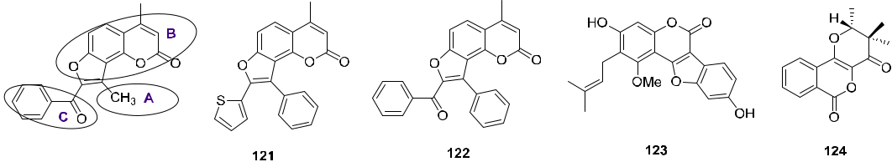

F I G U R E 15 Structures of coumarins and derivatives 120–124

18 | ZHANG ET AL.



Three theaflavin (130, TF) derivatives, TF‐3‐G (131), TF‐3′ G (132), and TF‐3,3′ DG (133), from black tea showed significant inhibitory activities against H1N1 (A/PR/8/34), H3N2 (A/Sydney/5/97), and IBV (Jiangsu/10/

2003) with IC50 values ranging from 10.67 ± 0.31 to 49.60 ± 4.74 μM, respectively (oseltamivir carboxylate: IC50 = 8.88−34.48 μM). The three TFs were more potent against IAV than IBV and against H3N2 subtype virus than H1N1. Compound 133 displayed the highest inhibitory activity against the NAs with an IC50 of 10.67 ± 0.31 μM, and CC50 value of 76.7. In addition, the TF derivatives significantly reduced H1N1 virus‐induced inflammation.113 Three oligostilbenes, viniferol C (134), amurensin K (135), and vitisin B (136), from Vitis amurensis showed strong activity toward the viral NA. Among them, 134 showed the highest activity (IC50 = 8.94 μM) against H1N1 (A/PR/8/34), whereas 135 and 136 showed the greatest activity against swine‐origin H1N1 (IC50 = 14.43 μM) and oseltamivir‐resistant novel H1N1 (H274Y, IC50 = 23.89 μM), respectively. Although the SARs of oligostilbenes were not investigated thoroughly, these results suggested that the presence of a cycloheptane ring in these compounds might be important for the in vitro NA inhibitory activity, and the tetramer of resveratrol was more potent than the trimer, dimer, and monomer.114 Dryocrassin ABBA (137) and filixic acid ABA (138), two phloroglucinols from Dryopteris crassirhizoma, inhibited H5N1 with IC50 values

of 18.59 ± 4.53 and 29.57 ± 2.48 μM, respectively.115

The chemical structures of 125−138 are shown in Figure 16.

4.6 | Stilbenoids and analogues

The anti‐influenza viral activities of six stilbenoids from the Gnetum pendulum were evaluated. In a CPE assay, isorhapontigenin (139), gnetupendin B (140), shegansu B (141), and gnetin D (142) exhibited significant anti‐ influenza viral activity in MDCK cells, with IC50 values ranging from 1.38 to 23.32 μM (ribavirin: IC50 = 22.69 μM), while, in an NA assay, all six compounds exerted NA inhibitory effects.116 Compound 143, a formylated stilbenoid derivative from Erythrina addisoniae, exhibited strong inhibitory effects against H1N1 (IC50 = 29.33 ± 1.13 μM) and H9N2 (IC50 = 23.96 ± 1.33 μM).117 Five stilbenoid analogs from Phellinus baumii inhibited H1N1, H5N1, and H3N2 NA activity and decreased the amount of virally‐induced CPE. Inoscavin A (144, IC50 = 22.6 μM, TI = 4.4) and phelligridin D (145) (IC50 = 24.6 μM) showed the strongest antiviral activity (ZA: IC50 = 64.7 μM, TI = 1.6).118

The chemical structures of 139−145 are shown in Figure 17.

4.7 | Flavonoids

Four C‐methylated flavonoids with a chalcone skeleton, purified from Cleistocalyx operculatus, exhibited significant inhibitory effects on the viral NAs of H1N1 and H9N2 with IC50 values between 18.57 ± 1.37 and 85.74 ± 7.25 μM. Among them, compound 146 showed the greatest inhibitory activity against H1N1 (H274Y mutant) and H1N1 (WT) with IC50 values of 3.31 ± 1.34 and 8.15 ± 1.05 μM, respectively, and low cytoxicity of CC50 > 120.119

Eight chalcones were isolated as active principles from Glycyrrhiza inflata. Among them, isoliquiritigenin (147), and echinantin (148) without a prenyl group exhibited broad‐spectrum inhibitory effects against H1N1, H9N2, H1N1 (WT), and H1N1 (H274Y). In addition, the combination of oseltamivir with 148 (5 μM) increased the efficacy against H274Y NA. Although SARs of these compounds were not thoroughly investigated, this study has suggested that chalcones can serve as NA inhibitors of influenza A. Synthesis of these naturally occurring compounds and their analogs might provide a lead for the development of new drugs to combat this serious disease.120

Six compounds from Caesalpinia sappan exhibited activity against H3N2, and the most active was 3‐deoxysappanchalcone (149) with an IC50 value of 3.92 μM and CC50 value of 17.25 μM (oseltamivir acid and ribavirin: IC50 = 2.08 and 37.55 μM, respectively). In addition, SAR analysis suggested that the presence of the 3‐OH group in 149 slightly reduced the activity.121 The anti‐influenza mechanism of 149 involved the control

|  |  |  |  |
| --- | --- | --- | --- |
| ZHANG ET AL. |  | | 19 |  |
|  |  |
|  |  |  |  |

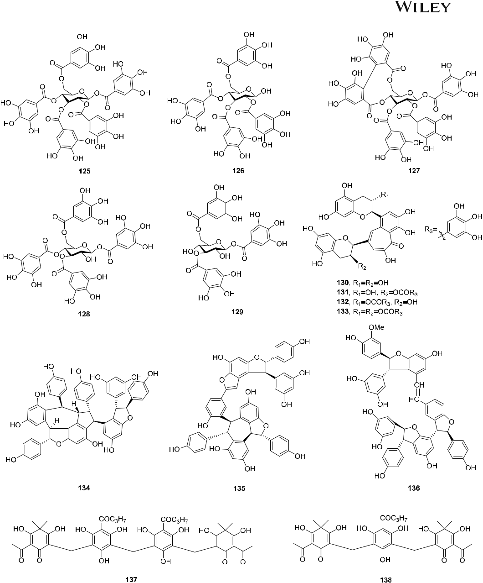

F I G U R E 16 Structures of polyphenols and derivatives 125–138

of viral replication, antiapoptosis in infected cells, and protection of host cells against influenza‐induced inflammation; reduced production of IL‐1β and IL‐6 and suppressed secretion of CCL5 and CXCL10 were found in endothelial cells.122

Bioassay directed fractionation of Cleistocalyx operculatus led to the isolation of nine compounds; among them, 150 and 151 showed broad‐spectrum inhibitory effects against H1N1, novel H1N1, H9N2, and oseltamivir‐ resistant H1N1 (H274Y) with IC50 values ranging from 5.07 ± 0.94 to 9.34 ± 2.52 μM. A SAR study demonstrated that flavonoids possessing OH groups at C‐7 and C‐4′, a double bond between C‐2 and C‐3, and more importantly, a carbonyl group at C‐4 were good inhibitors.123

20 | ZHANG ET AL.

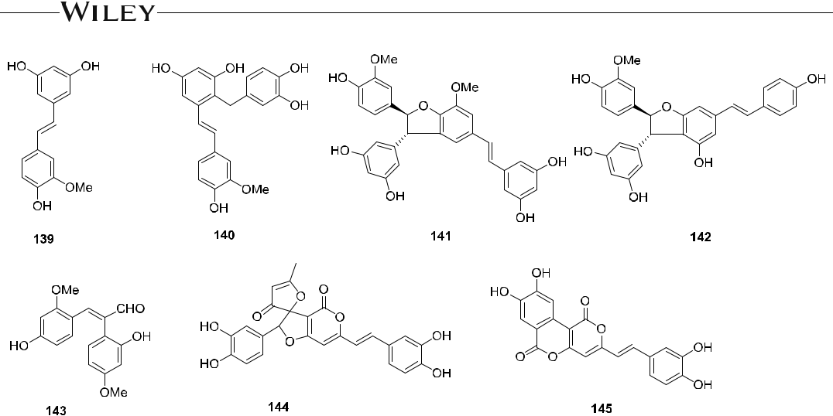

F I G U R E 17 Structures of stilbenoids and analogs 139–145

Tricin (152), derived from the hot water extract of Sasa albo‐marginata, exhibited broad‐spectrum inhibitory effects against influenza A/Narita/1/2009 (H1N1pdm, EC50 = 8.2 μM), A/NCalifornia/07/2009 (H1N1pdm, IC50 = 10.2 μM), H3N2 (EC50 = 3.4 μM), and IBV (EC50 = 4.9 μM) with low cytoxicity (CC50 > 20 μM). In a mechanism of action study, 152 decreased the matrix (M) and HA proteins, as well as mRNA expression of viral M and HA protein in the infected cells in vitro. In addition, compound 152 significantly controlled body weight loss and prolonged the survival rate of infected mice in vivo.124

An ethanolic extract (IC50 = 35.12 μg/ml) and ethyl acetate fraction (IC50 = 7.244 μg/ml) prepared from Mosla scabra showed potential inhibition against H1N1 (A/PR/8/34). Compounds 153–156 isolated from the ethyl acetate fraction showed significant activities with IC50 values ranging from 4.96 to 7.79 μM, and CC50 values ranging from 512.08 to 761.26 μM (ribavirin: IC50 = 242.66 μM). Mechanistically, the extracts might block ad-sorption of the virus to host cells or inhibit replication of the virus.125 Six flavonoids from Papaver rhoeas Bee pollen showed NA inhibitory activities with IC50 values of 10.7−151.1 μM. Among them, luteolin (157), the most potent NA inhibitor with low cytoxicity (CC50 > 100 μM), exhibited inhibitory effects against H1N1, H5N1, and H3N2, with IC50 values of 10.7, 12.6, and 25.6 μM, respectively.126

The 3'‐methylated flavonol isorhamnetin (158) showed antiviral activity against H1N1 (A/PR/08/34) with an IC50 value of 23 μM. It directly suppressed NA activity and virus adsorption onto host cells or indirectly inhibited the expression of viral HA and NA genes, reactive oxygen species (ROS) generation, virus‐induced autophagy, and ERK phosphorylation after IAV infection. The SAR study demonstrated that the methyl group located on the B ring of isorhamnetin may contribute to its strong antiviral potency in comparison with other flavonoids.127

Baicalin (159), baicalein (160), wogonin (161), chrysin (162), and oroxylin A (163) from Scutellaria baicalensis exerted potent inhibitory activities against H1N1 (IC50 = 7.4, 7.5, 2.1, 7.7, and 12.8 μM, respectively; oseltamivir phosphate IC50 = 45.6 μM).128 In terms of mechanism, baicalin (159) protected mice from H1N1 (A/PR/8/34) infection by in-hibiting A/PR/8/34 replication through interferon γ (IFN‐γ) in human peripheral blood mononuclear cells, inducing IFN‐γ synthesis in human CD4+ and CD8+ T cells and NK cells, and activating the JAK/STAT 1 signaling pathway.129

The baicalein analogs 164–168 with a brominated B‐ring were synthesized. They exhibited greater potency than oseltamivir or ribavirin against H1N1 oseltamivir‐resistant (H1N1 TR) virus with EC50 values between 4.0 and 4.5 μM (SI > 70). Against seasonal H3N2‐infected influenza virus, both 164 and 168 were more potent (SI > 17.3) than ribavirin (SI > 11.7). A SAR study indicated that the synthesis of new baicalein analogs, especially with brominated B‐rings and hydroxylated A‐rings, might be critical for potency against H1N1‐oseltamivir‐resistant influenza viruses.130

|  |  |  |  |
| --- | --- | --- | --- |
| ZHANG ET AL. |  | | 21 |  |
|  |  |
|  |  |  |  |



Quercetin (169) and its glucoside isoquercetin (170) reduced the replication of influenza viruses with low IC50 values and high therapeutic indexes. Moreover, 169 exhibited broad‐spectrum inhibitory effects against H1N1 (A/Puerto Rico/8/34), H1N1 (A/FM‐1/47/1), and H3N2 (A/Aichi/2/68) with IC50 values of 27.11 ± 3.83, 21.76 ± 1.63, and 9.57 ± 6.75 μM, respectively. Mechanistically, 169 interacted with the HA2 subunit and inhibited the entry of the H5N1 virus, thus, its inhibitory activity occurs at an early stage of influenza infection.131 Sub-sequently, quercetin analogs containing alkoxy, aminoalkoxy, and phenolic ester moieties on the C‐3, C‐3' and C‐5 hydroxy groups were synthesized, and quercetin‐3‐gallate (171) showed inhibitory activity against porcine H1N1 comparable to that of the tea polyphenol epigallocatechingallate but with a higher SI value. This result implied that further modification at C‐3 could improve anti‐influenza efficacy.132

Daidzein (172), a bioactive ingredient from beans, showed anti‐influenza H1N1 oseltamivir‐resistant virus (H1N1 TR) activity via inhibition of NA in vitro. Lee and coworkers synthesized various isoflavonoids by structural modification of 172. Among them, compound 173 was the most active analog (EC50 = 29.0 μM, SI > 10.3). A SAR analysis of the daidzein analogs revealed that CHO and OH groups on the A‐ring and Br‐substitution in the B‐ring played important roles in the activity and selectivity against H1N1 TR.133

The isolates obtained from bioassay guided separation of Campylotropis hirtella showed inhibitory effects against the NA (H1N1) enzyme. Among them, compound 174 had the best NA inhibitory activity with an IC50 value of 16.76 μM (oseltamivir, IC50 = 1.17 μM).134 Asebotin (175) and thalassodendrone (176) from Thalassodendron ciliatum exhibited inhibitory effects against H1N1 (A/WSN/33) with IC50 values of 4.44 and 3.21 μM, and CC50 values of 7.46 and 5.14 μM, respectively. A SAR study linked the antiviral inhibitory properties of chalcones and flavonoids to the electronic interactions between both A and B rings with possible receptor‐like structures in the cells, which prevent the influenza virus from attaching to and penetrating into the cell. These agonist–receptor interactions were enhanced by hydrogen bonding contributions and by specific geometrical arrangements asso-ciated with each compound.131

Safflomin A (177), an NA inhibitor, significantly reduced replication of H1N1 and H3N2 influenza viruses in MDCK cells; it bouns in the nonactive site of N1 and N2. In addition, 177‐oseltamivir combination treatment resulted in synergistic antiviral activity against NAs of H1N1 and H3N2, suggesting that it might serve as an effective supplementary option to the currently marketed anti‐influenza therapeutics.135 Among 19 flavonoids isolated from Matteuccia struthiopteris, matteflavoside G (178) exhibited strong inhibitory activity against H1N1 with an EC50 value of 6.8 ± 1.1 μM and SI value of 34.4 (ribavirin as positive control, EC50 = 19.7 ± 1.0 μM). In addition, the docking results showed that the hydrogen bond interactions played important roles in the ligand–protein interactions.136 Quercetin‐7‐O‐glucoside (179) from Dianthus superbus showed significant antiviral activity against A/PR/8/34, A/Vic/3/75, B/Lee/40, and B/Maryland/1/59 virus strains with IC50 values of 6.45, 13.77, 17.06, and 10.77 μM, respectively, and the CC50 values were more than 200. It reduced virus‐induced ROS and autophagy formation and inhibited viral RNA polymerase.137

The chemical structures of 146−179 are shown in Figure 18.

4.8 | Alkaloids

Berberine (180), a major isoquinoline alkaloid from Hydrastic canadensis (Ranunculaceae) and Berberis species (Berberidaceae), effectively inhibited the growth of two H1N1 strains of influenza A in several cell types.138 Mechanistic investigations indicated that 180 played an important role in preventing virus protein trafficking/ maturation and, in turn, inhibiting virus growth. It also greatly ameliorated the pathologic changes resulting from influenza‐induced viral pneumonia in a mice model by inhibiting the release of inflammatory substances.139 Several berberine derivatives were synthesized and their antiviral activities were evaluated. Among them, compounds 181–184 showed significant inhibitory activity against IAV (A/PR/34/8) with IC50 values of 29.01, 30.75, 1.69, and 2.96 μM, and CC50 values of 134.27, 755.84, 141.26, and 198.63 μM, respectively (oseltamivir as positive control,

22 | ZHANG ET AL.

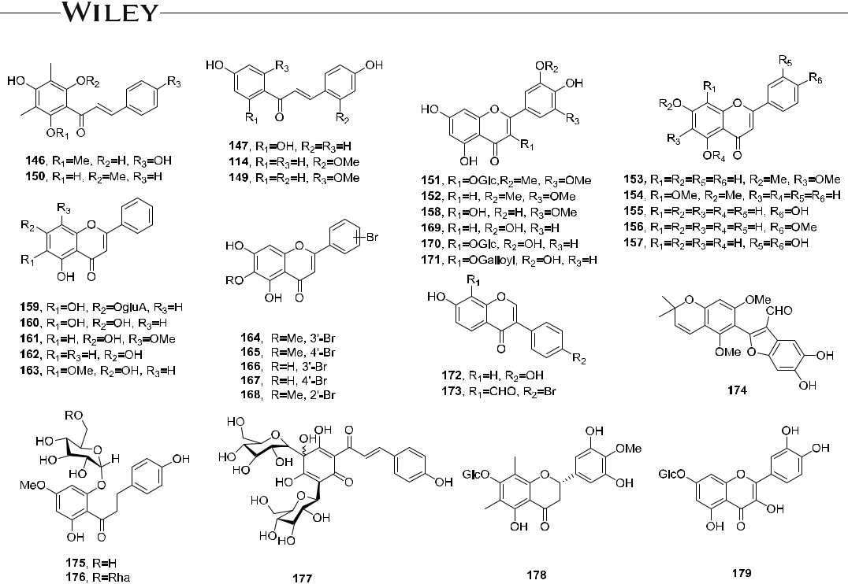

F I G U R E 18 Structures of flavonoids and derivatives 146–179

IC50 = 3.19 μM). A SAR study indicated that more H‐bonds and NA residues were occupied by berberine deriva-tives, resulting in stronger binding ability than that of oseltamivir. In addition, these derivatives inhibited various strains of influenza virus by blocking the viral NA subunit.140

Indole‐diterpenoids 185–191 from the fermentation broth of Penicillium camemberti OUCMDZ‐1492 grown at pH 5.0 showed activity against the H1N1 virus with IC50 values of 28.3, 6.6, 17.7, 38.9, 32.2, 34.1, and 26.2 μM, respectively. The SAR study showed that 3‐oxo, 4b‐hydroxy, and 9‐isopentenyl substitutions tended to increase the anti‐H1N1 activity of hexacyclic indole‐diterpenoids.141 Fifteen alkaloids from Lycoris radiata were evaluated for their antiviral activities, and lycorine (192) and hemanthamine (193) showed significant antiviral activities against H5N1 with EC90 values of 0.52 and 4.15 μM, and CC50 values of 20.9 ± 0.07 and 50.0 ± 0.12, respectively (oseltamivir: EC90 = 0.625 μM). Intracellular NP localization indicated that 192 and 193 blocked viral RNP nuclear export.142

Homonojirimycin (194) from Commelina communis exhibited antiviral activity against H1N1 (A/PR/8/34) (EC50 = 10.4 μM and SI = 17.9) compared with ribavirin (EC50 = 15.2 μM, SI = 21.4).143 In addition, Zhang and coworkers investigated the effects of 194 on protection against influenza virus infection in mice, and found that it prolonged the mean survival time, improved the survival rate, and reduced virus yields in lungs. In a biological mechanism study, compound 194 exerted a protective effect against influenza virus infection and produced effective immune responses in vivo, which may be useful for the prevention or treatment of influenza virus infection.144

Sophora quinolizidine alkaloids, the known main constituents of Sophora species, were identified as a new class of anti‐IAV agents. Among the tested Sophora alkaloids, aloperine (195) exhibited the best anti‐IAV (A/PR/8/1934) activity (EC50 = 14.5 μM, CC50 > 80 μM); the comparative EC50 values of oseltamivir and amantadine were greater than 80 μM. Subsequently, compound 195 was structurally modified to improve its activity. Hydrogenation of the double bond between C‐16 and C‐17 of 195 gave a racemic mixture of dihydroaloperine (196), which was slightly more potent (EC50 = 11.2 μM) than 195. Larger substituents on N‐12 resulted in derivatives 197 and 198, which

|  |  |  |  |
| --- | --- | --- | --- |
| ZHANG ET AL. |  | | 23 |  |
|  |  |
|  |  |  |  |



showed significant activity against the oseltamivir‐resistant IAV PR8 strain (EC50 = 2.4 and 6.2 μM, respectively). In addition, the derivatives of 195 and oseltamivir have different mechanisms of action, since the former strongly inhibited the expression of NP in the cells and might interact with NP.145

A class of prenylated indole diketopiperazine alkaloids obtained from the marine‐derived fungus Eurotium rubrum was tested against influenza A/WSN/33 virus, and neoechinulin B (199) exerted broad spectrum activity even against oseltamivir‐ and amantadine‐resistant viruses with decreased induction of viral resistance. Mechanism of action investigations indicated that 119 bound to the influenza envelope HA and disrupted the interaction of HA with the sialic acid receptor and the viral attachment to host cells. It also effectively inhibited influenza A/WSN/33 virus propagation even after the fifth passage. Therefore, with broad‐spectrum activity and high potency against influenza viruses together with less drug resistance development, compound 199 is a new potential influenza virus entry inhibitor.146

2(3H)‐Benzoxazolinone (200) from Strobilanthes cusia exhibited antiviral activity against H1N1 (A/PR/8/34) (IC50 = 46.0 ± 8.4 μM, CC50 = 51.2 ± 10.9 μM, and SI = 7.6; ribavirin: IC50 = 32.8 ± 4.3 μM, CC50 = 797.0 ± 14.6 μM, and SI = 24.3).111 Dendrobine (201) was isolated from Dendrobium nobile, a famous TCM named “Shi Hu,” and showed broad‐spectrum inhibitory activity against H1N1 (A/FM‐1/1/47), H1N1 (A/Puerto Rico/8/34 H274Y), and H3N2 (A/Aichi/2/68) with IC50 values of 12.9 ± 1.21, 8.21 ± 3.46, 20.2 ± 6.87 μM, respectively. In a mechanistic study, 201 bound to the highly conserved region of viral NP and subsequently restrained nuclear export of viral NP and its oligomerization as well as inhibited early steps in the viral replication cycle. The above results provide valuable information for the full application of this famous TCM.147

Herquline A (202) from Penicillium herquei FKI‐7215 inhibited replication of H1N1 virus (A/PR/8/34) in a dose‐ dependent manner with an IC50 value of 31.84 μM, without exhibiting cytotoxicity. As it did not inhibit the viral NA, its molecular target might be different from that of known anti‐influenza virus drugs and should be further investigated.148

Huang and coworkers found that ZBMD‐1 (203) inhibited the replication of H1N1 and H3N2 IAV strains in vitro (IC50 0.41−1.14 μM and CC50 > 100 μM). Mechanistic studies indicated that this promising anti‐influenza compound acts as a multifunctional NP inhibitor by disrupting the distribution of influenza NP protein in cells, blocking the nuclear export of NP, and obstructing the binding between NP and CRM1.149 Two diterpenoid alkaloids, tanguticulines A (204) and E (205), from Aconitum tanguticum exhibited anti‐H1N1 virus activity with IC50 values of 8.40 and 6.99 μM, and TI of 3.81 and 9.44, respectively.150

The chemical structures of 180−205 are shown in Figure 19.

1. | DEVELOPING INFLUENZA AGENTS FROM TCM 5.1 | TCM and influenza

Humans have been faced the threat of epidemics such as influenza throughout their existence. The treatments used against influenza in Western and Chinese countries differ mainly in their action modes and targets. In the West, many single‐target antiviral chemical drugs have been designed since the mid‐1960s; however, drug re-sistance is still common. To overcome this problem, the use of combination therapies that incorporate multiple drugs with multiple molecular targets into a single treatment is now well accepted in the West. Meanwhile, TCM practitioners began long ago to document their diagnostic and treatment principles related to epidemic diseases; for example, in the classic Chinese medical book, “Emperor Internal Medical Classic” written around 2600 BC. The unique treatments and Chinese herbal formulas used to combat influenza may serve as a useful source of in-formation and inspiration for the discovery of new drugs, as TCMs usually act via multiple modes of action that target not only the virus, but also the host's immune response, resulting in a synergistic effect. TCMs seek to restore balance and energy by using natural substances from medicinal plants, animal products, fungi, and minerals,

24 | ZHANG ET AL.

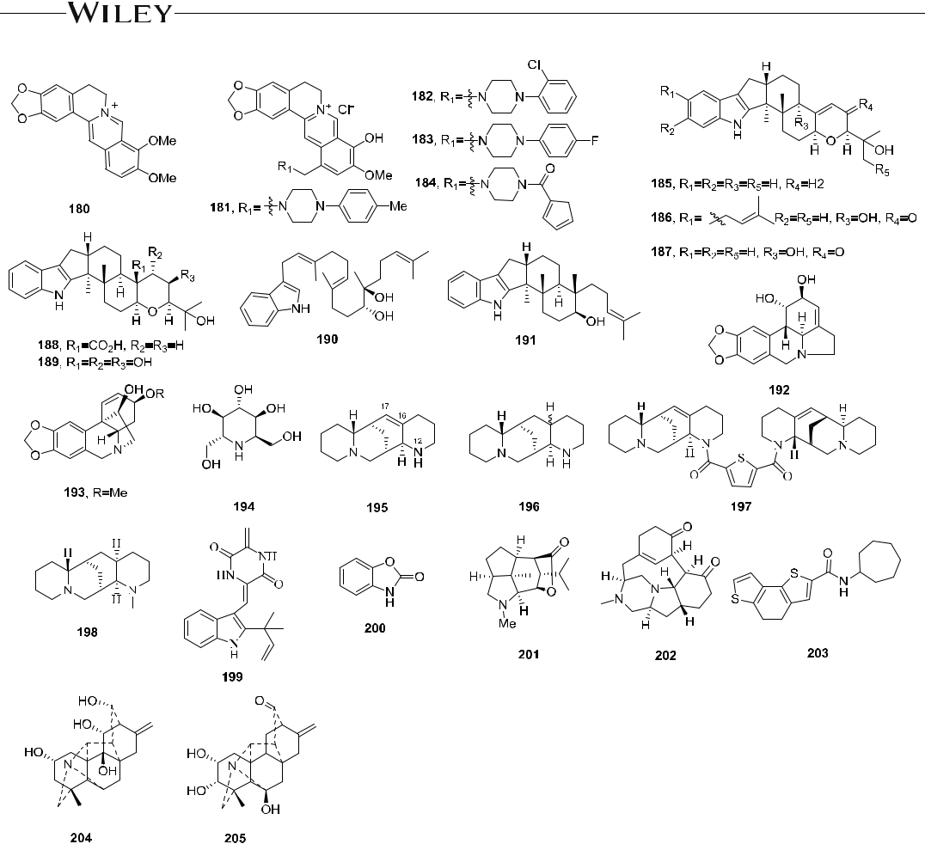

F I G U R E 19 Structures of alkaloids and derivatives 180–205

and, superficially, differ significantly from the reductionist approach of Western medicine. Therefore, TCMs have contributed to controlling influenza epidemics in China and other Asian countries in prior years. Three distinct host strategies, resistant host, tolerant host, and susceptible host, are used to deal with the same infection.151

5.2 | Anti‐influenza single herb medicine from TCM

5.2.1 | Investigation on the roots of Isatis indigotica

The dried roots and leaves of Isatis indigotica Fort. (Cruciferae), named “ban lan gen (BLG)” and “da qing ye,” re-spectively, are among the most popular herbal drugs for the treatment of colds, especially of the flu during influenza pandemics in China.152 Many formulations containing extracts of BLG or the raw material are compiled in Chinese Pharmacopoeia.153 To date, there are no reports on the obvious side effects of BLG. Phytochemical studies have resulted in the characterization of more than 150 ingredients with different structural features, including alkaloids,154‐161 lignans,162‐164 ceramides,165 flavonoids,166,167 2‐hydroxy‐3‐butenyl thiocyanateand sulfur‐containing epigoitrin, goitrin, proepigoitrin, and progoitrin;168 the major active ingredients are indole alkaloids.169

|  |  |  |  |
| --- | --- | --- | --- |
| ZHANG ET AL. |  | | 25 |  |
|  |  |
|  |  |  |  |



Zhong and coworkers conducted detailed biological and chemical analyses of crude extracts of BLG and found that the water extract of BLG inhibited different subtypes of human or avian influenza viruses at various mag-nitudes of activity (IC50 = 0.39−4.3 mg/ml) in vitro, including A/PR/8/34 (H1N1), A/FM/1/47 (H1N1), seasonal influenza (A/Guangzhou/GIRD/02/09 H1N1, B/Guangzhou/GIRD/08/09), novel swine‐originating influenza (A/Guangzhou/GIRD/07/09, H1N1), A/Aichi/2/68 (H3N2), A/Duck/Guangdong/94 (H7N3), A/Duck/Guangdong/09 (H6N2), and A/Chicken/Guangdong/96 (H9N2).170 In addition, the methanolic extract of BLG inhibited the de-gradation of Iκ‐Bα and production of NO, PGE2, and IL‐6 as well as exerted immune modulatory effects in vitro and in vivo.171 They also found that the polysaccharides prevented the influenza virus from attaching to host cell surfaces through a process involving HAs and promoted the proliferation of lymphocytes and macrophages, as well as production of IL‐2 and IFN‐γ in mouse models.170,172

In a study of the active constituents of BLG, clemastanin B (206) inhibited different subtypes of swine‐origin H1N1, H3N2, and influenza B, and avian influenza viruses (H6N2, H7N3, and H9N2). In a mechanism study, compound 206 blocked translocation of the nucleocapsid protein at an early stage of replication, primarily through modulation of NF‐κB signaling and inhibition of viral replication.173 Indole‐3‐acetonitrile‐6‐O‐β‐D‐pyran glucoside (207) played a major role in preventing viral infection of host cells.174 In addition, indirubin and its derivatives, such as 208, interrupted virus‐induced p38 MAP kinase activation and NF‐κB translocation, suppressed pro‐ inflammatory cytokines/chemokines, and reduced the expression of CCL5 in human bronchial epithelial cells.175,176 Another alkaloid, epigoitrin (209), significantly reduced the susceptibility to influenza virus via mitochondrial antiviral signaling.177 4(3H)‐Quinazolone (210) regulated innate immune signaling upon respiratory syncytial virus infection through moderate inhibition of the RIG‐1 pathway in RAW264.7 cells, indicating that it could inhibit inflammatory injury and eliminate virus without affecting the immune system.178 The lignan glycoside lariciresinol‐ 4‐O‐β‐D‐glucopyranoside (211) may provide beneficial telomere protection and, thus, defense against influenza virus‐induced telomere‐related DNA damage.179,180 A major active component in BLG is an arabinogalactan containing arabinose and galactose at a ratio of 1.0:1.5 with a β‐(1 → 3,6)‐galactan backbone. It exerted significant adjuvant activity with H1N1 influenza vaccines and might be used in mechanism studies as a vaccine adjuvant.181

However, it should be noted that the above active chemical studies mainly focused on ethanol or methanol extracts of BLG, which is not consistent with the practical utilization of decoctions of the drug materials or the formulations. Accordingly, To assess the chemical and biological diversity of BLG, Shi and coworkers carried out a detailed phytochemical study of an aqueous extract of BLG, mainly focusing on the minor components. In this study, 81 new compounds were isolated from the aqueous extract of BLG, and some of them showed antiviral activity against IAV (H3N2). Compounds 212−214 were the first examples of natural products with unique lin-kages between a molecule of 2‐(1H‐indol‐3‐yl) acetonitrile and 2‐(4‐methoxy‐1H‐indol‐3‐yl) acetonitrile, 2‐(4‐ methoxy‐1H‐indol‐3‐yl) acetonitrile, and 4‐hydroxyphenylethane, respectively. They showed antiviral activity against influenza virus A/Hanfang/359/95 (H3N2) with IC50 values of 3.70–12.35 μM and SI values of 2.2–4.0, respectively.182

Isatithioetherins B and D (215, 216) are novel sulfur‐enriched alkaloids originating from stereoselective as-semblies of epigoitrin‐derived units, displayed antiviral activity against the influenza virus A/Hanfang/359/95 (H3N2, IC50 = 0.60 and 1.92 μM).183 Isatindigotindolosides A (217) and D (218), indole‐3‐acetonitrile‐ 2‐S‐β‐D‐ glucopyranoside (219), indole‐3‐acetonitrile‐4‐methoxy‐2‐S‐β‐D‐ glucopyranoside (220), 221, isatindosulfonic acid B (222) and 223 showed antiviral activity against influenza virus H3N2 (A/Hanfang/359/95) with IC50 values ranging from 12.6 to 33.3 μM.184‐188 The chemical structures of 206−223 are shown in Figure 20.

Taken together, the above investigations of BLG led to the discovery of many new anti‐influenza chemical constituents with diverse structural types, suggesting that BLG might display beneficial clinical effects and pro-tection against viral infection by targeting both the virus and the host—markedly different from marketed che-mically synthesized drugs. Based on the present studies, the action mechanisms of BLG warrant further investigation. Importantly, using treatments with multiple sites of action may prevent or delay the generation of resistant viral strains.

26 | ZHANG ET AL.

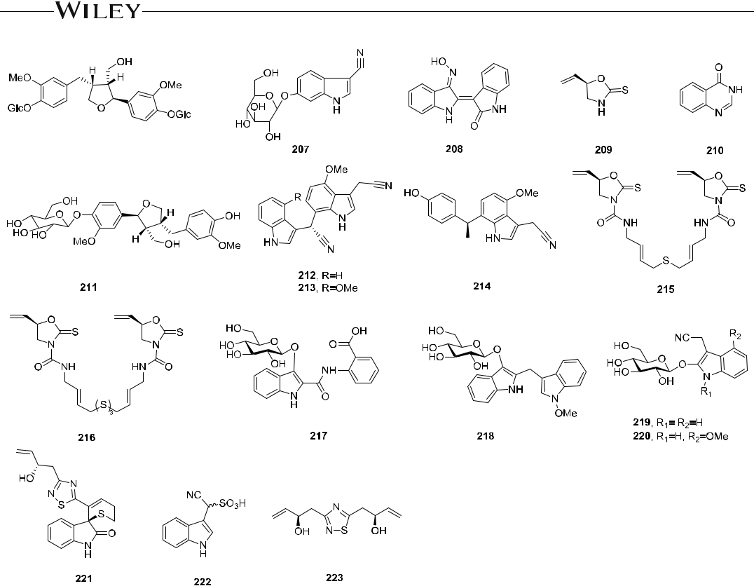

F I G U R E 20 The chemical structures isolated from BLG (206–223)

5.2.2 | Investigation on the flower buds of Lonicera japonica

The flower buds of Lonicera japonica, known as “Jin Yin Hua (JYH)” in Chinese, are a common component in TCM formulations used to treat influenza, cold, fever, and infections. It is also an important Chinese medicinal herb with a domestication history of more than 1000 years with no reported obvious side effects. Chemical and pharmacological studies of JYH extracts resulted in the discovery of caffeoyl quinic acids, secoiridoids, flavonoids, saponins, cerebrosides, polyphenols, and nitrogen‐containing iridoids.

Shi and coworkers conducted a detailed chemical study on an aqueous extract of JYH. Four new homo-secoiridoid alkaloids, lonijaposides O (224), R (225), T (226), and W (227), and the known 3,4‐di‐O‐caffeoylquinic acid (228), 3,5‐di‐O‐caffeoylquinic acid (229), and 5′ O‐methyladenosine (230), showed antiviral activity against the influenza virus A/Hanfang/359/95 (H3N2) with IC50 values of 11.6, 6.8, 10.3, 8.2, 10.2, 4.9, and 3.4 μM, and SI values of 23.0, 41.5, 16.2, 32.3, 120.3, 88.7, and 48.3, respectively (oseltamivir: IC50 = 1.3 μM, SI = 1164.2).189 In addition, chlorogenic acid (231), which is rich in JYH, alleviated inflammation and decreased virus titers in infected mouse lung tissues with limited toxicity, suggesting its potential utility in the control of influenza virus infections.190 The chemical structures of 224−231 are shown in Figure 21.

A future effective strategy for revealing active components from JYH should focus on a three‐tier strategy, including analysis of single compounds, extracted fractions, and the whole herb. A deeper examination of how identified bioactive ingredients affect disease processes may prove vital in characterizing the formulas' mechanism of action (Table 1).

|  |  |  |  |  |  |  |  |  |  |  |  |  |  |  |  |  |  |  |  |  |  |  |  |  |  |  |  |  |  |  |  |  |  |  |  |  |  |  |  |  |  |  |  |  |
| --- | --- | --- | --- | --- | --- | --- | --- | --- | --- | --- | --- | --- | --- | --- | --- | --- | --- | --- | --- | --- | --- | --- | --- | --- | --- | --- | --- | --- | --- | --- | --- | --- | --- | --- | --- | --- | --- | --- | --- | --- | --- | --- | --- | --- |
| ZHANG ET AL. | | | | |  | | | | | | | | | | | | | | | | | | | | | | | |  | | | | | | | | | | | | | 27 | | |  |
|  | | | | | | | | | | | |  |
|  |  |  |  |  |  |  |  |  |  |  |  |  |  |  |  |  |  |  |  |  |  |  |  |  |  |  |  |  |  |  |  |  |  |  |  |  |  |  |  |  |  |  |  |  |
|  |  |  |  |  |  |  |  |  |  |  |  |  |  |  |  |  |  |  |  |  |  |  |  |  |  |  |  |  |  |  |  |  |  |  |  |  |  |  |  |  |  |  |  |  |
|  |  |  |  |  |  |  |  |  |  |  |  |  |  |  |  |  |  |  |  |  |  |  |  |  |  |  |  |  |  |  |  |  |  |  |  |  |  |  |  |  |  |  |  |  |
|  |  |  |  |  |  |  |  |  |  |  |  |  |  |  |  |  |  |  |  |  |  |  |  |  |  |  |  |  |  |  |  |  |  |  |  |  |  |  |  |  |  |  |  |  |
|  |  |  |  |  |  |  |  |  |  |  |  |  |  |  |  |  |  |  |  |  |  |  |  |  |  |  |  |  |  |  |  |  |  |  |  |  |  |  |  |  |  |  |  |  |
|  |  |  |  |  |  |  |  |  |  |  |  |  |  |  |  |  |  |  |  |  |  |  |  |  |  |  |  |  |  |  |  |  |  |  |  |  |  |  |  |  |  |  |  |  |
|  |  |  |  |  |  |  |  |  |  |  |  |  |  |  |  |  |  |  |  |  |  |  |  |  |  |  |  |  |  |  |  |  |  |  |  |  |  |  |  |  |  |  |  |  |

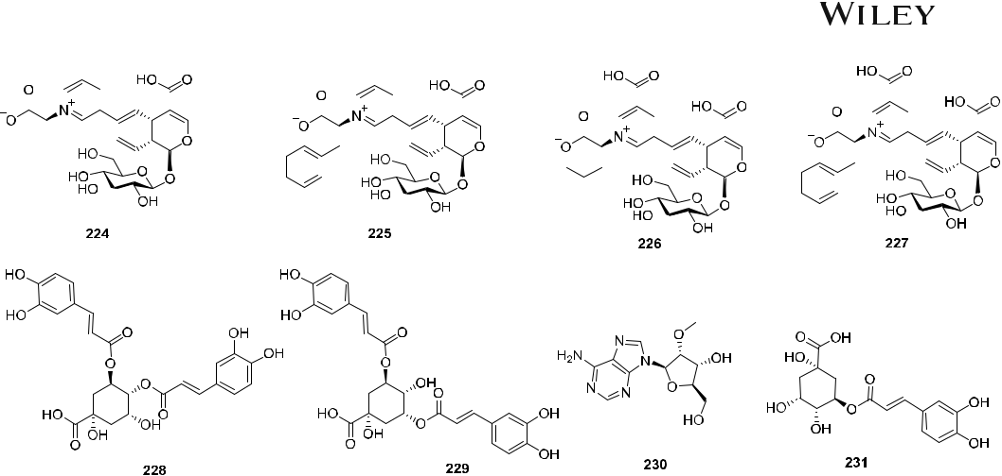

F I G U R E 21 The chemical structures isolated from JYH (224–231)

5.3 | Anti‐influenza Fufang from TCM

In TCM, Fufang refers to a group of therapeutic constituents derived from multiple plants, mineral, or occasionally animal sources. To study the efficacy and anti‐influenza activity of combinatorial formulas, several classical ancient prescriptions were chosen as test cases, such as Lianhuaqingwen capsule, Re Du Ning, HuangliangXiangru Decoction, Yi‐Zhi‐Hao pellet, Jinchai capsules, and others. Table 2 summarizes possible targets of prescriptions from TCM when treating influenza. Detailed critical discussions of the studies on two classic prescriptions are also provided.

5.3.1 | Anti‐influenza study on Lianhuaqingwen capsule (LH‐C)

LH‐C combines ingredients extracted from 13 natural herb medicines, including Fructus Forsythiae, Flos Lonicerae, Radix Glycyrrhizae, Radix Isatidis, Gypsum Fibrosum, Herba Ephedrae, Rhizoma Rhei, Heba Menthae, Dryopteridis Crassirhizomatis, Rhodiolae Crenulatae, Herba Pogostemonis, Herba Houttuyniae, Semen Armeniacae, based on two TCM prescriptions, MaxinShigan Tang and Yinqiao San, as originally described in two classic Chinese books, ShanghanLun from the Han Dynasty and Wenbing Tiaobian from the Qing Dynasty.

As a classical TCM prescription for respiratory diseases, LH‐C is the only approved medicine for the treatment of SARS and influenza and has been widely used as a broad‐spectrum antiviral agent in clinical practice. It inhibited viral propagation of several influenza viruses, regulated immune function, and achieved comparable therapeutic effectiveness to oseltamivir in reducing the course of H1N1 virus infection. Thus, LH‐C might be an alternative therapeutic option to treat influenza virus infection. Notably, the anti‐influenza activity of LH‐C in infected mice might depend on the regulation of cytokines, particularly in cytokine storm associated cytokines, such as IP‐10, MCP‐1, MIP1A, and tumor necrosis factor α (TNF‐α).191‐193 In another in vivo study, LH‐C protected Balb/C mice infected with IAV, based on survival rate and survival time.194 Ding and coworkers studied the therapeutic effectiveness of LH‐C and found that it inhibited the in vitro proliferation of influenza viruses of various strains, including H7N9, with IC50 values ranging from 0.35 to 2 mg/ml. Related mechanism studies indicated that LH‐C inhibited virus shedding, suppressed virus‐induced NF‐κB activation, lessened virus‐induced gene expression of IL‐6, IL‐8, TNF‐α, IP‐10, and MCP‐1 in a dose‐dependent manner, efficiently reduced the nuclear export of the viral RNP, and decreased the level of inflammatory cytokines in the early stages of infection. These results indicated that LH‐C exerted its anti‐influenza activity by regulating the immune response to interfere with both viral and host reactions.35

|  |  |  |  |  |  |  |
| --- | --- | --- | --- | --- | --- | --- |
| 28 | |  |  |  |  | ZHANG ET AL. |  |
|  |  |  |  |  |
|  |  |  | | | |  |
| T A B L E 1 Anti‐influenza virus effects of pure active natural products and derivatives | | | | | |  |
|  |  |  |  |  |  |  |
| Compounds | | | Source | Function | IC50/EC50/TC50/SI |  |
|  |  |  |  |  |  |  |
| Valtrate (3)40 | | | Valerianae officinalis | A/WSN/33 (H1N1) | IC50 = 0.19 μM, SI = 180 |  |
|  |  |  |  |  |  |  |
| Compounds 6–843 | | | Derivatives of 5 | A/WSN/33 (H1N1) | IC50 = 39.5–45.2 μM |  |
| Patchouli alcohol (9)44‐46 | | | Pogostemon cablin | Leningrad/134/17/ | IC50 = 4.03 ± 0.23 μM, CC50 > 20 |  |
|  |  |  |  | 1957 (H2N2) |  |  |
|  |  |  |  | A/PR/8/34 (H1N1) | IC50 = 2.635 μM |  |
|  |  |  |  | B/Ibaraki/2/85 | IC50 = 40.82 μM |  |
|  |  |  |  |  |  |  |
| Compound 1148 | | | Derivative of 10 | A3/jifang/90/15 | IC50 = 0.5 µM, TC50 = 18.9 µM |  |
| Compound 1249 | | | Derivative of 10 | H3N2 | IC50 = 0.97 µM |  |
|  |  |  |  | H1N1 | IC50 = 0.42 µM, TC50 = 27.1 µM |  |
|  |  |  |  |  |  |  |
| Compound 1350 | | | Derivative of 10 | B/jifang/97/13 (IBV) | IC50 = 3.77 μM |  |
| Compound 1650 | | | Derivative of 10 | B/jifang/97/13 (IBV) | IC50 = 5.17 μM |  |
|  |  |  |  |  |  |  |
| Compound 1850 | | | Derivative of 10 | B/jifang/97/13 (IBV) | IC50 = 8.98 μM |  |
| Compound 2051 | | | Curcuma wenyujin | A//Guangdong/219/ | IC50 = 6.80 ± 0.13 µM, |  |
|  |  |  |  | 2006 (H1N1) | TC50 = 65.35 ± 3.97 µM |  |
|  |  |  |  |  |  |  |
| Reynoudiol (21)52 | | | Reynoutria japonica | A/PR/8/34 (H1N1) | IC50 = 0.29 ± 0.01 μM, CC50 > 50 µM, |  |
|  |  |  |  |  | TI = 172.4 |  |
|  |  |  |  |  |  |  |
| Eudesm‐1β,6α,11‐ | | | Phellinus ignarius | H5N1 | IC50 = 0.657 μM, CC50 = 85.39 µM, |  |
| triol (22)53 | | |  |  | SI = 609 |  |
|  |  |  |  |  |  |  |
| Compounds 24–2655 | | | Artabotrys | A/Hanfang/359/ | IC50 = 19.24−33.33 μM, SI > 3.0 |  |
|  |  |  | hexapetalus | 95 (H3N1) |  |  |
|  |  |  |  |  |  |  |
| Phomanolide (27)56 | | | Fungus Phoma sp. | A/PR/8/34 (H1N1) | IC50 = 12.5 ± 2.7 μM, |  |
|  |  |  |  |  | CC50 = 438.00 ± 9.12 µM |  |
|  |  |  |  |  |  |  |
| 7‐Dehydroabietanone (29)58 | | | Fraxinus sieboldiana | A/Viet Nam/1203/ | IC50 = 4.8 μM |  |
|  |  |  |  | 2004 (H5N1) |  |  |
|  |  |  |  |  |  |  |
| Dugesin F (30)59 | | | Salvia dugesii | Influenza virus FM1 | IC50 = 26.4 μM, TC50 = 128.3 μM, |  |
|  |  |  |  | strain | TI = 4.84 |  |
|  |  |  |  |  |  |  |
| Wickerol A (31)60 | | | Fungus Trichoderma | A/PR/8/34, A/WSN/ | IC50 = 0.24 μM, CC50 = 240 μM, SI = 100 |  |
|  |  |  | atroviride | 33 (H1N1) |  |  |
|  |  |  | FKI‐3849 |  |  |  |
| Wickerol B (32)60 | | | Fungus Trichoderma | A/PR/8/34 (H1N1) | IC50 = 16.3 μM |  |
|  |  |  | atroviride |  |  |  |
|  |  |  | FKI‐3849 |  |  |  |
|  |  |  |  |  |  |  |
| Podocarpic acid (37)62 | | | Podocarpus totara | A/PR/8/34 (H1N1) | EC50 = 18.2 μM, CC50 > 40 μM |  |
| Compound 38–4062 | | | Derivatives of 37 | A/PR/8/34 (H1N1) | EC50 = 0.14, 0.16, 1.59 µM |  |
|  |  |  |  |  |  |  |
| Betulinic aldehyde (41)63 | | | Alnus japonica | KBNP‐0028 (H9N2) | EC50 = 28.4 μM, CC50 = 53.1 μM |  |
| Betulinic acid (42)64 | | | Zizyphus jujuba | A/PR/8/34 (H1N1) | IC50 = 50 µM |  |
|  |  |  |  |  |  |  |
| Ganoderic acid T‐Q (46) 67 | | | Ganoderma lingzhi | H1N1, H5N1 | IC50 = 5.6 ± 1.9, 1.2 ± 1.0 μM, |  |
|  |  |  |  |  | CC50 = 28.2 ± 0.8 μM |  |
| Ganoderic acid TR (47)67 | | | Phellinus ignarius | H1N1, H5N1 | IC50 = 4.6 ± 1.7, 10.9 ± 6.4 μM, |  |
|  |  |  |  |  | CC50 = 91.6 ± 3.4 μM |  |
|  |  |  |  |  |  |  |
| Compounds 48–5168 | | | Lyonia ovalifolia | A/95–359 (H1N1) | IC50 = 2.1–11.1 μM |  |
|  |  |  |  |  |  |  |



|  |  |  |  |  |  |  |  |  |
| --- | --- | --- | --- | --- | --- | --- | --- | --- |
| ZHANG ET AL. |  |  |  |  |  |  | | 29 |  |
|  |  |  |  |  |  |
| T A B L E 1 (Continued) |  |  |  |  |  |  |  |  |
|  |  |  |  |  |  |  |  |
|  |  |  |  |  |  |  |  |  |
| Compounds | Source | | | Function | IC50/EC50/TC50/SI | | |  |
|  |  |  |  |  |  |  |  |  |
| Nepasaikosaponin k (52)69 | Bupleurum | | | A/WSN/33 (H1N1) | EC50 = 17.91 μM, SI = 11.17 | | |  |
|  |  |  | marginatum var. |  |  |  |  |  |
|  |  |  | stenophyllum |  |  |  |  |  |
|  |  |  |  |  |  |  |  |  |
| Saikosaponin n (53)69 | Bupleurum | | | A/WSN/33 (H1N1) | EC50 = 7.67 μM, SI = 20.8 | | |  |
|  |  |  | marginatum var. |  |  |  |  |  |
|  |  |  | stenophyllum |  |  |  |  |  |
|  |  |  |  |  |  |  |  |  |
| Saikosaponin h (54)69 | Bupleurum | | | A/WSN/33 (H1N1) | EC50 = 10.09 μM, SI = 19.82 | | |  |
|  |  |  | marginatum var. |  |  |  |  |  |
|  |  |  | stenophyllum |  |  |  |  |  |
|  |  |  |  |  |  |  |  |  |
| Compound 5570 | Burkea africana | | | A/Jena/8178/09 (H1N1); | IC50 = 0.05 μM, CC50 = 1.5 ± 0.80 μM | | |  |
|  |  |  |  | HK/68 (H3N2) |  |  |  |  |
|  |  |  |  |  |  |  |  |  |
| Compound 5670 | Burkea africana | | | A/Jena/8178/09 (H1N1); | IC50 = 0.27 μM, CC50 = 1.5 ± 0.80 μM | | |  |
|  |  |  |  | HK/68 (H3N2) |  |  |  |  |
|  |  |  |  |  |  |  |  |  |
| Compounds 57 and 5871 | Rhododendron | | | A/95–359 (H1N1) | IC50 = 3.70, 2.57 μM, | | |  |
|  |  |  | latoucheae |  |  |  |  |  |
|  |  |  |  |  |  |  |  |  |
| Trametenolic acid B (59)72 | Gloeophyllum | | | HK/68 (H3N2) | IC50 = 14.1 μM, CC50 > 100 μM | | |  |
|  |  |  | odoratum | A/Jena/8178/09 (H1N1) | IC50 = 11.3 μM | | |  |
|  |  |  |  |  |  |  |  |  |
| Compounds 60 and 6173 | Semisynthesis | | | Goose/Qinghai/59/ | IC50 = 7.22–9.25 μM | | |  |
|  |  |  |  | 05 (H5N1) |  |  |  |  |
|  |  |  |  | A/Viet Nam/1203/ |  |  |  |  |
|  |  |  |  | 2004 (H5N1) |  |  |  |  |
|  |  |  |  |  |  |  |  |  |
| Compounds 62−6575 | Semisynthesis | | | H5N1 | IC50 = 0.98–2.48 μM | | |  |
|  |  |  |  |  |  |  |  |  |
| Glycyrrhizic acid (66)78 | Glycyrrhiza glabra | | | A/pdm09 (H1N1) | Not given | | |  |
| Compound 6778 | Derivative of 66 | | | A/pdm09 (H1N1) | IC50 = 5.3 μM, CTD50 = 860.0 μM, | | |  |
|  |  |  |  |  | SI = 161 | | |  |
|  |  |  |  |  |  |  |  |  |
| Compounds 68–7379 | Derivatives of 66 | | | A/pdm09 (H1N1) | EC50 = 3.5–6.28 μM, CC50 > 200 µM, | | |  |
|  |  |  |  |  | SI = 18–71 | | |  |
|  |  |  |  |  |  |  |  |  |
| Q8 (74)80 | Semisynthesis | | | A/WSN/33 (H1N1) | EC50 = 5 μM | | |  |
|  |  |  |  |  |  |  |  |  |
| Y3 (75)80 | Semisynthesis | | | A/WSN/33 (H1N1) | EC50 = 14.2 μM, CC50 > 200 µM | | |  |
| Y5 (76)80 | Semisynthesis | | | A/WSN/33 (H1N1) | EC50 = 15.1 μM, CC50 > 200 µM | | |  |
|  |  |  |  |  |  |  |  |  |
| Compounds 7881 | Semisynthesis | | | A/WSN/33 (H1N1) | IC50 = 41.2 ± 2.9 μM | | |  |
| Compound 7982 | Semisynthesis | | | A/WSN/33 (H1N1) | IC50 = 8.3 μM, CC50 = 188.1 ± 10.1 μM | | |  |
|  |  |  |  |  |  |  |  |  |
| Compound 8082 | Semisynthesis | | | A/WSN/33 (H1N1) | IC50 = 15.5 μM, CC50 > 200 μM | | |  |
| Compound 8182 | Semisynthesis | | | A/WSN/33 (H1N1) | EC50 = 8.7 μM | | |  |
|  |  |  |  |  |  |  |  |  |
| Compounds 82–8584 | Semisynthesis | | | A/WSN/33 (H1N1) | IC50 = 5.80−9.55 μM, CC50 > 100 μM | | |  |
| Compounds 86 and 8785 | Semisynthesis | | | Vaccine adjuvants | Not given | | |  |
|  |  |  |  |  |  |  |  |  |
| Compounds 88–9086 | β‐cyclodextrin | | | A/WSN/33 (H1N1) | IC50 = 1.6−2.8 μM, CC50 > 200 μM | | |  |
|  |  |  | conjugates |  |  |  |  |  |
|  |  |  |  |  |  |  |  |  |
| Compounds 91–9387 | β‐cyclodextrin | | | A/WSN/33 (H1N1) | IC50 = 4.7 ± 0.52−9.9 ± 0.79 μM | | |  |
|  |  |  | conjugates |  |  |  |  |  |
|  |  |  |  |  |  |  |  |  |
| Aloe‐emodin (94)88 | Cassia roxburghii | | | A/WSN/33 (H1N1) | IC50 = 8.4 μM, CC50 = 1.9 μM | | |  |
|  |  |  |  |  |  |  |  |  |



(Continues)

|  |  |  |  |  |  |  |
| --- | --- | --- | --- | --- | --- | --- |
| 30 | |  |  |  |  | ZHANG ET AL. |  |
|  |  |  |  |  |
|  |  |  |  |  |  |  |
| T A B L E 1 (Continued) | | |  |  |  |  |
|  |  |  |  |  |  |  |
| Compounds | | | Source | Function | IC50/EC50/TC50/SI |  |
|  |  |  |  |  |  |  |
| Aloe‐emodin acetate (95)88 | | | Cassia roxburghii | A/WSN/33 (H1N1) | IC50 = 36.5 μM, CC50 = 4.7 μM |  |
|  |  |  |  |  |  |  |
| Compounds 98–10190 | | | Nigrospora sp. | A/PR/8/34 (H1N1) | IC50 = .46, 26.1, 25.7, 2.53 μM, |  |
|  |  |  | YE3033 |  | CC50 = 584 μM |  |
| Compounds 104 and 10591 | | | Derivatives of 102 | A/Yucatán/2370/09 | IC50 = 30.77, 13.70 μM |  |
|  |  |  | and 103 |  |  |  |
|  |  |  |  |  |  |  |
| Curcumin (106)92 | | | Curcuma longa | HA inhibitor | EC50 = 0.47 μM, SI = 92.5 |  |
| Katsumadain A (107)93 | | | Alpinia katsumadai | A/PR/8/34 (H1N1) | IC50 = 1.05 ± 0.42 μM, CC50 = 66.9 μM |  |
|  |  |  |  |  |  |  |
| Compound 10894 | | | Alpinia officinarum | A/PR/8/34 (H1N1) | EC50 = 9.35 ± 0.96 μM, |  |
|  |  |  |  |  | CC50 = 199.5 ± 10.0 μM |  |
| Compound 10994 | | | Alpinia officinarum | A/PR/8/34 (H1N1) | EC50 = 2.35 ± 1.00 μM |  |
|  |  |  |  |  |  |  |
| Platyphyllone (110)96 | | | Alnus japonica | KBNP‐0028 (H9N2) | EC50 = 29.9 ± 2.5 μM, CC50 > 796 μM, |  |
|  |  |  |  |  | SI > 26.6 |  |
|  |  |  |  |  |  |  |
| Compound 11398 | | | Zanamivir (ZA) | NA inhibitor (N2 and N1) | IC50 = 7.2, 8.5 µM |  |
|  |  |  | conjugates |  |  |  |
|  |  |  |  |  |  |  |
| Compounds 114–11699 | | | Caffeoylquinic acid | A/Beijing/7/ | IC50 = 2.34, 1.06, 19.88 μM, |  |
|  |  |  | derivatives | 2009 (H1N1) | CC50 = 138 μM |  |
| Arctigenin (118)101 | | | Arctium lappa | A/WSN/33 (H1N1) | IC50 = 2.9 μM, SI = 16 |  |
|  |  |  |  |  |  |  |
| Compound 119103 | | | Calotropis gigantea | A/PR/8/34 and A/FM/1/ | IC50 = 13.4 μM, SI = 3.7 |  |
|  |  |  |  | 47 (H1N1), A/Aichi/ | IC50 = 39.8 μM, SI = 11.4 |  |
|  |  |  |  | 2/68 (H3N2), |  |  |
|  |  |  |  | B/Lee/1940 |  |  |
|  |  |  |  |  |  |  |
| Compound 120104 | | | High throughput | H1N1 | IC50 = 4.5 μM, CC50 > 25 μM |  |
|  |  |  | screening |  |  |  |
|  |  |  |  |  |  |  |
| Compound 121104 | | | Derivative of 120 | H1N1 IAV (H3N2) | IC50 = 70 nM |  |
|  |  |  |  | IBV | IC50 40–150 nM |  |
| BPR2‐D2 (122)105 | | | High throughput | H1N | EC50 = 0.043 ± 0.001 μM |  |
|  |  |  | screening |  |  |  |
|  |  |  |  |  |  |  |
| Glycyrol (123)106 | | | Glycyrrhiza uralensis | HA inhibitor | IC50 = 3.1 μM |  |
| Strobilanthes A (124)107 | | | Cassia roxburghii | A/PR/8/34 (H1N1) | IC50 = 29.2 ± 5.8 μM, |  |
|  |  |  |  |  | CC50 = 474.0 ± 6.4 μM, SI = 16.2 |  |
|  |  |  |  |  |  |  |
| Pentagalloylglucose (125)108 | | | Mangifera indica | A/WSN/33 (H1N1) | EC50 = 2.51 ± 0.31 μM, SI = 12.54 |  |
|  |  |  |  | A/RI/5+/1957 (H2N2) | IC50 = 11.9 μM |  |
| Compound 126109 | | | Mangifera indica | A/RI/5+/1957 (H2N2) | IC50 = 9.2 μM |  |
|  |  |  |  |  |  |  |
| Eugeniin (127)110 | | | Flos Caryophylli | NA inhibitor (H1N1) | IC50 = 8.4 μM |  |
| Compound 128111 | | | Euphorbia humifusa | A/California/07/ | IC50 = 0.11 μM |  |
|  |  |  |  | 2009 (H1N1) |  |  |
|  |  |  |  | A/Perth/16/ | IC50 = 0.04 μM |  |
|  |  |  |  | 2009 (H3N2) |  |  |
|  |  |  |  | B/Florida/04/2006 | IC50 = 3.63 μM |  |
|  |  |  |  |  |  |  |
| Isocorilagin (129)112 | | | Canarium album | A/PR/8/34 (H1N1) | IC50 = 8.52 ± 1.53 μM |  |
| Compounds 131–133113 | | | Derivative of 130 | A/PR/8/34 (H1N1) | IC50 = 10.67 ± 0.31−49.60 ± 4.74 μM, |  |
|  |  |  |  | A/Sydney/5/97 (H3N2) | CC50 = 76.7 μM |  |
|  |  |  |  | Jiangsu/10/2003 |  |  |



|  |  |  |  |  |  |  |
| --- | --- | --- | --- | --- | --- | --- |
| ZHANG ET AL. |  |  |  |  | | 31 |  |
|  |  |  |  |
| T A B L E 1 (Continued) |  |  |  |  |  |  |
|  |  |  |  |  |  |
|  |  |  |  |  |  |  |
| Compounds | Source | Function | IC50/EC50/TC50/SI | | |  |
|  |  |  |  |  |  |  |
| Viniferol C (134)114 | Vitis amurensis | A/PR/8/34 (H1N1) | IC50 = 8.94 μM | | |  |
| Amurensin K (135)114 | Vitis amurensis | Swine‐origin H1N1 | IC50 = 14.43 μM | | |  |
|  |  |  |  |  |  |  |
| Vitisin B (136)114 | Vitis amurensis | Oseltamivir‐resistant | IC50 = 23.89 μM | | |  |
|  |  | novel H1N1 (H274Y) |  |  |  |  |
|  |  |  |  |  |  |  |
| Dryocrassin ABBA (137)115 | Dryopteris | H5N1 | IC50 = 18.59 ± 4.53 µM | | |  |
|  | crassirhizoma |  |  |  |  |  |
|  |  |  |  |  |  |  |
| Filixic acid ABA (138)115 | Dryopteris | H5N1 | IC50 = 29.57 ± 2.48 μM | | |  |
|  | crassirhizoma |  |  |  |  |  |
|  |  |  |  |  |  |  |
| Compounds 139–142116 | Gnetum pendulum | NA inhibitor | IC50 = 1.38 to 23.32 μM | | |  |
|  |  |  |  |  |  |  |
| Compound 143117 | Erythrina addisoniae | H1N1 | IC50 = 29.33 ± 1.13 μM | | |  |
|  |  | H9N2 | IC50 = 23.96 ± 1.33 μM | | |  |
| Inoscavin A (144)118 | Phellinus baumii | NA inhibitor | IC50 = 22.6 μM, TI = 4.4 | | |  |
|  |  |  |  |  |  |  |
| Phelligridin D (145)118 | Phellinus baumii | NA inhibitor | IC50 = 24.6 μM | | |  |
| Compound 146119 | Cleistocalyx | H1N1 (H274Y | IC50 = 3.31 ± 1.34, 8.15 ± 1.05 μM, | | |  |
|  | operculatus | mutant, WT) | CC50 > 120 μM | | |  |
|  |  |  |  |  |  |  |
| 3‐deoxysappanchalcone | Caesalpinia sappan | H3N2 | IC50 = 3.92 μM, CC50 = 17.25 μM | | |  |
| (149)121 |  |  |  |  |  |  |
| Compounds 150 and 151123 | Cleistocalyx | Broad‐spectrum | IC50 = 5.07 ± 0.94, 9.34 ± 2.52 μM | | |  |
|  | operculatus |  |  |  |  |  |
|  |  |  |  |  |  |  |
| Tricin (152)124 | Sasa albo‐marginata | A/Narita/1/2009 | EC50 = 8.2 μM | | |  |
|  |  | (H1N1pdm) |  |  |  |  |
|  |  | A/NCalifornia/07/2009 | IC50 = 10.2 μM | | |  |
|  |  | (H1N1pdm) |  |  |  |  |
|  |  | H3N2 | EC50 = 3.4 μM | | |  |
|  |  | IBV | EC50 = 4.9 μM, CC50 > 20 μM | | |  |
| Compounds 153–156125 | Mosla scabra | A/PR/8/34 (H1N1) | IC50 = 4.96–7.79 μM, | | |  |
|  |  |  | CC50 = 512.08–761.26 μM | | |  |
|  |  |  |  |  |  |  |
| Luteolin (157)126 | Papaver rhoeas Bee | H1N1, H5N1, and H3N2 | IC50 = 10.7, 12.6, 25.6 μM, | | |  |
|  | pollen |  | CC50 > 100 μM | | |  |
| Compound 158127 | Not given | A/PR/8/34 (H1N1) | IC50 = 23 μM | | |  |
|  |  |  |  |  |  |  |
| Compounds 159–163128 | Scutellaria | A/PR/8/34 (H1N1) | IC50 = 7.4, 7.5, 2.1, 7.7, 12.8 μM | | |  |
|  | baicalensis |  |  |  |  |  |
|  |  |  |  |  |  |  |
| Compounds 164–168130 | Derivatives of 160 | Oseltamivir‐resistant | EC50 = 4.0−4.5 μM, SI > 70 | | |  |
|  |  | (H1N1 TR) |  |  |  |  |
|  |  |  |  |  |  |  |
| Quercetin (169)226 | Not given | A/PR/8/34 (H1N1) | IC50 = 27.11 ± 3.83 μM | | |  |
|  |  | A/FM‐1/47/1 (H1N1) | IC50 = 21.76 ± 1.63 μM | | |  |
|  |  | A/Aichi/2/68 (H3N2) | IC50 = 9.57 ± 6.75 μM | | |  |
| Compound 173133 | Derivative of 172 | Oseltamivir‐resistant | EC50 = 29.0 μM, SI > 10.3 | | |  |
|  |  | (H1N1 TR) |  |  |  |  |
|  |  |  |  |  |  |  |
| Quercetin (174)134 | Campylotropis | NA inhibitor | IC50 = 16.76 μM | | |  |
|  | hirtella |  |  |  |  |  |
|  |  |  |  |  |  |  |
| Compounds 175 and 176131 | Thalassodendron | A/WSN/33 (H1N1) | IC50 = 4.44, 3.21 μM, CC50 = 7.46, | | |  |
|  | ciliatum |  | 5.14 μM | | |  |



(Continues)

|  |  |  |  |  |  |  |  |
| --- | --- | --- | --- | --- | --- | --- | --- |
| 32 | | |  |  |  |  | ZHANG ET AL. |  |
|  |  |  |  |  |
|  | |  |  |  |  |  |  |
| T A B L E 1 (Continued) | | | |  |  |  |  |
|  | |  |  |  |  |  |  |
| Compounds | | | | Source | Function | IC50/EC50/TC50/SI |  |
|  | |  |  |  |  |  |  |
| Matteflavoside G (178)136 | | | | Matteuccia | H1N1 | EC50 = 6.8 ± 1.1 μM, SI = 34.4 |  |
|  |  |  |  | struthiopteris |  |  |  |
|  | |  |  |  |  |  |  |
| Quercetin‐7‐O‐glucoside | | | | Dianthus superbus | A/PR/8/34, A/Vic/3/75, | IC50 = 6.45, 13.77, 17.06, 10.77 μM; |  |
|  | (179)137 | |  |  | B/Lee/40, and B/ | CC50 > 200 μM |  |
|  |  |  |  |  | Maryland/1/59 |  |  |
|  | |  |  |  |  |  |  |
| Compounds 181–184140 | | | | Derivatives of 180 | A/PR/8/34 (H1N1) | IC50 = 29.01, 30.75, 1.69, 2.96 μM |  |
|  |  |  |  |  |  | CC50 = 134.27, 755.84, 141.26, |  |
|  |  |  |  |  |  | 198.63 μM |  |
| Compounds 185–191141 | | | | Penicillium | H1N1 | IC50 = 28.3, 6.6, 17.7, 38.9, 32.2, 34.1, |  |
|  |  |  |  | camemberti |  | 26.2 μM |  |
|  |  |  |  | OUCMDZ‐1492 |  |  |  |
|  | |  |  |  |  |  |  |
| Lycorine (192)142 | | | | Lycoris radiate | H5N1 | EC90 = 0.52 μM, CC50 = 20.9 ± 0.07 μM |  |
| Hemanthamine (193)142 | | | | Lycoris radiata | H5N1 | EC90 = 4.15 μM, CC50 = 50.0 ± 0.12 μM |  |
|  | |  |  |  |  |  |  |
| Homonojirimycin (194)143 | | | | Commelina | A/PR/8/34 (H1N1) | EC50 = 10.4 μM, SI = 17.9 |  |
|  |  |  |  | communis |  |  |  |
|  | |  |  |  |  |  |  |
| Aloperine (195)145 | | | | Sophora species | A/PR/8/34 (H1N1) | EC50 = 14.5 μM, CC50 > 80 μM |  |
|  | |  |  |  |  |  |  |
| Dihydroaloperine (196)145 | | | | Derivative of 195 | A/PR/8/34 (H1N1) | EC50 = 11.2 μM |  |
| Compounds 197, 198145 | | | | Derivative of 195 | A/PR/8/34 (H1N1)) | EC50 = 2.4, 6.2 μM |  |
|  | |  |  |  |  |  |  |
| 2(3H)‐Benzoxazolinone | | | | Strobilanthes cusia | A/PR/8/34 (H1N1) | IC50 = 46.0 ± 8.4 μM, |  |
|  | (200)107 | |  |  |  | CC50 = 51.2 ± 10.9 μM, SI = 7.6 |  |
| Dendrobine (201)147 | | | | Dendrobium nobile | A/FM‐1/1/47 (H1N1) | IC50 = 12.89 ± 1.21 μM |  |
|  |  |  |  |  | A/PR/8/34 | IC50 = 8.21 ± 3.46 μM |  |
|  |  |  |  |  | H274Y (H1N1) |  |  |
|  |  |  |  |  | A/Aichi/2/68 (H3N2) | IC50 = 20.22 ± 6.87 μM |  |
|  | |  |  |  |  |  |  |
| Herquline A (202)148 | | | | Penicillium herquei | A/PR/8/34 (H1N1) | IC50 = 31.84 μM |  |
|  |  |  |  | FKI‐7215 |  |  |  |
| ZBMD‐1 (203)149 | | | | High throughput | H1N1 and H3N2 | IC50 = 0.41−1.14 μM, CC50 > 100 μM |  |
|  |  |  |  | screening |  |  |  |
|  | |  |  |  |  |  |  |
| Tanguticuline A (204)150 | | | | Aconitum | H1N1 | IC50 = 8.40 μM, TI = 3.81 |  |
|  |  |  |  | tanguticum |  |  |  |
|  | |  |  |  |  |  |  |
| Tanguticuline E (205)150 | | | | Aconitum | H1N1 | IC50 = 6.99 μM, TI = 9.44 |  |
|  |  |  |  | tanguticum |  |  |  |
|  | |  |  |  |  |  |  |
| Compounds 212‐214182 | | | | Isatis indigotica | A/Hanfang/359/ | IC50 = 3.70–12.35 μM, SI = 2.2–4.0 |  |
|  |  |  |  |  | 95 (H3N2) |  |  |
|  | |  |  |  |  |  |  |
| Isatithioetherin B (215)183 | | | | Isatis indigotica | A/Hanfang/359/ | IC50 = 0.60 μM |  |
|  |  |  |  |  | 95 (H3N2) |  |  |
|  | |  |  |  |  |  |  |
| Isatithioetherin D (216)183 | | | | Isatis indigotica | A/Hanfang/359/ | IC50 = 1.92 μM |  |
|  |  |  |  |  | 95 (H3N2) |  |  |
|  | |  |  |  |  |  |  |
| Compounds 217‐223184‐188 | | | | Isatis indigotica | A/Hanfang/359/ | IC50 = 12.6–33.3 μM |  |
|  |  |  |  |  | 95 (H3N2) |  |  |
|  | |  |  |  |  |  |  |
| Compounds 224‐231189 | | | | Lonicera japonica | A/Hanfang/359/ | IC50 = 11.6, 6.8, 10.3, 8.2, 10.2, 4.9, |  |
|  |  |  |  |  | 95 (H3N2) | 3.4 μM; SI = 23.0, 41.5, 16.2, 32.3, |  |
|  |  |  |  |  |  | 120.3, 88.7, 48.3 |  |
|  |  |  |  |  |  |  |  |



T A B L E 2 Anti‐influenza prescriptions from traditional Chinese medicine

|  |
| --- |
| ZHANG |



Prescriptions

Lianhuaqingwen

Capsule35,191‐194

|  |  |  |  |
| --- | --- | --- | --- |
| Symptoms or therapeutic effect | Mechanism of action | Basic composition | Side effects |
| Cough, sore throat, fever, and | It inhibited virus shedding, suppressed virus‐ | Fructus Forsythiae, Flos Lonicerae, Radix | Not reported |
| fatigue | induced NF‐κB activation, lessened virus‐ | Glycyrrhizae, Radix Isatidis, Gypsum |  |
|  | induced gene expression of IL‐6, IL‐8, TNF‐α, | Fibrosum, Herba Ephedrae, Rhizoma |  |
|  | IP‐10, and MCP‐1 in a dose‐dependent | Rhei, Heba Menthae, Dryopteridis |  |
|  | manner, efficiently reduced the nuclear | Crassirhizomatis, Rhodiolae |  |
|  | export of the viral RNP, and decreased the | Crenulatae, Herba Pogostemonis, |  |
|  | level of inflammatory cytokines in the early | Herba Houttuyniae, Semen |  |
|  | stages of infection | Armeniacae. |  |

|  |
| --- |
| ET AL. |

|  |  |  |  |  |
| --- | --- | --- | --- | --- |
| Re Du Ning195‐197 | Cold, cough, acute upper respiratory | It downregulated the activation of NF‐κB, | Artemisiae annuae, | Allergic reactions such as |
|  | infection, and acute bronchitis; | reduced the expression of pro‐ | Gardenia jasminoides, | systemic redness, pruritus |
|  | anti‐inflammatory, anti‐influenza, | inflammatory cytokines, and increased | Flos Lonicerae | or rash; Dizziness, chest |
|  | and pneumonia | the expression of IFITM3 mRNA via the |  | tightness, dry mouth, |
|  |  | mitochondrial antiviral‐signaling |  | diarrhea, nausea and |
|  |  | protein (MAVS) |  | vomiting |
|  |  |  |  |  |
| Jinchai capsule198 | Cough, fever, anti‐inflammatory, | It prevented the virus from adsorbing to the | Flos lonicerae, Radix bupleuri, Radix | Not reported |
|  | anti‐influenza | cell wall and fusing with the cell | astragali, Radix codonopsis |  |
|  |  | membranes in the early stages of |  |  |
|  |  | infection as well as inhibited the viral |  |  |
|  |  | replication and transcription |  |  |
|  |  |  |  |  |
| Huangliang Xiangru | Cold in summer and summer heat‐ | It improved the body's immunity function and | Moslae chinensis, | Not reported |
| Decoction199 | dampness; antimicrobic and | antioxidant capacity as well as | Magnoliae officinalis, |  |
|  | antiviral | downregulated TLR7, the TLR3 signaling | Coptidis chinensis, |  |
|  |  | pathway, and the host's TLRs pathway |  |  |
|  |  |  |  |  |
| Kang Bing Du oral | Epidemic encephalitis B, mild | It enhanced the protein expression of MAVS | Isatis indigotica, Phragmites communis, | Not reported |
| liquid200 | childhood hand‐foot‐mouth |  | Rehmannia glutinosa, Curcuma |  |
|  | disease, acute upper respiratory |  | wenyujin, Anemarrhena |  |
|  | infection, and pneumonia |  | asphodeloides, Acorus tatarinowii, |  |
|  |  |  | Pogostemon cablin, Forsythia |  |
|  |  |  | suspensa |  |
|  |  |  |  | (Continues) |

|  |
| --- |
| | 33 |

T A B L E 2 (Continued)

|  |  |  |  |  |
| --- | --- | --- | --- | --- |
| Prescriptions | Symptoms or therapeutic effect | Mechanism of action | Basic composition | Side effects |
|  |  |  |  |  |
| Compound Yi‐Zhi‐ | Cold; antiviral | It prevented viral RNA and protein | Isatis Tinctoria | Not reported |
| Hao pellet201 |  | expression and induced Nrf2 and NF‐κB | Artemisia Rupestris |  |
|  |  | activation, which then enhanced | Isatis Tinctoria, |  |
|  |  | hemeoxygenase‐1 (HO‐1) expression. It |  |  |
|  |  | also protected cells from the oxidative |  |  |
|  |  | damage caused by reactive oxygen |  |  |
|  |  | species (ROS) |  |  |
|  |  |  |  |  |

|  |
| --- |
| 34 | |



Guizhi‐Mahuang Cold, fever, detoxify, respiratory‐ They effectively reduced transcription and

decoction202,203 tract infections, and allergies translation levels of components in the

viral TLR7/NF‐κB signaling pathway to

improve inflammation and promote viral

clearance

Ephedra intermedia, Cinnamomum cassia, Not reported Prunus armeniaca, Glycyrrhiza

uralensis, Paeonia lactiflora, Zingiber

officinale, Ziziphus jujuba

|  |  |  |  |  |
| --- | --- | --- | --- | --- |
| Yinqiao powder202 | Cold, fever, detoxify, respiratory‐ | They effectively reduced transcription and | Forsythia suspensa, Lonicera japonica, | Not reported |
|  | tract infections, and allergies | translation levels of components in the | Platycodon grandifloras, Mentha |  |
|  |  | viral TLR7/NF‐κB signaling pathway to | haplocalyx, Lophatherum gracile, |  |
|  |  | improve inflammation and promote viral | Glycyrrhiza uralensis, Schizonepeta |  |
|  |  | clearance | tenuifolia, Glycine max, Arctium |  |
|  |  |  | lappa, Phragmites communis |  |
|  |  |  |  |  |
| San Wu Huangqin | Colds and fever | Its blocked the proliferation and replication | Sophora flavescens, Scutellaria baicalensis | Not reported |
| decoction204 |  | of viral particles, mitigated lung injury, | Rehmannia glutinosa |  |
|  |  | and reduced the lung viral titers and |  |  |
|  |  | target protein expression |  |  |
|  |  |  |  |  |
| Xin‐Jia‐Xiang‐Ru‐ | Summer influenza, IAV influenza and | It elevated the expression of SOCS1 to inhibit | Mosla chinensis, Lonicera japonica | Not reported |
| Yin205 | the subsequent viral pneumonia | the uncontrolled inflammatory response | Dolichos lablab, Magnolia officinalis |  |
|  |  | and protected mice against lethal | Forsythia suspensa |  |
|  |  | influenza virus infection |  |  |
|  |  |  |  |  |
| Sheng Jiang San206 | Warm Disease, seasonal influenza | It inhibited 80% of NA enzymatic activity at | Rhei Radix et Rhizoma, Bombyx | Not reported |
|  |  | 2 mg/mL and significantly downregulated | Batryticatus, Cicadae Periostracum |  |
|  |  | TNF‐α and unregulated IL‐2 in influenza | Curcumae Longae Rhizoma |  |
|  |  | virus‐induced mice |  |  |
|  |  |  |  |  |

|  |
| --- |
| ZHANG ET AL. |

|  |  |  |  |
| --- | --- | --- | --- |
| ZHANG ET AL. |  | | 35 |  |
|  |  |
|  |  |  |  |



In December 2019, a pandemic of respiratory illness caused by a novel coronavirus named SARS‐CoV‐2 began sweeping the mainland of China. This virus soon triggered a global outbreak. It is worth mentioning that LH‐C was included in the Guideline for the Diagnosis and Treatment of Novel Coronavirus (2019‐nCoV) Pneumonia (on trials, the fourth/fifth/sixth/seventh edition) issued by the National Health Commission of the People's Republic of China, and also recommended by 20 provincial health commissions including Hubei, Beijing, and Shanghai as well as the National Administration of TCM for the treatment of COVID‐19. Yang and coworkers found that LH‐C significantly inhibited SARS‐CoV‐2 replication in Vero E6 cells and markedly reduced proinflammatory cytokine (TNF‐α, IL‐6, CCL‐2/MCP‐1 and CXCL‐10/IP‐10) production at the mRNA level. Furthermore, LH‐C treatment resulted in abnormal particle morphology of the virion in cells. These findings indicate that LH‐C protects against the virus attack, making its use a novel strategy for controlling the COVID‐19 disease.207 Although LH‐C sig-nificantly relieved the clinical symptoms of the COVID‐19, the underlying mechanism of the antiviral effects on coronavirus, especially on SARS‐COV‐2, is still elusive. At present, the side effects of LH‐C have not been reported.

5.3.2 | Anti‐influenza study on RDN

Another Fufang from TCM is the patented Chinese medicine Re Du Ning (RDN), which is prepared from the extracts of Herba Artemisi aeannuae, Gardenia jasminoides Ellis, and Flos Lonicerae. RDN has been widely used as an antipyretic and anti‐inflammatory drug to treat cold, cough, acute upper respiratory infection, and acute bronchitis. It also showed effects in the clinical therapy of influenza and pneumonia.195,196 Tang and coworkers investigated the protective effects of RDN against influenza and found significant reductions in mortality, mean dead day, and NP gene levels in the lung. Thus, RDN decreased the susceptibility and severity of influenza virus infection in restraint‐stressed mice. Mechanistically, RDN downregulated the activation of NF‐κB, reduced the expression of proinflammatory cytokines, and increased the expression of IFITM3 mRNA via the mitochondrial antiviral‐signaling protein. These findings suggest that the anti‐influenza effects of RDN are associated with its ability to adjust the unbalanced homeostasis caused by a stress response and are not related to direct antivirus activity.197 Regarding its side effects, a few patients experienced dizziness, chest tightness, dry mouth, diarrhea, nausea and vomiting (also see Table 2).

5.4 | Anti‐influenza herbal extracts from TCM

Table 3 lists the details on crude extracts from herbals with anti‐influenza activity (IC50 values below 100 μM or 100 μg/ml), as published over the past 10 years.

Extracts displaying desirable activities are in most cases subjected to a bioassay‐guided fractionation with the goal to identify the active principle(s). In the course of this process, the individual bioactive components re-sponsible for the given effects can ideally be traced down to a molecular level, allowing structure elucidation. This strategy represents one of the classical lead finding methods especially applied by academic research groups. The above results provide highly valuable data for further selection and processing of promising plant material, for example, in the course of bioassay‐guided fractionations.

6 | CONCLUDING REMARKS

Despite the recent advances in influenza therapies, the rapid spread of influenza virus still greatly threatens millions of lives worldwide. Moreover, due to antigenic shift and drift, new influenza virus strains emerge that are resistant to presently approved antiviral medications. Thus, the currently marketed antiviral drug and vaccines may not be effective in patients infected with new influenza virus strains. Therefore, we must continue to discover and

T A B L E 3 Anti‐influenza virus effects of crude plant extracts

|  |  |  |  |  |  |
| --- | --- | --- | --- | --- | --- |
| Original plant | Part used | Active fraction | Function | IC50/EC50/SI | |
|  |  |  |  |  |  |
| Alpinia katsumadai208 | Seeds | EtOH extracts | A/PR/8/34 (H1N1) | EC50 = 2.6 ± 1.2 μg/ml, SI = 10.4 | |
|  |  |  |  |  | |
| Alchemilla mollis209 | Flowers | Water and EtOH extracts | A/WSN/33 (H1N1) |  | IC50 = 0.12 ± 0.02%, SI = 42 |
|  |  |  | A/PR/8/34 (H1N1) |  | IC50 = 0.15 ± 0.05%, SI = 33 |
|  |  |  | A/HK/8/68 (H3N2) |  | IC50 = 0.08 ± 0.02%, SI = 63 |
|  |  |  | A/DP/84 (H5N2) |  | IC50 = 0.10 ± 0.03%, SI = 50 |
| Arachis hypogaea210 | Skin | Hexane extracts | A/WSN/33 (H1N1) | IC50 = 1.3 ± 0.1 μg/ml, | |
|  |  |  | A/PR/8/34 (H1N1) | IC50 = 2.6 ± 0.5 μg/ml, | |
|  |  |  | A/Virginia/ATCC2/2009 (H1N1) | IC50 = 2.4 ± 0.0 μg/ml, | |
|  |  |  | A/Aichi/2/68 (H3N2) | IC50 = 3.2 ± 0.6 μg/ml, | |
|  |  |  | B/Lee/40 | IC50 = 2.3 ± 0.4 μg/ml, | |
|  |  |  |  |  | |
| Eupatorium perfoliatum211 | Aerial parts | 70% MeOH/H2O extracts | IAV (H1N1) pdm09 I1 |  | IC50 = 7 μg/ml, SI = 52 |
|  |  |  | A/PR/8/34 (H1N1) |  | IC50 = 14 μg/ml, SI = 26 |
| Ginkgo biloba212 | Leaves | Flavonoids, terpenes | A/PR/8/34 (H1N1) | IC50 = 1.86 μg/ml, SI = 96.8 | |
|  |  |  | A/Udorn/72 (H3N2) | IC50 = 4.41 μg/ml, SI = 40.8 | |
|  |  |  | B/Lee/40 | IC50 = 6.79 μg/ml, SI = 26.5 | |
|  |  |  |  |  | |
| Laggera pterodonta213 | Aerial parts | Sesquiterpenes | A/PR/8/34 (H1N1) |  | IC50 = 79.4 μg/ml, SI > 2.52 |
|  |  |  | A/Guangzhou/GIRD07/09 (H1N1) |  | IC50 = 43.5 μg/ml, SI > 4.54 |
|  |  |  | A/Aichi/2/68 (H3N2) |  | IC50 = 75.0 μg/ml, SI > 2.67 |
| Paeonia lactiflora214 | N. A. | EtOH extracts at 50°C | A/WSN/33 (H1N1) | IC50 = 16 ± 5 μg/ml, SI = 13.5 | |
|  |  |  | A/TW/6663/09 (H1N1) | IC50 = 5 ± 1 μg/ml, SI = 42 | |
|  |  |  | A/3446/02 (H3N2) | IC50 = 3 ± 0.4 μg/ml, SI = 70 | |
|  |  |  | A/TW/2289/12 (H3N2) | IC50 = 17 ± 8 μg/ml, SI = 12.4 | |
|  |  |  | B/TW/70325/05 | IC50 = 36 ± 4 μg/ml, SI = 5.8 | |
|  |  |  |  |  | |
| Peganum harmala215 | Seeds | 96% EtOH/H2O extracts | A/PR/8/34 (H1N1) |  | IC50 = 15.7 μg/ml |
| Peganum harmala216 | Seeds | 80% EtOH/H2O extracts, | A/PR/8/34 (H1N1) | IC50 = 9.87 μg/ml, SI = 12.45 | |
|  |  | Total alkaloids |  | IC50 = 5.80 μg/ml, SI = 23.10 | |
|  |  |  |  |  | |
| Peperomia sui217 | Seeds | EtOH extracts | Virus A/Chicken/TW/0518/2011 (H6N1) |  | EC50 = 34.8 μg/ml, SI = 7.6 |
|  |  |  |  |  |  |



|  |
| --- |
| 36 | |



|  |
| --- |
| ZHANG ET AL. |

T A B L E 3 (Continued)

|  |  |  |  |  |  |
| --- | --- | --- | --- | --- | --- |
| Original plant | Part used | Active fraction | Function | IC50/EC50/SI | |
|  |  |  |  |  |  |
| Polygonum chinense218 | Whole plant | MeOH extracts | A/Puerto Rico/8/34 (H1N1) | IC50 = 38.4‐55.5 μg/ml | |
|  |  | BuOH layer | A/Hong Kong/8/68 (H3N2) | IC50 = 18.3‐70.1 μg/ml | |
|  |  | EtOAc layer | B/Lee/40 | IC50 = 23.2‐50.8 μg/ml | |
|  |  |  |  |  | |
| Psidium guajava219 | Leaves | Water extracts at 85°C | A/Narita/1/09 (H1N1pdm) |  | IC50 = 0.44 ± 0.05% |
|  |  |  | A/Yamaguchi/20/06 (huH1N1) |  | IC50 = 6.83 ± 0.80% |
|  |  |  | A/Kitakyushu/10/06 |  | IC50 = 7.50 ± 0.49% |
| Pyrola calliantha220 | Whole plant | EtOAc extracts | NA inhibitory activity | IC50 = 34.4 ± 1.18 μg/ml | |
|  |  |  |  |  | |
| Cynanchum wilfordii220 | Root tuber | EtOAc extracts | NA inhibitory activity |  | IC50 = 27.84 ± 1.72 μg/ml |
| Balanophora involucrata220 | Whole Plant | EtOAc extracts | NA inhibitory activity | IC50 = 34.85 ± 0.95 μg/ml | |
|  |  |  |  |  | |
| Paeonia delavayi.220 | Root cortex | EtOH extracts | NA inhibitory activity |  | IC50 = 33.64 ± 1.82 μg/ml |
|  |  | EtOAc extracts |  |  | IC50 = 12.66 ± 0.87 μg/ml |
| Fagopyrum dibotrys220 | Root tuber | EtOH extracts | NA inhibitory activity | IC50 = 31.92 ± 1.03 μg/ml | |
|  |  |  |  |  | |
| Polygonum multiflorum220 | Root tuber | EtOH extracts | NA inhibitory activity |  | IC50 = 31.92 ± 0.84 μg/ml |
|  |  | EtOAc extracts |  |  | IC50 = 28.77 ± 1.68 μg/ml |
| Salvia miltiorrhiza220 | Leaves | EtOAc extracts | NA inhibitory activity | IC50 = 27.33 ± 1.34 μg/ml | |
|  |  |  |  |  | |
| Rhus chinensis220 | Insect gall | EtOH extracts | NA inhibitory activity |  | IC50 = 28.24 ± 1.01 μg/ml |
|  |  | EtOAc extracts |  |  | IC50 = 19.26 ± 1.52 μg/ml |
|  |  | Water extracts |  |  | IC50 = 33.54 ± 0.85 μg/ml |
| Polygonum aubertii220 | Root | Petroleum ether extracts | NA inhibitory activity | IC50 = 30.94 ± 1.35 μg/ml | |
|  |  |  |  |  | |
| Curcuma longa220 | Rhizome | EtOH extracts | NA inhibitory activity |  | IC50 = 30.26 ± 1.37 μg/ml |
|  |  | EtOAc extracts |  |  | IC50 = 25.38 ± 1.51 μg/ml |
| Taxodium distichum220 | Stems | EtOH extracts at 70°C | A/PR8/34 (H1N1) | IC50 = 17 ± 2 μg/ml, SI = 16.88 | |
|  |  |  | A/Taiwan/6663/09 (H1N1) | IC50 = 6 ± 1 μg/ml, SI = 47.83 | |
|  |  |  | A/TW/3446/02 (H3N2) | IC50 = 41 ± 15 μg/ml, SI = 7 | |
|  |  |  | A/90167/09 (SOIV) | IC50 = 10 ± 5 μg/ml, SI = 28.7 | |
|  |  |  | B/TW/70325/05 | IC50 = 9 ± 4 μg/ml, SI = 31.89 | |
|  |  |  |  |  | (Continues) |



|  |
| --- |
| ZHANG ET AL. |



|  |
| --- |
| | 37 |

T A B L E 3 (Continued)

|  |  |  |  |  |  |
| --- | --- | --- | --- | --- | --- |
| Original plant | Part used | Active fraction | Function | IC50/EC50/SI | |
|  |  |  |  |  |  |
| Waldheimia glabra221 | Whole plant | Essential oils | A3/Beijing/30/95 (H3N2) |  | IC50 = 88.8 μg/ml |
| Coccomyxa gloeobotrydiformi222 | Dried cells | Polysaccharides | A/WSN/33 (H1N1) | IC50 = 41.6 ± 9.4 μg/ml | |
|  |  |  | A/USSR/90/77 (H1N1) | IC50 = 26.1 ± 3.9 μg/ml | |
|  |  |  | A/Adachi/2/57 (H2N2) | IC50 = 47.5 ± 4.4 μg/ml | |
|  |  |  | A/Aichi/2/68 (H3N2) | IC50 = 57.5 ± 10.7 μg/ml | |
|  |  |  | A/California/07/2009 (H1N1pdm) | IC50 = 49.1 ± 7.9 μg/ml | |
|  |  |  | A/Brisbane/59/2007 (H1N1) | IC50 = 36.3 ± 3.8 μg/ml | |
|  |  |  | A/Uruguay/716/2007 (H3N2) | IC50 = 69.8 ± 7.7 μg/ml | |
|  |  |  |  |  | |
| Duchesnea indica223 | Whole plant | Water extracts at 100°C | A/California/7/2009(H1N1) |  | IC50 = 83.2 ± 9.0 μg/ml |
| Prunlla vulgaris223 | Fruit spike | Water extracts at 100°C | A/California/7/2009(H1N1) | IC50 = 40.4 ± 2.8 μg/ml | |
|  |  |  |  |  |  |



|  |
| --- |
| 38 | |



|  |
| --- |
| ZHANG ET AL. |

|  |  |  |  |
| --- | --- | --- | --- |
| ZHANG ET AL. |  | | 39 |  |
|  |  |
|  |  |  |  |



develop new drugs of varying structural types with novel targets and greater antiviral effects, safety, and tolerability.

For almost 200 years, the traditional use of natural products has represented a source of effective drugs. To develop new agents to treat influenza, significant attention has been devoted to natural compounds and their modified derivatives. Within the last decade, anti‐influenza effects have been demonstrated for many natural compounds and their derivatives, such as sesquiterpenoids (11, 12, 21, and 22), diterpenoids (31, 39), triterpenoids (55, 56), quinone (101), diarylheptanoids (106, 107, and 109), the optimized lead coumarin (121, 122), polyphenol (128), and alkaloids (182, 183). Thus, natural compounds have great potential for the development of new anti‐influenza drugs. In addition, traditional medicinal plants of the families Papilionoideae, Lamioideae, Carduoideae, Apioideae, and Zingiberoideae, especially Papilionoideae and Lamioideae, are promising sources of new antiviral compounds.

Herbal extracts have been used for medicinal purposes since ancient times and are known for their antiviral properties and tolerable side effects. Thus, naturally based pharmacotherapy may be a proper alternative for treating viral diseases. Another important avenue in the search for novel antiviral agents is the use of prescriptions from TCM. Several TCMs are used to prevent or treat influenza infection in clinical practice. They interact synergistically both with the virus and the body to generally maintain a steady state of health without serious side effects. For example, LH‐C regulates the immune response to interfere with both viral and host reactions,35 while Jinchai capsule weakens viral replication by blocking the adsorption of viruses and preventing the membrane fusion induced by virus hyperalgesia.198

For TCM products to be accepted into a global, evidence‐based health care system, anti‐influenza drug development is necessary to assure treatment effectiveness, high‐quality consistency, safety assurance, and pa-tient affordability. To address the innate challenge in the complex composition of natural products, TCM research should stress these concerns.

Regarding single herbs from TCM, the chemical and pharmacological studies on BLG illustrate how active constituents with unique pharmaceutical activities are identified and also clarify that BLG exerts various actions in protecting against viral infection by targeting both the virus and the host—which is markedly different from most marketed chemically synthesized drugs. These results encourage further antiviral research on BLG as additional studies are required to define the anti‐influenza mechanisms.169‐188

Future work on single herbs from TCM should pay close attention to comprehensive systemic studies that combine both chemical and biological analyses to provide an effective strategy for discovering active components, including analysis of single compounds, extracted fractions, and the whole herb. In addition, through the in-tegration of pharmacology, molecular biology, and systems biology, multilevel biological evaluations should be performed at the levels of the molecule, cell, tissue, and whole animal to support the assertion that single TCMs work on multiple targets through multiple pathways.

Regarding Fufang from TCM, the establishment of chemical and biological quality standards for preparation represents a daunting analytical challenge. The pharmacologically active constituents of Fufang are not always the original natural structures, but may be host‐specific metabolites or molecular complexes formed following coad-ministration with other herbs. Therefore, studies on Fufang should embrace network pharmacology, which in-vestigates how the major constituents in a plant (or plants) act on various biological pathways to produce multiple, synergetic actions.

To provide better therapeutic efficacy when compared with single herb medicine TCM, Zhao and coworkers proposed the concept of a Jun‐Shi medicinal pair to guide the combination of different herbal medicines in Fufang.224 Based on these theories, they proposed an innovative strategy for new drug discovery through the screening of in vivo effector compounds from Jun‐Shi medicinal pairs. The Jun herb (the principal phytocomplex targeting the major symptom of the disease) performs the primary action, while the Shi herb potentiates this activity either by modifying the physicochemical properties of the Jun herb or facilitating its interaction with the pharmacological target. Accordingly, pharmacologically meaningful differences could be identified by comparing the action and efficacy of the Jun herb with or without the Shi herb. This new strategy entails of the selection of

40 | ZHANG ET AL.



Jun‐Shi medicinal pairs, the establishment of a quantitative model for analysis of causal relationships, and a system for the identification of active substances by receptor affinity chromatography. It can reduce the arbitrary nature and improve the efficiency of the drug discovery process, as well as significantly enrich TCM theory and offer new perspectives for the research on complex biomedical questions.

Through the integration of new technologies and strategies for comprehensive analysis of bioactive con-stituents, we believe that continuing studies will further accelerate the development of natural products and their derivatives, herbal extracts, and Fufang from TCM, which are major sources of anti‐influenza drug discovery and offer new prospects for influenza management (Figure 4). We expect that more novel active constituents with unique pharmaceutical activities will be found in the future. We also hope that this comprehensive review will not only fuel research on anti‐influenza active natural products and TCM but also provide ideas for further drug development.

ACKNOWLEDGMENTS

This study was supported financially by the National Natural Science Foundation of China (No. U1602222, 31960092, and 81860618), and the Project funded by China Postdoctoral Science Foundation (No. 2019M653498).

CONFLICT OF INTERESTS

The authors declare that there are no conflict of interests.

ORCID

Kuo‐Hsiung Lee <http://orcid.org/0000-0002-6562-0070>



REFERENCES

1. Johnson NP, Mueller J. Updating the accounts: global mortality of the 1918‐1920 “Spanish” Iinfluenza pandemic. Bull Hist Med. 2002;76:105‐115.
2. Murray CJ, Lopez AD, Chin B, Feehan D, Hill KH. Estimation of potential global pandemic influenza mortality on the basis of vital registry data from the 1918–20 pandemic: a quantitative analysis. Lancet. 2006;368:2211‐2218.
3. Collins SD. Age and sex incidence of influenza and pneumonia morbidity and mortality in the epidemic of 1928‐29 with comparative data for the epidemic of 1918‐19: based on surveys of families in certain localities in the United States following the epidemics. Public Health Rep. 1931;46:1909‐1937.
4. Hoffman BL. Influenza activity in Saint Joseph, Missouri 1910‐1923: evidence for an early wave of the 1918 pandemic. PLOS Curr. 2011;2:RRN1287.
5. Hildreth ML. The influenza epidemic of 1918–1919 in France: contemporary concepts of aetiology, therapy, and prevention. Soc Hist Med. 1991;4:277‐294.
6. Neumann G, Noda T, Kawaoka Y. Emergence and pandemic potential of swine‐origin H1N1 influenza virus. Nature. 2009;459:931‐939.
7. Tian SF, Bucklerwhite AJ, London WT, Reck LJ, Chanock RM, Murphy BR. Nucleoprotein and membrane protein

genes are associated with restriction of replication of influenza A/Mallard/NY/78 virus and its reassortants in squirrel monkey respiratory tract. Acta Acad Med Sin. 1986;53:771‐775.

1. Widjaja L, Krauss SL, Webby RJ, Xie T, Webster RG. Matrix gene of influenza a viruses isolated from wild aquatic birds: ecology and emergence of influenza a viruses. J Virol. 2004;78:8771‐8779.
2. Collin EA, Sheng ZZ, Lang YK, Ma WJ, Hause BM, Li F. Cocirculation of two distinct genetic and antigenic lineages of proposed influenza D virus in cattle. J Virol. 2015;89:1036‐1042.
3. Saunders‐Hastings PR, Krewski D. Reviewing the history of pandemic influenza: understanding patterns of emer-gence and transmission. Pathogens. 2016;5:66.
4. Chen R‐B, Holmes EC. The evolutionary dynamics of human influenza B virus. J Mol Evol. 2008;66:655‐663.
5. Dijkstra F, Donker GA, Wilbrink B, Gageldonk‐Lafeber AB, Van Der Sande MAB, Long time trends in influenza‐like illness and associated determinants in the Netherlands. Epidemiol Infect. 2009;137:473‐479.
6. William B, Baine MD, James P, Luby MD, Stanley M, Martin MS. Severe illness with influenza B. Am J Med. 1980;68: 181‐189.

|  |  |  |  |
| --- | --- | --- | --- |
| ZHANG ET AL. |  | | 41 |  |
|  |  |
|  |  |  |  |



1. Kauppila J, Rönkkö E, Juvonen R, et al. Influenza C virus infection in military recruits‐symptoms and clinical manifestation. J Med Virol. 2014;86:879‐885.
2. White SK, Ma WJ, Mcdaniel CJ, Gray GC, Lednicky JA. Serologic evidence of exposure to influenza D virus among persons with occupational contact with cattle. J Clin Virol. 2016;81:31‐33.
3. Fouchier RA, Munster V, Wallensten A, et al. Characterization of a novel influenza A virus hemagglutinin subtype (H16) obtained from black‐headed gulls. J Virol. 2005;79:2814‐2822.
4. Alexander DJ. An overview of the epidemiology of avian influenza. Vaccine. 2007;25:5637‐5644.
5. Enserink M, Cohen J. Virus of the year. The novel H1N1 influenza. Science. 2009;326:1607.
6. Ren HH, Zhou P. Epitope‐focused vaccine design against influenza A and B viruses. Curr Opin Immunol. 2016;42: 83‐90.
7. Wu X, Wu X, Sun Q, et al. Progress of small molecular inhibitors in the development of anti‐influenza virus agents. Theranostics. 2017;7:826‐845.
8. Feher M, Schmidt JM. Property distributions: differences between drugs, natural products, and molecules from combinatorial chemistry. J Chem Inf Comput Sci. 2003;34(17):218‐227.
9. Ertl P, Silvio Roggo A, Schuffenhauer A. Natural product‐likeness score and its application for prioritization of compound libraries. J Chem Inf Model. 2008;48:68‐74.
10. Newman DJ, Cragg GM. Natural products as sources of new drugs over the nearly four decades from 01/1981 to 09/2019. J Nat Prod. 2020;83:770‐803.
11. Kim CU, Lew W, Williams MA, et al. Influenza neuraminidase inhibitors possessing a novel hydrophobic interaction

in the enzyme active site: design, synthesis, and structural analysis of carbocyclic sialic acid analogues with potent anti‐influenza activity. J Am Chem Soc. 1997;119:681‐690.

1. Roxas M, Jurenka J. Colds and influenza: a review of diagnosis and conventional, botanical, and nutritional con-siderations. Altern Med Rev. 2007;12:25‐48.
2. Vlietinck AJ, Bruyne TD, Vanden‐Berghe DA. Plant substances as antiviral agents. Curr Org Chem. 1997;1:307–344.
3. Cos P, Vanden‐Berghe D, Bruyne TD, Vlietinck AJ. Plant substances as antiviral agents: an update (1997‐2001). Curr Org Chem. 2003;7 1163–1180.
4. Grienke U, Schmidtke M, Von GS, Kirchmair J, Liedl KR, Rollinger JM. Influenza neuraminidase: a druggable target for natural products. Nat Prod Rep. 2012;29:11‐36.
5. Wang XY, Jia W, Zhao AH, Wang XR. Anti‐influenza agents from plants and traditional Chinese medicine. Phytother Res. 2006;20:335‐341.
6. Ge H, Wang YF, Xu J, et al. Anti‐influenza agents from traditional Chinese medicine. Nat Prod Rep. 2010;27: 1758‐1780.
7. Gu S, Yin N, Pei J, Lai L. Understanding molecular mechanisms of traditional Chinese medicine for the treatment of influenza viruses infection by computational approaches. Mol BioSyst. 2013;9:2696‐2700.
8. Zhou J, Yao SL, Yang CX, Zhong JY, Wang HB, Zhang Y. In vitro inhibition of influenza virus infection by a crude extract from Isatis indigotica root resulting in the prevention of viral attachment. Mol Med Rep. 2012;5:793‐799.
9. Shin EK, Kim DH, Lim H, Shin HK, Kim JK. The anti‐inflammatory effects of a methanolic extract from radix isatidis in murine macrophages and mice. Inflammation. 2010;33:110‐118.
10. Yang ZF, Leung ELH, Liu L, Jiang ZH, Zhong NS. Developing influenza treatments using traditional Chinese medicine. Science. 2015;347 S35‐S37.
11. Ding Y, Zeng L, Li R, et al. The Chinese prescription lianhuaqingwen capsule exerts anti‐influenza activity through the inhibition of viral propagation and impacts immune function. BMC Com Altern Med. 2017;17:130.
12. Lu AP, Jia HW, Xiao C, Lu QP. Theory of traditional Chinese medicine and therapeutic method of diseases. World J Gastroenterol. 2004;10:1854‐1856.
13. Baker DD, Chu M, Oza U, Rajgarhia V. The value of natural products to future pharmaceutical discovery. Nat Prod Rep. 2007;24:1225‐1244.
14. Thies PW. Die konstitution der valepotriate: mitteilung über die wirkstoffe des baldrians. Tetrahedron. 1968;24: 313‐347.
15. Murakami N, Ye Y, Kawanishi M, et al. New rev‐transport inhibitor with anti‐HIV activity from Valerianae Radix. Bioorg Med Chem Lett. 2002;12:2807‐2810.
16. Watanabe K, Takatsuki H, Sonoda M, Tamura S, Murakami N, Kobayashi N. Anti‐influenza viral effects of novel nuclear export inhibitors from Valerianae Radix and Alpinia galanga. Drug Discov Ther. 2011;5:26‐31.
17. Yunshi Z, Jing Y, Xian Q, Xing L, Xieqin L, Ganzhu F. Geniposide demonstrates anti‐inflammatory and antiviral activity against pandemic A/Jiangsu/1/2009 (H1N1) influenza virus infection in vitro and in vivo. Antivir Ther. 2017; 22:599‐611.
18. Hase K, Li J, Basnet P, et al. Hepatoprotective principles of swertia japonica MAKINO on D‐galactosamine/ lipopolysaccharide‐induced liver injury in mice. Chin Pharma Bull. 1997;45(11):1823‐1827.

42 | ZHANG ET AL.



1. Wu S, Yang L, Sun W, et al. Design, synthesis and biological evaluation of gentiopicroside derivatives as potential antiviral inhibitors. Eur J Med Chem. 2017;130:308‐319.
2. Wu H, Li B, Wang X, Jin M, Wang G. Inhibitory effect and possible mechanism of action of patchouli alcohol against influenza A (H2N2) virus. Molecules. 2011;16(8):6489‐6501.
3. Kiyohara H, Ichino C, Kawamura Y, Nagai T, Sato N, Yamada H. Patchouli alcohol: in vitro direct anti‐influenza virus sesquiterpene in Pogostemon cablin Benth. J Nat Med. 2012;66:55‐61.
4. Wu XL, Ju DH, Chen J, et al. Immunologic mechanism of patchouli alcohol anti‐H1N1 influenza virus may; through regulation of the rlh signal pathway in vitro. Curr Microbiol. 2013;67:431‐436.
5. Yong J, Lu C, Aisa HA. Advances in studies on the rupestonic acid derivatives as anti‐influenza agents. Mini‐Rev Med Chem. 2013;13(2):310‐315.
6. Yong JP, Aisa HA. Chemical modification of rupestonic acid and preliminarily in vitro antiviral activity against influenza A3 and B viruses. Bull Korean Chem Soc. 2011;32:1293‐1297.
7. Zhao J, Aisa HA. Synthesis and anti‐influenza activity of aminoalkyl rupestonates. Bioorg Med Chem Lett. 2012;22(6): 2321‐2325.
8. He YW, Dong CZ, Zhao JY, Ma LL, Li YH, Aisa HA. 1,2,3‐triazole‐containing derivatives of rupestonic acid: click‐ chemical synthesis and antiviral activities against influenza viruses. Eur J Med Chem. 2014;76:245‐255.
9. Dong JY, Ma XY, Cai XQ, et al. Sesquiterpenoids from Curcuma wenyujin with anti‐influenza viral activities. Phytochemistry. 2013;85:122‐128.
10. Nhiem NX, Van Kiem P, Van Minh C, et al. Anti‐influenza sesquiterpene from the roots of Reynoutria japonica. Nat Prod Commun. 2014;9:315‐318.
11. Song AR, Sun XL, Kong C, et al. Discovery of a new sesquiterpenoid from Phellinus ignarius with antiviral activity against influenza virus. Arch Virol. 2014;159:753‐760.
12. Guan W, Li J, Chen Q, et al. Pterodontic acid isolated from Laggera pterodonta inhibits viral replication and in-flammation induced by influenza A virus. Molecules. 2017;22:1738.
13. Xi FM, Liu YB, Qu J, et al. Bioactive sesquiterpenoids from the roots of Artabotrys hexapetalus. Tetrahedron. 2017;73: 571‐582.
14. Chen C, Zeng Q, Zhang N, et al. A new antiviral 14‐nordrimane sesquiterpenoid from an endophytic fungus Phoma sp. Phytochem Lett. 2019;29:75‐78.
15. Gao L, Han J, Si J, et al. Cryptoporic acid E from Cryptoporus volvatus inhibits influenza virus replication in vitro. Antivir Res. 2017;143:106‐112.
16. Lin S, Zhang Y, Liu M, et al. Abietane and C20‐norabietane diterpenes from the stem bark of Fraxinus sieboldiana and their biological activities. J Nat Prod. 2010;73:1914‐1921.
17. Gang X, Fang Z, Xian‐Wen Y, et al. Neo‐clerodane diterpenoids from Salvia dugesii and their bioactive studies. Nat Prod Bioprospect. 2011;1:81‐86.
18. Yamamoto T, Izumi N, Ui H, et al. Wickerols A and B: novel anti‐influenza virus diterpenes produced by Trichoderma atroviride FKI‐3849. Tetrahedron. 2012;68:9267‐9271.
19. Cheng S, Zhao M, Sun Z, et al. Diterpenes from a Chinese collection of the brown alga Dictyota plectens. J Nat Prod. 2014;77:2685‐2693.
20. Dang Z, Jung K, Zhu L, et al. Phenolic diterpenoid derivatives as anti‐influenza A virus agents. ACS Med Chem Lett. 2015;6:355‐358.
21. Tung NH, Kwon HJ, Kim JH, Ra JC, Kim JA, Kim YH. An anti‐influenza component of the bark of Alnus japonica. Arch Pharm Res. 2010;33:363‐367.
22. Hong EH, Song JH, Kang KB, Sung SH, Ko HJ, Yang H. Anti‐influenza activity of betulinic acid from Zizyphus jujuba on influenza A/PR/8 virus. Biomol Ther. 2015;23:345‐349.
23. Zarubaev VV, Kiselev OI, Shtro AA, et al. The search for new drugs synthesis and antiviral activity of derivatives of meristotropic and macedonic acids. Pharma Chem J. 2013;46:579‐583.
24. Chen J, Duan M, Zhao Y, et al. Saikosaponin A inhibits influenza A virus replication and lung immunopathology. Oncotarget. 2015;6:42541‐42556.
25. Zhu QC, Bang TH, Ohnuki K, Sawai T, Sawai K, Shimizu K. Inhibition of neuraminidase by Ganoderma triterpenoids and implications for neuraminidase inhibitor design. Sci Rep. 2015;5:13194.
26. Lv XJ, Li Y, Ma SG, et al. Antiviral triterpenes from the twigs and leaves of Lyonia ovalifolia. J Nat Prod. 2016;79: 2824‐2837.
27. Fang W, Yang YJ, Guo BL, Cen S. Anti‐influenza triterpenoid saponins (saikosaponins) from the roots of Bupleurum marginatum var. stenophyllum. Bioorg Med Chem Lett. 2017;27:1654‐1659.
28. Mair CE, Grienke U, Wilhelm A, et al. Anti‐influenza triterpene saponins from the bark of Burkea africana. J Nat Prod. 2018;81:515‐523.

|  |  |  |  |
| --- | --- | --- | --- |
| ZHANG ET AL. |  | | 43 |  |
|  |  |
|  |  |  |  |



1. Liu F, Wang YN, Li Y, et al. Triterpenoids from the twigs and leaves of Rhododendron latoucheae by HPLC‒MS‒SPE‒ NMR. Tetrahedron. 2019;75:296‐307.
2. Grienke U, Zwirchmayr J, Peintner U, et al. Lanostane triterpenes from Gloeophyllum odoratum and their anti‐ influenza effects. Planta Med. 2019;85:195‐202.
3. Song G, Yang S, Zhang W, et al. Discovery of the first series of small molecule H5N1 entry inhibitors. J Med Chem. 2009;52:7368‐7371.
4. Ding N, Chen Q, Zhang W, Ren SM, Guo Y, Li YX. Structure–activity relationships of saponin derivatives: a series of entry inhibitors for highly pathogenic H5N1 influenza virus. Eur J Med Chem. 2012;53:316‐326.
5. Song G, Shen X, Li S, et al. Structure–activity relationships of 3‐O‐β‐chacotriosyl ursolic acid derivatives as novel H5N1 entry inhibitors. Eur J Med Chem. 2015;93:431‐442.
6. Song G, Shen X, Li S, et al. Structure‐activity relationships of 3‐O‐β‐chacotriosyl oleanane‐type triterpenoids as potential H5N1 entry inhibitors. Eur J Med Chem. 2016;19:109‐121.
7. Li S., Jia X, Shen X, et al. Structure‐activity relationships of 3‐O‐β‐chacotriosyl oleanic acid derivatives as entry inhibitors for highly pathogenic H5N1 influenza virus. Bioorg Med Chem. 2017;25:4384‐4396.
8. Baltina LA, Khudobko MV, Mikhailova LR, et al. Synthesis and antiviral activity of amino‐acid conjugates of gly-cyrrhetic acid. Chem Nat Compd. 2014;50:473‐477.
9. Baltina LA, Zarubaev VV, Baltina LA, et al. Glycyrrhizic acid derivatives as influenza A/H1N1 virus inhibitors. Bioorg Med Chem Lett. 2015;25:1742‐1746.
10. Yu M, Si L, Wang Y, et al. Discovery of pentacyclic triterpenoids as potential entry inhibitors of influenza viruses. J Med Chem. 2014;57:10058‐10071.
11. Han X, Shi Y, Si L, et al. Design, synthesis and biological activity evaluation of novel conjugated sialic acid and pentacyclic triterpene derivatives as anti‐influenza entry inhibitors. MedChemComm. 2016;7:1932‐1945.
12. Wang H, Xu R, Shi Y, et al. Design, synthesis and biological evaluation of novel l‐ascorbic acid‐conjugated pentacyclic triterpene derivatives as potential influenza virus entry inhibitors. Eur J Med Chem. 2016;110:376‐388.
13. Shi Y, Si L, Han X, et al. Synthesis of novel pentacyclic triterpene–Neu5Ac2en derivatives and investigation of their in vitro anti‐influenza entry activity. MedChemComm. 2017;8:1531‐1541.
14. Li H, Li M, Xu R, et al. Synthesis, structure activity relationship and in vitro anti‐influenza virus activity of novel polyphenol‐pentacyclic triterpene conjugates. Eur J Med Chem. 2019;163:560‐568.
15. Shirahata T, Nagai T, Hirata N, et al. Syntheses and mucosal adjuvant activity of simplified oleanolic acid saponins possessing cinnamoyl ester. Bioorg Med Chem. 2017;25:1747‐1755.
16. Xiao S, Si L, Tian Z, et al. Pentacyclic triterpenes grafted on CD cores to interfere with influenza virus entry: a dramatic multivalent effect. Biomaterials 2016;78:74‐85.
17. Tian Z, Si L, Meng K, et al. Inhibition of influenza virus infection by multivalent pentacyclic triterpene‐functionalized per‐O‐methylated cyclodextrin conjugates. Eur J Med Chem. 2017;134:133‐139.
18. Mohammed MMD, El‐Souda SS, El‐Hallouty SM, Kobayashi N. Antiviral and cytotoxic activities of anthraquinones isolated from cassia roxburghii linn. leaves. Herba Pol. 2013;59:33‐44.
19. Li SW, Yang TC, Lai CC, et al. Antiviral activity of aloe‐emodin against influenza A virus via galectin‐3 up‐regulation. Eu J Pharma. 2014;738:125‐132.
20. Zhang SP, Huang R, Li FF, et al. Antiviral anthraquinones and azaphilones produced by an endophytic fungus Nigrospora sp. from Aconitum carmichaeli. Fitoterapia. 2016;112:85‐89.
21. Borges‐Argáez R, Chan‐Balan R, Cetina‐Montejo L, et al. In vitro evaluation of anthraquinones from Aloe vera (Aloe barbadensis Miller) roots and several derivatives against strains of influenza virus. Ind Crop Prod. 2019;132:468‐475.
22. Chen DY, Shien JH, Tiley L, et al. Curcumin inhibits influenza virus infection and haemagglutination activity. Food Chem. 2010;119:1346‐1351.
23. Grienke U, Schmidtke M, Kirchmair J, et al. Antiviral potential and molecular insight into neuraminidase inhibiting diarylheptanoids from Alpinia katsumadai. J Med Chem. 2010;53:778‐786.
24. Sawamura R, Sun Y, Yasukawa K, Shimizu T, Watanabe W, Kurokawa M. Antiviral activities of diarylheptanoids against influenza virus in vitro. J Nat Med. 2010;64(1):117‐120.
25. Sawamura R, Shimizu T, Sun Y, et al. In vitro and in vivo anti‐influenza virus activity of diarylheptanoids isolated from Alpinia Officinarum. Antiviral Chem Chemother. 2010;21(1):33‐41.
26. Tung NH, Kwon HJ, Kim JH, et al. Anti‐influenza diarylheptanoids from the bark of Alnus japonica. Bioorg Med Chem Lett. 2010;20:1000‐1003.
27. Liu KC, Fang JM, Jan JT, et al. Enhanced anti‐influenza agents conjugated with anti‐inflammatory activity. J Med Chem. 2012;55:8493‐8501.
28. Xie YC, Huang B, Yu KX, Shi FY, Liu TQ, Xu WF. Caffeic acid derivatives: a new type of influenza neuraminidase inhibitors. Bioorg Med Chem Lett. 2013;23:3556‐3560.

44 | ZHANG ET AL.



1. Tian Y, Gao L, Li YS, Zhang XP, Cao L, Xu XD. Structural modification and biological evaluation of monomeric compound from Pandanus tectorius. Chin Tradit Herbal Drugs. 2015;46:1133‐1139.
2. Law AHY, Yang CLH, Lau ASY, Chan GCF. Antiviral effect of forsythoside A from Forsythia suspensa (Thunb.) Vahl fruit against influenza A virus through reduction of viral M1 protein. J Ethnopharmacol. 2017;209:236‐247.
3. Hayashi K, Narutaki K, Nagaoka Y, Hayashi T, Uesato S. Therapeutic effect of arctiin and arctigenin in im-

munocompetent and immunocompromised mice infected with influenza A virus. Biol Pharm Bull. 2010;33: 1199‐1205.

1. Srivastava D, Shukla K. Arctigenin, a plant lingan with tremendous potential: a review. Int J Curr Res. 2017;9: 50232‐50237.
2. Parhira S, Yang ZF, Zhu GY, et al. In vitro anti‐influenza virus activities of a new lignan glycoside from the latex of Calotropis gigantea. PLOS One. 2014;9:e104544.
3. Yeh JY, Coumar MS, Horng JT, et al. Anti‐influenza drug discovery: structure‐activity relationship and mechanistic insight into novel angelicin derivatives. J Med Chem. 2010;53:1519‐1533.
4. Shih SR, Horng JT, Poon LL, et al. BPR2‐D2 targeting viral ribonucleoprotein complex‐associated function inhibits oseltamivir‐resistant influenza viruses. J Antimicrob Chemother. 2010;65:63‐71.
5. Ryu YB, Kim JH, Park SJ, et al. Inhibition of neuraminidase activity by polyphenol compounds isolated from the roots of Glycyrrhiza uralensis. Bioorg Med Chem Lett. 2010;20:971‐974.
6. Gu W, Wang W, Li XN, et al. A novel isocoumarin with anti‐influenza virus activity from Strobilanthes cusia. Fitoterapia. 2015;107:60‐62.
7. Liu G, Xiong S, Xiang YF, et al. Antiviral activity and possible mechanisms of action of pentagalloylglucose (PGG) against influenza A virus. Arch Virol. 2011;156:1359‐1369.
8. Abdel‐Mageed WM, Bayoumi SA, Chen C, et al. Benzophenone C‐glucosides and gallotannins from mango tree stem bark with broad‐spectrum antiviral activity. Bioorg Med Chem. 2014;22:2236‐2243.
9. He Z, Lian W, Liu J, et al. Isolation, structural characterization and neuraminidase inhibitory activities of poly-phenolic constituents from Flos caryophylli. Phytochem Lett. 2017;19:160‐167.
10. Chang SY, Park JH, Kim YH, Kang JS, Min JY. A natural component from Euphorbia humifusa Willd displays novel,

broad‐spectrum anti‐influenza activity by blocking nuclear export of viral ribonucleoprotein. Biochem Bioph Res Co. 2016;471:282‐289.

1. Yang LP, Gu XL, Chen JX, Yang J, Tan SY, Duan WJ. Chemical constituents from Canarium album Raeusch and their anti‐influenza A virus activities. J Nat Med. 2018;72:808‐815.
2. Zu M, Yang F, Zhou WL, Liu A, Du GH, Zheng LS. In vitro anti‐influenza virus and anti‐inflammatory activities of theaflavin derivatives. Antivir Res. 2012;94:217‐224.
3. Nguyen TNA, Dao TT, Tung BT, et al. Influenza A (H1N1) neuraminidase inhibitors from Vitis amurensis. Food Chem 2011;124:437‐443.
4. Wang J, Yan YT, Fu SZ, et al. Anti‐influenza virus (H5N1) activity screening on the phloroglucinols from rhizomes of Dryopteris crassirhizoma. Molecules. 2017;22:431.
5. Liu AL, Yang F, Zhu M, et al. In vitro anti‐influenza viral activities of stilbenoids from the lianas of Gnetum pendulum. Planta Med. 2010;76:1874‐1876.
6. Nguyen PH, Na M., Dao TT, et al. New stilbenoid with inhibitory activity on viral neuraminidases from Erythrina addisoniae. Bioorg Med Chem Lett. 2010;20:6430‐6434.
7. Hwang BS, Lee IK, Choi HJ, Yun BS. Anti‐influenza activities of polyphenols from the medicinal mushroom Phellinus baumii. Bioorg Med Chem Lett. 2015;25:3256‐3260.
8. Dao TT, Tung BT, Nguyen PH, et al. C‐Methylated flavonoids from cleistocalyx operculatus and their inhibitory effects on novel influenza A (H1N1) neuraminidase. J Nat Prod. 2010;73:1636‐1642.
9. Dao TT, Nguyen PH, Lee HS, et al. Chalcones as novel influenza A (H1N1) neuraminidase inhibitors from Glycyrrhiza inflata. Bioorg Med Chem Lett. 2011;21:294‐298.
10. Liu AL, Shu SH, Qin HL, Lee SMY, Wang YT, Du GH. In vitro anti‐influenza viral activities of constituents from Caesalpinia sappan. Planta Med. 2009;75:337‐339.
11. Yang F, Zhou WL, Liu AL, et al. The protective effect of 3‐deoxysappanchalcone on in vitro influenza virus‐induced apoptosis and inflammation. Planta Med. 2012;78:968‐973.
12. Ha TK, Dao TT, Nguyen NH, et al. Antiviral phenolics from the leaves of Cleistocalyx operculatus. Fitoterapia. 2016; 110:135‐141.
13. Yazawa K, Kurokawa M, Obuchi M, et al. Anti‐influenza virus activity of tricin, 4′,5,7‐trihydroxy‐3',5'‐ dimethoxyflavone. Antivir Chem Chemoth. 2011;22:1‐11.
14. Wu QF, Yu CH, Yan YL, Chen J, Zhang CC, Wen XX. Antiviral flavonoids from Mosla scabra. Fitoterapia. 2010;81: 429‐433.

|  |  |  |  |
| --- | --- | --- | --- |
| ZHANG ET AL. |  | | 45 |  |
|  |  |
|  |  |  |  |



1. Lee IK, Hwang BS, Kim DW, et al. Characterization of neuraminidase inhibitors in Korean Papaver rhoeas bee pollen contributing to anti‐influenza activities in vitro. Planta Med. 2016;82:524‐529.
2. Dayem AA, Choi HY, Kim YB, Cho SG. Antiviral effect of methylated flavonol isorhamnetin against influenza. PLOS One. 2015;10:e0121610.
3. Ji S, Li R, Wang Q, et al. Anti‐H1N1 virus, cytotoxic and Nrf2 activation activities of chemical constituents from Scutellaria baicalensis. J Ethnopharmacol. 2015;176:475‐484.
4. Ming C, Lan X, Zhang MB, Chu ZY, Wang YD. Role of baicalin in anti‐influenza virus A as a potent inducer of IFN‐gamma. BioMed Res Int. 2015; 2015:263630.
5. Chung ST, Chien PY, Huang WH, Yao CW, Lee AR. Synthesis and anti‐influenza activities of novel baicalein analogs. Chem Pharma Bull. 2014;62:415‐421.
6. Mohammed MM, Hamdy AH, Elfiky NM, Mettwally WS, Elbeih AA, Kobayashi N. Anti‐influenza A virus activity of a new dihydrochalcone diglycoside isolated from the Egyptian seagrass Thalassodendron ciliatum (Forsk.) den Hartog. Nat Prod Res. 2014;28:377‐382.
7. Thapa M, Kim Y, Desper J, Chang KO, Hua DH. Synthesis and antiviral activity of substituted quercetins. Bioorg Med Chem Lett. 2012;22:353‐356.
8. Chung ST, Huang YT, Hsiung HY, Huang WH, Yao CW, Lee AR. Novel daidzein analogs and their in vitro anti‐ influenza activities. Chem Biodivers. 2015;12:685‐696.
9. Du X, Xuan BX, Shen ZW. Chemical constituents with neuraminidase inhibitory actives from Campylotropis Hirtella. Acta Chim Sinica. 2015;73:741‐748.
10. Yu M, Wang Y, Tian L, et al. Safflomin A inhibits neuraminidase activity and influenza virus replication. RSC Adv. 2015;5:94053‐94066.
11. Li B, Ni Y, Zhu LJ, et al. Flavonoids from Matteuccia struthiopteris and their anti‐influenza virus (H1N1) activity. J Nat Prod. 2015;78:987‐995.
12. Gansukh E, Kazibwe Z, Pandurangan M, Judy G, Kim DH. Probing the impact of quercetin‐7‐O‐glucoside on in-fluenza virus replication influence. Phytomedicine. 2016;23:958‐967.
13. Cecil CE, Davis JM, Cech NB, Laster SM. Inhibition of H1N1 influenza A virus growth and induction of inflammatory

mediators by the isoquinoline alkaloid berberine and extracts of goldenseal (Hydrastis canadensis). Int Immunopharmacol. 2011;11:1706‐1714.

1. Wu Y, Li JQ, Kim YJ, Wu J, Wang Q, Hao Y. In vivo and in vitro antiviral effects of berberine on influenza virus. Chin J Integr Med. 2011;17:444‐452.
2. Enkhtaivan G, Muthuraman P, Kim DH, Mistry B. Discovery of berberine based derivatives as anti‐influenza agent through blocking of neuraminidase. Bioorg Med Chem. 2017;25:5185–5193.
3. Fan Y, Wang Y, Liu P, et al. Indole‐diterpenoids with anti‐H1N1 activity from the aciduric fungus Penicillium camemberti OUCMDZ‐1492. J Nat Prod. 2013;76:1328‐1336.
4. He J, Qi WB, Wang L, et al. Amaryllidaceae alkaloids inhibit nuclear‐to‐cytoplasmic export of ribonucleoprotein (RNP) complex of highly pathogenic avian influenza virus H5N1. Influenza Other Resp. 2013;7:922‐931.
5. Zhang G, Zhang B, Zhang X, Bing F. Homonojirimycin, an alkaloid from dayflower inhibits the growth of influenza A virus in vitro. Acta Virol. 2013;57:85‐86.
6. Zhang GB, Tian LQ, Li Y, M., Liao YF, Li J, Bing FH. Protective effect of homonojirimycin from Commelina communis (dayflower) on influenza virus infection in mice. Phytomedicine. 2013;20:964‐968.
7. Dang Z, Jung K, Zhu L, et al. Identification and synthesis of quinolizidines with anti‐influenza A virus activity. ACS Med Chem Lett. 2014;5:942‐946.
8. Chen X, Si L, Liu D, et al. Neoechinulin B and its analogues as potential entry inhibitors of influenza viruses, targeting viral hemagglutinin. Eur J Med Chem. 2015;93:182‐195.
9. Li RC, Liu T, Liu MM, Chen FM, Liu SW, Yang J. Anti‐influenza A virus activity of dendrobine and its mechanism of action. J Agr Food Chem. 2017;65:3665‐3674.
10. Chiba T, Asami Y, Suga T, et al. Herquline A, produced by Penicillium herquei FKI‐7215, exhibits anti‐influenza virus properties. Biosci Biotech Bioch. 2017;81:59‐62.
11. Huang F, Chen J, Zhang J, et al. Identification of a novel compound targeting the nuclear export of influenza A virus nucleoprotein. J Cell Mol Med. 2018;22:1826‐1839.
12. Fan X, Yang L, Liu Z, et al. Diterpenoid alkaloids from the whole plant of Aconitum tanguticum (Maxim.) Stapf. Phytochemistry 2019;160:71‐77.
13. Akiko I, Pillai PS. Innate immunity to influenza virus infection. Nat Rev Immunol. 2014;14(5):315‐328.
14. College of Jiangsu New Medical. Dictionary of traditional Chinese medicine. Shanghai: Shanghai Science and Tech-nology Publishing House; 1986.
15. Chinese Pharmacopoeia Commission. Pharmacopoeia of People's Republic of China, Part 1. Beijing: China Medical Science Press; 2015.

46 | ZHANG ET AL.



1. Zhang SH. Chemical consitituents from root of Isatis indigotica. Chin Tradit Herb Drugs. 1983;14:247‐248.
2. Wu XY, Qin GW, Cheung KK, Cheng KF. New alkaloids from Isatis indigotica. Tetrahedron. 1997;53(39): 13323‐13328.
3. Wu X, Liu Y, Sheng W, Sun J, Qin G. Chemical constituents of Isatis indigotica. Planta Med. 1997;63:55‐57.
4. Li B, Chen WS, Zheng SQ, Yang GJ, Qiao CZ. Two new alkaloids isolated from tetraploidy banlangen. Acta Pharm Sin. 2000;35:508‐510.
5. Chen S, Li B, Dong W, Yang GJ, Zhuo C. A new alkaloid from the root of Isatis indigotica fort. Chin Chem Lett. 2001;6: 501‐502.
6. Wei XY, Leung CY, Wong CK, et al. Bisindigotin, a TCDD antagonist from the Chinese medicinal herb Isatis indigotica. J Nat Prod. 2005;68(3):427‐429.
7. Liu JF, Jiang ZY, Wang RR, et al. Isatisine A, a novel alkaloid with an unprecedented skeleton from leaves of Isatis indigotica. Org Lett. 2007;9(21):4127‐4129.
8. Sun DD, Dong WW, Li XB, Zhang HQ. Indole alkaloids from the roots of Isatis ingigotica and their antiherpes simplex virus type 2 (HSV‐2) activity in vitro. Chem Nat Compd. 2010;46(5):763‐766.
9. Li B, Chen WS, Zhao Y, Zhang HM, Qiao CZ. Phenylpropanoids isolated from tetraploid roots of Isatis indigotica. Chin Tradit Herb Drugs. 2005;36(3):326‐328.
10. He LW, Li X, Chen JW, Sun DD, Ju WZ, Wang KC. Chemical constituents from water extract of Radix isatidis. Acta Pharm Sin. 2006;41(12):1193‐1196.
11. Zuo L, Li JB, Xu J, Yang JZ, Zhang DM, Tong YL. Studies on chemical constituents in root of Isatis indigotica. Chin J Chin Mater Med. 2007;32:688‐691.
12. Sun DD, Dong WW, Li X, Zhang HQ. Isolation, structural determination and cytotoxic activity of two new ceramides from the root of Isatis indigotica. Sci China, Ser B: Chem. 2009;52(5):621‐625.
13. He Y, Lu J, Lin RC. Studies on chemical constituents in root of Isatis indigotica. Chin Tradit Herb Drugs. 2003;34: 777−778.
14. Huang QS, Yoshihira K, Natori S. Isolation of 2‐Hydroxy‐3‐butenyl thiocyanate, epigoitrin, and adenosine from 'banlangen', Isatis indigotica root. Planta Med. 1981;42(07):308‐310.
15. Liu JF, Zhang XM, Xue DQ, Jiang ZY, Gu Q, Chen JJ. Studies on chemical constituents from leaves of Isatis indigotica. Chin J Chin Mater Med. 2006;31(23):1961‐1965.
16. Yang L, Wang G, Wang M, et al. Indole alkaloids from the roots of Isatis indigotica and their inhibitory effects on nitric oxide production. Fitoterapia, 201495:175‐181.
17. Zhou J, Yao SL, Yang CX, Zhong JY, Wang HB, Zhang Y. In vitro inhibition of influenza virus infection by a crude extract from Isatis indigotica root resulting in the prevention of viral attachment. Mol Med Rep. 2012;5:793‐799.
18. Shin EK, Kim DH, Lim H, Shin HK, Kim JK. The anti‐inflammatory effects of a methanolic extract from Radix Isatidisin murine macrophages and mice. Inflammation. 2010;33(2):110‐118.
19. Zhao YL, Wang JB, Shan LM, Jin C, Ma L, Xiao XH. Effect of Radix Isatidis polysaccharides on immunological function and expression of immune related cytokines in mice. Chin J Integr Med. 2008;14(3):207‐211.
20. Yang ZF, Wang Y, Zeng Z, et al. Antiviral activity of Isatis indigotica root‐derived clemastanin B against human and avian influenza A and B viruses in vitro. Int J Mol Med. 2013;31:867‐873.
21. Zhu Q, Yang ZF, Li CY, et al., Inventors; Macau University of Science and Technology, assignee. Application of

indole‐3‐acetonitrile‐6‐O‐β‐D‐glucopyranoside in pharmaceuticals for treating influenza. Patent CN 102836168 A. 2012.

1. Mok CK, Kang SS, Chan RW, et al. Anti‐inflammatory and antiviral effects of indirubin derivatives in influenza A (H5N1) virus infected primary human peripheral blood‐derived macrophages and alveolar epithelial cells. Antiviral Res. 2014;106:95‐104.
2. O'Keefe BR, Smee DF, Turpin JA, et al. Potent anti‐influenza activity of cyanovirin‐N and interactions with viral hemagglutinin. Antimicrob Agents Chemother. 2003;47(8):2518‐2525.
3. Luo Z, Liu LF, Wang XH, et al. Epigoitrin, an alkaloid from Isatis indigotica, reduces H1N1 infection in stress‐induced susceptible model in vivo and in vitro. Front Pharmacol. 2019;10:78.
4. He L, Fan F, Hou X, et al. 4(3H)‐Quinazolone regulates innate immune signaling upon respiratory syncytial virus infection by moderately inhibiting the RIG‐1 pathway in RAW264.7 cell. Int Immunopharmacol. 2017;52:245‐252.
5. Li J, Zhou B, Li C, et al. Lariciresinol‐4‐O‐β‐D‐glucopyranoside from the root of Isatis indigotica inhibits influenza A virus‐induced pro‐inflammatory response. J Ethnopharmacol. 2015;174:379‐386.
6. Zhou BX, Li J, Liang XL, Yang ZF, Jiang ZH. Transcriptome profiling of influenza A virus‐infected lung epithelial (A549) cells with lariciresinol‐4‐β‐D‐glucopyranoside treatment. PLOS One. 2017;12(3):e0173058.
7. Shan J, Zhao C, Li Q, et al. An arabinogalactan from Isatis indigotica and its adjuvant effects on H1N1 influenza and hepatitis B antigens. J Funct Foods. 2015;18:631‐642.
8. Chen M, Gan L, Lin S, et al. Alkaloids from the Root of Isatis indigotica. J Nat Prod. 2012;75(6):1167‐1176.

|  |  |  |  |
| --- | --- | --- | --- |
| ZHANG ET AL. |  | | 47 |  |
|  |  |
|  |  |  |  |



1. Guo Q, Xu C, Chen M, et al. Sulfur‐enriched alkaloids from the root of Isatis indigotica. Acta Pharm Sin B. 2018;8(6): 933‐943.
2. Liu YF, Chen MH, Lin S, et al. Indole alkaloid glucosides from the roots of Isatis indigotica. J Asian Nat Prod Res. 2016; 18(1):1‐12.
3. Liu YF, Chen MH, Guo QL, et al. Antiviral glycosidic bisindole alkaloids from the roots of Isatis indigotica. J Asian Nat Prod Res. 2015;17(7):689‐704.
4. Chen M, Lin S, Li L, et al. Enantiomers of an indole alkaloid containing unusual dihydrothiopyran and 1,2,4‐ thiadiazole rings from the root of Isatis indigotica. Org Lett. 2012;14(22):5668‐5671.
5. Chen MH, Lin S, Wang YN, et al. Antiviral stereoisomers of 3,5‐bis(2‐hydroxybut‐3‐en‐1‐yl)‐1,2,4‐thiadiazole from the roots of Isatis indigotica. Chin Chem Lett. 2016;27(5):643‐648.
6. Meng L, Guo Q, Liu Y, et al. Indole alkaloid sulfonic acids from an aqueous extract of Isatis indigotica roots and their antiviral activity. Acta Pharm Sin B. 2017;7(3):334‐341.
7. Yu Y, Zhu CG, Wang SJ, Song WX, Yang YC, Shi JG. Homosecoiridoid alkaloids with amino acid units from the flower buds of Lonicera japonica. J Nat Prod. 2013;76(12):2226‐2233.
8. Ding Y, Cao ZY, Cao L, Ding G, Wang ZZ, Xiao W. Antiviral activity of chlorogenic acid against influenza A (H1N1/ H3N2) virus and its inhibition of neuraminidase. Sci Rep. 2017;7(1):45723.
9. Duan ZP, Jia ZH, Zhang J, et al. Natural herbal medicine Lianhuaqingwen capsule anti‐influenza A (H1N1) trial: a randomized, double blind, positive controlled clinical trial. Chin Med J. 2011;124:2925‐2933.
10. Ding Y, Zeng L, Li R, et al. The Chinese prescription lianhuaqingwen capsule exerts anti‐influ‐enza activity through the inhibition of viral propagation and impacts immune function. BMC Complement Altern Med. 2017; 17: 130.
11. Lu HZ. Drug treatment options for the 2019‐new coronavirus (2019‐nCoV). Biosci Trends. 2020;4:69‐71.
12. Liu GX, Zhang YX, Yang JQ, et al. The randomized controlled study of Lianhuaqinwen capsule in treating A/H1N1 influenza. Chin J Diffic and Compl Dis Cas. 2010;1:14‐16.
13. Ling CG. Effect of RDN on aging pneumonic. Guide Chin Med. 2010;8:453‐454.
14. Tang LP, Mao ZF, Li XX, et al. ReDuNing, a patented Chinese medicine, reduces the susceptibility to H1N1 influenza of mice loaded with restraint stress. Eur J Integrat Med. 2014;6:637‐645.
15. Li HB, Yu Y, Wang ZZ, Xiao W, Yao XS. Research on antiviral constituents in Re‐Du‐Ning injection (I). Chin Tradit Herb Drugs. 2014;45(12):1682‐1688.
16. Zhong J, Cui X, Shi Y, Gao Y, Cao H. Antiviral activity of Jinchai capsule against influenza virus. J Tadit Chin Med. 2013;33:200‐204.
17. Wu QF, Zhu WR, Yan YL, Zhang XX, Jiang YQ, Zhang FL. Anti‐H1N1 influenza effects and its possible mechanism of Huanglian Xiangru Decoction. J Ethnopharmacol. 2016;185:282‐288.
18. Chen H, Jie C, Tang LP, et al. New insights into the effects and mechanism of a classic traditional Chinese medicinal formula on influenza prevention. Phytomedicine. 2017;27:52‐62.
19. Yin J, Ma L, Wang H, et al. Chinese herbal medicine compound Yi‐Zhi‐Hao pellet inhibits replication of influenza virus infection through activation of heme oxygenase‐1. Acta Pharma Sin B. 2017;7:630‐637.
20. Fu YJ, Yan YQ, Qin HQ, et al. Effects of different principles of traditional Chinese medicine treatment on TLR7/NF‐ κB signaling pathway in influenza virus infected mice. Chin Med. 2018;13:42.
21. Qin HQ, Shi SS, Fu YJ, et al. Effects of Gui Zhi Ma Huang Ge Ban Tang on the TLR7 pathway in influenza virus infected mouse lungs in a cold environment. Evid‐Based Compl Alt. 2018;2018.5939720
22. Ma Q, Yu Q, Xing X, Liu S, Shi C, Luo J. San Wu Huangqin Decoction, a Chinese herbal formula, inhibits influenza a/PR/8/34 (H1N1) virus infection In vitro and in vivo. Viruses. 2018;10:117.
23. Li QL, Pang P, Zheng K, Sun L, Wang J, Chen XY. Xin‐Jia‐Xiang‐Ru‐Yin alleviated H1N1‐induced acute lung injury and inhibited the IFN‐γ‐related regulatory pathway in summer flu. Biomed Pharmacother. 2018;108:201‐207.
24. Zhang T, Xiao M., Wong CK, et al. Sheng Jiang San, a traditional multi‐herb formulation, exerts anti‐influenza effects in vitro and in vivo via neuraminidase inhibition and immune regulation. BMC Complem Altern Med. 2018;18:150.
25. Runfeng L, Yunlong H, Jicheng H, et al. Lianhuaqingwen exerts antiviral and anti‐inflammatory activity against novel coronavirus (SARS‐CoV‐2), Pharmacol Res. 2020; 156: 104761
26. Kwon HJ, Kim HH, Yoon SY, et al. In Vitro inhibitory activity of Alpinia katsumadai extracts against influenza virus infection and hemagglutination. Virol J. 2010;7(1):307.
27. Makau JN, Watanabe K, Kobayashi N. Anti‐influenza activity of Alchemilla mollis extract: possible virucidal activity against influenza virus particles. Drug Discov Ther. 2013;7:189‐195.
28. Makau JN, Watanabe K, Mmd M, Nishida N. Antiviral activity of peanut (Arachis hypogaea L.) skin extract against human influenza viruses. J Med Food. 2018;21:777–784.
29. Derksen A, Kühn J, Hafezi W, et al. Antiviral activity of hydroalcoholic extract from Eupatorium perfoliatum L. against the attachment of influenza A virus. J Ethnopharmacol. 2016;188:144‐152.
30. Haruyama T, Nagata K. Anti‐influenza virus activity of Ginkgo biloba leaf extracts. J Nat Med. 2013;67:636‐642.

48 | ZHANG ET AL.



1. Wang Y, Zhou B, Lu J, et al. Inhibition of influenza virus via a sesquiterpene fraction isolated from Laggera pterodonta by targeting the NF‐κB and p38 pathways. BMC Complem Altern Med. 2017;17:25.
2. Ho JY, Chang HW, Lin CF, Liu CJ, Hsieh CF, Horng JT. Characterization of the anti‐influenza activity of the Chinese herbal plant Paeonia lactiflora. Viruses. 2014;6:1861‐1875.
3. Moradi MT, Karimi A, Rafieian‐Kopaei M, Fotouhi F. In vitro antiviral effects of Peganum harmala seed extract and its total alkaloids against Influenza virus. Microb Pathogenesis. 2017;110:42‐49.
4. Moradi MT, Karimi A, Fotouhi F, Kheiri S, Torabi A. In vitro and in vivo effects of Peganum harmala L. seeds extract

against influenza A virus. Avicenna J Phytomed. 2017;7:519‐530.

217. Yang CH, Tan DH, Hsu WL, et al. Anti‐influenza virus activity of the ethanolic extract from Peperomia sui.

J Ethnopharmacol. 2014;155:320‐325.

1. Tran TT, Kim M, Jang Y, et al. Characterization and mechanisms of anti‐influenza virus metabolites isolated from the Vietnamese medicinal plant Polygonum chinense. BMC Complem Altern Med. 2017;17:162.
2. Sriwilaijaroen N, Fukumoto S, Kumagai K, et al. Antiviral effects of Psidium guajava Linn. (guava) tea on the growth of

clinical isolated H1N1 viruses: its role in viral hemagglutination and neuraminidase inhibition. Antivir Res. 2012;94: 139‐146.

1. Yang XY, Liu AL, Liu SJ, Xu XW, Huang LF. Screening for neuraminidase inhibitory activity in traditional chinese medicines used to treat influenza. Molecules. 2016;21:1138.
2. De J, Lu Y, Ling L, Peng N, Zhong Y. Essential oil composition and bioactivities of Waldheimia glabra (Asteraceae) from Qinghai‐Tibet plateau. Molecules. 2017;22:460.
3. Komatsu T, Kido N, Sugiyama T, Yokochi T. Antiviral activity of acidic polysaccharides from Coccomyxa gloeobo-trydiformi, a green alga, against an in vitro human influenza A virus infection. Immunopharma Immunot. 2013;35:1‐7.
4. Tian L, Wang Z, Wu H, et al. Evaluation of the anti‐neuraminidase activity of the traditional Chinese medicines and determination of the anti‐influenza A virus effects of the neuraminidase inhibitory TCMs in vitro and in vivo. J Ethnopharmacol. 2011;137:534‐542.
5. Zhao XF, Zheng XH, Fan TP, Li ZJ, Zhang YY, Zheng JB. A novel drug discovery strategy inspired by traditional medicine philosophies. Science. 2015;347(6219):S38‐S40.
6. Hsieh CF, Chen YL, Lin CF, et al. An extract from Taxodium distichum targets hemagglutinin‐ and neuraminidase‐ related activities of influenza virus in vitro. Sci Rep. 2016;6:36015.
7. Wu W, Li R, Li X, et al. Quercetin as an antiviral agent inhibits influenza A virus (IAV) entry. Viruses 2016;8:6.

AUTHOR BIOGRAPHIES



Zhi‐Jun Zhang received his B.S. in pharmacy from Southwest Jiaotong University in 2010, M.S. in medicinal chemistry from Kunming University of Science and Technology in 2013, and Ph.D. in medicinal chemistry from the University of Chinese Academy of Sciences in 2018. He is currently working as a postdoctoral scholar in Kunming University of Science and Technology. His research interests include the isolation, structural elucidation, and structural modification of bioactive compounds from natural products. He has published about 30 articles and worked on several projects.

Susan L. Morris‐Natschke received her B.S. in chemistry from the University of Maryland‐College Park in 1975 and her Ph.D. in organic chemistry from the University of North Carolina‐Chapel Hill (UNC‐CH) in 1982. She is currently a Research Professor in the Division of Chemical Biology and Medicinal Chemistry, UNC Eshelman School of Pharmacy, UNC‐CH, where she has been on the faculty since 1983. Her interests include scientific writing/editing, as well as the synthesis and structure‐activity relationships of bioactive natural products.

Yung‐Yi Cheng received her B.S. in Pharmacy, M.S. in medicinal chemistry, and Ph.D. in medicinal chemistry from China Medical University, Taiwan. She worked as a postdoctoral scholar on research related to pharmacokinetics at National Yang‐Ming University. She is currently an assistant researcher at China Medical University Hospital and a visiting scholar at the UNC Eshelman School of Pharmacy. Her research interests include drug metabolism and drug design and the development of liquid chromatography‐tandem mass spectrometry methods for medicinal pharmacokinetics and food safety. Currently, her research is related to developing drug‐like novel antitumor and anti‐HIV agents from natural products and their derivatives.

|  |  |  |  |
| --- | --- | --- | --- |
| ZHANG ET AL. |  | | 49 |  |
|  |  |
|  |  |  |  |



Kuo‐Hsiung Lee received his B.S. in pharmacy from Kaohsiung Medical University, Taiwan (1961), M.S. in pharmaceutical chemistry from Kyoto University, Japan (1965), and Ph.D. in medicinal chemistry from University of Minnesota, Minneapolis (1968). He joined the faculty of UNC Eshelman School of Pharmacy, University of North Carolina‐Chapel Hill, in 1970 and is now Kenan Distinguished Professor of Medicinal Chemistry and Director of the Natural Products Research Laboratories. He has published over 940 research articles, been granted over 121 patents, and received numerous awards.

Rong‐Tao Li received her Ph.D. from Kunming Institute of Botany, Chinese Academy of Science in 2004. She worked with Prof. Kuo‐Hsiung Lee from March 2013 to June 2014 as a Visiting Professor at the UNC Eshelman School of Pharmacy, University of North Carolina at Chapel Hill. She has been awarded several prizes conferred by national, CAS, provincial, or ministerial authorities, including the “March 8 Red‐banner pacesetter of Yunnan Province” in 2018, “Yunling Scholar of Yunnan Province” in 2017, “Young Academic and Technical Leader of Yunnan Province” in 2009, “Excellent Scholar of Fok Ying Tong” Ministry of Education in 2008, “National Excellent Doctoral Dissertation of P.R. China” in 2006, and the “New Century Excellent Talents on University” of Ministry of Education in 2006. She has performed phytochemical studies on more than 50 plants, published 12 patents, and over 130 scientific papers. She is now Professor, Kunming University of Science and Technology (2005–present). Her current research interests involve the activity‐directed isolation, structure elucidation and the structure–activity relationships of natural products from medically important plants.



How to cite this article: Zhang Z‐J, Morris‐Natschke SL, Cheng Y‐Y, Lee K‐H, Li R‐T. Development of anti‐ influenza agents from natural products. Med Res Rev. 2020;1‐49. <https://doi.org/10.1002/med.21707>