Received: 20 February 2020 | Revised: 4 June 2020 | Accepted: 26 June 2020

DOI: 10.1002/med.21708



REVIEW ARTICLE

Recent advances in natural anti‐HIV triterpenoids and analogs

Hai‐Feng Wu1,2 | Susan L. Morris‐Natschke1 | Xu‐Dong Xu2 | Mei‐Hua Yang2 | Yung‐Yi Cheng1,3 | Shi‐Shan Yu4 | Kuo‐Hsiung Lee1,3 

1Natural Products Research Laboratories, UNC Eshelman School of Pharmacy, University of North Carolina, Chapel Hill, North Carolina, USA

2Beijing Key Laboratory of New Drug Discovery based on Classic Chinese Medicine Prescription, Key Laboratory of Bioactive Substances and Resources Utilization of Chinese Herbal Medicine, Ministry of Education, Institute of Medicinal Plant Development, Chinese Academy of Medical Sciences and Peking Union Medical College, Beijing, China

3Chinese Medicine Research and Development Center, China Medical University and Hospital, Taichung, Taiwan

4State Key Laboratory of Bioactive Substance and Function of Natural Medicines, Institute of Materia Medica, Chinese Academy of Medical Sciences and Peking Union Medical College, Beijing, China

Correspondence

Hai‐Feng Wu, Beijing Key Laboratory of New Drug Discovery based on Classic Chinese Medicine Prescription, Institute of Medicinal Plant Development, Chinese Academy of Medical Sciences and Peking Union Medical College, Beijing 100191, China. Email: [hfwu@implad.ac.cn](mailto:hfwu@implad.ac.cn)

Kuo‐Hsiung Lee, Natural Products Research

Laboratories, UNC Eshelman School of Pharmacy, University of North Carolina, Chapel Hill, NC 27599, USA. Email: [khlee@unc.edu](mailto:khlee@unc.edu)

Funding information

Foundation of Hunan Double First‐rate Discipline Construction Projects of Bioengineering, Grant/Award Number: YYZW2019‐36; CAMS Innovation Fund for Medical Sciences, Grant/Award Numbers: CIFS 2017‐I2M‐1‐013, CIFS 2019‐I2M‐1‐005; State Scholarship Fund from China Scholarship Council; National Institute of Allergy and Infectious Diseases, Grant/Award Number: AI‐033066

Abstract

The human immunodeficiency virus/acquired im-munodeficiency syndrome (HIV/AIDS) epidemic is one of the world's most serious health challenges. Al-though combination antiretroviral therapy provides effective viral suppression, current medicines used against HIV cannot completely eradicate the in-fectious disease and often have associated toxicities and severe side effects in addition to causing drug resistance. Therefore, the continued development of new antiviral agents with diverse structures and no-vel mechanisms of action remains a vital need for the management of HIV/AIDS. Natural products are an important source of drug discovery, and certain tri-terpenes and their analogs have demonstrated potential as pharmaceutical precursors for the treat-ment of HIV. Over the past decade, natural triterpenoids and analogs have been extensively stu-died to find new anti‐HIV drugs. This review discusses

Med Res Rev. 2020;1–47. wileyonlinelibrary.com/journal/med © 2020 Wiley Periodicals LLC | 1

2 | WUETAL.



the anti‐HIV triterpenoids and analogs reported during the period of 2009–2019. The article includes not only a comprehensive review of the recent anti‐ HIV agent development from the perspective of medicinal chemistry, but also discusses structure– activity relationship analyses of the described triterpenoids.

KEYWORDS

anti‐HIV activity, medicinal plants, natural products,

structural modification, triterpenes

1 | INTRODUCTION

As of 2017, about 36.9 million people worldwide were estimated to be living with human immunodeficiency virus‐1 (HIV‐1) infection.1,2 Although combination antiretroviral therapy provides effective viral suppression, current medicines cannot cure HIV‐1 infection and often have associated toxicities and severe side effects in addition to causing drug resistance. For example, although access to highly active antiretroviral therapy has increased in recent years, rising to nearly 22 million people (59% of people living with HIV) in 2017, this therapy cannot achieve the ultimate goal of complete eradication of HIV and patients have to undergo long‐term treatment, which can result in permanent damage to tissues or organs. Besides, the virus rapidly develops resistance to drugs. Both problems underline the need to develop new therapeutic strategies against HIV/acquired immunodeficiency syndrome (AIDS) to complement the existing ones.3,4 During the last decade, much effort has been made to find effective anti‐HIV agents from natural products.5,6 Many classes of natural product derivatives have been eval-uated with varying success.7,8 For example, triterpenoids and their analogs have been extensively studied for their diverse structures and anti‐HIV activities.9 Most recently, triterpenoids have been found to influence a broad range of virus‐host fusion by wrapping the HR2 domain widespread in viral envelopes.10 As early as 1994, betulinic acid (1; Figure 1) was shown to inhibit the infectivity of HIV‐1 in vitro.11 Subsequently, numerous betulinic acid derivatives were synthesized with the goal to develop anti‐HIV drugs.12,13 Systematic structural modifications ultimately resulted in the identification of 3‐O‐(3′,3′ dimethylsuccinyl) betulinic acid, known as bevirimat (BVM; 2; Figure 1). BVM plays significant anti‐HIV activity in H9 lymphocytic cell lines with an EC50 value <0.35 nM and a selectivity index of 20 000.14 BVM is defined as a novel strategy against HIV and termed a maturation inhibitor. BVM inhibits HIV‐1 protease (PR), which causes the last cleavage of the Gag polyprotein, leading to the accu-mulation of the p25 capsid‐small peptide 1 (SP1) intermediate and thus resulting in noninfectious HIV‐1 virions. BVM dimeglumine (MPC‐4326; formerly PA‐457), a potent HIV‐1 maturation inhibitor, reached the most advanced stage of drug development.15 Although BVM exhibited promising pharmacokinetic (PK) profiles in clinical trials and was shown to be safe and effective in reducing viral loads in HIV‐1‐infected patients, its effectiveness was compromised by the high baseline drug resistance of HIV‐1 variants with a polymorphism in the putative drug‐ binding site.16 Naturally occurring polymorphisms in the SP1 region of Gag (e.g., SP1‐V7A; Figure 2) led to a variable response in some BVM‐treated patients.17–19 The reduced susceptibility of SP1‐polymorphic HIV‐1 to BVM led to the discontinuation of its clinical development.19,20 In addition, disadvantages of BVM include its poor solubility in aqueous and biologically pertinent organic media as well as high plasma protein binding. Eventually, the development of BVM was halted in 2010 after reaching Phase IIb clinical trials. Thereafter further

WUETAL. | 3

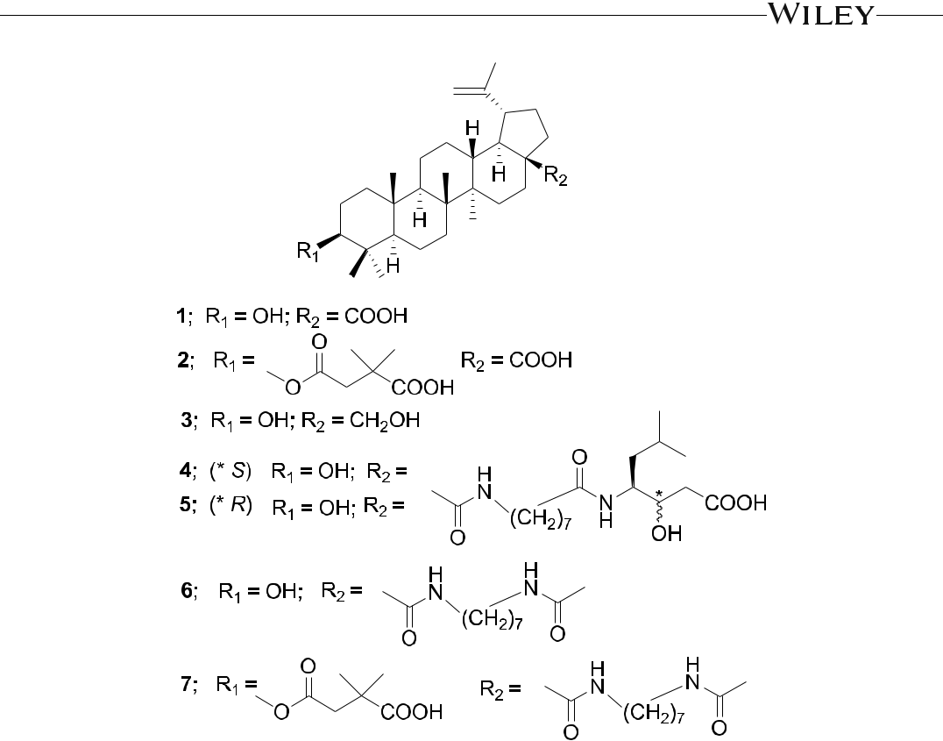

F I G U R E 1 Chemical structures of Compounds 1–7

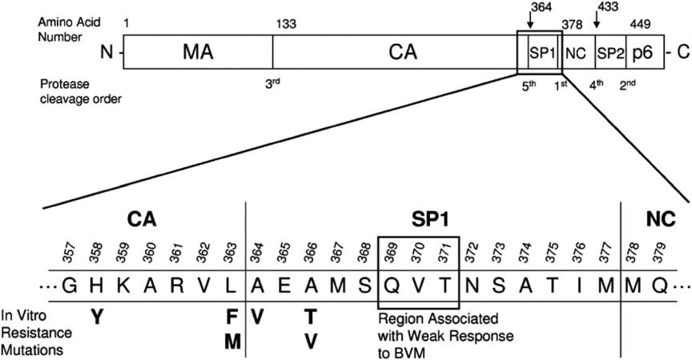

F I G U R E 2 Schematic of HIV‐1 Gag polyprotein showing amino acid residues associated with bevirimat susceptibility. BVM, bevirimat; CA, capsid; HIV‐1, human immunodeficiency virus‐1; MA, matrix; NC, nucleocapsid; SP1, small peptide 1; SP2, small peptide 2. Reproduced with permission from Margot et al.19

4 | WUETAL.



investigations of BVM derivatives are being carried out to improve polymorphic virus coverage, reduce protein binding, and obtain better pharmaceutical properties.

Two important reviews by Kuo et al.21 and Singh and Bodiwala22 were published just before the period covered in this article, the former more specifically concentrating on anti‐HIV triterpenoids and analogs. Two additional extensive reviews of the literature reported on anti‐HIV triterpenoids and derivatives were also published.23,24 Acyl derivatives of triterpenic oximes exhibit important pharmacological, including anti‐HIV activity.25 Related chemistry and pharmacology of synthetic triterpenoid dimers obtained from natural compounds were reviewed recently.26 The structures and anti‐HIV activities of protostane and fusidane triterpenoids covering the literature until 2013 were briefly reviewed (together with several other activities).27 Verma discussed a raft‐targeting method for prevention and therapy of AIDS using natural products, especially euphane‐type triterpenes.28 In another review, natural products including lignans, triterpenes, chlorogenic acid derivatives, and farnesyl hydroquinones, in vivo metabolites and synthesized derivatives as potential antiviral agents were described.29 A review covering the literature from 1991 to 2012 presented the microbial transformation of diterpenoids and some triterpenoids with anti‐HIV activities.30 In 2014, the antitumor and antiviral activities of pentacyclic triterpenes were discussed.31 Herein, this review describes the recent advances in anti‐HIV triterpe-noids and synthetic analogs covering the period from 2009 to 2019, with >300 anti‐HIV triterpenes discussed. The article includes not only a comprehensive review of the recent anti‐HIV drug development from the perspective of medicinal chemistry but also discusses structure–activity relationship (SAR) analyses of the described triterpenoids.

1. | PENTACYCLIC TRITERPENOID 2.1 | The lupane group

Plant‐derived pentacyclic triterpenoids of lupane families provide a versatile structural platform for the discovery of new biologically active compounds. Even small structural alterations in these triterpenoid derivatives can cause remarkable differences in their activity, making a convincing case for a systematic study of SARs in this compound class. The multiactivity profile of lupane‐type terpenoids can be a benefit for overcoming HIV‐1 resistance by simultaneously affecting multiple targets. Both betulinic acid (1) and betulin (3; Figure 1) are important lupane triterpenoids that exhibit many favorable biological effects, including anti‐HIV, anticancer, antimalarial, and anti‐ inflammatory properties, but cause minimal toxicity to unaffected cells.32 Betulinic acid is commonly found in some species of the family Betulaceae, while 3 is a major constituent in the bark of white‐barked birch trees with isolated yields up to 22% (dry weight) and can be easily converted synthetically to 1 in high yields.33 Many studies have been devoted to the investigation of betulinic acid, betulin, and their derived compounds. The last related review was published in 2014.34 It has been pointed out that structural changes at different positions of betulinic acid/ betulin can result in significant differences in the anti‐HIV mechanism of action. For example, betulinic acid derivatives altered at the C‐28 position are HIV‐1 entry inhibitors such as compounds RPR103611 (4), IC9564 (5), and A43D (6; Figure 1), among which A43D was effective against multiple HIV subtypes and displayed the strongest inhibition toward the clade C HIV‐1 strains.35 On the other hand, betulinic acid analogs modified at the C‐3 rather than C‐28 position, like BVM, are HIV‐1 maturation inhibitors. Furthermore, simultaneous modifications at C‐3 and C‐28 led to the identification of A12‐2 (7; Figure 1), a bifunctional HIV inhibitor with an EC50 value of 0.0026 μM at least 20 times more potent than either 2 or 5.36 Over the past 10 years, extensive work has been directed towards the optimization of the C‐3 and C‐28 side chains of betulinic acid and betulin derivatives and analogs (Table 1). C‐3 modifications comprise oxidation, acylation, conjugation, and heterocycle substitution, while C‐28 alterations include amination, esterification, and conjugations. In addition, chemical modifications at other

T A B L E 1 Structures and anti‐HIV activity of betulinic acid and betulin derivatives and analogs

|  |  |  |  |  |  |  |  |  |  |  |  |  |  |  |  |  |  |  |  |  |  |  |  |  |  |  |  |  |  |  |
| --- | --- | --- | --- | --- | --- | --- | --- | --- | --- | --- | --- | --- | --- | --- | --- | --- | --- | --- | --- | --- | --- | --- | --- | --- | --- | --- | --- | --- | --- | --- |
|  |  |  |  |  |  |  |  |  |  |  |  |  |  |  |  |  |  |  |  |  |  |  |  |  |  |  |  |  |  |  |
|  |  |  |  |  |  |  |  |  |  |  |  |  |  |  |  |  |  |  |  |  |  |  |  |  |  |  |  |  |  |  |
|  |  |  |  |  |  |  |  |  |  |  |  |  |  |  |  |  |  |  |  |  |  |  |  |  |  |  |  |  |  |  |
|  |  |  |  |  |  |  |  |  |  |  |  |  |  |  |  |  |  |  |  |  |  |  |  |  |  |  |  |  |  |  |
|  |  |  |  |  |  |  |  |  |  |  |  |  |  |  |  |  |  |  |  |  |  |  |  |  |  |  |  |  |  |  |
|  |  |  |  |  |  |  |  |  |  |  |  |  |  |  |  |  |  |  |  |  |  |  |  |  |  |  |  |  |  |  |
|  |  |  |  |  |  |  |  |  |  |  |  |  |  |  |  |  |  |  |  |  |  |  |  |  |  |  |  |  |  |  |
|  |  |  |  |  |  |  |  |  |  |  |  |  |  |  |  |  |  |  |  |  |  |  |  |  |  |  |  |  |  |  |
|  |  |  |  |  |  |  |  |  |  |  |  |  |  |  |  |  |  |  |  |  |  |  |  |  |  |  |  |  |  |  |
| Compound | | R1 | | | | | | | | | | | | | | | |  | R2 | | | |  |  |  | R3 | EC50 (μM) | | |  |
|  |  |  |  |  |  |  |  |  |  |  |  |  |  |  |  |  |  |  |  |  |  |  |  |  |  |  |  |  |  |  |
| 8 | | O | | | | | | | | | | | | | | | |  | CH2OH | | | |  |  |  | H | 3.40 |  |  |  |
|  |  |  |  |  |  |  |  |  |  |  |  |  |  |  |  |  |  |  |  |  |  |  |  |  |  |  |  |  |  |  |
| 9 | | O | | | | | | | | | | | | | | | |  | CHO | | | |  |  |  | H | 4.08 |  |  |  |
|  |  |  |  |  |  |  |  |  |  |  |  |  |  |  |  |  |  |  |  |  |  |  |  |  |  |  |  |  |  |  |
| 10 | | OH | | | | | | | | | | | | | | | |  |  |  |  |  |  |  |  | H | 1.66 |  |  |  |
|  |  |  |  |  |  |  |  |  |  |  |  |  |  |  |  |  |  |  |  |  |  |  |  |  |  |  |  |  |  |  |
|  |  |  |  |  |  |  |  |  |  |  |  |  |  |  |  |  |  |  |  |  |  |  |  |  |  |  |  |  |  |  |
| 11 | |  |  |  |  |  |  |  |  |  |  |  |  |  |  |  |  |  | CN | | | |  |  |  | H | 1.5 |  |  |  |
|  |  |  |  |  |  |  |  |  |  |  |  |  |  |  |  |  |  |  |  |  |  |  |
|  |  |  |  |  |  |  |  |  |  |  |  |  |  |  |  |  |  |  |  |  |  |  |  |  |  |  |  |  |  |  |
|  |  |  |  |  |  |  |  |  |  |  |  |  |  |  |  |  |  |  |  |  |  |  |  |  |  |  |  |  |  |  |
| 13 | |  |  |  |  |  |  |  |  |  |  |  |  |  |  |  |  |  | CHO | | | |  |  |  | H | 1.2 |  |  |  |
|  |  |  |  |  |  |  |  |  |  |  |  |  |  |  |  |  |  |  |  |  |  |  |
|  |  |  |  |  |  |  |  |  |  |  |  |  |  |  |  |  |  |  |  |  |  |  |  |  |  |  |  |  |  |  |
|  |  |  |  |  |  |  |  |  |  |  |  |  |  |  |  |  |  |  |  |  |  |  |  |  |  |  |  |  |  |  |
| 16 | |  |  |  |  |  |  |  |  |  |  |  |  |  |  |  |  |  | COOH | | | |  |  |  | H | 0.0006 |  |  |  |
|  |  |  |  |  |  |  |  |  |  |  |  |  |  |  |  |  |  |  |  |  |  |  |
|  |  |  |  |  |  |  |  |  |  |  |  |  |  |  |  |  |  |  |  |  |  |  |  |  |  |  |  |  |  |  |
|  |  |  |  |  |  |  |  |  |  |  |  |  |  |  |  |  |  |  |  |  |  |  |  |  |  |  |  |  |  |  |
| 17a | |  |  |  |  |  |  |  |  |  |  |  |  |  |  |  |  |  | COOH | | | |  |  |  | H | 4.28 (HIV‐1IIIB); 6.9 (HIV‐1BaL) | | |  |
|  |  |  |  |  |  |  |  |  |  |  |  |  |  |  |  |  |  |  |  |  |
|  |  |  |  |  |  |  |  |  |  |  |  |  |  |  |  |  |  |  |  |  |  |  |  |  |  |  |  |  |  |  |
|  |  |  |  |  |  |  |  |  |  |  |  |  |  |  |  |  |  |  |  |  |  |  |  |  |  |  |  |  |  |  |
| 18 | |  |  |  |  |  |  |  |  |  |  |  |  |  |  |  |  |  | COOH | | | |  |  |  | H | 61%b | | |  |
|  |  |  |  |  |  |  |  |  |  |  |  |  |  |  |  |  |  |  |  |  |  |  |  |  |  |  |  |  |  |  |
|  |  |  |  |  |  |  |  |  |  |  |  |  |  |  |  |  |  |  |  |  |  |  |  |  |  |  |  |  |  |  |

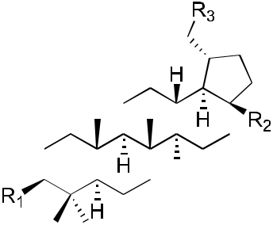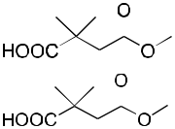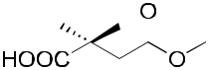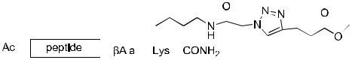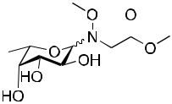

(Continues)

|  |
| --- |
| WU ET AL. |



|  |
| --- |
| | 5 |



|  |
| --- |
| 6 |

T A B L E 1 (Continued)



|  |
| --- |
| | |

|  |  |  |  |  |  |  |  |  |  |  |  |  |  |  |  |
| --- | --- | --- | --- | --- | --- | --- | --- | --- | --- | --- | --- | --- | --- | --- | --- |
| Compound | R1 | R2 |  |  |  |  |  | R3 | |  |  |  |  | EC50 (μM) |  |
| 21 | OH |  |  |  |  |  |  | H | | 0.09 | | | | |  |
|  |  |  |  |  |
|  |  |  |  |  |  |  |  |  |  |  |  |  |  |  |  |
|  |  |  |  |  |  |  |  |  |  |  |  |  |  |  |  |
|  |  |  |  |  |  |  |  |  |  |  |  |  |  |  |  |
|  |  |  |  |  |  |  |  |  |  |  |  |  |  |  |  |
| 22 | OH |  |  |  |  |  |  | H | | 0.12 | | | | |  |
|  |  |  |  |  |
|  |  |  |  |  |  |  |  |  |  |  |  |  |  |  |  |
|  |  |  |  |  |  |  |  |  |  |  |  |  |  |  |  |
|  |  |  |  |  |  |  |  |  |  |  |  |  |  |  |  |
| 24 | OH |  |  |  |  |  |  | H | |  |  |  |  | 0.15c |  |
|  |  |  |  |  |
|  |  |  |  |  |  |  |  |  |  |  |  |  |  |  |  |
| 25 | OH |  |  |  |  |  |  | H | |  |  |  |  | 0.35c |  |
|  |  |  |  |  |
|  |  |  |  |  |  |  |  |  |  |  |  |  |  |  |  |
|  |  |  |  |  |  |  |  |  |  |  |  |  |  |  |  |
| 26 | OH |  |  |  |  |  |  | H | |  |  |  |  | 0.23c |  |
|  |  |  |  |  |  |  |
| 29 | OH |  |  |  |  |  |  |  |  |  |  |  |  |  |  |
|  |  |  |  |  |  |  |  |  |  |  |  |  |  |
|  |  |  |  |  |  |  |  |  | | | | |  |
|  |  |  |  |  |  |  |  |  | | |  | 0.09 |  |
|  |  |  |  |  |  |  |  |  |
|  |  |  |  |  |  |  |  |  |  |  |  |  |  |  |  |
|  |  |  |  |  |  |  |  |  |  |  |  |  |  |  |  |
|  |  |  |  |  |  |  |  |  |  |  |  |  |  |  |  |



|  |
| --- |
| WU ET AL. |

T A B L E 1 (Continued)

|  |  |  |  |  |  |  |  |  |  |  |  |  |  |  |  |  |  |  |  |  |  |  |  |  |  |  |  |  |  |  |  |  |  |  |
| --- | --- | --- | --- | --- | --- | --- | --- | --- | --- | --- | --- | --- | --- | --- | --- | --- | --- | --- | --- | --- | --- | --- | --- | --- | --- | --- | --- | --- | --- | --- | --- | --- | --- | --- |
|  |  |  |  |  |  |  |  |  |  |  |  |  |  |  |  |  |  |  |  |  |  |  |  |  |  |  |  |  |  |  |  |  |  |  |
|  |  |  |  |  |  |  |  |  |  |  |  |  |  |  |  |  |  |  |  |  |  |  |  |  |  |  |  |  |  |  |  |  |  |  |
|  |  |  |  |  |  |  |  |  |  |  |  |  |  |  |  |  |  |  |  |  |  |  |  |  |  |  |  |  |  |  |  |  |  |  |
|  |  |  |  |  |  |  |  |  |  |  |  |  |  |  |  |  |  |  |  |  |  |  |  |  |  |  |  |  |  |  |  |  |  |  |
|  |  |  |  |  |  |  |  |  |  |  |  |  |  |  |  |  |  |  |  |  |  |  |  |  |  |  |  |  |  |  |  |  |  |  |
|  |  |  |  |  |  |  |  |  |  |  |  |  |  |  |  |  |  |  |  |  |  |  |  |  |  |  |  |  |  |  |  |  |  |  |
|  |  |  |  |  |  |  |  |  |  |  |  |  |  |  |  |  |  |  |  |  |  |  |  |  |  |  |  |  |  |  |  |  |  |  |
|  |  |  |  |  |  |  |  |  |  |  |  |  |  |  |  |  |  |  |  |  |  |  |  |  |  |  |  |  |  |  |  |  |  |  |
|  |  |  |  |  |  |  |  |  |  |  |  |  |  |  |  |  |  |  |  |  |  |  |  |  |  |  |  |  |  |  |  |  |  |  |
| Compound | | R1 | | | |  | R2 | | | | |  |  |  |  |  |  |  |  |  |  |  |  |  |  |  |  |  |  | R3 | EC50 (μM) | | |  |
|  |  |  |  |  |  |  |  |  |  |  |  |  |  |  |  |  |  |  |  |  |  |  |  |  |  |  |  |  |  |  |  |  |  |  |
| 30 | |  |  |  |  |  |  |  |  |  |  |  |  |  |  |  |  |  |  |  |  |  |  |  |  |  |  |  |  | H | 0.007 |  |  |  |
|  |  |  |  |  |  |  |  |  |  |  |  |  |  |  |  |  |  |  |  |  |  |  |  |  |  |  |  |  |  |  |  |  |  |  |
| 31 | |  |  |  |  |  |  |  |  |  |  |  |  |  |  |  |  |  |  |  |  |  |  |  |  |  |  |  |  | H | 0.006 |  |  |  |
|  |  |  |  |  |  |  |  |  |  |  |  |  |  |  |  |  |  |  |  |  |  |  |  |  |  |  |  |  |  |  |  |  |  |  |
|  |  |  |  |  |  |  |  |  |  |  |  |  |  |  |  |  |  |  |  |  |  |  |  |  |  |  |  |  |  |  |  |  |  |  |
|  |  |  |  |  |  |  |  |  |  |  |  |  |  |  |  |  |  |  |  |  |  |  |  |  |  |  |  |  |  |  |  |  |  |  |
| 32 | |  |  |  |  |  |  |  |  |  |  |  |  |  |  |  |  |  |  |  |  |  |  |  |  |  |  |  |  | H | 0.003 |  |  |  |
|  |  |  |  |  |  |  |  |  |  |  |  |  |  |  |  |  |  |  |  |  |  |  |  |  |  |  |  |  |  |  |
|  |  |  |  |  |  |  |  |  |  |  |  |  |  |  |  |  |  |  |  |  |  |  |  |  |  |  |  |  |  |  |
|  |  |  |  |  |  |  |  |  |  |  |  |  |  |  |  |  |  |  |  |  |  |  |  |  |  |  |  |  |  |  |  |  |  |  |
|  |  |  |  |  |  |  |  |  |  |  |  |  |  |  |  |  |  |  |  |  |  |  |  |  |  |  |  |  |  |  |  |  |  |  |
| 33 | |  |  |  |  |  |  |  |  |  |  |  |  |  |  |  |  |  |  |  |  |  |  |  |  |  |  |  |  | H | 0.007 |  |  |  |
|  |  |  |  |  |  |  |  |  |  |  |  |  |  |  |  |  |  |  |  |  |  |  |  |  |  |  |  |  |  |  |
|  |  |  |  |  |  |  |  |  |  |  |  |  |  |  |  |  |  |  |  |  |  |  |  |  |  |  |  |  |  |  |  |  |  |  |
|  |  |  |  |  |  |  |  |  |  |  |  |  |  |  |  |  |  |  |  |  |  |  |  |  |  |  |  |  |  |  |  |  |  |  |
| 34 | |  |  |  |  |  |  |  |  |  |  |  |  |  |  |  |  |  |  |  |  |  |  |  |  |  |  |  |  | H | 0.009 |  |  |  |
|  |  |  |  |  |  |  |  |  |  |  |  |  |  |  |  |  |  |  |  |  |  |  |  |  |  |  |  |  |  |  |
|  |  |  |  |  |  |  |  |  |  |  |  |  |  |  |  |  |  |  |  |  |  |  |  |  |  |  |  |  |  |  |
|  |  |  |  |  |  |  |  |  |  |  |  |  |  |  |  |  |  |  |  |  |  |  |  |  |  |  |  |  |  |  |  |  |  |  |
|  |  |  |  |  |  |  |  |  |  |  |  |  |  |  |  |  |  |  |  |  |  |  |  |  |  |  |  |  |  |  |  |  |  |  |
| 35 | |  |  |  |  |  |  |  |  |  |  |  |  |  |  |  |  |  |  |  |  |  |  |  |  |  |  |  |  | H | 0.003 |  |  |  |
|  |  |  |  |  |  |  |  |  |  |  |  |  |  |  |  |  |  |  |  |  |  |  |  |  |  |  |  |  |  |  |
|  |  |  |  |  |  |  |  |  |  |  |  |  |  |  |  |  |  |  |  |  |  |  |  |  |  |  |  |  |  |  |  |  |  |  |
|  |  |  |  |  |  |  |  |  |  |  |  |  |  |  |  |  |  |  |  |  |  |  |  |  |  |  |  |  |  |  |  |  |  |  |
| 36 | |  |  |  |  |  |  |  |  |  |  |  |  |  |  |  |  |  |  |  |  |  |  |  |  |  |  |  |  | H | 0.005 |  |  |  |
|  |  |  |  |  |  |  |  |  |  |  |  |  |  |  |  |  |  |  |  |  |  |  |  |  |  |  |  |  |  |  |
|  |  |  |  |  |  |  |  |  |  |  |  |  |  |  |  |  |  |  |  |  |  |  |  |  |  |  |  |  |  |  |  |  |  |  |
|  |  |  |  |  |  |  |  |  |  |  |  |  |  |  |  |  |  |  |  |  |  |  |  |  |  |  |  |  |  |  |  |  |  |  |
| 37 | |  |  |  |  |  |  |  |  |  |  |  |  |  |  |  |  |  |  |  |  |  |  |  |  |  |  |  |  | H | 0.005 |  |  |  |
|  |  |  |  |  |  |  |  |  |  |  |  |  |  |  |  |  |  |  |  |  |  |  |  |  |  |  |  |  |  |  |
|  |  |  |  |  |  |  |  |  |  |  |  |  |  |  |  |  |  |  |  |  |  |  |  |  |  |  |  |  |  |  |
|  |  |  |  |  |  |  |  |  |  |  |  |  |  |  |  |  |  |  |  |  |  |  |  |  |  |  |  |  |  |  |  |  |  |  |
|  |  |  |  |  |  |  |  |  |  |  |  |  |  |  |  |  |  |  |  |  |  |  |  |  |  |  |  |  |  |  |  |  |  |  |

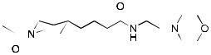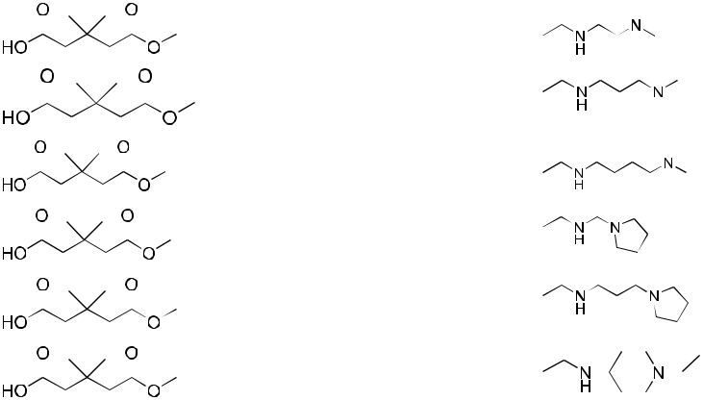

(Continues)

|  |
| --- |
| WU ET AL. |



|  |
| --- |
| | 7 |



|  |
| --- |
| 8 |

T A B L E 1 (Continued)



|  |
| --- |
| | |

|  |  |  |  |  |  |  |  |  |  |  |  |  |  |  |  |  |  |  |  |  |  |  |  |  |  |
| --- | --- | --- | --- | --- | --- | --- | --- | --- | --- | --- | --- | --- | --- | --- | --- | --- | --- | --- | --- | --- | --- | --- | --- | --- | --- |
| Compound | R1 | | | R2 | | | |  |  |  |  |  |  |  |  |  |  |  |  |  |  |  | R3 | EC50 (μM) |  |
| 38 |  |  |  |  |  |  |  |  |  |  |  |  |  |  |  |  |  |  |  |  |  |  | H | 0.021 |  |
|  |  |  |  |  |  |  |  |  |  |  |  |  |  |  |
|  |  |  |  |  |  |  |  |  |  |  |  |  |  |  |  |  |  |  |
|  |  |  |  |  |  |  |  |  |  |  |  |  |  |  |  |  |  |  |  |  |  |  |  |  |  |
|  |  |  |  |  |  |  |  |  |  |  |  |  |  |  |  |  |  |  |  |  |  |  |  |  |  |
| 39 |  |  |  |  |  |  |  |  |  |  |  |  |  |  |  |  |  |  |  |  |  |  | H | 0.002 |  |
|  |  |  |  |  |  |  |  |  |  |  |  |  |  |  |  |  |  |  |  |
|  |  |  |  |  |  |  |  |  |  |  |  |  |  |  |  |  |  |  |  |  |  |  |  |  |  |
|  |  |  |  |  |  |  |  |  |  |  |  |  |  |  |  |  |  |  |  |  |  |  |  |  |  |
| 40 |  |  |  |  |  |  |  |  |  |  |  |  |  |  |  |  |  |  |  |  |  |  | H | 0.0059 |  |
|  |  |  |  |  |  |  |  |  |  |  |  |  |  |  |  |  |  |  |  |  |
|  |  |  |  |  |  |  |  |  |  |  |  |  |  |  |  |  |  |  |  |  |  |  |  |  |  |
|  |  |  |  |  |  |  |  |  |  |  |  |  |  |  |  |  |  |  |  |  |  |  |  |  |  |
| 41 |  |  |  |  |  |  |  |  |  |  |  |  |  |  |  |  |  |  |  |  |  |  | H | 0.019 |  |
|  |  |  |  |  |  |  |  |  |  |  |  |  |  |  |  |  |  |  |  |  |  |
|  |  |  |  |  |  |  |  |  |  |  |  |  |  |  |  |  |  |  |  |  |  |  |  |  |  |
|  |  |  |  |  |  |  |  |  |  |  |  |  |  |  |  |  |  |  |  |  |  |  |  |  |  |
| 42 |  |  |  |  |  |  |  |  |  |  |  |  |  |  |  |  |  |  |  |  |  |  | H | 0.01 |  |
|  |  |  |  |  |  |  |  |  |  |  |  |  |  |  |  |  |  |  |  |  |  |  |
|  |  |  |  |  |  |  |  |  |  |  |  |  |  |  |  |  |  |  |  |  |  |  |  |  |  |
|  |  |  |  |  |  |  |  |  |  |  |  |  |  |  |  |  |  |  |  |  |  |  |  |  |  |
|  |  |  |  |  |  |  |  |  |  |  |  |  |  |  |  |  |  |  |  |  |  |  |  |  |  |
|  |  |  |  |  |  |  |  |  |  |  |  |  |  |  |  |  |  |  |  |  |  |  |  |  |  |
| 43 |  |  |  |  |  |  |  |  |  |  |  |  |  |  |  |  |  |  |  |  |  |  | H | 0.016 |  |
|  |  |  |  |  |  |  |  |  |  |  |  |  |  |  |  |  |  |  |  |  |  |  |  |  |  |
|  |  |  |  |  |  |  |  |  |  |  |  |  |  |  |  |  |  |  |  |  |  |  |  |  |  |
|  |  |  |  |  |  |  |  |  |  |  |  |  |  |  |  |  |  |  |  |  |  |  |  |  |  |
| 46 | OH | | |  |  |  |  |  |  |  |  |  |  |  |  |  |  |  |  |  |  |  | H | 0.017 |  |

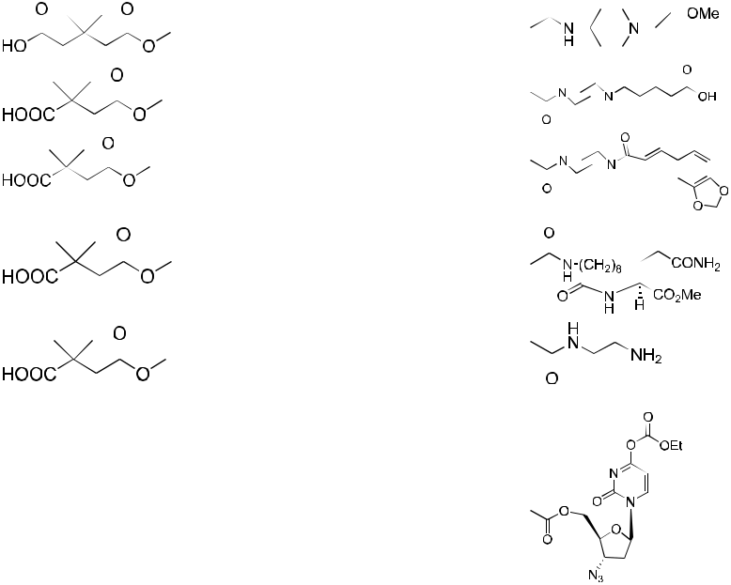

|  |
| --- |
| WU ET AL. |

T A B L E 1 (Continued)

|  |  |  |  |  |  |  |  |  |  |  |  |  |  |  |  |  |  |  |  |  |  |
| --- | --- | --- | --- | --- | --- | --- | --- | --- | --- | --- | --- | --- | --- | --- | --- | --- | --- | --- | --- | --- | --- |
|  |  |  |  |  |  |  |  |  |  |  |  |  |  |  |  |  |  |  |  |  |  |
|  |  |  |  |  |  |  |  |  |  |  |  |  |  |  |  |  |  |  |  |  |  |
|  |  |  |  |  |  |  |  |  |  |  |  |  |  |  |  |  |  |  |  |  |  |
|  |  |  |  |  |  |  |  |  |  |  |  |  |  |  |  |  |  |  |  |  |  |
|  |  |  |  |  |  |  |  |  |  |  |  |  |  |  |  |  |  |  |  |  |  |
|  |  |  |  |  |  |  |  |  |  |  |  |  |  |  |  |  |  |  |  |  |  |
|  |  |  |  |  |  |  |  |  |  |  |  |  |  |  |  |  |  |  |  |  |  |
|  |  |  |  |  |  |  |  |  |  |  |  |  |  |  |  |  |  |  |  |  |  |
|  |  |  |  |  |  |  |  |  |  |  |  |  |  |  |  |  |  |  |  |  |  |
| Compound | | R1 | | | | | |  | R2 | | | |  |  |  | R3 | EC50 (μM) | | | |  |
|  |  |  |  |  |  |  |  |  |  |  |  |  |  |  |  |  |  |  |  |  |  |
| 47 | |  |  |  |  |  |  |  | COOH | | | |  |  |  | H | 0.015 |  |  |  |  |
|  |  |  |  |  |  |  |  |  |  |  |  |  |  |
|  |  |  |  |  |  |  |  |  |  |  |  |  |  |  |  |  |  |  |  |  |  |
|  |  |  |  |  |  |  |  |  |  |  |  |  |  |  |  |  |  |  |  |  |  |
|  |  |  |  |  |  |  |  |  |  |  |  |  |  |  |  |  |  |  |  |  |  |
|  |  |  |  |  |  |  |  |  |  |  |  |  |  |  |  |  |  |  |  |  |  |
|  |  |  |  |  |  |  |  |  |  |  |  |  |  |  |  |  |  |  |  |  |  |
|  |  |  |  |  |  |  |  |  |  |  |  |  |  |  |  |  |  |  |  |  |  |
|  |  |  |  |  |  |  |  |  |  |  |  |  |  |  |  |  |  |  |  |  |  |
|  |  |  |  |  |  |  |  |  |  |  |  |  |  |  |  |  |  |  |  |  |  |

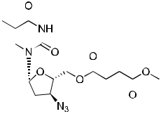

|  |  |  |  |  |  |  |  |
| --- | --- | --- | --- | --- | --- | --- | --- |
| 48 |  |  |  | COOH | H | 0.012 |  |
|  |  |  |

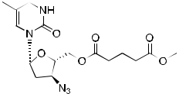

|  |  |  |  |
| --- | --- | --- | --- |
| 49 |  | H | 0.067 |
|  |  |  |  |
|  |  |  |  |
|  |  |  |  |
| 50 |  | H | 0.10 |

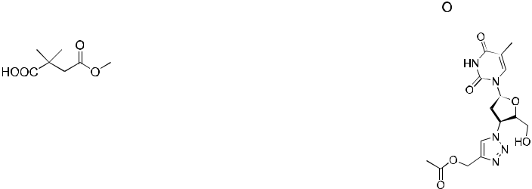

|  |
| --- |
| WU ET AL. |



|  |
| --- |
| | 9 |

(Continues)

T A B L E 1 (Continued)



|  |
| --- |
| 10 | |



|  |  |  |  |  |  |  |  |  |
| --- | --- | --- | --- | --- | --- | --- | --- | --- |
| Compound | R1 | R2 | | | |  | R3 | EC50 (μM) |
|  |  |  |  |  |  |  |  |  |
| 51 |  |  |  |  |  |  | H | 0.045 |
|  |  |  |  |  |  |  |  |  |
|  |  |  |  |  |  |  |  |  |
|  |  |  |  |  |  |  |  |  |
|  |  |  |  |  |  |  |  |  |
|  |  |  |  |  |  |  |  |  |
|  |  |  |  |  |  |  |  |  |

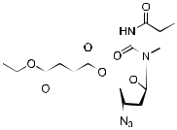

52  H 0.098



53  H 0.040

54 H 0.060

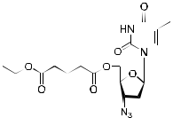

|  |
| --- |
| WU ET AL. |

T A B L E 1 (Continued)

|  |  |  |  |  |  |  |  |  |  |  |  |  |  |  |  |  |  |
| --- | --- | --- | --- | --- | --- | --- | --- | --- | --- | --- | --- | --- | --- | --- | --- | --- | --- |
|  |  |  |  |  |  |  |  |  |  |  |  |  |  |  |  |  |  |
|  |  |  |  |  |  |  |  |  |  |  |  |  |  |  |  |  |  |
|  |  |  |  |  |  |  |  |  |  |  |  |  |  |  |  |  |  |
|  |  |  |  |  |  |  |  |  |  |  |  |  |  |  |  |  |  |
|  |  |  |  |  |  |  |  |  |  |  |  |  |  |  |  |  |  |
|  |  |  |  |  |  |  |  |  |  |  |  |  |  |  |  |  |  |
|  |  |  |  |  |  |  |  |  |  |  |  |  |  |  |  |  |  |
|  |  |  |  |  |  |  |  |  |  |  |  |  |  |  |  |  |  |
|  |  |  |  |  |  |  |  |  |  |  |  |  |  |  |  |  |  |
| Compound | | R1 | |  | R2 | |  |  |  |  |  |  | R3 | EC50 (μM) | | | |
|  |  |  |  |  |  |  |  |  |  |  |  |  |  |  |  |  |  |
| 55 | |  |  |  |  |  |  |  |  |  |  |  | H | 0.063 |  |  |  |
|  |  |  |  |  |  |  |  |  |  |  |  |  |  |  |  |  |  |
|  |  |  |  |  |  |  |  |  |  |  |  |  |  |  |  |  |  |
|  |  |  |  |  |  |  |  |  |  |  |  |  |  |  |  |  |  |
|  |  |  |  |  |  |  |  |  |  |  |  |  |  |  |  |  |  |
|  |  |  |  |  |  |  |  |  |  |  |  |  |  |  |  |  |  |
|  |  |  |  |  |  |  |  |  |  |  |  |  |  |  |  |  |  |

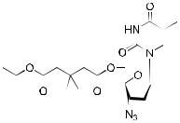

|  |  |  |  |  |  |  |  |
| --- | --- | --- | --- | --- | --- | --- | --- |
| 60 |  |  |  |  |  | 0.097 |  |
|  |  |  |  |  |  |
|  |  |  |  |  |  |  |  |
|  |  |  |  |  |  |  |  |
| 70 | OAc | CH3 | | H |  | – |  |
| 71 | OAc | CH3 | | CHO |  | – |  |
|  |  |  |  |  |  |  |  |
| 73 | NOH | CH3 | | H |  | – |  |
| 75 | OH | CH2OH | | CHO |  | – |  |
|  |  |  |  |  |  |  |  |
| 78 | OH | CH2OAc | | CHO | 1.70 | |  |
|  |  |  |  |  |  |  |  |



|  |
| --- |
| WU ET AL. |



|  |  |
| --- | --- |
| Abbreviations: HIV‐1, human immunodeficiency virus‐1; HIV‐2, human immunodeficiency virus‐2. |  |
| aPeptide: NNYTSLIHSLIEESQNQQEKNEQELL. |  |
| bAntiviral activity was assessed by the percent increase of cytoprotective effect over untreated HIV‐1‐infected cells. |  |
| cAnti‐HIV‐2 activity. | | |
|  | 11 |

12 | WU ET AL.



T A B L E 2 Structures and anti‐HIV activity of dihydrobetulinic acid derivatives and analogs

|  |  |  |  |  |  |  |  |  |  |  |  |  |  |  |  |  |  |  |  |  |
| --- | --- | --- | --- | --- | --- | --- | --- | --- | --- | --- | --- | --- | --- | --- | --- | --- | --- | --- | --- | --- |
|  |  |  |  |  |  |  |  |  |  |  |  |  |  |  |  |  |  |  |  |  |
|  |  |  |  |  |  |  |  |  |  |  |  |  |  |  |  |  |  |  |  |  |
|  |  |  |  |  |  |  |  |  |  |  |  |  |  |  |  |  |  |  |  |  |
|  |  |  |  |  |  |  |  |  |  |  |  |  |  |  |  |  |  |  |  |  |
|  |  |  |  |  |  |  |  |  |  |  |  |  |  |  |  |  |  |  |  |  |
|  |  |  |  |  |  |  |  |  |  |  |  |  |  |  |  |  |  |  |  |  |
|  |  |  |  |  |  |  |  |  |  |  |  |  |  |  |  |  |  |  |  |  |
|  |  |  |  |  |  |  |  |  |  |  |  |  |  |  |  |  |  |  |  |  |
|  |  |  |  |  |  |  |  |  |  |  |  |  |  |  |  |  |  |  |  |  |
| Compound | | R1 | |  |  |  |  |  |  | R2 | |  |  |  |  |  | IC50 (μM) | | |  |
| 12 | |  |  |  |  |  |  |  |  | CHO | | 1.8 | | | | | |  |  |  |
|  |  |  |  |  |  |  |  |  |  |  |  |  |  |  |  |  |  |  |  |  |
|  |  |  |  |  |  |  |  |  |  |  |  |  |  |  |  |  |  |  |  |  |
| 23 | | OH | |  |  |  |  |  |  |  |  |  |  |  |  | 0.05 | |  |  |  |
|  |  |  |  |  |  |  |  |  |  |  |  |  |
|  |  |  |  |  |  |  |  |  |  |  |  |  |  |  |  |  |  |  |  |  |
|  |  |  |  |  |  |  |  |  |  |  |  |  |  |  |  |  |  |  |  |  |
|  |  |  |  |  |  |  |  |  |  |  |  |  |  |  |  |  |  |  |  |  |
| 56 | |  |  |  |  |  |  |  |  |  |  | 0.087 | | | | | |  |  |  |

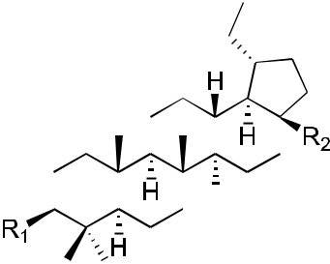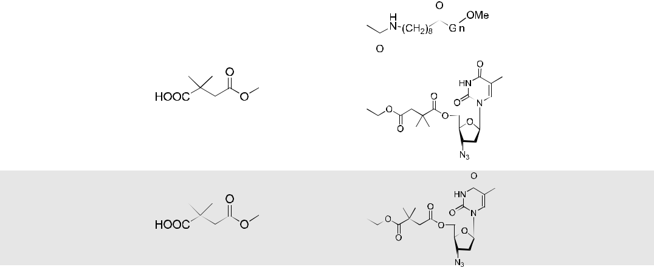

57  0.056



58  0.073

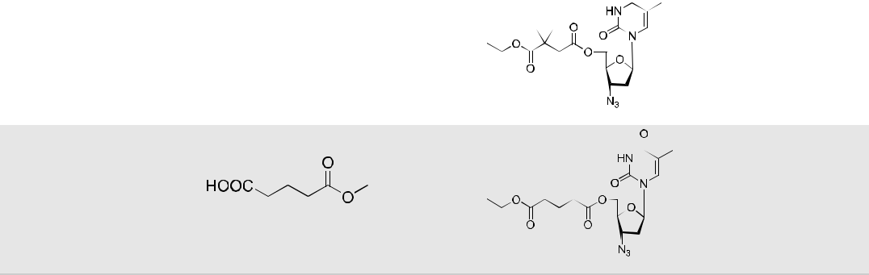

59  0.093

positions like C‐30 were also reported. Sousa et al.37 provided insight into the functionalization of betulinic acid and its analogs in the latest review.

Three betulin analogs (8–10; Table 1) were found to inhibit HIV‐1 infection by acting on multiple steps in the HIV‐1 replication cycle in both MT‐2 cells and primary human T cells. Betulone (8) targets reverse transcription, integration, viral transcription, Gag production, and maturation. 3‐Oxo‐lup‐20(29)‐en‐28‐al (9) inhibits HIV‐1 infec-tion by targeting integration, viral transcription, and Gag production. 28‐Acetoxy‐3β‐hydroxy‐lup‐20(29)‐en‐30‐al (10) targets reverse transcription, viral transcription, and Gag production. Compounds 8–10 inhibited HIV‐1 infection of human primary lymphocytes and infections with PR inhibitor‐ and BVM‐resistant HIV‐1 variants with similar IC50

|  |  |  |  |  |  |  |  |
| --- | --- | --- | --- | --- | --- | --- | --- |
| WU ET AL. |  | |  | | | | 13 |  |
|  | | |  |
|  |  |  |  |  |  |  |  |
|  |  |  |  |  |  |  |  |
|  |  |  |  |  |  |  |  |

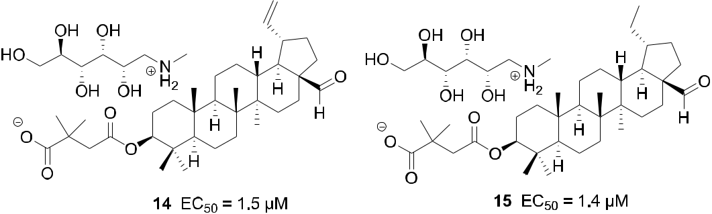

F I G U R E 3 Chemical structures of Compounds 14 and 15

values.38 Betulinic aldehyde and nitrile derivatives were identified to show anti‐HIV‐1 activity using a single‐cycle replication assay, which can differentiate whether a derivative targets the late or early steps in the viral life cycle. The betulinic nitrile derivative (11) and aldehyde derivatives (12–15; Tables 1 and 2 and Figure 3) inhibit a late step in virus replication in HEK 293T cells.39

Different C‐3 conformationally restricted 3‐O‐acyl derivatives were synthesized to explore the conformational space of the C‐3 pharmacophore of betulinic acid. The 3′S isomer of Compound 16 (Table 1) displayed slightly better activity than 2 in acutely infected MT‐2 cell lines.40 Click chemistry was used to synthesize hybrid molecules of triterpene sapogenins and helix zone‐binding domain‐containing peptides. P26–BApc (17; Table 1) exhibited anti‐ HIV‐1 activity against both T20‐sensitive and ‐resistant HIV‐1 strains and improved PK properties.41 The sugars attached to pharmaceutically important natural products could lead to improved key pharmacological properties and/or molecular mechanisms of action. A 37‐member library of betulinic acid C‐3‐neoglycosides was synthesized and each glycosylated derivative was tested for anti‐HIV activity in CEM‐SS cells infected with HIV‐1IIIB. Nineteen of thirty‐two ester‐linked compounds displayed at least a twofold improvement over betulinic acid. Among these compounds, L‐Fuc derivative (α:β/1:2) 18 (Table 1) was the most active.42 In 2016, Liu et al.43 synthesized a series of C‐3 phenyl‐ and heterocycle‐substituted derivatives of C‐3 deoxybetulinic acid and deoxybetulin. When compared with BVM, betulinic acid‐derived analog 19 containing a four‐substituted benzoic acid moiety exhibited comparable anti‐HIV activity against wild‐type virus in MT‐2 cells using variants of the NLRepRlucP373S virus in a multiple cycle assay. Furthermore, compared with 2, the potency of 19 was less affected by the presence of human serum displaying a similar PK profile in rats. In addition, 4‐benzoic acid deoxybetulin analog 20 exhibited comparable antiviral potency toward wild‐type and V370A viruses compared with 19, while in the presence of human serum albumin (HAS), 20

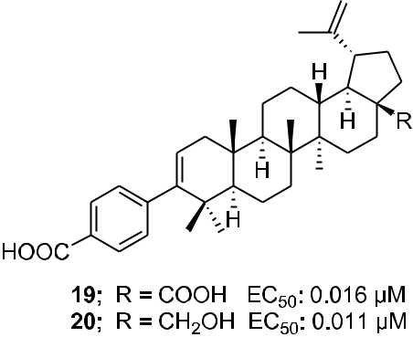

F I G U R E 4 Chemical structures of Compounds 19 and 20

|  |  |  |  |  |  |  |  |  |  |  |  |  |  |  |  |  |  |  |  |  |  |  |  |  |  |  |  |  |  |  |  |  |  |
| --- | --- | --- | --- | --- | --- | --- | --- | --- | --- | --- | --- | --- | --- | --- | --- | --- | --- | --- | --- | --- | --- | --- | --- | --- | --- | --- | --- | --- | --- | --- | --- | --- | --- |
| 14 | |  |  |  |  |  |  |  |  |  |  |  |  |  |  |  |  |  |  |  |  |  |  |  |  |  |  | WU ET AL. | | | | | |  |
|  |  |  |  |  |  |  |  |  |  |  |  |  |  |  |  |  |  |  |  |  |  |  |  |
|  |  | | | |  | | | | | | | | | | | | | |  |  |  |  |  |  |  |  |  |  |  |  |  |  |  |
| T A B L E 3 Antiviral activity of Compounds 21–23 toward BVM‐resistant virus | | | | | | | | | | | | | | | | | | | | |  |  |  |  |  |  |  |  |  |  |  |  |  |
|  |  |  |  |  |  |  |  |  |  |  |  |  |  |  |  |  |  |  |  |  |  |  |  |  |  |  |  |  |  |  |  |  |  |
| Compound | | | | | | | | | | 21 | | | |  | 22 | | | | |  | 23 | | | | | | | | | | |  |  |
|  |  |  |  |  |  |  |  |  |  |  |  |  |  |  |  |  |  |  |  |  |  |  |  |  |  |  |  |  |  |  |  |  |  |
| V370A/EC50 (μM) | | | | | | | | | | 0.02 | | | | | 0.05 | | | | |  | 0.02 | | | | | | | | | | |  |  |
|  |  |  |  |  |  |  |  |  |  |  |  |  |  |  |  |  |  |  |  |  |  |  |  |  |  |  |  |  |  |  |  |  |  |
| Abbreviation: BVM, bevirimat. | | | | | | | | | |  |  |  |  |  |  |  |  |  |  |  |  |  |  |  |  |  |  |  |  |  |  |  |  |
|  |  |  |  |  |  |  |  |  |  |  |  |  |  |  |  |  |  |  |  |  |  |  |  |  |  |  |  |  |  |  |  |  |  |
|  |  |  |  |  |  |  |  |  |  |  |  |  |  |  |  |  |  |  |  |  |  |  |  |  |  |  |  |  |  |  |  |  |  |
|  |  |  |  |  |  |  |  |  |  |  |  |  |  |  |  |  |  |  |  |  |  |  |  |  |  |  |  |  |  |  |  |  |  |
|  |  |  |  |  |  |  |  |  |  |  |  |  |  |  |  |  |  |  |  |  |  |  |  |  |  |  |  |  |  |  |  |  |  |
|  |  |  |  |  |  |  |  |  |  |  |  |  |  |  |  |  |  |  |  |  |  |  |  |  |  |  |  |  |  |  |  |  |  |
|  |  |  |  |  |  |  |  |  |  |  |  |  |  |  |  |  |  |  |  |  |  |  |  |  |  |  |  |  |  |  |  |  |  |
|  |  |  |  |  |  |  |  |  |  |  |  |  |  |  |  |  |  |  |  |  |  |  |  |  |  |  |  |  |  |  |  |  |  |

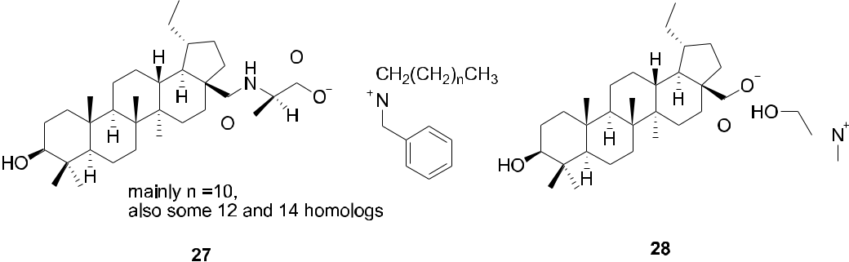

F I G U R E 5 Chemical structures of Compounds 27 and 28

was threefold more potent than 19 (Figure 4). Compounds 19 and 20 demonstrated potency towards the poly-morphic V370A with EC50 values of 0.23 and 0.21 μM, respectively.44

Three C‐28 glutamine ester derivatives of betulinic acid (21–23; Tables 1 and 2) were more potent against BVM‐resistant viruses in an HIV‐1 multicycle replication assay (Table 3). In addition, Compounds 21–23 showed markedly improved microsomal stability compared with 6.44 Betulinic acid C‐28 derivatives (24–26; Table 1) displayed selective anti‐HIV‐2 activity at nanomolar concentrations. A shorter C‐28 side chain was required for optimal anti‐HIV‐2 activity.45 Different ionic derivatives of betulinic acid were prepared by straightforward cou-pling chemistry; they displayed significantly improved water solubility without disrupting the structurally related bioactivity. These compounds had lower IC50 values towards HIV‐1 PR than 1; particularly, 27 and 28 (Figure 5) showed IC50 values roughly two and three times lower, respectively, than that of 1.46

Various 28,30‐disubstituted and 3,28‐disubstituted betulinic acid derivatives were also synthesized. Com-pound 29 (Table 1) showed improved solubility and anti‐HIV potency. Using a cyclic secondary amine to form the C‐28 amide bond significantly increased the metabolic stability of the derivatives in pooled human liver micro-somes. Compounds 30 and 31 (Table 1) displayed potent anti‐HIV activity.47 A collection of C‐28 alkyl amine derivatives of BVM was synthesized and tested for their ability to block CA‐SP1 processing and virus replication by using wild‐type and a V7A variant of NL4‐3. Some derivatives (32–39; Tables 1 and 4) showed markedly greater potency than BVM against an HIV‐1 clade B clone (NL4‐3) and robust antiviral activity against a variant of NL4‐3 containing the V7A polymorphism in SP1. One of the most potent compounds (37) also strongly inhibited a multiclade panel of primary HIV‐1 isolates.48 Among a series of synthetic betulinic acid derivatives with C‐28 substitution, all active compounds showed only antimaturation effects, as confirmed by TZM‐bl assay, in blocking the HIV replication. Compound 40 (Table 1) exhibited the best anti‐HIV activity and good in vitro metabolic stability in pooled human liver microsomes.49

T A B L E 4 Antiviral activity of Compounds 32–39 toward BVM‐resistant virus

|  |  |  |  |  |  |  |  |  |
| --- | --- | --- | --- | --- | --- | --- | --- | --- |
| Compound | 32 | 33 | 34 | 35 | 36 | 37 | 38 | 39 |
|  |  |  |  |  |  |  |  |  |
| V7A/EC50 (μM) | 0.009 | 0.014 | 0.022 | 0.026 | 0.022 | 0.010 | 0.008 | 0.019 |
|  | |  |  |  |  |  |  |  |
| Abbreviation: BVM, bevirimat. | |  |  |  |  |  |  |  |

|  |  |  |  |  |  |  |  |  |
| --- | --- | --- | --- | --- | --- | --- | --- | --- |
| WU ET AL. |  |  |  |  |  | | 15 | |  |
|  |  |  |  |  |  |
| TABLE 5 | Antiviral activity of Compound 42 toward BVM‐resistant viruses | | |  |  |  |  |  |
|  |  |  |  |  |
|  |  |  |  |  |  |  |  |  |
|  |  | EC50 (μM) |  |  |  |  |  |  |
| Compound |  | V370A | V370 | T371 |  | V362I | |  |
|  |  |  |  |  |  |  |  |  |
| 42 | 0.16 | | 0.32 | 0.067 | 0.016 | |  |  |
|  |  |  |  |  |  |  |  |  |



Abbreviation: BVM, bevirimat.

The integration of privileged motifs into promising natural product skeletons is an effective strategy for discovering potent derivatives. Two “privileged fragments,” caffeic acid, and piperazine were integrated into BVM. Compound 41 (Table 1) is a maturation inhibitor with improved metabolic stability and its activity was increased by 3‐fold against NL4‐3 and 51‐fold against NL4‐3/V370A (EC50 = 0.15 μM).50 Compound 42 (Tables 1 and 5) ex-hibited much improved activity against several HIV‐1 strains carrying BVM‐R polymorphisms and was at least 20‐ fold more potent than BVM against the replication of NL4‐3/V370A.51 To improve the water solubility of BVM, different hydrophilic substituents were added at the C‐28 position. Compound 43 (Table 1) showed higher hy-drophilicity associated with a 2.5‐fold increase in activity, a higher selectivity index, and a better antiviral profile. Also, nuclear magnetic resonance indicated a direct interaction between 43 and the domain CA‐SP1eNC.52 In 2017, a series of betulin‐derived α‐keto amides was identified as inhibiting HIV‐1 maturation. When tested in a panel of 62 HIV‐1 isolates covering a diversity of CA‐SP1 genotypes including A, AE, B, C, and G using a peripheral blood mononuclear cell (PBMC)‐based assay, GSK8999 (44; Figure 6) was potent against 57 of 62 isolates. Particularly, Compound 44 showed potency towards the polymorphic V370A and T371A with IC50 values of 0.025 and 0.008 μM, respectively.53 Furthermore, GSK2838232 (45), the only α‐keto amide betulin derivative in-vestigated in a Phase I clinical study, had low to moderate relative bioavailability (6%–40%) and was metabolized through hepatic Phase I oxidation, Phase II glucuronidation and biliary excretion, according to these preclinical studies. In clinical studies, GSK2838232 (100 and 200 mg) with 100 mg ritonavir for 11 days exhibited good safety but was significantly influenced by CYP3A4 and P‐gp inhibitors.54

Recently, conjugations between betulinic acid/betulin and AZT have been reported. One‐pot synthesis of ester‐linked conjugates of betulinic acid with AZT and its derivatives or with 3TC was accomplished. This direct synthesis provided a scalable procedure for preparing anti‐HIV hybrid conjugates. Compounds 46–48 (Table 1) exhibited very good anti‐HIV activity against HIV‐1IIIB infected MT‐4 cells.55 Alternatively, betulin/betulinic acid conjugation with AZT was achieved via a triazole linkage by click chemistry. Compounds 49 and 50 (Table 1) showed potent anti‐HIV activity.56 Various trisubstituted betulinic acid derivatives were prepared to contain 3‐O‐acyl and 28‐amide side chains and a propynyl group at the С‐2 position of ring A of the lupane core. Then, a series of C‐2 triazole‐linked bioconjugates of lupane triterpenoids with AZT was synthesized based on a

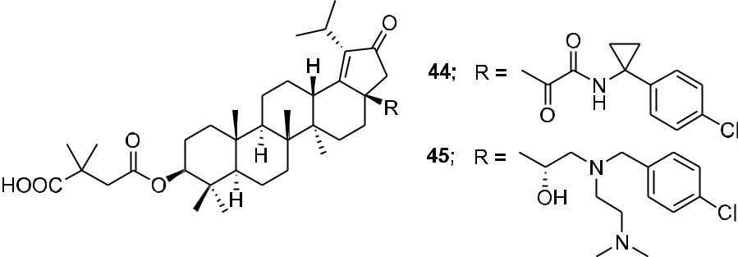

F I G U R E 6 Chemical structure of Compounds 44 and 45

16 | WU ET AL.

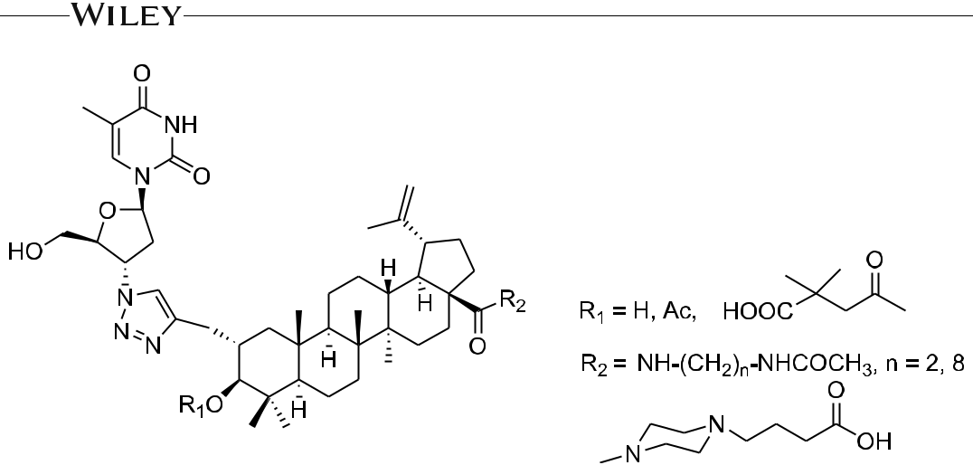

F I G U R E 7 Chemical structure of AZT–betulinic acid conjugates

CuI‐catalyzed 1,3‐cycloaddition between alkynes and azides (Figure 7). The proposed strategy concerning AZT–betulinic acid hybrid molecules as potential anti‐HIV agents makes it possible to vary the C‐3 and C‐28 pharmacophores in the triterpene moieties.57 Fourteen conjugates of 3,28‐di‐O‐acylbetulins with AZT were pre-pared and nine conjugates (51–59; Tables 1 and 2) exhibited potent anti‐HIV activity with EC50 values ranging from 0.040 to 0.098 μM in HIV‐1NL4‐3 infected MT‐4 cells.58

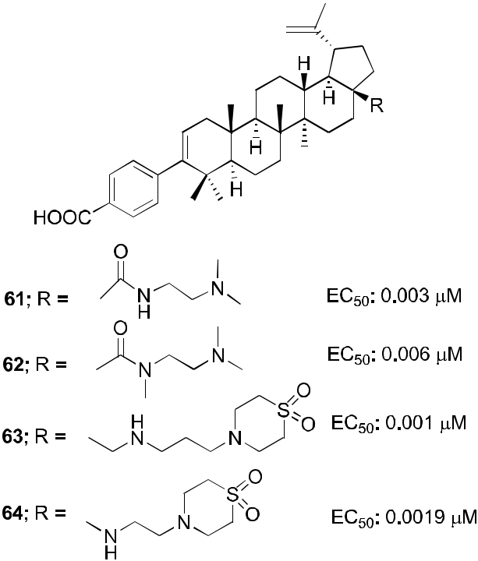

F I G U R E 8 Chemical structures of Compounds 61–64

|  |  |  |  |  |  |  |
| --- | --- | --- | --- | --- | --- | --- |
| WU ET AL. |  |  |  | | 17 | |  |
|  |  |  |  |
| TABLE 6 | Antiviral activity of Compounds 61 and 62 toward BVM‐resistant viruses | |  |  |  |  |
|  |  |  |  |
|  |  |  |  |  |  |  |
|  |  | EC50 (μM) |  |  |  |  |
| Compound |  | V370A | V370 | | |  |
|  |  |  |  |  |  |  |
| 61 | 0.008 | | 0.031 | |  |  |
|  |  |  |  |  |  |  |
| 62 | 0.038 | | 0.025 | |  |  |
|  |  |  |  |  |  |  |



Abbreviation: BVM, bevirimat.

Several fluorinated derivatives of BVM were synthesized. Compound 60 (Table 1), which has a trifluoromethyl group added to C‐30 of its isopropenyl group, exhibited similar potency as BVM against HIV‐1NL4‐3.59

At the C‐3 position, benzoic acid can be a suitable replacement for the dimethyl succinate side chain of BVM. SAR studies showed that the benzoic acid unit conferred topographical constraints on the pharmacophore and was associated with a lower shift in potency in the presence of HAS. To possibly improve the polymorphic coverage of betulinic acid derivatives, a series of C‐3 benzoic acid‐substituted betulinic acid derivatives were synthesized through modifications at the C‐28 position. The dimethylaminoethyl amides 61 and 62 (Figure 8) exhibited im-proved potency toward BVM‐resistant viruses and increased C24 values in rat oral PK studies (Table 6).60 In the continued efforts, C‐28 amine derivatives were designed and synthesized. Compared with the C‐28 amide series, the C‐28 amine derivatives exhibited further improvements in HIV‐1 inhibitory activity toward polymorphisms in the Gag polyprotein as well as improved activity in the presence of human serum. Compared with the C‐28 amide 61, the C‐28 amine Compound 63 (Figure 8) containing a thiomorpholine dioxide showed twofold to fourfold improved potency towards the screened viruses, such as wild‐type, V370A, and V370, exhibited low shifts in the EC50 values toward V370A and V370 viruses in the presence of human serum or HAS, and demonstrated improved potency towards the polymorphic T371A and V362I virus variants as well as low plasma exposure following oral administration to rats (Table 7).61

SARs led to the design of specific C‐17 amine moieties and ultimately enabled the discovery of BMS‐955176, also known as GSK3532795 (64; Figure 8), as a second‐generation maturation inhibitor that combines broad coverage of polymorphic viruses (EC50 < 15 nM toward a panel of common polymorphisms representative of 96.5% HIV‐1 subtype B virus) with a favorable PK profile in preclinical species.62 Compound 64 exhibited potent activity (EC50 = 3.9 nM) toward a library (n = 87) of gag/pr recombinant viruses representing 96.5% of subtype B poly-morphic Gag diversity near the CA/SP1 cleavage site and a median EC50 of 21 nM toward a library of subtype B clinical isolates assayed in PBMCs (Table 7). Potent activity was maintained against a panel of reverse tran-scriptase, PR, and integrase inhibitor‐resistant viruses, with EC50 values like those for the wild‐type virus. A 5.4‐ fold reduction in EC50 occurred in the presence of 40% human serum plus 27 mg/ml of HAS, which corresponded well to an in vitro measurement of 86% human serum binding. Time‐of‐addition and pseudotype reporter virus studies confirmed that the compound acts late in the virus replication cycle. Compound 64 inhibits HIV‐1 PR cleavage at the CA/SP1 junction within Gag in virus‐like particles (VLPs) and HIV‐1‐infected cells, and it binds

|  |  |  |  |  |  |  |  |  |  |  |  |
| --- | --- | --- | --- | --- | --- | --- | --- | --- | --- | --- | --- |
| TABLE 7 | Antiviral activity of Compounds 63 and 64 toward BVM‐resistant viruses | | | | | | |  |  |  |  |
|  |  |  |  |  |  |  |  |  |  |  |  |
|  |  | EC50 (μM) |  |  |  |  |  |  |  |  |  |
| Compound |  | V370A | V370 | Q369H | T371A | V362I | V370M | V370A/ | T371 | V371 | |
|  |  |  |  |  |  |  |  |  |  |  |  |
| 63 | 0.0025 | | 0.014 | – | 0.0017 | 0.00094 | – | – |  | – | |
|  |  |  |  |  |  |  |  |  |  |  |  |
| 64 | 0.0027 | | 0.013 | 0.0019 | 0.002 | 0.0045 | 0.0028 | 0.0036 |  | 0.0073 |  |
|  |  |  |  |  |  |  |  |  |  |  |  |



Abbreviations: BVM, bevirimat; –, not determined.

18 | WU ET AL.

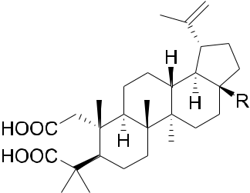

F I G U R E 9 Chemical structures of Compounds 65 and 66

reversibly and with high affinity to assembled Gag in purified HIV‐1 VLPs. Finally, in in vitro combination studies, the compound showed no antagonistic interactions with representative antiretrovirals of other mechanistic classes.63 A concise and scalable synthesis of 64 starting from betulin in seven steps and 47% overall yield has been described. The synthesis is framed by an oxidation strategy highlighted by a CuI‐mediated aerobic oxidation of betulin, a highly selective PIF‐mediated dehydrogenation of an oxime, and a subsequent Lossen rearrangement, which occurs through a unique reaction mechanism for the installation of the C‐17 amino functionality.64 Com-pound 64 demonstrated better anti‐HIV potency than BVM with no significant safety issues in its Phase IIa studies. However, Phase IIb studies with 64 were terminated due to gastrointestinal intolerance.65

In addition, 3D‐QSAR and molecular docking studies were also applied to help define the structural re-quirements responsible for the anti‐HIV activity of betulinic acid derivatives. In 3D‐QSAR studies, both the CoMFA and CoMSIA methods were satisfactory based on the statistical validation results as well as the contour map analysis. Molecular docking was used to explore the binding mode between these derivatives and HIV gp120. The correlation of the results obtained from 3D‐QSAR and docking studies can serve as useful guidelines for the further modification of betulinic acid to produce useful anti‐HIV agents.66

Two A‐secolupane derivatives (65 and 66; Figure 9) showed weak inhibitory activity against HIV‐1 PR (IC50 = 15.7 and 25.4 μM, respectively).67 In another report, the synthesis and evaluation of anti‐HIV activity of mono‐ and diamides of 2,3‐secolupane acids were reported, and Compound 67 (Figure 10) showed anti‐HIV activity.68 Lupane triterpene oximes (68 and 69; Figure 11) were synthesized using oxonitrile recyclization and the ThorpeeZiegler cyclization. Both 68 and 69 effectively suppressed the reproduction of HIV‐1 in vitro (EC50 = 0.06 μM).69 In a concurrent study, lupeol and betulin derivatives were prepared and evaluated for their ability to perturb X4‐ and R5‐tropic HIV‐1‐envelope (Env)‐mediated fusion membrane in a cell‐to‐cell fusion model.

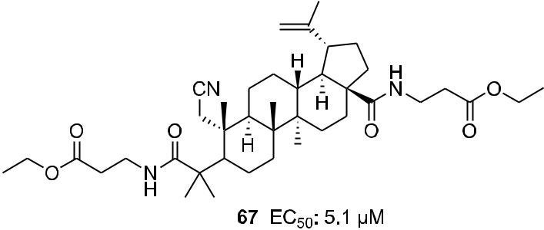

F I G U R E 10 Chemical structure of Compound 67

|  |  |  |  |
| --- | --- | --- | --- |
| WU ET AL. |  | | 19 |  |
|  |  |
|  |  |  |  |

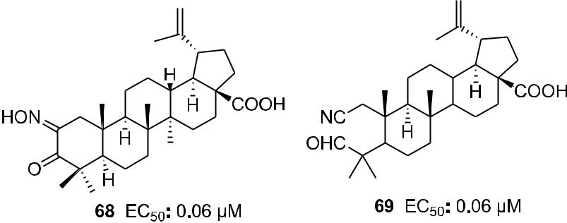

F I G U R E 11 Chemical structures of Compounds 68 and 69

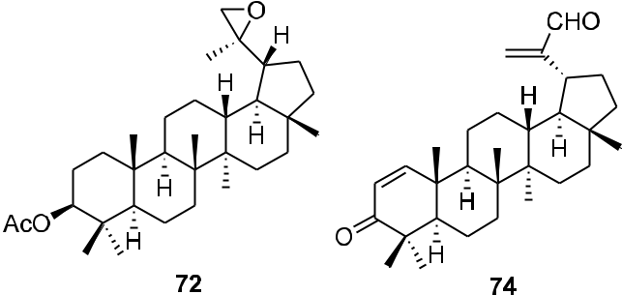

F I G U R E 12 Chemical structures of Compounds 72 and 74

Compounds 70–75 (Table 1 and Figure 12) showed a wide arrange of inhibitory activity.70 Recently, six novel lupane‐type C‐3 triterpenones with C‐28 heterocyclic moieties were synthesized. Compound 76 (Figure 13; EC50 < 10 nM) showed significant anti‐HIV potency in MT2 cells infected with 92HT599 in a 40% serum binding assay.71

30‐Oxo‐calenduladiol (77; Figure 14) is a specific CCR5 antagonist that inhibits CCR5‐mediated HIV‐1 in-fection. It binds to the CCR5 receptor without triggering cell signaling or receptor internalization, and inhibits RANTES (regulated on activation normal T cell expressed and secreted)‐mediated CCR5 internalization, in-tracellular calcium mobilization, and cell chemotaxis.72 Six new and twenty known lupane triterpenoids were

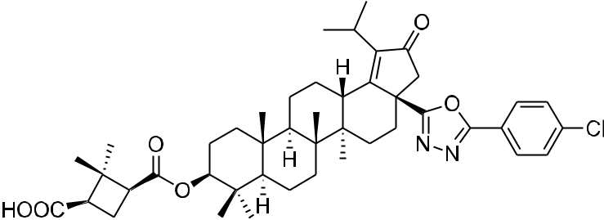

F I G U R E 13 Chemical structure of Compound 76

20 | WU ET AL.

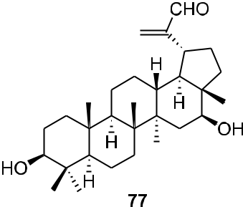

F I G U R E 14 Chemical structure of Compound 77

isolated from the stem of Cassine xylocarpa and root bark of Maytenus cuzcoina. In addition, some derivatives were prepared by chemical modification of the isolates. Sixteen compounds, including 78, from this series displayed inhibitory effects on HIV‐1 replication with IC50 values in the micromolar range (Table 1).73 2‐Acetoxyalphitolic acid (79) and 3‐acetoxyalphitolic acid (80; Figure 15) were isolated from the leaves and twigs of Garcinia hanburyi. They displayed anti‐HIV‐1 activities in anti‐HIV‐1 reverse transcriptase (IC50 = 116.9 and 16.3 μg/ml, respectively) and syncytium assays (EC50 = 5.6 and 6.0 μg/ml, SI = 2.8 and 3.3).74

2.2 | The oleanane and ursane groups

Acylated oleanolic (81) and maslinic (86) acid derivatives were synthesized through solution and solid‐phase procedures. Some acylated derivatives (82–85 and 87; Figure 16) proved to be potent inhibitors of the HIV‐1 PR with IC50 values between 0.31 and 0.8 μM.75 Oleanene derivatives 89 and 90 were prepared from germanicol (88). Compounds 88–90 (Figure 17) were assessed for their ability to perturb X4‐ and R5‐tropic HIV‐1‐envelope (Env)‐ mediated fusion membrane in a cell‐to‐cell fusion model. However, the olean‐18‐ene derivatives were inactive.70 Glycyrrhizic acid was conjugated with tert‐butyl esters of amino acids or benzyl esters of dipeptides containing two residues of L‐amino acids (Met, Phe, Pro, and Ile or dipeptides Gly–Leu and Gly–Phe). Conjugates 91 and 92 (Figure 18) containing dipeptide fragments –Gly–Leu–OH and –Gly–Phe–OH, respectively, expressed anti‐HIV‐1 activity in cultures of MT‐4 cells and were 90–70 times less cytotoxic than AZT. The selectivity indexes of the compounds exceeded those of glycyrrhizic acid by 110 and 34 times, respectively.76 In another report, a series of maslinic acid derivatives containing amino acid or peptide at C‐28 were synthesized using solution and solid‐phase

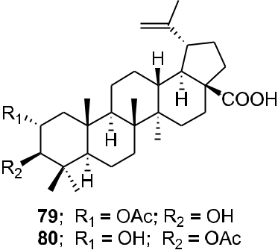

F I G U R E 15 Chemical structures of Compounds 79 and 80

WU ET AL. | 21

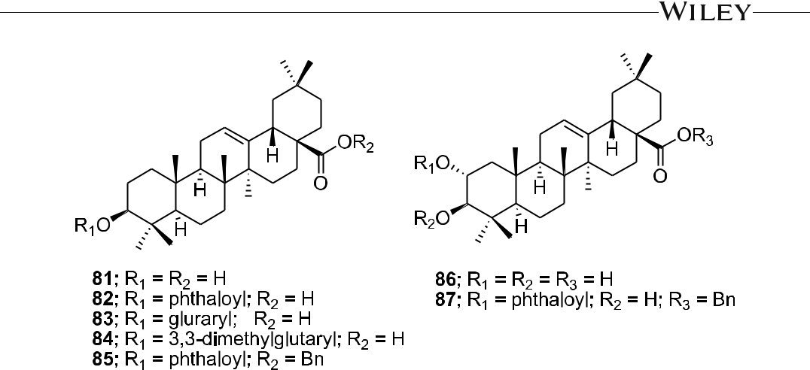

F I G U R E 16 Chemical structures of Compounds 81–87

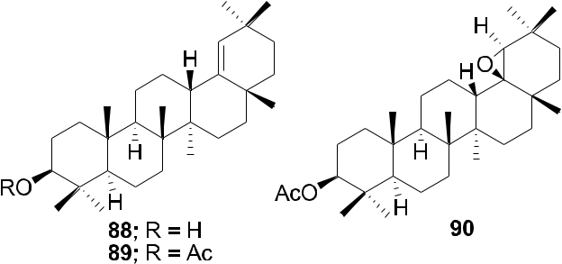

F I G U R E 17 Chemical structures of Compounds 88–90

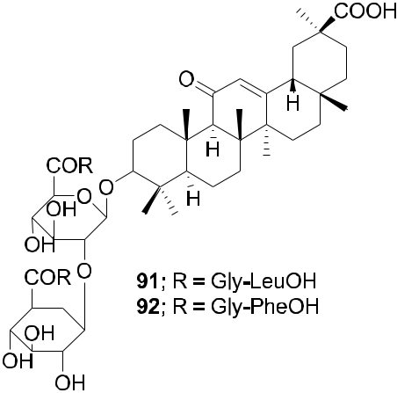

F I G U R E 18 Chemical structures of Compounds 91 and 92

22 | WU ET AL.

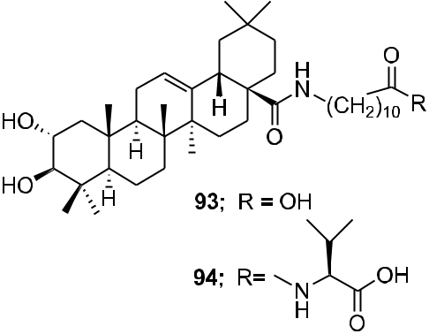

F I G U R E 19 Chemical structures of Compounds 93 and 94

synthetic procedures. Compounds 93 and 94 (Figure 19) showed anti‐HIV‐1 activity in MT‐2 cells infected with viral clones carrying the luciferase gene as a reporter.77

Di‐ and trisubstituted amides of glycyrrhizic acid containing fragments of heterocyclic and aromatic amines (2‐aminopyridine, 4‐aminopyridine, 5‐aminouracil, sulfadimezine, sulfapyridazine, and L‐histidine methyl ester) were synthesized using the dicyclohexylcarbodiimide method. Compound 96 exhibited marked anti‐HIV activity, efficiently inhibiting the accumulation of virus‐specific protein p24 (ID50 = 52.8 μM) and total viral antigens, decreasing RT activity (ID50 = 52.8 μM), and effectively protecting cells from death (102%–123%) and from viral infection. Compound 95 was less active than 96 (Figure 20).78 The newly developed method for synthesizing glycyrrhizic acid 3‐O‐galactosides produced primarily 3‐O‐α‐D‐ (97) or β‐D‐galactopyranoside (98; Figure 21) depending on the reaction conditions. When tested for inhibition of accumulated HIV‐1‐specific protein p24, Compound 97 exhibited an index of selectivity 2.9‐fold greater than that of glycyrrhizic acid. Compound 98 was more cytotoxic toward MT‐4 cells and exhibited only weak anti‐ HIV‐1 activity.79

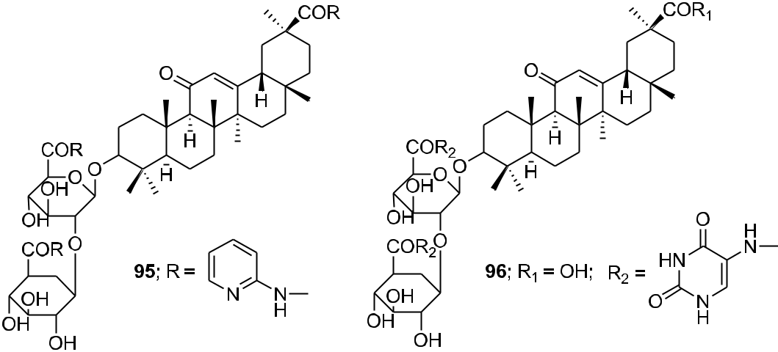

F I G U R E 20 Chemical structures of Compounds 95 and 96

|  |  |  |  |
| --- | --- | --- | --- |
| WU ET AL. |  | | 23 |  |
|  |  |
|  |  |  |  |

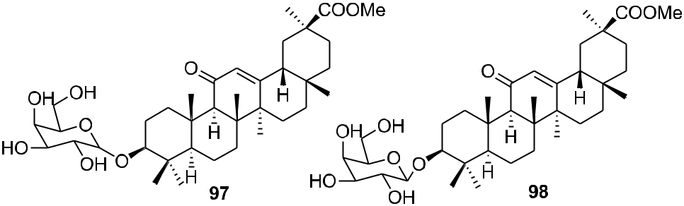

F I G U R E 21 Chemical structures of Compounds 97 and 98

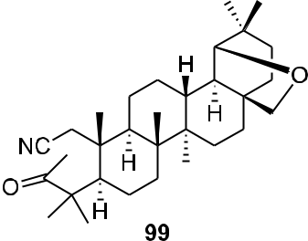

F I G U R E 22 Chemical structure of Compound 99

A‐seco‐triterpenoids with a methylketone group were synthesized via a Grignard reaction. 3‐Methyl‐1‐ cyano‐19β,28‐epoxy‐2,3‐seco‐2‐nor‐18αH‐olean‐3‐one (99; Figure 22) inhibited in vitro reproduction of HIV‐1 (EC50 = 7.2 μg/ml).80 Morolic acid derivatives (100–102; Figure 23) showed anti‐HIV‐1 activity with EC50 values of 15, 14, and 39 μM, respectively.39 C‐3 modified moronic acid analogs 103–111 (Figure 24) diverse substitutions at the 3β position were tested against HIV‐1IIIB; however, none of them showed significant anti‐HIV activity.40

Nine new and three known olean‐18‐ene triterpenes were isolated from C. xylocarpa and Maytenus jelskii. Five compounds (112–116) from this series displayed potent antiviral activity with IC50 values in the micromolar range; 112 and 116 being the most active compounds (Figure 25). Compared with currently licensed antiretroviral drugs, these compounds have a different target; they act as inhibitors of enhancer‐ dependent transcription.81

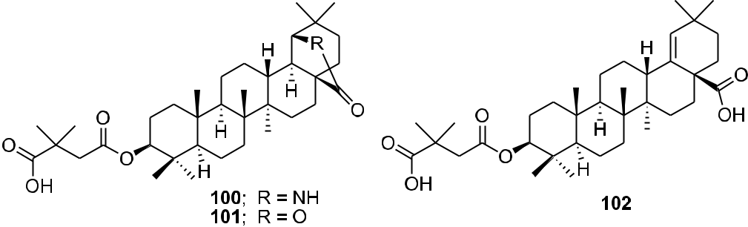

F I G U R E 23 Chemical structures of Compounds 100–102

24 | WU ET AL.

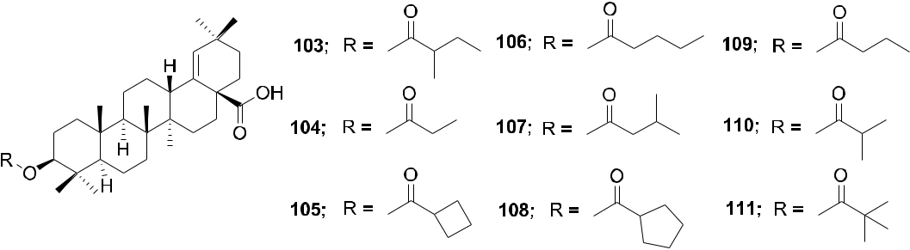

F I G U R E 24 Chemical structures of Compounds 103–111

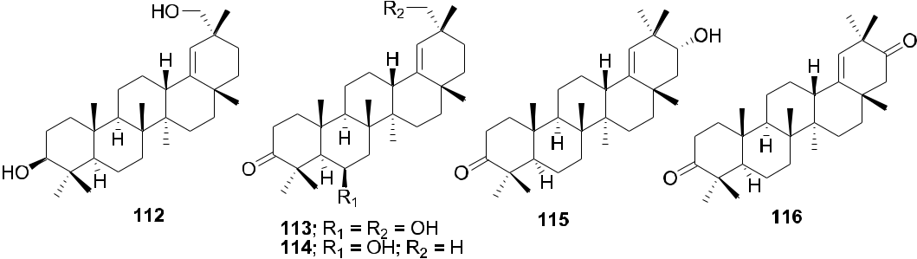

F I G U R E 25 Chemical structures of Compounds 112–116

Correspondingly, transactivator of transcription (Tat), an early virus‐encoded protein required for the efficient transcription of the HIV genome, could be developed as a target for small molecular therapeutics. Celastrol (117; Figure 26) isolated from Tripterygium wilfordii exhibited high inhibitory activity against Tat. By covalently modifying the cysteine thiols, celastrol inhibits Tat transactivation function as well as the transcription elongation of the HIV proviral genome through mechanisms other than Tat–transactivation‐responsive region interaction.82 22β‐ Acetoxyglycyrrhizin (118) and 3‐O‐β‐D‐glucuronopyranosylglycyrrhetinic acid (119; Figure 27) showed anti‐HIV activities with IC50 values of 29.5 and 41.7 μM, respectively.83

Recently, the anti‐HIV and other pharmacological activities of ursolic acid were reviewed.84 A new series of HIV‐1 PR inhibitors with pentacyclic triterpenoids as P2 ligands and phenylsulfonamide as P2′ ligands were

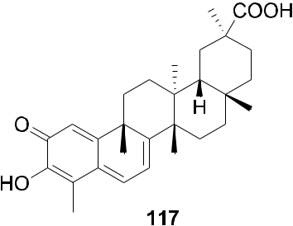

F I G U R E 26 Chemical structure of Compound 117

|  |  |  |  |
| --- | --- | --- | --- |
| WU ET AL. |  | | 25 |  |
|  |  |
|  |  |  |  |

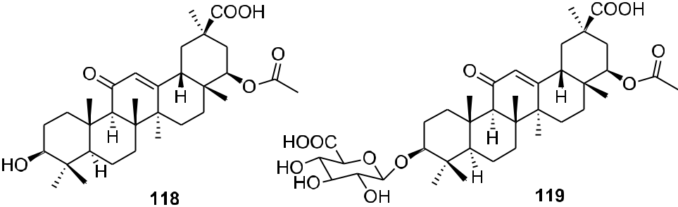

F I G U R E 27 Chemical structures of Compounds 118 and 119

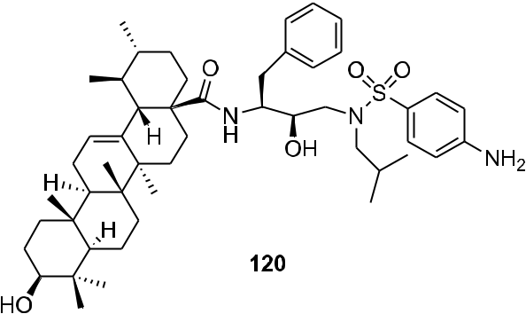

F I G U R E 28 Chemical structure of Compound 120

synthesized. These compounds exhibited micromolar inhibitory potency. Among them, Compound T1c (120; Figure 28) exhibited HIV‐1 PR inhibition with an IC50 value of 0.12 μM, thus, showing 67 times the inhibitory activity of its raw material ursolic acid (8.0 μM).85 A‐seco ursolic acid derivatives (121–124; Figure 29) showed inhibitory activity against HIV‐1 PR (IC50 = 5.7, 17.6, 3.9, and 88.1 μM, respectively).67

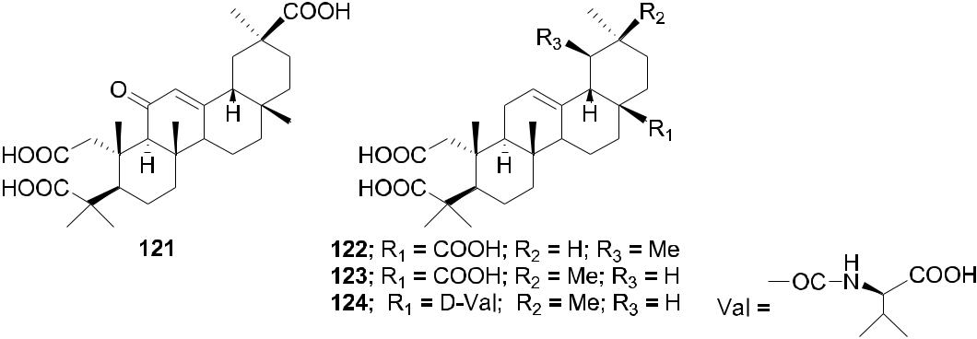

F I G U R E 29 Chemical structures of Compounds 121–124

26 | WU ET AL.

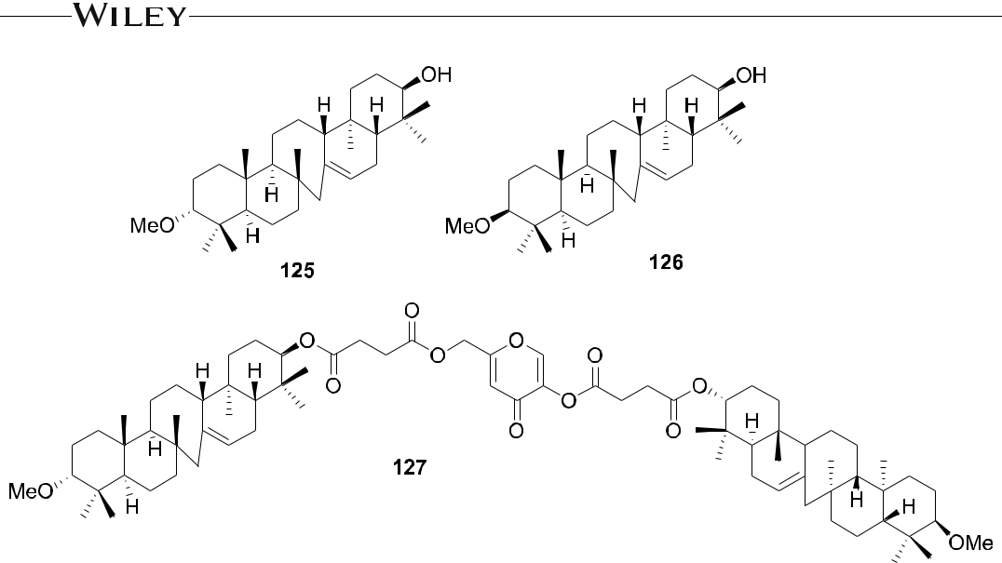

F I G U R E 30 Chemical structures of Compounds 125–127

2.3 | Others

3α‐Methoxyserrat‐14‐en‐21β‐ol (125) and 3β‐methoxyserrat‐14‐en‐21β‐ol (126) and their curcumin, kojic acid, quercetin, and baicalein conjugates were evaluated for in vitro anti‐HIV‐1 RT activity in infected C8166–CCR5 cells (Figure 30). Compound 127, the conjugate of two molecules of 126 and one molecule of kojic acid, exerted significant anti‐HIV activity with an EC50 value of 0.12 μg/ml.86 An efficient synthesis of epiceanothic acid (128; Figure 31) starting from betulin (3) was accomplished in 12 steps with a total yield of 10%. Epiceanothic acid (EC50 = 15.6 μM) exhibited moderate HIV‐1 inhibition in acutely HIV‐1NL4–3 infected MT‐4 cells.87

1. | TETRACYCLIC TRITERPENOID 3.1 | The lanostane group

Five highly oxygenated lanostane‐type triterpenoids, ganoderic acid GS‐1 (129), ganoderic acid GS‐2 (130), ga-noderic acid GS‐3 (131), 20(21)‐dehydrolucidenic acid N (132), and 20‐hydroxylucidenic acid A (133), as well as

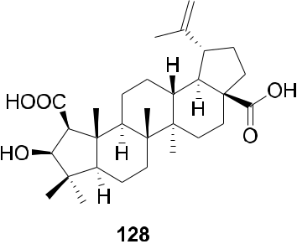

F I G U R E 31 Chemical structure of Compound 128

WU ET AL. | 27

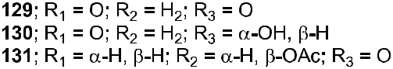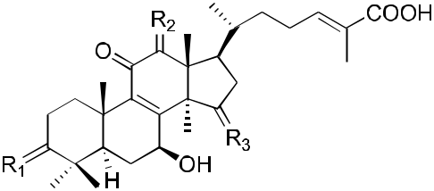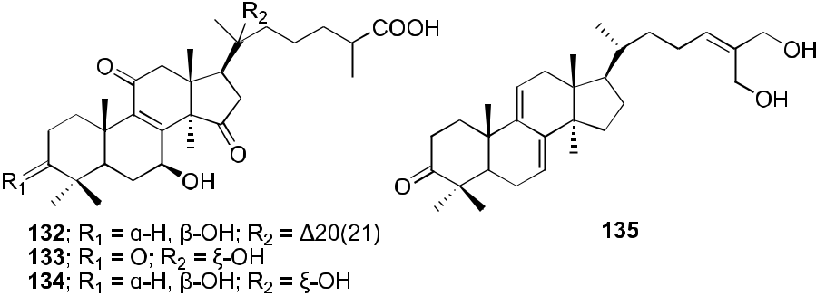

F I G U R E 32 Chemical structures of Compounds 129–135

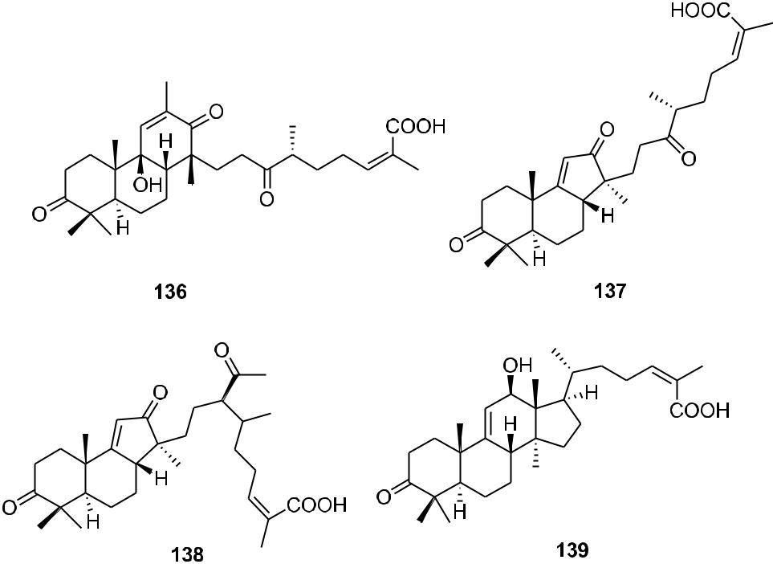

F I G U R E 33 Chemical structures of Compounds 136–139

28 | WU ET AL.

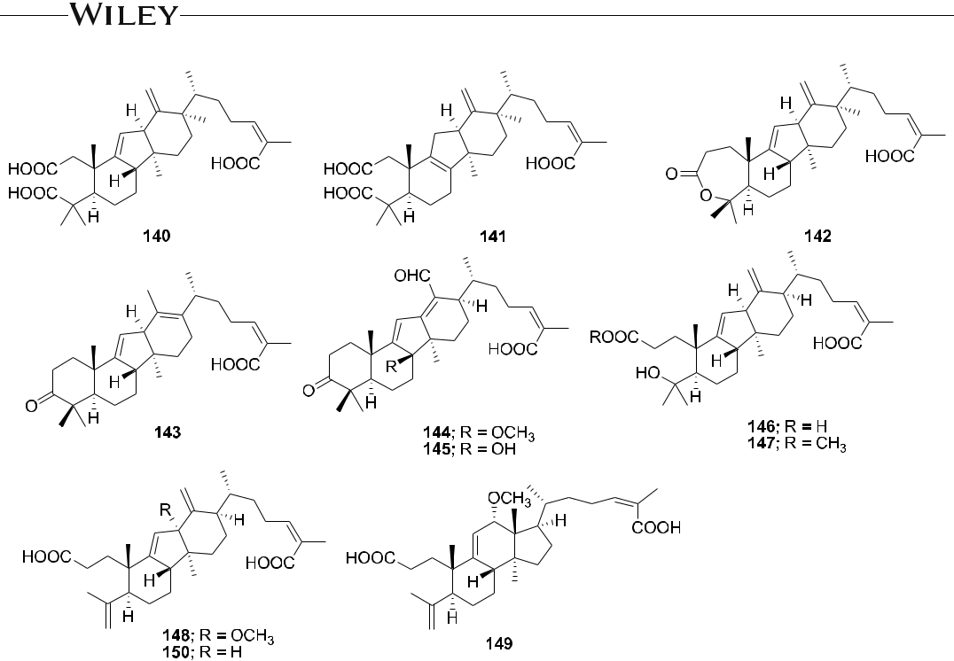

F I G U R E 34 Chemical structures of Compounds 140–150

several known compounds were isolated from the fruiting body of Ganoderma sinense (Figure 32). Compounds 130, 132, and 20‐hydroxylucidenic acid N (134), and ganoderiol F (135) inhibited HIV‐1 PR with IC50 values of 30, 48, 25, 22 μM, respectively.88 Three new tricyclic rearranged lanostane triterpenoids, kadcotriones A–C (136–138), together with a biogenetically related lanostane‐type triterpenoid (139), were isolated from Kadsura coccinea (Figure 33). Compounds 137 and 139 exhibited anti‐HIV‐1 activities with EC50 values of 30.29 and 54.81 μM, respectively.89 Later, 11 triterpene acids including kadcoccinic acids A–J (140–149) and 150 (Figure 34) were also isolated from the stems of K. coccinea by the same group. Except for 149, these compounds feature a rearranged lanostane skeleton with a 6/6/5/6 tetracyclic ring system. Compounds 140 and 141 are the first triterpenoids with

1. 2,3‐seco‐6/6/5/6‐fused tetracyclic skeleton. Among them, Compounds 143 and 146 demonstrated anti‐HIV‐1 activity with respective EC50 values of 62.0 and 58.7 μM.90 In a computational study on Ganoderma lucidum

triterpenoids, ganoderat acid‐B (151; Figure 35) showed the best affinity to HIV‐1 PR (binding energy = −7.49 kcal/ mol and Ki = 0.001 mM), better than that of nelfinavir.91 Another lanostane triterpene, garcinuntine (152; Figure 36), isolated from the roots of Garcinia nuntasaenii Ngerns. & Suddee was inactive.92

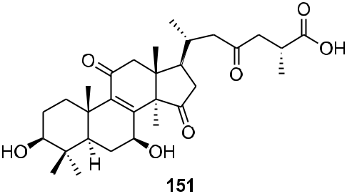

F I G U R E 35 Chemical structure of Compound 151

|  |  |  |  |
| --- | --- | --- | --- |
| WU ET AL. |  | | 29 |  |
|  |  |
|  |  |  |  |

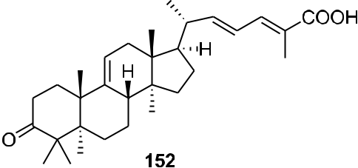

F I G U R E 36 Chemical structure of Compound 152

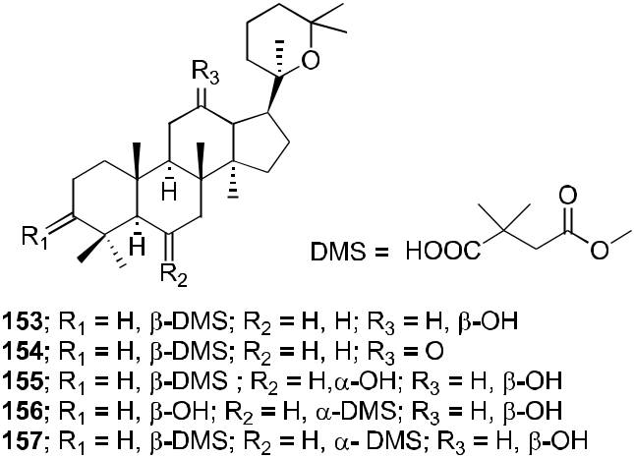

F I G U R E 37 Chemical structures of Compounds 153–157

3.2 | The dammarane group

Several dammarane triterpene derivatives were synthesized and evaluated for HIV‐1 PR inhibitory activity. The mono‐ and di‐succinyl derivatives 153–157 (Figure 37) were significant inhibitors of HIV‐1 PR with EC50 values of 2.7, 6.5, 3.9, 2.7, and 5.4 μM.93 Three other triterpenoids, (20R)‐20,25‐epoxy‐dammaran‐2‐en‐6α,12β‐diol (158), (20R)‐20,25‐epoxy‐3‐methyl‐28‐nordammaran‐2‐en‐6α,12β‐diol (159), and isodehydroprotopanaxatriol (160),

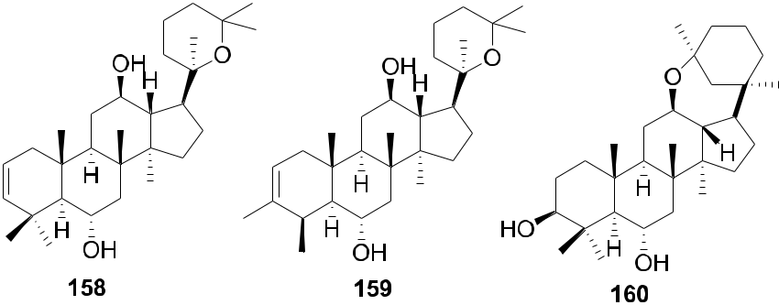

F I G U R E 38 Chemical structures of Compounds 158–160

30 | WU ET AL.

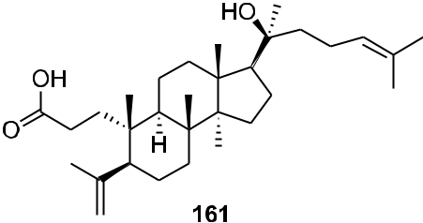

F I G U R E 39 Chemical structure of Compound 161

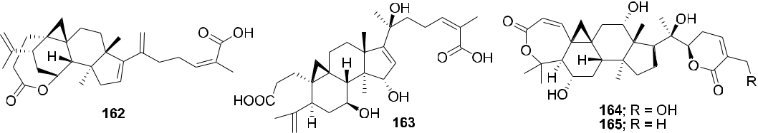

F I G U R E 40 Chemical structures of Compounds 162–165

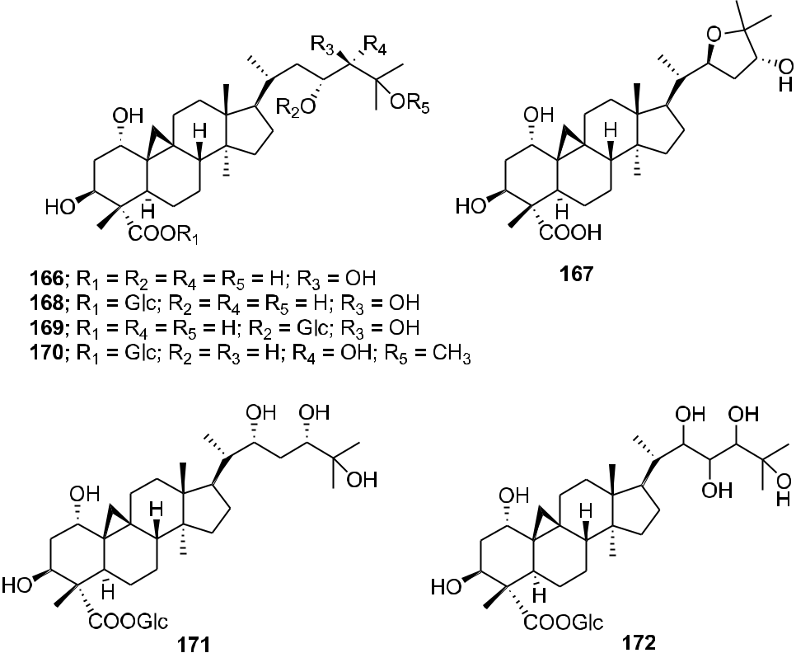

F I G U R E 41 Chemical structures of Compounds 166–172

|  |  |  |  |
| --- | --- | --- | --- |
| WU ET AL. |  | | 31 |  |
|  |  |
|  |  |  |  |

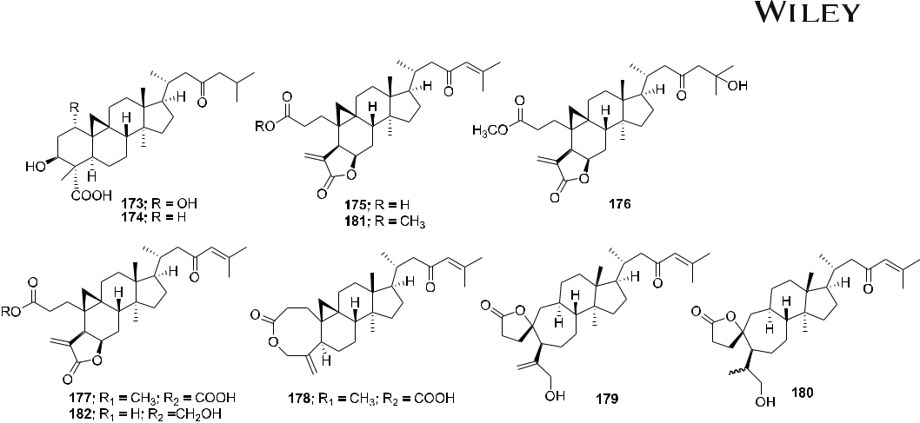

F I G U R E 42 Chemical structures of Compounds 173–182

isolated from an acidic hydrolysate of Panax ginseng (Figure 38), showed inhibitory activity against HIV‐1 PR with EC50 values of 10.5, 10.3, and 12.3 μM, respectively.94 In the screening of a panel of purified compounds isolated from Aglaia sp. (Meliaceae) for inhibition of early steps in the lentiviral replication cycle, the 3,4‐secodammarane triterpenoid 161 (Figure 39), exhibited potent inhibition of HIV‐1 infection (IC50 = 0.48 μg/ml), while cytotoxic effects and inhibition of cell proliferation were observed only at concentrations exceeding 10.69 μg/ml.95

3.3 | Cycloartane group

Four cycloartane triterpenoids, angustific acid A (162), angustific acid B (163), angustifodilactone A (164), and angustifodilactone B (165; Figure 40), were isolated from the branches of Kadsura angustifolia. Compound 162, characterized by the presence of a C‐16/C‐17, C‐20/C‐21 conjugated diene, and a C‐1/C‐7 ester bridge formed in rings A and B, exemplified a novel structural skeleton for 3,4‐secocycloartane triterpenoids. Compound 162 exhibited the most potent anti‐HIV activity with an EC50 value of 6.1 μg/ml in infected C8166 cells and a ther-apeutic index of >32.8.96 Two cycloartane triterpenoids, cycloccidentalic acids A and B (166 and 167), and five related saponins, cycloccidentalisides I–V (168–172; Figure 41), were isolated from Cassia occidentalis. Compounds 167 and 170 showed modest anti‐HIV‐1 activities with EC50 values of 2.23 and 4.36 μM, respectively.97

Eight cycloartane triterpenoids carinatins A–H (173–180), secaubryolide (181), and dikamaliartane D (182; Figure 42) were isolated from the leaves and twigs of Gardenia carinata and evaluated for anti‐HIV‐1 activities using HIV‐1 reverse transcriptase and syncytium inhibition assays using the Tat/RevMC99 virus and 1A2 cell line

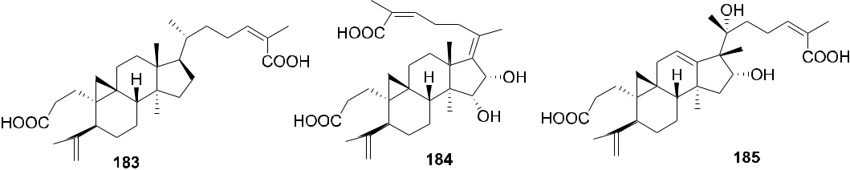

F I G U R E 43 Chemical structures of Compounds 183–185

32 | WU ET AL.

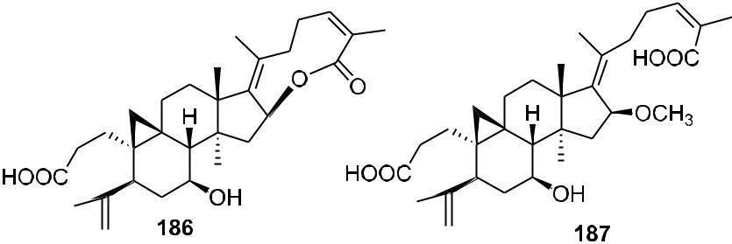

F I G U R E 44 Chemical structures of Compounds 186 and 187

system. Compounds 173, 174, 177–179, and 182 exhibited significant inhibitory activities by significantly reducing the number of syncytium formations in the syncytium inhibition assay. Compound 182 showed the most potent anti‐HIV‐1 activity (EC50 < 8.3 μM). In the reverse transcriptase assay, only Compounds 175 and 182 were active against HIV‐1 reverse transcriptase, with IC50 values of 85.7 and 68.7 μM, respectively.98

Two metabolites (184 and 185) were obtained by microbial transformation of the triterpene nigranoic acid (183) in a culture of Trichoderma sp. JY‐1, a fungus obtained from the branches of K. angustifolia. Compound 184 was characterized with an unusual 17(20),17(E)‐ene structure, while Compound 185 featured an unprecedented 18(13→17β)‐abeo‐secocyloartane skeleton. In addition, Compounds 183–185 (Figure 43) showed weak anti‐HIV activity with EC50 values of 10.5, 8.8, and 7.6 μg/ml and therapeutic index values of 8.48, 9.12, and 10.1, respectively.99 In another report, the microbiological transformation of the triterpene nigranoic acid (183) to 3, 4‐secocycloarta‐4(28),17(20),24(Z)‐triene‐7β‐hydroxy‐16β,26‐lactone‐3‐oic acid (186) and 3,4‐secocycloarta‐ 4(28),17(20)(Z),24(Z)‐triene‐7β‐hydroxy‐16β‐methoxy‐3,26‐dioic acid (187; Figure 44) by the freshwater fungus

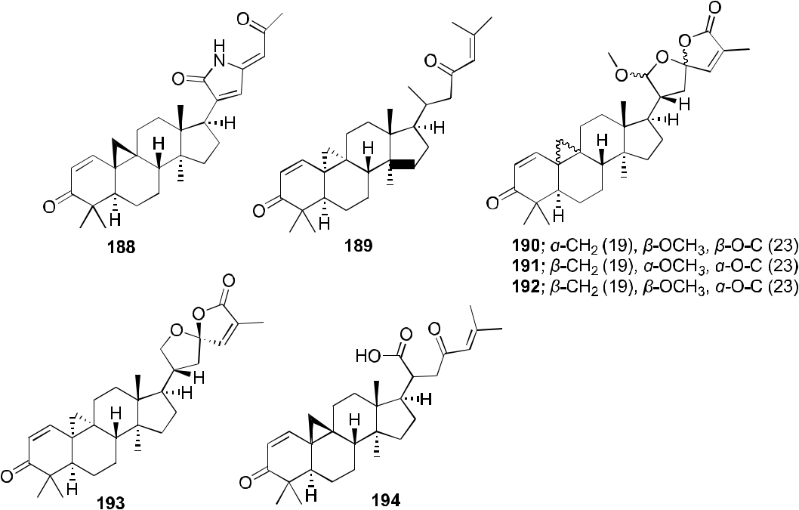

F I G U R E 45 Chemical structures of Compounds 188–194

|  |  |  |  |  |  |  |  |  |  |  |  |  |  |  |  |  |  |  |  |  |  |  |  |  |  |  |  |  |  |  |  |  |  |  |  |  |  |  |
| --- | --- | --- | --- | --- | --- | --- | --- | --- | --- | --- | --- | --- | --- | --- | --- | --- | --- | --- | --- | --- | --- | --- | --- | --- | --- | --- | --- | --- | --- | --- | --- | --- | --- | --- | --- | --- | --- | --- |
| WU ET AL. | | | | | | | | | | | | | | | | | | | | | | | | | | | | | | |  |  |  | | |  | | 33 |  |
|  | | |  |  |
|  |  |  |  |  |  |  |  |  |  |  |  |  |  |  |  |  |  |  |  |  |  |  |  |  |  |  |  |  |  |  |  |  |  |  |  |  |  |  |
|  |  |  |  |  |  |  |  |  |  |  |  |  |  |  |  |  |  |  |  |  |  |  |  |  |  |  |  |  |  |  |  |  |  |  |  |  |  |  |
|  |  |  |  |  |  |  |  |  |  |  |  |  |  |  |  |  |  |  |  |  |  |  |  |  |  |  |  |  |  |  |  |  |  |  |  |  |  |  |
|  |  |  |  |  |  |  |  |  |  |  |  |  |  |  |  |  |  |  |  |  |  |  |  |  |  |  |  |  |  |  |  |  |  |  |  |  |  |  |
|  |  |  |  |  |  |  |  |  |  |  |  |  |  |  |  |  |  |  |  |  |  |  |  |  |  |  |  |  |  |  |  |  |  |  |  |  |  |  |
|  |  |  |  |  |  |  |  |  |  |  |  |  |  |  |  |  |  |  |  |  |  |  |  |  |  |  |  |  |  |  |  |  |  |  |  |  |  |  |
|  |  |  |  |  |  |  |  |  |  |  |  |  |  |  |  |  |  |  |  |  |  |  |  |  |  |  |  |  |  |  |  |  |  |  |  |  |  |  |
|  |  |  |  |  |  |  |  |  |  |  |  |  |  |  |  |  |  |  |  |  |  |  |  |  |  |  |  |  |  |  |  |  |  |  |  |  |  |  |
|  |  |  |  |  |  |  |  |  |  |  |  |  |  |  |  |  |  |  |  |  |  |  |  |  |  |  |  |  |  |  |  |  |  |  |  |  |  |  |
|  |  |  |  |  |  |  |  |  |  |  |  |  |  |  |  |  |  |  |  |  |  |  |  |  |  |  |  |  |  |  |  |  |  |  |  |  |  |  |
|  |  |  |  |  |  |  |  |  |  |  |  |  |  |  |  |  |  |  |  |  |  |  |  |  |  |  |  |  |  |  |  |  |  |  |  |  |  |  |
|  |  |  |  |  |  |  |  |  |  |  |  |  |  |  |  |  |  |  |  |  |  |  |  |  |  |  |  |  |  |  |  |  |  |  |  |  |  |  |
|  |  |  |  |  |  |  |  |  |  |  |  |  |  |  |  |  |  |  |  |  |  |  |  |  |  |  |  |  |  |  |  |  |  |  |  |  |  |  |
|  |  |  |  |  |  |  |  |  |  |  |  |  |  |  |  |  |  |  |  |  |  |  |  |  |  |  |  |  |  |  |  |  |  |  |  |  |  |  |
|  |  |  |  |  |  |  |  |  |  |  |  |  |  |  |  |  |  |  |  |  |  |  |  |  |  |  |  |  |  |  |  |  |  |  |  |  |  |  |
|  |  |  |  |  |  |  |  |  |  |  |  |  |  |  |  |  |  |  |  |  |  |  |  |  |  |  |  |  |  |  |  |  |  |  |  |  |  |  |
|  |  |  |  |  |  |  |  |  |  |  |  |  |  |  |  |  |  |  |  |  |  |  |  |  |  |  |  |  |  |  |  |  |  |  |  |  |  |  |
|  |  |  |  |  |  |  |  |  |  |  |  |  |  |  |  |  |  |  |  |  |  |  |  |  |  |  |  |  |  |  |  |  |  |  |  |  |  |  |
|  |  |  |  |  |  |  |  |  |  |  |  |  |  |  |  |  |  |  |  |  |  |  |  |  |  |  |  |  |  |  |  |  |  |  |  |  |  |  |
|  |  |  |  |  |  |  |  |  |  |  |  |  |  |  |  |  |  |  |  |  |  |  |  |  |  |  |  |  |  |  |  |  |  |  |  |  |  |  |
|  |  |  |  |  |  |  |  |  |  |  |  |  |  |  |  |  |  |  |  |  |  |  |  |  |  |  |  |  |  |  |  |  |  |  |  |  |  |  |
|  |  |  |  |  |  |  |  |  |  |  |  |  |  |  |  |  |  |  |  |  |  |  |  |  |  |  |  |  |  |  |  |  |  |  |  |  |  |  |
|  |  |  |  |  |  |  |  |  |  |  |  |  |  |  |  |  |  |  |  |  |  |  |  |  |  |  |  |  |  |  |  |  |  |  |  |  |  |  |
|  |  |  |  |  |  |  |  |  |  |  |  |  |  |  |  |  |  |  |  |  |  |  |  |  |  |  |  |  |  |  |  |  |  |  |  |  |  |  |
|  |  |  |  |  |  |  |  |  |  |  |  |  |  |  |  |  |  |  |  |  |  |  |  |  |  |  |  |  |  |  |  |  |  |  |  |  |  |  |
|  |  |  |  |  |  |  |  |  |  |  |  |  |  |  |  |  |  |  |  |  |  |  |  |  |  |  |  |  |  |  |  |  |  |  |  |  |  |  |
|  |  |  |  |  |  |  |  |  |  |  |  |  |  |  |  |  |  |  |  |  |  |  |  |  |  |  |  |  |  |  |  |  |  |  |  |  |  |  |
|  |  |  |  |  |  |  |  |  |  |  |  |  |  |  |  |  |  |  |  |  |  |  |  |  |  |  |  |  |  |  |  |  |  |  |  |  |  |  |
|  |  |  |  |  |  |  |  |  |  |  |  |  |  |  |  |  |  |  |  |  |  |  |  |  |  |  |  |  |  |  |  |  |  |  |  |  |  |  |
|  |  |  |  |  |  |  |  |  |  |  |  |  |  |  |  |  |  |  |  |  |  |  |  |  |  |  |  |  |  |  |  |  |  |  |  |  |  |  |
|  |  |  |  |  |  |  |  |  |  |  |  |  |  |  |  |  |  |  |  |  |  |  |  |  |  |  |  |  |  |  |  |  |  |  |  |  |  |  |

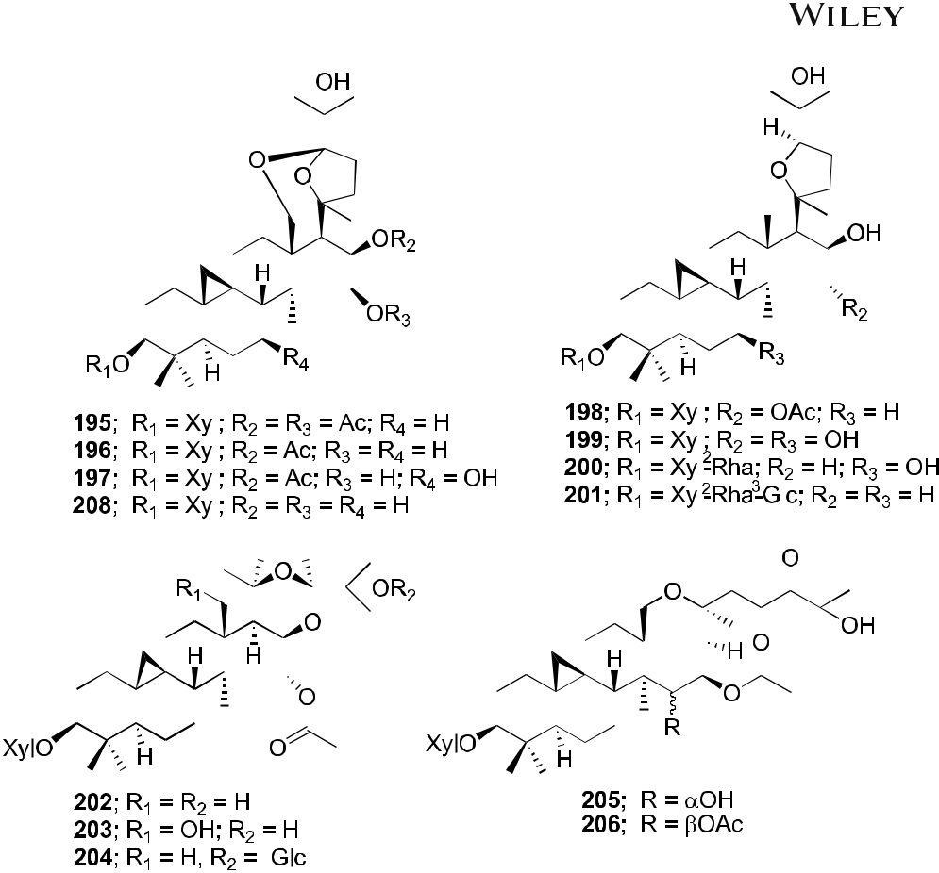

F I G U R E 46 Chemical structures of Compounds 195–206 and 208

Dictyosporium heptasporum YMF1.01213 was demonstrated. Compound 186, characterized by the presence of a formed C‐16/C‐26 ester bridge, exemplifies a novel nine‐membered lactone ring structural skeleton for 3,4‐secocycloartane triterpenoid. In addition, Compounds 186 and 187 exhibited weak in vitro anti‐HIV activity with respective EC50 values of 15.3 and 18.1 μg/ml.100 In a recent report, a novel cycloartane triterpenoid alkaloid, kleinhospitine E (188), and six cycloartane triterpenoids (189–194; Figure 45) were isolated from Kleinhovia hospita. Compound 188 is the first cycloartane alkaloid possessing an unusual γ‐lactam with an oxopropylidene side chain. Compounds 189, 190, and 194 were assigned as cycloartane triterpenoids with a 9α,10α‐cyclopropyl ring, which is found rarely among naturally occurring compounds, while 192 and 193 were established as isomers of 190 containing a 21,23‐diacetal side chain. Compound 194 exhibited anti‐HIV activity with an EC50 value of 0.8 μM.101

In our Natural Products Research Laboratories, 12 known cycloartane triterpenoids (195–206; Figure 46) with four different skeletons were isolated from the roots of Souliea vaginata and screened for their anti‐HIV activity. Among these compounds, beesioside I (195) showed the highest potency against HIV‐1NL4‐3 with an EC50 value of 2.32 μM. Further modification at the C‐3 position of the aglycone (207) of 195 led to a series of derivatives (208–221; Figure 47). Among them, Compound 214 was the most potent with an EC50 value of 0.025 μM and TI value >800, comparable with those of BVM. Other analogs exhibited strong to weak inhibition of HIV‐1 replication in MT‐4 cells.102

34 | WU ET AL.

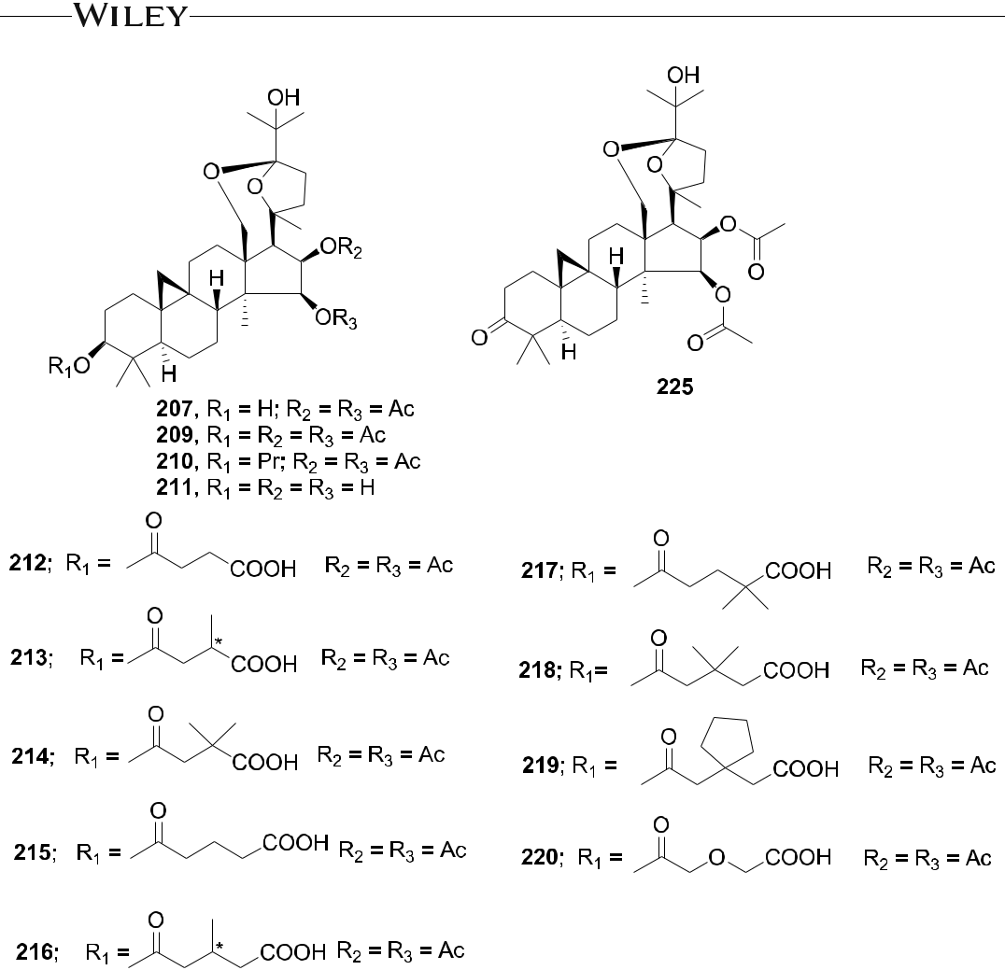

F I G U R E 47 Chemical structures of Compounds 207 and 209–221

3.4 | Limonoid group

Three limonoids, trichiconin A (222) with a unique carbon skeleton featuring a rearranged A,B‐ring system and trichiconins B (223) and C (224; Figure 48) with an unprecedented A,B,D‐seco skeleton, were isolated from the twigs of Trichilia connaroides. Compounds 223 and 224 showed modest anti‐HIV activity with EC50 values of 5.9 and 3.6 μM, respectively, while 222 was inactive.103 Sixteen limonoids, ciparasins A–P (225–240; Figure 49), were isolated from Cipadessa cinerascens. Ciparasins E–G (229–231) contain a rare gamma‐hydroxylbutenolide moiety at C‐17. Ciparasins B (230) and P (240) showed significant anti‐HIV activity with EC50 values of 5.5 and 6.1 μM, respectively.104 Five limonoids, sundarbanxylogranins A–E (241–245; Figure 50), were isolated from the seeds of Xylocarpus granatum. Sundarbanxylogranin A (241) is a rare limonoid containing a bicyclo[5.2.1]dec‐3‐en‐8‐one scaffold as the ring A/B‐fused core; whereas sundarbanxylogranin B (242) is a typical mexicanolide with an 8α,30α‐ epoxy ring. Sundarbanxylogranins C–E (243–245) belong to a small group of limonoids containing a C‐1–O–C‐29 oxygen bridge; both former compounds have a 29‐OMe group but with different orientations. Compound 242 exhibited moderate anti‐HIV activity with an IC50 value of 23.14 μM.105

|  |  |  |  |
| --- | --- | --- | --- |
| WU ET AL. |  | | 35 |  |
|  |  |
|  |  |  |  |

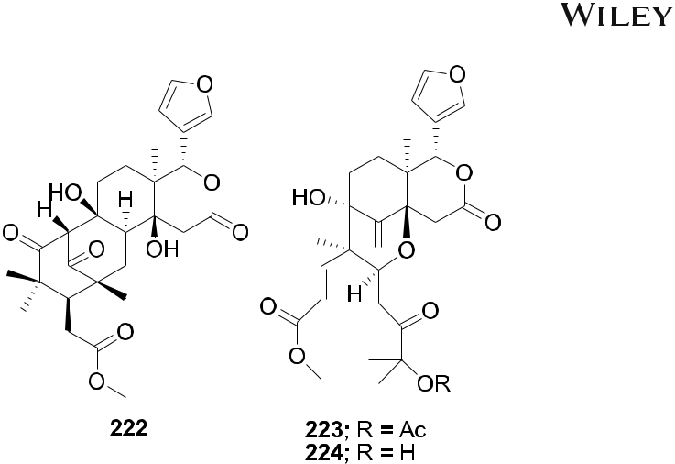

F I G U R E 48 Chemical structures of Compounds 222–224

Krishnolides A–D (246–249; Figure 51), four khayanolide‐type limonoids with a 2‐carbonyl group, were iso-

lated from the seeds of Xylocarpus moluccensis. Compounds 246–249 are unique khayanolides containing two large ester substituents of five or four carbon atoms at the C‐3 and C‐30 positions, respectively. Compound 246 with an 8,14‐epoxy group exhibited moderate anti‐HIV activity with an IC50 value of 17.45 μM.106

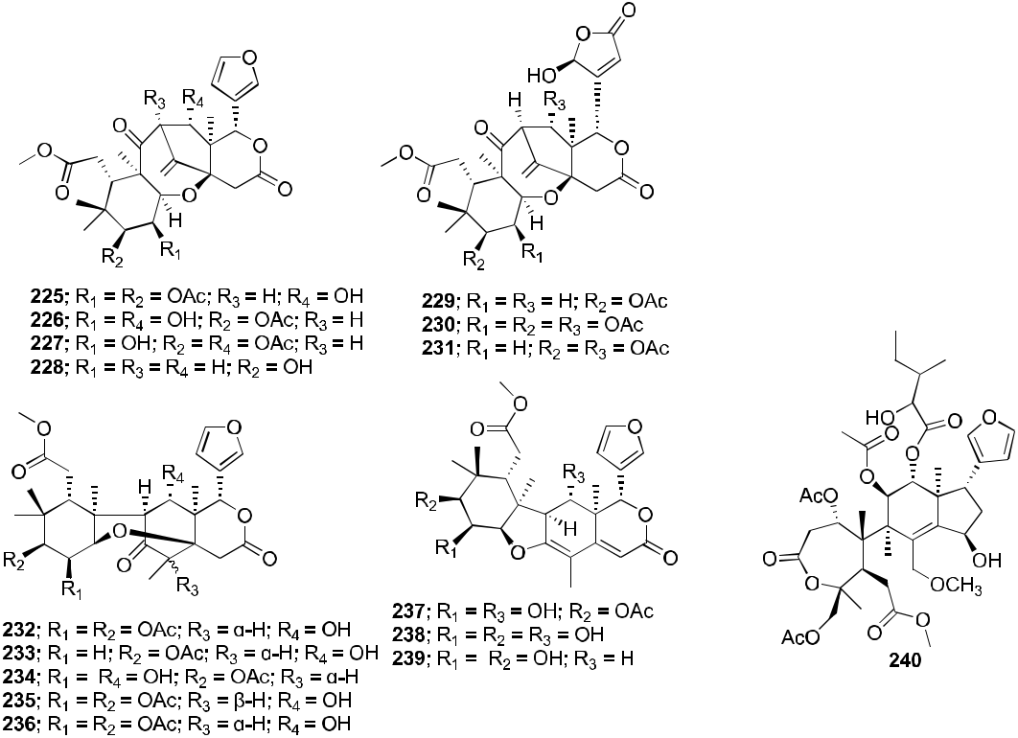

F I G U R E 49 Chemical structures of Compounds 225–240

36 | WU ET AL.

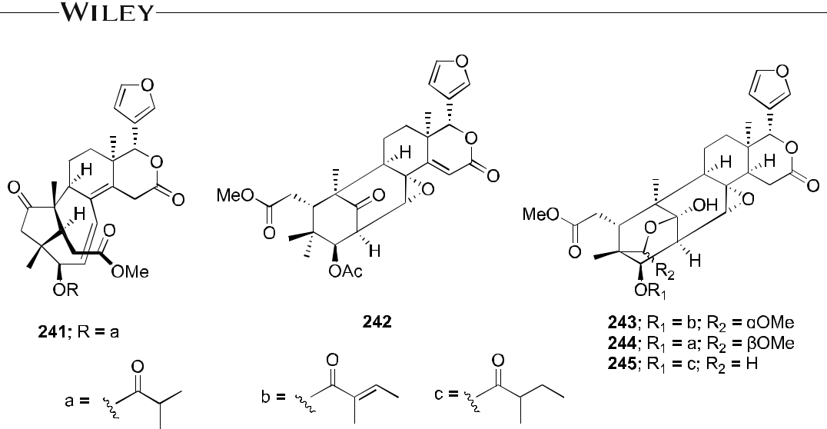

F I G U R E 50 Chemical structures of Compounds 241–245

3.5 | Nortriterpenoids of the Schisandraceae

Three nortriterpenoids, schigrandilactones A–C (250–252; Figure 52), were isolated from Schisandra grandiflora. Compounds 250 and 251 contain a spirocyclic moiety, and Compound 252 has a new oxygenated pattern. Com-pounds 250–252 displayed EC50 values of 80.2, 20.8, and 5.1 μg/ml in infected C8166 cells.107 A nortriterpenoid, 20‐hydroxymicrandilactone D (253; Figure 53) was isolated from Schisandra lancifolia. Compound 257 showed anti‐ HIV‐1 activities with EC50 value of 99.0 μg/ml.108 Six nortriterpenoids, schirubridilactones A–F (254–259; Figure 54) were isolated from Schisandra rubriflora. Compounds 254–259 showed anti‐HIV‐1 activity with EC50 values of 30.1, 15.2, 14.3, 80.8, 66.8, and 50.1 μg/ml and a selectivity index of 5.1, 9.0, 8.7, 2.2, 3.1, and 3.5, respectively.109

A novel triterpenoid, schinarisanlactone A (260; Figure 55), with an unprecedented skeleton of a 5/7/7/5/7/5/ 6/5‐fused octacyclic ring system was isolated from Schisandra arisanensis. Compound 260 showed significant in-hibition (11.8% survival rate) against the HIV virus at 10 μM.110 Three unique nortriterpenoids, schilancitrilactones A–C (261–263; Figure 56), were isolated from S. lancifolia. Compound 261 has a 5/5/7/5/5/5‐fused hexacyclic ring

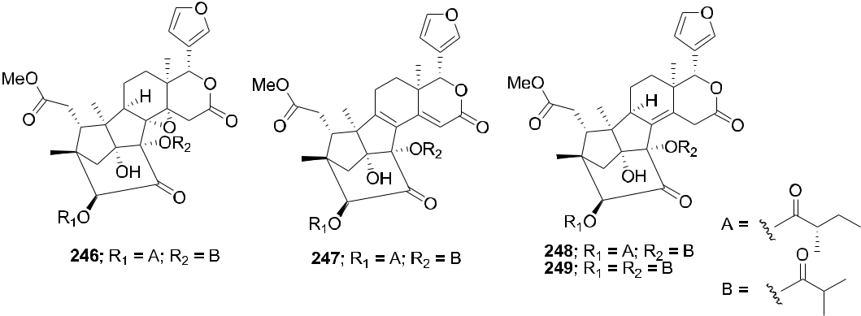

F I G U R E 51 Chemical structures of Compounds 246–249

WU ET AL. | 37

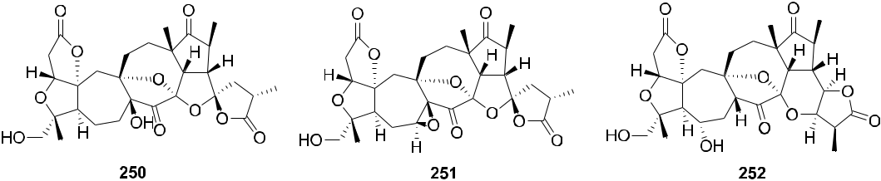

F I G U R E 52 Chemical structures of Compounds 250–252

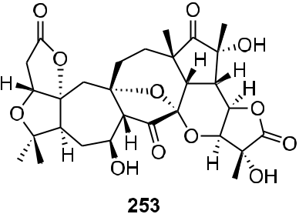

F I G U R E 53 Chemical structure of Compound 253

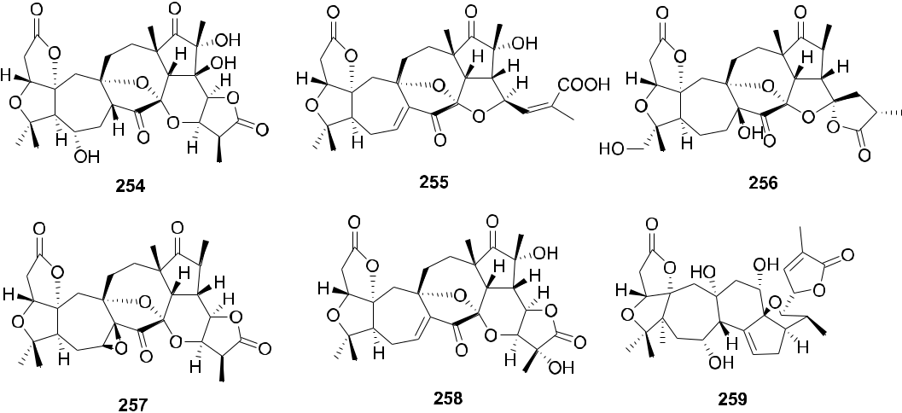

F I G U R E 54 Chemical structures of Compounds 254–259

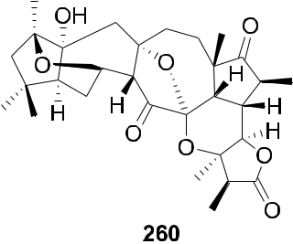

F I G U R E 55 Chemical structure of Compound 260

38 | WU ET AL.

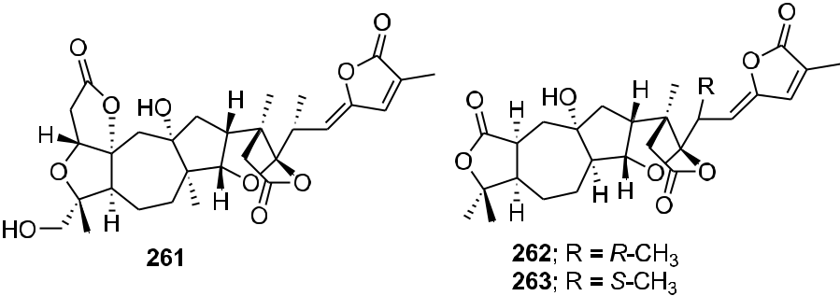

F I G U R E 56 Chemical structures of Compounds 261–263

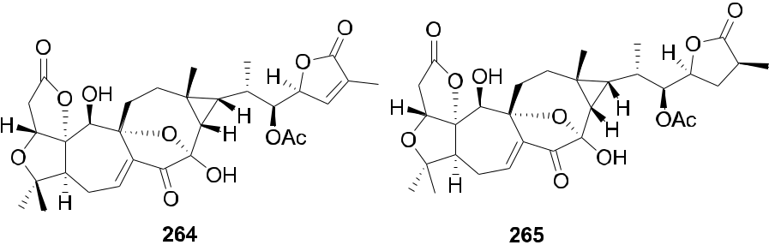

F I G U R E 57 Chemical structures of Compounds 264 and 265

system with a C‐29 backbone, while 262 and 263 feature a 5/7/5/5/5‐fused pentacyclic ring system with a C‐27 skeleton. Compound 263 showed anti‐HIV‐1 activity with an EC50 value of 27.54 μg/ml, while 261 and 262 were not active (EC50 > 100 μg/ml).111 Two new highly oxygenated nortriterpenoids, schilancidilactones V and W (264 and 265; Figure 57), were isolated from Schisandra wilsoniana. They showed moderate anti‐HIV‐1 activity with EC50 values of 3.05 and 2.87 μg/ml, respectively.112 Schisphendilactones A and B (266 and 267; Figure 58) isolated from Schisandra sphenanthera exhibited anti‐HIV‐1 activity with EC50 values of 8.79 and 1.09 μg/ml, respectively.113 Schisarisanlactones A (268) and B (269; Figure 59), were isolated from S. arisanensis. Compounds 268 and 269 have an unprecedented 5/5/7/5/5‐fused pentacyclic ring system. Compound 268 showed significant inhibition (15.5% survival rate), while Compound 269 exhibited moderate activity (39.8% survival rate) against the HIV virus at

1. μM.114

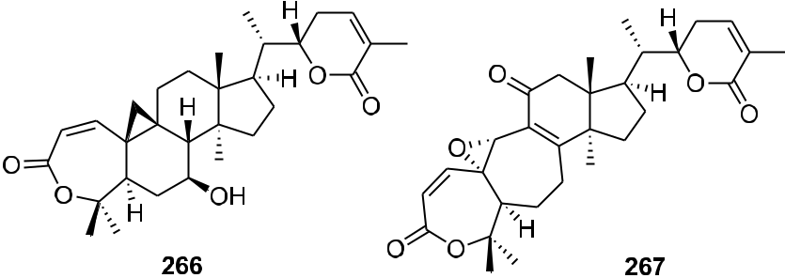

F I G U R E 58 Chemical structures of Compounds 266 and 267

|  |  |  |  |  |  |  |  |  |  |  |  |  |
| --- | --- | --- | --- | --- | --- | --- | --- | --- | --- | --- | --- | --- |
| WU ET AL. | | | | | | | |  |  | | | 39 |  |
|  |  | |  |
|  |  |  |  |  |  |  |  |  |  |  |  |  |
|  |  |  |  |  |  |  |  |  |  |  |  |  |
|  |  |  |  |  |  |  |  |  |  |  |  |  |
|  |  |  |  |  |  |  |  |  |  |  |  |  |
|  |  |  |  |  |  |  |  |  |  |  |  |  |

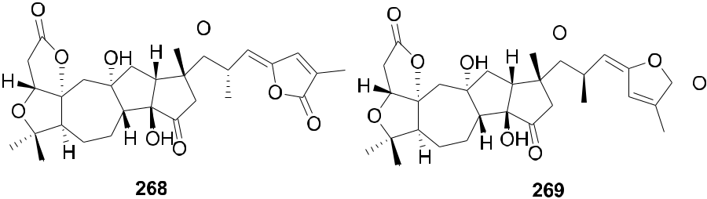

F I G U R E 59 Chemical structures of Compounds 268 and 269

3.6 | Others

Four types of piscidinol A derivatives were synthesized and evaluated for their ability to inhibit HIV‐1 PR. Among these tirucallane‐type triterpene derivatives, an A‐seco derivative (270) moderately inhibited HIV PR (IC50 = 38.2 μM). However, the 2,2‐dimethylsuccinic acid acylated tirucallane derivatives (271–273, ranging from 50 to 100 μM; Figure 60) were more inhibitory against the enzyme.115 Chemical investigation of the vines and leaves of Momordica charantia resulted in the isolation of 14 cucurbitane triterpenoids, kuguacins F–S (274–287; Figure 61). Compounds 285 and 287 showed anti‐HIV‐1 activity with EC50 values of 7.2 and 3.7 μg/ml, respectively.116

Kadheterilactone A (288) and kadheterilactone B (289; Figure 62) were isolated from Kadsura heteroclite. Compounds 288 and 289 were inactive against HIV‐1 PR and RT.117 A pair of triterpenoid epimers, kadcoccitones

1. (290) and B (291; Figure 63), together with a biogenetically related compound, kadcoccitone C (292), were

isolated from K. coccinea. These epimers featured an unprecedented carbon skeleton with a 6/6/5/5‐fused tet-racyclic ring system unit and a C‐9 side chain. Compounds 290 and 292 showed anti‐HIV‐1 activity with EC50

values of 47.9 and 32.7 μg/ml, respectively.118

Viral protein R (Vpr) is an accessory protein that plays important roles in the viral pathogenesis of HIV‐1. In an anti‐Vpr assay, the CHCl3‐soluble extract of Picrasma javanica bark exhibited potent anti‐Vpr activity. Furthermore, related research on quassinoids previously isolated from the extract demonstrated that Compounds 293–307 (Figure 64) exhibit anti‐Vpr activity. Among these compounds, javanicin I (307) exhibited the most potent anti‐Vpr activity in comparison with that of the positive control damna-canthal. The SAR analysis suggested that, in 2,12,14‐triene‐1,11,16‐trione‐2,12‐dimethoxy‐18‐norpicrasane quassinoids, a methyl group at C‐13 is the critical factor for a potent inhibitory effect in TREx‐HeLa‐Vpr cells.119

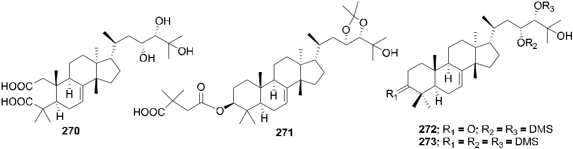

F I G U R E 60 Chemical structures of Compounds 270–273

40 | WU ET AL.

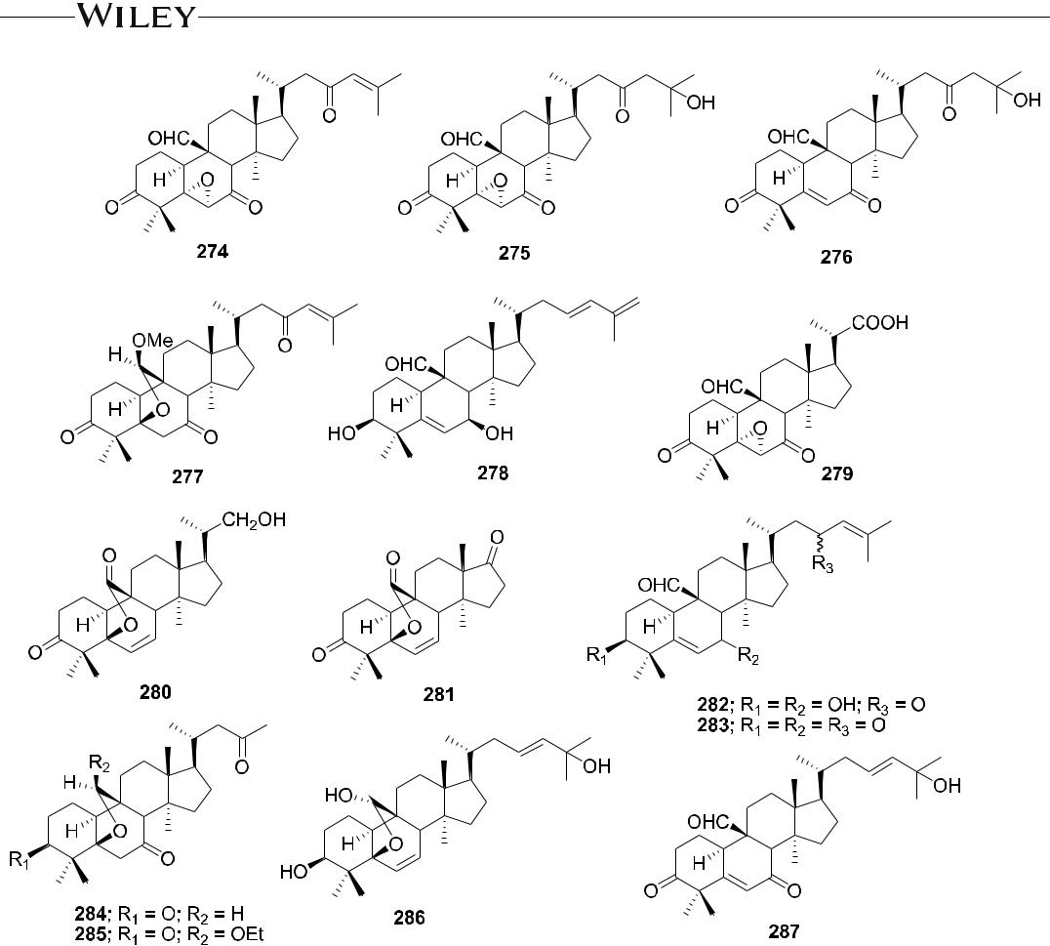

F I G U R E 61 Chemical structures of Compounds 274–287

4 | PERSPECTIVES AND CONCLUSIONS

HIV infection remains a major threat worldwide, especially in developing countries. Although antiretroviral mul-tidrug treatment can provide durable repression of HIV, these drugs have limited clinical benefit due to the emergence of drug resistance and severe side effects, which have hampered their usefulness to most people suffering from AIDS. Therefore, finding new drugs with novel targets is of clinical significance to treat infected persons and furthermore to ultimately achieve the goal of complete eradication of HIV. Natural products are an

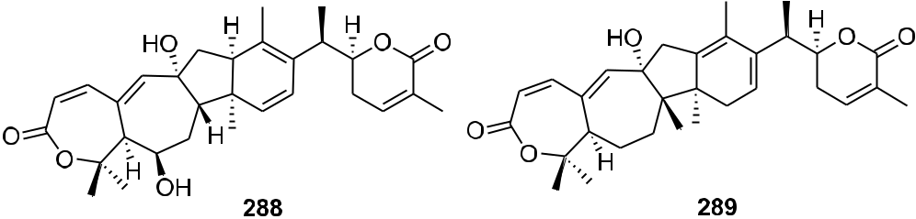

F I G U R E 62 Chemical structures of Compounds 288 and 289

|  |  |  |  |  |  |
| --- | --- | --- | --- | --- | --- |
| WU ET AL. |  |  | | | 41 |  |
|  |  | |  |
|  |  |  |  |  |  |
|  |  |  |  |  |  |

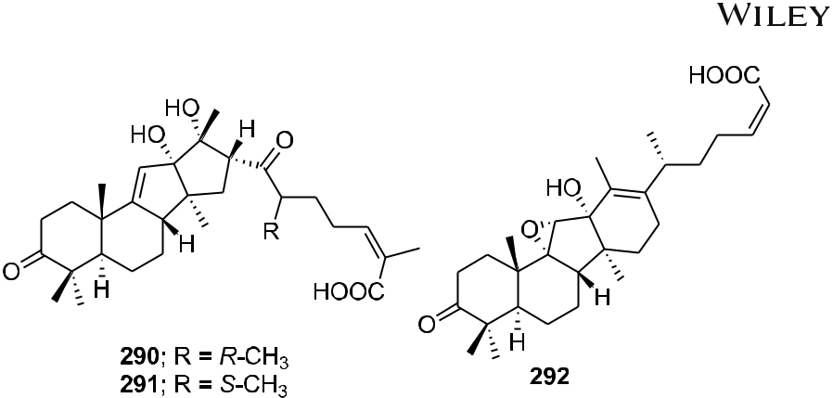

F I G U R E 63 Chemical structures of Compounds 290–292

important potential source for HIV–AIDS drug discovery. Over the past 10 years, extensive research on natural products has revealed that triterpenoids and their derivatives are an important reservoir of anti‐HIV drug leads. It appears that pentacyclic triterpenes are the most promising lead compounds for further development of novel antiviral drugs. The rational design of substituents linked to the C‐3 and C‐28 positions of betulinic acid and analogs is critical in attaining new derivatives with improved anti‐HIV activity. Although the development of BVM as the first‐in‐class HIV‐1 maturation inhibitor was halted due to the high baseline drug resistance of HIV‐1 variants with polymorphism, further studies identified the second‐generation maturation BMS‐955176 (64), which showed significantly improved anti‐HIV activity toward BVM‐resistant variants. Unfortunately, the development of BMS‐955176 was also discontinued by the pharmaceutical company GSK for gastrointestinal intolerance and treatment‐emergent drug resistance by patients. However, due to the proven biological properties demonstrated by betulinic acid derivatives, many studies involving them are still reported in the literature. These studies con-clude that artful modification both at C‐3 and C‐28 can effectively overcome HIV‐1 resistance and improve antiviral activity in the presence of human serum. However, the effect of functionalization at other positions such as C‐30 should not be neglected. Besides antiviral activity, solubility and microsomal stability should be considered. The corresponding SAR from the prior studies is a powerful prototype that affords optimal lead compounds to be emphasized for future endeavors. Even though betulinic acid is an interesting scaffold for developing antiviral agents and has attracted more attention, other classes of triterpenoids also offer unprecedented opportunities for the discovery of novel antiviral therapy. These results make it clear that natural triterpenoids and their synthetic derivatives will continue to be promising candidates for the development of novel anti‐HIV drugs.

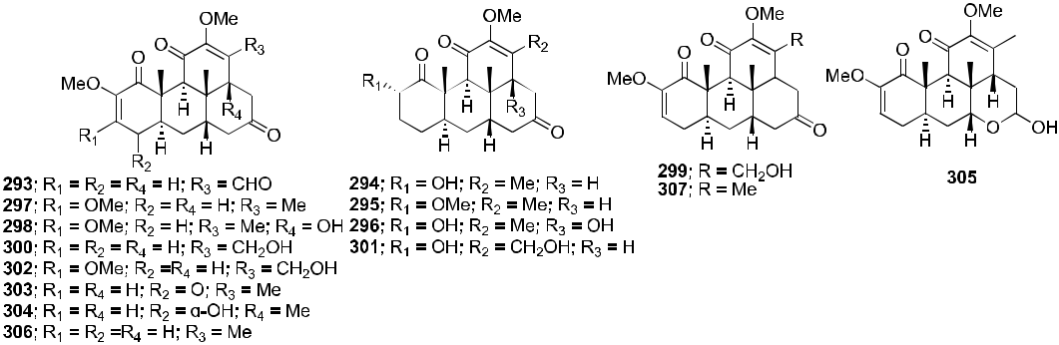

F I G U R E 64 Chemical structures of Compounds 293–307

42 | WU ET AL.



ACKNOWLEDGMENTS

This investigation was supported by NIH grant AI33066 from the NIAID awarded to Kuo‐Hsiung Lee, the CAMS Innovation Fund for Medical Sciences (CIFMS; Grant Nos. 2019‐I2M‐1‐005 and 2017‐I2M‐1‐013), the Foundation of Hunan Double First‐rate Discipline Construction Projects of Bioengineering (Grant No. YYZW2019‐36), and the

State Scholarship Fund from China Scholarship Council.

CONFLICT OF INTERESTS

The authors declare that there are no conflict of interests.

ORCID

Kuo‐Hsiung Lee <https://orcid.org/0000-0002-6562-0070>



REFERENCES

1. World Health Organization. 2018. [www.kff.org/global-health-policy/fact-sheet/the-global-hivaids-epidemic/](http://www.kff.org/global%2010health%2010policy/fact%2010sheet/the%2010global%2010hivaids%2010epidemic/). Accessed December 3, 2018.
2. Girum T, Wasie A, Worku A. Trend of HIV/AIDS for the last 26 years and predicting achievement of the 90‐90‐90 HIV prevention targets by 2020 in Ethiopia: a time series analysis. BMC Infect Dis. 2018;18:320.
3. Bhattacharya S, Osman H. Novel targets for anti‐retroviral therapy. J Infect. 2009;59:377‐386.
4. Marchand C, Maddali K, Metifiot M, Pommier Y. HIV‐1 IN inhibitors: 2010 update and perspectives. Curr Top Med Chem. 2009;9:1016‐1037.
5. Lin LT, Hsu WC, Lin CC. Antiviral natural products and herbal medicines. J Tradit Complement Med. 2014;4:24‐35.
6. Salehi B, Kumar NVA, Şener B, et al. Medicinal plants used in the treatment of human immunodeficiency virus. Int J Mol Sci. 2018;19:1459.
7. Kurapati KRV, Atluri VS, Samikkannu T, Garcia GNair MPN. Natural products as anti‐HIV agents and role in HIV‐ associated neurocognitive disorders (HAND): a brief overview. Front Microbiol. 2015;6:1444.
8. Habibi P, Daniell H, Soccol CR, Grossi‐de‐Sa MF. The potential of plant systems to break the HIV‐TB link. Plant Biotech J. 2019;17:1868‐1891.
9. Lee KH. Discovery and development of natural product‐derived chemotherapeutic agents based on a medicinal chemistry approach. J Nat Prod. 2010;73:500‐516.
10. Si LL, Meng K, Tian ZY, et al. Triterpenoids manipulate a broad range of virus‐host fusion via wrapping the HR2 domain prevalent in viral envelopes. Sci Adv. 2018;4:eaau8408.
11. Fujioka T, Kashiwada Y, Kilkuskie RE, et al. Anti‐AIDS agents, 11. Betulinic acid and platanic acid as anti‐HIV principles from Syzigium claviflorum, and the anti‐HIV activity of structurally related triterpenoids. J Nat Prod. 1994; 57:243‐247.
12. Yu D, Morris‐Natschke SL, Lee KH. New developments in natural products‐based anti‐AIDS research. Med Res Rev. 2007;27:108‐132.
13. Qian K, Morris‐Natschke SL, Lee KH. HIV entry inhibitors and their potential in HIV therapy. Med Res Rev. 2009;29: 369‐393.
14. Kashiwada Y, Hashimoto F, Cosentino LM, Chen CH, Garrett PE, Lee KH. Betulinic acid and dihydrobetulinic acid derivatives as potent anti‐HIV agents. J Med Chem. 1996;39:1016‐1017.
15. Dang Z, Huang L, Chen CH. HIV‐1 maturation inhibitors: an update. Drug Future. 2009;34:797‐802.
16. Van Baelen K, Salzwedel K, Rondelez E, et al. Susceptibility of human immunodeficiency virus type 1 to the

maturation inhibitor bevirimat is modulated by baseline polymorphisms in Gag spacer peptide 1. Antimicrob Agents Chemother. 2009;53:2185‐2188.

1. Lu W, Salzwedel K, Wang D, et al. A single polymorphism in HIV‐1 subtype C SP1 is sufficient to confer natural resistance to the maturation inhibitor bevirimat. Antimicrob Agents Chemother. 2011;55:3324‐3329.
2. Adamson CS, Sakalian M, Salzwedel K, Freed EO. Polymorphisms in Gag spacer peptide 1 confer varying levels of resistance to the HIV‐1 maturation inhibitor bevirimat. Retrovirology. 2010;7:36.
3. Margot NA, Gibbs CS, Miller MD. Phenotypic susceptibility to bevirimat in isolates from HIV‐1‐infected patients without prior exposure to bevirimat. Antimicrob Agents Chemother. 2010;54:2345‐2353.
4. McCallister S, Lalezari J, Richmond G, et al. HIV‐1 Gag polymorphisms determine treatment response to bevirimat (PA‐457). Antivir Ther. 2008;13:A10.
5. Kuo RY, Qian KD, Morris‐Natschke SL, Lee KH. Plant‐derived triterpenoids and analogues as antitumor and anti‐ HIV agents. Nat Prod Rep. 2009;26:1321‐1344.

|  |  |  |  |
| --- | --- | --- | --- |
| WU ET AL. |  | | 43 |  |
|  |  |
|  |  |  |  |



1. Singh IP, Bodiwala HS. Recent advances in anti‐HIV natural products. Nat Prod Rep. 2010;27:1781‐1800.
2. Cassels BK, Asencio M. Anti‐HIV activity of natural triterpenoids and hemisynthetic derivatives 2004−2009. Phytochem Rev. 2011;10:545‐564.
3. Patel RV, Park WS. Journey describing the discoveries of anti‐HIV triterpene acid families targeting HIV‐entry/ fusion, protease functioning and maturation stages. Curr Topics Med Chem. 2014;14:1940‐1966.
4. Bednarczyk‐Cwynar B, Zaprutko L. Recent advances in synthesis and biological activity of triterpenic acylated oximes. Phytochem Rev. 2015;14:203‐231.
5. Bednarczyk‐Cwyna B, Günther A. Advances in chemistry and pharmacology of triterpenoid synthetic dimers. Curr Med Chem. 2017;24:2205‐2240.
6. Zhao M, Goedecke T, Gunn J, Duan JA, Che CT. Protostane and fusidane triterpenes: a mini‐review. Molecules. 2013;

18:4054‐4080.

1. Verma SP. HIV: a raft‐targeting approach for prevention and therapy using plant‐derived compounds (review). Curr Drug Targets. 2009;10:51‐59.
2. Hattori M, Ma CM, El Dine RS, Sato N. Survey of anti‐HIV and anti‐HCV compounds from natural sources. Can Chem Trans. 2013;1:116‐140.
3. Bhatti HN, Khera RA. Biotransformations of diterpenoids and triterpenoids: a review. J Asian Nat Prod Res. 2014;16: 70‐104.
4. Paduch R, Kandefer‐Szerszen M. Antitumor and antiviral activity of pentacyclic triterpenes. Mini Rev Org Chem. 2014;11:262‐268.
5. Hordyjewska A, Ostapiuk A, Horecka A, Kurzepa J. Betulin and betulinic acid: triterpenoids derivatives with a powerful biological potential. Phytochem Rev. 2019;18:929‐951.
6. Yogeeswari P, Sriram D. Betulinic acid and its derivatives: a review on their biological properties. Curr Med Chem. 2005;12:657‐666.
7. Shi W, Tang N, Yan WD. Research and development in betulin and betulinic acid derived triterpenoids. Mini Rev Org Chem. 2014;11:343‐354.
8. Mayaux JF, Bousseau A, Pauwels R, et al. Triterpene derivatives that block entry of human immunodeficiency virus type 1 into cells. Proc Natl Acad Sci U S A. 1994;91:3564‐3568.
9. Huang L, Ho P, Lee KH, Chen CH. Synthesis and anti‐HIV activity of bi‐functional betulinic acid derivatives. Bioorg Med Chem. 2006;14:2279‐2289.
10. Sousa JLC, Freire CSR, Silvestre AJD, Silva AMS. Recent developments in the functionalization of betulinic acid and its natural analogues: a route to new bioactive compounds. Molecules. 2019;24:355.
11. Bedoya LM, Beltrán M, García‐Pérez J, et al. Promiscuous, multi‐target lupane‐type triterpenoids inhibits wild type and drug resistant HIV‐1 replication through the interference with several targets. Front Pharmacol. 2018;9:358.
12. Dorr CR, Yemets S, Kolomitsyna O, Krasutsky P, Mansky LM. Triterpene derivatives that inhibit human im-munodeficiency virus type 1 replication. Bioorg Med Chem Lett. 2011;21:542‐545.
13. Qian KD, Kuo RY, Chen CH, Huang L, Morris‐Natschke SL, Lee KH. Anti‐AIDS agents 81. Design, synthesis and structure‐activity relationship study of betulinic acid and moronic acid derivatives as potent HIV maturation in-hibitors. J Med Chem. 2010;53:3133‐3141.
14. Wang C, Lu L, Na HY, et al. Conjugation of a nonspecific antiviral sapogenin with a specific HIV fusion inhibitor: a promising strategy for discovering new antiviral therapeutics. J Med Chem. 2014;57:7342‐7354.
15. Goff RD, Thorson JS. Enhancing the divergent activities of betulinic acid via neoglycosylation. Org Lett. 2009;11: 461‐464.
16. Liu Z, Swidorski JJ, Nowicka‐Sans B, et al. C‐3 benzoic acid derivatives of C‐3 deoxybetulinic acid and deoxybetulin as HIV‐1 maturation inhibitors. Bioorg Med Chem. 2016;24:1757‐1770.
17. Dang Z, Qian KD, Ho P, et al. Synthesis of betulinic acid derivatives as entry inhibitors against HIV‐1 and bevirimat‐ resistant HIV‐1 variants. Bioorg Med Chem Lett. 2012;22:5190‐5194.
18. Dang Z, Lai WH, Qian KD, et al. Betulinic acid derivatives as human immunodeficiency virus type 2 (HIV‐2) inhibitors. J Med Chem. 2009;52:7887‐7891.
19. Zhao H, Holmes SS, Baker GA, Challa S, Bose HS, Song ZY. Ionic derivatives of betulinic acid as novel HIV‐1 protease inhibitors. J Enzyme Inhib Med Chem. 2012;27:715‐721.
20. Qian KD, Yu DL, Chen CH, et al. Anti‐AIDS agents 78. Design, synthesis, metabolic stability assessment, and antiviral evaluation of novel betulinic acid derivatives as potent anti‐human immunodeficiency virus (HIV) agents. J Med Chem. 2009;52:3248‐3258.
21. Urano E, Ablan SD, Mandt R, et al. Alkyl amine bevirimat derivatives are potent and broadly active HIV‐1 ma-turation inhibitors. Antimicrob Agents Chemother. 2016;60:190‐194.
22. Qian KD, Bori ID, Chen CH, Huang L, Lee KH. Anti‐AIDS agents 90. Novel C‐28 modified bevirimat analogues as potent HIV maturation inhibitors. J Med Chem. 2012;55:8128‐8136.

44 | WU ET AL.



1. Zhao Y, Gu Q, Morris‐Natschke SL, Chen CH, Lee KH. Incorporation of privileged structures into bevirimat can improve activity against wild‐type and bevirimat‐resistant HIV‐1. J Med Chem. 2016;59:9262‐9268.
2. Dang Z, Ho P, Zhu L, et al. New betulinic acid derivatives for bevirimat‐resistant human immunodeficiency virus type‐1. J Med Chem. 2013;56:2029‐2037.
3. Coric P, Turcaud S, Souquet F, et al. Synthesis and biological evaluation of a new derivative of bevirimat that targets the Gag CA‐SP1 cleavage site. Eur J Med Chem. 2013;62:453‐465.
4. Tang J, Jones SA, Jeffrey JL, et al. Discovery of a novel and potent class of anti‐HIV‐1 maturation inhibitors with improved virology profile against gag polymorphisms. Bioorg Med Chem Lett. 2017;27:2689‐2694.
5. Johnson M, Jewell RC, Peppercorn A, et al. The safety, tolerability, and pharmacokinetic profile of GSK2838232, a novel 2nd generation HIV maturation inhibitor, as assessed in healthy subjects. Pharmacol Res Perspect. 2018;6: e00408.
6. Dang ATT, Pham CT, Le TA, et al. New hybrids between triterpenoid acids and nucleoside HIV‐RT inhibitors. Mendeleev Commun. 2015;25:96‐98.
7. Bori ID, Hung HY, Qian KD, Chen CH, Morris‐Natschke SL, Lee KH. Anti‐AIDS agents 88. Anti‐HIV conjugates of betulin and betulinic acid with AZT prepared via click chemistry. Tetrahedron Lett. 2012;53:1987‐1989.
8. Spivak AY, Nedopekina DA, Galimshina ZR, et al. Click chemistry‐assisted synthesis of novel C‐2 triazole‐linked betulinic acid conjugates with azidothymidine as potential anti‐HIV agents. ARKIVOC. 2018:1‐19. [https://doi.org/10.](https://doi.org/10.24820/ark.5550190.p010.632) [24820/ark.5550190.p010.632](https://doi.org/10.24820/ark.5550190.p010.632)
9. Xiong J, Kashiwada Y, Chen CH, et al. Conjugates of betulin derivatives with AZT as potent anti‐HIV agents. Bioorg Med Chem. 2010;18:6451‐6469.
10. Li JZ, Goto M, Yang XM, et al. Fluorinated betulinic acid derivatives and evaluation of their anti‐HIV activity. Bioorg Med Chem Lett. 2016;26:68‐71.
11. Swidorski JJ, Liu Z, Sit SY, et al. Inhibitors of HIV‐1 maturation: development of structure–activity relationship for C‐28 amides based on C‐3 benzoic acid‐modified triterpenoids. Bioorg Med Chem Lett. 2016;26:1925‐1930.
12. Chen Y, Sit SY, Chen J, et al. The design, synthesis and structure‐activity relationships associated with C28 amine‐ based betulinic acid derivatives as inhibitors of HIV‐1 maturation. Bioorg Med Chem Lett. 2018;28:1550‐1557.
13. Regueiro‐Ren A, Swidorski JJ, Liu Z, et al. Design, synthesis, and SAR of C‐3 benzoic acid, C‐17 triterpenoid derivatives. Identification of the HIV‐1 maturation inhibitor 4‐((1R,3aS,5aR,5bR,7aR,11aS,11bR,13aR,13bR)‐3a‐ ((2‐(1,1‐ dioxidothiomorpholino)ethyl)amino)‐5a,5b,8,8,11a‐pentamethyl‐1‐(prop‐1‐en‐2‐yl)‐2,3,3a,4, 5,5a,5b,6,7,7a, 8,11,11a,11b,12,13,13a,13boctadecahydro‐1H‐cyclopenta[a]chrysen‐9‐yl) benzoic acid (GSK3532795, BMS‐955176). J Med Chem. 2018;61:7289‐7313.
14. Nowicka‐Sans B, Protack T, Lin ZY, et al. Identification and characterization of BMS‐955176, a second‐generation HIV‐1 maturation inhibitor with improved potency, antiviral spectrum, and gag polymorphic coverage. Antimicrob Agents Chemother. 2016;60:3956‐3969.
15. Ortiz A, Soumeillant M, Savage SA, et al. Synthesis of HIV‐maturation inhibitor BMS‐955176 from betulin by an enabling oxidation strategy. J Org Chem. 2017;82:4958‐4963.
16. Collins S. GSK discontinues development of maturation inhibitor BMS‐955176. HIV i‐Base website. [http://i-base.info/](http://i%2010base.info/htb/30865) [htb/30865](http://i%2010base.info/htb/30865). Accessed 13 December 2017.
17. Lan P, Chen WN, Huang ZJ, Sun PH, Chen WM. Understanding the structure‐activity relationship of betulinic acid derivatives as anti‐HIV‐1 agents by using 3D‐QSAR and docking. J Mol Model. 2011;17:1643‐1659.
18. Wei Y, Ma CM, Hattori M. Synthesis and evaluation of A‐seco type triterpenoids for anti‐HIV‐1 protease activity. Eur J Med Chem. 2009;44:4112‐4120.
19. Tolmacheva IA, Igosheva EV, Vikharev YB, et al. Synthesis and biological activity of mono and diamides of 2,3‐ secotriterpene acids. Russ J Bioorg Chem. 2013;39:186‐193.
20. Grishko VV, Galaiko NV, Tolmacheva IA, et al. Functionalization, cyclization and antiviral activity of A‐

secotriterpenoids. Eur J Med Chem. 2014;83:601‐608.

́‐ ́ ‐ ́ ́‐ ́ ‐

70. Gutierrez Nicolas F, Gordillo Roman B, Oberti JC, Estevez Braun A, Ravelo AG, Joseph Nathan P. Synthesis and anti‐HIV activity of lupane and olean‐18‐ene derivatives. Absolute configuration of 19,20‐epoxylupanes by VCD. J Nat Prod. 2012;75:669‐676.

71. Kargbo RB. Novel triterpenone for treatment of viral diseases‐HIV inhibitors. ACS Med Chem Lett. 2018;9:298‐299.

72. Barroso‐González J, Jaber‐Vazdekis NE, García‐Expósito L, et al. The lupane‐type triterpene 30‐oxo‐calenduladiol is a CCR5 antagonist with anti‐HIV‐1 and anti‐chemotactic activities. J Biol Chem. 2009;284:16609‐16620.

73. Callies O, Bedoya LM, Beltrań M, et al. Isolation, structural modification, and HIV inhibition of pentacyclic lupane‐ type triterpenoids from Cassine xylocarpa and Maytenus cuzcoina. J Nat Prod. 2015;78:1045‐1055.

74. Reutrakul V, Anantachoke N, Pohmakotr M, et al. Anti‐HIV‐1 and anti‐inflammatory lupanes from the leaves, twigs, and resin of Garcinia hanburyi. Planta Med. 2010;76:368‐371.

|  |  |  |  |
| --- | --- | --- | --- |
| WU ET AL. |  | | 45 |  |
|  |  |
|  |  |  |  |



1. Parra A, Martin‐Fonseca S, Rivas F, et al. Semi‐synthesis of acylated triterpenes from olive‐oil industry wastes for the development of anticancer and anti‐HIV agents. Eur J Med Chem. 2014;74:278‐301.
2. Baltina LA Jr., Kondratenko RM, Baltina LA, Baschenko NZ, Pl'yasunova OA. Synthesis and biological activity of new glycyrrhizic acid conjugates with amino acids and dipeptides. Russ J Bioorg Chem. 2009;35:510‐517.
3. Parra A, Rivas F, Lopez PE, et al. Solution‐ and solid‐phase synthesis and anti‐HIV activity of maslinic acid deri-vatives containing amino acids and peptides. Bioorg Med Chem. 2009;17:1139‐1145.
4. Kondratenko RM, Baltina LA, Baltina LA Jr., Plyasunova OA, Pokrovskii AG, Tolstikov GA. Synthesis of new hetero‐ and carbocyclic aromatic amides of glycyrrhizic acid as potential anti‐HIV agents. Pharm Chem J. 2009;43:383‐388.
5. Baltina LA Jr., Baltina LA, Kondratenko RM, Plyasunova OA, Nepogodiev SA, Field RA. Synthesis and anti‐HIV activity of triterpene 3‐O‐galactopyranosides, analogs of glycyrrhizic acid. Chem Nat Compd. 2010;46:576‐582.
6. Pereslavtseva AV, Tolmacheva IA, Slepukhin PA, et al. Synthesis of A‐pentacyclic triterpene‐alkenentitriles. Chem Nat Compd. 2014;49:1059‐1066.
7. Osorio AA, Muñóz A, Torres‐Romero D, et al. Olean‐18‐ene triterpenoids from Celastraceae species inhibit HIV replication targeting NF‐kB and Sp1 dependent transcription. Eur J Med Chem. 2012;52:295‐303.
8. Narayan V, Ravindra KC, Chiaro C, et al. Celastrol inhibits Tat‐mediated human immunodeficiency virus (HIV) transcription and replication. J Mol Biol. 2011;410:972‐983.
9. Song W, Si LL, Ji S, et al. Uralsaponins M−Y, antiviral triterpenoid saponins from the roots of Glycyrrhiza uralensis. J Nat Prod. 2014;77:1632‐1643.
10. Woźniak Ł, Skapska S, Marszałek K. Ursolic acid—a pentacyclic triterpenoid with a wide spectrum of pharmaco-logical activities. Molecules. 2015;20:20614‐20641.
11. Zhu M, Du XN, Li YG, Zhang GN, Wang JX, Wang YC. Design, synthesis and biological evaluation of novel HIV‐1 protease inhibitors with pentacyclic triterpenoids as P2‐ligands. Bioorg Med Chem Lett. 2019;29:357‐361.
12. Tanaka R, Tsujii H, Yamada T, et al. Novel 3α‐methoxyserrat‐14‐en‐21β‐ol (PJ‐1) and 3β‐methoxyserrat‐14‐en‐21β‐ ol (PJ‐2)‐curcumin, kojic acid, quercetin, and baicalein conjugates as HIV agents. Bioorg Med Chem. 2009;17: 5238‐5246.
13. Zhang P, Xu L, Qian KD, et al. Efficient synthesis and biological evaluation of epiceanothic acid and related compounds. Bioorg Med Chem Lett. 2011;21:338‐341.
14. Sato N, Zhang Q, Ma CM, Hattori M. Anti‐human immunodeficiency virus‐1 protease activity of new lanostane‐type triterpenoids from Ganoderma sinense. Chem Pharm Bull. 2009;57:1076‐1080.
15. Liang CQ, Shi YM, Li XY, et al. Kadcotriones A−C: tricyclic triterpenoids from Kadsura coccinea. J Nat Prod. 2013;76: 2350‐2354.
16. Liang CQ, Shi YM, Wang WG, et al. Kadcoccinic acids A−J, triterpene acids from Kadsura coccinea. J Nat Prod. 2015; 78:2067‐2073.
17. Kang D, Mutakin M, Levita J. Computational study of triterpenoids of Ganoderma lucidum with aspartic protease enzymes for discovering HIV‐1 and plasmepsin inhibitors. Int J Chem. 2015;7:62‐68.
18. Chaturonrutsamee S, Kuhakarn C, Surawatanawong P, et al. Polycyclic polyprenylated acylphloroglucinols and biphenyl derivatives from the roots of Garcinia nuntasaenii Ngerns. & Suddee. Phytochemistry. 2018;146:63‐74.
19. Wei Y, Ma CM, Hattori M. Synthesis of dammarane‐type triterpene derivatives and their ability to inhibit HIV and HCV proteases. Bioorg Med Chem. 2009;17:3003‐3010.
20. Wei Y, Ma CM, Hattori M. Anti‐HIV protease triterpenoids from the acid hydrolysate of Panax ginseng. Phytochem Lett. 2009;2:63‐66.
21. Esimone CO, Eck G, Nworu CS, Hoffmann D, Überla K, Proksch P. Dammarenolic acid, a secodammarane tri-terpenoid from Aglaia sp. shows potent anti‐retroviral activity in vitro. Phytomedicine. 2010;17:540‐547.
22. Sun R, Song HC, Wang CR, et al. Compounds from Kadsura angustifolia with anti‐HIV activity. Bioorg Med Chem Lett. 2011;21:961‐965.
23. Li SF, Di YT, Luo RH, et al. Cycloartane triterpenoids from Cassia occidentalis. Planta Med. 2012;78:821‐827.
24. Kongkum N, Tuchinda P, Pohmakotr M, et al. Cytotoxic, antitopoisomerase IIα, and anti‐HIV‐1 activities of tri-terpenoids isolated from leaves and twigs of Gardenia carinata. J Nat Prod. 2013;76:530‐537.
25. Yang YH, Sun R, Song HC, et al. Microbial transformation of the triterpene nigranoic acid in Trichoderma sp. Phytochem Lett. 2012;5:123‐127.
26. Sun R, Song HC, Yang YH, et al. Microbiological transformation of the triterpene nigranoic acid by the freshwater fungus Dictyosporium heptasporum. J Asian Nat Prod Res. 2013;15:433‐440.
27. Rahim A, Saito YH, Miyake K, et al. Kleinhospitine E and cycloartane triterpenoids from Kleinhovia hospita. J Nat Prod. 2018;81:1619‐1627.
28. Wu HF, Ma GX, Yang QW, et al. Discovery and synthesis of novel beesioside I derivatives with potent anti‐HIV activity. Eur J Med Chem. 2019;166:159‐166.

46 | WU ET AL.



1. Liu CP, Xu JB, Han YS, Wainberg MA, Yue JM. Trichiconins A‐C, limonoids with new carbon skeletons from Trichilia connaroides. Org Lett. 2014;16:5478‐5481.
2. Yu JH, Wang GC, Han YS, Wu Y, Wainberg MA, Yue JM. Limonoids with anti‐HIV activity from Cipadessa cinerascens. J Nat Prod. 2015;78:1243‐1252.
3. Dai YG, Wu J, Padmakumar KP, Shen L. Sundarbanxylogranins A‐E, five new limonoids from the Sundarban man-grove, Xylocarpus granatum. Fitoterapia. 2017;122:85‐89.
4. Zhang Q, Satyanandamurty T, Shen L, Wu J. Krishnolides A‐D: new 2‐ketokhayanolides from the Krishna mangrove, Xylocarpus moluccensis. Mar Drugs. 2017;15:333.
5. Xiao WL, Gong YQ, Wang RR, et al. Bioactive nortriterpenoids from Schisandra grandiflora. J Nat Prod. 2009;72: 1678‐1681.
6. Xiao WL, Yang LM, Zhang HB, et al. Chemical constituents from the leaves and stems of Schisandra lancifolia. Chem Pharm Bull. 2010;58:852‐855.
7. Xiao WL, Yang SY, Yang LM, et al. Chemical constituents from the leaves and stems of Schisandra rubriflora. J Nat Prod. 2010;73:221‐225.
8. Lin YC, Lo IW, Chen SY, et al. Schinarisanlactone A, a new bisnortriterpenoid from Schisandra arisanensis. Org Lett. 2011;13:446‐449.
9. Luo X, Shi YM, Luo RH, et al. Schilancitrilactones A‐C: three unique nortriterpenoids from Schisandra lancifolia. Org Lett. 2012;14:1286‐1289.
10. Gao XM, Li YQ, Shu LD, et al. New triterpenoids from the fruits of Schisandra wilsoniana and their biological activities. Bull Korean Chem Soc. 2013;34:827‐830.
11. Liang CQ, Luo RH, Yan JM, et al. Structure and bioactivity of triterpenoids from the stems of Schisandra sphe-nanthera. Arch Pharm Res. 2014;37:168‐174.
12. Lo IW, Lin YC, Liao TC, et al. Schisarisanlactones A and B: a new class of nortriterpenoids from the fruits of Schisandra arisanensis. Food Chem. 2013;136:1095‐1099.
13. Wei Y, Ma CM, Jiang TB, et al. Synthesis of piscidinol A derivatives and their ability to inhibit HIV‐1 protease. J Asian Nat Prod Res. 2015;17:1079‐1090.
14. Chen JC, Liu WQ, Lu L, et al. Kuguacins F‐S, cucurbitane triterpenoids from Momordica charantia. Phytochemistry. 2009;70:133‐140.
15. Xu LJ, Peng ZG, Chen HS, Wang J, Xiao PG. Bioactive triterpenoids from Kadsura heteroclite. Chem Biodivers. 2010;7: 2289‐2295.
16. Liang CQ, Shi YM, Luo RH, et al. Kadcoccitones A and B, two new 6/6/5/5‐fused tetracyclic triterpenoids from Kadsura coccinea. Org Lett. 2012;14:6362‐6365.
17. Win NN, Ito T, Win YY, et al. Quassinoids: viral protein R inhibitors from Picrasma javanica bark collected in Myanmar for HIV infection. Bioorg Med Chem Lett. 2016;26:4620‐4624.

AUTHOR BIOGRAPHIES



Hai‐Feng Wu received his BS degree (2001) in Biochemical Engineering from Beijing University of Chemical Engineering, China, and his PhD degree (2009) in Medicinal Chemistry from the Northwest Institute of Plateau Biology, Chinese Academy of Sciences, China. His postdoctoral research focused mainly on the isolation of bioactive natural products. He is currently working at the Institute of Medicinal Plant Development, Chinese Academy of Medicinal Sciences and Peking Union Medical College. The research area of Dr. Wu is natural product isolation and synthesis. He has published more than 60 research and review articles in peer‐reviewed journals and written several books/book chapters.

Susan L. Morris‐Natschke received her BS in Chemistry from the University of Maryland‐College Park in 1975 and her PhD in Organic Chemistry from the University of North Carolina‐Chapel Hill (UNC‐CH) in 1982. She is currently a research professor in the Division of Chemical Biology and Medicinal Chemistry, UNC Eshelman School of Pharmacy, UNC‐CH, where she has been on the faculty since 1983. Her interests include scientific writing/editing, as well as the synthesis and structure–activity relationships of bioactive natural products.

Xu‐Dong Xu received his PhD degree in Medicinal Chemistry from Peking Union Medical College in 1999. He undertook postdoctoral research at Chicago State University, Illinois (2001–2003). Since 2003, he has worked

|  |  |  |  |
| --- | --- | --- | --- |
| WU ET AL. |  | | 47 |  |
|  |  |
|  |  |  |  |



at the Institute of Medicinal Plant Development, Chinese Academy of Medical Sciences and Peking Union Medical College. His research interests include the isolation, structural elucidation, and structural modification of bioactive compounds from natural products. He has published about 100 articles.

Mei‐Hua Yang received her PhD degree in Pharmacognosy from the School of Pharmaceutical Sciences, Peking University. She undertook postdoctoral research with Zuze Wu at the Beijing Institute of Radiation Medicine (2001–2003). Since 2003, she has worked as a scientist at the Institute of Medicinal Plant Development, Chinese Academy of Medical Sciences and Peking Union Medical College, where she is currently a professor.

Yung‐Yi Cheng received her BS in Pharmacy, MS in Medicinal Chemistry, and PhD in Medicinal Chemistry from China Medical University, Taiwan. She had worked as a postdoctoral scholar whose research related to pharmacokinetics at the National Yang‐Ming University. She is currently an assistant researcher in China Medical University Hospital and also a visiting scholar at the UNC Eshelman School of Pharmacy. Her research interests include drug metabolism, drug design, and developing liquid chromatography‐tandem mass spectrometry methods for medicinal pharmacokinetics and food safety. Currently, her research is related to developing drug‐like novel antitumor and anti‐HIV agents from natural products and their derivatives.

Shi‐Shan Yu received his PhD degree in 1993. He has worked as a professor at the Institute of Materia Medica, Chinese Academy of Medical Sciences and Peking Union Medical College. His research interests focus on bioactive substances from toxic natural medicines. He has published >60 scientific papers in top peer‐reviewed journals.

Kuo‐Hsiung Lee received his BS in Pharmacy from Kaohsiung Medical University, Taiwan (1961), MS in Pharmaceutical Chemistry from Kyoto University, Japan (1965), and PhD in Medicinal Chemistry from University of Minnesota, Minneapolis (1968). He joined the faculty of UNC Eshelman School of Pharmacy, University of North Carolina‐Chapel Hill, in 1970 and is now Kenan Distinguished Professor of Medicinal Chemistry and Director of the Natural Products Research Laboratories. He has published over 940 research articles, has been granted over 121 patents, and has received numerous awards, including the Third Cheung On Tak International Award for Outstanding Achievement in Chinese Medicine from Hong Kong Baptist University in 2016.



How to cite this article: Wu H‐F, Morris‐Natschke SL, Xu X‐D, et al. Recent advances in natural anti‐HIV triterpenoids and analogs. Med Res Rev. 2020;1‐47. <https://doi.org/10.1002/med.21708>