OIKOS

***Research***

**Clonal integration enhances performance of an invasive grass**

**James A. Estrada, Chris H. Wilson and S. Luke Flory**

*J. A. Estrada (https://orcid.org/0000-0003-1690-7101)* ✉ *(estradaj@ufl.edu), C. H. Wilson and S. L. Flory, Agronomy Dept, Univ. of Florida, Gainesville, FL 32611, USA.*

**Oikos**

**00: 1–9, 2020**

[doi: 10.1111/oik.07016](http://dx.doi.org/10.1111/oik.07016)

Subject Editor: Eric Seablom Editor-in-Chief: Dries Bonte Accepted 25 June 2020



www.oikosjournal.org

While many clonal plants are highly successful invaders, the contribution of clonal integration (i.e. the translocation of resources among ramets) to invasion is often unknown. We used model simulations to ask if clonal integration would facilitate pho-tosynthate translocation, if the performance of daughter ramets might be enhanced by clonal integration, and if shaded ramets benefited relatively more from transferred photosynthate. Then, to test if photosynthate translocation augmented performance of emerging daughter ramets for a globally invasive grass (*Imperata cylindrica*), we combined a 13CO2 pulse-chase experiment with a greenhouse experiment manipulat-ing light levels and rhizome attachment. We found that acropetal photosynthate trans-fer occurred between all sampled parent–daughter ramet pairs and that this resource sharing led to higher biomass and tiller production when rhizomes between parent and daughter ramets were intact. We also found that the benefits of integration to recipient clones outweighed the costs to donors, since there was no reduction in parent plant performance due to sharing. Additionally, our data analyses show that photosyn-thate transfer was likely of greater benefit in overcoming growth constraints in shade than in full sun (posterior probability ~96.5%), a result that is further supported by our numerical simulations from a basic growth model. Thus, resource sharing among clonal plants may be a critical but underappreciated trait of invasive species. More generally, photosynthate transfer is a probable mechanism that explains why clonal integration can be particularly beneficial in heterogeneous resource environments.

Keywords: carbon, clonal integration, cogongrass, invasion mechanisms, invasive plants, photosynthate translocation, stable isotopes

**Introduction**

Identifying functional traits that underpin the establishment and performance of plants is an essential step toward better understanding the drivers of plant commu-nity composition (Lavorel and Garnier 2002). Clonal integration, the translocation of nutrients, water or photosynthate among ramets (de Kroon and van Groenendael 1997, Kui et al. 2013, Jaafry et al. 2016), is a trait that can support ramets in adverse environmental conditions (e.g. low light or nutrients, herbivore pressure; Yu et al. 2008), and improve performance (Du et al. 2010, Xiao et al. 2011). Ultimately, clonal integration may enhance establishment and spread of clonal plants (Wang et al. 2009). Consequently, it is believed that clonal integration may provide a key competitive

––––––––––––––––––––––––––––––––––––––––

© 2020 Nordic Society Oikos. Published by John Wiley & Sons Ltd

1

advantage for some invasive species (Pyšek 1997, Lowe et al. 2000, Song et al. 2013). Indeed, many clonal plants, includ-ing cordgrass *Spartina anglica*, goldenrod *Solidago canadensis* and cogongrass *Imperata cylindrica*, are often listed among the most problematic non-native invasive species (Pyšek 1997, Lowe et al. 2000). Although a recent study by Wang et al. (2017) documented clonal integration for more than 10 spe-cies, the degree to which resources are shared among ramets of clonal invaders is often unknown. Furthermore, it is often unclear whether integration contributes to invader perfor-mance or if the benefits of clonal integration to recipient ramets generally outweigh the costs assumed by the donors, and thus benefit the entire clonal colony (Liu et al. 2016).

Resource sharing may be an evolutionarily conserved strategy where the benefits to the recipient clone exceed the costs incurred by the supplying clone (Eriksson and Jerling 1990, Liu et al. 2016). For photosynthate integration, this cost-benefit relationship can be evaluated by considering how plant biomass or leaf area index (LAI) relate to performance (as total photosynthesis, Fig. 1). Here, the marginal benefit of investing photosynthate into new leaf tissue varies in accor-dance with leaf area/biomass because stand-level photosyn-thesis generally exhibits a saturating relationship with LAI (Larcher 2003). This marginal benefit can then be quantified, at least conceptually, by taking the derivative with respect to LAI. In doing so, it becomes apparent that parent ramets with large LAI suffer little (if any) reduction in performance from donating photosynthate (i.e. the slope of their derivative or tangent line is small). Conversely, the performance of daugh-ter ramets with much smaller LAI is comparatively large (steep slope of tangent line, Fig. 1). Therefore, the benefits of clonal integration during early growth and establishment should outweigh the costs for most species, including non-native invasive plants. However, the real-world implications of photosynthate integration must be experimentally tested,

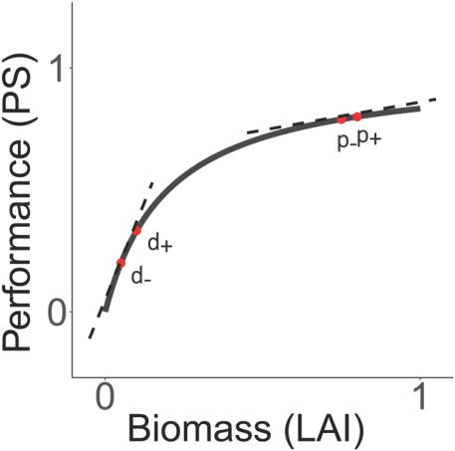

Figure 1. Conceptual analysis of the marginal utility of photosyn-thate translocation. A small amount of translocated assimilate will reduce performance (photosynthesis; PS) of the parent ramet only slightly (tangent line from p+ to p−), while conferring a large benefit to the daughter ramet (tangent line from d− to d+).

and it is unclear whether the relative benefits to the emerg-ing ramets scale with resource limitation, where translocated parental resources could significantly enhance tolerance, and thus, survival and performance. In resource limited environ-ments, such as shaded habitats, the requirements of daugh-ter ramets may be particularly costly and, thus, translocation may not be beneficial overall. Finally, the growth and spread of invaders in heterogeneous environments may be enhanced overall by clonal integration but only if there is a net benefit to the entire clone.

In this study, we combined model simulations, a 13CO2 pulse-chase study, and a greenhouse experiment to determine if 1) photosynthate translocation occurred between parent and daughter ramets, 2) the performance of daughter ramets was enhanced by clonal integration and 3) ramets under low resource conditions (i.e. shaded) benefited relatively more from transferred photosynthates than those in full sun condi-tions. We used the C4 grass cogongrass *Imperata cylindrica*, hereafter cogongrass as a model species in our experiments because of research suggesting it may benefit from clonal integration (Estrada et al. 2017) and because it threatens native biodiversity and ecosystem functions throughout the Southeast US, including in full sun and shaded habitats (MacDonald 2004, Brewer 2008, Estrada and Flory 2015). To gain qualitative insight into the benefits of clonal inte-gration across heterogeneous resource environments, we con-structed a theoretical model evaluating the relative benefits of clonal integration over time for full-sun and shaded daughter ramets. Thus, our study combines empirical and theoreti-cal results to elucidate the role of photosynthate integra-tion in invader performance across heterogeneous resource environments.

**Material and methods**

**Study species**

Cogongrass is a highly invasive, rhizomatous C4 grass that is of management concern throughout much of the south-east US due to its impacts on biodiversity and ecosystem processes (Estrada and Flory 2015). While there are a vari-ety of explanations for the invasive success of cogongrass, the ability to reproduce and spread rapidly via rhizomes is a commonly cited mechanism (Patterson 1980, Lippincott 2000, Holzmueller and Jose 2012, Estrada et al. 2016). Additionally, it has been suggested that cogongrass invasion in low resource environments (e.g. shade) is augmented by photosynthate transfer (Estrada et al. 2017).

**Research approach**

First, we programmed numerical simulations from a simple growth model to deduce the theoretical consequences of our marginal utility model (Fig. 1) for daughter ramets in con-trasting light environments. Then, we performed a green-house experiment with two parts: 1) a 13CO2 pulse-chase

2

to determine whether photosynthates were being integrated among invader ramets and 2) a randomized complete block design to test the overall performance of daughter ramets with or without clonal integration under ambient light or shaded environments. As always, scientific results from the convergence of theoretical and empirical lines of evidence are more likely to reliably generalize.

**Simulation from theoretical model**

To better understand the potential benefits of translocation under resource-limited conditions, we created a stand-level growth model with two levels of light availability (ambient and shade). Because the equations underlying this model are non-linear and coupled (via a translocation function), we simulated the model numerically to gain qualitative insight into the targeted question of how translocation impacts performance under ambient conditions versus low light. Across both light environments, we assumed that the pho-tosynthetic yield saturated at the same level of LAI, that is, the same amount of LAI captures 95% of available light, so the total yield is simply higher with greater irradiance. Therefore, net growth rates as a function of LAI follow the expected type II (saturating) response curve, while senescence increases linearly with LAI (Parsons et al. 1983) (Fig. 2a, d). In combination, these drivers yield the usual sigmoid growth curve in absence of other resource limitation or competitive

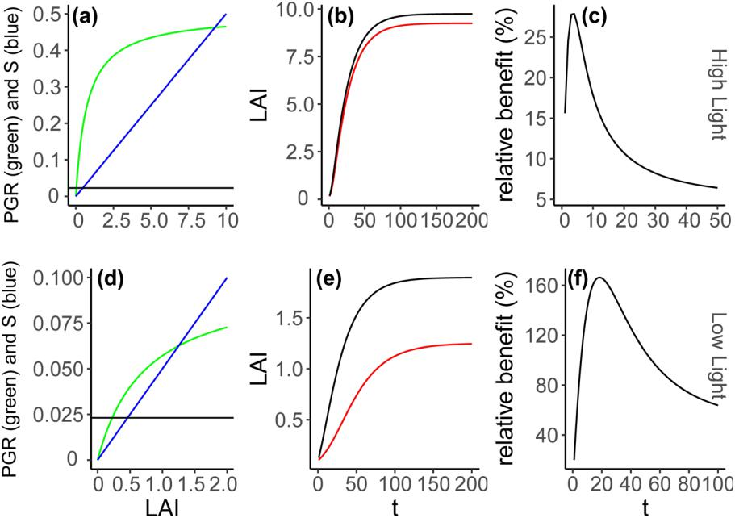

interactions (Fig. 2b, e). All parameter values used in the sim-ulation are in Supplementary material Appendix 3 Table A3.

To study the impact of translocation of carbon/energy we added a small constant *k* to the growth models in both sun and shade, representing a fixed level of photosynthate trans-fer. We fixed this quantity at a value representing 5% of net assimilate in the high light environment with maximal LAI. In the absence of detailed quantitation of acropetal carbon trans-location in rhizomatous grasses, we derived the 5% figure as a starting point based on estimates of translocation from culms of the sedge *Uncinia meridensis* (Callaghan 1984). We then quantified the net benefit to the stands of daughter ramets at time *t* using the following ratio (Fig. 2c, f):

( LAI*t* (+*k* ) - LAI*t* ( - *k* ) )LAI*t* ( -*k* ) (1)

**Pulse-chase**

We conducted a study utilizing greenhouse mesocosms at the Bivens Arm Research Site (BARS) in Gainesville FL (29°62'9''N, 82°35'3'' W). We established eight experimen-tal blocks (replicates) consisting of four mesocosms each. Mesocosms were plastic window planters (60 cm L × 17.8 cm W × 15.2 cm H) divided lengthwise into two zones: a 20 cm planting zone (zone 1) and a 40 cm zone for clonal spread

Figure 2. Results of numerical simulation from our growth model. Under high light environment: (a) describes how plant growth rate (PGR) and senescence (S) scale with leaf area index (LAI), (b) represents a time series of daughter ramet growth with (black) and without (red) clonal integration and (c) quantifies relative benefit of clonal integration over the time series of daughter ramet growth. Under low light environment: (d) describes how plant growth rate (PGR) and senescence (S) scale with leaf area index (LAI), (e) represents a time series of daughter ramet growth with (black) and without (red) clonal integration and (f) quantifies relative benefit of clonal integration over the time series of daughter ramet growth.

3

(zone 2). Zones were measured and marked on the side of the mesocosm; no physical barrier was installed.

Cogongrass rhizomes (no photosynthetic material included) were harvested from an existing invasion at BARS (spring 2016) and divided into three-node segments (of approximately equal diameter), a size that elicits high emer-gence rates (Estrada et al. 2016). Rhizome fragments were grown in the greenhouse until new rhizome formation was noted (~4 weeks). Emerging ramets were then transferred into zone 1 of the mesocosms with Fafard Germination Mix and maintained under well-watered conditions for six weeks to allow clonal colonization into zone 2.

To determine if parent plants transferred photosynthates to daughter ramets (i.e. acropetal translocation), we randomly selected four experimental blocks (n = 16 mesocosms) for isotopic labeling. The use of isotopic tracers, including 13C, is a powerful tool for evaluating clonal integration in plants by permitting the tracking of transferred carbon (Marshall 1990, Zhang et al. 2002, Luo et al. 2015). Zone 1 ramets (parents) were exposed to an enriched atmosphere of 13CO2 and zone 2 ramet (daughter) leaves and rhizomes were col-lected for isotopic analysis.

The 13CO2 gas (99%) pulses were conducted inside a 1-m3 plexiglass chamber fitted with cooling/air circulation fan to maintain ambient temperature and humidity (see Wilson et al. 2018 for details). Daughter ramets remained outside the chamber and were isolated from the labeled gas via a foam-rubber barrier that was flush with the soil. 13CO2 gas (5 l total) was introduced to the chamber over a 30-min period via plastic tubing through the top of the chamber. We performed the experiment under a highly enriched 13CO2 environment to ensure that most carbon fixed during a label-ing run was 13CO2. Labeling runs were conducted at full sun exposure (1200–1900 PAR; 10:00–12:00 h) and parent plants remained in the chamber for 60 min after 13CO2 label-ing to allow for complete drawdown of gas. 12CO2 was used as a proxy for total CO2 drawdown and was monitored using an EGM-3 Environmental Gas Monitor.

Cogongrass leaves and rhizomes were sampled from par-ent and daughter ramets for isotopic analysis 72 h after 13CO2 pulsing, a time period that allows for maximum isotopic enrichment in both above and belowground structures of grasses following 13C labeling (Bradford et al. 2012). Sampled daughter ramets were within 30 cm of zone 1 and had a veri-fied rhizomatous connection to the parent plant. Rhizome samples were oven dried at 60 °C and finely ground with a ball mill. The carbon isotope ratio (12C/13C) of rhizome mate-rial was analyzed at The Stable Isotope Mass Spectrometry Lab at the University of Florida (Gainesville, FL). Ground tissues were combusted on a ratio mass spectrometer with a ConFlo III interface linked to an elemental combustion sys-tem (elemental analyzer). All isotope values are expressed in the per mil notation (‰) as:

|  |  |
| --- | --- |
| d13C = ( R sample /R standard -1)´1000 | (2) |

where Rsample and Rstandard are the molar ratios of 13C/12C of the sample and Vienna Pee Dee Belemnite (V-PDB, the interna-tional standard), respectively.

**Experimental treatments and biomass harvest**

Factorial experimental treatments included manipulation of rhizome attachment (intact or cut to separate parent and daughter ramets) and light availability (ambient or 60% shade for daughter ramets). Rhizome connections were cut (entirely severed) on the border between zone 1 and 2 with pruning shears following isotopic sample collection. We controlled for the disturbance during rhizome cutting by displacing and then returning soil for all mesocosms in the intact treatment. For mesocosms in the shade treatment, we installed shade tents (40-cm tall; constructed of PVC piping and 60% shade cloth) over zone 2 prior to cogongrass addition. Mesocosms in the ambient treatment remained uncovered.

Approximately 10 g of Osmocote Smart-Release Plant Food (14-14-14) was applied to each mesocosm immediately after the rhizome cutting treatment and plants were main-tained under well-watered conditions. To evaluate the effects of the light and rhizome treatments on tiller production, par-ent and daughter aboveground biomass, and rhizome and fine root biomass (total belowground biomass), was harvested separately after four weeks. Biomass samples were oven dried to a constant weight at 60 °C prior to weighing.

**Statistical analyses**

We analyzed the effects of rhizome cutting and light envi-ronment on δ13C values, aboveground biomass, rhizome biomass, root biomass and tiller number using generalized linear mixed models, fit to data within a Bayesian framework. For biomass responses we used a normal likelihood because these were continuous data, whereas for tiller responses we used a negative binomial likelihood with a conventional log link function, because the underlying data are both discrete (counts) and overdispersed (variance > mean for all treat-ment groups). Moreover, we used a log transformation on the continuous biomass responses so that the resulting coef-ficients have a similar multiplicative interpretation as our log-linear count models, facilitating insight into the proportional impacts of rhizome cutting. The implementation of the nega-tive binomial likelihood in ‘rstanarm’ introduces a parameter ‘phi’ representing the reciprocal of dispersion. Compared to ANOVA, GLMMs have superior statistical power for count data (O’Hara and Kotze 2010), while the Bayesian framework readily facilitates quantification of uncertainty in predictive quantities of interest via the posterior predictive distribution (Gelman et al. 2013).

For all models, rhizome cutting, light environment, and their interactions were modeled as fixed effects using the conventional indicator (0/1) coding, while block was mod-eled as a random effect. Under indicator coding, the coef-ficients represent the effect of the treatment (i.e. rhizome cutting or shading) at the baseline level of the other treatment

4

(Schabenberger et al. 2000). Meanwhile, the interaction coef-ficient represents the difference in treatment effect when both treatments (i.e. in our case, both rhizome cutting and shade) are applied that is not accounted for by the sum of the sepa-rate simple effects. In other words, the interaction coefficient is the difference in average effect of one treatment across the two levels of the other treatment. In our coding, we assigned ambient light and uncut rhizomes as the baseline intercept. Thus, the interaction coefficient represents how rhizome cut-ting impacts differed in ambient versus shade conditions.

To gain targeted insight into the significance of rhizome cutting under contrasting light environments, and because in our experience indicator coded regression coefficients can be tricky to interpret directly, we plot the full posterior dis-tribution of proportional impacts of rhizome cutting under both ambient and shade conditions. To review, if we perform linear regression on the log of the response variable our model can be written as:

|  |  |  |  |
| --- | --- | --- | --- |
| log ( *y* *i* ) = *B*0 | + *B*Cut ´ Cut*i* + *B*Shade ´ Shade*i* + *B*Shade´Cut | (3) |  |
| ´ Shade*i* Cut*i* + e*i* | |  |
|  |  |

If we want to interpret the coefficients, it is natural to expo-nentiate them. Disregarding the error term (*ε*i) means that the resulting quantities (the exponentiated coefficients) rep-resent the geometric rather than arithmetic mean estimates on the original scale of the data *y*. The geometric means for the different groups were then obtained as linear combina-tions of the indicator coefficients. Our goal, however, was to assess the proportional impact of rhizome cutting (similar to Eq. 2 above). We obtain these quantities as the ratio of the geometric mean given cutting over the geometric mean with no cutting in either ambient or shade. For these two condi-tions, these amount to:

|  |  |  |  |  |  |  |  |
| --- | --- | --- | --- | --- | --- | --- | --- |
| exp( *B*0 + *B*Cut ) | = exp( *B* | | ) |  |  | (4) |  |
|  |  |  |
| exp( *B*0 ) | | Cut |  |  |  |  |  |
|  |  |  |  |  |  |
| exp( *B*0 + *B*Cut + *B*Shade + *B*Shade ´Cut ) | | | | = exp( *B* | + *B* | ) (5) |  |
|  | | | |  |
| exp( *B*0 + *B*Shade ) | |  |  | Cut | Shade´Cut |  |  |
|  |  |  |  |  |  |

Since we utilized a Bayesian framework, we simply used Markov chain Monte Carlo (MCMC) draws from the posterior distribution to quantify these derived quantities of interest (i.e. for each MCMC draw, compute appropri-ate exponentiation of the coefficients), which automatically accounts for and propagates uncertainty in estimation. We graphically present the full posterior distributions of the quantities in Eq. 4 and 5, which represent the proportional impacts of rhizome cutting in ambient versus shade environ-ments, using density plots, while also indicating the posterior means with dashed vertical lines (Fig. 4). In addition, we pro-vide coefficient plots as insets in each figure panel, derived from the underlying GLMMs summarized by the median

(50th percentile) surrounded by 50 and 95% credible inter-vals (Fig. 4). Where reported in text, we specify the median and the upper and lower endpoints of the 95% credible inter-val in the following format: 50th [2.5th; 97.5th].

Note that given our experimental setup we focus particu-larly on the tillers added post rhizome cutting as an indi-cation of the importance of clonal integration. The other responses, including total tiller count and various biomass compartments, are all diluted by accumulation prior to rhi-zome severing. Therefore, although we analyze and present all of our data, we focus specifically on tillers added post cutting in much of our discussion.

We implemented all GLMMs using Hamiltonian Monte Carlo via the ‘rstanarm’ package (ver. 2.18.2, Carpenter et al. 2016) within R (ver. 3.5.3, <www.r-project.org>, complete session information in Supplementary material Appendix 2). We assigned default weakly regularizing priors for all treat-ments, specifically Normal (0,1) for the count responses given the log-link scale, and Normal (0,50) for biomass responses, while the reciprocal dispersion parameter in the negative binomial models was assigned a Half Student-T prior with 4 degrees of freedom, and a scale of 25. We sampled four MCMC chains for 2000 iterations each. Convergence and sampler behavior were inspected via use of the R-hat <1.01 criterion, and visual inspection for chain mixing (Gelman et al. 2013).

**Results**

**Simulation from theoretical model**

Our model showed that the relative benefits of transloca-tion for daughter ramets were higher in shade than in ambi-ent light conditions (Fig. 2). Moreover, there was a marked unimodal temporal pattern where the net benefits rapidly peaked early in the growth cycle, and then declined to a con-stant value. For high light stands, the benefits peaked at just over 25% (relative benefit, Eq. 1) and then declined to a con-stant value around 5%, whereas in low light stands, the rela-tive benefits peaked at over 160% before declining to around 50%. Additionally, under low light, the unimodal curve took longer to reach peak benefits, and subsequently declined more slowly than under high light.

**Pulse-chase**

Acropetal photosynthates transfer occurred between all sampled parent–daughter ramet pairs (n = 16). Daughter rhizome and leaf δ13C values were enriched substantially (101.35 ± 58.66‰ and −7.65 ± 1.23‰, respectively) over pre-labeling baselines (−12.92 ± 0.07‰ and −12.5 ± 0.08‰). Post hoc testing also indicated a positive correlation between parent and daughter leaf δ13C values (r2 = 0.37). Our data did not show an effect of light treatment on transloca-tion to daughter ramets, leaves or rhizomes.

5

**Factorial experiment**

Exploratory analysis of parent plant performance, including aboveground biomass, belowground biomass, rhizome and root biomass and tiller production, suggested parent plants were minimally affected by the rhizome cutting and light treatments and their interaction (Supplementary material Appendix 1 Fig. A1). Moreover, responses in daughter ramets were of primary scientific interest. Hence, we report full sta-tistical results for daughter responses only.

For daughter ramets, shading resulted in 32% less aboveg-round biomass, 44% lower tiller production and 60% fewer tillers added after cutting (Fig. 3a–c). The proportional impacts of rhizome cutting varied considerably by response measured (Fig. 4a–f), showing the clearest effect in the til-lers added response (Fig. 4c). For tillers added post-cutting, the posterior mean of the proportional production was 44% under shade (i.e. roughly only half versus with no cutting), and 79% under ambient conditions (i.e. roughly 20% less).

Conversely, root production impacts of rhizome cutting appears not to vary with light environment (Fig. 4d). In terms of simple effects from the GLMMs, there is large uncertainty in all estimates, but the impacts of shading and the interaction of shading and rhizome cutting are clearer (i.e. larger poste-rior mass below zero line) for the tiller counts than biomass per se (Fig. 4a–c insets). Most importantly, the interaction of shading and rhizome cutting in the tillers added post-cutting response had 96.5% of posterior mass below zero, providing reasonably strong evidence that shading disproportionately impacts tiller production when combined with cutting than in intact daughter ramets.

Meanwhile, rhizome cutting resulted in less total below-ground biomass (rhizome + fine root biomass), fine root bio-mass, and number of daughter tillers added after rhizome

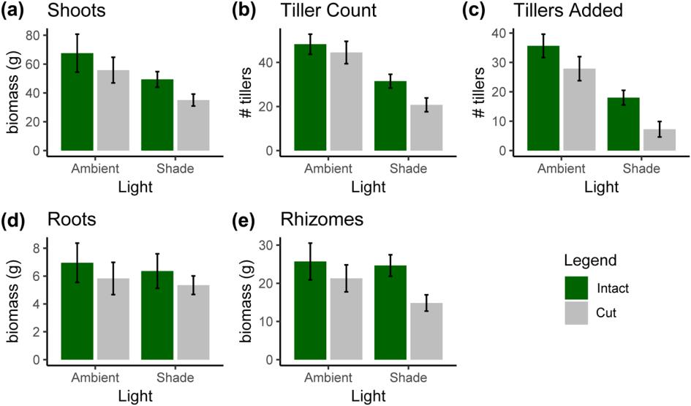

cutting by 30, 34 and 35%, respectively (Fig. 3), compared to daughter ramets with intact rhizomes. Once again, the simple effect coefficients reveal large uncertainty, with the clearest impact being rhizome cutting reducing root production −0.3 [−0.9;0.3] (Fig. 4d), although this effect manifestly has much uncertainty, so we caution against drawing strong conclu-sions either direction.

**Discussion**

Our theoretical simulation model and analysis of tiller pro-duction data post rhizome cutting provide significant sup-port for the concept that photosynthate transfer is of greater relative benefit in overcoming growth constraints under low resource conditions. We also experimentally demonstrated clonal integration, showing that photosynthate transfer can enhance performance of an invasive grass in light-limited conditions. We found that the benefits of integration to the recipient ramets outweighed the costs to donors since there was no reduction in parent plant performance when rhizome connections were intact. Thus, while previous studies have broadly shown that clonal integration can increase plant performance (Stuefer et al. 1994, Du et al. 2010, Kui et al. 2013), and invasive species specifically (Wang et al. 2017), our results show that photosynthate integration contrib-utes to invader performance by enhancing growth of new ramets in clonal plants, particularly during early coloniza-tion. The non-linearity of growth response to biomass and leaf area, which was especially acute during early coloniza-tion and establishment, provides a likely mechanism for why clonal integration is particularly beneficial in heterogeneous resource environments (Caraco and Kelly 1991, Alpert 1999, Dong and Alaten 1999, Xiao et al. 2010).

Figure 3. Raw data means ± SE for daughter ramet shoot biomass (a), tiller counts (b), tillers added after rhizome cutting (c), root biomass

1. and rhizome biomass under ambient light (A) and shade (S) treatments. Green bars represent mesocosms where parent–daughter rhi-zome connections were intact, while gray bars denote those with experimental rhizome cutting.

6

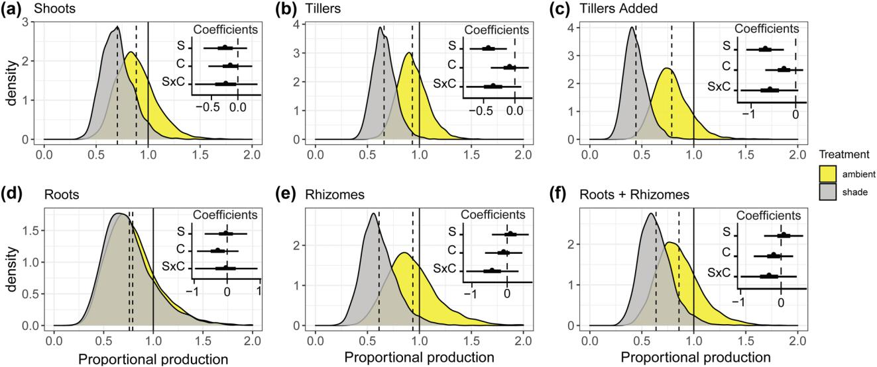

Figure 4. Posterior distribution of the proportional impact of rhizome cutting on daughter performance under ambient (yellow) or shade (grey) conditions, for: shoot biomass (a), tiller count (b), tillers added post rhizome cutting (c), root biomass (d), rhizome biomass (e) and root + rhizome biomass (f). The density plots show the full posterior distribution of proportional impacts based on 4000 MCMC draws, while the inset panels show the simple effect coefficients from the underlying log-linear generalized linear mixed models, where the indicator variables are coded as: S = Shade, C = Cut and S × C = Shade × Cut interaction. Note that under indicator (0/1) coding the difference in average effect of cutting between ambient and shaded conditions is given by the interaction coefficient (S× C). Hence the difference in plotted posterior densities is directly related to the S × C estimate shown in the inset panel.

Results from our simulation model indicate that daughter ramets in low-resource environments benefit more from clonal integration than those growing under more optimal conditions, consistent with our empirical findings and the wider literature (Wang et al. 2017). Our empirical analysis found that tillers added post cutting were approximately 50 and 20% fewer in the shade and ambient conditions, respectively, compared to when rhizomes were intact. This pattern is qualitatively consis-tent with the difference in peak relative benefits predicted by the simulation model, where we assumed that maximal growth rate varied 5-fold in high versus low light and a 5% acropetal translocation rate from parent to daughter ramet. Moreover, the non-linear (unimodal) temporal pattern in benefits to translocation implied by our model (see also Duchoslavova and Jansa 2018) suggests that an optimal strategy for integra-tion would be to maximize acropetal integration during early growth of the daughter ramets, but then lower integration as daughter ramets reach equilibrium with their environment and become more autonomous (Hartnett and Bazzaz 1983). From this point of view, continued translocation is inefficient for optimal colony growth. Indeed, based on empirical find-ings we expect transfer to decline as daughter ramets achieve maturity, particularly when they attain positive carbohydrate balance (Alpert and Mooney 1986, Bullock et al. 1994). Our simulation model provides a simple theoretical explanation of this generic pattern in terms of cost–benefit analysis.

In general, the whole-genet benefits of clonal integra-tion are expected to outweigh the costs (Fig. 1). Cogongrass appears to follow these theoretical expectations since our empirical data indicate that daughter ramets had higher

tiller production, particularly under shade and with intact rhizomes, with minimal effect on parent plant performance. Similar findings have been reported for other invasive clonal plants, including alligator weed *Alternanthera philoxeroides* (Liu et al. 2008, Wang et al. 2009). Additionally, we found that δ13C values for parent and daughter leaves were posi-tively correlated, implying that daughter ramets gain a larger benefit when parent plants have greater assimilation. Overall, these data suggest that photosynthate integration likely enhances whole-genet fitness and may provide cogongrass with a distinct advantage over non-clonal native species.

Although our simulation model and data both suggest biologically meaningful relative benefits of clonal integration, studies evaluating the effects of clonal integration on invasive-ness and competitive ability have yielded conflicting results (Liu et al. 2016). While some studies have determined that competitiveness is greater with clonal integration (Xiao et al. 2011, Wang et al. 2016), others have found that clonal inte-gration does not enhance interspecific competitive ability (Schmid and Bazzaz 1987, Wang et al. 2008, Wang et al. 2011). We speculate that the importance of clonal integra-tion to invasion success may lie in the exploitation of patchy resources (Peltzer 2002) and the occupation of new habitats (Liu et al. 2016) rather than direct effects on competitive ability. However, additional empirical investigations into the benefits of clonal integration to invasive plants, and compari-sons among multiple species, are needed before more general conclusions can be drawn.

To gain greater insight into the ecological and physiologi-cal regulation of clonal integration we recommend that future

7

pulse-chase experiments be designed to quantify the rate of translocation over time, as a function of critical ecological fac-tors such as resource availability and presence of competitors (Lechuga-Lago et al. 2016, Duchoslavova and Jansa 2018). These studies would involve sequential 13C pulse-chase exper-iments wherein the entire mass of daughter ramets is destruc-tively sampled and analyzed for excess 13CO2 enrichment as a measure of translocation after a suitable window of time has elapsed to allow for maximal transfer (we recommend 48–72 h). Furthermore, to verify non-linearity in relative benefits over time, as predicted by our simulation model, biomass could be harvested sequentially post rhizome cutting rather than at a single endpoint (Bullock et al. 1994). In the context of a factorial design manipulating competition intensity and resource availability (Alba et al. 2017, Fahey et al. 2018) such studies could help elucidate how the physiological regulation of the timing and intensity of integration impacts invasive success in heterogeneous environments.

Our data demonstrate that the performance of a highly invasive grass was enhanced by a clonal trait, photosynthates translocation, which augmented a critical factor that can be important for invasive spread, the production of new tillers in both full sun and shaded light environments. In line with our findings for tiller production, we also found that clonal integration likely enhances rhizome biomass production. Furthermore, we determined that the relative net benefits of translocation were higher in shaded compared to full sun con-ditions. These findings suggest that previous reports of shade tolerance in cogongrass (Patterson 1980, Gaffney 1996) may be due, at least in part, to photosynthate translocation from tillers in the sun to those under shade. However, there may be other benefits of clonal integration for cogongrass beyond translocation of photosynthate, such as transfer of other resources. Given these findings, management efforts should be directed toward eliminating and preventing the establish-ment of large populations in full sun environments, such as open disturbed fields, that may be connected to and providing benefits for ramets growing in shaded habitats. This strategy would eliminate the potential for acropetal translocation, and thus could reduce the likelihood of daughter ramet persistence. Overall, our results demonstrate the benefits that clonal traits can contribute to invasive species and highlight the need for a more mechanistic understanding of clonal invasive plant spread. Identifying life-history traits that promote invasiveness is critical if we are to better predict future invaders and protect natural ecosystems. More broadly, clonal integration should be further investigated as a physiological trait of native and inva-sive species that structures plant communities.

**Data availability statement**

Data are available from the Dryad Digital Repository: <http:// dx.doi.org/10.5061/dryad.905qfttht> (Estrada et al. 2020).

*Acknowledgements* – *Funding* – We thank the Florida Fish andWildlife Conservation Commission for funding this project and supporting our research on invasive species in Florida.

*Author contributions* – All authors contributed critically to this studyand gave final approval for publication.

**References**

Alba, C. et al. 2017. Methods to test the interactive effects of drought and plant invasion on ecosystem structure and func-tion using complementary common garden and field experi-ments. – Ecol. Evol. 7: 1442–1452.

Alpert, P. and Mooney, H. 1986. Resource sharing among ramets in the clonal herb, *Fragaria chiloensis*. – Oecologia 70: 227–233.

Alpert, P. 1999. Clontal integration in *Fragaria chiloensis* differs between populations: ramets from grassland are selfish. – Oec-ologia 120: 69–76.

Bradford, M. A. et al. 2012. Root carbon flow from an invasive plant to belowground foodwebs. – Plant Soil 359: 233–244.

Brewer, S. 2008. Declines in plant species richness and endemic plant species in longleaf pine savannas invaded by *Imperata* *cylindrica*. – Biol. Invas. 10: 1257–1264.

Bullock, J. et al. 1994. Physiological integration among tillers of *Holcus lanatus*: age-dependence and responses to clipping andcompetition. – New Phytol. 128: 737–747.

Callaghan, T. 1984. Growth and translocation in a clonal southern hemisphere sedge, *Uncinia meridensis*. – J. Ecol. 72: 529–546.

Caraco, T. and Kelly, C. K. 1991. On the adaptive value of physi-ological integraton in colonal plants. – Ecology 72: 81–93.

Carpenter, B. et al. 2016. Stan: a probabilistic programming lan-

|  |  |
| --- | --- |
| guage. – J. Stat. Softw. 76: 20. |  |
| Duchoslavova, J. and Jansa, J. 2018. The | direction of carbon and |
| nitrogen fluxes between ramets in *Agrostis stolonifera* changes | |
| during ontogeny under simulated | competition for light. |
| – J. Exp. Bot. 69: 2149–2158. |  |

Dong, M. and Alaten, B. 1999. Clonal plasticity in response to rhizome severing and heterogeneous resource supply in the rhi-zomatous grass *Psammochloa villosa* in an Inner Mongolian dune, China. – Plant Ecol. 141: 53–58.

Du, J. N. et al. 2010. Clonal integration increases performance of ramets of the fern *Diplopterygium glaucum* in an evergreen for-est in southeastern China. – FLORA 205: 399–403.

Eriksson, O. and Jerling, L. 1990. Hierarchical selection and risk spreading in clonal plants. – In: Clonal growth in plants: regu-lation and function. SPB Academic Publishing, The Hague, pp. 79–94.

Estrada, J. A. and Flory, S. L. 2015. Cogongrass (*Imperata cylin-drica*) invasions in the US: mechanisms, impacts, and threatsto biodiversity. – Global Ecol. Conserv. 3: 1–10.

Estrada, J. A. et al. 2016. Propagule quality mediates invasive plant establishment. – Biol. Invas. 18: 1–8.

Estrada, J. A. et al. 2017. Different factors drive emergence and persistence in an invasive grass. – Int. J. Plant Sci. 178: 406–410.

Estrada, J. A. et al. 2020. Data from: clonal integration enhances performance of an invasive grass. – Dryad Digital Repository. doi:10.5061/dryad.905qfttht.

Fahey, C. et al. 2018. Grass invasion and drought interact to alter the diversity and structure of native plant communities. – Ecol-ogy 99: 2692–2702. doi:10.1002/ecy.2536.

Gaffney, J. F. 1996. Ecophysiological and technological factors influencing the management of cogongrass (*Imperata cylin-drica*). – PhD thesis, Univ. of Florida.

Gelman, A. J. et al. 2013. Bayesian data analysis. – CRC Press.

8

Hartnett, D. C. and Bazzaz, F. A. 1983. Physiological integration among intraclonal ramets in *Solidago canadensis*. – Ecology 64: 779–788.

Holzmueller, E. and Jose, S. 2012. Response of the invasive grass *Imperata cylindrica* to disturbance in the southeastern forests,USA. – Forests. 3: 853-863.

Jaafry, W. H. et al. 2016. Role of clonal integration among different environmental conditions: a review. – Nat. Sci. 8: 475–486.

de Kroon, H. and van Groenendael, J. 1997. The ecology and evolution of clonal plants. – Backhuys Publishers.

Kui, L. et al. 2013. Can the riparian invader, *Arundo donax*, ben-efit from clonal integration? – Weed Res. 53: 370–377.

Lavorel, S. and Garnier, E. 2002. Predicting changes in plant com-munity compositoin and ecosystem functioning from plant traits: revisiting the Holy Grail. – Funct. Ecol. 16: 545–556.

Larcher, W. 2003. Physiological plant ecology: ecophysiology and stress physiology of functional groups. – Springer Science & Business Media.

Lechuga-Lago, Y. et al. 2016. Clonal integration facilitates the colonization of drought environments by plant invaders. – AoB Plants 8: plw023.

Lippincott, C. L. 2000. Effects of *Imperata cylindrica* (L.) Beauv.

(cogongrass) invasion on fire regime in Florida sandhill (USA).

– Nat. Areas J. 20: 140–149.

Liu, J. et al. 2008. Effects of clonal integration on photosynthesis of the invasive clonal plant *Alternanthera philoxeroides*. – Pho-tosynthetica 46: 299–302.

Liu, F. et al. 2016. Ecological consequences of clonal integration in plants. – Front. Plant Sci. 7: 770.

Lowe, S. et al. 2000. 100 of the world’s worst invasive alien species: a selection from the global invasive species database. – Invasive Species Specialist Group Auckland, New Zealand.

Luo, W. et al. 2015. Water but not photosynthates integration exists between mother and daughter ramets of a root-derived clonal shrub. – Plant Ecol. 21: 331–342.

MacDonald, G. E. 2004. Cogongrass (*Imperata cylindrica*) – biol-ogy, ecology, and management. – Crit. Rev. Plant Sci. 23: 367–380.

Marshall, C. 1990. Source–sink relations of interconnected ramets.

– In: Clonal growth in plants, regulation and function. SPB Academic Publishing, pp. 23–41.

O’Hara, R. B. and Kotze, D. J. 2010. Do not log-transform count data. – Methods Ecol. Evol. 1: 118–122.

Parsons, A. et al. 1983. The physiology of grass production under grazing. II. Photosynthesis, crop growth and animal intake of continuously-grazed swards. – J. Appl. Ecol. 20: 127–139.

Patterson, D. T. 1980. Shading effects on growth and partitioning of plant biomass in cogongrass (*Imperata cylindrica*) from shaded and exposed habitats. – Weed Sci. 28: 735–740.

Supplementary material (available online as Appendix oik-07016 at <www.oikosjournal.org/appendix/oik-07016>). Appendix 1–3.

Peltzer, D. A. 2002. Does clonal integration improve competitive ability? A test using aspen (*Populus tremuloides* [Salicaceae]) invasion into prairie. – Am. J. Bot. 89: 494–499.

Pyšek, P. 1997. Clonality and plant invasions: can a trait make a difference. – In: The ecology and evolution of clonal plants. Backbuys Publisbers, pp. 405–427.

Schmid, B. and Bazzaz, F. 1987. Clonal integration and population structure in perennials: effects of severing rhizome connections.

– Ecology 68: 2016–2022.

Schabenberger, O. et al. 2000. Collections of simple effects and their relationship to main effects and interactions in factorials.

– Am. Stat. 54: 210–214.

Song, Y.-B. et al. 2013. United we stand, divided we fall: a meta-analysis of experiments on clonal integration and its relation-ship to invasiveness. – Oecologia 171: 317–327.

Stuefer, J. F. et al. 1994. High benefits of clonal integration in two stoloniferous species, in response to heterogeneous light envi-ronments. – J. Ecol. 82: 511–518.

Wang, N. et al. 2008. Clonal integration affects growth, photosyn-thetic efficiency and biomass allocation, but not the competitive ability, of the alien invasive *Alternanthera philoxeroides* under severe stress. – Ann. Bot. 101: 671–678.

Wang, N. et al. 2009. Clonal integration supports the expansion from terrestrial to aquatic environments of the amphibious stoloniferous herb *Alternanthera philoxeroides*. – Plant Biol. 11: 483–489.

Wang, J. C. et al. 2011. Role of clonal integration in life strategy of sandy dune plant, *Eremosparton songoricum* (litv.) vass(fabaceae): experimental approach. – Pol. J. Ecol. 59: 455–461.

Wang, P. et al. 2016. Clonal integration increases relative com-petitive ability in an invasive aquatic plant. – Am. J. Bot. 103: 2079–2086.

Wang, Y. J. et al. 2017. Invasive alien plants benefit more from clonal integration in heterogeneous environments than natives.

– New Phytol. 216: 1072–1078.

Wilson, C. H. et al. 2018. Grazing enhances belowground carbon allocation, microbial biomass, and soil carbon in subtropical grassland. – Global Change Biol. 24: 2997–3009.

Xiao, K. et al. 2011. Physiological integration helps a clonal mac-rophyte spread into competitive environments and coexist with other species. – Aquat. Bot. 95: 249–253.

Xiao, Y. et al. 2010. Clonal integration enhances flood tolerance of *Spartina alterniflora* daughter ramets. – Aquat. Bot. 92: 9–13.

Yu, F. H. et al. 2008. Adaptation of rhizome connections in dry-lands: increase in tolerance of clones to wind erosion. – Ann. Bot. 102: 571–577.

Zhang, C. et al. 2002. Clonal integration and its ecological sig-nificance in *Hedysarum laeve*, a rhizomatous shrub in Mu Us Sandland. – J. Plant Res. 115: 0113–0118.

9