RESEARCH ARTICLE

Soil pH influences patterns of plant community composition after restoration with native-based seed mixes

Kathryn M. Barlow1,2 , David A. Mortensen3, Patrick J. Drohan4

Reclamation of highly disturbed lands typically includes establishing fast-growing, non-native plants to achieve rapid ground cover for erosion control. Establishing native plant communities could achieve ecosystem functions beyond soil erosion, such as providing wildlife habitat. Pipelines, or other disturbed corridors through a landscape, present unique challenges for establish-ing native plant communities given the heterogeneity of soil environments and invasive plant propagule pressure. We created two structural equation models to address multiple related hypotheses about the influence of soil pH on plant community com-position (current diversity and vegetative cover of the original restoration seed mix and background flora, and invasive plant density during mix establishment and current density) of a highly disturbed landscape corridor restored with native species. To test our hypotheses we conducted a plant survey on a gas pipeline crossing two state forests in the north-central Appalachians

that had been seeded with a native-based mixture 8 years prior. Low soil pH was a strong predictor of density of the invasive annual plant, Microstegium vimineum, and had resulted in lower species diversity and cover of the seeded mix. Overall, our data

provide evidence that native-based grass and forb mixtures can establish and persist on a wide range of soil environments and thrive in competition with invasive plants in moderately acidic to neutral soils. Advancing knowledge on restoration methods using native species is essential to improving restoration practice norms to incorporate multifunctional ecological goals.

Key words: invasive plant spread, Microstegium vimineum, native plants, piecewise SEM, restoration, soil pH

Implications for Practice



* Restoration seed mixes with native grasses, sedges, and forbs, such as Dichanthelium clandestinum, Panicum vir-gatum, Juncus effusus, and Chaemaecrista fasciculata, established and persisted on the highly disturbed forest soils of a pipeline corridor and should be considered as an alternative to non-native mixes with lower habitat value.
* Soil pH strongly influenced patterns of plant community composition and should be considered when designing restoration seed mixes.
* Microstegium vimineum spread faster and was more likely to become a dominant species on sites with soil pH less than 5. Monitoring protocols for this invasive annual grass should include soil pH as a factor in prioritization.

Introduction

Improved restoration practices and policies are needed to reha-bilitate ecosystem functions and services in heavily disturbed landscapes. Ecological restoration is particularly challenging after the complete removal of vegetation and severe disturbance of soil physical properties and associated soil ecology (Schlesinger 1986; Suding & Hobbs 2009). Such soil distur-bance is typical of natural resource extraction, like that

associated with coal mining (Lupton et al. 2013), and more recently with shale oil and gas production (Souther et al. 2014; Moran et al. 2015). Restoration of disturbed sites should be multi-functional by design (Lovell & Johnston 2009) and have a landscape perspective (Hobbs & Norton 1996). A comprehen-sive approach would restore dynamic soil properties and hydrol-ogy (Drohan & Brittingham 2012; Fink & Drohan 2015), consider the complexities of community assembly in light of the disturbance (Hobbs et al. 2007), and successfully establish plant communities that are resistant to plant invasion (Jordan et al. 2011). The establishment of persistent native plant com-munities that better match the soil, climate, and fauna of the region should be the baseline for ecosystem restoration and

Author contributions: KMB, DAM, PJD developed the research questions and design; KMB conducted the field work, analyzed the data, and wrote the manuscript; all authors contributed to editing.

1Department of Plant Science, The Pennsylvania State University, State College, PA

2Address correspondence to Kathryn M. Barlow, email [katy.barlow@gmail.com](mailto:katy.barlow@gmail.com) 3Department of Agriculture, Nutrition, and Food Systems, University of New Hampshire, State College, NH 03824, U.S.A.

4Department of Ecosystem Science and Management, The Pennsylvania State University, State College, PA 16802, U.S.A.

© 2020 Society for Ecological Restoration

doi: 10.1111/rec.13141

Supporting information at:

http://onlinelibrary.wiley.com/doi/10.1111/rec.13141/suppinfo

July 2020 Restoration Ecology Vol. 28, No. 4, pp. 869–879 869

Soil pH influences plant community composition

replace the norm of relying on non-native plants. Here we inves-tigate the establishment and persistence of a native-based plant mix along a gas pipeline and the invasion resistance of that plant community.

Pipeline Infrastructure Extent and Restoration Challenges

Currently, there are more than 349,228 km of gas pipeline in the United States, and pipeline capacity is expected to increase 1.0–1.2 billion m3 of natural gas per day between 2015 and 2030, some of which will require new pipeline (US DOE 2015). A disproportionate amount of that development will occur in the north-central Appalachians across the states of Pennsylvania and West Virginia (Feijoo et al. 2018). Transmis-sion lines represent a significant portion of the shale oil and gas footprint (Langlois et al. 2017), creating linear corridors of grass and shrublands across a landscape matrix that, in the eastern United States, is comprised predominantly of core, relatively undisturbed forest to a mix of forest, arable fields, and riparian buffers. Wildlife sensitive to forest fragmentation in the eastern United States will likely be affected by shale gas infrastructure (Kiviat 2013; Brittingham et al. 2014).

Revegetation of pipeline corridors should be consistent with the surrounding landscape to contribute to habitat and mitigate the effects of fragmentation. Yet, historically, restoration of coal mines, gas well pads, and gas and electric transmission corri-dors, particularly in the eastern United States, have relied on inexpensive non-native mixes comprised of fast-growing cool-season grasses and legumes. These species may provide rapid erosion mitigation, but have many unintended consequences for birds, mammals, and invertebrates (Ellis-Felege et al. 2013; Kelt & Meserve 2016). Such practices became the norm in part because restoration regulations prioritize site stabilization (e.g. the 1977 Surface Mining Control and Reclamation Act, Zipper et al. 2011) over a more multifunctional ecological approach.

Ecological Restoration With Native Plant Materials

Native prairie grasses can provide significant shoot and root bio-mass (Mahaney et al. 2015), provide rapid carbon sequestration (Guzman et al. 2016), limit invasive plants by increasing litter and reducing N availability (Mahaney et al. 2015), provide hab-itat for multiple trophic levels (Whiles & Charlton 2006; Fetcher et al. 2015), and support native fauna (Ballard et al. 2013; Kaiser-Bunbury et al. 2017). Research on incorporating native grasses to restore highly disturbed soils, such as mine lands, has been on-going, yet sparse, for several decades (Thompson et al. 1984; Skeel & Gibson 1996; Thorne & Cardina 2011). The long-term plant community dynamics of restored native perennial prairies in the midwestern United States have been well documented (Kindscher & Tieszen 1998; Trowbridge et al. 2017), but less is known about the range of environmental conditions that contribute to recruitment success and persistence in the various plant cover types, soils, and climates of eastern U.S. forests (Thorne & Cardina 2011; Miller 2013).

Transmission corridors span natural gradients of soil environ-ments, making them ideal transects with which to study the per-sistence of restoration mixes across heterogeneous abiotic conditions (Stuble et al. 2017). Given soil pH is a primary driver of plant diversity and species dominance within a given plant species pool (Gough et al. 2000; Pärtel 2002; Sebastia 2004), soil pH is likely an important factor in species recruitment and cover of desired species. Understanding the effects of soil pH on the diversity and cover of the seeded species over time, and resistance to invasive plants, will be crucial to expanding sup-port for the use of native plants in restoration.

Native Plant Community Resistance to Microstegium vimineum

Severe soil disturbance could impair recruitment success of the seeded species for restoration, resulting in an increased avail-ability of soil resources for weedy and invasive plant species. In native prairie restoration in the U.S. midwest, perennial tall-grass communities have been found to have strong resistance to plant invasion (Blumenthal et al. 2005; Foster et al. 2015), but resistance capability to the suite of regional invasive plants in eastern forest soils is largely unknown. Unlike most other non-native herbaceous species of concern in temperate north-eastern forests, the shade tolerant C4 annual grass, M. vimineum, can persist in the forest understory (Leicht et al. 2005) and is therefore of concern to forest managers on public and private lands from southern New England to the southeast-ern United States. Invasion of M. vimineum on forest soils has been found to increase soil pH, carbon cycling, and nitrification leading to a reduction in plant and microarthropod diversity (Ehrenfeld et al. 2001; McGrath & Binkley 2009) and therefore could impact resource availability for wildlife. For example, Simao et al. (2010) found that when disturbed soil was replanted with native forbs M. vimineum invasion indirectly reduced arthropod abundance because of the loss of native plant richness.

The niche requirements of M. vimineum are broad, while it thrives in high light environments it also grows reasonably well under lower light conditions and prefers moist soils (Warren et al. 2011). Previous research has shown that M. vimineum pres-ence and abundance is positively correlated with soil pH (Cole & Weltzin 2004; Nord et al. 2010), but can persist in more acidic soils (Gibson et al. 2002) and once established can raise soil pH (Ehrenfeld et al. 2001; McGrath & Binkley 2009). The high light availability of pipeline corridors, particularly in low-lying areas with high soil pH could result in new M. vimineum source sites that spread into adjacent, less disturbed forest interior.

Eradicating M. vimineum is not realistic, but impeding spread and dominance by establishing a competitive native plant com-munity would allow for a suite of other species to provide eco-system function benefits to the landscape. When selecting native dominants for restoration seed mixes managers could identify traits that could aid in suppressing invasive plants (Simmons 2005). For example, species with the same active growth period, such as the C4 Panicum virgatum, can impede the expansion of M. vimineum (Funk et al. 2008). As can species

870 Restoration Ecology July 2020

Soil pH influences plant community composition

with differing light tolerances, such as Dichanthelium clandesti-num which has been shown to outcompete M. vimineum in full sun, with the reverse outcome in full shade (Flory et al. 2007), and species with high leaf litter, a trait of most native warm sea-son grasses which Warren et al. 2011 has shown to prevent ger-mination and establishment of M. vimineum.

The objectives of this study were to document the success of native plants commonly recommended for restoration and to investigate the complex species-site interactions with inter-related hypotheses in structural equation models (SEM). To test the SEMs we assessed the plant community composition of a gas pipeline on Pennsylvania state forests 8 years after reclama-tion with a native-based species mix. We evaluated the effect of soil pH on the current diversity and cover of the seeded species, and the invasion resistance of the mix.

Methods

SEMs Test Soil pH Effect on Plant Community Composition

We hypothesized that sites along the restored pipeline with moderate to high soil pH would have lower vegetative cover of the original seed mix species, in part caused by a positive growth response and greater cover of the background flora, including M. vimineum, to greater soil pH. To assess the rel-ative abundance of vegetative cover in the plant community, species were grouped into one of the following three groups: the seeded mix, background flora (species not intentionally seeded, excluding M. vimineum), and M. vimineum. To test these effects of soil pH on plant community composition we created a series of hypotheses outlined in SEMa in which each arrow head in the SEM points to an outcome variable (Fig. 1). In SEMa we assessed the direct relationship of soil pH to mix cover, as well as the indirect effects from the non-seeded plant community on mix cover. In SEMb, we expanded the variable relationships in SEMa to test more indirect effects of soil pH on the cover of the mix species. In addition to greater background flora cover contributing

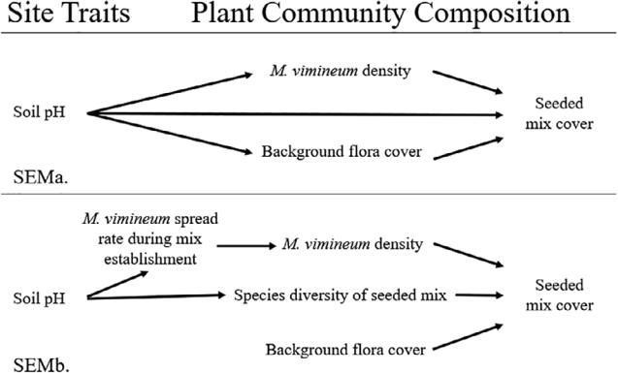

Figure 1. Hypothesized structural equation models for factors contributing to establishment of the seed mix and density of the invasive annual grass, Microstegium vimineum.

to the reduction of the mix cover, we hypothesized in SEMb that greater soil pH would have a positive effect on mix cover, potentially via initial mix species recruitment (not measured in this study), and that the density of M. vimineum during mix establishment could be predicted by soil pH and would in turn predict current M. vimineum density (Fig. 1). As described below, current invasion resis-tance of the mix was measured against a spatially explicit dataset of M. vimineum density spanning 5 years postrecla-mation during mix establishment.

Pipeline Corridor Survey Description

Survey locations were selected along the Dominion Transmis-sion, Inc. pipeline within the Rothrock (RSF) and Tuscarora state forests (TSF) in central Pennsylvania, United States. The pipeline was installed in 2007, alongside Spectra’s Texas East-ern Transmission pipeline completed in 1961. A 14.5 km section of the pipeline corridor runs through RSF and 7 km section through TSF. Soils typically consist of low pH (3.0–4.5) Ultisols and Inceptisols with varying rock fragment contents (0–90%) and a wide variability in depth to bedrock (Ciolkosz et al. 1990). Average annual temperature in central Pennsylvania is 13.2 C and average annual precipitation is 103 cm (NOAA 2018).

The following spring, in 2008, a native-based seed mix was broadcast along the pipeline at a density of 16.8 kg/ha then mulched with 3,362.5 8 kg/ha of straw mulch (Table 1). The steep slopes in RSF were reseeded in 2009 with a hydroseeder where establishment was poor with a modified native-based mix at 56 kg/ha (Table 1). The section of the pipeline in RSF was mowed annually in the summer. The section in TSF was mowed only twice since establishment.

Prior to the installation of the pipeline GAI Consultants, Inc. mapped the extent of invasive plants, including M. vimineum, along the planned pipeline corridor through RSF and TSF. Geor-eferenced data collection plots formed a contiguous grid of 22.9 m (width of the corridor) × 45.7 m plots along the pipeline, with 149 plots in TSF and 294 plots in RSF. GAI Consultants, Inc. classified the extent of invasion at the resolution of the plot as: absent (0% cover), trace (<1% cover), low (1–5% cover), moderate (5–25% cover), or high (25–100% cover) according to the Montana Noxious Weed Survey and Mapping System (Cooksey & Sheley 1997). Each year from 2009 through 2013 they repeated the survey at the plot level of the contiguous grid along the pipeline corridor.

Of the 443 total plots in the sampling grid, we subsampled from 76 that varied by two levels M. vimineum vegetative cover from 2009 to 2013 (Fig. 2). Plots were categorized as having “low” density where M. vimineum was either absent from 2009–2013, or the density changed from low or absent in 2009 to trace in 2013, or trace/low in 2009 to trace/low in 2013 (39 plots, RSF n = 27, TSF n = 12). Plots were categorized as having a “high” density where M. vimineum was either absent in 2009 but had expanded to moderate/high in 2013, or remained moderate/high from 2009 to 2013 (37 plots, RSF n = 22, TSF

July 2020 Restoration Ecology 871

Soil pH influences plant community composition

Table 1. The composition of seed mixes planted on the pipeline in RSF and TSF. The 2008 general native grass and forb mix is indicated by Ψ, the 2008 native-based steep slope mix by *, and the 2009 modified mix by ^, each followed by the percent of the total seed weight (kg/ha) of each mix.

|  |  |  |  |  |  |
| --- | --- | --- | --- | --- | --- |
|  | Family | Species | Nativity Status | Life Cycle | Wetland Status |
|  |  |  |  |  |  |
|  | Poaceae | Agrostis perennans (Ψ2%, *10%) | Native | Perennial | FACU |
|  |  | Andropogon gerardii (Ψ10%) | Native | Perennial | FACU |
|  |  | Bouteloua curtipendula (^6%) | Native | Perennial | not classified |
|  |  | Dactylis glomerata (^24%) | Non-native | Perennial | FACU |
|  |  | Dichanthelium clandestinum (Ψ10%) | Native | Perennial | FACW |
|  |  | Elymus canadensis (*20%) | Native | Perennial | FACU |
|  |  | Elymus riparius (^3%) | Native | Perennial | FACW |
|  |  | Elymus virginicus (Ψ15%) | Native | Perennial | FACW |
|  |  | Lolium multiflorum (*20%, ^30%) | Non-native | Annual/Perennial | FACU- |
|  |  | Panicum virgatum (Ψ5%, ^5%) | Native | Perennial | FAC |
|  |  | Schizachyrium scoparium (Ψ20%, *20%) | Native | Perennial | FACU |
|  |  | Sorghastrum nutans (Ψ10%, ^6%) | Native | Perennial | UPL |
|  |  | Sporobolus compositus (*10%) | Native | Perennial | not classified |
| Fabaceae | | Chamaecrista fasciculata (Ψ5%) | Native | Annual | FACU |
|  |  | Desmodium canadense (Ψ3%) | Native | Perennial | FAC |
|  |  | Lotus corniculatus (^18%) | Non-native | Perennial | FACU |
|  |  | Trifolium repens (^8%) | Non-native | Perennial | FACU |
|  | Asteraceae | Heliopsis helianthoides (Ψ5%) | Native | Perennial | FACU |
|  |  | Rudbeckia hirta (*5%) | Native | Annual/Perennial | FACU |
|  |  | Solidago nemoralis (*2%) | Native | Perennial | not classified |
|  |  | Symphyotrichum prenanthoides (*3%) | Native | Perennial | FAC |
|  | Asclepiadaceae | Asclepias syriaca (Ψ5%) | Native | Perennial | UPL |
|  | Polygonaceae | Persicaria pensylvanica (Ψ5%) | Native | Annual | FACW |
|  | Cyperaceae | Scirpus cyperinus (Ψ2%) | Native | Perennial | OBL |
|  | Juncaceae | Juncus effusus (Ψ3%) | Native | Perennial | OBL |

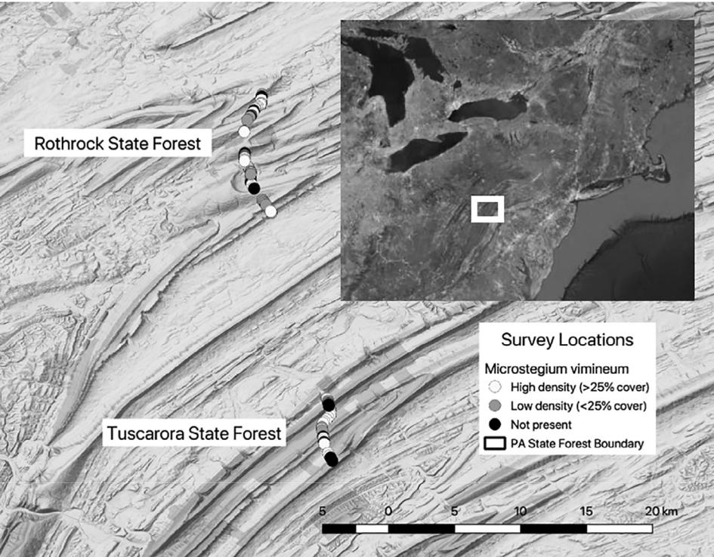

Figure 2. The 76 survey plots in RSF and TSF categorized by Microstegium vimineum density were located in the Ridge and Valley of central Pennsylvania, in the Northeast region of the United States. The map was created with QGIS (2009), using Google Terrain (Map data: Google, DigitalGlobe) basemap imagery and ESRI Satellite (2017) basemap imagery for the inset map of the Northeast United States.

872 Restoration Ecology July 2020

Soil pH influences plant community composition

n = 15). The SEMb variable “M. vimineum spread rate during mix establishment” represents this binomial dataset.

Soil Sampling and Plant Community Surveys

Soil pH and plant community composition was measured in the 76 plots and used as variables in the SEMs. Soil samples were taken in April 2017. At each location we collected five soil cores (each 0.02 m internal diameter × 0.10 m depth) from random points along the linear transect used for the plant surveys, described below, and removed a soil sample from the surface to a 0.10 m depth. Soil samples were homogenized at the plot level and air dried. Mineral soil pH was measured in a 1:2 (weight: volume) 0.01 M CaCl2 using a VWR SympHony pH meter (Soil Survey Staff 2014).

Plant community surveys were conducted from early August through early October 2016. Prior to conducting the field work a starting point for the survey transects within each of the 76 plots was georeferenced to avoid bias in transect placement in the field (QGIS Development Team 2009). In the field we used a tape measure to mark a 20 m linear transect running south from the starting point. Similar to Begley-Miller et al. (2014) we used the line-intercept method to quantify plant cover by species. For each species, all plants with vegetative parts within 0.2 m of either side of the tape were included and recorded as the length on the measuring tape to the nearest 0.05 m. For example, if spe-cies i was recorded along the tape from 0.15–0.75 m and from 1.50–3.00 m the total cover for that species was 2.10 m. The SEM variable “seeded mix cover,” or “mix cover” hereafter, is the proportion of the transect with vegetative cover by species from the original seed mix and mix cover was calculated as the sum of all mix species along the 20 m transect divided by the length of the transect and therefore could exceed 100%. The SEM variable “background flora cover” is the proportion of the transect covered by species not in the seed mix, except for M. vimineum. “Microstegium vimineum density” was deter-mined in the same manner on the transect, but was transformed to a binary variable for the model: low density (<25% cover) and high density (≥25% cover). This split was based on methods used by GAI Consultants, Inc., as described above, where M. vimineum cover greater than 25% was categorized as high density. “Species diversity of the seeded mix,” or “mix diver-sity” hereafter, is based on individual mix species cover and is

|  |  |  |  |
| --- | --- | --- | --- |
| reported | as a measure of | Simpson’s Diversity Index |  |
| (D=1– | s | is the proportion of individuals |  |
| i = 1pi2 ) in which pi |  |

in the ith species and S is species richness. Total plant commu-nity diversity was also measured by Simpson’s diversity index.

Statistical Analysis

We first report on the overall plant community composition trends, focusing on the species from the original seed mix. Given that survey plots were selected based on the variation in M. vimineum density (from 2009 to 2013), and the SEMs are structured to assess the influence of soil pH, we report on current plant community composition trends based on M. vimineum density and soil pH. We note the number of plots that shifted

from low to high M. vimineum density from 2013 to our 2016 survey, and vice versa. Because plant cover also serves as a sur-rogate for overall potential growing conditions we tested for dif-ferences in total plant cover on plots with low versus high density changes of M. vimineum. Additionally, we predicted that plant community diversity would rise with soil pH. For both tests we used linear mixed effects models, with the forest district (n = 2) as a random effect (“nlme” R package, Pinheiro et al. 2016).

Piecewise SEMs were constructed as in Figure 1. according to Lefcheck (2016). SEMs contain multiple linear models with variables that can be used as both predictor and outcome vari-ables, indicated by arrows in the model. Response variables were tested for normality with the Shapiro–Wilk test and trans-formed as needed. “Species diversity of seeded mix” and the “background flora cover” were transformed using Tukey’s lad-der of powers with the “transformTukey” function in the “rcom-panion” package (Mangiafico 2016). Each SEM used linear mixed models for response variables with normal distributions, or binomial mixed models for binary outcomes, and included the forest district (n = 2) as a random effect. Piecewise SEM model fit uses the Fisher C test statistic which incorporates the p values of all linear models and is indicated by p > 0.05 (Lefcheck 2016). All data analyses were performed in R version 3.5.2 (2018) with RStudio version 1.1.463 (2016).

Results

Pipeline Corridor Plant Community Composition

Across the 76 survey plots along the pipeline corridor plant community diversity ranged from 0.49 to 0.92 with a median of 0.82. Species diversity assessed solely from the seeded mix ranged from 0.00 to 0.83 with a median of 0.66. The mean cover of the species from the seed mix was over 100%, with a range of 2 to 282%. Only 2 plots had less than 5% cover of the mix spe-cies, and 13 had less than 50% cover. Plots with a low propor-tion of mix species cover to total vegetative cover also had high densities of M. vimineum (Fig. 3). Average M. vimineum cover was 49% 0.05 SE. across survey transects. The only spe-cies from the mix that had cover comparable to M. vimineum was D. clandestinum with an average cover of 51% 0.03 SE, the rest of the mix species each averaged less than 20% (Fig. S1).

Species from the mix were variable in frequency and vegeta-tive cover (Fig. S1). Dichanthelium clandestinum was the most frequent species across survey plots, followed by P. virgatum, Chamaecrista fasciculata, Sorghastrum nutans, and Lotus cor-niculatus, all present on over 50 survey locations (Fig. S1). The aforementioned species and Dactylis glomerata, Juncus effusus, Scirpus cyperinus, and Schizachyrium scoparium all averaged at least 10% vegetative cover. Rudbeckia hirta and Elymus virginicus were both frequently present but had consis-tently low vegetative cover. Andropogon gerardii was only pre-sent in three survey plots with low cover. Elymus riparius, Heliopsis helianthoides, Lolium multiflorum, Persicaria pensyl-vanica, Sporobolus compositus, and Symphyotrichum

July 2020 Restoration Ecology 873

Soil pH influences plant community composition

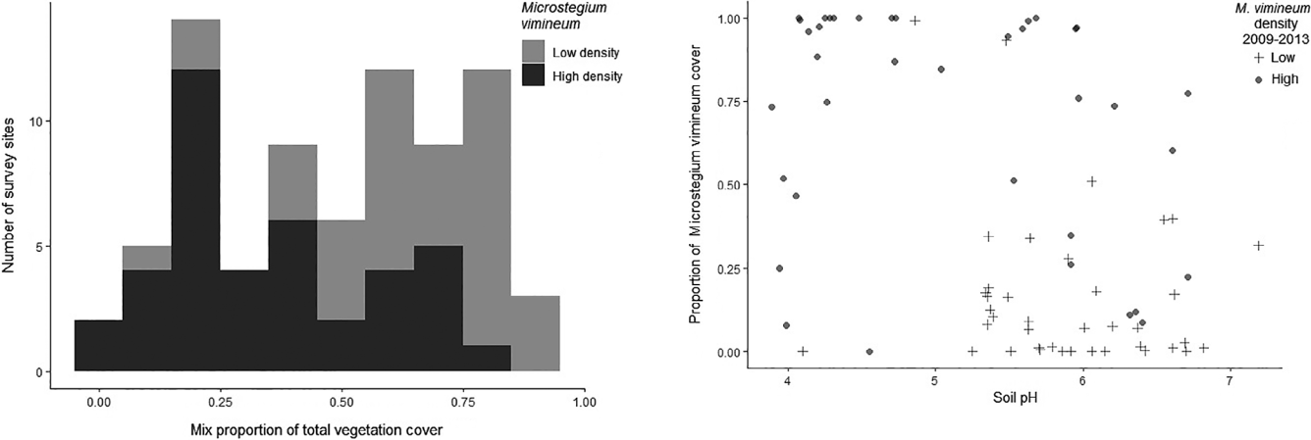

Figure 3. Distribution of seeded mix cover as a proportion of the total vegetation cover across survey plots. Plots with a high density (>25% cover) of Microstegium vimineum are marked in black. Plots where the mix species had a lower proportion of the total vegetative cover also had a greater proportion with high densities of M. vimineum.

prenanthoides were included in the seeded mix but were not detected in any of the pipeline survey plots. The background flora in the pipeline survey were largely native, early succes-sional species and only 4 out of the 21 most abundant species were non-native, Daucus carota, M. vimineum, Phleum pre-tense, and Taraxacum officinale (Fig. S2).

The 2016 survey plots were selected according to the density of M. vimineum during mix establishment between 2009 and 2013 to determine whether past M. vimineum density predicted its current density, or whether the species in the mix would out-compete M. vimineum over time. Overall, M. vimineum density was stable from the final GAI survey in 2013 to our 2016 survey. During this interval M. vimineum populations remained in the “high density” class at 31 locations, 30 locations remained in the “low density” class, and only 15 locations changed density classes. Nine locations shifted from low to high density, 2 in TSF and 7 in RSF, resulting in 40 of the 76 plots in 2016 with high densities of M. vimineum. The density of M. vimineum declined in 6 locations from high to low, 3 in TSF and 3 in RSF. Plots with high M. vimineum density during establishment had greater overall plant cover than plots with a low density (t = 3.013, p = 0.004). Yet, when M. vimineum cover was excluded from the overall plant cover there is no difference in plant cover between plots with low and high density levels (t = −0.845, p = 0.401).

Soil pH Filters Seed Mix Establishment and Plant Community Composition

Soil pH across the 76 survey plots ranged from 3.89 to 7.19, with a median of 5.63. In the SEMs we used soil pH as a continuous predictor of broad compositional changes of plant cover and diversity, as well as M. vimineum density. We observed a clear split in M. vimineum cover at soil pH 5 (Fig. 4). Survey plots had a greater proportion of M. vimineum cover below soil

Figure 4. The proportion of Microstegium vimineum cover in 2016 was largely lower than 0.50 on pipeline survey plots with a soil pH between 5 and 7, and greater than 0.50 on plots with a pH < 5. This trend followed the past M. vimineum densities recorded from 2009 to 2013.

pH 5 and therefore we report on the plant species compositional differences below and above soil pH 5.

Although we did not find evidence that diversity of the overall plant community (background flora and seeded mix) was

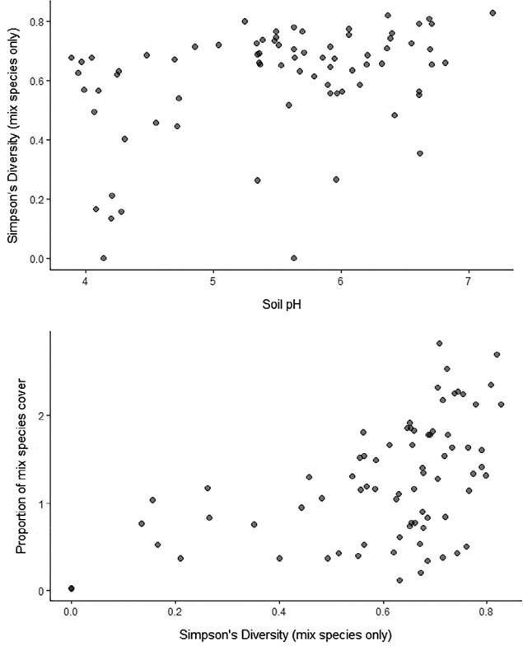

Figure 5. For the species from the restoration seed mix the species diversity increased with soil pH (top) and the proportion of vegetative cover increased with species diversity (bottom). The proportion of mix species cover is the sum of the proportional cover of individual species, and can therefore exceed 1.00.

874 Restoration Ecology July 2020

Soil pH influences plant community composition

influenced by soil pH (t = 1.195, p = 0.232), diversity of the mix species increased with greater soil pH (Figs. 5 & 6). Of the top 15 most frequent species present in low soil pH 9 were part of the seed mix, yet in plots with low soil pH only 5 out of the top 15 were from the seed mix. In low pH plots M. vimineum was the most frequent species present, followed by species from the seed mix Scirpus cyperinum, D. clandestinum, and J. effusus. In plots where the soil pH was above 5 the mix species

1. clandestinum, P. virgatum, and C. fasciculata were among the top four most frequently present species, along with

M. vimineum which was the second most frequent. M. vimineum had a wide range of tolerance to soil pH and was present in 90% of plots with low pH, and 96% of plots with mod-erate to high pH. Dichanthelium clandestinum has a wide range of tolerance to soil pH and was present on 96% of plots with moderate to high pH and 67% of plots with low pH (Fig. S3). Non-native components of the mix, L. corniculatus and D. glomerata, thrived on moderate to high soil pH (78 and 64% of plots), but did not on low soil pH (29 and 19% of plots). Commonly recommended natives P. virgatum, C. fasciculata, S. nutans, and E. virginicus were present on 65–96% of plots with moderate to high pH, but on plots with low soil pH were present on only 19–48%.

Native Mix Cover Indirectly Influenced by Soil pH

The data support both SEMs (Fig. 6); SEMa Fisher C = 4.07, df = 2, K = 13, p = 0.131, and SEMb Fisher C = 24.07, df = 16, K = 16, p = 0.088. The SEMs provide evidence that soil pH pre-dicts the species composition which in turn mediates the cover of the seeded mix. SEMa indicates soil pH influences mix spe-cies vegetative cover indirectly by favoring M. vimineum cover in lower soil pH (Fig. 4) and by a reduction in background flora cover in lower soil pH indirectly favoring the seeded mix cover (Fig. 7). SEMb further clarifies the role of soil pH on plant

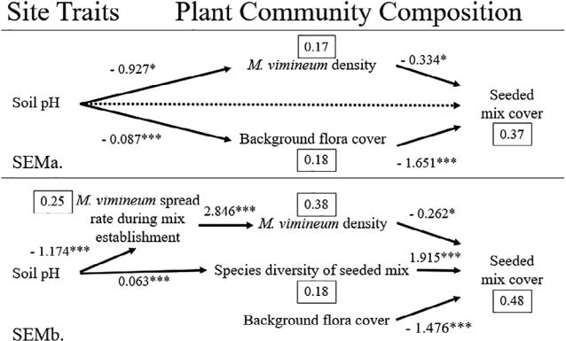

Figure 6. SEMa describes the influence of soil pH on plant community composition. SEMb clarifies the indirect influence of soil pH on mix cover. Dashed lines indicate insignificant causal paths in the model. The solid lines with unstandardized path coefficients are significant causal paths in the models, marked with the level of statistical significance (* = p < 0.05,

* = p < 0.01, *** = p < 0.001). Conditional r2 values for each component model are in rectangles.

Figure 7. Survey plots with a greater proportion of background flora cover had a lower proportion of cover of the species from the native-based restoration mix. The proportion of the mix species and the background flora cover is the sum of the proportional cover of individual species, and can therefore exceed 1.00.

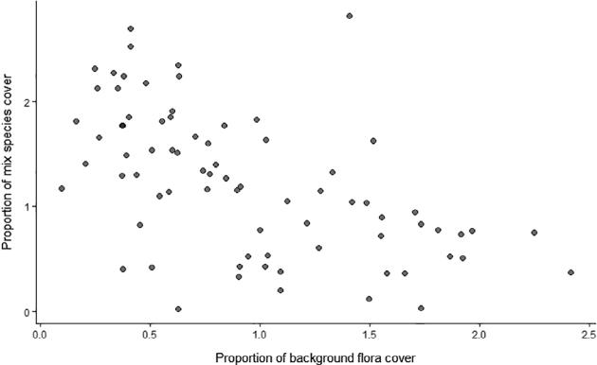

community composition in that soil pH drives greater diversity of the seeded mix (more species present from the original mix) which results in greater mix cover (Fig. 5). The density of M. vimineum from the first 4 years post restoration, which was greater in acidic soils, resulted in current high densities of M. vimineum which also resulted in reduced mix cover. Two missing paths were identified in SEMb; the density of M. vimineum during the early establishment years predicted a reduction in mix diversity (unstandardized coefficient −0.076, p < 0.05), and the background flora cover predicted a high den-sity of M. vimineum (unstandardized coefficient 4.143, p < 0.05).

Discussion

Native Seed Mix Establishment Success on Highly Disturbed Soils

We found that restoration with a native seed mix was broadly successful across the pipeline corridor with only 20% of sur-veyed locations having less than 50% coverage by species pre-sent in the seeded mix sown 8 years prior. Most species in the mix are native to the American prairie, or Eastern old fields and pastures, yet persisted on the highly disturbed forest soils of a pipeline corridor where site conditions ranged from steep slopes with thin, rocky soils to deeper soils typical of low-lying areas in this region. Originally sown in 2008 and 2009, many of the restoration mix species persisted as part of the corridor plant community through 2016. Given the establishment success of many species from the mix we see great potential for incorporat-ing more native seed in restoration mixes.

Influence of Soil pH on Plant Community Composition

The floristic surveys indicated a strong mediating effect of soil pH variation on plant community composition along the corri-dor 8 years after the restoration mixes were sown. Soil pH across our survey was representative of soils that had been minimally

July 2020 Restoration Ecology 875

Soil pH influences plant community composition

limed resulting in an atypically higher than normal pH value more than 5. While the pH of native, less disturbed soils in the forests adjacent to the pipeline corridor are typically 3–4.5 (Ciolkosz et al. 1990), the slightly higher values observed in the study may have resulted from liming at the time the seeded mix was planted.

We found that the impact of soil pH on mix species vegetative cover was mediated by the background flora, including M. vimineum density, and the mix species diversity at the time of the survey. Mix diversity increased with soil pH, and this greater diversity resulted in greater mix cover. Conversely, where soil pH was low, M. vimineum density remained high or increased much faster during the first 4 years post planting and continued to dominate the plant community through 2016. Those plots with high densities of M. vimineum in 2016 had lower seeded mix cover. As we do not have initial mix recruit-ment data we cannot confirm if initial recruitment and long-term persistence of the mix are linked. Some mix species, which were not present in our survey (such as the nurse crop L. multiflorum), could have had initial high recruitment and yet failed to persist. Mix species diversity was likely affected by a number of other abiotic and biotic factors we did not measure during the time between planting and our survey, such as soil moisture, nitrogen availability, and herbivory.

At the time of our survey we observed more weedy species in low soil pH. This suggests that either fast-spreading M. vimineum populations limit the establishment of the native mix, or low mix recruitment in extremely acidic soils results in an unfilled niche that is filled by M. vimineum and other weedy species already present at the site; likely both were factors. We had not hypothesized a relationship between the M. vimineum density during mix establishment and mix diversity, but a nega-tive relationship between the initial M. vimineum density and mix diversity was identified in SEMb suggesting that M. vimineum limited recruitment in early establishment.

We were surprised by the lower densities of M. vimineum in high pH soils given previous research had reported greater M. vimineum abundance on soils with high pH (Nord et al. 2010). In our surveys M. vimineum was the most frequent spe-cies on plots with lower pH while the proportion of the flora along the pipeline that was comprised of species in the seeded mix increased with soil pH. In fact, on sites with higher soil pH, compared to sites with more acidic soils, the background flora cover was 7% lower and M. vimineum was 60% less likely to be present in high densities. The cover of the mix species was reduced by 81% with increasing background flora cover, and reduced by 28% with high densities of M. vimineum. This effect on mix cover suggests that M. vimineum was one of the most competitive species in the species pool in low soil pH, or one of the few in the pool that can persist in low soil pH. We found no difference in total plant cover between the previously high and low density plots when excluding the cover of M. vimineum, which suggests that M. vimineum is not necessar-ily out-competing other vegetation, and that the site conditions are not necessarily limiting plant growth where M. vimineum density is low.

The background flora cover (here, all flora minus the mix spe-cies and M. vimineum) also declined with soil pH. This overall decline in weedy flora resulted in greater mix cover. Given SEMa we might presume that soil pH has a stronger effect on the weedy flora than on the mix cover. Yet with the results of SEMb we see that there were fewer species from the mix in lower soil pH. Mix diversity increased by 6.5% with increasing soil pH, and an increase in mix diversity led to an increase in mix cover by over 600%. We conclude that the mix had greater establishment success in soils greater than pH 5 and were there-fore able to compete with M. vimineum and other back-ground flora.

Including M. vimineum density from the 4 years post restora-tion in SEMb provides further evidence that soil pH was a factor driving plant community composition. We found that for every unit increase in site soil pH the likelihood that M. vimineum was present in high densities during those 4 years fell by 69%. Plots with low soil pH in contrast had higher M. vimineum den-sities in the first 4 years and low mix establishment. The odds that a plot with a high density of M. vimineum in the first 4 years maintained high densities through 2016 was 16 times greater than a plot with a low density through 2013.

Over time M. vimineum could play a role in altering soil envi-ronments and therefore site suitability for native plants. For example, some studies have shown M. vimineum raised soil pH (Ehrenfeld et al. 2001; McGrath & Binkley 2009), and Lee et al. (2012) found M. vimineum increased nitrification rates in natural invasions with variable productivity impacts dependent on competition with other plant species. Our study evaluated plant community composition post extreme soil disturbance; in other environmental site scenarios and longer timeframes the strong predictive nature of soil pH and M. vimineum invasion may not apply. To help inform long-term management contin-ued research is needed to track the evolving plant–soil interac-tions of invasions in native plant communities.

Implications for Mix Design, Monitoring, and Management

The lower mix diversity in extremely acidic soils has implica-tions for mix design. We recommend including more species that are better adapted to acidic conditions to increase the cover of the desired plant community and reduce the cover of weedy flora. Dichanthelium clandestinum, which is known for toler-ance to acidic soils (Sankaran & Ebbs 2007), was by far the most frequently present species (95% of surveyed plots) and had the greatest cover of species from the mix with an average of 50% cover across survey plots and as such is the best candidate for competing with M. vimineum.

The P. virgatum cultivar “Shelter” used in the mix was released in 1978 by the USDA NRCS for wildlife cover and can be grown on “shallow, acid and droughty soils” (USDA-NRCS 2015), which represents growing conditions on soils found on many steep slopes of the Ridge and Valley or Appala-chian Plateau physiographic province. We did not explicitly test for interspecific competition but we did see in our survey data that P. virgatum was prevalent throughout the pipeline corridor,

876 Restoration Ecology July 2020

Soil pH influences plant community composition

second only to D. clandestium in frequency and cover. In tall-grass prairie restoration this species has been known to dominate (Baer et al. 2005), but not necessarily limit diversity (McCain et al. 2010). P. virgatum would be a good choice for highly degraded soils and steep slopes where species options that can achieve both erosion control and wildlife benefit are limited. If growing conditions are not limited by moisture and soil pH, reducing the number and density of dominant grass species (e.g. D. clandestium and P. virgatum) may result in a more diverse plant community (Dickson & Busby 2009) and support a broader range of wildlife habitat.

Andropogon gerardii is less tolerant of acidic soils (optimal range 6.0–7.5) and was only found on three plots in TSF with less than 6% cover and was not present in RSF. Anecdotally, we only saw a few other small populations of this species while walking the entire length of the pipeline through both state for-ests. Because A. gerardii is pH and drought sensitive (Thorne & Cardina 2011) we do not recommend incorporating this species into restoration mixes for highly disturbed soils with low inputs and maintenance.

Chamaecrista fasciculata is often recommended as a native legume alternative to L. corniculatus and Trifolium repens because it provides abundant floral resources. Across the pipe-line C. fasciculata was just as frequent and abundant as L. corniculatus and its cover exceeded that of T. repens. We therefore highly recommend replacing non-native legumes in mixes with C. fasciculata. While not evident in our dataset, given our data collection methods only captured presence and linear cover, C. fasciculata appeared to be a poor competitor when growing with the dominant grasses in the mix. Our obser-vations are corroborated by Dickson and Busby (2009) and should be taken into consideration when designing mixes. Des-modium canadense is another native legume planted for addi-tional nitrogen fixation and floral resources, yet in our survey it was only present on a few plots. As D. canadense is typically a more expensive seed we suggest that unless there is an oppor-tunity for management or planting in strip monocultures, C. fasciculata is a better competitor on highly disturbed soils.

As expected, the prairie ruderal species Rudbeckia hirta was a frequent part of the realized mix along the pipeline corridor. Yet, many of the forbs included in the mix either did not establish because of environmental site conditions or were outcompeted by the background flora and the dominant grass species in the mix. To improve floral resources these mixes could have included more competitive forbs. Monarda species were not included in the mix, but Monarda fistulosa is another disturbance-adapted species with spreading rhizomes and sig-nificant floral resources (Rowe et al. 2018) that has potential to serve multiple ecosystem functions. To improve restoration with native species further research is needed to identify and test establishment success of a variety of forbs with dominant grasses and long-term persistence of species with high pollinator value.

Understanding the species filtering effects of soil pH com-bined with the propagule pressure of invasive weeds will be important for guiding management over the long term. Our data suggest that native perennial grass mixes can persist, even when

competing with an invasive annual warm-season grass, such as M. vimineum. As we found that low soil pH predicted the high densities of M. vimineum during the first 4 years post restoration, we suggest including more ecologically desirable species toler-ant of acidic soils to compete with M. vimineum. When restoring corridors with heterogeneous soil environments, such as our study location, it is unlikely managers will be able to treat each environment separately but should seed mixes with a wide range of pH tolerances to ensure coverage of ecologically desirable species.

Monitoring and invasive management of pipelines and other utility corridors in forests will be crucial as corridors could facil-itate the invasion of non-native weedy species, not just through the disturbed area itself, but also in the adjacent landscape (Prach et al. 2015). If collecting site soil or plant indicator data is not possible, monitoring for M. vimineum could be prioritized based on course predictions of sites with low soil pH. Except when off-site soils are used for restoration, soil pH can be pre-dicted by topography and parent soil data. M. vimineum seed spreads on pipelines by mowers, similar to the spread of M. vimi-neum by road graders on forest roads (Rauschert et al. 2017), and therefore identifying the ideal window for mowing will be important to managing for the desired plant community.

Restoration of highly disturbed and degraded soils, which require anti-erosion and sedimentation strategies to prevent sig-nificant soil loss, should not be limited to short-sighted revege-tation goals met with species-poor non-native mixtures. Broadening revegetation to ecological restoration is a global issue. The practice of revegetating temperate forests with spe-cies with limited habitat value and the tendency to arrest succes-sion will have long-term ecosystem consequences. We report here, as others have found, that native-based mixes have great potential for successful establishment, even with the competi-tion of an invasive weed, and should be assessed further for additional ecosystem functions and services. Given the exten-sive soil and hydrological disturbance associated with expan-sion in gas development, a significant shift in reclamation practices and norms must occur to support a diversity of ecosys-tem functions, such as increasing reliance on native plants.

Acknowledgments

Kelly Sitch, Ecologist with the Pennsylvania Department of Conservation and Natural Resources, provided helpful guidance on this research project. Funding from the PA DCNR award 4400015622 was used to support this research.

LITERATURE CITED

Baer SG, Collins SL, Blair JM, Knapp AK, Fiedler AK (2005) Soil heterogeneity effects on tallgrass prairie community heterogeneity: an application of eco-logical theory to restoration ecology. Restoration Ecology 13:413–424

Ballard M, Hough-Goldstein J, Tallamy D (2013) Arthropod communities on native and nonnative early successional plants. Environmental Entomology 42:851–859

Begley-Miller DR, Hipp AL, Brown BH, Hahn M, Rooney TP (2014) White-tailed deer are a biotic filter during community assembly, reducing species and phylogenetic diversity. Annals of Botany Plants 6:1–9

July 2020 Restoration Ecology 877

Soil pH influences plant community composition

Blumenthal DM, Jordan NR, Svenson EL (2005) Effects of prairie restoration on weed invasions. Agriculture, Ecosystems and Environment 107:221–230 Brittingham MC, Maloney KO, Farag AM, Harper DD, Bowen ZH (2014) Eco-logical risks of shale oil and gas development to wildlife, aquatic resources and their habitats. Environmental Science & Technology 48:11034–11047

Ciolkosz EJ, Carter BJ, Hoover MT, Cronce RC, Waltman WJ, Dobos RR (1990) Genesis of soils and landscapes in the Ridge and Valley province of central Pennsylvania. Geomorphology 3:245–261

Cooksey D, Sheley R (1997) Noxious weed survey and mapping system. Range-lands Archives 19:20–23

Cole PG, Weltzin JF (2004) Environmental correlates of the distribution and abundance of Microstegium vimineum, in east Tennessee. Southeastern Naturalist 3:545–562

Dickson TL, Busby WH (2009) Forb species establishment increases with decreased grass seeding density and with increased forb seeding density in a Northeast Kansas, U.S.A., experimental prairie restoration. Restoration Ecology 17:597–605

Drohan PJ, Brittingham M (2012) Topographic and soil constraints to shale-gas development in the Northcentral Appalachians. Soil Science Society of America Journal 76:1696–1706

Ehrenfeld JG, Kourtev P, Huang W (2001) Changes in soil functions following invasions of exotic understory plants in deciduous forests. Ecological Applications 11:1287–1300

Ellis-Felege SN, Dixon CS, Wilson SD (2013) Impacts and management of inva-sive cool-season grasses in the northern great plains: challenges and oppor-tunities for wildlife. Wildlife Society Bulletin 37:510–516

ESRI Satellite (2017) Sources: Esri, DigitalGlobe, GeoEye, i-cubed, USDA, USGS, AEX, Getmapping, Aerogrid, IGN, IGP, swisstopo, and the GIS User Community

Feijoo F, Iyer GC, Avraam C, Siddiqui SA, Clarke LE, Sankaranarayanan S, et al. (2018) The future of natural gas infrastructure development in the United States. Applied Energy 228:149–166

Fetcher N, Agosta SJ, Moore JC, Stratford JA, Steele MA (2015) The food web of a severely contaminated site following reclamation with warm season grasses. Restoration Ecology 24:421–429

Fink CM, Drohan PJ (2015) Dynamic soil property change in response to recla-mation following Northern Appalachian natural gas infrastructure develop-ment. Soil Science Society of America Journal 79:146–154

Flory SL, Rudgers JA, Clay K (2007) Experimental light treatments affect inva-sion success and the impact of Microstegium vimineum on the resident community. Natural Areas Journal 27:124–132

Foster BL, Houseman GR, Hall DR, Hinman SE (2015) Does tallgrass prairie res-toration enhance the invasion resistance of post-agricultural lands? Biolog-ical Invasions 17:3579–3590

Funk JL, Cleland EE, Suding KN, Zavaleta ES (2008) Restoration through reas-sembly: plant traits and invasion resistance. Trends in Ecology & Evolution 23:695–703

Gibson DJD, Spyreas G, Benedict J (2002) Life history of Microstegium vimi-neum (Poaceae), an invasive grass in southern Illinois. Journal of the Torrey Botanical Society 129:207–219

Gough L, Shaver GR, Carroll J, Royer DL, Laundre JA (2000) Vascular plant species richness in Alaskan arctic tundra: the importance of soil pH. Journal of Ecology 88:54–66

Guzman JG, Lal R, Byrd S, Apfelbaum SI, Thompson RL (2016) Carbon life cycle assessment for prairie as a crop in reclaimed mine land. Land Degra-dation and Development 27:1196–1204

Hobbs RJ, Norton DA (1996) Towards a conceptual framework for restoration ecology. Restoration Ecology 4:93–110

Hobbs RJ, Jentsch A, Temperton VM (2007) Restoration as a process of assem-bly and succession mediated by disturbance. Pages 150–167. In: Walker LR, Walker J, Hobbs RJ (eds) Linking restoration and ecological succession. Springer, New York

Jordan NR, Larson DL, Huerd SC (2011) Evidence of qualitative differences between soil-occupancy effects of invasive vs. native grassland plant spe-cies. Invasive Plant Science and Management 4:11–21

Kaiser-Bunbury CN, Mougal J, Whittington AE, Valentin T, Gabriel R, Olesen JM, Blüthgen N (2017) Ecosystem restoration strengthens pollina-tion network resilience and function. Nature 542:223–227

Kelt DA, Meserve PL (2016) To what extent can and should revegetation serve as restoration? Restoration Ecology 24:441–448

Kindscher K, Tieszen LL (1998) Floristic and soil organic matter changes after five and thirty-five years of native tallgrass prairie restoration. Restoration Ecology 6:181–196

Kiviat E (2013) Risks to biodiversity from hydraulic fracturing for natural gas in the Marcellus and Utica shales. Annals of the New York Academy of Sci-ences 1286:1–14

Langlois LA, Drohan PJ, Brittingham MC (2017) Linear infrastructure drives habitat conversion and forest fragmentation associated with Marcellus shale gas development in a forested landscape. Journal of Environmental Management 197:167–176

Lefcheck JS (2016) piecewiseSEM: piecewise structural equation modelling in R for ecology, evolution, and systematics. Methods in Ecology and Evolution 7:573–579

Lee MR, Flory SL, Phillips RP (2012) Positive feedbacks to growth of an invasive grass through alteration of nitrogen cycling. Oecologia 170: 457–465

Leicht SA, Silander JA, Greenwood K (2005) Assessing the competitive ability of Japanese Stilt Grass, Microstegium vimineum (Trin.) A. Camus. Journal of the Torrey Botanical Society 136:500–519

Lovell ST, Johnston DM (2009) Creating multifunctional landscapes: how can the field of ecology inform the design of the landscape? Frontiers in Ecol-ogy and the Environment 7:212–220

Lupton MK, Rojas C, Drohan P, Bruns MA (2013) Vegetation and soil develop-ment in compost-amended iron oxide precipitates at a 50-year-old acid mine drainage barrens. Restoration Ecology 21:320–328

Mahaney WM, Gross KL, Blackwood CB, Smemo KA (2015) Impacts of prairie grass species restoration on plant community invasibility and soil processes in abandoned agricultural fields. Applied Vegetation Science 18:99–109

Mangiafico SS (2016) Summary and analysis of extension program evaluation in R: transforming data. R package version 1.13.6

McCain KNS, Baer SG, Blair JM, Wilson GWT (2010) Dominant grasses sup-press local diversity in restored tallgrass prairie. Restoration Ecology 18: 40–49

McGrath DA, Binkley MA (2009) Microstegium vimineum invasion changes soil chemistry and microarthropod communities in Cumberland Plateau forests. Southeastern Naturalist 8:141–157

Miller C (2013) The evolving understanding of grassland restoration seeding pro-tocols. Ecological Restoration 31:127–130

Moran MD, Cox AB, Wells RL, Benichou CC, McClung MR (2015) Habitat loss and modification due to gas development in the Fayetteville Shale. Envi-ronmental Management 55:1276–1284

NOAA. 2018. Climate at a glance: city time series. [https://www.ncdc.noaa.gov/](https://www.ncdc.noaa.gov/cag/) [cag/](https://www.ncdc.noaa.gov/cag/) (accessed 5 Mar 2019)

Nord AN, Mortensen DA, Rauschert ESJ (2010) Environmental factors influence early population growth of Japanese Stiltgrass (Microstegium vimineum). Invasive Plant Science and Management 3:17–25

Pärtel M (2002) Local plant diversity patterns and evolutionary history at the regional scale. Ecology 83:2361–2366

Pinheiro J, Bates D, DebRoy S, Sarkar D and R Core Team (2016). _nlme: linear and nonlinear mixed effects models_. R package version 3.1-128

Prach K, Karešová P, Jírová A, Dvoˇ H, Konvalinková P (2015) Do not neglect surroundings in restoration of disturbed sites. Restoration Ecology 23: 310–314

QGIS Development Team, 2009. QGIS Geographic Information System. Open Source Geospatial Foundation. <http://qgis.osgeo.org>

RStudio Team (2016) RStudio: integrated development for R. RStudio, Inc., Boston, MA. URL <http://www.rstudio.com/>

Rauschert ESJ, Mortensen DA, Bloser SM (2017) Human-mediated dispersal via rural road maintenance can move invasive propagules. Biological Inva-sions 19:2047–2058

878 Restoration Ecology July 2020

Soil pH influences plant community composition

Rowe L, Gibson D, Landis D, Gibbs J, Isaacs R (2018) A comparison of drought-tolerant prairie plants to support managed and wild bees in conservation programs. Environmental Entomology 47:1128–1142

R Core Team (2018) R: a language and environment for statistical computing. R Foundation for Statistical Computing, Vienna, Austria. URL [https://www.](https://www.R-project.org/) [R-project.org/](https://www.R-project.org/)

Sankaran RP, Ebbs SD (2007) Cadmium accumulation in deer tongue grass (Pan-icum clandestinum L.) and potential for trophic transfer to microtine rodents. Environmental Pollution 148:580–589

Schlesinger WH (1986) Changes in soil carbon storage and associated properties with disturbance and recovery. Pages 194–220. In: Trabalka JR, Reichle DE (eds) The changing carbon cycle. Springer, New York

Sebastia M-T (2004) Role of topography and soils in grassland structuring at the landscape and community scales. Basic and Applied Ecology 5:331–346 Simmons MT (2005) Bullying the bullies: the selective control of an exotic, inva-sive annual (Rapistrum rugosum) by oversowing with a competitive native

species (Gaillardia pulchella). Restoration Ecology 13:609–615

Simao MCM, Flory SL, Rudgers JA (2010) Experimental plant invasion reduces arthropod abundance and richness across multiple trophic levels. Oikos 119:1553–1562

Skeel VA, Gibson DJ (1996) Physiological performance of Andropogon gerardii, Panicum virgatum, and Sorghastrum nutans on reclaimed mine spoil. Res-toration Ecology 4:355–367

Soil Survey Staff (2014) Soil survey field and laboratory methods manual. Soil Survey Investigations Report No. 51, Version 2.0. R. Burt and Soil Survey Staff (ed.). U.S. Department of Agriculture, Natural Resources Conserva-tion Service.

Souther S, Tingley MW, Popescu VD, Hayman DT, Ryan ME, Graves TA, Hartl B, Terrell K (2014) Biotic impacts of energy development from shale: research priorities and knowledge gaps. Frontiers in Ecology and the Envi-ronment 12:330–338

Stuble KL, Fick SE, Young TP (2017) Every restoration is unique: testing year effects and site effects as drivers of initial restoration trajectories. Journal of Applied Ecology 54:1051–1057

Coordinating Editor: Valerie Eviner

Suding KN, Hobbs RJ (2009) Threshold models in restoration and conserva-tion: a developing framework. Trends in Ecology & Evolution 24: 271–279

Thorne M, Cardina J (2011) Prairie grass establishment on calcareous reclaimed mine soil. Journal of Environmental Quality 40:1824–1834

Thompson RL, Vogel WG, Taylor DD (1984) Vegetation and flora of a coal surface-mined area in Laurel County, Kentucky. Castanea 49: 111–126

Trowbridge CC, Stanley A, Kaye TN, Dunwiddie PW, Williams JL (2017) Long-term effects of prairie restoration on plant community structure and native population dynamics. Restoration Ecology 25:559–568

USDA-NRCS (2015) Release brochure for ‘shelter’ switchgrass (Panicum virgatum L.). Big Flats Plant Materials Center, Corning, NY

Warren RJ, Wright JP, Bradford MA (2011) The putative niche requirements and landscape dynamics of Microstegiumvimineum: an invasive Asian grass. Biological Invasions 13:471–483

Whiles MR, Charlton RE (2006) The ecological significance of tallgrass prairie arthropods. Annual Review of Entomology 51:387–412

Zipper CE, Burger JA, Skousen JG, Angel PN, Barton CD, Davis V, Franklin JA (2011) Restoring forests and associated ecosystem services on Appalachian coal surface mines. Environmental Management 47:751–765

Supporting Information

The following information may be found in the online version of this article:

Figure S1. Seeded mix species vegetative cover (top) and frequency (bottom) across the 76 pipeline survey plots on two state forests.

Figure S2. Background flora vegetative cover across the 76 pipeline survey plots.

Figure S3. The frequency and proportion of Dichanthelium clandestinum on survey plots varied by soil pH.

Figure S4. The frequency and proportion of Panicum virgatum on survey plots varied by soil pH, with a drastic drop below pH 5.

Received: 3 October, 2018; First decision: 1 December, 2019; Revised: 19

January, 2020; Accepted: 18 February, 2020;

July 2020 Restoration Ecology 879