Received: 8 December 2019  Revised: 11 June 2020  Accepted: 13 June 2020

DOI: 10.1002/rra.3674



RESEARCH ARTICLE

Invasive macrophytes induce context-specific effects on oxygen, pH, and temperature in a hydropeaking reservoir

|  |  |  |  |
| --- | --- | --- | --- |
| Thomas P. Moore1 | | Susan J. Clearwater2 | | Ian C. Duggan1 | | Kevin J. Collier1 |



1Environmental Research Institute, School of Science, The University of Waikato, Hamilton, New Zealand

2Department of Conservation, Hamilton, New Zealand

Correspondence

Thomas P. Moore, Environmental Research Institute, School of Science, The University of Waikato, Hamilton, New Zealand. Email: [tom.moore.tpm@gmail.com](mailto:tom.moore.tpm@gmail.com)

Funding information

New Zealand Biological Heritage National

Science Challange, Grant/Award Number: C09X1501; Ministry of Business, Innovation and Employment

Abstract



Dense macrophyte beds are known to produce extreme diurnal oxygen and tempera-ture conditions in shallow lakes. However their influences in managed hydropeaking reservoirs has received limited attention. We measured dissolved oxygen, pH and

water temperature in the Lake Karapiro hydroreservoir, northern New Zealand, across a gradient of proportional water-column height occupied by the invasive mac-rophytes Egeria densa and Ceratophyllum demersum, which dominated in the upper-riverine (variable water inflow) and lower-lacustrine (variable water level) sections, respectively. Hypoxia and anoxia events that occurred inside invasive macrophyte beds during their summer peak biomass accumulation period were more pronounced for C. demersum than for E. densa, and within the bottom 20% of the water column. In contrast, pH and temperature changed little in relation to proportional macrophyte height. Macrophyte species differences in the production of hypoxia and anoxia events increased when site-specific hydropeaking management covariates (depth, inflows, water level) were accounted for. This association with hydropeaking likely resulted from contrasting hydrodynamics in the lower-lacustrine and upper-riverine lake sections, where oxygen can decrease with higher water levels and lower water inflow rates, respectively. During the course of our study, some macrophyte beds were treated with herbicide, enabling us to document prolonged and sustained hyp-oxic/anoxic conditions near the bottom following spraying. These results underscore the adverse effects of invasive macrophytes on water physicochemical attributes that sustain aquatic biota, and highlight the context-dependent nature of these effects moderated by reservoir management for hydropeaking and macrophyte control.

KEYWORDS

anoxia, aquatic plants, herbicide, hypoxia, lake management, littoral zone

1 | INTRODUCTION

Invasive macrophytes readily establish in human-modified environ-ments such as hydrogeneration reservoirs (Havel, Lee, & Vander Zanden, 2005; Johnson, Olden, & Vander Zanden, 2008), where daily water level fluctuations from reservoir management (i.e., hydropeaking) play a critical role in their proliferation in littoral zones (Shivers, Golladay, Waters, Wilde, & Covich, 2018; Zhao, Jiang,

Cai, & An, 2012). These beds can accumulate massive biomass over summer in temperate regions (Madsen, Chambers, James, Koch, & Westlake, 2001; Zohary & Ostrovsky, 2011), resulting in reduced native vegetation diversity (Andersen, Kragh, & Sand-Jensen, 2017; Parveen, Asaeda, & Rashid, 2017), changes in community composition of other trophic levels such as benthic invertebrates (Kelly & Hawes, 2005; Kovalenko & Dibble, 2010), and loss of ecosystem func-tions and services (Bunn, Davies, Kellaway, & Prosser, 1998;



|  |  |  |  |
| --- | --- | --- | --- |
| River Res Applic. 2020;1–13. | [wileyonlinelibrary.com/journal/rra](http://wileyonlinelibrary.com/journal/rra) | © 2020 John Wiley & Sons Ltd | 1 |

2  MOORE ET AL.

Villamagna & Murphy, 2010). Consequently, invasive macrophytes commonly represent ‘foundation species’ (Ramus, Silliman, Thomsen, & Long, 2017; Wood & Freeman, 2017) and have been referred to as ‘ecosystem engineers’ due to their dominance in abundance and influ-ence on lentic ecosystems (Thomaz, Mormul, & Michelan, 2014; Yarrow et al., 2009). A primary mechanism of impact by invasive mac-rophytes is the production of adverse physicochemical conditions above the sediment–water interface, which have been recorded inside dense beds in shallow lakes (Andersen et al., 2017; Bunch, Allen, & Gwinn, 2010; Vilas, Marti, Adams, Oldham, & Hipsey, 2017). How-ever, examination of the relationship between invasive macrophytes and adverse physicochemical conditions in the context of a hydro-peaking reservoir has received limited attention.

Studies of water physicochemical changes in shallow lake and slow-flowing river ecosystems report that dense macrophyte beds promote extreme diurnal variability in dissolved oxygen (i.e., anoxia-supersaturation), which can occur throughout the water column or be more starkly pronounced in bottom waters compared to surface waters (Andersen et al., 2017; Bunch et al., 2010; Caraco & Cole, 2002; Ribaudo et al., 2018; Vilas et al., 2017). These extreme diurnal cycles can be associated with changes in pH (Andersen et al., 2017; Ribaudo et al., 2018) and are driven by high volumetric rates of daytime photosynthesis and nocturnal respiration (Christensen, Sand-Jensen, & Staehr, 2013; Martinsen, Andersen, Kragh, & Sand-Jensen, 2017). Furthermore, invasive macrophytes can facilitate temperature stratification when they reach a threshold of percentage cover in the water column. For example, Vilas et al. (2017) recorded a 10 C maximum difference between the water surface and lake bottom during the daytime inside Potamogeton crispus beds occu-pying at least 50% of the water depth. Extreme diel changes in physi-cochemical conditions present a challenge for the survival of sessile and mobile animals (e.g., unionid mussels), and are expected to drive selection towards species tolerant of high temperature and/or hyp-oxia (Andersen et al., 2017).

The strength of invasive macrophyte impacts is dependent on their density and the consequent rate of hydrological exchange (Andersen et al., 2017; Vilas et al., 2017). Such impacts can be particu-larly pronounced at the end of summer when macrophyte senescence results in mass decomposition of organic matter that may consume large quantities of oxygen for prolonged periods (Godshalk & Wetzel, 1978). Although processes operating in shallow lakes may also occur in littoral zones of deep lakes, water level variations due to hydropeaking may further mediate the influence of invasive macro-phytes on physicochemical parameters. This is especially so given that dams can create conditions suitable for the proliferation of aquatic plants, but the nature of these conditions varies due to hydropeaking demand and the rate of water level change in inflows (Zhao et al., 2012).

With an increasing number of dams being constructed for hydro-power generation globally (Zarfl, Lumsdon, Berlekamp, Tydecks, & Tockner, 2014), and the associated spread of invasive species (Johnson et al., 2008), there is a need to understand the role invasive macrophyte species have on ecologically-relevant physicochemical

conditions during their peak biomass accumulation period in hydro-peaking reservoirs. Accordingly, a field study was conducted across a gradient of invasive proportional macrophyte height during the austral summer in the most downstream of a series of hydropeaking reser-voirs on New Zealand's longest river, the Waikato River. Two invasive macrophyte species, Egeria densa and Ceratophyllum demersum, domi-nated the upper-riverine and lower-lacustrine sections of this hydroreservoir, respectively, enabling a comparison between species where water inflow or water level were expected to generate context-specific effects on macrophyte-mediated physicochemical parameters. The following hypotheses were tested: (1) the magnitude of summer daytime physicochemical conditions will vary spatially in relation to a gradient of invasive macrophyte proportion (i.e., the height of macrophyte canopy expressed as a proportion of the water column depth) and water column-benthic processes, and; (2) hydro-peaking effects on physicochemical conditions produced by different macrophyte species in contrasting lake sections will be moderated by site hydrology (i.e., riverine vs. lacustrine locations). During the course of our study, some macrophyte beds were treated with herbicide, enabling us to examine treatment effects on physicochemical condi-tions, notably the diurnal magnitude and duration of bottom-water hypoxia conditions as the macrophytes decayed.

1. | MATERIALS AND METHODS 2.1 | Study site

Karapiro (37 550 42.8200 S, 175 320 40.300 E) is a large, deep (5.4 km2 surface area; 11 m mean and 30.5 m maximum depths; Lowe & Green, 1987) eutrophic (Livingston, Biggs, & Gifford, 1986) hydro-peaking reservoir on the Waikato River. It had a mean water inflow during the study of 262 m3 s−1 (minimum = 208, maximum 320 m3 s−1) equating to residence times of 3.3, 2.6, and 2.2 days, respectively, assuming full water column mixing and a lake water vol-ume of 60 × 106 m3; Gibbs et al., 2015). The upper section of Karapiro is riverine, with highly variable flows controlled by discharge from the upstream Arapuni hydropower station (i.e., mean discharge 271 m3 s−1, range 0.1–668 m3 s−1 in 2018). In contrast, the lower section closer to the dam is more lacustrine, with a diurnally variable water level related to hydropeaking operations at Karapiro dam (mean daily water level range of 1.2 m in 2018).

Two invasive macrophyte species are abundant in Karapiro: C. demersum and E. densa (Clayton, Wells, & Taumoepeau, 2006; McCarter, de Winton, Clayton, Wells, & Tanner, 1993; Schwarz, Wells, & Clayton, 1999). Ceratophyllum demersum dominates the lower-lacustrine section and is present in almost all shallow littoral areas to 5 m depth (Hofstra & de Winton, 2016), where it forms extensive monospecific beds. These beds develop dense subsurface canopies that displace and exclude native and other non-native vege-tation beneath (Coffey & Clayton, 1988). The resulting recreational, cultural, and environmental threats to hydrogeneration in the lower-lacustrine section has led to annual C. demersum control using the

|  |  |  |  |  |
| --- | --- | --- | --- | --- |
| MOORE ET AL. |  | | 3 |  |
|  |  |  |
|  |  |  |  |  |
|  |  |  |  |  |



herbicide diquat (Hofstra & de Winton, 2016). In the upper-riverine section, E. densa dominates littoral zones forming large, dense and monospecific beds that are rooted to the bottom and can withstand faster flows (Clayton, Matheson, & Smith, 2009). Although both E. densa and C. demersum are found throughout the year, rapid growth occurs in spring: e.g., 2–10% day−1 and 2–8% day−1 of dry biomass, respectively (Eller et al., 2015). Rapid summer growth leads to peak accumulation of biomass in autumn when both species often reach the water surface (Hofstra & de Winton, 2016).

2.2 | Measurement of physicochemical parameters

To understand differences in daytime physicochemical parameters in the water column (i.e., pH, temperature ( C), dissolved oxygen satura-tion % (hereafter oxygen), and specific conductivity (μS cm−1 at 25 C) associated with growth of macrophyte beds over the peak accumula-tion period, field data were collected at four sites in each of the lacus-trine (C. demersum) and riverine (E. densa) sections between

20 November and 7 December 2018 (C. demersum only) and January 22–30, 2019 (both species) following an initial echo-sound survey and aquatic vegetation mapping (Helminen, Linnansaari, Bruce, Dolson-Edge, & Curry, 2019; for site locations see Figure 1). At each site, vertical profiles of water-column physicochemical parameters were measured at four points designated in terms of macrophyte proportion (range 0–1) as: ‘macrophyte-free’ (A; x¯ ± SD; 0.1 ± 0.3 proportional macrophyte height), ‘light’ (B; 0.3 ± 0.2), ‘dense-edge’ (C; 0.6 ± 0.3), and ‘dense-bed’ (D; 0.7 ± 0.3) (see Figure 2b for further explanation). Pro-files at these four points were taken across three transects (5–10 m in length depending on depth) located 10 m apart, running perpendicular to the shore on each sampling occasion (Figure 2a).

A total of 144 physicochemical water-column profiles was col-lected to create a spatial dataset spanning a gradient of invasive mac-rophyte canopy height (i.e., 0–1.7 m for C. demersum in November; 0–4.2 m for C. demersum and 0–2.1 m for E. densa in January). From a boat anchored at two points to prevent movement, physicochemical parameters were measured with a sonde (650 MDS, YSI Incorporated, Yellow Springs, Ohio, United States). Measurement points started at the water surface (referred to as ‘0 m’, but equivalent to the depth required to submerge sonde probes: i.e., 0.05 m) and then every 0.5 m towards and including the lake bottom (Figure 2b). Invasive macro-phyte height was measured by lowering the sonde to the subsurface canopy (viewed using a bathyscope) then subtracting the calibrated depth reading from total depth. After each vertical profile, the time (09:30–16:00 hr), GPS location (easting, northing to 3–5 m), and water depth (1–4.2 m) were recorded.

To examine diurnal variation in physicochemical parameters asso-ciated with C. demersum, the sonde was deployed at the lake bottom

inside a bed previously used for vertical water profiles (37 560 41.200 S, 175 340 50.400 E). During the first deployment (12–19 February), herbicide was unexpectedly applied (as indicated by a spike in specific conductivity (increasing from 234 to 305 μS cm−1 at 25 C) across the site as part of annual C. demersum macrophyte

control, enabling comparison of short-term physicochemical changes before and after herbicide application (Figure 2c). The sonde was redeployed at the same site on 26 February for a further 7 days to assess longer-term changes in physicochemical parame-ters. All these sonde measurements were collected on the bottom every 10 min.

2.3 | Data preparation

For analysis of the spatial dataset (within the water column across lake sections), sonde measurements were classified as collected from inside or outside macrophyte beds if sonde depth was ≤ or > macrophyte height, respectively (Figure 2b). Specific conductivity (range 158–284 μS cm−1 at 25 C) showed no patterns in relation to macrophyte abundance so was not included in the spatial analysis, but it was used in the herbicide impact analysis to detect time of herbicide application and changes associated with C. demersum decomposition. For the latter analysis, data collected from the first hour of the seven-day sonde deployments before and after herbi-cide application were excluded to remove variation related to sonde installation.

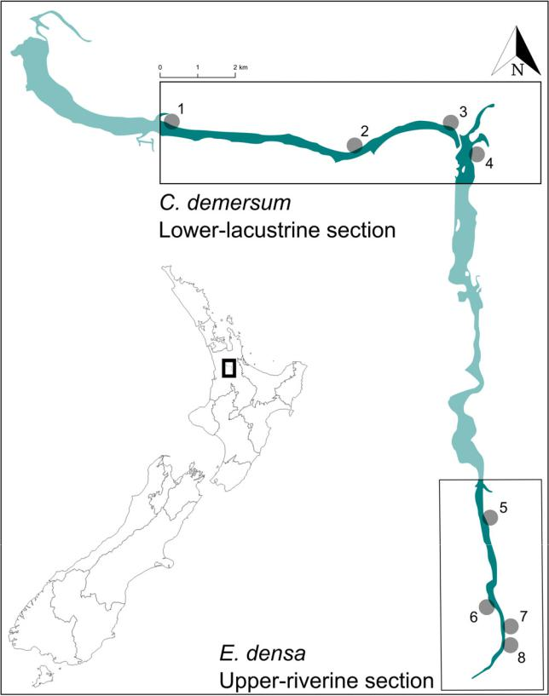

F I G U R E 1 Study site locations in Ceratophyllum demersum and Egeria densa in the lower-lacustrine and upper-riverine sections of

Karapiro, respectively. Enlarged area is located in the Waikato region, North Island, New Zealand (black box on country outline) [Color figure can be viewed at [wileyonlinelibrary.com]](http://wileyonlinelibrary.com)

4  MOORE ET AL.

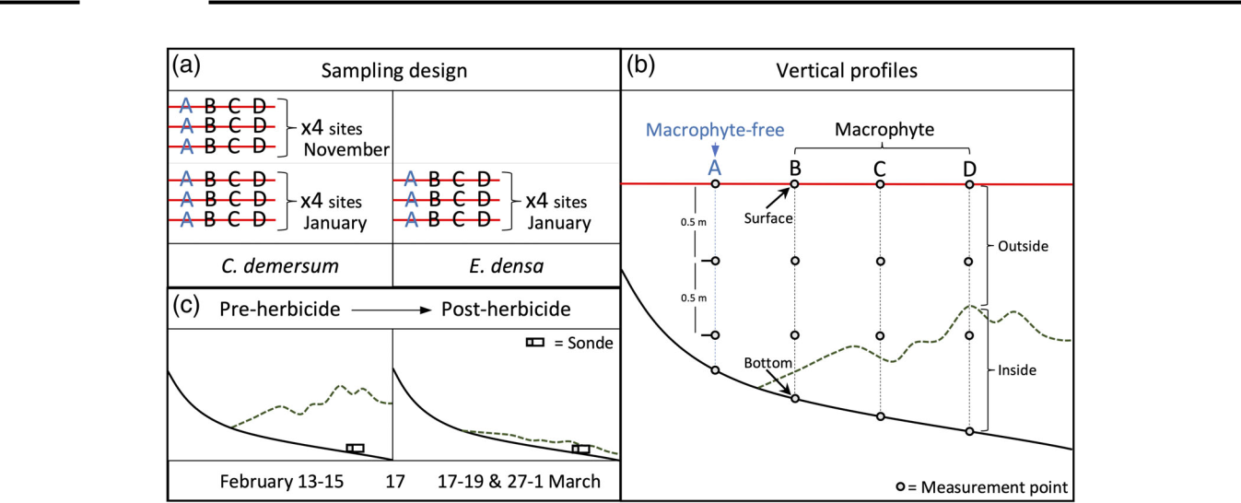

F I G U R E 2 Study design showing: (a) number of transects (red) perpendicular to the shoreline and location of vertical profiles (A)–(D) at four sites for each sampling occasion (Ceratophyllum demersum-lacustrine November; C. demersum-lacustrine January; and Egeria densa -riverine January);

1. measurement points (every 0.5 m from water surface including lake bottom) in macrophyte-free (A—blue) and macrophyte (B, C, D—black) vertical profiles, with inside/outside macrophyte bed (green dashed line) labelled; and (c) herbicide-impact measurement by 7-day deployment of a sonde in a C. demersum bed (dashed green line) and two-day periods selected for analysis [Color figure can be viewed at [wileyonlinelibrary.com]](http://wileyonlinelibrary.com)

To account for variability in physicochemical parameters related to macrophyte metabolism or Karapiro water level and water inflow fluctuations during the 6.5 hr required to collect the spatial data, the following covarying factors were included in data analyses:

1. measurement time expressed as minutes past midnight on each day; and (b) half-hourly data on water level at the Karapiro dam and water inflow (January 2018–May 2019) from the Arapuni dam located directly upstream (data acquired from Mercury New Zealand Limited). The time of measurement was rounded to the nearest half-hour to align with the supplied water level and water inflow data. Karapiro water level and water inflow were significantly inversely correlated (r = −.69, p < .001).

Data collected from the ‘surface’ (i.e., sonde probe depth of 0.05 m) and ‘bottom’ (i.e., sonde probe 0.05 m from the lake bed) in the spatial dataset (Figure 2b) were used to examine the strengths of relationships between potential covarying factors and physicochemi-cal parameters, which differed most at these extremes. Linear regres-sion was used to model each relationship, with the physicochemical parameter and potential covarying factor as the response and predic-tor variables, respectively. All relationships followed linear models (including measurement time) over the 7.5-hr period of daylight that measurements were collected (Table S1).

To remove the influence of the covarying factors of measurement time, and associated temporal variations in water depth induced by changes in Karapiro water level and water inflow, detrending (see below and Supporting Information for details) was performed prior to examining the relationship between proportional macrophyte height and measured pH, temperature or oxygen. Karapiro water level and water inflow were both detrended as different relationships with physicochemical parameters were shown for C. demersum and

E. densa sites. To detrend a physicochemical parameter, a correction was applied as follows:

x:detrended = x + ð x−y^Þ

where x is the raw physicochemical parameter and y the covarying factor. This was based on methods shown by Weisberg (2005), where a correction (difference between the mean physicochemical variable value (x) and fitted covarying factor value (y^)) was applied to the raw physicochemical parameter. For oxygen, resulting detrended values <0 were recoded to 0 (e.g., anoxic conditions measured in the after-noon could be adjusted to a negative value when accounting for the positive effect of measurement time).

2.4 | Statistical analyses

All data analyses presented were conducted using the R statistical soft-ware program v3.5.2 (R Core Team, 2019) and presented in ‘ggplot2’ v3.1.0 (Wickham, 2016). The relationship between raw physicochemical parameters and covarying factors collected across the three sampling occasions was explored using Principal Component Analysis (PCA) performed in the ‘Vegan’ community ecology package v2.5-4 (Oksanen, 2015). Prior to performing the PCA, raw physicochemical parameters and covarying factors were centred and scaled (subtracted from sample means and divided by their standard deviate) to standardize measurements on different scales (Sergeant, Starkey, Bartz, Wilson, & Mueter, 2016). Statistical significance and coefficients of determination of physicochemical parameters and covarying factors were tested with per-mutation tests (999) using the ‘envfit’ function in ‘Vegan’ (Oksanen, 2015).

MOORE ET AL.  5

To examine changes with depth, mean values of raw physico-chemical parameters in a vertical profile were binned into five groups of equal size based on proportional depth, and displayed as boxplots. Comparisons of proportional macrophyte height, Karapiro water level and water inflow, and physicochemical parameters between sampling occasions, sites, and vertical profiles were tested using ANOVA or t tests if parametric assumptions were met, or if not, their nonpara-metric equivalents were used (Kruskal–Wallis or Wilcoxon signed-rank tests). To account for multiple pairwise comparisons, Bonferroni corrections were applied for all tests with multiple groups. Propor-tional data were arcsine transformed prior to analysis (Zar, 1999).

Relationships between detrended physicochemical parameters of temperature, pH, and oxygen (transect mean of vertical profiles) were visualized in a ternary plot (scaled from 0 to 100) using ‘ggtern’ v3.1.0 (Hamilton & Ferry, 2018). To test the relationship between propor-tional macrophyte height and detrended physicochemical parameters at the lake bottom and water surface for each sampling occasion, lin-ear quantile regressions were performed using the 10th, 50th, and 90th quantiles (‘quantreg’ v5.38; Koenker et al., 2019). Each quantile regression slope was tested for significance from zero with xy-pair bootstrap standard errors (Koenker, 2019; Parzen, Wei, & Ying, 1994). Quantile regression was chosen since relationships were hetero-scedastic, with triangular patterns displayed in physicochemical parameters across the macrophyte proportion gradient. The 10th and 90th percentiles represent the upper and lower boundaries of these relationships and thereby can determine potential high and low limits in the data (Anderson & Jetz, 2005).

To examine the impact of herbicide application on diurnal variation of physicochemical parameters inside a C. demersum bed, two-day periods (starting at 09:00 hr; 288 measurements) were selected before (13–15 February), after (17–19 February), and 10-days after (27 February–1 March) herbicide application (17 February; Figure 2c). For each period, the coefficient of variation, and 10th, 50th, and 90th percentiles were calculated, with differences between periods in median value and variability tested using Wilcoxon Signed-rank and Levene's tests, respectively. As the herbicide-impact study was seren-dipitous, Bayesian structural models on the time-series data were applied to understand the effect of herbicide application compared to a modelled control (i.e., ‘counterfactual’; if no herbicide impact had occurred) using the ‘CausalImpact’ package (Brodersen, Gallusser, Koehler, Remy, & Scott, 2015). This impact analysis generated the mod-elled control based on the ‘before’ two-day period for specific conduc-tivity, pH, and oxygen (log +1) using covarying factors identified in the PCA (i.e., temperature, depth, measurement time, and Karapiro water level and water inflow) to compare with the ‘after’ two-day periods.

3 | RESULTS

3.1 | Sampling site characteristics

Water level in the lower-lacustrine section was significantly higher on average in January than November (mean ± SD of vertical profile

measurement points: 52.8 ± 0.1 and 52.6 ± 0.1 m above sea level, respectively; Wilcoxon signed-rank test, p < .001), with significant dif-ferences between sampling sites (November, Kruskal–Wallis,

1. = 32.46, p < .001; January, Kruskal–Wallis, H = 44.15, p < .001).

Water inflow in the upper-riverine section varied by 100 m3 s−1 on average between sampling days (overall mean 269.9 ± 42.9 m3 s−1; Kruskal–Wallis, H = 39.09, p < .001).

Across sampling occasions, macrophyte-free profile locations were 0.6–0.8 m shallower than locations with macrophytes (transect means 1.2 ± 0.5 and 1.9 ± 0.9 m, respectively; Wilcoxon signed-rank test, p = .016; Table 1). Vertical profile data were collected in signifi-cantly deeper water for C. demersum than E. densa sites in January (site means 1.9 ± 0.7 and 1.1 ± 0.2 m, respectively; Table 1) (Wilcoxon signed-rank test; p = .029).

Ceratophyllum demersum occupied 58% and 64% of the water col-umn on average in November and January, respectively, reaching mean heights of 1.3 and 1.4 m (Table 1). However, the proportion of water column occupied by C. demersum was not significantly different between sampling occasions (site mean arcsine transformed; Wilcoxon signed-rank test, p = .91). Across C. demersum transects (e.g., profile A versus profile C or D), vertical profile height was signifi-cantly different (Kruskal–Wallis, transect means, H = 24.2, p < .001), although A-B and C-D profiles showed nonsignificant pairwise differ-ences (Wilcoxon signed-rank tests Bonferroni corrected, p = .59 and

p = .39, respectively). In January, E. densa occupied a significantly higher proportion of the water column than C. demersum (by 20%; site mean arcsine transformed; t test, p = .013; Table 1). As with

C. demersum, E. densa height (mean 1.1 m; Table 1) was significantly

different across vertical profiles (ANOVA on transect means, F = 13.72, p = .003) except between A-B and C-D profiles (t tests Bonferroni corrected, p = .063 and p = .68, respectively).

3.2 | Temporal and spatial patterns

The PCA explained 36% and 22% of the variation in the spatial dataset across the first and second principal components, which were associated with distinctly different environmental gradients (all vec-tors p < .001). PC1 was positively associated with temperature and water level, and negatively with pH and water inflow, whereas PC2 was positively associated with oxygen and negatively with measured depth (Figure 3). The measurement time vector appeared on the diag-onal in relation to axes 1 and 2. Ceratophyllum demersum sampling occasions spread out temporally across the PC1 axis. Within sampling profile locations, macrophyte species spread out spatially across the PC2 axis, with macrophyte-free profiles (A) at the top and dense-bed profiles (D) at the bottom (Figure 3).

In macrophyte-free profiles (A), oxygen (range 140–141%) and pH (range 7.6–7.7) were not significantly different on average (tran-sect mean; t test; p = .6 and p = .6) between sampling occasions for C. demersum, but water temperature was significantly warmer by 4.0 C from November to January (t test on transect mean, p < .001; Table 1). Similarly, in vertical profiles with C. demersum (B-D; see

6



|  |  |  |  |  |  |  |  |  |  |  |  |  |  |
| --- | --- | --- | --- | --- | --- | --- | --- | --- | --- | --- | --- | --- | --- |
| andJanuary |  | Temp( | 2519. | 0.48 | 2.49 | 22.81 | 0.53 | 352. | 22.50 | 350. | 551. |  |  |
|  |  | C) |  |  |  |  |  |  |  |  |  |  |  |
|  |  |  |  |  |  |  |  |  |  |  |  |  |  |
| demersum (November 2018 |  | pH | 5695124.7. | 0.394240. | 32. 5.2035 | 7.15 | 0.38 | 305. | 112. 6.7984 | 4143.0.70 | 027338.6. |  |  |
|  | Oxygen (%) | 111.79 | 43.95 | 5138. |  |  |
|  |  |  |  |  |  |  |
| for C. |  | –(01) |  |  |  |  |  |  |  |  |  |  |  |
| and temperature | nProfiles()Macrophyte-free(A)Macrophyte(B-D)Sampling | (m) Proportion | 580. | 300. | 51.92 | 0.64 | 0.30 | 6446. | 0.84 | 0.29 | 3734. | macrophyte. |  |
| Summarystatisticsofwaterdepth,macrophyteheight,proportionofthewatercolumnoccupied,measuredoxygen,pH,TABLE12019)andE.densa(January2019)sitesinmacrophyte-freeandmacrophyte-occupiedverticalprofiles(seeFigure2) | occasionMFMDepth(m)Oxygen(%)pHTemp( | 3210C.demersumNovember20181236x¯1.140.7.19.2.1.49734327 | 0890553334SD0.13.0.0.0.1.25 | 81.699380285006CV20.9.4.2.42. | C.demersumJanuary20199 | SD0.8.0.0.0.1.472536479714 | 758273990828CV29.5.4.1.47.79. | 1.1.092450820263E.densaJanuary20191236x¯0.125.6.22. | 14.0.0.0.0.574125206112SD0. | 34CV18.11.2.1.33.52.1912916851 | Note:CV,coefficientofvariation;M-F,macrophytefree;M,macrophyte;n,number.a |  |
|  |  | Height |  |  |  | 1.44 |  |  |  |  |  | contain |  |
|  |  |  |  |  |  |  |  |  |  |  |  |  |
|  |  | Depth (m) |  |  |  | 2.06 |  |  |  |  |  | vegetation-free to |  |
|  |  |  |  |  |  |  |  |  |  |  |  |  |
|  |  |  |  |  |  | 23.49 |  |  |  |  |  | previously |  |
|  |  | C) |  |  |  |  |  |  |  |  |  |  |  |
|  |  |  |  |  |  | 7.59 |  |  |  |  |  | that were |  |
|  |  |  |  |  |  | 141.87 |  |  |  |  |  | profile locations |  |
|  |  |  |  |  |  | 1.58 |  |  |  |  |  | resulted in three |  |
|  |  |  |  |  |  |  |  |  |  |  |  |  |
|  |  |  |  |  |  | x¯ |  |  |  |  |  | January |  |
|  |  |  |  |  |  |  |  |  |  |  |  |
|  |  |  |  |  |  | a |  |  |  |  |  | to |  |
|  |  |  |  |  |  |  |  |  |  |  | November |  |
|  |  |  |  |  |  | 39 |  |  |  |  |  |  |  |
|  |  |  |  |  |  |  |  |  |  |  |  | Encroachment of C. demersum from |  |
|  |  |  |  |  |  |  |  |  |  |  |  |  |
|  |  |  |  |  |  |  |  |  |  |  |  |  |  |



MOORE ET AL.

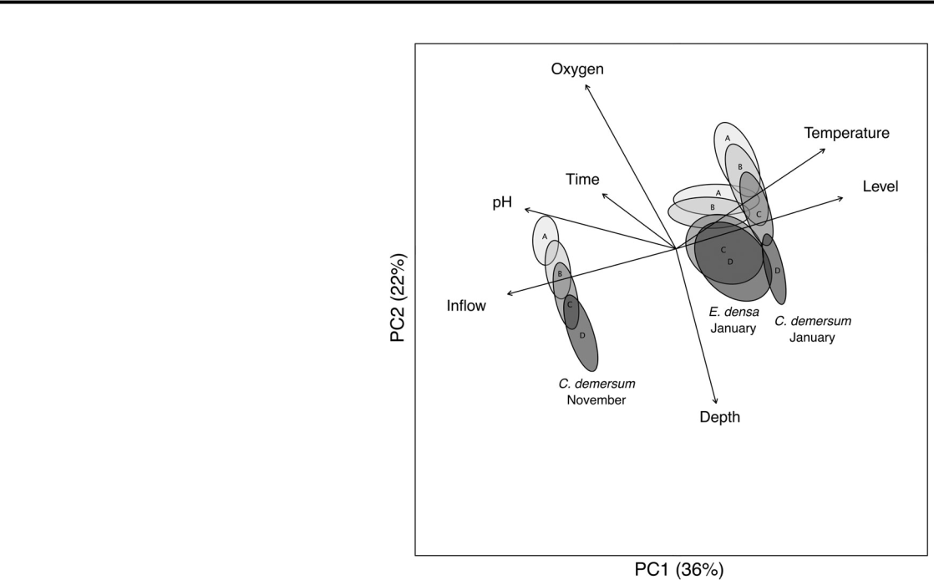

F I G U R E 3 Principal component analysis of environmental parameters. Vertical profiles are labelled on ellipses indicating standard error with 95% confidence intervals. Overlaid environmental vectors were statistically significant at p < .001

Figure 2), oxygen was not significantly different between sampling occasions (t test, p = .23), but lower average values of pH (difference 0.4) and higher temperature (difference 3.5 C) were found in January (t test, p = .034 and p < .001, respectively; Table 1). Comparison of macrophyte-free (A) and dense-bed (D) profiles indicated oxygen was significantly higher (by 15–30%) where C. demersum was absent (tran-sect mean of vertical profiles A and D; Wilcoxon signed-rank test, p < .001; Table 1). Significantly higher pH (difference range 0.2– 0.4 units) and temperature (difference range 0.2–0.7 C) values were also found in macrophyte-free profiles at C. demersum sites, with a more pronounced difference observed in January (transect mean of vertical profiles A and D; Wilcoxon signed-rank test, p = .023 and p < .001, respectively; Table 1).

Oxygen was the most variable physicochemical parameter at C. demersum sites, with higher coefficients of variation in macrophyte (range 32–39% CV) than macrophyte-free (range 6–10% CV) profiles, while temperature and pH were ≤5% CV (Table 1). Vertical profiles of oxygen (transect mean) showed depletion at 20% of the water depth from the lake bottom, with stronger depletion at higher C. demersum proportion (Figure 4). Temperature and pH showed no clear patterns with depth across profiles (see Figures S1 and S2). Comparison of macrophyte-free and dense-bed profiles within 20% of the lake bot-tom found oxygen was significantly lower in November but not in January (transect mean of vertical profiles A and D; t test, p = .01 and p = .37).

No significant differences in oxygen, pH or temperature were found within the E. densa sites between the macrophyte-free and dense-bed vertical profiles (transect mean of vertical profiles A and D;

MOORE ET AL.  7

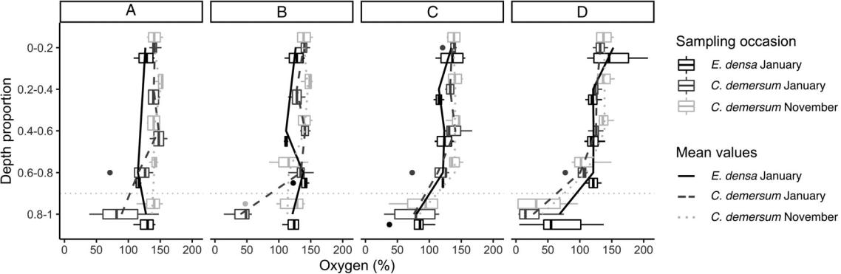

F I G U R E 4 Vertical profiles of measured oxygen values across vertical profiles for Ceratophyllum demersum in November (light grey long-dash), C. demersum in January (dark grey short-dash), and Egeria densa in January (black solid) with coloured solid lines linking mean values. A = macrophyte-free; B = light macrophyte; C = dense-edge; and D = dense-bed (see Figure 2). Depth proportion was split into five groups representing 20% intervals. Boxplots show median (black line inside boxplot); interquartile range (box); min/max (whiskers); and outliers (>1.5 × interquartile range, black dots). Dotted grey line indicates boundary where oxygen depletion occurred

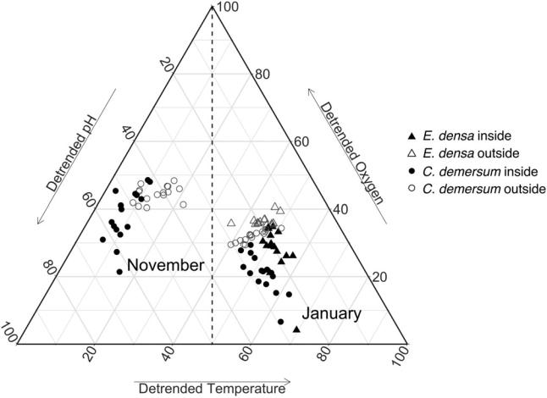

F I G U R E 5 Ternary diagram showing relationships between detrended environmental variables in the water column of dissolved oxygen, pH, and temperature scaled from 0 to 100 (transect mean of vertical profiles). Circular points = Ceratophyllum demersum; triangular points = Egeria densa; hollow grey points = measurement collected outside the macrophyte bed; solid black points = measurement collected inside the macrophyte bed (see Figure 2). Vertical dotted black line separates the November (left) and January (right) sampling occasions

Wilcoxon signed-rank test, p = .38, p = .17, p = .83; Table 1). Oxygen was the most variable physicochemical parameter in E. densa sites (temperature and pH ≤6% CV; Table 1). The CV values for dissolved oxygen were more variable than C. demersum sites in macrophyte-free profiles (6% and 12% CV, respectively), but similar in profiles con-taining macrophytes (32–39% CV; Table 1). On the E. densa sampling occasion, oxygen within 20% of the lake bottom was significantly lower on average (by 100% oxygen) in macrophyte profiles than macrophyte-free profiles (t test on transect mean, p = .01).

Comparison of upper-riverine and lower-lacustrine sections in January sampling occasions for macrophyte-free profiles found

oxygen and pH were not significantly different on average (i.e., t test of transect means, p = .13 and p = .053, respectively), although tem-perature was 1.0 C cooler in E. densa sites (both macrophyte-free and macrophyte profiles) which received upstream water inflows (t test, p < .001; Table 1). In vertical profiles with macrophytes (B-D; see Figure 2), average oxygen (range 112–113%), pH (range 6.8–7.2) and temperature (range 22.5–22.8 C) were not significantly different between C. demersum and E. densa in January (t test, p = .8, p = .15, p = .12, respectively; Table 1).

3.3 | Boundary effects of macrophytes

Detrended physicochemical variables, scaled from 0 to 100, showed clear separation between November and January related to tempera-ture, and between the lake bottom and water surface associated with oxygen and pH (Figure 5). Opposing oxygen (increase) and pH (decrease) gradients were more pronounced in January, when rela-tively low oxygen was more frequently measured at the lake bottom (Figure 5). Comparing the invasive macrophyte species, detrended physicochemical variables displayed separation in water surface and lake bottom, whereby E. densa had relatively higher oxygen and C. demersum more frequently displayed low oxygen, respectively (Figure 5).

For C. demersum sampling occasions across a gradient of propor-tional macrophyte height, detrended oxygen at the water surface sig-nificantly increased in January at the 90th percentile while median oxygen declined at the lake bottom on both sampling occasions (qua-ntile regressions; Figure 6; Table S1). Lake surface detrended temper-ature only significantly increased at the 10th percentile in January, when declines in detrended lake bottom pH and temperature were found across nearly all percentiles with increased C. demersum cover-age. In November, a decline was only found in lake bottom detrended temperature at the 10th percentile in relation to proportion of C. demersum in the water column (Figure 6).

|  |  |  |  |  |
| --- | --- | --- | --- | --- |
| 8 |  |  | MOORE ET AL. |  |
|  |  |  |
|  |  |  |  |  |
|  |  |  |  |  |



F I G U R E 6 Relationship

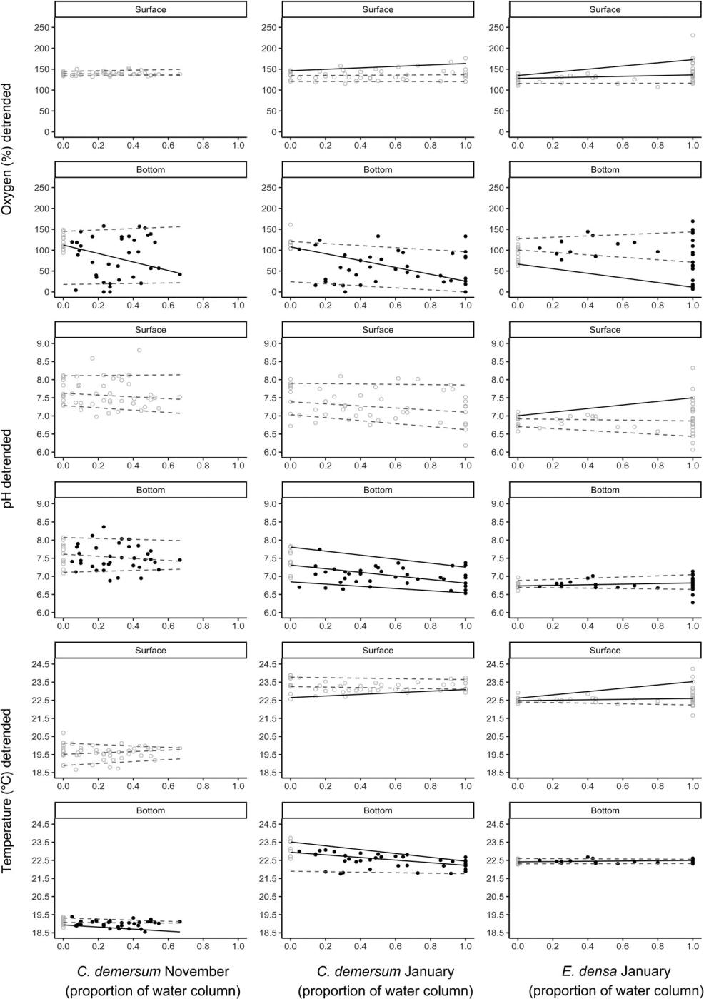

between detrended

environmental variables of

oxygen (%), pH and temperature

( C) with the proportion of

macrophyte in the water column

for November 2018

(Ceratophyllum demersum) and

January 2019 (C. demersum and

Egeria densa). Hollow grey

points = measurement collected

outside the macrophyte bed;

solid black points = measurement

collected inside the macrophyte

bed (see Figure 2). Quantile

regression model fit displayed for

the 10th, 50th (median), and 90th

percentiles, with solid lines

indicating statistical significance

at p = .05; dotted lines are not

statistically significant (see

Table S2 for model coefficients)

|  |  |  |
| --- | --- | --- |
| In January, both E. densa and C. demersum had at least a single | was associated with warmer temperatures. At the lake bottom, | |
| percentile that represented: (a) increased detrended oxygen values at | median temperature decreased at C. demersum sites and increased for | |
| the water surface (median, and 90th percentile and median, respec- | E. densa sites (Figure 6; Table S2). | |
| tively), and (b) decreased values at the lake bottom (median and 10th |  |  |
| percentile, respectively) related to the proportion of the water column |  |  |
| occupied by macrophytes (Figure 5; Table S2). Detrended pH only | 3.4 | | Herbicide-induced macrophyte |
| increased at the water surface for E. densa (90th percentile), with | decomposition | |
| decreased C. demersum and increased E. densa found at the lake bot- |  |  |
| tom for the median (Figure 6). Detrended surface temperature | Comparison of specific conductivity, oxygen, and pH 2 days before, | |
| showed a similar pattern, whereby increased proportion of E. densa | 2 days | after, and 10 days after herbicide application indicated |

|  |  |  |  |  |
| --- | --- | --- | --- | --- |
| MOORE ET AL. |  | | 9 |  |
|  |  |  |
|  |  |  |  |  |
|  |  |  |  |  |



T A B L E 2 Summary statistics of selected 2-day periods before, immediately after, and 10-days after herbicide application

|  |  |  |  |  |  |  |  |  |  |  |  |  |  |  |  |  |  |
| --- | --- | --- | --- | --- | --- | --- | --- | --- | --- | --- | --- | --- | --- | --- | --- | --- | --- |
|  |  |  | Specific conductivity (μS/cm at 25 C) | | | |  | Oxygen (%) | |  |  |  | pH |  |  |  |  |
|  | 2-Day period |  | CV | 10th | 50th | 90th |  | CV | 10th | 50th | 90th |  | CV | 10th | 50th | 90th | |
|  |  |  |  |  |  |  |  |  |  |  |  |  |  |  |  |  |  |
|  | Pre-herbicide 13–15 Feb |  | 4.86 | 212 | 221 | 241 | 100.69 | | 1.2 | 19.2 | 74.3 | 3.71 | | 6.7 | 6.9 | 7.4 |  |
|  |  |  |  |  |  |  |  |  |  |  |  |  |  |  |  |  |  |
|  | Post-herbicide 17–19 Feb |  | 7.74 | 214 | 230 | 260 | 177.74 | | 0.6 | 0.9 | 10.7 | 1.54 | | 7.1 | 7.3 | 7.4 |  |
|  | Post-herbicide (10-days) |  | 15.23 | 274 | 342 | 419 | 439.47 | | 0 | 0 | 0 | 1.15 | | 7.1 | 7.2 | 7.30 |  |
|  | 27 Feb–1 Mar |  |  |  |  |  |  |  |  |  |  |  |  |  |  |  |  |
|  |  |  |  |  |  | |  |  |  |  | |  |  |  |  | |  |
|  | Comparison |  | Pre-post |  | Pre-Post10 | |  | Pre-post |  | Pre-Post10 | |  | Pre-post |  | Pre-Post10 | | |
|  | Wilcoxon signed-rank test | W | 27,878 |  | 35 |  | 72,992 | |  | 80,836 |  | 17,625 | |  | 20,239 |  |  |
|  |  | p | <.001 |  | <.001 |  | <.001 | |  | <.001 |  | <.001 | |  | <.001 |  |  |
|  |  |  |  |  |  |  |  |  |  |  |  |  |  |  |  |  |  |
|  | Levene's test | DF | 576 |  | 576 |  | 576 | |  | 576 |  | 576 | |  | 576 |  |  |
|  |  | F | 61.42 |  | 437.89 |  | 226.74 | |  | 252.04 |  | 91.56 | |  | 157.52 |  |  |
|  |  | p | <.001 |  | <.001 |  | <.001 | |  | <.001 |  | <.001 | |  | <.001 |  |  |
|  | Causal impact | O x¯ | 233 |  | 343 |  | 1 .72 | |  | 0.23 |  | 7.28 | |  | 7.20 |  |  |
|  |  | P x¯ | 236 |  | 232 |  | 46.94 | |  | 10.94 |  | 7.42 | |  | 7.40 |  |  |
|  |  | p | .469 |  | .026 |  | .009 | |  | .001 |  | .416 | |  | .373 |  |  |
|  |  |  |  |  |  |  |  |  |  |  |  |  |  |  |  |  |  |

Abbreviations: CV, coefficient of variation; 10th, 50th, and 90th percentiles; DF, degrees of freedom; Feb, February; Mar, March; O x = observed mean value; P x = predicted mean value. W and F are test-statistics.

Note: Bold text indicates significance at p < .05.

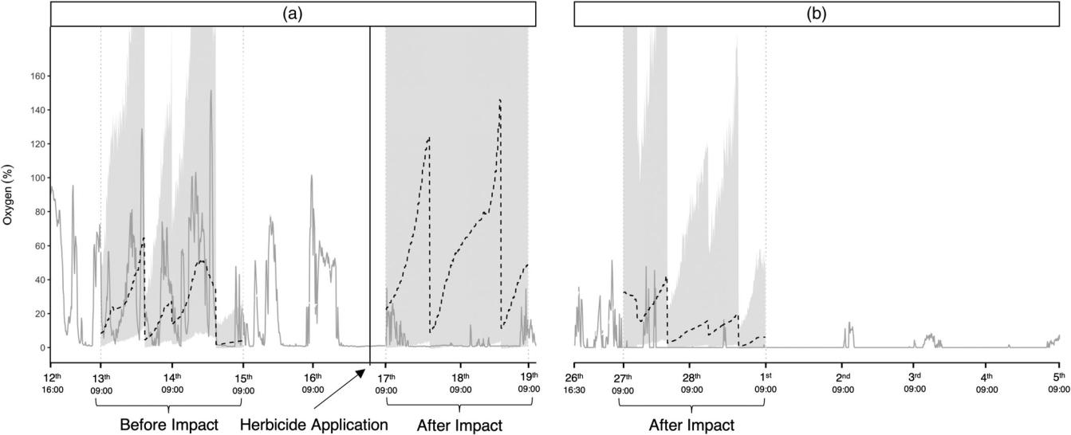

F I G U R E 7 Response of observed dissolved oxygen (%) (grey solid line) to Ceratophyllum demersum-decomposition induced by a single herbicide application (arrow and black vertical line). Oxygen was measured for 2 days before, and 2 and 10 days after, herbicide application (see Table 2). (a) First sonde deployment and (b) second sonde deployment. Graph includes modelled Causal-Impact control values (black dashed line) and 95% confidence interval (grey smooth)

significant changes in physicochemical median values and variability through time (Table 2). Pre-herbicide median oxygen saturation declined from 19.2% to <1% post-herbicide application, whereas median pH and specific conductivity increased from 6.9 to 7.2–7.3 and from 221 to 230–342 μS cm−1 at 25 C, respectively (Table 2). Specific conductivity and oxygen became more variable post-herbicide application (CVs from 4.9 to 15.2%, and from 100.7 to 439.5%, respectively), in contrast to pH which decreased in

variability (CV from 3.7 to 1.2%; Table 2). The modelled oxygen con-trol (i.e., no herbicide impact) exhibited similar diurnal changes and tracked observed oxygen before herbicide application (Figure 7). Comparing observed data after herbicide application with the mod-elled control indicated a significant increase in specific conductivity 10-days post-impact (47%) and significant decreases in oxygen at the bottom two-days (74%) and 10-days (91%) post-impact (Table 2; Figure 7).

10  MOORE ET AL.

4 | DISCUSSION

We were able to disentangle the complex effects of macrophytes and reservoir management on physicochemical parameters by progressive detrending to isolate the effects of covarying factors, namely varia-tions in sampling time spanning 6.5-hr; sampling depth due to a macrophyte-free varial zone induced by hydropeaking; and daily water flow and level changes caused by hydropeaking operations. Additionally, we used causal-impact analysis to interpret the diurnal effects of an unanticipated macrophyte-spraying event on physico-chemical parameters at the sediment–water interface. This combina-tion of approaches enabled us to disentangle the relationships between physicochemical parameters and the proportional macro-phyte height in the water column for two species of invasive macro-phyte from management factors. Quantile regression analysis of upper and lower limits highlighted the adverse conditions that benthic biota may encounter within dense invasive macrophyte beds, which are of particular importance to species such as unionid mussels that contribute to ecosystem function and services (Moore, Collier, & Duggan, 2019; Vaughn, 2018) and are abundant in Karapiro (Moore, unpublished data).

Ecologically detrimental physicochemical conditions in the water column produced inside invasive macrophyte beds during their peak biomass accumulation period within this hydropeaking reservoir were primarily low dissolved oxygen events, including anoxia, but were not evident for water pH or water temperature. Hypoxic events were more pronounced at the end of summer, and notably for C. demersum in the lower-lacustrine section of the reservoir within the bottom 20% of the water column where proportional macrophyte height was greatest, supporting Hypothesis 1. After accounting for hydropeaking management covariates (i.e., short-term changes in water flow or level), C. demersum produced hypoxic conditions across a wider range of macrophyte cover than E. densa, likely resulting from contrasting site hydrology in the lower-lacustrine and upper-riverine sections, respectively (Hypothesis 2). The unexpected application of the herbi-cide diquat led to prolonged and sustained hypoxic/anoxic conditions near the bottom of the water column, highlighting the interaction of hydropeaking and macrophyte management on reservoir benthic physicochemical conditions. These results underscore the adverse effects of invasive macrophytes on physicochemical attributes that support aquatic biota, and highlight the context-dependent nature of these effects moderated by reservoir management for hydropeaking and macrophyte control.

the inside of dense invasive macrophyte beds parallels studies in a shallow lake (Vilas et al., 2017) and large river (Caraco & Cole, 2002), which have suggested high macrophyte cover reduces horizontal water exchange from the edge to centre of the bed. Similarly, dense growths of five emergent macrophyte species in a shallow North American lake increased the probability of occurrence of hypoxia events with increased macrophyte cover (25% and 65% probability of <2 mg/L dissolved oxygen at 50–64% and 80–95% cover, respec-tively), although areas with lower percentage cover were not exam-ined (Bunch et al., 2010).

Our measurement of low oxygen conditions near the bottom-water interface at low proportional macrophyte height (i.e., from 10% of the water column) contrasts with findings of Vilas et al. (2017), who found oxygen effects at 50% P. crispus cover in a shallow Australian lake following temperature stratification (not observed in the unstratified hydropeaking reservoir, but see also Andersen et al., 2017; Ribaudo et al., 2018; Torma & Wu, 2019). The main mechanisms involved in these small-scale differences likely involve reduced wind-induced hydrological exchange (i.e., water flow) as mac-rophyte cover and bed size increased, leading to the higher influence of solar radiation on photosynthesis rates (Torma & Wu, 2019), although we did not detect an increase in temperature associated with this inferred reduced mixing.

Benthic hypoxia and anoxia have important ecological conse-quences associated with the release of phosphorus, dissolved inor-ganic carbon and nitrogen, and toxic ions such as ammonia, sulfide, and ferrous iron from bottom sediments (Andersen et al., 2017; James, Dechamps, Turyk, & McGinley, 2007; Ribaudo et al., 2018). These impacts can be particularly pronounced during macrophyte decomposition (Godshalk & Wetzel, 1978), and were detected in this study as increased and highly variable specific conductivity measure-ments post-herbicide application. Furthermore, the toxic metalloids/ metals arsenic and mercury, which can be high in systems with geo-thermal inputs such as the upper Waikato River, may be released and accumulate in freshwater fish (mercury only; Robinson, Brooks, Out-red, & Kirkman, 1994) and unionid mussels (both arsenic and mercury; Hickey, Roper, & Buckland, 1995). Finally, the larvae (glochidia) of uni-onid mussels present in Karapiro (Echyridella menziesii) are highly sen-sitive to relatively low concentrations of copper and ammonia (Clearwater, Thompson, & Hickey, 2014); therefore, benthic release of toxic compounds could be a mechanism to explain the adult-skewed size structures of mussel populations present in this system (Roper & Hickey, 1994; Moore, unpublished data).

4.1 | Spatial scales of invasive macrophyte effects 4.2 | Context-specific effects of management

As well as being evident at a large spatial scale between upper and lower sections of the reservoir (discussed below), the context-dependent impacts of dense C. demersum and E. densa beds on physi-cochemical parameters were detectable at smaller scales, both inside and outside of macrophyte beds and within the water column. Our finding that adverse physicochemical conditions were restricted to

The relationship between dense invasive macrophyte beds and physi-cochemical conditions in shallow lakes was expected to differ in hydrolakes where differences in hydrology between sites could exac-erbate or mitigate their effects. In our study, contrasting hydrological characteristics between upper and lower reservoir sections led to extensive shoreline varial zones in which macrophytes could not

MOORE ET AL.  11

establish in the lower section, and were associated with the domi-nance of different macrophyte species contributing to context-specific effects on physicochemical conditions. Lacustrine sections in the lower reservoir have lower hydrological exchange and more adverse physicochemical parameters inside dense invasive macro-phyte beds during periods of water retention compared to the upper-riverine section, associated with a higher water-level and higher flows. These findings suggest that physicochemical conditions inside dense invasive macrophyte beds in more riverine reservoir sections could be deliberately influenced by flow management, with higher water inflows leading to increased hydrological exchange and improved physicochemical conditions inside beds.

Although physicochemical parameter measurements were taken during the daytime, continuous measurements at one site indicated a wide range of physicochemical conditions were encountered during the sampling period in the lacustrine section. Furthermore, these mea-surements showed that diurnal processes were disrupted by herbicide spraying due to invasive macrophyte decomposition causing pro-longed benthic anoxia. Although rapid decomposition effects on oxy-gen conditions are considered for herbicide application in terms of frequency and area of application (Hussner et al., 2017), post-herbicide monitoring across a vertical water profile would be useful to detect the onset of hypoxic events and initiate management interven-tion (Parsons, Hamel, & Wierenga, 2007; Waltham & Fixler, 2017). At these times, higher water inflows from hydropeaking management may reduce the frequency of prolonged hypoxic/anoxic events near the lake bottom.

4.3 | Conclusions

We have shown that dense invasive macrophyte beds produce detri-mental physicochemical conditions in a hydropeaking reservoir during summer, and that site hydrology (water level and inflows) can be impor-tant covarying factors influencing the prevalence of low oxygen events. Spatial variations in the hydroreservoir due to operational effects on hydrology, and vertically and laterally within and around macrophyte beds, lead to context–specific effects on physicochemical conditions. Implementation of adjusted ecological operating guidelines has the potential to reduce the impacts of high invasive macrophyte biomass in hydropeaking reservoirs at key times. These steps may help reduce the prolonged adverse impacts of low dissolved oxygen over summer, especially for biota that reside close to, or in, the lake bed (Andersen et al., 2017). Future research is required to investigate interactions between impacts of adverse benthic physicochemical conditions on freshwater species and alternative hydropeaking management regimes.

ACKNOWLEDGEMENTS

This work was funded by the Ministry of Business, Innovation and Employment (New Zealand's Biological Heritage NSC, C09X1501). The authors thank Warrick Powrie for field work assistance, David Payne and Mercury New Zealand Ltd, for water level and water inflow data, Marcus Girvan for macrophyte-control reporting, Mary de

Winton for client reports, and Linda Te Aho for liaising with Taumatawiiwii and Ngaati Korokii-Kahukura Trusts.

CONFLICT OF INTEREST

The authors have no conflicts of interest to disclose.

DATA AVAILABILITY STATEMENT

The data that support the findings of this study are available from the corresponding author upon reasonable request.

ORCID

Thomas P. Moore<https://orcid.org/0000-0002-8373-627X>



Susan J. Clearwater <https://orcid.org/0000-0003-1739-0298>



Ian C. Duggan <https://orcid.org/0000-0002-6037-9759>



Kevin J. Collier <https://orcid.org/0000-0002-5213-9907>

REFERENCES

Andersen, M. R., Kragh, T., & Sand-Jensen, K. (2017). Extreme diel dis-solved oxygen and carbon cycles in shallow vegetated lakes. Proceed-ings of the Royal Society B: Biological Sciences, 284(1862), 20171427. <https://doi.org/10.1098/rspb.2017.1427>

Anderson, K. J., & Jetz, W. (2005). The broad-scale ecology of energy expenditure of endotherms. Ecology Letters, 8(3), 310–318. [https://](https://doi.org/10.1111/j.1461-0248.2005.00723.x) [doi.org/10.1111/j.1461-0248.2005.00723.x](https://doi.org/10.1111/j.1461-0248.2005.00723.x)

Brodersen, K. H., Gallusser, F., Koehler, J., Remy, N., & Scott, S. L. (2015). Inferring causal impact using Bayesian structural time-series models. The Annals of Applied Statistics, 9(1), 247–274. [https://doi.org/10.](https://doi.org/10.1214/14-AOAS788) [1214/14-AOAS788](https://doi.org/10.1214/14-AOAS788)

Bunch, A. J., Allen, M. S., & Gwinn, D. C. (2010). Spatial and temporal hyp-oxia dynamics in dense emergent macrophytes in a Florida lake. Wet-lands, 30(3), 429–435. <https://doi.org/10.1007/s13157-010-0051-9>

Bunn, S., Davies, P., Kellaway, D., & Prosser, I. (1998). Influence of invasive macrophytes on channel morphology and hydrology in an open tropi-cal lowland stream, and potential control by riparian shading. Freshwa-ter Biology, 39(1), 171–178. [https://doi.org/10.1046/j.1365-2427.](https://doi.org/10.1046/j.1365-2427.1998.00264.x) [1998.00264.x](https://doi.org/10.1046/j.1365-2427.1998.00264.x)

Caraco, N. F., & Cole, J. J. (2002). Contrasting impacts of a native and alien macrophyte on dissolved oxygen in a large river. Ecological Applica-tions, 12(5), 1496–1509. [https://doi.org/10.1890/1051-0761(2002)](https://doi.org/10.1890/1051-0761(2002)012[1496:CIOANA]2.0.CO;2) [012[1496:CIOANA]2.0.CO;2](https://doi.org/10.1890/1051-0761(2002)012[1496:CIOANA]2.0.CO;2)

Christensen, J. P., Sand-Jensen, K., & Staehr, P. A. (2013). Fluctuating water levels control water chemistry and metabolism of a charophyte-dominated pond. Freshwater Biology, 58(7), 1353–1365. [https://doi.](https://doi.org/10.1111/fwb.12132) [org/10.1111/fwb.12132](https://doi.org/10.1111/fwb.12132)

Clayton, J. S., Matheson, F., & Smith, J. (2009). Lake Karapiro weed control from March to June 2009. National Institute of Water and Atmospheric Research Client Report HAM2009–133, prepared for Land Information New Zealand (LMT08201), 14.

Clayton, J. S., Wells, R., & Taumoepeau, A. (2006). Weed control in Lake Karapiro. National Institute of Water and Atmospheric Research Client Report HAM2006-13, prepared for Land Information New Zealand, 25.

Clearwater S. J., Thompson K. J., & Hickey C. W. (2014). Acute toxicity of copper, zinc, and ammonia to larvae (glochidia) of a native freshwater mussel echyridella menziesii in new zealand. Archives of Environmental Contamination and Toxicology, 66(2), 213–226. [http://dx.doi.org/10.](http://dx.doi.org/10.1007/s00244-013-9972-7) [1007/s00244-013-9972-7.](http://dx.doi.org/10.1007/s00244-013-9972-7)

Coffey, B. T., & Clayton, J. S. (1988). New Zealand waterplants: A guide to plants found in New Zealand freshwaters (Vol. 63). New Zealand: Minis-try of Agriculture and Forestry.

Eller, F., Alnoee, A. B., Boderskov, T., Guo, W.-Y., Kamp, A. T., Sorrell, B. K., & Brix, H. (2015). Invasive submerged freshwater

12  MOORE ET AL.

macrophytes are more plastic in their response to light intensity than to the availability of free CO2 in air-equilibrated water. Freshwater Biol-ogy, 60(5), 929–943. <https://doi.org/10.1111/fwb.12547>

Gibbs, M., Safi, S., Albert, A., Duggan, I. C., Bowman, E., & Burger, D. (2015). Factors influencing chlorophyll a concentrations in the Wai-kato River. National Institute of Water and Atmospheric Research Client Report HAM2014-059, prepared for Dairy New Zealand. Retrieved from [https://www.waikatoregion.govt.nz/assets/PageFiles/35431/](https://www.waikatoregion.govt.nz/assets/PageFiles/35431/DNZ14204%2010Karapiro%2010final.pdf) [DNZ14204-Karapiro-final.pdf](https://www.waikatoregion.govt.nz/assets/PageFiles/35431/DNZ14204%2010Karapiro%2010final.pdf)

Godshalk, G. L., & Wetzel, R. G. (1978). Decomposition of aquatic angio-sperms. I. Dissolved components. Aquatic Botany, 5, 281–300. [https://](https://doi.org/10.1016/0304-3770(78)90073-6) [doi.org/10.1016/0304-3770(78)90073-6](https://doi.org/10.1016/0304-3770(78)90073-6)

Hamilton, N. E., & Ferry, M. (2018). ggtern: Ternary diagrams using ggplot2. Journal of Statistical Software, Code Snippets, 87(3), 1–17. <https://doi.org/10.18637/jss.v087.c03>

Havel, J. E., Lee, C. E., & Vander Zanden, J. M. (2005). Do reservoirs facili-tate invasions into landscapes? Bioscience, 55(6), 518–525. [https://doi.](https://doi.org/10.1641/0006-3568(2005)055[0518:DRFIIL]2.0.CO;2) [org/10.1641/0006-3568(2005)055[0518:DRFIIL]2.0.CO;2](https://doi.org/10.1641/0006-3568(2005)055[0518:DRFIIL]2.0.CO;2)

Helminen, J., Linnansaari, T., Bruce, M., Dolson-Edge, R., & Curry, R. A. (2019). Accuracy and precision of low-cost echosounder and auto-mated data processing software for habitat mapping in a large river. Diversity, 11(7), 116.

Hickey, C., Roper, D., & Buckland, S. (1995). Metal concentrations of resi-dent and transplanted freshwater mussels Hyridella menziesi (Unionacea: Hyriidae) and sediments in the Waikato River, New Zealand. Science of the Total Environment, 175(3), 163–177.

Hofstra, D. E., & de Winton, M. (2016). Weed Management Plan for Horn-wort in Lake Karapiro 2016 to 2025. National Institute of Water and Atmospheric Research Client Report HAM2016-071. Retrieved from [https://www.linz.govt.nz/system/files_force/media/doc/cp_lake-karapiro-weed-management-plan_201610.pdf?download=1](https://www.linz.govt.nz/system/files_force/media/doc/cp_lake%2010karapiro%2010weed%2010management%2010plan_201610.pdf?download=1)

Hussner, A., Stiers, I., Verhofstad, M. J. J. M., Bakker, E. S., Grutters, B. M. C., Haury, J., … Hofstra, D. (2017). Management and control methods of invasive alien freshwater aquatic plants: A review. Aquatic Botany, 136, 112–137. [https://doi.org/10.1016/j.aquabot.](https://doi.org/10.1016/j.aquabot.2016.08.002) [2016.08.002](https://doi.org/10.1016/j.aquabot.2016.08.002)

James, W. F., Dechamps, A., Turyk, N., & McGinley, P. (2007). Contribution of Potamogeton crispus decay to the phosphorus budget of McGinnis lake, Wisconsin. APCRP technical notes collection. ERDC/TN APCRP-EA-15. Vicksburg, MS: U.S. Army Engineer Research and Development Center Retrieved from [www.wes.army.mil/el/aqua](http://www.wes.army.mil/el/aqua)

Johnson, P. T. J., Olden, J. D., & Vander Zanden, M. J. (2008). Dam invaders: Impoundments facilitate biological invasions into freshwa-ters. Frontiers in Ecology and the Environment, 6(7), 357–363. [https://](https://doi.org/10.1890/070156) [doi.org/10.1890/070156](https://doi.org/10.1890/070156)

Kelly, D. J., & Hawes, I. (2005). Effects of invasive macrophytes on littoral-zone productivity and foodweb dynamics in a New Zealand high-country lake. Journal of the North American Benthological Society, 24(2), 300–320. <https://doi.org/10.1899/03-097.1>

Koenker, R. (2019). Quantile regression in R: A vignette. Retrieved from [https://cran.r-project.org/web/packages/quantreg/vignettes/rq.pdf](https://cran.r%2010project.org/web/packages/quantreg/vignettes/rq.pdf) Koenker, R., Portnoy, S., Ng, P. T., Zeileis, A., Grosjean, P., & Ripley, B. D.

(2019). Package ‘quantreg’. University of College London. Retrieved

from [ftp://ftp.ussg.iu.edu/pub/CRAN/web/packages/quantreg/](http://ftp://ftp.ussg.iu.edu/pub/CRAN/web/packages/quantreg/quantreg.pdf) [quantreg.pdf](http://ftp://ftp.ussg.iu.edu/pub/CRAN/web/packages/quantreg/quantreg.pdf)

Kovalenko, K. E., & Dibble, E. D. (2010). Effects of invasive macrophyte on trophic diversity and position of secondary consumers. Hydrobiologia, 663(1), 167–173. <https://doi.org/10.1007/s10750-010-0570-7>

Livingston, M. E., Biggs, B. J., Gifford, J. S. (1986). Inventory of New Zealand lakes. Water and Soil Miscellaneous Publication 80 & 81 200 Wellington, New Zealand: National Water and Soil Conserva-tion Authority.

Lowe, D. J., & Green, J. D. (1987). Appendix B: Some morphometric parameters of named lakes with areas 1.0 km2, and some smaller lakes, in New Zealand. In A. B. Viner (Ed.), Inland waters of

New Zealand. DSIR bulletin 241 (pp. 471–474). Wellington: Science Information Publishing Center, Department of Scientific and Industrial Research.

Madsen, J. D., Chambers, P. A., James, W. F., Koch, E. W., & Westlake, D. F. (2001). The interaction between water movement, sediment dynamics and submersed macrophytes. Hydrobiologia, 444 (1–3), 71–84. <https://doi.org/10.1023/A:1017520800568>

Martinsen, K. T., Andersen, M. R., Kragh, T., & Sand-Jensen, K. (2017). High rates and close diel coupling of primary production and ecosys-tem respiration in small, oligotrophic lakes. Aquatic Sciences, 79(4), 995–1007. <https://doi.org/10.1007/s00027-017-0550-3>

McCarter, N. H., de Winton, M., Clayton, J. S., Wells, R., & Tanner, C.

(1993). Grass carp in Lake Karapiro: Options for plant management.

National Institute of Water and Atmospheric Research Client Report.

Moore, T. P., Collier, K. J., & Duggan, I. C. (2019). Interactions between Unionida and non-native species: A global meta-analysis. Aquatic Con-servation: Marine and Freshwater Ecosystems, 29, 1–14. [https://doi.](https://doi.org/10.1002/aqc.3040) [org/10.1002/aqc.3040](https://doi.org/10.1002/aqc.3040)

Oksanen, J. (2015). Multivariate analysis of ecological communities in R: Vegan tutorial. Finland: University Oulu Retrieved from [http://cc.oulu.](http://cc.oulu.fi/%2DCjarioksa/opetus/metodi/vegantutor.pdf) [fi/˜jarioksa/opetus/metodi/vegantutor.pdf](http://cc.oulu.fi/%2DCjarioksa/opetus/metodi/vegantutor.pdf)

Parsons, J. K., Hamel, K., & Wierenga, R. (2007). The impact of diquat on macrophytes and water quality in Battle Ground Lake, Washington. Journal of Aquatic Plant Management, 45, 35–39.

Parveen, M., Asaeda, T., & Rashid, M. H. (2017). Biochemical adaptations of four submerged macrophytes under combined exposure to hypoxia and hydrogen sulphide. PLoS One, 12(8), e0182691. [https://doi.org/](https://doi.org/10.1371/journal.pone.0182691) [10.1371/journal.pone.0182691](https://doi.org/10.1371/journal.pone.0182691)

Parzen, M., Wei, L., & Ying, Z. (1994). A resampling method based on piv-otal estimating functions. Biometrika, 81(2), 341–350. [https://doi.org/](https://doi.org/10.2307/2336964) [10.2307/2336964](https://doi.org/10.2307/2336964)

R Core Team. (2019). R: A language and environment for statistical comput-

ing. Vienna: R Foundation for Statistical Computing.

Ramus, A. P., Silliman, B. R., Thomsen, M. S., & Long, Z. T. (2017). An inva-sive foundation species enhances multifunctionality in a coastal eco-system. Proceedings of the National Academy of Sciences of the United States of America, 114(32), 8580–8585. [https://doi.org/10.1073/pnas.](https://doi.org/10.1073/pnas.1700353114) [1700353114](https://doi.org/10.1073/pnas.1700353114)

Ribaudo, C., Tison-Rosebery, J., Buquet, D., Jan, G., Jamoneau, A., Abril, G.,

* Bertrin, V. (2018). Invasive aquatic plants as ecosystem engineers in an Oligo-Mesotrophic shallow lake. Frontiers in Plant Science, 9(1781). <https://doi.org/10.3389/fpls.2018.01781>

Robinson, B. H., Brooks, R. R., Outred, H. A., & Kirkman, J. H. (1994). Mer-cury and arsenic in trout from the taupo volcanic zone and Waikato River, North Island, New Zealand. Chemical Speciation and Bioavailabil-ity, 7, 27–32. <https://doi.org/10.1080/09542299.1995.11083237>

Roper, D. S., & Hickey, C. W. (1994). Population structure, shell morphol-ogy, age and condition of the freshwater mussel Hyridella menziesi (Unionacea: Hyriidae) from seven lake and river sites in the Waikato River system. Hydrobiologia, 284(3), 205–217.

Schwarz, A.-M., Wells, R., & Clayton, J. S. (1999). An overview of aquatic weeds in Lake Taupo and the Waikato River. National Institute of Water and Atmospheric Research Client Report CHC98/OA (ELE80520), 35.

Sergeant, C., Starkey, E., Bartz, K., Wilson, M., & Mueter, F. (2016). A prac-titioner's guide for exploring water quality patterns using principal components analysis and Procrustes. Environmental Monitoring and Assessment, 188(4), 249. <https://doi.org/10.1007/s10661-016-5253-z> Shivers, S. D., Golladay, S. W., Waters, M. N., Wilde, S. B., & Covich, A. P. (2018). Rivers to reservoirs: Hydrological drivers control reservoir function by affecting the abundance of submerged and floating macro-phytes. Hydrobiologia, 815(1), 21–35. [https://doi.org/10.1007/](https://doi.org/10.1007/s10750-018-3532-0)

[s10750-018-3532-0](https://doi.org/10.1007/s10750-018-3532-0)

Thomaz, S. M., Mormul, R. P., & Michelan, T. S. (2014). Propagule pressure, invasibility of freshwater ecosystems by macrophytes and their

|  |  |  |  |  |
| --- | --- | --- | --- | --- |
| MOORE ET AL. |  | | 13 |  |
|  |  |  |
|  |  |  |  |  |
|  |  |  |  |  |



ecological impacts: A review of tropical freshwater ecosystems. Hydrobiologia, 746(1), 39–59. <https://doi.org/10.1007/s10750-014-2044-9>

Torma, P., & Wu, C. (2019). Temperature and circulation dynamics in a small and shallow lake: Effects of weak stratification and littoral sub-merged macrophytes. Water, 11(1), 128.

Vaughn, C. C. (2018). Ecosystem services provided by freshwater mussels. Hydrobiologia, 810(1), 15–27. <https://doi.org/10.1007/s10750-017-3139-x>

Vilas, M. P., Marti, C. L., Adams, M. P., Oldham, C. E., & Hipsey, M. R. (2017). Invasive macrophytes control the spatial and temporal patterns of temperature and dissolved oxygen in a shallow lake: A proposed feedback mechanism of macrophyte loss. Frontiers in Plant Science, 8, 2097.

Villamagna, A., & Murphy, B. (2010). Ecological and socio-economic impacts of invasive water hyacinth (Eichhornia crassipes): A review. Freshwater Biology, 55(2), 282–298. <https://doi.org/10.1111/j.1365-2427.2009.02294.x>

Waltham, N., & Fixler, S. (2017). Aerial herbicide spray to control invasive water hyacinth (Eichhornia crassipes): Water quality concerns fronting fish occupying a tropical floodplain wetland. Tropical Conservation Sci-

ence, 10, 1940082917741592. [https://doi.org/10.1177/](https://doi.org/10.1177/1940082917741592) [1940082917741592](https://doi.org/10.1177/1940082917741592)

Weisberg, S. (2005). Applied linear regression (3rd ed.) Hoboken, New Jersey:

John Wiley & Sons.

Wickham, H. (2016). ggplot2: Elegant graphics for data analysis (2nd ed.)

New York: Springer.

Wood, J., & Freeman, M. (2017). Ecology of the macrophyte Podostemum ceratophyllum Michx. (Hornleaf riverweed), a widespread foundation species of eastern North American rivers. Aquatic Botany, 139, 65–74. <https://doi.org/10.1016/j.aquabot.2017.02.009>

Yarrow, M., Marin, V. H., Finlayson, M., Tironi, A., Delgado, L. E., & Fischer, F. (2009). The ecology of Egeria densa Planchon (Liliopsida: Alismatales): A wetland ecosystem engineer? Revista Chilena de Historia Natural, 82(2), 299–313.

Zar, J. (1999). Biostatistical analysis (5th ed.). Upper Saddle River, NJ: Pren-tice Hall.

Zarfl, C., Lumsdon, A. E., Berlekamp, J., Tydecks, L., & Tockner, K. (2014). A global boom in hydropower dam construction. Aquatic Sciences, 77(1), 161–170. <https://doi.org/10.1007/s00027-014-0377-0>

Zhao, D., Jiang, H., Cai, Y., & An, S. (2012). Artificial regulation of water level and its effect on aquatic macrophyte distribution in Taihu Lake. PLoS One, 7(9), e44836. [https://doi.org/10.1371/journal.pone.](https://doi.org/10.1371/journal.pone.0044836) [0044836](https://doi.org/10.1371/journal.pone.0044836)

Zohary, T., & Ostrovsky, I. (2011). Ecological impacts of excessive water level fluctuations in stratified freshwater lakes. Inland Waters, 1(1), 47–59. <https://doi.org/10.5268/IW-1.1.406>

SUPPORTING INFORMATION

Additional supporting information may be found online in the Supporting Information section at the end of this article.



How to cite this article: Moore TP, Clearwater SJ, Duggan IC, Collier KJ. Invasive macrophytes induce context-specific effects on oxygen, pH, and temperature in a hydropeaking reservoir. River Res Applic. 2020;1–13. [https://doi.org/10.](https://doi.org/10.1002/rra.3674) [1002/rra.3674](https://doi.org/10.1002/rra.3674)