|  |  |
| --- | --- |
| *et al. J Nanobiotechnol* | *(2* |

Journal of Nanobiotechnology



*Oryza sativa*



*Oryza sativa*

|  |  |  |  |  |
| --- | --- | --- | --- | --- |
|  |  | **K** | |  |
| ] | |  | –] |  |
|  |  | ] | |  |
|  |  | ] | –] |  |
|  |  |  |  |
|  |  |  | –] |  |
|  |  |  |  |
| ’ | |  |  |  |
|  |  | © |  |  |
|  |  | ’ | |  |
|  |  | ’ | |  |



*et al. J Nanobiotechnol* *(2* P

]

]

|  |  |  |  |  |  |  |
| --- | --- | --- | --- | --- | --- | --- |
| ] |  |  |  |  |  |  |
| ] |  |  |  |  |  |  |
| ] |  |  |  |  |  |  |
| ] |  |  |  |  |  |  |
| ] |  |  |  |  |  |  |
| ] |  |  |  |  |  |  |
| ] | *Oryza* | *sativa* |  |  |  |  |
|  |  |  |  |  |  |
| ] |  |  |  |  |  |  |
| –] | ± ° | |  |  |  |  |
| ] |  |  |  |  |
|  | μ |  | ·μ | · |  |  |
| ] | μ |  | μ |  |
|  | μ | μ | · | μ |  |
|  | μ | μ | ·μ |  | · |  |
|  | · | μ |  |  |  |
|  | *N* |  |  |  |  |  |
| ] | μ |  |  |  |  |  |
|  | − | ± °± | ° |  |  |  |
|  |  |  |  |  |
| *Oryza sativa* |  |  |  |  |  |  |
|  | ] |  |  |  |  |  |
| ] |  |  | · |  |  |  |
| ] |  |  |  |  |  |  |
| ] | *g* |  |  |  |  |  |

*et al. J Nanobiotechnol* *(2* P

’

***Experiment 1. Whether plants can uptake SeNPs?***

***Experiment 3. Comparison of uptake and transformation between SeNPs and inorganic Se in plants***

μ

μμμ

μ

°

– °

]

***Experiment 2. How SeNPs is taken up by plants?***

]

|  |  |  |  |
| --- | --- | --- | --- |
|  |  | *g* |  |
| μ | + | *g* |  |
| μ |  |
| ] |  |  |  |

μμ

+μ +μ

°

*et al. J Nanobiotechnol* *(2* P

|  |  |  |  |  |  |
| --- | --- | --- | --- | --- | --- |
| ] |  |  | CSHOOT−SE, CROOT−SE, CSHOOT F1/F2/F3−SE, CROOT F1/F2/F3−SE | |  |
|  |  | − | | (TSHOOT−SE , |  |
|  |  |  |  |  |
|  |  |  | TROOT −SE , TRICE−SE ) | (SHOOT − SE%, |  |
| ° |  |  | ROOT − SE%, SHOOTF 1/F 2/F 3 − SE%, ROOTF 1/F 2/F 3 − SE% | |  |
|  |  | *TF* |  |  |
|  |  |  |  |  |
| ° |  |  | TShoot−Se = CShoot−Se × BiomassShoot | |  |
|  |  |  |  |  |
|  |  |  | TRoot−Se = CRoot−Se × BiomassRoot | |  |
| – |  |  | TRice−Se = TShoot−Se | + TRoot−Se |  |
|  |  |  | Se uptake = TRice−Se / BiomassRoot | |  |
|  |  |  | Shoot − Se% = TShoot−Se / TRice−Se × 100% | |  |
|  | × × μ |  | Root − Se% = (TRoot−Se / TRice−Se) × 100% | |  |
|  | | |  | |  |
| ShootF 1/F 2/F 3−Se% = CShootF 1/F 2/F 3−Se / CShootF 1−Se + CShootF 2−Se + CShootF 3−Se × 100% | | | | |  |
| RootF 1/F 2/F 3−Se% = CRootF 1/F 2/F 3−Se / (CRootF 1−Se + CRootF 2−Se + CRootF 3−Se) × 100% | | | | |  |
|  |  |  |  | |  |
| × × | μ |  | TF = CShoot−Se / CRoot−Se | |  |
|  |  |  |  |
| − |  |  |  | ± = |  |
|  | + |  | ’ |  |
|  |  |  |  |

+

*p*

−

−

–

*et al. J Nanobiotechnol* *(2* P

**a1** **a2**

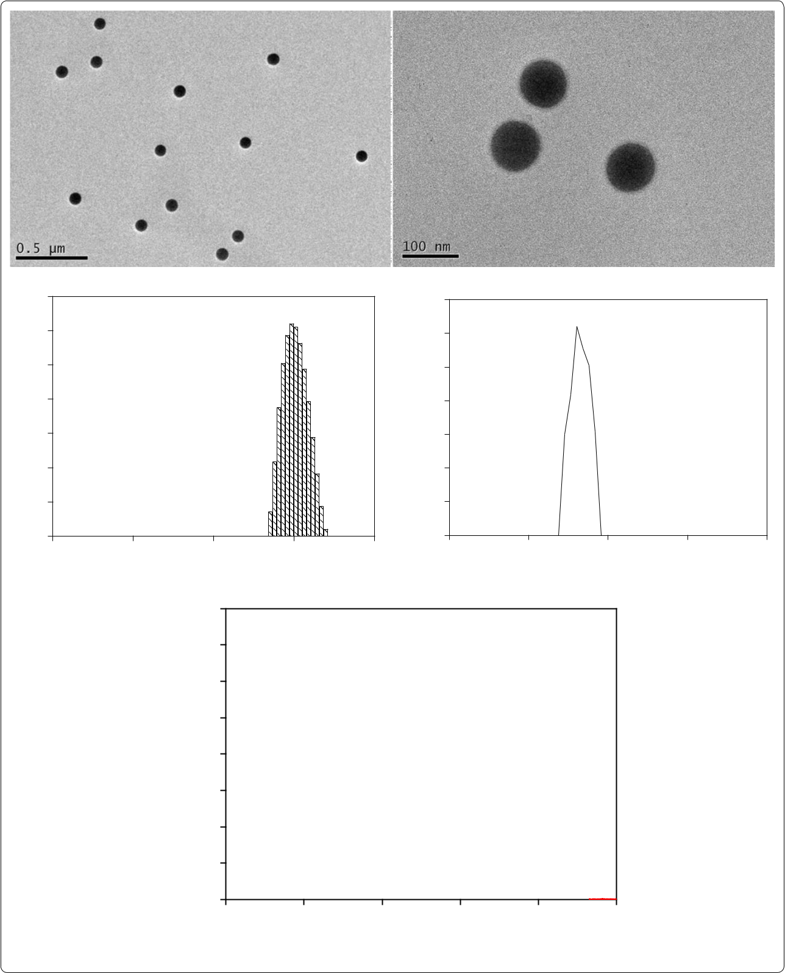

|  |
| --- |
| Frequency (%) |

|  |  |  |  |  |  |  |  |  |  |  |  |  |
| --- | --- | --- | --- | --- | --- | --- | --- | --- | --- | --- | --- | --- |
| 14 | **b** |  |  |  |  | 1.4 | **c** |  |  |  |  |  |
| 12 |  |  |  |  |  |  |  |  |  |  |
|  |  |  |  |  | 1.2 |  |  |  |  |  |  |
| 10 |  |  |  |  | (a.u.) | 1.0 |  |  |  |  |  |  |
| 8 |  |  |  |  | 0.8 |  |  |  |  |  |  |
| 6 |  |  |  |  | Intensity | 0.6 |  |  |  |  |  |  |
|  |  |  |  |  |  |  |  |  |  |  |
| 4 |  |  |  |  |  | 0.4 |  |  |  |  |  |  |
| 2 |  |  |  |  |  | 0.2 |  |  |  |  |  |  |
| 0 |  |  |  |  |  | 0.0 |  |  |  |  |  |  |
|  | 0.1 | 1 | 10 | 100 | 1000 | -200 | | -100 | 0 | 100 | 200 |  |

Hydrodynamic diameter (nm) Zeta potential (mV)

|  |
| --- |
| Cps (eV) |

4000

3500

3000

2500

2000

**d**

Se

**.**

|  |  |  |  |  |  |  |
| --- | --- | --- | --- | --- | --- | --- |
| 1500 |  |  |  |  |  |  |
| 1000 | O |  | Cu | Se |  |  |
|  |  |  |  |  |
|  |  |  |  |  |  |
| 500 | Na |  | Cu |  | Se |  |
|  |  |  |  |
| 0 |  |  |  |  |  |  |
| 0 | 3 | 6 | 9 | 12 | 15 |  |

Enegy (keV)

*et al. J Nanobiotechnol* *(2* P

μ

μ −

μ −

μ −

* −

|  |  |  |  |  |  |  |  |  |  |  |  |  |  |  |  |  |  |  |  |  |  |  |  |  |  |  |  |  |  |  |  |
| --- | --- | --- | --- | --- | --- | --- | --- | --- | --- | --- | --- | --- | --- | --- | --- | --- | --- | --- | --- | --- | --- | --- | --- | --- | --- | --- | --- | --- | --- | --- | --- |
|  | 16 |  |  | | |  |  |  |  |  |  |  |  |  |  |  |  |  |  |  |  |  |  |  |  |  |  |  |  |  |  |
| DW) |  | **a** | | |  |  |  |  |  |  |  |  |  |  |  |  |  |  |  |  |  |  |  |  |  |  | a | |  |  |
| 14 |  |  |  |  |  |  |  |  |  |  |  |  |  |  |  |  |  |  |  |  |  |  |  |  |  |  |  |  |
| 12 |  |  |  |  |  |  |  |  |  |  |  |  |  |  |  |  |  |  |  |  |  |  |  |  |  |  |  |  |  |  |
|  |  |  |  |  |  |  |  |  |  |  |  |  |  |  |  |  |  |  |  |  |  |  |  |  |  |  |  |  |  |
| -1 |  |  |  |  |  |  |  |  |  |  |  |  |  |  |  |  |  |  |  |  |  |  | b | | |  |  |  |  |  |
| g |  |  |  |  |  |  |  |  |  |  |  |  |  |  |  |  |  |  |  |  |  |  |  |  |  |  |  |  |
| g( | 10 |  |  |  |  |  |  |  |  |  |  |  |  |  |  |  |  |  |  |  |  |  |  |  |  |  |  |  |  |  |  |
|  |  |  |  |  |  |  |  |  |  |  |  |  |  |  |  |  |  |  |  |  |  |  |  |  |  |  |  |  |  |
| shoots |  |  |  |  |  |  |  |  |  |  |  |  |  |  |  |  |  |  |  | c | |  |  |  |  |  |  |  |  |  |
|  |  |  |  |  |  |  |  |  |  |  |  |  |  |  |  |  |  |  |  |  |  |  |  |  |  |  |  |  |
| 8 |  |  |  |  |  |  |  |  |  |  |  |  |  |  |  |  |  |  |  |  |  |  |  |  |  |  |  |  |  |  |
|  |  |  |  |  |  |  |  |  |  |  |  |  |  |  |  |  |  |  |  |  |  |  |  |  |  |  |  |  |  |
| in |  |  |  |  |  |  |  |  |  |  |  |  |  |  |  |  |  |  |  |  |  |  |  |  |  |  |  |  |  |  |  |
| content | 6 |  |  |  |  |  |  |  |  |  |  |  |  |  |  |  |  |  |  |  |  |  |  |  |  |  |  |  |  |  |  |
|  |  |  |  |  |  |  |  |  |  |  |  |  |  |  |  |  |  |  |  |  |  |  |  |  |  |  |  |  |  |
| 4 |  |  |  |  |  |  |  |  |  |  |  |  |  |  |  | d | | |  |  |  |  |  |  |  |  |  |  |  |  |
|  |  |  |  |  |  |  |  |  |  |  |  |  |  |  |  |  |  |  |  |  |  |  |  |  |  |  |
| Se |  |  |  |  |  |  |  |  |  |  |  |  |  |  |  |  |  |  |  |  |  |  |  |  |  |  |  |  |
|  | 2 |  | f | | | f | | | f | | |  | e | | |  |  |  |  |  |  |  |  |  |  |  |  |  |  |  |  |
|  |  |  |  |  |  |  |  |  |  |  |  |  |  |  |  |  |  |  |
|  | 0 |  |  |  |  |  |  |  |  |  |  |  |  |  |  |  |  |  |  |  |  |  |
|  |  |  |  |  |  |  |  |  |  |  |  |  |  |  |  |  |  |  |  |  |  |  |  |  |  |  |  |  |  |  |
|  |  |  | 0 | | | 1 | | | 5 | | | 12 | | | | 24 | | | | 48 | | | 72 | | | | 120 | | |  |  |

Exposure time (h)

**.**

= *p*

+

+

μμ

μ

μ

μ

μ



|  |  |  |  |  |  |  |  |  |  |  |  |  |  |  |  |  |  |  |  |  |  |  |  |  |  |  |  |  |  |  |  |
| --- | --- | --- | --- | --- | --- | --- | --- | --- | --- | --- | --- | --- | --- | --- | --- | --- | --- | --- | --- | --- | --- | --- | --- | --- | --- | --- | --- | --- | --- | --- | --- |
|  | 350 |  |  | | |  |  |  |  |  |  |  |  |  |  |  |  |  |  |  |  |  |  |  |  |  |  |  |  |  |  |
|  |  | **b** | | |  |  |  |  |  |  |  |  |  |  |  |  |  |  |  |  |  |  |  |  |  | a | | |  |  |
| DW) | 300 |  |  |  |  |  |  |  |  |  |  |  |  |  |  |  |  |  |  |  |  |  |  |  |  |  |  |  |
|  |  |  |  |  |  |  |  |  |  |  |  |  |  |  |  |  |  |  |  |  |  |  | b | |  |  |  |  |  |  |
| -1 | 250 |  |  |  |  |  |  |  |  |  |  |  |  |  |  |  |  |  |  |  |  |  |  |  |  |  |  |  |  |  |  |
| g |  |  |  |  |  |  |  |  |  |  |  |  |  |  |  |  |  |  | b | | |  |  |  |  |  |  |  |  |  |
| g( |  |  |  |  |  |  |  |  |  |  |  |  |  |  |  |  |  |  |  |  |  |  |  |  |  |  |  |  |
|  |  |  |  |  |  |  |  |  |  |  |  |  |  |  |  |  |  |  |  |  |  |  |  |  |  |  |  |
| roots | 200 |  |  |  |  |  |  |  |  |  |  |  |  |  |  |  | c | |  |  |  |  |  |  |  |  |  |  |  |  |  |
|  |  |  |  |  |  |  |  |  |  |  |  |  |  |  |  |  |  |  |  |  |  |  |  |  |  |  |  |
|  |  |  |  |  |  |  |  |  |  |  |  |  |  |  |  |  |  |  |  |  |  |  |  |  |  |  |  |  |
| in | 150 |  |  |  |  |  |  |  |  |  |  |  |  | c | |  |  |  |  |  |  |  |  |  |  |  |  |  |  |  |  |
|  |  |  |  |  |  |  |  |  |  |  |  |  |  |  |  |  |  |  |  |  |  |  |  |  |  |  |  |
| content |  |  |  |  |  |  |  |  |  |  |  |  |  |  |  |  |  |  |  |  |  |  |  |  |  |  |  |  |
| 100 |  |  |  |  |  |  |  |  | d | | |  |  |  |  |  |  |  |  |  |  |  |  |  |  |  |  |  |  |  |
|  |  |  |  |  |  |  |  |  |  |  |  |  |  |  |  |  |  |  |  |  |  |  |  |  |  |  |
|  |  |  |  |  |  |  |  |  |  |  |  |  |  |  |  |  |  |  |  |  |  |  |  |  |  |  |
|  |  |  |  |  |  |  |  |  |  |  |  |  |  |  |  |  |  |  |  |  |  |  |  |  |  |  |
| Se | 50 |  | e | | | e | | |  |  |  |  |  |  |  |  |  |  |  |  |  |  |  |  |  |  |  |  |  |  |  |
|  |  |  |  |  |  |  |  |  |  |  |  |  |  |  |  |  |  |  |  |  |  |  |  |  |
|  |  |  |  |  |  |  |  |  |  |  |  |  |  |  |  |  |  |  |  |  |  |  |  |  |
|  |  |  |  |  |  |  |  |  |  |  |  |  |  |  |  |  |  |  |  |  |  |  |  |  |  |
|  | 0 |  |  |  |  |  |  |  |  |  |  |  |  |  |  |  |  |  |  |  |  |  |  |  |  |  |  |  |
|  |  |  | 0 | | | 1 | | | 5 | | | | 12 | | | 24 | | | 48 | | | | 72 | | | 120 | | | |  |  |

Exposure time (h)

±

’

|  |  |
| --- | --- |
| *et al. J Nanobiotechnol* | *(2* |

|  |  |  |  |  |  |  |  |  |  |  |  |  |  |  |  |  |  |  |  |  |  |  |  |  |  |  |  |  |
| --- | --- | --- | --- | --- | --- | --- | --- | --- | --- | --- | --- | --- | --- | --- | --- | --- | --- | --- | --- | --- | --- | --- | --- | --- | --- | --- | --- | --- |
|  | 3.5 | |  |  |  |  |  |  |  |  |  |  |  |  |  |  |  |  |  |  |  |  |  |  |  |  |  |  |
|  | **a** | | | | |  |  |  |  |  |  |  |  |  |  |  |  |  |  |  |  |  |  |  |  |  |
| DW) | 3.0 | |  |  |  |  |  | a | | | | | | |  |  |  |  |  |  |  |  |  |  |  |  |  |  |
|  |  |  |  |  |  |  |  |  |  |  |  |  |  |  |  |  |  |  |
|  |  |  |  |  |  |  |  |  |  |  |  |  |  |  |  |  |  |  |  |  |
|  |  |  |  |  |  |  |  |  |  |  |  |  |  |  |  |  |  |  |  |  |  |
| h | 2.5 | |  |  |  |  |  |  |  |  |  |  |  |  |  |  |  |  |  |  |  |  |  |  |  |  |  |  |
| -1 |  |  |  |  |  |  |  |  |  |  |  |  |  |  |  |  |  |  |  |  |  |  |  |  |  |  |  |  |
| root | 2.0 | |  |  |  |  |  |  |  |  |  |  |  |  |  |  |  |  |  |  |  |  |  |  |  |  |  |  |
| 1 |  |  |  |  |  |  |  |  |  |  |  |  |  |  |  |  |  |  |  |  |  |  |  |  |  |  |
| - |  |  |  |  |  |  |  |  |  |  |  |  |  |  |  |  |  |  |  |  |  |  |  |  |  |  |  |  |
| ( g g | 1.5 | |  |  |  |  |  |  |  |  |  |  |  |  |  |  |  |  |  |  |  |  |  |  |  |  |  |  |
|  |  |  |  |  |  |  |  |  |  |  |  |  |  |  |  |  |  |  |  |  |  |  |  |  |  |
| influx | 1.0 | |  |  |  |  |  |  |  |  |  |  |  |  |  |  |  |  |  |  | b | | | | | | |  |
|  |  |  |  |  |  |  |  |  |  |  |  |  |  |  |  |  |  |  |  |  |  |
| Se |  |  |  |  |  |  |  |  |  |  |  |  |  |  |  |  |  |  |  |  |  |  |  |  |  |  |  |  |
|  | 0.5 | |  |  |  |  |  |  |  |  |  |  |  |  |  |  |  |  |  |  |  |  |  |  |  |  |  |  |
|  |  |  |  |  |  |  |  |  |  |  |  |  |  |  |  |  |  |  |  |  |  |  |  |  |  |  |
|  | 0.0 | |  |  |  |  |  |  |  |  |  |  |  |  |  |  |  |  |  |  |  |  |  |  |  |  |  |  |
|  |  |  |  |  |  |  |  | SeNPs | | | | | | |  |  |  | SeNPs + AgNO3 | | | | | | | | | |  |
|  |  |  |  |  |  |  |  |  |  |  |  |  | Treatments | | | | | | | |  |  |  |  |  |  |  |  |
| **.** |  |  |  |  |  |  |  |  |  |  |  |  |  |  | ± = | | | |  |  |  |  |  |  |  |  |  |  |
| ’ |  |  |  |  |  |  |  |  |  |  |  |  |  |  |  |  | *p* | | | | | | |  |
|  |  |  |  |  |  |  |  |  |  |  |  |  |  |  |  |  |  |  |  |  |  |  |  |  |  |  |  |
|  | 10 |  |  |  |  |  |  |  |  |  |  |  |  |  |  |  |  |  |  |  |  |  |  |  |  |  |  |  |
|  |  | **a** | | | | |  |  |  |  |  |  |  |  |  |  |  |  |  |  |  |  |  | a | | |  |
|  |  |  |  |  |  |  |  |  |  |  |  |  |  |  |  |  |  |  |  |  |
| FW) | 8 |  |  |  |  |  |  |  |  |  |  |  |  |  |  |  |  |  |  |  |  |  |  |
|  |  |  |  |  |  |  |  |  |  |  |  |  |  |  |  |  |  |  |  |  |  |  |  |  |  |  |
|  |  |  |  |  |  |  |  |  |  |  |  |  |  |  |  |  |  |  |  |  |  |  |  |  |  |  |
| -1 |  |  |  |  |  |  |  |  |  |  |  |  |  |  |  |  |  |  |  |  |  |  |  |  |  |  |  |
|  |  |  |  |  |  |  |  |  |  |  |  |  |  |  |  |  |  |  |  |  |  |  |  |  |  |  |  |
| g( g | 6 |  |  |  |  |  |  |  |  |  |  |  |  |  |  |  |  |  |  |  |  |  |  |  |  |  |  |  |
| in shoots |  |  |  |  |  |  |  |  |  |  |  |  |  |  |  |  |  |  |  |  |  |  |  |  |  |  |  |
|  |  |  |  |  |  |  |  |  |  |  |  |  |  |  |  |  |  |  |  |  |  |  |  |  |  |  |
| 4 |  |  |  |  |  |  |  |  |  |  |  |  |  |  |  |  |  |  |  |  |  |  |  |  |  |  |  |
| content |  |  |  |  |  |  |  |  |  |  |  |  |  |  | b | | | | |  |  |  |  |  |  |  |  |
|  |  |  |  |  |  |  |  |  |  |  |  |  |  |  |  |  |  |  |  |  |  |
|  |  |  |  |  |  |  |  |  |  |  |  |  |  |  |  |  |  |  |  |  |  |  |
|  |  |  |  |  |  |  |  |  |  |  |  |  |  |  |  |  |  |  |  |  |  |  |  |
| Se | 2 |  |  |  |  |  |  |  |  |  |  |  |  |  |  |  |  |  |  |  |  |  |  |  |  |  |  |  |
|  |  |  |  |  |  |  |  |  |  |  |  |  |  |  |  |  |  |  |  |  |  |  |  |  |  |  |
|  |  |  |  |  |  |  |  |  |  |  |  |  |  |  |  |  |  |  |  |  |  |  |  |  |  |  |  |
|  |  |  |  | c | | | |  |  |  | c | | | |  |  |  |  |  |  |  |  |  |  |  |  |  |  |
|  | 0 |  |  |  |  |  |  |  |  |  |  |  |  |  |  |  |  |  |  |  |  |  |  |  |  |  |  |  |
|  |  |  | 10 M SeNPs 30 M SeNPs | | | | | | | | | | | | 10 M selenite | | | | | |  |  | 10 M selenate | | | | |  |
|  |  |  |  |  |  |  |  |  |  |  |  |  | Treatments | | | | | | | |  |  |  |  |  |  |  |  |
| **.** |  |  |  |  |  |  |  |  |  |  |  |  |  |  |  |  |  |  |  |  |  |  |  |  |  |  |  |  |
| *p* |  |  |  |  |  |  |  |  |  |  |  |  |  |  |  |  |  |  |  |  |  |  |  |  |  |  | ’ |  |

|  |
| --- |
| Se influx ( g g-1 root h-1 DW) |

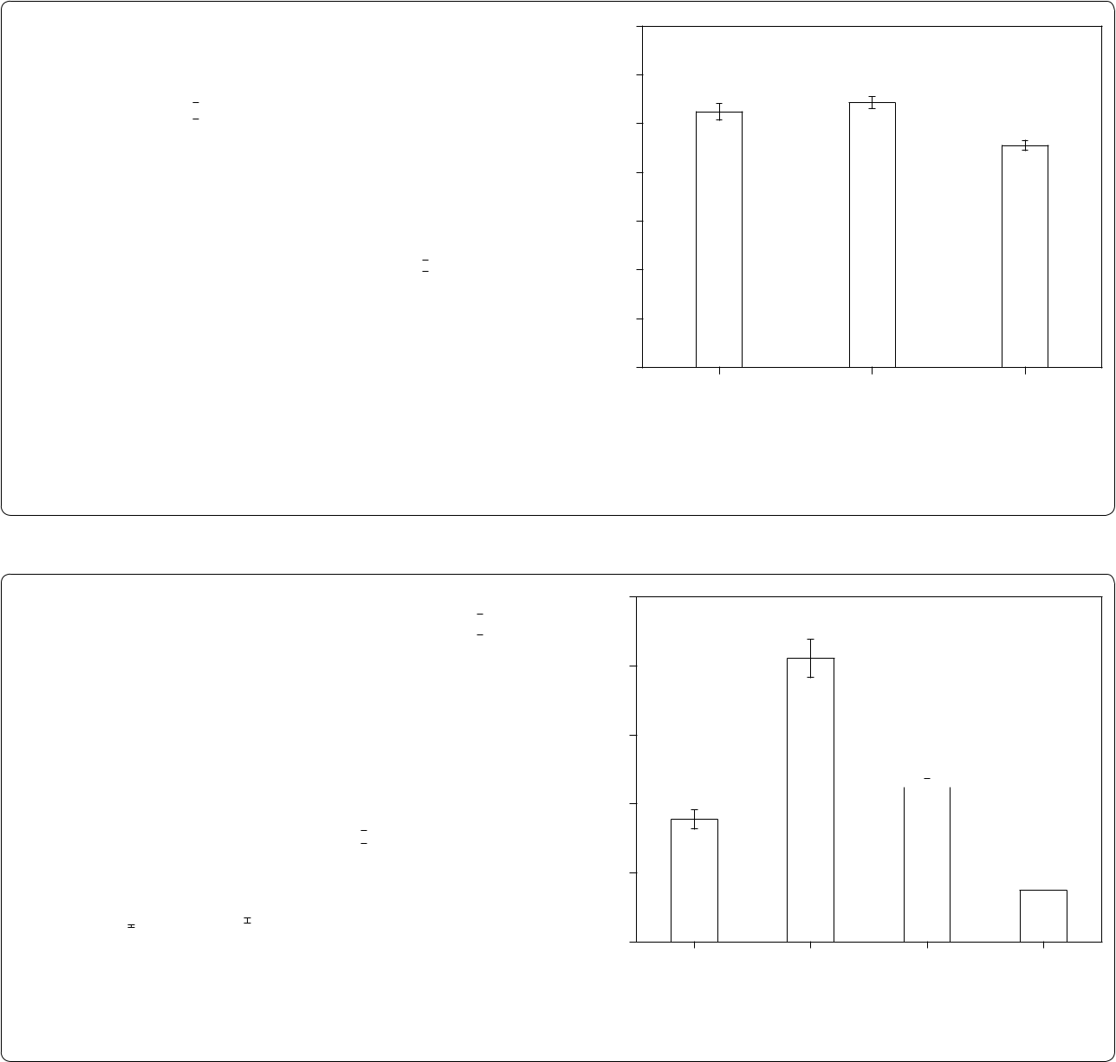

|  |
| --- |
| Se content in roots (g g-1 FW) |

3.5

3.0

2.5

2.0

1.5

1.0

0.5

0.0

50

40

30

20

10

0

P

**b**

a a

b

SeNPs SeNPs + Ethanol SeNPs + CCCP

Treatments

**b** a

b

b

c

10 M SeNPs 30 M SeNPs 10 M selenite 10 M selenate

Treatments

± =

|  |  |  |
| --- | --- | --- |
| μ | μ |  |
|  |  |
| μ | μ |  |

μ μ

μ ≈ μ

μμ≈ μμ

*et al. J Nanobiotechnol* *(2* P

**,**

|  |  |  |  |  |  |  |  |  |
| --- | --- | --- | --- | --- | --- | --- | --- | --- |
|  |  | **−** |  |  |  |  | ***TF*** |  |
|  |  |  |  |  |  | **−** |  |  |
|  |  |  |  |  |  |  |  |
|  |  |  |  |  |  |  |  |  |
| ± | | ± | ± | | ± | ± | ± |  |
| ± | | ± | ± | | ± | ± | ± |  |
| ± | | ± | ± | | ± | ± | ± |  |
| ± | | ± | ± | | ± | ± | ± |  |
| ±= | | *p* |  |  |  |  | <’ |  |

*TF*

μ

*TF*

μ

μ

μ

≫

–

*R* ≥

μ

μ –

μ

|  |  |  |  |  |  |  |  |  |  |  |  |  |
| --- | --- | --- | --- | --- | --- | --- | --- | --- | --- | --- | --- | --- |
| *et al. J Nanobiotechnol* | | | *(2* |  |  |  |  |  |  |  | P |  |
| FW) | 3.5 | **a** F1 |  |  | a | FW) | 35 | **d** F1 | a |  |  |  |
| 3.0 |  |  |  |  | 30 |  |  |  |  |  |
|  |  |  |  |  |  |  |  |  |  |
|  |  |  |  |  |  |  |  |  |  |  |  |
| -1 | 2.5 |  |  |  |  | -1 | 25 |  |  |  |  |  |
| g |  |  |  |  | g |  |  |  |  |  |
| ( g |  |  |  |  |  | ( g |  |  |  |  |  |  |
| Secontentinshoots | 2.0 |  |  |  |  | Secontentinroots | 20 |  |  |  |  |  |
| 1.5 |  |  | b |  | 15 | b |  | b |  |  |
|  |  |  |  |  |  |  |  |
|  |  |  |  |  |  |  |  |  |  |  |  |
|  | 1.0 |  |  |  |  |  | 10 |  |  |  |  |  |
|  | 0.5 | c | c |  |  |  | 5 |  |  |  |  |  |
|  |  |  |  |  |  |  |  |  |  | c |  |
|  |  |  |  |  |  |  | 0 |  |  |  |  |
|  | 0.0 |  |  |  |  |  |  |  |  |  |  |
| FW) | 1.0 | **b** F2 |  |  | a | FW) | 7 | **e** F2 | a |  |  |  |
|  |  |  |  | 6 |  |  |  |  |
|  |  |  |  |  |  |  |  |  |  |
| 0.8 |  |  |  |  |  |  |  |  |  |  |
| -1 |  |  |  |  | -1 |  |  |  |  |  |  |
|  |  |  |  |  | 5 |  |  |  |  |  |
| g |  |  |  |  |  | g |  |  |  |  |  |
| ( g | 0.6 |  |  |  |  | ( g |  |  |  |  |  |  |
| Secontentinshoots |  |  |  |  | Secontentinroots | 4 |  |  |  |  |  |
| 0.2 |  |  |  |  |  |  |  |  |  |
|  |  |  |  |  |  |  |  |  |  |  |  |
|  |  |  |  |  |  |  | 3 | b |  | b |  |  |
|  | 0.4 |  |  |  |  |  |  |  |  |  |
|  |  |  | b |  |  |  |  |  |  |  |  |
|  |  |  |  |  |  |  |  |  |  |  |  |
|  |  |  |  |  |  |  | 2 |  |  |  |  |  |
|  |  |  | c |  |  |  | 1 |  |  |  | c |  |
|  |  | c |  |  |  |  |  |  |  |  |
|  | 0.0 |  |  |  |  | 0 |  |  |  |  |  |
|  |  |  |  |  |  |  |  |  |  |  |
| FW) | 4.0 | **c** F3 |  |  | a |  | 7 | **f** F3 |  | a | a |  |
| 3.5 |  |  |  | FW) | 6 |  |  |  |
|  |  |  |  |  |  |  |
| 3.0 |  |  |  |  |  |  |  |  |  |  |
| -1 |  |  |  |  | -1 | 5 |  |  |  |  |  |
| g |  |  |  |  |  | g |  |  |  |  |  |
| ( g | 2.5 |  |  |  |  | ( g |  |  |  |  |  |  |
| Secontentinshoots |  |  |  |  | Secontentinroots | 4 |  |  |  |  |  |
|  |  |  |  |  |  |  |  |  |  |
|  |  |  |  |  |  |  |  |  |  |  |  |
|  | 2.0 |  |  |  |  |  |  |  | b |  |  |  |
|  | 1.5 |  |  |  |  |  | 3 |  |  |  |  |
|  |  |  |  |  |  |  |  |  |  |  |  |
|  | 1.0 |  |  |  |  |  | 2 | c |  |  |  |  |
|  |  |  |  |  |  |  |  |  |  |  |
|  | 0.5 |  |  | b |  |  | 1 |  |  |  |  |  |
|  | 0.0 | c | c |  |  |  | 0 |  |  |  |  |  |
|  | 10 M SeNPs | 30 M SeNPs | 10 M selenite | 10 M selenate |  | 10 M SeNPs | 30 M SeNPs | 10 M selenite | 10 M selenate |  |
|  |  |  |  |  |
|  |  |  | Treatments | |  |  |  |  | Treatments | |  |  |
| **.** |  |  |  |  |  | ± = | |  |  |  |  |  |
| *p* |  | ’ |  |  |  |  |  |  |  |  |
|  |  |  |  |  |  |  |  |  |  |  |
| μ |  |  |  |  |  | μ |  |  |  |  | − |  |
|  |  |  |  |  |  |  |  |  |  |  |

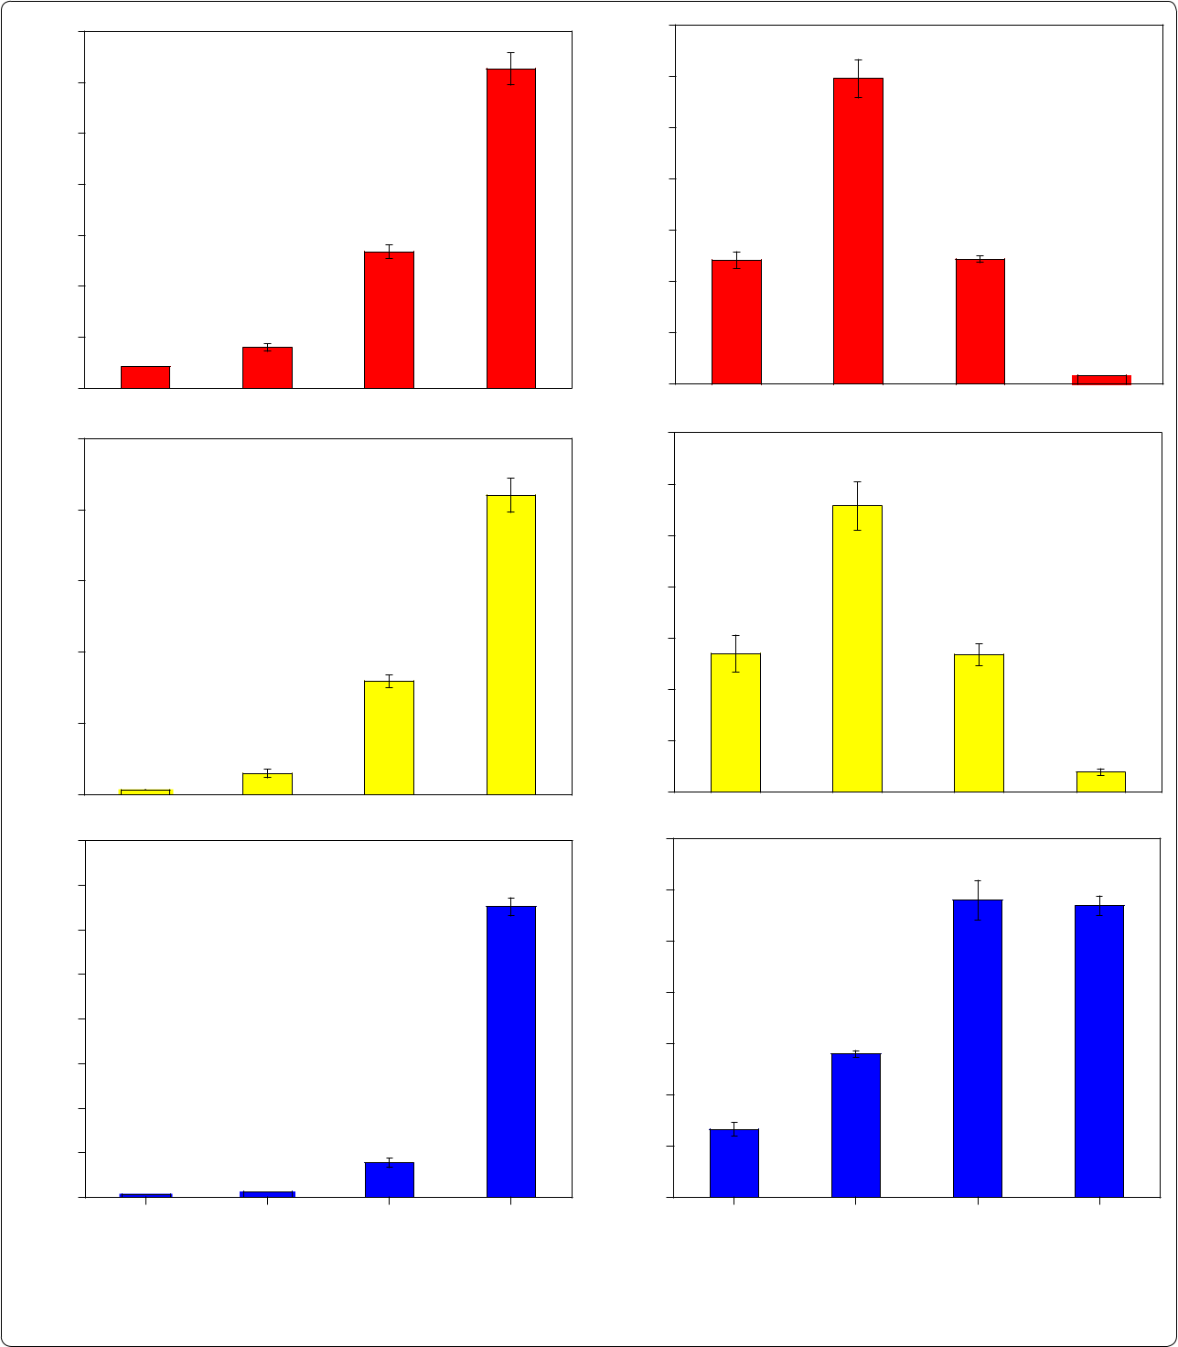

μ −

*et al. J Nanobiotechnol* *(2* P

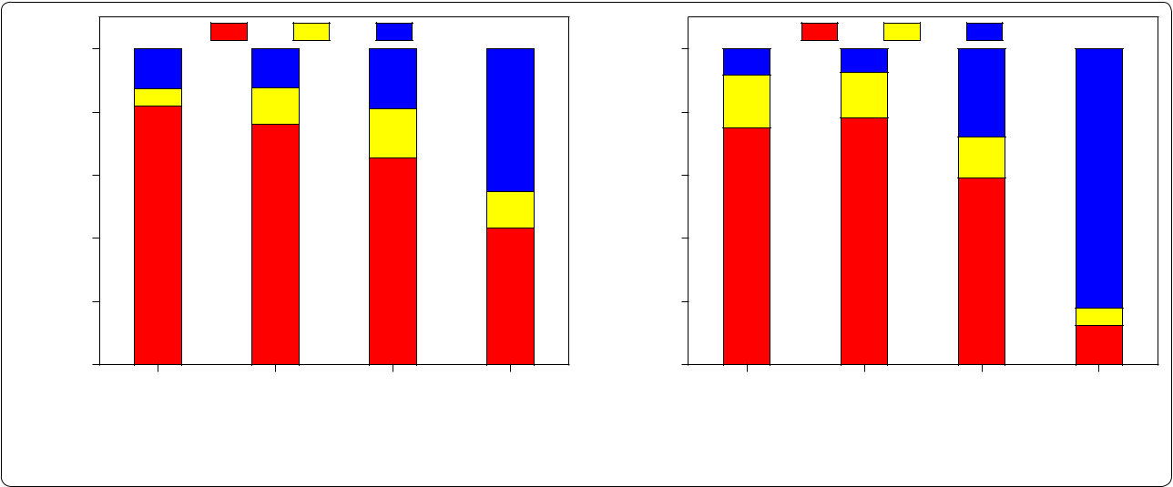

|  |  |  |  |  |  |  |  |  |  |  |  |  |  |  |  |  |  |  |  |  |  |  |  |
| --- | --- | --- | --- | --- | --- | --- | --- | --- | --- | --- | --- | --- | --- | --- | --- | --- | --- | --- | --- | --- | --- | --- | --- |
|  |  | 100 | **a** |  |  | F1 |  | F2 | F3 |  |  |  |  | 100 | **b** |  |  | F1 | F2 | F3 |  |  |  |
| DistributionofSeindifferent | subcellularfractions(%) |  |  |  |  |  |  |  |  | DistributionofSeindifferent | subcellularfractions(%) |  |  |  |  |  |  |  |  |
| 80 |  |  |  |  |  |  |  |  |  | 80 |  |  |  |  |  |  |  |  |  |
|  |  |  |  |  |  |  |  |  |  |  |  |  |  |  |  |  |  |  |  |  |  |
|  |  | 60 |  |  |  |  |  |  |  |  |  |  |  | 60 |  |  |  |  |  |  |  |  |  |
|  |  | 40 |  |  |  |  |  |  |  |  |  |  |  | 40 |  |  |  |  |  |  |  |  |  |
|  |  | 20 |  |  |  |  |  |  |  |  |  |  |  | 20 |  |  |  |  |  |  |  |  |  |
|  |  | 0 | 10 M SeNPs | | | 30 M SeNPs | | 10 M selenite | | 10 M selenate | |  |  | 0 | 10 M SeNPs | | 30 M SeNPs | | 10 M selenite | | 10 M selenate | |  |
|  |  |  |  |  |  |  |
|  |  |  |  |  |  |  | Treatments | |  |  |  |  |  |  |  |  |  | Treatments | |  |  |  |  |
| **.** |  |  |  |  |  |  |  |  |  |  |  |  |  |  |  |  |  |  |  |  |  |  |  |
|  | 400 | | Shoots | |  |  |  |  |  |  | **a** |  | 400 | | Shoots | |  |  |  |  |  | **b** |  |
|  |  |  |  |  |  |  |  |  |  |  |  |  |  |  |  |  |  |
|  | 350 | | Roots | |  |  |  |  |  |  |  |  | 350 | | Roots | |  |  |  |  |  |  |  |
|  |  |  |  |  |  |  |  |  |  |  |  |  |  |  |  |  |  |  |  |
| (mV) | 300 | |  |  |  |  |  |  |  |  |  | (mV) | 300 | |  |  |  |  |  |  |  |  |  |
| 250 | |  |  |  |  |  |  |  |  |  | 250 | |  |  |  |  |  |  |  |  |  |
| Signal |  |  |  |  |  |  |  |  |  | Signal |  |  |  |  |  |  |  |  |  |
| 200 | |  |  |  |  |  |  |  |  |  | 200 | |  |  | 5 |  |  |  |  |  |  |
|  |  |  |  |  |  |  |  |  |  |  |  |  |  |  |  |  |  |  |
|  |  |  |  |  |  | 5 |  |  |  |  |  |  |  |  | 2 | 3 |  |  |  |  |  |  |
|  |  |  |  |  |  |  |  |  |  |  |  |  |  |  |  |  |  |  |  |  |
|  | 150 | | 2 | 3 | 4 |  |  |  |  |  |  |  | 150 | |  | 4 |  |  |  |  |  |  |  |
|  |  |  |  |  |  |  |  |  |  |  |  |  |  |  |  |  |  |  |  |
|  | 100 | |  |  |  |  |  |  |  |  |  |  | 100 | |  |  |  |  |  |  |  |  |  |
|  |  | 50 |  |  |  |  |  |  |  |  |  |  |  | 50 |  |  |  |  |  |  |  |  |  |
|  |  | 0 | 200 | |  | 400 | 600 |  | 800 | 1000 | 1200 |  |  | 0 | 200 | | 400 | 600 |  | 800 | 1000 | 1200 |  |



Retention time (s) Retention time (s)

|  |
| --- |
| Signal (mV) |

**.**

|  |  |  |  |  |  |  |  |  |  |  |  |  |  |  |  |  |  |  |  |  |  |  |
| --- | --- | --- | --- | --- | --- | --- | --- | --- | --- | --- | --- | --- | --- | --- | --- | --- | --- | --- | --- | --- | --- | --- |
| 500 |  |  |  |  |  |  |  |  |  |  |  |  |  |  |  |  |  |  |  |  |  |  |
|  |  |  | Shoots | | | |  |  |  |  |  |  |  |  |  |  |  |  | **c** |  |  |
|  |  |  |  |  |  |  |  |  |  |  |  |  |  |  |  |  |  |
|  |  |  |  |  |  |  |  |  |  |  |  |  |  |  |  |  |  |
| 400 |  |  |  | Roots | | | | 5 |  |  |  |  |  |  |  |  |  |  |  |  |  |  |
|  |  |  |  |  |  |  |  |  |  |  |  |  |  |  |  |  |
|  |  |  |  |  |  |  |  |  |  |  |  |  |  |  |  |  |  |  |  |  |
|  |  |  |  |  |  |  |  |  |  |  |  |  |  |  |  |  |  |  |  |  |
| 300 |  |  |  |  | 2 |  |  | 4 |  |  |  |  |  |  |  |  |  |  |  |  |  |  |
|  |  |  |  |  |  |  |  |  |  |  |  |  |  |  |  |  |  |  |  |
|  |  |  |  |  |  |  |  |  |  |  |  |  |  |  |  |  |  |  |  |  |
| 200 |  | 1 | | |  |  |  |  |  |  |  |  |  |  |  |  |  |  |  |  |  |
|  | 3 | | | 6 | | |  |  |  |  |  |  |  |  |  |  |  |  |
|  |  |  |  |  |  |  |  |  |  |  |  |  |
|  |  |  |  |  |  |  |  |  |  |  |  |  |  |
|  |  |  |  |  |  |  |  |  |  |  |  |  |  |  |  |  |  |  |  |
|  |  |  |  |  |  |  |  |  |  |  | 7 |  |  |  |  |  | 8 | | |  |  |  |
| 100 |  |  |  |  |  |  |  |  |  |  |  |  |  |  |  |  |  |  |  |  |  |  |
|  |  |  |  |  |  |  |  |  |  |  |  |  |  |  |  |  |  |  |  |  |  |
|  |  |  |  |  |  | | |  |  |  |  |  |  |  |  |  |  |  |  |  |  |  |
|  | 0 | |  |  | 200 | | | 400 | | | 600 | | | 800 | | | 1000 | | | 1200 | |  |

Retention time (s)

|  |
| --- |
| Signal (mV) |

|  |  |  |  |  |  |  |
| --- | --- | --- | --- | --- | --- | --- |
| 900 |  |  |  |  |  |  |
|  |  |  | Shoots | **d** |  |
|  |  |  |  |  |
|  |  |  |  |  |
| 750 |  |  |  | Roots | 8 |  |
|  |  |  |  |
|  |  |  |  |  |  |
|  |  |  |  |  |  |

600

450

300 5

|  |  |  |  |  |  |  |  |  |  |  |  |  |  |  |  |  |  |  |  |  |  |
| --- | --- | --- | --- | --- | --- | --- | --- | --- | --- | --- | --- | --- | --- | --- | --- | --- | --- | --- | --- | --- | --- |
| 150 |  |  |  | 2 | 3 | | 4 |  |  |  |  |  |  |  |  |  |  |  |  |  |  |
|  |  |  |  |  |  |  |  |  |  |  |  |  |  |  |  |  |
|  |  |  |  |  | | |  |  |  |  |  |  |  |  |  |  |  |  |  |  |  |
| 0 | | | | 200 | | | 400 | | | 600 | | | 800 | | | 1000 | | | 1200 | |  |

Retention time (s)

*et al. J Nanobiotechnol* *(2* P

**−** **−** **−** **−**

|  |  |  |  |
| --- | --- | --- | --- |
|  |  |  | ± |
|  | ± | ± | ± |
|  |  |  | ± |
| ± | ± | ± | ± |
|  |  | ± | ± |
| ± | ± | ± | ± |
| ± | ± | ± |  |
| ± | ± | ± |  |
| ± | ± | ± | ± |
|  |  | ± | ± |
| ±= | *p* |  | <’ |

*SeCys2MeSeCysSe(IV)SeMetSe(VI)ND*

×

μ μ

μ −

]

−

+ ]

]

]

]

]

*et al. J Nanobiotechnol* *(2* P

]

]

]

] ]

*Astragalus crotolariae*

*Glycin max* ]

] ]

]

]

]

*TF*

*TF* ]

μ

]

]

]

|  |  |
| --- | --- |
| *et al. J Nanobiotechnol* | *(2* |

μ

|  |  |  |
| --- | --- | --- |
| μ | ] |  |
| μ | ] |  |
|  |  |
|  | ] |  |

]

]

]

μ

]

*Brassica juncea* **y**

**y**

]

]

]

±=

P

]

]



*SeCys* *2MeSeCys*

*Se(IV)SeMetSe(VI)*

*et al. J Nanobiotechnol* *(2* P

*Oryza sativa*

**’**

*Phaseolus aureus*

*Nicotiana tabacum*

’

’



í

d

*Triticum aestivum*

*Oryza sativa*

’

*Oryza sativa*

*Oryza sativa*

*Brassica chinensis*

\ *et al. J Nanobiotechnol* *(2* P

*Brassica juncea*

á

*salmonella Raphanus sativus typhimurium*

áø

**’**



*Ready to submit your research ? Choose BMC and benefit from:*

**•** fast, convenient online submission

**•** thorough peer review by experienced researchers in your field

**•** rapid publication on acceptance

**•** support for research data, including large and complex data types

**•** gold Open Access which fosters wider collaboration and increased citations

**•** maximum visibility for your research: over 100M website views per year

**At BMC, research is always in progress.**

**Learn more** biomedcentral.com/submissions