

**A revision of Ventilago (Rhamnaceae) in New Caledonia and Vanuatu with notes on dyeing properties**

Authors: Cahen, Daniel, Toussirot, Marine, and Pillon, Yohan

Source: Willdenowia, 50(2) : 253-266

Published By: Botanic Garden and Botanical Museum Berlin (BGBM)

URL: https://doi.org/10.3372/wi.50.50211



BioOne Complete (complete.BioOne.org) is a full-text database of 200 subscribed and open-access titles in the biological, ecological, and environmental sciences published by nonprofit societies, associations, museums, institutions, and presses.

Your use of this PDF, the BioOne Complete website, and all posted and associated content indicates your acceptance of BioOne’s Terms of Use, available at www.bioone.org/terms-of-use.

Usage of BioOne Complete content is strictly limited to personal, educational, and non - commercial use. Commercial inquiries or rights and permissions requests should be directed to the individual publisher as copyright holder.



BioOne sees sustainable scholarly publishing as an inherently collaborative enterprise connecting authors, nonprofit publishers, academic institutions, research libraries, and research funders in the common goal of maximizing access to critical research.

Downloaded From: https://bioone.org/journals/Willdenowia on 23 Aug 2020

Terms of Use: https://bioone.org/terms-of-use

Willdenowia



Annals of the Botanic Garden and Botanical Museum Berlin

DANIEL CAHEN1*, MARINE TOUSSIROT2,3 & YOHAN PILLON4

**A revision of *Ventilago* (*Rhamnaceae*) in New Caledonia and Vanuatu with notes on dyeing properties**

Version of record first published online on 12 June 2020 ahead of inclusion in August 2020 issue.

**Abstract:** The climbing genus*Ventilago*Gaertn. (*Rhamnaceae*) is revised in New Caledonia and Vanuatu. The de-scription of *V. pseudcalyculata* Guillaumin was based on four gatherings (syntypes). The name is lectotypified with a specimen from Lifou, and the species is now considered to be restricted to the Loyalty Islands, while the specimens from Grande Terre (the main island of New Caledonia) are treated as a new species, *V. tinctoria* Cahen, Toussirot

* Pillon. A total of four endemic species are therefore recognized in New Caledonia: *V. buxoides* Baill., *V. neo­* *caledonica* Schltr. and *V. tinctoria* from Grande Terre and *V. pseudocalyculata* from the Loyalty Islands. The plantsfrom Vanuatu, often identified as *V. neocaledonica*, are treated here as a new species, *V. vanuatuana* Cahen, Toussirot
* Pillon, endemic to that archipelago.

**Key words:** dye, island, lectotype, Melanesia, New Caledonia, new species,*Rhamnaceae*, taxonomy, tinctorialplants, tropical climbers, ultramafic, Vanuatu, *Ventilagineae*, *Ventilago*

**Article history:** Received 13 November 2019; peer-review completed 3 February 2020; received in revised form 21April 2020; accepted for publication 25 April 2020.

**Citation:** Cahen D., Toussirot M. & Pillon Y. 2020: A revision of*Ventilago*(*Rhamnaceae*) in New Caledonia and

Vanuatu with notes on dyeing properties. – Willdenowia 50: 253–266. doi: <https://doi.org/10.3372/wi.50.50211>

**Introduction**

*Rhamnaceae* are represented by about ten species inseven genera in New Caledonia (Morat & al. 2012; Munzinger & al. 2012+). The most complete overview for New Caledonia is a short summary of the family with identification keys and description of new species by Guillaumin (1926). A short description of the family and a key to species was also included in *Flore analy­* *tique et synoptique de la Nouvelle-Calédonie* (Guillamin1948a). Recent work has included the lectotypification

of *Emmenosperma pancherianum* Baill., a species once thought to be endemic to New Caledonia and discov-ered in 2005 in Queensland (Bean 2013). A molecular phylogenetic study (Hopkins & al. 2015) has indicat-ed that *Alphitonia erubescens* Baill. and *A. xerocarpa* Baill. were misplaced in the genus *Alphitonia* Reissek ex Engl. and were accommodated in a newly described genus *Jaffrea* H. C. Hopkins & Pillon, endemic to New Caledonia. This study also included the lectotypifica-tion of these two species names, along with *A. neo­* *caledonica* Schltr. A phylogenetic and biogeographic

1 Herbarium, Royal Botanic Gardens, Kew, Richmond, Surrey TW9 3AE, U.K.; *e-mail: [d.cahen@kew.org](mailto:d.cahen%40kew.org?subject=) (author for corre-spondence).

1. Tinctonéa, BP 615, 98 836 Dumbéa, New Caledonia.
2. Institut Agronomique néo-Calédonien, Agriculture, Biodiversité et Valorisation (ARBOREAL), BP A5, 98848 Noumea cedex, New Caledonia.
3. LSTM, IRD, INRAE, CIRAD, Montpellier SupAgro, Université de Montpellier, Montpellier, France.

Downloaded From: https://bioone.org/journals/Willdenowia on 23 Aug 2020

Terms of Use: https://bioone.org/terms-of-use

254 Cahen & al.: A revision of *Ventilago* in New Caledonia and Vanuatu

analysis of *Alphitonia* and of related *Emmenosperma* F. Muell., *Granitites* Rye and *Jaffrea* supports the cur-rently applied taxonomy in these genera (Hauenschild

* al. 2018). The genera *Colubrina* Rich. ex Brongn. (Johnston 1971) and *Rhamnella* Miq. (= *Dallachya* F. Muell.; Smith 1943) are each represented by a single non-endemic species: *Colubrina asiatica* (L.) Brongn. and *Rhamnella vitiensis* (Benth.) A. C. Sm.

No taxonomic treatment of *Ventilago* Gaertn. or *Goua­* *nia* Jacq. in New Caledonia has been published since Guil-laumin (1926, 1948a). However, recent work on *Ventilago*

in neighbouring regions was published (Cahen­ & Utteridge 2017), and the closely related genus *Smythea* Seem., which occurs in Vanuatu, was revised (Cahen & Utteridge 2018). *Ventilago* and *Smythea* are the only members of tribe *Ven­ tilagineae* Hook. f., unique in *Rhamnaceae* in its members’fruits having a pronounced apical appendage. Generic de-limitation between *Ventilago* and *Smythea* is based on the shape of the seed chamber of the fruit: conspicuously glo-bose and clearly differentiated from the wing in *Ventilago*, compressed and gradually flattened into the wing (when present) in *Smythea* (Cahen & Utteridge 2018). *Ventilago* is a genus of about 30 species of tropical climbing shrubs, lianas and, rarely, small trees, absent from the Neotropics, easily recognized by their fruits having the combination of an oblong wing-like apical appendage and a conspicu-ously globose seed chamber (Suessenguth 1953; Medan & Schirarend 2004; Cahen & Utteridge 2018). The tradition-al use of *Ventilago* plants as a source of dyes in New Cal-edonia and Vanuatu and potential further uses were docu-mented in Blanc (2008), Cardon (2007) and Cardon & al. (2010). Three species of *Ventilago* were considered to be native to New Caledonia (Morat & al. 2012; Munzinger

* al. 2012+): *V. buxoides* Baill., *V. neocaledonica­* Schltr. and *V. pseudocalyculata* Guillaumin. An additional spe-cies, *V. tinctoria* Cahen, Toussirot & Pillon is recognized here. The abundance of ultramafic soils in New Caledonia, which cover one-third of the surface of Grande Terre (the main island) acts as an ecological filter affecting species composition, with plants having to face high Mg:Ca ratios, high metal concentrations, poor fertility and often limited water availability (Pillon & al 2010). Despite this, species of *Ventilago* appear to grow indiscriminately on both ul-tramafic and non-ultramafic substrates in New Caledonia.

The genus is also present in Vanuatu, where the mate-rial has often been determined as *Ventilago neocaledonica* (e.g. Guillaumin 1948b), but is identified here as belong-ing to a distinct endemic species: *V. vanuatuana* Cahen, Toussirot & Pillon (see Remarks for *V. vanuatuana* and Notes on dyeing properties). Other *Rhamnaceae* genera reported to occur in Vanuatu are *Colubrina*, *Gouania*, *Rhamnella* and *Smythea* (Wheatley 1992). While somespecies in these genera were enumerated or described by Guillaumin (1931), Wheatley (1992) and Ramon & Sam (2015), no comprehensive taxonomic treatment of *Rham­* *naceae* has been published for Vanuatu. The archipelagois located very near New Caledonia, with Aneityum just

over 200 km northeast of the Loyalty Islands and 350 km from Grande Terre, and in some cases phytogeographic relationships between the two archipelagos are strong (Lowry 1989), despite most plants possibly coming to Vanuatu from the northwest from Malesia via New Guinea and the Solomons, and from Fiji (Ramon & Sam 2015). Given their geographic proximity and because of previous misidentifications of Vanuatu material as *V. neo­* *caledonica*, the genus is advantageously studied for bothareas together and its taxonomy is revised here for both New Caledonia and Vanuatu.

**Material and methods**

Herbarium specimens from CANB, K, L, MPU, NOU, P and Z were studied; an exclamation mark (!) is used to show that a specimen has been seen, whereas “image!” is used to show that an image of the specimen has been seen. Hair density terms are defined as follows: *sparse* when hairs are scattered enough not to touch when pressed toward each other, *abundant* when hairs are close enough to touch if pressed toward each other, *dense* when hairs are so close to each other that they hide the surface of the organ they grow on. Leaf anatomy terms used are from Hickey (1979) and other morphology terms follow Beentje (2010). GeoCat (Bachman & al. 2011) was used to calculate Extent of Occurrence (EOO). All examined specimens appear in the Appendix (see Supplemental content online), sorted alphabetically first by species and then by collector’s name.

**Results and Discussion**

**Notes on dyeing properties**

Natural dyes are an integral component of cultural herit-age worldwide, and the use of plant-derived dyes in the Pacific Ocean is the subject of ongoing research (e.g. Cardon 2007; Cardon & al. 2010: Toussirot & al. 2012, 2014). The phytochemical study of *Ventilago* species shows that the colours obtained from them are often due to a rich mixture of quinones (Cardon & al. 2010). Three anthraquinones in particular, emodin, physcion and chrys-ophanol, are found in the bark and roots (Blanc 2008; Toussirot 2014).

Studies conducted with the University of New Cal-edonia examined the dyeing and biological properties of the *Ventilago* species present in New Caledonia and Van-uatu (Blanc 2008; Cardon & al. 2010; Toussirot 2014). A climber from Vanuatu, named *laba* (Apma language, central Pentecost) is of great cultural significance in some islands of north-central Vanuatu, where the bark of its root is used to prepare the red dye of ceremonial mats. Bourdy

* Walter (1986) described its use in Pentecost and had al-ready noted the need for an in-depth taxonomic as well as ethnological study of this plant. The *laba* climber was at

Downloaded From: https://bioone.org/journals/Willdenowia on 23 Aug 2020

Terms of Use: https://bioone.org/terms-of-use

|  |  |
| --- | --- |
| Willdenowia 50 – 2020 | 255 |
|  |  |

the time identified as *V. neocaledonica*. However, signifi-cant colour differences were observed following dyeing tests carried out with different species (including among the species from New Caledonia, Fig. 8). The experi-mental protocols of these tests, including the mordanting methods and types of fibres used, as well as colorimetric and colour absorption measurements, are documented by Blanc (2008). Furthermore, subsequent analyses of the chemical profile of the specimens revealed qualitative and quantitative differences in their anthraquinone com-position (Blanc 2008). The differences in colour and in quinone composition suggested that *laba* and *V. neocale­* *donica* could be different species of *Ventilago*, and at thisstage it was hypothesized that *laba* was *V. vitiensis* A. Gray rather than *V. neocaledonica* (Blanc 2008; Cardon

* al. 2010). The taxonomic work presented here shows that *laba* is actually morphologically different from both *V. neocaledonica* and *V. vitiensis* and represents a dis-tinct, hitherto undescribed species: *V. vanuatuana*.

This shows the potential benefits of interdisciplinary scientific research allowing analyses to complement one another. In this case, the study of the traditional use of dyes eventually led to the hypothesis of an undescribed species, which was confirmed here by study of herbarium specimens. Alternatively, improved taxonomic knowl-edge could refine studies of the traditional uses of these plants, for example by determining whether separate spe-cies previously believed to be the same have slightly dif-ferent properties and therefore uses.

**Key morphological characters**

All species of *Ventilago* in New Caledonia and Vanuatu are woody climbers, sometimes growing as scandent shrubs, and are easily recognized when in fruit, as the fruits have a distinct wing-like apical appendage and a conspicuous, globose basal portion enclosing the seed chamber (Fig. 4A, K; Fig. 6A, K). These characters help distinguish *Ventilago* species from all other *Rhamnaceae* genera occurring in the region: species of *Alphitonia* in New Caledonia and Vanuatu are all trees or shrubs with unwinged capsular fruits; *Emmenosperma pancherianum* is a shrub with capsular fruits and red seeds persisting on the pedicel after the pericarp has fallen; species of *Jaffrea* are trees and shrubs with conical flowers andlate-dehiscent beaked fruits; *Rhamnella vitiensis* is a shrub with flowers in umbel-like cymes, and drupaceous fruits. Among the climbing genera, *Colubrina asiatica* (occasionally scandent) is distinct in the 3-seeded cap-sules with the outer pericarp irregularly breaking away and leaves with only 2 or 3 secondary veins (vs 4 – 8 in *Ventilago*); *Gouania* is distinct in the presence of ten-drils and fruits that are 3-winged schizocarps; *Smythea* *lanceata* is distinct in the crustaceous inflated winglessfruits (see Remarks for *V. vanuatuana* for further distin-guishing characters). Morphological differences between *Alphitonia*, *Emmenosperma* and *Jaffrea* are discussed

in Hopkins & al (2015) and genus-level morphological descriptions in *Rhamnaceae* are available in Medan & Schirarend (2004).

***Leaves***

In all *Ventilago* species of New Caledonia and Vanuatu, leaves are simple, alternate, ± symmetric, usually sub­ coriaceous, glabrous to subglabrous, and have a single medial primary vein serving as the origin for 4 – 8 up-turned secondary veins gradually diminishing apically in-side the margin (“camptodromous venation” sensu Hick-ey 1979) (Fig. 4A; Fig. 6A). *Ventilago buxoides* differs from all other species in the small (0.5 – 3.5 × 0.3 – 2 cm vs 2.2 – 13 × 1.2 – 8.5 cm) often apically notched leaves (vs unnotched). Leaf margin and lamina shape characters are useful to distinguish the remaining species: margin crenate to serrate in *V. vanuatuana* (Fig. 6B, F); entire to weakly serrate in *V. neocaledonica*; entire, obscurely repand in both *V. pseudocalyculata* and *V. tinctoria*, but lamina broadly ovate to (broadly) elliptic in *V. pseudoca­* *lyculata* vs (narrowly) elliptic in *V. tinctoria* (Fig. 4A, E).

***Inflorescences and flowers***

In New Caledonia and Vanuatu, *Ventilago* flowers are ar-ranged in cymes congested into fascicles (Fig. 4G; Fig. 6H). In *V. buxoides*, leaves subtending fascicles of open flowers are usually persistent. In all other species, sub-tending leaves are mostly fugaceous so that the fascicles of open flowers are arranged in racemiform thyrses (Fig. 4F; Fig. 6G), and often enough leaves are fugaceous for the thyrses to be arranged in a panicle*.* Flowers in *Ventilago* species of the area are remarkably homog-enous: all are bisexual, c. 3 mm wide when open, with 5 triangular adaxially keeled sepals (Fig. 4J; Fig. 6J), 5 clawed apically notched petals each enclosing a sta-men, a 2-locular ovary partially immersed in a smooth glabrous subpentagonal disk, and a bifid style (Fig. 4J; Fig. 6J). *Ventilago neocaledonica­* can be distinguished from *V. pseudocalyculata­*, *V. tinctoria* and *V. vanuatuana* in the inflorescence rachis, pedicels and abaxial surface of the calyx being glabrous to densely hairy (the hairs may be close enough to touch each other but are usu-ally not so close as to hide the surface they grow on) vs almost always densely hairy (the hairs are so close to each other that they hide the surface they grow on). *Ven­* *tilago vanuatuana* differs from *V. pseudocalyculata* and *V. tinctoria* in the indumentum of mostly spreading hairson most parts of the plant, including the inflorescence ra-chis, pedicels and abaxial surface of the calyx (Fig. 6H) vs indumentum mostly appressed antrorse (Fig. 4G, H).

***Fruit***

All *Ventilago* species of New Caledonia and Vanuatu have fruits with a distinct wing-like apical appendage

Downloaded From: https://bioone.org/journals/Willdenowia on 23 Aug 2020

Terms of Use: https://bioone.org/terms-of-use

256 Cahen & al.: A revision of *Ventilago* in New Caledonia and Vanuatu

and a conspicuous globose basal portion enclosing the seed chamber (see Introduction) (Fig. 4A, K; Fig. 6A, K). The dimensions of the wing are quite homogenous among species of the area (from c. 3 × 0.7 cm in *V.* *buxoides* to c. 3.5 × 0.8 cm in *V. neocaledonica* and

1. *pseudocalyculata*). The only species with glabrousfruits are *V. buxoides* and *V. neocaledonica*, which are distinguished from each other in leaf and inflorescence characters (see above). All other species have densely hairy fruits, and *V. vanuatuana* is recognized in the hairs being mostly spreading (vs mostly appressed antrorse in *V. pseudocalyculata* and *V. tinctoria*). The fruit wing of *V. pseudocalyculata* is usually slightly curved and often

± trullate, distinctly narrower at the base, vs oblong in all other *Ventilago* species in the area. The species is further distinguished from *V. tinctoria* in the pedicel be-ing usually swollen in fruit, gradually widening into the calyx, vs remaining slender in fruit, suddenly expand-ing into the calyx (Fig. 4K).

**The species of *Ventilago* in New Caledonia and Vanuatu**

1. Leaf lamina small, to c. 3.5 cm long, apex rounded, often notched; inflorescences with usually 1 flower left per fascicle at anthesis; leaves subtending fasci-cles of open flowers and fruits usually persistent . .

. . . . . . . . . . . . . . . . **1.** ***V. buxoides***

– Leaf lamina longer, apex rounded to attenuate, not notched; inflorescences with usually several flowers left per fascicle at anthesis; leaves subtending fas-cicles of open flowers and fruits usually fugaceous so that fascicles are arranged in racemiform thyrses,

thyrses­ often arranged in a panicle . . . . . . . **2**

1. Fruit glabrous; inflorescence rachis, pedicels and abaxial surface of calyx glabrous to densely hairy, hairs may be close enough to touch each other but are usually not so close as to hide surface they grow on .

. . . . . . . . . . . . . **2. *V. neocaledonica***

– Fruit hairy; inflorescence rachis, pedicels and abaxial surface of calyx usually densely hairy, hairs are so close to each other that they hide surface they grow

on . . . . . . . . . . . . . . . . . . . . **3**

1. Leaf lamina margin crenate to serrate; hairs of branchlets, petioles, inflorescence and fruit mostly

spreading . . . . . . . . . . **5. *V. vanuatuana***

– Leaf lamina margin (sub)entire; hairs of branchlets, petioles, inflorescence and fruit mostly appressed an-

trorse . . . . . . . . . . . . . . . . . . . **4**

1. Leaf lamina broadly ovate, base symmetric, round-ed; petiole 0.5 – 1 cm long; fruit wing usually slightly curved, often distinctly tapering at base; pedicel usu-ally swollen in fruit, gradually widening into calyx.

. . . . . . . . . . . . **3.** ***V. pseudocalyculata***

– Leaf lamina elliptic, base slightly asymmetric, cuneate; petiole 0.3 – 1.5 cm long; fruit wing oblong; pedicel remaining slender in fruit, suddenly expand-ing into calyx . . . . . . . . . . **4.** ***V. tinctoria***

1. ***Ventilago buxoides*** Baill*.*in Adansonia 11: 268. 1874.

– Type citation in protologue: “[…] in Austro-Caledonia, ubi cl. *Deplanche* (exs. n. 272) in insula *Taule* in ramis iisdem floriferam fructigeramque legit (Herb. Mus. par. et alior.)”. – **Lectotype (designated here):** New Caledonia, North Province, Île Tanlé, 1861 – 1867, *Deplanche 272* (P! [[P06886610];](http://coldb.mnhn.fr/catalognumber/mnhn/p/p06886610) isolectotypes: K! [K001342513], P! [P06886607, P06886609]).

– *Ventilago ‘buxifolia’*, orthographical variant in Guil-laumin (1926).

*Description* — *Woody climber*, to at least 4 m long. *In­ dumentum* sparse at base of branchlets, dense at distalend of branchlets and inflorescence rachis, hairs most-ly whitish to sometimes fulvous, straight to slightly curved, mostly spreading. *Branches* slender, terete, smooth; branchlets often deeply ridged. *Stipules* fuga-ceous, though often persisting past flowering at distal end of branchlets, c. 1 mm long, narrowly deltoid to subulate. *Leaves*: petiole 1 – 2 mm long, densely hairy; lamina dark green, shiny adaxially, broadly to narrowly ovate, 0.5 – 3.5 × 0.3 – 2 cm, subcoriaceous, subglabrous, sparsely hairy abaxially along primary vein, base usually slightly asymmetric, rounded to cordate, margin entire or broadly crenate to serrate, obscurely near base, serra-tions topped by callosities, apex rounded, often notched; secondary veins 4 – 8, often not readily discernible from tertiary veins, remaining separate near margin or join-ing each other and forming loops near margin; tertiary venation not conspicuously scalariform. *Inflorescence* of cymes congested in fascicles in axils of leaves, fascicles sometimes arranged in racemiform thyrses when leaves subtending fascicles are fugaceous, flowers up to 6 per fascicle when in bud, usually only 1 left per fascicle by anthesis, racemiform thyrses usually less than 2 cm long. *Flowers* bisexual, c. 3 mm wide; pedicel c. 2 mm long when fully developed, pedicel and abaxial side of hypanthium sparsely hairy, with hairs spreading to ap-pressed, white, straight to slightly curved, c. 0.1 mm long; sepal lobes 5, triangular, c. 1.2 mm long, adaxially keeled with an apical protuberance; petals 5, obcordate, c. 0.9 mm long, glabrous, base clawed, apex notched; stamens 5, each opposite and enclosed by a petal, fila-ments c. 0.7 mm long, anthers dorsifixed; disk subpen-tagonal, filling hypanthium, fleshy, smooth, glabrous; ovary immersed in to sometimes more than ½ exserted from disk, slightly hairy at level of exsertion from disk, glabrous distally, locules 2; style 2-fid. *Fruit* glabrous, with a conspicuous globose basal portion enclosing seed chamber and a distinct wing-like apical appendage, ob-long, reaching c. 3 × 0.7 cm at maturity; apex rounded with style remains forming a distinct mucro; persistent calyx annular at base of fruit to slightly cupular and en-closing less than ¼ of globose part of fruit.

*Distribution and ecology* — This species is found inscrubland (maquis) and possibly forest at low elevation

Downloaded From: https://bioone.org/journals/Willdenowia on 23 Aug 2020

Terms of Use: https://bioone.org/terms-of-use

Fig. 2. Distribution of *Ventilago neocaledonica* (●) in New Caledonia.

|  |  |
| --- | --- |
| Willdenowia 50 – 2020 | 257 |
|  |  |

Fig. 1. Distribution of *Ventilago buxoides* (●) in New Caledonia.

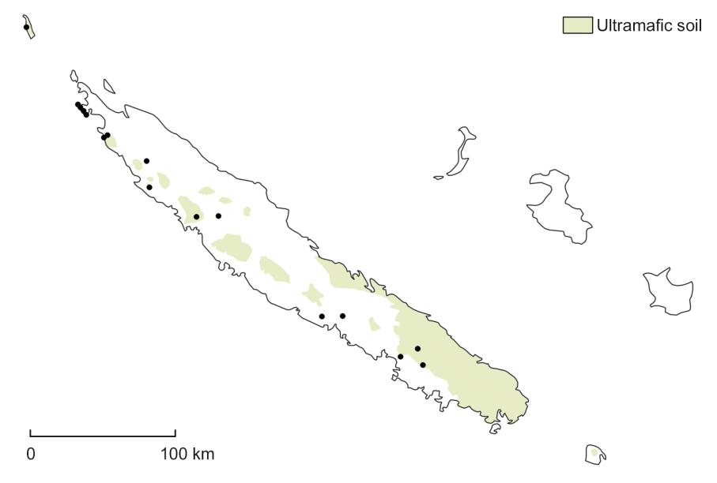

on the western side of New Caledonia, from Mt Mou and the Tontouta valley to Île Art. It has been ­collected on ultramafic substrate, probably on serpentine in most cases. Fig. 1.

*Conservation status* — This relatively widespread spe-cies (Extent of Occurrence: 8350 km2) has been evaluat-ed as Least Concern (LC) according to the IUCN criteria (2012, 2017) during the workshop of the New Caledonia Plant Red List Authority of 24 Oct 2019.

*Remarks* — *Ventilago buxoides* is recognized by itssmall and often apically notched leaves. It also dif-

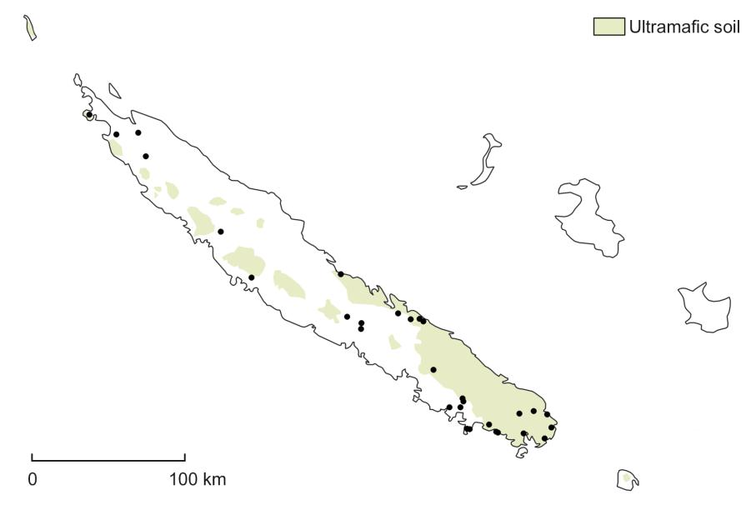

fers from *V. neocaledonica* and *V. tinctoria* in the in-florescences with usually one flower left per fascicle at anthesis and leaves sub-tending fascicles of open flowers and fruits usually persistent; the flowers are more rarely in a racemiform thyrse when the distal leaves fall off. The venation pattern is distinctive, with the terti-ary venation not conspicu-ously scalariform, and the secondary veins often not readily discernible from the tertiary veins and sometimes forming loops near the leaf margin.

In the protologue, Bail-lon (1874) cited a single gathering, *Deplanche 272*.

Baillon worked in Paris and there are three specimens of *Deplanche 272* in P, but only one of them bears the handwritten “*Ventilago buxoides* H. Bn.”, presumably in Baillon’s hand, and is therefore ­chosen as the lecto-type.

*Selected specimens* — New Caledonia: Mt Koniambo,

1. Dec 1950, *Guillaumin & Baumann-Bodenheim 9541* (P! [P06888200], Z image! [Z-000058892]); Pente sud-ouest du dôme de Tiébaghi, 100 m, 9 May 1966, *MacKee* *14906* (MPU image! [MPU312097], P! [P06900529]);Pouembout: base nord du plateau de Tia, 100 m, 16 Sep 1968, *MacKee 19530* (MPU image! [MPU312096],

P! [P06888876]); Poya: Avangui, 200 m, 29 Oct 1973, *MacKee 27622* (P! [P06765294]); Île Art: plateau Nord, 200 m, 10 Dec 1975, *MacKee 30494* (P! [P06765312]); Poya: Ndokoa, 50 m, 14 Aug 1977, *MacKee 33621* (P! [P06765322]); Montagne de Poum, west of village, 29 Nov 1983, 60 m, *McPherson* *6078* (P! [06765292]); Ton­touta, 21 Nov 2004, *Mun­* *zinger & Labat 2606* (P![P01068511, P06765326]); Col de Mo, 22 Aug 2004, *Munzinger & Letocart 2325* (P! [P06765167]); Basse vallée de la Tontouta, 22 Oct 1968, *Veillon 1852* (P! [P06765324]).

Downloaded From: https://bioone.org/journals/Willdenowia on 23 Aug 2020

Terms of Use: https://bioone.org/terms-of-use

258 Cahen & al.: A revision of *Ventilago* in New Caledonia and Vanuatu

1. ***Ventilago neocaledonica*** Schltr. in Bot. Jahrb. Syst.39: 178. 1906 [*‘neo-caledonica’*]. – Type citation in pro-tologue: “Süd-Bezirk: längs der Bäche auf den Hügeln bei Paita, ca. 50 m ü. M. — n. 14905, blühend im Oktober 1902.” – **Lectotype (designated here):** New Caledonia,­ South Province, auf den Hügeln bei Paita, 50 m, 4 Oct 1902, *Schlechter 14905* (K! [[K000681978];](http://specimens.kew.org/herbarium/K000681978) isolecto-types: BR image! [5238804], HBG image! [510061], M image! [0211801], P! [P06886583], S image! [S-G6301], Z image! [Z-000020556]).

– *Ventilago maderaspatana* sensu Guillaumin (1911), non Gaertn.

*Description* — *Woody climber*, to at least 3 m long. *Indumentum* very sparse to sometimes dense at distalend of branchlets, inflorescence rachis and calyx, hairs mostly whitish to sometimes fulvous, slightly curved, mostly appressed antrorse, hairs usually denser on calyx. *Branches* slender, terete, smooth; branchlets often deep-ly ridged. *Stipules* fugaceous, usually gone by anthesis, c. 1.2 mm long, subulate. *Leaves*: petiole 0.5 – 1.5 cm long, glabrous to sparsely hairy; lamina dark green and shiny adaxially, paler green and shiny abaxially, broadly to narrowly ovate-elliptic, 2.2 – 7.2 × 1.2 – 5 cm, charta-ceous to subcoriaceous, glabrous, base often asymmet-ric, broadly cuneate, margin entire, obscurely repand to weakly serrate with sometimes a minute black callosity on undulation lobes or serrations, apex rounded to attenu-ate; secondary veins 5 or 6, clearly discernible, remain-ing separate, gradually curving upward and diminishing near margin; tertiary venation conspicuously scalariform. *Inflorescence* of cymes congested in fascicles with sub-tending leaves mostly fugaceous so that fascicles are ar-ranged in racemiform thyrses, flowers up to 7 per fascicle at anthesis, racemiform thyrses to 3.5 cm long. *Flowers* scented, bisexual, c. 3.5 mm wide; pedicel c. 3 mm long when fully developed, pedicel and abaxial side of hypan-thium glabrous; sepal lobes 5, triangular, c. 1.5 mm long, adaxially keeled with an apical protuberance; petals 5, obcordate, c. 1 mm long, glabrous, base clawed, apex notched; stamens 5, each opposite and enclosed by a petal, filaments c. 0.7 mm long, anthers dorsifixed; disk subpentagonal, filling hypanthium, fleshy, smooth, gla-brous; ovary less than ½ exserted from disk, glabrous, locules 2; style 2-fid. *Fruit* glabrous, with a conspicuous globose basal portion enclosing seed chamber and a dis-tinct wing-like apical appendage, oblong, c. 3.5 × 0.8 cm at maturity; apex rounded with style remains forming a distinct mucro; persistent calyx annular at base of fruit to cupular and enclosing basal c. ⅓ of globose part of fruit.

*Distribution and ecology* — This species is widespreadacross the main island of New Caledonia, collected on both ultramafic and non-ultramafic substrate, in maquis, dry forest and rainforest. Fig. 2.

*Conservation status* — This relatively widespread spe-

cies (Extent of Occurrence: 14950 km2) has been evaluat-ed as Least Concern (LC) according to the IUCN criteria (2012, 2017) during the workshop of the New Caledonia Plant Red List Authority of 24 Oct 2019.

*Remarks* — *Ventilago neocaledonica* is recognized byits glabrous fruits. It most resembles *V. tinctoria* in the flower fascicles in racemiform thyrses, often arranged in panicles, and ovate leaf shape, but differs in the glabrous fruits, the sparser indumentum throughout, smaller leaves with a sometimes serrated margin and calyx usually en-closing more of the globose part of the fruit. *Ventilago* *buxoides* also has glabrous fruits, but has smaller leaveswith a notched apex and open flowers and fruits most of-ten inserted singly in the axils of persistent leaves.

In the protologue, Schlechter (1906) cited a single gathering, *Schlechter 14905*. The specimen in B was presumably destroyed in World War II (no specimen of *Schlechter 14905* is currently in B, Robert Vogt, pers.comm.), but several duplicates of this gathering have been found with the indication “*Ventilago neocaledonica* Schltr. n. sp.”, probably in Schlechter’s hand, and the better-preserved specimen in K is chosen as a lectotype.

*Selected specimens* — New Caledonia: Tina, 20 m, 20Dec 2015, *Bruy 114* (P! [P00982902]); Houailou, 30 Oct 1965, *MacKee 13765* (P! [P06888191]); Col d’Amieu, 350 m, 22 Feb 1966, *MacKee 14437* (P! [P06888194]); Sarramea, 20 m, 20 Dec 1966, *MacKee 16089* (K!, P! [P06888205]); Noumea: Montravel, 50 – 100 m, 20 Mar 1969, *MacKee 20301* (P! [P06765164]); Koumac, 1 Dec 1972, *MacKee 25991* (P! [P06888193]); Vallée de la Koelagogaumba, 100 m, 9 Dec 1977, *MacKee 34045* (K!, P! [P06765310]); Ouegoa: Mérétrice, 10 m, 7 Jan 1983, *MacKee 41140* (P! [P06765297]); Dumbea, 50 m, 5 Jan1984, *MacKee 41742* (P! [P06765305]); Valley of Riviere des Pirogues, 22°11'S, 166°45'E, 200 m, 12 Nov 1999, *McPherson & van der Werff 17885* (P! [P06888202]).

1. ***Ventilago pseudocalyculata*** Guillaumin in Bull. Soc.Bot. France 73: 105. 1926 [*‘pseudo-calyculata’*]. – Type citation in protologue: “Nouvelle-Calédonie : Port Saint-Vincent (*Pancher*), bord de la Rivière des Français (*Balan­* *sa* 528), bords du Kouétou-Kouéta (*Balansa* 1036), Lifou(*Deplanche* 62).” – **Lectotype (designated here):** New Caledonia, Lifou, s.d., *Deplanche 62* (P! [[P06886566];](http://coldb.mnhn.fr/catalognumber/mnhn/p/p06886566) isolectotype: P! [P06886565]). – Excluded syntypes (all these are taxonomically *Ventilago tinctoria*): Baie du Port saint Vincent, s.d., *Pancher 5746* (P! [P06886569]); Bords de la rivière des Français, près de Nouméa, Oct 1868, *Ba­* *lansa 528* (P! [P06886560, P06886561, P06886562]);Bords du ruisseau de Kouétou-Kouéta, 26 Dec 1868, *Ba­* *lansa 1036* (P! [P06886559, P06886564]).

*Description* — *Woody climber*, to at least 3 m long. *In­ dumentum* dense, at least at distal end of branchlets andinflorescence rachis; hairs whitish to fulvous slightly

Downloaded From: https://bioone.org/journals/Willdenowia on 23 Aug 2020

Terms of Use: https://bioone.org/terms-of-use

|  |  |  |  |  |
| --- | --- | --- | --- | --- |
| Willdenowia 50 – 2020 |  | 259 |  |  |
|  |  |  |  |  |
|  |  | ally widening into calyx; | |  |
|  |  | persistent calyx cupular, en- | |  |
|  |  | closing basal c. ⅓ of globose | |  |
|  |  | part of fruit. | |  |
|  |  | *Distribution and ecology* — | |  |
|  |  | This species has been col- | |  |
|  |  | lected only in the Loyalty Is- | |  |
|  |  | lands, on Lifou and Maré, in | |  |
|  |  | forest or forest edge on lime- | |  |
|  |  | stone. It may be present on | |  |
|  |  | other Loyalty Islands (Ouvéa | |  |
|  |  | and Tiga). Fig. 3. | |  |
|  |  | *Conservation status* — This | |  |
|  |  | species has been evaluated | |  |
|  |  | as Near Threatened (NT) ac- | |  |
|  |  | cording to the IUCN crite- | |  |
|  |  | ria (2012, 2017) during the | |  |
| Fig. 3. Distribution of *Ventilago pseudocalyculata* (●) in the Loyalty Islands. | | workshop of the New Cale- | |  |
| donia Plant Red List Author- | |  |
|  |  |  |
|  |  | ity of 24 Oct 2019. | |  |
| curved, mostly appressed antrorse. *Branches* slender, |  |  |  |  |
| terete, smooth; branchlets often deeply ridged. *Stipules* | *Remarks* — *Ventilago pseudocalyculata* resembles *V.* | | |  |
| fugaceous, often persisting by fruiting stage, c. 0.8 mm | *tinctoria* from Grande Terre in the usually dense and | | |  |
| long, deltoid. *Leaves*: petiole 0.5 – 1 cm long, subglabrous; | mostly appressed antrorse hairs of branchlets, petioles, | | |  |
| lamina green and shiny on both surfaces, broadly ovate | inflorescence | and fruit and in the (sub-)entire leaf mar- | |  |
| to (broadly) elliptic, 5 – 13 × 2.5 – 8.5 cm, chartaceous to | gin. It differs | in the usually slightly curved fruit wing, | |  |
| subcoriaceous, glabrous, base ± symmetric, rounded to | often distinctly narrower at the base (vs oblong in *V. tinc­* | | |  |
| broadly cuneate, ± perpendicular to petiole, margin en- | *toria*), the usually larger and more broadly ovate leaves, | | |  |
| tire, obscurely repand with sometimes a minute black | with a symmetric and rounded base (vs slightly asym- | | |  |
| callosity on undulation lobes, apex rounded to attenuate; | metric and cuneate base), and the pedicel usually swollen | | |  |
| secondary veins 5 or 6, clearly discernible, remaining | in fruit, gradually widening into the calyx (vs suddenly | | |  |
| separate, gradually curving upward and diminishing near | expanding into the calyx). | | |  |
| margin; tertiary venation conspicuously scalariform. *In­* | In the protologue, Guillaumin (1926) cited four gather- | | |  |
| *florescence* of cymes congested in fascicles with subtend- | ings but no herbarium locations: *Pancher s.n.* (Port Saint- | | |  |
| ing leaves mostly fugaceous so that fascicles are arranged | Vincent), *Balansa 528* (bord de la Rivière des Français), | | |  |
| in racemiform thyrses, thyrses often arranged in a pani- | *Balansa 1036* (bords du Kouétou-Kouéta) and *Deplanche* | | |  |
| cle, flowers up to 7 per fascicle at anthesis, racemiform | *62* (Lifou). In P, where Guillaumin worked, one specimen | | |  |
| ­thyrses to 8 cm long. *Flowers* bisexual, c. 2 – 2.5 mm wide; | of *Balansa 1036*, one of *Balansa 528*, two of *Deplanche* | | |  |
| pedicel 2 – 3 mm long when fully developed, pedicel and | *62* and one of *Pancher 5746* (Port Saint Vincent) bear the | | |  |
| abaxial side of hypanthium densely hairy with hairs sub- | name “*Ventilago pseudocalyculata* Guillaum” and Guil- | | |  |
| appressed, whitish to fulvous, slightly curved, c. 0.1 mm | laumin’s signature, one of *Deplanche 62* also bears the | | |  |
| long; sepal lobes 5, triangular, c. 1 mm long, adaxially | handwritten “type” in Guillaumin’s hand and is therefore | | |  |
| keeled with an apical protuberance; petals 5, obcordate, | chosen as the lectotype. *Deplanche 62* is the only one of | | |  |
| c. 0.6 mm long, glabrous, base clawed, apex notched; sta- | Guillaumin’s syntypes that taxonomically belongs to *V.* | | |  |
| mens 5, each opposite a petal, filaments c. 0.5 mm long, | *pseudocalyculata*. *Pancher s.n.*, *Balansa 528* and *Balansa* | | |  |
| anthers dorsifixed, slightly exserted above enclosing pet- | *1036* are all specimens of *V. tinctoria*. | | |  |
| al apex; disk subpentagonal, filling hypanthium, fleshy, |  |  |  |  |
| smooth, glabrous; ovary c. ½ immersed in disk, densely | *Selected specimens* — New Caledonia: Lifou: | | |  |
| hairy, locules 2; style 2-fid. *Fruit* very densely appressed | Xépénéhé, 25 Oct 1925, *Däniker 2304* (P! [P06886563], | | |  |
| hairy, with a conspicuous globose basal portion enclos- | Z image! [Z-000058887]); Lifou: Mutchaweng, 30 m, | | |  |
| ing seed chamber and a distinct wing-like apical append- | 18 Feb 1974, *MacKee 28189* (K!, P! [P04458673]); Li- | | |  |
| age, usually slightly curved, often ± trullate, distinctly | fou: secteur de Chépénéhé, 20 May 1966, *Schmid 1321* | | |  |
| narrower at base, sometimes oblong with edges parallel, | (P! [P06765329]); Lifou: au sud de Chila, 24 May 1966, | | |  |
| to at least 3.5 × 0.8 cm; apex rounded with style remains | *Schmid 1321* (P! [P06765330]); Lifou: plateau secteur de | | |  |
| forming a distinct mucro; pedicel swollen in fruit, gradu- | Xépénéhé, 15 Aug 1966, *Schmid 1321* (P! [P06888192]). | | |  |

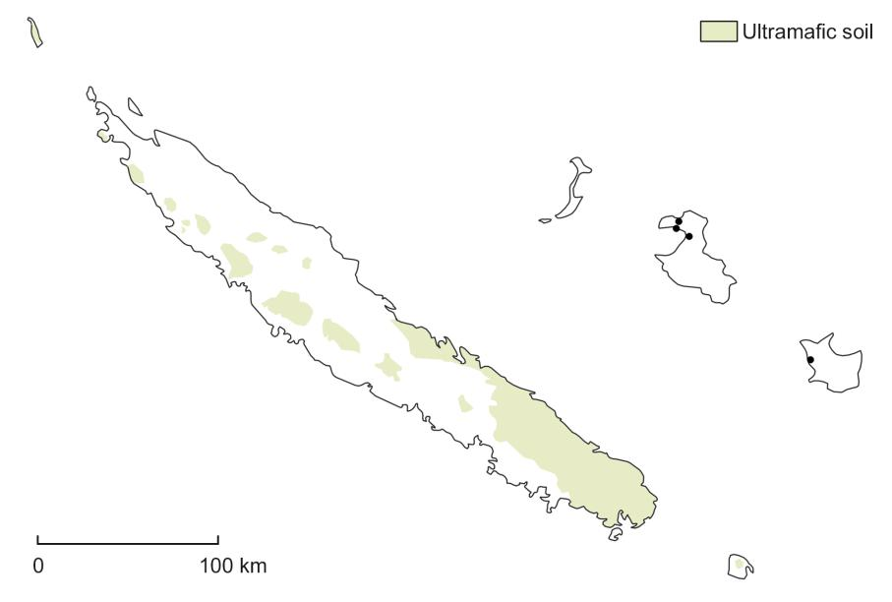

Downloaded From: https://bioone.org/journals/Willdenowia on 23 Aug 2020

Terms of Use: https://bioone.org/terms-of-use

260 Cahen & al.: A revision of *Ventilago* in New Caledonia and Vanuatu

1. ***Ventilago tinctoria*** Cahen, Toussirot & Pillon,**sp. nov.**

– Fig. 4.

Holotype: New Caledonia, South Province, Upper reaches of valley Rivière des Pirogues, 200 m, 12 Dec 1981, *McPherson 4447* (P! [[P06765327];](http://coldb.mnhn.fr/catalognumber/mnhn/p/p06765327) isotypes: K! [K001342514], L images! [L.2336455, L.2336456], MO, NOU! [017688], NSW [505283]).

– *Ventilago pseudocalyculata* sensu Guillaumin (1926, 1948a), Blanc (2008), Cardon & al (2010) et Munzin-ger & al. (2012+), omnia pro parte, excluso lectotypo.

*Diagnosis* — *Ventilago tinctoria* is most similar to *V. pseudocalyculata* in the hairy fruits, in the usually denseand mostly appressed antrorse hairs of the branchlets, pet-ioles, inflorescence and fruit, and in the (sub)entire leaf margin, but it differs in the oblong fruit wing (vs usually slightly curved and tapering at base in *V. pseudocalycu­* *lata*), usually smaller and more narrowly elliptic leaves(3 – 11.5 × 1.5 – 5.5 cm in *V. tinctoria* vs 5 – 13 × 2.5 – 8.5 cm in *V. pseudocalyculata*), usually slightly asymmetric and cuneate at the base (vs symmetric and rounded in *V. pseu­* *docalyculata*), and in the pedicels remaining slender infruit and suddenly expanding into the calyx (vs gradually widening into the calyx in *V. pseudocalyculata*).

*Description* — *Woody climber*, to at least 10 m long. *In­ dumentum* dense, at least at distal end of branchlets andinflorescence rachis; hairs yellowish-white to fulvous, slightly curved, mostly appressed antrorse. *Branches* slender, terete, smooth; branchlets often deeply ridged. *Stipules* fugaceous, rarely persisting by fruiting stage,c. 1 mm long, subulate. *Leaves*: petiole 0.3 – 1.5 cm long, subglabrous; lamina green and shiny on both surfaces, (narrowly) elliptic, 3 – 11.5 × 1.5 – 5.5 cm, chartaceous to subcoriaceous, glabrous, base usually asymmetric, (nar-rowly) cuneate, margin entire, obscurely repand with sometimes a minute black callosity on undulation lobes, apex rounded to attenuate; secondary veins 4 – 6(or 7), clearly discernible, remaining separate, gradually curv-ing upward and diminishing near margin; tertiary vena-tion conspicuously scalariform. *Inflorescence* of cymes congested in fascicles with subtending leaves mostly fugaceous so that fascicles are in racemiform thyrses, ­thyrses often arranged in a panicle, flowers up to 7 per fas-cicle at anthesis, racemiform thyrses to 6 cm long. *Flow­* *ers* fragrant, bisexual, c. 2.5 mm wide; pedicel c. 4 mmlong when fully developed, pedicel and abaxial side of hypanthium densely hairy with hairs subappressed, whit-ish to fulvous, slightly curved, c. 0.1 mm long; sepal lobes 5, triangular, c. 1 mm long, adaxially keeled with an api-cal protuberance; petals 5, obcordate, c. 0.6 mm long, glabrous, base clawed, apex notched; stamens 5, each opposite a petal, filaments c. 0.7 mm long, anthers dor-sifixed, slightly exserted above enclosing petal apex; disk subpentagonal, filling hypanthium, fleshy, smooth, gla-brous; ovary c. ½ immersed in disk, densely hairy, locules 2; style 2-fid. *Fruit* very densely appressed hairy, with a

conspicuous globose basal portion enclosing seed cham-ber and a distinct wing-like apical appendage, straight, oblong with parallel edges, c. 3 × 0.8 cm at maturity; apex rounded with style remains forming a distinct mucro; pedicel remaining slender in fruit, suddenly widening into calyx; persistent calyx annular, enclosing at most basal ⅕ of globose part of fruit at maturity.

*Distribution and ecology* — This species has been col-lected in scrubland (maquis) and forest on ultramafic substrate in New Caledonia in the south and the eastern side of Grande Terre and on Île des Pins. Fig. 5.

*Etymology* — The specific epithet refers to the dyeingproperties of this species (Blanc 2008; Cardon & al. 2010, cited as *Ventilago pseudocalyculata*).

*Conservation status* — Because its ecology and distri-bution are still imperfectly understood, this species has been evaluated as Data Deficient (DD) according to the IUCN criteria (2012, 2017) during the workshop of the New Caledonia Plant Red List Authority of 24 Oct 2019.

*Remarks* — *Ventilago tinctoria* differs from all other Grande Terre *Ventilago* species (*V. buxoides* and *V. neo­* *caledonica*) in its hairy fruit. It resembles *V. pseudocaly­ culata* of the Loyalty Islands, but differs in having anoblong fruit wing (Fig. 4A, K), usually smaller and nar-rower leaves that are slightly asymmetric and cuneate at the base (Fig. 4A, B), and slender pedicels that suddenly expand into the calyx (Fig. 4K).

Three of the four gatherings that Guillaumin cited in the protologue of *Ventilago pseudocalyculata* were col-lected in Grande Terre and are now recognized as *V. tinc­* *toria*. The fourth gathering, *Deplanche* 62, from Lifou, isdesignated here as the lectotype of *V. pseudocalyculata* (see *Remarks* for *V. pseudocalyculata*). Most herbarium material of *V. tinctoria* had previously been identified as *V. pseudocalyculata*, following Guillaumin (1926), butthe Grande Terre specimens are morphologically distinct from those of Lifou, and *V. pseudocalyculata* as recog-nized here seems to be restricted to the Loyalty Islands.

*Selected specimens* — New Caledonia: Bords de la­rivière des Français, près de Nouméa, Oct 1868, *Balansa* *528* (P! [P06886560, P06886561, P06886562]); Bordsdu ruisseau de Kouétou-Kouéta, 26 Dec 1868, *Balansa* *1036* (K!, P! [P06886559, P06886564]); Houaïlou-Pone-rihouen, 21°10'S, 165°30'E, 150 m, 29 Nov 1977, *Bamps* *5864* (NOU image! [17685], P! [P06751515]); Ouroué,10 – 150 m, 20 Oct 1965, *MacKee 13645* (NOU image! [017684], P! [P06784016]); Col de Tonghoue, 100 m, 22 Oct 1970, *MacKee 22770* (P! [P06765318]); Île des Pins, plateau central, 100 m, 7 Sep 1977, *MacKee 33783* (NOU image! [017682], P! [P06765317]); Monéo, 10 m, 25 Nov 1977, *MacKee 34324* (P! [P06765320]); Road to Yaté from Nouméa, 30 Oct 1980, *McPherson 3293* (NOU! [017687],

Downloaded From: https://bioone.org/journals/Willdenowia on 23 Aug 2020

Terms of Use: https://bioone.org/terms-of-use

|  |  |
| --- | --- |
| Willdenowia 50 – 2020 | 261 |
|  |  |

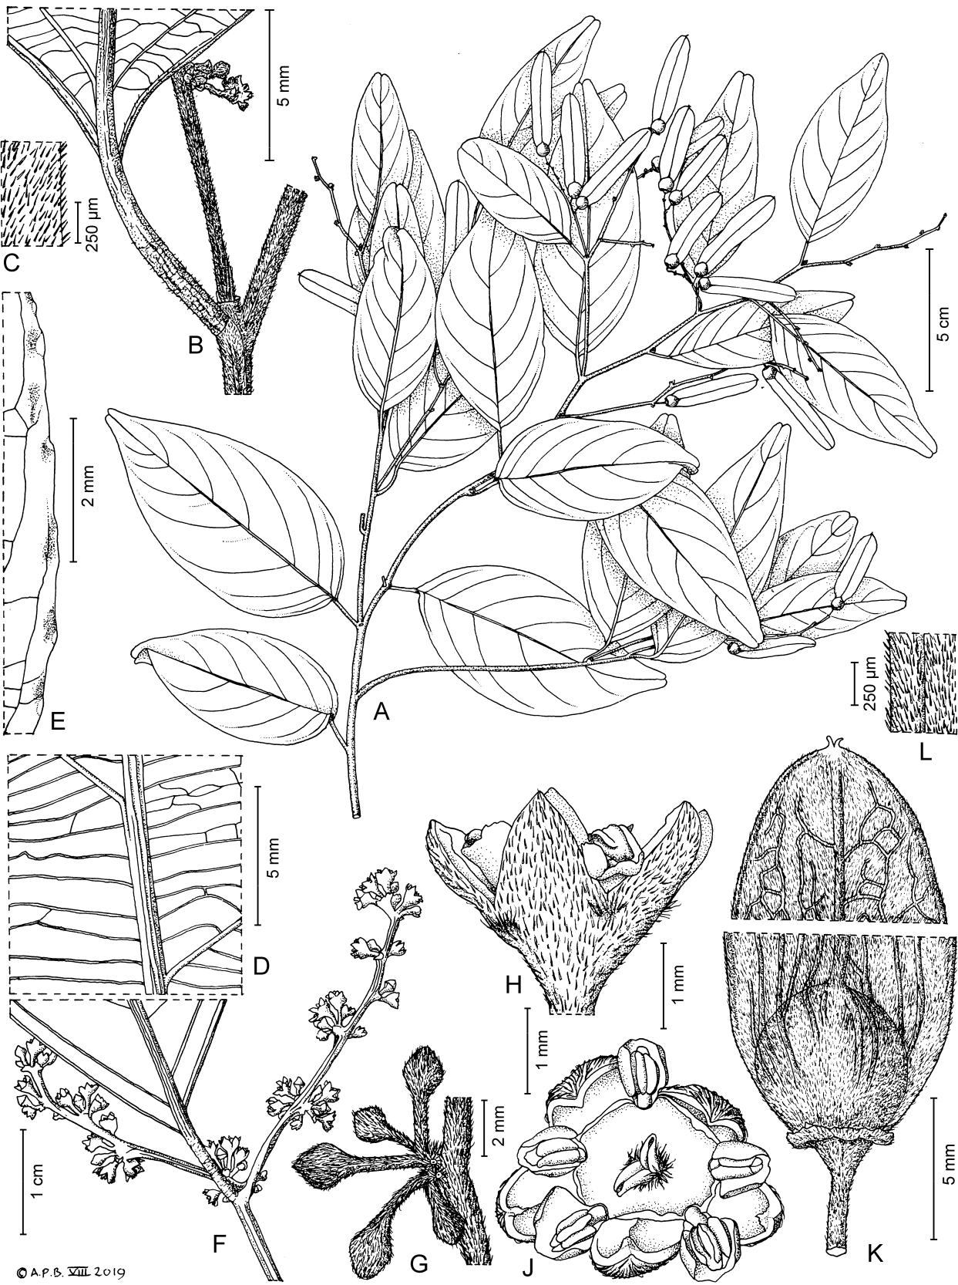

Fig. 4. *Ventilago tinctoria* – A: habit; B: leaf node with base of inflorescence; C: stem indumentum; D: leaf venation, abaxial view;

1. leaf margin, adaxial view; F: flower fascicles (hairs omitted); G: flower buds; H: flower, side view; J: flower, face view; K: fruit apex and base detail; L: fruit wing edge indumentum. – A, K, L from *MacKee 34324* (P); B – E, G – J from *McPherson 3293* (P); F from *MacKee* 13645 (P). – Drawn by Andrew Brown.

Downloaded From: https://bioone.org/journals/Willdenowia on 23 Aug 2020

Terms of Use: https://bioone.org/terms-of-use

Fig. 5. Distribution of *Ventilago tinctoria* (●) in New Caledonia.

262 Cahen & al.: A revision of *Ventilago* in New Caledonia and Vanuatu

P! [P06765331]); Port Boisé, 10 m, 20 Nov 1981, *McPher­* *son 4405* (NOU! [017692], P![P06765328]); Baie du Port saint Vincent, s.d., *Pancher* *5746* (P! [P06886569]);2.1 km SE of col de Mouirange, 21 Aug 1978, *Phillips & Schmid 3317* (P![P04458712]).

1. ***Ventilago vanuatuana*** Cahen, Toussirot & Pillon, **sp. nov.** – Fig. 6.

Holotype: Vanuatu, Santo, Penaorou, parcelle 600-C, 14°58'0.22"S, 166°38'41.5"E,

1. m, 27 Oct 2006, *Munzin­* *ger 3609* (P! [[P06765295];](http://coldb.mnhn.fr/catalognumber/mnhn/p/p06765295) isotypes: CANB image! [CANB 00726521]), K! [K001342515], MO, NOU, P! [P06765293], PVNH).

– *Ventilago neocaledonica* sensu Bourdy & Walter (1986), Cardon (2007) et Ramon & Sam (2015), non Schltr.

– *Ventilago vitiensis* sensu Cardon & al (2010), non A. Gray.

*Diagnosis* — *Ventilago vanuatuana* most closely resem-bles *V. tinctoria* in the hairy fruits with an oblong wing and in the flower fascicles being in racemiform thyrses, often arranged in panicles, but it differs in its narrower leaves with a crenate to serrate margin (vs margin entire, obscurely repand in *V. tinctoria*) and hairs of branchlets, petioles, inflorescence and fruit mostly spreading (vs hairs mostly appressed antrorse in *V. tinctoria*).

*Description* — *Woody climber. Indumentum* sparse to usu-ally dense at distal end of branchlets and inflorescence rachis; hairs mostly yellowish-white to fulvous, slight-ly curved, mostly spreading. *Branches* slender, terete, smooth; branchlets often deeply ridged. *Stipules* fuga-ceous, rarely persisting by fruiting stage, c. 1 mm long, subulate. *Leaves*: petiole 3 – 6 mm long, with dense subap-pressed to mostly spreading hairs; lamina broadly to nar-rowly ovate, 3 – 10 × 1.5 – 4.7 cm, chartaceous to subcoria-ceous, glabrous, sometimes hairy abaxially along primary and secondary veins, base ± symmetric, rounded to weakly cordate, margin crenate to serrate, serrations topped by callosities, apex rounded to attenuate; secondary veins 5 or 6, clearly discernible, remaining separate, gradually curv-ing upward and diminishing near margin; tertiary venation conspicuously scalariform. *Inflorescence* of cymes con-gested in fascicles, with subtending leaves mostly fuga-ceous so that fascicles are arranged in racemiform thyrses, thyrses often arranged in a panicle, flowers up to at least 5

per fascicle at anthesis, racemiform thyrses to 9 cm long. *Flowers* bisexual, c. 3 mm wide; pedicel c. 2 mm longwhen fully developed, pedicel and abaxial side of hypan-thium densely hairy with hairs subappressed to spreading, whitish to fulvous, slightly curved, c. 0.1 mm long; sepal lobes 5, triangular, c. 1 mm long, adaxially keeled with an apical protuberance; petals 5, obcordate, c. 0.9 mm long, sparsely hairy abaxially, base clawed, apex notched; sta-mens 5, each opposite and enclosed by a petal, filaments c. 0.8 mm long, anthers dorsifixed; disk subpentagonal, filling hypanthium, fleshy, smooth, glabrous; ovary c. ½ immersed in disk, densely hairy, locules 2; style 2-fid. *Fruit* very densely mostly spreading hairy, with a conspic-uous globose basal portion enclosing seed chamber and a distinct wing-like apical appendage, oblong, to at least 3 × 0.8 cm at maturity, wing straight; apex rounded with style remains forming a distinct mucro; persistent calyx cupular, enclosing basal c. 1/5of globose part of fruit.

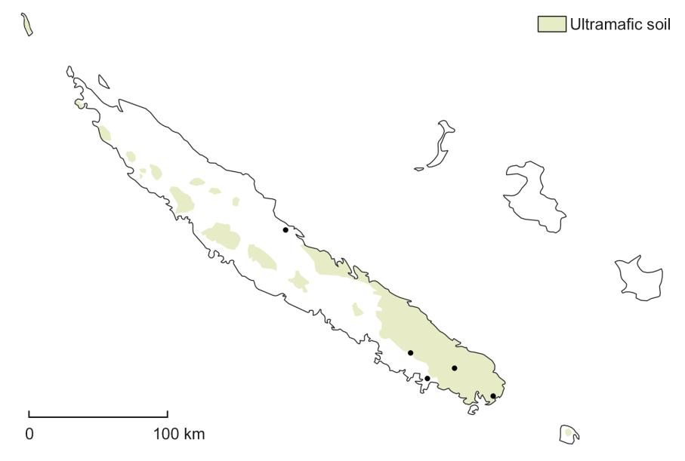

*Distribution and ecology* — This plant has been collectedin forests in Vanuatu, on the islands of Santo, Malekula, Pentecost, Éfaté and Anatom. It probably occurs on other islands of the archipelago. Fig. 7.

*Etymology* — The plant is named after the country inwhich it is endemic, Vanuatu.

*Vernacular name* — Called *(butsu) laba* in the Apma lan-guage (Pentecost), according to field notes on *Aubert de* *la Rue s.n.* and Bourdy & Walter (1986).

*Conservation status* — The distribution of this species isincompletely known because there are still few botanical collections from Vanuatu. The ecology is not well known, and it is not known if there are important threats. The spe-

Downloaded From: https://bioone.org/journals/Willdenowia on 23 Aug 2020

Terms of Use: https://bioone.org/terms-of-use

|  |  |
| --- | --- |
| Willdenowia 50 – 2020 | 263 |
|  |  |

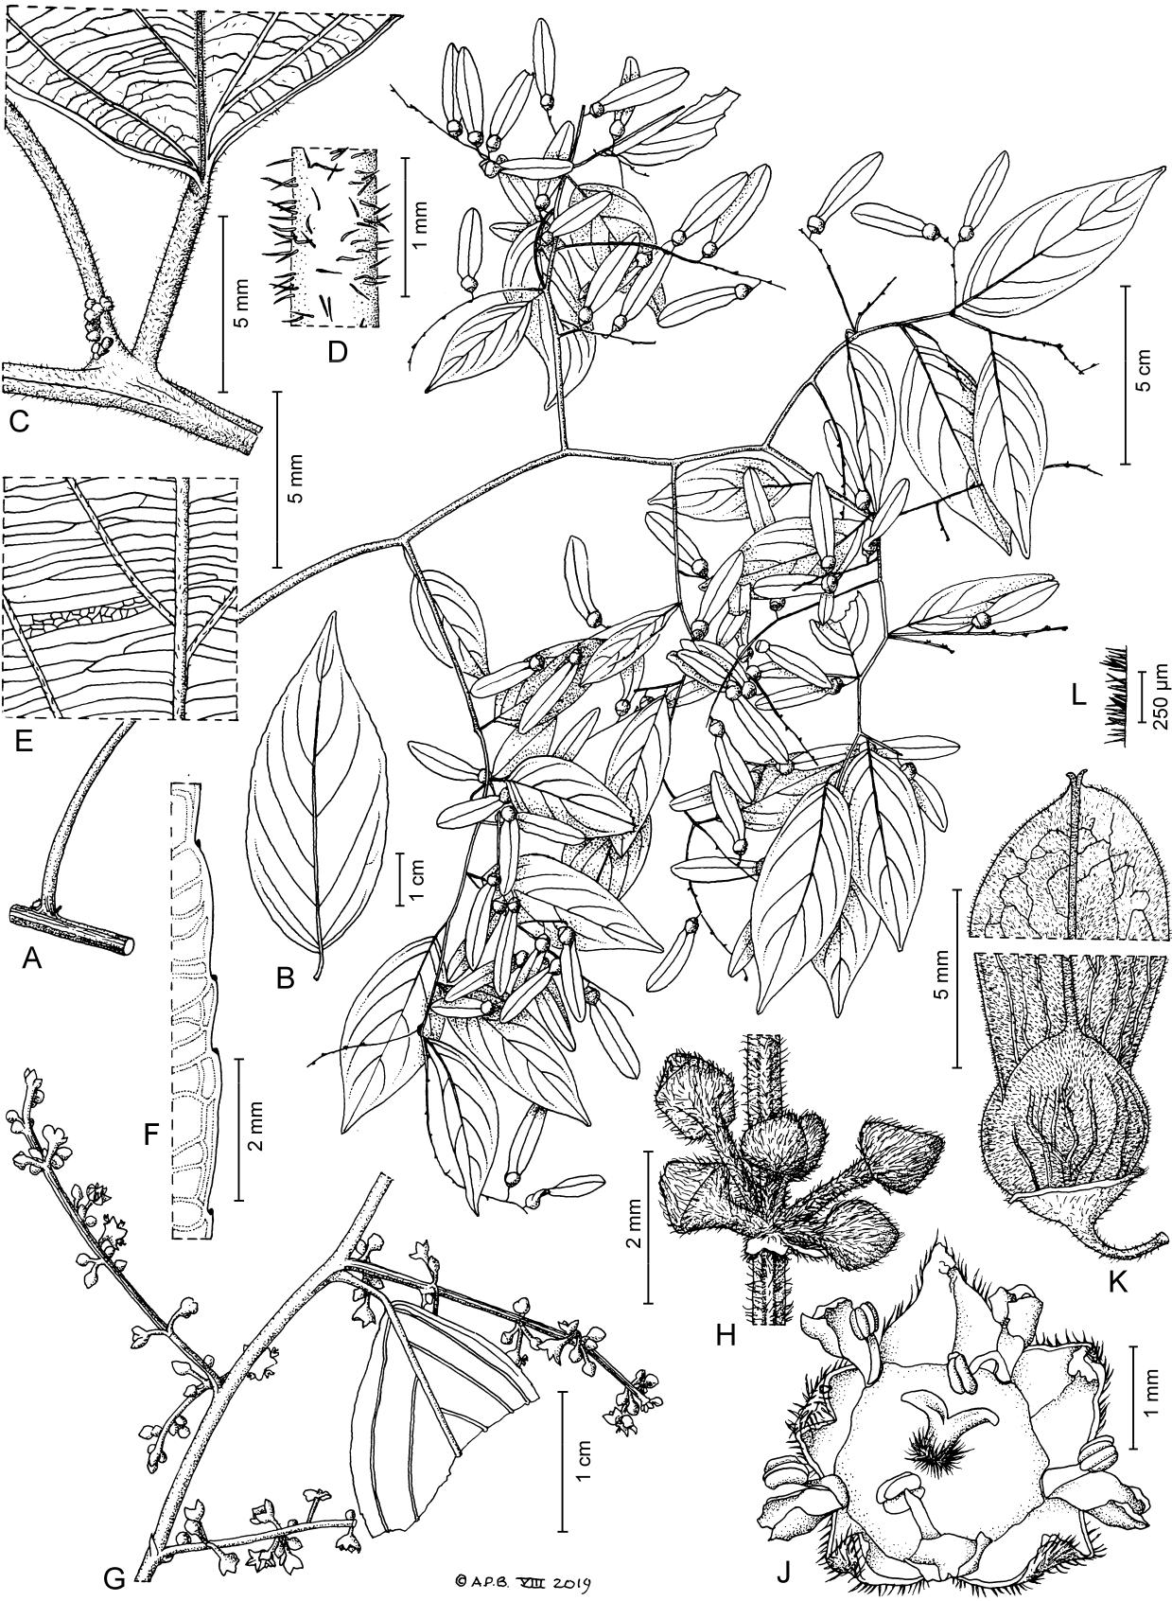

Fig. 6. *Ventilago vanuatuana* – A: habit; B: leaf, adaxial view; C: leaf node with base of inflorescence; D: petiole indumentum;

1. leaf venation, abaxial view; F: leaf margin, adaxial view; G: flower fascicles; H: flower buds; J: flower, face view; K: fruit apex and base detail; L: fruit wing edge indumentum. – A – F from *Munzinger 3609* (P); G – J from *Ramon 237* (P); K, L from *Munzinger* *3609* (K). – Drawn by Andrew Brown.

Downloaded From: https://bioone.org/journals/Willdenowia on 23 Aug 2020

Terms of Use: https://bioone.org/terms-of-use

264 Cahen & al.: A revision of *Ventilago* in New Caledonia and Vanuatu

cies is therefore assessed here as Data Deficient (DD). It is not clear if the use of the roots as a dye is sustainable or may represent a threat to the populations.

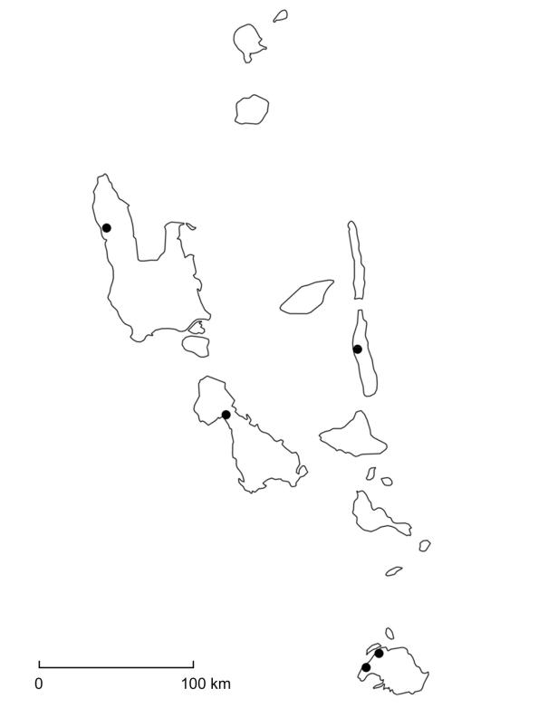

|  |  |  |
| --- | --- | --- |
| *Remarks* — *Ventilago vanuatuana* is the only known spe- |  |  |
| cies of *Ventilago* to occur in Vanuatu. It was previously |  |  |
| identified as *V. neocaledonica* on various herbarium sheets, |  |  |
| but *V. neocaledonica* has glabrous fruits. It has also been |  |  |
| suggested that material from this species could belong to |  |  |
| *V. vitiensis* A. Gray, originally described from Fiji (Cardon |  |  |
| & al. 2010), but *V. vanuatuana* has hairy fruits and a cre- |  |  |
| nate to serrate leaf margin (vs glabrous fruits and an entire |  |  |
| leaf margin in *V. vitiensis*). It differs from the other New |  |  |
| Caledonian species *V. pseudocalyculata* and *V. tinctoria* in |  |  |
| the narrower crenate to serrate leaves (Fig. 6A, B, F) and |  |  |
| indumentum of mostly spreading hairs (Fig. 6C, D, H). It |  |  |
| also differs from the Solomon Island *Ventilago* specimens, |  |  |
| which seem to belong to *V. papuana* Merr. & L. M. Perry |  |  |
| and which have wider leaves with an entire margin and |  |  |
| flowers with densely hairy nectary disks. |  |  |
| *Smythea lanceata* (Tul.) Summerh., a mostly coastal |  |  |
| species with a wide distribution, in a genus closely relat- |  |  |
| ed to *Ventilago* (Cahen & Utteridge 2018), was recently |  |  |
| observed and collected in Vanuatu (Éfaté-Mosso-Sounaï, |  |  |
| 0 m, 28 Sep 2014, *Ramon 167* (P image! [P02434008]). | Fig. 7. Distribution of *Ventilago vanuatuana* (●) in Vanuatu. |  |
| When the crustaceous inflated wingless fruits are available |  |
| it is easily distinguished from *V. vanuatuana.* The flowers |  |  |
| are arranged in fascicles in the axils of persistent leaves | [P02434415], NY, PVNH); Malekula: Walla: endroit ap- |  |
| (vs leaves fugaceous in *V. vanuatuana* so that the fascicles | pelé Nimev, 20 m, 9 Nov 1980, *Sam 35* (NOU! [080586] |  |
| are in racemiform thyrses, the thyrses often arranged in a | [sterile]); Vaté [Éfaté], Tututuk, 15 Nov 1974, *Sam 5124* |  |
| panicle). When sterile, it can be recognized by the leaves | (NOU! [080587]); Anatom, SE, 20 Jul 1971, *Schmid* |  |
| having 3 – 5 pairs of secondary veins (vs 5 or 6 in *V. vanu­* | *3987* (NOU! [080588] [sterile]). |  |
| *atuana­*), well spaced along |  |  |
| the primary vein, and in the |  |  |
| conspicuous domatia, pock- |  |  |
| ets often combined with tufts |  |  |
| of hairs in the axils of the |  |  |
| secondary veins (vs domatia |  |  |
| absent in *V. vanuatuana*). |  |  |

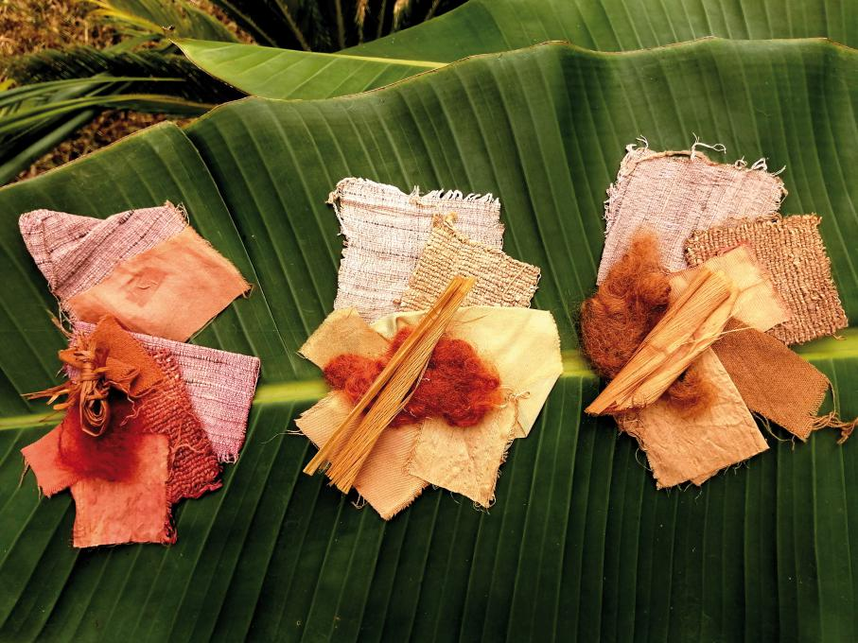

*Selected specimens* —Vanuatu: Pentecost, Van-mul, côte 50, 31 Dec 1935, *Aubert de la Rüe s.n.* (P![P06886649] [sterile]); Pen-tecost, route Melsisi, Hou-bikou, 350 – 400 m, 4 Oct 1980, *Cabalion 1196* (NOU! [080584], P! [P06886651]); Santo, Penaorou, 14°58'00"S, 166°38'15"E, 300 m, 16 Nov 2006, *McPherson & al. 19426* (NOU! [062758]); Pentecost: Namaran, Dec 1976, *Morat* *5248* (NOU! [080585] [ster-ile]); Éfaté, Mangaliliu, 50 m, 14 Aug 2015, *Ramon 237* (P!

Fig. 8. Dyes on different fibres obtained with the three species of *Ventilago* from New Caledo-nia. Dyes from left to right: *V. buxoides*; *V. tinctoria*; *V. neocaledonica*. – Photo: M. Toussirot. – Dyes: B. Blanc, D. Cardon and M. Boulanger-Penduff.

Downloaded From: https://bioone.org/journals/Willdenowia on 23 Aug 2020

Terms of Use: https://bioone.org/terms-of-use

|  |  |
| --- | --- |
| Willdenowia 50 – 2020 | 265 |
|  |  |

**Acknowledgements**

The authors thank the curators of NOU and P for their help-ful assistance, Jürgen Kellermann and Timothy ­Utteridge for critically reading the manuscript and suggesting sub-stantial improvements, and Andrew Brown for his excel-lent illustrations. The authors also thank Barbara Blanc, Pierre Cabalion, Dominique Cardon and Édouard Hnawia for their study of the dyeing properties of *Ventilago* spe-cies in New Caledonia and Vanuatu.

**References**

Bachman S., Moat J., Hill A., de la Torre J. & Scott B. 2011: Supporting Red List threat assessments with GeoCAT: Geospatial Conservation Assessment Tool.

– [ZooKeys **150:** 117 – 126.](https://doi.org/10.3897/zookeys.150.2109.figure1)

Bean A. R. 2013: *Emmenosperma pancherianum* Baill. (*Rhamnaceae*) newly recorded in Australia. – Austro­ baileya **9:** 150 – 152.

Beentje H. 2010: The Kew plant glossary: an illustrated dictionary of plant terms. – Kew: Royal Botanic Gar-dens, Kew.

Blanc B. 2008: L’ethnobotanique et le pharmacien: appli-cation à l’étude de plantes tinctoriales en Nouvelle-Calédonie. – Lyon: PhD thesis, Université Claude Bernard.

Bourdy G. & Walter A. 1986: Notes sur quelques plantes tinctoriales de Vanuatu. – Naïka (Journal Des Scien­ ces Naturelles Du Vanuatu) **24:** 1 – 21.

Cahen D. & Utteridge T. M. A. 2017: Three new species of *Ventilago* (*Rhamnaceae*) from South-East Asia. – [Phytotaxa **307:** 171 – 182.](https://doi.org/10.11646/phytotaxa.307.3.1)

Cahen D. & Utteridge T. M. A. 2018: A synopsis of the

genus *Smythea* (*Rhamnaceae*). – [Kew Bull. **73:** 2.](https://doi.org/10.1007/s12225-017-9724-3)

Cardon D. 2007: Natural dyes: sources, tradition, technol-

ogy and science. – London: Archetype Publications.

Cardon D., Cabalion P., Blanc B., Boulanger-Penduff M., Hnawia É., Nowik W., Waikedre J. & Sam C. 2010: Plantes tinctoriales des traditions et sociétés du Pa-cifique : de la sauvegarde des savoirs aux nouvelles perspectives d’application. – Ethnopharmacologia

1. 17 – 23.

Guillaumin A. 1911: Catalogue des plantes phanéro-games de la Nouvelle-Calédonie et Dépendances (Iles des Pins et Loyalty). – Ann. Mus. Colon. Mar-seille, ser. 2, **9:** 77 – 290, 1 map.

Guillaumin A. 1926: Matériaux pour la flore de la Nou-velle-Calédonie XX. Révision des Rhamnacées. – [Bull. Soc. Bot. France **73:** 104 – 107.](https://doi.org/10.1080/00378941.1926.10833587)

Guillaumin A. 1931: Contribution to the flora of the New

Hebrides: plants collected by S. F. Kajewski in 1928

and 1929. – J. Arnold Arbor. **12:** 221 – 264.

Guillaumin A. 1948a: Flore analytique et synoptique de la Nouvelle-Calédonie. – Paris: Office de la Re-cherche Scientifique Coloniale.

Guillaumin A. 1948b: Compendium de la flore phanéro-gamique des Nouvelles Hébrides. – Ann. Mus. Colon. Marseille, ser. 6, **5 – 6:** 5 – 56.

Hauenschild F., Favre A., Schulz M. & Muellner-Riehl A. N. 2018: Biogeographic analyses support an Aus-tralian origin for the Indomalesian-Australasian wet forest-adapted tropical tree and shrub genus *Alphito­* *nia* and its close allies (*Rhamnaceae*). – [Bot. J. Linn.](https://doi.org/10.1093/botlinnean/boy048) [Soc. **188:** 1 – 20.](https://doi.org/10.1093/botlinnean/boy048)

Hickey L. J. 1979: A revised classification of the architec-ture of dicotyledonous leaves. – Pp. 25 – 39 in: Metcalfe C. R. & Chalk L. (ed.), Anatomy of the dicotyledons

1. **1**. – Oxford: Oxford Science Publications.Hopkins H. C. F., Pillon Y., Stacy E. A. & Kellermann J.

2015: *Jaffrea*, a new genus of *Rhamnaceae* endemic to New Caledonia, with notes on *Alphitonia* and *Em­* *menosperma*. – [Kew Bull. **70:** 42.](https://doi.org/10.1007/s12225-015-9593-6)

IUCN 2012: IUCN Red List categories and criteria. Ver-sion 3.1. Second edition. Prepared by the IUCN Spe-cies Survival Commission. – Gland & Cambridge: IUCN. – Published at [https://www.iucnredlist.org](https://www.iucnredlist.org/resources/categories-and-criteria) [/resources/categories-and-criteria](https://www.iucnredlist.org/resources/categories-and-criteria)

IUCN 2017: Guidelines for using the IUCN Red List cate-gories and criteria. Version 13. Prepared by the Stand-ards and Petitions Subcommittee of the IUCN Spe-cies Survival Commission. – Published at [http://www](http://www.iucnredlist.org/documents/RedListGuidelines.pdf)

[.iucnredlist.org/documents/RedListGuidelines.pdf](http://www.iucnredlist.org/documents/RedListGuidelines.pdf) Johnston M. C. 1971: Revision of *Colubrina* (*Rhamna­*

*ceae*). – [Brittonia **23:** 2 – 53.](https://doi.org/10.2307/2805841)

Lowry P. P., II 1989: A revision of *Araliaceae* from

Vanuatu­. – Bull. Mus. Natl. Hist. Nat., B, Adansonia **11:** 117 – 155.

Medan D. & Schirarend C. 2004: [*Rhamnaceae*. – Pp.](https://doi.org/10.1007/978-3-662-07257-8_37) [320 – 338](https://doi.org/10.1007/978-3-662-07257-8_37) in: Kubitzki K. (ed), The families and gen-era of vascular plants **VI.** Flowering plants. Dicoty-ledons. *Celastrales*, *Oxalidales*, *Rosales*, *Cornales*, *Ericales*. – Berlin & Heidelberg: Springer.

Morat P., Jaffré T., Tronchet F., Munzinger J., Pillon Y., Veillon J. M. & Chalopin M. 2012: Le référen-tiel taxonomique Florical et les caractéristiques de la flore vasculaire indigène de la Nouvelle-Calédonie. – [Adansonia, ser. 3, **34:** 179 – 221.](https://doi.org/10.5252/a2012n2a1)

Munzinger J., Morat P., Jaffré T., Gâteblé G., Pillon Y., Rouhan, G. Bruy, D., Veillon J.-M. & Chalopin M. 2012+ [continuously updated]: FLORICAL: Check-list of the vascular indigenous flora of New Caledo-nia. – Published at [http://publish.plantnet-project.org](http://publish.plantnet-project.org/project/florical) [/project/florical](http://publish.plantnet-project.org/project/florical) [accessed 2 Oct 2019].

Pillon Y., Munzinger J., Amir H. & Lebrun M. 2010:

Ultramafic­ soils and species sorting in the flora of New Caledonia. – [J. Ecol. **98:** 1108 – 1116.](https://doi.org/10.1111/j.1365-2745.2010.01689.x)

Ramon L. & Sam C. 2015: Plantes remarquables du

Vanuatu­. Remarkable plants of Vanuatu. – Mèze: Bio-

tope Editions; New York: New York Botanical Garden Press.

Schlechter R. 1906: Beiträge zur Kenntnis der Flora von Neu-Kaledonien. – Bot. Jahrb. Syst. **39:** 161 – 274.

Downloaded From: https://bioone.org/journals/Willdenowia on 23 Aug 2020

Terms of Use: https://bioone.org/terms-of-use

266 Cahen & al.: A revision of *Ventilago* in New Caledonia and Vanuatu

Smith A. C. 1943: Studies on Pacific island plants – III. New and noteworthy flowering plants from Fiji. – [Bull. Torrey Bot. Club **70:** 533 – 248.](https://doi.org/10.2307/2481400)

Suessenguth K. 1953: *Rhamnaceae*. – Pp. 1 – 173 in:

Engler­ A. & Prantl K. (ed.), Die natürlichen Pflan-zenfamilien, ed. 2, **20d.** – Berlin: Duncker and Hum-blot.

Toussirot M. 2014: Etudes phytochimiques et pharmaco-logiques des colorants naturels issus de la biodiver-sité végétale de Nouvelle-Calédonie et perspectives de valorisation. – Nouméa: PhD thesis, Université de Nouvelle-Calédonie.

Toussirot M., Hnawia É., Cardon D., Nowik W., de la ­Sayette A., Dijoux-Franca M.-G., Lebouvier N.,

Cabalion­ P. & Nour M. 2012: Potential new sourc-es of natural dyes from the traditional pharmaco-poeia of New-Caledonia. – [Pl. Med. (Stuttgart) **78:**](https://doi.org/10.1055/s-0032-1320815) [1027 – 1310.](https://doi.org/10.1055/s-0032-1320815)

Toussirot M., Nowik W., Hnawia É., Lebouvier N., Hay A.-E., de la Sayette A., Dijoux-Franca M.-G., Cardon­

D. & Nour M. 2014: Dyeing properties, coloring compounds and antioxidant activity of Hubera ni-tidissima (Dunal) Chaowasku (*Annonaceae*). – [Dyes](https://doi.org/10.1016/j.dyepig.2013.11.010) [and Pigments **102:** 278 – 284.](https://doi.org/10.1016/j.dyepig.2013.11.010)

Wheatley J. I. 1992: A guide to the common trees of ­Vanuatu with lists of their traditional uses and ni-Vanuatu names. – Port Vila: Department of Forestry, Republic of Vanuatu.

Willdenowia



Open-access online edition [bioone.org/journals/willdenowia](https://bioone.org/journals/willdenowia)

Online ISSN 1868-6397 · Print ISSN 0511-9618 · 2018 Journal Impact Factor 1.156 Published by the Botanic Garden and Botanical Museum Berlin, Freie Universität Berlin © 2020 The Authors · This open-access article is distributed under the [CC BY 4.0 licence](https://creativecommons.org/licenses/by/4.0/)

Downloaded From: https://bioone.org/journals/Willdenowia on 23 Aug 2020

Terms of Use: https://bioone.org/terms-of-use