[Applied Acoustics 166 (2020) 107373](https://doi.org/10.1016/j.apacoust.2020.107373)



Contents lists available at [ScienceDirect](http://www.sciencedirect.com/science/journal/0003682X)

Applied Acoustics

j o u r n a l h o m e p a g e : [w w w . e l s e v ie r . c o m / l o c a t e / a p a c o u s t](http://www.elsevier.com/locate/apacoust)

Acoustics of performance buildings in Hispania: The Roman theatre and amphitheatre of Segobriga, Spain



M. Galindo a,1,⇑, S. Girón a, R. Cebrián b

1. Instituto Universitario de Arquitectura y Ciencias de la Construcción (IUACC), Escuela Técnica Superior de Arquitectura, Universidad de Sevilla, Av. Reina Mercedes 2, 41012 Seville, Spain
2. Dpto. de Prehistoria, Historia Antigua y Arqueología, Área de Arqueología, Facultad de Geografía e Historia, Universidad Complutense de Madrid. C/ Profesor Aranguren, s/n, Ciudad Universitaria, 28040 Madrid, Spain

a r t i c l e i n f o

Article history:

Received 14 February 2020

Received in revised form 3 April 2020 Accepted 6 April 2020 Available online 24 April 2020

Keywords:

Roman theatre

Roman amphitheatre

Unroofed building acoustics

Ancient performance building

a b s t r a c t

In Roman times, Segobriga (Cuenca) was the capital of the Celtiberia region. The specular gypsum of its mines, used as glass in windows, was exported across the whole Roman Empire through the port of Carthago Nova (Cartagena), which made Segobriga a major centre of commerce with the Mediterranean. The construction of the two performance buildings took place outside the urban wall of the city and must have begun in the time of Tiberius; they were inaugurated around 79 AD under Vespasian. The Roman theatre has one of the best conserved cavea in Hispania, although it lacks a scaenae frons. In the amphitheatre, only its southern cavea has been restored to accommodate the audience. In this work, experimental results and analyses are presented of impulse responses and of the values of the monaural and binaural acoustic parameters recorded in situ in these two performance buildings of this imperial city of Hispania. These results correspond to the source-receiver combinations of three posi-tions of the sound source, in the places where the natural sources are located in each building with mul-tiple positions of the microphones. Analyses of the room impulse response signals in the two venues are carried out, as is a study of focalization in the amphitheatre together with a comparison of the acoustics of the two sites in terms of temporal, energy, and spatial acoustic parameters. These buildings feature as study cases of a wider research project that aims to evaluate and revalue the acoustics of the principal Roman theatres of Spain.

2020 Elsevier Ltd. All rights reserved.

1. Introduction

Ancient theatres and amphitheatres are public buildings of the utmost importance in the history of Western culture and in univer-sal cultural heritage. These venues are mainly disseminated in countries along the Mediterranean coast, and in other regions and cities beyond those that belonged to the Roman Empire [1]. In addition to their archaeological interest, increasing attention has been paid to other intangible values, such as the acoustics of these performance spaces. Much of this interest is due to two research projects: ERATO [3] (Identification, Evaluation, and Revi-val of the Acoustical Heritage of Ancient Theatres and Odea), financed by the European Union; and, on a more local scale, the Italian project ATLAS [3], of national interest, dedicated to safe-



⇑ Corresponding author.

E-mail addresses: [mgalindo@us.es](mailto:mgalindo@us.es) (M. Galindo), [sgiron@us.es](mailto:sgiron@us.es) (S. Girón), [marcebri@ucm.es](mailto:marcebri@ucm.es) (R. Cebrián).

1. Part of this paper has been presented at the Internoise Conference 2019.

<https://doi.org/10.1016/j.apacoust.2020.107373> 0003-682X/ 2020 Elsevier Ltd. All rights reserved.

guarding the acoustic and visual aspects of ancient theatres. The former project, with a duration of three years, was created in order to conserve and restore the architectural heritage of these build-ings while also taking into account their acoustic characteristics. Within the framework of this ERATO project, the Roman theatre of Aspendus, Turkey, was studied, which is in a magnificent state of conservation [4].

While there are certain similarities between circuses, theatres, and amphitheatres, both in construction (stone and Roman con-crete) and in purpose (citizen leisure and the prestige of benefac-tors), each building presented a different function and shape. Amphitheatres did not need superior acoustics, since they hosted circus games and gladiatorial events, unlike those provided by the structure of a Roman theatre. Theatres hosted events such as plays, pantomimes, choral events, and orations.

Roman theatres are Greek in origin: they followed the earlier Greek seating pattern, but limited the seating arc to 180L, and also added a stagehouse (skené) behind the actors, a raised acting area (proskenion), and hung awnings (velaria) overhead to shade the

2 M. Galindo et al. / Applied Acoustics 166 (2020) 107373

patrons or protect them from rain. The acoustic principles used in such designs are signalled by Vitruvius [5], engineer of ancient Rome, II Century BC, in whose writings his own experience in the field of architecture is described. In his fifth book (V, III, 6), Vitru-vius gives a basic interpretation of sound propagation, and describes a series of factors for the creation of a suitable sensation for the listener.

The amphitheatre is a space related to gladiatorial combats, which were provided as entertainment, and originated in Italy, possibly from the Etruscan or Samnite culture. Traditionally, the early versions were called Spectacula (a place for watching, whereby oral comprehension was not essential) and later the name ‘‘Amphitheatre” was used. Never adopted in Greek culture, the main characteristics of amphitheatres are the oval-shaped ‘‘Arena” in the middle and the audience seated on all sides around the arena. Its oval ground plan is a consequence of the duplicity of two theatres united via their stages. Its name is of Greek origin and means two theatres (am phi = two). Like the theatre, this was an unroofed space with the possibility of a velum as protection against sun and rain. The most impressive of the Roman amphithe-atres, the Flavian amphitheatre, was built between AD 70 and 81, and was later called the Colosseum, due to its proximity to a colos-sal statue of Nero. With a total seating capacity of approximately 40,000 people, it constitutes, except for buildings for racecourses, the largest structure for a seated audience of the ancient world; however, its architect remains unknown [6,7]. The principles of the designs of Roman amphitheatres are used in modern stadia.

There is a major lack of studies on the natural acoustics of Roman amphitheatres and their suitability for specific events com-pared to the theatres of ancient Greece and Rome. However, Roman amphitheatres are currently used for various genres of pub-lic performances, drama, opera, classical music, pop, dance, rock, and jazz, some of which are organized with seasonal continuity

1. and are famous worldwide, as in the case of the Colosseum in Rome and the amphitheatres of Nimes and Verona. Along these lines, Nevvab et al. [9] present an application of beamforming com-bined with computer simulation to provide the relevant acoustical aspects of the Flavian Amphitheatre. The method includes ISO standard descriptors and a 3D format of the sound signals.

According to Golvin [10], amphitheatres lacked good acoustics since the elliptical shape of the building implied a whole series of sound energy concentrations that made it impossible to clearly hear any sound unless it was powerful, repetitive, and rhythmic. The most that would be heard, then, would be an enormous mass of unclear sound, something in which some ancient authors agree when talking about the noise in an amphitheatre [11]. However, the study of their acoustic behaviour has never been analysed. Only Greek and Roman theatres have been addressed, where acoustics play an essential role.

A prominent theoretical contribution in this regard is provided by Canac [12], who studies various geometries with image sources and shows how the first reflections in the orchestra and the back wall of the stage of a classical theatre were significant in the ampli-fication of the voices of the actors by supporting their direct sound.

Several papers deal with the evolution of open-air Greek and Roman theatres in their examination of the influences of the changes of forms and materials on their acoustics. These studies rely on acoustic measurement in the surviving remains of ancient theatres to support analyses with computer simulation [13,14]. A single study with an analogous aim was based on measurements carried out in a reduced-scale physical model [15].

In another context, based on a computational model of a classi-cal theatre (Epidaurus), Declercq and Dekeyser [16] incorporate multiple diffraction orders and conclude that the rows of seats play a major role in the acoustics of the theatre, at least when it is not completely occupied by spectators, since they constitute a corru-

gated surface that works as a filter in terms of the periodicity of the rows of seats. Hence the sound is retro-dispersed from the cavea towards the audience, and hence the public receives the sound, not only from the front, but also retro-scattered from behind. In addition, these authors show that such retro-dispersions better amplify the high frequencies, which are essen-tial for speech intelligibility. In research by Lokki et al. [17], the authors also develop a 3D model of the lower cavea of the theatre of Epidaurus. Acoustic simulation was carried out, both for low fre-quencies via a finite-difference time domain (FDTD) technique, and for high frequencies via a beam-tracing method. Results and visu-alization from a 2D FDTD simulation clearly shows all the compo-nents of early reflections: from the stage wall, orchestra, seating rows, and backscattering of the seating rows, which fuse well with direct sound.

Other aspects that deserve mention that have been studied in these theatres include the state of knowledge and arrangements in the use of velaria in ancient Roman theatres in the past [18], and, through simulation models, their possible acoustic influence in three Italian open-air theatres.

Since ancient theatres are used in the modern age for a variety of cultural activities, virtual models were also adjusted to recreate the acoustic conditions by adding certain scenic elements in the theatre [19] or by including the presence of the audience in the cavea [20] to evaluate their influence on acoustic quality.

For seven centuries, the Romans remained in Hispania (present-day, Spain), and during this period, from the year 218 BC until the V Century, they built great architectural works that represented the splendour of Rome. It is worth clarifying, however, that, from the III Century onwards, the Roman cities have been transformed: there are no monumental constructions, rather reoccupations, and the only structures representing power are related to the Catholic Church. Some of the best-preserved constructions are the amphitheatres, those public places with their elliptical shape and with graduated floors, where a great diversity of performances were held, such as gladiatorial fights. In Spain, 5 amphitheatres (Tarragona, Merida, Cartagena, Seville, and Cuenca) stand out for their relatively good state of conservation as do 22 documented Roman theatres. In a few of these theatres, only vestiges of the the-atre remain, while others are in an excellent state of preservation, as is the case of the study herein: the Roman Theatre and Amphitheatre of Segobriga in the town of Saelices, Cuenca (Fig. 1).

In this work, the acoustic field of the two performance buildings is described and compared through a parametric analysis corre-sponding to three positions of the sound source and to multiple receiver positions, as a consequence of an on-site measurement campaign in these ancient performance buildings [21].

These buildings constitute one of the cases of study of a research project financed by the Spanish government, and carried out by the authors, which aims to evaluate and revalue the acous-tics of the principal Roman theatres of Spain.

2. The high imperial city of Segobriga

From an Iron Age castrum, a town in Celtiberian territory emerged on the hill of Cabeza de Griego (Saelices, Cuenca), whose main economic activity was linked to the lapis specularis (Pliny, NH 36.160), a translucent material used for window panes. It was Pliny (NH 2.25) who included Segobriga in his lists of stipendiary cities of the Carthaginensis convent, such as caput Celtiberiae, along with other cities on the southern plateau and southeast peninsular.

In the middle of the I Century BC, the city began major urban-ization work, which was planned with orthogonal streets and aligned with the city wall. On the northern slope of the hill, recent archaeological excavations have documented the remains of sev-

|  |  |
| --- | --- |
| M. Galindo et al. / Applied Acoustics 166 (2020) 107373 | 3 |

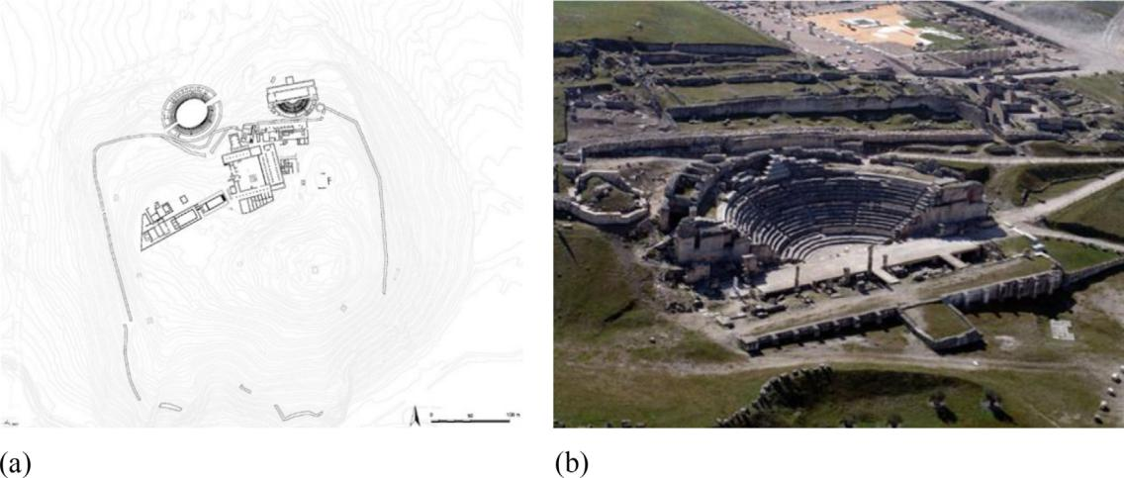

Fig. 1. (a) Archaeological topography of Segobriga at the peak of the high imperial era, showing both the amphitheatre and the theatre outside the urban wall. (Image: I.

Hortelano). (b) Aerial view of the Roman theatre of Segobriga and remains of the square next to the wall in 2006 (Image: Segobriga Archaeological Park).

eral blocks of houses contemporary to the pre-Augustus phase, built with masonry plinths, adobe elevations, and wooden roofs. In the same sector, a triple cella temple and the so-called Thermae near the theatre formed part of the urban fabric of that time [22].

Segobriga would end up becoming a municipium during the time of Augustus. The granting of this municipal status entailed an urban renewal programme that followed the architecture of a Roman city. The experience of Hellenism brought to Rome the sys-tem of terraces, which levelled and expanded the space available in built-up cities [23]. This was the case of Segobriga, where the solu-tion to the building of a crypto-porticus involved the maintenance of a regular level in the construction of a public space and took advantage of the hillsides to support part of the performance buildings.

The city occupied 10.5 ha and was surrounded by a wall. Its main access was through the door located to the north, which gave onto the north–south main street or kardo maximus, which was one of the most important urban road axes (Fig. 1a).

The performance buildings were designed and built on the out-skirts of the city. The theatre and the amphitheatre occupied the northern slope of the hill, and flanked the main entrance to the city and were practically attached to the wall. Both held prominent positions within the city, despite being located in peri-urban land, and were integrated into the urban space through their accesses (Fig. 1b).

During the imperial era, Segobriga was a large urban centre of the southern plateau of Hispania, which had gone from being a small fortified village to becoming a municipality with a strong external projection thanks to the wealth generated by the exploita-tion and commercialization of the lapis specularis. Its privileged location at the crossroads linking the Ebro valley with the Bética and Lusitania valleys, and the peninsular centre with the Valencian port and especially with Carthago Nova, also made Segobriga a major centre of commerce with the Mediterranean, where materi-als and products from different sources arrived [24].

2.1. The Roman theatre of Segobriga

In the descriptions and discoveries regarding the hill of Cabeza de Griego between the XVI and XIX Centuries, the existence of a theatre is not mentioned. The performance building remained undocumented until the middle of the XX Century, when its exca-vation began. For centuries, it was pillaged in the same way as that

of the remains of Roman buildings, although the collapse of its scaenae frons onto the stands in the III Century AD favoured its con-cealment, thereby preventing its complete plunder.

Archaeological work in the theatre began in 1953 under the direction of Gaspar de la Chica. In 1962, the excavation in the the-atre was resumed by M. Almagro Basch, which extended until 1970, when most of the building was revealed and a significant set of architectural and sculptural elements that had adorned the scaenae frons were discovered. The first restoration of the theatre was undertaken in 1966–67 by the architect J. Menéndez Pidal.

According to a large monumental inscription, whose remains have appeared among the ruins, the construction of the theatre began in the time of Tiberius, and was built in the time of Claudius or Nero, and finally it was inaugurated in the time of Titus or Ves-pasian, in approximately 79 AD.

The theatre of Segobriga presents a small almost semi-circular cavea, of 63.7 m in diameter, with its proscenium 6.5 m wide and 42 m long. The pulpitum is 25.6 m long. The stands offer three dis-tinct zones: the ima, media, and summa cavea. Each of these zones consists of five steps separated by a balteus, behind which runs a praecinctio, which served as an access, that leads towards the vom-itoria. In the lower part of the stands, three privileged tiers are placed around the orchestra, the proedria, destined as seats for the members of the ordo decurionum and carved into the natural rock as a large part of the cavea. The capacity of the theatre is 1500 spectators, which rises to 1900 if the summa cavea seats are included (Fig. 2).

The pulpitum wall was articulated with a series of semi-circular and rectangular niches, decorated with a continuous leafy kyma frieze, and where striated and spiral shaft pilasters were sculpted. The underground chamber, or hyposcaenium is preserved in good condition. It conserves six pits, where the curtain and the machin-ery for its descent or elevation were housed, together with the stone pillars that supported the wooden floor of the stage. The adi-tus maximi of the main access to the orchestra joins the scenic building and the curve of the stands. Given that their preserved remains start on the eastern side, they would have been covered by vaults.

The scaenae frons has not been preserved. Three doors opened onto it: the central or valva regia and the lateral or valva hospitalar-ium, from which the actors left, which led to a long straight corri-dor located between the back of the wall of the monumental scaena and the enclosing wall of the construction (Fig. 2). It is possible to

4 M. Galindo et al. / Applied Acoustics 166 (2020) 107373

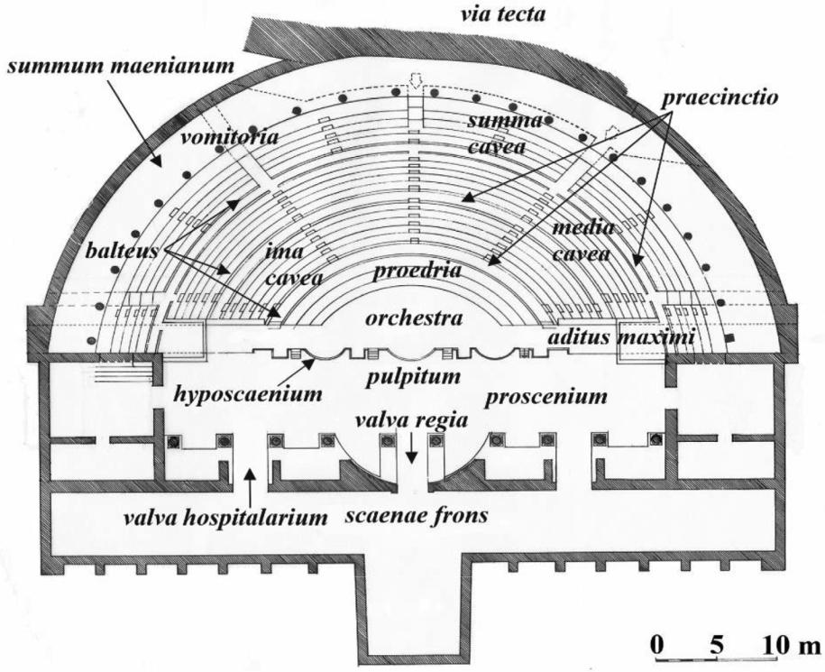

Fig. 2. Parts of the Roman theatre of Segobriga (adapted from diagrams by M. Almagro Basch and A. Almagro).

extrapolate the orders of the scaenae frons from the preserved architectural elements: it would reach 16.6 m high and have two floors decorated with columns of the Corinthian order [25].

The theatre was linked, above the wall, to a porch supported by a lower crypto-porticus, which provided access to a large square that was set around a pre-existing temple. The level of circulation achieved through the use of this structure would be that of the summum maenianum (arcaded gallery) above the stands of the theatre.

The central part of the outer ring of the theatre, known as the summa cavea, rests on the city wall [26]. In this way, access to the theatre from inside the city would be through this square. A via tecta ran between the wall and the theatre, linking the north gate with the eastern gate and, in addition, allowed an increase in the capacity of the building (Fig. 2a).

The theatre of Segobriga today remains one of the principal buildings of the Roman city and constitutes one of the emblematic monuments of the Archaeological Park. The installation of wooden parquet in its proscaenium has, since 1984, enabled the annual cel-ebration of a theatre festival that still continues today (Fig. 3a and b). It is sporadically used for concerts, cultural events such as book presentations, and educational activities. The absence of the scae-nae frons determines the configuration of the performances, limits the layout of the scenography elements, and provokes the loss of sound.

2.2. The Roman amphitheatre of Segobriga

The outer wall of the northern stands had always been visible, and the oval shape of its arena was distinguished, according to the description by Ambrosio de Morales in 1574. Its excavations began at the end of the XVIII Century and the beginning of the XIX Century when the access doors to the arena, and one of the praecinctiones of the northern cavea were discovered. Subse-quently, its remains would eventually be covered in earth until vir-

tually no evidence of the building on the hillside remained. The first excavation campaigns were carried out on the amphitheatre at the same time as those in the theatre, although the archaeolog-ical work of recovery by M. Almagro Basch took place between 1972 and 1986. The latest intervention in the amphitheatre was carried out in the period 2011–2013 within the framework of a consolidation and adaptation project of the southern cavea, financed by the national government and the regional government.

As in the theatre, the construction of the amphitheatre began in Tiberian times, and was inaugurated in the Vespasian era [27]. The amphitheatre measured 74 m in length and 66.2 m in maximum width, with an area in the arena that reached 1377 m2. The original capacity of the building is established as having been 5500 specta-tors. Structurally, it is built as two distinct halves: the southern side is attached to the hillside and is partially excavated into the rock while the northern half rises from its foundations with a structure formed by three rings, which constitute the façade wall, the balteus wall, and the first praecinctio and the tiers of honour.

The podium is constructed in the northern stands with a high wall of ashlars and, in a large part of the southern zone, in the carved rock itself, crowned by a moulding that in turn delimited the first praecinctio of the stands. A perimeter gallery next to the north podium, covered by large stone slabs, linked the gates and gave access to the arena. The gate located to the east, or Porta Tri-umphalis, has two sections of vaults supported by three arches and retains the traces of its threshold, which enables the restoration of a two-door gate and a smaller door for access to the service corri-dor. The West Gate, which was also covered by vaults, has a very steep staircase carved into the rock and shows evidence of having been closed by a single door. Next to these gates, on their northern side, two vaulted carceres of similar size were placed (Fig. 4).

The stands of the Segobriga amphitheatre are divided into two maeniana, the ima and the summa cavea, which are separated by the balteus wall. The seats of the ima cavea were made of stone, while those of the upper part were made of wood. The most remote

|  |  |
| --- | --- |
| M. Galindo et al. / Applied Acoustics 166 (2020) 107373 | 5 |

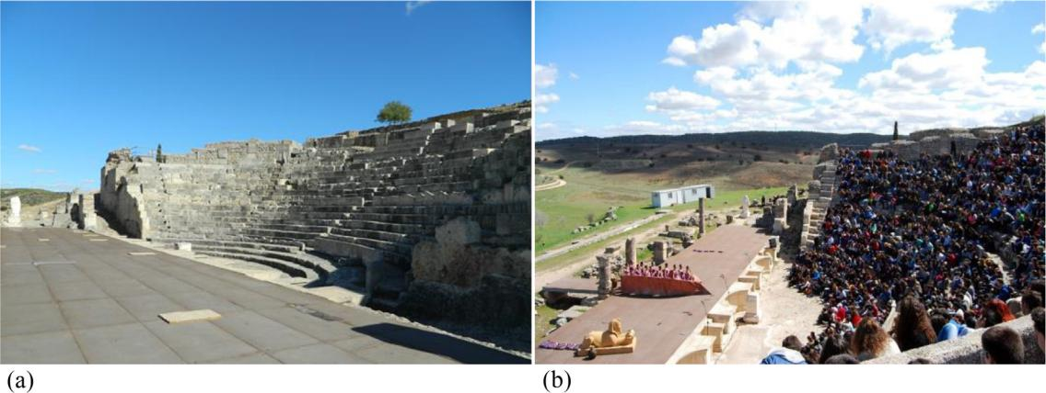

Fig. 3. Roman theatre of Segobriga (Saelices, Cuenca, Spain): (a) Cavea of the theatre (Image: The authors); (b) Day of performances during the Segobriga Classical Theatre

Festival in the Spring of 2017 (Image: R. Cebrián).

Fig. 4. Parts of the Roman amphitheatre of Segobriga (adapted from A. Almagro).

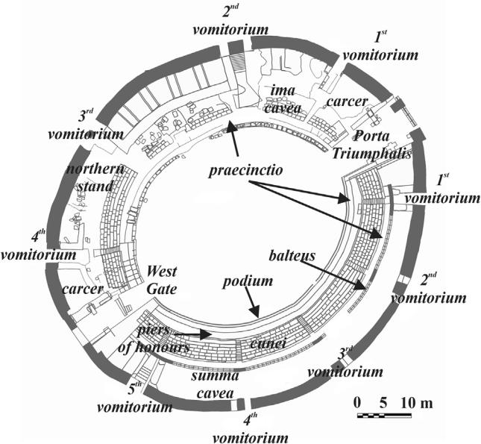

antecedents of wooden stands date back to the late republican era, as a result of the prohibitions decreed against permanent perfor-mance buildings in the city of Rome [28].

The ima cavea began with an annular corridor next to the podium of the arena, behind which ran a tier for preferential seat-ing and seven rows of stands, the first with footrests. A second cor-ridor was located on the same level as the top row of stands and adjacent to the balteus wall. Five radial staircases provided com-munication between the two praecinctiones and divided the stands into six cunei. A structure of ashlars located in the centre of the 4th cuneus, which occupied the entire grandstand, and resting on the small vaulted room accessible from the arena, enabled preferential seats to be raised, which probably constituted a box reserved for the president or the director of the games.

Today the amphitheatre is used for historical recreation in the framework of the cultural activities of the Archaeological Park (Fig. 5b) and for musical performances (Fig. 6a).

3. Experimental methods

Measurements were carried out on the theatre and amphithe-atre without the presence of the public. There was no wind during measuring time (air velocity less than 0.5 m/s) and environmental conditions were monitored by means of measuring the tempera-ture (range in the theatre 27.9–44.3 LC; range in the amphitheatre 18.4–41.7 LC) and relative humidity (range in the theatre 17–

44.4%; range in the amphitheatre 21.2–76.1%) and by following the recommendations of the ISO 3382-1 standard [29].

The process of generation, acquisition, and analysis of the acoustic signal was performed via the application of the EASERA v1.2 programme, through an AUBION x8 multichannel sound card. In the theatre, 3 source positions have been considered: two located in the proscaenium, T0 and T1, and one in the orchestra, T2. There were also 19 reception points, distributed across the cavea, the proedria, and the proscaenium (see Fig. 7). In the amphitheatre, three source locations were established in the arena, A0, A1, and A2, and 15 reception points were distributed in the southern tiers and in the arena (Fig. 8, northern tiers were not restored and do not accommodate an audience). At each reception point, located at 1.20 m from the floor in all cases, the room impulse responses (RIRs) were registered by exciting the space with sine-swept signals (10.9 s long for the theatre and 20.8 s for the amphitheatre), in which the scanning frequency increased exponentially with time. The frequency range, the level, and the duration of the excitation signal were adjusted so that the fre-quency range would cover the octave bands from 63 to 16,000 Hz, and the impulse response to noise ratio (INR) would be at least 45 dB in each octave band to guarantee accuracy of cer-tain parameters, such as T30 [30].

The generated signal was emitted through an AVM DO-12 dodecahedral sound source with a B&K 2734 power amplifier, for the three positions of the source located 1.50 m above the floor. At each reception point, RIRs were captured by means of an Audio-Technica AT4050/CM5 microphone in its omnidirectional and figure-of-eight configurations connected to a Sound Field SMP200 polarisation source. The binaural RIRs were obtained with a Head Acoustics HMS III torso simulator (Code 1323) and a B&K-2829 microphone polarization source (Fig. 6b). The background noise level was recorded with an SVAN 958 analyser, of SVANTEK. The B&K 4190 microphone was used with a B&K 2669 preamplifier and with the B&K Type 2829 4-channel microphone power supply.

6 M. Galindo et al. / Applied Acoustics 166 (2020) 107373

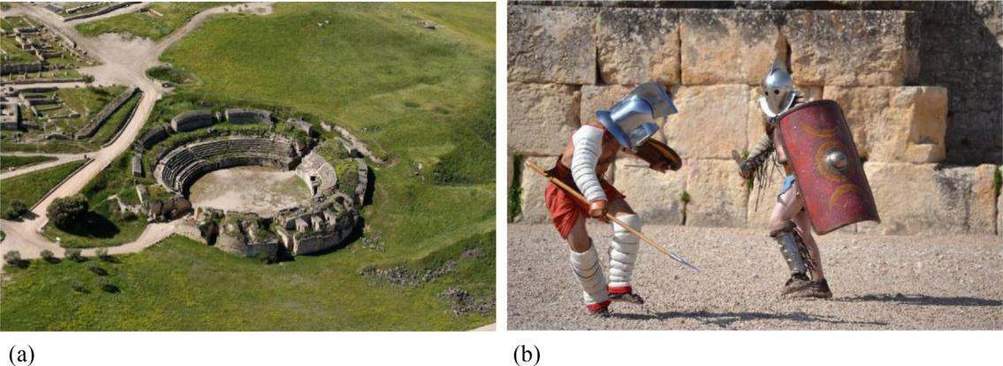

Fig. 5. (a) Roman Amphitheatre of Segobriga. Aerial view before the restoration of its southern tier (Image: Segobriga Archaeological Park). (b) Recreation of gladiatorial

combat during the autumn of 2014 in the Amphitheatre of Segobriga, showing the perimeter wall of the arena (Image: I. Hortelano).

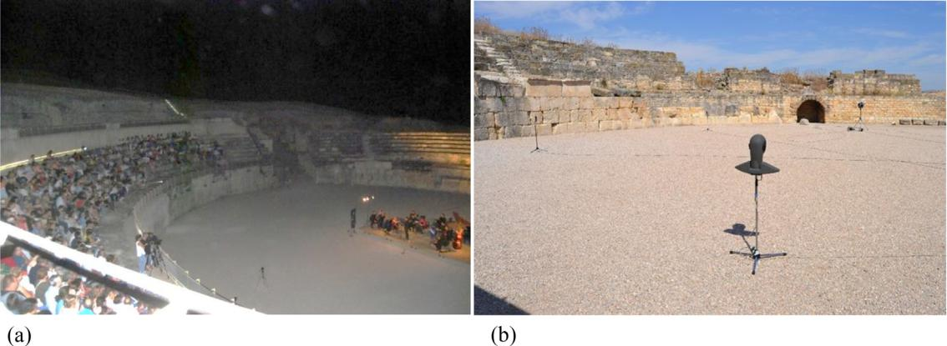

Fig. 6. (a) Classical music concert in the amphitheatre (Image: R. Cebrián). (b) Omnidirectional sound source, bidirectional microphone, and torso simulator in the arena of

the amphitheatre (Image: The authors).

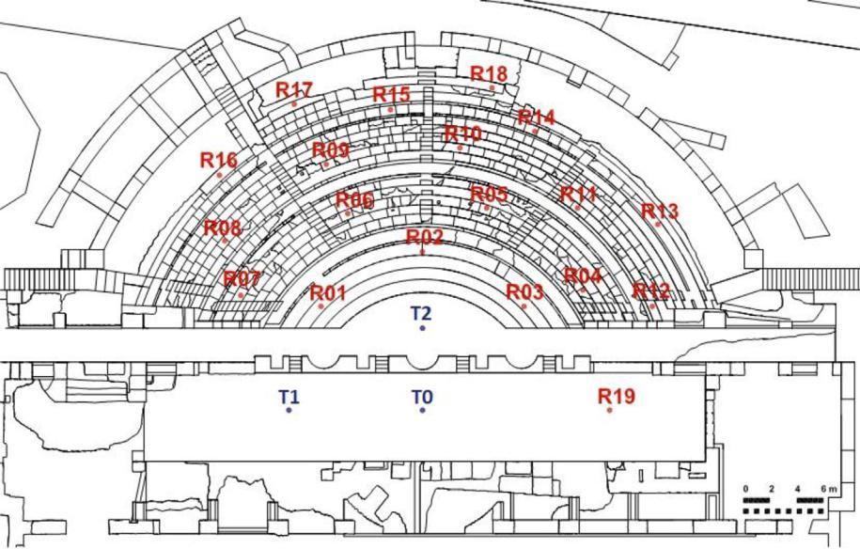

Fig. 7. Ground plan of the theatre with the source positions (T) and receptors (R) shown.

|  |  |
| --- | --- |
| M. Galindo et al. / Applied Acoustics 166 (2020) 107373 | 7 |

Fig. 8. Ground plan of the amphitheatre, with the source positions (A) and receptors (R) shown. The foci of the ellipse F and F’ are also shown.

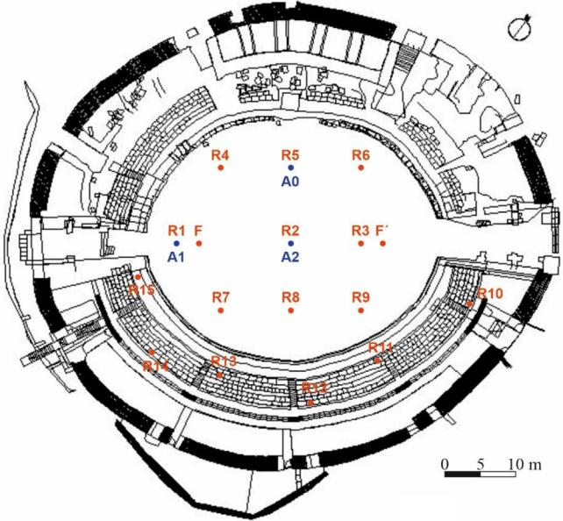

1. Experimental results and discussion of the Roman theatre and amphitheatre

This section presents and analyses the results of impulse signals and of the acoustic parameters attained in the two classical perfor-mance spaces of the archaeological city of Segobriga, in terms of temporal, energy, and spatial parameters and speech intelligibility indices. Given their uniqueness, the signals are also analysed when the source and receiver are located at the conjugate focal points of the ellipse of the arena of the Segobriga amphitheatre. Finally, auralisations are presented for comparison, for the amphitheatre at receiver R13, and for the theatre at receiver R11, in both cases for the three positions of the source.

4.1. Room impulse responses and time parameters

Analyses of RIRs in these singular spaces should be carried out with special attention. Since they are open spaces, the reverbera-tion times are confined between 0.5 and 2 s, depending on their conservation status and the various interventions that they have suffered in recent centuries: in the case of theatres, these interven-tions are mainly due to the presence or absence, to varying degrees, of parts of the cavea and the scaenae frons; in the case of amphitheatres, in addition to the cavea, they are largely due to the various heights of the podium that delimits the elliptical space of the arena. These are therefore spaces with rapid energy decays. This is especially expected in the case of the Roman theatre of Segobriga, where there is no scaenae frons. Consequently, early reflections take on a special importance in the acoustics of these buildings, which may reach the spectator distanced in time, which gives rise to non-linear acoustic energy-decay curves.

In the case of the Roman amphitheatre under study, it is expected that this non-linearity exists, due to the geometric partic-ularity of the space formed by the podium and the arena together with the presence of the ellipse foci.

The analysis of the RIRs and the energy-decay curves for each receptor has shown that, in the case of the theatre, for all the source positions and for all frequencies, the energy-decay curves are linear [31]; however, this is not the case for the amphitheatre.

In order to show the suitability of the registered room impulse responses, a typical measured broadband RIR and the energy-decay curves filtered by frequency for different source-receiver combina-tions in the theatre and amphitheatre are presented in Fig. 9.

For the theatre, Fig. 9(a) corresponds to the combination of the sound source in the centre of the stage, T0, and receiver 10. In Fig. 9 (b), the Schroeder curve for the same source-receiver position fil-tered at 125 Hz is displayed. For the amphitheatre, Fig. 9(c) corre-sponds to the combination of the sound source near one focus of the ellipse, A1, and receiver 10. In Fig. 9(d), the Schroeder curve for the same source-receiver position filtered at 125 Hz is dis-played. As commented below, several of the RIRs in the amphithe-atre give inadequate energy-decay curves and the acoustical parameters related with reverberation time (T30, T20, T10, EDT) must be called into question.

In order to assess the linearity of decays in this space, parame-ters C and n, defined in Annex B of the ISO 3382–2: 2008 standard [32], are analysed.

|  |  |  |  |  |  |
| --- | --- | --- | --- | --- | --- |
| T30 |  |  | ð%Þ | ð1Þ |  |
| C ¼ 100 T20 | 1 |  |

C values between 0% and 5% denote linearity in the decay, while values above 10% indicate a decay curve that digresses far from a straight line.

The non-linearity parameter, n, is expressed as:

n ¼ 1000 1 r2 ð%Þ ð2Þ

where r is the coefficient of linear correlation between the line of best fit and the curve of energy decay. Values of n between 0‰ and 5‰ denote linearity in the decay, while values above 10‰ indi-cate a decay curve that cannot resemble a straight line.

The results show major dependence on the source location. Non-linear energy-decay curves are more frequent when the source is located near the focus of the ellipse, A1, and improve when the source is on the minor axis, A0, especially in the centre of the ellipse, A2. According to the n parameter, the number of cases that verify a value equal to or less than 5‰ with respect to the total points and frequencies analysed, corresponds to 0%, 29.8%, and 36.9% for sources A1, A0, and A2, respectively. For the C parameter, the standard states that it should not take negative values. However, in the case of the amphitheatre (see Fig. 9d), this requirement is not always met. Values that fall within the range [ 5, +5] % have therefore been chosen as appropriate. Taking this range into account, the percentage becomes 17.9%, 76.2%, and 83.3% for the same sources.

Despite the lack of linearity in the energy decay in certain cases in the amphitheatre, in all frequencies, and for the two buildings, a sufficient range is obtained in the impulse-response-to-noise ratio (INR > 45 dB in each octave band). Table 1 shows the average of the INR in all octave bands with their associated standard errors for the assessment of the spatial dispersion. The lowest values are obtained for the position of source A2 in the amphitheatre. Like-wise, the measured equivalent continuous sound level of back-ground noise is 33.10 dBA for the theatre and 33.02 dBA for the amphitheatre.

As for reverberation times, Fig. 10 shows the measured values of the early decay time, measured reverberation time T10, reverbera-tion time T20, and reverberation time T30, all versus the frequency in octave bands for the three sources analysed, together with their standard errors for the assessment of the spatial dispersion in each octave band in the theatre and in the amphitheatre.

In the case of the theatre, for all frequencies, short reverberation values are obtained in consonance with it being an open space and with the absence of the stage front. The three sources have very similar behaviour with only small variations between them in

8 M. Galindo et al. / Applied Acoustics 166 (2020) 107373

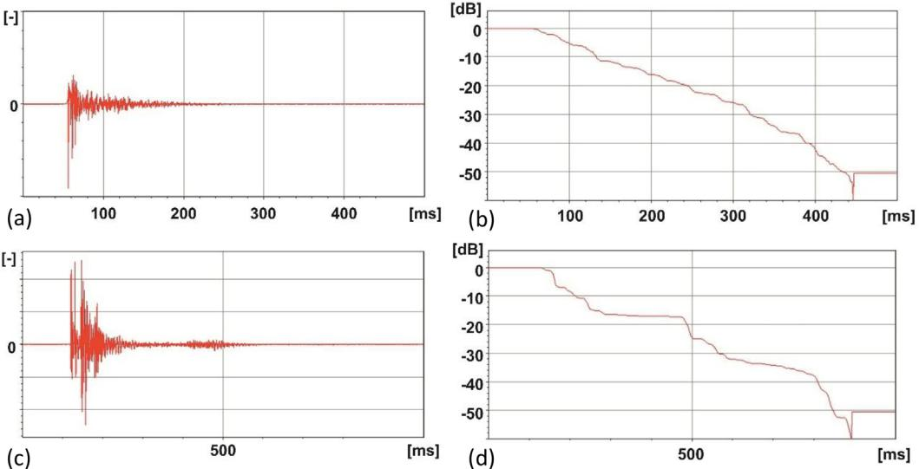

Fig. 9. (a) Room impulse response (T0-R10 combination in the theatre). (b) Schroeder curve at 125 Hz at the same position in the theatre. (c) Room impulse response (A1-R10 combination in the amphitheatre). (d) Schroeder curve at 125 Hz at the same position in the amphitheatre.

Table 1

Spatially averaged values of the INR (dB) in all octave bands (first row) with their associated standard errors (second row) for each of the three sources in the theatre and in the amphitheatre of Segobriga.

|  |  |  |  |  |  |  |
| --- | --- | --- | --- | --- | --- | --- |
| Frequency (Hz) | 125 | 250 | 500 | 1000 | 2000 | 4000 |
|  |  |  |  |  |  |  |
| T0 Theatre | 52.61 | 66.06 | 72.44 | 60.45 | 62.94 | 73.88 |
|  | 2.21 | 2.58 | 1.38 | 0.98 | 0.66 | 3.94 |
| T1 Theatre | 52.51 | 66.46 | 69.97 | 58.89 | 63.17 | 78.05 |
|  | 1.66 | 2.86 | 1.20 | 1.16 | 0.57 | 1.51 |
| T2 Theatre | 52.49 | 67.56 | 72.73 | 56.66 | 66.22 | 73.67 |
|  | 1.90 | 2.01 | 1.88 | 1.89 | 0.34 | 0.64 |
| A0 Amphitheatre | 58.84 | 62.59 | 68.48 | 57.65 | 62.19 | 74.65 |
|  | 1.28 | 2.41 | 2.00 | 1.00 | 0.81 | 0.88 |
| A1 Amphitheatre | 53.63 | 70.40 | 72.35 | 55.92 | 58.83 | 76.33 |
|  | 1.84 | 1.39 | 0.53 | 2.21 | 4.13 | 1.24 |
| A2 Amphitheatre | 48.77 | 57.05 | 60.86 | 52.43 | 54.56 | 67.02 |
|  | 1.23 | 1.93 | 2.18 | 2.36 | 1.71 | 2.72 |
|  |  |  |  |  |  |  |

EDT, T20, and T30. Only T10 for the source located in the centre of the stage shows variations with the other sources at medium and high frequencies. There is generally a coincidence of the values of EDT and T10 on the one hand (with the exception of the results of T0), and of T20 and T30 on the other hand. The spatial dispersion remains, in all cases, very small and these short reverberation val-ues are obtained in line with being an unroofed space and the absence of the stage front. Longer values were found in other Span-ish Roman theatres, such as in Italica, (Santiponce, Seville) [33], and Regina Turdulorum, (Casas de Reina, Badajoz) [34]. Both the-atres present, to a greater or lesser extent, a stage front and larger and smaller dimensions respectively than the Segobriga theatre. The standard errors are low and minor when the source is placed in the orchestra.

In the case of the amphitheatre, a considerable increase of T30 values takes place at all frequencies with an average increase at mid frequencies of 0.9 s. The most similar behaviour at all frequen-cies takes place for the sources A0 and A2, located on the minor axis of symmetry and in the centre of the arena, respectively. For the position of the source in A1, near one focus of the ellipse, reverber-ation times are slightly shorter at low frequencies than in the other two positions, since the values for all sources converge from 1 kHz onwards. The EDT values differ notably for each source position, whereby the longest values are presented in the centre of the arena.

In Fig. 10, for the amphitheatre, the values corresponding to the points that meet the condition of not exceeding 10% and 10‰, at all

frequencies, in the values of the indices of C and n respectively, have also been included in all the temporal parameters, which implies an increase in the standard error. In addition, the number of points that meet this condition changes with the position of the source. For the source in the centre of the ellipse A2, the per-centage of valid points is 71.2%; when the source is on the minor axis A0, then this figure falls to 28.6%; and when the source is near the focus A1, to 16.7%.

Based on these results, it can be observed that the values of EDT, T10, T20, and T30 are coincident at all frequencies with the values obtained that include all points for sources A2 and A0, with slight discrepancies for source A0 in the EDT values at high frequencies. For source A1, the behaviour is similar to that obtained when all points are included, although it remains true that there are greater differences for the different ranges of energy decay in the various octave bands. These are minimized by analysing the first 35 dB of decay.

4.2. Sound focalization in the amphitheatre of Segobriga

Throughout the history of architecture, the use of concave sur-faces has been very common, and these surfaces constitute a well-known problem in room acoustics. Prediction of the sound field by geometrical methods of the full reflection against a hard concave surface, and its approximation to various conic sections, as a func-tion of the distance of the source from the reflector and the curva-

|  |  |  |  |  |  |  |  |  |  |  |  |  |  |  |  |  |  |  |  |  |  |  |  |  |  |  |  |  |  |  |  |  |  |  |  |  |  |  |  |  |  |  |  |  |  |  |  |  |  |  |  |  |  |  |  |  |  |  |  |  |  |  |  |  |  |  |  |
| --- | --- | --- | --- | --- | --- | --- | --- | --- | --- | --- | --- | --- | --- | --- | --- | --- | --- | --- | --- | --- | --- | --- | --- | --- | --- | --- | --- | --- | --- | --- | --- | --- | --- | --- | --- | --- | --- | --- | --- | --- | --- | --- | --- | --- | --- | --- | --- | --- | --- | --- | --- | --- | --- | --- | --- | --- | --- | --- | --- | --- | --- | --- | --- | --- | --- | --- | --- |
|  |  |  |  |  |  |  |  |  |  |  |  |  |  |  | M. Galindo et al. / Applied Acoustics 166 (2020) 107373 | | | | | | | | | | | | | | | | | | | | | | | | | | | | | | | | | | | | | | | | | | | | | | | | | | | 9 | |
|  |  | | | | | | | | | | | | | | | | | | | | | | | | | | | | | | | | | | | |  | | |  | | | | | | | | | | | | | | | | | | | | | | | | | |  | |
|  |  | | | | | | | | | | | | | | | | | | | | | | | | | | | | | | | | | | | |  | | |  |  |  |  | | | | | | | | | | | | | | | | | | | | | | |  | |
|  |  | | | | | | | | | | | | | | | | | | | | | | | | | | | | | | | | | | | |  | | |  | |  | | | | | | | | | | |  | | |  | | | | | | | | | |  | |
|  |  |  | | |  | | | | | | | | | | | | | | | | | | | | | | | | | | | | | | | |  | | |  | |  | |  | | |  | | | | | | | | | | | | | | | | | | |  | |
|  |  | | | | |  | | |  | | | | | | | | | | | | | | | | | | | | | | | |  | | |  |  | | |  | |  | | | | | |  | | | |  | | | | | | | | | | | | | |  | |
|  |  | | | | |  | | |  | | | | | | | | | | | | | | | | | | | | | | | | | | | |  | | |  | |  | | | | | | | | | | | | | | | | | | | | | | | |  | |
|  |  | | | | | | | | | | | | | | | | | |  | | |  | | | | | | | | | | | | | | |  | | |  |  |  |  |  | | |  | | | | | | | | | | | | | | | | | | |  | |
|  |  |  | | |  |  | | |  | |  | | | |  |  | |  |  | | |  | | | | | | | | | | |  | | |  |  |  | |  |  | |  |  | | |  |  | | | |  |  | | |  |  | | | |  |  | | |  |  | |
|  | | | | | | | | | | | | | | | | | | | | | | | | | | | | | | | | | | | | | | |  |  | | | | | | | | | | | | | | | | | | | | | | | | | |  |  |
|  | | | | | | | | | | | | | | | | | | | | | | | | | | | | | | | | | | | | | |  |  | | | | | | | | | | | | | | | | | | | | | | | | | | | |  |
|  |  | | | | | | | | | |  | | | |  |  |  |  |  | |  |  | | | | | | | | | | |  | | |  |  | | |  | | | | | | | | | | | | | | | | | | | | | | | | | |  | |
|  |  |  | | |  |  | | |  | |  | | | |  |  | |  |  | | |  | | | | | | | | | | |  | | |  |  | | |  |  | |  |  | | |  |  | | | |  | |  |  | | |  |  |  |  | | | | |  | |
|  |  | | | | | | | | | | | | | | |  | |  | | | | | | | | | | | | | | |  | | |  |  | | |  | | | | | | | | | | | | |  | | |  |  | | | |  |  | | |  |  | |
|  |  | | | | | | | | | | | | | | | | | | | | | | | | | | | | | | | | | | | |  | | |  | | | | | | | | | | | | | | | | | | | | | | |  |  | |  | |
|  |  | | | | | | | | | | | | | | | | | | | | | | | | | | | | | | | | | | | |  | | |  | | | | | | | | | | | | | | | | | | | | | | | | | |  | |
|  |  |  | | |  | | | | | | | | | | | | | | | | | | | | | | | | | | | | | | | |  | | |  |  | |  | | | | | | | | | | | | | | | | | | | | | | |  | |
|  |  |  | | |  |  | | |  | |  | | | |  |  | |  |  | | |  | | | | | | | | | | |  | | |  |  | | |  |  | |  | | | | |  | | | |  |  | | |  | |  | | |  |  | | |  |  | |
|  |  | | | | | | | | | | | | | | | | | | | | | | | | | | | | | | | | | | | |  |  |  |  | | | | | | | | | | | | | | | | | | | | | | | | | |  |  |
|  | | | | | | | | | |  | |  | | | | | | | |  | | |  | |  | | |  |  | |  | | | | | | | | | | | | | | | | | | | | | | | | | | | | | | | | | | | | |
|  | | | | | | | | | |  | |  | | | | | | | |  | | |  | |  | | |  |  | |  | | | | | | | | | | | | | | | | | | | | | | | | | | | | | | | | | | | | |
|  | | | | | | | | | |  | |  | | | | | | | | |  | | |  | |  |  | | |  | |  | | | | | | | | | | | | | | | | | | | | | | | | | | | | | | | | | | | |

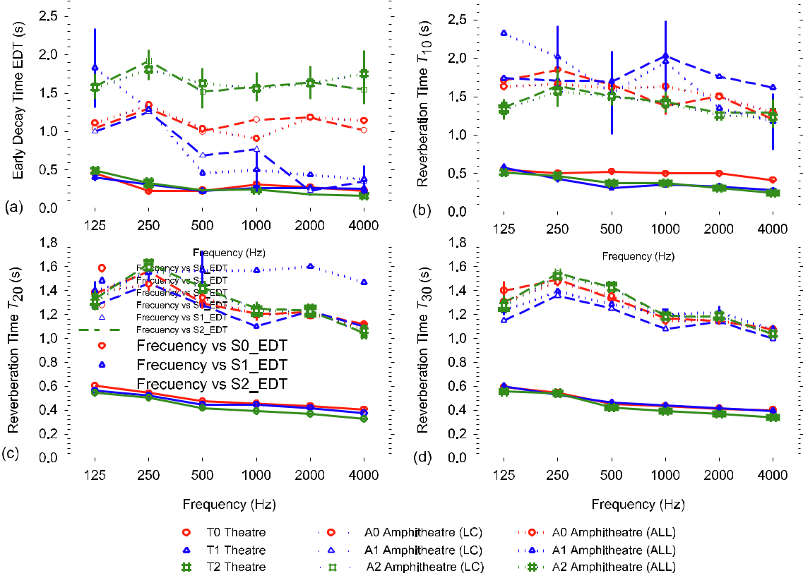

Fig. 10. (a) Early decay time; (b) measured reverberation time T10; (c) measured reverberation time T20; (d) measured reverberation time T30 and their standard errors versus frequency octave band for the three source positions: solid lines for the three sources in the theatre, dashed lines for the three sources in the amphitheatre with points with linearity criteria (C 10% and n 10‰) (LC), and dotted lines in the amphitheatre with all reception points (ALL).

ture radius ratio, have been described by Cremer and Müller [35]. The concentration of reflections can cause serious acoustic defects, such as echoes, flutter echoes, unbalanced amplification, and incor-rect source localisation. Vercammen [36] provides a mathematical approximation based on the wave formulation of the sound field in and around the focal point due to reflections by a spherical surface [37].

The ellipse of the arena of the amphitheatre presents the prop-erty that the sum of the distances from the two foci to any point on the ellipse remains constant. Furthermore, this curve has the pecu-liarity that the rays from the two foci form the same angle with the tangent to the perimeter. Therefore the rays that radiate from one focus, no matter what the direction, are all collected at the other focus by reflection and at the same time. Due to these properties, the temporal delay between the direct sound and these collected reflections when the source and receiver are located at the two conjugate foci is:

Dt ¼ 2ð a f Þ ð3Þ c

where a is the major semi-axis of the ellipse, f the focal length, and c the velocity of sound in air.

In order to illustrate these phenomena, Fig. 11 shows the impulse response measured with the source at position F, and the microphone at position F’ (see Fig. 7), in wide band, and filtered at 125, 500, and 4000 Hz octave bands.

At the focal point, the amplification of the pressure in relation to direct sound appears not to depend heavily on wavelength (see Fig. 11b and c), in contrast to that highlighted by Vercammen for spherical and cylindrical surfaces [37].

According to the geometrical data of the amphitheatre, 2a = 42.8 m, 2f = 26.25 m, and the velocity of sound in air is 354 m/s, calculated at the dry air temperature of the amphitheatre. Substitution in (3) yields Dt = 46.8 ms which corresponds to that measured in the RIR of 48.5 ms, and therefore the delay is shorter than the threshold of echo detectability. The small differences between the two values are probably due to imperfections in the construction of the ellipse.

With respect to the direct level, there is an increase in the level of sound pressure of 6 dB in wide band, a value which is of the same order of magnitude as the theoretical amplifications carried out by Wulfrank and Orlowski [38] from the reflection of a cylin-drical wall stage: their amplifications were in the order of 3– 5 dB, depending on the listener’s distance to the stage and for var-ious source positions.

This sound focalization can also be illustrated with Radit2D software, which is based on the theory of image sources [39] on a flat plot (Fig. 12). The 2D simulation makes sense due to the height at which the microphone is placed and to the existence of a whole perimeter wall around the arena (see Fig. 5b).

The polar diagrams of the programme show that, with eight times the number of rays, (theoretically, by doubling the number of rays, the reverberant level increases by 3 dB), the reverberant level reaches greater increases than those found in situ. In these calculations, only purely specular reflections without absorption are considered. The reduction, expressed in DL, of the reflected energy from sound-absorbing materials can be based on the sound absorption coefficient of the material: DL = 10 log (1 a). For prac-tical purposes, reductions of up to 10 dB can be achieved. These values are hard to obtain, especially for low frequencies. In addi-tion, the reduction, expressed in DL, of the reflected energy from

10 M. Galindo et al. / Applied Acoustics 166 (2020) 107373

Fig. 11. Measured impulse response with the sound source at F and the receiver at F0 in wide band, and at 125, 500, and 4000 Hz octave bands.

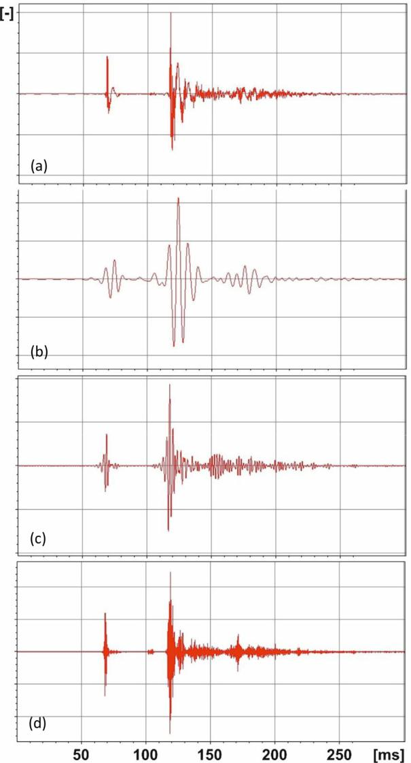

an irregular surface can be determined from the scattering coeffi-cient: DL = 10 log (1 s). Furthermore, the geometric imperfec-tions of the ellipse of the arena with respect to the mathematical ellipse can contribute to this difference.

4.3. Energy and spatial parameters. Speech intelligibility

In order to cover other subjective qualities perceived by a lis-tener, Fig. 13 shows the average values for the various octave fre-quencies and the associated standard errors for clarity (C80), definition (D50), centre time (TS), and sound strength (G), related to the clarity of the perceived sound for music and speech and to the balance between early and late sound for the first three param-eters, and to the amplification of the sound signal for the fourth parameter.

As for clarity, in the theatre, the behaviour with frequency is very similar for the three sources, with low spatial dispersion. Only for the T0 source, from 500 Hz onwards, can a drop in musical clar-ity be observed. In the amphitheatre, the spectral behaviour is very similar for the three sources, with greater spatial dispersions than for the theatre, However, while the values obtained are very simi-lar for the sources A0 and A2, at A1 the values increase consider-

ably. The proximity of the source to the focus of the ellipse suggests a greater contribution of early reflections in the first 80 ms compared to the other sources analysed. Although the results obtained in the amphitheatre are lower than those in the theatre, in both cases they can be considered appropriate for the musical message, since they exceed the usual values in auditori-ums [29]. All these comments are endorsed with the analysis of the centre of gravity of the squared impulse response, centre time, and definition in the two venues.

The sound strength presents similar trends in frequency for the theatre and for the amphitheatre. In both spaces there are signifi-cant differences in the results of the parameter according to the location of the sound source. For the theatre, when the source is placed in the orchestra, a greater amplification associated with the closer proximity to the receivers is achieved. For the amphithe-atre, the source near the focus of the ellipse has a greater spatial dispersion and less amplification of the sound than the other two sources, which is in line with the measured reverberation times. Both enclosures have adequate subjective sound levels, even when open, with values close to the lowest values found in auditoriums worldwide [29].

In order to compare the behaviour in free-field conditions with that of these unroofed venues, Fig. 14 shows the variation of the parameter Gmid (spectral average of the 500 and 1000 Hz frequen-cies) as a function of source-receiver distance for each source and for the two enclosures. The theoretical curve for free-field condi-tions is also included. In the theatre, similar values of the parame-ter are obtained for the sources in positions T0 and T1, and an attenuation with distance similar to the free-field conditions: the attenuation for T0 is 5 dB within 10 m, while for T1, this is 3.9 dB. Source T2 has greater attenuation with distance: 6.7 dB within 10 m. The coefficient of determination R squared is greater than 0.74 in the three cases in the theatre. As for the amphitheatre, the sound level perceived is very similar to that of the theatre. The attenuations for sources A0 and A2 are similar: 3.8 dB within 10 m, 4.9 dB within 10 m; again, source A1 presents the greatest differ-ence, with a very low attenuation with distance of 1 dB within 10 m. In the amphitheatre, the coefficient of determination R squared is greater than 0.84 except for source A1, which is very low.

The early inter-aural cross-correlation coefficient (IACCE) asso-ciated to the sense of spatiality for the listener as a function of fre-quency is shown in Fig. 15a. In particular, the greatest differences occur when the sound source is located on one side of the stage for the theatre, or of the arena in the amphitheatre. However, in all cases, the signals that reach the public are very similar for either ear, due to the spatial symmetry of both venues and there is no major subjective sensation of apparent source width, which is related to the value of (1-IACCE).

The results of the STI parameter as a function of source-receiver distance, Fig. 15b, indicate that, while in the theatre, for all recei-vers the results of the parameter are in the excellent range, there is, in the amphitheatre, a greater dispersion of STI values. The results of the parameter are in the excellent range only for the posi-tion of the sound source close to the focus of the ellipse, while for the other two positions of the source, the results lie within the good range. The absence of the scaenae frons in the theatre and the pres-ence of the perimeter wall of the arena of the amphitheatre are lar-gely responsible for this effect.

4.4. Differences between sources in the Roman theatre and amphitheatre

In order to quantify these differences between the sources, Fig. 16 shows the absolute differences found in terms of the octave bands for each parameter studied, by using the sound source either

|  |  |
| --- | --- |
| M. Galindo et al. / Applied Acoustics 166 (2020) 107373 | 11 |

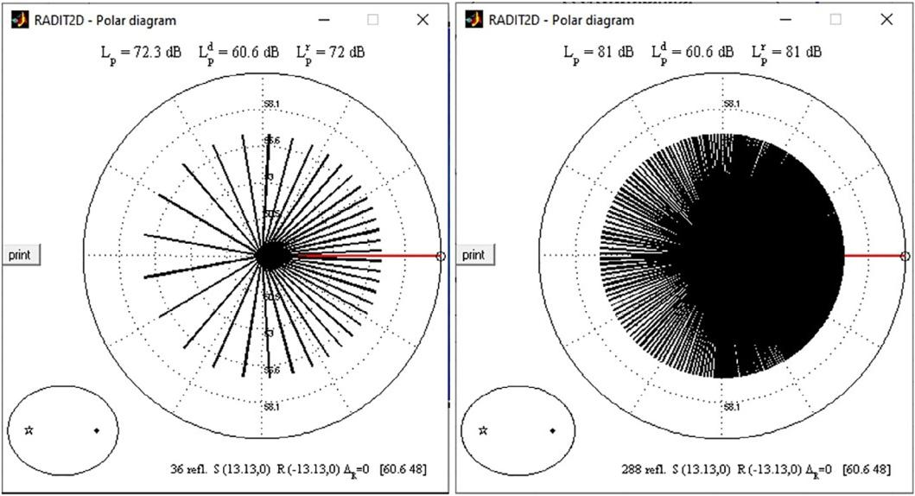

Fig. 12. Polar diagrams from RADIT2D software show the influence on the reflected sound when the number of segments to approximate the curved surface are duplicated.

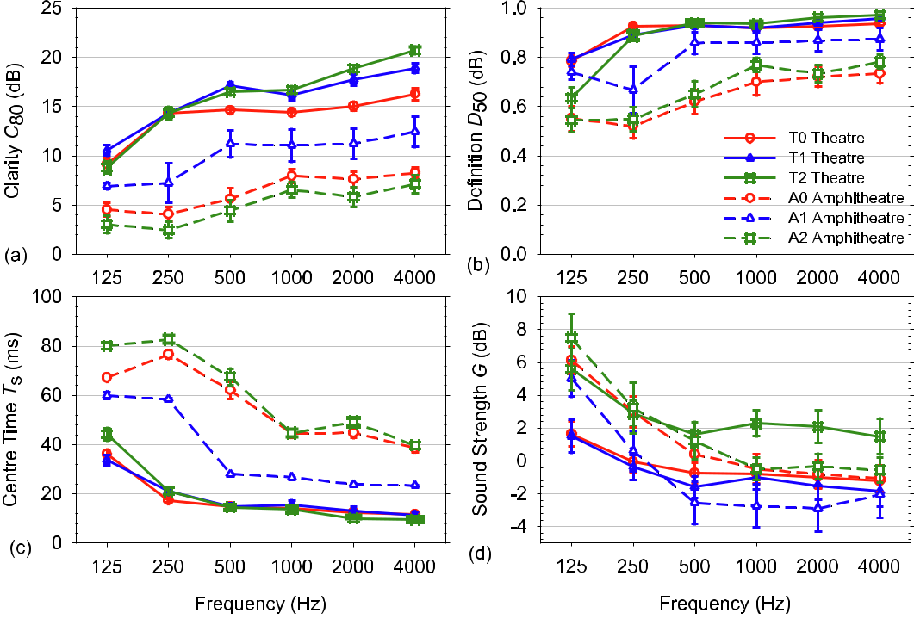

Fig. 13. (a) Clarity parameter; (b) Definition parameter; (c) Centre time; and (d) Sound strength all with their standard errors versus frequency octave band for the three source positions. For the theatre, solid lines are used, while dashed lines are employed for the amphitheatre.

located in the centre of the stage of the Roman theatre (T0) or in the minor semi-axis of the ellipse of the arena (A0) in the amphitheatre as a reference, since these are the most frequent source locations in the cultural and musical activities in these venues. These differences correspond to the mean of the absolute value of those measured for each source, divided by the corre-sponding value in each parameter of its differential threshold (JND) [29]. In this regard, it should be noted that the JND values employed refer to venues whose reverberation times are longer than those obtained in the theatre. Therefore, in the absence of

an adequate differential threshold for rooms with short reverbera-tion times, the normative JNDs of the parameters that evaluate this subjective perception, corresponding to 5% of the measured values, give rise to large differences in the present study.

In relation to the temporal parameter EDT (JND relative to 5%), there is a great variability of this parameter in these performance spaces due to the varied pattern of early reflections.

In the case of the theatre, the greatest differences occur when relating the two sources T2 and T0, which can reach values of up to 9.46 JND at 250 Hz. In the amphitheatre, the differences are

12 M. Galindo et al. / Applied Acoustics 166 (2020) 107373

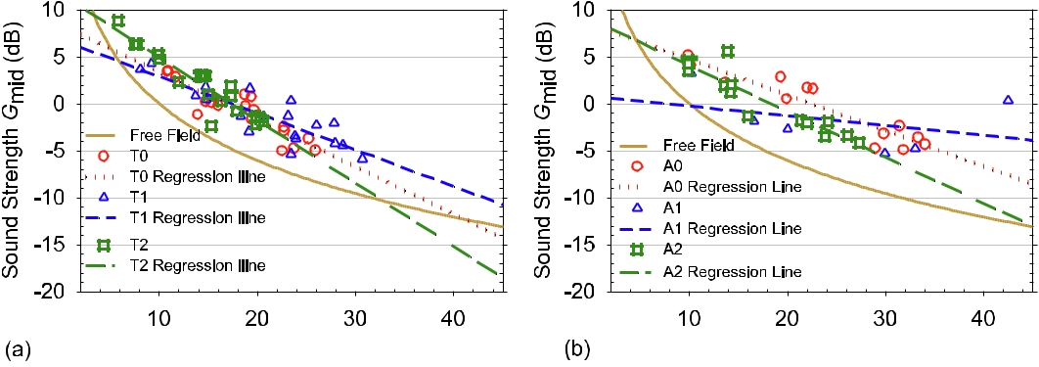

Fig. 14. Gmid (spectral average of the 500 and 1000 Hz frequencies) parameter versus source-receiver distance (a) for the theatre, (b) for the amphitheatre, in the two cases for each source with their regression lines, and in free-field conditions.

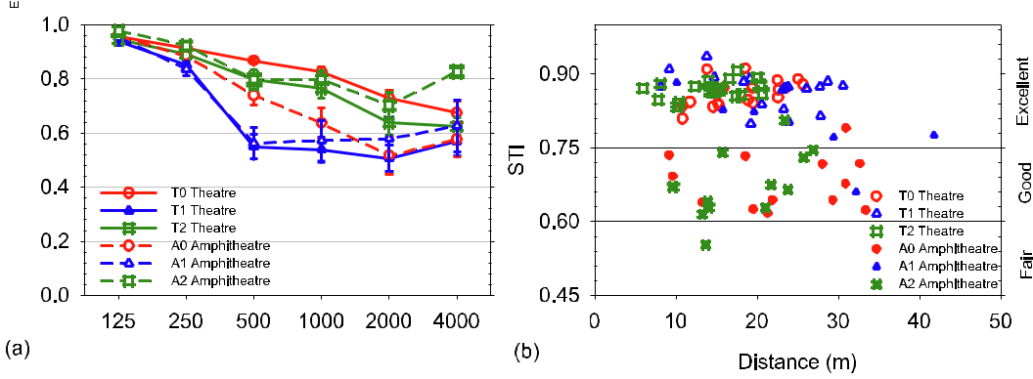

Fig. 15. (a) Early inter-aural cross-correlation coefficient, with its standard errors versus frequency octave band for the three sources in the theatre (solid lines) and in the amphitheatre (dashed lines). (b) STI versus distance in the theatre and in the amphitheatre for all sources.

markedly greater than in the theatre, both for the two sources A1 and A2 and in general for almost all frequencies, and attain values up to 14.33 JND for A2-A0 at 1 kHz.

In the case of T30, (JND relative to 5%) the differences between the sources are much smaller than in the previous time parameter. The theatre presents the greatest differences between T2 and T0, but in all cases these remain below or around 3 JND. In the amphitheatre, the differences remain close to 1 JND or less than the difference limen. It should be noted here that this comparison of EDT and T30 results has been made in the amphitheatre while taking into account the results with all reception points.

Regarding the analysis of the clarity (JND 1 dB): in the theatre at low frequencies, the differences are low for both sources (in the order of 1.5 JND); at medium frequencies, the deviations lie between 1 and 2.5 JND; and at high frequencies, the deviations between the average values of the three sources are greater and can reach up to 4.43 JND. For the amphitheatre, the greatest differ-ences are obtained between A1 and A0, where values of up to 5.57 JND can be reached at 500 Hz.

As for the definition (JND 0.05) of the oral message, in the the-atre the differences are smaller than 1 JND except certain frequen-cies; in the amphitheatre there are appreciable differences between A1 and A0 sources at all frequencies.

The centre time parameter (JND 10 ms) in the theatre presents differences of less than 1 JND for both sources and at all frequen-cies. As for the amphitheatre, there are major differences especially for A1 and A0 sources that reach up to 3.40 JND at 500 Hz.

For the sound strength parameter (JND 1 dB) in the theatre, the differences between T1 and T0 are less than 1 JND at all frequen-

cies, while for T2 and T0 there are many differences at all frequen-cies; for the amphitheatre, between sources A2 and A0, the differences are less than those between A1 and A0.

In the case of the sensation of spatiality (IACCE) (JND 0.075) in the theatre, there are very few differences for the source located at T0 and T2 at all frequencies, while between T0 and T1, there are greater differences. For the amphitheatre, the differences are less than 1 JND with certain exceptions.

As a summary, it can be stated that different subjective percep-tions can be obtained for the various source positions within the same enclosure. The major differences are due to the position of the sound source in the orchestra for the theatre, and to the posi-tion near the focus of the ellipse in the amphitheatre. This is evi-dent at all frequencies, except on very few occasions, for the parameters related to reverberation, the definition for the spoken word, and the subjective sound level for the theatre, and with the reverberation and the clarity of sound perceived in the amphitheatre. In the case of the theatre, the trend is reversed for the spatial sensation with the sound source on one side of the scaena.

If we take into account the subjective difference depending on the JND, in the theatre there are no differences between the sources on the stage for the T30, Ts, and G parameters, nor between the source on the centre of the stage and that located in the orchestra for the D50, TS, and IACCE parameters. In the amphitheatre, there are no differences between the sources located on the minor axis of the ellipse for T30, D50, TS, and G, nor between the source on the minor axis and that near the focus for T30, and IACCE.

|  |  |  |  |  |  |  |  |  |  |  |  |  |  |  |  |  |  |  |  |  |  |  |  |  |  |  |  |  |  |  |  |  |  |  |  |  |  |  |  |  |  |  |  |  |  |  |  |  |  |  |  |  |  |  |  |  |  |  |  |  |  |  |  |  |  |  |  |  |  |
| --- | --- | --- | --- | --- | --- | --- | --- | --- | --- | --- | --- | --- | --- | --- | --- | --- | --- | --- | --- | --- | --- | --- | --- | --- | --- | --- | --- | --- | --- | --- | --- | --- | --- | --- | --- | --- | --- | --- | --- | --- | --- | --- | --- | --- | --- | --- | --- | --- | --- | --- | --- | --- | --- | --- | --- | --- | --- | --- | --- | --- | --- | --- | --- | --- | --- | --- | --- | --- | --- |
|  |  |  |  |  |  |  |  |  |  |  |  |  |  |  |  |  |  | M. Galindo et al. / Applied Acoustics 166 (2020) 107373 | | | | | | | | | | | | | | | | | | | | | | | | | | | | | | | | | | | | | | | | | | | | | | | | | | | 13 |
|  | | | | | | | | | | | | | | | | | | | | | | | | | | |  |  | | | | | | | | | | | | | | | | | | | | | | | | | | | | | | | | | | | | | | | | |  |
|  |  | | | | | | | | | | | | | | | | | | | | | | | | | |  | |  | | | | | | | | | | | | | | | | | | | | | | | | | | | | | | | | | | | | | | | |  |
|  |  | | | | |  |  | | | | | | | | | | | |  | |  |  | | |  |  |  | |  | | | | | | | | | | | | | | | | | | | | | | | | | | | | | | | | | | | |  | | | |  |
|  |  | | | | |  |  | |  |  | | | |  |  | | | |  | |  |  | | |  |  |  | |  | | | | | | | | | | | | | | | | | | | | | | | | | | | | | | | | | | | |  | | | |  |
|  |  | | | | |  |  | |  |  | | | |  |  | | |  |  | |  |  | | |  |  |  | |  | | | | | | | | | | | | | | | | | | | | | | |  | | | | | |  | | | | | | |  | | | |  |
|  |  | | | | |  |  |  |  |  | | | |  |  | | |  |  | |  |  | | |  |  |  | |  | | | | | | | | | | | | | | | | | | | | | | |  | | | | | |  | | | | | | |  | | | |  |
|  |  | | | | |  |  |  |  |  |  |  | |  |  | | |  |  | |  |  | | |  |  |  | |  | | | | | | | | | | | | | | | | | | | | | | |  | | | | | |  | | | | | | |  | | | |  |
|  |  | | | | |  |  |  |  |  |  |  | |  |  | | |  |  | |  |  | |  |  |  |  | |  | | | | | | | | | | | | | | | | | | | | | | |  | | | | | |  | | | | | | |  | | | |  |
|  |  | | | | |  |  |  |  |  |  |  | |  |  |  |  |  |  | |  |  | |  |  |  |  | |  | | | | | |  |  | | | |  |  | | |  | | |  |  | | | |  |  | | | | |  |  | | | | | |  | | | |  |
|  | | | | | | | | | | | | | | | | | | | | | | | | | | |  |  | | | | | | | | | | | | | | | | | | | | | | | | | | | | | | | | | | | | | | | | |  |
|  |  | | | | | | | | | | | | |  |  | | | | | | | | | | | |  | |  | | | | | | | | | | | | | | | | | | | | | | | | | | | | | | | | | | | | | | | |  |
|  |  | | | | | | | | | | | | |  |  | | | | | | | | | | | |  | |  | | | | | | | | | | | | | | | | | |  |  | | | | | | | | | | | | | | | | | | | | |  |
|  |  | | | | | | | | | | | | |  |  | | | | | | | | |  |  | |  | |  | | | | | | | | | | | | | | | | | |  |  | | | | | | | | | | | | | | | | | | | | |  |
|  |  | | | | | | | | | | | | |  |  | | | | | | | | |  |  |  |  | |  | | | | | | | | | | | | | | | | | |  |  | | | | | | | | | | | | | | | | | | | | |  |
|  |  | | | | | | | | | | | | |  |  | | | | | | | | |  |  |  |  | |  | | | | | | | | | | | | | | | | | |  |  | | | | | | | | | | | | | | | | | | | | |  |
|  |  | | | | | | | | |  |  | | |  |  | | |  |  | |  |  | |  |  |  |  | |  | | | | | |  |  | | | |  |  | | | | | |  |  | | | |  |  | | | | | | | | | | | | | | | |  |
|  |  | | | | |  |  | | |  |  | |  |  |  | |  |  |  |  |  |  |  |  |  |  |  | |  | | | | | |  |  | | | |  |  | | | | | |  |  | | | |  |  | | | | |  |  | | | | | |  |  | | |  |
|  | | | | | | | | | | | | | | | | | | | | | | | | | | |  |  | | | | | | | | | | | | | | | | | | | | | | | | | | | | | | | | | | | | | | | | |  |
|  |  | | | | | | | | | | | | |  |  | | | | | | | | | | | |  | |  | | | | | | | | | | | | | | | | | | | | | | | | | | | | | | | | | | | | | | | |  |
|  |  | | | | | | | | | | | | |  |  | | | | | | | | | | | |  | |  | | | | | | | | | | | | | | | | | | | | | | | | | | | | | | | | | | | | | | | |  |
|  |  | | | | | | | | | | | | |  |  | | | | | | | | | | | |  | |  | | | | | |  | | | | | | | | | | | | | | | | | | | | | | | | | | | | | | | | | |  |
|  |  | | | | | | | | | | | | |  |  | | | | | | | | | | | |  | |  | | | | | |  | | | | |  | | | | | | |  |  | | | |  | | | | | |  | | | | | | | | | | |  |
|  |  | | | | | | | | | | | | |  |  | | | | | |  |  | | | | |  | |  | | | | | |  | | | | |  |  | | | | | |  |  | | | |  | | | | | |  | | | | | | |  | | | |  |
|  |  | | | | | | | | |  |  | | |  |  | | |  |  | |  |  | | |  |  |  | |  | | | | | |  | | | | |  |  | | | | | |  |  | | | |  |  | | | | |  |  | | | | | |  | | | |  |
|  |  | | | | | |  | | |  |  | | |  |  | | |  |  | |  |  | | |  |  |  | |  | | | | | |  | | | | |  |  | | | | | |  |  | | | |  |  | | | | |  |  | | | | | |  | | | |  |
|  |  | | |  | |  |  | | |  |  | | |  |  | | |  |  | |  |  | | |  |  |  | |  | | | | | |  |  | | | |  |  | | | | | |  |  | | | |  |  | | | | |  |  | | | | | |  | | | |  |
|  | | | | | | | | | | | | | | | | | | | | | | | | | | |  |  | | | | | | | | | | | | | | | | | | | | | | | | | | | | | | | | | | | | | | | | |  |
|  |  | | | | | | | | | | | |  |  | | | | | | | | | | | | |  | | | | | | | | | | | | | | | | | | | | | | | | | | | | | | | | | | | | | | | | | | |
|  |  | | | | | | | | | | | |  |  | |  |  | | | | | | | | | |  | | |  | | | | | | | | | | | | | | | | | | | | | |  | | | | | | | | | | | | | | | | | |
|  |  | | | | | | | | | | | |  |  | |  |  | | | | | | | | | |  | | |  |  | | | |  | | | | | | | | | | | | | | | | |  | | | | | | | | | | | | | | | | | |
|  |  | | | | | | | | | | | |  |  | |  |  | | |  |  | | | | |  |  | | |  |  | | | |  | | | | | | | | | | | | | | | | |  | | | | | | | | | | | | | | | | | |
|  |  | | | | | | | | | | | |  |  | |  |  | | |  |  | | | | |  |  | | |  |  | | | |  | | | | | | | | | | | | | | | | |  | | | | | | | | | | | | | | | | | |
|  |  | | | | | | | | | | | |  |  |  |  |  | |  |  |  |  | | | |  |  | | |  |  | | | |  | | | | | | | | | | | | | | | | |  | | | | | | | | | | | | | | | | | |
|  |  | | | | | | | | | | | |  |  |  |  |  | |  |  |  |  |  |  | |  |  | | | | | | | | | | | | | | | | | | | | | | | | | | | | | | | | | | | | | | | | | | |
|  |  | | | | | | | | | | | |  |  |  |  |  | |  |  |  |  |  |  | |  |  | | | | | | | | | | | | | | | | | | | | | | | | | | | | | | | | | | | | | | | | | | |
|  |  | | | | | | |  |  |  |  |  |  |  |  |  |  |  |  |  |  |  |  |  |  |  |  | | | | | | | | | | | | | | | | | | | | | | | | | | | | | | | | | | | | | | | | | | |
|  |  |  | | | |  |  |  |  |  |  |  |  |  |  |  |  |  |  |  |  |  |  |  |  |  |  | | | | | | | | | | | | | | | | | | | | | | | | | | | | | | | | | | | | | | | | | | |

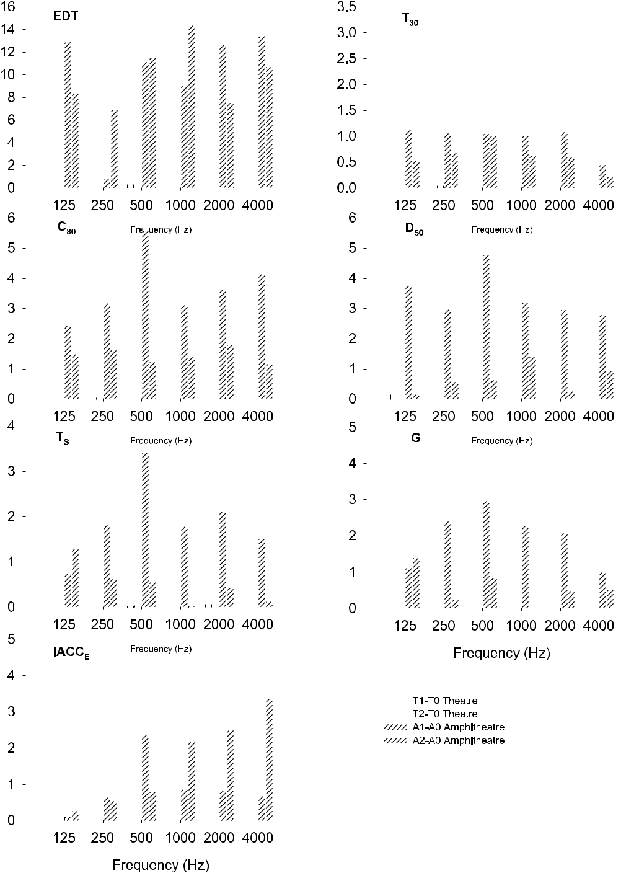

Fig. 16. Absolute differences between sources (T0 reference in the theatre, and A0 in the amphitheatre) expressed as values of JND versus frequency octave bands for the acoustical parameters analysed. The striped bars represent the amphitheatre.

4.5. Auralisations

The acoustic study is complemented by auralisations, which, according to Vorländer, can be defined as the technique of creating audible sound files from numerical (simulated, measured, or syn-thesized) data [40]. Auralisations enable the subjective perception of the sound by a specific sound-receiver combination to be attained and the acoustic differences of the two classical perfor-mance buildings of Segobriga to be better appreciated.

As supplementary material, this study includes seven audio files of which three files reproduce the acoustic conditions in the thea-tre with the source centred on the stage (Theatre_T0_R11.wav) and lateral on the stage (Theatre_T1_R11.wav) and in the orchestra (Theatre_T2_R11.wav), and with the receiver on the right-hand side of the media cavea, R11. In the amphitheatre, another four audio files reproduce the acoustic conditions with the three posi-tions of the source in the arena (Amphitheatre_A0_R13.wav, Amphitheatre_A1_R13.wav and Amphitheatre_A2_R13.wav), and

14 M. Galindo et al. / Applied Acoustics 166 (2020) 107373

the receptor near the centre of the southern tiers of the cavea, R13; the fourth audio file corresponds to the auralisation with the source and receiver at the foci of the arena ellipse (Amphithea-tre_AF_RF’.wav).

The auralisations presented have been carried out with Matlab software by convolving the measured binaural impulse responses with an anechoic speech recording. The anechoic signal is a frag-ment of 26 s from ‘‘SI_Harvard_Word_Lists_Female” from the library of Odeon [41].

The sampling frequency of the two signals to be convolved first had to be unified, and the measured binaural signal from each ear was mixed by means of Audacity software.

In these audio files, good intelligibility can be verified in each building, with a lower reverberation in the theatre, and, in the case of the amphitheatre, a greater persistence in the time of early reflections with high acoustic energy.

5. Conclusions

In this research, the acoustic behaviour of the Roman theatre and amphitheatre of Segobriga, (Saelices, Cuenca, Spain) has been described. In these types of open-air venues, with very short rever-beration times in the theatre on the one hand, and non-linear energy decay in the amphitheatre on the other hand, suitable con-ditions for the measurement of reliable room impulse responses are achieved.

For the amphitheatre, non-linear energy-decay curves show a great dependence on the source location. These curves are more frequent when the source is located near the focus of the ellipse and improve when the source is on the minor axis, especially in the centre of the ellipse. The values of EDT, T10, T20, and T30, obtained with receivers that meet the linearity criteria, are, in gen-eral, coincident at all frequencies with the values obtained that include all points for all sources. Discrepancies are minimized by analysing the first 35 dB of decay. At the focal point, the amplifica-tion of the pressure in relation to direct sound appears not to depend heavily on wavelength. When the source and receiver are located at the two conjugate foci, the temporal delay between the direct sound and the collected reflections is shorter than the threshold of echo detectability.

The position of the sound source is crucial for the EDT parame-ter and therefore for the pattern of early reflections in the amphitheatre, which is in contrast to the similarity in the beha-viour for the three positions of the sound source in the theatre. For the T30 parameter, a greater similarity in behaviour regarding frequency is obtained for all sources both in the theatre and in the amphitheatre, whereby the T30mid value in the theatre is 0.45 s as compared to 1.3 s in the amphitheatre; although both are enclosures without a roof, the complete lateral closure of the amphitheatre and the perimeter wall of the arena of the amphithe-atre exert their influence on the reverberant tail of the energy decay. The energy parameters show an excess of clarity for music and a high definition of the word for the three positions of the source in the theatre: this also corresponds to the rating of excellent for the STI parameter. For the amphitheatre, the results depend on the position of the sound source, and show that the best acoustic results for reverberation, clarity of speech, and music are obtained with the source close to the focus of the arena. The sole difference is that it has a lower sound strength than the remaining sources, although this is suitable for the perception of the subjective level of sound. The amplification of the sound is also of note when the source is placed in the orchestra of the theatre. The parameter that evaluates the sensation of early spatiality shows that the best results are obtained when the sound source is located on the side of the stage in the theatre, and in the amphitheatre when it is close to the focus of the ellipse of its arena.

Declaration of Competing Interest

The authors declare that they have no known competing finan-cial interests or personal relationships that could have appeared to influence the work reported in this paper.

Acknowledgements

The authors are very grateful to Professor T. Zamarreño for his help and valuable discussions. This work is funded by ERDF funds and the Spanish Ministry of Economy, Industry, and Competitive-ness (MINECO) with ref. BIA2017-85301-P.

References

1. Mourjopoulos J, Fausti P. The acoustics of the ancient theatres. Acta Acust United Acust 99. Preface 2013. , <https://doi.org/10.3813/AAA.918581>.
2. Rindel JH. Roman theatres and revival of their acoustics in the ERATO Project. Acta Acust United Acust 2013;99:21–9. <https://doi.org/10.3813/AAA.918584>.
3. Pompoli R, Gugliermetti F. ATLAS: Un progetto di Ricerca di interesse Nazionale interamente dedicato alla fruizione, tutela e valorizzazione acustica e visiva dei teatri antichi. IV Congr. Naz. IGIIC, Lo Stato dell’ Arte, Siena, 28-30 Settembre; 2006.
4. [Gade AC, Lisa M, Lynge C, Rindel JH. Roman theatre acoustics; Comparison of](http://refhub.elsevier.com/S0003-682X(20)30204-8/h0020) [acoustic measurement and simulation results from the Aspendos Theatre,](http://refhub.elsevier.com/S0003-682X(20)30204-8/h0020) [Turkey. Proceedings of International Congress on Acoustics ICA, Kyoto 2004](http://refhub.elsevier.com/S0003-682X(20)30204-8/h0020).
5. Vitruvio Polión M. (In Spanish, Los diez libros de arquitectura, traducidos del latín y comentados por J. Ortiz y Sanz), The ten books of architecture, translated and commented by J. Ortiz y Sanz. Imprenta Real, Madrid, 1787.
6. [Long M. In: Architectural acoustics. London, UK: Elsevier; 2006. p. 1–7](http://refhub.elsevier.com/S0003-682X(20)30204-8/h0030).
7. [Izenour GC. Theater design. 2nd ed. New Haven, CT: Yale University Press;](http://refhub.elsevier.com/S0003-682X(20)30204-8/h0035) [1996](http://refhub.elsevier.com/S0003-682X(20)30204-8/h0035).
8. [Ianniello C. Modern shows in Roman amphitheatres. Acoust Pract](http://refhub.elsevier.com/S0003-682X(20)30204-8/h0040) [2017;6:13–22](http://refhub.elsevier.com/S0003-682X(20)30204-8/h0040).
9. Navvab M, Bisegna F, Gugleirmetti F. Capturing ancient theaters sound signature using beamforming. Proceedings of the 23th International

Congress on Sound and Vibration, Athens Greece, 2016.

1. Golvin JC. L’amphithéâtre romain: essai sur la théorisation de sa forme et de ses fonctions, Volumen 1, París, Boccard, 1988.
2. Saint Augustine. Confessions, 6, 8 or Inscription no. 298 by Louis Robert: Les, Gladiateurs dans l’Orient Grec 1940 Paris, Champion.
3. Canac F. L’acoustique des théâtres antiques. Ses enseignements. C.N.R.S., Paris; 1967.
4. [Vassilantonopoulos SL, Mourjopoulos JN. A Study of ancient Greek and Roman](http://refhub.elsevier.com/S0003-682X(20)30204-8/h0065) [theater acoustics. Acta Acust United Acust 2003;89:123–36](http://refhub.elsevier.com/S0003-682X(20)30204-8/h0065).
5. Chourmouziadou K, Kang J. Acoustic evolution of ancient Greek and Roman theatres. Appl Acoust 2008;69:514–29. [https://doi.org/10.1016/j.](https://doi.org/10.1016/j.apacoust.2006.12.009) [apacoust.2006.12.009](https://doi.org/10.1016/j.apacoust.2006.12.009).
6. Farnetani A, Prodi N, Pompoli R. On the acoustics of ancient Greek and Roman theaters. J Acoust Soc Am 2008;124(3):1557–67. [https://doi.org/10.1121/](https://doi.org/10.1121/1.2951604) [1.2951604](https://doi.org/10.1121/1.2951604).
7. Declercq NF, Dekeyser CSA. Acoustic diffraction effects at the Hellenistic amphitheatre of Epidaurus: seat rows responsible for the marvellous Acoustics. J Acoust Soc Am 2007;121(4):2011–22. [https://doi.org/10.1121/](https://doi.org/10.1121/1.270984) [1.270984](https://doi.org/10.1121/1.270984).
8. Lokki T, Southern A, Siltanen S, Savioja L. Acoustics of Epidaurus – studies with room acoustics modelling methods. Acta Acust United Acust 2013;99(1):40–7. <https://doi.org/10.3813/AAA.918586>.
9. Alfano FRd, Iannace G, Ianniello C, Ianniello E. ‘‘Velaria” in ancient Roman theatres: Can they have an acoustic role? Energy Build 2015;95:98–105. <https://doi.org/10.1016/j.enbuild.2015.03.010>.
10. Bo E, Astolfi A, Pellegrino A, Pelegrin-Garcia D, Puglisi GE, Shtrepi L, et al. The modern use of ancient theatres related to acoustic and lighting requirements: stage design guidelines for the Greek theatre of Syracuse. Energy Build 2015;95:106–15. <https://doi.org/10.1016/j.enbuild.2014.12.037>.
11. Iannace G, Trematerra A. The acoustic effects of the audience in the modern use of the Ancient theatres. J Teknol 2018;80(4):147–55. , [https://doi.org/10.](https://doi.org/10.11113/jt.v80.9128) [11113/jt.v80.9128](https://doi.org/10.11113/jt.v80.9128).
12. Girón S, Álvarez-Corbacho A, Zamarreño T. Exploring the acoustics of ancient open-air theatres. Arch Acoust 45(2): in press.
13. [Cebrián R. Segobriga civitas stipendiaria (Plin. HN 3.25). Nuevos datos](http://refhub.elsevier.com/S0003-682X(20)30204-8/h0110) [arqueológicos sobre el urbanismo inicial de la ciudad. Gerión 2017;35:471–89](http://refhub.elsevier.com/S0003-682X(20)30204-8/h0110).
14. [Gros P. L’architecture romaine. 1. Paris, Picard: Les monuments publics; 1996](http://refhub.elsevier.com/S0003-682X(20)30204-8/h0115).
15. Abascal JM, Almagro-Gorbea M, Cebrián R. Segobriga: caput Celtiberiae and Latin municipium, en L. Abad – S. Keay – S.F. Ramallo (Eds.), Early Roman Towns in Hispania Tarraconensis (Journal of Roman Archaeology Supplementary Series, 62), Portsmouth, Rhode Island; 2006. p. 184–196.
16. [Gris F. Propuesta de restitución del teatro romano de Segobriga. Madrider](http://refhub.elsevier.com/S0003-682X(20)30204-8/h0125) [Mitteilungen 2014;55:331–70](http://refhub.elsevier.com/S0003-682X(20)30204-8/h0125).

|  |  |
| --- | --- |
| M. Galindo et al. / Applied Acoustics 166 (2020) 107373 | 15 |

1. Abascal JM, Almagro-Gorbea M, Cebrián R, Sanfeliu D. Cronología y entorno urbano del teatro romano de Segobriga. In C. Márquez and A. Ventura (coords.), Jornadas sobre teatros romanos en Hispania; 2006. p. 311–337.
2. Almagro-Gorbea A, Almagro-Gorbea M. El anfiteatro de Segobriga. In Bimilenario del anfiteatro romano de Mérida. Coloquio internacional (Mérida 1992) 1995. p. 139–176.
3. Welch KE. The Roman Amphitheatre. From its origins to the Colosseum, Cambridge; 2009.
4. ISO 3382-1:2009(E). Acoustics-Measurement of room acoustic parameters-Part 1: Performance spaces. International Organisation for Standardisation, Geneva, Switzerland; 2009.
5. Hak CCJM, Wenmaekers RHC, Van Luxemburg LJC. Measuring room impulse responses: impact of the decay ranges on derived room acoustic parameters. Acta Acust United Acust 2012;98:907–15. <https://doi.org/10.3813/AAA.918574>.
6. [Álvarez-Corbacho A, Bustamante P, Galindo M, Girón S, Zamarreño T.](http://refhub.elsevier.com/S0003-682X(20)30204-8/h0155) [Measurement and analysis of the acoustics of the Roman theatre of](http://refhub.elsevier.com/S0003-682X(20)30204-8/h0155) [Segobriga (Spain). Proc INTERNOISE 2019;1833:11](http://refhub.elsevier.com/S0003-682X(20)30204-8/h0155).
7. ISO 3382-2. Acoustics-Measurement of room acoustic parameters-Part 2: reverberation time in ordinary rooms. International Organisation for Standardisation, Geneva, Switzerland; 2008.
8. [Álvarez-Corbacho A, Zamarreño T, Galindo M, Girón S. Virtual acoustics of the](http://refhub.elsevier.com/S0003-682X(20)30204-8/h0165) [Roman theatre of Italica (Acústica Virtual del teatro Romano de Itálica).](http://refhub.elsevier.com/S0003-682X(20)30204-8/h0165) [Proceedings of Tecniacustica, Murcia 2014:1229–36](http://refhub.elsevier.com/S0003-682X(20)30204-8/h0165).
9. Álvarez-Corbacho A, Zamarreño T, Galindo M, Girón S. Virtual acoustics of the Roman theatre of Regina Turdulorum (Acústica Virtual del teatro Romano de Regina Turdulorum). Proceedings of Tecniacustica, Valencia; 2015. p. 1515– 1522.
10. [Cremer L, Müller H. Principles and applications of room acoustics. London and](http://refhub.elsevier.com/S0003-682X(20)30204-8/h0175) [New York: Applied Science Publisher; 1982](http://refhub.elsevier.com/S0003-682X(20)30204-8/h0175).
11. Vercammen M. Sound reflections from concave spherical surfaces. Part I: wave field approximation. Acta Acust United Acust 2010;96:82–91. [https://doi.org/](https://doi.org/10.3813/AAA.918259) [10.3813/AAA.918259](https://doi.org/10.3813/AAA.918259).
12. Vercammen M. Sound reflections from concave spherical surfaces. Part II: Geometrical acoustics and engineering approach. Acta Acust United Acust

2010;96:92–101. <https://doi.org/10.3813/AAA.918260>.

[38] [Wulfrank T, Orlowski RJ. Acoustic analysis of Wigmore Hall, London,](http://refhub.elsevier.com/S0003-682X(20)30204-8/h0190) [in the context of the 2004 refurbishment. Proc Inst Acoust 2006;28(2):](http://refhub.elsevier.com/S0003-682X(20)30204-8/h0190) [255–67](http://refhub.elsevier.com/S0003-682X(20)30204-8/h0190).

1. B. Beckers, L. Masset, Radit2D www.heliodon.net, (accessed 10/12/2019).
2. Vorländer M, Auralization. Fundamentals of acoustics, modelling, simulation, algorithms and acoustic virtual reality. Springer-Verlag Berlin, Germany; 2008.
3. Odeon Room Acoustics Software: Speech recordings, female voice, Harvard Word List. <https://odeon.dk/downloads/anechoic-recordings/>(accessed 15/01/ 2020).