[Computers, Environment and Urban Systems 82 (2020) 101485](https://doi.org/10.1016/j.compenvurbsys.2020.101485)



Contents lists available at [ScienceDirect](http://www.sciencedirect.com/science/journal/01989715)



Computers, Environment and Urban Systems

journal homepage: [www.elsevier.com/locate/ceus](https://www.elsevier.com/locate/ceus)

Life is a scene and we are the actors: Assessing the usefulness of planning [T](http://crossmark.crossref.org/dialog/?doi=10.1016/j.compenvurbsys.2020.101485&domain=pdf) support theatres for smart city planning 



E.P. Punta,b,c, , S.C.M. Geertmanb, A.E. Afroozd, P.A. Witteb, C.J. Pettitc

1. *Technische Universität Darmstadt, Dolivostraße 15, 64293 Darmstadt, Germany*
2. *Faculty of Geosciences, Human Geography and Spatial Planning, Utrecht University, Utrecht, the Netherlands*
3. *City Futures Research Centre, University of New South Wales, Sydney, Australia*
4. *School of Art, Architecture and Design, University of South Australia, Adelaide, Australia*

ARTICLE INFO

*Keywords:*

Planning support system

Planning support theater

Dashboards

PSS implementation gap

Smart planning

City analytics lab

ABSTRACT

There are numerous studies on the identification and explanation of the implementation gap of planning support systems (PSS), that support the smart planning process by analyzing and visualizing data, but which are cur-rently not systematically used in urban planning practice. There is insufficient knowledge about how the PSS implementation gap can be bridged and how PSS can be embedded into the planning process. This study pro-vides insight into how the City Analytics Lab (CAL) can contribute to the promise of smart planning. It aims to first determine how CAL can yield the promise of smart planning. Then it provides insight into how CAL can contribute to close the PSS implementation gap. Accordingly, we organized fifteen workshops and surveyed planning practitioners (*N* = 89) at CAL to assess its usefulness for smart planning as well as its contribution in bridging the PSS implementation gap. The results show that users are positive towards the usefulness and us-ability of the support tools in the CAL, in particular the collaborative nature of the lab through its interactive tables and software applications. With regards to the PSS implementation gap, we find that there is a continued and increasingly successful conversation between the CAL and it's PSS tools and planning practice (i.e. ‘tech-nology-to-people’) by collaborating with local governments, industry partners and other universities. However, further refinement of the lab through continued conversation between users and developers (i.e. ‘people-to-people’) is necessary, where tools are codesigned and user preferences and participation protocols are further considered. More broadly this research suggests that Planning Support Theatres, such as CAL can assist in re-ducing the technology adoption barriers commonly experienced in the application of PSS in practice. Such Planning Support Theatres, also provide a space to support new ideas and interactions importantly between both the key actors and the technology and the actors themselves.

**1. Introduction**

Planning decision making tools are increasingly acknowledged through big data, city analytics and modelling, and can contribute to the technological development of a smart city (Pettit et al., 2018). A smart city can be defined as a city that uses information and commu-nication technologies (ICT) and data to make a city more efficient, sustainable, equitable and livable (Nam & Pardo, 2014). Through the wider adoption of digital technologies urban planning is arguably be-coming smarter. In this context planning is tapping into big data, ma-chine learning, urban modelling, visualization and digital dashboards. These data augmented approaches and new technologies support planners in dealing with the complexities and future challenges that cities face (Pettit et al., 2018). The interaction between technology and



governance is especially relevant, since planning is inseparable from politics and power (Lissandrello & Grin, 2011; Nam & Pardo, 2011).

It is expected that planning support tools, as instruments attuned to analyzing and visualizing data, would frequently be used in planning. However, despite their availability there are issues preventing their widespread use and adoption (Geertman, 2017; Pettit et al., 2018; Russo, Lanzilotti, Costabile, & Pettit, 2017; Vonk, Geertman, & Schot, 2005). This results in an implementation gap, where an increasing number of planning support systems (PSS) are being developed, without likewise being applied or implemented by planning practi-tioners. Research has focused on identifying, measuring, classifying and explaining the PSS implementation gap (Geertman, 2017). Pelzer, Geertman, van der Heijden, and Rouwette (2014), for example, as-sessed the usefulness of PSS in planning, which is the question of

Corresponding author at: Technische Universität Darmstadt, Dolivostraße 15, 64293 Darmstadt, Germany. *E-mail address:* [e.p.punt@uu.nl](mailto:e.p.punt@uu.nl)(E.P.Punt).

<https://doi.org/10.1016/j.compenvurbsys.2020.101485>

Received 5 December 2019; Received in revised form 20 March 2020; Accepted 23 March 2020

Available online 11 April 2020

0198-9715/ © 2020 The Authors. Published by Elsevier Ltd. This is an open access article under the CC BY license

(http://creativecommons.org/licenses/BY/4.0/).

*E.P. Punt, et al.*

whether a system can achieve its desired goals. There are different kinds of usefulness of PSS, including learning about objects and opi-nions of other participants, collaboration, efficiency and better-in-formed plans. Bottlenecks and potentials for PSS implementation have also been identified (e.g. Geertman, 2017; Russo et al., 2017; Russo, Lanzilotti, Costabile, & Pettit, 2018; Vonk et al., 2005). Since research surrounding the explanation and identification of this gap is reaching a saturation point, Geertman (2017) suggests that we should move away from defining and explaining the PSS implementation gap and instead focus on successful applications. This yields insights into how the gap can be bridged and how PSS tools can be embedded fully into the planning process.

The City Analytics Lab (CAL) at the University of New South Wales in Sydney supports the planning and design of future cities. CAL's aim is to enhance information-sharing amongst planning agencies and to support an interdisciplinary approach to decision-making (Millman, 2018). CAL harbors a number of planning support tools designed to support smart planning. *Smart planning* is defined as planning activities enriched through digital technologies including data, models and vi-sualizations (Stratigea, Papadopoulou, & Panagiotopoulou, 2015). In our view, smart planning includes both increased support of planning processes and outcomes through technology usage (i.e. ‘technology-to-people’) as well as increased interaction between stakeholders them-selves (i.e. ‘people-to-people’). In this study we held workshops with planning practitioners at CAL to assess the lab's usefulness for smart planning and determine the lab's contribution in bridging the PSS im-plementation gap. Therefore, this study has two aims: 2a) determine how CAL can yield the promise of smart planning; and b) analyze how the lab can contribute to close the PSS implementation gap.

Section 2 reviews literature around the PSS implementation gap. In Section 3 the chosen methodology is explained. In Section 4 we de-termine how the usefulness of CAL together with contextual factors influence the implementation of CAL as a planning support theater and how this can ultimately yield the promise of smart planning. To con-clude suggestions for future research on this topic are presented in Section 5.

**2. Literature review**

*2.1. Planning support science and the implementation gap*

Planning support science has emerged as a way to develop and improve digital planning tools (Geertman, 2017). It supports planning in navigating big data and increased participation in planning processes (e.g. Champlin, te Brömmelstroet, & Pelzer, 2019; Pettit et al., 2018; Witte, Punt, & Geertman, 2020). PSS are particularly suited to deal with challenges of smart planning. They are geoinformation-technology-based instruments that incorporate a suite of components, which col-lectively support all or some part of unique professional planning tasks (Geertman, 2006). The role of PSS tools in planning has been examined: Silva, Bertolini, te Brömmelstroet, Milakis, and Papa (2017) studied the implementation of accessibility instruments in planning; te Brömmelstroet (2017) performed five experiments to measure the user-friendliness and usefulness indicators of different PSS tools and ex-plored the relations between the two concepts; and Russo et al. (2017, 2018) evaluated the level of PSS implementation into planning practice in Australia, Italy and Switzerland.

Generally, it can be deduced that PSS are technological develop-ments that are valuable to smart planning. Despite their availability and benefits, issues prevent the use and adoption of PSS. Geertman (2017) referred to this as the “PSS implementation gap”, which is a discrepancy between supply and demand. The market is providing a growing number and diversity of potentially valuable PSS tools, but the intended customers are hesitant to buy, implement or apply them. Research has analyzed this PSS implementation gap. Vonk et al. (2005) distinguished three types of bottlenecks; human, technological, and institutional.

*Computers, Environment and Urban Systems 82 (2020) 101485*

They found that in particular, a lack of awareness, discrepancy between demand and supply and fear for the unknown, blocks widespread usage and adoption of PSS in smart planning. Pelzer et al. (2014) noted that there is a lack of attention to the added value of PSS for planning practice. te Brömmelstroet, Curtis, Larsson, and Milakis (2016) argued that the disconnect between planning theory and practice manifests itself in various ways, but that the overall result is that PSS rarely fit the dynamic and fluid contexts of most planning processes. We built upon this knowledge to identify how a collection of PSS tools made available in a dedicated fit-for-purpose facility – the City Analytics Lab - can contribute to closing this gap and move towards smart planning.

*2.2. How to address the PSS implementation gap?*

*2.2.1. The usefulness framework*

It is believed that increasing the value of PSS for planning will in-crease their uptake by practitioners (Arciniegas, Janssen, & Rietveld, 2013; Pelzer et al., 2014; te Brömmelstroet, 2013). In this context Pelzer (2017), Russo et al. (2018) and others have studied the useful-ness of PSS. The usefulness framework was first developed by Nielsen (1993). Pelzer (2017) later adapted it to the field of PSS. The term usefulness can be defined as an attribute that indicates whether a system allows people to achieve their desired goals easily and with satisfaction (Nielsen, 1993). Two sub-categories of usefulness are utility and usability. According to Nielsen (1993, p.25) utility is “the question of whether the functionality of the system in principle can do what is needed”, while the usability of a system relates to “the question of how well users can use that [utility] functionality”. For the sub-category usability Pelzer (2017) summarized ten variables generally used to analyze the usability of a PSS. These include transparency, user friendliness, and interactivity amongst others. The importance of the variables differs based on the planning task and PSS support functions. The utility refers to the way in which PSS can support the planning process.

*2.2.2. Task-technology fit*

The utility of PSS is analyzed through the task-technology fit, which is “the matching of the functional capability of available information technology with the activity demands of the task at hand” (Dishaw & Strong, 1998 in Pelzer, Arciniegas, Geertman, & Lenferink, 2015, p.157). Technology refers to the support function of PSS: “the cap-abilities of the PSS to support planning tasks” (Pelzer, 2017, p.86). Planning tasks are considered as “combinations of planning behaviors that accomplish particular functions or purposes” (Hopkins, 2001 in Pelzer, 2017, p.86). Pelzer (2017) focused on two distinctive planning tasks named generation and selection tasks. Vonk, Geertman, and Schot (2007b) suggest instead to focus on planning stages that reflect the dynamic character of planning processes. In this study we define tasks for each stage of the planning process, for example activities such as problem signaling and agenda setting that are performed during the initial stage of problem definition (Vonk et al., 2007b; Vonk, Geertman,

* Schot, 2007a). We consider the support functions of a PSS to be analysis, communication, design, information gathering, storage and retrieval, and visualization (Steinitz, 2012; Vonk et al., 2007b).

*2.2.3. Towards implementation: best practices*

As indicated, Geertman (2017) suggested studying successful sys-tems support rather than explaining the PSS implementation gap. Successful systems support requires, amongst other things, good in-strumental infrastructure and appropriate organization (Geertman, 2017). It also requires sufficient access to data. And furthermore, like expressed by Silva et al. (2017), one needs to be aware of the organi-zational barriers and institutional limits of systems' uptake. The most important factor for PSS uptake is the application of the system in real-world planning to deal with real-world problems. This requires a shift from experimental PSS case studies towards application in factual

2

*E.P. Punt, et al.*

planning.

For this to happen, Geertman (2006) proposed to focus on influ-ential factors of planning support adoption, which include context specificities of the planning process, explicitness and transparency in underlying premises, methods and outcomes, and the adaptation of planners. The factors of Geertman's (2006) conceptual framework in-clude (1) the content of the planning issues at stake; (2) the char-acteristics of the users; (3) the characteristics of the planning and policy process; (4) the political context; (5) the characteristics of the instru-ments; and both the dominant (6) planning style and (7) policy model. This framework provides an interpretative model with which develop-ments within planning can be confronted with the actual and potential support functions of PSS tools. Despite critique that it lacks concept specificity and descriptions of relations between variables, the frame-work can be used to highlight the importance of context and user re-quirements in implementing a PSS (Goodspeed & Hackel, 2017). te Brömmelstroet and Bertolini (2008) argue that focusing on a common language around these requirements can bridge differences in planning contexts; in ideas of planning theory and practice and in ideas between developers and users of planning support tools. Reducing these differ-ences leads to increased implementation of PSS tools. We use the con-ceptual framework by Geertman (2006) to not only study the usefulness of a collection of PSS tools, but also include the discussion of contextual factors that ultimately facilitates a common language that contributes to the successful implementation of planning support theatres.

*2.3. Conceptual framework*

Based on previous discussion, the usefulness of CAL can be found by determining its utility and usability (Fig. 1). This informs us on the fit between the support function of the technology and the planning task and the easiness of using the technology. This tells us how well-equipped CAL is to yield the promise of smart planning. Next, the lab's contribution to bridging the PSS implementation gap is studied by ex-amining a number of contextual factors that together with the useful-ness of the lab will tell us the success rate of implementation of CAL as a planning support theater.

**3. Methodology**

To determine CAL's usefulness, a series of workshops (*N* = 15) with participants (*N* = 89) has been conducted between September 2018 and January 2019 using observational methods, group discussions and questionnaires.

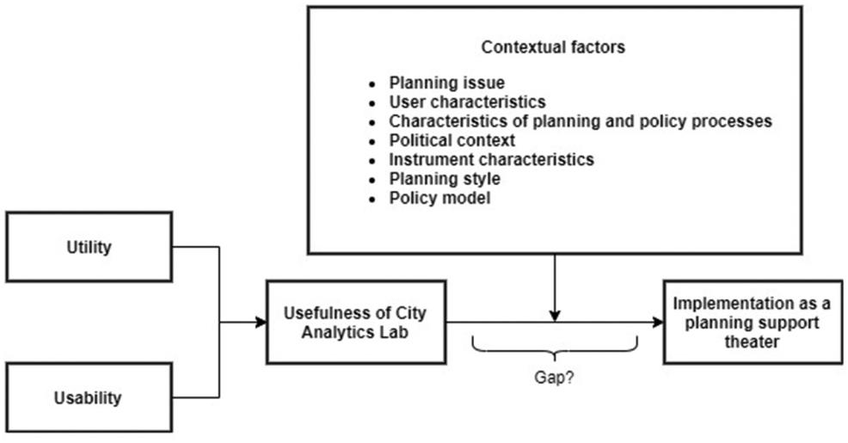

*Computers, Environment and Urban Systems 82 (2020) 101485*

*3.1. The city analytics lab*

CAL is a space designed to support collaborative planning and user-centered design. CAL consists of a planning support theater, equipped with six high-resolution multi-touch tables on which various PSS tools can be loaded (Fig. 2), three Virtual Reality (VR)/Augmented Reality (AR) rooms, an Augmented Reality (AR) Sandbox (Fig. 3) and ob-servation rooms. CAL's primary goal is to support data augmented planning and design through the support of analytics, models, visuali-zations, and dashboards. CAL provides a collaborative space to bring together planning professionals, industry, citizens and governments in the formulation and evaluation of future city scenarios. Geodesign (Steinitz, 2012) is one of the design thinking methods for understanding place and space, supported in CAL. The geodesign framework creates and evaluates sustainable urban futures through proposing critical questions and collecting data and metrics (Pettit, Hawken, Ticzon, & Nakanishi, 2019; Pettit, Hawken, Ticzon, Steinitz, et al., 2019). Geo-design and data analytics underpin the development and application of PSS tools in CAL to benefit smart planning.

Figs. 4–6 show the PSS tools available at CAL. Their most important support functions are information gathering, storage and retrieval, vi-sualization, communication, analysis, modelling and design. CityViz (Fig. 4) is a data visualization and analytics platform that presents a comprehensive and integrated visual depiction of Sydney based on urban big data (Goodspeed, Pelzer, & Pettit, 2018). It includes the ‘30 Min City’ visualization tool used in this study, which is based on smart card (Opal Card) data and depicts the travel time to reach key areas in Sydney Metropolitan Area (Leao, Pettit, Rashidi, Hassan, & Jian, 2016; Pettit & Leao, 2017). Other PSS tools available at CAL are CityData; City Dashboard, also known as CityDash (Pettit, Lieske, & Jamal, 2017; Pettit, Tice, & Randolph, 2017), and the value uplift tool Rapid Ana-lytics Interactive Scenario Explorer (RAISE) (Lieske, van den Nouwelant, Han, & Pettit, 2019), which all support data gathering, storage, retrieval, analysis and visualization (Figs. 5 and 6). Ad-ditionally, the Cruiser software allows data to be visualized, manipu-lated, and communicated (Fig. 6; Apted, Kay, & Assad, 2005). CAL provides communication support through the ‘swipe’-function in Cruiser, which allows information to be send to other interactive tables. All planning support tools, except the AR Sandbox, can be run on the six interactive tables in the planning support theater. The AR Sandbox is set up in a separate room and can be used for the modelling and design of new landscapes (Afrooz, Ballal, & Pettit, 2018; Fig. 3).

Ultimately CAL need to fit into the collaborative planning process to become useful to planning practitioners and policy makers (Lissandrello

**Fig. 1.** Conceptual model for conducting usefulness evaluation of City Analytics Lab (adapted fromPelzer, 2017andGeertman, 2006).

3

*E.P. Punt, et al.* *Computers, Environment and Urban Systems 82 (2020) 101485*

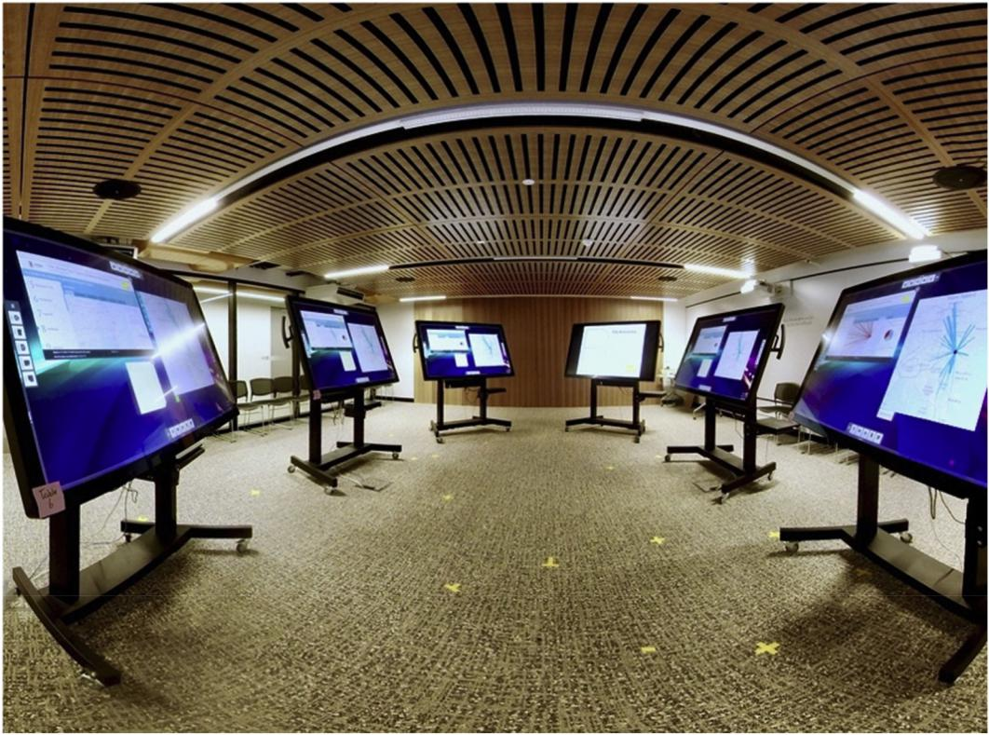

**Fig. 2.** Multi-touch tables with Cruiser software located in CAL (source: authors).

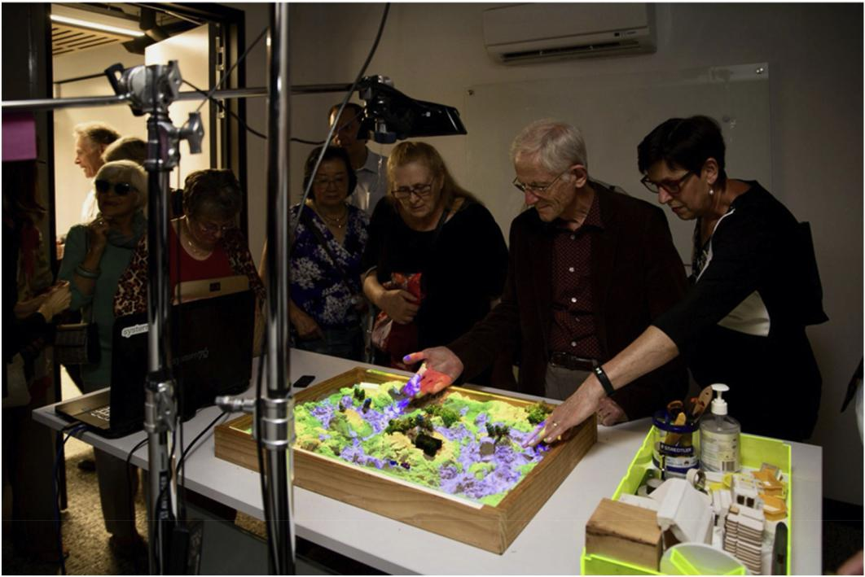

**Fig. 3.** AR Sandbox used by participants (source: authors).

* Grin, 2011; Pelzer, 2017). An example in Australia is the Department of Industry, Innovation and Science's Cooperative Research Centres (CRC) program that involves policy makers, practitioners or industry collaboratively defining research questions and communicating results, often in ways geared towards non-academic audiences (Gurran, 2018).

*3.1.1. CAL compared to other planning support theatres*

While local media called CAL the first dedicated lab that supports the planning and design of future cities (GovTech Review, 2018; Johnston, 2018; Millman, 2018), there are other initiatives around the world that aim for similar smart planning support. The City Science Group at MIT for example proposes a new methodology of interaction

4

*E.P. Punt, et al.* *Computers, Environment and Urban Systems 82 (2020) 101485*

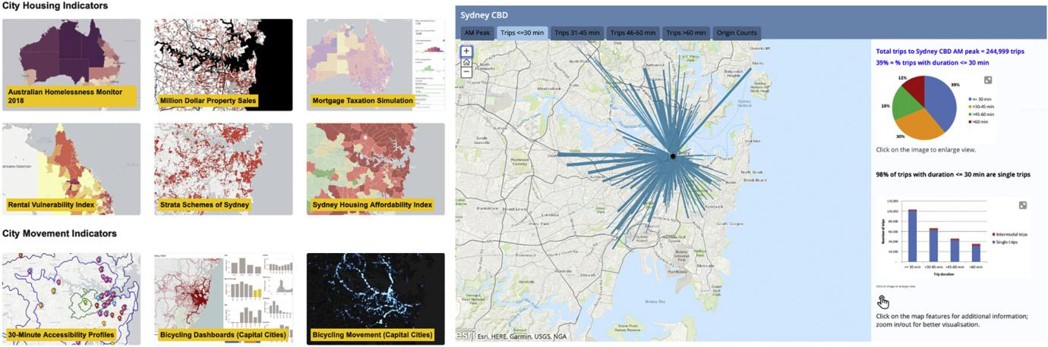

**Fig. 4.** CityViz tool available at the City Analytics Lab, including the ‘30 Min City’ visualization map (source:<https://cityfutures.be.unsw.edu.au/cityviz/>).

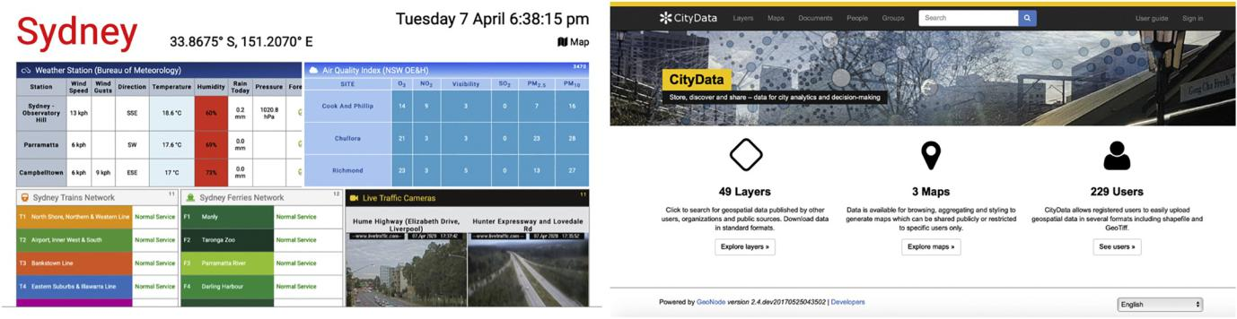

**Fig. 5.** CityDash and City Data PSS support tools available at the City Analytics Lab (sources:<http://citydashboard.be.unsw.edu.au/>and[https://citydata.be.unsw.](https://citydata.be.unsw.edu.au/)

[edu.au/](https://citydata.be.unsw.edu.au/)).

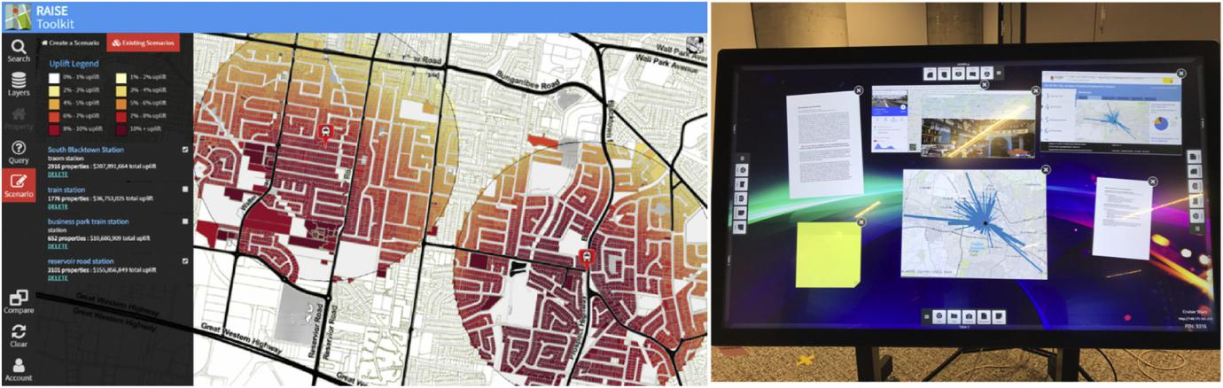

**Fig. 6.** RAISE support tool and Cruiser software available at the City Analytics Lab (source:https://cityfutures.be.unsw.edu.au/research/projects/rapid-analytics-interactive-scenario-explorer-raise/).

and collaboration called CityScope – a data-driven platform that si-mulates the impact of proposed interventions on urban ecosystems to enable better prediction and understanding (Fig. 7). Other planning support theatres such as the Arizona State University or the Aalto Built Environment Laboratory (ABE), actively encourage researchers and leaders to interact with visual solutions using collaborative, computing and display technologies (Arizona State University, 2014; Fig. 8;

Staffans, Kahila-Tani, Geertman, Sillanpää, & Horelli, 2020). These theatres offer similar support like CAL, using a video wall instead of interactive and connected multi-touch screens. Additionally, there are various research groups and city councils that use virtual platforms to create digital immersive experiences, including city labs in Beijing, Berlin, Melbourne, and ETH Future Cities labs in Singapore, and Zurich. Each of these labs promote city analytics and offer augmented reality

5

*E.P. Punt, et al.* *Computers, Environment and Urban Systems 82 (2020) 101485*

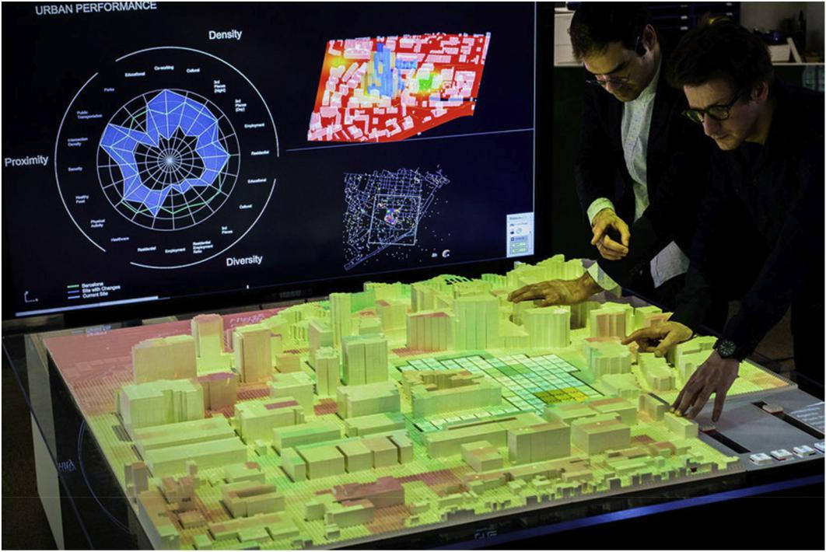

**Fig. 7.** CityScope, MIT Media Lab (Source:Grignard et al., 2018).

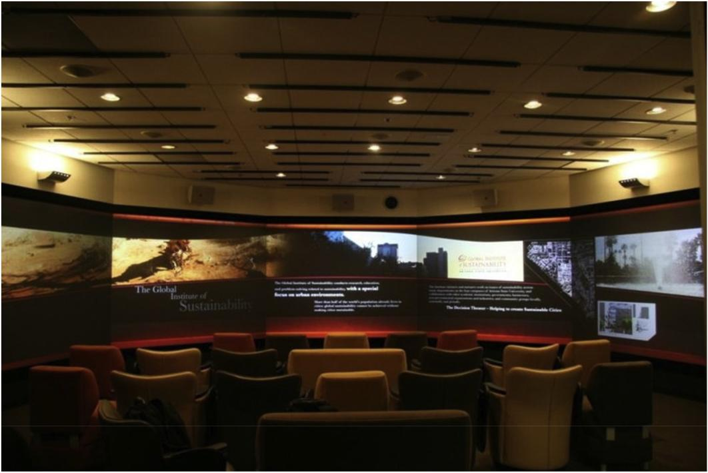

**Fig. 8.** Decision Theater at Arizona State University (Source:Hu, 2011).

and data-based support tools. They aim to visualize complex urban relations and create digital immersive and collaborative experiences. CAL aims for similar support and additionally is focused on actively engaging and collaborating with planning to further develop PSS tools to benefit smart planning.

*3.2. Study design and participants*

We conducted a pilot study, 10 workshops and four reflective

workshops between September 2018 and January 2019 (Table 3) with the overall goal of engaging participants with CAL facilities specifically designed for collaborative and analytical planning. 89 participants took part in this study, including urban planners, policy makers, academics (architects, urban planners and designers), students and industry part-ners. Participants had various backgrounds including engineering, urban planning, geography, business, management, biology and climate studies; and had different levels of experiences with digital-supported planning workshops. These participants were self-selected to take part

6

*E.P. Punt, et al.*

**Table 3**

Workshop and participant characteristics (source: authors).

|  |  |  |  |  |
| --- | --- | --- | --- | --- |
| Date | *N* | Sector | Association |  |
|  |  |  |  |  |
| 20/09/2018 | 3 | Academia | Science Faculty UNSW |  |
| 28/09/2018 | 9 | Government | NSW Local Government |  |
| 25/10/2018 | 3 | Industry | WSP Global |  |
| 02/11/2018 | 7 | Industry | China delegation |  |
| 02/11/2018 | 5 | Industry | Austrade |  |
| 02/11/2018 | 5 | Industry | Austrade |  |
| 07/11/2018 | 8 | Government | Future Earth Australia – Australian Academy of |  |
| 07/11/2018 | 15 | Government | Sciences |  |
| Future Earth Australia – Australian Academy of |  |
| 14/11/2018 | 2 | Academia | Sciences |  |
| Public Health Faculty UniSA |  |
| 23/11/2018 | 22 | Academia | Electrical Engineering students |  |
| 28/11/2018 | 3 | Academia | Built Environment Faculty UNSW |  |
| 29/11/2018 | 2 | Academia | Built Environment Faculty UNSW |  |
| 29/11/2018 | 2 | Academia | Built Environment Faculty UNSW |  |
| 14/12/2018 | 4 | Government | Olympic Park Authority |  |
| 21/01/2019 | 6 | Academia | Built Environment Faculty UNSW |  |
|  |  |  |  |  |

in the workshops based on their previously shown interest in the lab. Participation was on a voluntary basis, with no compensation. Since this was a non-random selection method, there is to some degree an unavoidable bias in participants experiencing a positive disposition to attending the lab and exploring the available PSS.

Since there usually were multiple participants from the same or-ganization there was already a degree of familiarity between partici-pants. This is quite common in real world planning workshops and can potentially strengthen the collaboration process. For consistency pur-poses each workshop followed the same format: (1) an introduction to the lab; (2) a demonstration of lab functions (3) a scenario exercise using the ‘30 Min City’ project interactive map; and (4) a discussion about the usefulness of the lab based on the demo exercise. In the group discussions items related to the usefulness of the lab and the contextual factors that impact the implementation of CAL were identified and discussed. The aim of the workshops was to demonstrate and evaluate the usefulness of CAL for digitally supported collaborative planning. Additionally, four reflective workshops were held, one with industry, one with government, and two with academic staff, where the best practices regarding implementation of CAL as a planning support theater were discussed (Table 3). These sessions provided in-depth discussion on CAL's usefulness for participants' own work projects.

During the workshops, participants performed an exercise based on the ‘30 Min City’ project which looks at accessibility issues of public transport in Randwick City situated within the Greater Metropolitan Sydney. The concept of the ‘30 Min City’ in an integral component to the Greater Metropolitan Sydney Planning Strategy which aims to promote better accessibility to required services and activities within a travel time of 30 min (Greater Sydney Commission, 2018). This is vi-sualized via an online dashboard using ArcGIS StoryMaps (Fig. 9). The ‘30 Min City’ Dashboard identifies origin of public transport trips to key destinations in Sydney based on travel time and visualizes it in inter-active maps. It uses the tap-on and tap-off data provided by Transport for NSW's Opal Smart Card System to get a better understanding of the alignment or deviation of actual public transport trips to the ‘30 Min City’ (Leao et al., 2016). The tool indicates that only 44% of daily commuters into Randwick City reach the area within 30 min. After a brief introduction, participants were asked to consider new planning concepts and ideas which could improve the accessibility of Randwick City. Supporting digital information was provided through the ‘City Dashboard’ and ‘CityData’ tools (Fig. 5). Through this exercise partici-pants were able to test and evaluate a number of digital tools available in the City Analytics Lab in a collaborative environment.

*Computers, Environment and Urban Systems 82 (2020) 101485*

*3.3. Procedure*

Data collection methods included non-participant observations during the workshops, questionnaires, and group discussions.

By analyzing the recorded video footage of the workshops, the re-search team determined how participants used the equipment in the room, how often they interacted verbally and non-verbally and how often they used the collaborative function (swiping information across tables) on the Cruiser software. The video footage was replayed and observed by the researchers. An example of observation notes from the video footage includes: “*Participants were found pointing to data on* *screens and across the room. Participants followed the information send to other tables to check if it showed up. The ‘swipe’-function forced non-verbal interaction*.” (notes from the workshop on 07/11/2018). The notes fromthe video footage have been used to determine the collaborative nature of the lab regarding ‘people to technology’ and ‘people to people’ in-teraction. Additionally, the results of the scenario exercise based on screenshots of the Cruiser software (Fig. 10) have been studied to de-termine which PSS tools were used by the participants and how the features benefited the exercise. It was recorded how many data sources and cruiser software features participants used and what they did with those sources and features. Additionally, voice recorders were placed around the room to record both the discussions at each individual table and the group discussion at the end of the workshop. Those recordings were transcribed and studied to determine opinions expressed by par-ticipants about CAL. An example of a positive opinion expressed during a group discussion in a workshop is “*[the tools in the lab] are such tan-gible, fun tools to play with”* (Participant 2). A more critical perspectivewas provided by another participant who argued some of the data sources were outdated and “they were not real-time data sources” (Participant 40). The data participants worked with was from 2016. The reflective workshops were recorded and analyzed to obtain information regarding the contextual factors that influence the best practices of implementation of CAL.

Furthermore, a questionnaire was designed to review the usefulness of CAL in smart planning. The questionnaire consisted of four sections: general questions about the participants, satisfaction rate of using CAL equipment, a general reflection of contextual factors and their interest in using CAL for their own work. The first section gathered information such as age, gender, professional background and experience with di-gitally supported workshops. The second section focussed on the use-fulness of CAL; strengths and weaknesses of the equipment; the us-ability of the Cruiser tables and questions related to the potential use of CAL and the equipment in the everyday work of participants. The questionnaire ended with a space to leave additional comments and rate their overall experience.

**4. Results**

This section presents the findings of the study, including the use-fulness of CAL for participants at different stages of the planning pro-cess; the strengths and limitations of CAL and the contextual factors that influence the success rate of CAL as a planning support theater.

*4.1. Usefulness of the city analytics lab*

*4.1.1. Utility*

Overall participants indicated that the PSS tools at CAL fitted the task of initial problem identification of the accessibility issues within Randwick City. This is concluded from the questionnaire where parti-cipants generally valued the visualization, analysis and communication support CAL and the ‘30 Min City’ dashboard provided. They especially valued the visualization of Opal Card big data in the ‘30 Min City’ tool and the consequent simplification of average travel times and patterns across Sydney. Their understanding was enhanced through manip-ulating the ‘30 Min City’ data and other relevant data sources through

7

*E.P. Punt, et al.* *Computers, Environment and Urban Systems 82 (2020) 101485*

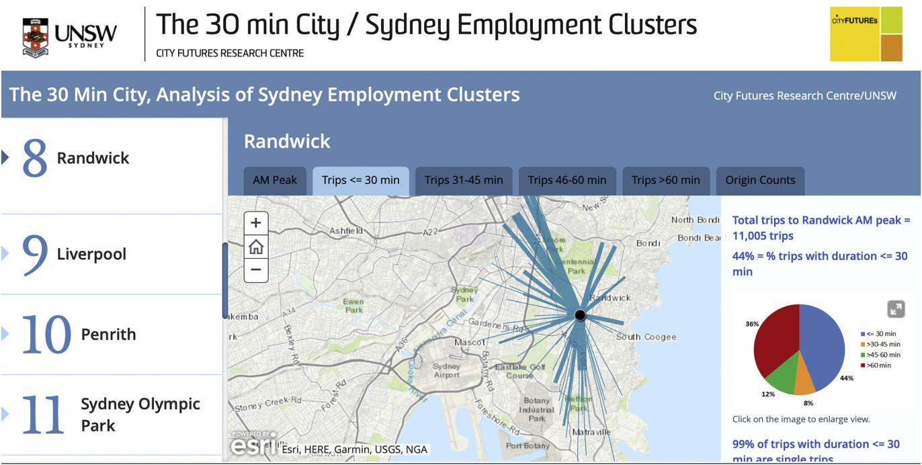

**Fig. 9.** Screenshot of ‘30 Min City’ Online Dashboard for the Randwick Employment Cluster. This figure illustrates the count of public transportation trips which tookless than 30 min to Randwick as destination of users. (source: https://cityfutures.be.unsw.edu.au/cityviz/30-min-city/).

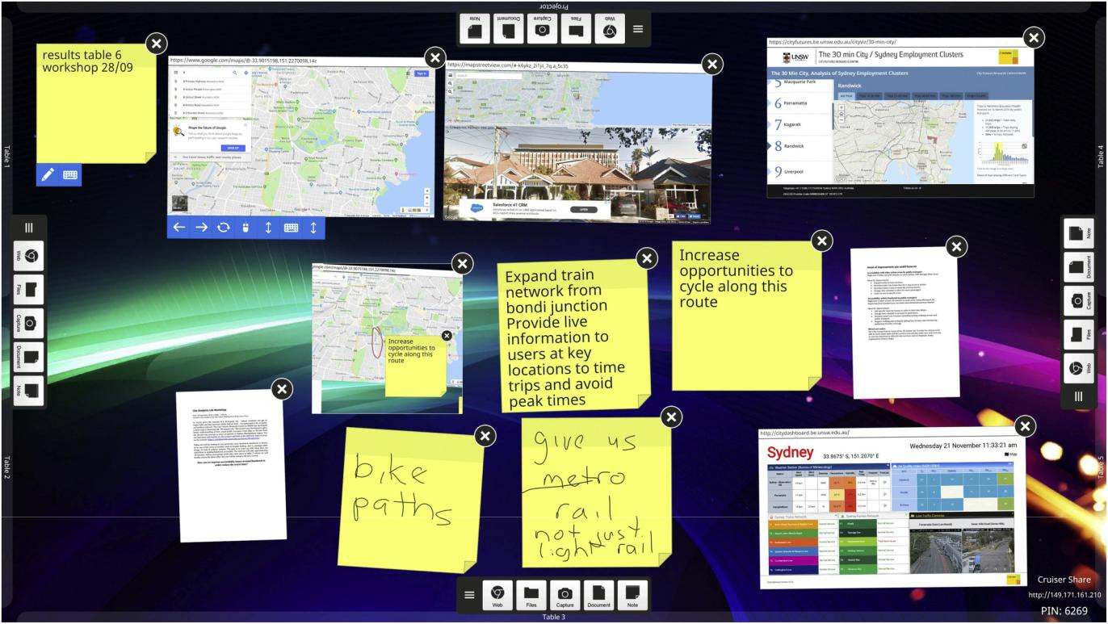

**Fig. 10.** Image from Cruiser software used in the ‘30 min City’ exercise, showing all its features (including note-taking, screenshotting, annotating) (source: authors).

the screenshot, drawing and note-taking features of the Cruiser soft-ware (Fig. 10). In terms of communication support, the ‘swipe’-function in Cruiser was found to promote engagement and dynamic team-based discussion (Fig. 11). In the observations of the sessions participants frequently pointed to data on the multi-touch screens to support their statements, and movement around the room to gather information was

easy. Participants often discussed the data and its interpretation amongst each other. They were particularly interested in how the data was obtained and visualized. At the same time however, participants did not always initiate discussions amongst themselves without inter-vention from the facilitating researchers. This indicates that the tools were initially difficult to operate. However, after familiarizing

8

*E.P. Punt, et al.* *Computers, Environment and Urban Systems 82 (2020) 101485*

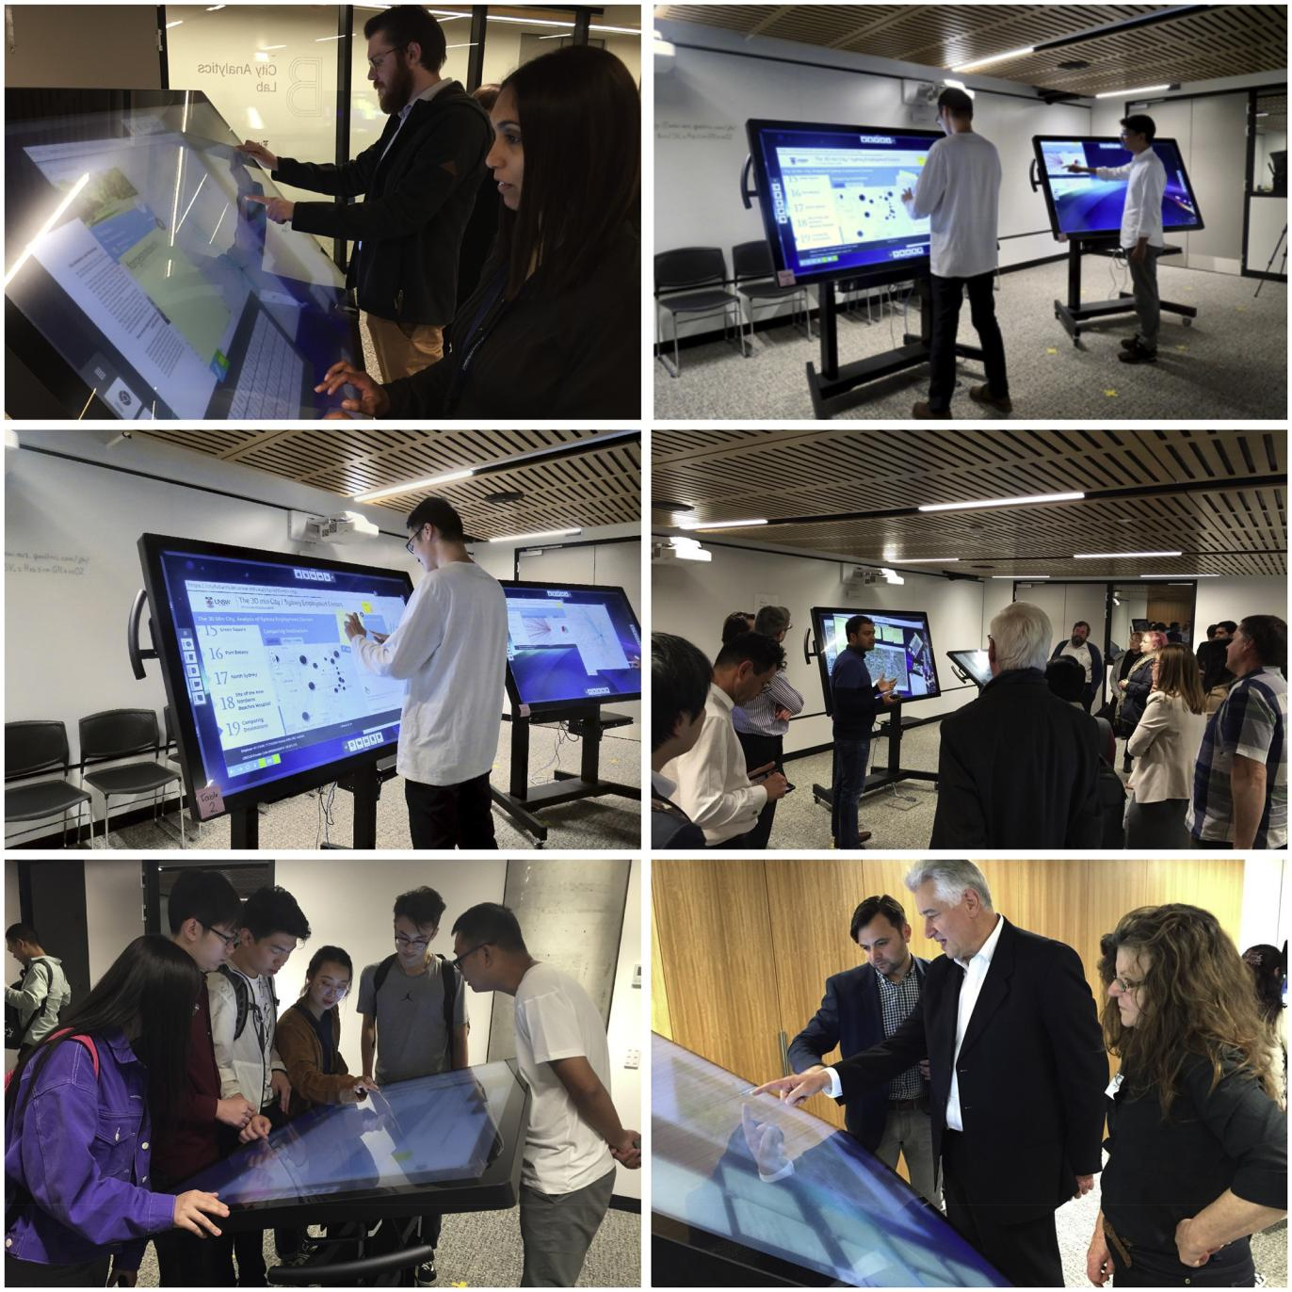

**Fig. 11.** Observations from various workshops of participants interacting in the City Analytics Lab (source: authors).

themselves with the equipment, participants started to collaborate. This led to an understanding of the technology and resulted in ideas and solutions.

Participants also saw opportunities to use CAL for other purposes. From the questionnaire it was apparent that participants would like to use CAL for stakeholder engagement, academic exchange; group col-laboration; data visualization, spatial data analysis; and co-design workshops (Table 5). However, there were a few concerns in translating the support of CAL to the requirements of their own work. One parti-cipant enquired whether CAL can be used “on topics that are not visual data” (Participant 2); another questioned whether it is possible to “run more advanced spatial analysis using for example ArcGIS” (Participant 64). Large touch screens, like the ones in CAL, are generally not opti-mized or configured for a number of software packages such as ArcGIS.

From these findings, we argue that the utility of CAL for certain tasks, such as early solution generation, is high, but that issues appear for more detailed analytical tasks performed in specialised software packages which are not optimized for large multi-touch screens.

*4.1.2. Usability*

The usability rating of the support tools at CAL is based on di-mensions identified by Pelzer (2017). There are eight indicators in total. Table 4 shows the mean score and standard deviation for each dimension separated by sector (industry, academia, government). In-terestingly, there are significant differences in responses for the in-dicators of user-friendliness, data adequacy, level of detail and reliable results between sectors. Overall, the government sector was more cri-tical than the other sectors, while the academic sector was mostly

9

*E.P. Punt, et al.* *Computers, Environment and Urban Systems 82 (2020) 101485*

**Table 4**

Mean scores (out of 5) of indicators of usability for different sectors (source:

authors).

|  |  |  |  |  |
| --- | --- | --- | --- | --- |
|  | Academia | Government | Industry |  |
|  |  |  |  |  |
| The equipment was transparent | 4.53 (0.6) | 4.15 (0.7) | 4.43 (0.6) |  |
| .The communication value of the | 4.31 (0.7) | 4.35 (0.5) | 4.36 (0.6) |  |
| equipment was high | 4.56 (0.7) | 3.90 (0.9) | 4.29 (0.5) |  |
| The equipment was user-friendly |  |
| The equipment could be used | 4.53 (0.7) | 4.40 (0.5) | 4.57 (0.6) |  |
| interactively | 4.09 (0.9) | 4.10 (0.6) | 4.29 (0.5) |  |
| The equipment was flexible in use |  |
| The data available during the session was | 4.29 (0.8) | 3.60 (0.8) | 3.71 (1.0) |  |
| adequate | 4.37 (0.9) | 3.55 (0.8) | 3.57 (1.0) |  |
| The level of detail was acceptable |  |
| I consider the results of the session to be | 4.52 (0.7) | 3.60 (0.8) | 4.00 (0.8) |  |
| reliable |  |  |  |  |

Sig: *p* < .05; *p* < .01; *p* < .000.

positive about the usability scores. This implies that CAL requires fur-ther consideration in attuning to the demands of the government sector. Additionally, scores for level of detail and data availability were rela-tively low and the interactivity and communication value of the equipment was high for all sectors. This reflects the nature of the workshop and equipment that particularly focused on collaboration and brainstorming. Overall, the scores are relatively high, the lowest score being 3.55 for level of detail, indicating high usability.

*4.1.3. Usefulness*

From the previous discussion, we can argue that CAL has a high usability and utility rating, even if this is dependent on the type of task performed and the support functions available in CAL. Additionally, we find that needs between participants differ. The academic sector argued to use CAL for more efficient research translation to practice. Government would use CAL to create more informed outcomes and the industry sector believed CAL could facilitate better cooperation be-tween industry and government. Participants identified various strengths and limitations of CAL (Table 5). The ability to instantly share data and the responsiveness of tool attributes were considered strengths. Participants were concerned about limited software support, which can be contributed to the lack of optimization of PSS tools pre-sented for performance on the interactive touch screens. Participants were also concerned about the breadth of functionality of some of the PSS tools and the lack of data export options. A participant questioned “*when everyone has contributed, and you've got this screen [in Cruiser* *software]. How do you save it? Is it just* a *screenshot?*” (Participant 3). Itcan be difficult to export results without access to Cruiser software. This can limit the usefulness of CAL for some purposes. Overall, we find that CAL is useful to a range of activities, but it is ultimately dependent on the type of tasks, the type of users and the structure of the workshop.

*4.2. Best practice: implementation of PSS into smart planning*

From the literature it becomes apparent that there are a few shortcomings of PSS that have contributed to the implementation gap, despite some PSS having been successfully implemented in collabora-tive and adaptive planning processes in recent years, such as a public participation GIS tool used in the Helsinki Master Plan process (Kahila-Tani, Broberg, Kyttä, & Tyger, 2016). Shortcomings include, a lack of collaboration and co-design in the development processes – to over-come the PSS supply/user demand discrepancy – and an under-represented role for contextual factors (te Brömmelstroet & Bertolini, 2008; Geertman, 2006; Kahila-Tani, Broberg, Kyttä, & Tyger, 2016 . To bridge the PSS implementation gap, an understanding of the usefulness of PSS in combination with the most valuable contextual factors, such as user preferences, policy characteristics, planning style, policy context and development of the tools is required. These characteristics have been assessed in the CAL case to show how the lab serves as a best practice of PSS implementation.

Based on discussions with participants during the workshops, we found that most important for bridging the PSS implementation gap were a consideration of policy, context and user preferences in the development of PSS tools. Integrating user preferences is difficult, since user preferences differ per sector and generation, usually around the content of planning issues, the planning process or the role of support functions (Mouter & Pelzer, 2014). Some participants were instantly drawn to the technological side of CAL, while others were more inter-ested in the interpretation of visualized data. For some participants it was difficult to identify how CAL can fit into their planning style and work. For example, the Austrade group from Singapore argue: *“We are* *not looking at cityscapes, more at individual buildings, but we are interested in smart initiatives and smart cities. We are not sure how we want to in-tegrate that into our work”* (Workshop 02/11). Other participants arguedthat the tools would need to be adjusted to fit their work, for example by adding databases to tools. A first step to solve these issues of com-patibility is to facilitate conversation and find common ground, before specifying how CAL can be useful for the work each organization does. This is also something that te Brömmelstroet and Bertolini (2008) re-commend: finding a common language. CAL is developing this common language through collaborating with government and industry part-ners. By co-designing and collaboratively developing tools, CAL con-tributes to bridging the PSS implementation gap.

Additionally, there are opportunities for CAL to tie in with policy plans around Sydney as a smart city (Australian Government, 2016; Greater Sydney Commission, 2018). CAL has developed PSS tools like the ‘30 Min City’ Dashboard to address key planning policies and out-comes. In the workshops it was highlighted that: “*The lightrail doesn't* *have green light priorities, it is not given preference. That's one of the major issues in terms of actually travel times. If it doesn't have the green light, it doesn't actually travel faster than the bus*.” (Participant 1). This in-formation contributes to knowledge of Sydney as a 30-min city. Fea-tures like this have been developed through research at the university in

**Table 5**

Analysis of the strengths and limitations of the city analytics lab (source: authors).

|  |  |
| --- | --- |
| Strengths | Weaknesses |
|  |  |
| Responsiveness of tool attributes | Technology takes up a lot of space |
| Ability to instantly share data | Tools are touch sensitive when typing or writing |
| Easy operation of tools | Limited functionality of tools |
| Simplification of geographical data analysis | Limited ability to export data and remote access |
| Clear data visualization | Lack of user knowledge |
| Flexibility | Not as flexible as designing or planning on paper |
| Access to different data sources simultaneously | Only as strong as the data available |
| Co-design support | Difficult to integrate advanced analysis tools on touch screens |
| Suited for strategic scenario planning | Focus on technology rather than content |
| Large space to bring in groups | Limited software support |
| Suitable for workshops, group collaboration and teaching |  |
|  |  |

10

*E.P. Punt, et al.*

collaboration with external partners. The 30-min city visualization tool was designed in collaboration with NSW Transport, and Cruiser soft-ware, which support the multi-touch tables, has been developed by Cruiser Interactive. The city analytics research team is actively enga-ging with both industry and local government to develop tools based on their needs. With the numerous tools available at CAL and the con-tinuous development of these tools, CAL has potential to deal with a variety of planning issues in Sydney. Especially since Champlin et al. (2019) suggest that process facilitation that provides both in-dividualized support for idea generation and collaborative support for evaluating ideas could be beneficial to the added value of PSS for planning practitioners. As a result, the tools in CAL are fitted to match contextual factors.

We find that CAL can be used to support a conversation around a myriad of planning tasks and thus there is not one predefined use for CAL. A conversation between user and developer needs to be held on how to optimally use the technology available in CAL. One of the strengths of CAL is its collaborative nature in providing a physical space to co-design and further develop support tools and functions in part-nership with government and industry end users. When also re-cognizing the differences in user preferences, CAL can be reconfigured both physically and digitally, increasing its versatility as a planning support theater. This characteristic of support theatres is different from support tools, such as public participation GIS or Maptable (Kahila-Tani, Broberg, Kyttä, & Tyger, 2016; Pelzer, Arciniegas, Geertman, & de Kroes, 2013), that are less capable of providing a collaborative space for planning support. Other planning support theatres, such as the one at Arizona State University are also integrating both physical and digital supportive tools or, like the City Science labs, focus on new meth-odologies of interaction and collaboration based on data analytics. What makes CAL unique compared to other labs is that it collaborates and engages more actively with planning practice to further develop PSS tools to benefit smarter planning. This ultimately contributes to bridging the PSS implementation gap.

**5. Conclusion**

There has been significant research undertaken on PSS, especially regarding their added value for smart planning. Globally, the use of PSS supports smart planning, through big data analysis, visualization and modelling. In this study, we have moved away from this experimental tradition in which the usefulness of a PSS is usually established, by focusing on the PSS implementation gap through the study of the use-fulness of CAL as a planning support theater. CAL is reconfigurable through the use of movable multi-touch screens and can embed PSS including the interactive ‘30 Min city’ dashboard. While the user feedback reported on some limitations to CAL including limited soft-ware support (software not specifically designed for touch screens) and the limited ability to export data (i.e. ‘technology-to-people’ interac-tion), the digital tools available in CAL were considered to promote engagement and dynamic team-based discussions and provide visuali-zation support (i.e. ‘people-to-people’ interactions). Additionally, the access to different data sources simultaneously and the ease of opera-tion of the tools were considered strengths. The results of the usability of CAL, based on the indicators of user-friendliness, data adequacy and reliability, were generally considered to be high, despite the govern-ment sector being more critical regarding data adequacy and level of detail. Overall, we found that CAL is useful for a range of activities, including stakeholder engagement, teaching, group collaboration, spa-tial data analysis and co-design. While CAL facilitates smart planning, it should be noted that CAL needs further refinement to ensure it will become better attuned to the demands of users. It is a continued process where a shared language needs to be developed, and tools are co-de-signed, and user preferences are further considered in the refinement of CAL to support collaborative planning.

*Computers, Environment and Urban Systems 82 (2020) 101485*

The lack of collaboration and co-design in the development pro-cesses of PSS tools has previously been defined as a shortcoming of PSS tools that contributed to the PSS implementation gap. Thus, an im-portant aspect when considering the success rate of PSS, is the con-tinued conversation that is held between the tool developer and users in which context and user requirements for implementation are con-sidered (te Brömmelstroet & Bertolini, 2008). We have observed that CAL actively engages with both industry and government partners to develop tools based on their needs However, developing a shared lan-guage requires time and close collaboration between key stakeholders. CAL was established in May 2018 and further refinement of CAL and its facilities are envisioned to further bridge the PSS implementation gap between planners and digital planning tool developers. Additionally, we have found that a particular benefit of CAL is the development of PSS tools which address key planning policies and outcomes such as the ‘30 Min City’ concept which is embedded in the Greater Sydney Me-tropolitan Strategy and the Smart Cities Plan for Australia (Australian Government, 2016). This is an example of a PSS tool development in CAL where the political context, planning issues and policy models have been considered explicitly. This ultimately benefits the implementation and the uptake of CAL as a planning support theater. However, other contextual factors, especially user characteristics and preferences that differ per sector and generation are more difficult to integrate. In-tegrating these preferences requires time and effort and involves facil-itating conversations and finding common ground. Not only between developer and user, but also between different types of users.

Ultimately planning support theatres will be beneficial to smart planning through mainstream use in facilitating groups of key actors to collaboratively plan and design smart cities. CAL has been considered useful by participants as a collaborative space that supports a number of key actors (20–30 people) to come together and interact with a suite of digital planning and design tools to formulate and explore current and future urban environments. Compared to other planning support theatres, it has attempted to address the PSS implementation gap by considering contextual factors and user preferences in the development and application of PSS tools made available to participants through a configuration of six multi-touch screens, two wall mounted projectors and an Augmented Reality Sandbox. As a result, we argue that the CAL can serve as an example in addressing the PSS implementation gap. However, it should be noted that there is not yet enough research on best practices of these planning theatres to be able to fully compare planning support theatres or other PSS tools with the CAL. Additionally, it is recommended that the role of power dynamics and citizen en-gagement should be further studied in relation to the PSS im-plementation gap, since it is essential that citizens and local commu-nities are engaged in the use and development of PSS. It remains a challenge to incorporate a wide range of user preferences in the de-velopment and application of digital planning tools. This research suggests that the field of Planning Support Science should shift from not merely studying PSS tools in an experimental manner to study the collaboration and co-design processes in which such digital tools are used, to address the PSS implementation gap. Planning Support Theatres such as the City Analytics Lab presented in this paper not only provides access to a suite of digital planning tools but importantly provides a dedicated space to enable a deeper level of collaboration and co-design across the citizenry and other key actors in process of city shaping. If life indeed is a scene, and we are the actors, it might benefit Planning Support Theatres in achieving smart planning to focus not just on the scenery but also increasingly on the actors' play.

**Declaration of competing interest**

This work has been facilitated by City Futures at the University of New South Wales.

11

*E.P. Punt, et al.*

**Acknowledgements**

We would like to thank all participants for their time. Many thanks also to the City Futures research group at the University of New South Wales for facilitating this research.

**References**

Afrooz, A., Ballal, H., & Pettit, C. (2018). Implementing augmented reality sandbox in geodesign: A future for geodesign. *ISPRS Annals of Photogrammetry, Remote Sensing &* [*Spatial Information Sciences, 4*(4), 5–12](http://refhub.elsevier.com/S0198-9715(19)30764-1/rf0005).

Apted, T., Kay, J., & Assad, M. (2005). Sharing digital media on collaborative tables and [displays. *(a) A, 1* 2](http://refhub.elsevier.com/S0198-9715(19)30764-1/rf0010).

Arciniegas, G., Janssen, R., & Rietveld, P. (2013). Effectiveness of collaborative map-based decision support tools: Results of an experiment. *Environmental Modelling &* [*Software, 39*, 159–175](http://refhub.elsevier.com/S0198-9715(19)30764-1/rf0015).

*Arizona State University. Video: Decision theatre. (2014, March 7).* Accessed at:[https://](https://vimeo.com/88455683)

[vimeo.com/88455683](https://vimeo.com/88455683) Accessed on: 16 August 2019 .

*Australian Government, Department of the Prime Minister and Cabinet. Smart cities plan. (2016).* Accessed at:https://infrastructure.gov.au/cities/smart-cities/plan/files/[Smart_Cities_Plan.pdf](https://infrastructure.gov.au/cities/smart-cities/plan/files/Smart_Cities_Plan.pdf) Accessed on: 14 April 2019 .

te Brömmelstroet, M. (2013). Performance of planning support systems: What is it, and [how do we report on it? *Computers, Environment and Urban Systems, 41*, 299–308](http://refhub.elsevier.com/S0198-9715(19)30764-1/rf0030).

te Brömmelstroet, M. (2017). PSS are more user-friendly, but are they also increasingly [useful? *Transport Research Part A, 104*, 96–107](http://refhub.elsevier.com/S0198-9715(19)30764-1/rf0035).

te Brömmelstroet, M., & Bertolini, L. (2008). Developing land use and transport PSS: ‘Meaningful information through a dialogue between modelers and planners’ [*Transport Policy, 15*, 251–259](http://refhub.elsevier.com/S0198-9715(19)30764-1/rf0040).

te Brömmelstroet, M., Curtis, C., Larsson, A., & Milakis, D. (2016). Strengths and weak-nesses of accessibility instruments in planning practice: Technological rules based on [experiential workshops. *European Planning Studies, 24*(6), 1175–1196](http://refhub.elsevier.com/S0198-9715(19)30764-1/rf0045).

Champlin, C., te Brömmelstroet, M., & Pelzer, P. (2019). Tables, tablets and flexibility: Evaluating planning support system performance under different conditions of use. [*Applied Spatial Analysis and Policy, 12*(3), 467–491](http://refhub.elsevier.com/S0198-9715(19)30764-1/rf0050).

Dishaw, M., & Strong, D. (1998). Assessing software maintenance tool utilization using task-technology fit and fitness-for-use models. *Journal of Software Maintenance* [*Research and Practice, 10*(3), 151–179](http://refhub.elsevier.com/S0198-9715(19)30764-1/rf0055).

[Geertman, S. (2006). Potentials for planning support: A planning-conceptual approach.](http://refhub.elsevier.com/S0198-9715(19)30764-1/rf0065)

[*Environment and Planning. B, Planning & Design, 33*(6), 863–880](http://refhub.elsevier.com/S0198-9715(19)30764-1/rf0065).

[Geertman, S. (2017). PSS: Beyond the implementation gap. *Transportation Research Part A:*](http://refhub.elsevier.com/S0198-9715(19)30764-1/rf0070)

[*Policy and Practice, 104*, 70–76](http://refhub.elsevier.com/S0198-9715(19)30764-1/rf0070).

Goodspeed, R., & Hackel, C. (2017). Lessons for developing a planning support system infrastructure: The case of Southern California's Scenario Planning Model. *Environment and Planning B: Urban Analytics and City Science*.[https://doi.org/10.](https://doi.org/10.1177/2399808317727004)[1177/2399808317727004](https://doi.org/10.1177/2399808317727004).

[Goodspeed, R., Pelzer, P., & Pettit, C. (2018). Planning our future cities: the role computer](http://refhub.elsevier.com/S0198-9715(19)30764-1/rf0080)

[technologies can play. *For urban planning knowledge and research* (pp. 210–225).](http://refhub.elsevier.com/S0198-9715(19)30764-1/rf0080)

[Routledge (Ed T.W. Sanchez)](http://refhub.elsevier.com/S0198-9715(19)30764-1/rf0080).

GovTech Review (2018, May 7). *Future cities lab launched at UNSW.* GovTech Review. Accessed at: https://www.govtechreview.com.au/content/gov-geospatial/news/ [future-cities-lab-launched-at-unsw-37343840](https://www.govtechreview.com.au/content/gov-geospatial/news/future-cities-lab-launched-at-unsw-37343840) Accessed on: 14 April 2019 .

Greater Sydney Commission (2018). *Greater Sydney regional plan – A metropolis of three* [*cities, March 2018.* Sydney, NSW](http://refhub.elsevier.com/S0198-9715(19)30764-1/rf0090).

Grignard, A., Alonso, L., Taillandier, P., Gaudou, B., Nguyen-Huu, T., Gruel, W., & Larson, K. (2018, July). The impact of new mobility modes on a city: A generic approach [using abm. *International conference on complex systems* (pp. 272–280). Cham: Springer](http://refhub.elsevier.com/S0198-9715(19)30764-1/rf0095).

Gurran, N. (2018). Public cities, public scholars? Questioning urban policy and research [in Australia. *Urban Policy and Research, 36*(1), 1–10](http://refhub.elsevier.com/S0198-9715(19)30764-1/rf0100).

Hopkins, L. (2001). *Urban development: The logic of making plans.* Washington, DC: Island [Press](http://refhub.elsevier.com/S0198-9715(19)30764-1/rf0105).

Hu, Q. (2011). *Fostering collaboration through IT tools: An experimental study of public de-*[*liberation on water sustainability.* Arizona State University](http://refhub.elsevier.com/S0198-9715(19)30764-1/rf0110).

Johnston, M. (2018, May 7). *Uses big data to create a “30-minute city”* ITnews. Accessed at: https://www.itnews.com.au/news/unsw-opens-smart-city-analytics-lab-490319 Accessed date: 14 April 2019 .

Kahila-Tani, M., Broberg, A., Kyttä, M., & Tyger, T. (2016). Let the citizens map - Public participation GIS as a planning support system in the Helsinki master plan process. [*Planning practice & research, 31*(2), 195–214](http://refhub.elsevier.com/S0198-9715(19)30764-1/rf1000).

Leao, S., Pettit, C., Rashidi, T., Hassan, M., & Jian, S. (2016). The 30 Min city, analysis of Sydney employment clusters. Accessed at: [https://cityfutures.be.unsw.edu.au/](https://cityfutures.be.unsw.edu.au/cityviz/30-min-city/) cityviz/30-min-city/.

*Computers, Environment and Urban Systems 82 (2020) 101485*

Lieske, S., van den Nouwelant, R., Han, H. J., & Pettit, C. J. (2019). A novel hedonic price modelling approach for estimating the impact of transportation infrastructure on [property prices. *Urban Studies*](http://refhub.elsevier.com/S0198-9715(19)30764-1/rf0125).

Lissandrello, E., & Grin, J. (2011). Reflexive planning as design and work: Lessons from [the Port of Amsterdam. *Planning Theory & Practice, 12*(2), 223–248](http://refhub.elsevier.com/S0198-9715(19)30764-1/rf0130).

Millman, R. (2018, May 1). *World’s first smart city research lab opens in Sydney.* Internet of Business. Accessed at: https://internetofbusiness.com/research-lab-opens-up-in-[sydney-to-help-plan-future-smart-cities/](https://internetofbusiness.com/research-lab-opens-up-in-sydney-to-help-plan-future-smart-cities/) Accessed date: 20 February 2019 .

Mouter, N., & Pelzer, P. (2014). Een wensenlijst voor planondersteuning. *Rooilijn, 47*(1), [31–35](http://refhub.elsevier.com/S0198-9715(19)30764-1/rf0140).

Nam, T., & Pardo, T. A. (2011). Conceptualizing smart city with dimensions of tech-nology, people, and institutions. *Proceedings of the 12th annual international digital* *government research conference: Digital government innovation in challenging times* (pp.[282–291). ACM](http://refhub.elsevier.com/S0198-9715(19)30764-1/rf0145).

Nam, T., & Pardo, T. A. (2014). The changing face of a city government: A case study of [Philly311. *Government Information Quarterly, 31*(Supplement), 1–9](http://refhub.elsevier.com/S0198-9715(19)30764-1/rf0150).

[Nielsen, J. (1993). *Usability engineering.* San Diego, CA: Academic Press](http://refhub.elsevier.com/S0198-9715(19)30764-1/rf0155).

Pelzer, P. (2017). Usefulness of planning support systems: A conceptual framework and an empirical illustration. *Transportation Research Part A: Policy and Practice, 104*, [84–95](http://refhub.elsevier.com/S0198-9715(19)30764-1/rf0160).

Pelzer, P., Arciniegas, G., Geertman, S., & de Kroes, J. (2013). Using maptable to learn about sustainable urban development. In S. C. M. Geertman, (Ed.). *Planning support* [*systems for sustainable urban development* (pp. 167–186). Berlin: Springer](http://refhub.elsevier.com/S0198-9715(19)30764-1/rf2000).

Pelzer, P., Arciniegas, G., Geertman, S., & Lenferink, S. (2015). Planning support systems and task-technology fit: A comparative study. *Applied Spatial Analysis and Policy, 8*(2), [155–175](http://refhub.elsevier.com/S0198-9715(19)30764-1/rf0165).

Pelzer, P., Geertman, S., van der Heijden, R., & Rouwette, E. (2014). The added value of planning support systems: A practitioner’s perspective. *Computers, Environment and* [*Urban Systems, 48*, 16–27](http://refhub.elsevier.com/S0198-9715(19)30764-1/rf0175).

Pettit, C., Bakelmun, A., Lieske, S. N., Glackin, S., Thomson, G., Shearer, H., ... Newman, P. (2018). Planning support systems for smart cities. *City, Culture and Society, 12*, [13–24](http://refhub.elsevier.com/S0198-9715(19)30764-1/rf0180).

[Pettit, C., Hawken, S., Ticzon, C., & Nakanishi, H. (2019). Geodesign – A tale of 3 cities. In](http://refhub.elsevier.com/S0198-9715(19)30764-1/rf0185)

S. C. M. Geertman, Q. Zhan, A. Allan, & C. P. Pettit (Eds.). *Computational urban* *planning and management for smart cities* (pp. 139–161). Cham, Switzerland: Springer[International Publishing](http://refhub.elsevier.com/S0198-9715(19)30764-1/rf0185).

Pettit, C., Hawken, S., Ticzon, C., Steinitz, C., Ballal, H., Cranfield, T., ... Lieske, S. (2019). Breaking down the silos through geodesign – Envisioning sydney’s urban future. *Environment and Planning B: Urban analytics and City Science. 46*(8), 1387–1404.[Pettit, C., Lieske, S. N., & Jamal, M. (2017). CityDash: Visualising a changing city using](http://refhub.elsevier.com/S0198-9715(19)30764-1/rf0195)

open data. *Planning support science for smarter urban futures* (pp. 337–353). Springer [International Publishing](http://refhub.elsevier.com/S0198-9715(19)30764-1/rf0195).

Pettit, C., Tice, A., & Randolph, B. (2017). Using an online spatial analytics workbench for understanding housing affordability in Sydney. *Seeing cities through big data* (pp. 233– [255). Cham: Springer](http://refhub.elsevier.com/S0198-9715(19)30764-1/rf0200).

Pettit, C. J., & Leao, S. Z. (2017). *Dashboard.* Encyclopedia of Big Data. L. A. Schintler and [C. L. McNeelyCham: Springer International Publishing1–6](http://refhub.elsevier.com/S0198-9715(19)30764-1/rf0205).

Russo, P., Lanzilotti, R., Costabile, M. F., & Pettit, C. (2017). Adoption and use of software in land-use planning practice: A multiple-country study. *International Journal of* [*Human Computer Interaction,* 1–16](http://refhub.elsevier.com/S0198-9715(19)30764-1/rf0210).

Russo, P., Lanzilotti, R., Costabile, M. F., & Pettit, C. J. (2018). Towards satisfying practitioners in using Planning Support Systems. *Computers, Environment and Urban* [*Systems, 67*, 9–20](http://refhub.elsevier.com/S0198-9715(19)30764-1/rf0215).

Silva, C., Bertolini, L., te Brömmelstroet, M., Milakis, D., & Papa, E. (2017). Accessibility instruments in planning practice: Bridging the implementation gap. *Transport Policy,* [*53*, 135–145](http://refhub.elsevier.com/S0198-9715(19)30764-1/rf0225).

Staffans, A., Kahila-Tani, M., Geertman, S., Sillanpää, P., & Horelli, L. (2020). Communication-oriented and process-sensitive planning support. *International* [*Journal of E-Planning Research (IJEPR), 9*(2), 1–20](http://refhub.elsevier.com/S0198-9715(19)30764-1/rf0230).

[Steinitz, C. (2012). *A framework for geodesign: Changing geography by design*](http://refhub.elsevier.com/S0198-9715(19)30764-1/rf0235).

Stratigea, A., Papadopoulou, C. A., & Panagiotopoulou, M. (2015). Tools and technologies for planning the development of smart cities. *Journal of Urban Technology, 22*(2), [43–62](http://refhub.elsevier.com/S0198-9715(19)30764-1/rf0240).

Vonk, G., Geertman, S., & Schot, P. (2005). Bottlenecks blocking the widespread use of [planning support systems. *Environment and Planning A, 37*(5), 909–924](http://refhub.elsevier.com/S0198-9715(19)30764-1/rf0245).

Vonk, G., Geertman, S., & Schot, P. (2007a). New technologies stuck in old hierarchies: The diffusion of geo-information technologies in Dutch public organizations. *Public* [*Administration Review, 67*(4), 745–756](http://refhub.elsevier.com/S0198-9715(19)30764-1/rf0250).

Vonk, G., Geertman, S., & Schot, P. (2007b). A SWOT analysis of planning support sys-[tems. *Environment and Planning A, 39*(7), 1699–1714](http://refhub.elsevier.com/S0198-9715(19)30764-1/rf0255).

Witte, P., Punt, E., & Geertman, S. (2020). Smart governance in the making: Integrating “smart”in local spatial planning. *Handbook of planning support science*. Edward Elgar [Publishing](http://refhub.elsevier.com/S0198-9715(19)30764-1/rf0260).

12