**AN ANALYSIS OF INSTAGRAM’S DIALOGICAL COMMUNICATION BUILDING POTENTIAL IN TURKISH THEATER INSTITUTIONS**

**Assist. Prof. Canan ARSLAN\***

**ABSTRACT**

*The advances in social media applications have changed the way we communicate, interact, share and conduct our relationships. In our “web society”, generating dialogical communication is becoming more and more important. The web 2.0 is enabling organizations to engage in dialogue with their audience, thus transforming their communication into a more interactive manner. The effects of this transformation is also witnessed in the way theater institutions are communicating with their publics. Due to the dialogic communication fostered by web 2.0 tools, the relationship between theaters and their audience is becoming more interactive, intersubjective and collaborative.*

*The aim of this article is to assess the level of dialogic communication developed by theaters on the internet, by analyzing the use of Instagram and Instagram stories of seven theatres from public and private sector in Turkey. Taking Kent and Taylor’s dialogical principles as its assessment criteria, the article aims to shed a light on how Instagram is to be used dialogically by theater institutions to foster a strong level of communication and thus fulfill their goal of enlightening the society.*

**Keywords:** *Dialogic Communication, Instagram,**Theater Instituitions*



*\* Dogus University, Art and Design Faculty, New Media Department, Istanbul/ TURKEY, cananarslan@dogus.edu.tr*

84  ANADOLU ÜNİVERSİTESİ

TÜRK TİYATRO KURUMLARININ

INSTAGRAM KULLANIMLARININ DİYALOJİK İLETİŞİM AÇISINDAN İNCELENMESİ

Dr. Öğr. Üyesi Canan ARSLAN*

**ÖZET**

*Sosyal medya uygulamalarında gözlemlenen baş döndürücü gelişmeler, iletişim biçimlerimizi, etkileşimi, paylaşımı ve ilişkilerimizi yönetim biçimimizi etkilemektedir. Günümüz ağ toplumunda, diyalojik iletişim uygulamaları daha da önem kazanmaktadır. Web 2.0, kurumlara kitleleriyle diyalog kurmaya imkan sağlayarak daha etkileşimsel bir iletişimi mümkün kılmıştır. Bu dönüşümün etkileri tiyatro kurumlarının seyircisiyle olan iletişiminde de gözlemlenmiştir. Web 2.0 araçlarının sağladığı diyalojik iletişimle birlikte, tiyatrolar ve izleyicileri arasındaki ilişki her geçen gün daha etkileşimsel ve öznelerarası olmaktadır.*

*Bu makalenin amacı, tiyatroların internet üzerinde takipçileriyle olan iletişim biçimlerini diyalojik açıdan değerlendirmektir. Bunun için Türkiye’deki kamu ve özel tiyatrolara ait 7 Instagram hesabı ve bu hesaplara ait Instagram hikayeleri incelenecek ve Kent ve Taylor’ın diyalojik iletişim prensipleri temel alınarak, tiyatro kurumlarının takipçileriyle daha kuvvetli bir iletişim kurmak adına Instagram’ı nasıl kullandıkları gözler önüne serilecektir.*

**Anahtar Kelimeler:** *Diyalojik**İletişim, Instagram, Tiyatro Kurumları*



*\* Doğus Üniversitesi, Sanat ve Tasarım Fakültesi, Yeni Medya Bölümü, İstanbul/ TÜRKİYE, cananarslan@dogus.edu.tr*

SANAT & TASARIM DERGİSİ  85

**1. INTRODUCTION**

In our days, dialogic communication is essential in the on-line communication of any type of instituition, and theaters are no exception. Being a medium of establishing a relationship betwe-en the actors and the audience, theater depends on the art of communication to a wide extend. And this art of communication has changed dramatically with the advent of web 2.0, which gave way to social platforms such as facebook, twitter and instagram.

Kent and Taylor defined dialogic communication as “any negotiated exchange of ideas and opinions” (Kent, Taylor, 1998: 325) and identified on-line communication as an ideal tool for fostering dialogue. Claiming that organizations would be able to build dialogical communica-tion through the use of strategically built web- sites, they identified five principles of dialogic communication that organizations could follow to promote open communication with their publics (Rybalko, Seltzer, 2010: 337). Although these principles were originally built for or-ganizational websites, the essence of each principle is also valid for social media sites, such as instagram, in building dialogic communication.

Although a lot of research has been conducted on assesing the dialogic potential of social media sites, especially Twitter, not much has been done on Instagram’s capacity for building di-alogic communication. The main purpose of this article is to fill in this gap by assessing dialogic communication through Instagram in Turkish Theaters. The article proposes that Instagram and Instagram stories has the power to enhance the level of dialogic communication between theaters and their publics, provided that they are used in an effective manner.

In the first part of the article, the principles of dialogic communication identified by Kent and Taylor will be discussed, since they still hold true for the social media site, Instagram. In the second part of the article, Instagram and Instagram stories will be reconsidered from a dialo-gical perspective. In the final part of the paper, the instagram sites of seven leading theaters in Istanbul will be analyzed in depth to assess the level of dialogical communication.

**2. THEORETICAL BACKGROUND**

The theory of dialogue dates back to the beginning of 1900’s, when Martin Buber wrote his famous book, “I and Thou”. Buber (1878- 1975) based his theory of dialogue on two types of in-teractions among human beings; the instrumental “I- it” and the relational or dialogic, “I-Thou” (Kent, 2017: 14) According to Buber, “I- it” relationships keep people outside the moment of relationship as the person sees the other as an object. He notes that it is possible to place our-selves completely into a relationship, “to be there” without any preconditions. Buber viewed communication as a way to appreciate the other person’s views as one’s own. He suggested that humans engage in conversations to gain an understanding of the other. For Buber, dialogue is a process that requires commitment and concentration from both parties, and people involved share a relationship of respect and openness with each other:

86  ANADOLU ÜNİVERSİTESİ

“The basic Word I- Thou can be spoken only with one’s whole being. The concentration and fusion into a whole being can never be accomplished by me, can never be accomplished without me. I require a You to become; becoming I, I say you” (Buber, 2010: 62).

Dialogic philosophy, which was elaborated by Martin Buber was developed by Mikhail Bakh-tin within the limits of literature, especially the genre of novel. As a philosopher of language and literacy critic, Bakhtin argued that texts have meaning that can only be understood through an encounter with a text, or holding a dialogue with it (Kent,2017: 26). According to Bakhtin, the novel preserves imagined interactions on paper. As a result, it can not create the dialogic and unpredictable nature of language as experienced in dialogue (Kac, 2004: 199-216). Bakhtin contrasts the single voiced speech of the monologue, where only one person is speaking with the idea of dialogue, where two or more people engage with each other from different points of view. Monologue is associated with a single voice speaking the only truth that can exist, without any interplay. Dialogic speech, on the other hand, involves multiple speakers and a variety of perspectives; meaning developes along the way (Bakhtin, 1984: 270).

Although Martin Buber and Mikhail Bakhtin are known as the fathers of dialogic theory, it was Michael Kent and Maureen Taylor who elaborated dialogic theory from public relations perspective and integrated dialogic public relations with the World Wide Web.

Kent and Taylor define dialogue as “ any negotiated exchange of ideas and opinions” (Kent, Taylor, 1998: 325) and add that parties in a relationship should try to engage in an honest, open and ethically based give and take (Kent, 2013: 337). They claim that dialogic communication is the theoretical framework for constructing relationships between organizations and their pub-lics on the internet. They identified on-line communication, in particular, as an ideal avenue for fostering dialogue. They suggested that organizations have an opportunity to build dialogic relationships with stakeholders through the use of strategically designed websites. They identi-fied five principles of dialogic communication that organizations could follow to promote open communication with publics (Rybalko, Seltzer, 2010: 338). These principles include the ease of the interface, usefulness of information, conservation of visitors, generation of return visits, and the rule of the dialogic loop (Kent, Taylor, 1998: 326).

The ease of interface principle states that information should be organized and structured in order for the public to access it easily. The content should be textual rather than graphical as graphics take more time to load and they may not be as informative as contextual content (Kent, Taylor, 1998:330). The usefulness of information principle considers that organizational websites should provide valuable information which serves to the interests, values and concerns of their publics. In other words, it should not be about what we want to say, but it should contain the information what the public would want to know (Kent, 2013: 341).

The third principle, the conservation of visitors, is based on the idea users should be motiva-ted to stay on the site. Kent and Taylor suggested that organizations should minimize the use of third party links such as advertisements that might take users away from the organization site. The goal should be to keep the focus of users on the site as much as possible. In order to do so, the site should be “interesting, informative and valuable” to publics (Kent, Taylor, 1998: 330).

SANAT & TASARIM DERGİSİ  87

The generation of return visits principle considers the importance of encouraging visitors to return to the site on several occasions over time. Kent and Taylor state that web sites that contain unchanging information are not attractive to the visitors. They claim that, “only updating or ad-ding interesting information is not enough; dialogic strategies should be developed to generate return trips” (Kent, Taylor: 1998: 331).

The last but the most important principle of dialogic communication put forward by Kent and Taylor is the dialogic loop. This principle focuses on the opportunity an on-line environ-ment offers: the feedback loop (Agozzino, 2015,p. 3). According to Kent and Taylor (1998), a dialogic loop allows publics to directly communicate to the organization and in turn it allows the organization to answer the questions, concerns and problems of the public directly. Kent and Taylor assert that the person in charge of this duty should be specially trained and dedicated to respond to public concerns, questions and requests (Kent, Taylor, 1998: 327).

Although the above principles put forward by Kent and Taylor were originally intended for organizational websites, the essence of each principle holds true for other on-line sites, such as social media. Since organizational social media applications are similar to organizational websi-tes in that both are on-line and both are relationship building tools, Kent and Taylor’s principles of dialogic communication can be used to assess the level of dialogic communication fostered by social media and Instagram in particular.

1. **RECONSIDERING INSTAGRAM AND INSTAGRAM STORIES FROM A DIALOGICAL PERSPECTIVE**

Social Media is defined as, “a group of internet based applications that exist on the web 2.0 platform and enable the internet users from all over the World to interact, communicate and share ideas, content, thoughts, experiences, perspectives, information and relationships” (Chan, Guillet, 2011: 350). Social media have changed the nature of everyday communication by provi-ding a platform for both individuals and organizations to engage with each other in a dynamic, syncronized, multidirectional and multisubjective dialogue.

Since social media involve the process of colloboration and interaction on-line where dialo-gue is crucial to its existance, it can serve the function of building dialogic relationships between the organization and its publics (Kent, 2013: 340).

As Bortree and Seltzer put it, “social networking sites provide organizations with a space to interact with key publics and to allow users to engage with one another on topics of mutual inte-rest; this should provide the ideal conditions for stimulating dialogic communication” (Bortree, Seltzer, 2009: 317). The growth in the popularity of the social site Instagram and its adoption by organizations to communicate with their publics brings the necessity of investigating its capa-city to foster dialogic communication.

88  ANADOLU ÜNİVERSİTESİ

Instagram was first launched in 2010 as a photo sharing platform where users would share their photos and videos in a timeline. The app is one of the most popular social media platforms today, with more than 400 million daily active users (Amancio, 2017: 14). Instagram has gained popularity for a variety of reasons, one of them being the audience that the platform has att-racted. The audience of instagram is younger and more diverse than any other social platforms (Solomon, 2013: 408). In addition, as image based communication becomes more and more popular, the popularity of instagram increases. Photos express experiences and feelings more easily than words alone (Bakhshi, Shamma, Gilbert, 2014: 965).

One of the features of instagram that makes it unique is that it is not a web based social me-dia platform, but a mobile- based platform, which means it generates a certain type of image posting and interaction from its users. Since users can reach their smartphones everywhere and at all times, the mobile based feature of instagram creates a different user behaviour and moti-vation compared to the other social media platforms.

In August 2016, “stories” feature was launched in Instagram. Beside its original basic func-tion, Instagram features the “stories” function in the top part of the timeline. Users can access photos and videos that last for 24 hours. The “stories” belong to the users, it is their part of view, it is what they are doing and how they want to show it to their followers (Amancio, 2017: 17). Due to its ephemeral nature, the content of the stories are less filtered and this leads to a more personal way to interact on-line. Users can add emoji, their location, temperature, and time to their stories. They can even draw small icons and write with their fingers on top of their stories.

The growth in the popularity of the social site instagram and instagram stories, as well as its adoption by organizations to communicate with their publics brings the necessity of investi-gating its capacity to foster dialogic communication. Being a medium that depends on the art of communication, it is important for theater institutions to build a dialogic communication with their audience. In fact, all forms of art has been a means of communication since the be-ginning of history. However, with the emergence of the on-line communication technologies, art instituitions, including theaters, try to establish dialogic communication in order to reach a wider range of audience and conduct a more intimate relationship with them. In the next part of the article the instagram accounts and instagram stories of 5 private theatre, account of State Theater and Istanbul City Theater in Turkey will be analyzed in their capacity to foster dialogic communication, based on Kent and Taylor’s dialogic principles.

Previous studies have examined how organizations use online communication to facilita-te dialogic communication with publics. A number of researches have examined the dialogic communication potential of traditional websites, weblocks and social networking sites. Studies on dialogic communication within social media have been realized on various topics such as environmental issues, non profit organizations, pollitical candiddates, fortune 500 companies (Bortree, Seltzer, 2009).

SANAT & TASARIM DERGİSİ  89

Seltzer and Mitrook (2007) made a content analysis to study 50 environmental web blogs. They used Kent and Taylor’s (1998) five principles of dialogic communication to determine whether web blogs were more dialogic in nature than websites. They concluded that web blogs used many of the five dialogic principles more often than websites.

In a later study, Taylor and Kent (2010) concluded that social networking sites such as Face-book or Twitter can be used by organizations to find out their use of social networking sites to build relationships with their public. Waters and Jamal (2011) made their research on non-profit organizations to find out their of social networking sites (twitter) to build relationship with their public. They found out that non profit organizations used twitter as a one way communication tool although it has the potential to facilitate two way communication. In 2010, Rybalko and Seltzer found similar results as Waters and Jamal (2011) when they researched if Fotune 500 companies were using twitter dialogically. They modified Kent and Taylor’s (1998) principles of dialogic communication, originally used for websites ,to fit the context of social media. They concluded that Twitter was being under utilized as a tool to create a dialogue with consumers.

Very few researches have been made on the dialogic communication potential of the social networking site, Facebook. A study by Sweetser and Lariscy (2008) concluded that political candidates in the 2006 midterm election didnot use Facebook in a two way dialogical manner.

Bortree and Seltzer (2009) came up to a similar conclusion as a result of their research on environmental advocacy groups’ Facebook pages. Modifying Kent and Taylor’s dialogic prin-ciples to become more suitable for social networking sites, they made a content analysis of 50 Facebook profiles. They found out that advocacy groups are not using Facebook to its greates extend in employing dialogic features to build relationships with customers.

Rybalko and Seltzer (2010) extended the investigation of online relationship building by exa-mining the Twitter profiles of Fortune 500 companies to understand how these companies use twitter to facilitate dialogic communication with their stakeholders. Their findings also suppor-ted the relationship between online communication and dialogic principles in that, just as with traditional websites, weblogs and social networking sites like Facebook, Twitter is also being under utilized by organizations to facilitate dialogic communication with stakeholders.

**4. METHODOLOGY**

The article explores dialogic communication as it is used by theater instituitions through a content analysis of the instagram pages of theaters both from the private and public sector. This study employed modifications made by Bortree and Seltzer (2009) and Rybalko and Seltzer (2010) to Kent and Taylor’s (1998) five principles of dialogic communication to be applicable to social networking sites. The official instagram pages of five well known popular private thea-ters, state theaters and city theaters have been examined in the light of the principles of dialogic communication during the period of 15th March- 15th April 2018. Ease of interface is excluded

90  ANADOLU ÜNİVERSİTESİ

from this research study since the layout of instagram pages are almost the same. Instagram has been adopted broadly among public due to its ease of interface. In other words, ease of interface is a fundamental feature of instagram and it can not be used as an assestment criteria.

Another important point to clarify is that the 5 private theaters which have been examined all have an official instagram page of their own. However, 37 state theaters all around Turkey have one official Instagram account under the name of State Theaters. Similarly, 11 city theaters dep-loyed in Istanbul have one official Instagram account under the name of “Istanbul city theaters”. As a result, although 7 instagram accounts have been examined, it refers to 53 theaters in total.

Taking into account the principles of “usefulness of information, conversation of visitors, generation of return visits and dialogic loop, a code sheet was created including sub- items relevant to each dialogic principle. The sub- items were constituted so as to assess the level of di-alogic communication between the sample theater institutions and their audience. The number of posts on instagram pages and the number of instagram stories of the organizations during the period of research were recorded. The existence of other items was marked on the code sheet. If the Instagram page lacks the relevant item, the box was left as blank.

**5. ANALYSIS AND DISCUSSION**

In this study, Instagram accounts and Instagram stories of 53 theaters, 5 private 48 public, have been analyzed comparatively in the axis of dialogical communication principles. Since the 37 state theaters and the 11 city theaters have one common account each, the number of ins-tagram sites examined was literally 7. Taking the Instagram accounts which have been analyzed comparatively into account, it has been observed that private theaters use their Instagram ac-counts actively, thus costituiting an open, direct and close communication with their followers. It has also been observed that private theaters use instagram stories to a wide extend and this enables them to build a less formal, more intimate relationship based on the “stories” created by themselves, from their own point of view. On the other hand, the results of the study reveal that state theaters and city theaters never use instagram stories, which causes them to lag behind pri-vate theaters in building dialogic communication. In addition, state and city theaters’ instagram accounts have fewer followers (i.e 16.4 thousand followers for 37 state theaters) and they prefer to have a one way communication with their followers (Table 1). They use instagram mostly for announcing the monthly program of each theater under their management at the begining of the month and they have few sharings after that. To illustrate, during the one month period between 15th March- 15th April, 37 state theaters had 161 posts and 11 Istanbul City theaters had 50 posts.

SANAT & TASARIM DERGİSİ  91

**Table 1:** *Theater Instituitions and Number of Followers*

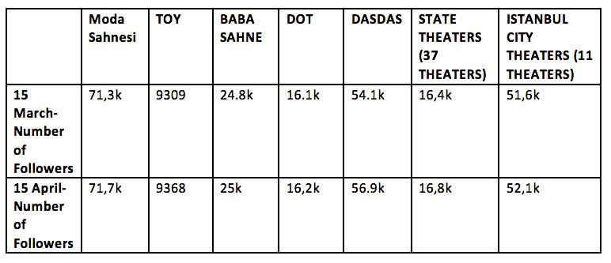

Usefulness of information criteria requires that organizations should post materials that are important and useful to the customers. The information provided must be a way for customers to answer their questions or explore their curiosities. As Kent and Taylor put it, “sites should contain the information what the public would want to know (Kent, Taylor, 1998:331). As for theater audiences, information about the dates of plays, what the play is about, who the actors are and the price and availability of tickets are the most important information. Therefore, three sub items (description of events, calendar of events and information about tickets) were taken as assesment criteria for this principle.

Considering the principle of usefulness of information (Table 2), both public and private the-ater institutions were observed to be successful in realizing this principle. All the theaters which have been examined posted a calendar of their events, gave a detailed description of the plays (i.e information about the context, actors) and all of them, except the State Theaters, informed their followers about the availability of tickets, when they are put up for sale or if they are all sold out or not.

**Table 2:** *Usefulness of Information*

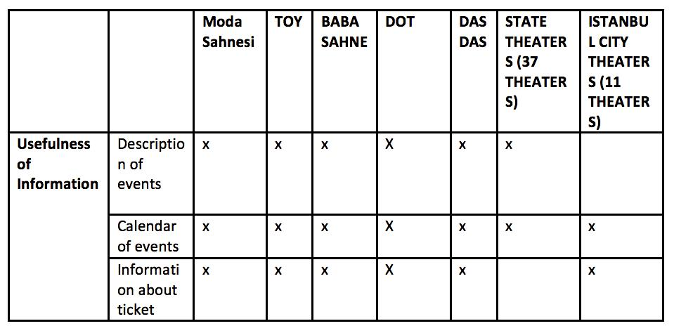

92  ANADOLU ÜNİVERSİTESİ

Conservation of visitors principle requires trying to keep visitors on the organization’s site, rather than encouraging them to “surf ” to other sites (Taylor, 2001: 270) In other words, it is the extent organizations use features to keep their stakeholders on their page. The most important feature to keep the stakeholders on their page is that the page should be active. In other words, there should not be a long time interval between the posts. Increase in the number of users is another indication to measure the conservation of visitors principle since it is a sign of attracting stakeholders and keeping them on the page. Instagram stories and links to relevant Instagram accounts by hashtags are two other items that keep theater audience on the site of the institution.

Looking into the conservation of visitors principle (Table 3), an increase in the number of visitors has been witnessed in all theaters’ instagram accounts. Among the 7 accounts examined, DasDas is the one which has the highest increase in the number of visitors during the period of examination (2,8 thousands), and this relates to its using both instagram and stories actively and effectively, creating a two- way open communication with its followers.

As stated before, State and Istanbul City theaters do not use stories on their Instagram pages. Among the 5 private theaters using Instagram stories, again DasDas has the highest rate of using, with 160 stories posted during the one- month period. Since stories reflect the identity and the point of view of the institutions, they are an important means for communication and conserving the visitors on the institutions instagram page.

Another factor that influenced to keep the visitors on the instituition’s site is enabling the followers to buy their tickets on-line. 5 private theater instituitions offer this service to their followers by just asking them to slide the screen up to buy tickets. By doing so, they are either connected to the Office of the instituition or to Biletix or other institutions which provide tic-kets on-line for a wide range of events.

Links to relevant Instagram accounts by hashtags is another feauture of Instagram that aids to its conservation of visitors principle. Hashtags offer the followers to visit the related Instagram accounts by just tapping on the hashtag. All of the theater accounts examined are using hashtags. Among them, Baba Sahne is the one which uses hashtags the most frequently. To illustrate, pos-ting their weekly program of 9- 15 April, Baba Sahne offered the hashtags “#BabaSahnedeBu-Hafta, #BabaSahne1Yasinda #BabaTakvim, #BabaSahne, #SavasDincelSalonu, #tiyatro, #sahne, #oyun, #konuk, #kadikoyetkinlik, #moda, #kadıköy, #istanbuldaetkinlik, #tiyatroiyidir, #tiyat-roiyilestirir, #istanbuldayasam which were all refering to their program and kept the followers on their sites for a longertime. Also by posting general hashtags like #kadıköy, #kadikoyetkinlik, #moda, #kadıköy, #istanbuldaetkinlik, #tiyatroiyidir, it’s possible to attract new followers.

SANAT & TASARIM DERGİSİ  93

**Table 3:** *Conversation of Visitors*

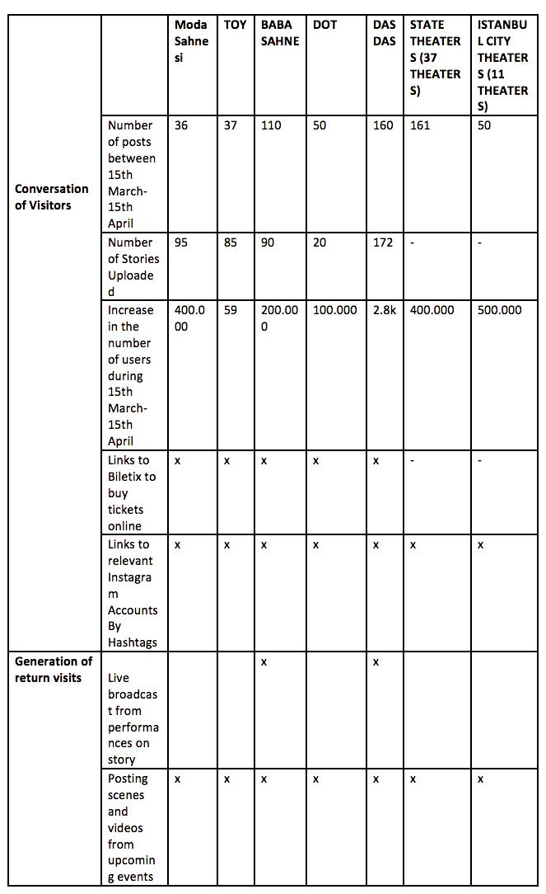

94  ANADOLU ÜNİVERSİTESİ

Relationship building requires time, trust and other strategies that can only occur over repea-ted interactions. Theater institutions invite their visitors to return their visitors to return to their page by posting scenes and videos from upcoming events. Live broadcast from performances on Instagram stories also encourage visitors to return since the visitors want to be a part of the experience. It is important for institutions to keep their followers return to their instagram site at regular intervals in order to generate dialogic communication. Among the 7 Instagram accounts examined, only two of them, DasDas and Baba Sahne, made live broadcasts from per-formances on stories. They announced in advance that they were going to have a live broadcast giving information about the performance and its time. This was a very successfull tool for ma-king the followers return to the site as by watching the live broadcast, they could have the feeling of being there and forming a dialogic relationship with the theater. All 7 instagram accounts posted scenes and videos from upcoming events in advance, to create a feeling of curiosity and cause the followers to visit the page to see if more news about the event was available.

The last but the most important principle of dialogic communication between institutions and their stakeholders is the “dialogic loop”. Communication can not be considered fully dialo-gic if it does not accomplish the requirements to create a dialogic loop. Likewise, an instagram account will not be considered as dialogic if it lacks the features that forms a dialogic loop.

As mentioned earlier, the dialogic loop is in a way similar to a feedback loop in that they both depend on intersubjective and interactive communication. In order for an Instagram ac-count to have a dialogic loop, the first requirement is enabling the followers to ask questions to the instituition and the instituition give a reply directly in return. In other words, the insti-tuition and its instagram followers should be able to be in a direct dialogue. Looking into the 7 instagram accounts, it has been observed in 5 of them (3 private, state and city) questions were asked to the instituition by the followers. (i.e: Will the game re- performed? Will you have a performance in Izmir? The tickets are always sold out, how can we gain access to tickets?) (Table

1. However, during the one month observation period, only one theater instituition, DasDas, replied to the questions asked by its followers.(i.e: We are sorry for the unavailability of tickets. Hope you can get one next time. As DasDas, we currently operate only in Istanbul) As menti-oned earlier in the text, Kent and Taylor (1998) assert that instituitions should have a specially trained and dedicated staff to respond to public concerns and questions. DasDas has a person in charge of this position who is actively communicating with its followers and this makes it have a more dialogic communication with its followers than the other theater institutions examined.

SANAT & TASARIM DERGİSİ  95

**Table 4:** *Dialogic Loop*

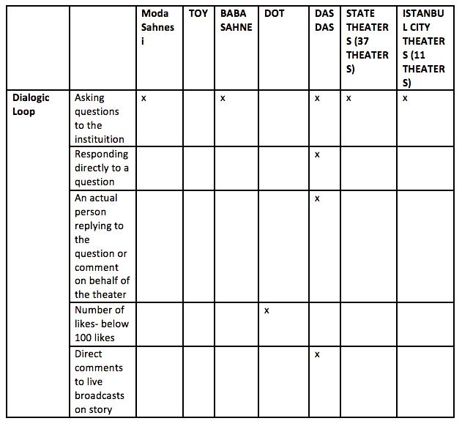

Another item that strengthens the dialogic loop is the users’ direct comments to live broad-casts on story. A real intersubjective dialogue is created among the followers during live bro-adcasts. Followers write messages commenting on the performance and conversing with each other. (i.e: “the broadcast quality is bad. “, “no, we can’t see anything”, “ improve the broadcast quality”) Out of the seven instagram accounts subject to study, only one of them uses the op-portunity of Instagram stories to create an intersubjective dialogue in real time with its followers and this gives the instituition a unique dialogical communication power among the others.

To sum up, the results of this study reveal that private theater institutions give more impor-tance to create a dialogical communication with their followers than state and city theaters. Alt-hough the principle of “usefulness of information” was present in the instagram accounts of all theaters examined, it is not enough to conduct a two way interactive, dialogic communication. It has been observed that the dialogical loop principle, which is the backbone of dialogic com-munication, has the least rate of occurance, with only one out of seven, fullfilling the require-ments of applying a dialogic loop. This reveals that the majority of the theater instituitions lack

96  ANADOLU ÜNİVERSİTESİ

the capacity to apply the defining features of social media which are, being relational, involving feedback, having potential for real time interaction, to their instagram sites (Kent, Taylor, 2016: 62).

**CONCLUSION**

Theaters, as a medium of disseminating some form of information and establishing a relati-onship with their audience, hinge strongly on the art of communication. Instagram has gradu-ally become increasingly important in theaters’ communication and provides various tools with high dialogical potential for engaging in dialogue with their publics. Instagram stories are the most prominent of these tools, providing a less filtered content, more natural perspective and a more personal way to interact on-line.

Theater organizations which realize the power of dialogical communication with their pub-lics are trying to keep up with the pace of changes that web 2.0 offers. These theaters are mostly from the private sector and are trying to apply Kent and Taylor’s dialogic principles to their Instagram accounts. Although not all of them meet all the requirements of dialogical communi-cation through their instagram pages, they display improvements by providing useful informa-tion, trying to keep their followers on the site and enabling them to return to their sites as often as possible. However, dialogic communication is not accomplished unless the dialogic loop is created and this is what is missing even in a majority of private theaters. The dialogic loop has not been applied in 6 of the 7 theaters examined.

On the other hand, state and city theaters take their publics for granted and do not take full advantage of the interactive opportunities and resources of instagram tools to establish an open dialogic communication with their publics. These institutions are still in the initial evolutionary state of communication which is highly monologic.

In conclusion, as Taylor and Kent put it, “social media have enormous untapped potential as persuasive and relational communication tools” and this potential still needs to be unfolded for creating stronger dialogical communication between theaters and their publics.

SANAT & TASARIM DERGİSİ  97

**REFERENCES**

*Agozzino, A (2015) Dialogic Communication Through “Pinning”: An Analysis of Top 10 Most Followed Organizations Pinterest Profiles. Public Relations Journal 9(3), Retrieved from http://www.prsa.org/Intelligence/PRJournal/Vol9/No3/ (Accessed 31 March 2018)*

*Amancio, B. (2017). “Put it Your Story: Digital Storytelling in Instagram and Snapchat Stories”. Retrieved from http://urn. kb.se/resolve?urn=urn:nbn:se:uu:diva-324812</div>(Accessed 29 March 2018)*

*Bakshi, S. Shamma, D. Gilbert, E (2014). “Faces Engage Us: Photos with Faces Attract*

*More Likes and Comments on Instagram”. The 32nd annual ACM conference (pp. 965–974). New York, New York, USA:*

*ACM. Retrieved from http://doi.org/10.1145/2556288.2557403 (Accessed 11 April 2018)*

*Bakhtin, M.M.(1981). Discourse in the Novel. In M. Holquis (Ed). The Dialogic Imagination: Four Essays by Bakhtin.*

*Austin: University of Texas Press.*

*Bortree, D. Seltzer, T. (2009). “Dialogic Strategies and Outcomes: An Analysis of Environmental Advocacy Groups Facebook*

*Profiles”. Public Relations Review 35: 317- 319*

*Buber, M. (2010). I and Thou, USA: Martino Publishing.*

*Chan, N. Guillet, B (2011). “Investigation of Social Media Marketing: How does the Hotel Industry in Hong Kong Perform in Marketing on Social Media Websites?”. Journal of Travel&Tourism Marketing, 28:4, 345- 368*

*Kaye D. Sweetser & Ruthann Weaver Lariscy (2008). Candidates Make Good Friends: An Analysis of Candidates’ Uses of*

*Facebook, International Journal of Strategic Communication, 2:3, 175-198, DOI: 10.1080/15531180802178687*

*Kent, M, Taylor, M (1998). “Building Dialogic Relationships Through The World Wide Web”. Public Relations Review, 24 , (324- 334)*

*Kent, M, Taylor, M (2016). “From Homo Economicus to Homo dialogicus: Rethinking socialmedia use in CSR*

*communication”. Public Relations Review 42: 60-67*

*Kent, M (2013). “Using Social Media Dialogically: Public Relations Role in Reviving Democracy”. Public Relations Review,39, 337- 345*

*Kent, M. (2017). “Principles of Dialogue and the History of Dialogic Theory in Public Relations”. Retrieved from https:// www.researchgate.net/publication/318509024 (Accessed 17 April 2018)*

*Rybalko, S, Seltzer, T. (2010). “Dialogic Communication in 140 Characters or Less: How Fortune 500 Companies Engage Stakeholders Using Twitter”. Public Relations Review, 36(4), 336- 441*

*Solomon, M; Bamossy, G J; Askegaard, S; Hogg, M K. (2013). “Consumer Behaviour: A European Perspective”. Pearson Education Limited, England.*

*Taylor, M. & Kent, M. L. (2014). “The value of social media for pushing activist organizations social agendas: Implications for public relations theory and practice”. Quarterly Review of Business Disciplines, 1(1), 76–87.*

*Waters, Richard D., & Jamal, Jia Y. (2011). Tweet, tweet, tweet: A content analysis of nonprofit organizations’ Twitter updates. Public Relations Review, 37(3), 321-324.*

98  ANADOLU ÜNİVERSİTESİ