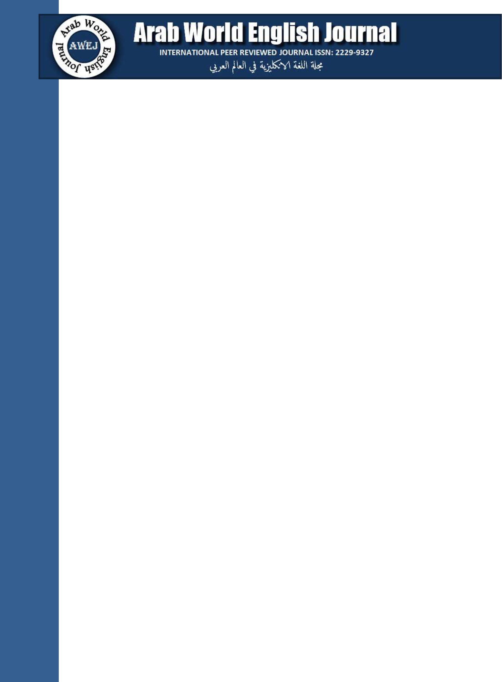

Arab World English Journal (AWEJ) Vol.6. No.2 June 2015

Pp. 329 – 336

**DOI**: https://dx.doi.org/10.24093/awej/vol6no2.25

**Syrian Drama Escaping Censorship: Sa’dallah Wannous’s *The King’s Elephant* and *The* *King is King***

**Samar Zahrawi**

Department of foreign Languages

College of Humanities and Social Sciences

Sam Houston State University Texas, USA

**Abstract**

Sadallah Wannous (1941-1997), a leading Syrian playwright, was concerned in his political theater with preaching democracy and raising the awareness of the masses in order to have more involvement in the public arena. His drama was hurdled with censorship and he had to find indirect ways in his plays to instigate opposition. This article investigates whether the lack of freedom of expression curbs the creativity of the dramatist. My aim is to study and evaluate the dramatic techniques Wannous used in his attempt to circumvent censorship. This is mainly done through a critique of his plays in the light of my textual analysis, Wannous’s statements in his non dramatic writing and available literary criticism. Wannous’s polemical play *An Evening* *for the fifth of June* (1967-8) was banned after the first performance. Two later plays werechosen for this study; *The King’s Elephant* (1969) and *The King is King* (1977). In both plays, Wannous analyzed the nature of authoritarianism and the psyche of the repressed majority, and urged for dissent in far fetched plots that do not directly reflect the status quo. To do so, he made extensive use of fables, folk tales, allegory and symbolism. By exploring new theatrical modes, Wannous was able, not only to politicize the masses, but also to produce high quality art that is thought-provoking and entertaining at the same time. For the purpose of economy I limited my article to two plays. However *The Adventure of the Slave Jaber’s Head* (1970) is very pertinent to the main question herein and can be added later in a more extended book-length study.

***Key words*:***Censorship, Revolution, Syrian drama, Syrian theater, Wannous.*

**Cite as:** Zahrawi, S.(2015).Syrian Drama Escaping Censorship: Sa’dallah Wannous’s TheKing’s Elephant and The King is King. *Arab World English Journal, 8* (1). DOI: https://dx.doi.org/10.24093/awej/vol6no2.25

|  |  |  |
| --- | --- | --- |
| Arab World English Journal | www.awej.org | 329 |
| ISSN: 2229-9327 |  |  |