

|  |  |
| --- | --- |
| IMAGO Revista de Emblemática y Cultura Visual | http://dx.doi.org/10.7203/imago.8.8503 |
| [Núm. 8, 2016] pp. 93-105 | ISSN: DIGITAL 2254-9633 - IMPRESO 2171-0147 |
|  |  |



THE EMBLEM TRADITION IN SHAKESPEARE’S PLAYS: MIRROR-EFFECTS AND ANAMORPHOSES

LA TRADICIÓN DEL EMBLEMA EN LAS OBRAS DE SHAKESPEARE:

EFECTOS-ESPEJO Y ANAMORFOSIS

Jean-Jacques Chardin

*University of Strasbourg*

ABSTRACT: An emblem is a witty combination of various texts and one image which delivers a moral message. The emblem is an art of the gaze, the purpose of which is to lead the eye to the transcendent ideas lying behind the veil of worldly appearances. Shakespeare was obviously sensitive to the visual potential of emblems. This paper aims to show that Shakespeare drew upon the *modus operandi* of emblems but rejected the emblem as a fixed ideological discourse. Shakespeare used the emblem in an anamorphic way to confront the spectator with the shifting world he lives in.

KEYWORDS: emblems; theater; Shakespeare.

RESUMEN: Un emblema es una ingeniosa combinación de varios textos y una imagen que esconden un mensaje moral. El emblema es un arte de la mirada cuyo propósito es conducir el ojo a las ideas trascendentes que se encuentran detrás del velo de las apariencias mundanas. Shakespeare era obviamente sensible al potencial visual de los emblemas. Este trabajo pretende mostrar que Shakespeare se basó en el modus operandi de los emblemas, pero rechazó el emblema como un discurso ideológico fijo. Shakespeare utilizó el emblema de manera anamórfica para confrontar al espectador con el mundo cambiante en el que vive.

PALABRAS CLAVES: emblemas; teatro; Shakespeare.

Fecha recepción: 30-6-2016 / Fecha aceptación: 4-7-2016

93

Jean-Jacques Chardin

Emblems emerged from the tradition of commonplace books, collections of proverbs and maxims such as Erasmus’s *Adages* and *Apophthegmata*, the purpose of which was to help pupils develop themes by means of classical quotes and allegorical moralizations. *Imprese* and earlier combinations of texts and images in decorative arts, along with stained glass windows with scrolls represented on them and ceremonial practices like royal entries have also been identified as possible sources of the genre (Strong: 85-90). Whatever the sources, emblems are primarily an art of recreation and tuition, teaching the gaze in order for the mind to be instructed on moral, religious and even political truths.

Tracing emblematic sources in Shakespeare’s plays has been a challenging occupation ever since Henry Green’s *Shakespeare and the Emblem Writers* was issued in 1870. Shake-speare’s texts are rich in iconic clusterings and numerous studies have been published over the past thirty years or so. In *Shakespeare’s Speaking Pictures* (1974), John Doebler offered an insightful approach to the relationship of icon and text in the Bard’s works, and Marion Trousdale (*Shakespeare and the Rhetoricians*, 1982) argued that Shakespeare’s plays should be read like emblems (145-6).1 More recently, Kwang Cho (*Emblems in Shakespeare’s Last Plays*, 1997) has convincingly shown that it is virtually impossible to come to a clear understand-ing of the romances without paying attention to Shakespeare’s use of the moral discourse of emblems. Following in his footsteps, Peggy Muñoz Simonds has connected the prevailing themes of reconciliation and reunion in *Cymbeline* to the play’s web of motifs encoded with iconic symbolism (*Myth, Emblem and Music in Shakespeare’s* Cymbeline, 1992). Finally, Clay-ton MacKenzie (*Emblems of Mortality*, 2000) has been interested in Shakespeare’s manipu-lation of the life-in-death iconography in the historical plays and in *Hamlet*. Most of these texts focus on the manner in which Shakespeare transposes familiar emblematic motifs into a theatrical context. This paper aims to show that emblematic discourse in some of Shake-speare’s plays operates an ironic reversal of the moral conventions of the genre so as to put the spectator’s eye in immediate contact with an endlessly shifting reality.

The typical emblem is made up of image and words and its most common structure rests upon a tripartite construction with a picture (*pictura*) inserted between a *motto*, usually in Latin, and a verse epigram. The *emblema triplex* was codified by Alciato’s *Emblematum Liber* (1531), originally a collection of classical epigrams illustrated by Alciato’s Augsburg pub-lisher, Heynrich Steiner. However, many emblems do not conform to this code sometimes, there is no visual image, as in Denis de Harsy’s 1540 edition of Guillaume de La Perrière’s *Theatre des bons engins*, and other emblems have more than two textual layers, like Quarles’s *Hieroglyphikes of the Life of Man* (1638).

Present-day readers often find emblematic images and epigrams difficult to interpret. An emblem by Geffrey Whitney entitled «Providentia» features a crocodile whose connection with the *motto* appears to be arbitrary. In order to construct the sense of an emblematic im-age, the viewer has to turn to a body of authoritative texts, classical or more contemporary ones, the writings of Renaissance mythographers (Natale Conti’s *Mythologiae* among oth-ers), and various symbolic *compendia* like Valeriano’s *Hieroglyphica* (1556). Originally printed in Latin, *Hieroglyphica* describes a host of emblematic figures hearkening back to Egyptian hieroglyphs, which the author partly glosses as types of Christian symbolism.2 In the wake

1. Trousdale’s view is that Shakespeare is a good case in point for a study of the way emblematic *topoï* and forms permeate the literature and the arts of the Renaissance.
2. The idea that Christianity was announced by, or contained within, the pagan religions of Antiquity was widely accepted during the Renaissance (see for instance Pico della Mirandola’s *Conclusiones Cabalisticae*). Edgar Wind ar-gues that such views were the consequence of Augustine’s postulation in *Retractationes* (see Wind, 1958: chapt. 1).

94 IMAGO, NÚM. 8 2016, 93-105



The Emblem Tradition in Shakespeare’s Plays

of Horapollo, whose *Hieroglyphica* was printed in 1505,3 Valeriano considered hieroglyphs as a form of primary, Adamic language, and he glosses the crocodile as follows:



*Colebant siquidem Aegyptij Deum sub Crocodili, quod non inficiamur, imagine, proptere a quod solus inter animalia elinguis esse deprehensus est, quod Divinitatis esse prehibent […] Habet insuper Crocodilus eam cum Deo similitudinem quod eius solius oculi pellicula tenui translucidaque […] atque ita cernat […] Ita oculum Dei perlustrare intuerioque omnia […]* The Egyptians worshipped God in the image of acrocodile as it is the only animal deprived of a tongue, which they considered to be the hall-mark of the divine […] On top of that the crocodile is similar to God as its eyes are covered by a light transparent veil through which he sees things. In the same way, God’s eye pierces through everything […] (1556: 206-7)

Emblematic images are but «speaking pictures» (Bath, 1994: title-page), *i.e*. a form of rhetoric both silent and eloquent. They are codified items the sense of which requires the reader’s capacity to recall texts pertaining to a cultural preconstruct. They belong to the *artes memoriae* tradition used from Antiquity as a means of organizing memory and servingas a prop for some forms of Christian

|  |  |
| --- | --- |
| meditation. |  |
| Emblematic images also problema- |  |
| tize the connection between signifiers |  |
| and signifieds. In Whitney’s emblem |  |
| discussed above, the viewer’s eye sees |  |
| a crocodile but his mind’s eye should |  |
| perceive the reality of God’s Providence |  |
| which his physical eyes may not see |  |
| properly; in other words, emblematic |  |
| images are descriptive and figurative, |  |
| mimetic and symbolic, and the process |  |
| of figuration relies on the assumption |  |
| developed by Anne-Elisabeth Spica |  |
| that there exists a natural, although |  |
| strictly arbitrary, connection between |  |
| the objective forms on the picture and |  |
| the concepts signified (1996: 226). |  |
| Epigrams on the other hand do not |  |
| always repeat or explain the visual |  |
| codes, and the collaboration of image |  |
| and texts is not always perfectly har- |  |
| monious. Epigrams often resort to deix- |  |
| is, as in the case of Henry Peacham’s |  |
| «Virtus romana et antiqua» (*Minerva* |  |
| *Britanna*, 1612) [fig. 1], and the rhe- |  |
| torical technique of «enargeia,» which |  |
| Erasmus defines in *De copia verborum* as |  |
| one of the tools of amplification: | Fig. 1. Henry Peacham, *Minerva Britanna*. Emb. 36. |

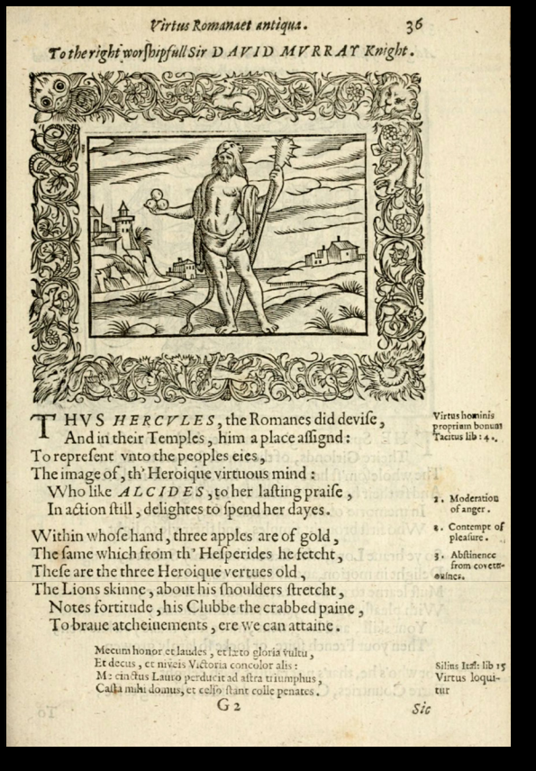

1. The 1505 edition is in Greek, it was translated into Latin in 1515.

IMAGO, NÚM. 8, 2016, 93-105 95

Jean-Jacques Chardin

We use this whenever, for the sake of amplifying […] we do not state a thing simply, but set it forth to be viewed as though portrayed in color on a tablet, so that it may seem to have been painted, not narrated, and the reader has seen, not read. (1963: 47)

Epigrams are imagistic pieces addressing the eye as much as the mind and directing the reader’s gaze from the description to the more fundamental message encoded in the figuration.

The interlocking of, and analogies between, picture and text define emblems as illustra-tions of the *ut pictura poesis* theory where image is identified with adage, both appearing as re-verse and complementary discourses. As signifying practices, emblems reflect the Renaissance episteme which, in Gary Gutting‘s paraphrase of Foucault, «saw things as ordered through their resemblances to one another» (1989: 140) and relied on the platonic distinction between the world of the sensible and that of the intelligible. They are inseparable from a perception of reality as a fixed and stable unit and appear as a kind of hermeneutic code leading the eye and the mind from the deceptive veil of appearances to the more reliable world of *noumena*.

A telling example of Shakespeare’s usage of emblematic discourse is in the comic love-duet of Titania and Bottom (*A Midsummer Night’s Dream*, 4,1). When the Fairy Queen falls in love with Bottom and his ass-head, she embraces him and exclaims:

So doth the woodbine the sweet honeysuckle

Gently entwist; the female ivy so

Enrings the barky fingers of the elm. (4. 1. 41-3).

The vignette of ivy entwisting an elm tree recalls an emblem by Whitney entitled «Amic-itia etiam post mortem durans» featuring a vine cleaving within the branches of an elm, which Whitney moralizes as an instance of mutual assistance [fig. 2].4 Henry Peacham proposes a variation on the same motif in «Ope mutua» with a similar moral conclusion: «This friendship should inviolate remain,/The rich with Bountie should reward the Artes.» Whitney’s emblem elaborates on two of Pliny’s passages on the marriage of the elm and the vine, the latter helping the former to grow (*NH*, XVI, xxix, 1949-54: vol.4, 72; XVII, xxxv, 1949-54: vol.5, 199-201) and appears as the combination of various biblical quotes («Thy wife shall be as a fruitful vine by the sides of thine house,» *Psalm* 128; «I am the vine, ye are the branches,» *John*, 15:5). The *motto* of Whitney’s emblem is a classical *dictum*, often attributed to Pythagoras, and a clear echo of an adage by Erasmus, «Amicorum omnia communia» in which friendship and love are praised as tokens of Christian charity.5 Once the sources have been identified, Whitney’s and Peacham’s emblems can be interpreted as «silent parables»6 teaching the reader Christian virtues by a classical fable. Shakespeare was certainly aware of the mixture of classical and Christian meanings in the image of the vine and the elm, but he has Titania substitute ivy for the vine of the original sources. Pliny calls ivy «civilized» («urbanae»), along with other evergreens because they afford fruit or shade («*fructu aut aliqua dote umbrarumque officio humanius iuvant*,» *NH*, XVI, xxxii (1949-54: vol.

1. It is commonly assumed that Shakespeare was acquainted with Whitney’s *A Choice of Emblemes*. See MacKenzie, 2000: 10; Simonds, 1992: 268. For a detailed analysis of the motif of the elm and the vine see Demetz, 1978: 512-32.
2. It is the first adage of Erasmus’s 1508 *Chiliades*. The same idea is found in Hythlodaeus’s presentation of «The Religions of the Utopians, « in the 2nd book of Thomas More’s *Utopia*: «[…] it was a matter of no small moment with them to hear that Christ approved of life in common for his disciples and that it is still practiced among the most genuine Christian communities» (2001:117).
3. I borrow the expression from Francis Quarles, *Emblems Divine and Moral* (1635) (A3).

96 IMAGO, NÚM. 8 2016, 93-105



The Emblem Tradition in Shakespeare’s Plays

4, 439). Shakespeare on the other hand of-ten conceives ivy in less positive terms. For instance Prospero compares Antonio to «the ivy which had hid [his] princely trunk,/And sucked [his] verdure out on’t,» and depicts him as a parasite unable to curb his desires (*The Tempest*, 1. 2. 86-7). As used by Tita-nia, the image of the ivy embracing the elm is gendered and underlines the dangerous and potentially destructive force of female desire. The vine-elm comparison in Titania’s love declaration forefronts Shakespeare’s playful treatment of emblematic discourse where the codified sense is displaced to-wards a more mundane –and in this case primarily erotic– interpretation, erasing the Christian message of the original sources. Shakespeare’s manipulation of the language of emblems urges the spectator to form a multilayered image, both recalling and dis-torting the original *topos*,7 as he does also in

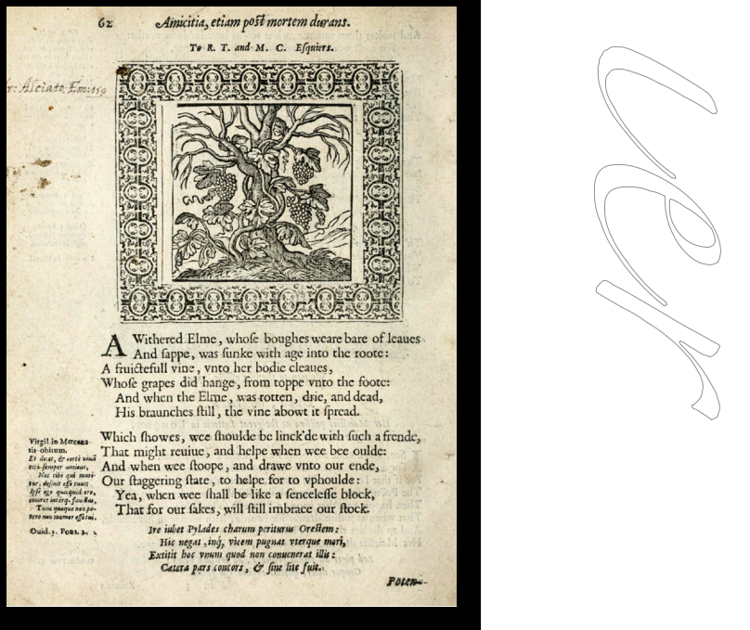

*King Lear*. Fig. 2. Geffrey Whitney, *A Choice of Emblemes*. Emb. 68. Many critics have called attention to the

fact that *King Lear* is structured on a series of emblematic tableaux, such as the encounter between the king and poor Tom on the heath. Lear’s vituperation against his daughters’ cruelty concludes on a very visual reference to the myth of the pelican:

Is it the fashion that discarded fathers

Should have thus little mercy on their flesh?

Judicious punishment! ‘Twas this flesh begot

Those pelican daughters. (3. 4. 67-70)

The story of the pelican was extremely popular in early modern Europe. The 1593 edi-tion of Ripa’s *Iconology* has an emblem entitled «Bonta» recounting how the pelican feeds her young ones on her own blood to signify Christ’s self-sacrifice.8 Ripa clearly rephrases Valeriano who equally provides a Christian interpretation of the pelican motif:

*Sed enim, nostri quoque cum Aegyptiis sacerdotibus […] Pelecanum pro miseratione ponunt […] in summa cruce statuunt, qui nos sospitaturus, atrocissima torqueri morte voluerit*. But ours [our priests] concurwith the Egyptian priests […] and consider the pelican a symbol of commiseration […] they place it as a hieroglyph at the top of Jesus’ cross, who accepted to die this awful death in order to save us. (1556: 146)

The pelican, a commonplace of many emblem collections, is a symbol of patience, con-stancy, compassion and love. But Lear’s use of the image reverses the conventional sym-

1. Peggy Muñoz Simonds has a very percipient analysis of the elm and the vine as marriage topos in *Cymbeline* (1992: 243-271).
2. The original Italian edition of *Iconologia* has no pictures in it.

IMAGO, NÚM. 8, 2016, 93-105 97

Jean-Jacques Chardin

bolic value of the pelican by identifying Goneril and Regan as cannibalistic figures whose ingratitude feeds upon their father’s love. Stephen Orgel convincingly argues that «the cari-tas emblem in *Lear* is of a piece with the play’s invocation of the barbarous Scythian, ‘Or he that makes his generation messes’» (1996: 134-6). It might even be added that it supports the challenging of the ideology9 of humanism so pervasive in the play.

The characterization of Cordelia likewise draws on an ironic treatment of emblematic sources. At the beginning of the play, Cordelia chooses silence and the mute language of the heart against the oily rhetoric of her sisters: «Love and be silent […] Unhappy that I am, I cannot heave/My heart into my mouth (*KL*, 1, 1, 61-91). Cordelia rephrases a verse from *Ecclesiasticus*, an Old Testament deuterocanonical text commonly accepted by the CatholicBible, «the heart of fooles is in their mouth: but the mouth of the wise is in their heart» (xxi, 26), and provides an echo to Valeriano’s moral comment on the heart in *Hieroglyphica*: «*Ap-erto pectore frequentissimo eorum usu qui citra sucum loqui se profitentur*» («Open heart is an ex-pression frequently used by those who profess to speak sincerely,» *Hieroglyphica*, 1556: 430). Later, when banished by her enraged father, she voices her belief that the passing of time will eventually reveal truth, «Time shall unfold what plighted cunning hides» (*KL*. 1. 1. 279). Cordelia’s proverb-like affirmation is a commonplace which, in Erasmus’s words, provides «a readie and shorte way to learne virtue» (1963: 67). It is also reminiscent of Whitney’s emblem «Veritas Temporis Filia» and possibly harks back to a paraphrase by Richard Tav-erner of Erasmus’s adage «Tempus omnia revelat»: «Time discloseth all thinges. Nothinge is covered, but shalbe reveled, nothinge is hid, that shall not be knowen, saith Christe» (1569: 35). Shakeapeare might have had access to the Erasmus text *via* Taverner’s translation which apparently influenced him on more than one occasion: for example the epilogue of *As You* *Like It* spoken by Rosalind compares the play to «good wine» which «needs no bush,» anintriguing comment found in Taverner’s adaptation of Erasmus’s «Vino vendibili suspensa hedera nihil opus» (1569: 47). Taverner’s paraphrase of Erasmus works to identify Lear’s rejected daughter as a Christian figure, as do the momentous mentions of her tears.

Tears are a pervasive motif in *King Lear*, as is in many of Shakespeare’s plays, and Cord-elia is the figure most conspicuously connected with weeping. After the King of France has abruptly left England, Cordelia is reported to have wept upon reading letters brought along by a gentleman:

Kent: Did your letters pierce the queen to any demonstration of grief?

Gent: Ay; sir; she took them, read them in my presence;

And now and then an ample tear trill’d down

Her delicate cheek […]

Kent: O! then it moved her.

Gent: Not to a rage; patience and sorrow strove

Who should express her goodliest. You have seen

Sunshine and rain at once; her smiles and tears

Were like, a better way; those happy smilets

That play’d on her ripe lip seem’d not to know

What guests were in her eyes; which parted thence,

As pearls from diamonds dropp’d […]

There she shook

The holy water from her heavenly eyes […] (*KL*, 4. 3. 9-30).

1. I understand the concept of «ideology» in the sense sociologist Karl Mannheim defined it, that is a body of beliefs shared by everyone and constructed by the context in which they were produced. See Mannheim, 1936.

98 IMAGO, NÚM. 8 2016, 93-105



The Emblem Tradition in Shakespeare’s Plays

The vignette of Cordelia’s eyes shedding tears evokes the *pictura* of an emblem by Pea-cham entitled «Hei mihi quod vidi» (although not issued until 1612) [fig. 3] which features a large eye shedding three huge tears. The first stanza of the epigram depicts the alchemical operation whereby tears are produced:



Looke how the Limbeck gentlie downe distil’s,

In pearlie drops, his heartes deare quitescence:

So I, poor Eie, while coldest sorrow fills,

My brest by flames, enforce this moisture thence

In Christall floods, that thus their limits breake,

Drowning the hearte, before the tongue can speake.

Melancholy, a cold, dry humour, is heat-ed up in the breast eventually to be purified into water by a process of distillation. Re-fined in the alembic of the breast, tears are turned into the quintessence of the heart which is then washed clean of all impuri-ties and filth. In alchemy, quintessence is the pure extract obtained by digestion at a gentle heat, but it is also the fifth essence of which heavenly bodies were supposed to be composed. Tears establish a relation-ship between the weeper and the cosmos, no wonder then that Cordelia’s eyes shed holy water («She shook/The holy water from her heavenly eyes» 4, 3, 30). The to-pos of purity is taken up in the image of tears as «Christall floods,» with crystal be-ing the most refined form of glass. The im-age also stresses the sacredness of tears as attributes pertaining to Christ. The Bible abounds with mentions of tears, in the Old Testament, Rachel, Jacob, Esaü all weep, God himself weeps, and in the New Testa-ment, Christ is reported to have wept three times.10 The gift of tears is a sign of the di-

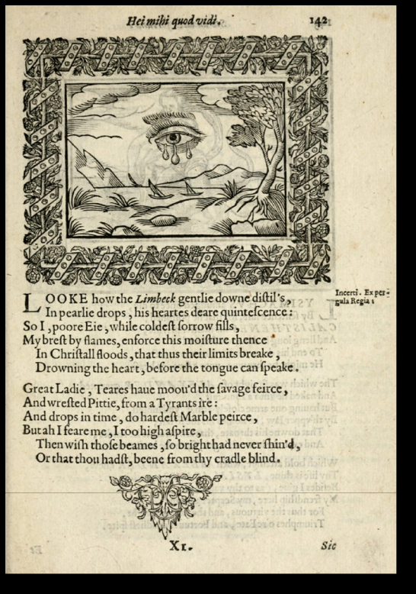

Fig. 3. Henry Peacham, *Minerva Britanna*, Emb. 142.

vine in man, which validates a reading of

Cordelia as a Christ-like figure.

Later in the play Cordelia’s function as a redemptive force is stressed when she helps to save Lear and reestablishes a right relationship with him (*KL*, 4, 7). She kneels to receive Lear’s blessing and weeps again in a very visual tableau recalling Ripa’s emblem on the third Beatitude, «Beati, qui lugent, quoniam ipsi consolabuntur» which depicts a young woman kneeling and weeping. Cordelia’s tears are part of a significant thread of Christian imagery in the play, and the echo of Ripa’s emblem, along with the importance of the Biblical inter-

10. Among many percipient analyses of Christ’s tears, see Chalier, 2003; Le Goff and Truong, 2003.

IMAGO, NÚM. 8, 2016, 93-105 99

Jean-Jacques Chardin

text contained in it, identifies Lear’s rejected daughter as one open to express mercy and forgiveness with integrity. The language of emblems helps to construct Cordelia as an alle-gory of Christian concepts similar to a character in a morality play. Yet *King Lear* is far from complying with the ethical code of medieval drama. The play is probably Shakespeare’s darkest exploration of Renaissance skepticism, showing the collapse of accepted ideological structures like natural order or divine justice, and Cordelia’s unjustified death evidences the inadequacy of emblematic schemata. The rhetoric of emblems with its repeated use of *sententiae* and fixed moral precepts intensifies the clash between «ready-made» systems ofthought and the unintelligible world staged at the close of the play. In the words of Huston Diehl, emblems «force their readers to confront the disparity between signifier and signi-fied and at the same time to pursue the analogous relationship between disparate things, between the image and the invisible thing it signifies» (1986: 61). While problematizing the relationship between words (or images) and things, emblems are the expression of a world based on what Michel Foucault identified as an episteme characterized by resemblance and similitude. It is precisely this tendency to stratification that Shakespeare questions by his very use of emblematic discourse.

According to James Siemon whose analyses inform this paper, the rhetoric of emblems attempts «to solidify living flux into significance» (1985: 249). In Shakespeare’s plays em-blematic echoes are often inserted within contexts which undermine the codified symbolic message.

At the beginning of *Henry V*, the archbishop of Canterbury, the bishop of Ely and the Duke of Exeter strive to convince the young king that he can safely invade France despite the Scottish threat in the north. The government, they claim, «doth keep in one consent,

* Congreeing in a full and natural close, / Like music» (*HV*, 1. 2. 181-3). Canterbury com-pletes his exposition with the comparison between the kingdom and the hive:

For so work the honey-bees,

Creatures that by a rule in nature teach

The act of order to a peopled kingdom.

They have a king and officers of sorts;

Where some, like magistrates, correct at home,

Others, like merchants, venture trade abroad,

Others, like soldiers, armed in their stings,

Make boot upon the summer’s velvet buds,

[…] I this infer,

That many things, having full reference

To one consent, may work contrariously:

As many arrows, loosed several ways,

Come to one mark […] (*HV*,1. 2. 187-208)

The analogy between music, the order of the kingdom and the hive is a commonplace of sixteenth-century political theory and of emblematic literature. Whitney’s «Ex bello, pax» for instance, moralizes the hive as a symbol of concord and order. It is possible that Shake-speare drew on Pliny who dwells at length on the military organization of the hive and the way work is divided amongst the various members of the colony (*HN*, IX. x. 20). Pliny’s description echoes Virgil’s detailed depiction of the beehive in the 4th *Eclogue* which opens on the metaphor of honey as the dew of the sky and a gift of heaven, an image taken up by Christian writers to signify that the bee is a figuration of God. According to *Physiologus* the bee’s works are numberless, like those of God, which though apparently unfathomable to

100 IMAGO, NÚM. 8 2016, 93-105



The Emblem Tradition in Shakespeare’s Plays

men are sweet like honey and wax.11 In Psalm 19 it is written that «the judgments of the Lord are […] sweeter than honey and the honeycomb» (9-10), and the Church Fathers set the comparison between the hive and the convent, later developed by humanist thinkers into the analogy between the hive and the kingdom. In the *Book of the Governour*, Thomas Elyot argues that a kingdom should be ruled by one king, bound to his people who submit to him, just as a hive has one governor only:



Wherefore undoubtedly the best and most sure governance is by one king or prince, which ru-leth only for the weal of his people to him subject […] just as in the bee is left to man by nature, as it seemeth, a perpetual figure of a just governance or rule. (1962: 7)

According to Elyot, and also to Canterbury, the hive’s organization reflects the law of Nature which most humanists interpreted as the expression of the divine will, like Richard Hooker in the *Lawes of Ecclesiasticam Politie*:

The Law which, as it is laid up in the bosom of God, they call eternal, receiveth […] different and sundrie kinds of names. The part of it which ordereth natural agents, we usually call Nature’s law

* The Law of Reason, that which bindeth creatures reasonable in this world, and with which, by reason, they may plainly perceive themselves bound; that which bindeth them, and is not known but by special revelation from God, divine Law. (2009: 36)

The cluster of classical, patristic and emblematic reminiscences in Canterbury’s use of the hive symbolism evinces Shakespeare’s apparently normative usage of a conventional *topos*. It is difficult though to take Canterbury’s words to the king at their face value, espe-cially in view of the way the archbishop has previously manoeuvered the king in order to secure the interests of the Church: he is ready to allow Henry more money for his campaign in France than his predecessors ever had, in return for the king blocking the bill urged by the commons against the Church:

*Ely*: But, my good Lord,

How now for mitigation of this bill

Urg’d by the commons?

*Cant*: I have made an offer to his majesty

[…]

As touching France, to give a greater sum

Than ever at one time the clergy yet

Did to his predecessors part withal (*HV,* 1. 1. 69-81).

Canterbury is tactical and his language is highly equivocal. The discourse of ideology, to which the rhetoric of emblems belongs, is used by an intriguer, which creates in the spectator’s mind an effect similar to that of an anamorphosis in painting and exposes the inadequacy of any single perspective on the archbishop. Using the emblem tradition in an oblique way, Shakespeare creates a parallax effect which offers the spectators a means of refocusing their impression of the character. Like the Canterbury passage in *Henry V*, the storm scenes in *King Lear* also provide telling instances of the anamorphic treatment of em-blematic discourse.

11. The bee section is to be found in the 2nd Collection of *Physiologus* also called the Byzantine Collection.

IMAGO, NÚM. 8, 2016, 93-105 101

Jean-Jacques Chardin

From the very first lines of 3, 1 Kent and the Gentleman offer allegorical visions of the storm:

Kent:Who’s there, besides foul weather?

Gent: One minded like the weather, most unquietly.

Kent: I know you. Where’s the King?

Gent: Contending with the fretful elements;

[…] tears his white hair,

With the impetuous blasts […]

Strives in his little world of man to out-storm

The to-and-fro-conflicting wind and rain. (3. 1. 1-11)

To them the storm is a magnified mirror of Lear’s demented mind, a view consolidated by the King’s own system of images in the next scene:

Blow, winds, and crack your cheeks! Rage! Blow!

You cataracts and hurricanoes, spout

Till you have drenched our steeples, drowned the cocks!

You sulphurous and thought-executing fires,

Vaunt-curiers of oak-cleaving thunderbolts,

Singe my white head! And thou, all-shaking thunder,

Strike flat the thick rotundity o’ the world!

Crack Nature’s moulds, all germens spill at once,

That makes ingrateful man! (3. 2. 1-9)

The prosopopeia in the first line endows the storm with human features and, in Lear’s view, the wind and rain are elemental signs of human cruelty. Because of his experience with his evil daughters, Lear schematizes the world around him and applies to the signifier «storm» the only signified possible, «ingratitude.» The metaphors he uses promote corre-spondences between the elements and his daughters, because to him analogy possesses a heuristic value.

Understandably, the hardships of the trial on the heath are supposed to teach Lear cour-age and virtue: «No, I will be the pattern of all patience; I will say nothing» (3. 2. 37-8). Lear rephrases the ethical message of many emblems on the fate of man caught up in the storms of existence: in Whitney’s «Constantia comes victoria,» the image depicts a ship tossed about by a stormy sea and the epigram argues that the storm is overcome by the patient man who has awakened his faith in the designs of Providence. When the spectator recognizes the emblematic echo in Lear’s words, he can empathize with the king and par-ticipate in his spiritual awakening.

It seems though that such a moralizing view of the storm and the trials it inflicts is not fully satisfactory. It is heavily impaired by the Fool’s remarks whose function is to de-alle-gorize the storm which to him means nothing more than wind and rain:

He that has and a little tiny wit

With hey, ho, the wind and the rain,

Must make content with his fortunes fit,

Though the rain it raineth everyday.

The Fool provides a matter of fact approach to the storm that clashes with Lear’s –and possibly the spectator’s– complacent figural interpretation. Besides, the trial undergone by

102 IMAGO, NÚM. 8 2016, 93-105



The Emblem Tradition in Shakespeare’s Plays

Lear leads only to the nauseating illumination that «unaccommodated man is no more but such a poor, bare, forked animal» (3. 4. 103-4), an ironic anagnorisis which negates the biblical precept that man was created in the image of God. And this somber enlightenment shows Lear’s view being paralyzed by the rigid, allegorical language of emblems.



Lear’s tendency to schematization leads him to envisage Edgar/Tom as an image of ut-ter destitution and a degraded icon of human nature. But this disenchanted view of man standing outside traditional representations, poses, in James Siemon’s words, «an ultimate anti-emblem» (1985: 267), that is an emblem denying the emblem’s essential allegorical functioning. Siemon very convincingly argues that Lear’s tragedy is that he can think only in terms of the «generalizations provided by the emblematic vision» (1985: 249) which the action of the play proves to be inoperative. *King Lear* stages «a lifeworld,» in Jürgen Habermas’s words (1985: 315), that is a set of values and ideas men use to construct their perception of the world around them, which has been totally denatured by triumphant self-ishness and an aggressive use of reason. As a result Lear and Cordelia, but also Gloucester and Kent, are estranged from the culture that has shaped their values, and the language of emblems sounds ironically foreign in an enigmatic universe where «all’s cheerless, dark, and deadly» (5. 3. 288).

Theatre, as the Greek etymology of the word suggests, is a language made for the eye and an art of the gaze. Criticism has often pointed out that Shakespeare’s plays are struc-tured like mannerist mirror-cabinets with images superimposed on one another, the effect of which is to sabotage the prospect of semantic closure. The technique of characteriza-tion is often based on a system of catoptrics, offering varying perspectives on the charac-ters, which urges the spectator to accommodate his gaze perpetually. In the plays that I have analyzed, Shakespeare confronts the spectator’s eye with a Protean world of change whence the sense of unity and harmony has eventually disappeared. Theatre is a world of illusions which helps us to get a better view of our own reality through the illusions of life that it stages. Emblems similarly address the gaze in order for the eye to see the divine na-ture of things beyond the objective forms of the *hic et nunc*. In an emblem the visual contact with the text or the picture is the first stage in a process of meditation whereby the spiritual eye is awakened to the existence of a more transcendent reality. It is clear that Shakespeare was undoubtedly sensitive to the visual potential of emblems and some of his plays do not question the ethical value of emblems. He drew upon the *modus operandi* of emblems, *i.e.* the creation of images within the mind’s eye, but rejected the emblem as the expression of a system of analogies and correspondences, and he used the rhetoric of emblems to question the validity of a *mundus significans* suddenly experienced as meaningless. As emblems direct the gaze towards the world of immutable ideas, Shakespeare’s plays redirect it towards the spectator’s more immediate reality. In his treatment of emblematic discourse, Shakespeare creates a dissonant dialogue between the fixed discourse of ideology and the new percep-tion of a shifting and destabilizing human reality.

IMAGO, NÚM. 8, 2016, 93-105 103

Jean-Jacques Chardin

BIBLIOGRAPHY

Alciato, A. [1531]. *Emblematum Liber*, Augsburg, Heinrich Steyner.

Bath, M. [1994]. *Speaking Pictures: English Emblem Books and Renaissance Culture*, London and New York, Longman.

Chalier, C. [2003]. *Traité des larmes: Fragilité de Dieu, fragilité de l’âme*, Paris, Albin Michel.

Cho, K. S. [1997]. *Emblems in Shakespeare’s Last Plays*, Antwerp, University Press Antwerp.

Conti, N. [1586]. *Mythlogiae*, Venice.

Demetz, P. [1958]. «The Elm and the Vine: Notes toward the History of a Marriage Topos», *PMLA* 73.5, 512-32.

Diehl, H. [1986], «Graven Images: Protestant Emblem Books in England», *Renaissance Quar-terly*, 39, 49-66.

Doebler, J. [1974]. *Shakespeare’s Speaking Pictures*: *Studies in iconic imagery,* Alburquerque, NM, University of New Mexico Press.

Elyot, T. [1531, 1962]. *The Book named the Governor*, ed. by S.E. LEHMBERG, London, Dent.

Erasmus, D. [1508]. *Adagiorum Chiliades*, Venice, Aldus.

— [1511, 1963]. *De copia verborum*, translated from the latin with an introduction by Don-ald B. King and H. David Rix. Milwaukee, WI, Marquette University Press.

Green H. [1870]. *Shakespeare and the Emblem Writers*, London, Trübner and Co.

Gutting, G. [1989]. *Michel Foucault’s Archeology of Scientific Reason*, Cambridge, Cambridge University Press.

Habermas, J. [1985, 1987]. *The Philosophical Discourse of Modernity*, translated by F. LAW-RENCE, Cambridge, Polity.

Hooker, R. [1593-7, 2009]. *Of the Lawes of Ecclesiastical Politie*, in R. CHAPMAN (ed.), *Law and* *Revelation: Richard Hooker and his Writings*, Norwich, Canterbury Press.

Horapollo [1505]. *Hieroglyphica*, Venice, Aldus.

La Perriere, G. [1536]. *Le Théâtre des bons engins*, Lyon, Denis de Harsi.

Le Goff, J. and TRUONG, N. [2003]. *Une Histoire du corps au Moyen Âge*, Paris, Liana Levi. Mackenzie, C. [2000]. *Emblems of Mortality*: *Iconographic Experiments in Shakespeare’s Theatre*,

Antwerp, University Press Antwerp.

Mannheim, K. [1929 1936]. *Ideology and Utopia*, London, Routledge and Kegan Paul.

More, T. [1516, 2001]. *Utopia*, New Haven and London, Yale University Press.

Orgel, S. [1996], «Gendering the Crown,» in M. de GRAZIA, M. QUILLIGAN and P. STAL-LYBRASS (eds.), *Subject and Object in Renaissance Culture*, Cambridge, Cambridge Univer-sity Press, 133-65.

Peacham, H. [1612]. *Minerva Britanna*, London, Dight.

Pliny the Elder. [1949-54]. *Natural History*, translated by H. RACKHAM, London, William Heinemann.

Quarles, F. [1635]. *Emblems Divine and Moral*, London, Printed by G.M. and sold at Iohn Marriots shope in St. Dunstons church yard Fleetstreet.

— [1638]. *Hieroglyphikes of the Life of Man*. London, Printed by M. Flesher, for Iohn Marriot. Ripa, C. [1593]. *Iconologia*, Roma, Heredi di Giovanni Gigliotti

Shakespeare, W. [1982]. *Henry V*, Oxford World’s Classics. Oxford, Oxford University Press.

— [1987]. *The Tempest*, Oxford World’s Classics. Oxford, Oxford University Press.

— [1994]. *A Midsummer Night’s Dream*, Oxford World’s Classics, Oxford, Oxford University Press.

104 IMAGO, NÚM. 8 2016, 93-105



The Emblem Tradition in Shakespeare’s Plays

Shakespeare, W. [1997]. *King Lear*, Bloomsbury, The Arden Shakespeare.

Siemon, J. [1985]. *Shakesparean Iconoclasm*, Berkeley, University of California Press.



Simonds, P. M. [1992]. *Myth, Emblem and Music in Shakespeare’s* Cymbeline, Newark, Univer-sity of Delaware Press.

Spica, A-E. [1996]. *Symbolique humaniste et emblématique*, Paris, Champion.

Strong, R. [1973, 1984]. *Art and Power*, Woodbridge, Boydell Press.

Taverner, R. [1569]. *Proverbes or Adages, Gathered out of the Chiliades of Erasmus*, Imprinted at London, In Fleetestreete, by William Hovv.

Trousdale, M [1982]. *Shakespeare and the Rhetoricians*, Aldershot, The Scolar Press.

Valeriano, P. [1556]. *Hieroglyphica*, Lugdunum, Pauli Frelon.

Whitney, G. [1586]. *A Choice of Emblemes*, Imprinted at Leyden, In the house of Christopher Plantyn, by Francis Raphelengius.

Wind, E. [1958 1967]. *Pagan Mysteries in the Renaissance*, Harmondsworth, Penguin Books.

IMAGO, NÚM. 8, 2016, 93-105 105