**Frimberger, Katja (2017) 'Some people are born strange': A Brechtian theatre pedagogy as**

**philosophical ethnography**, Qualitative Inquiry, Volume 23, Issue 3, pp. 228-239

Link to Publication: http://journals.sagepub.com/doi/10.1177/1077800416643995

**Abstract**

The article explores the role of a Brechtian theatre pedagogy as 'philosophical ethnography' (Lather 2009a,b) in four investigative drama-based workshops, which took international students' intercultural 'strangeness' experiences as the starting point for aesthetic experimentation. It is argued that a Brechtian theatre pedagogy allows for a productive rather than representational orientation in research, which is underpinned by a love for the aesthetic 're-entanglement' of (dis-embodied) language and ethical concerns about mimetic representational acts. In order to show how a Brechtian research pedagogy functioned as philosophical ethnography, the article maps the aesthetic transformation of participant Jamal's verbatim account in the drama workshops - from (a) its emergence in a post-creative-writing-discussion in workshop 2; to (b) its enactment as a body sculpture in workshop 3; and (c) to its translation into a rehearsal piece in workshop 4.

**Introduction**

(insert image 1/Title: Drama-based experimentation)

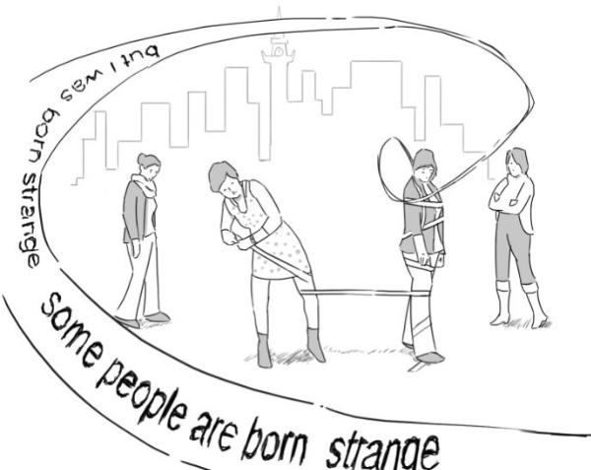

This sketch, provided by artist Simon Bishopp, is based on video footage taken during my research workshops, which worked from

international students' intercultural 'strangeness' experiences through a drama-based approach.

Simon's sketch, more obviously than a photograph, inhabits a place *between* reality and fiction. Its representation is not purely mimetic but 'references' and thus helps to 'map' the embodied acts of meaning-making that took place in the drama workshops. Participant-performers Marta and Amy built a body sculpture themed 'strangeness', using sticky tape and bodily expression only. Sonja and Aleksandra engaged with the frozen human sculpture 'dramatically': they studied its shape, walked around it and recited aloud participant Jamal's verbatim account, which had occurred in the previous workshop:

'Either I am a strange person, I don't know but I was born strange. Some people are born strange (...)'

The following article maps (some of) these performative acts of collective, aesthetic re-entanglement. Jamal's verbatim account is one node on this map. Other material agents - participant-performers bodies, the sticky tape, my researcher subjectivity when 'reading' the performative encounter, Simon's post-workshop sketches - are other nodes. By honing in on the aesthetic transformation of Jamal's verbatim account throughout the workshops, research is asserted as an act of ongoing 'production' rather than static 'representation' of knowledge. A Brechtian theatre pedagogy aids such performative framing and connects to the ontological turn in critical social science research.

**The ontological turn in social science research**

New materialists (e.g. McLure, 2013; Law, 2004, 2009; Lather, 2013, 2009a, 2009b; Lenz Taguchi, 2013; Martin & Kamberelis, 2013; St Pierre 2013; St. Pierre & Pillow, 2000) formulate a re-newed critique of humanist approaches to qualitative research that builds on postmodern and poststructural thinkers such as Deleuze (2004), Deleuze & Guattari (1987), Derrida (1978) and Foucault (1989). They problematise the representational logic of positivist research orientations and

assert instead a logic of connection, which is rooted in more situated understandings of human interaction *in* and *with* the material world (Martin & Kamberelis, 2013).

Conventional forms of analysis frequently find the bodily entanglement of language troublesome or trivial, focusing instead on the ideational and cultural aspects of utterances (spoken or written). (...) Qualitative method wants its participants, both researchers and 'subjects' to be angels (...). Speakers need no bodies, no unconscious, no social fabrication or historical entanglements in order to function as the mere emitters of signals or carriers of linguistic universals. (McLure, 2013, p. 664)

Traditional forms of data collection and analysis often treat language as dis-connected from, yet representative of, the material world. Such focus on linguistic universals, however, does not take into account language's fundamental interdependency with other material factors. St Pierre & Lather (2013) suggest that we need to think researcher subjectivity from a position of material 'entanglement' (p. 630) rather than from a 'dis-entangled' stance of neutral observation; a position that preludes conventional research designs. 'Language' and with that participants' and researchers' 'voices' can hereby not be essentialised and taken as representative of a primary reality. Instead, St. Pierre (2013) reminds us that 'language and reality exist together on the surface' (p. 649) and produce reality interdependently. Given the difficulty to work towards an ontological representational practice where language, materiality and subjectivity are all considered constitutive of each other, St Pierre (2013) cautions not to disregard the linguistic too easily but to struggle with such 'aesthetic of depthlessness' (p. 649f). Alternative research practices might then be shaped from within this struggle to de-centre the human subject (and her language) as the only agent of knowledge production (Lather, 1993; Hultman & Lenz Taguchi, 2010; Lenz Taguchi, 2013).

In poststructuralist terms, the 'crisis of representation' is not the end of representation, but the end of pure presence. Derrida’s point regarding the 'inescapability of representation' (Arac, quoted in McGowan 1991, p. 26) shifts

responsibility from representing things in themselves to representing the web of

'structure, sign and play' of social relations (Derrida 1978). (Lather, 1993, p. 675)

A refusal to regard 'language' and 'voice' as merely second-order representations of primary reality is not a call for the end of representation. It is a call for ‘a politics of the real’ (Law, 2009, p. 243), which makes transparent the meaning-making processes and thus power dynamics underlying our acts of representing the world through our practices of inquiry. It is also a reminder to consider language as first-order materiality and welcome the potential for deconstructive play and reflection this entails. This involves, for example, attention to where taken for granted communication processes in research might be *interrupted*. Discursive interruptions can manifest as silences, sickness, other non-verbal or verbal expressions which can cause a linearly conceived research to 'stutter' and 'falter' (McLure, 2013, p. 663). Interruptions assert the performative dimensions of research communication by bringing embodied expressions to the fore, which can't be easily collected and coded as neutral, dis-embodied, linguistic utterance. These trans-lingual manifestations (Canagarajah, 2013), by nature of their undeniable, first-order entanglement, draw attention to the 'hinterland of material practices' (Law, 2009, p. 241) that caused the interruption and slowed down our 'rage for meaning' (McLure, 2013, 663).

'How are we in entanglement? How might we become in becoming?' (St. Pierre &

Lather, 2013, p. 631)

Such experience of material interruption of taken-for-granted communication flows in the research process, leads us to reflect on how research might be thought from an ontological position of entanglement. Drawing on post-structural and postmodern thinkers (Deleuze, 2004; Deleuze & Guattari, 1987; Derrida, 1978), new materialists think of interruptions as the key for putting a poststructuralist research practice to work, because they force us to re-orient our practices of inquiry towards an 'aesthetic of depthlessness' (St Pierre, 2013). Interruptions can open spaces for an 'ontology of becoming' - where we question the ways things (including ourselves) *are* in research,

and making us think of the ways things might *become* (Martin & Kamberelis, 2013). In other words, a stuttering research process can enable reflection on the validity of our methods and the realities and knowledge practices these, sometimes inadvertently, strengthen or weaken (Law, 2009). The term 'validity', although commonly associated with positivist approaches to research, is not dismissed by new materialists but re-inscribed to concur with a performative view on knowledge (Lenz Taguchi, 2013; St Pierre & Pillow, 2000; St Pierre, 2013; Lather 1993). Validity, so Lather (1993; 2013) explains, is not about ‘epistemological guarantees’ but about the invention of creative counter-practices which can work from *within* entanglement and thus rupture existing, hegemonic discourses.

Structured by relations of difference and ontological troubles, across a variety of angles and different registers, we “imagine forward” (Gaventa, 2006) out of troubling a scientificity that claims that objectivity is not political, empiricism is not interpretive, chance can be tamed via mathematization, and progress equals greater governmentality. (Lather, 2013, p. 634)

Post-humanist research asserts the anti-hierarchical, proliferating structure of knowledge in which human agents and matter produce meaning in 'intra-action' (Barad, 2003). 'Valid' research methods then need to take into account the 'rhizomatic' (Deleuze & Guattari, 1987) materiality of knowledge, which can't be conceived as a linear, stable entity that can be easily represented in language as second-order materiality.

Rhizomes are ever-growing horizontal networks of connections among

heterogeneous nodes of discursive and material force. (Martin & Kamberelis, 2013,

p. 670)

A rhizomatic view instead regards acts of knowledge production as marked by a logic of connection and overlap, ruptures, multiplicity and heterogeneity (Martin & Kamberelis, 2013) - in other words a logic that counters linear, representational research activities.

The practical politics of putting deconstruction to work entails a sort of getting lost as an ethical relationality of non-authoritarian authority. (…) what I am urging is that qualitative research resist the siren call to socially useful research that positions it within repositivization and, instead, work towards embracing constitutive unknowingness, generative undecidability, and what it means to document becoming. (Lather, 2009b, p. 354)

Lather (2009a; 2009b) encourages us to embrace the epistemological uncertainty of orienting our practices of inquiry towards a rhizomatic validity (Lather, 1993) that 'works against the constraints of authority, regularity, and common sense, and opens up thought to creative constructions' (p. 680). She guards against a perspectivism, which merely institutionalises reflexive practices in an act of re-scientification and suggests that critical social science research should be more akin to an ‘investigative workshop’ rather than a 'potential hard science' (Lather, 2009b, p. 349). Putting deconstruction to work then does not simply mean a methodological enablement of multiple perspectives and reflexive practices, which can easily flow within conventional, linear forms of data collection, coding and analysis. A 'philosophical ethnography' (Lather 2009a,b) creatively works from within the mess of unknowabilty and encourages an orientation towards knowledge production that is creatively 'becoming'.

**Brechtian theatre pedagogy**

Following from such productive orientation in social science research, I saw a particular potential in experimenting with Bertolt Brecht's (Brecht & Willett, 1964) theatre techniques in my investigate research workshops. I recognised an important parallel connection to the way critical social science researchers marry questions of ethics and epistemology and seek to put deconstruction to work through alternative practices of inquiry, which (aesthetically) acknowledge the entanglement of the material world.

Whilst exiled from Nazi Germany for 15 years, Brecht continued his artistic and intellectual work, and critique of fascism, by laying the ground for a new modern theatre. He called it the 'epic' or

'dialectic' theatre (Mumford, 2009, p. 167). Brecht, not unlike new materialists (Law, 2004, 2009; Lather, 2009a,b; McLure, 2013; St. Pierre, 2013), advocated for a clear linkage between theatre's representational activity and its social and political responsibility. Brecht was hereby critical of the classic Aristotelian theatre for the same reason neo-materialist scholars query conventional social science methods. Aristotelian theatre and positivist social science research both view the world mimetically: they assume an originary reality which can be known and represented through traditional theatrical conventions (acting, costumes, sets, music) or, to that effect, the agreed-upon language of qualitative research. Brecht criticised that classical theatrical conventions didn't question the power-dynamics underlying these seemingly 'neutral' acts of representing the world on stage.

The crux of the matter is that true realism has to do more than just make reality recognisable in the theatre. One has to be able to see through it too. One has to be able to see the laws that decide how the process of life develop. (Brecht, 1965, p. 27)

Brecht postulated a crisis of representation in the theatre and asserted that there is no such thing as a neutral act of seeing or representing in the first place. He wanted the theatre, as a medium that cannot escape representation, to work the tension between theatre's social responsibility and the impossibility of representing the world as if one's act of doing so did not shape that world in the first place. In the vein of a 'philosophical ethnography' (Lather, 2009a,b), Brecht's theatre aesthetic worked creatively from within the crisis of Aristotelian representation and *interrupted* it. He called these artistic, interruptive devices the 'Verfremdungseffekt' (Brecht & Willett, 1964). The estrangement effect was applied to all theatrical conventions - acting and narrative style, stage and musical arrangements. An actor might suddenly burst into reflective song in the middle of dialogue. The audience might be directly addressed with a social commentary on the character's underlying motivation for action. Storylines were deliberately juxtaposed rather than linearly arranged.

Individuals remain individual, but become a social phenomenon; their passions and also their fates become a social concern. The individual's position in society loses

its God-given quality and becomes the centre of attention. The estrangement effect

is a social measure. (Brecht, 1965, p. 104)

Brechtian 'breaks', now of course all too common theatre devices, startled the audience out of a mode of viewing as consumption into a mode of critical reflection on the representations on stage (e.g. class behaviour, gender roles) and what these revealed about present societal arrangements. The estrangement effect opened a space for questioning everyday representations of the individual, for example, concerning his/her role and capacity for action in society more widely. Brecht's play *Der* *Gute Mensch von Sezuan/The Good Person of Szechwan* (Brecht, 1955) tells the story of Shan Te, afemale prostitute. In her efforts to be a 'good person' in accordance with the moral code passed on to her by the gods, she is forced to invent a male alter ego *Shui Ta*. Only through living her life in split character is she able to avert her own downfall, caused by the aggressive exploitation of her goodness through neighbours and so called friends. By means of an 'aesthetic of heterogeneity' (Jameson, 1998, p. 79), as suggested in the split character of Shan Te/Shui Ta, Brecht aesthetically problematised the ways society sanctions (seemingly) universal moral aims, which can only be sustained through the individual's (here: the woman Shan Te's) ethical degradation.

The epic theatre did not represent reality in way of a universally consumable, self-standing aesthetic whole, which functioned outside of ethical considerations. Instead, Brecht worked from an aesthetic-ethics nexus (Otty, 1995; Franks & Jones, 1999), which produced an aesthetic of interruption. He saw such estranged aesthetic experimentation as crucial 'to the pleasurable and historically specific mastery [as opposed to the mere reproduction] of contradictory social reality' (Mumford, 2009, p. 175). Brechtian representational practice was shaped through the fruitful tension between a simultaneous commitment to (representational) estrangement, unknowablility *and* concrete social justice concerns. This didn't mean that the enjoyment of theatricalrepresentation was denied to the audience or executed in an overly didactic way. Brechtian theatre practice worked in a mode of deconstruction that was always playful (Brecht & Willett, 1964, p. 64-66) and full of what Lather (2009b) calls 'jouissance' (p. 227).

A theatre that can't be laughed in is a theatre to be laughed at. Humourless people are ridiculous. (Brecht, 1965, p. 95)

(...)

Concern with reality [in the theatre] sets the imagination off on the right pleasurable road. Gaiety and seriousness revive in criticism, which is of a creative kind. (Brecht, 1965, p. 105).

Pleasure was not seen as a random by-product of theatre's representational practice. It was at the heart of the work of deconstruction in the theatre and functioned as a 'deliberative' (and joyful) counter-practice (Lather, 2009a, p. 227). Such counter-practice also involved the multiplying and changing of the means of production. Brecht believed that theatre's main potential for social change lay in amateur theatre projects and outside of the main theatre institution. In seeming contrast, Brecht mostly worked within the theatre institution himself, especially after returning from exile to be given his own theatre (the Berliner Ensemble) in the newly found GDR in 1949. In the early 1920's and 1930's he had, however, developed a series of short, experimental plays, especially designed for community theatre context (e.g. workers' groups). He called these the Lehrstücke/the learning plays (Brecht, Müller & Manheim, 1977).

They were meant not so much for the spectator as for those engaged in the performance. It was, so to speak, art for the producer, not art for the consumer. (Brecht & Willet, 1964, p. 80)

The learning plays took participants' social realities as the starting point for an inquiry into the roles and relationships presented in the text.

(...) Lehrtheater breaks with the bourgeois theatre and provides a new revolutionary praxis. (...) It allows the text to be tried out in practice and changed by those who are undergoing the learning experience. (Wright, 1989, p. 13)

Through the application of estrangement effects to the text, participants were enabled to interrogate the text's construction and discuss its underlying assumptions in the light of their own

life experiences. There are a range of scholars who work in a Brechtian tradition to critical social science research. Conrad (2014; 2004) and Salzar (1991) for example use Brechtian-infused popular and applied theatre approaches as ways to collaboratively reflect and represent young people's at-risk' behaviour (in Canadian rural communities, in prison facilities) and reframe the label 'at-risk', which society commonly assigns to such groups. Dennis (2009) uses Boal's (1979) Theatre of the Oppressed techniques, which combines popular education approaches (Freire, 1973; 1995) and Brecht's Lehrtheater approach (Brecht, Müller & Manheim, 1977). In a mode of aesthetic experimentation and reflection, Dennis (2009) explores the complex processes of integration of English language learners in a Midwestern US high school, with teachers and learners. Denzin (2003) developed performance ethnography as a critical qualitative research method. It engages with participants' ordinary life experiences in a reflexive manner by making the researcher into a 'montage maker' (Denzin & Lincoln, 2011), in the vein of a Brechtian estrangement aesthetic. Performance texts are created out of participants' present experiences and hopes for the future, which provoke the audience's active engagement with people's contested social reality. My research builds on these Brechtian-infused approaches which work from an ethics-epistemology nexus. Particular attention is however directed to new materialists' ontological challenge. How does a Brechtian theatre pedagogy help to think materialists' ontological concern for an 'aesthetic of depthlessness' (St. Pierre, 2013), in which 'language' and 'voice' are not representative of reality but just one among many other material meaning-making agents?

**The workshops**

My research explored international students' intercultural 'strangeness' experiences through a series of 4 four-hour drama-based workshops. My research focus was ontological. Aiming to put deconstruction to work, I sought to explore how a drama-based approach can build trans-lingual (Canagarajah, 2013) communication spaces in research which embrace 'constitutive unknowingness, generative undecidability and [work towards] what it means to document becoming' (Lather, 2009b, p. 354). The research encouraged participant narratives through an arts-based approach, which didn't aim to elicit 'factual' data for thematic analysis or representation. My focus was instead productive, aiming to generate playful research encounters and embodied acts of meaning-making.

My research activities were designed to work creatively and collaboratively from the crisis of representation in a mode of an 'investigative workshop' (Lather, 2009a). The Brechtian framing of the research sought to value the estrangement at the heart of a materially entangled research as creative potentiality.

I chose the term 'strangeness' in order to convey to research participants my ontological focus on collective engagement, in which the subjective, visceral and materially entangled dimensions of our intercultural lives might act as the starting point for aesthetic experimentation. This emphasis on 'strangeness' was underpinned by my aim to orient my research towards 'a philosophical ethnography' (Lather, 2009a), which embraces the productive nature of knowledge in a language that is always slipping away (St. Pierre, 2013). In other words, strangeness was conceived as an ongoing creative practice.

A group of 10 international students took part in my workshops over a 4-week period, in November 2010, at the School of Education, the University of Glasgow (Scotland, UK). This was an elite and intelligent group of international MA and PhD students (EU and non-EU) who had the privilege of higher education and possessed a wide range of critical and analytical skills. My participants were a self-selected group from across humanities and social science disciplines (film studies, education, political science). They were between 25 and 52 years old and all women, with the exception of one man called Jamal, a Pakistani participant with an eager interest in arts-based methods. There was a diverse range of nationalities present (Canadian, Chinese, Columbian, Greek, Pakistani, Polish, Russian, Saudi-Arabian) and all participants were (at least) bi-lingual. Their reasons for participating in my research were varied. Some came with a methodological curiosity and wanted to learn more about drama-based research. Others were keen to socialise with other internationals and share their intercultural 'strangeness' experiences in a creative environment. Although most participants pursued their own academic research projects, they were unfamiliar with the format of the drama-based research workshop.

*Workshop structure*

Workshop 1 thus prepared participants for the 'playful' discursive structures that were at the core of my Brechtian research pedagogy. I introduced a range of simple games and crafts as a way to build our research relationships and 'achieve flexibility, resonance with other practitioners and an attunement of the senses' (Grasseni, 2004, p. 53, quoted in Pink, 2009, p. 71). This also included an attunement with meaning-making processes in research that didn't rely on language as second-order materiality. Games such as modelling your partner's life in clay, an alternative version of speed dating which involved singing your favourite childhood lullaby and describing your dream profession as a child, exploited language as first-order materiality for jouissance. Workshop 2 continued these playful modes of deconstruction through improvisational drama exercises, based on Spolin’s (1999) ‘seven aspects of spontaneity’ (p. 4), which combined coordinated movement, music as well observation exercises.

Before the start of the workshops, participants were asked to take a picture of something that occurred 'strange' to them when they first arrived in Glasgow. These images were taken as stimuli for a creative writing exercise in session 2. In a Brechtian vein, these pictures were a springboard for 'complex seeing' (Brecht & Willett, 1964, p. 44) and aesthetic experimentation *between* reality and fiction. The pictures were *not* a way to elicit factual data in an attempt to re-scientificy my research (Lather, 2009a) and make an inventory of what is strange out there in the world.

There is nothing in a data set to be 'found', instead findings are produced through mapping activity - drawing lines that connect the multiple acts, actions, activities, events, and artifacts that constitute the data set. (Martin & Kamberelis, 2013, p. 676)

Instead, the act of creative writing is just one node in the map of the many individual and collective performative acts of making and re-making meaning throughout the workshops. The differentiation between 'mapping' and 'tracing' is important here. The act of tracing implies a mimetic act of tracing

an assumed stable world, whereas the act of mapping allows for this world to 'become' through our creative research practice (Martin & Kameberelis, 2013).

Mapping charts open systems that are contingent, unpredictable and productive. The map has to do with performance, whereas tracing always involves an alleged 'competence'. (Deleuze & Guattari 1987, p. 12-13, quoted in Martin & Kamberelis, 2013, p. 670).

By focusing on participant Jamal's verbatim account, which occurred in the post-creative writing discussion, I hone in on a node on the research map and discuss how it changed and shaped in intra-action with other nodes (bodies, tape, my researcher subjectivity). I haven't chosen Jamal's account because it was the most 'meaningful' piece of data about strangeness experience. I chose it because Jamal's words 'glowed' (McLure, 2013) at me. In their poetic nature, his words defied my easy categorisations and interpretive acts.

We are obliged to acknowledge that data have their way of making themselves intelligible to us (...) The glow appears around singular points - "bottlenecks, knots and foyers" (Deleuze, 2004, p. 63). It involves a loss of mastery of language (and ultimately over ourselves). (McLure, 2013, p. 660ff)

I think that strangeness makes you describe things. It makes you describe things. I feel something is strange, therefore I describe, I describe. (Jamal)

As Jamal observes himself, strangeness (in my case, the 'glowing' strangeness of his account) can evoke continuous acts of philosophising. His account had its way of making itself intelligible to me. It triggered my playful reading between its metaphoric gaps as well as called for further 'strangeness practice' through creative explorations in the subsequent workshops.

Either I am a strange person I don’t know but I was born strange.

Some people are born strange, if you see some people within your own culture and they are quite estranged from that culture. Either they are very creative or they are not acting according to the tradition of that culture. They are quite strange. I gave the example of my cousin. He was quite strange. He was born strange, believe me.

I noticed there are some people and they are quite strange and they can bring change.

(Jamal)

*Jamal*

When Jamal joined my research he expressed a keen interest in arts-based methods. He founded a range of schools for girls in the Pashtun tribal areas on the Pakistani/Afghani border. He worked as a police officer in Pakistan but left his job to learn more about pedagogy and came to Glasgow (Scotland, UK) to undertake a Masters in Education. When I met him first he told me about the difficulties he faced in his region for promoting equal access to education. He also shared his disappointment with his course in the UK. He expected to learn more practically about 'good' pedagogy and creative methods, and felt instead left alone with his questions and learning needs. He joined the workshops to learn more about drama-based research and see how it might become useful for his own context of work. In his creative writing piece, Jamal critically reflected on the material, emotional and psychological 'needs' in his home country and the ways he might help in addressing these. He shared his piece in the group and his subsequent account emerged as part of the group discussion.

*I am reading Jamal's account*

In Jamal's spoken account, which followed the sharing of his creative writing piece, the proposed characteristic that 'some people are born strange' appears a positive and even progressive trait, not

1. 'flaw' or 'lack' of personality. Jamal's strangers display aspirations for change. They are described as subtle, 'creative' rebels who are not understood within their own society. Being born strange seems to equip these 'outsiders' with an innate instinct for change and thinking against the

grain of cultural traditions. This almost missionary appeal of these 'natural born strangers' however does not depict a figure of an over-zealous 'saviour-type'. Jamal plays with the term 'strange' and thus averts the emergence of a 'stranger figure', which can be described, categorised and know in definite terms and explanatory models. Jamal plays poetically with the absurdity of the fact that somebody could have been 'born strange'. His repeated labelling of what constitutes stranger-ness might also (satirically) reference an 'institutional reply' to forms of 'resistance', involving the strategic labelling and social marginalisation of those acting against received tradition. Highlighting the creativity and productive stance of the stranger, Jamal subtly criticises a monolithic conception of culture which seeks to preserve the status quo.

The strangeness of Jamal's strangers does not lie in set traits, definable gestures or set agendas. Instead, the 'disposition' for strangeness emerges through active acts of (self-) questioning and critical-creative engagement with one's environment. This process-based aspect of being a stranger then defies the emergence of a 'stranger figure' or 'stranger fetishism' (Ahmed, 2000). It 'prevents (stranger) identity from being assured as the ontological given of the subject' (ibid, p. 125). 'Some people are born strange', which initially suggests ontological given-ness, simultaneously enacts its rupture. The playful estrangement and metaphoric gaps, which occur when juxtapposing the idea of 'innate strangeness' versus its 'creation through practice', is heightened when Jamal puts himself in relation to this paradox:

Either I am a strange person, I don't know, but I was born strange. Some people are born strange. (Jamal)

By drawing attention to his own 'disposition' for strangeness, he dissolves an entirely dichotomous perception of stranger-ness – for example as 'romantic fascination or felt threat - by returning everyone [including himself] to his or her otherness or foreign status' (Kristeva, 1991, p. 147).

Either they are very creative or they are not acting according to the tradition of that culture. They are

quite strange. (Jamal)

Jamal' s account, not unlike a Brechtian estrangement device, playfully draws my attention to the ontological politics (Law, 2004, p. 143) around the act of creating knowledge about the stranger.

How can we understand the relationship between identity and strangerness

in lived embodiment without creating a new 'community of strangers'? I

|  |  |  |  |  |
| --- | --- | --- | --- | --- |
| suggest that we can only avoid | stranger fetishism, that is, | avoiding welcoming | | |
| or expelling the stranger as a | figure which has linguistic | and | bodily | integrity, |
| by examining the social relationships that are concealed | | | by | this very |
| fetishism. (Ahmed, 2000, p. 6) |  |  |  |  |

Jamal's stranger account, like Ahmed suggests, acts in a playful mode of deconstruction, which defies stranger fetishism, but still playfully philosophises around the *possible* relationship between identity and stranger-ness.

Through the process of attuning our senses in the drama-based games and writing creatively about *strangeness*, Jamal's account emerged as a piece of *philosophising*. His account does not stand as ameaningful piece of data in and of itself but is constituted by the multiple modes of creative engagement that preceded and will follow it. This of course also includes my continuous acts of reading and re-reading Jamal's account in aesthetic transformation.

*Re-entangling Jamal's account*

(insert image 2/Title: Re-entangling Jamal's account in a body sculpture)

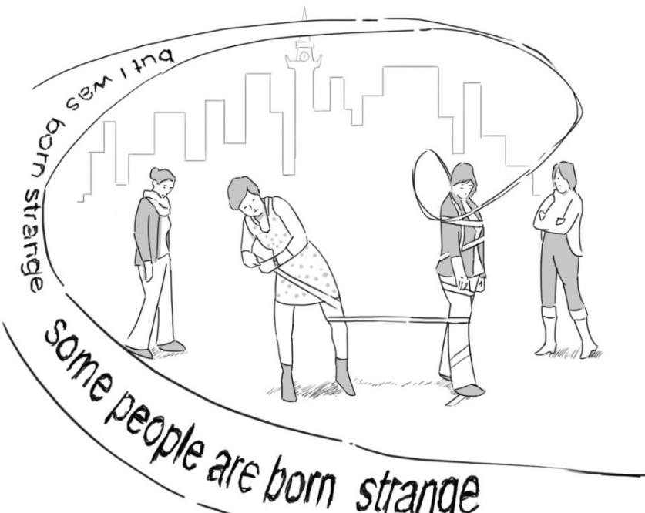

*The School of Education's gym. A grey, Saturday morning in November in Glasgow, Scotland. Amy and Marta volunteer to create a spontaneous sculpture. Amy takes the roll of sticky tape, marks a space on the ground, entangles herself into the tape, and freezes her movements into a sculpture. The white tape is the connecting element. Marta takes the tape out of Amy's hand and composes herself into the sticky body sculpture. I hand out Jamal's account to Aleksandra and Sonja. They rehearse the text, read it aloud, then in turns whilst walking around the sculpture. The two women 'encircle' the two female bodies entangled in white tape whilst reading Jamal's account aloud.*

**Aleksandra:** Either I am a strange person I don’t know but I was born strange.

**Sonja:** Some people are born strange, if you see some people within your own culture and theyare quite estranged from that culture.

**Aleksandra:** Either they are very creative or they are not actingaccording to the tradition of that culture. **Sonja:** They are quite strange.

**Aleksandra:** I gave the example of my

cousin.

**Sonja:** He was quite strange.

**Aleksandra:** He was born strange, believe me.

**Sonja:** I noticed there are some people and they are quite strange and they can bring change.

*I am the audience now (first in the gym, later re-watching the footage). I associate oppressive gestures: encircling, gazing and explaining strangeness. Aleksandra's and Sonja's reading and walking, together with Amy's and Marta's silently posing bodies in the middle, perform the pose of the expert: they gaze, measure, comment, explain strangeness, thus turning the sculpture into a commodity. Stranger-ness, in the embodiment of the sculpture, can be known and 'judged'. Stranger identity, through the aesthetic interplay of the silent, taped bodies and Jamal's read-aloud stranger account, is performed (and read by me) as 'ontologically given' (Ahmed, 2000). The poetic elusiveness of language which guided my initial 'reading' of 'Some people are born strange' has transformed into my 'bodily felt' reading of the sculpture as a 'stranger fetish' (ibid).*

The silent posing of Amy's and Marta's bodies, taped-up in the middle of the room, and Aleksandra's and Sonja's bodies in movement - walking-encircling-gazing - all acted as material agents and separate aesthetic elements which produced meaning. Each element 'quoted' the other but was not fully absorbed in it. In the vein of a Brechtian 'tableaux aesthetic' or 'separation principle' (Mumford, 2009, p. 85), the materiality of the frozen and moving bodies, the materiality of the tape, the materiality of Jamal's words (uttered by other bodies), and my reading of it all, worked in aesthetic juxtapposition, rather than in a linear, easily consumable 'Gesamtkunstwerk' (Brecht & Willett, 1964). Through participants' estranged aesthetic acts, 'meaning' is revealed as being of a rhizomatic nature. It is 'entangled' (but not fully absorbed) in all the material agents present, all central to the production of knowledge between the 'metaphoric gaps' (Carney, 2005) of the creative research activity. This also included the opening of a space for reflection around my own positioning as researcher.

What is my goal as researcher: empathy? emancipation? advocacy? learning

from/working with/standing with? (Lather, 1993, p. 685)

Aware of my changed researcher subjectivity when 'reading' the performative emergence of the collective body sculpture, I decided to emplace myself more consciously within the performance and to further de-centre my researcher subjectivity. I joined all subsequent rehearsal activities and inhabited a direct 'outsider' position only when watching the filmed footage after the workshops had ended. As a group, we continued to experiment with the creation of the *sticky body sculpture*, combining the act of reading out Jamal's lines and the act of sculpting strangeness. We walked through the room, each learning one line from Jamal's account, and practicing its delivery using various, Brecht-infused rehearsal exercises.

In order to disrupt familiar customs and habitual ways of performing, Brecht sometimes used somatic exercises that played with spatial and temporal expectations. (…) Rhythmical (verse-) speaking while tap-dancing alters the usual emphases, tempo and line flow of text, which in turn can generate awareness of the way the text was initially constructed, and of the assumptions underpinning dominant ways of reading it. (Mumford, 2009, p. 136)

Brecht used somatic rehearsal exercises with his actors (Brecht & Willett, 1964, p. 129) to enable reflection on the power-dynamics underlying assumed way of constructing, reading and performing texts. Our continued acts of making strange Jamal's account allowed its continuous alteration and transformation in an open discursive space.

(insert image 3/Title: Rehearsing Jamal's account)

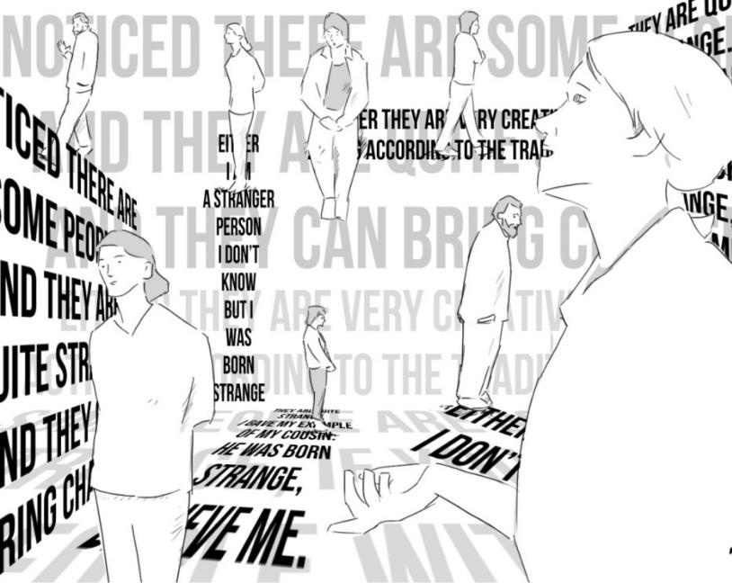

We recited our lines in chorus and individually, delivered them chronologically and at random, and experimented with various intonations, volumes and pace of delivery. We sang hymn-like, shouted, whispered and walked at various speeds and rhythms. After this walking text rehearsal, I started building the body sculpture using the sticky tape, with the aim to aesthetically highlight the meaning-making potential of this material agent.

(insert image 4/ Title: My sticky tape gesture)

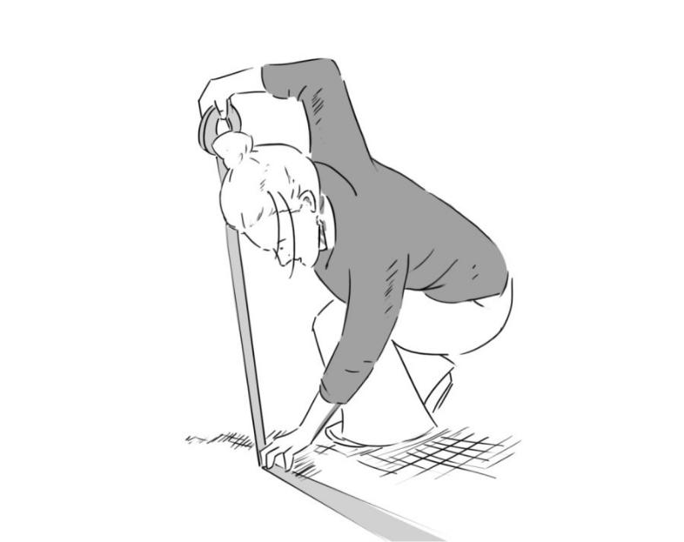

*How does the sticky surface feel on my cheek? Sticking a straight line of tape on the ground I feel the non-sticky surface with my flat hand and smooth out the tape against the floor. I listen to the sound the tape makes when unrolling it with increasing speed, and then abruptly stop.*

*Marking out a triangle with the tape on the floor, I decidedly kneel within it and recite my line:*

*Either they are very creative or they are not acting according to the tradition of their culture.*

(insert image 5/ Title: Reciting my line)

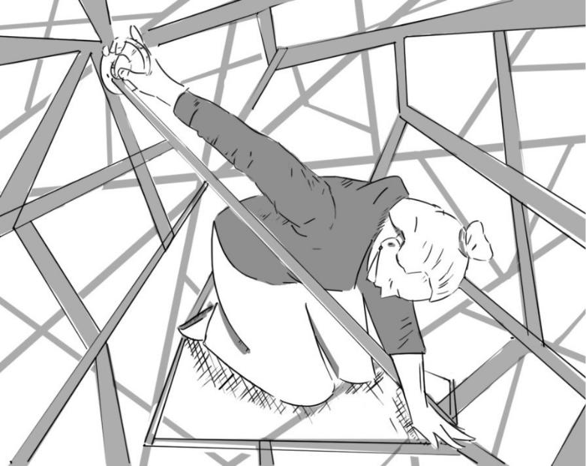

*My sight is limited. I can't see Marta when she enters the space, but feel how she takes the role out of my hand and walks away to my left. I can't visually make out her actions but hear the sound of tape being unrolled and torn rapidly.*

Amy volunteered to step behind the camera to film our performance. I watch the footage after the workshop. Amy's visual framing and Simon's drawings as a response to her framing, aid the mapping of our collective acts of re-entangling Jamal's account.

(insert image 6/ Title: Marta continues the sculpture)

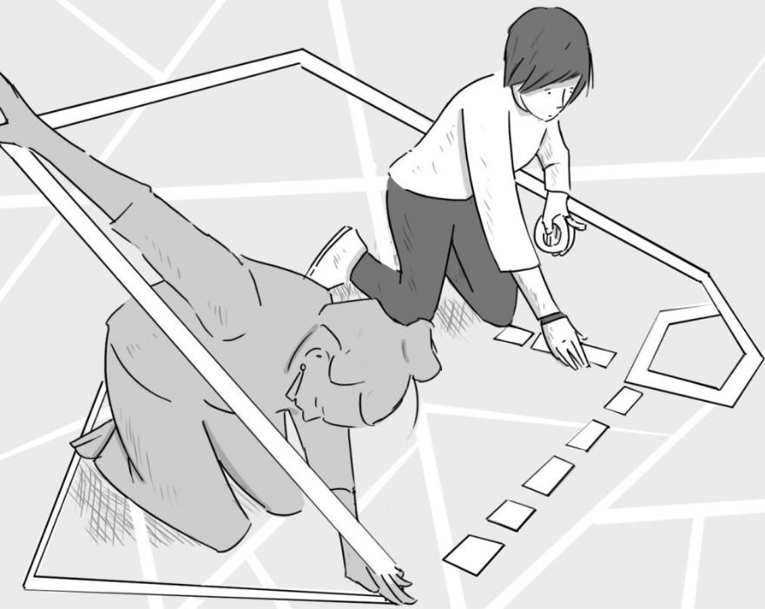

*To my left, still out of sight, Marta marks out space. She creates a small sticky tape space. It looks like a house with an open roof on one side. Marta adds two intermittent lines which emanate from the house. One of the fragmented lines points in my direction. Marta, stands back from her tape trail on the floor. She sings her sentence. Her arms hang loosely on her side.*

*They are quite strange.*

*She unrolls the tape further and sings:*

*I gave the example of my cousin.*

*Marta pauses, then speaks her last sentence:*

*He was quite strange.*

*She freezes.*

*I am watching the footage. There are footsteps off-camera. Who is ready to enter the scene?*

There was no set sequence to our devised sculpture. The emergence of the scene depended entirely on people's active participation in it.

(...)

Karolina enters the frame. She stretches the tape in Marta's hand all the way down to the floor. Her movements are slow and gentle.

She kneels in Marta's house-shape and sings her lines.

And there are some people who are quite strange, and they can bring change.

(insert figure 7/ Title: Karolina kneels and sings)

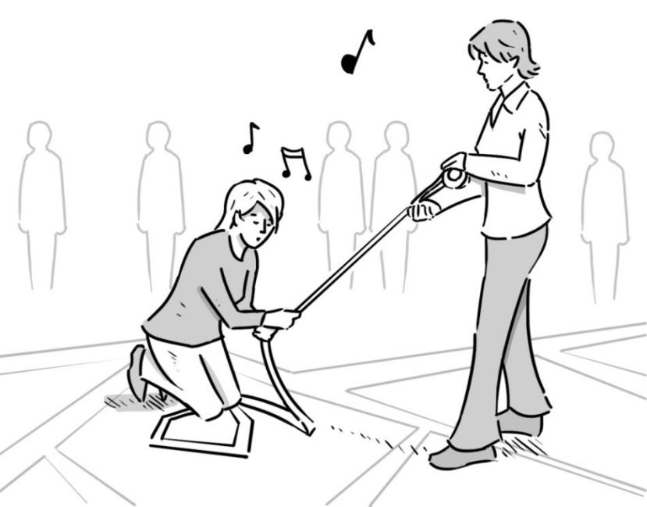

Karolina looks around nervously as if seeking affirmation. A moment of silence follows. Nobody enters the rehearsal space. Karolina's uncertainty 'hangs in the air'. Does she wonder if her

performance was 'good enough', 'appropriate' for my research or 'aesthetically correct'? Does she wonder why I am insisting on calling these strange aesthetic experiments *research*? Participants in a participatory drama workshop take a risk. They take responsible for their own creative acts even if unsure of its (aesthetic, ethical) consequence. It is a 'vulnerable' stance, as there is no guarantee that their acts of meaning-making won't be channelled into out-of-context representations that deny the map of our collective knowledge production? Without the participant-performers' trust and openness to the expressive potential of their bodies, and my ethical commitment to unknowingness and our material entanglement, there can be no philosophical ethnography brought into being.

(...)

*Jamal breaks Karolina's silence and enters the space. He continues our sticky-tape philosophising. He takes the tape role from Marta and re-establishes a connection by putting his hand on her hand. Jamal carefully positions himself in the space, freezes and, in a mix of singing and speaking, recites his lines:*

*Some people are born strange. When you see some people in their own culture, and they are*

*quite estranged from that culture.*

He pauses.

(...)

(insert figure 8/Title: Jamal takes his place in the sculpture)

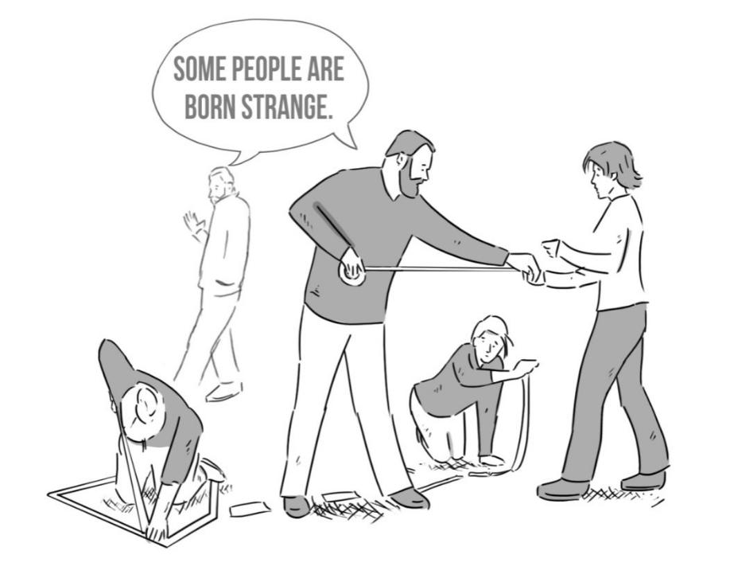

*How does Jamal feel when re-visiting his own account performatively, to be in the middle of its re-entanglement, to hear his own words (and not just his own anymore) being sung back to him in the strange, estranged space of this sticky strangeness sculpture?*

(...)

*The camera is shaking. Amy prepares her arrival in the scene by framing a slightly wider shot. She performs a 'double' aesthetic framing. On a technical level, she directs the camera frame so it can record her second, embodied, aesthetic framing as part of our collective re-entanglement of Jamal's account.*

Amy takes the tape role and continues Jamal's tape movement upwards, her arms stretching into the air. She sings:

Either I am a strange person I don’t know but I was born strange.

(...)

We stand for a moment in this collective image, taped up, connected - 'heterogeneous nodes of discursive and material force' (Martin & Kamberelis, 2013, p. 670). We recite our lines again, this time chronologically, the way Jamal 'uttered' them originally, two workshops ago.

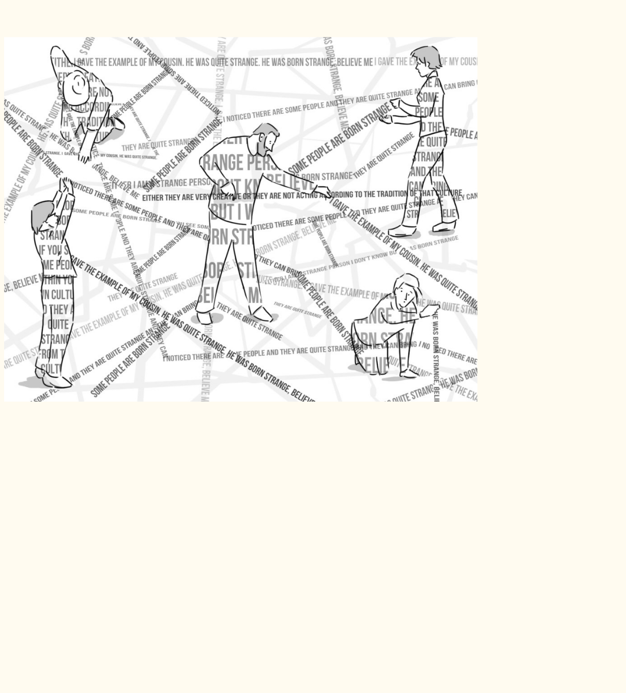

(insert figure 9/ Title: Acts of knowledge production in the body sculpture)

**Amy:** Either I am a strange person I don’t know but I was born strange.

**Jamal:** Some people are born strange, if you see some people within your own culture and theyare quite estranged from that culture.

**Katja:** Either they are very creative or they are not actingaccording to the tradition of that culture.

**Marta:** They are quite strange. I gave the example of mycousin. He was quite strange. He was born strange, believe me.

**Karolina:** I noticed there are some people and they are quite strange and they can bring change.

Here we stand. Silence.

(...)

Amy goes to switch off the camera. The screen goes to black.

My reading of Jamal's account has been turned back on itself in vibrating immobility (McLure, 2013, p. 663). In this last move of mapping the aesthetic transformation of Jamal's account, my body has become part of the sticky image. My researcher subjectivity is 'in transposition' (Braidotti, 2006, p. 5, quoted in Lenz Taguchi 2013, 713), (quite literally) entangled in a five body-sticky-strangeness-body-sculpture in a Glasgow gym hall on a Saturday morning in November. My line of sight is turned back on myself as I sing my lines and trust they will resonate with the other bodies standing, 'sticking together' meaning, 'taped-up' in strangeness production. Our collective sculpture, as a node on the rhizomatic map of knowledge production, attests to the mess of unknowability and the stickiness of making meaning in entanglement. Strangeness has become our ongoing research practice; one which involved 'all kinds of matter in the event' (Barad, 2007, p. 185, quoted in Lenz Taguchi, 2013, p. 713).

**Acknowledgement**

Thank you to artist Simon Bishopp for helping to map our creative acts in the workshops through his drawings, which are based on the original film footage.

**Declaration of Conflicting Interests**

The author declared no potential conflicts of interest with respect to the research, authorship, and/or publication of this article.

**Funding**

The author thanks the School of Education/University of Glasgow (Scotland, UK) for the PhD scholarship that made this research possible.

**References**

Ahmed, S. (2000). *Strange encounters: embodied others in post-coloniality*. London: Routledge.

Barad, K. (2007). *Meeting the universe halfway: Quantum physics and the entanglement of matter*

*and meaning*. Durham, NC: Duke University Press.

Boal, A. (1979). *Theatre of the Oppressed*. New York: Theatre Communications Group.

Brecht, B., Müller, C., Manheim, R. (eds./trans.) (1977). *The Measures Taken and Other Lehrstücke.*

London, New Delhi: Bloomsbury.

Braidotti, R. (2006). *Transpositions. On nomadic ethics*. Cambridge, MA: Polity Press

Brecht, B. (1965). *The Messingkauf Dialogues*. London: Methuen.

Brecht, B., Willet, J. (ed./trans.) (1964). *Brecht on theatre*. London: Methuen.

Brecht, B. (1955). *Der Gute Mensch von Sezuan*. Frankfurt am Main: Suhrkamp Verlag.

Canagarajah (2013). *Translingual practice: Global Englishes and Cosmopolitan Relations*. Oxon,

NewYork: Routledge.

Carney, S. (2005). *Brecht and critical theory: dialectics and contemporary aesthetics*. London, New

York: Routledge.

Conrad, D. (2014). 'Lock 'Em Up . . .' but Where's the Key? Transformative Drama with Incarcerated Youth. In: *Journal of Contemporary Issues in Education*. Vol. 8(2), 4-18.

Conrad, D. (2004). Exploring Risky Youth Experiences: Popular Theatre as a Participatory,

Performative Research Method. In: *International Journal of Qualitative Studies*. Vol. 3 (1). Retrieved

at: https://www.ualberta.ca/~iiqm/backissues/3_1/html/conrad.html.

Dennis, B.K. (2009). Acting Up: Theatre of the Oppressed as Critical Ethnography. In: *International* *Journal of Qualitative Studies*. Vol. 8 (2), 65-96.

Denzin, N. (2003). *Performance Ethnography: Critical Pedagogy and the Politics of Culture*. Thousand

Oaks, CA: Sage Publishing.

Denzin, N. & Lincoln, Y.S. (eds.) (2011). *The Handbook of Qualitative Inquiry* (4th Ed.). Thousand Oaks, London: Sage Publishing.

Deleuze, G. (2004). *The logic of sense.* London: Continuum.

Deleuze, G. & Guattari, F. (1987). *A thousand plateaus: Capitalism and Schizophrenia*. Minneapolis,

MN: University of Minnesota Press.

Derrida, J. (1978). *Writing and Difference*. Chicago: University of Chicago Press.

Franks, A. & Jones, K. (1999). Lessons from Brecht: a Brechtian approach to drama, texts and

education. *Research in Drama Education: The Journal of Applied Theatre and Performance*, 4 (2), pp.

181-200, DOI: 10.1080/1356978990040203.

Foucault, M. (1989). *The archaeology of knowledge*. Abingdon, Oxon: Routledge.

Freire, P. (1995). *Pedagogy of Hope: Reliving Pedagogy of the Oppressed.* Trans. Robert R. Barr. New

York: Continuum.

Freire, P. (1973). Pedagogy of the Oppressed. New York: Seabury

Gaventa, J. (2006). *Triumph, deficit or contestation: Deepening the ‘deepening democracy’ debate.* Working paper # 264, Citizenship Institute of Development Studies, University of Sussex. www.ids.ac.uk/ids/

Grasseni (2004). Skilled vision. An apprenticeship in breeding aesthetic. In: *Social Anthropology,* Volume 12 (1), February 2004, pp. 41-55, Cambridge University Press.

Hultman, K., & Lenz Taguchi, H. (2010). Challenging anthropocentric analysis of visual data: A relational materialist methodological approach to educational research. In: *International Journal of* *Qualitative Studies in Education*, 23, 525–542.

Jameson, F. (1998). *Brecht and Method*. London, New York:Verso.

Kristeva, J. (1991). *Strangers To Ourselves.* New York: Columbia University Press.

Lather, P. (2013). Methodology-21: what do we do in the afterward? In: *International Journal of*

*Qualitative Studies in Education*, 26:6, 634-645, DOI: 10.1080/09518398.2013.788753.

Lather, P. (2009a). Getting Lost: Feminist Efforts toward a Double(d) Science. In: *Frontiers: A Journal* *of Women Studies*, Vol.30/1, pp. 222-230.

Lather, P. (2009b). Getting Lost: Social Science and/as Philosophy. In: *Educational Studies*, 45, pp.

342-357. DOI: 10.1080/00131940903066248

Lather, P. (1993). Fertile obsessions: Validity after Poststructuralism. In: *The Sociological Quarterly*, Vol.34/4, pp. 673-693. http://www.jstor.org/stable/4121374

Law, J. (2004). *After Method: Mess in Social Science Research*. Oxon, New York: Routledge.

Law, J. (2009). Seeing like a survey. In: *Cultural Sociology*, July 2009/Vol 3, pp. 239-256.

Doi: 10.1177/1749975509105533.

Lenz Taguchi, H. (2013). Images of thinking in feminist materialisms: ontological divergences and the

production of researcher subjectivities. In: *International Journal of Qualitative Studies in Education*,

26:6, 706-716, DOI: 10.1080/09518398.2013.788759.

Martin, A.D. & Kameberelis, G. (2013). Mapping not tracing: qualitative educational research with

political teeth. In: *International Journal of Qualitative Studies in Education*, 26:6, 668-679, DOI:

10.1080/09518398.2013.788756.

Mc Lure, M. (2013). Researching without representation? Language and materiality in post-qualitative methodology. In: *International Journal of Qualitative Studies in Education*, 26:6, pp. 658-

1. http://dx.doi.org/10.1080/09518398.2013.788755 Mumford, M. (2009). *Bertolt Brecht.* London and NY: Routledge.

Otty, N. (1995). Theatre of the Oppressed: Cultural Action for Freedom. *Contemporary Theatre*

*Review*, 3 (1), 87-100, DOI: 10.1080/10486809508568329.

Pink, S. (2009). *Doing Sensory Ethnography.* London, Thousand Oaks, New Delhi, Singapore: Sage Publications.

Salazar, M. (1991). Young labourers in Bogotá: Breaking authoritarian ramparts. In: O. Fals-Borda &

M. Rahman (Eds.), *Action and knowledge: Breaking the monopoly with participatory action-research*

(pp. 54-63). New York: Apex Press.

Spolin, Viola (1999). *Improvisation for the Theater* (3rd ed.). Evanston: Northwestern University Press.

St. Pierre, E. (2013). The posts continue: becoming. *International Journal Of Qualitative Studies In* *Education (QSE)*, 26(6), 646-657.

St. Pierre & Lather (2013). Post-qualitative research. In: *International Journal of Qualitative Studies in*

*Education*, 26:6, 629-633, DOI: 10.1080/09518398.2013.788752.

St. Pierre, E. & Pillow, W. (2000). *Working the Ruins: Feminist Poststructuralist Practice and Theory in*

*Education*. New York: Routledge.

Wright, E. (1989). *Postmodern Brecht - a re-presentation*. London: Routledge.