**University of Nebraska - Lincoln**

[**DigitalCommons@University of Nebraska - Lincoln**](http://digitalcommons.unl.edu?utm_source=digitalcommons.unl.edu%2Fcsearticles%2F125&utm_medium=PDF&utm_campaign=PDFCoverPages)

[CSE Journal Articles](http://digitalcommons.unl.edu/csearticles?utm_source=digitalcommons.unl.edu%2Fcsearticles%2F125&utm_medium=PDF&utm_campaign=PDFCoverPages) [Computer Science and Engineering, Department of](http://digitalcommons.unl.edu/computerscienceandengineering?utm_source=digitalcommons.unl.edu%2Fcsearticles%2F125&utm_medium=PDF&utm_campaign=PDFCoverPages)

2011

A Midsummer Night’s Dream (with flying robots)

Robin Murphy

*Texas A&M University*, murphy@cse.tamu.edu

Dylan Shell

*Texas A&M University*, dshell@cs.tamu.edu

Amy Guerin

*Texas A&M University*

Brittany Duncan

*University of Nebraska-Lincoln*, bduncan@unl.edu

Benjamin Fine

*Texas A&M University*

***See next page for additional authors***

Follow this and additional works at: [http://digitalcommons.unl.edu/csearticles](http://digitalcommons.unl.edu/csearticles?utm_source=digitalcommons.unl.edu%2Fcsearticles%2F125&utm_medium=PDF&utm_campaign=PDFCoverPages)

 Part of the [Aeronautical Vehicles Commons](http://network.bepress.com/hgg/discipline/219?utm_source=digitalcommons.unl.edu%2Fcsearticles%2F125&utm_medium=PDF&utm_campaign=PDFCoverPages), [Management and Operations Commons](http://network.bepress.com/hgg/discipline/1311?utm_source=digitalcommons.unl.edu%2Fcsearticles%2F125&utm_medium=PDF&utm_campaign=PDFCoverPages), [Multi-Vehicle Systems and Air Traffic Control Commons](http://network.bepress.com/hgg/discipline/227?utm_source=digitalcommons.unl.edu%2Fcsearticles%2F125&utm_medium=PDF&utm_campaign=PDFCoverPages), [Other Electrical and Computer Engineering](http://network.bepress.com/hgg/discipline/278?utm_source=digitalcommons.unl.edu%2Fcsearticles%2F125&utm_medium=PDF&utm_campaign=PDFCoverPages) [Commons](http://network.bepress.com/hgg/discipline/278?utm_source=digitalcommons.unl.edu%2Fcsearticles%2F125&utm_medium=PDF&utm_campaign=PDFCoverPages), [Other Theatre and Performance Studies Commons](http://network.bepress.com/hgg/discipline/558?utm_source=digitalcommons.unl.edu%2Fcsearticles%2F125&utm_medium=PDF&utm_campaign=PDFCoverPages), [Performance Studies Commons](http://network.bepress.com/hgg/discipline/556?utm_source=digitalcommons.unl.edu%2Fcsearticles%2F125&utm_medium=PDF&utm_campaign=PDFCoverPages), and the [Robotics Commons](http://network.bepress.com/hgg/discipline/264?utm_source=digitalcommons.unl.edu%2Fcsearticles%2F125&utm_medium=PDF&utm_campaign=PDFCoverPages)

Murphy, Robin; Shell, Dylan; Guerin, Amy; Duncan, Brittany; Fine, Benjamin; Pratt, Kevin; and Zourntos, Takis, "A Midsummer Night’s Dream (with flying robots)" (2011). *CSE Journal Articles*. 125. [http://digitalcommons.unl.edu/csearticles/125](http://digitalcommons.unl.edu/csearticles/125?utm_source=digitalcommons.unl.edu%2Fcsearticles%2F125&utm_medium=PDF&utm_campaign=PDFCoverPages)

This Article is brought to you for free and open access by the Computer Science and Engineering, Department of at DigitalCommons@University of Nebraska - Lincoln. It has been accepted for inclusion in CSE Journal Articles by an authorized administrator of DigitalCommons@University of Nebraska - Lincoln.

**Authors**

Robin Murphy, Dylan Shell, Amy Guerin, Brittany Duncan, Benjamin Fine, Kevin Pratt, and Takis Zourntos

This article is available at DigitalCommons@University of Nebraska - Lincoln: [http://digitalcommons.unl.edu/csearticles/125](http://digitalcommons.unl.edu/csearticles/125?utm_source=digitalcommons.unl.edu%2Fcsearticles%2F125&utm_medium=PDF&utm_campaign=PDFCoverPages)

Published in *Autonomous Robots* 30 (2011), pp. 143–156; doi 10.1007/s10514-010-9210-3



Copyright © 2010 Springer Science+Business Media, LLC. Used by permission.

Submitted December 12, 2009; accepted September 9, 2010; published online October 6, 2010.



**digitalcommons.unl.edu**

***A Midsummer Night’s Dream* (with flying robots)**

Robin Murphy,1 Dylan Shell,1 Amy Guerin,2 Brittany Duncan,1 Benjamin Fine,1 Kevin Pratt,1 and Takis Zourntos3

1 Department of Computer Science and Engineering, Texas A&M University, College Station, TX, USA

2 Department of Performance Studies, Texas A&M University, College Station, TX, USA

3 Department of Electrical and Computer Engineering, Texas A&M University, College Station, TX, USA

*Corresponding authors* **—**D. Shell, dshell@cs.tamu.edu ; R. Murphy, murphy@cse.tamu.edu

**Abstract**

Seven flying robot “fairies” joined human actors in the Texas A&M production of William Shakespeare’s *A Midsummer* *Night’s Dream*. The production was a collaboration betweenthe departments of Computer Science and Engineering, Electri-cal and Computer Engineering, and Theater Arts. The collabo-ration was motivated by two assertions. First, that the perform-ing arts have principles for creating believable agents that will transfer to robots. Second, the theater is a natural testbed for evaluating the response of untrained human groups (both actors and the audience) to robots interacting with humans in shared spaces, i.e., were believable agents created? The production used two types of unmanned aerial vehicles, an AirRobot 100-b quadrotor platform about the size of a large pizza pan, and six E-flite Blade MCX palm-sized toy helicopters. The robots were used as alter egos for fairies in the play; the robots did not re-place any actors, instead they were paired with them. The in-sertion of robots into the production was not widely advertised so the audience was the typical theatergoing demographic, not one consisting of people solely interested technology. The use of radio-controlled unmanned aerial vehicles provides insights into what types of autonomy are needed to create appropriate affective interactions with untrained human groups. The obser-vations from the four weeks of practice and eight performances contribute (1) a taxonomy and methods for creating affect ex-

changes between robots and untrained human groups, (2) the importance of improvisation within robot theater, (3) insights into how untrained human groups form expectations about ro-bots, and (4) awareness of the importance of safety and reli-ability as a design constraint for public engagement with robot platforms. The taxonomy captures that apparent affect can be created without explicit affective behaviors by the robot, but requires talented actors to convey the situation or express reac-tions. The audience’s response to robot crashes was a function of whether they had the opportunity to observe how the actors reacted to robot crashes on stage, suggesting that pre-existing expectations must be taken into account in the design of auton-omy. Furthermore, it appears that the public expect robots to be more reliable (an expectation of consumer product harden-ing) and safe (an expectation from product liability) than the current capabilities and this may be a major challenge or even legal barrier for introducing robots into shared public spaces. These contributions are expected to inform design strategies for increasing public engagement with robot platforms through af-fect, and shows the value of arts-based approaches to public en-counters with robots both for generating design strategies and for evaluation.

**Keywords:** Robot theater, Robot affect, Human-robot interac-tion, Public performance, Unmanned aerial vehicles

143

144  Murphy et al . in *Autonomous Robots* 30 (2011)

**1 Introduction**

Seven flying robot “fairies” joined human actors in the Texas A&M production of William Shakespeare’s *A Midsummer* *Night’s Dream*. The November 2009 production grew out of aJanuary 2009 meeting between members of the Computer Sci-ence and Engineering (Murphy) and Performing Arts (Casey, Hopper, and Morris) departments to discuss how to expose ro-boticists to the principles in creating believable agents.

The theater arts offer many advantages for studying human-robot interaction in public encounters. Theater has an experi-ence base of creating believable agency and predicting how “untrained” observers (the audience) will interpret agents’ in-tent, but this base is not codified in a form suitable for com-putational systems. It is a domain where success is defined by large numbers of the general population observing agents (at-tendance) and by the believability of the agents (as measured by reviews and audience feedback) working together in a shared space. Breazeal et al. (2003) argue that the theater is a suitable test domain for social robots because the interaction is bounded by the script, the environment is constrained and can be engi-neered to support robots, and the robots must be convincing and compelling.

The introduction of the robots, one pizza -sized AirRobot 100 -b Quad- rotor and six E-flite palm-sized toy helicopters, did not alter the play and were not limited to a single scene (as with the recent production of *Phantom of the Opera* (Lin et al. 2009)). The robots did not subsume any roles, yet the in-tegration of the robots into the narrative of the play made the robots more than props, in contrast to the robotic technology used in *Cymbeline* (McCoy 2008; Ruggiero 2008). More im-portantly, the robots were inserted into an existing play written about humans rather than a play written specifically for robots (cf., Werger 1998) or about human-robot interaction. By being supporting elements in a “human” play, the robots provide in-sights into believable human-robot interaction.

The plot of *A Midsummer Night’s Dream* can be summa-rized as follows. In the days leading up to the marriage of Duke Theseus of Athens and Queen Hippolyta of the Amazons, love-struck Athenian teenagers Lysander and Hermia run away to-gether through the Athens forest pursued by Demetrius, who loves Hermia, and Demetrius is pursued by Helena, who loves him. Meanwhile, a blue-collar community theater troupe meets in the same forest to rehearse the play they are performing in honor of the wedding of Theseus and Hippolyta. Unfortunately for all, this forest is ruled by an arguing Fairy King and Queen. The Fairy King decides to get back at his queen by placing a magic spell on her, and, after encountering the teenagers and workers in his forest, he decides to have some fun placing magic spells on most of them, too. When the spells are finally released by the Fairy King, harmony and love are restored to

all and the wedding and play happen as planned. The director (Hopper) began envisioning the forest as a fairy “otherworld” where human fairies shape-shift into robot fairies, costumes in-corporate high- tech elements (LEDs, light ribbons, fiber optic fibers, metallic jewelry), and fairy movements generate evoc-ative sounds, similar to the sound shifts in the humming of a light saber in Star Wars.

The concept of using small unmanned aerial systems as fair-ies was a part of the production from its inception. When the production officially began in the Fall semester, the three lead engineering professors (Murphy and Shell from Computer Sci-ence and Engineering and Zourntos from Electrical and Com-puter Engineering) attended all the production meetings. The professors, operators, and robots participated in all develop-ment and dress rehearsals. The choice of robot platforms, the decision for teleoperation, the behaviors and staging, and all as-pects were collaborative. As a result, the production provides a solid foundation for understanding how robots can generate believable agency.

The play ran for eight performances and one preview over two weeks and was entirely sold-out during the second week. The presence of robots in the play was not advertised, though the announcement for the local newspaper did mention robots would be involved. In general, the audience was the typical the-ater-goer and were not disproportionately technophiles. Thus the audiences represented “untrained observers” who had lit-tle or no knowledge of, or previous interaction with, robots and were there to see a Shakespearean play. The audience re-action to the play was outstanding as evidenced by the sold-out shows, the review in the university newspaper praised the pro-duction and seamless incorporation of the robots, and the pro-duction was covered by Wired and other online news outlets which circulated video clips.

This article describes the flying robots and their roles in the play, focusing on identifying the human-robot interaction mechanisms employed that generated the attribution of affect by observers as a first step in formalizing how humans perceive affect in non-humanoid robots. It begins by surveying the pre-vious and related work in affective robotics, identifying the few known instances of mobile robots in theater productions. The article next describes the two types of robots used as fair-ies, followed by a description of each scene involving robots. The audience and actor reaction to the robots is then captured, culminating in a discussion in which we provide four insights gained from our experience with this production: (1) codifying the mechanisms used for generating affect in the form of a pre-liminary taxonomy; (2) a new understanding of the role of ac-tor improvisation in robotic theater; (3) an explanation of ob-served expectation forming processes; and (4) observations on the importance of safety and reliability.

|  |  |
| --- | --- |
| A Midsummer Night’s Dream (with flying robots) | 145 |

**2 Previous and related work**

The staging of *A Midsummer Night’s Dream* appears to be the first integration of mobile robots, either ground or aerial, into a complete production of an existing play. The inclusion of ro-bots was motivated by an intent to explore affect in nonanthro-pomorphic robots versus portraying socio -political themes or demonstrating improvements to humanoid robots. The produc-tion also differs in the conclusions about the role of improvisa-tion. As with many of the robot theater systems surveyed, the aerial vehicles in *A Midsummer Night’s Dream* were operated by humans.

Ground robots have participated in portions of *The Phan-tom of the Opera* but not the complete play (Lin et al. 2009).Robotic technology such as a large printer was used in a recent production of Shakespeare’s *Cymbeline* but actual mobile robots do not appear to have been present (McCoy 2008; Ruggiero 2008). As such, *A Midsummer Night’s Dream* is the first use of robots alongside with human actors in a play that is part of the theater canon. The staging of *A Midsummer Night’s Dream* is also unusual in that the inclusion of robots was not widely advertised or used to attract the audience; publicity about the robots came from a review of the play by the student news-paper (Gerhart 2009) followed by national press (Squatriglia 2009) after the play ended. Thus the audience for the perfor-mances were primarily “normal” theatergoers expecting a play by Shakespeare.

Since the 1990’s, ground robots have been used in plays written for robots (e.g. Werger 1998) or for improvisational theater (e.g., Bruce et al. 2000). Bruce et al. (2000) and later Breazeal et al. (2003) compare the challenges of using robots in a scripted play versus improvisation, with Bruce et al. (2000) arguing that improvisational drama is superior in terms of au-dience satisfaction and understanding dramatic structure for human- robot interaction. The experience with *A Midsummer* *Night’s Dream* provides a counterpoint to Bruce et al. (2000)and Breazeal et al. (2003); a play performance by robots re-quires understanding the context of a particular evening’s per-formance, changes in lines, pacing with respect to the particu-lar audience, changes in lighting speed, failures of technological elements, etc. Improvisation occurs even in a scripted play per-formed by only human actors, as it is not an entirely predict-able sequence of events. As described in Sect. 4.8, the inclu-sion of robots led to minor improvisations within the context of the play to compensate for variations in robot behavior and crashes, illustrating how the inclusion of robots is richer than mere playback of fixed patterns. Likewise Sect. 5 describes the audience reaction which clearly found the staging to be satis-fying as a performance of a Shakespeare play.

The motivation for incorporating robots or writing a play specifically for robots generally falls into three categories: to

explore socio- political themes in accepting robots into soci-ety (which are too numerous to cite here, but begin with Karel Čapek’s R.U.R.), affect and expressiveness of robots (Lin et al. 2009; Mavridis and Hanson 2009a, 2009b; Perkowski et al. 2005), experimental aesthetics (Apostolos et al. 1996; Dom-pierre and Laurendeau 2006; Iida et al. 2008;Mavridis and Hanson 2009a, 2009b; Ohya et al. 1996; Paricio García and Moreno Aróstegui 2007), or some combination. The majority of productions exploring affect and expressiveness of robots have concentrated on improving the physical expressiveness of humanoid robots (Lin et al. 2009; Mavridis and Hanson 2009a; Perkowski et al. 2005), on creating the sensing needed for awareness (Lin et al. 2009; Perkowski et al. 2005), or com-putational structures (Burke et al. 2006;Mavridis and Hanson 2009a, 2009b;Wallis et al. 2010). The production of *A Mid-summer Night’s Dream* was motivated by the desire to under-stand affect and expressiveness of non-humanoid robots, us-ing commercially available robots designed for flight stability with limited degrees of freedom.

The robots used in *A Midsummer Night’s Dream* were con-trolled by human operators, placing this within the puppetry category defined by Beaumont (1958) and Tillis (1992) . As noted in Demers and Horakova (2008), puppets and robot per-formers are both inert entities called on to perform in front of an audience. However, we believe that this distinction is in-significant for this article as the purpose of the reported re-search is to better understand affect and expressiveness as the first step towards capturing it with autonomous behav-iors. Of the robotic performance systems, only Breazeal et al. (2003), Lin et al. (2009), Perkowski et al. (2005) appear to use fully autonomous robot actors, while Iida et al. (2008) had the audiences and actors interact essentially through teleop-eration, Mavridis and Hanson (2009a, 2009b), Paricio García and Moreno Aróstegui (2007) support both autonomous and teleoperation, while Ohya et al. (1996) and Goto and Yama-saki (2007) captures human performers’ movements and trans-late them into robot or avatar actions. The teleoperation of the robots in *A Midsummer Night’s Dream* is somewhat similar to the participatory theater described in Ambach and Repen-ning (1996), where an artist painted in conjunction with au-tonomous robots.

**3 Robots**

We employed two types of micro unmanned aerial vehicles. Both types were teleoperated by volunteers positioned in seat-ing aisles and exit corridors so as to maintain constant line-of-sight with the robot. The two types of robot were different enough in size, payload, controllability, and sound to provide quite distinct costuming, staging, and flying challenges.

146  Murphy et al . in *Autonomous Robots* 30 (2011)

3.1 AirRobot 100-b Quad-Rotor

The AirRobot 100-b is a micro (1 m diameter) unmanned aerial vehicle equipped with autonomous flight and naviga-tion capabilities and modular 200 g payload. The robot was designed with outdoor reconnaissance and surveillance tasks in mind. Four separately driven battery-powered electric mo-tors turn four fixed pitch rotors positioned near the corners of the robot; this arrangement permits vertical take-off and landing, and a stable hover. Typically these robots are flown hundreds of feet above the ground, the extremely confined indoor spaces and close proximity to people meant that au-tonomous flight was infeasible. The low ceiling and angled shape of stairwell posed a particular challenge in launching and landing the device, requiring the pilot to demonstrate considerable skill.

The platform proved to be stable, reliable, and adequately controllable for the performance. The natural stabilization of roll and pitch by the device meant that synchronization to mu-sic in dancing scenes was mainly produced by moving the po-sition of the robot back and forth which creating an undulating effect with concomitant variation in the roll and pitch.

While the robot’s size and payload permitted several possi-bilities in developing the costume, its shape and need for free space around the rotors resulted in a Jellyfish inspired costume. Figure 1 gives an impression of the quad-rotor robot and the ef-fect produced by the electroluminescent wire wrapped around the carbon-fiber frame.

Although considered silent by unmanned aerial vehicle stan-dards, we found it to be louder than ideal for the theatrical setting.

3.2 EFlite micro-blade MCX

The second type of robot used was a miniature (20 g) radio-controlled helicopter produced by EFlite for hobbyist and spe-cifically intended for indoor flight. The electrically powered helicopter (we term micro-heli) uses two adjustable pitch con-tra-rotating 19 cm blades that enable it to do without a tail rotor. Although at most six were used concurrently, from rehearsal to the final production a total of 22 micro- helis were used; dam-aged helis supplemented our collection of bought spare-parts. Frequent crashes, and at least one instant of a robot being sat on, meant that repair and maintenance was an ongoing process. Extremely light weight components result in a device that is in-herently fragile. The micro-helis themselves are not a particu-larly stable platform, not designed for a regiment of repeated flights involving interactions with scaffolding and actors. Al-though no mean time between failures is provided by the man-ufacturer, we believe the hours of flight logged by the operators exceed the time envisioned by the manufacturer.

**Figure 1.** Fairy King Oberon with costumed Quad-Rotor. The robotserves as his fairy minion, hovering overhead, and exiting in response to his commands.

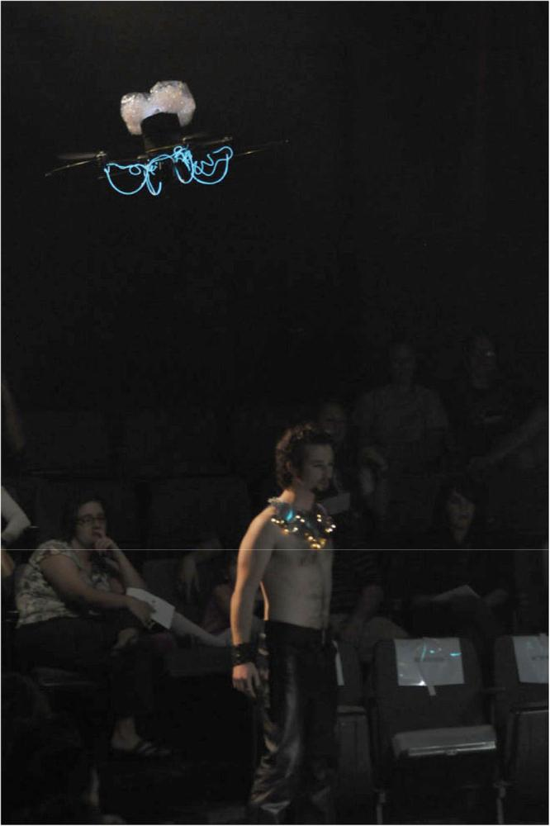

The severe weight restrictions limited the costume options for the micro-helis. After several experiments, the final costume was a wrap of colored cellophane attached around the innards of the robot once the manufacturer’s cowl had been removed. Colored cellophane was also used to wrap the tail. The micro-helis have onboard power LEDS, so the cellophane acted as a filter, making each one uniquely identifiable. The wrap was de-signed to be removable so that the batteries could be replaced with freshly recharged ones between scenes.

The costumes altered the flight characteristics of the micro-helis, making them somewhat more challenging to fly. The oper-ators also discovered that it was easier to fly costumed helis tail-forward rather than the more traditional tail-backward manner.

The Quad-rotor and micro-helis are very different unmanned aerial vehicles and represent opposite extremes of systems that are feasible for indoor theater use.

|  |  |
| --- | --- |
| A Midsummer Night’s Dream (with flying robots) | 147 |

**4 Production**

The production used the New Folger Library Shakespeare 1993 edition (edited by B.A. Mowat and P. Werstine) as the source, from which ±300 lines were excised. The show ran in the Rud-der Forum Theatre which has a stage space of approximately 800 ft2 and holds 250 in stadium seating arranged in a “U” with two levels. The lower seating is divided into three areas by two aisles which were used by the actors along with the main stage. The 6 micro-heli robot operators stood behind the audience in right section, while the Quad-Robot pilot stood in an aisle. *A Midsum-mer Night’s Dream* has nine scenes in five acts; robots partici-pated in five scenes, each of which is discussed in sections below with particular emphasis on how the actors adapted to variations in the flight and crashes of the micro-helis. The presence of the robots did not add any roles or alter the action, with the excep-tion of a prologue which was added to introduce the robots.

4.1 Prologue

A prologue was devised as a way to introduce the robots to the audience separate from the dramatic action. The result was a choreographed dance that featured all the human and robot fair-ies. The dance showcased each human fairy individually while hinting at their relationship within the play. The robots hovered over the humans and attempted to keep time with the music by rotating back and forth.

The intention here was to get the audience used to the idea and presence of the robots, so that at their next appearance, the audience would keep their primary focus on the dramatic action and not the robots. Our intention worked— the robots were introduced—but the humans never acknowledged the ro-bots during the prologue; doing so would have made the scene even more effective.

4.2 Act 2, Scene 1

This is the first appearance of the fairies into the world of the play. The estranged fairy king (Oberon) and queen (Titania) enter from opposite sides of the stage with their respective en-tourages. With Oberon is the Quad-Rotor, which flies directly above and behind him during his entrance (see Figure 1), and at his signal, flies away, exiting the scene.

The intention here was to use the Quad-Rotor as a fairy min-ion of Oberon. Anecdotally, some members of the audience re-ported neither seeing Oberon’s signal nor understanding their relationship; they were perplexed by the Quad-Rotor’s sudden exit. Artistically, the Quad-Rotor was prohibitively loud and so had to have a limited presence within the production, if the ac-tor’s lines were to be heard without disturbing the pace of the dramatic action. Additionally, the small stage area and dense seating meant that the Quad-Robot had only a few safe corridors

**Figure 2.** As Titania is cocooned, five human fairies interact with four mi-cro- helis. The two most salient are visible *above* the actors *on the right*. The third is *in the hand* of the green fairy, who is relaunching it. The fourth robot is flying *above the scaffolding.*

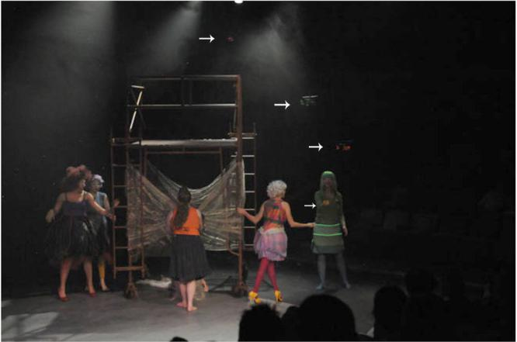

to fly without being directly over the audience or an actor and had a small landing zone. Consequently, the Quad-Rotor is not seen again until the last scene of the play, giving credence to the criticism that the relationship between it and Oberon was not as strong as it could have been.

4.3 Act 2, Scene 2

Titania enters with her six human fairies and micro-heli fairies; each fairy is costumed with a different color and each micro-heli has a matching color. Titania’s fairies sing as they cocoon their queen, all the while the micro-heli fairies hover over the action (see Figure 2). At the end of the lullaby, a fairy waves for the micro-heli fairies to come down. The micro-helis land in the hands of their associated fairy and they all exit.

The intention in this scene was for the micro -helis to com-plement the enchanted world that Shakespeare created. They hovered above the action and when near a human fairy, that ac-tor would interact with it, establishing what some identified as a mother-baby relationship. The actors learned to interact with the micro-helis in a very convincing manner, improvising pet-ting or cooing to the micro-helis as they landed, or scolding a micro- heli that crashed or was being difficult to catch. By the end of this scene, the relationship between human and baby fairy was crystallized.

4.4 Act 3, Scene 1

Awaking after spells have been cast, Titania seduces Bottom, a laborer who has been turned into a donkey. She calls in her hu-man fairies to wait upon him, and when the human fairies en-ter, so do the micro-helis. (See Figs. 3 and 4.)

As in Act 2, Scene 2, the intention was to have the micro-heli fairies as a part of the fairy world. The human fairies continue

148  Murphy et al . in *Autonomous Robots* 30 (2011)

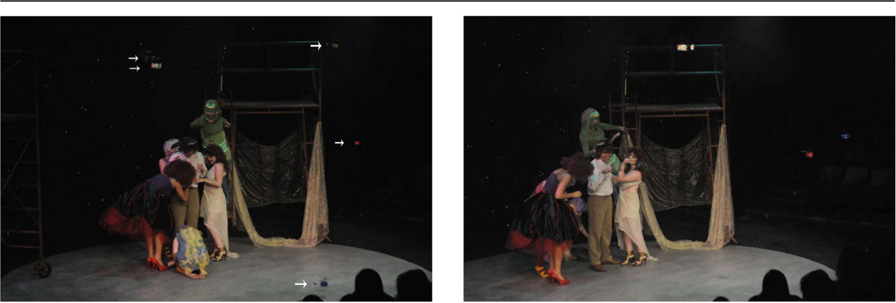

**Figure 3** Four human fairies and five micro-heli fairies are introduced toBottom by Titania. The two *near stage back and right* are close to mid-air collision.

**Figure 4** In the same scene, Mustardseed stoops to pick up and relauncha crashed micro-heli fairy.

to interact with the micro-helis and, in addition, Bottom notices them. Despite having no direct interaction, Bottom’s awareness is an important cue to the audience indicating that fairies can be seen by humans. Unlike the earlier scene, significant dialog is delivered while the micro-helis were in flight. Bottom’s lines and braying consistently got laughs, supporting other evidence that the robots did not monopolize the attention of the audience.

4.5 Act 4, Scene 1

Titania, wanting to be with Bottom, dismisses all her fairies (hu-man and robot) and the two sleep. After some time, and inter-vening foreground action, Bottom awakes and leaves the for-est. As he leaves, one of the human fairies and her micro-helis come up behind him to mock and laugh at him.

There were two intentions in 4.1. In the first part of the scene, the intention with the micro-helis is the same as in 2.2 and 3.1 to add to the otherworldliness of the fairies and sur-roundings. However, in the second part of the scene, during Bottom’s exit, the intention was for the micro-heli to contribute to in mocking Bottom. The human actor and the chosen micro-heli had set movements to do together, including laughing and spinning. The human fairy, Mustardseed, would enter the stage carrying her micro-heli as Bottom began exiting and launch the robot from her hand. The robot would follow behind Bottom, who was oblivious to the robot, then it would bounce in the air (*i.e.*, display rapid vertical oscillations) to convey laughter and would spin (*i.e.*, display rapid yaw rotations) at the same time as the human actor spun on the spot.

4.6 Act 5, Scene 1

This is the final scene of the play. Oberon calls for music and dancing, and all the human fairies and micro-helis join them

on stage for a dance. As Oberon exits (together with Titania), he gestures up and out, and the Quad-Rotor flies in, waiting for him. Oberon gestures up and out again, and the Quad-Rotor pre-cedes Oberon and Titania out of the theater.

Here the Quad-Rotor could be brought back in a way that made sense dramatically without intruding on the action itself. There were actors still dancing and music was still playing at the entrance of the Quad-Rotor, which made the entrance and the interaction between the Quad-Rotor and Oberon a part of the ongoing action, rather than a special, separate event.

4.7 Curtain call

Once the final monologue has been delivered, the cast return to accept applause and take a bow. At this point the Quad-Ro-tor and any available micro-helis were flown back on stage. The Quad-Rotor would land center stage (which is the only planned landing maneuver of the play). Micro- helis, launched either by robot operators or by fairies who retained them from the last scene, fly over the stage and interact with the cast. (See Figure 6.) Most catching and relaunching interac-tions were performed with fairies positioned on the scaffold-ing, although interactions with other cast members occurred too. After taking a bow, the cast collectively gestured to the robot operators.

Although no attempt was made to obscure the relationship between the micro-helis and operators throughout the play, the curtain call was the only time the robot operators and their role was explicitly acknowledged. Most performances resulted in the audience showing their appreciation by applauding while fac-ing the operators. Because the operators were concentrating on maintaining steady flight, they responded with micro-heli yaw motions. This response at a distance was an unnatural interac-tion and caused slight discordance.

|  |  |
| --- | --- |
| A Midsummer Night’s Dream (with flying robots) | 149 |
|  |  |

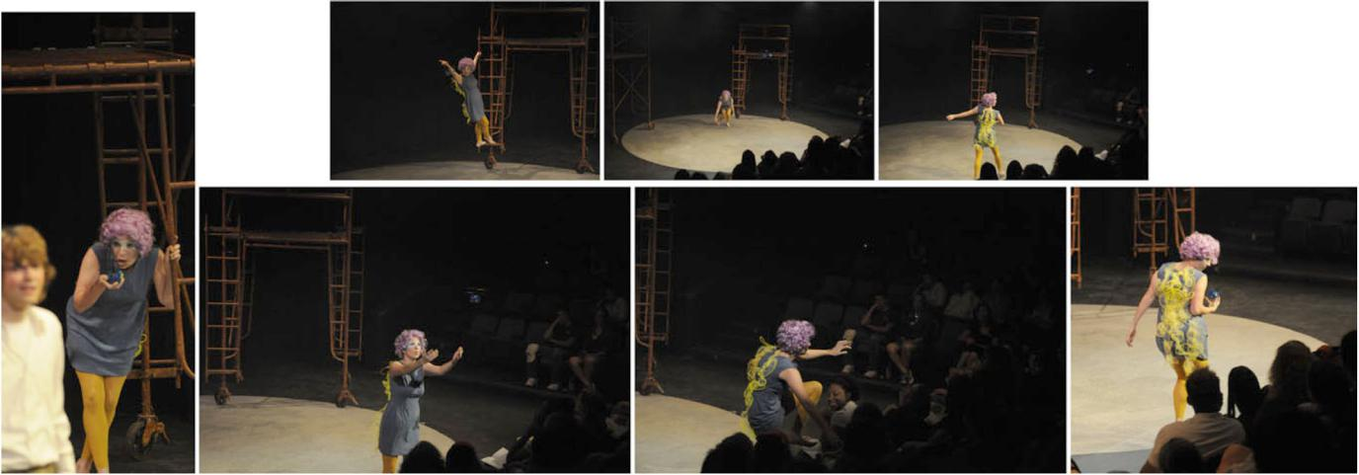

**Figure 5** Mustardseed launches her micro-heli fairy and together they mock Bottom. In ending the scene, the micro-heli flies over the audience. Mustard-seed improvises by clamoring over the audience and casting them with a look of scorn for stealing her baby fairy, much to their amusement .

**Figure 6** The robots are flown or carried onto stage at the beginning of thecurtain call, as the human fairies take their bow.

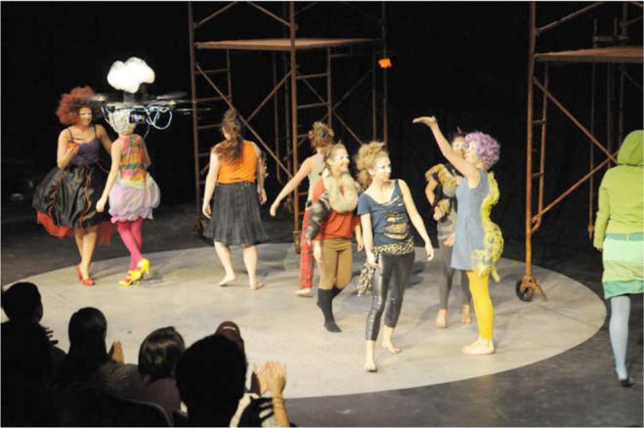

4.8 Crashes and staging problems

The micro-helis were not always at the right place at the right time, occasionally crashed, and sometimes fewer than six were flown during a scene. The micro-helis were surprisingly fragile, were sensitive to air flow from the ventilation system, and the costumes impacted the control. Operator expertise and avail-ability also varied. In general, the larger number of micro-helis that flew, the more effective their contribution to a particular scene; that is, the number of agents increased comprehension of intent. Fortunately, through the noteworthy adaptability of the human actors, crashes did not distract from play and further engaged the audience.

As shown in Tables 1 and 2, the micro-helis frequently crashed, causing the human actors to improvise. In the Prologue or Final scene (Act 5, Scene 1), the micro-helis did not have an explicit interaction with the actors, and the actors adapted by

the closest actor picking up a crashed micro- heli or kicking it out of the way of the dance. (See Figure 7 for a particularly el-egant response during this scene.) However in the other scenes, the micro-helis were closely tied to human fairies and their ac-tivities, so the human fairies improvised after a crash or would chase a micro-heli that began landing away from the action.

There were two opportunities for improvisation to a crash or errant behavior depending on whether the micro-heli was over the stage or over the audience. If the crash struck an ac-tor or became entangled in a costume or wig, the nearest hu-man fairy might extract the micro-heli and mime scolding it. If the micro-heli simply crashed to the stage, a human fairy would usually pick it up with exaggerated gentleness, and stroke or coo over it as it is were a bruised bird or child, then hold it up to let the operator attempt to relaunch and resume hovering. If the operator did not spin up the rotors or if it were the second crash in a row (the operator presumed a me-chanical failure and would not attempt flight again for fear of distracting from the play), the human fairy would just cuddle the robot as she continue her role.

The most interesting variations were when a micro-heli crashed into the audience or drifted over the audience prior to landing. If a micro-heli crashed into the stage first and the au-dience saw a fairy treating the robot as a baby, the audience in-variably duplicated the action. The audience member might be surprised, but not visibly annoyed, and would gently pick up the robot and hold it in their palm to allow a relaunch. The opera-tor would turn off the LED to signal that it wasn’t going to fly and the audience member would either spontaneously pass the micro-heli to the end of the row or a human fairy or the stage manager would retrieve the robot at the end of the scene. How-ever, if a micro-heli crashed into the audience first, the audience member was generally disgruntled. Observed reactions by the audience were kicking the robot back onto the stage, throwing

150

|  |  |  |  |  |  |  |  |  |  |  |  |  |  |  |  |  |  |  |  |  |
| --- | --- | --- | --- | --- | --- | --- | --- | --- | --- | --- | --- | --- | --- | --- | --- | --- | --- | --- | --- | --- |
| typically a turnover of micro-helis | aOperators Notes | BAJKNC Opening night | BTSJKV | | TNJKV | | BJKV Matinée | | BATRJC | | BANRCS | | BAJRCN | | BATRJN Matinée, operators | | BSKRJV subst. at intermission | of robots in the flight for duration of the |  |  |
| variance,therewas | Curtaincall | 0)*Q* | 0)*Q* | | 9)*Q* | | 9)*Q* | | 0)*Q* | | 6)*Q* | | 5)*Q*– | | | | 4)*Q* | maintainedmean*=* |  |  |
|  |  | +3 3(0)*/* | +6 6(0)*/* | | +3 3(0)*/* | | +4 4(0)*/* | | +6 4(0)*/* | | +5 5(0)*/* | | +5 3(0)*/* | |  |  | +5 4(0)*/* |  |  |  |
|  |  | 2 | | 2 | | 2 | | 2 | | 2 | | 2 | | 2 | |  | 2 |  |  |  |
| theplay.Notingthatevenwhenstatisticsshowlow | Act4,MustardseedAct5,Scene1flightScene1 | 6 2 5(1*/..* | 5 3 0(1*/..* | | 4 2 6(0*/..* | | 4 3 6(0*/..* | | 6 3 3(1*/..* | | 6 4 1(1*/..* | | 6 4 7(1*/..* | | 7)634(11)–––*./..* | | 6 4 8(0*/..* | Quad-Rotorflightfromhouseright.()→robotslaunched;*l/μσl=μ*fordurationofthescene |  |  |
| 5)527(06)638(08)1*.//Q....* | 5)641(04)635(13)1*.//Q....* | | 0)530(00)517(12)1*.//Q....* | | b4)440(00)3+130(00)1*.//Q....* | | 0)532(10)633(05)1*.//Q....* | | 8)644(09)628(15)1*.//Q....* | | 4)538(08)633(05)1*.//Q....* | | –635(08)1*/Q..* |  |  |
|  |  | +++++++ | | | | | | | | | | | | |  |  | + |  |  |  |
| **Table1.**Summaryofflightstatisticscollectedforthecompleterun of |  | 2 | | 2 | | 2 | | 2 | | 2 | | 2 | | 2 | |  | 2 |  |  |  |
| PerformancePrologueAct2,Act2,Act3,Scene1Scene2Scene1 | 1.Thr5-Nov*Q* | 2.Fri6-Nov*Q* | | 3.Sat7-Nov*Q* | | 4.Sun8-Nov*Q* | | 5.Thr12-Nov*Q* | | 6.Fri13-Nov*Q* | | 7.Sat14-Nov*Q* | | 8.Sun15-Nov*Q*– | | | Key:*Q*scene; | a.MustardseedandQuad-Rotoroperatorsnotlistedinthiscolumnb.Missedcue,additionalrobotjoined~20secondslateIntermissionprecededAct4. |  |
|  |  | 613(1*/.* | 533(0*/.* | | 530(0*/.* | | 438(0*/.* | | 650(0*/.* | | 634(0*/.* | | 643(1*/.* | | 638(1*/.* | | – | *Q*flight |  |  |
|  |  |  |  |  |  |  |  |  |  |  |  |  |  |  |  |  |  | → |  |  |
|  |  |  |  |  |  |  |  |  |  |  |  |  |  |  |  |  |  | 2 |  |  |
|  |  | 6)*.Q* | 0)*.Q* | | 4)*.Q* | | 0)*.Q* | | 8)*.Q* | | 0)*.Q* | | 3)*.Q* | | 0)*.Q* | | – | fromhouseleft;ofrobotsinthe |  |  |
|  |  | 1 | | 1 | | 1 | | 1 | | 1 | | 1 | | 1 | | 1 | | Quad-Rotorflightstandarddeviation |  |  |
|  |  | 1 | | 1 | | 1 | | 1 | | 1 | | 1 | | 1 | | 1 | |  |  |
|  |  | 6 2 3(0*/.* | 6 1 0(0*/.* | | 5 1 2(0*/.* | | 4 3 0(0*/.* | | 6 3 3(0*/.* | | 6 4 0(1*/.* | | 6 2 8(1*/.* | | 6 3 2(1*/.* | |  |  |  |  |
|  |  | ++++++++ | | | | | | | | | | | | | | |  |  |  |  |
|  |  |  |  |  |  |  |  |  |  |  |  |  |  |  |  |  |  | →*=* |  |  |
|  |  |  |  |  |  |  |  |  |  |  |  |  |  |  |  |  |  | 1*σ* |  |  |
|  |  |  |  |  |  |  |  |  |  |  |  |  |  |  |  |  |  |  |  |  |

Murphy et al . in *Autonomous Robots* 30 (2011)

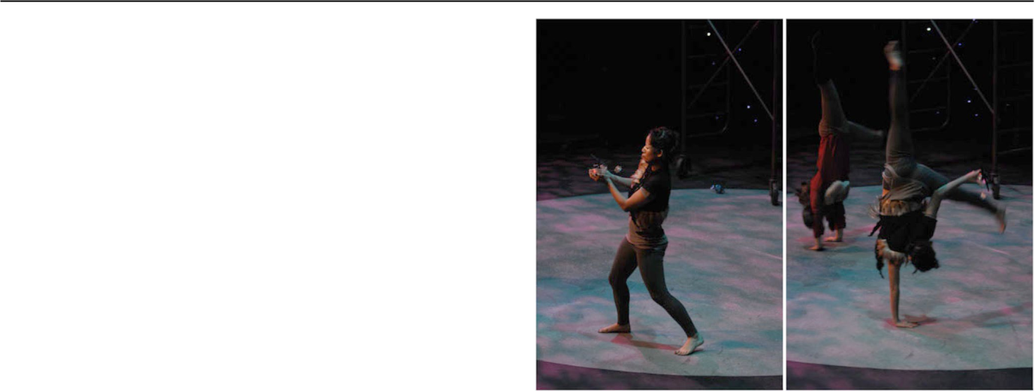

**Figure 7** A dancing fairy carries off a crashed micro-heli by improvisinga one-handed cartwheel, robot in hand.

the robot like a baseball apparently intending to relaunch it, or passing it to the end of the aisle. It was significant that the au-dience did not look to the operators for instruction as to what to do with the robot; the audience member seemed to look for cues on how to behave from the actors or the robot itself.

Particularly during Act 4.1 where Mustardseed and her ro-bot mock Bottom, the micro-heli had a tendency to drift over the audience, although this sometimes happened in Acts 2.2 and 3.1. In order to maintain the fast tempo of the staging, the actor would improvise getting the robot back rather than wait for the operator to try to move the robot back to position. She might reach over the audience or even climb on seats. If the mi-cro-heli had drifted too far, the operator would land in the au-dience and Mustardseed would gesture for the micro-heli to be returned to her. Mustardseed reacted as if this was all the audi-ence’s fault; she mimed scolding the audience and implied that they were trying to steal the micro-heli. In general when a mi-cro-heli drifted over the audience, the audience did not appear to pay attention to it and instead focused on the action on stage. However, there was one exception when a audience member ap-peared to intend to humorously swat the micro-heli away but the disrupted airflow caused a crash and much embarrassment on the part of the audience member.

**5 Audience and actor reactions to interaction**

The audience reaction to the use of flying robots was over-whelmingly positive and their unintended interactions with the robots are described in Sect. 4.8, while the reaction of the ac-tors changed from wariness to positive over time. The one re-view of the play was by the university student paper, The Bat-talion, which clearly viewed the robots as one aspect of the play

|  |  |
| --- | --- |
| A Midsummer Night’s Dream (with flying robots) | 151 |

**Table 2.** Identified unplanned flight events aggregated over the eightperformance run of the play

|  |  |
| --- | --- |
| Event | Count |
|  |  |
| Collision with the scaffolding, side-wall, or curtains | 34 |
| Collision with audience | 23 |
| Collision with cast | 3 |
| Midair collision between robotsa | 10 |
| Downdraft interference | 3 |
| Landed on stage or stairsb | 21 |
| Landed on scaffolding | 1 |
| Relaunched from fairy’s hand | 25 |
| Relaunched from audience member’s hand | 2 |

a. A collision between a pair of robots is counted as two collision events

b. This includes robots beyond the line of sight of flyers, and those that land on stage

that accentuated the acting and dancing (Gerhart 2009) rather than the major distinguishing point seen in other uses of robot in theater (Lin et al. 2009; McCoy 2008; Ruggiero 2008). An interesting point is that the reviewer interpreted the micro-heli crashes as due to lost communications, rather than mechanical failure, environmental variability, or operator error.

The robots did not distract the audience from the play as ev-idenced by the lack of attention paid the robots or operators. No more than four audience members at any performance were observed to follow the Quad-Rotor’s exits, despite close prox-imity to a loud device creating a large air current. As noted in Sect. 4.8, the audience generally ignored the micro-helis when they flew overhead. Consistent with puppetry, starting with Jap-anese Bunraku which originated in the 17th century and had 3 to 4 puppeteers visibly operating a puppet (Tillis 1992) and continuing through the recent productions of Disney’s *The Lion* *King* and the musical *Avenue Q* where puppeteers are visible,the audience treated robot operators as invisible even though they were in view.

Observations of the actors, statements from the “talkback” sessions after select performances, and a follow up interview with one of the human fairies suggest that the actors had expec-tations of the robots based on the movies (especially the Termi-nator) and consumer products (much more hardened and safe). This talk-back is a less formal form of the independently de-veloped Theatre HRI method described in Chatley et al. (2010). The actors had expected humanoid robots and also that the ro-bots might take over roles normally given humans. Initially the actors treated the micro-helis roughly and perhaps being non-science majors did not show an understanding of “naive phys-ics” of flight and continually surprised the robot operators with

how the robots were launched. The actors also appeared to be oblivious to the safety hazards associated with the Quad-Ro-tor. Although it was extremely unlikely that an injury could re-sult, the dancers were often on eye level with the rotors as the robot descended the aisle to the stage. The robot operators gave an official safety and care briefing, creating two analogies that persisted and were mentioned by the actors in their interviews for The Battalion: one was to think of the Quad-Rotor as a “gi-ant flying weed wacker of death” and the other was to think of the micro-helis as robot babies (Gerhart 2009). The metaphors produced the desired effect of a more safety conscious culture. Finally, the actors were at first annoyed at the robots, not the op-erators, by the limited expressiveness and frequency of crashes. The actors playing the fairies then realized the opportunity for improvisation and to expand their roles. One actor commented that the unpredictability of the robots kept the actors on their toes and not to lapse into inattentiveness. The peer reaction to the “coolness” of having robots in the play also seemed to fa-cilitate the shift from wariness to enthusiasm.

**6 Lessons from the theater about affect**

The production of *A Midsummer Night’s Dream* forwarded an understanding of how affect, an important component of believ-ability in agents, is created. The results are synthesized into a preliminary taxonomy for generating affect. A major surprise was the importance of improvisation and its necessity for even a highly scripted play; the necessity and contribution of impro-visation had been eschewed in the literature. The production raises two real concerns that merit additional research: how untrained human groups form expectations about robots (it ap-pears social proof Cialdini (2007) is a major form of influence on those expectations) and the implications of human expec-tations of safety and reliability of robots (robots may not met those expectations and thus pose significant risk).

6.1 Preliminary taxonomy for generating affect

A goal of the collaborative production was to codify the be-haviors would lead to untrained observers perceiving the de-sired affect and intent. Towards this goal, three categories of how robots can generate affect were identified. The first two categories, *apparent affect from animacy* and *apparent affect* *from actor reaction*, require that the robot be proximate tothe action and only loosely coupled; in essence, the robots do not have to have or execute affective expressions because the overall action or the response of the actors is sufficient to cre-ate the perception of affect. Only in the third category, *affect* *from explicit affective expressions*, does the robot begin to ex-plicitly contribute to the perception of affect. The three cate-gories are ordered by increasing robot affective complexity:

152  Murphy et al . in *Autonomous Robots* 30 (2011)

animacy and reaction require less behavioral subtlety from the robot than the explicit affective expression. A weakness of the taxonomy is that it categorizes the effort required by robots to generate affect, rather than organizing the audience’s un-derstanding of the affect based on the contribution of mech-anisms (proximity, synchronization, mirroring, sounds, etc.). Even without a detailed model of the audience’s understand-ing of affect, important distinctions of degree or kind of affect may alter which taxonomic categories are applicable. Appar-ent affect by actor reaction was the dominant mechanism in the play; in all but one case, the actors led the action and their reaction created the affect. While robot capabilities or opera-tor skill may limit expressions of affect to the first category or first and second categories, the experience is that this need not imply a hard limit on the expressiveness of the robot. Within the first two categories a lack of complexity in the individual robot is compensated for by other agents: the observed robot-actor relationship and interaction is the expressive element, rather than the robot itself. When generating affect the robot should be considered a socially situated agent within a broader ecology of agents, the scene, and staging.

*6.1.1 Apparent affect from animacy (the Heider-Simmel effect)*

Consistent with the seminal Heider and Simmel study that showed observers assign affect and interpret intent based on motion (Heider and Simmel 1944), the audience perceived af-fect and group coordination even though the robot motions where independent of the actors’ motions. As seen in the Pro-logue and Acts 2.1 and 5.1, the connection between the actors and robots was through accidental *proximity* and *loosely cou-pled synchronization*. For example, in the Prologue, the goalfor each robot operator was simply to get their robot over the dancers and, if the mechanical control and environmental con-ditions permitted, to rotate their robot to the beat of the music. The apparent affect was perceived more strongly when there were more robots, possibly because the probability of a favor-able synchronization confirming an intent was increased (e.g., “that robot is moving to the beat; oh, all the robots are excited by the music …” or “those two robots are above the action, they all must be watching the action”). Demers and Horakova (2008) refer to animacy in performing robots as anthropopathy, a term from theater denoting the attribution of affect to non-hu-man beings.

*6.1.2 Apparent affect from actor reaction*

Consistent with stage theory, where the visible reaction of the actor to an action by another actor creates the impression of af-

fect, the human actors can create affect even if the robot’s ac-tions are independent. This type of apparent affect occurred in Acts 2.2, 3.1, and the first part of 4.1, where the micro -helis swarmed overhead and then landed in the human fairies’ hand, creating an impression of baby fairies. Unlike the Prologue and Acts 2.1 and 5.1, there was explicit interaction between the ac-tors and robots but the human was expected to compensate for deficiencies in the robot. For example, the lead fairy cued the robots to descend and then all fairies attempted to gracefully catch the robots. The actors compensated for the robots’ lack of control and unpredictable locations, creating an impression of cooperation. Rather than the robots or their operators keeping up with “their” mother fairy, the mother fairies were expected to keep up and compensate for the robots.

The robot’s contribution to the generation of affect in this case was *proximity* and a more *tightly coupled interaction* (i.e., descend on cue) but the responsibility for the perception of af-fect relied on the skill of the actors, very precise stage direc-tions, and an awareness on their part of the situation, and their ability to improvise.

It is interesting to note that the audience learned how to in-terpret the robot agent’s actions based on the actor’s reactions; as described in Sect. 4.8, the response of an audience member to a robot crash depended on whether they had witnessed an ac-tor responding to a crash.

*6.1.3 Affect from explicit affective expressions*

In this category, the robot initiates and performs some, if not all, of the direct cues to create affect, with a much lessened de-pendency on the reaction of the actors. In some sense, this is where a robot can deliberately project affect and intent. Only one scene in the play had a robot attempt to create affect us-ing explicit affective expressions. In that act where Mustard-seed mocks Bottom, a robot baby fairy is launched by a mis-chievous Mustardseed, it then moves away from Mustardseed to follow behind Bottom while making a set of mocking (up/ down, roll/yaw) motions and “sneaky” noises like Snidely the Dog (the sound was not added for technical reasons), then spins to communicate enjoyment of the prank. Note that in theory, the interpretation of affect in this category would de-pend more on what the robot actually does independently of the actors. However, this was only weakly demonstrated in *A* *Midsummer Night’s Dream*; the success of the act dependedon the actor who non-verbally conveyed mischievousness be-fore and during launching her robot baby and that impression was transferred and attached to the robot. It should be empha-sized that the actor was chosen for her ability to set up the af-fective nature of the scene, and other actors in the production would not have been as successful as she.

|  |  |
| --- | --- |
| A Midsummer Night’s Dream (with flying robots) | 153 |

6.2 The importance of improvisation within robot theater

Perhaps the most surprising aspect uncovered while creating the taxonomy was the degree of improvisation required of the hu-man actors and the lack of improvisation required by the robot. While improvisation is a key element in digital character ani-mation (see Perlin 2000 and Göbel et al. 2006 for representa-tive approaches), the prior work in the nascent robotics theater community has argued that actor-robot improvisation would be too hard (Breazeal et al. 2003) or that anything but impro-visation would be unsatisfying (Bruce et al. 2000). This work found that improvisation by the actor was both necessary to stage a production with robots and effective in communicating and amplifying affect within a scripted play, but that the robot did not have improvise. It also found that symmetry is not re-quired; robots do not have match human capabilities in improv.

The use of improvisation runs counter to Breazeal et al. (2003), which postulated that improvising would be the hardest case of interaction for robot and human actors and thus should be attempted last. However, Breazeal et al. (2003) only consid-ered fully autonomous robots, while this effort shows that the robot does not have to be the improvising party. The experi-ences with *A Midsummer Night’s Dream* show that improvisa-tion is required both implicitly (to compensate for timing, ac-tor variations, etc., also seen in Apostolos et al. 1996; Wallis et al. 2010) and explicitly (to compensate for technological fail-ures, such as the crashes in Sect. 4.8). The implicit and explicit opportunities for improvisation may be thought of as de facto “scene-advancing offers” Baumer and Magerko (2009), the ini-tial step in effective improvisation. Furthermore, the taxonomy shows that it can be simpler from a programming standpoint to produce believable characters with improvisation than without (which is consistent with digital character animation), as creat-ing apparent affect from animacy and actor reaction is less com-plex for a robot than explicit generation of affect. Therefore, improvisation should be expected to be incorporated into any human-robot theater production both from necessity and from simplicity. If Breazeal et al. (2003) argue for improv being at-tempted last because it is so difficult, then the findings from *A* *Midsummer Night’s Dream* suggest improv is easy and shouldbe attempted first.

The clear audience acceptance of robots as an enhancement to *A Midsummer Night’s Dream* and their demonstrated enjoy-ment of the play described in Sect. 5 contradict Bruce et al. (2000) who argue for robots in fully improvisation drama say-ing that “Having robots perform a prescripted, complex play (say, Hamlet) would be an obviously unsatisfying experience.” Bruce et al. (2000) can be interpreted in a less extreme “do away with scripts” fashion as a fear of the loss of dynamic co-ordination and timing between actors. However, the lessons learned from *A Midsummer Night’s Dream* was that while such

timing is critical for an enjoyable play, the robot does not neces-sarily have to be responsible for it. Affect can be generated with unsynchronized timing (apparent affect from animacy) and from the human actor (apparent affect from actor reaction). Certainly having autonomous robots which can observe and respond ap-propriately is a goal, but in terms of the goal of this article, *A* *Midsummer Night’s Dream* shows that the robot may not haveto explicitly generate or be responsible for affect production.

6.3 How untrained human groups form expectations

The observations of the actors during pre-production and the audience suggests that people base how they will interact with robots from watching others. This appears to be an extension of the concept of “social proof” forwarded by Cialdini (2007). So-cial proof is the phenomena of responding to a situation based on the observations of how others are responding. One exam-ple is that despite reporting hating canned laugh tracks, people will laugh longer and more often with it. Cialdini notes that so-cial proof is especially pronounced in ambiguous situations; if a person does not know what to do, they look to see what oth-ers are doing. An example includes bystander inaction, such as the famous Kitty Genovese case where 38 people witnessed her murder but did not intervene. However, social proof applies to any uncertain situation where there are large numbers of people who are not acquainted. The witnessed behavior of the actors, and especially that of the audience, suggests that social proof will be the default mechanism at play in first encounters be-tween the public and a robot(s). The default social proof of hu-man-robot interaction from the movies must be managed or re-placed so that the correct expectations are formed or reinforced and people respond appropriately.

Social proof appears to have influenced the actors’ response to the robots, but more importantly the actor’s source of social proof helps explain the audience’s stronger exhibition of social proof. During pre-production, the actors had very little interac-tion with the robots and as a group were not told how to react to the robots; only the individual human fairies were formally introduced to the robots and that was brief as the frequency of crashes and potential for unsafe interactions was not anticipated. This created an ambiguous situation with a large number of peo-ple present, though many of the cast members knew each other. As reported in the talk-back sessions in Sect. 5, the actors stated that they started off with expectations formed by movies and TV and previous interactions with hardened consumer goods. This suggests that social proof of how to behave around and with the robots was provided by the media; Cialdini reports that thera-pists often use films of threatening experiences and how others behave in that context to provide social proof of how to respond appropriately (Cialdini 2007). Possibly as a result of the prior social proof in the media of robots as capable, advanced agents,

154  Murphy et al . in *Autonomous Robots* 30 (2011)

the actors were surprisingly trusting of the large robot, coming far too close to the exposed rotors, and being too rough with the smaller platforms. The actors’ default expectations had to be modified by explicit instruction so that they would maintain a safe distance from the larger AirRobot platform and would handle the fragile Eflite platforms more carefully.

Social proof appears to be the best explanation for the vari-ances in audience reaction to a small robot fairy crashing in the seated area. As described in Sect. 4.8, if a crash into the audi-ence occurred *after* a crash on-stage where a cast member re-launched a robot, the nearby audience members would treat the robot in the same gentle way and use the same careful motions to relaunch. If a crash occurred *before* an on-stage crash and re-launch, the audience members often looked around then were generally rough and threw the robot to relaunch. A crash into the audience met all three conditions for social proof: the oc-currence of the crash (and the presence of the robots at all) cre-ated uncertainty as how to respond, there was a large number of people present, and the audience and cast were not acquainted. Consistent with social proof, the audience reaction to a crash was based on what they observed up to that point. If they had observed actors handling the robots, they followed that model, if they had not, they were likely using the same expectations as the actors formed by the media and consumer goods. Unlike the talk-back sessions with the actors, there was no question-ing of the audience to explore their state of mind, so this re-mains a conjecture.

6.4 The importance of safety and reliability

Although safety and reliability might be considered an expec-tation of an untrained human group, the impact on robot phys-ical design and human-robot interaction behaviors warrants a separate discussion. Both the actors and audience appeared to treat both the large Quad- Rotor and the small micro-helis as safe. Only when explicitly informed of the potential for injury did the actors maintain an appropriate distance from the Quad-Rotor. Likewise, both the actors and audience treated the mi-cro-helis roughly and launched them from demanding positions without apparently considering the consequences.

Safety and reliability is particularly important in theater as proximity may be the most important factor in generating af-fect. Affect requires proximity between robots and humans, but close proximity introduces risk to the humans (and robots, as seen by the audience member swatting a robot).

Safety and reliability is also a design issue; how will robot designers meet the expectations of safety and reliability or indi-cate that the default expectations are incorrect? One way to in-dicate that a robot is unsafe or to encourage maintaining a safe distance is to behave erratically; however, the AirRobot Quad-Rotor is designed to be stable and is hard to produce noticeable

erratic behavior without risking the platform. The micro-helis had one way of communicating state: the LED that illuminated the costume. An operator would turn off the link to a micro-heli, causing the LED to turn off, signaling that the robot was inop-erable. Significant attention was paid to safety during pre-pro-duction and scenes and stagings were cut or modified to mini-mize any possible risk to the audience.

**7 Conclusions**

In conclusion, the successful production of *A Midsummer* *Night’s Dream* with humans and robots provides insight intocreating believable agents. Seven non-anthropomorphic aer-ial vehicles with only a few degrees of freedom to provide expressiveness were able to amplify the emotional content of the play.

The experience produced a preliminary taxonomy of how robots can generate affect. Affect can be generated with no ex-plicit behaviors as a consequence of the assignment of causality to animate objects (apparent affect from animacy). It can also be generated without explicit affective behaviors through the response or context setting by the actors (apparent affect from actor reaction). As the third level of complexity, the robot it-self can explicitly contribute to the perception of affect (affect from explicit affective expressions). Lessons learned for cre-ating apparent affect include having robots in close proximity to humans, multiple robots do not have be tightly coordinated or synchronized to generate affect, and having more robots in-creases the understanding of intent when robots are perform-ing in parallel to humans (i.e., humans aren’t providing direct cues). There remains the question of whether affect production in the theater, which is surreal, will hold for real world public encounters with robots.

The production also illustrates the importance of improvisa-tion to be a workable and desirable means for interacting with robots. Such improvisation is necessary to overcome the natu-ral behavioral variability in theater and also the results of con-trol error, noise, and uncertainty. While *A Midsummer Night’s* *Dream* relied on the human actors to be the improvisationalagent, it is expected that improvisation will be a fundamen-tal component of believable agency and not an optional, ad-vanced case.

The research also identified that much more work needs to be done in how people generate expectations about robots and the implications for safe and reliable interactions.

Future work is expected to continue to refine the ideas put forth in this article, especially addressing how the audience per-ceives for affect (versus how a robot can generate affect). Plans for another human- robot production are underway and a new play with key roles for robots has been proposed.

|  |  |
| --- | --- |
| A Midsummer Night’s Dream (with flying robots) | 155 |

**References**

Ambach, J., & Repenning, A. (1996). Participatory theater: interacting with autonomous tools for creative applications. *Knowledge-Based* *Systems*, *9*(6), 351–358.

Apostolos, M. K., Littman, M., Lane, S., Handelman, D., & Gelfand, J. (1996) . Robot choreography: An artistic- scientific connection. *Com-puters & Mathematics with Applications*, *32*(1), 1–4.

Baumer, A., &Magerko, B. (2009). Narrative development in improvisa-tional theatre. In *Lecture notes in computer science*: *Vol*. *5915*. *Inter-active storytelling* (pp. 140–151). Berlin: Springer.

Beaumont, C. (1958). *Puppets and puppetry*. New York: Studio Publications.

Breazeal, C., Brooks, A., Gray, J., Hancher, M., Kidd, C., McBean, J., Stiehl, D., & Striken, J. (2003). Interactive robot theatre. In *IEEE/RSJ* *international conference on intelligent robots and system’s* (pp. 3648–3655), Las Vegas, NV.

Bruce, A., Knight, J., Listopad, S., Magerko, B., & Nourbakhsh, I. R. (2000). Robot improv: Using drama to create believable agents. In *Proceedings IEEE international conference on robotics and automa-tion* (Vol. 4, pp. 4002–4008), San Francisco, CA.

Burke, J., Friedman, J., Mendelowitz, E., Park, H., & Srivastava, M. B. (2006). Embedding expression: Pervasive computing architecture for art and entertainment. *Pervasive and Mobile Computing*, *2*(1), 1–36.

Chatley, A. R., Dautenhahn, K., Walters, M. L., Syrdal, D. S., & Chris-tianson, B. (2010). Theatre as a discussion tool in human-robot in-teraction experiments—A pilot study. In *Proceedings of the third in-ternational conference on advances in computer-human interactions (ACHI ’10)* (pp. 73–78).

Cialdini, R. B. (2007). *Influence: the psychology of persuasion*. Glasgow:

Collins.

Demers, L.-P., & Horakova, J. (2008) . Anthropocentrism and the staging of robots. In *Sound, vision and the new screen, communication in com-puter and information science*: *Vol*. *7*. *Transdisciplinary digital art* (pp.434–450). Berlin: Springer.

Dompierre, C., & Laurendeau, D. (2006). Avatar: A virtual reality based tool for collaborative production of theater shows. In *The 3rd Cana-dian conference on computer and robot vision, 2006* (p. 35).

Gerhart, A. (2009). ‘*A Midsummer Night’s Dream’* is a successful team ef-fort. *The Battalion*, 9 November 2009.

Göbel, S., Malkewitz, R., & Iurgel, I. (Eds.) (2006). *Lecture notes in com-puter science*: *Vol*. *4326*. *Technologies for interactive digital storytell-ing and entertainment*. Berlin: Springer.

Goto, S., & Yamasaki, F. (2007). Integration of percussion robots “Ro-botMusic” with the Data-Suit “BodySuit”: Technological aspects and concepts. In *The 16th IEEE international symposium on robot and hu-man interactive communication, 2007. RO-MAN 2007* (pp. 775–779).

Heider, F., & Simmel, M. (1944). An experimental study of apparent be-haviour. *American Journal of Psychology*, *57*(2), 243–259.

Iida, K., Itai, S., Watanabe, T., & Miwa, Y. (2008). Public viewing with shadows: Design of theater-type space where remote actors and audi-ences can coexist using the shadow as their own agents. In *The 17th* *IEEE international symposium on robot and human interactive com-munication, 2008. RO-MAN 2008* (pp. 677–682).

Lin, C.-Y., Tseng, C.-K., Teng, W.-C., Lee, W.-C., Kuo, C.-H., Gu, H.-Y., Chung, K.-L., & Fahn, C.-S. (2009). The realization of robot theater: Humanoid robots and theatric performance. In *International confer-ence on advanced robotics, 2009. ICAR 2009* (pp. 1– 6).

Mavridis, N., & Hanson, D. (2009a). The IbnSina Center: An augmented reality theater with intelligent robotic and virtual characters. In *The* *18th IEEE international symposium on robot and human interactive communication, 2009. RO-MAN 2009* (pp. 681– 686).

Mavridis, N., & Hanson, D. (2009b) . The IbnSina interactive theater: Where humans, robots and virtual characters meet. In *The 18th IEEE* *international symposium on robot and human interactive communi-cation, 2009. RO-MAN 2009* (pp. 213–213).

McCoy, A. (2008). Quantum clicks gears with Robot 250. *Pittsburgh Post-Gazette*, July 31 2008.

Ohya, J., Ebihara, K., Kurumisawa, J., & Nakatsu, R. (1996). Virtual Ka-buki Theater: Towards the realization of human metamorphosis sys-tems. In *5th IEEE international workshop on robot and human com-munication, 1996* (pp. 416–421).

Paricio García, R., & Moreno Aróstegui, J. M. (2007) . A cooperative ro-botic platform for adaptive and immersive artistic installations. *Com-puters & Graphics*, *31*(6), 809–817.

Perkowski, M., Sasao, T., Kim, J. H., Lukac, M., Allen, J., & Gebauer, S. (2005). Hahoe KAIST robot theatre: Learning rules of interactive ro-bot behavior as a multiple-valued logic synthesis problem. In *Proceed-ings of the 35th international symposium on multiple-valued logic, 2005* (pp. 236–248).

Perlin, K. (2000). Creating emotive responsive characters within virtual worlds. In *Lecture notes in computer science*. *Virtual worlds* (pp. 99– 106). Berlin: Springer.

Ruggiero, P. (2008). Shakespeare’s *Cymbeline* is a machine of sorts— Or so proposes Quantum Theatre. *Pittsburgh City Paper*, July 31 2008.

Squatriglia, C. (2009). Robots perform Shakespeare. *Wired*, November 18 2009.

Tillis, S. (1992). *Toward an aesthetics of the puppet: Puppetry as a theat-*

*rical art*. Westport: Greenwood Press.

Wallis, M., Popat, S., McKinney, J., Bryden, J., & Hogg, D.C. (2010). Em-bodied conversations: Performance and the design of a robotic danc-ing partner. *Design Studies*, *31*(2), 99–117.

Werger, B. (1998). Profile of a winner: Brandeis University and Ullanta performance robotics robotic love triangle. *AI Magazine*, *19*(3), 35–38.

**Robin Murphy** is the Raytheon Pro-fessor of Computer Science and Engi-neering at Texas A&M. She received a B.M.E. in mechanical engineering, a M.S. and Ph.D. in computer science in 1980, 1989, and 1992, respectively, from Georgia Tech, where she was a Rockwell International Doctoral Fellow. Her re-search interests are artificial intelligence, human-robot interaction, and heteroge-neous teams of robots. In 2008, she was awarded the Al Aube Outstanding Con-tributor award by the AUVSI Founda-tion for her insertion of ground, air, and

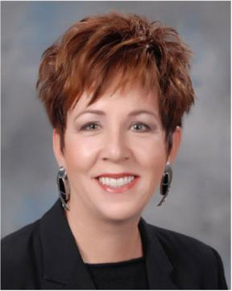

sea robots for urban search and rescue (US&R) at the 9/11 World Trade Center disaster, Hurricanes Katrina and Charley, and the Crandall Canyon Utah mine collapse. She is a Distinguished Speaker for the IEEE Robot-ics and Automation Society, and has served on numerous boards, includ-ing the Defense Science Board, USAF SAB, NSF CISE Advisory Coun-cil, and DARPA ISAT.

156  Murphy et al . in *Autonomous Robots* 30 (2011)

**Dylan Shell** is an assistant professorcomputer science and engineering at Texas A&M University in College Sta-tion, Texas. He received his B.Sc. degree in computational & applied mathematics and computer science from the Univer-sity of the Witwatersrand, South Africa, and his M.S. and Ph.D. in Computer Sci-ence from the University of Southern California. He took a position as Post-doctoral Research Associate in the USC Interaction lab in 2008, before joining Texas A&M. His research aims to syn-thesize and analyze complex, intelligent

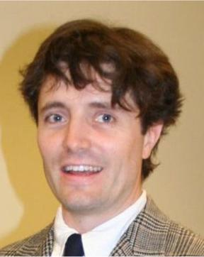

behavior in distributed systems that exploit their physical embedding to interact with the physical world. He studies both natural (social insect and human crowd) and synthetic systems (sensor networks and multirobot swarms) by using techniques that model behavior across multiple scales.

**Amy Guerin** received her BFA in Act-ing from the University of Oklahoma, and her MFA in Directing from the Uni-versity of Houston. Raised in Houston, Amy lived in Austin for six years after graduating from OU, and worked with Salvage Vanguard Theater, The Vortex, State Theatre Company, Gypsy Baby, Different Stages and Disciples of Mel-pomene. In Houston, she directed *Owen* *Wister*, *Considered and The Danube* atthe University of Houston. She is a co-founder and Founding Director of Nova Arts Project, a Houston-based theatre

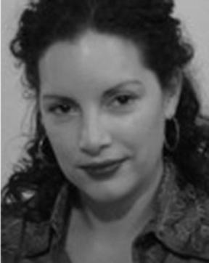

company, which received the Houston Press MasterMind Award for Out-standing Creative Contribution in 2009. With Nova Arts Project, Amy di-rected their debut production of *Stella … Stella for Star* in May 2006 and *Richard III* as a part of July 2008’s *The War of the Roses Cycle*. As an ac-tor with the company, Amy has been in the ensemble of *Oedipus3*, *Ham-let*, *…The Ambassadors…*, *TempOdyssey* and *Love Loves a Pornographer*.At Texas A&M, Amy directed *Lend Me a Tenor* in Fall 2008 and will di-rect *A Midsummer Night’s Dream* in Fall 2009.

**Brittany Duncan** is a first year gradu-

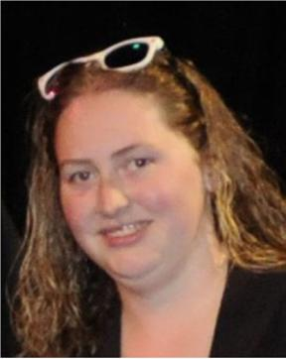

ate student in the Department of Com-

puter Science and Engineering at Texas

A&M University where she is pursuing

her doctorate. Her areas of interest in-

clude Robotics, HRI, UAVs and affect.

**Benjamin Fine** is a first year gradu-ate student in the Department of Com-puter Science and Engineering at Texas A&M University where he is pursuing his doctorate. His areas of interest in-clude multi-robot systems.

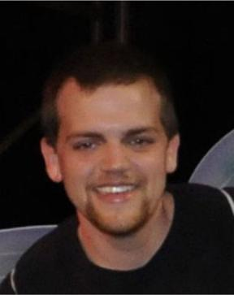

**Kevin Pratt** is a graduate student inthe Department of Computer Science and Engineering at Texas A&M Univer-sity where he is pursuing his doctorate. His areas of interest include UAVS and Robotics.

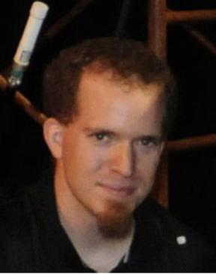

**Takis Zourntos** is an Assistant Profes-sor in the Department of Electrical and Computer Engineering at Texas A&M University. He hails from Canada and earned all his degrees from the Univer-sity of Toronto. His core expertise are in the areas of control theory, mixed-signal integrated circuits and signal processing, which he attempts to apply synergisti-cally in the field of robotics. He was the recipient of the 2003– 2004 IEEE Stu-dent’s Choice Award for Best Electri-cal Engineering Professor (Texas A&M Chapter).

